CASE REPORT
PRESERVED CONDUCTION IN EBSTEIN’S ANOMALY REVEALED BY DUAL ACCESSORY PATHWAY ABLATION
ABSTRACT
Aims: To report a unique case of Ebstein's Anomaly (EA) where successful radiofrequency catheter ablation of two accessory pathways revealed a remarkably preserved native conduction system, and to discuss the role of thyrotoxicosis as a metabolic trigger in destabilizing congenital substrates leading to acute symptomatic presentation.
Case Presentation: A 13-year-old female with underlying EA and Wolff-Parkinson-White syndrome (baseline QRS 170 ms) presented with palpitations exacerbated by thyrotoxicosis. EPS and 3D mapping identified two distinct right-sided bypass tracts. Following successful radiofrequency ablation (RFA) utilizing an irrigated catheter (25 Watts, temperature – limited for 45 seconds), the post-procedural ECG revealed a narrow QRS of 78 ms with a striking absence of the expected right bundle branch block (RBBB).
Discussion: EA is classically coupled with severe intrinsic right-sided conduction system disease. This case challenges the "universal" RBBB paradigm. Thyrotoxicosis served as a metabolic "second hit," increasing myocardial excitability and triggering symptomatic tachycardia.
Conclusion: Conduction system disease in EA displays remarkable clinical heterogeneity. Clinicians must remain vigilant for extracardiac metabolic triggers when a previously stable arrhythmic substrate becomes acute, and long-term surveillance is necessary given the high recurrence risk associated with remodelled tricuspid rings.
Keywords: Ebstein’s anomaly, Accessory Pathway, Pre-excitation, WPW syndrome, Radiofrequency Ablation, Right Bundle Branch Block, Thyrotoxicosis.
Abbreviations
ABL D: Distal Ablation
AP: Accessory Pathway
EA: Ebstein’s anomaly
ECG: Electrocardiogram
EPS: Electrophysiology Study
RBBB: Right Bundle Branch Block
RFA: Radiofrequency Ablation
SCD: Sudden Cardiac death
SVT: Supraventricular Tachycardia
TSH: Thyroid Stimulating Hormone
WPW: Wolff- Parkinson-White Syndrome

1.Introduction
Ebstein’s anomaly (EA) is a multifaceted congenital cardiac malformation characterized fundamentally by the failure of proper tricuspid leaflet delamination of the septal and posterior leaflets, resulting in the apical displacement of the functional annulus into the right ventricular cavity and creating a structurally thinned, "atrialized" right ventricle. This significant mechanical and structural remodelling disrupts normal electrical isolation, facilitating the development of accessory pathways (APs) and ventricular pre-excitation in approximately 30% of this population [1,2].
In classical congenital heart disease literature, as emphasized by Perloff, EA is nearly universally associated with intrinsic right bundle branch block (RBBB) due to congenital elongation, thinning, or fibro-fatty insulation of the right-sided conduction system [1]. In patients presenting concurrently with Wolff-Parkinson-White (WPW) syndrome, this baseline right-sided conduction delay is typically "masked" by rapid antegrade pre-excitation over the bypass tract [1,3]. Consequently, successful elimination of the accessory pathway is traditionally expected to "unmask" a broad, underlying RBBB pattern. We report an unusual presentation where the successful ablation of dual right-sided accessory strands revealed a completely intact native conduction network with a narrow QRS, defying established electrophysiological expectations.

2.Case Presentation
A 13-year-old female presented to our emergency department with an acute exacerbation of intensified, rapid-onset palpitations. On initial physical evaluation, she demonstrated sinus tachycardia, a wide-split second heart sound, and a palpably soft, mildly enlarged thyroid gland without associated bruits or orbitopathy. The baseline 12-lead electrocardiogram (ECG) displayed classic features of ventricular pre-excitation: a markedly shortened PR interval, broad QRS complex measuring 170 ms, and prominent positive delta waves across precordial leads V1 to V4, indicating an active right-sided bypass tract substrate (Figure 1a).
Transthoracic echocardiography parameters confirmed the diagnosis of Ebstein’s anomaly, showcasing a severe apical displacement of the septal tricuspid leaflet measuring 28 mm (>8mm/m² body surface area), severe tricuspid regurgitation, and a markedly dilated, thinned atrialized right ventricular segment (Figure 1c). Left ventricular structural dimensions, geometry, and systolic function remained completely preserved (ejection fraction 63%). Comprehensive baseline serum laboratory screenings—including complete blood count, serum renal function markers (creatinine 0.6 mg/dL), and routine serum electrolytes—were entirely within normal physiologic limits. However, given the clinical thyroid fullness, an emergency endocrine panel was obtained, revealing a state of acute biochemical thyrotoxicosis: a highly suppressed thyroid-stimulating hormone (TSH) level of <0.01mIU/L}, an elevated Free T4 of 3.12 ng/dL, and an elevated Free T3 of 7.20 pg/mL. Anti-TSH receptor antibodies, anti-thyroid peroxidase, and anti-thyroglobulin titres returned negative.
To definitively characterize the aetiology of the thyroid dysfunction, a high-resolution thyroid ultrasonography was performed. The imaging demonstrated an asymmetrically enlarged thyroid gland with the right lobe measuring 3.8 x 1.2 x 1.4 cm and the left lobe measuring 3.5 x 1.1 x 1.3 cm. The parenchymal echotexture was diffusely heterogeneous and hypoechoic, displaying patchy areas of altered echogenicity without any discrete focal nodules or macrocalcifications. Colour Doppler interrogation revealed completely normal intraparenchymal vascularity, without the classic hyper vascular "thyroid storm" flow patterns typical of active Graves' disease. These sonographic landmarks combined with the autoantibody profile firmly established a primary diagnosis of acute subacute/transient thyroiditis.
While hospitalized and awaiting elective electrophysiological intervention under stabilization, the patient experienced a sudden, hemodynamically stable paroxysm of extreme palpitations. A surface 12-lead ECG confirmed a regular, narrow-complex supraventricular tachycardia (SVT) at a rate of 190 beats per minute, which promptly terminated back into pre-excited sinus rhythm following the rapid intravenous administration of a single 6 mg bolus of adenosine.
Following initial management, the patient was taken to the electrophysiology laboratory. The entire electrophysiology study (EPS) and subsequent radiofrequency ablation were carried out under general anaesthesia Diagnostic catheters were advanced securely into the high right atrium, His-bundle region, RV apex, and coronary sinus.
Due to the complex, anatomically distorted substrate inherent to EA, advanced 3D electro anatomical mapping was performed to construct a high-density activation sequence matrix of the tricuspid annulus. Mapping successfully localized two independent, distinct right-sided bypass tract strands: a prominent right inferior free wall pathway and a secondary right anterior free wall pathway, with the successful target delivery zones subsequently marked by red ablation clusters (Figure 2). Intracardiac electrograms (EGMs) recorded at these critical sites during atrial pacing and sinus rhythm demonstrated absolute local "fusion" of the atrial and ventricular signals at the distal mapping ablation electrode pair (ABL d), confirming precise physical juxtaposition over the bypass insertions (Figure 3).
Radiofrequency energy delivery was executed utilizing an irrigated ablation catheter. Ablation was applied at the site of best local VA fusion using a temperature-limited mode, restricted to a power output of 25 Watts and an effective lesion burn duration of 45 seconds at each targeted annular marker. Following ablation of the first pathway (inferior free wall), immediate intermediate surface ECG tracings demonstrated a distinct shift in QRS axis and morphology, yet persistent ventricular pre-excitation remained evident, validating the autonomous, active nature of the second, anterior free wall pathway (Figure 4).
Application of radiofrequency energy to the anterior annular site successfully eliminated the residual accessory pathway, breaking all ventricular fusion (Figure 5). Strikingly, the immediate post-procedural 12-lead ECG revealed normal sinus rhythm with an optimized PR interval of 114 ms and a remarkably narrow QRS complex measuring just 78 ms, with a total, clear absence of any RBBB morphology (Figure 1b). Following successful ablation, the patient was initiated on a tailored course of antithyroid medications. At her one-month and three-month clinical follow-up, she remained completely asymptomatic, euthyroid, and showed no evidence of pre-excitation or pre-arrhythmic events.

3.Discussion
This case offers a compelling clinical counterpoint to classical dogmas, illuminating the substantial anatomical and electrophysiological heterogeneity that characterizes Ebstein’s Anomaly. While the expanded, atrialized right ventricular chamber typically generates thinned, fibrotic, and electrically fragmented areas prone to macro-re-entrant circuits, our findings demonstrate that structural displacement does not always go hand-in-hand with severe, irreversible damage to the proximal right bundle branch [2,4].
The technical execution of catheter mapping and ablation in EA remains heavily demanding. This difficulty stems from the apical displacement of the true functional annulus, the presence of multiple fragmented local right atrial and ventricular electrograms, and regular catheter instability within the dilated right-sided chambers [3]. In this patient, the sequential unmasking and elimination of two separate right-sided bypass tracts were clinically required to isolate and evaluate the native AV conduction system. Achieving a post-ablation QRS duration of 78 ms represents a major clinical departure from expected outcomes; it demonstrates that despite severe macro-structural distortion of the right ventricle, the central specialized conduction pathways can remain completely functional and intact [1,4].
The choice of ablation modality is crucial in these structurally anomalous rings. The use of an irrigated ablation catheter at a lower wattage (25 Watts) with temperature limitation prevents excessive endocardial heating and thinned wall charring while maximizing deep lesion formation through the fibro-fatty layers of the displaced annulus. This protective biophysical approach is essential for achieving permanent conduction block at the site of maximum local VA fusion without inducing collateral structural disruption.
A primary focus of this case is the severe clinical role played by the "second hit" of acute thyroiditis-induced thyrotoxicosis. As demonstrated by Klein and Danzi, elevated circulating levels of thyroid hormones significantly upregulate myocardial beta-adrenergic receptor density and structurally alter intracellular calcium-handling genes [7]. This hyper-metabolic state shortens the refractory periods of both atrial tissue and accessory bypass tracts while increasing automaticity [7,8].
The utility of emergency high-resolution thyroid ultrasonography was critical in this case to differentiate transient thyroiditis from underlying Graves’ disease or toxic adenomas. The sonographic findings of asymmetric enlargement and heterogeneous, hypoechoic echotexture combined with completely normal vascular flows effectively confirmed a leaking, inflamed parenchymal state rather than active hyperplastic hormone synthesis. In our patient, this transient metabolic shift served as an acute electrical catalyst, turning a previously stable, silent congenital dual-pathway substrate into a symptomatic tachyarrhythmia emergency. This presentation matches Perloff's long-standing clinical rule that whenever an adult or paediatric patient with congenital heart disease shows an abrupt, "unnatural" change in symptomatic status, clinicians must immediately screen for extracardiac compounding factors [1].
Furthermore, recent consensus reviews by Dearani et al. emphasize that managing arrhythmias in EA demands strict risk stratification [5]. Pre-excited patients are at a higher baseline risk for sudden cardiac death (SCD). When rapid tachyarrhythmias arise—especially when amplified by a thyrotoxic hyper-adrenergic surge—extremely rapid antegrade conduction down multiple accessory pathways during SVT or atrial fibrillation can rapidly trigger ventricular fibrillation [5,6]. It is also well-documented that catheter ablation along the tricuspid annulus in EA carries a higher risk of late pathway recurrence and the need for re-intervention compared to structurally normal hearts [3,6]. This occurs because of thick, multi-stranded accessory bundles and ongoing structural stretching of the right-sided annulus. This risk reinforces the importance of structured long-term clinical and electrocardiographic follow-up for this patient, even given the excellent post-procedural result.

4.Conclusion
Ebstein’s anomaly frequently involves multiple accessory pathways [1]. The diagnosis and management of arrhythmias in Ebstein’s Anomaly must account for significant clinical heterogeneity. While RBBB is a hallmark of the disease, its absence post-ablation highlights that the conduction system may occasionally be spared [1]. Clinicians must also screen for metabolic triggers like thyrotoxicosis, which can transform stable congenital cardiac substrates into peri-procedural emergencies [7]. Finally, given the structural abnormalities of the tricuspid ring, close long-term follow-up remains necessary to monitor for potential pathway recurrence.

Authors Contributions
This work was carried out in absolute collaboration among all listed authors. Author AS was directly responsible for patient care management, primary literature review, drafting the initial manuscript, and overall case coordination. Author HVS assisted in local data collection, structural tracking, and initial proofreading of the draft. Author AT conceptualized the report, supervised the electrophysiology study, contributed heavily to the clinical case analysis, and provided critical structural revisions for intellectual content. All authors read, edited, and gave final approval for the final version to be published.
Consent
All authors declare that written informed consent was obtained from the patient’s legal guardians for publication of this case report and the accompanying images.
Ethical Approval
As per international or university standards, written ethical approval has been collected and preserved by the authors.

Disclaimer (Artificial Intelligence)
The authors hereby declare that no generative artificial intelligence tools (ChatGPT, Copilot, etc.) were used in the writing, editing, or production of this manuscript.
Acknowledgements
The authors would like to thank the cardiology and EP teams at KIMSHEALTH for their assistance.
Competing Interests
Authors have declared that no competing interests exist.
References
1. Perloff JK, Marelli AJ. Perloff's Clinical Recognition of Congenital Heart Disease. 7th ed. Elsevier; 2023; 13:176-195.
2. Attenhofer Jost CH, et al. Ebstein's anomaly: review of a multifaceted congenital cardiac condition. Swiss Med Wkly. 2005; 135:269-281.
3. Wei W, et al. Catheter ablation of accessory pathways in Ebstein's anomaly. J Cardiovasc Electrophysiology. 2022;33(9):2011-2018.
4.Walsh EP. Arrhythmias in Ebstein's Anomaly: Pearls, Pitfalls, and Practical Mapping Strategies. JACC: Clin Electrophysiol. 2024;10(2):312-321.
5 Dearani JA, Mora BN, Nelson TJ, Haile DT, O’Leary PW. Ebstein anomaly review: what’s now, what’s next? Expert Rev Cardiovasc Ther. 2015;13(10):1101-1109.
6 Kriebel T, Mandica C, Deiss O, et al. Catheter ablation of multiple right-sided accessory pathways in congenital heart disease: Long-term outcomes and recurrence patterns. Int J Cardiol. 2023; 381:114-122.
7. Klein I, Danzi S. Thyroid Disease and the Heart. Circulation. 2007;116(15):1725-1735.
8. Osman F, et al. The effects of treatment of hyperthyroidism on radiofrequency ablation of supraventricular tachycardia. BMC Cardiovascular Disorders. 2024; 24:112.

Figures:
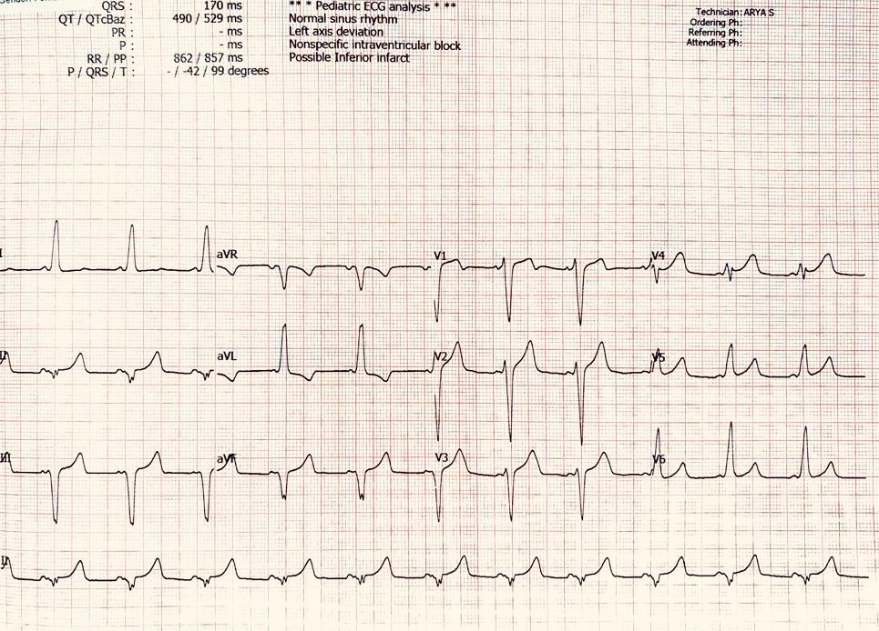
Figure 1a: Baseline 12-Lead ECG demonstrates sinus rhythm with hallmark features of WPW syndrome including shortened PR interval, widened QRS (170 ms), positive delta waves in leads V1-V4 and the predominantly negative QRS in the inferior leads suggests a right sided accessory pathway.
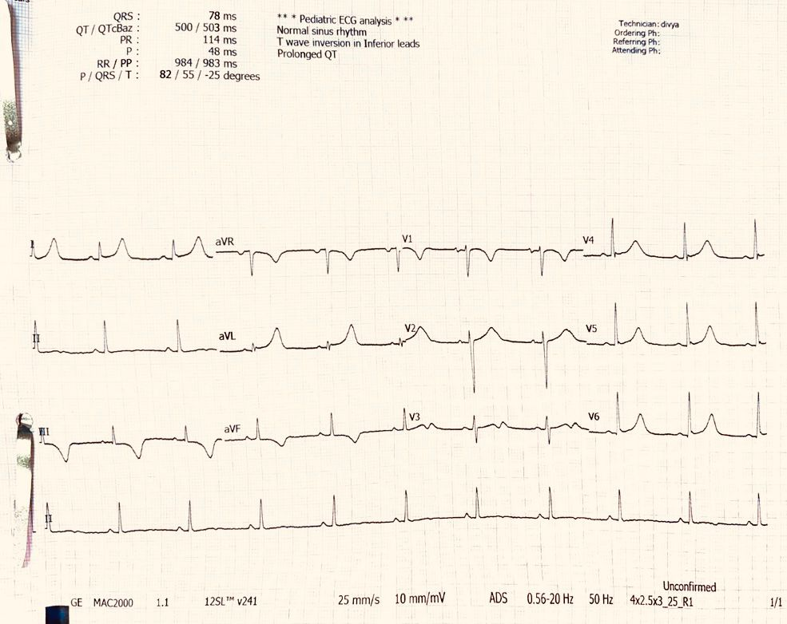
Figure 1b: 12-Lead ECG taken post ablation showing normal sinus rhythm with normal PR interval of 114 ms, narrow QRS (78ms), normalisation of conduction with disappearance of delta waves and the striking feature of absence of RBBB.

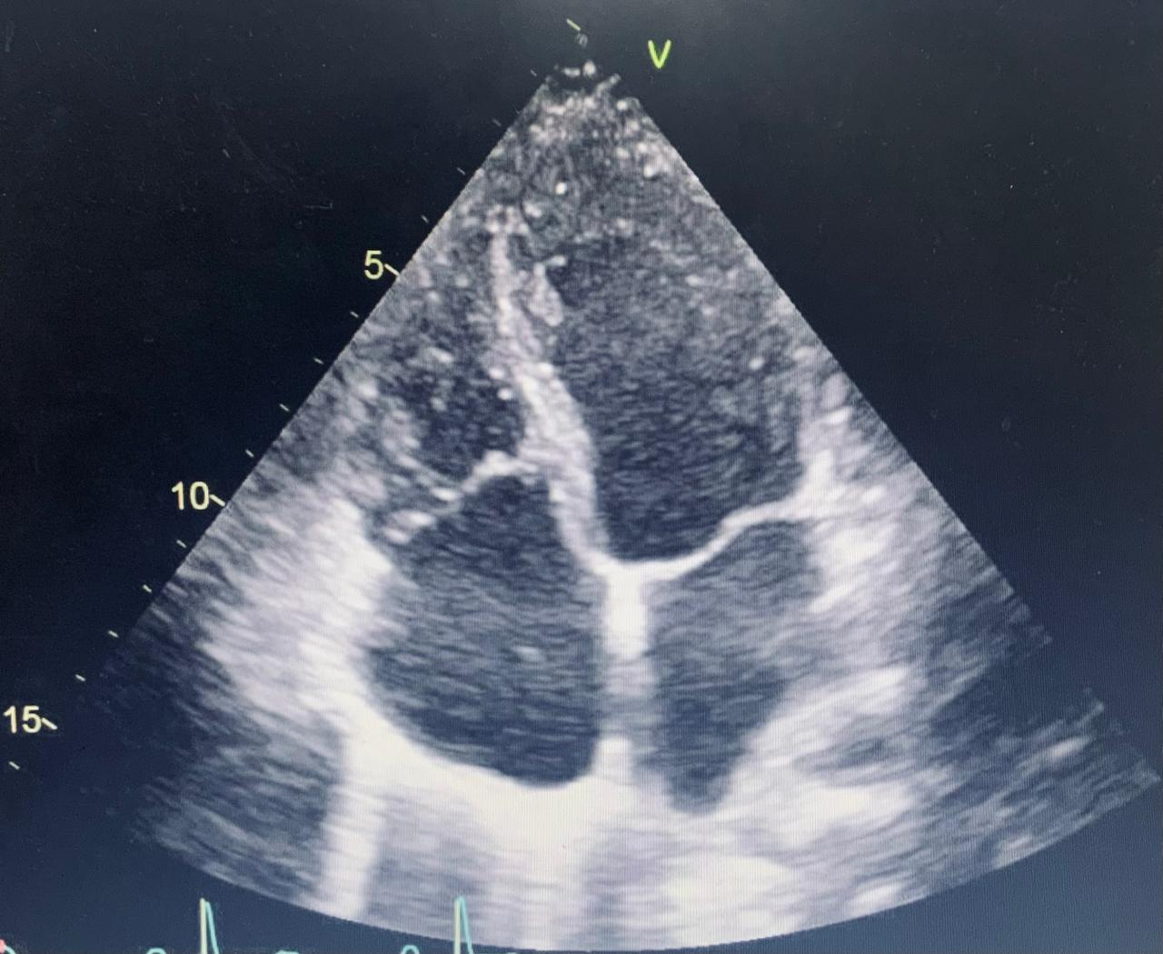
Figure 1c: Transthoracic echocardiogram (apical four-chamber view) demonstrates significant (28 mm) apical displacement of the septal tricuspid valve leaflet relative to the mitral valve annulus and the atrialization of the right ventricle.

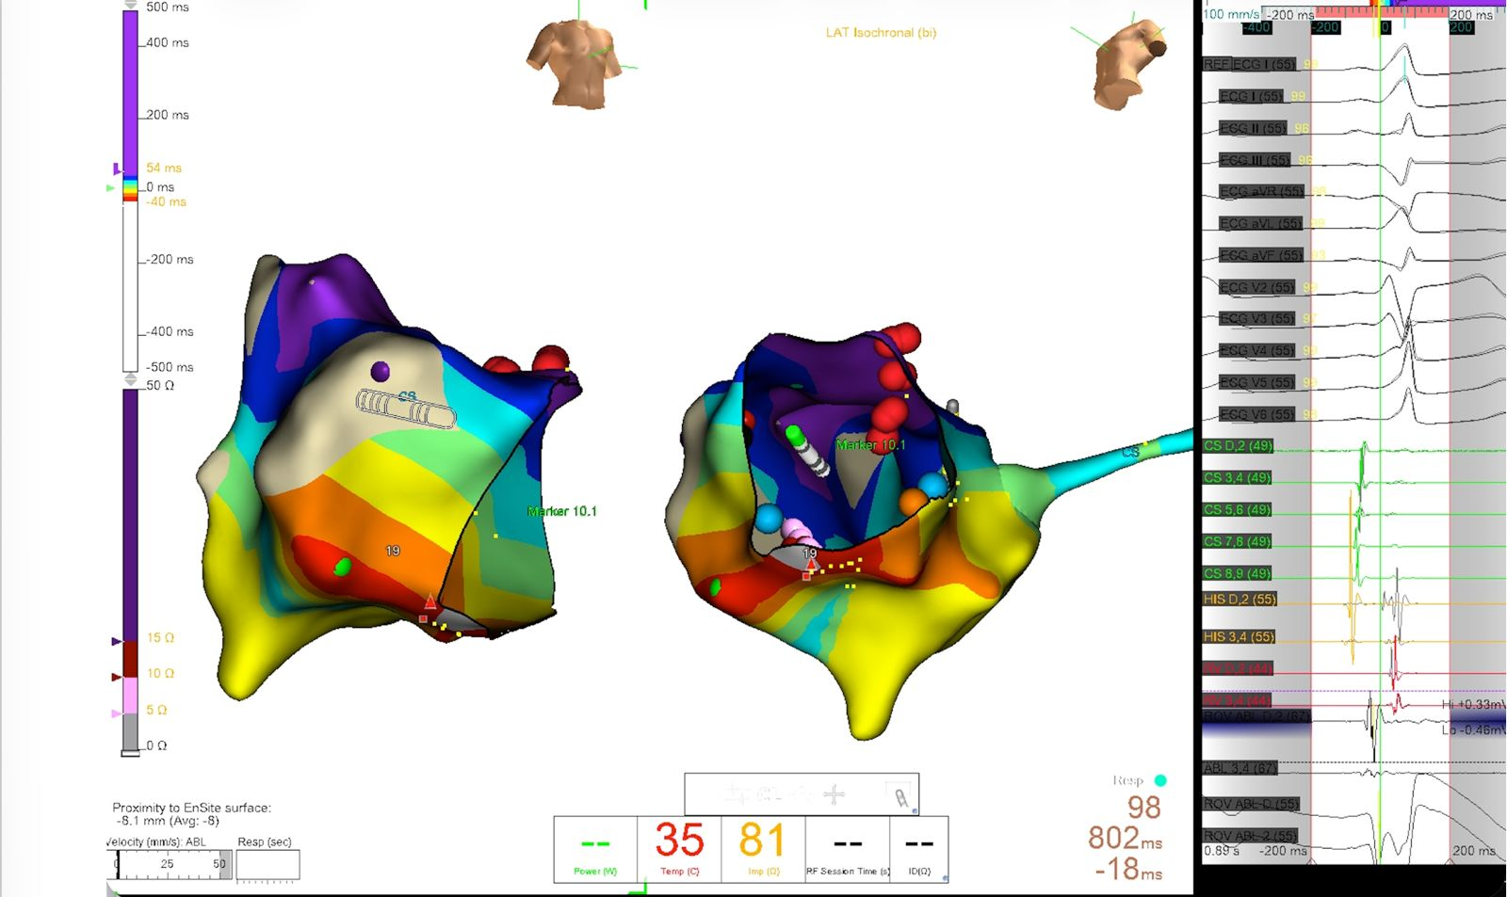
Figure 2: 3D electroanatomical mapping provides a precise spatial reconstruction of the “atrialized” right ventricle, with red clusters marking the successful radiofrequency ablation sites.

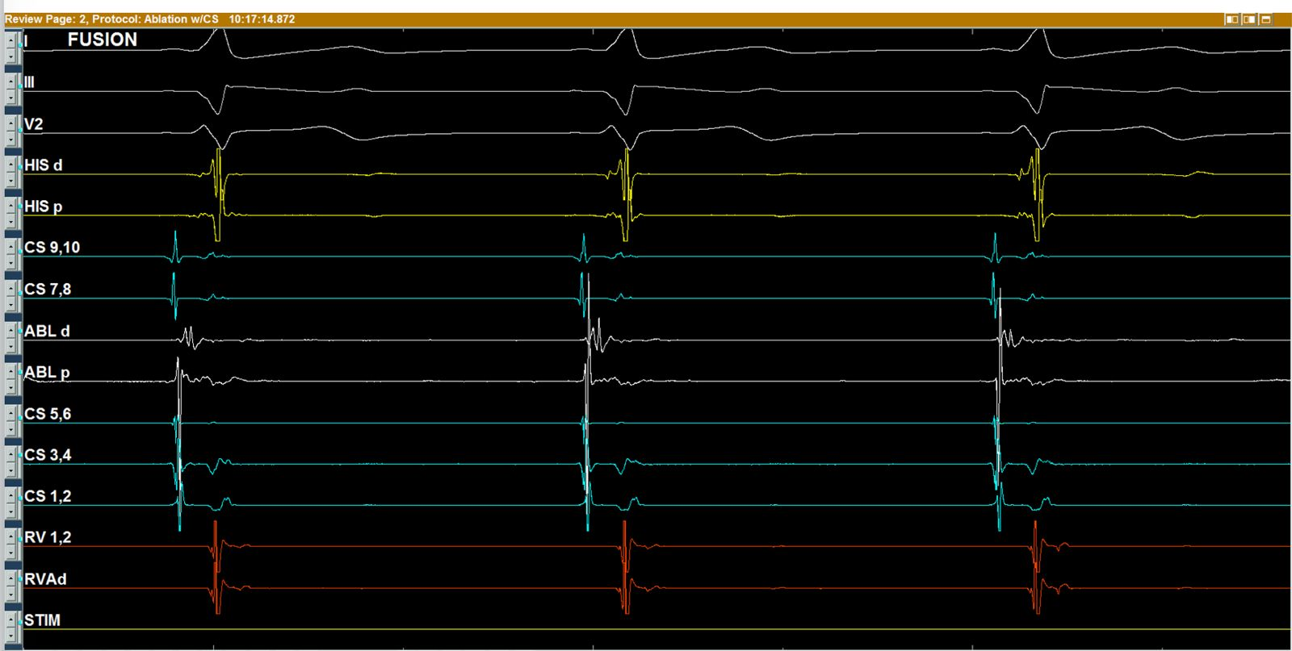
Figure 3: Intracardiac electrogram demonstrating pre- excitation through “fusion” of atrial and ventricular signals at the distal ablation electrode (ABL d), confirming the precise location of accessory pathway.
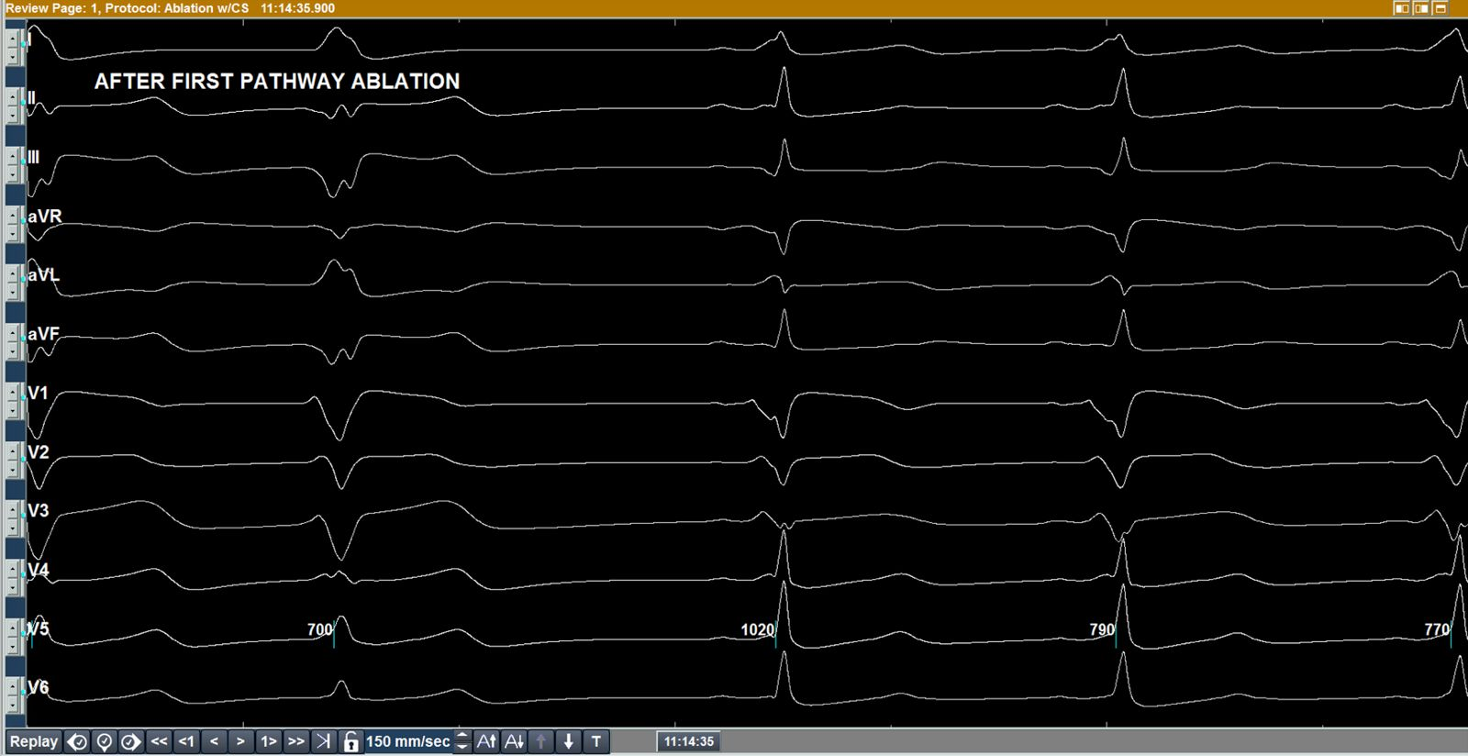
Figure 4: Intermediate tracing recorded after the first ablation, showing a shift in QRS morphology but persistent pre-excitation, confirming the presence of a second, independent accessory pathway.

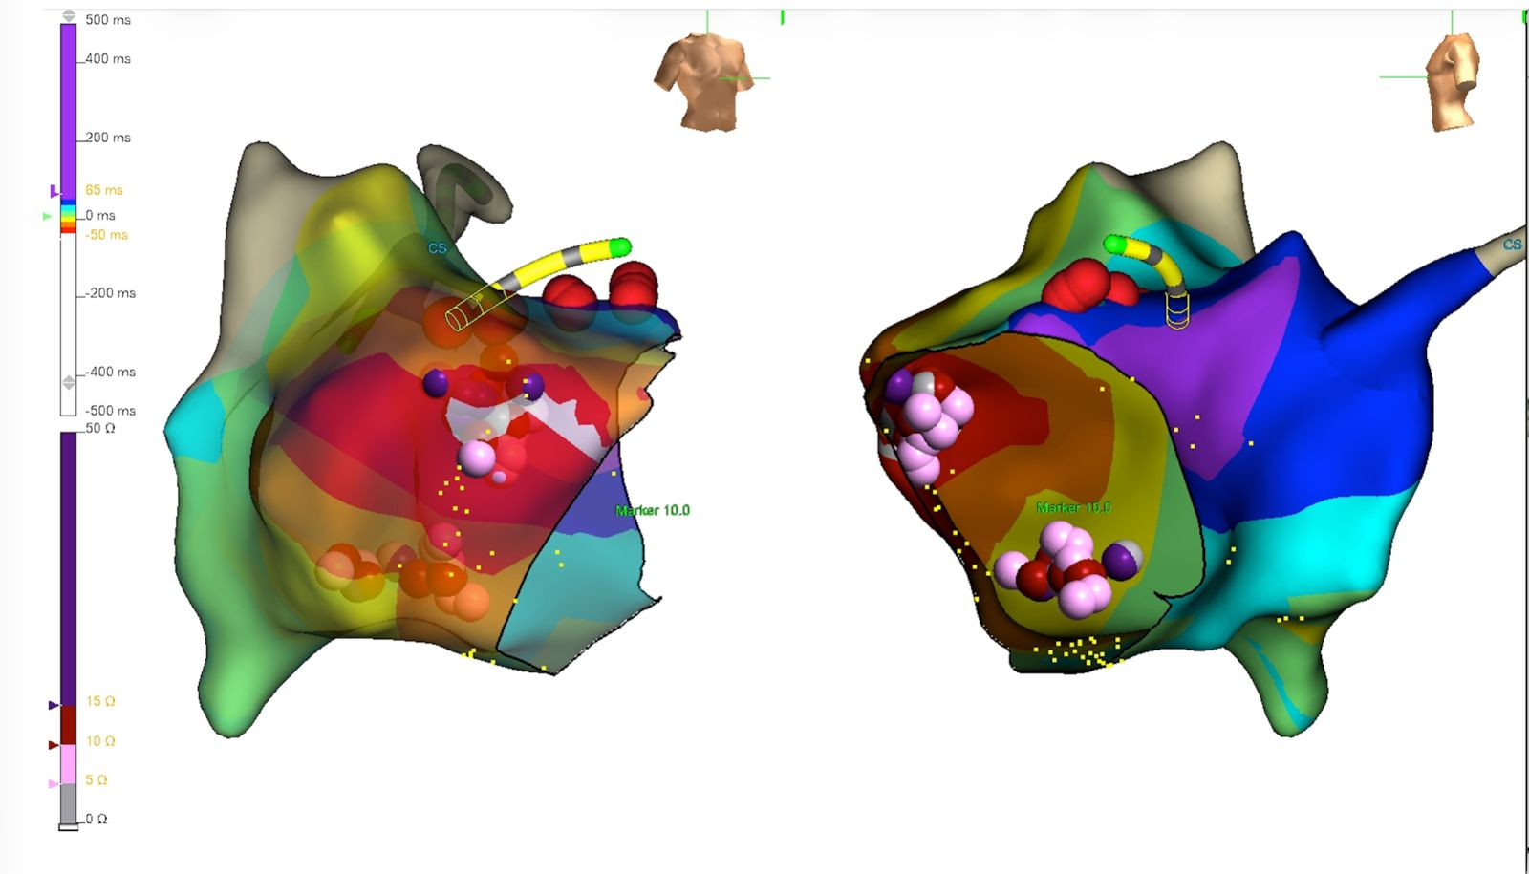
Figure 5: Final 3D map confirming the successful localization and elimination of the dual- pathway substrate along the right anterior and inferior tricuspid annulus.

