When Less Is More: Drug-Coated Balloon–Only Treatment of Acute Anterior STEMI with High Thrombus Burden

Abstract
Drug-coated balloons (DCBs) have emerged as an established alternative to drug-eluting stents (DES) in selected coronary settings, particularly for in-stent restenosis and small vessel disease. Their role in de novo coronary lesions during the acute phase of ST-elevation myocardial infarction (STEMI) remains less clearly defined.
We report the case of a 56-year-old woman with type 2 diabetes mellitus who presented with acute anterior STEMI. Emergency coronary angiography revealed a thrombotic occlusion of the proximal left anterior descending artery. Following pharmacological optimization and thrombus aspiration, antegrade flow was restored with no significant residual stenosis. A drug-coated balloon was subsequently used with excellent angiographic and clinical outcomes. At six-month follow-up, angiographic and echocardiographic reassessments demonstrated sustained vessel patency and complete functional recovery.
This case highlights the potential role of DCB-only angioplasty in carefully selected de novo coronary lesions in the acute thrombotic setting. We discuss current indications, advantages and limitations of DCBs compared with DES, and review emerging evidence supporting their use in acute coronary syndromes.
Keywords:
drug-coated balloon, st-elevation myocardial infarction, de novo coronary lesion, thrombus aspiration, primary percutaneous coronary intervention,

Introduction
Primary percutaneous coronary intervention (PCI) with drug-eluting stent implantation remains the cornerstone of reperfusion therapy in patients presenting with ST-elevation myocardial infarction (STEMI) [1]. Despite its well-established efficacy in restoring coronary blood flow and reducing mortality, stent implantation in the acute thrombotic milieu presents several inherent limitations. These include an increased risk of distal embolisation, suboptimal stent apposition due to a high thrombus burden, and the potential for late stent thrombosis. Furthermore, the requirement for prolonged dual antiplatelet therapy (DAPT) to mitigate thrombotic complications may increase the risk of bleeding and pose challenges in patients with contraindications or poor adherence [2]. These considerations have prompted ongoing investigation into alternative or adjunctive reperfusion strategies aimed at optimising clinical outcomes in this high-risk setting.
Drug-coated balloons (DCBs) represent an attractive alternative strategy, delivering antiproliferative therapy without leaving a permanent metallic scaffold [3]. While their efficacy is well established in in-stent restenosis and small vessel disease, their role in de novo coronary lesions, particularly in acute coronary syndromes (ACS), remains an area of active investigation [4].
We present a case illustrating the feasibility, safety, and mid-term efficacy of a DCB-only strategy for a de novo coronary lesion during acute anterior STEMI with a high thrombotic burden.

Case Presentation
A 56-year-old woman with a medical history notable only for type 2 diabetes mellitus presented to the emergency department with acute-onset, severe retrosternal chest pain of three hours’ duration. She had no prior history of coronary artery disease or other significant cardiovascular conditions.
On admission, physical examination was unremarkable, with stable haemodynamic parameters and no clinical evidence of heart failure. Electrocardiography demonstrated ST-segment elevation in the anterior leads, consistent with a diagnosis of acute anterior ST-elevation myocardial infarction (STEMI).
Following initial stabilisation, the patient received loading doses of aspirin (300 mg) and clopidogrel (600 mg) in accordance with current STEMI management guidelines. She was promptly transferred to the cardiac catheterisation laboratory for primary percutaneous coronary intervention.
Coronary angiography revealed a proximal thrombotic occlusion of the left anterior descending (LAD) artery (Figure 1). A guidewire was successfully advanced across the lesion; however, no restoration of antegrade flow was observed, indicating a substantial thrombus burden. In view of this finding, a glycoprotein IIb/IIIa inhibitor (tirofiban) was administered as an initial bolus followed by continuous intravenous infusion (Figure 2A), with the aim of reducing thrombus load and improving coronary perfusion.
Subsequently, manual thrombus aspiration was performed ( Figure 2B), retrieving multiple thrombotic fragments ( Figure 3) and restoring normal antegrade flow (TIMI 3). After thrombus removal, the residual angiographic stenosis was carefully reassessed and estimated to be less than 30% ( Figure 2C). Because the residual lesion was not hemodynamically significant, stent implantation was considered unnecessary.Therefore, a drug-coated balloon was used in order to deliver antiproliferative therapy without leaving a permanent metallic scaffold ( Figure 4A), resulting in an excellent final angiographic outcome without flow limitation or dissection. ( Figure 4B)
Intravascular imaging (IVUS or OCT) was not performed because this technology is not available in our institution.
Transthoracic echocardiography performed in the coronary care unit showed localized hypokinesia of the apical and adjacent segments, with preserved left ventricular ejection fraction. No intracardiac thrombus, mechanical complications, or pericardial effusion were detected, and right ventricular function was normal.
The patient’s clinical and electrical course was uneventful. She was discharged home on day three with optimal medical therapy.
A routine angiographic follow-up performed six months later demonstrated sustained vessel patency without restenosis or residual lesions. Repeat echocardiography showed near-complete recovery of apical wall motion, and the patient remained asymptomatic.

Discussion

1. Drug-Coated Balloons: Definition and Historical Perspective
Drug-coated balloons are semi-compliant angioplasty balloons coated with an antiproliferative agent, most commonly paclitaxel, combined with an excipient that facilitates rapid drug transfer to the vessel wall during short balloon inflation [3]. Unlike drug-eluting stents, DCBs do not provide mechanical scaffolding, allowing homogeneous drug delivery while preserving native vessel anatomy.
Initially developed for peripheral arterial disease, DCBs were later validated for coronary applications, particularly for in-stent restenosis, where they demonstrated non-inferiority to DES [5].

2. Current Guideline-Supported Indications
According to European Society of Cardiology (ESC) guidelines, the strongest indications for coronary DCB use include in-stent restenosis and small vessel disease, particularly in vessels <2.75 mm in diameter [1,6]. These indications are supported by robust randomized data demonstrating favorable angiographic and clinical outcomes.

3. Advantages and Limitations of DCBs Compared with DES
DCBs offer several advantages over DES: absence of a permanent implant, reduced risk of late stent thrombosis, preservation of vessel vasomotion, and the potential for shorter DAPT duration [7]. These characteristics are particularly appealing in thrombotic lesions and in patients at high bleeding risk.
However, DCB angioplasty requires meticulous lesion preparation and is less forgiving in cases of recoil or flow-limiting dissection. In addition, evidence remains limited in large proximal vessels and complex lesions [8].

4. Role of DCBs in De Novo Lesions in Acute and Chronic Coronary Syndromes
Emerging data suggest that DCB-only strategies may be effective in selected de novo lesions, even in ACS settings, provided that adequate flow is restored and residual stenosis is non-significant [9]. Our experience aligns with recent case series and small registries reporting favorable outcomes in STEMI patients treated with DCBs after thrombus management [10].
In comparison with DES, DCBs may reduce the risk of stent-related complications in the acute thrombotic milieu, while maintaining comparable mid-term efficacy.

5. Future Perspectives and Potential Expansion of Indications
Future guideline updates may consider expanding DCB indications to include selected de novo lesions, particularly when residual stenosis is mild, in highly thrombotic acute settings, or as part of hybrid revascularization strategies. In multivessel disease with a distal culprit lesion, a DCB-first approach followed by staged coronary artery bypass grafting may represent an attractive option [11].

Conclusion
This case illustrates that a DCB-only strategy can be a safe and effective alternative to stent implantation in selected patients with acute STEMI and de novo coronary lesions. Careful patient selection, optimal thrombus management, and appropriate lesion preparation are key determinants of success. Larger randomized studies are warranted to further define the role of DCBs in acute coronary syndromes and to potentially broaden their indications in future clinical practice.

Conflicts of Interest Statement
The authors declare no conflicts of interest.
Funding Statement
The authors received no financial support for the research, authorship, and/or publication of this article.
Consent Statement
Written informed consent was obtained from the patient for the publication of this case report, including all clinical data and accompanying images. All authors have read and approved the final manuscript and agree with its submission.
Ethical Approval:
As per international standards or university standards written ethical approval has been collected and preserved by the author(s).
Authors’ Contributions
Mohamed Sarsari, Oualid Kerrouani, Soukaina Cherkaoui , Jamila Zarzur, and Mohamed Cherti all contributed substantially to the conception, drafting, and critical revision of the manuscript. Mohamed Sarsari responsible for data collection, case analysis, literature review and manuscript preparation. Oualid Kerrouani and Soukaina Cherkaoui contributed to literature review and data collection. Jamila Zarzur and Mohamed Cherti supervised the work and provided senior guidance.
All authors approved the final version of the manuscript and agree to be accountable for all aspects of the work.
Guarantor: Mohamed Sarsari.

References
- Ibanez B, James S, Agewall S, et al. 2017 ESC guidelines for the management of acute myocardial infarction in patients presenting with ST-segment elevation. Eur Heart J. 2018;39(2):119–177. doi:10.1093/eurheartj/ehx393
- Stone GW, Witzenbichler B, Guagliumi G, et al. Heparin plus a glycoprotein IIb/IIIa inhibitor versus bivalirudin monotherapy in acute myocardial infarction. N Engl J Med. 2008;358(21):2218–2230. doi:10.1056/NEJMoa0708191
- Scheller B, Hehrlein C, Bocksch W, et al. Treatment of coronary in-stent restenosis with a paclitaxel-coated balloon catheter. N Engl J Med. 2006;355(20):2113–2124. doi:10.1056/NEJMoa061254
- Jeger RV, Farah A, Ohlow MA, et al. Drug-coated balloons for small coronary artery disease (BASKET-SMALL 2): An open-label randomised non-inferiority trial. J Am Coll Cardiol. 2018;72(24):3298–3309. doi:10.1016/j.jacc.2018.09.027
- Rittger H, Brachmann J, Sinha AM, et al. A randomized, multicenter, single-blind trial comparing paclitaxel-coated balloon angioplasty with paclitaxel-eluting stent implantation in patients with coronary in-stent restenosis. J Am Coll Cardiol. 2012;59(15):1377–1382. doi:10.1016/j.jacc.2012.01.015
- Neumann FJ, Sousa-Uva M, Ahlsson A, et al. 2018 ESC/EACTS guidelines on myocardial revascularization. Eur Heart J. 2019;40(2):87–165. doi:10.1093/eurheartj/ehy394
- Cortese B, Buccheri D, Piraino D, et al. Drug-coated balloon angioplasty: An attractive alternative to stent implantation. Eur Heart J. 2020;41(20):1904–1916. doi:10.1093/eurheartj/ehz761
- Kleber FX, Mathey DG, Rittger H, Scheller B. How to use the drug-coated balloon: Recommendations by the German Consensus Group. EuroIntervention. 2011;7(Suppl K):K125–K128. doi:10.4244/EIJV7SKA21
- Her AY, Rha SW, Choi BG, et al. Drug-coated balloon treatment in coronary artery disease: Recommendations from an Asia-Pacific Consensus Group. Cardiovasc Revasc Med. 2021;22:31–41. doi:10.1016/j.carrev.2020.02.004
- Li C, Ding X, Wang L, et al. Feasibility and safety of drug-coated balloon-only angioplasty for de novo ostial lesions of the left anterior descending artery: A two-center retrospective study. Front Cardiovasc Med. 2022;9:874394. doi:10.3389/fcvm.2022.874394
- Byrne RA, Joner M, Kastrati A. Stent thrombosis and restenosis: What have we learned and where are we going? J Am Coll Cardiol. 2015;65(18):191–201. doi:10.1016/j.jacc.2014.10.060

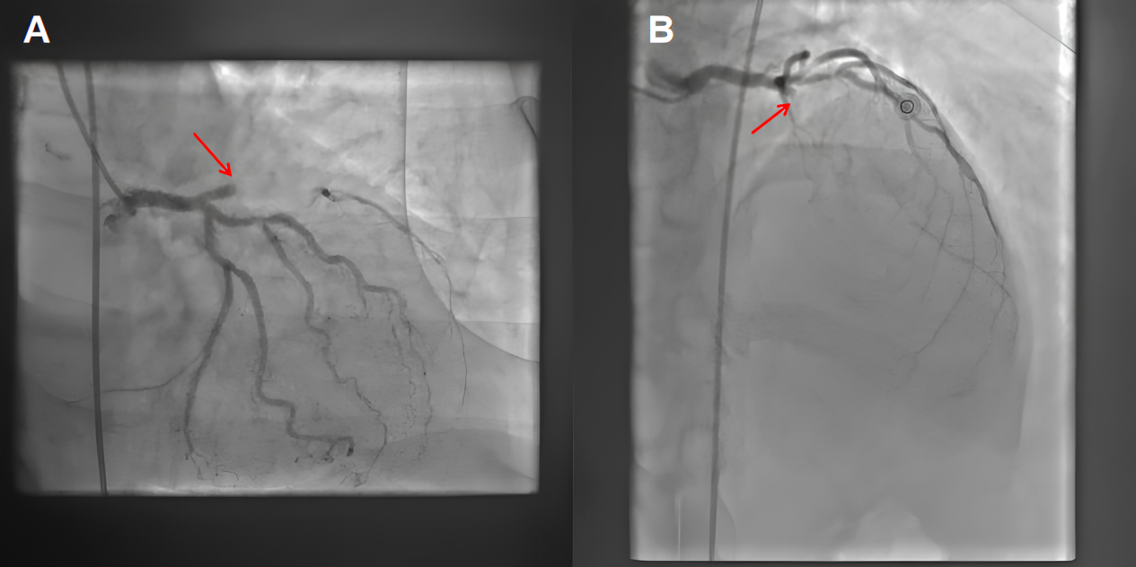
Figure 1: Coronary angiography showing a thrombotic occlusion of the proximal left anterior descending artery (red arrow) in caudal (A) and cranial (B) projections.

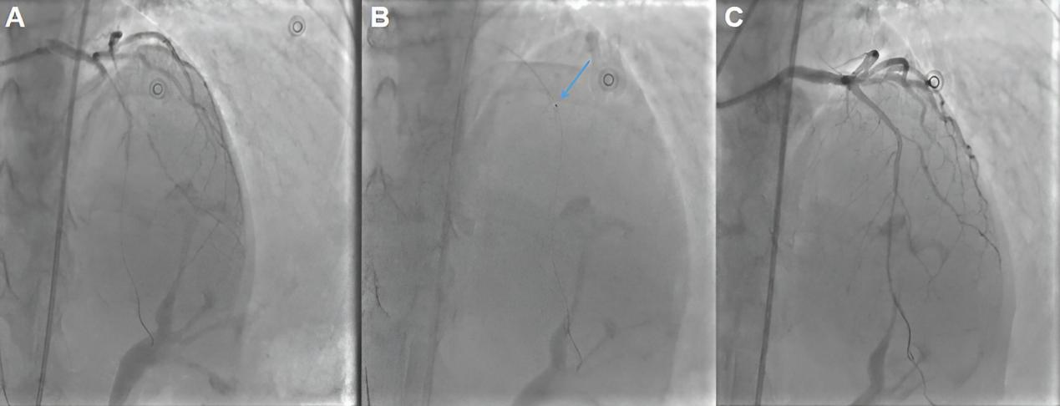
Figure 2: Coronary angioplasty procedure. (A) Guidewire crossing of the occluded segment without restoration of coronary flow. (B) Manual thrombus aspiration (blue arrow). (C) Post-thrombus aspiration angiographic result demonstrating restoration of TIMI 3 antegrade flow with no significant residual stenosis.

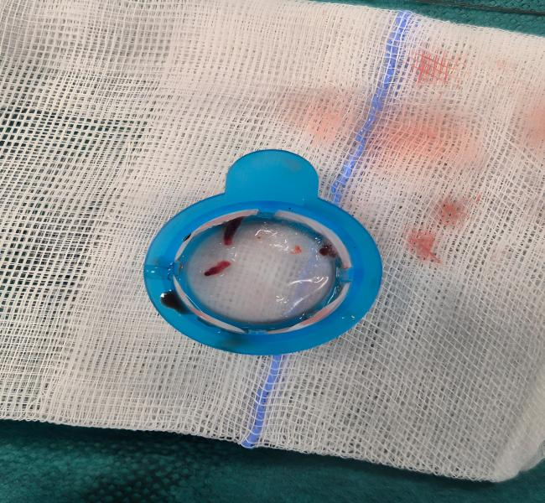

Figure 3: Macroscopic view of the aspirated material following manual thrombus aspiration, demonstrating multiple retrieved thrombotic fragments, confirming the effectiveness of thrombus removal during the primary percutaneous coronary intervention.

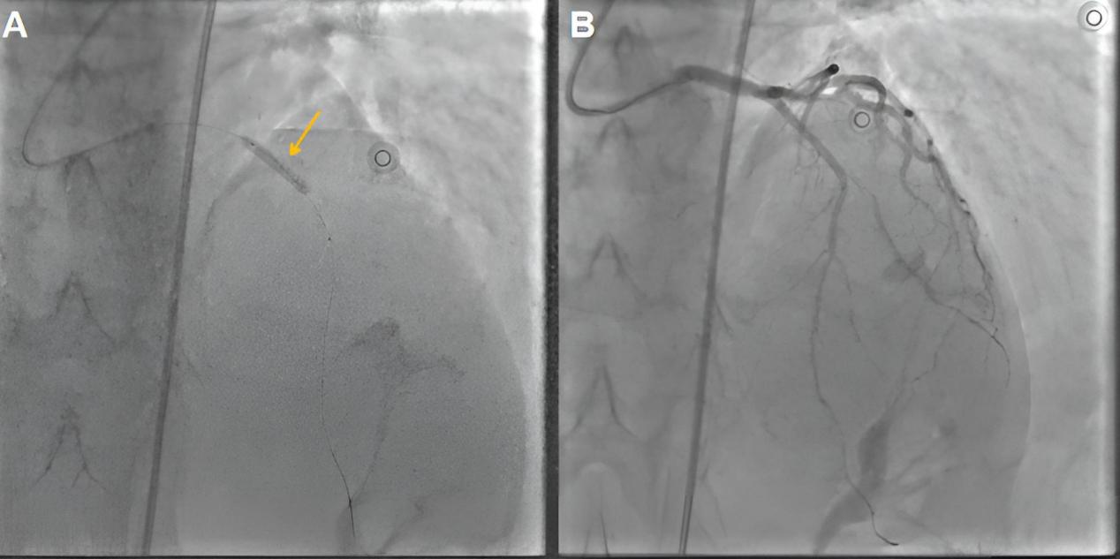
Figure 4: Drug-coated balloon angioplasty. (A) Inflation of a drug-coated balloon at the target lesion (orange arrow). (B) Final angiographic result showing an optimal outcome.

