Isolated Round Ligament Dermoid Cyst Mimicking an Inguinal Hernia Through a False-Positive Cough Impulse: A Case Report

.
ABSTRACT

Background: Persistent canal of Nuck or round ligament lesions are rare causes of female inguinal swellings that can clinically mimic inguinal hernias, making preoperative diagnosis challenging.
Aim:
To report an isolated round ligament dermoid cyst in an elderly female presenting clinically as an inguinal hernia, and to highlight the diagnostic challenges associated with atypical cystic groin lesions.

Presentation of Case:
A 76-year-old woman presented with a progressively enlarging left inguinal swelling of one-year duration. Examination revealed a soft, mobile, non-tender mass extending toward the labia majora. Although non-reducible, the swelling demonstrated a cough impulse, initially favoring the diagnosis of an inguinal hernia. Contrast-enhanced computed tomography showed a well-circumscribed cystic lesion along the course of the round ligament, radiologically suggestive of a Canal of Nuck cyst. Due to persistent diagnostic uncertainty, surgical exploration was performed. Intraoperatively, a thick-walled cyst containing sebaceous material and keratinous debris was identified without evidence of a true hernial sac or peritoneal communication. Complete excision of the lesion was carried out, followed by posterior wall reinforcement using modified Bassini repair with Prolene darning. Histopathological examination confirmed a benign dermoid cyst. The postoperative recovery was uneventful.

Discussion:
Dermoid cysts involving the inguinal canal are exceedingly uncommon, particularly as isolated extra-gonadal lesions of the round ligament in elderly women. In this case, the cough impulse was likely secondary to transmitted intra-abdominal pressure through a weakened inguinal floor, creating a false-positive clinical impression of hernia. In addition, preoperative imaging favored an alternative cystic pathology, emphasizing the difficulty in accurately characterizing rare inguinal lesions preoperatively.

Conclusion:
Isolated dermoid cysts should be considered in the differential diagnosis of atypical inguinal swellings, particularly when clinical and radiological findings are incongruent. This case highlights the importance of careful intraoperative assessment and histopathological confirmation in establishing the definitive diagnosis.

Keywords: Inguinal dermoid cyst; Round ligament cyst; Canal of Nuck cyst; Inguinal hernia mimic; False-positive cough impulse; Extra-gonadal cyst

1. INTRODUCTION

Inguinal swellings in female patients encompass a wide spectrum of pathologies, ranging from common inguinal hernias to uncommon cystic and developmental lesions. Among the rarer causes is pathology involving the canal of Nuck, an embryological remnant of the persistent processus vaginalis that accompanies the round ligament. Failure of obliteration may result in hydroceles or cystic lesions presenting as groin masses in adult women [1,2]. Owing to overlapping clinical features, these lesions may closely resemble inguinal hernias and pose a diagnostic challenge in routine surgical practice [3,4].
Radiological investigations such as ultrasonography, computed tomography (CT), and magnetic resonance imaging (MRI) are valuable in assessing lesion morphology and anatomical relationships. However, accurate preoperative characterization of atypical inguinal cystic lesions may remain difficult, particularly in rare pathologies [2,5,7]. As a result, definitive diagnosis is often established only after surgical exploration and histopathological evaluation.
Dermoid cysts are benign developmental lesions composed predominantly of ectodermal elements, including keratinized squamous epithelium, sebaceous glands, and hair follicles. Although commonly encountered in gonadal locations, extra-gonadal occurrence within the inguinal canal or along the round ligament is exceedingly uncommon [1,6,8]. Their rarity and variable presentation can further complicate clinical diagnosis.
We report an isolated dermoid cyst arising along the round ligament in an elderly female presenting as an inguinal swelling with a demonstrable cough impulse. In the absence of a true hernial sac or peritoneal communication, the cough impulse was likely attributable to transmitted intra-abdominal pressure through a weakened inguinal floor, resulting in a false-positive clinical impression of hernia. This case highlights the diagnostic difficulty associated with unusual inguinal cystic lesions and underscores the importance of careful radiologic interpretation, intraoperative assessment, and histopathological confirmation in establishing the definitive diagnosis.

2.CASE PRESENTATION

A 76-year-old woman presented with a progressively enlarging swelling in the left inguinal region for one year. The swelling had increased gradually in size and was associated with a dull aching pain over the preceding week. She denied vomiting, abdominal distension, or other symptoms suggestive of bowel obstruction. There was no history of trauma, chronic cough, or significant weight loss. She reported intermittent low-grade fever over the past year and increased urinary frequency for one month. Her medical history was significant for well-controlled hypertension. She had undergone an open hysterectomy three decades earlier and was concurrently under evaluation for cholelithiasis and an incidental left adrenal lesion.
On examination, the patient was hemodynamically stable. Local examination revealed a solitary, well-defined swelling measuring approximately 6 × 4 cm in the left inguinal region, extending toward the labia majora. The swelling was soft, cystic, mobile, and non-tender, with no overlying skin changes or regional lymphadenopathy. It was non-reducible and non-transilluminant. Notably, a cough impulse was elicited despite the cystic nature of the lesion, initially raising suspicion of an inguinal hernia. Based on the clinical findings, a provisional diagnosis of a Canal of Nuck cyst was considered, with differentials including inguinal hernia, lipoma, and dermoid cyst.
Contrast-enhanced computed tomography of the abdomen and pelvis demonstrated a well-circumscribed cystic lesion measuring approximately 7 × 4 cm within the left inguinal canal, extending along the course of the round ligament toward the labia majora (Fig. 1). The lesion appeared thin walled with predominantly fluid attenuation and lacked definitive radiological features suggestive of a dermoid cyst, such as calcification or obvious fat-fluid levels, thereby favoring the diagnosis of a Canal of Nuck cyst.
In view of the persistent diagnostic uncertainty, surgical exploration was undertaken. Intraoperatively, a thick-walled cystic lesion was identified within the inguinal canal and carefully dissected free from the surrounding structures (Fig. 2). No true hernial sac or communication with the peritoneal cavity was identified. On opening, the cyst contained dense sebaceous material with keratinous debris rather than clear serous fluid, raising suspicion of a dermoid cyst (Fig. 3). Complete excision of the lesion was performed. Further inspection demonstrated attenuation of the posterior wall of the inguinal canal, which likely accounted for the clinically appreciable cough impulse through passive transmission of intra-abdominal pressure. Reinforcement of the posterior wall was therefore carried out using a modified Bassini repair with Prolene darning (Fig. 4).
The postoperative recovery was uneventful, and the patient remained asymptomatic on follow-up without evidence of recurrence. Histopathological examination revealed a cyst lined by keratinized stratified squamous epithelium containing adnexal structures including sebaceous glands and hair follicles, consistent with a dermoid cyst (Fig. 5). No evidence of malignant transformation was identified.

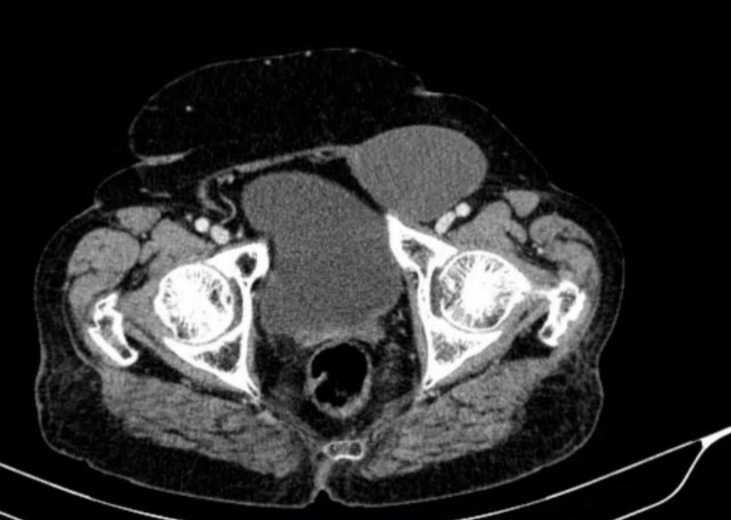

Figure 1: Axial contrast enhanced CT scan showing a well defined, thin walled cystic lesion in the left inguinal/pelvic region

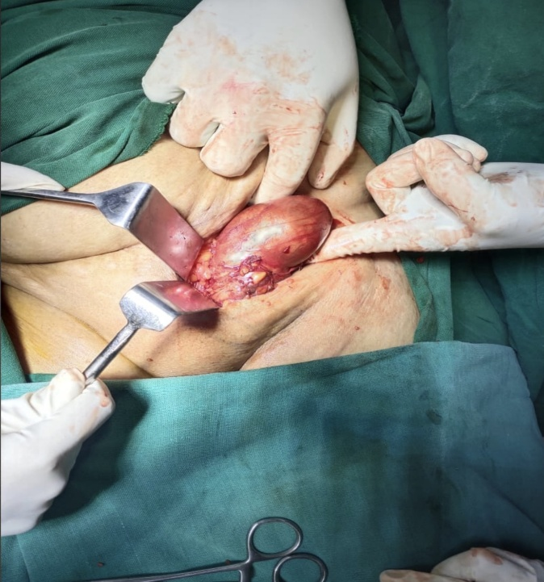

Figure 2: Intraoperative image showing surgical exposure of a well encapsulated dermoid cyst arising in the left inguinal region.

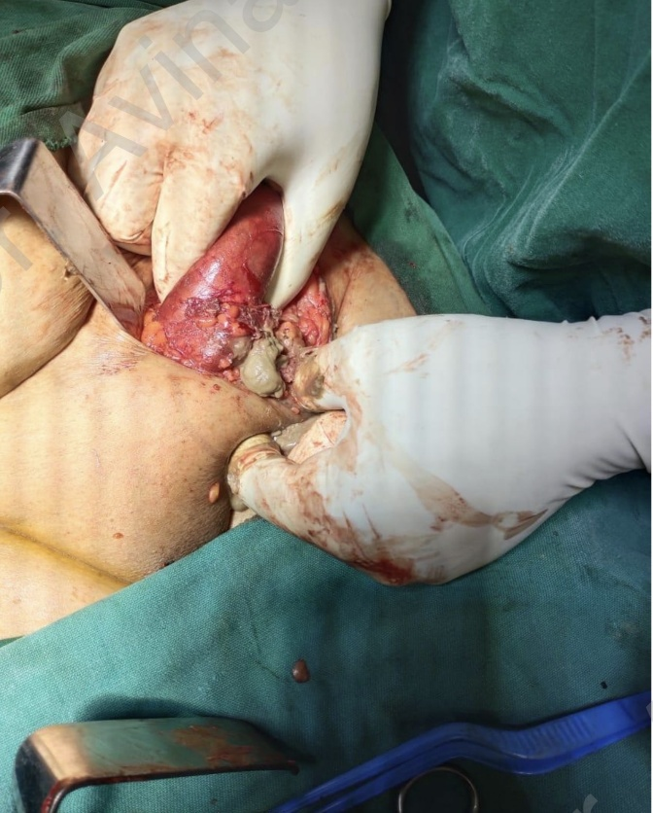

Figure 3: Intraoperative image demonstrating careful dissection and delivary of the dermoid cyst from surrounding tissue.

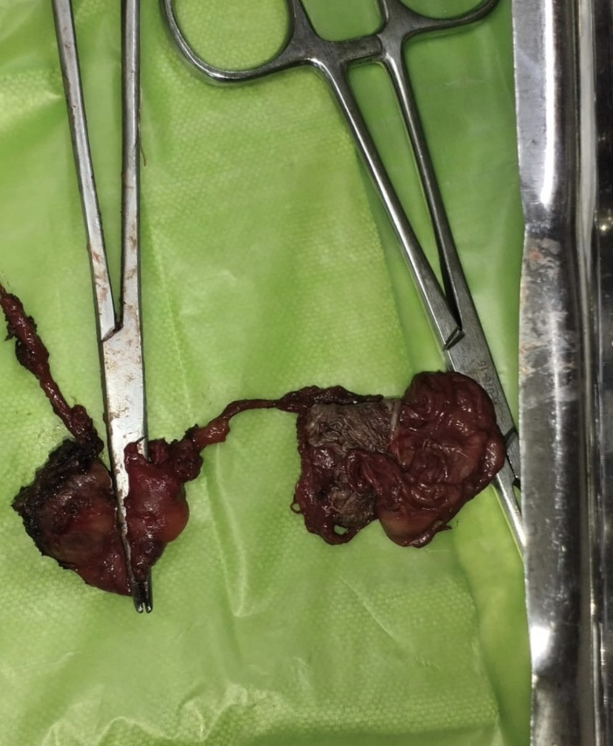

Figure 4: Excised specimen of the dermoid cyst following complete surgical removal.

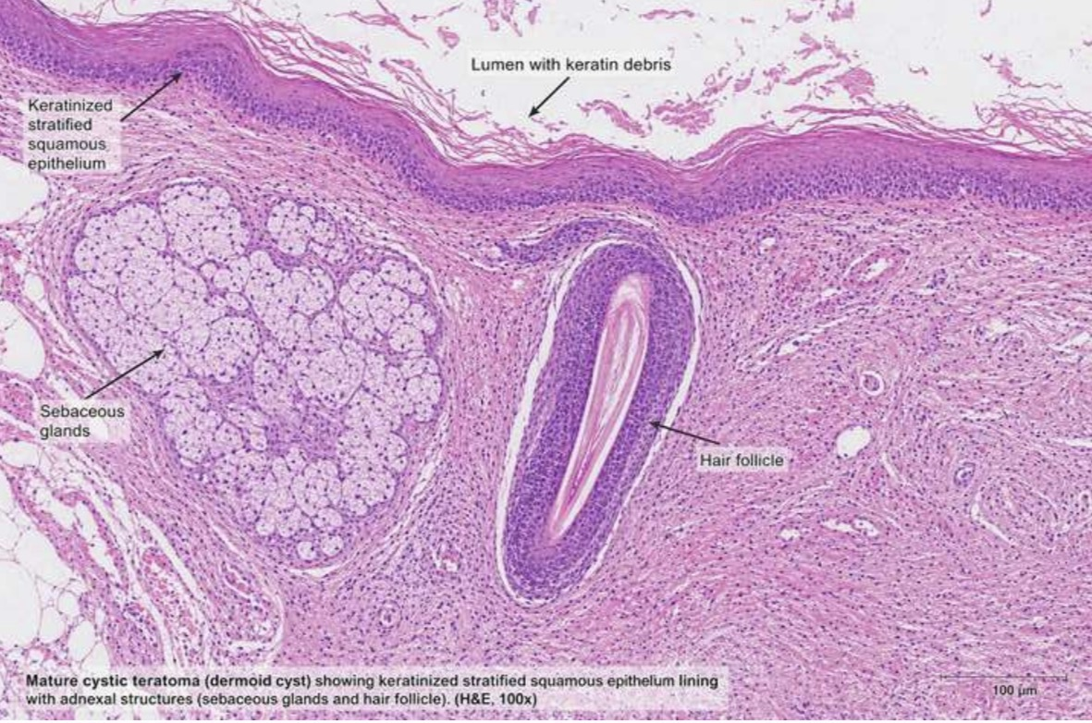

Figure 5: Histopathology (H & E, 100X) showing keratinized stratified squamous epithelium with sebaceous glands and hair follicles consistent with dermoid cyst

3. Discussion

Evaluation of inguinal swellings in female patients can be challenging because several uncommon cystic lesions may clinically resemble more frequently encountered conditions such as inguinal hernias. Among these, lesions involving the canal of Nuck and round ligament constitute important differential diagnoses, particularly when the presentation is atypical [2–5,7]. The canal of Nuck represents a persistent processus vaginalis accompanying the round ligament through the inguinal canal, and failure of obliteration may result in hydroceles or cystic lesions presenting as groin masses in adult women [2,4]. These lesions are typically described as non-reducible swellings without a cough impulse, findings that generally help distinguish them from hernias [3,7].
In the present case, the presence of a demonstrable cough impulse strongly favored the clinical diagnosis of an inguinal hernia and contributed to the preoperative diagnostic uncertainty. However, surgical exploration revealed neither a true hernial sac nor peritoneal communication. The cough impulse was therefore likely attributable to passive transmission of increased intra-abdominal pressure across a weakened inguinal floor, resulting in a false-positive clinical impression of hernia. This observation highlights the limitations of relying solely on classical examination findings in atypical groin swellings.
Radiological imaging serves as an important adjunct in preoperative evaluation. Ultrasonography and CT commonly demonstrate well-circumscribed cystic lesions, while MRI may further aid in characterizing tissue composition and anatomical relationships [2,5,7]. Nevertheless, overlap in radiological appearance among canal of Nuck cysts, mesothelial cysts, dermoid cysts, and other rare inguinal lesions may limit accurate preoperative diagnosis. In the present case, CT findings favored a Canal of Nuck cyst, whereas definitive diagnosis was established only following surgical excision and histopathological examination.
Dermoid cysts are benign developmental lesions derived predominantly from ectodermal inclusions and characteristically contain keratinous debris, sebaceous glands, and hair follicles. Although commonly encountered in gonadal locations, extra-gonadal occurrence within the inguinal canal or along the round ligament is exceedingly rare [1,6,8]. Previous reports have largely described dermoid cysts occurring within true inguinal hernia sacs [8]. In contrast, the present case demonstrated an isolated dermoid cyst arising along the round ligament without evidence of a true hernial sac, thereby representing a distinct clinicopathological entity. The unusual combination of an isolated cystic lesion and a false-positive cough impulse contributed significantly to the diagnostic challenge.
Complete surgical excision remains the treatment of choice and is generally curative. In addition to symptom resolution, excision permits definitive histopathological evaluation and exclusion of malignant transformation, which, although rare, has been described in long-standing dermoid lesions. In the presence of associated weakness of the inguinal floor, simultaneous posterior wall reinforcement may further reduce the risk of recurrence and improve structural stability.
This case highlights several important clinical considerations. Rare cystic lesions should remain within the differential diagnosis of inguinal swellings in female patients, particularly when clinical and radiological findings are discordant. Furthermore, the presence of a cough impulse should not be regarded as exclusively indicative of a true hernia. Careful intraoperative assessment together with histopathological confirmation remains essential for establishing the definitive diagnosis in unusual inguinal lesions.

4. Conclusion

This case highlights the diagnostic complexity of atypical inguinal swellings in female patients and underscores the importance of considering rare extra-gonadal lesions within the differential diagnosis. The presence of a false-positive cough impulse despite the absence of a true hernial sac created a convincing clinical impression of inguinal hernia, while preoperative imaging favored an alternative cystic pathology. Together, these findings illustrate the limitations of relying solely on clinical examination or radiologic appearance in unusual groin lesions. Definitive diagnosis was established only after surgical exploration and histopathological evaluation. Awareness of isolated round ligament dermoid cysts as a potential hernia mimic may improve diagnostic assessment and guide appropriate surgical management in similar presentations.

AcknowledgEments

A brief acknowledgement section may be given after the conclusion section just before the references. The acknowledgments of people who provided assistance in manuscript preparation, funding for research, etc. should be listed in this section. All sources of funding should be declared as an acknowledgement. Authors should declare the role of funding agency, if any, in the study design, collection, analysis and interpretation of data; in the writing of the manuscript. If the study sponsors had no such involvement, the authors should so state. Competing interests

The authors declare that they have no competing interests.

Authors’ Contributions

This work was carried out in collaboration among all authors. All authors read and approved the final manuscript.

Consent

As per international standards or university standards, patient(s) written consent has been collected and preserved by the author(s).

Ethical approval
As per international standards or university standards written ethical approval has been collected and preserved by the author(s).

Disclaimer (Artificial intelligence)

Author(s) hereby declare that NO generative AI technologies such as Large Language Models (ChatGPT, COPILOT, etc.) and text-to-image generators have been used during the writing or editing of this manuscript.

References

1. Ergun, T., & Lakadamyali, H. (2010). A Dermoid Cyst of the Round Ligament Clinically Misdiagnosed as Incarcerated Inguinal Hernia. Acta Chirurgica Belgica, 110(1), 80–82. https://doi.org/10.1080/00015458.2010.11680571
2. Prodromidou A, Paspala A, Schizas D, Spartalis E, Nastos C, Machairas N. Cyst of the Canal of Nuck in adult females: A case report and systematic review. Biomed Rep. 2020 Jun; 12(6):333-338. doi:10.3892/br.2020.1295. Epub 2020 Mar 27. PMID: 32346477; PMCID: PMC7184959.

3. Topal U, Sarıtaş AG, Ülkü A, Akçam AT, Doran F. Cyst of the Canal of Nuck mimicking inguinal hernia. Int J Surg Case Rep. 2018; 52:117-119. doi: 10.1016/j.ijscr.2018.09.053. Epub 2018 Oct 10. PMID: 30342391; PMCID: PMC6197703.

4. Keeratibharat N, Chansangrat J. Hydrocele of the Canal of Nuck: A Review. Cureus. 2022 Apr 2;14(4):e23757. doi: 10.7759/cureus.23757. PMID: 35402114; PMCID: PMC8980195.

5. Vrysis C, Gkatziolis V, Demetriou N, Geroulis K, Mastrogianni R, Dais A, Giovanitis D, Ponirakos M, Papadimitropoulos K. A Round Ligament Mesothelial Cyst Imitating an Inguinal Hernia in a Woman of Reproductive Age. Acta Med Acad. 2024 Dec;53(3):314-319. doi: 10.5644/ama2006-124.455. PMID: 39651940; PMCID: PMC11831546.

6. Antonino A, Lovisetto F, Corradini C, De Cesare F, Geraci O, et al. (2016) Preperitoneal Dermoid Cyst Simulating a Direct Inguinal Hernia: Case Report. Med Rep Case Stud 1: 116.

7. Khadim B, AlNuaimi D, Abdulghaffar S, AlKetbi R. Hydrocele of the canal of Nuck: a rare differential diagnosis for an inguinal hernia. J Ultrason. 2024 Feb 27;24(96):20240007. doi: 10.15557/jou.2024.0007. PMID: 38419838; PMCID: PMC10897368.

8. Ba-Shammakh SA, Almaletti M, Aqel BA. Beyond the Norm: Unveiling a Dermoid Cyst in an Inguinal Hernia Case. Cureus. 2023 Aug 19;15(8):e43736. doi: 10.7759/cureus.43736. PMID: 37727175; PMCID: PMC10505832.

