Case report
Single-Incision Gasless Laparoscopic Management of Non-Parasitic Splenic Cyst: A Case Report

ABSTRACT
Aims: To describe the successful application of single-incision gasless laparoscopic fenestration for the management of a large non-parasitic splenic cyst in a young female patient, and to review the operative technique and clinical outcomes of this spleen-preserving minimally invasive approach.
Presentation of Case: A 19-year-old female presented with a two-month history of left upper abdominal discomfort. Imaging revealed an 8 × 8 cm cystic lesion at the superior pole of the spleen. Hydatid serology was negative, confirming a non-parasitic splenic cyst. Spleen-preserving laparoscopic fenestration via a single infraumbilical incision using a gasless technique was performed. Approximately 500 ml of serous fluid was aspirated and the anterior cyst wall was excised using a Ligasure device. The postoperative course was uneventful and the patient was discharged on the third postoperative day. Histopathology confirmed a splenic pseudocyst. At one-year follow-up, the patient was asymptomatic with no recurrence.
Discussion: Non-parasitic splenic pseudocysts are uncommon benign lesions increasingly managed with minimally invasive, spleen-preserving techniques. Single-incision gasless laparoscopic fenestration combines the cosmetic advantages of reduced port surgery with the physiological benefits of avoiding pneumoperitoneum-related hemodynamic and respiratory disturbances. This approach is particularly suited to superficially located cysts.
Conclusion: Single-incision gasless laparoscopic fenestration is a safe, effective, and cosmetically favorable approach for appropriately selected patients with non-parasitic splenic cysts. Careful patient selection, precise surgical technique, and diligent postoperative surveillance are essential to achieving optimal outcomes. This case report highlights significance of cosmetic minimally invasive spleen preserving approach for management of splenic cysts in a young female.
Keywords: non-parasitic splenic cyst; splenic pseudocyst; gasless laparoscopy; single-incision laparoscopy; cyst fenestration; spleen-preserving surgery
1. INTRODUCTION
Splenic cysts are rare, with a reported incidence of only 0.07–0.3% (1). True, or primary, splenic cysts possess an epithelial lining and often result from parasitic infection, whereas secondary splenic cysts (pseudocysts) lack an epithelial lining and typically arise secondary to trauma, infarction, or infection (2). Primary non-parasitic splenic cysts (NPSCs) may be congenital or neoplastic in origin. NPSCs are usually asymptomatic and are most often discovered incidentally on imaging, particularly in children and young adults, accounting for 20% of all non-parasitic cyst cases (3). The incidence of diagnosed splenic cysts is increasing due to the widespread use of abdominal imaging techniques. Current surgical management of NPSCs depends on symptom status and cyst size. Enhanced understanding of the spleen’s immunological function has promoted the development of spleen-preserving techniques for non-parasitic lesions (4).

2. PRESENTATION OF CASE
A 19-year-old female presented with upper left abdominal discomfort persisting for two months. There was no history of fever, nausea, vomiting, or palpable abdominal mass. Ultrasonography identified a cystic lesion measuring 8 x 8 cm in adjacent to the upper and mid poles of the spleen, characterized by low-level internal echoes and several septations. (Fig. 1).
Contrast-enhanced computed tomography (CECT) of the abdomen revealed a well-defined, non-enhancing, 8 x 7 cm hypodense lesion within the splenic parenchyma, involving the superior pole. (Fig. 2).
Hematologic and physical examinations were unremarkable. Lab values were Hemoglobin 12.3g/dl, TLC 8200/mm3, platelets 169000/mm3, Serum albumin 3.9g/dl. Hydatid serology was negative, confirming the diagnosis of a non-parasitic splenic cyst (NPSC). Given the patient's young age and the peripheral location of the cyst, spleen-preserving laparoscopic fenestration was planned.

Surgical Technique

Under general anesthesia, a 2 cm infraumbilical midline incision was made, the peritoneum was opened, and a retractor for insufflation-less surgery was positioned and docked with a ring inserted through the incision, oriented toward the left upper quadrant to optimize visualization of the splenic cyst. Following division/displacement of the omentum, a large cyst was identified, originating from the superior pole of the spleen and extending behind the lateral end of the left lobe of the liver. (Fig. 3)
The cyst roof was punctured, and approximately 500 ml of yellowish (serous) fluid was aspirated and sent for culture and cytological examination. The anterior cyst wall, free from splenic parenchyma, was excised using a Ligasure energy device, achieving unroofing of the cyst wall with minimal blood loss. (Fig. 4)

The specimen was extracted through the infraumbilical incision. The postoperative course was uneventful. The patient resumed an oral diet on the first postoperative day and was discharged on the third postoperative day.
Bacteriological examination of the aspirated fluid was negative, and cytological analysis revealed a few lymphocytes and histiocytes. Histological examination of the cyst wall demonstrated fibro collagenous tissue with areas of hyalinization. (Fig. 5)
The inner aspect of the cyst wall lacked mucosa or epithelial lining, confirming the diagnosis of a splenic pseudocyst. At one-year follow-up, the patient remained in good clinical condition without symptoms of recurrence.

3. DISCUSSION
Splenic cysts are a rare pathological entity. Fowler and Martin classified these cysts as primary (true) or secondary (false) based on the presence or absence of a cellular lining of the cyst wall (5). Most true splenic cysts are epithelial in origin and contain embryonic inclusions of epithelial cells from adjacent structures (6). Echinococcal parasitic cysts account for 50–80% of splenic parasitic cysts. In rare instances, 0.5–4% of hydatid disease cases may result in a parasitic cyst of the spleen (7). False (secondary) splenic cysts constitute approximately 80% of all splenic cysts. The most common causes of secondary splenic cysts include trauma, splenic infarction, disorganized hematoma, splenic abscess, and intrasplenic pancreatic pseudocyst. NPSCs are most frequently observed in the second and third decades of life, with a slight female predominance, although they can occur at any age. Most are clinically asymptomatic, but some may present with mild pain or a palpable mass in the left upper quadrant (8). Dyspepsia and constipation may result from compression of the stomach and colon, respectively, while dyspnoea can occur if the left diaphragm is displaced. Large cysts may rupture, leading to hemoperitoneum or anaphylactic reaction (9). Ultrasonography is a reliable, non-invasive modality for differentiating between solid and cystic splenic lesions. NPSCs typically appear as anechoic masses with thin walls and septations or irregular walls on ultrasonography. Peripheral or focal calcifications are uncommon, occurring in 10% to 15% of cases, but may be observed in complex cases (10). Abdominal computed tomography provides detailed information regarding the cyst’s origin and its relationship to surrounding structures.
In the present case, absence of epithelial lining on histopathology confirmed the diagnosis of a splenic pseudocyst. The optimal management of NPSCs remains a subject of debate. In recent decades, treatment strategies have shifted from routine splenectomy to spleen-preserving, minimally invasive techniques. (11) Symptomatic cysts or those exceeding 5 cm in diameter are at increased risk of spontaneous rupture or infection. However, some reports indicate that even small cysts may rupture following minor trauma (12). Laparoscopic cyst fenestration is among the most commonly performed procedures for NPSCs. Its advantages include reduced postoperative pain, shorter hospital stay, faster recovery, and avoidance of long-term risks associated with splenectomy, such as overwhelming post-splenectomy infection (13), (14). Recent advancements in minimally invasive surgery have led to the development of single-incision laparoscopic surgery (SILS) and, specifically, gasless single-incision laparoscopic fenestration. This approach combines the cosmetic and minimally invasive benefits of SILS with the physiological advantages of avoiding pneumoperitoneum. Mechanical abdominal wall lifting, rather than carbon dioxide insufflation, is used in gasless techniques, thereby eliminating hemodynamic and respiratory alterations associated with increased intra-abdominal pressure, such as reduced venous return, hypercapnia, and acidosis (15). However, this method also has inherent associated limitations like instruments clashing, restricted intra-abdominal visibility and difficulty in suitable retraction of the surrounding structures. Hemostasis during cyst fenestration could be difficult at times and cyst may require careful adhesiolysis for unroofing of the cyst. Epithelial-lined NPSCs may have high recurrence rate in patients undergoing cyst fenestration since the residual base of the cyst may continue to produce fluid with cyst recurrence over time. This technique is most suitable for superficial, anteriorly located cysts, where adequate exposure and complete deroofing can be safely achieved. Deep hilar or posterior cysts may not be ideal candidates due to technical challenges and an increased risk of incomplete excision and recurrence. (16)

4. CONCLUSION
Non-parasitic splenic pseudocysts are uncommon benign lesions, and their management has increasingly favored minimally invasive, spleen-preserving strategies. The primary objectives of treatment include symptom relief, prevention of complications, minimization of recurrence, and preservation of splenic immunological function. Laparoscopic fenestration has become an effective and safe therapeutic option for appropriately selected patients, particularly those with superficially located splenic cysts. The adoption of gasless single-incision techniques further enhances the minimally invasive approach by reducing physiological disturbances associated with pneumoperitoneum and improving patient comfort. Optimal outcomes require careful patient selection, meticulous surgical technique, and close postoperative follow-up.

6. COMPETING INTERESTS
Authors have declared that no competing interests exist.

7. CONSENT
Written informed consent was obtained from the patient for publication of this case report and any accompanying images. A copy of the written consent is available for review by the Editorial office/Chief Editor/Editorial Board members of this journal.

9. ETHICAL APPROVAL
This case report is exempt from formal ethical committee review as it concerns a single de-identified patient case with written informed consent obtained. All experiments have been examined and approved by the appropriate ethics committee and have been performed in accordance with the ethical standards laid down in the 1964 Declaration of Helsinki.

Disclaimer (Artificial intelligence)

Author(s) hereby declare that NO generative AI technologies such as Large Language Models (ChatGPT, COPILOT, etc.) and text-to-image generators have been used during the writing or editing of this manuscript.

REFERENCES
- S.B. Hammouda, S. Mabrouk, A. Bellalah, M. Maatouk, A. Zakhama, L. Njim, Large splenic epithelial cyst: a rare presentation, Int. J. Surg. Case Rep. 95 (2022), 107201
- Hansen MB, Moller AC: Splenic cysts. Surg Laparosc Endosc Percutan Tech 2004, 14:316–22
- Morgenstern L: Nonparasitic splenic cysts: Pathogenesis, classification, and treatment. J Am Coll Surg, 2002; 194: 306–14
- Karfis EA, Roustanis E, Tsimoyiannis EC: Surgical management of nonparasitic splenic cysts. JSLS 2009, 13:207–12.
- Martin JW. Congenital splenic cysts. Am J Surg 1958;96(2):302-8
- Lippitt WH, Akhavan T, Caplan GE. Epidermoid cyst of the spleen with rupture and inflammation. Arch Surg 1967;95(1):74-8.
- Y. Merad, H. Derrar, A. Zeggai, M. Chadli, N. Bemrah, B. ElHabachi, Primary splenic hydatid cyst an unexpected diagnosis: case report, Ann. Med. Surg. (Lond.) 65 (2021), 102293
- Sakamoto Y, Yunotani S, Edakuni G et al: Laparoscopic splenectomy for a giant splenic epidermoid cyst: Report of a case. Surg Today, 1999; 29: 1268–72
- K. Rasheed, S.A. Zargar, A.A. Telwani, Hydatid cyst of spleen: a diagnostic challenge, N. Am. J. Med. Sci. 5 (1) (2013) 10–20
- Siniluoto TM, Päivänsalo MJ, Lähde ST et al: Nonparasitic splenic cysts. Ultrasonographic features and follow-up. Acta Radiol, 1994; 35: 447–51
- Tiutiuca RC, Nastase Puscasu AI, Stoenescu N, Moscalu M, Bradea C, Eva I, Lupascu CD, Ivan L, Palaghia MM, Prisecariu DI, Târcoveanu E. Laparoscopic approach to primary splenic cyst: case report and review of the literature. Life. 2024 Jan 14;14(1):120.
- Sleiman YA, Bohlok A, El-Khoury M, Demetter P, Zalcman M, El Nakadi I. Splenic epithelial cyst mistaken with Hydatid cyst: A case report. International journal of surgery case reports. 2018 Jan 1;53(C):21-4.
- AlKhafaji B, Younis MU: Laparoscopic splenic cyst fenestration – a viable spleen preserving option. J Surg Case Rep, 2017; 2017(8): rjx154
- Sabha MR, Thalji M, Laila KA, Alhashlamoun M, Rumaila AA, Bannoura S. A giant non-traumatic splenic pseudocyst successfully treated with cyst aspiration and partial cystectomy: a case report and review of literature. Cureus. 2024 May 26;16(5):e61110.
- Hyodo M, Sata N, Koizumi M, Sakuma Y, Kurihara K, Lefor AT, Ohki J, Nagai H, Yasuda Y. Laparoscopic splenectomy using pneumoperitoneum or gasless abdominal wall lifting: A 15‐year single institution experience. Asian journal of endoscopic surgery. 2012 May;5(2):63-8.
- Rafique M, Muzaffar MM, Rauf F, Khan MH, Tahir MU, Hanif M, Sabir Khan H. A Rare Case of a Primary Non-parasitic Splenic Cyst Removed via Laparoscopic Intervention. Cureus. 2024 Dec 7;16(12):e75263-.

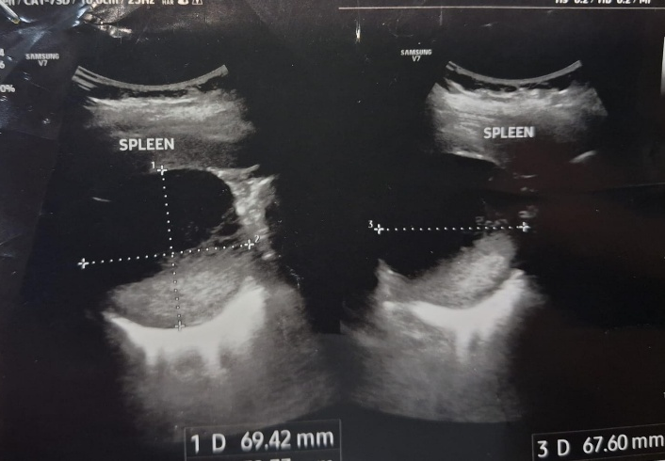
Figure 1. Ultrasonographic images of the spleen demonstrating a well-defined cystic lesion in the splenic parenchyma, measuring approximately 69.4 mm × 67.6 mm. Measurements were obtained in two orthogonal planes.

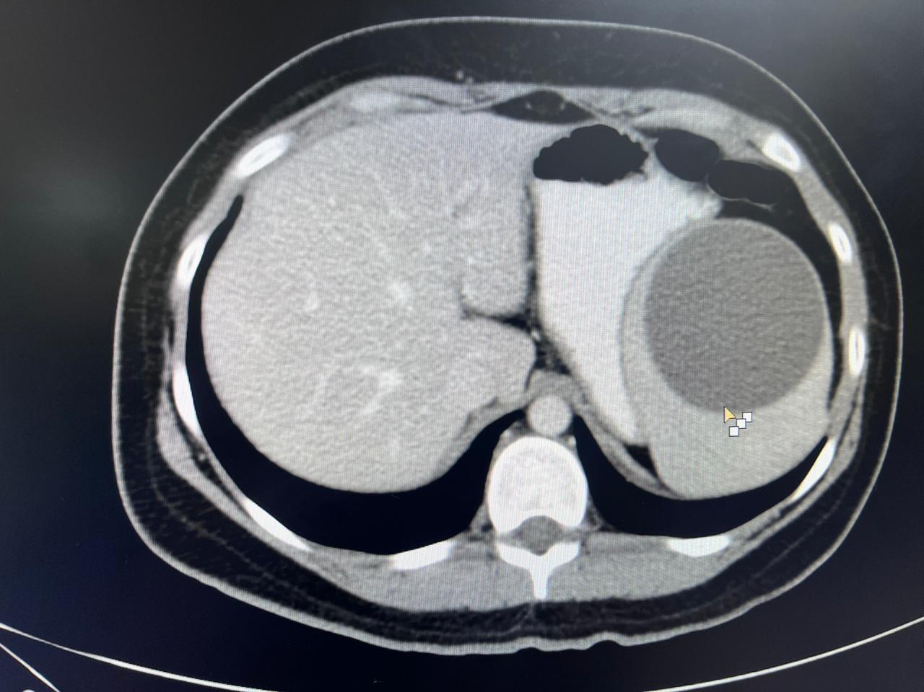
Figure 2. CECT Abdomen demonstrating unilocular hypodense splenic cyst

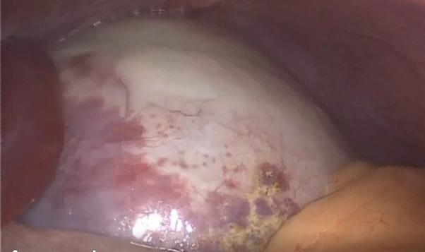

Figure 3. Intraoperative Laparoscopic view showing splenic cyst extending behind lt lobe of liver

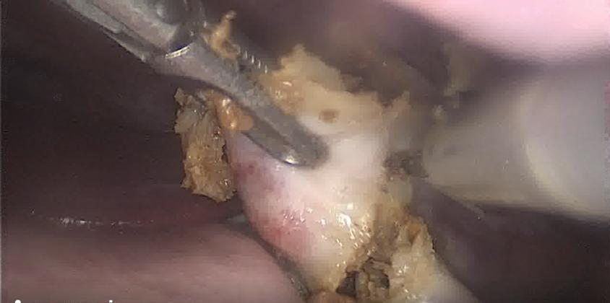
Figure 4. Laparoscopic cyst unroofing

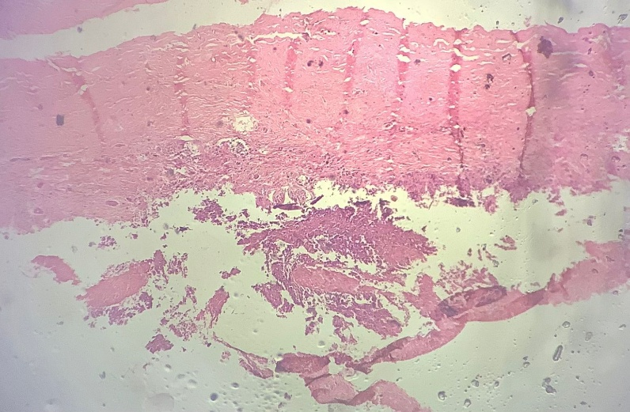
Figure 5. Histopathological view demonstrating splenic and fibro collagenous cystic wall (magnification - 10x)

