Mcswain type V Appendiceal Intussusception as a Lead Point in Infantile Ileocolic Intussusception: A rare Case report
Abstract
Both appendicitis and intussusception can have similar presentations which can pose diagnostic and therapeutic challenges. Appendiceal intussusception is a rare condition, particularly in infants, and may serve as a pathological lead point for ileocolic intussusception. While most early intussusceptions can be managed by non-surgical reductions, these appendiceal intussusceptions stand out as exceptions. Of the available literature, the youngest cases reported has been in 4-year old child and above. We report a 5-month-old male presenting with abdominal pain, red currant jelly stools, and a palpable abdominal mass. Imaging suggested ileo-colic intussusception, and surgical exploration revealed a markedly elongated appendix (~10 cm) acting as the lead point. Appendectomy with vice versa reduction of intussusception was performed successfully. This case highlights the importance of considering rare lead points in atypical presentations of intussusception in infancy.
Keywords: Intussusception, appendix, lead point, infant, McSwain classification
Introduction
Intussusception is one of the most common causes of intestinal obstruction in infants. Most cases are idiopathic; however, pathological lead points are identified only in a few cases, especially in atypical age groups or presentations¹. Appendiceal intussusception is rare, with an incidence of approximately 0.01%². Its occurrence as a lead point in infants is extremely uncommon and often diagnosed intraoperatively³. Bhattarai B et al⁴ have reported a similar case in a 4-year-old child and did literature search on this topic and found that a total of 11 cases have been reported till date in both children and adults. They have nick-named this condition as ‘Appendi-spection’. They have noted that the lowest age reported till date was in an 8-month-old infant. They have postulated that intussusception and acute appendicitis often present with similar symptoms like vomiting and abdominal pain which makes pre-operative distinction difficult. Secondly, the secondary cause (in these cases- appendicitis) should be considered when initial treatments like hydro or pneumostatic reduction fail.

Most Pediatric intussusceptions are ileo-colic intussusceptions which can which can be manged non-surgically with air/hydrostatic enemas. Type V appendiceal intussusceptions are frequently misidentified as ileo-colic. Reporting such cases will alert radiologists and clinicians about this entity especially since in these cases, non-surgical reductions would fail and patient would require surgery only. Also limited case reports suggest partial cecal resection. However, we have only performed simple appendectomy and the child is doing well. Thus, it adds to the limited data on this pathology.
Herewith we present a rare or unusual case of a 5-month-old infant presenting with a Mc-Swain type V intussusception which was an intra-operative surprise for us.
Case Presentation
A 5-month-old male otherwise healthy and without any significant post-natal history, presented with a 2-day history of intermittent abdominal pain and excessive crying, followed by passage of blood-stained stools for 1 day. There was no history of vomiting or fever. There was no history of similar complaints in the past.
On examination, the infant was afebrile but had tachycardia. Abdominal examination revealed a palpable sausage-shaped mass in the left iliac region with an empty right iliac fossa. Digital rectal examination showed blood-stained mucoid discharge.
Lab results showed an HB of 9 gm/dl, A total leucocyte count of 12000 cells/mm³, a platelet count of 2lakhs/mm³ an elevate CRP of 35 and rest of reports were within normal range.
Ultrasonography demonstrated a target sign suggestive of intussusception. (Fig 1)
The child was put on an NG tube to decompress the stomach. Since there were no overt signs of small bowel obstruction, a trial of pneumostatic reduction (which involved the use of air enema under ultrasonic guidance) was attempted which failed to reduce the intussusception. Therefore, emergency surgical exploratory laparotomy was undertaken via 3 cm lower abdominal transverse incision.
Intraoperative Findings
Ileocolic intussusception of approximate length 5 cm was identified. After reduction of the intussusception, a markedly elongated appendix (~10 cm) was found acting as the lead point, (fig 2) with invagination into the cecum—consistent with appendiceal intussusception.
Appendectomy was done. The reduced bowel was viable. There was no redundant ceacum or left colon. However, in order to prevent recurrence, a ceacopexy was performed by suturing lateral wall of the ceacum to the abdominal wall using non absorbable sutures.
Postoperative Course
The postoperative period was uneventful. The child was started on oral feeds on post operative day (POD) 2. He tolerated feeds well. He was discharged in stable condition on POD 4. Histopathological examination of the excised appendix revealed no specific pathology. The child has been followed up for almost 5 months now and is doing well.

Discussion
Appendiceal intussusception is an uncommon entity and an even rarer cause of ileocolic intussusception in infants³. According to Shihab R et al⁵, the total number of studies reported worldwide till date is twelve with total number of cases reported being thirteen. They found that the mean age of children presenting with this pathology is 5 years.

While most pediatric intussusceptions are idiopathic, the likelihood of a pathological lead point increases in younger infants, atypical presentations, or cases with bleeding per rectum^{6,7}.
The present case is distinctive due to the presence of a markedly elongated appendix (~10 cm) acting as a lead point in a 5-month-old infant—an association that is only sparsely described in the literature. To the best of our knowledge, this is the first reported case of intussusception with the appendix as the lead point in a patient of this age.
Previously reported pediatric cases have implicated appendiceal inflammation, infection, or associated bowel pathology as predisposing factors^{6,7,}. In contrast, our case did not demonstrate any underlying inflammatory or neoplastic pathology on histopathology, suggesting that anatomical factors such as marked appendiceal elongation alone may predispose to intussusception.
Hurtado CG et al⁸ reported a case of an 11-year-old boy having a Mc-Swain type III appendiceal intussusception in which owing to inflamed base of the appendix, the child had to undergo partial cececotomy along with appendectomy. This adds another dimension to this disease.
Preoperative identification of an appendiceal lead point remains challenging, as ultrasonography typically confirms intussusception but rarely can the sonologist delineate the appendix as the causative structure⁹. Most of them confirm the diagnosis of intussusception by viewing the ‘target sign’ classical of intussusception. (Fig 1) Consequently, in most cases the lead point is often found intraoperatively, as in our case.
From a surgical standpoint, the presence of a pathological lead point necessitates operative management rather than non-operative reduction. Since pre-operatively we were unaware of the lead point, we performed pneumostatic reduction as is the protocol. However, pneumostatic reduction failed to reduce the intussusception. Thus, the decision of operative intervention was made. It is well established now, that in cases with a pathological lead point, excision of the lead point is curative and prevents recurrence. So, appendectomy was done in this case along with cecopexy as described before. The child did not have any recurrence and is doing well on post-operative follow up even after 3 months. The timing of surgery is crucial as any undue delay leads to compromised bowel viability and increased morbidity and/or mortality.
Thus, this case contributes to the limited literature on appendiceal intussusception and highlights marked appendiceal elongation as a potential independent risk factor, expanding current understanding of lead points in infantile intussusception. It also emphasises on the need of performing appendectomy as a definitive procedure in these types of cases.
McSwain Classification¹⁰
According to the McSwain classification of appendiceal intussusception, appendiceal intussusception is classified into five types: (Fig 3)
• Type I: Invagination of the appendiceal tip
• Type II: Invagination along the length
• Type III: Invagination at the base into the cecum
• Type IV: Retrograde intussusception
• Type V: Complete invagination into the cecum
The present case corresponds to Type V, given involvement of the appendiceal base and its role as a lead point.
Limitations of the case report-
While highly valuable for rare conditions, this case report has some inherent limitations. These are:
Low level of evidence- Case reports lie at the bottom of ‘Level of Evidence’ hierarchy hence they cannot establish a cause-effect relation. Also, the data comes from a single patient, hence the results cannot be generalised to the entire pediatric population.
Retrospective dependency- Since the pathology was an intra-operative surprise, there is a risk of missing out on subtle details especially early symptoms and radiological clues.
Conclusion:
For an infant presenting with acute abdomen, it is prudent to keep intussusception as a differential although appendiceal intussusceptions are a rare entity. They are often missed radiologically and are typically discovered intraoperatively. Failure of non-surgical reduction should alert the clinician to this possibility as most of these cases are successfully managed surgically only. Here, we have presented a Type V Mc Swain appendiceal intussusception in the youngest age reported so far (5 months). The child was operated and appendectomy done. Since the child presented early, there was no difficulty during surgery. The child is doing well on follow up.
Consent
As per international standards, parental written consent has been collected and preserved by the author(s).
Ethical Approval:

As per international standards or university standards written ethical approval has been collected and preserved by the author(s).

Disclaimer (Artificial intelligence)

Author(s) hereby declare that NO generative AI technologies such as Large Language Models (ChatGPT, COPILOT, etc.) and text-to-image generators have been used during the writing or editing of this manuscript.

References
1. Stringer MD, Pablot SM, Brereton RJ. Paediatric intussusception. Br J Surg. 1992;79(9):867–76.
2. Collins DC. 71,000 human appendix specimens: a final report. Am J Proctol. 1963;14:365–81.
3. Chaar CI, Wexelman B, Zuckerman K, Longo W. Intussusception of the appendix: comprehensive review of the literature. Am J Surg. 2009;198(1):122–8.
4.Bhattarai B, et al. Concomitant intussusception and appendicitis “appendi-sception” in children: A case report and review of literature. Int J Surg Case Rep. 2024 Sep;122:110022: https://doi.org/10.1016/j.ijscr.2024.110022, doi: 10.1016/j.ijscr.2024.110022
5. Shihab R, Abdallah HO, Nafaa A, Abdallah YN, Kittaneh M. McSwan type V appendiceal intussusception and acute appendicitis coexistence in a 4-year-old child: a case report and review of the literature. J Surg Case Reports. 2025;2025(4):rjaf236. doi:10.1093/jscr/rjaf236
6. Adane B, Kebede T, Ayalew M. Appendiceal intussusception as a lead point for ileocolic intussusception in children. Afr J Paediatr Surg. 2019;16(2):45–8.
7. El Yaagoubi M, et al. Appendiceal intussusception in children: a rare cause of acute abdomen. J Pediatr Surg Case Rep. 2017;25:20–3.
8. Hurtado CG, Chen L, Meckmongkol T. Concurrent acute appendicitis and type III appendiceal intussusception: a case report. Cureus. 2022 Jul 26;14(7):e27310. doi: 10.7759/cureus.27310.
9. Furlong H, et al. Recurrent intussusception due to appendiceal lead point. Pediatr Radiol. 2007;37(3):280–3.
10. McSwain B. Intussusception of the appendix. South Med J. 1941;34:263–71.

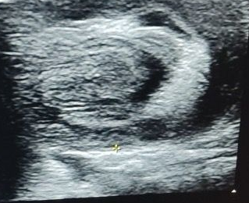
Fig 1- Ultrasound picture of the patient with the white arrow demonstrating the classical ‘Target Sign’ of Intussusception.

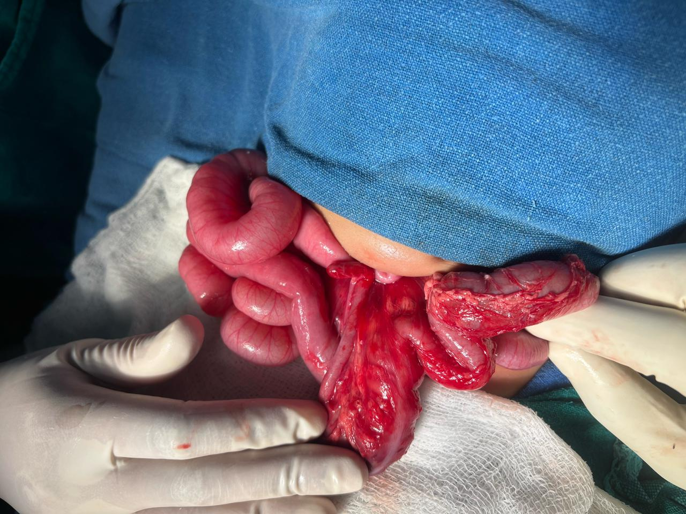
Fig 2- Intra- operative picture of reduced intussusception mass showing elongated appendix (Mc Swain type V- yellow arrow) as the lead point, ceacum and ascending colon- white arrow and terminal ileum- green arrow.
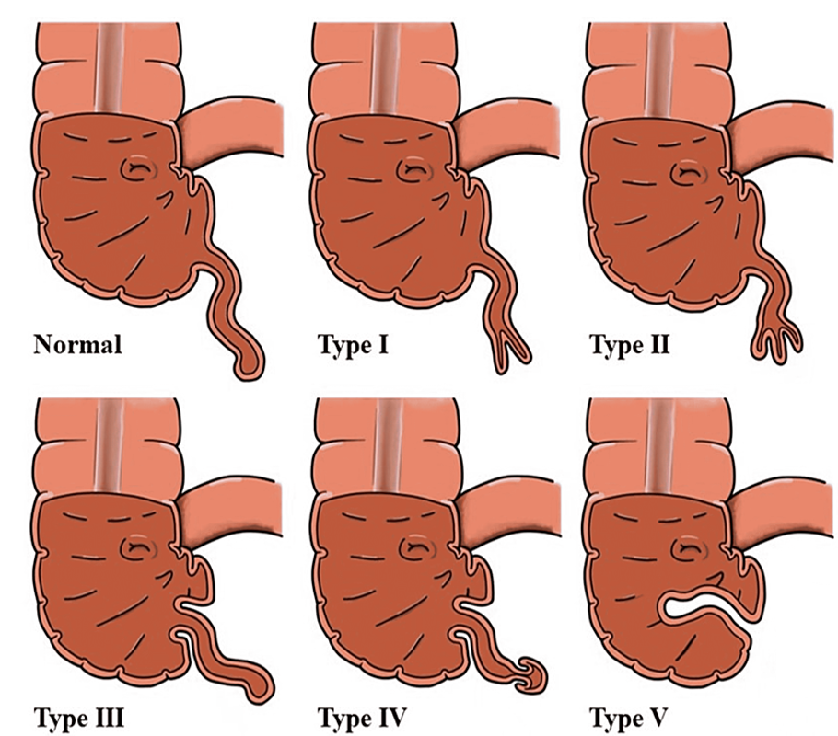

Fig 3- Diagrammatic representation of Mc Swain classification of Appendiceal Intussusception⁸

