ENTEROBIUS VERMICULARIS: A RARE PRESENTATION AS ACUTE APPENDICITIS

ABSTRACT
Enterobius vermicularis (pinworm) is a common intestinal helminth infection worldwide, particularly in developing regions. Although typically associated with mild gastrointestinal symptoms, its role in acute appendicitis remains controversial, with reports suggesting it may mimic or contribute to appendiceal inflammation.
We report the case of an 18-year-old female who presented with persistent lower abdominal pain, nausea, and anorexia. Clinical findings raised suspicion of acute appendicitis; however, ultrasonography was unremarkable and did not reveal definitive features of appendiceal inflammation. Despite negative imaging results, persistent symptoms necessitated surgical intervention.
Diagnostic laparoscopy and appendectomy were performed. Intraoperatively, the appendix was found to be inflamed and dilated, and a live E. vermicularis worm was observed emerging from the appendiceal lumen following transection, confirming appendiceal enterobiasis. Histopathology showed nonspecific chronic inflammatory changes. The patient received postoperative anti-helminthic therapy with albendazole and had an uneventful recovery with complete symptom resolution.
This case highlights the diagnostic challenge of parasitic appendiceal disease, particularly when routine laboratory and imaging findings are inconclusive. It underscores the importance of considering helminthic infection in patients with atypical presentations of suspected appendicitis, especially in endemic and resource-limited settings.
Keywords: Enterobiasis, acute appendicitis, laparoscopic appendectomy, parasitic infection, albendazole
Introduction
Acute appendicitis remains one of the most frequent causes of emergency surgical intervention worldwide, with an estimated prevalence of approximately 6% in individuals aged 10–30 years and a lifetime incidence approaching 9% [1]. It is defined as an acute inflammatory condition of the vermiform appendix, typically presenting with abdominal pain and requiring timely diagnosis to prevent complications such as perforation and peritonitis.
The diagnosis of acute appendicitis is primarily clinical and is supported by a combination of patient history, physical examination, laboratory investigations, and radiological imaging. Classical clinical features include periumbilical pain migrating to the right lower quadrant, anorexia, nausea, and low-grade fever. In the majority of patients—approximately 90%—who present with this typical symptom complex, a diagnosis of acute appendicitis is ultimately confirmed. Laparoscopic appendectomy remains the standard and most widely adopted therapeutic approach [2]. Although most cases arise from luminal obstruction due to faecoliths or lymphoid hyperplasia, a diverse range of uncommon aetiologies has been reported, including neuroendocrine tumours, serrated adenomas, low-grade appendiceal mucinous neoplasms, hyperplastic polyps, and intestinal parasites [3].
Enterobius vermicularis is among the most prevalent intestinal helminthic infections globally, particularly affecting paediatric populations. Recent meta-analytic data estimate a global prevalence of approximately 12.9% among children, with significantly higher rates observed in regions characterised by inadequate sanitation and poor hygiene practices [4,17]. Transmission occurs predominantly via the faecal–oral route, through ingestion of infective eggs acquired from contaminated hands, fomites, or, less commonly, inhaled particles that are subsequently swallowed. Following ingestion, larvae hatch in the small intestine and migrate to the colon, especially the caecum and appendix, where maturation occurs. Gravid females then migrate nocturnally to the perianal region to deposit eggs, which become infective within hours, thereby facilitating both autoinfection and person-to-person transmission [5].
Although E. vermicularis infection is generally considered benign and self-limiting, often remaining asymptomatic or presenting with non-specific manifestations such as perianal pruritus or irritability, it may occasionally be associated with clinically significant complications. Appendiceal involvement, although relatively uncommon, has been increasingly reported in the literature [6–9]. Proposed pathogenic mechanisms include mechanical obstruction of the appendiceal lumen by adult worms or ova, mucosal irritation, and activation of local inflammatory or immune responses [10,11]. In certain cases, the parasite may be an incidental histopathological finding, whereas in others it may act as a contributing factor in the development of acute appendicitis [12].
Accordingly, the identification of E. vermicularis in appendectomy specimens, particularly among paediatric and adolescent patients presenting with abdominal pain, requires careful correlation of clinical, radiological, and histopathological findings to determine its true clinical significance. Reported associations between E. vermicularis infestation and acute appendicitis vary widely, ranging from 0.2% to 41.8% among patients undergoing appendectomy for suspected appendicitis [13]. This substantial heterogeneity is likely attributable to regional, socioeconomic, and methodological differences, highlighting the need for further context-specific epidemiological studies.
Against this background, the present case report aims to document a rare instance of appendiceal enterobiasis in a resource-limited setting in eastern India, with the objective of contributing to a better understanding of the potential relationship between parasitic infections and acute appendicitis.
Case Presentation
An 18-year-old female, presented to the Outpatient Department with a primary complaint of persistent lower abdominal pain, accompanied by nausea, anorexia, and a low-grade fever.
On physical examination, the patient was febrile and appeared clinically pale. Abdominal palpation revealed mild tenderness localized to the right iliac fossa (RIF); however, there were no clinical markers of peritonitis, such as guarding, rigidity, or rebound tenderness.
Diagnostic Evaluation
Initial laboratory investigations revealed anemia (hemoglobin-7.7g/dl) . Other biochemical markers—including Serum Urea, Creatinine, Liver Function Tests (LFTs), and C-Reactive Protein (CRP)—were within normal limits. Routine urinalysis was also unremarkable.
Ultrasonography (USG) of the abdomen and pelvis identified a left-sided hemorrhagic ovarian cyst. Following a gynecological consultation, the cyst was deemed clinically insignificant and unrelated to the patient's symptoms. Notably, the USG provided no definitive findings regarding the status of the appendix.
Management and Surgical Intervention
Based on clinical suspicion, a provisional diagnosis of acute appendicitis was made. The patient was initially managed conservatively with intravenous fluids and broad-spectrum antibiotics. During this period, she also received a one-unit blood transfusion to address her anemia.
After five days of conservative therapy, the patient’s condition failed to improve, with persistent dull aching pain in the RIF. Consequently, the surgical team proceeded with a diagnostic laparoscopy.
Intraoperative Findings:
- Upon insertion of the laparoscope, the appendix appeared significantly dilated, elongated, and inflamed.
- A standard laparoscopic appendectomy was performed using a three-port technique.
- Key Finding: Upon transection of the appendiceal base, a live worm was visualized emerging from the lumen, confirming parasitic involvement.
Histopathology and Postoperative Course
The appendix was successfully retrieved and sent for histopathological examination. The report later confirmed non-specific chronic inflammatory changes, a common finding in cases where parasites cause luminal obstruction (appendiceal colic) rather than primary bacterial infection.
Postoperative Recovery:
- The patient transitioned to a liquid diet on Day 1 and a solid diet on Day 2.
- To treat the underlying parasitic infection, she was prescribed Albendazole (400 mg daily) for 14 days, starting on the first postoperative day.
- The patient was discharged on Day 3 in stable condition.
At the two-week follow-up, she showed complete resolution of symptoms, normal dietary habits, and no recurrence of abdominal pain.

DISCUSSION
The presence of Enterobius vermicularis within the human appendix has been widely documented in histopathological studies (13,14); however, its exact pathogenic significance in appendiceal disease remains a matter of ongoing debate. While several authors regard its detection as an incidental finding, particularly in cases lacking neutrophilic infiltration or other definitive histological features of acute appendicitis, others have suggested that E. vermicularis may contribute to appendiceal pathology through multiple mechanisms. These include lymphoid follicular hyperplasia, partial or complete luminal obstruction, and low-grade inflammatory responses that may not meet the conventional histopathological criteria for acute suppurative appendicitis (2–4,7,15).
Importantly, these perspectives are not necessarily mutually exclusive. E. vermicularis may function either as a harmless luminal coloniser or as a contributory aetiological factor, depending on the interaction between parasite load, host immune response, and local tissue environment. Recent literature further supports this duality, suggesting that parasitic appendiceal involvement represents a heterogeneous spectrum of disease in which helminths may act as true pathogens in selected cases or remain incidental findings in others. This variability is largely influenced by the interplay between worm burden, degree of luminal obstruction, and host inflammatory response (16).
The Limitations of Conventional Diagnostics
This case underscores a profound clinical challenge: the frequent failure of routine laboratory and radiological investigations to detect parasitic appendicitis. In our case the presentation was markedly non-specific; the absence of leukocytosis, peripheral eosinophilia, and elevated inflammatory markers, coupled with an unremarkable ultrasonography, created a significant diagnostic dilemma.
In many such instances, the pathology is intraluminal (obstruction by the parasite) rather than transmural (infection of the appendiceal wall). Consequently, standard tests—which are designed to detect systemic inflammation or macroscopic tissue changes—often remain silent, leading to the underrecognition of parasitic etiologies.
The Role of Diagnostic Laparoscopy
The lack of symptomatic resolution despite aggressive antibiotic therapy was a key clinical pivot. It demonstrates that when conservative management fails in the face of "negative" imaging, diagnostic laparoscopy remains the gold standard for definitive diagnosis. In this case, the direct visualization of the whitish, slender Enterobius vermicularis emerging from the appendiceal lumen provided the only conclusive evidence of the disease.
The immediate improvement in the patient’s condition following anthelmintic therapy confirms that the symptoms were primarily driven by the parasitic load rather than a bacterial process.
Socio-Epidemiological Barriers and Underreporting
Enterobius vermicularis remains a significant public health concern in regions with developing socioeconomic infrastructure, where fecal-oral transmission is common. However, the true prevalence is likely obscured by two factors:
- Variable Symptomatology: The absence of "classic" signs like perianal pruritus often leads clinicians to exclude parasites from their differential diagnosis.
- Social Stigmata: The perceived stigmata associated with parasitic infections can prevent patients from providing a full history, leading to delayed treatment.

CONCLUSION
This case highlights that Enterobius vermicularis remains a noteworthy, albeit rare, cause of appendiceal symptoms that can mimic acute appendicitis. The diagnostic dilemma encountered—characterized by unremarkable ultrasonography and the absence of classic markers like eosinophilia—underscores the limitations of routine investigations in parasitic etiologies. Surgical intervention and direct visualization remain the definitive means of diagnosis in such presentations. Furthermore, the patient’s successful recovery following appendectomy and anthelmintic therapy reinforces the necessity of a dual treatment approach. Clinicians should maintain a high index of suspicion for parasitic infestations in pediatric and adolescent patients from endemic or resource-limited areas to ensure timely management and appropriate public health follow-up.

PREOPERATIVE INVESTIGATIONS
TABLE 1.Complete blood count showing anemia with hemoglobin of 7.7g/dl
TOTAL LEUCOCYTE COUNT | 7.81 x10³ ul
HEMOGLOBIN | 7.7 g/dl
PLATELET | 331x10³ ul
NEUTROHPHIL | 4.81x10³ul
LYMPHOCYTE | 2.37x10³ul
EOSINOPHIL | 0.27x10³ul
MONOCYTE | 0.33x10³ul
BASOPHIL | 0.3x10³ul

FIG 1.ULTRASOUND OF ABDOMEN AND PELVIS
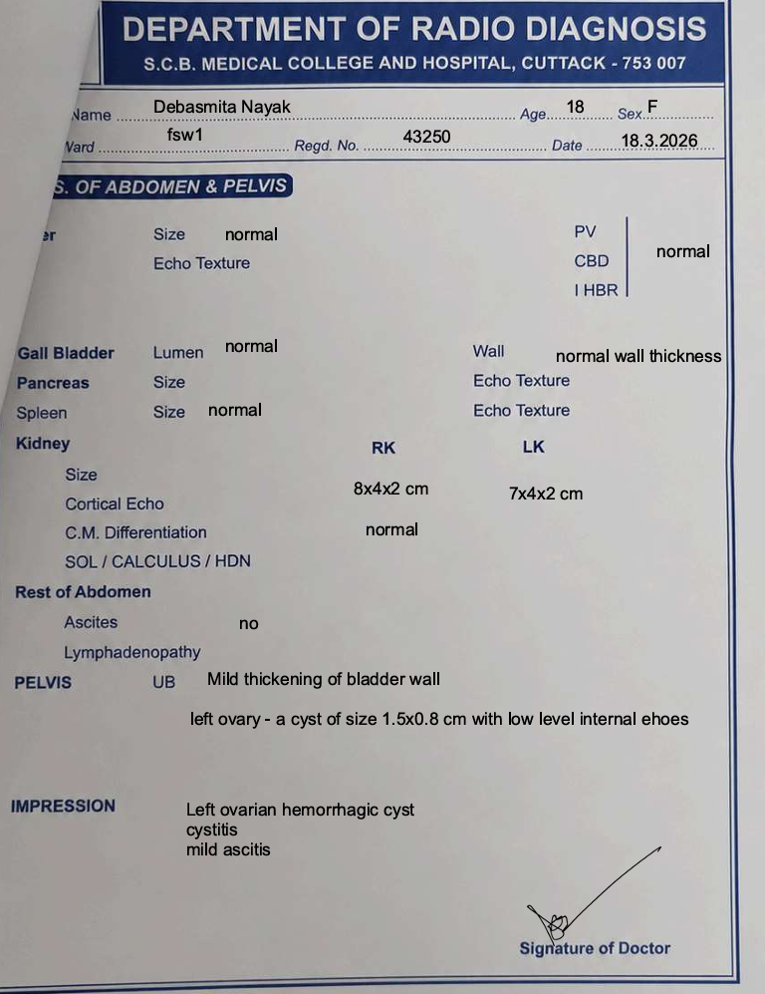

FIG 2.INTRA OPERATIVE IMAGES SHOWING WORMS COMING OUT OF THE LUMEN OF APPENDIX
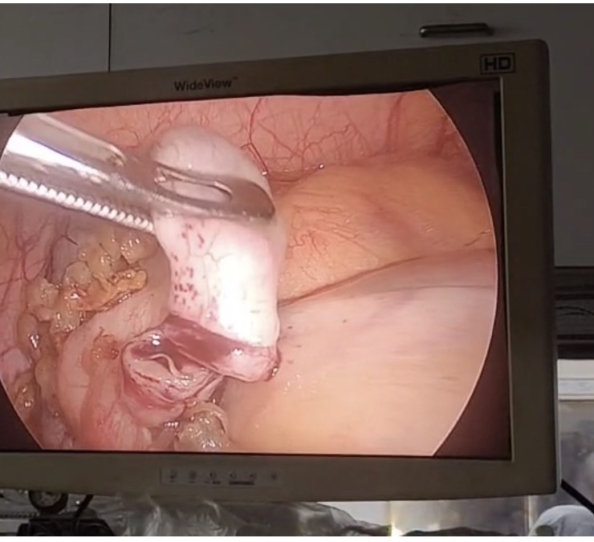

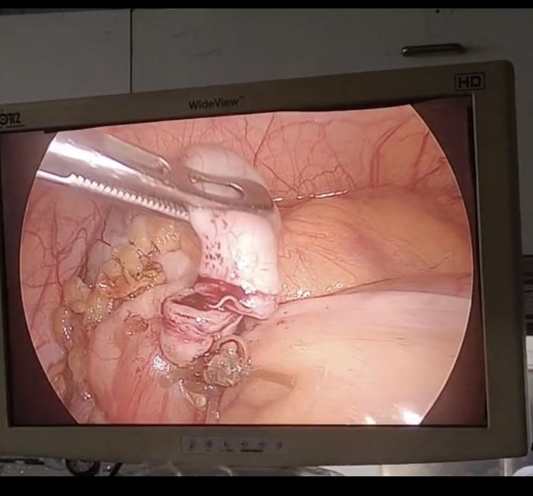
Consent
As per international standards or university standards, patient(s) written consent has been collected and preserved by the author(s).

Disclaimer (Artificial intelligence)

Author(s) hereby declare that NO generative AI technologies such as Large Language Models (ChatGPT, COPILOT, etc.) and text-to-image generators have been used during the writing or editing of this manuscript.

REFERENCES
1.M. Podda, C. Gerardi, N. Cillara, N. Fearnhead, C.A. Gomes, A. Birindelli, et al.
Antibiotic treatment and appendectomy for uncomplicated acute appendicitis in adults and children: a systematic review and meta-analysis
Ann. Surg. (2019)

2.Moris D., Paulson E.K., Pappas T.N. Diagnosis and Management of Acute Appendicitis in Adults: A Review. JAMA. 2021;326:2299–2311. doi: 10.1001/jama.2021.20502. [DOI] [PubMed] [Google Scholar]

3.Kamalı G.H., Ulusoy C., Nikolovski A., Eğin S., Kamalı S. Uncommon causes of acute appendicitis: Retrospective analysis of 6785 histopathological findings in a tertiary center. Turk. J. Trauma Emerg. Surg. 2022;28:1708–1715. doi: 10.14744/tjtes.2022.84937. [DOI] [PMC free article] [PubMed] [Google Scholar]

4.LashakiEKMizaniAHosseiniSAHabibiBTaherkhaniKJavadiAet al. Global prevalence of enterobiasis in young children over the past 20 years: a systematic review and meta-analysis.Osong Public Health Res Perspect. (2023) 14:441–50. 10.24171/j.phrp.2023.0204

5.LeungAKCLamJMBarankinBWongAHCLeongKFHonKL. Pinworm (Enterobius Vermicularis) infestation: an updated review.Curr Pediatr Rev. (2025) 21:333–47. 10.2174/0115733963283507240115112552

6.LampsLW. Infectious causes of appendicitis.Infect Dis Clin North Am. (2010) 24:995–1018. 10.1016/j.idc.2010.07.012

7.ChhetriSAl MamariAHAl AwfiMMAl KhaldiNHNAbedNMPandakNet al. Enterobius vermicularis related acute appendicitis: a case report and review of the literature.Infect Dis Rep. (2023) 15:417–24. 10.3390/idr15040042

8.Flores UribeAPérez MacíasJPGonzález ArévaloJAFlores UribeOA. Diagnosis and surgical intervention of acute appendicitis secondary to enterobius vermicularis: case report.Int J Surg Case Rep. (2022) 99:107678. 10.1016/j.ijscr.2022.107678

9.RazzaghiMRezaeiHMohammadiFSalehiAM. Enterobius vermicularis in the appendiceal lumen: a case report.Case Rep Surg. (2024) 2024:7806541. 10.1155/2024/7806541

10.TaghipourAOlfatifarMJavanmardENorouziMMirjalaliHZaliMR. The neglected role of Enterobius vermicularis in appendicitis: a systematic review and meta-analysis.PLoS One. (2020) 15:e0232143. 10.1371/journal.pone.0232143

11.MatthewsBKAuldM. Enterobius vermicularis infection at time of appendicectomy: is it a neglected risk factor?Int Surg J. (2024) 11:545–8. 10.18203/2349-2902.isj2024059

12.PehlivanoğluBİşlerSÖzdaşSAbesM. Findings in appendectomies with Enterobius vermicularis infection: pinworm is not a cause of appendicitis.Turkiye Parazitol Derg. (2019) 43:21–5. 10.4274/tpd.galenos.2019.6177
13.IssinGDemirFSimsekHACagatayDVTayfurMKandemirAet al. Seeds or parasites? Clinical and histopathological features of seeds and parasites in the appendix.Turk Patoloji Derg. (2023) 39:42–54. 10.5146/tjpath.2022.01586

14.AydinO. Incidental parasitic infestations in surgically removed appendices: a retrospective analysis.Diagn Pathol. (2007) 2:16. 10.1186/1746-1596-2-16

15.GetzlaffJMFulghumGH. Enterobius vermicularis (Pinworm) appendicitis: the real vermiform appendix.Mil Med. (2024) 189:e894–6. 10.1093/milmed/usad357

16.LaorBHassanAS. Parasitic appendicitis, what do we know? -a literature review.Transl Gastroenterol Hepatol. (2025) 10:32. 10.21037/tgh-24-148
17. Carraturo, F., Colicchio, R., Di Mento, C., Continisio, L., Chiodi, A., Escolino, M., ... & Vitiello, M. (2026). Enterobius vermicularis as a cause of acute appendicitis: a case report. Frontiers in Medicine, 13, 1818165.
ABBREVIATIONS
- USG – ULTRASONOGRAPHY
- CRP – C REACTIVE PROTEIN
- RIF- RIGHT ILIAC FOSSA
- E.VERMICULARIS-ENTEROBIUS VERMICULARIS
- LFT- LIVER FUNCTION TEST

