Case report

Lemmel Syndrome Mimicking Choledocholithiasis: A Rare Cause of Obstructive Jaundice

.
ABSTRACT

Lemmel syndrome is a rare but clinically important cause of obstructive jaundice, arising from external compression of the common bile duct (CBD) by a periampullary duodenal diverticulum, typically in the absence of choledocholithiasis or underlying malignancy. Although infrequently encountered in clinical practice, it represents a significant differential diagnosis in patients presenting with cholestatic liver function abnormalities and evidence of biliary obstruction where no definitive obstructing lesion is identified on routine evaluation. We report the case of a 60-year-old Malay woman who presented with right hypochondriac pain associated with cholestatic features. Initial clinical assessment raised suspicion of biliary obstruction secondary to biliary sludge or choledocholithiasis. However, further evaluation with contrast-enhanced computed tomography (CT), endoscopic ultrasound (EUS), and magnetic resonance cholangiopancreatography (MRCP) demonstrated extrinsic compression of the distal CBD by a periampullary duodenal diverticulum, consistent with Lemmel syndrome. The patient was managed conservatively and showed clinical improvement without the need for surgical intervention. This case highlights the importance of considering Lemmel syndrome as a potential cause of obstructive jaundice, particularly when common etiologies such as biliary stones or malignancy are absent. It also emphasizes the valuable role of advanced imaging modalities, including CT, EUS, and MRCP, in establishing an accurate diagnosis and guiding suitable management.

Keywords: Lemmel syndrome, obstructive jaundice, periampullary diverticulum, MRCP

1. INTRODUCTION
Lemmel syndrome is an uncommon aetiology of obstructive jaundice, characterised by external compression of the distal common bile duct (CBD) due to a periampullary duodenal diverticulum (PAD), in the absence of choledocholithiasis or malignant pathology. periampullary duodenal diverticulum refers to an extraluminal sac-like outpouching of the duodenal wall located within a 2–3 cm radius of the ampulla of Vater (Krisem et al., 2023). This condition was first described by Gerhard Lemmel in 1934. Although PAD is commonly identified incidentally and is often asymptomatic in the majority of cases, it may be detected in up to 22% of the general population, with fewer than 10% of individuals developing clinical symptoms (Goroztieta-Rosales et al., 2022).
While typically asymptomatic, PAD may lead to complications in approximately 5% of cases, presenting with right upper quadrant abdominal pain, hyperbilirubinaemia, and elevated hepatic and/or pancreatic enzyme levels (Volpe et al., 2021). The present report describes a case of Lemmel syndrome in a diabetic female patient presenting with atypical obstructive jaundice, in whom initial radiological evaluation showed no evidence of biliary calculi and findings were initially misinterpreted as biliary sludge. In this context, advanced imaging modalities played a crucial role in establishing the definitive diagnosis.

2. CASE PRESENTATION
A 60-year-old Malay female with a background of type 2 diabetes mellitus and dyslipidemia presented with a one-week history of right hypochondrium pain and two weeks of tea-colored urine. She reported feeling feverish but denied pale stools, pruritus, nausea, or weight loss. On physical examination, she was alert with a full Glasgow Coma Scale (GCS) and appeared clinically well. Her vital signs were stable. Abdominal examination revealed mild tenderness over the right hypochondrium region on deep palpation, without signs of peritonism. Initial laboratory investigations revealed total white blood cell count of 7.5 x 10⁹/L, total bilirubin of 121 µmol/L with direct predominant and normal serum amylase of 26 U/L. An ultrasound of the hepatobiliary system showed gallbladder sludge with no biliary ductal dilatation. Persistent symptoms prompted further evaluation. A contrast-enhanced CT of the abdomen revealed a dilated CBD (1.1 cm) with a distal iso- to hyperdense intraductal lesion suggestive of a soft stone, and focal air locules near the pancreatic head, raising suspicion of a periampullary diverticulum ( Figure 1 )

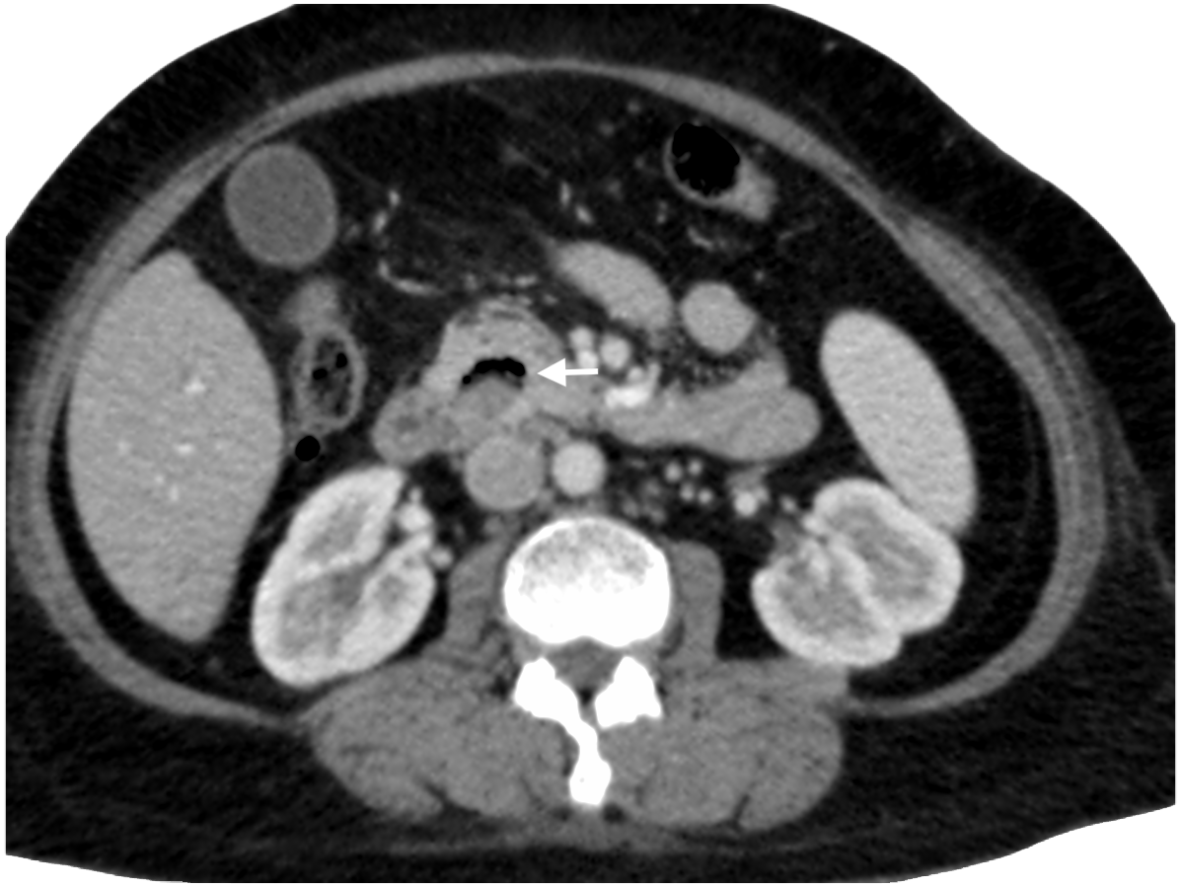
Figure 1 : Axial contrast-enhanced computed tomography (CT) scan of the abdomen shows presence of air locules (arrow) near the common bile duct without demonstrable cholelithiasis
An ERCP was attempted but failed due to unsuccessful cannulation. Subsequent endoscopic ultrasound (EUS) revealed a dilated CBD and a large periampullary diverticulum compressing the distal duct. MRCP confirmed the diagnosis of Lemmel syndrome, showing CBD narrowing due to external compression by the diverticulum. (Figure 2)
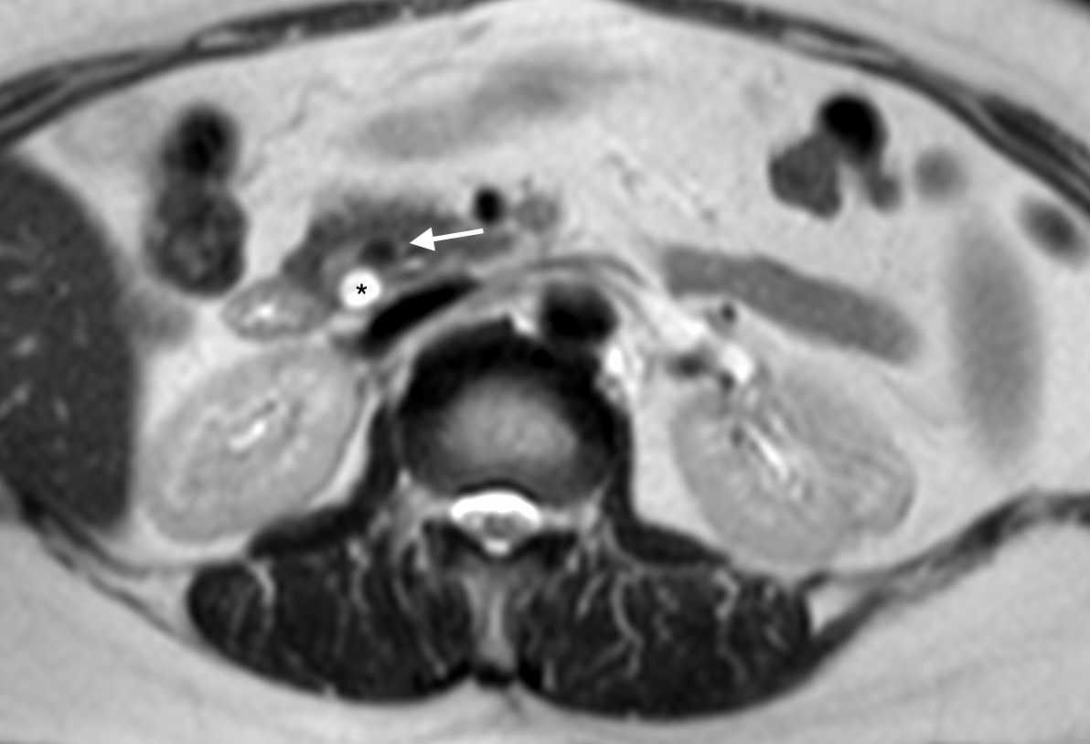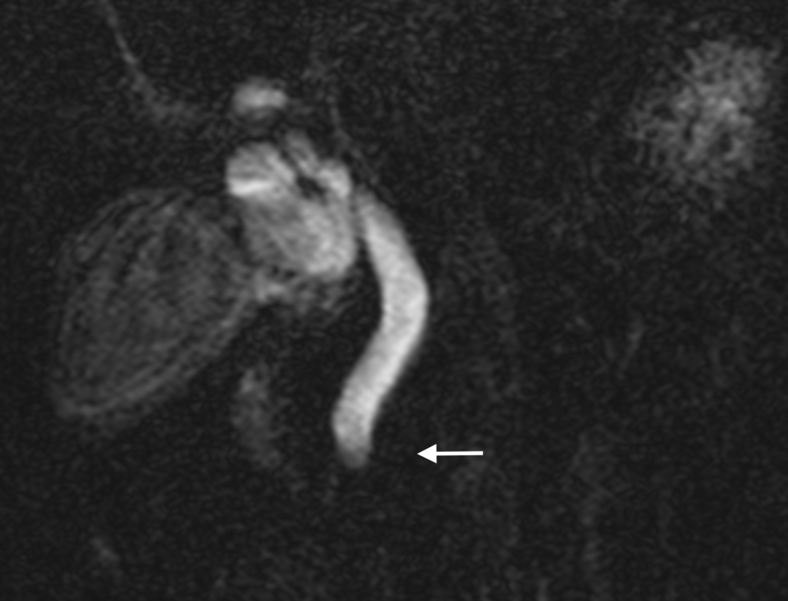
Figure 2 : Coronal T2-weighted magnetic resonance imaging of the abdomen shows an periampullary diverticulum (arrow) mechanically compressing the biliary duct with distal common bile duct (CBD) dilatation (asterisk)
The patient was managed conservatively due to clinical improvement and down-trending bilirubin levels. No surgical or endoscopic decompression was required. She was followed up for one year, during which liver function tests remained normal and she remained asymptomatic.
3. discussion

Gastrointestinal diverticula are sac-like protrusions of the intestinal wall that may occur at any point along the gastrointestinal tract, although they are most frequently observed in the colon and, less commonly, in the duodenum. The most prevalent form of duodenal diverticulum is the periampullary duodenal diverticulum (PAD). In most cases, individuals with PAD remain asymptomatic, and the condition is often identified incidentally during imaging or endoscopic evaluation.
However, complications develop in approximately 5% of cases and may include gastrointestinal haemorrhage, perforation, fistula formation, diverticulitis, cholangitis, pancreatitis, gallstone formation, and, in rare instances, obstructive jaundice (Krisem et al., 2023). periampullary duodenal diverticulum refers specifically to mucosal outpouchings located within 2–3 cm of the ampulla of Vater and is detected in up to 22% of individuals, particularly among older populations (Goroztieta-Rosales et al., 2022). Although the majority of PADs remain clinically silent, they may occasionally give rise to significant complications, including biliary obstruction, pancreatitis, and, in rare cases, perforation.
Periampullary duodenal diverticula (PAD) become increasingly common with advancing age, particularly after 50 years old. One possible explanation is that diverticula may result from dysfunction of the intestinal smooth muscle caused by vagal nerve degeneration and age-related weakening of the local supporting structures. Another explanation is that increased intraduodenal pressure may lead to outpouching of the intestinal wall at its weakest points, especially around the major duodenal papilla, where the pancreatic duct opens into the duodenum ( Chen et al., 2021 )
Lemmel syndrome is an uncommon clinical entity in which a periampullary duodenal diverticulum (PAD) induces extrinsic compression of the distal common bile duct (CBD), leading to obstructive jaundice in the absence of choledocholithiasis or malignancy (Krisem et al., 2023). This atypical aetiology often renders diagnosis challenging, as routine imaging modalities such as ultrasonography may fail to identify either the diverticulum or the precise mechanism of biliary obstruction.
Several pathogenetic mechanisms have been proposed for Lemmel syndrome. One hypothesis suggests that chronic mechanical irritation of the ampullary region, accompanied by persistent inflammation or chronic periampullary diverticulitis, may result in fibrosis of the papilla (papillitis chronica fibrosa) (Venkatanarasimha et al., 2019). A second proposed mechanism involves dysfunction of the sphincter of Oddi secondary to the presence of a PAD (Tomita et al., 1998). A third mechanism attributes the condition to direct mechanical compression of the CBD or ampulla by the diverticulum, resulting in obstructive jaundice, as observed in the present case (Nishida et al., 1995).
Lemmel syndrome may also predispose to bile stasis, thereby increasing the risk of cholangitis. Both mild and severe forms of Lemmel syndrome-associated cholangitis have been reported, and rare pathogenic organisms, including Edwardsiella tarda, have been documented in isolated cases (Shinji Miyajima, 2018).
Imaging plays a pivotal role in the diagnosis of this condition. While ultrasonography may demonstrate biliary ductal dilatation, its utility is limited in evaluating periampullary bowel pathology. In contrast, computed tomography (CT) and magnetic resonance cholangiopancreatography (MRCP) are considered the imaging modalities of choice, as they enable accurate visualisation of periampullary structures and facilitate exclusion of alternative causes such as biliary calculi or periampullary neoplasms (Krisem et al., 2023). In the present case, initial ultrasonography revealed only gallbladder sludge without evidence of biliary dilatation. However, due to persistent symptoms, further imaging was undertaken. CT imaging demonstrated dilatation of the CBD with a suspected periampullary diverticulum, which was subsequently confirmed by endoscopic ultrasound (EUS) and MRCP. It is noteworthy that the presence of intradiverticular contents such as food debris, bile, or calculi may contribute to obstruction of the biliary or pancreatic ducts, potentially leading to complications including choledocholithiasis, pancreatitis, or cholangitis. Nevertheless, the precise pathophysiological role of such contents remains incompletely understood, warranting further investigation.
Endoscopic retrograde cholangiopancreatography (ERCP) is often considered the preferred therapeutic approach in high-risk patients due to its minimally invasive nature and favourable outcomes in experienced centres. However, technical difficulties and procedure-related complications may arise, particularly when the papilla is located within or adjacent to a diverticulum, leading to failed cannulation (Yanagaki et al., 2019). In the present case, ERCP was attempted but cannulation was unsuccessful due to difficulty in identifying the ampullary opening. Notably, failed ERCP cannulation may itself serve as an indirect diagnostic indicator of PAD, given the anatomical distortion of the periampullary region. In such scenarios, EUS and MRCP are invaluable complementary diagnostic modalities. The management of Lemmel syndrome is guided by the severity of obstruction and the patient’s overall clinical condition. While endoscopic sphincterotomy or surgical diverticulectomy may be required in selected cases, conservative management may be appropriate in clinically stable patients demonstrating biochemical and symptomatic improvement, as observed in the present case. Conversely, patients presenting with significant pancreaticobiliary complications such as cholangitis, persistent obstructive jaundice, or pancreatitis require urgent intervention, typically involving endoscopic decompression or stenting. Surgical diverticulectomy is generally reserved for refractory or complicated cases, as it is associated with relatively higher morbidity and mortality (Volpe et al., 2021; Yoneyama et al., 2004).
As a temporising measure prior to definitive surgical intervention, less invasive endoscopic techniques such as simple tap-water lavage have been suggested as potential options for symptomatic relief. However, the clinical relevance of different subtypes of Lemmel syndrome in influencing prognosis and therapeutic outcomes remains uncertain, largely due to the scarcity of systematically reported cases (Love et al., 2022). Overall, current evidence supports endoscopic evaluation as the diagnostic gold standard, with additional therapeutic utility in selected cases, whereas surgical management remains reserved for complex presentations or cases associated with significant complications.

4. Conclusion
Lemmel syndrome is a rare but important differential in patients presenting with obstructive jaundice without gallstones or tumors. High clinical suspicion and the use of appropriate imaging modalities such as MRCP and EUS are essential for diagnosis. Selected patients can be managed conservatively with good outcomes. Early recognition and appropriate imaging are key to avoiding unnecessary interventions and ensuring timely, effective management.

Competing interests

Authors have declared that no competing interests exist.

Consent (where ever applicable)

As per international standards , patient written consent has been collected and preserved by the authors

Ethical approval

As per international standards or university standards written ethical approval has been collected and preserved by the author(s).

Disclaimer (Artificial intelligence)

Author(s) hereby declare that NO generative AI technologies such as Large Language Models (ChatGPT, COPILOT, etc.) and text-to-image generators have been used during the writing or editing of this manuscript.

References

- Chen, Q., Zhang, Y., Tang, Z., Yu, M., Liu, Z., Zhou, X., Li, G., Chen, Y. & Zhou, X. (2021). The role of periampullary diverticulum on the incidence of pancreaticobiliary diseases and the outcome of endoscopic retrograde cholangiopancreatography. Archives of Medical Science, 17(4), 905–914. https://doi.org/10.5114/aoms.2020.94591
- Goroztieta-Rosales LM, Gómez-Farías J, López-García KD, Davila-Rodriguez DO. Lemmel syndrome: an extraordinary cause of obstructive jaundice-a case report. J Surg Case Rep. 2022 Jan 17;2022(1):rjab593. doi: 10.1093/jscr/rjab593. PMID: 35047177; PMCID: PMC8763606.
- Krisem M, Hirunpat P, Tungtrongchitr N. Lemmel syndrome, a rare cause of obstructive jaundice by periampullary duodenal diverticulum: Case report and review of the literature. J Clin Imaging Sci. 2023 Apr 21;13:11. doi: 10.25259/JCIS_9_2023. PMID: 37152440; PMCID: PMC10159321.
- Love JS, Yellen M, Melitas C, Yazici C, Zar F. Diagnosis and Management of Lemmel Syndrome: An Unusual Presentation and Literature Review. Case Rep Gastroenterol. 2022 Dec 16;16(3):663-674. doi: 10.1159/000528031. PMID: 36605730; PMCID: PMC9808136.
- Miyajima S, Yamakawa G, Ohana M. Edwardsiella tarda-associated cholangitis associated with Lemmel syndrome. IDCases 2018;11:94–6Published 2018 Feb 2. 10.1016/j.idcr.2018.01.009.
- Nishida K, Kato M, Higashijima M, Takagi K, Akashi R. A case of Lemmel’s syndrome caused by a large diverticular enterolith at the peripapillary portion of the duodenum Nihon Ronen Igakkai Zasshi 1995;32:825-9
- Tomita R, Tanjoh K. Endoscopic manometry of the sphincter of Oddi in patients with Lemmel’s syndrome. Surg Today 1998;28:258-61.
- Volpe A, Risi C, Erra M, Cioffi A, Casella V, Fenza G. Lemmel's syndrome due to giant periampullary diverticulum: report of a case. Radiol Case Rep. 2021 Oct 4;16(12):3783-3786. doi: 10.1016/j.radcr.2021.08.068. PMID: 34659600; PMCID: PMC8502835.
- Venkatanarasimha N, Yong YR, Gogna A, Tan BS. Case 265: Lemmel syndrome or biliary obstruction due to a periampullary duodenal diverticulum. Radiology 2019;291:542-5.
- Yanagaki M, Shiba H, Hagiwara S, Hoshino M, Sakuda H, Furukawa Y, et al. A successfully treated case of Lemmel syndrome with pancreaticobiliary maljunction: a case report. Int J Surg Case Rep 2020;72: 560–3
- Yoneyama, F., Miyata, K., Ohta, H. et al. Excision of a juxtapapillary duodenal diverticulum causing biliary obstruction: report of three cases. J Hepatobiliary Pancreat Surg 11, 69–72 (2004). https://doi.org/10.1007/s00534-003-0854-7

