Case report

Donor Site Metastasis in Oral Cavity Carcinoma: A Rare Oncologic Phenomenon
ABSTRACT
Background: Donor site metastasis following reconstructive surgery for oral cavity carcinoma is a rare and underrecognized phenomenon. It challenges conventional pathways of tumour spread and raises concerns regarding iatrogenic tumour seeding during oncologic surgery.
Case Presentation: A 37-year-old female with locally advanced carcinoma of the left buccal mucosa underwent composite resection with segmental mandibulectomy, ipsilateral neck dissection, and reconstruction using a bipaddled pectoralis major myocutaneous (PMMC) flap. The surgical pathology report revealed perineural invasion and nodal metastases, so she was initiated on adjuvant concurrent chemoradiotherapy. During adjuvant concurrent chemoradiotherapy, after completion of 26 fractions of radiotherapy and four cycles of weekly cisplatin, she developed a painful, indurated swelling at the PMMC donor site over the left anterior chest wall. Fine-needle aspiration cytology (FNAC) demonstrated metastatic squamous cell carcinoma, and imaging revealed infiltration into the underlying musculature and adjacent ribs.
Discussion: Donor site metastasis is a rare entity, most plausibly explained by intraoperative tumour implantation, although hematogenous and lymphatic dissemination have also been proposed as possible mechanisms.
Conclusion: This case underscores the importance of strict adherence to oncologic surgical principles, early evaluation of atypical donor-site symptoms, and heightened clinical vigilance for rare patterns of disease spread.

KEYWORDS
Pectoralis Major Myocutaneous Flap; Donor Site Metastasis; Iatrogenic Tumour Implantation; Reconstructive Surgical Procedures.

INTRODUCTION
Oral cavity squamous cell carcinoma constitutes a major subset of head and neck malignancies, particularly in regions with a high prevalence of tobacco exposure, and presents a significant oncologic and reconstructive challenge [1]. Despite advances in early detection, a substantial proportion of patients present with locoregionally advanced disease, necessitating multimodal management with radical surgery and adjuvant radiotherapy or chemoradiotherapy [1,2]. Surgical resection frequently results in large composite defects involving mucosa, soft tissue, and bone, thereby mandating immediate reconstruction to preserve function and anatomical integrity [2].
Over the past few decades, reconstructive methods have evolved toward microvascular free tissue transfer due to superior functional outcomes. However, in high-volume centres, resource-constrained settings, or in patients unsuitable for prolonged microsurgical procedures, use of the pectoralis major myocutaneous (PMMC) flap is most practical [2,3]. Since its first use, the PMMC flap has been described as a dependable reconstructive option owing to its vascularity, technical simplicity, and ability to address large defects [3,4]. It remains a “workhorse” flap in many parts of the world, particularly where logistical constraints limit the routine use of free flaps [3].
There are several complications of the PMMC flap, including partial flap necrosis, wound dehiscence, fistula formation, infection, and donor site deformity [4,5]. In contrast, metastatic involvement of the donor site is exceedingly rare, with only isolated case reports described over several decades [6,7]. This occurrence challenges conventional concepts of tumour dissemination and raises the possibility of iatrogenic tumour implantation during reconstructive procedures.
The concept of tumour implantation introduced in the late nineteenth century proposed that malignant cells could be mechanically transferred and implanted into distant tissues during surgical manipulation [8]. Subsequent reports have documented implantation metastases in diverse clinical scenarios, including needle tract seeding, gastrostomy site metastasis, and surgical scar recurrence [9]. However, implantation at flap donor sites, particularly in head and neck oncology, is an uncommon and underreported entity.
Among the various reconstructive methods, both pedicled and free flaps have been associated with metastasis at the donor site, indicating that this occurrence is not confined to a specific technique but is instead related to broader oncologic and surgical principles [6,9–11]. Proposed mechanisms of flap metastasis include direct implantation of viable tumour cells, hematogenous dissemination to sites of surgical trauma, and lymphatic spread along flap pedicles [9,10].
Recent advances in molecular oncology have demonstrated that head and neck squamous cell carcinomas possess complex dissemination pathways involving tumour microenvironment interactions, immune escape mechanisms, epithelial–mesenchymal transition, and circulating tumour cell dynamics. These mechanisms may contribute not only to conventional metastatic spread but also to atypical implantation phenomena observed following surgical manipulation. Contemporary studies examining biological behaviour and dissemination patterns in head and neck cancers have further emphasized the multifactorial nature of tumour spread and recurrence [12-13].
In this context, we report a rare case of donor site metastasis occurring during adjuvant chemoradiotherapy following PMMC reconstruction for buccal mucosa carcinoma. Through this case, we aim to contribute to the limited existing literature and examine the pathology, surgical implications, and preventive strategies associated with this unusual pattern of spread.
CASE PRESENTATION
A 37-year-old female presented with the complaint of a non-healing ulcer over the inner surface of the left buccal mucosa for two months, associated with progressive swelling in the left submandibular region for two weeks. She reported a history of chronic smokeless tobacco use for approximately three years, averaging two packets per day. There was no significant history of comorbidities or past medical issues. General physical examination was unremarkable, and her Eastern Cooperative Oncology Group (ECOG) performance status at presentation was 1.
On local examination, an ulcero-proliferative lesion measuring approximately 4 × 3 cm was identified over the left buccal mucosa, extending anteriorly to the oral commissure and posteriorly to the retromolar trigone. The lesion appeared indurated with irregular margins and restricted mobility, suggestive of deep infiltration. A single palpable lymph node was noted in the left level IB region.
A punch biopsy revealed well-differentiated squamous cell carcinoma (Figure 1). Contrast-enhanced computed tomography demonstrated a lesion in the left buccal mucosa with infiltration into the buccinator muscle and multiple enlarged lymph nodes in left level IB and II. No distant metastasis was identified. The disease was staged as cT2N2bM0 (AJCC 8th edition).

Figure 1: Photomicrograph of well-differentiated squamous cell carcinoma (H&E stain).
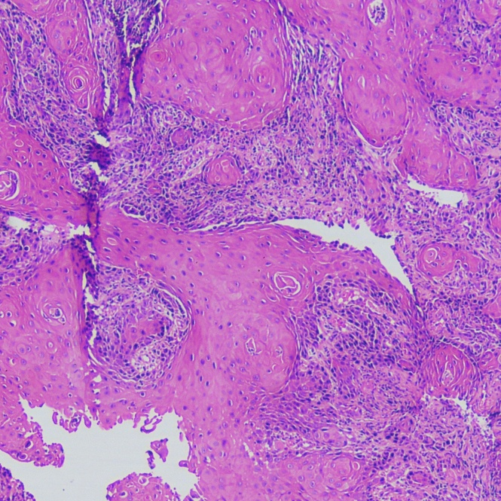
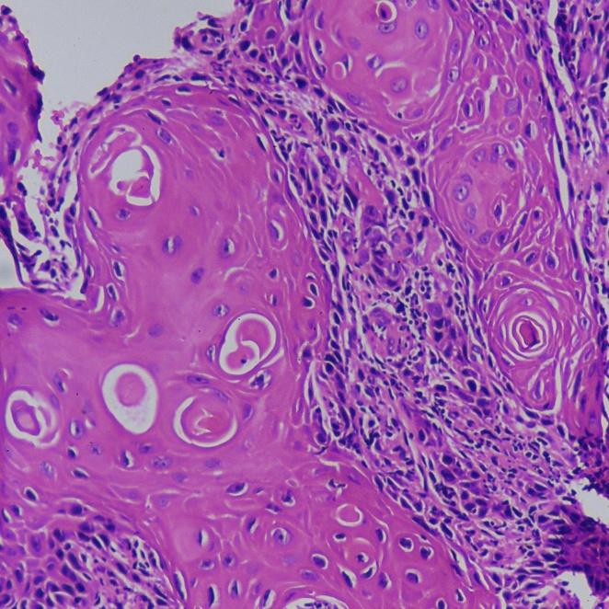
A
B

(A) 4× (low power): Section shows infiltrating nests and sheets of malignant squamous epithelial cells arranged in lobules within the stroma, with prominent keratinization and formation of keratin pearls (arrow), consistent with a well-differentiated squamous cell carcinoma.
(B) 10× (intermediate power): Higher magnification demonstrates tumour nests composed of polygonal cells with abundant eosinophilic cytoplasm, intercellular bridges, nuclear pleomorphism, and prominent keratin pearl formation, confirming well-differentiated squamous cell carcinoma.

The patient underwent left bite composite resection with segmental mandibulectomy and ipsilateral selective neck dissection (levels I–IV), followed by reconstruction using a bipaddled pectoralis major myocutaneous (PMMC) flap under general anaesthesia. Intraoperatively, the primary tumour was resected with a gross margin of approximately 1 cm. The composite resection specimen included the involved segment of mandible, buccal mucosa, retromolar trigone, and adjacent soft tissues. The resultant defect measured approximately 12 × 7 cm. Neck dissection included nodal levels IA, IB, II, III, and IV. Critical neurovascular structures, including the marginal mandibular, lingual, and hypoglossal nerves, were identified and preserved. Reconstruction was performed using a well-vascularized PMMC flap harvested from the left anterior chest wall, with satisfactory intraoperative perfusion and tension-free inset.
Histopathology revealed moderately differentiated keratinizing squamous cell carcinoma with perineural invasion and nodal metastases, staged as pT2N2b. Given the presence of adverse pathological features and nodal metastases, the patient was initiated on adjuvant concurrent chemoradiotherapy. During the course of treatment, after completion of 26 fractions of radiotherapy and four cycles of weekly cisplatin, the patient developed severe pain localized to the left anterior chest wall at the PMMC flap donor site (Figure 2). Fine-needle aspiration cytology (FNAC) findings from the chest wall lesion were consistent with metastatic squamous cell carcinoma (Figure 3).

Figure 2: Clinical photograph of the donor site lesion.
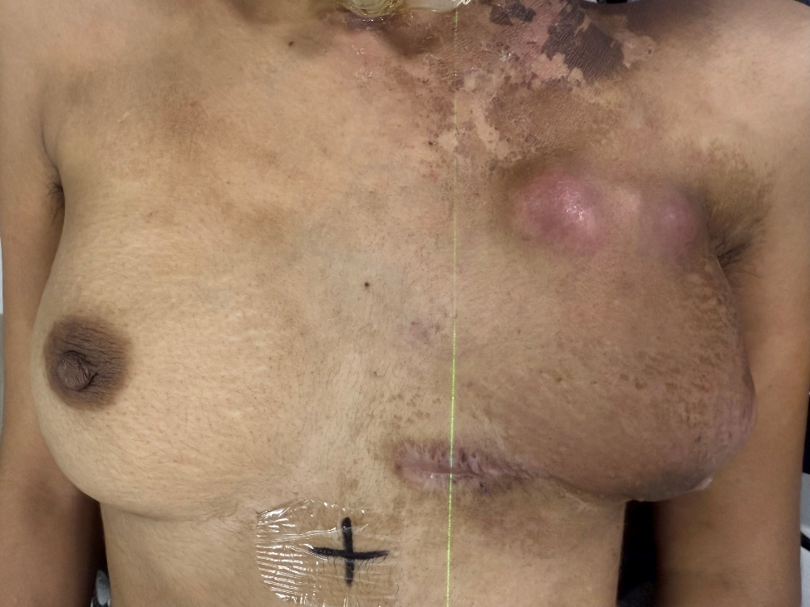

A swelling is seen over the left anterior chest wall at the PMMC donor site (arrow) with overlying erythematous, indurated skin that was non-pinchable. The lesion was tender and clinically suspicious for metastatic involvement.

Figure 3: Cytology of chest wall lesion (FNAC).
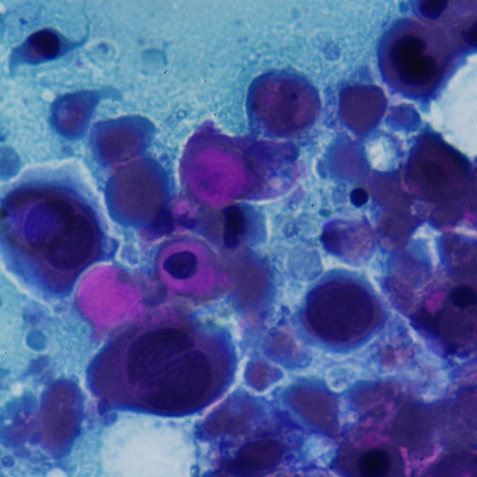
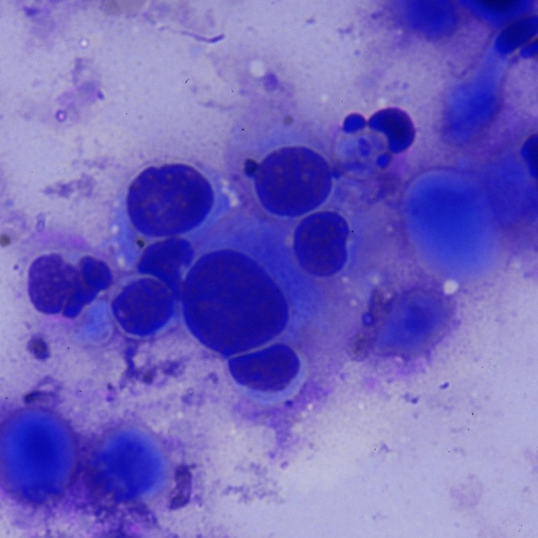
A
B

(A) Giemsa stain (40×): Smears show high cellularity with malignant epithelial cells arranged in sheets, clusters, and singly scattered forms. (B) Papanicolaou stain (40×): Malignant umour cells exhibit marked nuclear pleomorphism, hyperchromatic, occasional prominent nucleoli, and dense cytoplasm, consistent with squamous differentiation.

Due to severe pain, rapid progression, and poor clinical condition during ongoing adjuvant therapy, tissue biopsy from the chest wall lesion was not feasible. Diagnosis was therefore established based on clinicoradiological correlation and FNAC findings in the appropriate clinical context. The adjuvant treatment was interrupted, and the patient was planned for palliative radiotherapy to the chest wall metastasis. CT simulation revealed a dominant 6 × 3 × 2 cm lesion at the donor site along with multiple smaller satellite nodules involving the skin and subcutaneous tissue, with radiological evidence of infiltration into underlying pectoral musculature and adjacent rib involvement, without pleural breach (Figure 4).

Figure 4: CT simulation and planning palliative radiotherapy to chest wall lesion.
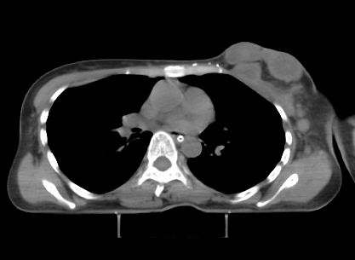
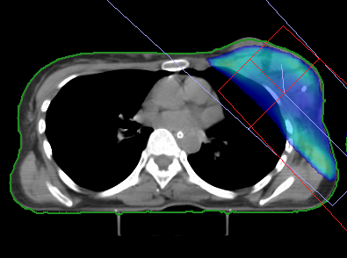
A
B

(A) Axial CT image demonstrates a dominant soft tissue lesion at the PMMC donor site over the left anterior chest wall, with multiple smaller satellite nodules involving the overlying skin and subcutaneous tissue. (B) Representative 3DCRT for the chest wall lesion, with delineation of the target volume and conformal dose distribution using 6 MV photon beams.
The patient received palliative external beam radiotherapy to the chest wall to a dose of 20 Gy in 5 fractions using three-dimensional conformal radiotherapy (3DCRT) and reported significant subjective relief in pain following completion of radiotherapy. In view of oligometastatic but aggressive disease biology with treatment interruption, she was planned for palliative chemotherapy with a platinum-based doublet regimen.

DISCUSSION
Donor site metastasis in oral cavity carcinoma represents a significant shift from traditional oncologic trends, where recurrence usually remains limited to the primary site, regional lymphatics, or distant visceral organs [1]. The appearance of metastasis at a surgically established donor site reflects a complex interaction between tumour biology, surgical methods, and wound microenvironment.
Circulating tumour cells are frequently detected during surgical manipulation, and their implantation requires a permissive microenvironment. Surgical trauma induces inflammatory mediators, angiogenesis, and endothelial disruption that transiently render the donor site susceptible to tumour cell adhesion and proliferation [10].
The most convincing explanation is the direct introduction of tumour cells during surgical procedures. Contamination of surgical tools, gloves, or the operative environment has been implicated [8,9]. Reports of implantation metastasis in free flap donor sites and needle tracts further support this mechanism [9]. In PMMC reconstruction, tumour removal and flap collection occur within the same operative field, increasing the potential for cross-contamination if oncological and reconstructive phases are not separated [11].
Nevertheless, implantation metastasis cannot be established with absolute certainty in the present case. An alternative mechanism involves hematogenous seeding of circulating tumour cells to a surgically traumatized donor site. Surgical intervention may elevate circulating tumour cells, while the inflammatory environment promotes adhesion and invasion [10]. Lymphatic spread along vascular pedicles has also been suggested, though this appears less consistent [6].
While previous reports describe donor site metastasis occurring months after surgery, this case is notable for development during adjuvant chemoradiotherapy. This pattern suggests intraoperative tumour implantation with rapid proliferation during treatment. The painful, indurated chest wall lesion with multiple satellite deposits and rib infiltration highlights the aggressive nature of the implanted tumour.
Importantly, this progression occurred during adjuvant therapy, necessitating a shift from curative to palliative intent. The donor site, often considered a separate anatomical region, must be regarded as a potential field of spread when reconstruction accompanies tumour resection. Symptoms at the donor site during radiotherapy should not be dismissed as inflammatory or postoperative changes and require prompt evaluation. In this case, timely FNAC allowed rapid diagnosis.
The rapid progression during concurrent chemoradiotherapy suggests aggressive tumour biology and possible resistance to conventional treatment. The interruption of adjuvant therapy and shift to palliative radiotherapy highlights that such patterns may not be amenable to curative intent. This raises questions regarding routine donor site evaluation and whether selected high-risk cases may benefit from inclusion of donor sites in radiation fields, although evidence remains limited [11].
This experience emphasizes strict adherence to oncologic principles during reconstruction. There must be clear separation between tumour removal and reconstruction phases. Changing gloves, and surgical instruments before flap harvest and inset, re-draping when feasible, copious wound irrigation, minimizing tumour manipulation, and avoiding direct contact between tumour specimens and reconstructive tissues are essential to prevent tumour implantation [11]. Although routinely recommended, these measures may be underestimated in practice, leading to rare but significant events. Such precautions may reduce the likelihood of inadvertent tumour implantation, particularly in advanced oral cavity malignancies with high tumour burden.
The literature on donor site metastasis remains scarce, with isolated reports in PMMC and free flap donor sites [6,7,9-11,14-18]. These cases demonstrate an uncommon but consistent phenomenon, with implantation seeding as the dominant mechanism. Reports of progression during adjuvant therapy remain limited, making this case particularly informative.
This report has certain limitations. Histopathological confirmation of the donor site lesion could not be obtained, and diagnosis relied on FNAC with clinical and radiological correlation. Although implantation metastasis appears likely, alternative mechanisms such as hematogenous dissemination cannot be excluded. As a single case report, broader conclusions regarding pathophysiology and preventive strategies remain limited.

CONCLUSION
Metastasis at the donor site in oral cavity carcinoma, while uncommon, is a clinically significant and potentially preventable occurrence. This case demonstrates that the donor site is not immune to metastasis, particularly when reconstruction is performed simultaneously with tumour removal. Early development during adjuvant therapy raises the possibility of intraoperative tumour implantation and highlights the aggressive biological behaviour associated with such atypical patterns of spread. Vigilant postoperative surveillance and strict adherence to oncologic surgical principles are essential to minimize this risk and ensure timely diagnosis and management of such atypical disease spread.
Ethical Approval:

As per international standards or university standards written ethical approval has been collected and preserved by the author(s).

Consent
Written informed consent was obtained from the patient for this case report and accompanying images.
Conflicts of Interest: All authors have completed the ICMJE uniform disclosure form. The authors have no conflicts of interest to declare.

Disclaimer (Artificial intelligence)

Author(s) hereby declare that NO generative AI technologies such as Large Language Models (ChatGPT, COPILOT, etc.) and text-to-image generators have been used during the writing or editing of this manuscript.

REFERENCES
- Biswas N, Dutta B, Deb AR. Metastatic implantation of oral cancer in forearm: An unusual presentation. Indian J Case Rep. 2020;6(8):445–447. doi:10.32677/IJCR.2020.v06.i08.009
- Tripathi M, Parshad S, Karwasra RK, et al. Pectoralis major myocutaneous flap in head and neck reconstruction: An experience in 100 consecutive cases. Natl J Maxillofac Surg. 2015 Jan-Jun;6(1):37-41. doi: 10.4103/0975-5950.168225.
- Chaturvedi G, Kushwaha AK, Jha R, et al. Evaluating Pedicled Pectoralis Major Myocutaneous Flap Reconstructions for Oral Malignancy and the Influence of Laterally Based Rotational Advancement Flap on Donor Site Integrity and Nipple Position in Male Patients. Cureus. 2024 Apr 11;16(4):e58022. doi: 10.7759/cureus.58022.
- Ariyan S. The pectoralis major myocutaneous flap. A versatile flap for reconstruction in the head and neck. Plast Reconstr Surg. 1979 Jan;63(1):73-81. doi: 10.1097/00006534-197901000-00012.
- Ossoff RH, Wurster CF, Berktold RE, et al. Complications after pectoralis major myocutaneous flap reconstruction of head and neck defects. Arch Otolaryngol. 1983 Dec;109(12):812-4. doi: 10.1001/archotol.1983.00800260034008.
- Chandrapattan P, Panda SK, Sahoo PK, et al. Isolated donor site tumour recurrence at pectoralis major myocutaneous flap in oral cavity squamous cell carcinoma: a rare case report and review of literature. Res Sq [Preprint]. 2021 Sep 13. doi:10.21203/rs.3.rs-871686/v1
- Reddy CV, Vijayakumar M, Sabitha KS, et al. Pectoralis major myocutaneous (PMMC) flap donor site recurrence in a case of buccal mucosal cancer: a case report. Int J Health Sci Res. 2013;3:55–57.
- Gerster AG. II. On the Surgical Dissemination of Cancer. Ann Surg. 1885 Aug;2(8):98-109. doi: 10.1097/00000658-188507000-00009.
- Lack HL. Contribution to operative treatment of malignant disease of larynx with special reference to danger of cancerous wound infection. Lancet. 1896;1:1638–41.
- Badellino F, Berrino P, Campora E, et al. Metastatic spread of floor of the mouth squamous cell carcinoma via pectoralis major myocutaneous flap. J Surg Oncol. 1988 May;38(1):45-7. doi: 10.1002/jso.2930380112.
- Jog M, Mackenzie K, Dempster J. Tumour recurrence at the donor site of the pectoralis major myocutaneous flap with a tumour-free index site. Internet J Otorhinolaryngol. 2004;3(2).
- Litsou E, Goussia A, Ragos V, et al. Multiple head and neck cancers: molecular and immunologic underpinnings. J BUON. 2025;28:1-6. doi:10.5530/jbuon.20250036.
- Litsou E, Goussia A, Ragos V, et al. Clinical and treatment approach of multiple head and neck cancers. Maedica (Bucur). 2025;20(3):583-592. doi:10.26574/maedica.2025.20.3.583.
- Kroll SS, Tavollali M, Castello-Sendra J, et al. Risk of dissemination of cancer to flap donor sites during immediate reconstructive surgery. Ann Plast Surg. 1994 Dec;33(6):573-5. doi: 10.1097/00000637-199412000-00001.
- Robbins KT, Woodson GE. Chest wall metastasis as a complication of myocutaneous flap reconstruction. J Otolaryngol. 1984 Feb;13(1):13-4.
- Ellison DE, Hoover LA, Ward PH. Tumor recurrence within myocutaneous flaps. Ann Otol Rhinol Laryngol. 1987 Jan-Feb;96(1 Pt 1):26-8. doi: 10.1177/000348948709600106.
- Sacco AG, Cohen EE. Current Treatment Options for Recurrent or Metastatic Head and Neck Squamous Cell Carcinoma. J Clin Oncol. 2015 Oct 10;33(29):3305-13. doi: 10.1200/JCO.2015.62.0963.
- Brockstein B, Haraf DJ, Rademaker AW, et al. Patterns of failure, prognostic factors and survival in locoregionally advanced head and neck cancer treated with concomitant chemoradiotherapy: a 9-year, 337-patient, multi-institutional experience. Ann Oncol. 2004 Aug;15(8):1179-86. doi: 10.1093/annonc/mdh308.

