Case report

Psoas Muscle Schwannoma Mimicking Abdominal Pathology with Lumbar Plexus Involvement

.
ABSTRACT

Background: Schwannomas are benign nerve sheath tumours that rarely occur in the retroperitoneum, with involvement of the psoas muscle being particularly uncommon. Due to their deep location and nonspecific presentation, they often mimic more common pathologies, leading to diagnostic uncertainty.

Case Presentation: A 47-year-old male presented with dull aching pain in the left lower abdomen and flank for four months, radiating to the lateral thigh and associated with mild numbness. Clinical examination revealed a vague, non-tender mass in the left lumbar region with features suggestive of psoas irritation. Imaging studies demonstrated a well-defined cystic lesion within the left psoas muscle measuring around 9 × 7 cm, provisionally diagnosed as a hydatid cyst. The patient underwent open surgical excision via a lateral approach. Intraoperatively, a well-encapsulated intramuscular cystic lesion was identified and completely excised. Histopathological examination revealed spindle cells with strong S-100 positivity, confirming the diagnosis of schwannoma. Postoperatively, the patient developed transient thigh weakness and numbness, which resolved with physiotherapy. At three-month follow-up, the patient remained asymptomatic with no recurrence.

Conclusion: Psoas schwannoma is a rare differential diagnosis for chronic abdominal pain and retroperitoneal cystic lesions. Imaging may be inconclusive, and definitive diagnosis requires histopathological confirmation. Complete surgical excision is curative, and the lateral approach provides effective access with minimal morbidity in selected cases. Early recognition and appropriate surgical management result in excellent outcomes. Clinicians should maintain a high index of suspicion for nerve sheath tumors in atypical cystic retroperitoneal lesions to avoid misdiagnosis and guide appropriate management.

Keywords: [Psoas schwannoma, retroperitoneal tumor, abdominal pain, lateral approach, nerve sheath tumor]

1. INTRODUCTION

Schwannomas are benign, slow-growing neoplasms arising from Schwann cells of the peripheral nerve sheath (Makhoul E., 2017). They typically occur as solitary lesions but may rarely be associated with syndromic conditions such as neurofibromatosis. Histologically, schwannomas are well-encapsulated tumors characterized by alternating hypercellular Antoni A areas and hypocellular Antoni B areas, with nuclear palisading and Verocay body formation. Immunohistochemically, they demonstrate strong and diffuse positivity for S-100 protein, reflecting their neural crest origin. These features are critical for definitive diagnosis and differentiation from other spindle cell tumors.
Schwannomas most commonly arise in the head and neck region and along the flexor surfaces of the extremities. Retroperitoneal schwannomas are rare, accounting for approximately 0.7–3% of all schwannomas, and involvement of the psoas muscle represents an exceptionally uncommon subset. Due to the capacious nature of the retroperitoneal space, these tumors can attain significant size before becoming clinically apparent. Consequently, patients often present with vague, poorly localized abdominal or flank pain. In cases where the tumor lies in close proximity to the lumbar plexus, symptoms may include radicular pain radiating to the thigh and associated sensory disturbances, further complicating the clinical picture.
Radiological evaluation plays an important role in detecting and localizing retroperitoneal masses; however, imaging findings are often nonspecific. On ultrasonography and cross-sectional imaging, schwannomas may appear as well-defined cystic or heterogeneous lesions, frequently mimicking more common entities such as psoas abscesses, hematomas, or hydatid cysts. Degenerative changes, including cystic transformation, hemorrhage, and calcification, may further obscure the diagnosis. As a result, preoperative identification of schwannoma remains challenging, and definitive diagnosis is typically established only after surgical excision and histopathological examination.
A review of the limited literature reveals only a small number of reported cases of schwannomas arising within the psoas muscle, underscoring the rarity of this entity (D’Silva, 2003; Latino R., 2017). We present the case of a 47-year-old male with chronic abdominal and flank pain radiating to the thigh, ultimately diagnosed as a psoas schwannoma. This case highlights the diagnostic challenges posed by atypical retroperitoneal lesions and emphasizes the importance of maintaining a broad differential diagnosis. It also reinforces the dual role of surgical excision as both a definitive therapeutic and diagnostic modality.

2. Case presentation

A 47-year-old male with no significant comorbidities or prior surgical history presented with dull aching pain in the left lower abdomen and flank for four months. The pain was insidious in onset, radiated to the lateral aspect of the thigh, and was not associated with any aggravating or relieving factors. The patient also reported mild numbness over the thigh but denied fever, weight loss, or gastrointestinal symptoms.
On clinical examination, a vague, non-tender mass was palpable in the left lumbar region with associated lumbar fullness. Pain intensity mildly increased on hip extension, suggestive of psoas irritation. Neurological examination was largely unremarkable except for subjective numbness in the thigh.
Based on clinical findings, differential diagnoses included hydatid cyst, psoas abscess, retroperitoneal soft tissue tumor, hydronephrosis, renal cell carcinoma, and lymphoma/sarcoma.
Laboratory investigations, including complete blood count and inflammatory markers, were within normal limits. Ultrasonography revealed a cystic lesion with septations in the left psoas muscle measuring approximately 9 × 7 cm. Contrast-enhanced computed tomography and magnetic resonance imaging confirmed a well-defined cystic lesion within the psoas muscle without involvement of adjacent structures (Beaman, F. D., 2004) (Goh, B. K., 2006).
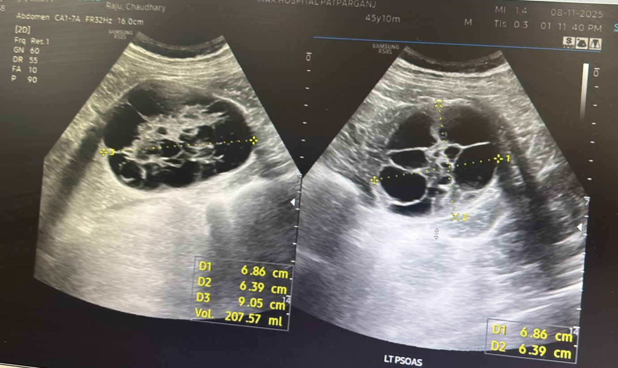
Fig. 1, Ultrasonography image of left psoas muscle showing cystic lesion with internal septations and echogenic sludge like material

A provisional diagnosis of hydatid cyst was made based on imaging characteristics.
The patient underwent open surgical excision via a left lateral approach. Intraoperatively, a well-encapsulated cystic lesion was identified within the psoas muscle. The lesion was intramuscular, with no involvement of the ureter or major vessels. No daughter cysts or typical hydatid features were observed. Complete excision of the lesion was performed without spillage, and the operative field was irrigated with 3% normal saline as a precaution.
Gross examination revealed a globular soft tissue specimen measuring 9.5 × 7 × 5 cm. Cut section showed a multilocular cyst filled with grey-brown mucoid material. An additional smaller cystic lesion measuring 0.5 × 3 cm was also identified.
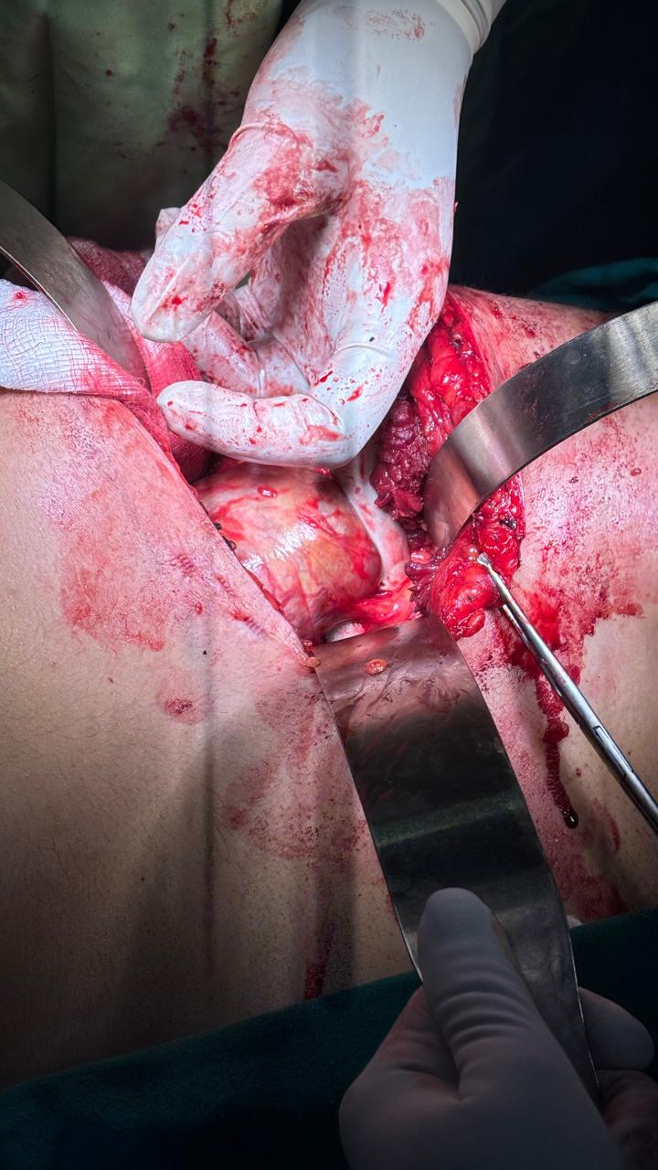
Fig. 2, Lateral incision in left flank region.

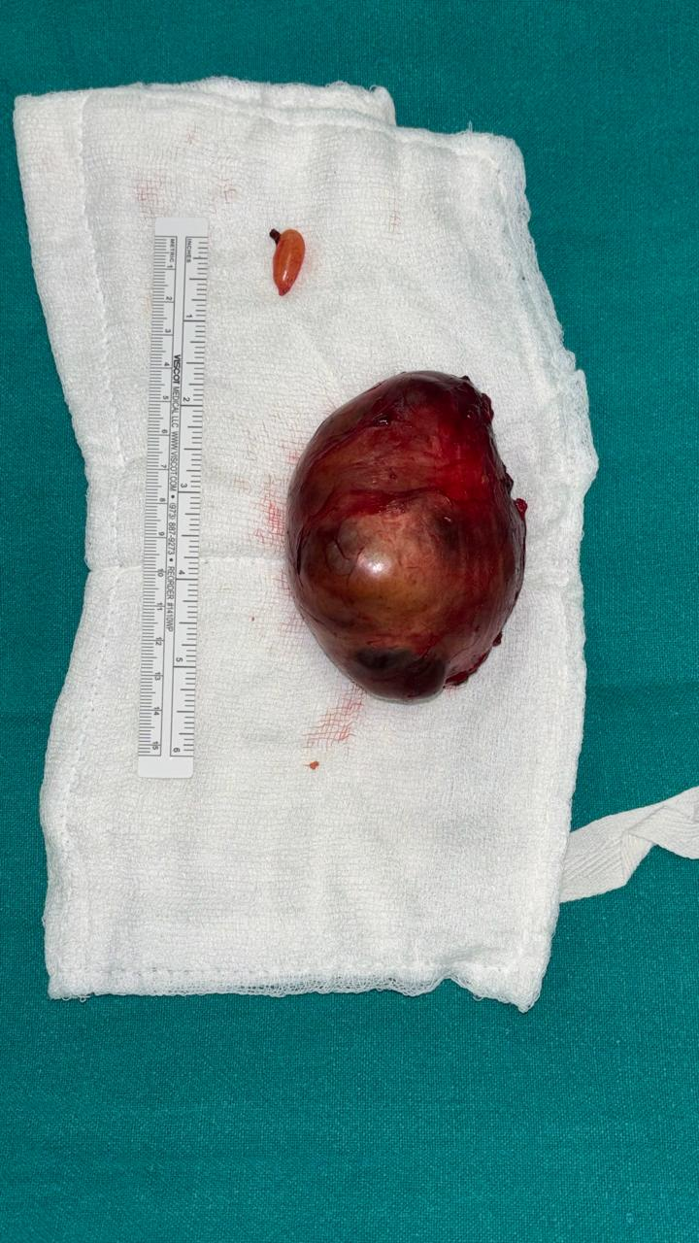
Fig. 3, Excised cystic lesion from psoas with smaller cystic lesion by the side from abdominal wall with scale for comparison

Microscopic examination demonstrated cystic structures surrounded by spindle cells arranged haphazardly, with rare mitoses and no evidence of necrosis. Thick-walled blood vessels were noted. Immunohistochemistry showed strong S-100 positivity, while markers including cytokeratin (CK), smooth muscle actin (SMA), desmin, CD34, and caldesmon were negative. The Ki-67 proliferation index was approximately 4–5%. These findings confirmed the diagnosis of schwannoma.
Postoperatively, the patient developed transient weakness of the left thigh lasting for two days, followed by numbness that gradually improved over two months with physiotherapy. At three-month follow-up, the patient was asymptomatic with no evidence of recurrence (Liang, J., 2025).

3. discussion

A review of the literature reveals that schwannomas arising from the psoas muscle are exceedingly rare, with approximately 10 cases reported in the English literature since 1987. These cases demonstrate considerable variability in clinical presentation, ranging from asymptomatic masses to chronic abdominal or flank pain, occasionally associated with radicular symptoms due to lumbar plexus involvement. Preoperative diagnosis remains challenging in most reports, with frequent misinterpretation as cystic or infective lesions. Surgical excision was the treatment of choice in all cases, with generally favorable outcomes and low recurrence following complete resection.
3.1 Literature Review
Table 1. Review of 5 cases comparing demographic data, presentation, size, imaging findings, preoperative diagnosis, surgical approach and outcome

Author & Year | Age/Sex | Presentation | Tumor Size | Imaging Diagnosis | Surgical Approach | Outcome
D’Silva et al., 2003 | 56/F | Back pain and abdominal pain which was worse on left side | 7.5 x 6 x 5cm | Retroperitoneal tumor - Schwannoma | Combined surgical approach – Neurosurgeon performed laminectomy and Abdominal Surgeon performed resection via anterior approach | Left lower extremity monoparesis as expected and was able to walk with a walker.
Latino et al., 2017 | 42/F | incidental | 113 x 93 x 87 mm | rounded mass of 89 x 78 x 110 mm with regular margins that displaces all surrounding parenchymatous structures. | Not specified | Uneventful recovery
Benjamin et al., 2016 | 38/M | lumbar pain radiating to the toes bilaterally and progressive motor weakness in his feet. | 1-cm enhancing nodule of the left L4 nerve root distal to the dorsal root ganglion. | central disk herniation and stenosis at the L4–L5 level and a 1-cm enhancing nodule of the left L4 nerve root distal to the dorsal root ganglion. | Minimally invasive | No recurrence
Goh, B. K et al., 2017 | 25/F | lower abdominal pain for 1 year and progressively increasing lower abdominal mass for the last 3 month | 10.1 x 7.9 x 9.5 cm | broad ligament fibroid or neurogenic tumour. | Open anterior | Good recovery
Makhoul et al., 2017 | 86/M | Chronic abdominal pain | 5.5 x 4 x 3.5 cm | multi-partitioned, circumscribed, heterogeneous, cystic mass measuring 5 cm on the right psoas muscle repressing the ureter. Hydatic cyst could not be ruled out and echinococcosis serology was negative | Laparoscopic approach | No complications

Schwannomas arising within the psoas muscle are rare entities, and their clinical behavior often makes them diagnostically elusive. Unlike more common intra-abdominal pathologies, these tumors tend to grow silently within the capacious retroperitoneal space, only becoming symptomatic when they reach a size sufficient to cause mass effect. As seen in this case, patients frequently present with vague, poorly localized abdominal or flank pain, which can delay diagnosis and lead to initial misattribution to more common gastrointestinal or musculoskeletal conditions. Similar presentations have been described in previously reported cases of psoas schwannoma, where patients commonly report vague abdominal or flank pain, often leading to delayed diagnosis due to the absence of specific clinical signs (D’Silva, 2003; Latino R., 2017). This underscores the importance of maintaining a broad differential when evaluating persistent, unexplained abdominal pain.
From a diagnostic standpoint, imaging provides valuable anatomical detail but lacks specificity. While CT and MRI can delineate a well-circumscribed retroperitoneal mass and suggest neural origin through features such as encapsulation and cystic degeneration, they rarely establish a definitive diagnosis. Several authors have reported frequent preoperative misdiagnosis of these lesions as psoas abscesses, hydatid cysts, or other cystic retroperitoneal masses due to overlapping imaging characteristics (Ramos-Fresnedo A., 2022). Consequently, histopathological evaluation remains essential. The identification of Antoni A and Antoni B areas, along with strong S-100 positivity, confirms the diagnosis and distinguishes schwannomas from other retroperitoneal neoplasms. These histopathological features are consistently described across reported cases and remain the gold standard for definitive diagnosis.
Surgical excision remains the cornerstone of management, with the primary goal being complete resection while preserving adjacent neurovascular structures. Given the deep-seated location of psoas schwannomas, multiple surgical approaches have been described, each with its own technical considerations and advantages. Reported cases in the literature demonstrate variability in surgical approach selection, largely influenced by tumor size, location, and relation to adjacent neurovascular structures.
The open anterior (transperitoneal) approach provides a wide operative field and familiar anatomical landmarks, making it particularly useful for large tumors or when malignancy cannot be excluded. It allows excellent exposure of major vascular structures; however, it involves bowel handling, increased risk of postoperative ileus, and longer recovery times.
The posterior (retroperitoneal) approach avoids entering the peritoneal cavity, thereby reducing intra-abdominal complications and facilitating direct access to the psoas muscle. However, the working space is limited, visualization can be suboptimal, and there is a higher risk of inadequate exposure for larger lesions.
Minimally invasive techniques, including laparoscopic and robotic approaches, have gained popularity due to reduced postoperative pain, shorter hospital stay, and faster recovery. These approaches offer enhanced visualization, particularly with robotic platforms, but require advanced expertise and may be technically demanding in cases where the tumor is closely related to major vessels or nerves.
The lateral (transpsoas or direct lateral) approach offers a distinct anatomical advantage in selected cases. By accessing the tumor through a muscle-splitting approach along the flank, it provides a more direct route to the psoas without traversing the peritoneal cavity. This minimizes visceral manipulation and reduces the risk of postoperative ileus. Importantly, the lateral approach allows better alignment with the longitudinal axis of the psoas muscle, facilitating controlled dissection along tissue planes and potentially improving nerve preservation. It also provides a relatively bloodless field and shorter operative time in appropriately selected patients. While anterior and minimally invasive approaches are more commonly described, selected reports have highlighted the lateral approach as a safe and effective alternative for intrapsoas lesions, offering direct access with reduced visceral morbidity. For tumors confined within the psoas and not encasing major vessels, this approach can therefore be more efficient and less morbid compared to traditional anterior routes. (Benjamin, C. G., 2016) (Ramos-Fresnedo, A., 2022).
In the present case, the postoperative transient neurological deficit likely reflects manipulation of adjacent lumbar plexus elements, a known and generally self-limiting complication. Similar transient neurological deficits have been reported in the literature and are typically attributed to manipulation or stretching of adjacent nerve fibers rather than direct injury. The gradual recovery observed with physiotherapy aligns with the benign and non-infiltrative nature of schwannomas, where nerve fibers are typically displaced rather than invaded (Ahmadian, A., 2013).
Overall, this case emphasizes that although rare, psoas schwannoma should be considered in the differential diagnosis of atypical abdominal pain. Equally important is the thoughtful selection of surgical approach, tailored to tumor characteristics and anatomical considerations. Among the available options, the lateral approach offers a compelling balance of direct access, reduced morbidity, and favorable functional outcomes in carefully chosen patients
4. Conclusion

Psoas muscle schwannoma is a rare and often under-recognized cause of chronic abdominal or flank pain, frequently mimicking more common retroperitoneal pathologies such as hydatid cyst or psoas abscess. Published literature suggests that retroperitoneal schwannomas account for approximately 0.7–3% of all schwannomas, with intrapsoas location representing only a small fraction of these cases, contributing to frequent preoperative diagnostic uncertainty.
Definitive diagnosis relies on histopathological and immunohistochemical confirmation, with S-100 positivity reported consistently across nearly all cases, reinforcing its role as a diagnostic hallmark. Complete surgical excision remains the treatment of choice, with reported outcomes demonstrating low recurrence rates following complete resection and an overall excellent prognosis.
The lateral approach, in appropriately selected patients, offers a safe and effective route for tumor excision, providing direct access to the psoas muscle while minimizing intra-abdominal morbidity. Although transient neurological deficits may occur due to proximity to the lumbar plexus, published series indicate that these deficits are typically temporary and resolve with conservative management, as observed in our case (Li Q., 2007).
Overall, this case underscores the need for a high index of suspicion for rare retroperitoneal tumors in patients with atypical, persistent abdominal pain. It also highlights the importance of correlating clinical, radiological, and pathological findings, and supports individualized surgical planning, which is consistently associated with favorable functional outcomes and minimal morbidity in reported cases.
5. limitations

This case report has several limitations. As a single-patient observation, the findings are inherently limited in generalizability and may not be representative of all cases of retroperitoneal or psoas schwannomas. Preoperative serological testing for hydatid disease was not performed despite the provisional radiological diagnosis, which may be considered a diagnostic limitation. Although the imaging findings have been described in detail, radiological images could not be included due to technical constraints, potentially limiting visual interpretation and external validation. Additionally, the follow-up period was limited to three months; while the patient demonstrated complete clinical recovery with no evidence of recurrence during this period, longer follow-up would be necessary to assess long-term outcomes and recurrence risk more definitively.
.
COMPETING INTERESTS
Authors have declared that no competing interests exist.

CONSENT
All authors declare that ‘written informed consent was obtained from the patient (or other approved parties) for publication of this case report and accompanying images. A copy of the written consent is available for review by the editorial office/chief editor/editorial board members of this journal.

ETHICAL APPROVAL
It is not applicable.

Disclaimer (Artificial intelligence)

Author(s) hereby declare that NO generative AI technologies such as Large Language Models (ChatGPT, COPILOT, etc.) and text-to-image generators have been used during the writing or editing of this manuscript.

References

Makhoul, E., Abi Saad, G., Sader-Ghorra, C., & Haddad, M. C. (2017). Schwannoma of the psoas: An unusual cause of abdominal pain. Arab Journal of Gastroenterology, 18(1), 44–46. https://doi.org/10.1016/j.ajg.2017.01.005

D’Silva, K. J., Dwivedi, A. J., & Shetty, P. (2003). Schwannoma of the psoas major presenting with abdominal and back pain. Southern Medical Journal, 96(7), 720–722. https://doi.org/10.1097/01.SMJ.0000066814.11788.5F

Latino, R., Bosco, D., Frattallone, M. E., Amico, A., Lanteri, R., & Di Cataldo, A. (2017). Unusual presentation of retroperitoneal schwannoma: Case report. Giornale di Chirurgia, 38(6), 295–298. https://doi.org/10.11138/gchir/2017.38.6.295

Beaman, F. D., Kransdorf, M. J., & Menke, D. M. (2004). Schwannoma: radiologic-pathologic correlation. Radiographics, 24(5), 1477-1481.

Goh, B. K., Tan, Y. M., Chung, Y. F. A., Chow, P. K., Ooi, L. L., & Wong, W. K. (2006). Retroperitoneal schwannoma. The American Journal of Surgery, 192(1), 14-18.

Liang, J., Wei, Y., & Deng, J. (2025). A 3-year follow-up case report of rare intramuscular schwannoma of psoas major: Insights into progression and management. Medicine, 104(26), e42918. https://doi.org/10.1097/MD.0000000000042918

Benjamin, C. G., Oermann, E. K., Thomas, J. A., Distaso, C. T., & Sandhu, F. A. (2016). Minimally Invasive Direct Lateral Transpsoas Approach for the Resection of a Lumbar Plexus Schwannoma: Technique Report. Surgery journal (New York, N.Y.), 2(3), e66–e69. https://doi.org/10.1055/s-0036-1587692

Ramos-Fresnedo, A., Perez-Vega, C., Ravindran, K., & Fox, W. C. (2022). MIS lateral retroperitoneal transpsoas approach allows gross total resection of a giant L4 schwannoma. Neurosurgical focus: Video, 7(1), V10. https://doi.org/10.3171/2022.3.FOCVID2220

Ahmadian, A., Deukmedjian, A. R., Abel, N., Dakwar, E., & Uribe, J. S. (2013). Analysis of lumbar plexopathies and nerve injury after lateral retroperitoneal transpsoas approach: diagnostic standardization. Journal of neurosurgery. Spine, 18(3), 289–297. https://doi.org/10.3171/2012.11.SPINE12755

Li, Q., Gao, C., Juzi, J. T., & Hao, X. (2007). Analysis of 82 cases of retroperitoneal schwannoma. ANZ journal of surgery, 77(4), 237-240.

