Case report
Unusual Subcutaneous Metastasis of a Malignant Granular Cell Tumor Mimicking Desmoid Fibromatosis: A Case Report

.

ABSTRACT

Background: Malignant granular cell tumor of the larynx is an exceptionally rare Schwann cell neoplasm with high metastatic potential, and metastatic soft-tissue lesions may mimic benign entities such as desmoid-type fibromatosis on imaging, posing a significant diagnostic challenges.
Aims: To report an unusual case of subcutaneous abdominal wall metastasis from a malignant laryngeal granular cell tumor (Abrikossoff tumor) mimicking a desmoid-type fibromatosis on magnetic resonance imaging (MRI), and to highlight the contribution of diffusion-weighted imaging (DWI) and of a multidisciplinary approach in this diagnostic challenge.
Presentation of Case: A 54-year-old woman with a 9 cm laryngeal granular cell tumor, treated by total laryngectomy with focally positive margins (R1 resection) and adjuvant radiotherapy, developed locoregional and pulmonary recurrence approximately 24 months postoperatively, both confirmed as the same histological type. Thirteen months later, a subcutaneous mass of the right anterolateral abdominal wall was detected. Contrast-enhanced computed tomography (CT) showed a well-circumscribed soft-tissue mass with mild post-contrast enhancement and regular contours. MRI demonstrated a lobulated lesion with intermediate T2 signal, marked diffusion restriction with a low apparent diffusion coefficient (ADC) value of 0.9 × 10⁻³ mm²/s, and intense homogeneous post-gadolinium enhancement, initially suggestive of a desmoid-type fibromatosis. Percutaneous biopsy confirmed a granular cell tumor metastasis identical to the laryngeal primary.
Discussion: Subcutaneous metastases from a malignant granular cell tumor may share several morphological MRI features with abdominal wall desmoid-type fibromatosis. In this case, the lesion showed marked diffusion restriction with a low ADC value, a finding not typical of desmoid-type fibromatosis, which usually shows mild to moderate diffusion restriction with intermediate to high ADC values. The laryngeal primary had been initially labeled benign, yet its subsequent metastatic behavior — together with clinicopathological features such as large size and focally positive margins — indicated an underestimated malignant granular cell tumor.
Conclusion: In a patient with a previously treated granular cell tumor, a new soft-tissue mass should raise the suspicion of metastasis. Multiparametric MRI, particularly DWI, combined with a multidisciplinary correlation of clinical, radiological and pathological data, is valuable in differentiating this entity from desmoid-type fibromatosis and in guiding histological confirmation.

Keywords: Granular cell tumor; Abrikossoff tumor; malignant granular cell tumor; subcutaneous metastasis; abdominal wall; desmoid fibromatosis; magnetic resonance imaging; diffusion-weighted imaging.
1. INTRODUCTION
Granular cell tumor (GCT), or Abrikossoff tumor, is an uncommon mesenchymal neoplasm of Schwann cell origin, accounting for approximately 0.5% of all soft tissue tumors (Fanburg-Smith et al., 1998). Approximately half of GCTs occur in the head and neck region; laryngeal localization represents only 6–10% of all GCTs (Scala et al., 2008). The malignant variant accounts for only 1–2% of cases and behaves as a high-grade sarcoma, with a 50% metastasis rate and 39% disease-related mortality at a median of three years (Fanburg-Smith et al., 1998). Histological grading relies on the six Fanburg-Smith criteria — necrosis, spindling, vesicular nuclei with prominent nucleoli, mitotic count >2/10 high-power fields, increased nuclear-to-cytoplasmic ratio, and pleomorphism — with three or more features defining malignancy (Fanburg-Smith et al., 1998). However, true biological malignancy is ultimately defined by metastatic dissemination, irrespective of the initial histological label (Nasser et al., 2011). Recent molecular studies have clarified the genetic basis of these tumors: most GCTs harbor loss-of-function somatic mutations affecting ATP6AP1 or ATP6AP2, two genes governing endosomal acidification, and these alterations are now regarded as the principal oncogenic event, found in roughly seven out of ten cases (Pareja et al., 2018). Importantly, when a malignant GCT and its metastasis are sequenced in parallel, the same mutation is recovered in both, establishing their clonal origin (Dehner et al., 2023).
The radiological diagnosis of soft-tissue metastases from a malignant GCT is challenging, as these lesions can mimic benign or low-grade mesenchymal entities. Desmoid-type fibromatosis is a particularly relevant differential when the lesion is well-circumscribed, involves the abdominal wall, and exhibits intermediate T2 signal with homogeneous enhancement (Braschi-Amirfarzan et al., 2016). This radiological pitfall has been previously documented in primary abdominal wall GCT, both malignant (Yoon et al., 2016) and benign in the postpartum setting (Qiu et al., 2025). To our knowledge, no similar case has been reported when the abdominal wall lesion is itself a metastasis from a laryngeal primary, although a comprehensive systematic review was beyond the scope of this report. We illustrate this scenario through a case where contrast-enhanced multiparametric MRI and a multidisciplinary correlation were essential in reaching the diagnosis.
2. PRESENTATION OF CASE
A 54-year-old woman was followed for a laryngeal granular cell tumor first diagnosed three years earlier, when she had presented with progressive dysphonia. Cervical MRI at that time had shown a locally advanced tumoral process centered on the visceral compartment of the neck, narrowing the laryngotracheal lumen and associated with bilateral jugulocarotid lymphadenopathy. Endoscopic biopsy had confirmed a granular cell tumor, and total laryngectomy had been performed. Histopathological examination of the surgical specimen had described a granular cell (Abrikossoff) tumor measuring 9 cm, reported as showing no malignant transformation, with focally positive posterior and bilateral lateral surgical margins (R1 resection). Given the rarity of the tumor and the positive margins, adjuvant radiotherapy had been delivered.
The patient remained clinically stable until, approximately 24 months postoperatively, she developed dyspnea and a painful peristernal mass. Contrast-enhanced CT then demonstrated locoregional progression at the laryngectomy site — an ill-defined latero-tracheal soft-tissue infiltrate involving the cutaneous plane, the tracheostomy orifice, the thyroid gland and the sterno-cleido-mastoid muscle, measuring up to 77 × 67 mm — together with bilateral centrilobular pulmonary nodules of secondary appearance, the largest measuring 15 mm. A biopsy of the cervico-thoracic mass confirmed the same granular cell histology; the pulmonary nodules were not biopsied because of their infra-centimetric, inaccessible nature. The lesion was deemed unresectable, and palliative systemic chemotherapy was initiated. Follow-up was performed with serial contrast-enhanced CT at approximately yearly intervals.
Thirteen months after the diagnosis of recurrence, a subcutaneous mass of the right anterolateral abdominal wall was identified. On physical examination, a non-tender, non-reducible peri-umbilical subcutaneous swelling was palpable, with a soft abdomen and a preserved general condition. Abdominal ultrasound raised concern for a suspicious soft-tissue lesion, prompting further characterization.
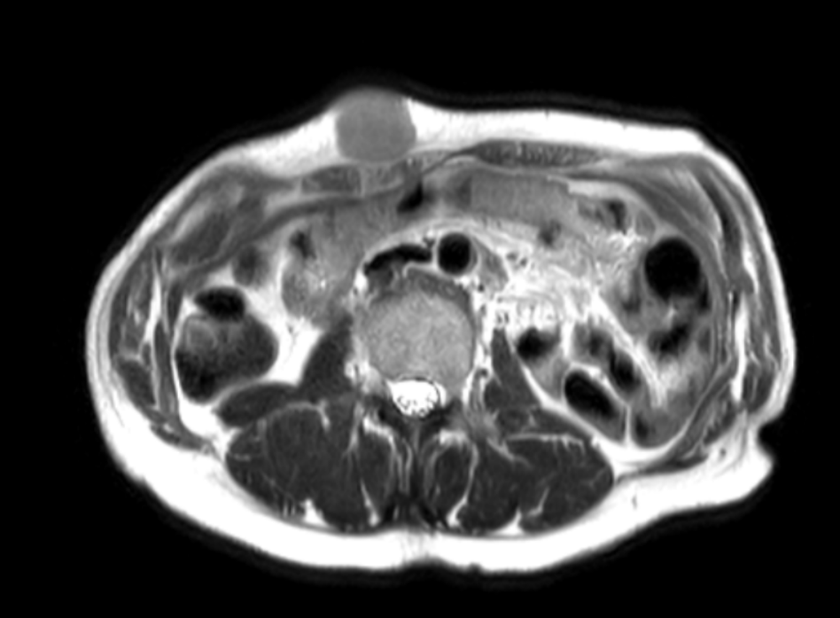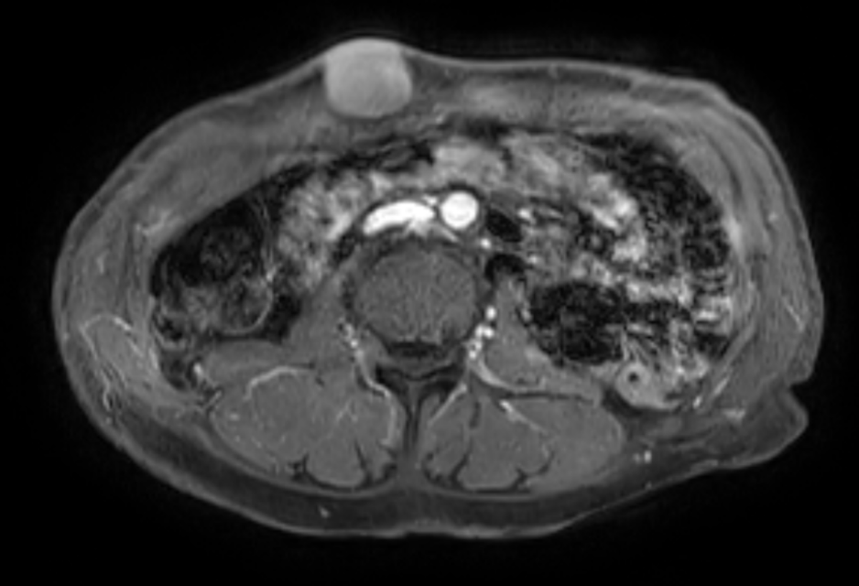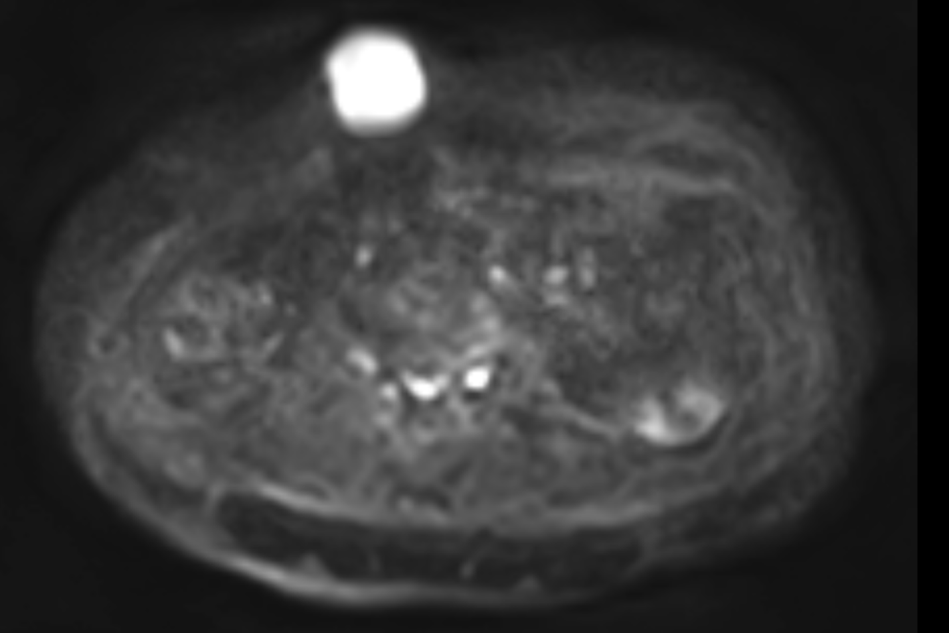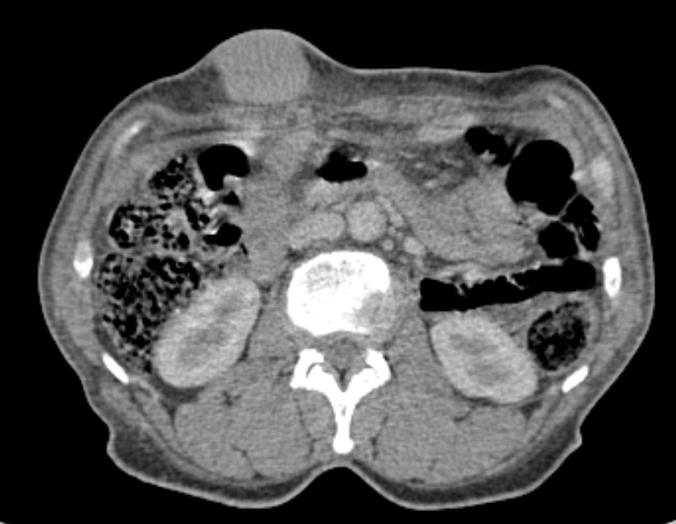Contrast-enhanced CT demonstrated a well-circumscribed, ovoid, superficial soft-tissue mass of the right anterolateral abdominal wall, with mild post-contrast enhancement and regular contours (Fig. 1A). MRI was subsequently performed with axial T1-weighted, T2-weighted, diffusion-weighted, and post-gadolinium T1-weighted Fat-Sat sequences. The lesion was lobulated and located in the supraumbilical region, measuring 33 × 25 mm (transverse × anteroposterior). It showed intermediate T2 signal intensity (Fig. 1B), marked diffusion restriction with a low ADC value of 0.9 × 10⁻³ mm²/s (Fig. 1D), and intense, homogeneous post-gadolinium enhancement (Fig. 1C). A preserved fat plane separated the lesion from the underlying rectus abdominis muscle, with anterior deformation of the cutaneous plane. Based on these morphological features, a desmoid-type fibromatosis was initially considered; however, the marked diffusion restriction was atypical for that diagnosis, and the metastatic clinical context, a subcutaneous metastasis was suspected.
Fig. 1. Subcutaneous abdominal wall metastasis from a malignant laryngeal granular cell tumor.
(A) Contrast-enhanced axial CT shows a well-circumscribed, ovoid soft-tissue mass of the right anterolateral abdominal wall (arrow), with mild and homogeneous post-contrast enhancement. (B) Axial T2-weighted MRI demonstrates intermediate and homogeneous signal intensity of the lesion (arrow), with well-defined margins. (C) Axial post-gadolinium T1-weighted MRI shows intense and homogeneous enhancement of the lesion (arrow). (D) Diffusion-weighted imaging reveals marked diffusion restriction (arrow), reflecting high cellularity.

A
B
C
D

Percutaneous biopsy of the subcutaneous mass revealed morphological features and an immunohistochemical profile consistent with a granular cell tumor, identical to the laryngeal primary, establishing the diagnosis of subcutaneous metastasis. After this diagnosis, the disease was managed with systemic therapy within a palliative, multidisciplinary framework, and follow-up cross-sectional imaging subsequently showed further disease progression.
3. DISCUSSION
This case illustrates a rare clinical scenario: a granular cell tumor arising at an uncommon site (the larynx), exhibiting a rarely reported malignant biological behavior that was not recognized on the initial pathological examination of the primary tumor, and subsequently presenting as an abdominal wall metastasis that was not initially suspected on imaging. It highlights how the clinical, radiological and pathological features of malignant granular cell tumor may each be individually misleading.
Subcutaneous metastases from a malignant GCT may share several morphological features with abdominal wall desmoid-type fibromatosis on MRI — well-defined contours, intermediate T2 signal, and homogeneous post-contrast enhancement (Braschi-Amirfarzan et al., 2016; Iglesias-Hidalgo et al., 2023; Moon et al., 2023). This overlap explains the initial radiological interpretation in our case. A potentially discriminating feature, both in our observation and in published series, is diffusion-weighted imaging (DWI). Granular cell tumors are hypercellular lesions with dense cytoplasmic granular content and characteristically show marked diffusion restriction with low ADC values, reported at 0.624–0.857 × 10⁻³ mm²/s in a published soft-tissue MRI series (Iglesias-Hidalgo et al., 2023) and 0.68–0.81 × 10⁻³ mm²/s in a head-and-neck cohort (Moon et al., 2023). Desmoid-type fibromatosis, predominantly composed of collagenous and fibrous stroma, usually shows mild to moderate diffusion restriction with intermediate to high ADC values (mean ADC ≈ 1.46 × 10⁻³ mm²/s, range 1.00–2.20) (Braschi-Amirfarzan et al., 2016). In our patient, the degree of diffusion restriction was marked and the ADC value was low, both atypical for desmoid-type fibromatosis; the degree of restriction and the ADC value therefore appear to be of particular significance in this differential diagnosis. The potential for a malignant GCT to mimic a desmoid tumor on MRI has been reported previously, including a malignant GCT showing marked fibrosis-related low T1 and T2 signal mimicking a desmoid tumor (Osanai et al., 2004). The main multiparametric MRI features distinguishing these two entities are summarized in Table 1.
Table 1. Main multiparametric imaging features distinguishing subcutaneous granular cell tumor (metastasis) from abdominal wall desmoid-type fibromatosis.
Feature | Granular cell tumor (metastasis) | Desmoid-type fibromatosis
CT density | Soft-tissue density, regular contours | Soft-tissue density, often infiltrative
CT enhancement | Mild, homogeneous | Mild to moderate, often heterogeneous
T1 signal | Iso- to hypointense vs muscle | Iso- to hypointense vs muscle
T2 signal | Intermediate, often homogeneous | Intermediate; hypointense fibrous bands (“band sign”)
Margins | Well-circumscribed, lobulated | Infiltrative, ill-defined; “fascial tail sign”
Enhancement (MRI) | Intense, homogeneous | Substantial, often late-phase
DWI / ADC value | Marked diffusion restriction; low ADC (≈0.6–0.9 × 10⁻³ mm²/s) | Mild to moderate restriction; intermediate to high ADC (mean ≈1.46 × 10⁻³ mm²/s)
Clinical context | Known primary malignancy; multi-site disease | Sporadic; FAP-associated; postpartum or post-surgical scar
ADC : apparent diffusion coefficient; CT: computed tomography; DWI: diffusion-weighted imaging; FAP: familial adenomatous polyposis.
The differential diagnosis of a diffusion-restricting soft-tissue mass of the abdominal wall is nonetheless broader and also includes soft-tissue sarcomas (such as undifferentiated pleomorphic sarcoma and malignant peripheral nerve sheath tumor), dermatofibrosarcoma protuberans — which accounts for approximately 20% of abdominal wall sarcomas — metastatic deposits from other primary malignancies, and, less frequently, lymphoma (Li et al., 2019). Cutaneous and subcutaneous sarcomas, although rare, share a non-specific clinical presentation and likewise require histopathological and immunohistochemical confirmation (Kumari et al., 2023; Meftah et al., 2025). Including these hypercellular entities in the differential reinforces the principle that marked diffusion restriction indicates a hypercellular process that warrants histological confirmation rather than a specific diagnosis.
It should also be emphasized that, although DWI may help, no imaging feature reliably distinguishes a benign from a malignant granular cell tumor; the radiological appearances overlap substantially and the distinction remains histological (Gu et al., 2025). Features such as large size, rapid growth, infiltrative margins, signal heterogeneity and, above all, the presence of metastases may suggest malignancy but are not specific. On 18F-FDG PET/CT, malignant GCT is metabolically active and PET may contribute to the detection and staging of metastatic disease; however, benign GCT may also show marked FDG avidity, so that metabolic activity alone does not reliably distinguish benign from malignant GCT (Treglia et al., 2013).
Previous reports have addressed similar pitfalls in primary abdominal wall GCT. Yoon et al. (2016) described a malignant primary abdominal wall GCT initially mistaken for a desmoid tumor on CT, and Qiu et al. (2025) reported a benign abdominal wall GCT mimicking a postpartum desmoid tumor on multiparametric MRI. The present case differs from these published observations in that the abdominal wall lesion was not a primary tumor but a metastasis from a laryngeal granular cell tumor, a combination not previously documented in the English literature.
In our patient, the primary laryngeal tumor had been reported as a granular cell tumor showing no malignant transformation. The detailed microscopic description and the specific features that led to this benign interpretation were not available for retrospective review (see Limitations). The subsequent clinical course — local recurrence, pulmonary metastases, subcutaneous abdominal metastasis, and progression under systemic therapy — nevertheless demonstrated unequivocally malignant behavior, indicating that the primary tumor was in fact a malignant granular cell tumor that had been initially mislabeled as benign. The tumor size (9 cm), the focally positive surgical margins and the subsequent metastatic dissemination are clinicopathological features in keeping with a primary malignant granular cell tumor; they are not, in themselves, part of the histological Fanburg-Smith criteria, which are strictly microscopic (necrosis, spindling, vesicular nuclei with prominent nucleoli, mitotic count >2/10 high-power fields, increased nuclear-to-cytoplasmic ratio, pleomorphism). A Ki-67 index above 10% has also been associated with metastatic risk (Nasser et al., 2011).
Finally, this case confirms the importance of a multidisciplinary team approach, particularly in rare entities such as malignant granular cell tumor, where the clinical, radiological and pathological findings may diverge. The integration of clinical history, multiparametric imaging — with particular attention to the degree of diffusion restriction and the ADC value — and careful pathological evaluation against the Fanburg-Smith criteria is essential for the correct assessment of the biological behavior of any granular cell tumor.
Our study has some limitations. As a single case report, it does not allow generalization of the observations. Moreover, the detailed histopathological description of the primary laryngeal tumor — including the complete microscopic description and the immunohistochemical profile — was not available for retrospective review, the original operative record providing only a summary diagnosis.
4. CONCLUSION
Subcutaneous metastasis from a laryngeal granular cell tumor is an exceptional situation in which the lesion may closely mimic a desmoid-type fibromatosis on imaging. Marked diffusion restriction with a low ADC value is a useful indicator of a hypercellular neoplastic process rather than a desmoid-type fibromatosis, although it is not specific and histological confirmation remains mandatory. In any patient with a previously treated granular cell tumor — including tumors initially classified as benign — a new soft-tissue mass should be regarded as potentially metastatic until proven otherwise. A multidisciplinary approach integrating clinical, radiological and pathological data, with particular attention to the Fanburg-Smith criteria, is recommended for the proper assessment of the biological behavior of granular cell tumors.

CONSENT
All authors declare that written informed consent was obtained from the patient for publication of this case report and accompanying images.
ETHICAL APPROVAL
All authors hereby declare that all procedures performed in this case report were in accordance with the ethical standards laid down in the 1964 Declaration of Helsinki and its later amendments.
DISCLAIMER (ARTIFICIAL INTELLIGENCE)
Author(s) hereby declare that NO generative AI technologies such as Large Language Models (ChatGPT, COPILOT, etc.) and text-to-image generators have been used during the writing or editing of this manuscript.
COMPETING INTERESTS
Authors have declared that no competing interests exist.
REFERENCES
- Braschi-Amirfarzan, M., Keraliya, A. R., Krajewski, K. M., Tirumani, S. H., Shinagare, A. B., Hornick, J. L., Baldini, E. H., George, S., Ramaiya, N. H., & Jagannathan, J. P. (2016). Role of imaging in management of desmoid-type fibromatosis: A primer for radiologists. RadioGraphics, 36(3), 767–782. https://doi.org/10.1148/rg.2016150153
- Dehner, C. A., Schroeder, M. C., Lyu, Y., Bell, R., Borcherding, D. C., Moon, T., Hirbe, A., & Chrisinger, J. S. A. (2023). Molecular characterization of multifocal granular cell tumors. American Journal of Surgical Pathology, 47(3), 326–332. https://doi.org/10.1097/PAS.0000000000001992
- Fanburg-Smith, J. C., Meis-Kindblom, J. M., Fante, R., & Kindblom, L. G. (1998). Malignant granular cell tumor of soft tissue: Diagnostic criteria and clinicopathologic correlation. American Journal of Surgical Pathology, 22(7), 779–794. https://doi.org/10.1097/00000478-199807000-00001
- Gu, H., Yu, L., & Wu, Y. (2025). Imaging features and clinical characteristics of granular cell tumors: A single-center investigation. Diagnostics, 15(11), 1336. https://doi.org/10.3390/diagnostics15111336
- Iglesias-Hidalgo, G., Lopez-Maseda, A., Zaldumbide-Dueñas, L., & Canteli-Padilla, B. (2023). Granular cell tumor of soft tissues: MR findings. Radiología (English Edition), 65(Suppl 2), S83–S87. https://doi.org/10.1016/j.rxeng.2022.12.008
- Kumari, J., Das, K., Patil, A., Babaei, M., Cockerell, C. J., & Goldust, M. (2023). Clinical update on cutaneous and subcutaneous sarcomas. Journal of Cosmetic Dermatology, 22(2), 402–409. https://doi.org/10.1111/jocd.15369
- Li, M., Zhang, L., Xu, X. J., Shi, Z., & Zhao, X. M. (2019). CT and MRI features of tumors and tumor-like lesions in the abdominal wall. Quantitative Imaging in Medicine and Surgery, 9(11), 1820–1839. https://doi.org/10.21037/qims.2019.09.03
- Meftah, A., Lahmidi, H., Benyoussef, J., Fikry, A., Elaj, I., El Youssoufi, A., Karti, S., Sabur, S., El Harti, A., Diouri, M., Abatourab, M., El Alami, O., Marnissi, F., & Karkouri, M. (2025). Cutaneous leiomyosarcoma: Clinical presentation, histological diagnosis, and surgical management. Asian Journal of Case Reports in Surgery, 8(1), 208–215. https://doi.org/10.9734/ajcrs/2025/v8i1625
- Moon, H. H., Jin, K., Choi, Y. J., Cho, K. J., Lee, Y. S., & Lee, J. H. (2023). Imaging findings of granular cell tumours of the head and neck. Clinical Radiology, 78(12), e1075–e1080. https://doi.org/10.1016/j.crad.2023.09.003
- Nasser, H., Ahmed, Y., Szpunar, S. M., & Kowalski, P. J. (2011). Malignant granular cell tumor: A look into the diagnostic criteria. Pathology - Research and Practice, 207(3), 164–168. https://doi.org/10.1016/j.prp.2010.12.007
- Osanai, T., Ishikawa, A., Ogino, T., & Yamakawa, M. (2004). Contrast-enhanced magnetic resonance imaging of malignant granular cell tumor with pathological correlation: A case report. Journal of Orthopaedic Science, 9(5), 529–532. https://doi.org/10.1007/s00776-004-0814-3
- Pareja, F., Brandes, A. H., Basili, T., Selenica, P., Geyer, F. C., Fan, D., … Reis-Filho, J. S. (2018). Loss-of-function mutations in ATP6AP1 and ATP6AP2 in granular cell tumors. Nature Communications, 9(1), 3533. https://doi.org/10.1038/s41467-018-05886-y
- Qiu, W., Patel, Z., Pierce, J., & Iafe, T. (2025). Benign granular cell tumor of the abdominal wall mimicking postpartum desmoid tumor. Skeletal Radiology, 54(9), 1983–1992. https://doi.org/10.1007/s00256-025-04913-6
- Scala, W. A., Fernandes, A. M., Duprat, A. D., & Costa, H. O. (2008). Granular cell tumor of the larynx in children: A case report. Brazilian Journal of Otorhinolaryngology, 74(5), 780–785. https://doi.org/10.1016/S1808-8694(15)31391-4
- Treglia, G., Mormando, M., Iacovazzo, D., Caldarella, C., Muoio, B., Bianchi, A., & Ricci, R. (2013). A rare case of malignant granular cell tumor of the colon incidentally detected by 18F-FDG positron emission tomography/computed tomography. Nuclear Medicine and Molecular Imaging, 47(2), 148–150. https://doi.org/10.1007/s13139-013-0192-x
- Yoon, J., Ahn, S. E., Lee, D. H., Park, S. J., Moon, S. K., & Lim, J. W. (2016). Malignant granular cell tumour of the abdominal wall mimicking desmoid tumour: A case report with CT imaging findings and literature review. Journal of the Korean Society of Radiology, 75(2), 138–142.

