Case report
Autonomic Dysfunction and Plasmapheresis Intolerance in Guillain-Barré syndrome: A Case Report

ABSTRACT:
Guillain-Barré syndrome is an acute immune-mediated polyradiculoneuropathy and a major cause of acute flaccid paralysis, often triggered by antecedent infections through molecular mimicry. Autonomic dysfunction is a significant complication that contributes to morbidity, mortality, and challenges in treatment. We report a case of a 27-year-old previously healthy male who developed progressive ascending weakness following an episode of acute gastroenteritis. Clinical evaluation and electrophysiological findings were consistent with acute inflammatory demyelinating polyradiculoneuropathy (AIDP) with secondary axonal involvement. The patient developed significant dysautonomia, manifesting as tachycardia, hypotension, diaphoresis, and respiratory discomfort during therapeutic plasma exchange. Plasmapheresis had to be discontinued after three sessions due to intolerance related to autonomic instability. The case highlights the clinical complexity of managing GBS with severe autonomic dysfunction and emphasizes the importance of close hemodynamic monitoring and individualized therapeutic strategies in patients undergoing immunomodulatory treatment.

KEYWORDS: Acute Inflammatory Demyelinating Polyneuropathy; Autonomic Dysfunction; Guillain-Barré Syndrome; Plasmapheresis Intolerance.

INTRODUCTION:
Guillain-Barré syndrome (GBS) is an acute immune-mediated polyradiculoneuropathy and a leading cause of acute flaccid paralysis worldwide. It is commonly triggered by antecedent infections that induce an aberrant autoimmune response through molecular mimicry, resulting in peripheral nerve injury. Among its subtypes, acute inflammatory demyelinating polyradiculoneuropathy (AIDP) is the most common form, characterized by immune-mediated demyelination of the peripheral nerves [1,2]. A major determinant of morbidity and mortality in GBS is autonomic dysfunction, which can present with marked blood pressure fluctuations, cardiac arrhythmias, and other features of cardiovascular instability. Such dysautonomia necessitates intensive monitoring and complicates both the disease course and therapeutic interventions [3]. Immunomodulatory treatment with intravenous immunoglobulin or plasma exchange forms the mainstay of management; however, treatment tolerance may be limited in patients with severe autonomic involvement, posing significant clinical challenges [4]. This report describes a case of AIDP with secondary axonal involvement complicated by dysautonomia and intolerance to plasmapheresis, underscoring the complexity of managing demyelinating GBS in the critical care setting.

CASE PRESENTATION:
A 27-year-old previously healthy male with no known comorbidities or recent vaccination history, presented with progressive limb weakness to our hospital in 2026. Fourteen days prior to the onset of the symptoms, he had a history of travel during which he consumed food from the outside vendor, following which he developed acute gastroenteritis characterized by abdominal pain and loose stools occurring approximately three times daily for three to four days, which resolved spontaneously. Approximately three days after the diarrhoeal illness, the patient developed tingling and numbness in both palms and fingers, along with tongue paresthesia. Within the next one to two days, he noticed weakness in both upper limbs, evidenced by repeated dropping of his mobile phone from his hands. This was followed by progressive weakness in the lower limbs, eventually leading to an inability to stand, walk, or move his limbs independently. The weakness reached its nadir approximately one week after onset. He was initially admitted to another hospital, where he was clinically diagnosed with Guillain-Barré syndrome. At the time of admission, he had tachycardia (pulse rate 119 beats/min) and elevated blood pressure (160/90 mmHg), with oxygen saturation of 99% at room air, suggestive of autonomic dysfunction. Therapeutic plasmapheresis was initiated. However, after three sessions, plasmapheresis was discontinued because the patient developed episodes of dyspnoea, diaphoresis, and hypotension during therapy. According to the referral records, these episodes improved with supportive management and fluid resuscitation. He was subsequently referred to our centre for further management. On arrival to our centre, the patient had a Guillain-Barré syndrome disability score of 4, as he was bedridden and unable to walk independently. Vital signs at admission were stable, with blood pressure of 120/80 mmHg, pulse rate of 101 beats/min, and oxygen saturation of 98% at room air. In view of the risk of autonomic instability, the patient was kept under continuous monitoring. However, he remained hemodynamically stable and did not require intensive care. The patient remained conscious, alert, and oriented throughout the illness. He denied dysphagia, nasal regurgitation, slurred speech, diplopia, facial weakness, or bladder dysfunction. There was mild constipation but no urinary retention. The patient did not report significant pain or backache.

Motor examination revealed generalized hypotonia with flaccid weakness. Initially, muscle power was graded as 1/5 in both upper limbs, 1/5 in the left lower limb, and 4/5 in the right lower limb. Deep tendon reflexes were absent in both upper and lower limbs. Plantar responses were mute. Sensory examination was normal, with intact light touch, pain, vibration, and joint position sense, despite subjective sensory symptoms. Cranial nerve examination was normal, with no facial, bulbar, or ocular involvement. The patient was able to count up to 30 in the single-breath test, and there were no signs of respiratory distress.

Routine laboratory investigations including complete blood count, thyroid function tests and serum electrolytes were within normal limits (Table 1). Serology for HIV, hepatitis B, and hepatitis C was negative. Magnetic resonance imaging (MRI) of the brain and spine performed at the referring hospital showed no abnormalities (Figure 1, 2). Two-dimensional echocardiography demonstrated preserved left ventricular function (ejection fraction >69%) with mild aortic regurgitation. Serial ECGs showed no arrhythmias. Nerve conduction studies performed subsequently, demonstrated a demyelinating motor neuropathy with secondary axonal and sensory involvement in all four limbs.

Table 1: Blood investigation results
Laboratory parameter | Result | Range
Hemoglobin | 165 g/L | 130-180 g/L
Red cell count | 5.42 x 10¹²/L | 4.0-5.9 x 10¹²/L
Mean corpuscular volume | 81.7 fL | 76.0-100.0 fL
Mean corpuscular hemoglobin | 30.4 pg | 27.0-33.0 pg
Hematocrit | 0.44 L/L | 0.40-0.54 L/L
White cell count | 10.6 x 10⁹/L | 3.7-11.0 x 10⁹/L
Neutrophils | 71 % | 40-70 %
Lymphocytes | 24 % | 20-45 %
Platelet count | 245 x 10⁹/L | 150-450 x 10⁹/L
Serum calcium (ionized) | 1.21 mmol/L | 1.12-1.32 mmol/L
Serum sodium | 137 mmol/L | 133-146 mmol/L
Serum potassium | 4.3 mmol/L | 3.5-5.3 mmol/L
Serum chloride | 98 mmol/L | 96-106 mmol/L
Serum urea | 10.57 mmol/L | 2.5-7.8 mmol/L
Serum creatinine | 70.74 umol/L | 62-106 umol/L
Estimated GFR* | 124 mL/min | >90 mL/min
T3 triiodothyronine | 2.12 nmol/L | 1.3-3.1 nmol/L
T4 thyroxine | 140.28 nmol/L | 57-148 nmol/L
Thyroid stimulating hormone | 3.71 mIU/L | 0.4-5.0 mIU/L
Hepatitis B surface antigen | Negative | -
Hepatitis C antibody | Negative | -
HIV 1 and 2 antibodies | Not detected | -
*GFR: Glomerular filtration rate

Figure 1: MRI of brain
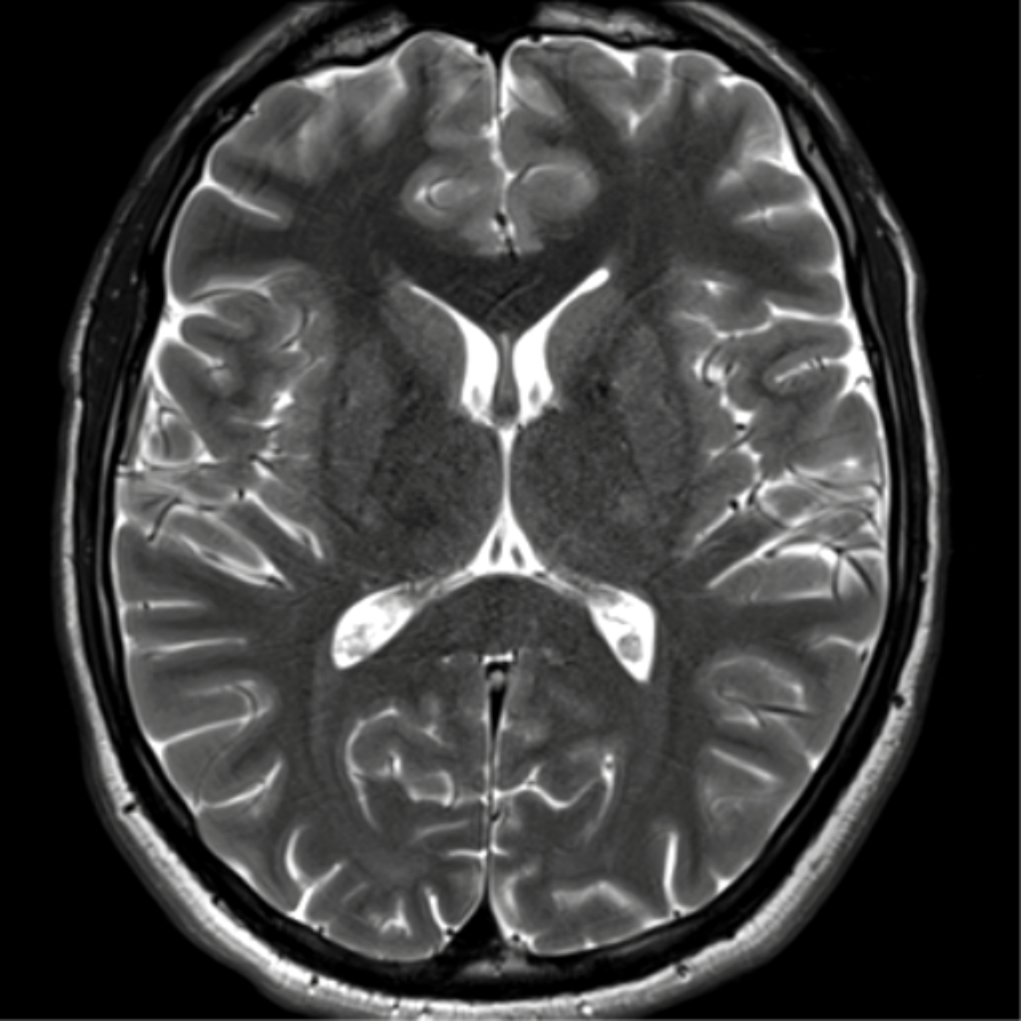
Axial T2-weighted MRI of the brain demonstrating normal ventricular configuration and preserved gray-white matter differentiation with no evidence of focal intracranial lesion, edema, or demyelinating changes.

Figure 2: MRI of spine
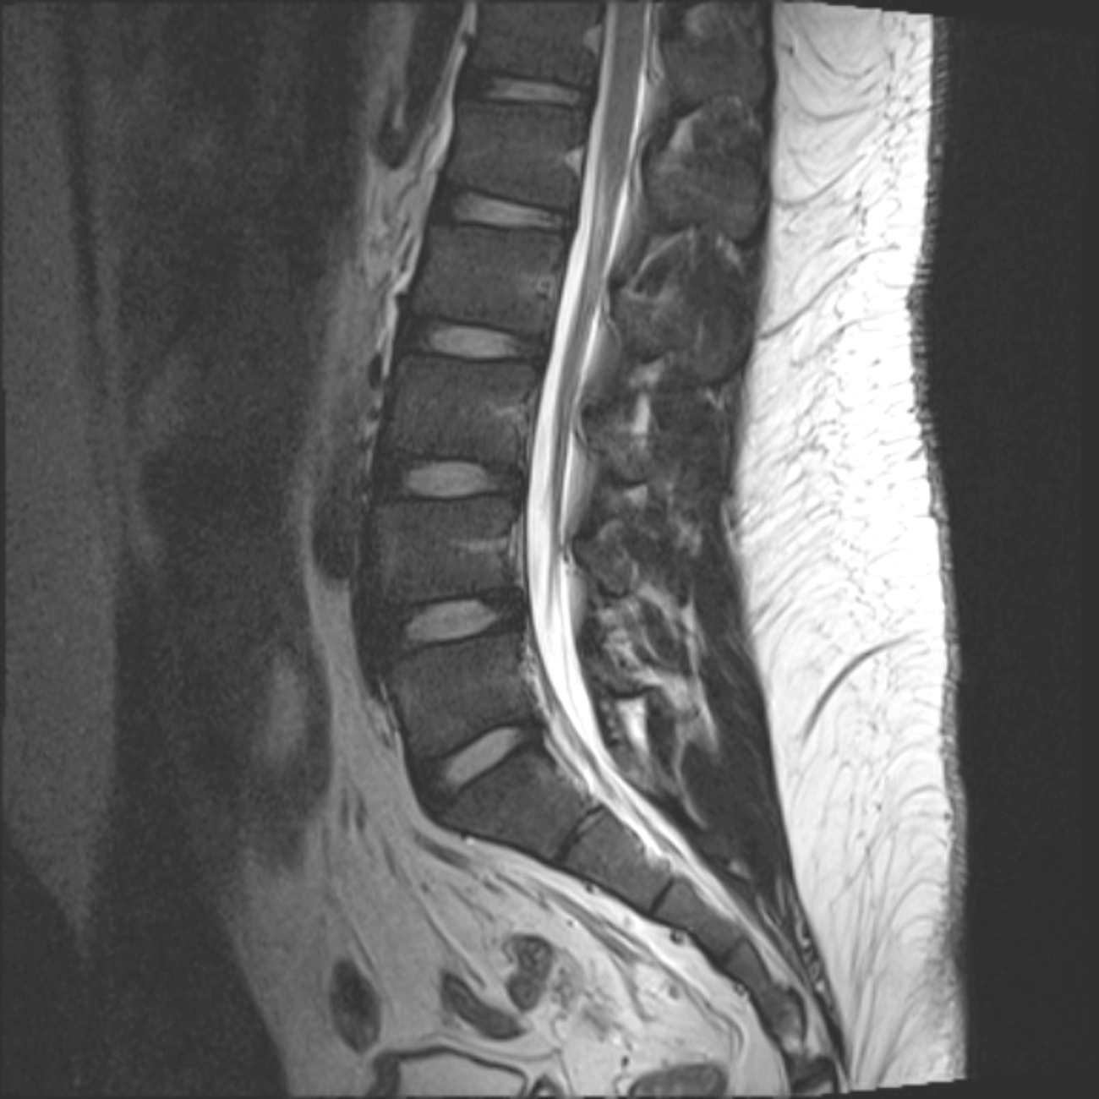
Sagittal T2-weighted MRI of lumbosacral spine showing normal vertebral alignment, preserved intervertebral disc spaces, and no evidence of spinal canal stenosis or compressive pathology.

In view of the prior hemodynamic intolerance during plasmapheresis and autonomic instability, repeat plasmapheresis was deferred and the patient was started on intravenous immunoglobulin (IVIG) at a dose of 0.4 g/kg/day for five consecutive days in our hospital. The patient remained hemodynamically stable throughout the course of IVIG therapy and responded well, with clinical improvement observed by the third day of treatment. Muscle strength improved to 3/5 in both upper limbs, 4/5 in the right lower limb, and 3/5 in the left lower limb. By the time of discharge, the patient was able to ambulate independently with significant improvement in limb strength, corresponding to an approximate Guillain-Barré syndrome disability score improvement to 2.

DISCUSSION:
Guillain-Barré syndrome (GBS) is an acute immune-mediated polyradiculoneuropathy typically triggered by an antecedent infection that induces an aberrant autoimmune response through molecular mimicry, resulting in peripheral nerve injury. It is characterized by rapidly progressive, symmetrical limb weakness, areflexia, and variable sensory and autonomic involvement [2]. A distinct preceding history of acute gastroenteritis approximately three days prior to the onset of neurological symptoms is notable. The patient developed rapidly progressive, predominantly motor weakness beginning in the upper limbs and subsequently involving the lower limbs, reaching its nadir within approximately one week, consistent with the monophasic progression typical of GBS [5]. Deep tendon reflexes were absent in all limbs, while objective sensory examination including vibration and joint position sense remained normal, despite subjective paresthesias. Cranial sensory symptoms such as tongue paresthesia, although uncommon, have been described in GBS and may reflect involvement of sensory nerve roots or cranial nerve sensory fibers without detectable objective deficits [6]. Cranial nerve examination was normal, and there was no bulbar or respiratory compromise. Nerve conduction study further supported the diagnosis of AIDP, demonstrating prolonged distal latencies, reduced CMAP amplitudes, slowed conduction velocities, and prolonged F-wave latencies involving bilateral median, ulnar, tibial, and common peroneal nerves, along with sensory nerve involvement. These findings were consistent with demyelinating motor and sensory neuropathy involving all four limbs with secondary axonal involvement. An additional important feature in this case was early autonomic dysfunction, manifested by tachycardia and transient hypertension. Autonomic dysfunction is a well-recognized complication of Guillain-Barré syndrome and may occur in up to two-thirds of patients, particularly in severe disease. Dysautonomia may manifest as fluctuations in blood pressure, cardiac arrhythmias, tachycardia, bradycardia, diaphoresis, gastrointestinal dysmotility, urinary dysfunction, and hemodynamic instability. These manifestations result from immune-mediated involvement of autonomic fibers and are associated with increased morbidity and risk of sudden cardiovascular complications [7,8].

A noteworthy aspect of this case is intolerance to therapeutic plasmapheresis. The patient developed dyspnoea, hypotension, and diaphoresis during plasmapheresis sessions, necessitating discontinuation after three cycles. These manifestations were likely related to autonomic instability, rapid intravascular volume shifts, or citrate-related reactions. This highlights an important clinical consideration, even though both plasmapheresis and intravenous immunoglobulin (IVIG) are considered equally effective first-line therapies, treatment tolerability may vary among patients, and early recognition of complications is essential. Following discontinuation of plasmapheresis, the patient received IVIG at a dose of 0.4 g/kg/day for five days, with clinical improvement noted by the third day of therapy. Prompt initiation of immunotherapy is known to shorten disease progression and improve functional outcomes [9,10]. This case is notable for the combination of post-diarrhoeal onset, early autonomic features, unusual tongue paresthesia, and intolerance to plasmapheresis requiring a switch to IVIG. These elements highlight the heterogeneity of GBS presentations and reinforce the importance of individualized management strategies. This report has certain limitations. Detailed hemodynamic parameters during plasmapheresis sessions performed at the referring centre were unavailable. In addition, cerebrospinal fluid analysis and anti-ganglioside antibody testing were not performed, as the diagnosis was considered sufficiently supported by the characteristic clinical presentation and nerve conduction study, and these investigations were not expected to significantly alter management. Furthermore, microbiological confirmation of antecedent Campylobacter jejuni infection through stool culture or serology testing was not performed since the gastrointestinal symptoms had resolved prior to presentation to the referring centre.

CONCLUSION:
This case illustrates a post-infectious Guillain-Barré syndrome of the AIDP subtype, characterized by rapidly progressive motor weakness following gastroenteritis, preserved objective sensory function, and areflexia. Early autonomic dysfunction and intolerance to plasmapheresis complicated management, necessitating transition to intravenous immunoglobulin therapy, following which clinical improvement was observed. The case highlights the importance of recognizing autonomic instability in GBS, close hemodynamic monitoring during immunomodulatory therapy, and individualized treatment strategies when first-line treatment is not tolerated.

CONSENT:
As per international standards or university standards, patient(s) written consent has been collected and preserved by the author(s).
COMPETING INTERESTS:
Authors have declared that no competing interests exist.

DISCLAIMER (ARTIFICIAL INTELLIGENCE)
Author(s) hereby declare that NO generative AI technologies such as Large Language Models (ChatGPT, COPILOT, etc.) and text-to-image generators have been used during the writing or editing of this manuscript.

REFERENCES:
- Bhatti, K. S., Maheshwary, A., & Sun, C. E. (2026). Guillain–Barré syndrome. StatPearls. https://www.ncbi.nlm.nih.gov/books/NBK532254/
- Shahrizaila, N., Lehmann, H. C., & Kuwabara, S. (2021). Guillain–Barré syndrome. Lancet, 397, 1214–1228. https://doi.org/10.1016/S0140-6736(21)00517-1.
- Chakraborty, T., Kramer, C. L., Wijdicks, E. F. M., & Rabinstein, A. A. (2020). Dysautonomia in Guillain–Barré syndrome: Prevalence, clinical spectrum, and outcomes. Neurocritical Care, 32, 113–120. https://doi.org/10.1007/s12028-019-00781-w.
- Zaki, H. A., Iftikhar, H., Najam, M., Masood, M., Al-Marri, N. D. R., Elgassim, M. A. M., et al. (2023). Plasma exchange (PE) versus intravenous immunoglobulin (IVIG) for the treatment of Guillain–Barré syndrome (GBS) in patients with severe symptoms: A systematic review and meta-analysis. eNeurologicalSci, 31, 100468. https://doi.org/10.1016/j.ensci.2023.100468.
- Leonhard, S. E., Mandarakas, M. R., Gondim, F. A. A., Bateman, K., Ferreira, M. L. B., Cornblath, D. R., et al. (2019). Diagnosis and management of Guillain–Barré syndrome in ten steps. Nature Reviews Neurology, 15, 671–683. https://doi.org/10.1038/s41582-019-0250-9.
- Bhargava, A., Banakar, B. F., Pujar, G. S., & Khichar, S. (2014). A study of Guillain–Barré syndrome with reference to cranial neuropathy and its prognostic implication. Journal of Neurosciences in Rural Practice, 5(Suppl 1), S43–S47. https://doi.org/10.4103/0976-3147.145200.
- Zaeem, Z., Siddiqi, Z. A., & Zochodne, D. W. (2019). Autonomic involvement in Guillain–Barré syndrome: An update. Clinical Autonomic Research, 29(3), 289–299. https://doi.org/10.1007/s10286-018-0542-y.
- Elendu, C., Osamuyi, E. I., Afolayan, I. A., Opara, N. C., Chinedu-Anunaso, N. A., Okoro, C. B., et al. (2024). Clinical presentation and symptomatology of Guillain–Barré syndrome: A literature review. Medicine, 103(30), e38890. https://doi.org/10.1097/MD.0000000000038890.
- Bellanti, R., & Rinaldi, S. (2024). Guillain–Barré syndrome: A comprehensive review. European Journal of Neurology, 31, e16365. https://doi.org/10.1111/ene.16365.
- Joshi, R., Mendhe, D., & Wanjari, M. (2021). Guillain–Barré syndrome: A case report and literature review. Journal of Pharmaceutical Research International, 33, 158–161. https://doi.org/10.9734/jpri/2021/v33i58A34101.

