Original Research Article

Antioxidant Activities and In-Silico Evaluation of Selected Active Biomolecules from Syzygiumaromaticum and Kalanchoe pinnatum on Target Bacterial Proteins

ABSTRACT
Syzygium aromaticum and Kalanchoe pinnatum possess relevant bioactive compounds rich in antioxidant and antimicrobial potentials. This study evaluates the antioxidant activities and in-silico identification of potential compounds against target proteins (OmpA and CitA) in Acinetobacter baumannii and Klebsiella pneumoniae.
Crude extracts from S. aromaticum and K. pinnatum were obtained by hot and cold aqueous extraction method and concentrated with a rotary evaporator. The antioxidant activities of the crude extracts were evaluated using DPPH free radical scavenging and H₂O₂ assay at different concentrations. Selected compounds from GC-MS analysis were subjected to in-silico ADMET prediction to determine their pharmacokinetic properties. Docking was performed to evaluate binding interactions between ligands and bacterial proteins (OmpA and CitA) from A. baumannii and K. pneumoniae. Data obtained were analyzed using SPSS version 26.0 and mean and standard deviation was calculated and accepted at P≥0.05.
The DPPH assay showed that S. aromaticum had the best inhibition at 25% concentration with 65.95% and 63.33% in hot and cold extract respectively while highest inhibition in K. pinnatum was observed at 60.02 % in the cold extract. S. aromaticum increased from 30.07%–60.35% and 38.63%–50.49%, while K. pinnatum increased from 23.55% to 53.31% with increasing concentration.Selected compounds showed Caco-2 permeability ranging from 1.423–1.734×10⁻⁶ cm/s, blood brain barrier penetration and CYP safety. Tannin had the strongest binding affinity at −8.0 kcal/mol against the target proteins.
These plants possess notable antioxidant and antibacterial activities, thus suggesting their promising option for safer and effective therapeutic agent development against rising multidrug-resistant bacteria.
Keywords: Plant extracts, Bacterial, Proteins, Molecular Docking, ADMET

- INTRODUCTION
The rapid threat of antibiotic resistance (ABR) by pathogenic microorganisms represents a major global health concern. Conventional antibiotics that are once highly effective against these bacteria are increasingly losing their efficacies due to the spread of resistance mechanisms among bacteria (O’neill, 2016). This increasing resistance necessitates the need for alternative therapeutic approaches, especially from natural sources such as medicinal plants. Bioactive compounds or their metabolites from plant have gained attention as a result of their diverse pharmacological properties, such as antioxidants, antimicrobial, anticancer, and anti-inflammatory activities which offer a promising niche for novel drugs with enhanced potencies and decreased human and environmental toxicity (O’neill, 2016). Antioxidants are compounds that scavenge free radicals and reduce oxidative damage, thereby maintaining cellular homeostasis. Natural antioxidants, particularly plant-derived are highly priced as a result of their therapeutic potential and safety profile. Phenolic compounds and flavonoids that are commonly found in medicinal plants have been reported to demonstrate strong antioxidant activity by neutralizing the free radicals and chelating metal ions present in the body (Uddin et al., 2022).
Furthermore, natural products in drug discovery align with the increasing demand for safer and more sustainable therapeutic alternative. Unlike synthetic drugs, compounds derived from plant are usually associated with lower toxicity and fewer side effects (Uddin et al., 2022). Additionally, diversity in the structure of phytochemicals offers enormous chemical capacity for the discovery of novel bioactive molecules. The use of gas chromatoAnexy-mass spectrometry (GC-MS) in analytical technique has facilitated the identification of various compounds in plant extracts which enable further screening of their biological activities (Akinterinwa et al., 2025). Syzygiuma romaticum (commonly known as clove) are among the most studied plants due to the high presence of bioactive metabolites. The plant is recognized for its high content of phenolic compounds, especially eugenol (Abdelmuhsin et al., 2025). Eugenol has been reported to possess potent activities such as antioxidant, antimicrobial, and anti-inflammatory properties. The antioxidant activity of clove is attributed to its phenolic constituents that are capable of scavenging free radicals. Studies have demonstrated that extracts of S. aromaticum showed antioxidant activity (Abdelmuhsin et al., 2025). K. pinnatum (commonly known as bryophyllum) is another medicinal plant with important pharmacological importance. Phytochemical investigations of K. pinnatum showed the presence of diverse bioactive constituents, including tannins, terpenoids, steroids, and glycosides that contribute to their antioxidant and antimicrobial properties (Akinterinwa et al., 2025).
Recently, computational approaches including molecular docking has changed face in drug discovery and development. Molecular docking is an in-silico method that predicts the interaction between a ligand (organic compounds) and a target bacteria protein. It provides knowledge into the binding affinity, stability and their possible action mechanism. This technique is useful in identifying potential drug candidates that can inhibit bacterial proteins responsible for critical cellular processes such as DNA replication, cell wall synthesis, and metabolic pathways (Abdelmuhsin et al., 2025). Studies have demonstrated the potential of eugenol to exhibit good binding affinity to bacterial enzymes such as DNA gyrase and dihydrofolate reductase reflecting their ability as potential antibacterial agents. Despite this, there remain the need to study the pharmacological properties of S. aromaticum and K. pinnatum that combine both experimental and computational analyses (Abdelmuhsin et al., 2025). The identification and assessment of specific organic compounds from these plants and their interaction with bacterial proteins can provide valuable knowledge for the screening of potential drug candidates against rising clinical pathogens.
2.0 METHODS
2.1 Collection, Preparation and Preliminary Screening of Plants Extracts
Fifty grams (50.0 g) each of collected plants S. aromaticum and K. pinnatum were procure from local market and authenticated by a taxonomist in the Department of Pure and Applied Biology, LAUTECH. The plants were prepared into powder and dissolved in 250 mL sterile distilled water (cold and hot water extraction) by maceration and soaked for 48 hours. The extracts mixtures are then filtered through Whatman’s filter paper to obtain crude extract and concentrated with rotary evaporator which was then used for antioxidant and in-Silico evaluation (Malini et al., 2023).
2.2 Confirmatory screening of Multi-resistant Bacteria
Clinical isolates, A. baumannii and K. pneumoniae were collected from different anatomical sites in three different hospitals including; LAUTECH Teaching Hospital, Ogbomoso, Oyo State, Bowen Teaching Hospital, Ogbomoso and University of Ilorin Teaching Hospital, Ilorin, Nigeria. These isolates were previously screened by their different biochemical features and studied for their multi-antibiotic resistance.
2.3 Antioxidant Activities of Plant Extracts
2.3.1 Antioxidant Screening by 2,2-diphenyl-1- picrylhydrazyl solution (DPPH)
Each hot and cold extracts of S. aromaticum and K. pinnata was prepared at four different concentrations of 25, 50, 75 and 100 %. Then, 4ml from each concentration of extract was dispensed in a test tube and 1 mL of prepared DPPH (2,2-diphenyl-1- picrylhydrazyl) solution was added to the test tube and kept in the dark at room temperature for 30 minutes. Also, the blank was prepared from the extract (with no DPPH) (Asma et al.,2015). The absorbance of each concentration of each extract and blank was measured at wavelength 517 nm with the UV–visible spectrophotometer. The percentage inhibition of each plant crude extracts was then calculated using the formula;
% inhibition = $\frac{Ablank-Aextract}{Ablank}$ × 100 _____________________________ eqn. 1

2.3.2 H₂O₂ Scavenging Activities of Extracts of S. aromaticum and K. pinnata
The hydrogen peroxide scavenging activity of the plant extracts was determined following the method of Lateef et al. (2018). 0.6mL of 40 mM H₂O₂ prepared in phosphate buffer (7.4) was mixed with 4 mL of crude extract at different concentration of 25, 50, 75 and 100 %. The reaction mixture was then incubated at 30 ± 2ºC for 20 minutes. A solution containing H₂O₂ without the extract serves as control while distilled water was used as blank. The absorbance was measured at 610nm with a spectrophotometer. The percentage of scavenging activity was calculated using the equation below;
% scavenging =$\frac{Acontrol-Asample}{Acontrol}×100$ ___________________________________ eqn. 2
2.4 Prediction of ADMET Property of Important Phytochemicals from S. aromaticum and K. pinnatumExtracts
This study involved an in silico computational approach to evaluate the absorption, distribution, metabolism, excretion and toxicity properties of some selected phytochemicals (Daina et al., 2017). After identification of the phytochemicals by GC-MS, the chemical structures of these compounds were then retrieved from the database (PubChem) in a Structure Data File format. The ADMET properties were predicted using the pkCSM prediction software to assess the drug properties using the Lipinski’s Rule of Five (that is, the solubility, toxicity, lipophilicity, molecular weight and ability to pass blood brain barriers) (Lipinski et al., 2001). The predicted ADMET profiles were compared with standard data on available conventional antibiotic used in the treatment of infection caused by these clinical pathogens (A. baumannii and K. pneumoniae).
2.5 Computational Prediction of Binding Sites by Molecular docking
This was performed using docking tools (AutoDock Vina, Discovery studio) for preparation of input files. The three-dimensional (3D) structure of the protein from A. baumannii and K. pneumoniae were retrieved from the Protein Data Bank (PDB) (https://www.rcsb.org/).The protein structure was then cleaned by removing water molecules, heteroatoms and unnecessary ions. The prepared protein structure was converted and saved in a PDB format. The structure of the ligand (organic compound) was obtained from ‘PubChem’ database(https://pubchem.ncbi.nlm.nih.gov/) and then converted into PDB format using AutoDockTools. A grid box defining the active site of the protein was also set using AutoDock tool which ensures that the docking is restricted to biologically relevant sites of the protein.
Docking was carried out using AutoDock Vina which uses an iterative search algorithm combining random conformational changes and local optimization to predict binding poses. Visualization tool ‘Discovery Studio’ was then used to examine their interactions such as hydrogen bonds, and hydrophobic interactions.Validation was performed by re-docking the co-crystallized ligand into the protein active site. The Root Mean Square Deviation (RMSD) between experimental and predicted poses was evaluated and accepted if ≤ 2.0 Å. Interaction profiles between ligand and amino acid residues were analyzed and the binding modes were compared to conventional standard antibiotics to predict biological relevance (Forli et al., 2016; AutoDock Vina Documentation, 2024).
2.5 Data Analysis
The data obtained from the analysis were independently analyzed. A one-way analysis of variance (ANOVA) was also used to analyzethe results and Duncan multiple tests was used for mean separation as necessary. Statistical Package forSocial Science, version 26.0 (SPSS, Armonk, New York) for Windows was used for the analysis and the significant difference was accepted at p < 0.05.
3.0 RESULTS
3.1 Antioxidant Activities of Plant Extracts by 2,2-diphenyl-1- picrylhydrazyl solution (DPPH)
The colour of DPPH solution changed from a deep purple colour to a yellowish colour indicating the ability of the extracts to scavenge free radicals. The best antioxidant activity was observed inS. aromaticum extractat 25% concentration with DPPH inhibition at 65.95% and 63.33% in hot and cold extraction solvent respectively. The least scavenging activity was observed at 100% extract concentration with 7.81% inhibition (Table 1). The DPPH assaysin both hot and cold extracts of K. pinnata exhibit considerable antioxidant activity at lower concentrations, with the hot extract showing slightly higher radical scavenging potential. InK. pinnata extract, highest observed for 25% concentration at 60.02% and 57.66% DPPH inhibition in the hot and cold extract respectively. At 75% concentration, weak scavenging effect was observed in the extract with 12.53% and 7.66% (Table 2).
3.2 Scavenging Activity S. aromaticum and K. pinnata extract by H₂O₂
The scavenging activity of hot S. aromaticum extract increased progressively from moderate activity at 30.07% in low concentration of the extract (25%) to 60.35% at 100% concentration. Also, cold of S. aromaticum showed an increase from 38.63% to 50.49%, though at a lower activity that the hot extract. At lower concentration of the cold extract, that is, 25 – 50%, showed higher scavenging activity at 38.63 – 40.06 % compared to the hot extract. At high concentration of extract, the hot extract performed better than cold extract. In the K. pinnata extract, highest percentage activity was recorded with highest concentration at 53.31%; while the least activity was recorded at 23.55% with the lowest extract concentration. Moderate scavenging activity was recorded with 75% extract concentration. Low scavenging activity was recorded at 25%, 50% and 75% extract concentration while moderate activity was observed with 100% concentration of extract (Table 3 and 4).
Table 1: Antioxidant activity of S. aromaticum extract
Extract concentration (%) | Hot S. aromaticum extract | % DPPH inhibition | Cold S. aromaticum extract | % DPPH inhibition
25 | 0.881±0.011ª | 65.95 | 0.900±0.012ª | 63.33
50 | 1.536±0.006^{b} | 40.63 | 1.450±0.006^{b} | 40.91
75 | 1.712±0.023^{b} | 33.82 | 1.780±0.001^{c} | 27.46
100 | 2.385±0.087^{c} | 7.81 | 2.637±0.012e | -7.46
Blank (No DPPH) | 2.587±0.059^{d} | 0.00 | 2.454±0.883^{d} | 0.00
Note: Alphabets in the superscript indicate significant difference at the 0.05 level
Table 2: Antioxidant activity of K. pinnata extract
Extract concentration (%) | Hot K. pinnata extract | % DPPH inhibition | Cold K. pinnata extract | % DPPH inhibition
25 | 1.133±0.028ª | 60.02 | 1.232±0.008ª | 57.66
50 | 1.818±0.010^{b} | 35.85 | 2.002±0.013^{b} | 31.20
75 | 2.479±0.047^{c} | 12.53 | 2.687±0.008^{c} | 7.66
100 | 2.794±0.006^{d} | 1.41 | 2.957±0.016^{d} | -1.62
Blank (No DPPH) | 2.834±0.031^{d} | 0.00 | 2.910±0.016^{d} | 0.00
Note: Alphabets in the superscript indicate significant difference at the 0.05 level
Table 3: Scavenging Activity of S. aromaticum extract by H₂O₂
Extract concentration (%) | Hot S. aromaticum extract | % Scavenging activity | Cold S. aromaticum extract | % Scavenging activity
25 | 0.686±0.005^{d} | 30.07 | 0.602±0.005^{d} | 38.63
50 | 0.634±0.005^{c} | 35.37 | 0.588±0.004^{c} | 40.06
75 | 0.490±0.002^{b} | 50.05 | 0.549±0.003^{b} | 44.04
100 | 0.389±0.003ª | 60.35 | 0.486±0.007ª | 50.49
Control (H₂O₂) | 0.981±0.008e | 0.00 | 0.981±0.008e | 0.00
Note: Alphabets in the superscript indicate significant difference at the 0.05 level
Table 4: Scavenging Activity of K. pinnata extract by H₂O₂
Extract concentration (%) | Hot K. pinnata extract | % Scavenging activity | Cold K. pinnata extract | % Scavenging activity
25 | 0.750±0.004^{d} | 23.55 | 0.798±0.004^{d} | 18.65
50 | 0.710±0.001^{c} | 27.62 | 0.751±0.003^{c} | 23.45
75 | 0.648±0.003^{b} | 33.94 | 0.688±0.002^{b} | 29.87
100 | 0.458±0.003ª | 53.31 | 0.532±0.003ª | 45.77
Control (H₂O₂) | 0.981±0.008e | 0.00 | 0.981±0.008e | 0.00
Note: Alphabets in the superscript indicate significant difference at the 0.05 level
3.3 Prediction of ADMET Propertiesof Selected Organic Compounds from S. aromaticum Extracts
All selected compounds showedhigh Caco-2 permeabilityat range of 1.423–1.734 ×10⁻⁶ cm/s. However, the conventional antibiotics showedzero intestinal absorption. All compounds showednegative skin permeability values, indicating low likelihood of skin penetration. None of the selected compounds are predicted to useP-glycoprotein substrates when compared to polymyxin B and colistin. BBB permeability results showed that eugenol, isoeugenol, and caryophyllene have ability to cross the blood–brain barrier, while 3-allyl-6-methoxyphenol showed limited CNS penetration. None of the compounds are substrates for CYP2D6 or CYP3A4 enzymes;however, eugenol and isoeugenol act as CYP1A2 inhibitors. None of the compounds has ability to inhibit CYP2C19. Caryophyllene was predicted to have the best total clearance at1.088 log mL/min/kg.Toxicity analysis showed that only eugenol is AMES toxic. The compound showed possible mutagenic risk while the others were non-mutagenic. All compounds are predicted to be non-hERG I inhibitors revealing low risk of severe cardiotoxicity. Polymyxin B, colistin, and some other compounds show hERG II inhibition (Table 5).
Table 5: ADMET Property of Selected Organic Compounds from S. aromaticum
Properties | Model Name | Predicted Value |  |  |  | Predicted Value of Conventional antibiotic |  |  | Unit
Properties | Model Name | Eugenol (MW:164.2 g/mol) | Isoeugenol (MW: 164.2 g/mol) | 3-Ally-6-6methoxylphenol (MW: 124.14 g/mol) | Caryophyllene (MW: 204.35 g/mol) | Polymyxin B (MW: 1203.5 g/mol) | Colistin (MW: 1155.5 g/mol) | Standard Interpretation value | Unit
Absorption | Water solubility | -2.25 | -1.641 | -1.264 | -5.555 | -2.891 | -2.891 | > −2 | Mol/L
Absorption | Caco-2 permeability | 1.559 | 1.734 | 1.595 | 1.423 | 0.108 | 0.05 | >0.90 | 10⁻⁶cm/s
Absorption | Intestinal absorption | 92.041 | 92.64 | 93.374 | 94.845 | 0 | 0 | ≥ 70% | %Absorbance
Absorption | Skin permeability | -2.207 | -1.851 | -2.477 | -1.58 | -2.735 | -2.735 | >−2.5 | logKp
Absorption | P-glycoprotein substrate | No | No | No | No | Yes | Yes | No | Yes/No
Distribution | BBB permeability | 0.374 | 0.335 | -0.226 | 0.733 | -2.37 | -2.445 | > 0.3 | logBB
Distribution | CNS permeability | -2.007 | -1.91 | -2.043 | -2.172 | -6.141 | -5.943 | > −2 | logPS
Metabolism | CYP2D6 substrate | No | No | No | No | No | No | No | Yes/No
Metabolism | CYP3A4 substrate | No | No | No | No | No | No | No | Yes/No
Metabolism | CYP1A2 inhibitior | Yes | Yes | No | No | No | No | No | Yes/No
Metabolism | CYP2C19 inhibitior | No | No | No | No | No | No | No | Yes/No
Excretion | Total Clearance | 0.282 | 0.221 | 0.307 | 1.088 | -1.075 | -1.208 | >0.7 | Logml/min/kg
Excretion | Renal OCT2 substrate | No | No | No | No | No | No | No | Yes/No
Toxicity | AMES toxicity | Yes | No | No | No | No | No | No (Safe) | Yes/No
Toxicity | hERG I inhibitor | No | No | No | No | No | No | No | Yes/No
Toxicity | hERG II inhibitor | No | No | No | No | Yes | Yes | No | Yes/No
Toxicity | Hepatotoxicity | No | Yes | No | No | No | Yes | No | Yes/No
Toxicity | Skin Sensitisation | Yes | Yes | Yes | Yes | No | No | No | Yes/No
Toxicity | Minnow toxicity (LC50) | 1.702 | 1.311 | 1.952 | 0.504 | 18.041 | 18.103 | Low | logmM

3.4 Prediction of ADMET Propertiesof Selected Organic Compounds from K. pinnataExtracts
The absorption property of selected compounds from extract of K. pinnata showed that D-limonene, squalene, and 2,6-bis(1,1-dimethylethyl)phenolexhibitedhigh intestinal absorption at 89–98%.Water solubilitywas found to be generally low for all the compounds, particularly squalene at -8.401.Tannin shows relatively better solubility at -2.901 compared to other extracted organic compounds, but has a large molecular weight that may limits its absorption. BBB permeability for squalene is high at 0.965 and D-limonene at 0.557, while tannin exhibit extremely low permeability at -4.293. CNS permeability property showed that squalene and 2,6-bis compounds have better CNS access, while tannin and antibiotics have very poor CNS penetration. None of the compounds can utilize CYP2D6 as substrate while squalene and tannin are CYP3A4 substrates.D-limonene and 2,6-bis compounds have capacity to inhibit CYP1A2.Squalene exhibits the highest total clearance at 1.791 log mL/min/kg while antibiotics show negative clearance values. All organic compounds are non-mutagenic (that is, AMES negative) and non-hERG I inhibitors. Inhibition of hERG II is observed in squalene, tannin, and the conventional antibiotics. Ecotoxicity (minnow toxicity) is significantly higher in the conventional antibiotics, while the organic molecules show lower toxicity.
Table 6: ADMET Property of Selected Organic Compounds from K. pinnata Extract
Properties | Model Name | Predicted Value |  |  |  | Predicted Value of Conventional antibiotic |  |  | Unit
Properties | Model Name | D-Limonene (MW:136.23 g/mol) | Squalene (MW: 410.7 g/mol) | 2,6,-bis(1-1-dimethylethyl(MW: 220.4 g/mol) | Tannin(MW: 952.7 g/mol) | Polymyxin B (MW: 1203.5 g/mol) | Colistin (MW: 1155.5 g/mol) | Standard Interpretation value | Unit
Absorption | Water solubility | -3.608 | -8.401 | -5.298 | -2.901 | -2.891 | -2.891 | >−2 | Mol/L
Absorption | Caco-2 permeability | 1.248 | 1.193 | 1.444 | -1.736 | 0.108 | 0.05 | >0.90 | 10⁻⁶cm/s
Absorption | Intestinal absorption | 98.048 | 89.002 | 94.739 | 0 | 0 | 0 | ≥70% | %Absorbance
Absorption | Skin permeability | -1.5 | -2.763 | -1.759 | -2.735 | -2.735 | -2.735 | >−2.5 | logKp
Absorption | P-glycoprotein substrate | Yes | No | Yes | Yes | Yes | Yes | No | Yes/No
Distribution | BBB permeability | 0.557 | 0.965 | 0.287 | -4.293 | -2.37 | -2.445 | >0.3 | logBB
Distribution | CNS permeability | -2.006 | -0.935 | -0.475 | -5.399 | -6.141 | -5.943 | >−2 | logPS
Metabolism | CYP2D6 substrate | No | No | No | No | No | No | No | Yes/No
Metabolism | CYP3A4 substrate | No | Yes | No | Yes | No | No | No | Yes/No
Metabolism | CYP1A2 inhibitior | Yes | No | Yes | No | No | No | No | Yes/No
Metabolism | CYP2C19 inhibitior | No | No | No | No | No | No | No | Yes/No
Excretion | Total Clearance | 0.224 | 1.791 | 0.714 | 0.585 | -1.075 | -1.208 | >0.7 | Logml/min/kg
Excretion | Renal OCT2 substrate | No | No | No | No | No | No | No | Yes/No
Toxicity | AMES toxicity | No | No | No | No | No | No | No (Safe) | Yes/No
Toxicity | hERG I inhibitor | No | No | No | No | No | No | No | Yes/No
Toxicity | hERG II inhibitor | No | Yes | No | Yes | Yes | Yes | No | Yes/No
Toxicity | Hepatotoxicity | No | No | No | No | No | Yes | No | Yes/No
Toxicity | Skin Sensitisation | Yes | No | Yes | No | No | No | No | Yes/No
Toxicity | Minnow toxicity | 1.132 | -3.275 | -0.319 | 2.701 | 18.041 | 18.103 | Low | logmM

3.6 In-Silico Evaluation of Selected Organic Compounds from S, aromaticumand K. pinnatumExtracts with Proteins from Bacterial Isolates by Docking Approach
The in-silico study and molecular docking result showed that all tested organic compounds from S. aromaticum and K. pinnata is represented in the Table 7 and Figure 1-15. All ligandsdemonstratednegative binding affinities at varying degrees. This indicates favorable interactions with the bacterial proteins tested for. Among the selected ligands tested against A. baumannii protein (OmpA), tannin showed the highest binding affinity at −8.0 kcal/mol. Caryophyllene and Isoeugenol, from S. aromaticum also exhibited better binding affinity at −5.6 kcal/mol and −5.2 kcal/molwhen compared to docking with standard polymyxin.The D-limonene and squalene, from K. pinnata exhibited weaker binding interactions at −4.7 kcal/mol and −4.4 kcal/mol respectively suggesting a lower inhibitory/antimicrobial potentials of the K. pinnataextract against A. baumannii. The standardpolymyxin at −3.1 kcal/moldemonstrated significantly lower binding affinity compared to selected compounds (Table 7).
For the docking withK. pneumoniae expression protein (histidine kinase, CitA),similar binding affinity was observed with tannin at −8.0 kcal/mol. Squalene, from K. pinnatashowedgood affinity at −5.4 kcal/mol against K. pneumoniae compared to A. baumannii, while isoeugenol at −4.9 kcal/mol and eugenol at −4.8 kcal/mol demonstrated moderate binding affinities. The standardcolistin for K. peumoniaeat−2.5 kcal/mol showed the least binding affinity. The low RMSD values at 0.0 Å for most ligands reflectreliable conformations and stable docking poses. However, D-limonene showed a higher RMSD at 1.77 Å (Table 7). The 3D structure demonstrated that the ligands were well accommodated within the active site, to form stable interactions with key amino acid residues. The 2D interaction further confirmed these in silico results illustrating hydrogen bonds, hydrophobic interactions, and distance with surrounding amino acid residues which collectively contribute to the stability of the ligand–protein complex (Figure 1 - 15).
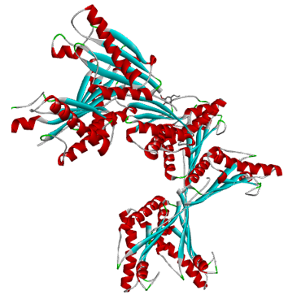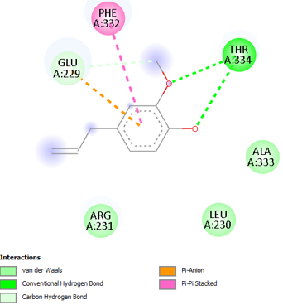
Figure 1:2D and 3D structure of binding siteof eugenol on A. baumannii protein(OmpA)
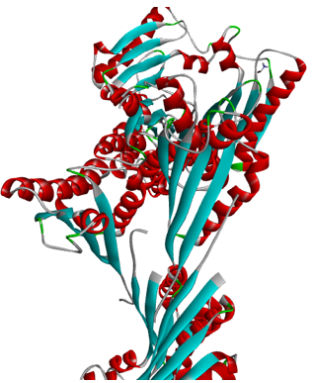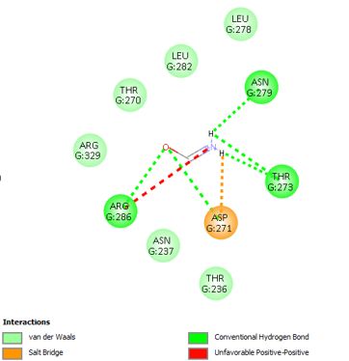
Figure 2:2D and 3D structure of binding siteof Polymyxin B (Standard antibiotic) on A. baumannii protein (OmpA)
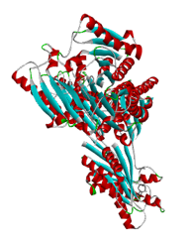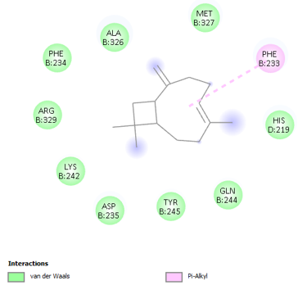
Figure 3:2D 3D structure of caryophyllene on A. baumannii protein (OmpA)
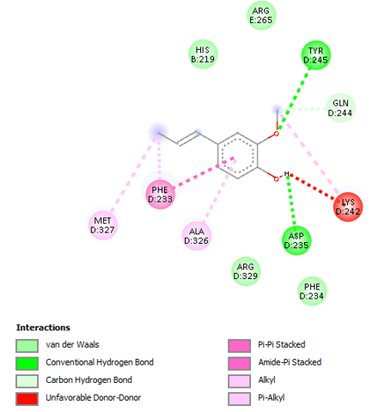
Figure 4:2D structure of binding siteof isoeugenol on A. baumannii protein (OmpA)
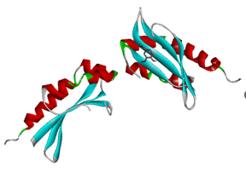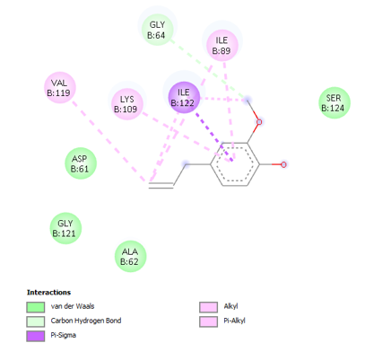
Figure 5:2D structure of binding siteof eugenol on Klebsiella pneumoniae protein (histidine kinase, CitA)
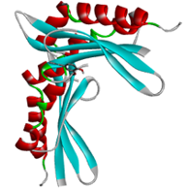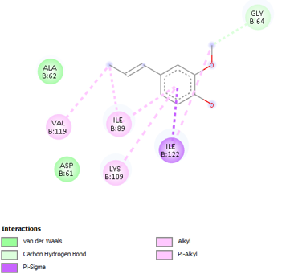
Figure 6:2D and 3D structure of binding siteof isoeugenol on Klebsiella pneumoniae protein (histidine kinase, CitA)
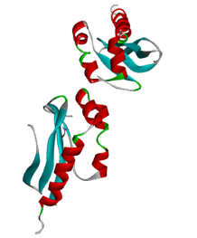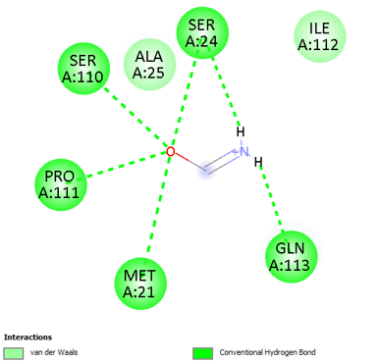
Figure 7:2D and 3D structure of binding siteof Colistin on Klebsiella pneumoniae protein (histidine kinase, CitA)
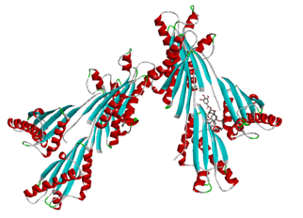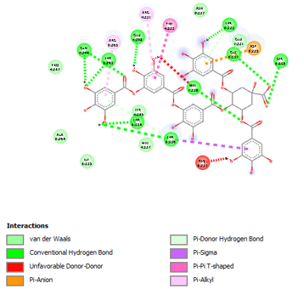
Figure 8: 2D structureof binding site of tannin on A. baumannii protein (OmpA)
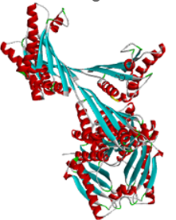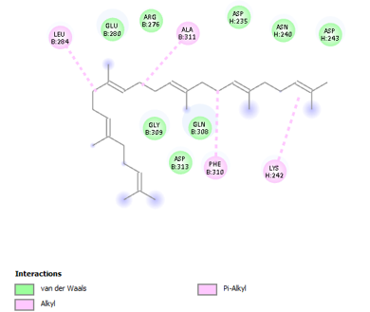
Figure 9: 2D and 3D structure of binding siteof D-Limonene on A. baumannii protein (OmpA)
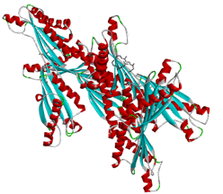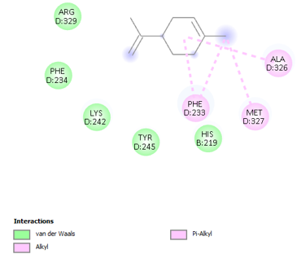
Figure 10: 2D and 3D structure of binding siteof squalene on A. baumannii protein (OmpA)
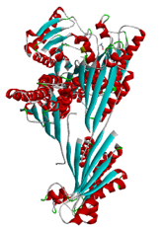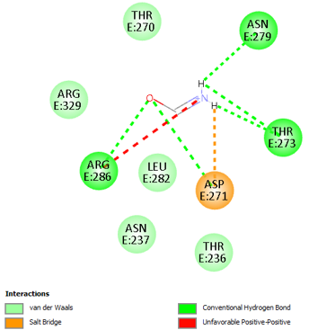
Figure 11: 2D and 3D structure of binding site of polymyxin B (standard antibiotic) on A. baumannii protein (OmpA)
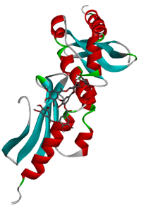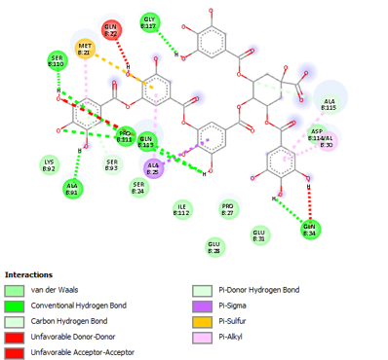
Figure 12: 2D and 3D structure of binding siteof tannin on K. pneumoniae protein (histidine kinase, CitA)
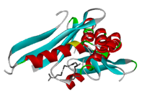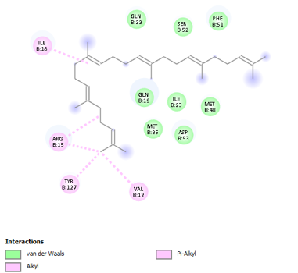
Figure 13: 2D and 3D structure of binding siteof squalene on K. pneumoniae protein (histidine kinase, CitA)
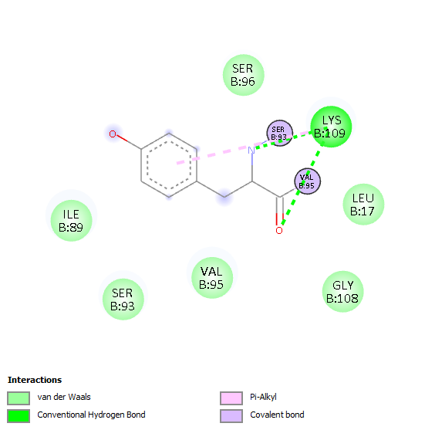
Figure 14: 2D structure of binding siteof D- Limonene on K. pneumoniae protein (histidine kinase, CitA).
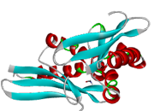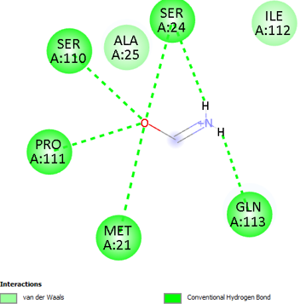
Figure 15: 2D and 3D structure of binding site of colistin (standard antibiotic) on K. pneumoniae protein (histidine kinase, CitA)
Table 7: Interaction of the Selected Organic Compounds and Bacterial Protein
Ligand-Protein Interaction | Energy (Coulomb) | Binding Affinity (kcal/mol) | RMSD (Å)
Polymyxin (Standard forA. baumannii) | 1405.08 | -3.1s | 0.0
Eugenol | 169.59 | -4.9 | 0.00
Isoeugenol | 170.74 | -5.2 | 0.00
Caryophyllene | 740.89 | -5.6 | 0.0
Tannin | 1111.94 | -8.0 | 0.0
D-Limonene | 101.92 | -4.7 | 1.77
Squalene | 248.91 | -4.4 | 0.00
Colistin (Standard for K. pneumoniae) | 1350.46 | -2.5 | 0.0
Eugenol | 169.59 | -4.8 | 0.00
Isoeugenol | 170.74 | -5.0 | 0.00
Isoeugenol | 101.92 | -4.9 | 0.00
Tannin | 1017.14 | -8.0 | 0.0
Squalene | 248.91 | -5.4 | 0.00

4.0 DISCUSSION
The DPPH assay evaluates antioxidant activity based on the ability of plant extracts to donate hydrogen/electrons to the stable free radical DPPH (deep purple color). When antioxidants neutralize DPPH, the solution becomes lighter, and absorbance decreases. In this study, the colour of DPPH solution changed from a deep purple colour to a yellowish colour indicating the ability of the extracts to scavenge free radicals. In S. aromaticum extract, highest antioxidant activity was observed at 25% prepared extract concentration DPPH inhibition with 65.95% and 63.33% in hot and cold extraction solvent respectively. This correlates with previous study by Abdelmuhsinet al. (2025) showing significant antioxidant activity of clove extract as measured by DPPH assays in various preparations. It is reported thatS. aromaticum strong free radical scavengers is due to the ability of phenols to readily donate hydrogen atoms to neutralize DPPH radicals. Also, other research work has demonstrated that ethanol and water clove extracts showed up to 90% DPPH inhibition at certain concentrations (Abo El-Maatiet al., 2016).
InK. pinnata extract, highest antioxidant activity observed at 25% concentration with 60.02% and 57.66% DPPH inhibition in the hot and cold extract respectively. This indicates the strong radical scavenging ability of the K. pinnata at lower concentration. However, antioxidant activity decreased significantly with increasing concentration, possibly due to spectrophotometric interference, phenolic compound interactions, saturation effects, or pro-oxidant behavior at high extract concentrations. At 50% concentration, the result showed a decrease in antioxidant activity in hot and cold K. pinnata extracts with 35.85% and 31.20% respectively. At 75% concentration, weak scavenging effect was observed in the extract with 12.53% and 7.66%. A similar result was reported by Christiana et al. (2019) on the ethanolic leaf extracts of K. pinnata showing notable DPPH radical scavenging activity, with IC₅₀ values in a range comparable to standard antioxidants, indicating that the plant possesses inherent free-radical scavenging potential due to its phenolic constituents. Generally, the result from this study is consistent with other similar research reporting that K. pinnata contains compounds with antioxidant activity, especially at lower concentrations (Christiana et al., 2019).
The antioxidant potential of S. aromaticum extracts by H₂O₂was found to be concentration-dependent. This is consistent with the report of Mańkowska and Dems-Rudnicka, (2025), who demonstrated that antioxidant activity of plant extracts generally increases with increasing concentration due to the availability of more phenolic and flavonoid compounds.At lower concentrations (25–50%), the cold extract exhibited stronger activity at 38.63–40.06 % compared to the hot extract at 30.07–35.37 %. The result recorded may be due to the preservation of thermolabile antioxidant compounds such as certain flavonoids and other volatile compounds, which may be partially degraded during hot extraction. At higher concentrations (75–100%), the hot extract recorded stronger scavenging activity, up to 60.35% compared to the cold extract at 50.49 %. The stronger activity observed may be as result of the heat treatment which enhances the extraction of phenolic compounds and other antioxidant compounds that are not readily released during cold conditions. The improved performance of the hot extract at higher concentrations may therefore be due to increased solubility and extraction efficiency of these compounds. The scavenging activity in K. pinnata increased from 23.55% at low concentration to 53.31% at the highest concentration. The low scavenging activity observed at low concentrations and moderate activity at higher concentrations indicates that sufficient quantities of antioxidant compounds are only effective at high concentrations.
The ADMET profiling of the selected organic compounds present in the plant chemical (eugenol, isoeugenol, 3-allyl-6-methoxyphenol, and caryophyllene) generally showed favorable pharmacokinetic properties when compared to the conventional antibiotics used (Table 5). This study corresponds with recent in silico studies on drug discovery which reported that plant-based secondary metabolites often showenhanced drug-likeness and good bioavailability as a result of their moderate molecular weight and balanced lipophilicity profiles as reported by Ajiboye et al. (2025) who predicted the pharmacokinteic properties of plant extracts to determine the binding dynamics against five selected targets of breast cancer. The absorption property of selected organic compounds (eugenol, isoeugenol, 3-allyl-6-methoxyphenol, and caryophyllene)from S. aromaticum showedgood oral absorption, with intestinal absorption values above 90% which indicategood gastrointestinal uptake suggesting that these compounds are strong candidate for oral drug formulation.This result is consistent with earlier ADMET reportsby Alminderejet al., (2020) that phenolic compounds such as eugenol and their derivativesshow high membrane permeability due to themoderate hydrophilic–lipophilic balance in their In-Silico study o the antioxidant activities of new chemotype of Piper cubeba fruit.
The distribution property showed that eugenol, isoeugenol, and caryophyllene demonstratedmoderate blood–brain barrier (BBB) permeability suggesting the potential for central nervous system penetration.This result is supported by recent pharmacokinetic studies of phytochemicals that target Helicobacter pylori andwhich confirm that small lipophilic molecules can cross the BBB through passive diffusion (Kanji et al., 2024). Caryophyllene has been reported to demonstrate neuroactive and anti-inflammatory properties partly as a result of its ability to cross the BBB (Almeida-Bezerra et al., 2025). However, the conventional antibiotics exhibited very low BBB permeability which agrees with their polar nature and large molecular size.None of the molecules were substrates of CYP2D6 or CYP3A4 which indicate a reduced chance of rapid hepatic metabolism. Conversely, eugenol and isoeugenol were identified to inhibitCYP1A2 metabolism.Such inhibition may improve bioactivity but also increases the risk of pharmacokinetic interactions when other drugs metablozed by CYP1A2 is co-administered.
The toxicity property showed that most compounds were non-mutagenic(that is, AMES negative) with the exception of eugenol which exhibit potential for AMES toxicity. However, studies indicate that eugenol demonstrates dose-dependent biological activity and toxicity is only significant at high concentrations (Tavvabi-Kashaniet al., 2024). All selected importantcompounds were predicted to be non-hERG I inhibitors. This suggests a low risk of severe cardiotoxicity. In contrast, some showed hERG II inhibitionwhich indicates a mild to moderate cardiac safety concern aligning with recent ADMET studies by Zhang et al., (2022) where phytochemicals often show reduced cardiotoxicity compared to synthetic antibiotics.
The ADMET property of the selected important compounds from K. pinnata, D-limonene, squalene, 2,6-bis(1,1-dimethylethyl)phenol, and tannin demonstratedgood pharmacokinetic profiles compared to conventional antibiotics (Table 7). This result is in consonance with report which emphasize that plant-based compounds such as terpenoids and phenolics have possess desirable drug-like features like lipophilicity and improved permeability (Amawi and Ashmawy, 2025).The observed high intestinal absorption for D-limonene, 2,6-bis compounds and squalene at 98.05 %, 94.74 %, and 89.00 % respectively showing strong oral bioavailability. Tannin and other conventional antibiotics showed zero absorption that can be attributed to their high molecular weight, thus limiting passive diffusion. The observed high Caco-2 permeability for most compounds supporttheir potential for oral drug delivery. However, the identification of D-limonene and 2,6-bis compounds act as P-glycoprotein substratesreflecting possible efflux, which may reduce intracellular accumulation.Recent ADMET report byAlminderejet al.,(2020) were similarin that some essential oil constituents are substrates of transport proteins, which affect their pharmacokinetic behavior and bioavailability. It has been reported that compounds which are structurally related to limonene exhibit neuroactive properties as a result of their ability to diffuse across lipid membranes (Amawi and Ashmawy, 2025).Squalene, which showedhighest total clearancereflect rapid elimination of lipophilic terpenoids has been associated with reduced bioaccumulation and improved safety profiles.In contrast, the negative clearance values exhibited bystandard polymyxin B and colistin usedshowed slower elimination that might contribute to toxicity risks.All selected compounds from K. pinnata were predicted to be non-mutagenic (AMES negative) and non-hERG I inhibitor reflecting their low cardiotoxic and genotoxic risks. In contrast, hERG II inhibition observed in squalene and tanninreflects moderate cardiotoxicity risk. This is in consonance withthe ADMET predictions in phytochemical studies where mild cardiac interactions may occur but less severe than synthetic compounds (Alqahtani et al., 2022).
The in-silico study and molecular docking result showed that all tested organic compounds from S. aromaticum and K. pinnata is represented in the Table 7 and Figure 1-15 below. All ligandsdemonstratednegative binding affinities at varying degrees.Among the selected ligands tested against A. baumannii protein (OmpA), tannin showed the best binding affinity at −8.0 kcal/mol. A higher interaction with bacterial cell surface proteins and enzymes resulting to bacterial inhibition has been documented by Daglia (2020) and Farhadi et al. (2021). Caryophyllene and Isoeugenol, from S. aromaticum also exhibited better binding affinity at −5.6 kcal/mol and −5.2 kcal/molwhen compared to docking with standard polymyxin.This can be attributed to the slight structural modifications which enhance interaction between the ligand and bacterial protein. The weaker bindingaffinityof D-limonene and squalene, suggests lower inhibitory/antimicrobial potentials of the K. pinnataextract against A. baumannii. The standardpolymyxin at −3.1 kcal/moldemonstrated significantly lower binding affinity compared to selected compounds.This suggests that natural compounds can sometimes have better binding potential in silico. This is in consonance with the report of Gupta et al. (2022) who reported that plant-derived compounds had better docking scores compared to conventional antibiotics.
For the selectedK. pneumoniae expression protein (histidine kinase, CitA),similar binding affinity was observed with tannin at −8.0 kcal/mol. This confirms its consistent high interaction affinity across different bacterial proteins (Sieniawska, 2021). Squalene, from K. pinnatashowedgood affinity at −5.4 kcal/mol against K. pneumoniae compared to A. baumannii, while isoeugenol at −4.9 kcal/mol and eugenol at −4.8 kcal/mol demonstrated moderate binding affinities. This further supports the best docking performance ofphytochemicals. The high binding affinity of tanninobserved may be due to its large molecular size and multiple hydroxyl groups which enable extensive hydrogen bonding and electrostatic interactions in the binding pocket. This aligns with the report by Sieniawska (2021) who reported that tannins showed against multiple bacterial species by targeting membrane enzymes and proteins.
The low RMSD values at 0.0 Å for most ligands reflectreliable conformations and stable docking poses. However, D-limonene showed a higher RMSD at 1.77 Å. This indicates less stable binding and conformational flexibility within the protein active site (Table 7) (AutoDock Vina, 2024).The 3D structure demonstrated that the ligands were well accommodated within the active site, to form stable interactions with key amino acid residues (Figure 1-15). The 2D interaction further confirmed these in silico results illustrating hydrogen bonds, hydrophobic interactions, and distance with surrounding amino acid residues which collectively contribute to the stability of the ligand–protein complex (Figure 1-15). This agrees with the findings by Lavecchia and Di Giovanni, (2021) who reported that combined non-covalent interactions are crucial for ligand specificity and stability.
CONCLUSION
This study demonstrated that S. aromaticum and K.pinnatum possess notable antioxidant and antibacterial potential with concentration-dependent free radical scavenging ability.S. aromaticum had better DPPH inhibition up to 65.95% and both plants showing increased H₂O₂ scavenging activity at higher concentrations. Molecular docking revealed strong antibacterial interactions, with tannin exhibiting the highest binding affinity (−8.0 kcal/mol) against bacteria protein from A. baumannii and K. pneumoniae. ADMET analysis indicated favorable pharmacokinetic profiles, including high intestinal absorption good permeability, low toxicity, and non-mutagenic natuure, although some showed limited solubility and enzyme interactions. This suggest that plant compounds especially tannin, eugenol and their derivatives, are promising option for developing safer and effective therapeutic agents against rising multidrug-resistant bacteria.

Data Availability
The data generated in this study are included in this article.

COMPETING INTERESTS DISCLAIMER:
Authors have declared that they have no known competing financial interests OR non-financial interests OR personal relationships that could have appeared to influence the work reported in this paper.

Disclaimer (Artificial intelligence)

Author(s) hereby declare that NO generative AI technologies such as Large Language Models (ChatGPT, COPILOT, etc.) and text-to-image generators have been used during the writing or editing of this manuscript.

REFERENCES
Abdelmuhsin, A. A., Sulieman, A. M. E., Salih, Z. A., Al-Azmi, M., Alanaizi, N. A., Goniem, A. E., & Alam, M. J. (2025). Clove (Syzygiumaromaticum) pods: Revealing their antioxidant potential via GC-MS analysis and computational insights. Pharmaceuticals, 18(4), 504. https://doi.org/10.3390/ph18040504
Abo El-Maati, M. F., Mahgoub, S. A., Labib, S. M., Al-Gaby, A. M. A., & Ramadan, M. F. (2016). Phenolic extracts of clove (Syzygiumaromaticum) with novel antioxidant and antibacterial activities. European Journal of Integrative Medicine, 8(4), 494–504. https://doi.org/10.1016/j.eujim.2016.02.006
Ajiboye, B. O., Fatoki, T. H., Akinnusi, P. A., Ajuwon, O. R., Oyinloye, B. E., Jeje, T. O., Owolabi, O. V., Ogedengbe, O. O., & Genovese, C. (2025). Molecular docking, MMGBSA, and ADMET studies of phytoconstituents of Ocimumgratissimum on multiple breast cancer targets. Natural Product Research, 39(16), 4669–4677. https://doi.org/10.1080/14786419.2024.2344193
Akinterinwa, E. T., Oladejo, B. O., &Oladunmoye, M. K. (2025). Antibacterial, antioxidant, and phytochemical properties of Bryophyllumpinnatum (Lam.) leaf extracts against pathogenic bacteria. Journal of Vocational Health Studies, 9(1), 54–63. https://doi.org/10.20473/jvhs.V9.I1.2025.54-63
Almeida-Bezerra, J. W., da Costa Silva, J. T., Morais-Braga, M. F. B., da Cruz, R. P., Alencar, G. G., Alves, D. S., de Sousa Rodrigues, E. Y., de Sousa, S. G., de Menezes, I. R. A., Rocha, J. E., Filho, J. M. B., Leite Dos Santos, C. A., Costa, A. R., Domiciano, C. B., de Lima, L. R., &Coutinho, H. D. M. (2025). ADME/Tox study and the effect of β-caryophyllene on the resistant strain of Staphylococcus aureus carrying the QacA/B efflux pump gene. Toxicology Reports, 14, 101929. https://doi.org/10.1016/j.toxrep.2025.101929
Alminderej, F., Bakari, S., Almundarij, T. I., Snoussi, M., Aouadi, K., & Kadri, A. (2020). Antioxidant activities of a new chemotype of Piper cubeba L. fruit essential oil (methyleugenol/eugenol): In silico molecular docking and ADMET studies. Plants, 9(11), 1534. https://doi.org/10.3390/plants9111534
Alqahtani, S., Mohamed, T., & Khan, A. (2022). In silico ADMET prediction of natural compounds: Implications for drug discovery. Journal of Biomolecular Structure and Dynamics, 40(14), 6789–6802.
Amawi, R. M., & Ashmawy, N. S. (2026). GC-MS-based metabolic profiling of essential oils from Citrus paradisi, Lawsoniainermis, and Rutagraveolens and assessment of their acetylcholinesterase inhibitory potential. Frontiers in Chemistry, 13, 1761973. https://doi.org/10.3389/fchem.2025.1761973
Asma, H. S., & Amzad, M. H. (2015). Evaluation of total phenols, total flavonoids and antioxidant activity of the leaves crude extracts of locally grown pigeon pea traditionally used in Sultanate of Oman for the treatment of jaundice and diabetes. Journal of Coastal Life Medicine, 3(4), 317–321.
AutoDock Vina Documentation. (2024). Basic docking protocol.
Christiana, K. A., Mary, K. L., & Esther, A. A. (2019). Phytochemical, antioxidant and antimicrobial evaluation of Nigerian Kalanchoe pinnata (Lam.). Journal of Chemical Society of Nigeria, 44(6). https://journals.chemsociety.org.ng/index.php/jcsn/article/view/374
Daglia, M. (2020). Polyphenols as antimicrobial agents. Current Opinion in Biotechnology, 23(2), 174–181.
Daina, A., Michielin, O., & Zoete, V. (2017). SwissADME: A free web tool to evaluate pharmacokinetics, drug-likeness and medicinal chemistry friendliness of small molecules. Scientific Reports, 7, 42717. https://doi.org/10.1038/srep42717
Farhadi, F., Khameneh, B., Iranshahi, M., & Iranshahy, M. (2019). Antibacterial activity of flavonoids and their structure–activity relationship: An update review. Phytotherapy Research, 33(1), 13–40. https://doi.org/10.1002/ptr.6208
Forli, S., Huey, R., Pique, M. E., Sanner, M. F., Goodsell, D. S., & Olson, A. J. (2016). Computational protein–ligand docking and virtual drug screening with the AutoDock suite. Nature Protocols, 11(5), 905–919. https://doi.org/10.1038/nprot.2016.051
Gupta, A., Sharma, S., & Verma, S. (2022). Molecular docking studies of phytochemicals against resistant bacterial strains. Journal of Biomolecular Structure and Dynamics, 40(12), 5678–5690.
Gyawali, R., & Ibrahim, S. A. (2014). Natural products as antimicrobial agents. Food Control, 46, 412–429. https://doi.org/10.1016/j.foodcont.2014.05.047
Kanji, S., & Mondal, S. (2024). In silico exploration for potent phytochemicals targeting Helicobacter pylori: Assessment of ADMET profiles and molecular docking analysis. Discover Chemistry, 1, 21. https://doi.org/10.1007/s44371-024-00028-4
Lavecchia, A., & Di Giovanni, C. (2021). Virtual screening strategies in drug discovery. Current Medicinal Chemistry, 20(23), 2839–2860.
Lipinski, C. A., Lombardo, F., Dominy, B. W., & Feeney, P. J. (2001). Experimental and computational approaches to estimate solubility and permeability in drug discovery. Advanced Drug Delivery Reviews, 46(1–3), 3–26. https://doi.org/10.1016/S0169-409X(00)00129-0
Malini, G., Saranya, B., & Parameswari, A. (2023). Review on extraction techniques for medicinal and aromatic plants. International Journal of Pharmaceutical Chemistry and Analysis, 10(4), 253–256. https://doi.org/10.18231/j.ijpca.2023.042
Mańkowska, D., & Dems-Rudnicka, K. (2025). Antioxidant activity and phenolic compounds in medicinal plants: A comparison of organic and conventional Mentha piperita, Melissa officinalis, Salvia officinalis, and Urtica dioica. Molecules, 30(24), 4812. https://doi.org/10.3390/molecules30244812
O’Neill, J. (2016). Tackling drug-resistant infections globally: Final report and recommendations. Wellcome Trust. https://amr-review.org
Sieniawska, E. (2021). Activities of tannins—from in vitro studies to clinical trials. Natural Product Communications, 16(5), 1–12. https://doi.org/10.1177/1934578X211026954
Tavvabi-Kashani, N., Hasanpour, M., Baradaran Rahimi, V., Vahdati-Mashhadian, N., & Askari, V. R. (2024). Pharmacodynamic, pharmacokinetic, toxicity, and recent advances in eugenol's potential benefits against natural and chemical noxious agents: A mechanistic review. Toxicon, 238, 107607. https://doi.org/10.1016/j.toxicon.2024.107607
Uddin, A. B. M. N., Hossain, F., Reza, A. S. M. A., Nasrin, M. S., & Alam, A. H. M. K. (2022). Traditional uses, pharmacological activities, and phytochemical constituents of the genus Syzygium: A review. Food Science & Nutrition, 10(6), 1789–1819. https://doi.org/10.1002/fsn3.2797
Zhang, L., Sun, Y., & Liu, Q. (2022). Sustained-release polymyxin-loaded nanoparticles for treatment of multidrug-resistant Gram-negative infections. Journal of Controlled Release, 347, 675–687. https://doi.org/10.1016/j.jconrel.2022.05.041

