Original Research Article

Spatial Clustering and Factors Associated with Acute Respiratory Infection among Under-five Children in India: A District-level Perspective

ABSTRACT
Background: Acute Respiratory Infection (ARI) is one of the leading causes of death in children Under-five years (U5), especially in developing countries like India. Despite various efforts by international and national agencies, the prevalence of ARI among children in India has increased from 2016 to 2021. Therefore, the present study was conducted to estimate the prevalence and contextual factors associated with ARI among U5 children across districts in India.
Methods: The study used data from the National Family Health Survey-5 conducted during 2019-21. We used spatial analysis software (ArcGIS and GeoDa) to demonstrate the spatial prevalence and clustering across districts in India. A multilevel logistic regression model was employed to identify the factors associated with ARI.
Results: . The study revealed that the prevalence of ARI in India is 2.8 percent. The clustering analysis (Moran’s I=0.27) identified 58 hot-spot and 66 cold-spot districts across India. Most of the hot-spot districts are from Uttar Pradesh, Maharashtra, Panjab, Delhi, Jammu & Kashmir, Odisha and Assam. The study also found significant associations between the prevalence of ARI in India and exposure to smoking in the household (AOR:1.13; 95% CI: 1.06-1.19), mothers with respiratory illness/asthma (AOR:2.33; 95% CI: 1.93-2.8), mothers' smoking behaviour (AOR:1.34; 95% CI:1.2-1.5), child malnutrition (AOR:1.08; 95% CI: 1.02-1.18), and history of diarrhoea (AOR:3.76, 95% CI: 3.52-4.02).
Conclusion: The study recommends that public health programs focus on the high prevalence and hotspot districts and implement a district and state-level policy to control the incidence and burden of childhood ARI in India.
Kew Words: Acute Respiratory Infection, Spatial clustering, Prevalence, Hot-spot, , ArcGIS

INTRODUCTION
Acute respiratory infections (ARIs) remain one of the most prevalent health problems affecting children under five years of age worldwide. According to the World Health Organization, ARIs account for approximately 20% of all global deaths among children under five years of age (WHO, 2022a). The principal infectious agents responsible for ARIs include influenza viruses (IV), parainainfluenza viruses (PIV), adenoviruses (ADVs), and coronavires (CVs) (Lukšić et al., 2013). Among these infections, lower respiratory tract infections (LRTIs) constitute a major public health concern and are recognised as the leading causes of morbidity and mortality among children under five globally (Troeger et al., 2018; WHO, 2022b). In 2016 alone, LRTIs were responsible for an estimated 652,572 deaths among children younger than five years worldwide (Troeger et al., 2018). Nevertheless, the burden of ARI-related mortality exhibits substantial regional variation (Wang et al., 2017). Evidence from a multi-country study conducted across 28 sub-Saharan African nations reported an overall ARI prevalence of 25.3% among children under five years of age (Seiduu et al., 2019).
ARI continues to represent a major cause of mortality among children below five years of age, particularly in low-income and developing countries (Frese et al., 2011; Walker et al., 2013), including India (WHO, 1998). It has been estimated that Bangladesh, India, Indonesia, and Nepal collectively account for approximately 40% of global ARI-related mortality (Kumar et al., 2015). In India, ARIs contribute to nearly 30–50% of outpatient health facility visits and 20–40% of hospital admissions among children (Vashishtha, 2010). Beyond their health implications, ARIs also impose considerable economic burdens on households and society through increased healthcare expenditure, productivity losses, and long-term social consequences (Ramaekers et al., 2017).
The reduction of ARI-related morbidity and mortality is therefore essential for India to achieve the targets outlined under the United Nations Sustainable Development Goals (SDGs), particularly SDG 3.2, which aims to end preventable deaths of newborns and children under five years of age by 2030 (SDG-UN, 2015). In addition, the World Health Organization and UNICEF have jointly formulated the Global Action Plan for Pneumonia and Diarrhoea (GAPPD) to reduce preventable childhood deaths associated with pneumonia and diarrhoeal diseases by 2025. In alignment with these global commitments, India has established a national target of reducing under-five mortality to 25 deaths per 1,000 live births by 2030 (SDG-UN, 2015). However, according to the International Institute for Population Sciences National Family Health Survey-V (NFHS-V, 2019–21), the current under-five mortality rate remains substantially higher at 42 deaths per 1,000 live births (IIPS IC, 2021). Furthermore, the prevalence of ARIs in India increased marginally from 2.7% to 2.8% between 2016 and 2019 (IIPS IC, 2021), indicating the persistent burden of these infections despite ongoing public health interventions.
Although several international and national programmes have been implemented to prevent and control childhood illnesses such as diarrhoea, pneumonia, and ARIs, a considerable proportion of children, particularly those from socioeconomically disadvantaged backgrounds, continue to suffer from these preventable conditions, resulting in substantial levels of child morbidity and mortality in developing countries, including India (Tiwari et al., 2016). Previous studies have also highlighted the importance of employing multilevel analytical approaches, as contextual factors operating at community, district, and state levels may significantly influence ARI outcomes (Varghese and Muhammad, 2023). However, district-level investigations examining the spatial distribution and determinants of ARI episodes across India remain limited. Given that India contributes substantially to the global burden of live births and neonatal mortality, progress in reducing ARI-related child mortality will be critical for achieving the SDG targets.
In this context, a comprehensive understanding of the prevalence, spatial clustering, and determinants of ARIs among children across districts of India is of considerable public health importance. Therefore, the present study aims to examine the prevalence and spatial clustering of ARIs among children in India and to identify the contextual factors associated with these infections through hotspot analysis. The identification of hotspot districts and the underlying determinants of ARIs will provide valuable evidence for healthcare practitioners, researchers, and policymakers in designing targeted interventions and region-specific public health strategies. Such evidence-based approaches may contribute significantly to reducing the burden of ARIs and advancing India’s progress towards achieving SDG target 3.2 by 2030.

DATA SOURCE AND METHODOLOGY

2.1 Data Source
The present study was based on the NFHS-5, which was conducted during 2019-21 by the Ministry of Health and Family Welfare (MoHFW), India. NFHS is a large, nationally representative demographic survey that covers all states, union territories, and districts of India. The NFHS seeks to provide data on various aspects of maternal and child health, including fertility, mortality, morbidity, immunization, reproductive health, and domestic violence. A two-stage stratified random sampling design was used to collect the data. NFHS complied with internationally accepted ethical standards of medical research. The data are publicly available in science and no additional ethical approval is necessary.The data is freely available on DHS website: https://dhsprogram.com/data/dataset_admin/login_main.cfm

2.2 Study Design and Sample Size
This large scale survey was done using two-stage stratified sampling techniques. In urban areas Primary Sampling Units (PSUs) are selected as Census Enumeration Blocks (CEB) and in rural areas villages are selected as PSUs. In the second stage, households have been selected in urban and rural areas (IIPS IC, 2021). NFHS-5 covered 636,699 households out of which 724,115 women respondents (15-49) and 101,839 men respondents (15-54). Given the objectives of our study, we have opted to analyse responses from female respondents only. 230,870 children, children's mothers interviewed, who were live born in the last five years (n=230,870). The total number of children was 230,870. Among them, 8637 dead children. Children who lived elsewhere or who did not live with their mothers were excluded (N=8637). Finally, a total of 2,22,233 under-five children were alive at the time of the interview and had been born to the women interviewed in the five years before the survey (Figure 1).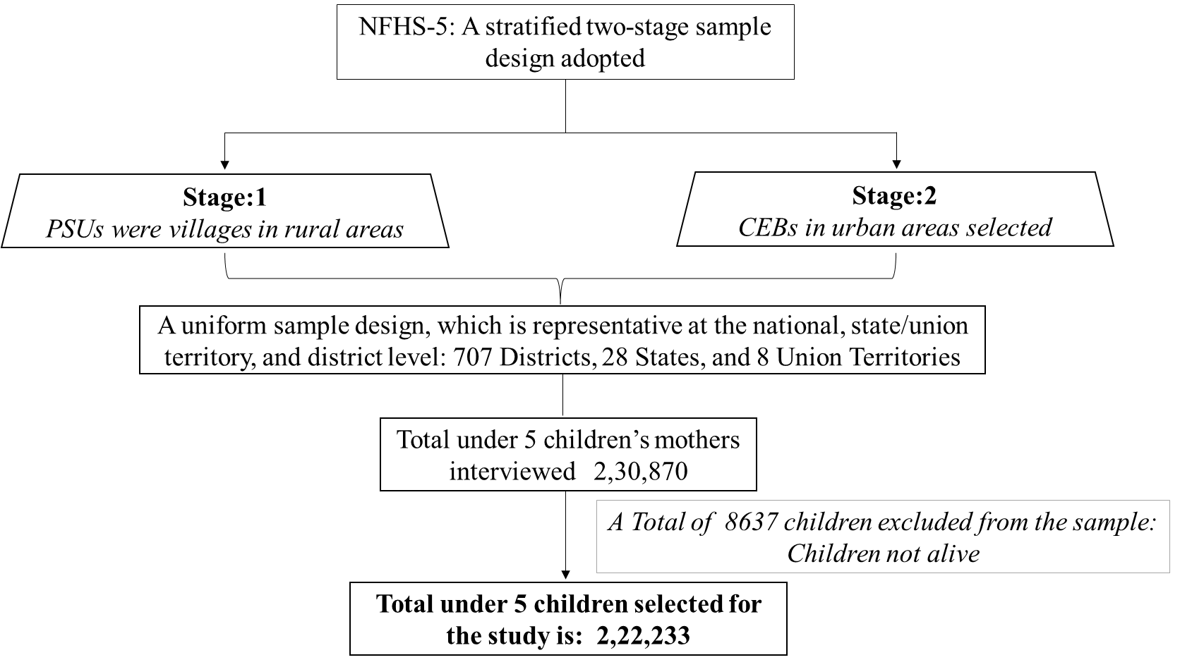
Figure 1: Flow diagram showing children aged 0-59 months included in the study for analysis from NFHS-5, 2019-2021, India

2.3 Dependent and Independent Variables
Acute Respiratory Infection (ARI): The NFHS survey asked mothers if their children had had a cough in the two weeks preceding the survey. This kind of cough is associated with fast, shallow breathing with pain in the chest. If the answer was “yes”, the respective variable was recoded to 1, indicating the presence of ARI. If the answer was “no”, it was recorded as 0, which means no ARI.
Independent Variable: The independent variables were selected from previous studies and available data sets (Varghese and Muhammad, 2023; Hasan et al., 2022). Table 1. Description of the selected variables.
Table 1: Description of the Explanatory Variable
Variables | Description of the Variable
- Household Environment
Type of House | House type categories as (1) Kaccha house (2) Semi-pucca houses
Type of fuel used for cooking | Cooking fuel categories as (1) Unclean Fuel (kerosene, coal, lignite, charcoal, wood, straw/shrubs/grass, agricultural crop, animal dung, and other); and (2) Clean fuel /no food cooked at home (electricity, LPG, biogas, no food cooked in house)
Smoke exposure in the household | Household’s smoking exposure recorded as (0) No and (1) Yes
Separate kitchen | Availability of a separate kitchen is coded as (0) for a household without a separate kitchen, and (1) for a household with a separate kitchen.
Household crowding | Household crowding is classified as follows: (1) Not crowded (<= 3 persons sleep in a room); (2) Crowded (> 3 persons sleep in a room); and (3) No room for sleep.
Place of handwashing in household | Handwashing in households is categorized as (0) if not observed and (1) if observed.
Season of interview | The season of the interview was considered and was classified as (1) Winter Season (October-January); (2) Summer Season (February-May); and (3) Rainy Season (June-September)
- Socio-Economic Characteristics
Place of Residence | Place of residence has two categories: (1) urban and (2) rural
Social Group | Social groups are coded into four categories: Scheduled Caste (SC) (1), Scheduled Tribe (ST) (2), Other Backward Classes (OBC) (3), 'Others' (4)
Religion Group | Religion is categorized into two groups: (1) Hindu, (2) Non-Hindu (including Muslim, Christian, Sikh, Buddhist, neo-Buddhist, Jain, Jewish, and others).
Wealth Quintile | The wealth index is a measure of a household's wealth based on the possessions and facilities they have. It reflects their socio-economic status, with each household receiving a score based on the goods they own. To calculate this score, 33 different assets and housing features were considered using Principal Component Analysis. The resulting score is then divided into five equal categories: (1) poorest, (2) poorer, (3) middle, (4) richer, and (5) richest, each representing 20% of the population.
- Maternal Characteristics
Mother's education | The education level of women is classified into four categories: 'no education' (0), 'primary' (1), 'secondary' (2), 'higher' (3).
Mother's age | The age of women has four categories: '15–19' (1), '20–29' (2), '30–29' (3), '40–49' (4)
Mother smoking exposure | Mother's smoking behavior is recorded as follows: (1) if she smokes bidis and cigarettes regularly, and (2) for never smokers.
Mother exposure to mass media | Exposure to mass media (contents of newspapers/magazines, television, and radio) is divided into four categories: (0) 'no' (the respondent is not exposed to any mass media), (1) 'low' (the respondent is exposed to any one type of mass media); (2) 'medium' (exposed to any two types of mass media); (3) 'high' (the respondent is exposed to all three types of mass media).
Mother had respiratory diseases/asthma | Chronic respiratory disease in women, including asthma, is classified as: (0) No, and (1) Yes."
- Children Characteristics
Age of Child (Months) | The age of the child at the time of survey is recorded in completed months as follows: (1) 0-11 months; (2) 12-23 months; (3) 24-35 months; (4) 36-47 months; and (5) 48-59 months.
Sex of the child | The sex of the child was used as original (1) male (2) female
Child Nutrition Status | As per the NFHS guideline, the children whose weight-for-age Z-score (WAZ) is below minus two standard deviations (-2 SD) from the median are classified as underweight. On the other hand, children whose WAZ score is below minus three standard deviations (-3 SD) from the median are considered as severely underweight.
Whether the child had diarrhoea | Childhood diarrohea is classified as: (0) No, and (1) Yes.
Child’s birth order | The original birth order of the child was categorized into two groups: (1) less than 3, and (2) 3 or more.
- Others
Regions in India | The NFHS categorizes the regions as follows: The Northern region comprises Chandigarh, Delhi, Haryana, Himachal Pradesh, Jammu & Kashmir, Punjab, Rajasthan, Uttarakhand, and Ladakh. The Eastern region includes Bihar, Jharkhand, Odisha, and West Bengal. The North-Eastern region is made up of Arunachal Pradesh, Assam, Manipur, Meghalaya, Mizoram, Nagaland, Sikkim, and Tripura. The Central region consists of Chhattisgarh, Madhya Pradesh, and Uttar Pradesh. The Western region encompasses Dadra & Nagar Haveli, Daman & Diu, Goa, Gujarat, and Maharashtra. Lastly, the Southern region contains Andaman & Nicobar Islands, Andhra Pradesh, Karnataka, Kerala, Lakshadweep, Puducherry, Tamil Nadu, and Telangana.

2.4 Spatial Analysis
Based on NFHS-V data, we conducted some studies using a spatial autocorrelation analysis to identify the spatial clustering patterns of childhood diarrhoea across districts in India (Ghosh et al., 2023). The same measure was used for the ARI prevalence and for clustering analysis using the latest data from NFHS-5. We analyzed the data with both methods. (i) Moran's I, provides a general indication of the spatial autocorrelation of a dataset over the neighbourhood districts. (ii) Local indicator of spatial association (LISA) that identifies the spatial clusters or outliers for each location in a dataset.
Moran’s I: The spatial autocorrelation is computed using a global measure of Moran’s I statistic which measures the extent to which data points are randomly or perfectly clustered and similar to their spatial neighbours (Anselin, 2013; Bivand et al., 2015). It measures how similar an object is to its neighboring objects and calculates a correlation coefficient that reflects the overall spatial autocorrelation of the data set. Moran’s- I is between −1 and +1 (Anselin, 2013; Bivand et al., 2015; Ghosh et al., 2020).
Local Indicators of Spatial Autocorrelation (LISA): LISA map is a measure of autocorrelation across neighbourhood districts (Anselin, 2013; Bivand et al., 2015; Ghosh et al., 2020; Ghosh et al., 2023). LISA measures the similarity of its values with the values of its neighboring districts and also checks the significance level at each location. LISA map shows results for three scenarios:
- Hot-Spots
- High-high: High values with similar neighbours.
- Cold-Spots:
- Low-low: Low values with similar neighbours.
- Spatial Outliers
- Low-high: Low values but with higher values of neighbours.
- High-low: High values but with low-value neighbours.
- no significant local autocorrelation

2.5 Statistical Analysis
Multilevel Logistics Regression: Multilevel models are particularly appropriate for the analysis of hierarchical and clustered data structures. Failure to account for such hierarchical clustering may lead to biased estimation of standard errors associated with predictor variables and residual error terms, thereby compromising the validity of statistical inferences. Owing to the sampling design employed in the National Family Health Survey (NFHS), the dataset exhibits a clear hierarchical structure in which women and men are nested within households, households are nested within primary sampling units (PSUs) or villages, and these are further nested within districts and states.

This data structure leads to a dataset where observations are not completely independent as they are sampled from the same household or primary sampling unit (PSU). This violates the assumption of independent observations in a simple regression model. Such data sets can be handled by a Multilevel model that also provides standard error adjustments for clustered observations. Another reason for using multilevel logistic regression in this study is to estimate the effect of contextual variables at the village or community level on the prevalence of childhood ARI. These variables are fixed across individuals within a community, leading to a clustering effect that can only be accounted for through the fitting of a multilevel regression model (Ghosh et al., 2023). A logit model with four levels can be written as:
logit=

Whereas,
i, j, k, and l are the level one (individual)
level 2 (village or PSU)
level 3 (district) and level 4 (state) or community units, respectively
is the probability of suffering from ARI, for the i^{th} children in the j^{th}, k^{th} and l^{th} PSUs, districts, and state level.

We performed multilevel logistic regression analysis and district-level analysis using STATA 14 software. It is always good to look at the extent to which the outcome of interest varies at a higher level before applying multilevel models. We used logistic model and Hosmer-Lemeshow chi-square (p=0.678) showed insignificant relationship, meaning the model is suitable for logistic regression. Furthermore, we applied a multilevel logistic model after accounting for the district, which gave a significant intra-cluster correlation coefficient (ICC), suggesting that a multilevel model is appropriate and best fit for our study (Ghosh et al., 2023).
Multicollinearity Check: The Variance Inflation Factors (VIFs) were measured to determine the level of multi-collinearity in the model (Midi et al., 2010). The average VIF computed was 1.83, well below the conventional threshold of five, indicating that multicollinearity is not an issue in the models examined (see Supplementary file 1).

Results

3.1 Prevalence with Geographical Variance of ARI among under-five children across the State/UTs in India
Table 2 gives the prevalence of childhood ARI in the States/UTs of India. The national prevalence of ARI has increased slightly from 2.7 percent in 2016 to 2.8 percent in 2021. ARI was more common in rural (2.3%) than urban (3.0%) children. Delhi (5.6%) has the highest prevalence of ARI, and Dadra & Nagar Haveli/Daman & Diu (0.3%) has the lowest prevalence of ARI in 2021. About 72 percent of States/UTs have children having higher prevalence of ARI than the national average (i.e, 2.8%). Northeast, eastern and central regions are more prevalent than the national average (i.e., 2.8%).

Table 2: Prevalence of ARI among children (0-5 years) across the state and UTs in India in NFHS-IV (2019-21)
State/UTs | Weighted Prevalence of ARI (in Percentage)
State/UTs | Total | Urban | Rural | Sample (N)
A. North Region | 3.0 | 3.2 | 2.9 | 29, 963
Chandigarh | 0.3 | 0.3 | 0.0 | 141
Nct Of Delhi | 5.6 | 5.5 | 6.0 | 2, 868
Haryana | 2.3 | 1.9 | 2.5 | 4, 256
Himachal Pradesh | 1.5 | 4.0 | 1.1 | 934
Jammu & Kashmir | 3.9 | 2.9 | 4.1 | 1, 611
Punjab | 2.5 | 1.3 | 3.1 | 3, 949
Rajasthan | 2.9 | 2.6 | 3.0 | 14, 430
Uttarakhand | 2.3 | 2.9 | 1.9 | 1, 748
Ladakh | 5.3 | 10.5 | 4.0 | 26
B. Central Region | 3.2 | 2.7 | 3.3 | 61, 096
Chhattisgarh | 1.5 | 1.5 | 1.5 | 4, 849
Madhya Pradesh | 2.6 | 3.2 | 2.5 | 13, 271
Uttar Pradesh | 3.5 | 2.7 | 3.8 | 42, 976
C. East Region | 3.1 | 2.4 | 3.3 | 57, 887
Bihar | 3.5 | 2.9 | 3.7 | 28, 959
Jharkhand | 2.1 | 1.6 | 2.2 | 6, 678
Odisha | 3.2 | 2.8 | 3.2 | 6, 906
West Bengal | 2.8 | 2.1 | 3.1 | 15, 344
D. Northeast Region | 2.5 | 2.4 | 2.5 | 8, 115
Arunachal Pradesh | 2.1 | 2.5 | 2.1 | 170
Assam | 2.5 | 2.5 | 2.5 | 5, 649
Manipur | 1.8 | 2.4 | 1.4 | 437
Meghalaya | 4.8 | 5.8 | 4.7 | 838
Mizoram | 0.6 | 0.9 | 0.2 | 176
Nagaland | 1.1 | 1.0 | 1.1 | 206
Sikkim | 0.7 | 0.8 | 0.7 | 60
Tripura | 1.3 | 0.8 | 1.5 | 579
E. West Region | 2.4 | 1.9 | 2.8 | 27, 916
Dadra & Nagar Haveli and Daman & Diu | 0.3 | 0.6 | 0.1 | 85
Goa | 0.9 | 0.0 | 2.4 | 199
Gujarat | 1.0 | 0.9 | 1.1 | 9, 418
Maharashtra | 3.2 | 2.4 | 3.8 | 18, 213
F. South Region | 1.8 | 1.6 | 1.9 | 37, 256
Andaman & Nicobar Islands | 1.7 | 0.0 | 3.2 | 39
Andhra Pradesh | 2.4 | 2.1 | 2.4 | 7, 081
Karnataka | 1.5 | 1.2 | 1.7 | 9, 881
Kerala | 2.4 | 1.9 | 2.9 | 4, 502
Lakshadweep | 1.4 | 2.0 | 0.0 | 10
Puducherry | 4.9 | 6.4 | 1.6 | 145
Tamil Nadu | 1.1 | 1.4 | 0.9 | 10, 610
Telangana | 2.2 | 1.9 | 2.5 | 4, 988
India | 2.8 | 2.3 | 3.0 | 2, 22, 233

3.2 Spatial prevalence of ARI among children (0–5 years) across the districts in India (2019-21)
Figure 2 shows the spatial pattern of ARI across the 707 districts of India for the year 2019-21. From the map it can be seen that around 36 percent of districts (254 out of 707) in India had a prevalence of ARI above the national average of 2.8 percent. In 2016, further, the prevalence was between 2% and 2.8% for 15% (109 districts) and less than 2% for the rest of 49% districts. The highest prevalence of ARI was found in Gonda (19.5%) and Bundi (16.6%) districts of Uttar Pradesh and Rajasthan. The high prevalence districts are mainly situated in the states of Uttar Pradesh, Bihar, Madhya Pradesh, Jammu & Kashmir, Chhattisgarh, Meghalaya, Delhi, Odisha, Rajasthan, Telangana and Andhra Pradesh.
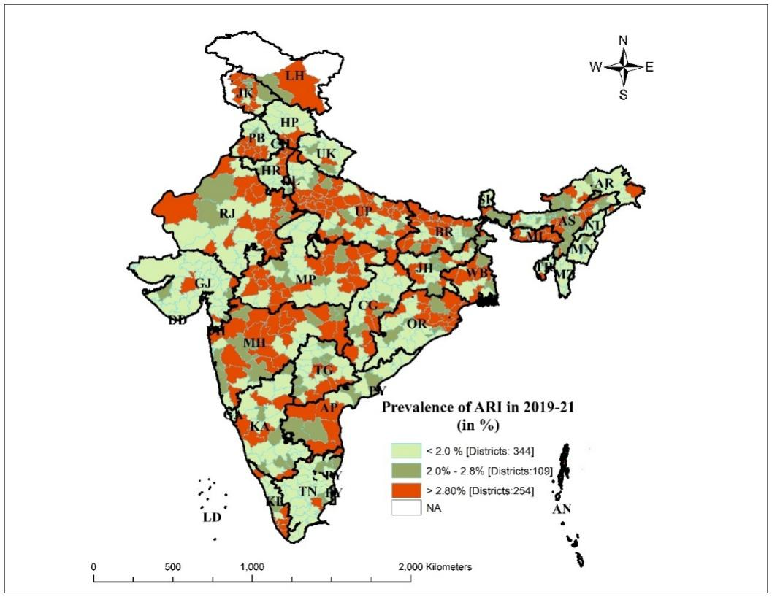
Figure 2: Prevalence of ARI among children (0–5 years) across the districts in India (2019-21

3.3 Spatial clustering of ARI across the districts in India
Figure 3 depicts the spatial clustering in the prevalence of ARI in districts of the country. The results show that 58 districts were identified as hotspot areas out of 707 districts (Figure 3-A) with a value of Moran’s Index of 0.27 indicating a positive spatial autocorrelation. The majority of the hotspot districts are mainly concentrated in Maharashtra, Uttar Pradesh, Panjab, Jammu & Kashmir, Assam and Odisha. On the other hand, 66 districts are classified as cold spots and are predominantly in Mizoram, Gujarat and Tamil Nadu. The significance map also shows around 152 districts were found statistically significant with a ≤5% significance level (Figure 3-B).

- LISA cluster map | - LISA significance map
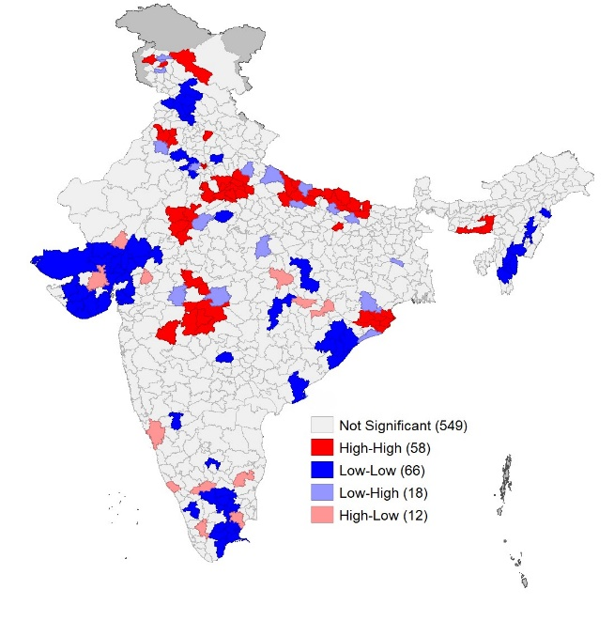 | 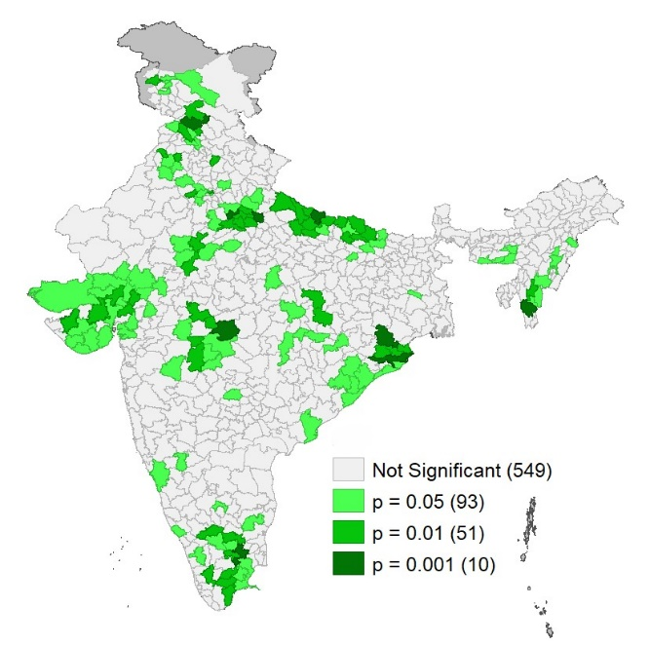
Figure 3: LISA cluster map and significance map for ARI prevalence among children in districts of India, 2019–21 (NFHS-5)

3.4 Prevalence of ARI with background characteristics
Table 3 shows the prevalence of ARI among children with the background characteristics in India during 2021. The analysis showed that semi pucca houses (3.7%) and household using unclean cooking fuel (2.9%) had higher prevalence of ARI than their counterparts. In addition, childhood ARI was more prevalent in households exposed to smoking (3.2%) and households without separate kitchens (3.3%).
Findings indicate that the prevalence of ARI among rural children (3%) and children from poor households (3.2%) is higher than their counterparts. Among social groups, the SC caste group had the highest prevalence (3.0%) and the ST group the lowest (2.4%).
According to the mother’s characteristics, it was found that exposure to smoking by the mother (4.07%) and having respiratory diseases/asthma (7.03%) increased the prevalence of childhood ARI. More cases of childhood ARI are also seen in mothers with primary education (3.4%) and in mothers aged 15-24 years (3.1%). If the mother had respiratory diseases/asthma, the prevalence of childhood ARI was found to be higher (7%). Interestingly, children born to smoking mothers have a significantly lower incidence of ARI than children born to non-smoking mothers.

Table 3: Multilevel logistic regression model assessing the factors associated with ARI among children (0-59 Months) in India

Background characteristics | Sample N (%) | Prevalence N (%) | AOR 95% CI
A. Household Environment
House type |  | χ2 p<.001*
Kuchha | 517 (0.3) | 14 (2.75) | Ref.
Semi-Pucca | 40,537 (18.2) | 1489 (3.68) | 1.24 (0.73-2.11)
Pacca | 1,81,178 (81.5) | 4694 (2.6) | 1.16 (0.68-1.97)
Household cooking environment |  | χ2 p <.001*
Clean cooking environment | 1,11,637 (50.2) | 2899 (2.6) | Ref.
Unclean cooking environment | 1,10,596 (49.8) | 3299 (2.99) | 0.99 (0.93-1.07)
Smoking exposure in the household |  | χ2 p<.001*
No | 1,20,699 (54.3) | 2990 (2.48) | Ref.
Yes | 1,01,534 (45.7) | 3208 (3.16) | 1.13 (1.06-1.19) ***
Separate kitchen in the household |  | χ2 p<.001*
No | 60,635 (27.3) | 1991 (3.29) | Ref.
Yes | 1,61,598 (72.7) | 4206 (2.61) | 0.95 (0.89-0.97) *
Persons per room used for sleeping |  | χ2 p=0.121
≤ 3 persons | 1,12,029 (50.4) | 3106 (2.78) | Ref.
More than 3 persons | 1,08,496 (48.8) | 3037 (2.8) | 0.91 (0.86-0.97) **
No room for sleeping | 1,708 (0.8) | 54 (3.18) | 1.19 (0.89-1.59)
Season of interview |  | χ2 p<.001*
Winter Season | 83,938 (37.8) | 2421 (2.89) | Ref.
Summer Season | 70,685 31.8 () | 1985 (2.81) | 1.03 (0.91-1.15)
Rainy Season | 67,610 (30.4) | 1792 (2.65) | 1.07 (0.94-1.22)
Place of hand washing in household |  | χ2 p=0.548
Not observed | 8,184 (3.7) | 257 (3.15) | Ref.
Observed | 2,14,049 (96.3) | 5941 (2.78) | 1.02 (0.88-1.18)
B. Socio-Economic Characteristics
Place of residence |  | χ2 p<.001*
Urban | 59,780 (26.9) | 1378 (2.31) | Ref.
Rural | 1,62,452 (73.1) | 4820 (2.97) | 1.05 (0.97-1.14)
Social group |  | χ2 p<.001*
SC | 51,395 (23.1) | 1551 (3.02) | Ref.
ST | 22,135 (10) | 532 (2.41) | 0.86 (0.77-0.95) **
OBC | 96,762 (43.5) | 2676 (2.77) | 0.97 (0.91-1.05)
Others | 51,941 (23.4) | 1438 (2.77) | 0.99 (0.91-1.08)
Religion rroup |  | χ2 p=0.466
Hindu | 1,76,335 (79.3) | 4927 (2.8) | Ref.
Non-Hindu | 45,897 (20.7) | 1271 (2.77) | 1.03 (0.95-1.11)
Household wealth quintile |  | χ2 p<.001*
Poor | 53,817 (24.2) | 1723 (3.21) | Ref.
Poorer | 47,984 (21.6) | 1472 (3.07) | 0.97 (0.89-1.05)
Middle | 43,519 (19.6) | 1167 (2.69) | 0.91 (0.83-1.01) *
Richer | 41,242 (18.6) | 993 (2.41) | 0.89 (0.79-1) **
Richest | 35,671 (16.1) | 844 (2.37) | 0.97 (0.84-1.12)
C. Maternal Characteristics
Mother's education |  | χ2 p<.001*
Not educated | 46,635 (21) | 1343 (2.88) | Ref.
primary | 27,133 (12.2) | 915 (3.38) | 1.21 (1.11-1.32) ***
Secondary | 1,13,099 (50.9) | 3169 (2.81) | 1.08 (1-1.17)
Higher | 35,366 (15.9) | 772 (2.19) | 0.99 (0.89-1.11)
Mother's age |  | χ2 p<.001*
14-24 Years | 72,967 (32.8) | 2269 (3.12) | Ref.
25-34 Years | 1,30,954 (58.9) | 3458 (2.65) | 0.94 (0.88-1) *
35 Years and above | 18,312 (8.2) | 470 (2.57) | 0.99 (0.89-1.1)
Mother smoking exposure |  | χ2 p<.001*
No | 2,15,130 (96.8) | 5909 (2.75) | Ref.
Yes | 7,102 (3.2) | 289 (4.07) | 1.34 (1.2-1.5) ***
Mother exposure to mass media |  | χ2 p=0.224
No | 63,206 (28.4) | 1781 (2.82) | Ref.
Yes | 1,59,026 (71.6) | 4416 (2.78) | 1.18 (1.1-1.26) ***
Mother had respiratory diseases/asthma |  | χ2 p<.001*
No | 2,20,275 (99.1) | 6060 (2.76) | Ref.
Yes | 1,958 (0.9) | 138 (7.03) | 2.33 (1.93-2.8) ***
D. Child Characteristics
Age of child (months) |  | χ2 p<.001*
0-11 Months | 44,493 (20) | 1489 (3.35) | Ref.
12-23 Months | 43,247 (19.5) | 1429 (3.31) | 1.02 (0.94-1.1)
24-35 Months | 43,916 (19.8) | 1193 (2.72) | 0.89 (0.82-0.96) **
36 to 47 Months | 44,075 (19.8) | 1104 (2.51) | 0.86 (0.79-0.93) ***
48 to 59 Months | 46,503 (20.9) | 983 (2.12) | 0.77 (0.71-0.84) ***
Child weight during birth |  | χ2 p<.001*
Low birth weight (<2.50 Kg) | 35,939 (16.2) | 1142 (3.18) | Ref.
Normal (>2.50 Kg) | 1,67,149 (75.2) | 4446 (2.66) | 0.9 (0.84-0.96) **
Not weighed at birth/don’t know | 19,145 (8.6) | 609 (3.19) | 0.83 (0.75-0.93) **
Child’s birth order |  | χ2 p<.001*
Less than 3 | 1,62,289 (73) | 4383 (2.71) | Ref.
3 and above | 59,944 (27) | 1815 (3.03) | 1.06 (0.99-1.13)
Child nutrition status |  | χ2 p<.001*
Normal | 1,39,995 (63) | 3916 (2.8) | Ref.
Underweight | 44,232 (19.9) | 1288 (2.92) | 1.01 (0.94-1.08)
Severely Underweight | 21,885 (9.8) | 690 (3.16) | 1.08 (1.02-1.18) *
Missing | 16,120 (7.3) | 304 (1.89) | 0.8 (0.7-0.90) ***
Whether child had diarrhoea |  | χ2 p<.001*
No | 2,06,020 (92.7) | 4812 (2.34) | Ref.
Yes | 16,213 (7.3) | 1386 (8.55) | 3.76 (3.52-4.02) ***
E. Other Characteristic
Regions in India |  | χ2 p<.001*
North | 29,962 (13.5) | 893 (2.99) | Ref.
Central | 61,096 (27.5) | 1945 (3.19) | 0.98 (0.81-1.19)
East | 57,887 (26) | 1816 (3.14) | 1.03 (0.83-1.27)
Northeast | 8,114 (3.7) | 204 (2.51) | 0.75 (0.6-0.95) *
West | 27,916 (12.6) | 676 (2.43) | 0.7 (0.54-0.91) **
South | 37,256 (16.8) | 664 (1.79) | 0.69 (0.56-0.86) **
Total | 2,22,223 | 6198 (2.79)
Model Evaluation
Constant |  |  | 0.02 (p<0.001)
Var (constant) |  |  | 0.5054478
Observation (weighted) |  |  | 2,22,223
Districts (cluster in groups) |  |  | 707
Log likelihood |  |  | -26294.028
Wald chi² |  |  | 2090.51 (p<0.001)
LR test vs. logistic model: (chibar²) |  |  | 1289.15 (p<0.001)
Intra-class correlation coefficient (ICC) |  |  | 0.13 (CI:0.12-0.15)
Note: N: number of ARI cases; %: Percentage of ARI (Row percentage), χ2: Chi-square test (applied for each variable) χ2 p-value <0.05 (Significance), AOR: Adjusted Odds Ratio, Ref: Reference Catagorey, CI: Confidence interval, ***p<0.001, **p<0.01, *p<0.05, SC: Scheduled Caste, ST: Scheduled Tribe, OBC: Other Backward Caste

3.5 Factors associated with ARI among children (0-59 Months) in India (2019-21)
Table 3 presents the results of the multilevel logistic regression analysis conducted to determine the factors associated with ARI among children aged 0-59 months in the districts of India during NFHS 5 (2019-21). The household characteristics showed that the smoking behavior of a household member increases the risk of childhood ARI by 1.13 times (AOR:1.13; 95% CI: 1.06-1.19) compared to households without smokers. Households with a separate kitchen reduced the risk of ARI by 0.95 times (AOR:1.13; 95% CI:0.89-0.97) than households without a separate kitchen. The results of the study suggest that Acute Respiratory Infection (ARI) was less likely to occur in the children belonging to the ST group (AOR: 0.86; 95% CI: 0.77-0.95) in comparison to the children belonging to the SC group. Also, household wealth quantile was also significantly associated with the diseases. Children from middle (AOR: 0.91; 95% CI: 0.83-1.01) and richer (AOR: 0.89; 95% CI:0.79-1.0) households were less likely to contract ARI as compared to children from poorer households. The characteristics of mothers were also found to be an important risk factor for childhood ARI. It was also found that the mothers’ smoking behaviour had a significant relation with the development of ARI among their children. Children born to mothers with smoking exposure were 1.34 times more likely (AOR:1.34; 95% CI:1.2-1.5) to have ARI compared to children born to mothers who do not have smoking exposure. Interestingly mothers with exposure to mass media (AOR: 1.18; 95% CI:1.1-1.26) and mothers with primary education (AOR: 1.21; 95% CI: 1.11-1.32) increased the risk of the diseases as compared to their counterparts. It was observed that mothers with respiratory diseases or asthma have significant higher risk of their children to develop ARI. Mothers with respiratory diseases or asthma have 2.33 times higher risk (AOR:2.33; 95% CI: 1.93-2.8) of their children developing ARI than mothers who do not have these conditions.
The risk of ARI is lower in older children because of the characteristics of childhood. Compared to children aged 0-11 months, children aged 24-35 months (AOR: 0.89; 95% CI: 0.82-0.96), 36-47 months (AOR: 0.86; 95% CI: 0.79-0.93), and 48-59 months (AOR: 0.77; 95% CI: 0.71-0.84) had significantly less chance of getting the disease. Children with normal birth weight had 0.9 times higher odds (AOR: 0.9; 95% CI: 0.84-0.96) of developing ARI as compared to children with low birth weight. Additionally, the risk of ARI for underweight children with severe degree (AOR:1.08; 95% CI: 1.02-1.18) is higher than that of normal weight children. Children who had diarrhoea were 3.76 times (AOR: 3.76, 95% CI: 3.52-4.02) more likely to have ARI than children who did not have diarrhoea two weeks before the survey. The northeast (AOR: 0.75; 95% CI: 0.6-0.95), west (AOR: 0.70; 95% CI: 0.54-0.91) and south (AOR: 0.69; 95% CI: 0.56-0.86) regions had lower odds of developing ARI than the north region.

4. Discussion
The present study aims to evaluate the geographic distribution and identify spatial clusters of ARI in children aged 0-59 months across the districts in India. The study will also explore the contextual factors associated with this morbid condition and health-seeking behavior using data from National Family Health Survey (NFHS) IV (2015-16) and NFHS V (2019-21).
The prevalence of ARI has increased slightly from 2.7 percent to 2.8 percent between 2016 and 2021. Delhi has the highest prevalence of ARI while Dadra & Nagar Haveli/Daman & Diu has a low prevalence of ARI in 2021. The prevalence of ARI among children is more than the national average (i.e. 2.8%) in more than 72 percent of States/UTs. However, at the district level, about 36 per cent of districts in India reported a prevalence of ARI greater than the national average of 2.8 per cent. The districts with high prevalence are mainly in the states of Uttar Pradesh, Bihar, Madhya Pradesh, Jammu & Kashmir, Chhattisgarh, Meghalaya, Delhi, Odisha, Rajasthan, Telangana and Andhra Pradesh. The results suggest significant spatial clustering in the prevalence of childhood ARI among the districts of India (Moran’s I=0.27, p<0.001). So, the analysis shows that 58 districts are identified as hotspots and 66 districts as cold spots. Most of the hotspot districts are from Uttar Pradesh, Maharashtra, Punjab, Jammu & Kashmir, Odisha and Assam. Similarly, Balasubramani et al. (2022) also reported that the districts with the highest number of ARI cases were primarily in the states/union territories of Uttar Pradesh, Bihar, Delhi, Haryana, and Punjab, which are the homes of the Indo-Gangetic Plain residents (Balasubramani et al., 2022). The literature demonstrates that the western part of Punjab is surrounded by Khyber Pakhtun Khawan, the snow-capped Hindu Kush mountains, and the high Karakoram Range to the north and northwest (Kumar et al., 2015; Aftab et al., 2022). The occurrence of ARI symptoms may be more likely in children due to dry seasonal pattern in western Punjab (Kumar et al., 20115; Aftab et al., 2022). Pathogens carried in the air with dust during dry seasons (Akinyemi and Morakinyo, 2018) increase the risk of infection in children. Exposure to PM2.5 pollution was also reported to be associated with increased likelihood of ARI among children in Delhi (Nidhiet al., 2007; Adhikary et al., 2024). Exposure to fine particulate matter induces oxidative stress and inflammatory responses in the respiratory tract, which can damage respiratory epithelial cells and impair their ability to clear pathogens and pollutants from the airways [49]. This can result in an increased susceptibility to respiratory infections such as ARI (Sigaud et al., 2007). Another suggested mechanism is that PM pollution can impair the immune system function especially in children who have developing immune systems (Adhikary et al., 2024; Sigaud et al., 2007).
Table 4: Results of logistic regression model to identify factors influencing ARI among children in India. It shows that children living in pucca houses are less prone to suffer from ARI as compared to children living in kuchha houses. The results are in line with the previous study by Akinyemi and Morakinyo in 2018 (Akinyemi and Morakinyo, 2018). The study has shown a strong association between living in houses with poor quality materials and the increased risk of ARI, especially pneumonia and bronchiolitis among children (Akinyemi JO, Morakinyo . Also, in our research we have considered the presence of smokers in the household, and the absence of a separate kitchen is the increased risk of developing ARI among the living children in the household. This is in line with the previous studies (Savitha and Gopalakrishnan, 2018; Varghese and Muhammad, 2023). Exposure to household smoke can increase children’s risk of respiratory infections from passive smoking (Varghese and Muhammad, 2023). Moreover, separating the kitchen in another room can help reduce the amount of smoke inhaled by the children, which can be more harmful in case of using solid fuels for cooking (Varghese and Muhammad, 2023; Savitha and Gopalakrishnan, 2018). Mothers with respiratory diseases or asthma are at a higher risk of ARI transmission to their children than mothers without these diseases (Sharma et al., 2008). The possible reason is that children generally spend most of their time indoors and are more susceptible to infections from family members with respiratory diseases (Savitha and Gopalakrishnan, 2018).
The present study found that the socioeconomic characteristics of the household play a significant role in the development of children’s ARIs. Children from middle and higher income households have a lower risk of ARI than children from lower income households. Existing studies have suggested that children from rural areas and low-income families are more vulnerable to ARIs (Sultana et al., 2019). The increased vulnerability has been attributed to the poor social economic status of households in rural areas, consistent with the similar findings in other low and middle-income countries (Sultana et al., 2019). Our findings are consistent with other studies which have shown that maternal smoking behaviour increases the risk of ARI among children in India (Ramani eta l., 2016; Savitha et al., 2007). Our findings showed that mass media exposure and mothers with primary education were associated with increased risk of the diseases compared to their counterparts. One possible explanation could be that women that are well qualified and knowledgeable about this disease tend to recall and report more accurately (Ghosh et al., 2023).
With regard to child-specific characteristics, the findings of the present study demonstrate a clear inverse association between the prevalence of acute respiratory infections (ARIs) and the age of children, indicating that the risk of ARI increases as age decreases. This observation is consistent with findings reported in previous studies (Sultana et al., 2019; Kai et al., 2019). Furthermore, the study revealed that malnourished children and those who had recently experienced diarrhoeal episodes were at a significantly higher risk of developing ARIs. Similar associations have also been documented in recent studies conducted in both India and Ethiopia (Merera, 2021; Hasan et al., 2022). A recent episode of diarrhoea may reflect compromised immune function, thereby increasing children’s susceptibility to subsequent respiratory infections.
The present study also identified low birth weight as a significant risk factor for ARIs, with children born with low birth weight exhibiting a greater likelihood of developing respiratory infections compared with those born with normal birth weight. Birth weight constitutes a critical determinant of the physical and physiological development of infants. Infants with low birth weight are known to face a substantially higher risk of morbidity and mortality, particularly during the early months of life. This heightened vulnerability may be attributed to inadequate immune system development and reduced production of protective immunological substances, which increase susceptibility to infectious diseases, including pneumonia and other respiratory illnesses. In addition, low birth weight infants frequently possess underdeveloped lungs and weaker respiratory musculature, thereby predisposing them to respiratory conditions such as ARIs (Kai et al., 2019).
Despite these important findings, the present study is subject to several limitations. First, the diagnosis of ARI was based on maternal reports of symptoms experienced by their children and was not clinically verified by healthcare professionals, which may have introduced reporting inaccuracies. Second, mothers were required to recall symptoms occurring within the two weeks preceding the survey, thereby increasing the possibility of recall bias. Third, owing to the cross-sectional nature of the study design, causal relationships between the identified factors and ARI prevalence could not be definitively established.

5. Conclusion

ARI is one of the major causes of morbidity and mortality in under-five children in low income and developing countries like India. The present study was designed to study the prevalence and factors associated with ARI among children across the districts of India and to do the hotspot analysis. The results revealed that ARI prevalence is high in some districts of the country and some districts were identified as hotspot areas. The study found that ARI was more common among children from households where there was exposure to smoking, mothers with respiratory illness or asthma, cooking without a separate kitchen, malnutrition, low birth weight and history of diarrhoea. Hence, the study recommends that public health programmes should be targeted towards high-prevalence and hotspot districts and framing district- and state-level policies to bring down the burden of childhood ARI in India. Addressing the factors identified can contribute towards reducing child morbidity and mortality due to ARI and help achieve SDG 3.2 by 2030.

Abbreviation:
ARI - Acute Respiratory Infection; NFHS - National Family Health Survey; SDGs - Sustainable Development Goals; DHS - Demographic and Health Survey; CEB - Census Enumeration Blocks; PSU - Primary Sampling Unit; LISA - Local Indicator of Spatial Association; IIPS - International Institute for Population Sciences; U5- Under-five.

Ethical approval: No formal ethics approval is required for this study, as it is based on secondary data and the survey data are publicly available. The data can be extracted from: https://dhsprogram.com/Data/

Declarations:

Availability of data and material: The data of a particular study is available in the public domain and can be extracted from: https://dhsprogram.com/Data/

Disclaimer (Artificial intelligence)
Author(s) hereby declare that NO generative AI technologies such as Large Language Models (ChatGPT, COPILOT, etc.) and text-to-image generators have been used during the writing or editing of this manuscript.

References:
Adhikary M, Mal P, Saikia N (2024) Exploring the link between particulate matter pollution and acute respiratory infection risk in children using generalized estimating equations analysis: A robust statistical approach. Environmental Health 23(1): 12.
Aftab A, Noor A, Aslam M (2022) Housing quality and its impact on acute respiratory infection (ARI) symptoms among children in Punjab, Pakistan. PLOS Global Public Health 2(9): e0000949.
Akinyemi JO, Morakinyo OM (2018) Household environment and symptoms of childhood acute respiratory tract infections in Nigeria, 2003–2013: A decade of progress and stagnation. BMC Infectious Diseases 18: 1–12.
Anselin L (2013) Spatial econometrics: Methods and models. Vol. 4. Springer Science & Business Media.
Balasubramani K, Prasad KA, Kodali NK, Abdul Rasheed NK, Chellappan S, Sarma DK, Balabaskaran Nina P (2022) Spatial epidemiology of acute respiratory infections in children under 5 years and associated risk factors in India: District-level analysis of health, household, and environmental datasets. Frontiers in Public Health 10: 906248.
Bivand R, Altman M, Anselin L, Assunção R (2015) Spatial dependence: Weighting schemes, statistics and models. White Paper 8–10.
Chhabra SK, Chhabra P, Rajpal S, Gupta RK (2001) Ambient air pollution and chronic respiratory morbidity in Delhi. Archives of Environmental Health 56(1): 58–64.
Frese T, Klauss S, Herrmann K, Sandholzer H (2011) Children and adolescents as patients in general practice: The reasons for encounter. Journal of Clinical Medicine Research 3(4): 177.
Ghosh K, Chakraborty AS, SenGupta S (2023) Identifying spatial clustering of diarrhoea among children under 5 years across 707 districts in India: A cross-sectional study. BMC Pediatrics 23(1): 272.
Ghosh K, Dhillon P, Agrawal G (2020) Prevalence and detecting spatial clustering of diabetes at the district level in India. Journal of Public Health 28: 535–545.
Hasan MM, Saha KK, Yunus RM, Alam K (2022) Prevalence of acute respiratory infections among children in India: Regional inequalities and risk factors. Maternal and Child Health Journal 26(7): 1594–1602.
International Institute for Population Sciences (IIPS) (2021) National Family Health Survey (NFHS-5), 2019–21: India. IIPS.
Kai MW, Tomayahu MB, Syamsidar S, Anggraini R (2019) The relationship of low birth weight with acute respiratory infection (ARI) among toddlers. In: Proceedings of the Surabaya International Health Conference 2019 1(1): 268–276.
Kumar SG, Majumdar A, Kumar V, Naik BN, Selvaraj K, Balajee K (2015) Prevalence of acute respiratory infection among under-five children in urban and rural areas of Puducherry, India. Journal of Natural Science, Biology and Medicine 6(1): 3–6.
Lukšić I, Kearns PK, Scott F, Rudan I, Campbell H, Nair H (2013) Viral etiology of hospitalized acute lower respiratory infections in children under 5 years of age: A systematic review and meta-analysis. Croatian Medical Journal 54(2): 122–134.
Merera AM (2021) Determinants of acute respiratory infection among under-five children in rural Ethiopia. BMC Infectious Diseases 21: 1–12.
Midi H, Sarkar SK, Rana S (2010) Collinearity diagnostics of binary logistic regression model. Journal of Interdisciplinary Mathematics 13(3): 253–267.
Nidhi, Jayaraman G (2007) Air quality and respiratory health in Delhi. Environmental Monitoring and Assessment 135: 313–325.
Ramaekers K, Keyaerts E, Rector A, Borremans A, Beuselinck K, Lagrou K, Van Ranst M (2017) Prevalence and seasonality of six respiratory viruses during five consecutive epidemic seasons in Belgium. Journal of Clinical Virology 94: 72–78.
Ramani VK, Pattankar J, Puttahonnappa SK (2016) Acute respiratory infections among under-five children in urban slums of Gulbarga city: A longitudinal study. Journal of Clinical and Diagnostic Research 10(5): LC08.
Savitha AK, Gopalakrishnan S (2018) Determinants of acute respiratory infections among under-five children in a rural area of Tamil Nadu, India. Journal of Family Medicine and Primary Care 7(6): 1268–1273.
Savitha MR, Nandeeshwara SB, Pradeep Kumar MJ, Raju CK (2007) Modifiable risk factors for acute lower respiratory tract infections. Indian Journal of Pediatrics 74: 477–482.
Seidu AA, Dickson KS, Ahinkorah BO, Amu H, Darteh EKM, Kumi-Kyereme A (2019) Prevalence and determinants of acute lower respiratory infections among children under five years in sub-Saharan Africa. SSM – Population Health 8: 100443.
Sigaud S, Goldsmith CAW, Zhou H, Yang Z, Fedulov A, Imrich A, Kobzik L (2007) Air pollution particles diminish bacterial clearance in the primed lungs of mice. Toxicology and Applied Pharmacology 223(1): 1–9.
Sultana M, Sarker AR, Sheikh N, Akram R, Ali N, Mahumud RA, Alam NH (2019) Prevalence, determinants and healthcare-seeking behavior of childhood acute respiratory tract infections in Bangladesh. PLOS ONE 14(1): e0210433.
Tiwari S, Bharadva K, Yadav B, Malik S, Gangal P, Banapurmath CR, IYCF Chapter of IAP (2016) Infant and young child feeding guidelines. Indian Pediatrics 53: 703–713.
Troeger C, Blacker B, Khalil IA, Rao PC, Cao J, Zimsen SR, Reiner RC (2018) Estimates of the global burden of lower respiratory infections, 1990–2016. The Lancet Infectious Diseases 18(11): 1191–1210.
United Nations (2015) Transforming our world: The 2030 agenda for sustainable development. United Nations.
Varghese JS, Muhammad T (2023) Prevalence, potential determinants, and treatment-seeking behavior of acute respiratory infection among children under five in India. BMC Pulmonary Medicine 23(1): 195.
Vashishtha VM (2010) Current status of tuberculosis and acute respiratory infections in India. Indian Pediatrics 47(1): 88–89.
Walker CLF, Rudan I, Liu L, Nair H, Theodoratou E, Bhutta ZA, Black RE (2013) Global burden of childhood pneumonia and diarrhoea. The Lancet 381(9875): 1405–1416.
Wang H, Bhutta ZA, Coates MM, Coggeshall M, Dandona L, Diallo K, Damtew SA (2016) Global, regional, and national levels of child mortality, 1980–2015. The Lancet 388(10053): 1725–1774.
World Health Organization (2022a) Child mortality (under 5 years): Fact sheet. WHO.
World Health Organization (2022b) Pneumonia in children: Fact sheet. WHO.
World Health Organization, UNICEF (1998) Management of childhood illness in developing countries: Rationale for an integrated strategy. WHO & UNICEF.

Supplementary file 1: Variance inflation factors

Background characteristics | NFHS-V
Background characteristics | VIF | 1/VIF
A. Household Environment
House Type
Kuchha | Ref.
Semi-Pucca | 4.67 | 0.02
Pacca | 4.97 | 0.02
Household cooking environment
Clean cooking environment | Ref.
Unclean cooking environment | 1.82 | 0.55
Smoking exposure in the household
No | Ref.
Yes | 1.14 | 0.87
Separate kitchen in the household
No | Ref.
Yes | 1.16 | 0.86
Persons per room used for sleeping
3 persons | Ref.
More than 3 persons | 1.2 | 0.83
No room for sleeping | 1.02 | 0.98
Season of interview
Winter Season | Ref.
Summer Season | 1.37 | 0.73
Rainy Season | 1.49 | 0.67
Place of handwashing in household
Not observed | Ref.
Observed | 1.01 | 0.99
B. Socio-Economic Characteristics
Place of Residence
Urban | Ref.
Rural | 1.34 | 0.74
Social Group
SC | Ref.
ST | 1.96 | 0.51
OBC | 1.85 | 0.54
Others | 1.8 | 0.56
Religion Group
Hindu | Ref.
Non-Hindu | 1.34 | 0.75
Wealth Quintile
Poor | Ref.
Poorer | 1.72 | 0.58
Middle | 2.23 | 0.45
Richer | 2.76 | 0.36
Richest | 3.27 | 0.31
C. Maternal Characteristics
Mother's education
Not educated | Ref.
primary | 1.45 | 0.69
Secondary | 2.23 | 0.45
Higher | 2.13 | 0.47
Mother's age
14-24 Years | Ref.
25-34 Years | 1.45 | 0.69
35 Years and above | 1.52 | 0.66
Mother smoking exposure
Yes | Ref.
No | 1.15 | 0.87
Mother exposure to mass media
No | Ref.
Yes | 1.41 | 0.71
Mother had respiratory diseases/asthma
No | Ref.
Yes | 1 | 1.00
D. Child Characteristics
Age of Child (Months)
0-11 Months | Ref.
12-23 Months | 1.6 | 0.63
24-35 Months | 1.63 | 0.62
36 to 47 Months | 1.67 | 0.60
48 to 59 Months | 1.74 | 0.57
Child weight during birth
Low birth weight (<2.50 Kg) | Ref.
Normal (>2.50 Kg) | 1.49 | 0.67
Not weighed at birth/dont't know | 1.56 | 0.64
Child’s birth order
Less than 3 | Ref.
3 and above | 1.41 | 0.71
Child nutrition status
Normal | Ref.
Underweight | 1.09 | 0.92
Severely Underweight | 1.07 | 0.93
Missing | 1.04 | 0.96
Whether child had diarrhea
No | Ref.
Yes | 1.02 | 0.98
E. Other Characteristics
Regions in India
North | Ref.
Central | 2.07 | 0.48
East | 2.1 | 0.48
Northeast | 2.38 | 0.42
West | 1.7 | 0.59
South | 1.89 | 0.53
Mean VIF | 1.83

