Enhancing Agricultural Productivity using IoT based Predictive Analysis and Decision Support Systems

.
ABSTRACT

The Agricultural sector is a great factor that helps to promote the economy of developing countries since a significant percentage of the human population lives off agriculture. However, the potential is not the only threat to the sector, and unpredictable circumstances of nature are certainly among the most important threats. Since there is a necessity to preserve the sustainability of agricultural production, the use of modern technologies to monitor the condition of the soil and products with some level of control has become a priority in the past several years. In this respect, the geospatial technologies such as Geographic Information Systems (GIS) and remote sensing techniques can prove useful. The instruments are highly needed in terms of forecasting crop maturity and crop stand management, as well as proper management of agricultural yields. Besides, agricultural weather information and meteorology of agriculture play a crucial role in the estimation of crop management, improving crop management activities. The testing of such is also encouraged by the usage of various kinds of sensors and modelling methods. Remote sensing can also prove quite useful in the detecting and appraising crop loss due to biotic processes to make prompt decisions about how to make better decisions and implement more effective methods of management. This study is a short overview of the applications and benefits of GIS and remote sensing technologies on the agricultural industry, and their significance in terms of escalating productivity and resistance. With the continued advancement of technology, the development of innovative methodologies and analytical tools is expected to further expand the application of remote sensing and Geographic Information Systems (GIS) within the agricultural sector. These technological innovations are likely to enhance the accuracy and efficiency of monitoring, modelling, and managing agricultural systems, thereby supporting more informed decision-making processes. Furthermore, such progress will contribute significantly to the promotion of sustainable, resilient, and resource-efficient agricultural practices in the context of evolving environmental and socio-economic challenges.

Keywords: Agriculture, GIS, remote sensing, geospatial technology.

1. INTRODUCTION

Precision farming is a significant shift from traditional agricultural systems, utilizing contemporary techniques to enhance crop yield while minimizing resource consumption. The progress in many agricultural areas has been sped up by the remarkable development of machine learning (ML) and Artificial Intelligence (AI) vision in agriculture (Karunathilake et al., 2023). The World Summit on Food Security estimates that the world will have twice its current population by 2050, which will pose a huge challenge in the production and distribution of food. Different technical innovations, including the so-called Green Revolution, have transformed the mode of agriculture in the last century. The Green Revolution was the period between the 1960s and 1980s, and in the course of the years, there were new varieties of high-yielding crops, chemical fertilisers, insecticides, and improved irrigation methods that facilitated the production of food (Pingali, 2012). Nevertheless, due to the reduced volumes of arable land, the World Bank predicts that the demand for food and agricultural products will rise by 30% by 2025 and over 70% by 2045. Agricultural revolution number four is still being experienced, which, to a large extent, has been accelerated by the development of information and communication technology (Boursianis et al., 2022). Precision agriculture leads to the overall development of agriculture, like the utilization of resources and fertilizer without wastage. In proper times, we have to use them, and the requirements that are needed by crops should be provided so that the production rate will increase, which can benefit the farmers compared to traditional farming. So, smart farming can replace traditional farming, which will improve the production rate of crops; ultimately, a farmer will obtain benefits using precision agriculture (Senapaty et al., 2024).
Remote sensing is one of the technologies in this change, and this involves tracking of items or areas on the earth without physically touching them. Through satellite sensors and on-the-ground observations, remote sensing is able to perform efficient and accurate monitoring of the resources of the Earth. The principle that it operates on is that the earth's features are studied by application of the electromagnetic spectrum (visible, infrared, and microwave wavelengths). They can be defined and described as their reflection and absorption of the different land cover, such as vegetation, bare soil, and water bodies, among others, in one form or another. Field data, which is combined with remote sensing, is heavily employed in agriculture. They can be the development of crops, land use dynamics, field water cover changes, water resource mapping, field water, pests and diseases, crop output, harvests, precision farming, and weather predictions (Gebeyehu, 2019). When crop simulation models are combined with remote sensing data, there is a high degree of accuracy in yield projections.

2. REMOTE SENSING AND GEOGRAPHIC INFORMATION SYSTEMS
The concept of remote sensing (RS) implies the acquisition of data concerning the surface and the atmosphere of the Earth when seen through an aeroplane or a satellite-mounted sensor. Such sensors can respond to such signals as radar or sonar since they are sensitive to the electromagnetic radiation of different wavelengths, i.e., visible light, infrared, and microwaves. Remote sensing uses the information to analyse natural resources, map, and monitor environmental changes. Many companies, such as those in the agricultural industry, land use planning, environmental monitoring, and mineral mining, are predominantly dependent on it. Agriculture has made extensive use of remote sensing to perform crop monitoring, especially of the crop canopy. The key benefit of this technology is that it provides data that can be used consistently and without alteration, so there is no necessity to physically test crops as a significant part of the precision method of agriculture. Moreover, satellites can be used to collect data inexpensively in extensive geographical regions (Sharma, 2023). Remote sensing via satellite is most often employed in estimating crop production and acreage in India. The collected information plays a significant role in estimating the yield, crop phenology (Bernerdes et al., 2012), and the determination of stress states in the crops (Gu et al., 2007). The latest innovations in remote sensing have been stimulated by the invention of narrowband and hyperspectral sensors, as well as enhanced spatial resolution of satellite and airborne systems. Specifically, hyperspectral remote sensing has improved crop characterisation with more spectral details.
GIS supports models that have been simulated using data provided by maps and satellite images. In agriculture, GIS has been used to estimate crop yields, identify soil erosion, detect soil conditions, and remediate eroded soils. These applications help farmers to know and control the agricultural resources even in situations where they do not have control over the factors. GIS will allow the user to develop maps, combine dissimilar data, model scenarios, address complex issues, construct convincing arguments, and generate workable solutions. The applications of GIS in agriculture are numerous and include resource management, corporate analytics, urban planning, rural planning, and defence. Naturally, it is highly applicable to natural resources management and inventory studies (Campbell and Shin, 2019). These features have helped to popularise the GIS technology in many sectors within a short time.

3. TECHNIQUES USED IN PREDICTIVE ANALYSIS AND DECISION SUPPORT SYSTEMS IN AGRICULTURE

Predictive analysis and decision support systems (DSS) in agriculture are based upon an extensive range of high-order computational, statistical, and artificial intelligence (AI) methods to eliminate problems in crop management, resource optimisation, disease detection, and yield forecasting. Machine learning (ML) and deep learning (DL) algorithms are generally popular in the context of crop selection, yield prediction, disease and pest detection, and soil compatibility classification at the core. Commonly applied in classification, regression, and time series prediction, ML techniques, such as random forests, support vector machines (SVM), decision trees, k-nearest neighbours (k-NN), and ensemble methods, allow accurate forecasts of the future based on previous and current data (Mortazavizadeh et al., 2025; Mesias-Ruiz et al., 2023; Aslan et al., 2024). DL models, specifically, convolutional neural networks (CNNs) and recurrent neural networks (RNNs), are well-suited to image-based tasks such as plant disease detection, weed detection, yield estimation with the help of satellite or UAV data, and processing of hyperspectral and multimodal data to gain more nuanced information (Sakka et al., 2025). ARIMA and hybrid ML-statistical models are essential time series analytical models that can be used to predict crop yields, commodity prices, and irrigation requirements so that proactive actions can be taken (Guindani et al., 2024). Geostatistical techniques like kriging and co-kriging are used together with ML in interpolating soil properties and in optimising the fertilisation strategies in soil and nutrient management (Ennaji et al., 2023). The Internet of Things (IoT) plays a crucial role in integrating physical farm components through smart sensors and connected devices. IoT-based systems enable real-time monitoring of soil moisture, temperature, humidity, nutrient status, and crop health, providing continuous and comprehensive tracking of field conditions (Das et al., 2026). The combination of Internet of Things (IoT) devices and remote sensing technologies allows obtaining real-time data, which, with the help of AI-based algorithms, allows automated and adaptive DSS to schedule irrigation, manage water, and monitor the environment (Mortazavizadeh et al., 2025; Espinel et al., 2024).

4. APPLICATION OF REMOTE SENSING (RS) AND GEOGRAPHIC INFORMATION SYSTEM (GIS) IN DIFFERENT FACETS OF AGRICULTURE

a) Observing the Crop
Crop growth and development are influenced by several factors, such as soil moisture content, when to plant, air temperature, day length, and soil conditions. In order to identify stress via remote sensing, plants that are stressed by unfavourable weather circumstances may change their spectral reflectance and emission properties (Palanisamy et al., 2019). Droughts are one example that render the land unusable and detrimental to both human and animal life. In recent years, it has become widely acknowledged to utilize the vegetative condition index (VCI) and normalized difference vegetation index (NDVI) to diagnose agricultural dryness in different parts of the world with different biological features (Palanisamy et al., 2019).

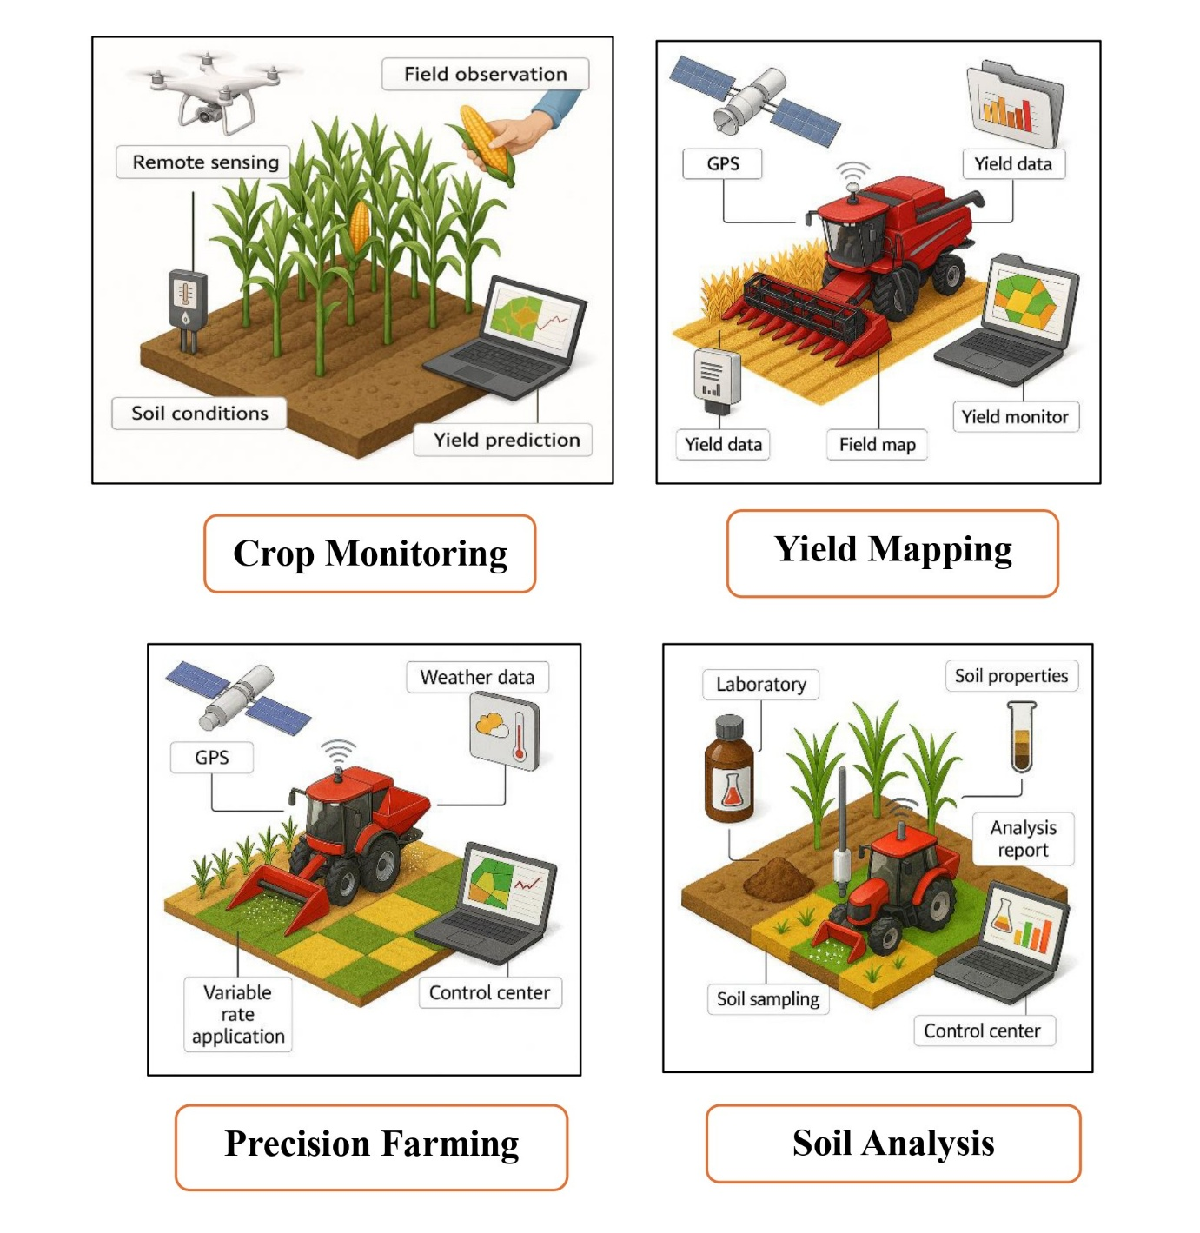
Figure 1: Applications of Remote Sensing (RS) and Geographic Information Systems (GIS) in Modern Agriculture

b) Water Management and Estimation of Crops' Nutrient
Nutrient and water stress are two determinants of crop health and productivity, and can be addressed with precision farming through remote sensing and Geographic information systems (GIS). By utilising these technologies, farmers will be able to better detect the nature of nutrients that the soil is deficient in and place fertiliser where it is required, leading to significant financial savings and an increase in fertiliser production. Mapping of these indicators is important in precision farming because it assists in determining the nutrient status of a field in different areas. In tractor-mounted systems, sensors are normally attached to the front of the spray boom, whereby they can keep up with the status of the crop in real time. The sensors apply the indices, such as the NDVI, to determine the requirements of nitrogen (N) and forward the same to the nutrient spreaders to enable the fertiliser to be applied in the areas where it is required. To deliver effective and flexible in-season nutrition management, the sensor data are converted into accurate nitrogen dose recommendations through algorithms. Combined with cost-effective solutions, the vegetation indicators can be employed to optimise the nitrogen application according to various crops based on different fertiliser rate algorithms (Ali et al., 2017).
Remote sensing could be useful in measuring crop water stress. Plants under stress are more likely to reflect more light than well-irrigated crops. This information assists in areas in need of irrigation or other rectification. Microwave remote sensing has also enhanced the determination of the availability of soil moisture significantly. Agro farmers receive information about the water needs and moisture in the soil and how it influences crop growth at various development stages, and therefore make more prudent decisions on sustainable agricultural practices and sound water utilisation through remote sensing.

c) Directly to calculate the Water Needs of Crops
The FAO Penman-Monteith model is popular in GIS applications to estimate the evapotranspiration (ET) of reference crops to permit spatial analysis of crop water needs. The method assists in identifying how much water crops require in particular regions to improve the planning of irrigation and water resource management.
Made a correlation between values of monthly crop coefficient and certain classes of crops and created an evapotranspiration reference map to aid in estimating water requirements (Casa et al., 2009). Vegetation indices obtained with the help of satellites to measure crop water consumption across four growing seasons in northern Mexico, producing detailed maps of evapotranspiration to be used in scheduling irrigation (Reyes-González et al., 2018).
Also, an integrated dual crop coefficient approach with multi-satellite photographs was used to design a novel ArcGIS toolkit (Ramírez-Cuesta et al., 2018). This toolkit offers an effective and sensible way of determining the water amount needed by crops, and it is the one that would be useful in the context of water balance consideration in agroecosystems. It assists in making irrigation decisions, thus minimising water consumption and maximising yield.

d) Irrigation Scheduling
Irrigation timing refers to the time and quantity of water that should be used on crops. It is a serious process to conserve water resources and make sure that crops have the required moisture to develop positively (Bwambale et al., 2022). Geographic Information Systems (GIS) have become a resource of great potential in enhancing irrigation management. To achieve a high water-use efficiency of agricultural activities, researchers have come up with simulation models coupled with GIS. These models help in streamlining the irrigation practices by giving spatially sensitive advice, hence enhancing the conservation of water and crop yields (Fortes et al., 2005).

e) Estimation of Soil Moisture

The method LST-VI retrieves the soil moisture by analysing pixel distributions of plot-space generated by data of temperature and vegetation index. With a large range of conditions of soil moisture and vegetation density in the image (when outliers, e.g., clouds or surface water, are removed), the data points are likely to have a triangular or trapezoidal shape. The surface of the land would be hotter, and the drier surface of the triangle would denote drier conditions with low soil moisture (the dry side) and the wetter conditions with high soil moisture (the wet side) (Zhu et al., 2017).

On the premise of this concept, a new generation of triangle models was developed and validated with the aim of high-resolution soil moisture mapping (Carlson et al., 2019). The models have been particularly beneficial in precision agriculture, where they may be used to conduct detailed assessments of the variability of soil moisture to facilitate predictive and targeted irrigation and improved crop control.

f) Crop Yield and Production Prediction

Remote sensing has also been widely used in predicting crop yields using statistical and empirical relationships between the vegetation indices and crop yield (Palanisamy et al., 2019). Two main approaches exist for inferring agricultural yields when working with remotely sensed data. Such models can be used to produce crop yield maps in the target agricultural regions. The method used to evaluate how maize crop yield, biomass accumulation, and spectral indicators measured at the V12 growth stage relate was a regression-based approach (Maresma et al., 2016).

g) Sensors in the detection of plant diseases

The use of remote sensing in the detection of plant diseases in precision agriculture research can be further divided into four categories of sensors, namely RGB (Red, Green, Blue), multispectral, hyperspectral, and thermal sensors. These sensors record images of high resolution that provide in-depth information about multiple vegetation characteristics and stress levels (Figure 2).

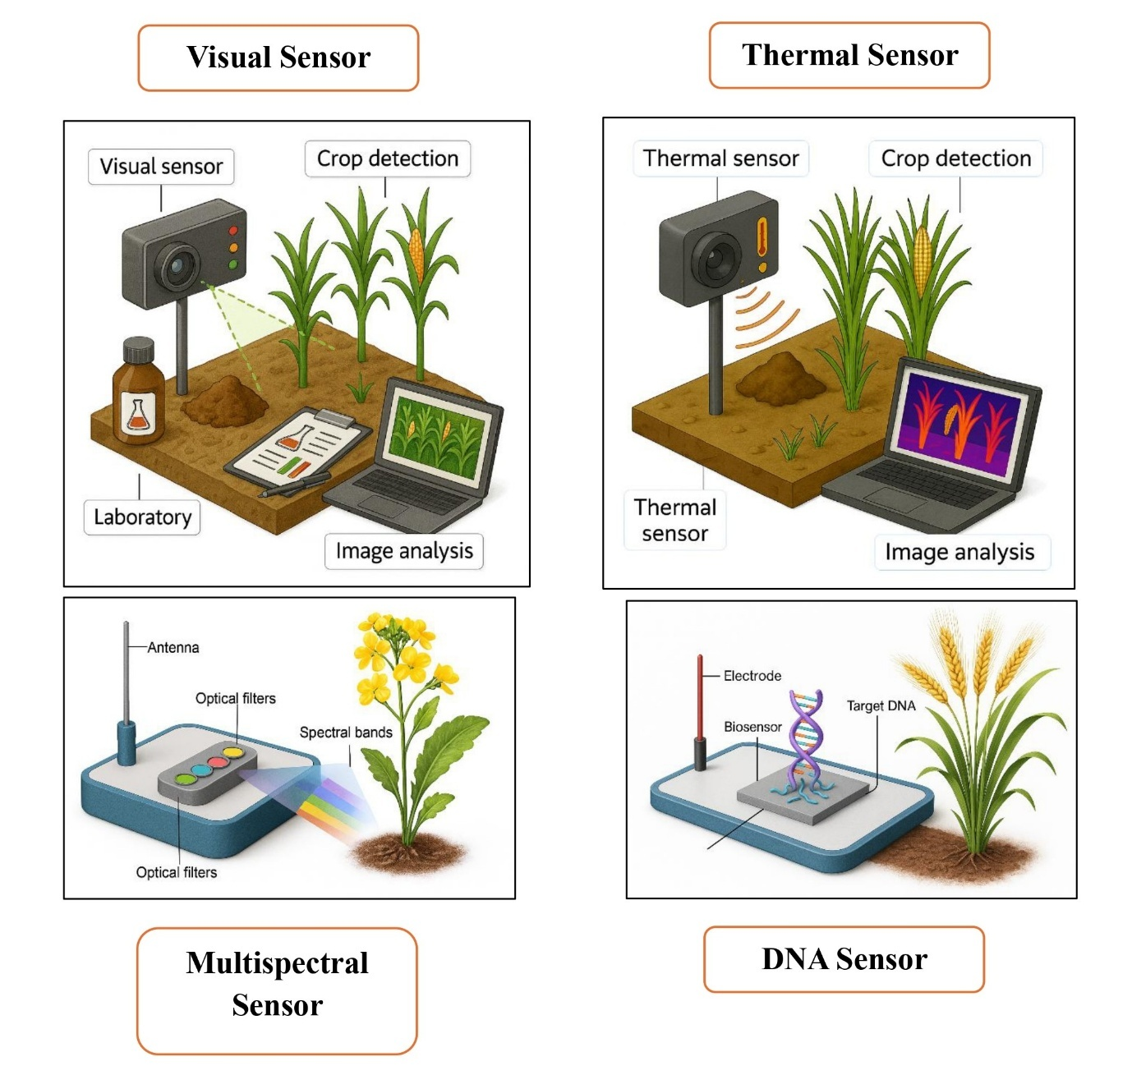
Figure 2: Types of sensors in the detection of plant diseases

RGB Sensors:

RGB sensors capture images of colours depending on red, green, and blue light. Such images can be applied in the detection of the symptoms of diseases, lack of nutrients, and invasive plants, weeds, and the identification of certain plants in crop land. The visualisation of objects in RGB images depends on light reflectance, optical, and human perception. They are used in the identification of weeds, crop mapping, measuring physiological changes across leaf surfaces, and in the enumeration of plant stands.

Multispectral Sensors:
In addition to the visible red, green, and blue bands, multispectral sensors also record information in the red edge and near-infrared. Band ratios and vegetation indices, such as the Normalised Difference Vegetation Index (NDVI), are commonly used in the processing of multispectral pictures. These techniques offer the chance to identify crop disease signs, pesticide damage, and weed species.

Hyperspectral Sensors:

Hyperspectral sensors measure spectral reflectance (narrow bandwidths) of the visible, near-infrared, and mid-infrared segments of the electromagnetic spectrum (typically, 510 nm). The spectral signature of a plant is a specific reflectance of the plant at the canopy level or leaf level. Inspecting these spectral patterns, hyperspectral imaging will be able to identify weeds, different crop species, and several symptoms of diseases with a high level of accuracy.

Thermal Sensors:

Thermal imaging has the principle that things release infrared energy in relation to their temperature; hotter things release a lot of the radiation compared to the cooler things. The thermal cameras can see the electromagnetic radiation present within the infrared spectrum (around 800-1400nm) and display differences in the temperature as a false-color image. The temperature of each pixel is a distinct value. It is an effective technique that is commonly employed to measure canopy or leaf temperatures in fields. The high temperature can indicate the symptoms of the disease of the plants, water stress, or the presence of pests, which will help detect them early and control them.

h) The use of Remote Sensing to detect plant disease

The vegetation patterns of reflectance of different spectral domains vary with regard to the remote sensing processes. The biomass, moisture content, pigment concentration, leaf area index (LAI), and spatial arrangement (or, to put it another way around, biophysical and biochemical properties of vegetation) influence the leaf reflectance and sunlight absorption significantly (Sahoo et al., 2015). The remote sensing assists in detecting the disease in the plants at an early stage since it monitors the variations in the colour of the plants, the shape of the canopy, and other signs. By analysing spectral data at different points in time, a person can be capable of tracking and monitor the changes in the environment of a wide variety of landscapes, such as agricultural fields, forests as well and even cities.

This follow-up and notification capability in the change in the plant reflectance provides essential information to the decision maker in the sphere of resource management, disaster response, and environmental monitoring. The field of agriculture also promotes remote sensing, which assists in the identification of diseases emerging and taking measures at an early stage.
- Spectral Signature of Disease-infected Plant
The interactions in different spectral ranges, such as visible range (400-700 nm), near-infrared (700-1100 nm), and short-wave infrared (1100-2500 nm), determine the reflection of sunlight by plant leaves. The absorption, scattering, and reflection of sunlight are aspects that depend on factors, which include leaf chemistry, surface structure, internal anatomy, water content, proteins, and the carbon composition (Mahlein et al., 2012). Spectral Vegetation Indices (SVIs) are essential in tracking, examining, and mapping the vegetation changes with time and space. The ratios calculated among various spectral bands make SVIs easier to interpret the data and increase the discrimination of disease. Specific pigment indices have come in handy, especially in identifying stress caused by fungi, because the changes in pigment concentrations are directly proportional to the physiological state of the leaf. As one example, used SVIs were used to determine the presence of apple scab of Venturia inaequalis in distinct stages of the disease progression (Delalieux et al., 2007a). Hyperspectral imaging systems have also been utilized in several host-pathogen systems, and these have provided accurate detection and monitoring of diseases. Table 1 displays some of the selected examples.
Table 1: Table of plant disease and pathosystems analysed using hyperspectral imaging.

Host–Pathogen System | Scale | Detection | Early Detection | Quantification | References
Apple - Venturia inaequalis | Leaf | ✅ Yes | ❌ N.I. | ✅ Yes | Delalieux et al., (2007b); Mahlein et al., (2012)
Barley - Blumeria graminis f. sp. hordei | Tissue | ✅ Yes | ✅ Yes | ❌ N.I. | Mahlein et al. (2012)
Cucumber - Cucumber mosaic virus, Cucumber green mottle mosaic virus, Sphaerotheca fuliginea | Leaf | ✅ Yes | ❌ N.I. | ✅ Yes | Berdugo et al., (2014)
Oilseed rape - Alternaria spp. | Leaf | ✅ Yes | ❌ N.I. | ✅ Yes | Baranowski et al., (2015)
Wheat - Fusarium spp. | Ear | ✅ Yes | ✅ Yes | ✅ Yes | Mahlein et al. (2012)
✅ = Yes | ❌ = Non-investigated (N.I.) aspect
- Use of RS and GIS in Insect-Pest Detection
When the remotely sensed images are to be calibrated, one of the methods is to construct large reference panels in the scene, which are known to have certain properties. Such panels are used in the process of adjusting the image data to analyse it correctly. The Normalised Difference Vegetation Index (NDVI) is often applied as one of the most commonly used indices to analyse multispectral data. Applied to NDVI maps based on multispectral imagery, in conjunction with data on soil and crop conditions, to investigate the activities of tarnished plant bugs (Lygus lineolaris) in cotton (Gossypium hirsutum) fields (Willers et al., 2005). The method enhanced field scouting work since it gave a better insight into the distribution and hotspots of pests. Reflectance profile of insect bodies, which is used in insect detection, is known to identify physiological, biochemical, or taxonomic dissimilarities between insects. When investigating individual insects in benchtop remote sensing, they are likely to associate variations in reflectance patterns with metabolic changes brought about by treatments, since variations change the penetration depth of radiometric energy in particular spectral bands.
Also, various studies have indicated that insect herbivory and other types of plant stressors affect photosynthesis, leading to a rise in the leaf reflectance values because of the decreased light absorption by pigments. Pest managers have used GIS technologies to map and track the population of pests in agriforests. As an example, in an effort to cut down on the unnecessarily applied pesticides, GIS was used in the tracking of the Ceratitis capitata, which, in effect, contributed to a reduction in the use of pesticides when the pest was not a threat to citrus crops (Cohen, 2008). GIS to examine distributions of different families of beetles as Elateridae, Silphidae, and Chrysomelidae (Toepfer, 2007), when locust management interventions based on GIS and remote sensing data assisted in prioritising control regions of ecological value (Lazar et al., 2016). Ghobadifar et al. (2014) used the NDVI, Standard Difference Indices (SDI), and Ratio Vegetation Index (RVI) to develop the thresholds of outbreak areas, which helps to monitor pest outbreaks by the occurrence of these indicators (Figure 3).
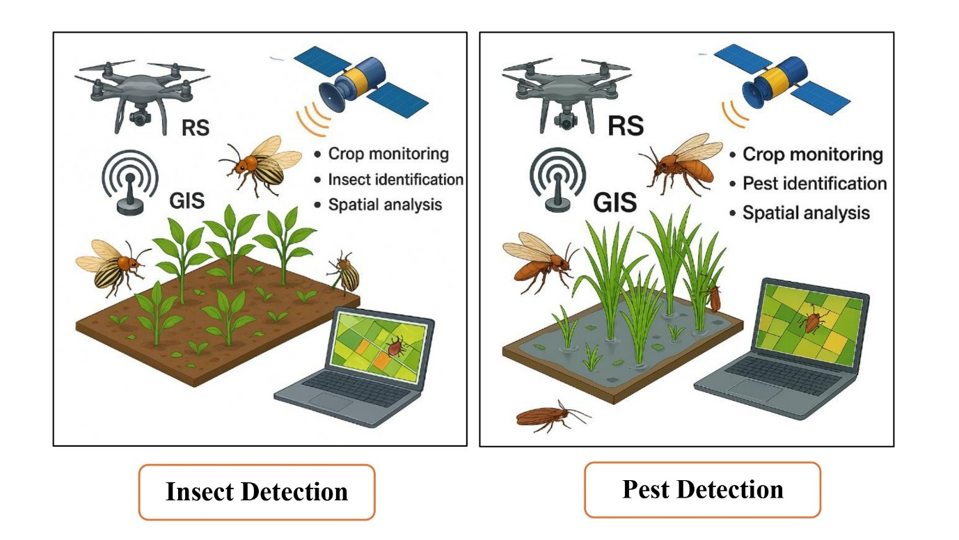
Figure 3: Use of RS and GIS in Insect-Pest Detection

5. KEY FINDINGS AND TRENDS
Artificial intelligence (AI), machine learning (ML), deep learning (DL), and big data analytics are transforming agriculture to be more productive, sustainable, and resource-efficient, with predictive analysis and decision support systems (DSS) able to do so. These technologies allow accurate prediction of crop yields, detection of diseases, management of nutrients, and real-time monitoring to make informed decisions in farming and policymaking. Convolutional neural networks and recurrent neural networks are the most common types of ML and DL algorithms that are employed in crop classification, yield forecasting, pest and disease management, and smart irrigation, which result in higher yields and less damage to the environment (Albahar, 2023). The DSSs, which are usually driven by these algorithms, process sensor, weather station, and remote sensing data and give practical advice on irrigation, fertilisation, pest control, and harvest timing (Petraki et al., 2025; Gebresenbet et al., 2023). Predictive analytics and DSSs are also used in the dairy and livestock farming industry to optimise feed regimes, detection of disease, and distribution of resources, enhance productivity, and animal welfare (Bang et al., 2023; Palma et al., 2025). A combination of IoT gadgets and wireless sensor systems improves the collection of data and real-time analysis so that automated decision-making systems can transform the situation in the field (Alaoui et al., 2024). Despite such developments, there are still numerous issues, such as the integration of various forms of data, computational issues, the digital literacy gap, and the inability to use cost-effective solutions with a high level of scalability. The studies emphasise the value of multidisciplinary cooperation, functionality, and continuous training to increase the use and effectiveness (Petraki et al., 2025; Bang et al., 2023; Gebresenbet et al., 2023). Future directions are focused on creating strong multimodal foundation models, better integration of simulations and ML, and agroecological and circular economy-specific DSSs, which can guarantee the food security, environmental stability, and economic sustainability in agriculture (Yin et al., 2025; Whitney et al., 2023; Lombardi and Todella, 2023).

Table 2. Applications and Impacts of Predictive Analysis and DSS in Agriculture
Application Area | Key Technologies/Methods | Main Benefits/Findings | Citations
Crop Yield Prediction | ML, DL, Time Series Analysis | Accurate yield forecasts, improved planning | (Albahar, 2023)
Disease & Pest Detection | ML, DL, IoT, UAVs | Early detection, targeted interventions, and reduced chemical use | (Alaoui et al., 2024)
Nutrient & Soil Management | ML, AI, Geostatistics | Optimized fertilization, efficient resource use | (Ennaji et al., 2023)
Irrigation & Water Management | DSS, IoT, MPC | Water conservation, precise scheduling, and higher yields | (Petraki et al., 2025; Bwambale et al., 2024; Gebresenbet et al., 2023)
Livestock & Dairy Management | Predictive Analytics, DSS, ML | Disease detection, feeding optimization, productivity gains | (Bang et al., 2023; Palma et al., 2025)
Agroecology & Sustainability | DSS, MCDA, Decision Analysis | Enhanced sustainability, circular economy, risk assessment | (Petraki et al., 2025; Whitney et al., 2023; Lombardi & Todella, 2023)
Commodity Forecasting | ML, Hybrid Models, AI | Market risk mitigation, price prediction, supply chain support | (Guindani et al., 2024)

6. FUTURE DIRECTIONS IN PREDICTIVE ANALYSIS AND DECISION SUPPORT SYSTEMS IN AGRICULTURE
It is anticipated that the future of predictive analysis and decision support systems (DSS) in the agricultural industry will experience groundbreaking expansion, triggered by the accelerated development of artificial intelligence (AI), machine learning (ML), deep learning (DL), Internet of Things (IoT), and big data analytics. A significant trend is the construction and implementation of foundation models (FM) and agricultural foundation models (AFM), which use multimodal data (images, sensor data, weather, and textual information) to generate detailed, contextual decision-making support. These models will contribute to more accurate crop yield prediction, disease and pest detection, resource optimisation, and supply chain management, which will eventually encourage the digitalisation of agriculture and intelligent transformation of agriculture (Yin et al., 2025). This will be through the combination of smart sensors and IoT gadgets, which will allow automated data gathering and analysis in real-time and generate adaptive, location-specific recommendations to enhance the efficiency and sustainability of resources (Soussi et al., 2024; Mansoor et al., 2025). Individual DSS will adopt more explainable AI (XAI) methods in the future, which will make complex models more transparent and trustworthy by farmers and other interested parties, thus increasing adoption (Dhal and Kar, 2024). The emphasis on user-friendly interfaces and mobile platforms is another crucial tendency since it is necessary to provide farmers of different digital literacy and technical skills with advanced analytics (Gebresenbet et al., 2023). It will be crucial to engage in multidisciplinary collaboration, i.e., agronomists, data scientists, engineers, and end-users, to create powerful, context-specific solutions to meet the needs of global agriculture across categories (Bang et al., 2023; Gebresenbet et al., 2023). Studies are also shifting towards integrating blockchain technology to share data securely, edge and cloud computing to have scalable processing, and the application of drones and autonomous vehicles to do a field of work automatically (Padhiary et al., 2024; Saini et al., 2025; Gebresenbet et al., 2023). Solving the issues related to data privacy, interoperability, infrastructure constraints, and initial high costs of technology implementation will be key to the maximization of the effects of predictive analytics and DSS, particularly in resource-limited and smallholder farming settings (Padhiary et al., 2024; Mansoor et al., 2025; Dhal and Kar, 2024).

7. CONCLUSIONS
GIS is currently an essential part of agricultural production across the world, where farmers can optimise crop production, minimise costs of production, and properly utilise land resources. In order to make the most of the remote sensing and GIS, the development of structured information systems is at the state or district level. These systems have the potential to combine the crop data, which has been obtained by the satellite images and the field surveys, and utilise it by the stakeholders to initiate economic gains and make informed decisions. Comparisons between past and present data are made easy by GIS, which allows one to effectively predict the occurrence of a disease outbreak and a pest infestation. GIS enables researchers, extension workers, and planners to predict and control agricultural threats through the provision of powerful geospatial maps and analysis tools. With the further evolution of the technology, the design of novel methodologies and tools is likely to increase the use of remote sensing and GIS even more. Such innovations will improve the monitoring, prediction, and control of agricultural systems and help to achieve more sustainable and resilient agricultural practices.

Disclaimer (Artificial intelligence)
Author(s) hereby declare that NO generative AI technologies such as Large Language Models (ChatGPT, COPILOT, etc.) and text-to-image generators have been used during the writing or editing of this manuscript.

REFERENCES
Alaoui, M., Amraoui, K., Masmoudi, L., Ettouhami, A., & Rouchdi, M. (2024). Unleashing the potential of IoT, Artificial Intelligence, and UAVs in contemporary agriculture: A comprehensive review. Journal of Terramechanics. https://doi.org/10.1016/j.jterra.2024.100986
Albahar, M. (2023). A Survey on Deep Learning and Its Impact on Agriculture: Challenges and Opportunities. Agriculture. https://doi.org/10.3390/agriculture13030540
Ali, M. M., Al-Ani, A., Eamus, D., & Tan, D. K. (2017). Leaf nitrogen determination using non-destructive techniques–A review. Journal of Plant Nutrition, 40(7), 928-953. DOI: 10.1080/01904167.2016.1143954
Aslan, M., Sabancı, K., & Aslan, B. (2024). Artificial Intelligence Techniques in Crop Yield Estimation Based on Sentinel-2 Data: A Comprehensive Survey. Sustainability. https://doi.org/10.3390/su16188277
Balafas, V., Karantoumanis, E., Louta, M., & Ploskas, N. (2023). Machine Learning and Deep Learning for Plant Disease Classification and Detection. IEEE Access, 11, 114352-114377. https://doi.org/10.1109/access.2023.3324722
Bang, R., Guajardo, M., & Hansen, B. (2023). Recent advances in decision support for beef and dairy farming: modeling approaches and opportunities. Int. Trans. Oper. Res., 30, 2807-2839. https://doi.org/10.1111/itor.13311
Baranowski, P., Jedryczka, M., Mazurek, W., Babula-Skowronska, D., Siedliska, A., & Kaczmarek, J. (2015). Hyperspectral and thermal imaging of oilseed rape (Brassica napus) response to fungal species of the genus Alternaria. PloS one, 10(3), e0122913. https://doi.org/10.1371/journal.pone.0122913
Berdugo, C. A., Zito, R., Paulus, S., & Mahlein, A. K. (2014). Fusion of sensor data for the detection and differentiation of plant diseases in cucumber. Plant Pathology, 63(6), 1344-1356. https://doi.org/10.1111/ppa.12219
Boursianis, A. D., Papadopoulou, M. S., Diamantoulakis, P., Liopa-Tsakalidi, A., Barouchas, P., Salahas, G., & Goudos, S. K. (2022). Internet of things (IoT) and agricultural unmanned aerial vehicles (UAVs) in smart farming: a comprehensive review. Internet of Things, 18, 100187. https://doi.org/10.1016/j.iot.2020.100187
Bwambale, E., Abagale, F. K., & Anornu, G. K. (2022). Smart irrigation monitoring and control strategies for improving water use efficiency in precision agriculture: A review. Agricultural Water Management, 260, 107324. https://doi.org/10.1016/j.agwat.2021.107324
Bwambale, E., Wanyama, J., Adongo, T., Umukiza, E., Ntole, R., Chikavumbwa, S., Sibale, D., & Jeremiah, Z. (2024). A Review of Model Predictive Control in Precision Agriculture. Smart Agricultural Technology. https://doi.org/10.1016/j.atech.2024.100716
Carlson, T. N., & Petropoulos, G. P. (2019). A new method for estimating evapotranspiration and surface soil moisture from optical and thermal infrared measurements: The simplified triangle. International Journal of Remote Sensing, 40(20), 7716-7729. DOI: https://doi.org/10.1080/01431161.2019.1601288
Casa, R., Rossi, M., Sappa, G., & Trotta, A. (2009). Assessing crop water demand by remote sensing and GIS for the Pontina Plain, Central Italy. Water Resources Management, 23, 1685-1712. DOI: https://doi.org/10.1007/s11269-008-9347-4
Cohen, Y., Cohen, A., Hetzroni, A., Alchanatis, V., Broday, D., Gazit, Y., & Timar, D. (2008). Spatial decision support system for Medfly control in citrus. Computers and Electronics in Agriculture, 62(2), 107-117. https://doi.org/10.1016/j.compag.2007.12.005
Das, N., Mandal, A., & Sarkar, M. (2026). Agriculture 5.0: AI-Enabled Smart Farming with Advanced Monitoring and Pest Management. Asian Journal of Advances in Agricultural Research, 26(3), 23–41. https://doi.org/10.9734/ajaar/2026/v26i3715
Delalieux, S., Van Aardt, J. A. N., Keulemans, W., Schrevens, E., & Coppin, P. (2007a). Detection of biotic stress (Venturia inaequalis) in apple trees using hyperspectral data: Non-parametric statistical approaches and physiological implications. European Journal of Agronomy, 27(1), 130-143. https://doi.org/10.1016/j.eja.2007.02.005
Delalieux, S., Van Aardt, J. A. N., Keulemans, W., Schrevens, E., & Coppin, P. (2007b). Detection of biotic stress (Venturia inaequalis) in apple trees using hyperspectral data: Non-parametric statistical approaches and physiological implications. European Journal of Agronomy, 27(1), 130-143. http://dx.doi.org/10.1016/j.eja.2007.02.005
Dhal, S., & Kar, D. (2024). Transforming Agricultural Productivity with AI-Driven Forecasting: Innovations in Food Security and Supply Chain Optimization. Forecasting. https://doi.org/10.3390/forecast6040046
Ennaji, O., Vergütz, L., & Allali, A. (2023). Machine learning in nutrient management: A review. Artificial Intelligence in Agriculture. https://doi.org/10.1016/j.aiia.2023.06.001
Espinel, R., Herrera-Franco, G., García, J., & Escandón-Panchana, P. (2024). Artificial Intelligence in Agricultural Mapping: A Review. Agriculture. https://doi.org/10.3390/agriculture14071071
Fortes, P. S., Platonov, A. E., & Pereira, L. S. (2005). GISAREG - A GIS-based irrigation scheduling simulation model to support improved water use. Agricultural Water Management, 77(1-3), 159-179. https://doi.org/10.1016/j.agwat.2004.09.042
Gebeyehu, M. N. (2019). Remote sensing and GIS applications in agriculture and natural resource management. International Journal of Environmental Sciences & Natural Resources, 19(2), 45-49. DOI: https://doi.org/10.19080/IJESNR.2019.19.556009
Gebresenbet, G., Bosona, T., Patterson, D., Persson, H., Fischer, B., Mandaluniz, N., Chirici, G., Zacepins, A., Komašilovs, V., Pitulac, T., & Nasirahmadi, A. (2023). A concept for the application of integrated digital technologies to enhance future smart agricultural systems. Smart Agricultural Technology. https://doi.org/10.1016/j.atech.2023.100255
Ghobadifar, F., Wayayok, A., Shattri, M., & Shafri, H. (2014, June). Using SPOT-5 images in rice farming for detecting BPH (Brown Plant Hopper). In IOP Conference Series: Earth and Environmental Science (Vol. 20, No. 1, p. 012015). IOP Publishing. https://doi.org/10.1088/1755-1315/20/1/012015
Gu, Y., Brown, J. F., Verdin, J. P., & Wardlow, B. (2007). A five‐year analysis of MODIS NDVI and NDWI for grassland drought assessment over the central Great Plains of the United States. Geophysical Research Letters, 34(6). https://doi.org/10.1029/2006GL029127
Guindani, L., Oliveirai, G., Ribeiro, M., Gonzalez, G., & De Lima, J. (2024). Exploring current trends in agricultural commodities forecasting methods through text mining: Developments in statistical and artificial intelligence methods. Heliyon, 10. https://doi.org/10.1016/j.heliyon.2024.e40568
Huang, W., Lamb, D. W., Niu, Z., Zhang, Y., Liu, L., & Wang, J. (2007). Identification of yellow rust in wheat using in-situ spectral reflectance measurements and airborne hyperspectral imaging. Precision Agriculture, 8, 187-197. doi: https://doi.org/10.1007/s11119-007-9038-9
Ji, L., & Peters, A. J. (2003). Assessing vegetation response to drought in the northern Great Plains using vegetation and drought indices. Remote Sensing of Environment, 87(1), 85-98. https://doi.org/10.1016/S0034-4257(03)00174-3
Lazar, M., Piou, C., Doumandji‐Mitiche, B., & Lecoq, M. (2016). Importance of solitarious desert locust population dynamics: lessons from historical survey data in Algeria. Entomologia Experimentalis et Applicata, 161(3), 168-180. https://doi.org/10.1111/eea.12505
Lombardi, P., & Todella, E. (2023). Multi-Criteria Decision Analysis to Evaluate Sustainability and Circularity in Agricultural Waste Management. Sustainability. https://doi.org/10.3390/su152014878
Mahlein, A. K., Oerke, E. C., Steiner, U., & Dehne, H. W. (2012). Recent advances in sensing plant diseases for precision crop protection. European Journal of Plant Pathology, 133(1), 197–209. https://doi.org/10.1007/s10658-011-9878-z
Mansoor, S., Iqbal, S., Popescu, S., Kim, S., Chung, Y., & Baek, J. (2025). Integration of smart sensors and IOT in precision agriculture: trends, challenges, and future prospects. Frontiers in Plant Science, 16. https://doi.org/10.3389/fpls.2025.1587869
Maresma, Á., Ariza, M., Martínez, E., Lloveras, J., & Martínez-Casasnovas, J. A. (2016). Analysis of vegetation indices to determine nitrogen application and yield prediction in maize (Zea mays L.) from a standard UAV service. Remote Sensing, 8(12), 973. https://doi.org/10.3390/rs8120973
Mesías-Ruiz, G., Pérez-Ortiz, M., Dorado, J., De Castro, A., & Peña, J. (2023). Boosting precision crop protection towards agriculture 5.0 via machine learning and emerging technologies: A contextual review. Frontiers in Plant Science, 14. https://doi.org/10.3389/fpls.2023.1143326
Mortazavizadeh, F., Bolonio, D., Mirzaei, M., Ng, J., Mortazavizadeh, S., Dehghani, A., Mortezavi, S., & Ghadirzadeh, H. (2025). Advances in machine learning for agricultural water management: a review of techniques and applications. Journal of Hydroinformatics. https://doi.org/10.2166/hydro.2025.258
Padhiary, M., Saha, D., Kumar, R., Sethi, L., & Kumar, A. (2024). Enhancing Precision Agriculture: A Comprehensive Review of Machine Learning and AI Vision Applications in All-Terrain Vehicles for Farm Automation. Smart Agricultural Technology. https://doi.org/10.1016/j.atech.2024.100483
Palanisamy, S., Selvaraj, R., Ramesh, T., & Ponnusamy, J. (2019). Applications of remote sensing in agriculture: A review. International Journal of Current Microbiology and Applied Sciences, 8(1), 2270–2283. https://doi.org/10.20546/ijcmas.2019.801.238
Palma, O., Plà-Aragonés, L., Mac Cawley, A., & Albornoz, V. (2025). AI and Data Analytics in the Dairy Farms: A Scoping Review. Animals: an Open Access Journal from MDPI, 15. https://doi.org/10.3390/ani15091291
Petraki, D., Gazoulis, I., Kokkini, M., Danaskos, M., Kanatas, P., Rekkas, A., & Travlos, I. (2025). Digital Tools and Decision Support Systems in Agroecology: Benefits, Challenges, and Practical Implementations. Agronomy. https://doi.org/10.3390/agronomy15010236
Pingali, P. L. (2012). Green revolution: impacts, limits, and the path ahead. Proceedings of the National Academy of Sciences, 109(31), 12302-12308. DOI: https://doi.org/10.1073/pnas.0912953109
Reyes-González, A., Kjaersgaard, J., Trooien, T., Hay, C., & Ahiablame, L. (2018). Estimation of crop evapotranspiration using satellite remote sensing-based vegetation index. Advances in Meteorology, 2018, 1-12. https://doi.org/10.1155/2018/4525021
Sahoo, R. N., Ray, S. S., & Manjunath, K. R. (2015). Hyperspectral remote sensing of agriculture. Current Science, 108, 848-859.
Saini, A., Yadav, A., & D. (2025). A Comprehensive review on technological breakthroughs in precision agriculture: IoT and emerging data analytics. European Journal of Agronomy. https://doi.org/10.1016/j.eja.2024.127440
Sakka, M., Ivanovici, M., Chaâri, L., & Mothe, J. (2025). A Review of CNN Applications in Smart Agriculture Using Multimodal Data. Sensors (Basel, Switzerland), 25. https://doi.org/10.3390/s25020472
Sharma, T., Singh, A., Kumar, N., & Chauhan, G. (2023). Digital Technologies and Tools for the Ensuing Digital Era. In Applying Drone Technologies and Robotics for Agricultural Sustainability (pp. 1-11). IGI Global. DOI: https://doi.org/10.4018/978-1-6684-6413-7.ch001
Soussi, A., Zero, E., Sacile, R., Trinchero, D., & Fossa, M. (2024). Smart Sensors and Smart Data for Precision Agriculture: A Review. Sensors (Basel, Switzerland), 24. https://doi.org/10.3390/s24082647
Toepfer, S., Ellsbury, M. M., Eschen, R., & Kuhlmann, U. (2007). Spatial clustering of Diabrotica virgifera virgifera and Agriotes ustulatus in small‐scale maize fields without topographic relief drift. Entomologia Experimentalis et Applicata, 124(1), 61-75. https://doi.org/10.1111/j.1570-7458.2007.00549.x
Whitney, C., Biber-Freudenberger, L., & Luedeling, E. (2023). Decision analytical methods for assessing the efficacy of agroecology interventions. CABI Agriculture and Bioscience, 4. https://doi.org/10.1186/s43170-023-00151-9
Willers, J. L., Jenkins, J. N., Ladner, W. L., Gerard, P. D., Boykin, D. L., Hood, K. B.,... & Bethel, M. M. (2005). Site-specific approaches to cotton insect control. Sampling and remote sensing analysis techniques. Precision Agriculture, 6, 431-452. https://doi.org/10.1007/s11119-005-3680-x
Yin, S., Xi, Y., Zhang, X., Sun, C., & Mao, Q. (2025). Foundation Models in Agriculture: A Comprehensive Review. Agriculture. https://doi.org/10.3390/agriculture15080847
Zhu, W., Jia, S., & Lv, A. (2017). A universal Ts‐VI triangle method for the continuous retrieval of evaporative fraction from MODIS products. Journal of Geophysical Research: Atmospheres, 122(19), 10-206. https://doi.org/10.1016/j.agwat.2024.109017
Karunathilake, E. M. B. M., Le, A. T., Heo, S., Chung, Y. S., & Mansoor, S. (2023). The path to smart farming: Innovations and opportunities in precision agriculture. Agriculture, 13(8), 1593.

Senapaty, M. K., Ray, A., & Padhy, N. (2024). A Decision Support System for Crop Recommendation Using Machine Learning Classification Algorithms. Agriculture, 14(8), 1256. https://doi.org/10.3390/agriculture14081256

