PEDI-KNEE: PROTOTYPE DEVELOPMENT OF A 3D PRINTED PEDIATRIC KNEE JOINT

Abstract

Background: Paediatric prosthetic knee design remains challenging due to factors such as rapid growth, high activity levels, and the need for lightweight, cost-effective solutions. Conventional knee joints often fail to balance functionality, affordability, and adaptability, particularly in low-resource settings. Advances in 3D printing and CAD modelling offer promising alternatives for developing customized and efficient prosthetic components for children.
Aim: To design and evaluate a lightweight, cost-effective paediatric prosthetic knee joint (Pedi-Knee) using 3D printing technology.
Study Design: Prototype development study.
Place and Duration of Study: Indian Spinal Injuries Centre, New Delhi, India, 2024–2025.
Methodology: The prosthetic knee joint was designed using CAD software and fabricated using additive manufacturing with PA12 nylon. The design incorporated a single-axis mechanism to allow controlled flexion and extension. Mechanical properties, stress distribution, weight, fabrication time, and cost efficiency were evaluated.
Results: This study describes the design and fabrication of Pedi-Knee, a pediatric single-axis prosthetic knee developed through CAD modeling and selective laser sintering (SLS) using PA12 (also known as Nylon 12). The prototype achieved a weight of approximately 240 grams and provided a smooth range of motion from 0 to 120 degrees. A modular pyramid connector ensured easy compatibility with existing pediatric prosthetic systems. Pedi-Knee fabrication requires shorter periods. By combining simplicity, durability, and accessibility, Pedi-Knee presents a practical and scalable solution to address a longstanding gap in pediatric prosthetic care.
Discussion: The findings suggest that a 3D-printed single-axis prosthetic knee joint can provide a practical balance between functionality, affordability, and customization for paediatric users. While advanced prosthetic knees offer superior performance, their limitations in cost and complexity restrict their use. The proposed design addresses these gaps; however, further clinical validation is required to assess long-term performance and user outcomes.
Conclusion: The Pedi-Knee provides a lightweight, affordable, and clinically viable solution for pediatric prosthetic applications.

Keywords: Pediatric prosthesis, single-axis knee, 3D printing, PA12, SLS

INTRODUCTION

In paediatric population, amputations can result from congenital limb deficiencies, trauma, or medical conditions such as tumours. The prevalence of lower limb amputations in the paediatric population is accounting for approximately 3–6% of all amputations with an incidence of 1–2 per 10,000 children relatively low compared to adults. The development of paediatric prosthetic knee joints is a critical area of research due to the unique challenges presented by children’s rapid growth, high activity levels, and need for enhanced stability and comfort. ⁽¹⁾ Current prosthetic solutions include single-axis, polycentric, hydraulic, and microprocessor-controlled knee joints, each with advantages and limitations.
Single-axis knees are the simplest design, operating with a single pivot point that allows flexion and extension. This mechanism offers durability, low maintenance, and affordability, making it a widely used choice for paediatric applications. However, the lack of stance phase control increases the risk of instability, particularly during weight acceptance. ⁽²⁾ Polycentric knees, which incorporate multiple pivot points, provide improved stability during the stance phase and better simulate the natural knee's roll-glide motion. While these designs enhance toe clearance during the swing phase, they tend to be mechanically complex, heavier, and more expensive. ⁽³⁾ Hydraulic knees incorporate fluid dynamics to adjust resistance based on walking speed and terrain, allowing for a smoother gait.
Although effective in improving gait adaptability, their weight, cost, and maintenance requirements limit their widespread application in paediatric cases. ⁽⁴⁾ Microprocessor-controlled knees represent the most advanced option, utilizing sensors and algorithms to continuously adjust resistance and provide real-time adaptations. While these designs offer superior gait efficiency and adaptability, they are expensive, require battery power, and may not be accessible in low-resource settings. ⁽⁵⁾
With advancements in 3D printing technology, new opportunities for developing lightweight, customizable, and cost-effective prosthetic components have emerged. Additive manufacturing techniques, such as selective laser sintering (SLS) and fused deposition modelling (FDM), allow for the creation of intricate prosthetic designs tailored to individual anatomical and biomechanical needs. 3D-printed prosthetics, particularly those made from nylon-based materials like polyamide 12 (PA12), offer excellent strength-to-weight ratios, making them ideal for paediatric use. ⁽⁶⁾
Computer-aided design (CAD) software plays a crucial role in the development of prosthetic components. SolidWorks, a widely used CAD platform, enables prosthetists to create highly detailed and accurate models before fabrication. Through virtual simulations, the design can be tested for stress distribution, material durability, and biomechanical functionality. This process minimizes the risk of manufacturing errors and allows for adjustments before committing to physical production. The application of CAD modelling ensures that the prosthetic knee joint meets necessary performance standards while being adaptable to paediatric users. ⁽⁷⁾ The importance of paediatric prosthetic knee joints extends beyond functionality to considerations of comfort and psychological well-being. A well-designed prosthesis enhances mobility, encourages participation in physical activities, and fosters social integration. Children who receive appropriate prosthetic interventions demonstrate improved gait patterns, reduced compensatory movements, and better long-term musculoskeletal health outcomes. The ability to create customized designs using 3D printing technology ensures that these young users have access to prosthetics that meet their unique anatomical and functional needs. ⁽⁸⁾
This study focuses on developing a single-axis paediatric prosthetic knee joint using 3D-printed nylon (PA12). The design prioritizes simplicity, lightweight characteristics, and affordability while maintaining adequate biomechanical performance. The use of CAD software, specifically SolidWorks, allows for precise modelling and simulation before fabrication. The CAD model was analysed to ensure appropriate stress distribution and durability. The knee joint incorporates stance-phase control to enhance stability, addressing one of the major limitations of traditional single-axis designs.
By integrating 3D printing technology with established biomechanical principles, the proposed prosthetic knee aims to bridge the gap between cost-effectiveness and functional performance. Further testing, including mechanical and patient trials, will be required to validate the efficiency of this design and ensure long-term durability which will be done in second phase of this research work. The outcomes of this study may contribute to the development of improved paediatric prosthetic solutions, expanding accessibility for children with lower-limb amputations.
AIM
The primary aim of this project is to develop a prototype of a paediatric prosthetic knee, named Pedi-Knee, utilizing 3D printed nylon to create a single-axis knee joint.

OBJECTIVE
This research seeks to address the limitations of current paediatric prosthetic designs by focusing on creating a lightweight, cost-effective, and functional knee joint that can be easily produced and adjusted as needed.
The primary objective of developing this prototype on Pedi-Knee, a 3D printed nylon-based single-axis knee joint, is to address the specific challenges faced by paediatric amputees and to fill existing gaps in prosthetic design for children. Many of the available prosthetic designs were not adequately tailored for children, often being too heavy or complex due to the use of metal components like motors and gears, which made them uncomfortable and impractical for children to wear. It aims to fill these gaps by focusing on a design that is lightweight, cost-effective, and easily customizable.
The single-axis knee joint design provides several benefits, including improved stability and ease of customization. The simplicity of the single-axis mechanism allows for easier adjustments and modifications, which is crucial for accommodating the rapid growth and changing needs of paediatric users. Additionally, the use of 3D printing technology enables the production of prosthetic components that are tailored to the specific anatomical and functional requirements of each child, further enhancing the fit and comfort of the prosthesis.
material and methods
Design of Pedi-Knee
The Pedi-Knee was designed in SolidWorks CAD software as a single-axis mechanism consisting of two interlocking blocks connected by a stainless-steel rod (Figure 1). The upper segment incorporated a pyramid connector for compatibility with modular prosthetic systems, while the lower segment was designed to accommodate the pylon. Posterior shaping was introduced to promote smoother gait mechanics and passive stability. The design allowed flexion up to 120 degrees to enable functional mobility for activities of daily living.
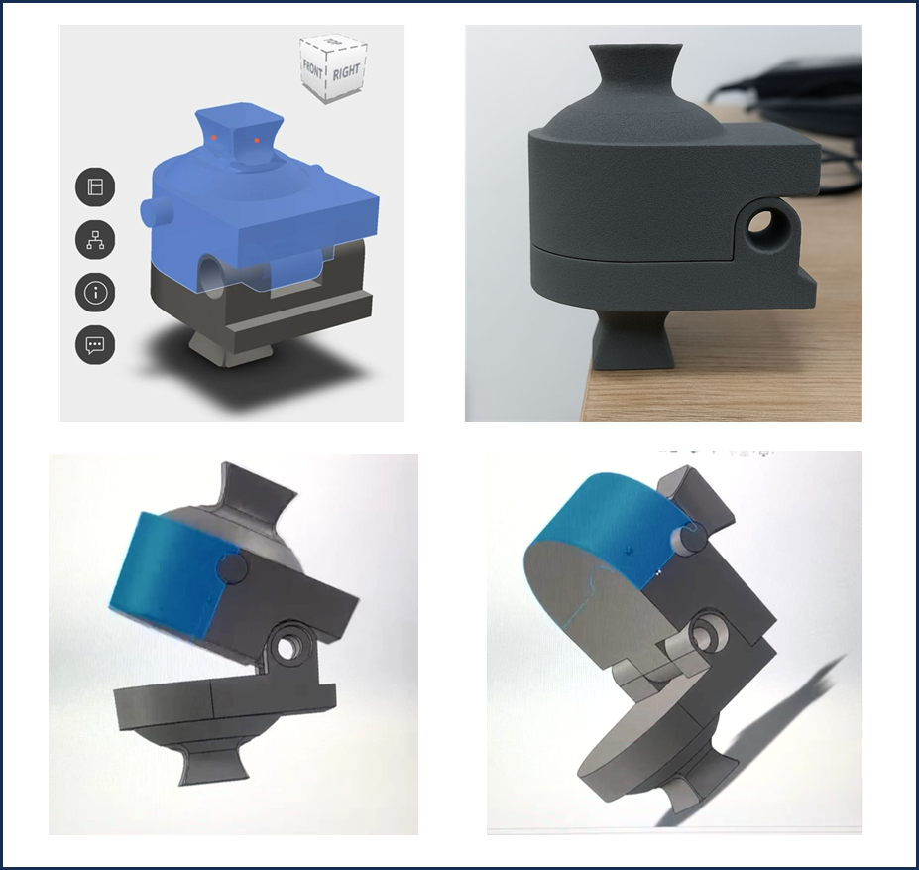
Figure 1. Design and Fabrication of Pedi-Knee Joint.
The Pedi-Knee was fabricated using the Formlabs Fuse 1+ SLS system with PA12 powder. In this process, a roller spreads a thin layer of powder over the build platform, and a laser selectively fuses the particles based on the CAD model (Figure 2). The platform lowers after each pass, and layers are repeated until the part is formed, with unfused powder acting as natural support.
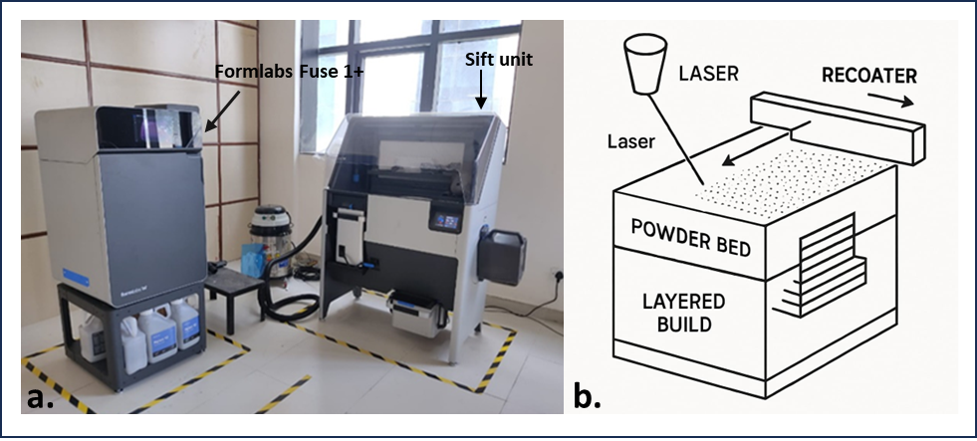
Figure 2. Selective Laser Sintering (SLS) Technology: (a) Formlabs SLS Printer, (b) Working principle of the SLS process.
PA12 powder was selected due to its proven performance in prosthetic applications, combining durability with lightness. PA12’s high tensile (45–50 MPa) and flexural strength (~65 MPa) ensure durability under daily stresses, while its elongation (20–30%) and fatigue resistance allow safe use during active play. Its low density (~1.01 g/cm³) keeps the joint lightweight (~240 g), reducing strain for children. The heat deflection temperature (~95 °C) provides stability in varied conditions, and ISO 10993 biocompatibility makes it safe for skin contact (Table 1). These combined properties make PA12 ideal for producing a strong, light, and clinically practical pediatric knee joint.
Table 1 Mechanical properties of PA12.
Property | Value / Range | Significance
Density (powder) | ~0.95 g/cm³ | Before sintering
Density (sintered part) | ~1.01 – 1.02 g/cm³ | After SLS processing
Tensile Strength | 45 – 50 MPa | High strength for polymer
Elongation at Break | 20 – 30 % | Provides flexibility, reduces brittleness
Young’s Modulus | 1650 – 1750 MPa | Good stiffness-to-weight ratio
Flexural Strength | ~65 MPa | Supports load-bearing applications
Impact Strength (Izod, notched) | ~4.4 kJ/m² | Toughness against sudden load
Heat Deflection Temperature (HDT, @1.8 MPa) | ~95 °C | Suitable for daily prosthetic use
Melting Point | ~178 – 182 °C | Stable under SLS conditions
Fatigue Resistance | High | Sustains repetitive loading
Biocompatibility | ISO 10993-5 & -10 compliant | Safe for skin contact and medical use
Printing and cooling of the Pedi-Knee components required approximately 8–10 hours, ensuring complete sintering and dimensional stability of the parts. Post-processing began with powder recovery in the Fuse Sift unit, where unsintered material was separated and recycled for future prints. This was followed by sandblasting to remove residual particles and achieve a clean surface finish that allowed smooth articulation of the joint. Final assembly was completed using nylon bushings and a stainless-steel rod, and alignment was achieved with a jig to maintain vertical balance and accuracy. The prototype was evaluated in terms of weight, articulation smoothness, and range of motion.
Stress Analysis
To evaluate the structural reliability of the Pedi-Knee, the fundamental stress relationship
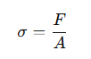

was considered, where σ is the stress experienced by the component, F is the applied load, and A is the cross-sectional area resisting the load. In this context, F represents the forces transmitted through the knee joint due to the child’s body weight. For example, a child weighing 25 kg exerts a static load of approximately 245 N, which can rise to 2–3 times body weight (≈500–750 N) during walking or running.
The area A corresponds to the load-bearing sections of the joint, primarily the cross-sectional area of the stainless-steel rod, calculated as: 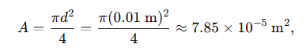
Step 1: Static load stress
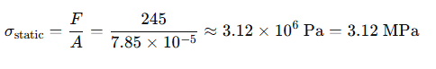

Step 2: Dynamic load stress

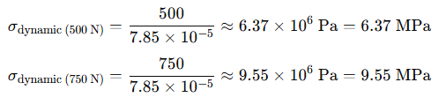

IMAGE 1 Blueprint of developed knee joint- Pedi-Knee
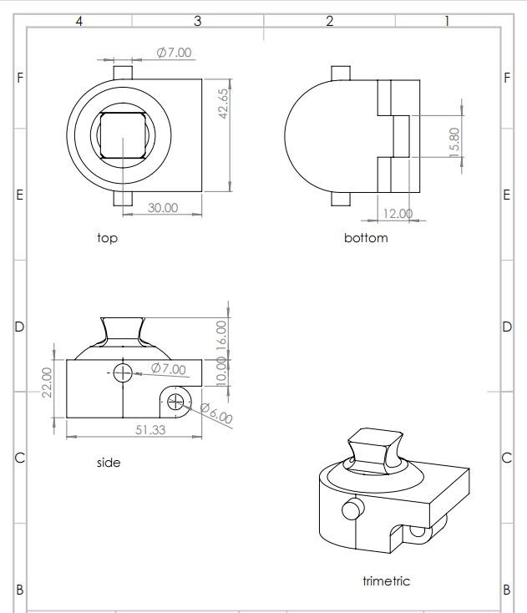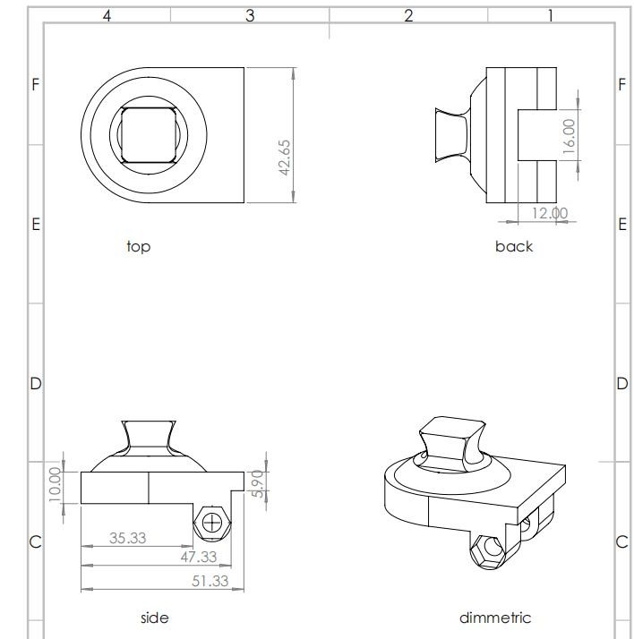

Post-Processing and Assembly
Printed parts were cleaned of excess powder using compressed air and brushing. Burrs from holes and sliding surfaces were removed using fine sandpaper. A stainless-steel rod was inserted to form the axis. Nylon spacers/bushings were press-fitted between the upper and lower joint sections to minimize friction. The pyramid was aligned for verticality using a prosthetic alignment jig. Once the CAD model was finalized, the knee joint was fabricated using 3D printing technology. Selective Laser Sintering (SLS) with Nylon PA12 was chosen as the manufacturing method due to its ability to produce high-strength, lightweight components with intricate details. Selective Laser Sintering (SLS) is a 3D printing technology that creates objects layer by layer using a laser to fuse powdered material together. A bed of powdered material is spread evenly after that laser beam selectively fuses the powder particles together, creating the desired shape and this process is repeated layer by layer until the final object is formed.
Benefits of SLS include high precision and accuracy, ability to produce complex geometries and designs, reduced material waste, fast production times, durable and functional parts, faster prototyping cycles, increased customization, ideal for rapid prototyping.
Material Properties of PA12
Polyamide 12 (PA12), when processed through selective laser sintering (SLS), demonstrates distinct and reliable mechanical characteristics as follows:
• Elastic Modulus: Approximately 205 MPa, indicating higher stiffness compared to PA6 and good resistance to deformation under applied load
• Ultimate Strength: Around 57.7 MPa, reflecting the ability of the material to withstand significant stress before failure
• Elongation at Break: About 11.5%, demonstrating moderate ductility and capacity for deformation prior to fracture
• Stress–Strain Behaviour: Exhibits relatively stable mechanical response with balanced strength and deformation characteristics under flexural loading
• Storage Modulus (E′): High initial value (~1060 MPa at −50°C), indicating strong stiffness at low temperatures; gradually decreases with increasing temperature, with a sharper decline up to ~80°C and a slower reduction thereafter until melting (~178°C)
• Thermal Mechanical Stability: Maintains structural integrity over a wide temperature range, with progressive reduction in stiffness rather than abrupt failure
• Glass Transition Temperature (Tg): Approximately 48.8°C, representing the transition from rigid to more flexible molecular behaviour in the amorphous phase
• Viscoelastic Behaviour: Loss tangent (tan δ) peak around 0.12, indicating moderate energy dissipation and stable viscoelastic performance
• Creep Behaviour: Shows lower permanent plastic deformation (~18%) under sustained load, suggesting better resistance to long-term deformation
• Elastic Recovery: Demonstrates higher recovery (~34%) after removal of load, indicating good resilience and ability to regain original shape
• Fatigue Behaviour: Exhibits reduction in stiffness under cyclic loading, with a stress decrease of approximately 1.4 MPa after prolonged cycles, indicating gradual softening
• Overall Mechanical Performance: Characterized by a combination of high stiffness, adequate strength, moderate ductility, good elastic recovery, and predictable viscoelastic response under varying thermal and loading conditions ⁽⁹⁾.

RESULTS
Since the tensile strength of PA12 is 45-50 MPa and the tensile strength of stainless steel is over 200 MPa, the maximum induced stress of 9.55 MPa is well below the strength limits of both materials.
The completed prototype weighed approximately 240 grams, which is substantially lighter than many conventional pediatric knees. The device provided a smooth and controlled flexion-extension range of 0 to 120 degrees, replicating functional motion required for basic ambulation. The modular pyramid connector allowed seamless integration with existing pediatric sockets and pylons, demonstrating clinical adaptability.
Fabrication was efficient, with printing and post-processing completed in about eight to ten hours. These results suggest that Pedi-Knee can offer both economic and functional advantages in pediatric prosthetic care.
DISCUSSION
Paediatric prosthetic knee joint development is still a difficult field both clinically and technically. Prosthetic options for children with transfemoral amputations must consider rapid growth and high activity levels in addition to anatomical and biomechanical considerations. J. Andrysek (2009) highlights the urgent need for paediatric-specific technologies, pointing out that most existing systems are either prohibitively expensive, excessively complicated, or ill-suited to the particular requirements of children.⁽²⁾ By providing a lightweight, single-axis prosthetic knee joint that was created using CAD modelling and produced using additive manufacturing with PA12 nylon, this study expands on earlier research. The selected design addresses the need for mechanical simplicity, durability, and weight optimization. Andrysek and Naumann (2004) highlighted these priorities, advocating for a design approach that integrates minimal mechanical components while ensuring sufficient joint stability and ease of use for paediatric wearers.⁽⁵⁾ In alignment with their recommendations, this joint maintains structural integrity through a basic flexion-extension mechanism, reducing the cognitive and physical burden of use on the child while improving safety and adaptability during ambulation.
The material choice of PA12 nylon was studied by recent work by Estrada and Delaughter et al. (2023), who demonstrated its suitability in paediatric applications due to its compliant behaviour, fatigue resistance, and excellent printability through Selective Laser Sintering (SLS).⁽⁶⁾ The integration of PA12 in this project supports reduced overall prosthetic weight, enhanced mechanical responsiveness, and customizable geometries that can be scaled for individual anatomical variation.
Furthermore, gait stability and stance-phase support are fundamental to successful prosthetic integration. In their gait analysis study, Andrysek and Redekop (2007) emphasized the biomechanical necessity of stance phase control mechanisms in paediatric prosthetics. ⁽³⁾ Although the present prototype does not incorporate an automatic locking mechanism, it provides inherent stance support through axis alignment and component geometry, demonstrating a passive yet effective approach to meeting this requirement.
Modularity and future growth accommodation are also vital for paediatric prosthetic success. Ngan and Andrysek (2019) articulated the importance of modularity in paediatric prosthetic knee systems, particularly in contexts requiring periodic adjustment or scaling of components. ⁽⁷⁾ This prototype, developed with CAD-based modelling and 3D printing, allows for rapid iteration and simplified modification—ensuring that the joint remains clinically relevant across various stages of the child's development.
In comparison to more advanced prosthetic knee technologies such as polycentric, hydraulic, or microprocessor-controlled systems, the single axis design presented here offers a practical alternative that emphasizes functionality, cost-efficiency, and ease of implementation in low-resource or high-need settings. The simplified mechanical configuration also reduces the likelihood of component failure and minimizes maintenance requirements, making it a sustainable and accessible solution. This study presents a solid proof-of-concept for paediatric prosthetic knee development based on evidence-based design, pertinent material science, and scalable digital manufacturing processes, even though clinical validation is still a future goal.
Findings support further research into user trials, alignment optimization, and potential integration of low-complexity control mechanisms to enhance user adaptability and safety.
In summary, this study contributes to a growing body of literature that seeks to bridge the gap between engineering innovation and paediatric clinical needs. It reinforces the value of design principles grounded in simplicity, adaptability, and patient-specific customization principles that are essential for improving mobility and quality of life in paediatric prosthetic users.
Although the prototype has not yet undergone clinical testing, its development highlights the potential for 3D-printed prosthetic components to meet paediatric needs effectively. The design may also be refined further to include modular adjustments for alignment and improved aesthetics. Continued research and trials are necessary to assess long-term user satisfaction, comfort, and biomechanical performance.
CONCLUSION
In conclusion, the prototype development of a 3D-printed single-axis prosthetic knee joint for paediatric users has provided meaningful insights into designing affordable and functional prosthetic solutions for children with lower limb amputations. This device aims to support essential mobility functions such as walking, sitting, and transitioning between positions thereby contributing to a child's independence and daily living activities.
The prosthetic knee joint is designed to be lightweight, durable, and simple in structure, making it easier to fabricate, maintain, and customize as the child grows. Its single-axis mechanism provides basic flexion and extension, allowing the child to perform common movements safely and more naturally. The use of nylon (PA12) through 3D printing also offers a cost-effective manufacturing method that makes it suitable for low resource settings.
By considering input from clinicians, caregivers, and potential users, further improvements can be made to enhance comfort, functionality, and user experience. With future clinical testing and iterative design updates, the prosthetic knee joint can be developed into a reliable assistive device that improves mobility, confidence, and quality of life for children with limb loss.
Phase two of the research will focus on mechanical strength testing of the knee joint, along with real-time patient trials to evaluate the performance and reliability of the newly designed 3D-printed joint in real-life conditions to implement the designed prototype for real-world applications.
LIMITATION OF THE STUDY
Mechanical performance testing which could reveal that the joint could withstand repetitive flexion-extension cycles without significant material fatigue or joint instability is missing, which will be conducted in phase two of the research. Functional Assessment:
Initial functional trials on paediatric participants depicting any improvements in gait symmetry, stability during ambulation, and user comfort is missing in the research, which will carried out in phase two of the research.
One of the main limitations of this study is that the prosthetic knee joint prototype was not tested on actual patients due to time constraints and the scope of an undergraduate project. Since no real-life trials were conducted, the feedback and data on how well the joint performs during daily use by paediatric users could not be collected. As a result, the study is limited to design and development stages without practical testing or long-term evaluation.
FUTURE RESEARCH
This study has included the prototype development of a 3D-printed single-axis prosthetic knee joint for the paediatric population. The future research may focus on conducting clinical testing to evaluate the biomechanical performance and analysing the long-term durability and effectiveness of the material used in dynamic paediatric environment.
Additionally, testing can be extended to the adult population using materials with higher tensile strength and load-bearing capacity.
ACKNOWLEDGEMENT
The authors acknowledge the support of ISIC Institute of Rehabilitation Sciences and ALIMCO.
COMPETING INTERESTS
Authors have declared that no competing interests exist.

REFERENCES
- Hara H, Kawamoto T, Fukase N, Katayama E, Takemori T, Fujiwara S, Sakai Y, Nishida K, Kuroda R, Akisue T. Successful First Gait of a Child with Hip-Disarticulation Prosthesis. Am J Phys Med Rehabil. 2018 Oct;97(10): e90-e92. doi: 10.1097/PHM.0000000000000894. PMID: 29324457.
- Andrysek J. Development of prosthetic knee joint technologies for children and youth with above-knee amputations. Disability and Rehabilitation: Assistive Technology Journal. 2009 Jun 30;4(4):203–212. doi:10.1080/17483100902912827.
- Andrysek J, Redekop S, et al. Preliminary evaluation of an automatically stance phase controlled paediatric prosthetic knee joint using quantitative gait analysis. 'Archives of Physical Medicine and Rehabilitation; 2007;44(5):701–710. doi:10.1682/JRRD.2006.10.0129.
- Mohanty RK, et al. A systematic review on design technology and application of polycentric prosthetic knee in amputee rehabilitation. 'Physical and Engineering Sciences in Medicine'. 07 Jul 2020, 43(3):781-798
https://doi.org/10.1007/s13246-020-00882-3 PMID: 32638327.
- Andrysek J, Naumann S, et al. Design characteristics of paediatric prosthetic knees. IEEE Transactions on Neural Systems and Rehabilitation Engineering. 12 (4): 369-378, 10. DOI https://ui.adsabs.harvard.edu/link_gateway/2004ITNSR..12.369A/doi:10.1109/TNSRE.2004.838444
- Estrada B, Delaughter A, et al. Design and analysis of a paediatric prosthetic knee with compliant hinges. Proc Inst Mech Eng H. 2023 Jan;237(1):23–34. DOI: 10.1177/09544119221136169
- Ngan CC, Andrysek J. Modeling and Design of the Automatic Stance Phase Lock (ASPL) Knee Joint Control Mechanism for Paediatric Users With Transfemoral Amputations. IEEE Trans Neural Syst Rehabil Eng. 2020 Jan;28(1):203-210. doi: 10.1109/TNSRE.2019.2952004. Epub 2019 Nov 6. PMID: 31714228.Edgar S, Jones T. Paediatric prosthetic knee design: the technical requirements of a swing phase control mechanism are correlated with parameters of childhood growth. Prosthet Orthot Int. 2024 Mar;48(1):45–55. doi:10.1177/03093646231178964.
- Triwiyanto, Luthfiyah, S., Utomo, B., Pawana, I.P.A., Caesarendra, W., Athavale, V.A. (2024). Recent Advances and Challenges in 3D Printing of Prosthetic Hands. In: Triwiyanto, T., Rizal, A., Caesarendra, W. (eds) Proceedings of the 4th International Conference on Electronics, Biomedical Engineering, and Health Informatics. ICEBEHI 2023. Lecture Notes in Electrical Engineering, vol 1182. Springer, Singapore. https://doi.org/10.1007/978-981-97-1463-6_43
- G.V. Salmoria, J.L. Leite, L.F. Vieira, A.T.N. Pires, C.R.M. Roesler, Mechanical properties of PA6/PA12 blend specimens prepared by selective laser sintering, Polymer Testing, Volume 31, Issue 3, 2012, Pages 411-416, ISSN 0142-9418,https://doi.org/10.1016/j.polymertesting.2011.12.006. (https://www.sciencedirect.com/science/article/pii/S0142941811002108)
- Kafle, A., Luis, E., Silwal, R., Pan, H. M., Shrestha, P. L., & Bastola, A. K. (2021). 3D/4D Printing of Polymers: Fused Deposition Modelling (FDM), Selective Laser Sintering (SLS), and Stereolithography (SLA). Polymers, 13(18), 3101. https://doi.org/10.3390/polym13183101

