Development of Nutrient-Dense Nut-Based Chocolate as an Alternative to Healthy Snacking
Abstract
Background
In recent years, Increased screen time in children is strongly linked to unhealthy snacking habits, characterized by the consumption of energy-dense, nutrient-poor foods. These trends contribute significantly to childhood obesity and poor nutritional health, creating an urgent need for healthier, child- friendly snack alternatives.
Objective
The present study aimed to develop a nutrient-rich snack, nut-based chocolate and evaluate its overall acceptability among children as a healthier alternative to commonly consumed snacks during screen time.
Methods
The present research was conducted as an experimental study to formulate a healthy snack alternative for children. Nut-based chocolate was developed using nutrient-dense ingredients such as almonds, cashews, walnuts, makhana, oats, honey, milk powder, cocoa powder, and dark chocolate. Standard preparation techniques, including roasting, mixing and moulding, were employed. The developed product was evaluated by 51 participants using a sensory evaluation scale to assess overall acceptability. Statistical analysis included descriptive statistics, frequency distribution, and a one-sample t-test to determine the significance of acceptability scores.
Results
The findings showed high acceptability of the developed product, with 64.7% participants liking it extremely and 33.3% liking it very much, while only 2% moderate liking. The mean acceptability score was 8.63±0.528, indicating very good to excellent acceptance. The one-sample t-test revealed statistically significant (t=116.764,p<0.001), confirming that the high ratings were not due to chance. Additionally, the product was equally accepted by both male and female participants, demonstrating broad consumer appeal.
Conclusion
The developed nut-based chocolate was found to be highly acceptable and may serve as a healthier alternative to unhealthy snacks commonly consumed during screen time. The study highlights the importance of nutrient-dense snack options to improve dietary habits and promote better health outcomes among children. Further research is recommended to assess large-scale acceptability, shelf life, and long-term nutritional impact.
Keywods
Screen time, snacking, children, nut-chocolate , healthy snacks.

Intoduction
Childhood is a critical period of growth and development, during which lifestyle behaviours such as dietary patterns, Physical activity, and sleep play a vital role in determining long-term health outcomes. In recent decades, rapid technological advancements have significantly altered the daily routines of children, leading to increased engagement with screen-based devices such as television, smartphones, tablets, and computers. This shift toward a more sedentary and screen-oriented lifestyle has global concerns regarding its impacts on children's nutritional status, behavioural patterns, and overall well-being, according to the World Health Organisation (2020).
Screen time has become an integral component of modern childhood, often exceeding recommended limits. According to international guidelines, children should limit recreational screen time to less than two hours per day; however, several studies have reported that children frequently exceed this threshold, particularly in urban settings(American Academy of Paediatrics,2016). Increased screen exposure has been associated with reduced physical activity, disrupted sleep patterns, and unhealthy dietary behaviours, all of which contribute to the rising prevalence of childhood overweight and obesity (Sahoo et.al.,2015).
One of the most concerning consequences of excessive screen use is its influence on eating behaviour, particularly the increased tendency toward snacking. Snacking during screen time has become a habitual behaviour among children, often characterized by the consumption of energy-dense, nutrient-poor foods such as fast foods, packaged foods, chocolates and sugar-sweetened beverages. This behaviour is influenced by multiple factors, including distraction while eating, emotional engagement with screen content, and exposure to persuasive food advertisements (Boyland et.al., 2016).
The relationship between screen time and snacking behaviour is complex and multifactorial. When children engage in screen-based activities, they are more likely to eat mindlessly, leading to increased caloric intake without awareness of portion size or hunger cues. Additionally, the presence of food advertisements during television viewing and digital media exposure significantly influences children's food preferences and consumption patterns, promoting unhealthy food choices(Harris et.al.,2009). Studies have demonstrated that children exposed to food marketing are more likely to prefer and consume high-fat, high-sugar foods, thereby increasing the risk of obesity and related health complications.
Furthermore, family environment and parental practices play a crucial role in shaping children's screen use and dietary behaviours. In many households, particularly where both parents are working, children are often provided with easy access to digital devices and are ready to eat as a means of entertainment and convenience. This lack of supervision may result in prolonged screen exposure and irregular eating patterns, including frequent snacking and skipping of main meals (Pearson et.al.,2009). Such behaviours not only affect dietary quality but also disrupt normal hunger and satiety mechanisms.
Another important factor associated with screen time is its impact on physical activity levels. Increased sedentary behaviours due to prolonged screen use reduce opportunities for outdoor play and physical exercise, which are essential for maintaining energy balance and healthy growth in children. The combination of high caloric intake through unhealthy snacking and low energy expenditure due to physical inactivity creates a positive energy balance, ultimately contributing to weight gain and obesity (Tremblay et.al., 2011).
In addition to physical health outcomes, excessive screen exposure and poor dietary habits have been linked to various health-related problems such as eye strain, headaches, sleep disturbances, and gastrointestinal issues. Children who spend long hours in front of screens are more likely to experience reduced sleep duration and poor sleep quality, which further influences the hormonal regulation of appetite and metabolism (Chaupt et. al.,2017). Moreover, irregular eating habits, including frequent consumption of processed and sugary foods, may lead to digestive problems and dental issues.
The prevalence of unhealthy snacking behaviour among children has also been associated with sociodemographic factors such as age, gender, weight, and height. Older children tend to have autonomy in food choices and screen use, which may increase their exposure to unhealthy lifestyle behaviours. Similarly, your peer influence and social interactions play a significant role in shaping children's preferences for screen content and snack consumption (Story et.al., 2002).
Given the growing burden of childhood obesity and related health complications, there is an urgent need to address modifiable lifestyle factors such as screen time and dietary habits. Interventions aimed at reducing screen exposure, promoting mindful eating, and encouraging healthy snacking practices are essential for improving children's health outcomes. Understanding these relationships is essential for developing effective interventions to promote healthier lifestyle habits among children.
Furthermore recogonizing the need for healthier snacks, the study explored the development of a nutrient-rich snack product in the form of nut -based chocolate. This product was formulated using ingredients such as almonds, cashews, walnuts, makhana, oats, honey and dark chocolate, which are known for their high nutritional value. These ingredients provide essential nutrients, including protein, healthy fats, dietary fibre, vitamins and antioxidants, which contribute to improved health and reduced risk of chronic diseases (Ros et.al.,2010).
The development of such functional snack options aligns with the concept of improving dietary quality while maintaining acceptability among children. By replacing unhealthy snacks with nutrient-dense alternatives, it is possible to address both the behavioural and nutritional aspects of childhood health. This approach not only helps in reducing the risk of obesity and related disorders but also promotes better growth, cognitive function, and overall well-being.
In conclusion, the increasing prevalence of screen-based lifestyles and unhealthy snacking behaviour among children represents a significant public health challenge. The interplay between screen exposure, dietary habits, and health outcomes highlights the need for comprehensive strategies to promote healthier behaviours. The present study contributes to this field by providing insights into the relationship between screen time and snacking behaviour and by proposing a practical nutritional intervention in the form of a healthy snack alternative.
Review of Literature
The Impact of Screen Time on Eating Habits: Recent studies highlight a concerning link between prolonged screen time and poor dietary choices in children. Research indicates that digital engagement often leads to “mindless eating”, where children consume food without responding to natural fullness cues. Furthermore, exposure to unhealthy food advertisements during screen use significantly shifts children's preference toward high-fat, high-sugar snacks. This combination of sedentary behaviour and increased calorie intake is a primary driver of the rising childhood obesity epidemic.
Global Trends in Healthy Snack Development: The development of nutrient-dense snacks is a critical focus in pediatric nutrition to counter the prevalence of energy-dense, nutrient-poor food consumed during screen time. Recent research has explored various child-friendly formats such as:
- Biofortifies Snack Bars: Studies in Tanzania developed bars from germinated crops (Maize, Beans, Sweet Potato) to provide upto 70% of the Recommended Dietary Allowance (RDA) for iron and zinc.
- Protein-Rich Baked Chips: In Pakistan, Sorghum-soy baked chips were developed as a gluten-free, low glycemic alternative, showing high acceptability for flavour and crispiness.
- Pulse-Based Crackers: Recent Formulations using quinoa and chickpea flours enriched with inulin (Chicory fibre) have successfully reduced fat content by 57% while maintaining sensory appeal.
Functional Benefits of Key Ingredients: The inclusion of specific ingredients in nut-based chocolate aligns with established functional food science:
- Nutritional Powerhouse: Nuts such as almonds, cashews, and walnuts are recogonized for their high levels of arginine and resveratrol, which support cardiovascular health, immune function, and brain blood flow.
- Fortification and Bioavailability: Like the use of makhana and oats, other researchers have found that incorporating local legumes, such as bambara nuts, into complementary foods significantly improves protein bioavailability and textural characteristics.
Antioxidant Support: The use of dark chocolate and honey mirrors current trends in “medicated” or “hematinic” confectionery, where flavonoids are used to protect against oxidative stress.
Sensory Acceptability and Behavioural Impact: A healthy snack is only effective if it is accepted by the target population.
- Children's Perceptions: Qualitative research shows that sensory attributes and packaging are the primary factors children use to evaluate sugary snacks.
- Screen Time Context: Objective analysis using wearable cameras confirms that home is the most frequent location for snacking, where children often consume up to one-third of their total energy intake through discretionary “ snack foods”.
- Feasibility of Intervention: Replacing High-sugar confectionery with nutrient- dense alternatives like nut-based chocolate is supported by literature suggesting that early modifications in eating habits can decrease the risk of chronic diseases later in life.
Materials and Methods
Ingredients and their uses
Ingredient | Uses
Almonds | High in Vitamin E, antioxidants, and healthy fats, it supports heart health, skin, and blood sugar regulation.
Cashews | High in Magnesium and copper, it supports Heart health, Bone strength and immune function.
Walnuts | High in Omega-3 Fatty acids, it supports brain function, reduces inflammation, and promotes heart health.
Makhana | High in antioxidants, magnesium, calcium, and Phosphorus help maintain a healthy heart, strong bones, proper muscle functions, and good sleep patterns
Cranberries | High in polyphenols (which help the body bounce back, fight daily damage, and keep things running smoother), Vitamin C load feeds the body’s first line of defence.
Honey | It is full of natural sugars, antioxidants, phenolics, enzymes, antibacterial properties, and anti-inflammatory properties.
Milk Powder | High in calcium, protein and essential vitamins
Cocoa Powder | -------
Dark Chocolate | Flavonoids protect the body from oxidative stress and lower the risk of chronic diseases
Oats Powder | High in protein and fibres
Butter | High in fat soluble vitamins (Vitamin A,D,E,K)
Table 1: List of Ingredients

Table 2: Composition of Chocolate
Content | Amount
Almonds | 40g
Cashews | 85g
Walnuts | 85g
Makhana | 85g
Cranberries | 55g
Oats Powder | 30g
Milk Powder | 10g
Cocoa Powder | 22g
Butter | 10g
Honey | 25g
Dark Chocolate | 400g
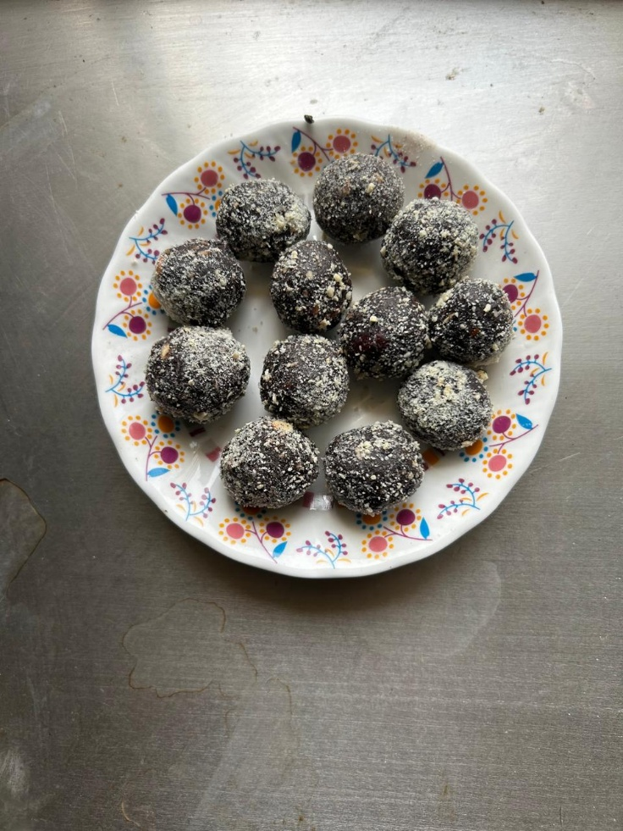
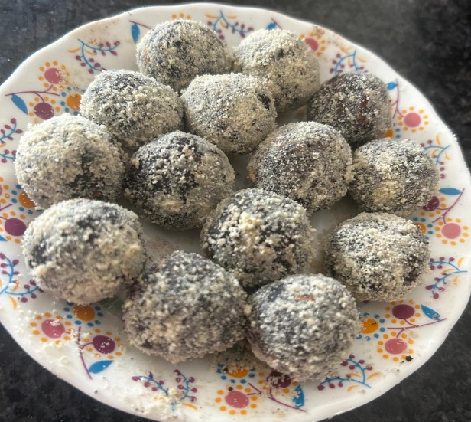

Fig 1. Cashew Coated Nutty Chocolate Fig 2:- Nutty Chocolate

Table 3: Nutrition Table
Content | Amount | Energy(Kcal) | Carbohydrates | Protein | Fats
Almonds | 40g | 262 | 8.6 | 8.4 | 23.2
Cashews | 80g | 474 | 24 | 14.4 | 37.6
Walnuts | 85g | 586 | 11.9 | 12.8 | 55.3
Makhana | 85g | 296 | 64.6 | 8.1 | 0.4
Cranberries | 55g | 179 | 45.1 | 0.1 | 0.6
Oats Powder | 30g | 117 | 19.8 | 5.1 | 2.1
Milk Powder | 10g | 50 | 3.8 | 2.6 | 2.7
Cocoa Powder | 22g | 50 | 12.7 | 4.3 | 3.0
Butter | 10g | 72 |  | 0.1 | 8.1
Honey | 25g | 76 | 20.6 | 0.1 | 0.0
Dark Chocolate | 400g | 2392 | 184 | 31.2 | 168
Total | 842g | 4554Kcal | 394.1g | 87.1g | 300.9g

CHART1: Hedonic Rating Scale
S.no | Hedonic Ratting Parameter
1. | Dislike Extremely
2. | Dislike Very Much
3. | Dislike Moderately
4. | Dislike Slightly
5. | Neither like Nor dislike
6. | Like slightly
7. | Like moderately
8. | Liked very much
9. | Liked Extremely

Note: Worked on Hedonic rating scale for data analysis.
Procedure
- Roasting the nuts: Firstly, a deep frying pan was heated, and each nut, almonds, cashews, walnuts, and Makhana, was roasted separately until they gave a nice smell and became a light golden-brown colour. The nuts were then roasted, cooled, and chopped into small pieces.
Reason why this step is necessary: Roasting nuts releases their natural oil, which enhances flavour, aroma and provides the crunch. This crunchiness helps in giving the texture of chocolate.
- Melting the dark chocolate: The dark compound chocolate was cut into small, uniform chunks for even melting. It was then melted, using the double-boiler method- Placing a heat-safe bowl at the top of the pot over simmering water. We mix the chocolates until all lumps disappear and are completely melted.
Reason why this step is necessary: Controlling the heat is necessary during the melting of the chocolate in the double boiler method because it can become too warm and develop a hard texture in the finished product.Correct melting results in impeccable consistency, which gets melted together with other ingredients and can be poured into moulds effectively as well.
- Addition of some glossy products:- Slowly add melted butter, milk powder, and cocoa powder while melting the chocolate continuously.
Reason why this step is necessary: Incorporating melted butter, milk powder, and cocoa powder into chocolate while stirring keeps it smooth and shiny. Butter gives a little shine and mouthfeel, milk powder creates creaminess, and cocoa powder rounds out the chocolate flavour.
- Mixing of nuts and oats powder: Slowly add the nuts into the melted chocolate until well combined.
Reason why the step is necessary: One of the key factors to improve the composition of your products is uniform mixing, as it ensures that every portion contains nuts in a fixed quantity. The oats powder helps the chocolate and nuts to hold together while providing a nutty chocolate with some protein content.
- Gently spread on butter paper: Transfer the mixture from the boiling pot to butter paper.
Reason why this step is necessary: The cooled and thickened mixture is then transferred to butter paper, which helps the mixture to shape into a workable dough. It is a non-stick property of butter paper that prevents adhesion and makes it easy to handle the mixture. It gives you the advantage of easy portions and rounding up the uniform chocolate balls.
- Making Chocolate Balls: The chocolate dough was pinched into small round balls with clean hands or a scoop.
Reason why this step is necessary: This is necessary for a good presentation.
- Packaging of chocolate: Chocolate balls were packaged in proper food-grade packaging.
Reason why this step is necessary: Packaging helps preserve quality, protects the balls from contaminants and moisture during storage and keeps hygiene intact.
Evaluation
Table 4: Frequency table of overall acceptability
Overall Acceptability |  | Frequency | Percent
 | Like Moderately | 1 | 2.0
 | Like Very Much | 17 | 33.3
 | Like Extremely | 33 | 64.7
 | Total | 51 | 100.0

Fig 3 Overall acceptability of Chocolate

The data on the overall acceptability of the developed product indicate a highly positive response among the participants. The majority of the respondents liked the product extremely (64.7%), followed by 33.3% who liked it very much, while only a small proportion (2.0%) liked it moderately. None of the participants expressed dislike toward the product.
These findings suggest that the developed nut-based chocolate was highly acceptable in terms of sensory attributes such as taste, texture, aroma, flavour, and overall appeal. The high percentage of participants who rated the product as “liked extremely” reflects a stronger consumer preference and indicates the potential feasibility of introducing this product as a healthier snack alternative for children.
Overall, the results demonstrate that the product achieved a high level of acceptability, supporting its suitability for inclusion in dietary interventions aimed at improving snacking behaviour among children.
Descriptive Statistics | N | Minimum | Maximum | Mean | Std. Deviation
Overall acceptability | 51 | 7 | 9 | 8.63 | .528
Valid N (listwise) | 51
Table 5: Descriptive Statistics

Fig 4 Descriptive Statistics
The descriptive statistics for overall acceptability indicate that the developed product was highly appreciated by the participants. A total of 51 respondents evaluated the product, with scores ranging from a minimum of 7 to a maximum of 9 on the acceptability scale. The mean score was 8.63, with a standard deviation of 0.528.
The high mean value suggests that the product was rated close to the upper end of the scale, reflecting very good to excellent acceptability among participants. The relatively low standard deviation indicates less variability in responses, meaning that most participants had similar positive perceptions of the product.
Overall, these findings confirm that the developed nut-based chocolate had consistently high acceptability, supporting its potential as a nutritious and well-accepted snack option among children.
 |  | Overall acceptability |  |  | Total
 |  | Like Moderately | Like Very Much | Like Extremely | Total
Gender of participants | Female | 1 | 14 | 27 | 42
Gender of participants | Male | 0 | 3 | 6 | 9
Total |  | 1 | 17 | 33 | 51
Table 6 Association between gender and overall acceptability

Fig 5 Association between gender and overall acceptability
The relationship between the gender of participants and the overall acceptability of the product. Among female participants, the majority liked the product (27), followed by 14 who liked it very much, and only 1 participant liked it moderately. Similarly, among male participants, 6 liked the product extremely, followed by 3 who liked it very much.
Overall, the findings indicate that both male and female participants showed a high level of acceptability toward the developed product, with the majority in both groups expressing a strong preference. This suggests that the product was equally well accepted across genders, highlighting its broad appeal and suitability as a healthy snack option for children.

One-Sample Test
 | Test Value = 0
 | t | df | Sig. (2-tailed) | Mean Difference | 95% Confidence Interval of the Difference
 |  |  |  |  | Lower | Upper
Overall acceptability | 116.764 | 50 | .000 | 8.627 | 8.48 | 8.78
Table 7 One Sample T-test

Fig 6 One-sample t-test
A one-sample t-test was conducted to evaluate the overall acceptability of the developed product against a test value of zero. The result showed the mean acceptability score (M=8.63) was significantly higher than test value, t(50)= 116.764, p<0.001
The mean difference of 8.627 indicates a substantial positive deviation from the test value, reflecting a very high level of acceptability among participants. Additionally, the 95% confidence interval (8.48 to 8.78) suggests that the true mean acceptability score lies within a narrow and consistently high range,
These findings confirm that the developed nut-based chocolate product was statistically highly acceptable, demonstrating stronger preference and positive evaluation by the participants. This further supports its potential as a nutritious and well-accepted snack alternative for children.

Discussion
The present study was conducted to develop and evaluate a nutrient-rich product in the form of nut-based chocolate as a healthier alternative to commonly consumed energy- dense snacks among children. The study was undertaken in the context of increasing concerns regarding unhealthy snacking habits associated with prolonged screen time and sedentary lifestyles among children.
The findings of the study revealed that the developed nut-based chocolate was highly acceptable among participants, as reflected by both sensory evaluation and statistical analysis. A majority of the respondents expressed a strong preference for the product, with 64.7% liking it extremely and 33.3% liking it very much, indicating a high level of overall acceptability. The descriptive statistics further supported these findings, with a high mean acceptability score(8.63 ±0.528), suggesting that the product was consistently well- received across participants.
The one-sample t-test results demonstrated that the acceptability of the product was statistically significant (p<0.001), confirming that the observed high ratings were not due to chance. Additionally, the association between gender and acceptability indicated that the product was equally preferred by both male and female participants, highlighting its broad appeal.
The formulation of the product using nutrient-dense ingredients such as almonds, cashews, walnuts, makhana, oats, blueberries, honey and dark chocolate contributed to its enhanced nutritional profile. These ingredients are rich in essential nutrients, including proteins, healthy fats, dietary fibres, vitamins and antioxidants, which are beneficial for growth, development and overall health. Thus, the developed product not only meets sensory expectations but also provides nutritional advantages over conventional snacks.
In the context of rising consumption of unhealthy snacks during screen time, the development of such functional food products offers a practical and effective approach to improving dietary habits among children. The study highlights the importance of promoting healthier snack alternatives that are both nutritionally balanced and acceptable to the target population.
In conclusion, the developed nut-based chocolate can be considered a nutritious, acceptable, and feasible snack option for children, with the potential to improve snacking behaviour and support better health outcomes. Further research may focus on large-scale acceptability trials, shelf -life studies, and nutritional intervention programmes to further validate and promote the use of such products in child nutrition.

Conclusion
The study demonstrates that the developed nut-based chocolate is a highly acceptable, nutritious, and feasible snack option for children. It serves as a suitable, healthier substitute for the energy- dense, unhealthy snacks typically consumed during prolonged screen time. Introducing such nutrient-dense alternatives provides a practical approach to improving children’s dietary habits, which can potentially enhance overall snacking behaviours and promote better health outcomes. To fully validate and encourage the use of these products in child nutrition, the study recommends further research focusing on large-scale acceptability trials, shelf-life studies, and long-term nutritional intervention programs.
Limitations of the Study
The study was conducted on a limited number of participants, which may restrict the generalization of the findings.
The sensory evaluation was based on subjective responses and individual taste preferences
The study focused only on overall acceptability and did not include biochemical or shelf life analysis of the developed product.
Long-term effects of nut-based chocolate on health and dietary behaviour were not assessed.
The study was conducted within a short duration and under specific conditions
Disclaimer (Artificial intelligence)
Author(s) hereby declare that generative AI technologies such as Large Language Models, etc. have been used during the writing or editing of manuscripts. This explanation will include the name, version, model, and source of the generative AI technology and as well as all input prompts provided to the generative AI technology
Details of the AI usage are given below:
- Generative AI tools for language improvement, grammar correction, and formatting assistance during manuscript preparation.

All scientific content, data analysis, interpretation, and final responsibility for the manuscript remain with the authors.
References
American Academy of Paediatrics. (2016). Media and young minds. Pediatrics, 138(5), e20162591.
Boyland, E. J., Nolan, S., Kelly, B., Tudur-Smith, C., Jones, A., Halford, J. C. G., & Robinson, E. (2016). Advertising as a cue to consume: A systematic review and meta-analysis of the effects of acute exposure to unhealthy food advertising on intake in children and adults. The American Journal of Clinical Nutrition, 103(2), 519–533.
Chaput, J. P., Grey, C. E., Poitras, V. J., Carson, V., Gruber, R., Birken, C. S., MacLean, J. E., Aubert, S., Sampson, M., & Tremblay, M. S. (2017). Systematic review of the relationships between sleep duration and health indicators in school-aged children and youth. Obesity Reviews, 17(S1), 7–19.
Harris, J. L., Bargh, J. A., & Brownell, K. D. (2009). Priming effects of television food advertising on eating behaviour. Health Psychology, 28(4), 404–413.
Pearson, N., Biddle, S. J. H., & Gorely, T. (2009). Family correlates of fruit and vegetable consumption in children and adolescents: A systematic review. Public Health Nutrition, 12(2), 267–283.
Ros, E., Tapsell, L. C., & Sabaté, J. (2010). Nuts and berries for heart health. Current Atherosclerosis Reports, 12(6), 397–406.
Sahoo, K., Sahoo, B., Choudhury, A. K., Sofi, N. Y., Kumar, R., & Bhadoria, A. S. (2015). Childhood obesity: Causes and consequences. Journal of Family Medicine and Primary Care, 4(2), 187–192.
Story, M., Neumark-Sztainer, D., & French, S. (2002). Individual and environmental influences on adolescent eating behaviours. Journal of the American Dietetic Association, 102(3), S40–S51.
Tremblay, M. S., LeBlanc, A. G., Kho, M. E., Saunders, T. J., Larouche, R., Colley, R. C., Goldfield, G., & Gorber, S. C. (2011). Systematic review of sedentary behaviour and health indicators in school-aged children and youth. Applied Physiology, Nutrition, and Metabolism, 36(1), 59–64.
World Health Organization. (2020). Guidelines on physical activity and sedentary behaviour. WHO Press.
Surkar, S., Dobariya, P., Vasoya, D., & Patel, S. (2025). PREPARATION AND EVALUATION OF HEMATINICS CHOCOLATE..
SIVAPRAKASH, S. (2022). ‘FORTIFICATION AND NUTRIENT ASSESSMENT OF CHOCOLATE MILKSHAKE WITH PEANUT POMACE PROTEIN’.
Doğan, G., & Yılmaz, İ. (2023). Product Development and Sensory Evaluation of Dark Chocolate Filled with Chestnut Honey. Black Sea Journal of Agriculture, 6(5), 452-458.
Amevor, P. M., Laryea, D., & Barimah, J. (2018). Sensory evaluation, nutrient composition and microbial load of cashew nut–chocolate spread. Cogent Food & Agriculture, 4(1), 1480180.
Jadhav, P., Jadhav, H., & Sakore, A. (2022). Formulation and evaluation of medicated chocolates using nuts (almonds, cashews, walnuts, pistachios). International Journal of Pharmaceutical Research, 10(2), 123–130.
Afoakwa, E. O., Paterson, A., & Fowler, M. (2007). Factors influencing rheological and textural qualities in chocolate–a review. Trends in Food Science & Technology, 18(6), 290-298.
Ros, E. (2010). Health benefits of nut consumption. Nutrients, 2(7), 652-682.
Guinard, J. X., & Mazzucchelli, R. (1996). The sensory perception of texture and mouthfeel. Trends in Food Science & Technology, 7(7), 213-219.
De Pelsmaeker, S., De Clercq, G., Gellynck, X., & Schouteten, J. J. (2019). Development of a sensory wheel and lexicon for chocolate. Food Research International, 116, 1183-1191.
De Pelsmaeker, S. (2016). Understanding sensory analysis in consumer-driven product development in chocolate confectionery (Doctoral dissertation, Ghent University).
Arya, S. S., Salve, A. R., & Chauhan, S. (2016). Peanuts as functional food: a review. Journal of food science and technology, 53(1), 31-41.
Gage, R., Girling-Butcher, M., Joe, E., Smith, M., Ni Mhurchu, C., McKerchar, C., ... & Signal, L. (2020). The frequency and context of snacking among children: an objective analysis using wearable cameras. Nutrients, 13(1), 103.
Hassanally, S., Naicker, A., & Singh, E. (2020). Snack development for school feeding programs in Africa: A scoping review. International Journal of Environmental Research and Public Health, 17(14), 4967.
James, S., Akosu, N. I., Maina, Y. C., Baba, A. I., Nwokocha, L., Amuga, S. J., ... & Omeiza, M. Y. M. (2018). Effect of addition of processed bambara nut on the functional and sensory acceptability of millet‐based infant formula. Food science & nutrition, 6(4), 783-790.
Mahmood, L., Flores-Barrantes, P., Moreno, L. A., Manios, Y., & Gonzalez-Gil, E. M. (2021). The influence of parental dietary behaviours and practices on children’s eating habits. Nutrients, 13(4), 1138.
Martín-Esparza, M. E., Raigón, M. D., García-Martínez, M. D., & Albors, A. (2023). Toward the development of potentially healthy low-energy-density snacks for children based on pseudocereal and pulse flours. Foods, 12(15), 2873.

