Applications of Agriculture Waste (Mustard Husk) in Production of Sustainable Bio Bricks

ABSTRACT
One of India's fastest-growing sectors, building development places a significant strain on the country's finite natural resources. One of the main components used in the building sector, fired clay bricks emit a significant quantity of greenhouse gases. This research paper looks at ways to modify alternative materials to fit the needs of the Indian building sector. Bio-bricks are one such substance that functions well as an insulator and has the potential to be a sustainable and economical solution. It is made from cement mortar and Mustard husk. Then testing the bio-bricks by checking Compressive strength increases concurrently with variable conditions. In present research work by using mustard husk the compressive strength is increasing up to 0.75% and then decreased at 1%. Construction industry is increasingly seeking sustainable alternatives to traditional materials to reduce environmental impact and promote resource efficiency. Utilizing agricultural waste in the bricks not only helps in waste management but also enhances the properties of construction materials.
KEYWORDS: -Bio-Brick, Mustard Husk, Cement, Compressive Strength, Sustainable

1 INTRODUCTION
The construction industry is at a pivotal crossroads, facing increasing pressure to adopt sustainable practices while meeting the ever-growing demand for building materials. As urbanization accelerates and populations swell, the need for efficient, durable, and environmentally friendly construction solutions has never been more urgent. This study aims to investigate the potential of agricultural waste as a viable alternative in the production of BIO-Concrete cubes and bricks—two fundamental components of modern construction. By exploring the incorporation of agricultural waste into construction practices, this research highlights a promising avenue for enhancing the sustainability of the industry and addressing the pressing challenges of waste management and resource depletion. [1]
Agricultural waste, which includes by-products such as straw, husks, and other plant residues, is often discarded or burned, contributing to environmental degradation and air pollution. However, recent advancements in material science have demonstrated that these waste materials can be repurposed to create high-quality construction materials. The incorporation of agricultural waste into concrete and brick production not only helps to mitigate the environmental impact of waste disposal but also enhances the properties of the final products. Studies have shown that using agricultural waste can improve the compressive strength and durability of concrete and bricks, making them more resilient and suitable for various construction applications. This dual benefit of enhanced performance and reduced environmental impact positions agricultural waste as a valuable resource in the quest for sustainable construction solutions. One of the most significant advantages of utilizing agricultural waste in construction is its cost-effectiveness. Traditional building materials, such as cement and clay, can be expensive and resource-intensive to produce. By incorporating agricultural waste, manufacturers can reduce production costs significantly, providing economic benefits not only to themselves but also to farmers who generate these by-products. This creates a symbiotic relationship where agricultural producers can find new markets for their waste materials, while construction companies can lower their material costs. This economic incentive is particularly crucial in developing regions, where budget constraints often limit the availability of quality building materials. [2, 3]
Moreover, the environmental impact of using agricultural waste in construction is profound. The construction industry is a significant contributor to global waste generation, with millions of tons of materials ending up in landfills each year. By repurposing agricultural waste, the industry can significantly reduce its reliance on virgin materials and minimize landfill contributions. This practice promotes sustainable resource management and aligns with global efforts to combat climate change and environmental degradation. The circular economy model, which emphasizes reusing and recycling materials, is increasingly relevant in this context, and agricultural waste fits seamlessly into this framework. In addition to the environmental and economic benefits, the use of agricultural waste in construction also opens up new avenues for innovation. Researchers and engineers are continually exploring novel methodologies for integrating these materials into existing production processes. For instance, advancements in chemical treatments and processing techniques can enhance the properties of agricultural waste, making it more suitable for use in concrete and bricks. This ongoing research not only improves the quality of the final products but also expands the range of agricultural waste materials that can be utilized, further diversifying the sources of sustainable building materials. The traditional definition of a brick, typically associated with dried clay, is evolving as new materials enter the market. Bricks are essential components in masonry construction, providing structural integrity, thermal insulation, and water absorption. The incorporation of agricultural waste into brick production can enhance these properties, resulting in bricks that are not only more sustainable but also more efficient in their performance. [8,9,10,11]
The scope of this study encompasses a comprehensive exploration of the utilization of agricultural waste in the production of bricks, aiming to highlight its potential benefits and applications in the construction industry. It begins with an overview of various types of agricultural waste that are suitable for incorporation into building materials, setting the stage for a detailed analysis of the physical and mechanical properties of bricks produced with these materials. This analysis is crucial for understanding how agricultural waste can enhance the performance of construction elements. Additionally, the study reviews the environmental benefits associated with using agricultural waste, emphasizing its role in reducing waste and promoting sustainability. Through case studies, the research will showcase successful applications of agricultural waste in concrete and brick manufacturing, providing real-world examples of its effectiveness. The significance of this study lies in its potential to foster sustainable practices within the construction industry. By integrating agricultural waste into building materials, the research aims to reduce reliance on non-renewable resources, lower carbon emissions, and contribute to a circular economy. Ultimately, this study seeks to provide valuable insights that can lead to the development of innovative, eco-friendly construction materials, paving the way for a more sustainable future in building practices. [4 ,5 ,6]
2 MATERIALS & METHODOLOGY
The selection of materials for the production of agricultural waste-based bricks is a critical aspect of this study, focusing on sustainable alternatives to traditional construction materials. For the Agri-based bricks, the primary components include soil as the fine aggregate, fly ash, mustard husk, and water. The material preparation is shown in Fig. 1 Notably, while soil, lime, water, and fly ash are conventional ingredients for brick-making, this study innovatively replaces lime with agricultural waste, specifically mustard husk, to enhance sustainability. The mustard husk requires further chopping and fining to achieve the desired consistency. Overall, this selection of materials not only aims to reduce environmental impact but also seeks to demonstrate the feasibility of using agricultural waste in construction applications. [7 8, 9] The main objective of the study is to reduce the usage of conventional material (fine aggregates) by replacing it with waste materials (mustard- husk) in bricks. And increase the compressive strength of cement bricks by bio waste. The materials such as cement, fine aggregate, water and mould of size (230X115X75) mm along with mustard husk was used. OPC Cement confirming 53 grade is used and fine aggregate as per zone 2 of IS 456-2000 is utilized mix ratio in order of 1: 3 used for cement and sand and quantity if proposed materials is found.
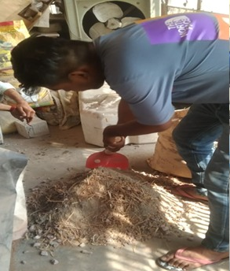
Fig. 1: Preparation of mixture
2.1 METHODOLOGY:
In order to assess the viability, mechanical integrity, and functional performance of mustard husk when used as a partial replacement for conventional fine aggregates in the manufacturing of sustainable building materials, the experimental framework used in this study was carefully planned. This research methodology's main goal was to progressively lessen dependency on traditional natural resources while concurrently assessing the structural viability and compressive strength of cementitious masonry units by incorporating biological waste. This required a multi-phase, highly controlled experimental approach that included material characterization, careful bio-waste preparation, exact mix proportioning, standardized production methods, and stringent mechanical testing.
Characterization and Acquisition of Materials: In order to create a trustworthy baseline for comparison analysis, the experimental program's foundation mainly depended on the meticulous selection and characterization of raw materials. Ordinary Portland Cement (OPC) that complied with the 53-grade criteria was the main binding agent used during the investigation. This particular grade was selected because of its exceptional durability and quick strength acquisition, both of which are essential for load-bearing building applications. Material that complied with Zone 2 of the Indian Standard code IS 456-2000 was used for the standard fine aggregate. A dense, well-packed mortar matrix with few interstitial gaps requires an ideal particle size distribution, which is ensured by choosing Zone 2 aggregate. To speed up the chemical hydration process, clean water was used for both mixing and curing. Mustard husk was chosen as the experimental variable because it could improve the final bricks' thermal and acoustic properties in addition to being a way to manage agricultural waste. The weighing of bricks is shown in Fig. 2
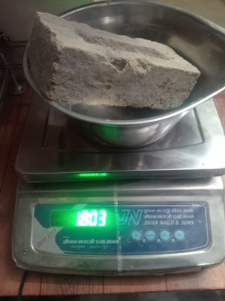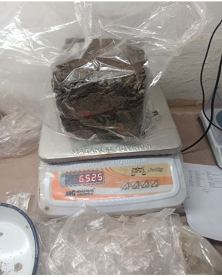
Fig.2: The weighing of produced bricks.
Bio-Waste Preparation and Preconditioning: The precise preparation and conditioning of the raw mustard husk before it was added to the cement mortar was a crucial and extremely technical part of the process. Agricultural leftovers have a significant capacity to absorb water and are intrinsically very porous. The particular volume of water intended for the chemical hydration of the cement particles would be quickly absorbed if raw, dry husk were added straight to the cement mix. This quick suction of water into the husk would seriously impair the mortar's workability and cause insufficient hydration, which would ultimately produce a matrix that is brittle and structurally flawed.
The mustard husk was put through a strict preparation procedure to combat this occurrence. To get a consistent, desired consistency, the raw material was first chopped and fined. Large organic fibers must undergo this mechanical breakdown in order to avoid producing excessive voids or structural weak areas in the brick. The mustard husk was completely soaked in water for the entire night after size reduction. By ensuring that the husk's internal pores were pre-filled with moisture, this saturation procedure stabilized the surrounding mortar's water-to-cement ratio during the mixing and curing stages that followed.
Design Strategy and Mix Proportioning: The purpose of the mix proportioning strategy was to methodically isolate the impacts of the mustard husk substitution. To set the standard for structural performance, a nominal control mix was created. One part OPC 53-grade cement to three parts fine aggregate by weight was the standard mix ratio used in this control group, which was 1:3. Constant water-to-cement (W/C) ratio of 0.5 was rigorously maintained throughout all test batches to guarantee sufficient workability and ideal conditions for cement hydration.
In the experimental permutations, this baseline was altered by substituting the pre-soaked mustard husk with a predetermined fraction of the fine aggregate. Four different intervals were used for the substitution: 0.25%, 0.5%, 0.75%, and 1% of the fine aggregate's weight. The methodology made sure that any changes in the final compressive strength could be directly linked to the different concentrations of the agricultural waste by keeping consistent binder content and a constant W/C ratio of 0.5.
Protocol for Fabrication, Compaction, and Curing: To ensure consistency and repeatability, the bio-bricks were physically manufactured in accordance with strict laboratory procedures. To reach the desired 0.5 W/C ratio, water was added after blending the dry cement and leftover fine aggregate with the preset amount of pre-soaked mustard husk. The resultant bio-mortar was promptly poured into standard rectangular molds measuring 230 x 115 x 75 mm.
A methodical compaction procedure was used to remove trapped air and increase the end product's density. Three separate, equal layers of mortar were poured into the molds, and a typical tamping rod was used to firmly compact each layer. The molds were left undisturbed in the lab setting for a 24-hour initial setting time after the casting and compaction procedure. Following this first stage of hardening, the bricks were promptly submerged in room-temperature water after being carefully taken out of the molds to avoid micro-cracking. The continual chemical reaction between the cement and water, which holds the matrix together and promotes strength development over time, depends on this continuous, submerged curing.
Methods of Testing and Analytical Assessment: A thorough analytical testing routine to measure the structural and physical characteristics of the manufactured specimens comprised the last stage of the study technique. Compressive strength, which determines the brick's ability to bear axial loads without breaking, was the main indicator of structural viability. Specimens from the control group and all mustard husk replacement groups were taken out of the curing tanks and tested every seven, twenty-one, and twenty-eight days in order to create a solid strength gain profile. A calibrated Universal Testing Machine (UTM) was used to perform the destructive testing in strict compliance with the applicable IS regulations.
The methodology included qualitative physical evaluations in addition to quantitative mechanical testing. To examine the internal cross-section, sample bricks were purposefully broken in two. This macroscopic analysis was crucial for assessing the mixture's internal homogeneity, confirming that the mustard husk was dispersed uniformly throughout the cement matrix, and demonstrating that the layered compaction technique effectively reduced the amount of internal voids. The study was able to conclusively determine that 0.75% is the ideal replacement level for optimizing both sustainability and structural performance thanks to this thorough, multi-tiered approach.[10,11,12]
2.2 TESTING: Bricks are taken and are broken into half to check the uniformity of mixture and to check the voids present in the brick. The mustard husk is used in making the brick should be present uniformly throughout the brick and there should be less voids in the brick.

2.2.1 COMPRESSIVE STRENGTH
Compressive strength is computed from universal testing machine as per is code for specimens of normal brick and specimen with mustard husk replacement. Table 1 and table 2 below present results obtained.
Table 1: compressive strength for normal bricks
S. no | Mix ratio | Days | Average strength (N/mm2)
1 | 1:3 | 7 | 20.69
2 | 1:3 | 21 | 22.61
3 | 1:3 | 28 | 28.52

Table 2: compressive strength for mustard husk bricks
S. no | % mustard husk | Mix ratio | 7 days Strength | 21 days Strength | 28 days Strength
1 | 0.25 | 1:3 | 22.15 | 24.44 | 26.45
2 | 0.5 | 1:3 | 24.37 | 26.35 | 29.19
3 | 0.75 | 1:3 | 26.86 | 33.66 | 37.09
4 | 1.0 | 1:3 | 23.08 | 23.94 | 24.49

Figure 3: variations of compressive strength with mustard husk replacement

It is observed from the above table that, we used different proportions of mustered husk i.e., 0.25, 0.5, 0.75 and 1% by weight of cement and it is observed that compressive strength is increasing up to 0.75% and then decreased at 1%. An addition of proportions up to 0.75% in cement bricks is benefited. Graphs below show comparison of compressive strength for normal bricks and mustard husk bricks. [13, 14, 15] the measurement of compressive strength of material is shown in Fig.4
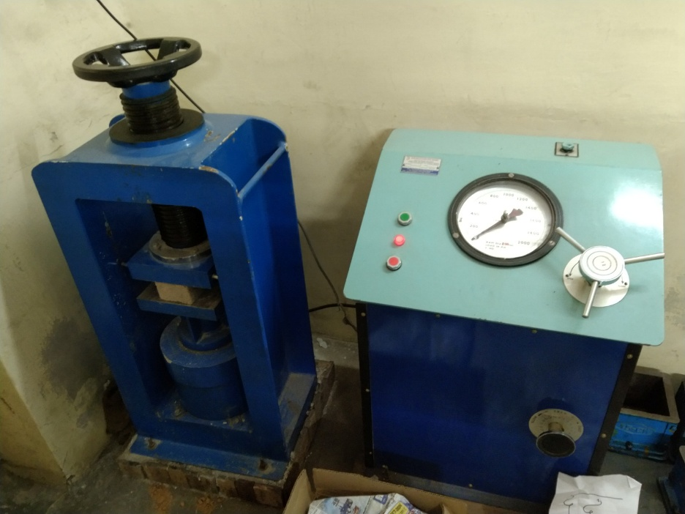
Fig.4: Measurement of compressive strength of material

4. RESULTS AND DISCUSSION
The results of this study's experimental analysis show that the mechanical characteristics of cement bricks are greatly affected when mustard husk is used in place of some of the fine aggregate. The assessment compared "bio-bricks" with different mustard husk percentages (0.25%, 0.5%, 0.75%, and 1.0%) to conventional cement mortar bricks (1:3 mix ratio). The research's crucial conclusion is that the bricks' compressive strength peaks at a particular threshold rather than progressing linearly. [16, 17]. According to data analysis, the average 28-day compressive strength of the control (normal) bricks was 28.52 N/mm². On the other hand, as the mustard husk percentage increased from 0.25% to 0.75%, the bio-bricks' strength gradually increased. With a strength of 37.09 N/mm² at 28 days, the 0.75% mustard husk replacement produced the highest strength in the study—a significant improvement above the conventional nominal mix. This rise is explained by the husk's potential to improve the brick's interior matrix when employed in the right amounts.
The study does point out a certain limit to these advantages, though. The 28-day compressive strength fell precipitously to 24.49 N/mm² when the mustard husk content was raised to 1.0%, falling short of even the control brick's performance. Similarly Dwivedi et al. [18] found a good test results of maximum compressive strength and absorption of 3.67 MPa, and 21.7% of concrete bricks made up of some agro bio waste. This suggests that a greater proportion of agricultural waste results in a decrease in structural integrity, either as a result of an increase in voids or a disturbance in the cement mortar's bonding. Jaramillo et al. [19] also stated that bio-waste generated bricks have a compressive strength was to be around ~1.7 MPa, indicating the composition suitability for eco-friendly construction. The produced brick samples are shown in Fig. 5
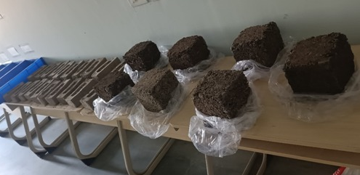
Fig.5: The produced brick samples
The presentation emphasizes a number of practical benefits of these sustainable materials that go beyond their mechanical strength. The addition of mustard husk enhances soundproofing and thermal insulation, which can result in increased building energy efficiency. Additionally, Ahmad et al. [20] also stated that bio waste based in bricks with increased porosity (up to 64% at 50% agro residue addition) and decreases the density, minimum energy requirement while firing by in between 15–20% by keeping compressive strength in the range of 15–20 MPa. Economically speaking, using locally obtained agricultural waste cuts shipping costs and the need for pricey raw materials. By recycling husks that would otherwise be burned, this method reduces air pollution and the building industry's carbon footprint, addressing the crucial environmental issue of waste management. There are some limitation of present research work the availability of the agricultural waste wheat straw, mustard and rice husk in off-season which makes the production of the Bio-brick difficult in off-season. The agricultural waste is available only during a certain period throughout the year due which they can only produce during a certain period. Currently, there are limited productions capacity due to which currently they are unable to fulfill the demand of the customer. Generally, the agricultural waste is used for feeding the livestock which makes it difficult to collect the agriculture waste for production purpose. Whenever, we increases the contain of agricultural waste in production, the compressive strength of the Bio-Bricks decreases. Its means the agriculture waste must be used at fixed proportion to obtained the maximum compressive strength in bio-bricks. It’s also very difficult to compete with the traditional clay brick which are already available in market and dominating since from many years. Social acceptance among common people and a sense of awareness and maturity regarding bio-bricks are essential for their successful adoption.

5. CONCLUSIONS
We have observed that using mustard husk as replacement of fine aggregate in bricks is benefited up to 0.75% and beyond 0.75% of mustard husk in cement bricks compressive strength will be reduced. Higher percentage of mustard husk decreases the compressive strength in cement bricks. Compressive strength of mustard husk modified brick is more than nominal cement brick and can be preferable in construction works. Bricks manufactured with mustard husks exhibit improved thermal insulation and soundproofing qualities, contributing to energy efficiency in buildings. Furthermore, the use of locally sourced agricultural waste can lead to cost savings for manufacturers and builders, as it reduces the need for expensive raw materials and transportation costs. By investigating the benefits, challenges, and methodologies associated with this innovative approach, stakeholders can gain valuable insights into how agricultural waste can be harnessed to create more sustainable construction solutions. As the construction industry continues to evolve, embracing agricultural waste as a resource not only addresses pressing environmental concerns but also fosters economic growth and innovation.
Ethical Statement: All the authors have no conflicts of interest and also certify that there is no any financial interest with this original work.
Disclaimer (Artificial intelligence)
Author(s) hereby declare that NO generative AI technologies such as Large Language Models (ChatGPT, COPILOT, etc.) and text-to-image generators have been used during the writing or editing of this manuscript.

REFERENCES
- Sharma, Minerva, et al. "Utilization of Maize Waste for Various Applications." Sustainable Solutions for Agricultural Waste. CRC Press, 2026. 103-120.
- Mishra, Vibhooti Narayan, et al. "Eco-Innovative Fiber Composites: Utilization of Industrial and Agricultural Waste for Sustainable Structures." Smart Materials Engineering: Data-Driven Approaches and Multiscale Modelling. Cham: Springer Nature Switzerland, 2026. 65-85.
- Phonphuak, Nonthaphong, Siwat Lawanwadeekul, and Prinya Chindaprasirt. "Fired clay brick containing waste glass and agricultural waste." Advances in Sustainable Masonry Bricks and Blocks. Woodhead Publishing, 2026. 263-284.
- YEL, Hüsnü, and Uğur ARAS. "THE POTENTIAL OF AGRICULTURAL RESIDUES AS SUSTAINABLE RAW MATERIALS IN CEMENT-BONDED PARTICLEBOARD PRODUCTION." PROF. DR. KORAY ÖZRENK ASSOC. PROF. DR. ALI BOLAT: 211.
- CHEN, Yiliang, et al. "Research progress in preparation of functional materials for water treatment using agricultural and forestry wastes." Environmental Engineering 44.1 (2026): 168-176.
- Abdelhady, Rania, et al. "Thermally Efficient Clay Bricks Incorporating Mushroom Cultivation Waste for Sustainable Construction in Hot-Arid Climates." JES. Journal of Engineering Sciences 54.1 (2026): 78-95.
- Gonfa, Yilma Hunde, et al. "An Overview of the Current Status of World Agricultural-Based Waste Materials: Applications, Challenges, and Management." Sustainable Solutions for Agricultural Waste (2026): 1-10.
- Tesfaye, Meron, et al. "Sustainable Concrete Production through Partial Cement Replacement Using Fly Ash and Rice Husk Ash." Tropical Environment, Biology, and Technology 4.1 (2026): 1-10.
- Kandari, Laxman Singh, et al. "Wheat Straw Waste: Application, Challenges, and Management." Sustainable Solutions for Agricultural Waste. CRC Press, 2026. 88-102.
- Manickaraj, Karuppusamy, et al. "Value‐added utilization of agricultural wastes in biocomposite production: Characteristics and applications." Annals of the New York Academy of Sciences 1549.1 (2025): 72-91.
- Pamu, Yashwanth, and Sanjana Alugubelli. "Waste to wealth: a comprehensive review of agricultural waste in sustainable building materials." E3S web of conferences. Vol. 616. EDP Sciences, 2025.
- Małek, Marcin, et al. "Comparative Study of Agricultural Wastes Utilization in Cementitious Composites." Journal of Natural Fibers 22.1 (2025): 2453488.
- Ahmad, Muhammad Salman, et al. "Utilizing agricultural waste in brick manufacturing for sustainable consumption and circular economy." Scientific Reports 15.1 (2025): 22741.
- Alsharari, Fahad. "Utilization of industrial, agricultural, and construction waste in cementitious composites: A comprehensive review of their impact on concrete properties and sustainable construction practices." Materials Today Sustainability 29 (2025): 101080.
- Khalife, Esmail, et al. "Recent advances in the application of agricultural waste in construction." Applied Sciences 14.6 (2024): 2355.
- Zhao, Jun, et al. "Exploring the potential of agricultural waste as an additive in ultra-high-performance concrete for sustainable construction: A comprehensive review." Reviews on Advanced Materials Science 63.1 (2024): 20230181.
- Al-Luhybi, Ashtar S., et al. "Evaluating the mechanical performance and durability of cement mortars incorporating sesame shells as partial cement and sand replacement." Scientific Reports 15.1 (2025): 21875.
- Dwivedi, Vijay Kumar, Arun Kumar Parashar, Rajat Yadav, and Anas Islam. "Analysis of compressive strength and water absorption of bricks made up of agro-waste (rice straw) material." In 2nd International Conference on Futuristic and Sustainable Aspects in Engineering and Technology: Fsaet-2021, vol. 2721, no. 1, p. 020027. AIP Publishing LLC, 2023.
- Jaramillo, Haidee Yulady, Oscar Vasco-Echeverri, Rafael López-Barrios, and Ricardo Andrés García-León. "Optimization of bio-brick composition using agricultural waste: mechanical properties and sustainable applications." Sustainability 17, no. 5 (2025): 1914.
- Ahmad, Muhammad Salman, Muhammad Nauman Ahmad, Tufail Muhammad, Muhammad Jalal Khan, Farwa Jabbir, Saleh A. Alghamdi, Majid Alhomrani, Abdulhakeem S. Alamri, and Shahen Shah. "Utilizing agricultural waste in brick manufacturing for sustainable consumption and circular economy." Scientific Reports 15, no. 1 (2025): 22741.

