Review Article

Diagnostic Complexity of Cemental Tear: An Integrative Review

ABSTRACT
Aims: This study aimed to understand the main clinical and imaging challenges in the diagnosis of cemental tears through an integrative review.
Methodology: The databases consulted were PubMed, Web of Science, Scopus, and LILACS, combining the English descriptors "Cemental tear," "Cemental delamination," and "Diagnosis," and using the Boolean operators "OR" and "AND." A 10-year filter (2015 to 2025) was established, and the availability of full articles in English was considered, resulting in 22 articles.
Results: Of the studies evaluated, 77.3% used periapical radiography for the detection of cemental delamination. The main clinical and imaging signs and symptoms were periodontal and periapical bone loss, mobility of varying degrees, high probing depth, pain and discomfort, presence of fistulous tracts, and tissue edema. The proposed treatments included scaling and root planing with or without antibiotics, endodontic treatment, and surgical periodontal therapy for the removal of cementum fragments. Tooth extraction was indicated in cases of progression of bone resorption. Histologically, circumferential fibrous connective tissue was observed, with infiltration of inflammatory cells around a deep periodontal pocket.
Conclusion: It is concluded that cementum delamination presents itself as a condition that is difficult to diagnose, frequently confused with severe periodontal diseases or endodontic lesions. Recognizing this condition as a differential diagnosis is fundamental to avoid inappropriate management that worsens the prognosis and results in tooth loss.
Keywords: cemental tear; cemental delamination; diagnosis; radiology

1. INTRODUCTION

Cemental tear (CT), or cemental delamination, consists of the complete or incomplete detachment of cementum from the cementodentinal junction (CDJ), or even its partial detachment along the incremental line within the root cementum. Detachment of cementum from the root surface can cause extensive periodontal and periapical destruction (Ong; Harun; Lim, 2019). It is commonly misdiagnosed as primary periodontal or endodontic diseases, or as combined periodontal-endodontic lesions. Cemental delamination can also mimic vertical root fractures (Lee et al., 2021; 2025).

The detached cementum fragment remains in the periodontal ligament (PL) for months or years, acting as a constant irritant, which can result in painless or minimally painful, low-grade inflammation of the PL and surrounding bone (Qari et al., 2019). As the inflammation progresses, alveolar bone defects gradually increase, eventually creating periodontal pockets or fistulous tracts that communicate directly with the oral cavity and facilitate the accumulation and retention of bacterial plaque, exacerbating the destruction of periodontal and periapical tissues. Furthermore, microbial pathogens can continuously invade through exposed dentinal tubules, accessory canals, or lateral canals, potentially leading to pulpal inflammation (Liang et al., 2025).

Recently, Lee et al. (2021) proposed a classification based on two-dimensional and three-dimensional images, basically describing six classes and four stages according to the evolution and location of the affected areas. Class 0 denotes a clinically inaccessible cemental fracture, with the entire fragment covered by intact crestal alveolar bone, without an associated bone defect. Classes 1 and 2 denote a cemental fracture with the entire fragment and the associated bone defect covered by intact crestal alveolar bone, without (Class 1) and with (Class 2) apical involvement. Classes 3 and 4 denote a clinically inaccessible cemental fracture associated with an infraosseous defect and/or dehiscence, without (Class 3) and with (Class 4) apical involvement. Classes 5 and 6 denote a clinically accessible cementum fragment associated with infraosseous defect and/or dehiscence, without (Class 5) and with (Class 6) apical involvement. Cementum fractures can be further subclassified into stages A, B, C, and D, representing fractures involving one, two, three, and four or all surfaces or the palatal/lingual surface of the root surface, respectively.

Careful evaluation of intraoral radiographs is essential to minimize the risk of misdiagnosis and unnecessary treatment. However, two-dimensional radiographic images, among other well-known limitations, allow the detection of cementum delamination only in the proximal portion of the root (Lee et al., 2021). In contrast, cone-beam computed tomography (CBCT) offers better diagnostic accuracy compared to periapical radiography in detecting cementum delamination (Ong; Harun; Lim, 2019). Although direct inspection of a ruptured cemental fragment during exploratory surgery or extraction is possible, histopathological findings from biopsied specimens remain the gold standard for confirming the diagnosis (Lee et al., 2021). Its incidence, prevalence, etiology, and mechanism of development remain a subject of ongoing debate and research (Jeng et al., 2018; Lee et al., 2025; Lin et al., 2014; Özkan and Özkan, 2020). Therefore, the aim of this study was to understand the main clinical and imaging challenges in the diagnosis of cemental tears, highlighting the determining factors for therapeutic success.

2. METHODOLOGY

2.1 Study Design
This study consisted of an integrative literature review conducted according to the methodological framework proposed by Botelho, Cunha and Macedo (2011), following six stages: identification of the theme and research question; establishment of inclusion and exclusion criteria; identification and selection of studies; categorization of included studies; analysis and interpretation of results; and presentation of the review synthesis.
The research question was structured using the PEO strategy (Population, Exposure and Outcome), where Population corresponded to human teeth/dental roots, Exposure included cemental tear-related conditions (cemental tear, cemental delamination, and cement displacement/cracking), and Outcome referred to diagnosis. Based on this strategy, the guiding question was defined as follows: What are the most effective methods for diagnosing cemental tears?
2.2 Search Strategy
The search was performed from September to October 2025 in the PubMed/MEDLINE, LILACS via BVS, Scopus and Web of Science databases by three independent reviewers. The descriptors “cemental tear”, “cemental delamination” and “diagnosis” were combined using the Boolean operators OR and AND, according to the indexing characteristics of each database.
The inclusion criteria comprised original studies published between 2015 and 2025, written in English, available in full text, and addressing diagnostic methods for cemental tears in humans. Review articles, duplicate studies and articles that did not answer the research question were excluded.
2.3 Selection of Studies
Study screening was performed independently by three reviewers using Rayyan software (Ouzzani et al., 2016). Titles and abstracts were initially assessed according to the eligibility criteria. Whenever this information was insufficient, full texts were retrieved and analyzed. Disagreements were resolved by consensus among the reviewers.
The study identification and selection process followed the PRISMA flow diagram (Figure 1). The initial search identified 124 records: PubMed/MEDLINE (31), LILACS (21), Scopus (25), and Web of Science (47). Following preliminary filtering and removal of records not meeting the basic eligibility criteria, 80 studies remained. After removal of 39 duplicate records, 41 studies were screened by title and abstract. Of the 30 studies selected for full-text assessment, 8 were excluded for not meeting the eligibility criteria, resulting in a final sample of 22 studies.
2.4 Data Extraction and Analysis
Data were extracted using a standardized form containing the following information: author, year and country of publication, study design, patient characteristics, affected teeth, signs and symptoms, diagnostic methods employed and main findings.
Studies were categorized and analyzed through descriptive and comparative synthesis (clinical examination, radiographic assessment, cone-beam computed tomography, histological analysis or combined approaches), allowing identification of the diagnostic methods used for cemental tears and evaluation of their advantages, limitations and clinical applicability.

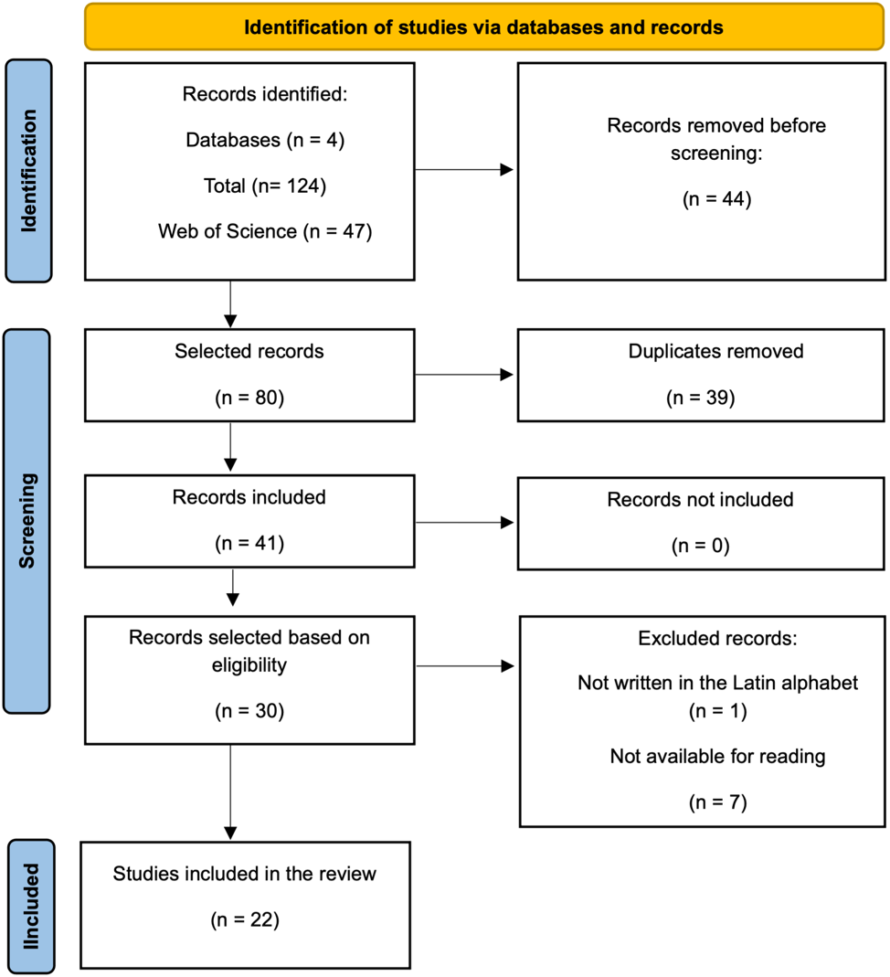
Fig. 1. PRISMA flow diagram of the study search and selection process.

3. RESULTS AND DISCUSSION

3.1 Mapping and methodological profile of publications

Among the articles analyzed, the highest concentration of publications comes from the United States, followed by Japan. Studies from China, Malaysia, Turkey, Australia, India, South Korea, Spain, and Italy were also identified, showing that the topic has been investigated in different regions of the world, with a predominance of countries in North America and Asia (Figure 2). Of the 22 articles selected for the research, 14 are clinical case reports, 2 studies perform post-mortem analyses, and 7 are retrospective cohort studies. The study by Harrel et al. (2016) involves one of the post-mortem case studies in human skulls and performs a retrospective analysis of the detection of radicular microfissures in patients via videoscopy. Of the case reports analyzed, 2 are pediatric (Puranik et al., 2025a,b).

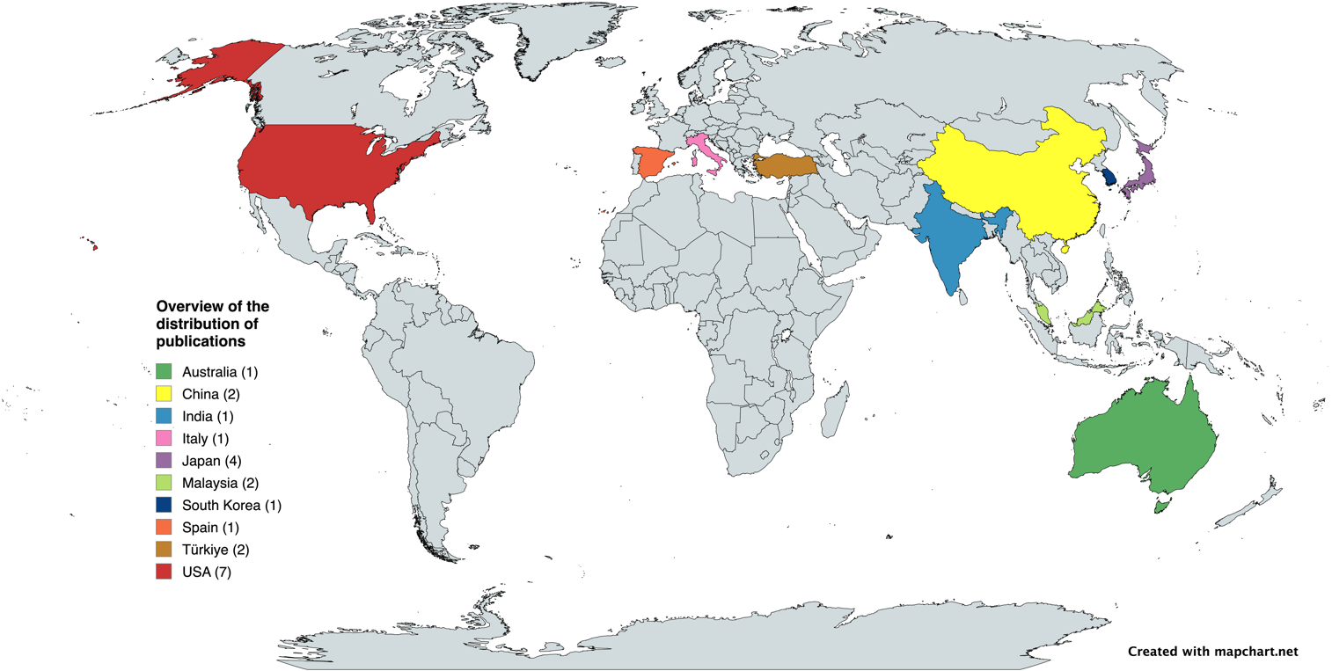
Fig. 2. Geographic distribution of the publications included in this integrative review.

Table 1 below presents a compilation of the selected studies.
Table 1. Characteristics, evidence strength and methodological considerations of included studies
Study | Design | Diagnostic Method | Main Finding | Evidence Strength* | Methodological Concerns
Nagata; Kanie; Shima (2016) | Case report | PR + Histology | CT associated with periodontal destruction | Limited | Single case; no generalizability
Nagata et al. (2016) | Case report | PR + Histology | Histologic confirmation of CT | Limited | Single case
Harrel et al. (2016) | Retrospective observational | Videoscopy | Microcracks associated with bone defects | Moderate | Indirect evidence; not direct CT diagnosis
Keskin and Güler (2017) | Retrospective | PR | Prevalence 0.89% | Moderate | 2D imaging limitations
Ong; Harun; Lim (2019) | Case report | PR/CBCT + Histology | Fracture location may affect prognosis | Limited | Two cases only
Chawla and Kumar (2019) | Case report | PR | Surgical management favorable | Limited | Single case
Pilloni et al. (2019) | Case report | PR + CBCT | Regenerative treatment favorable | Limited | Single case
Qari et al. (2019) | Retrospective | PR | Vertical lesions predominated | Moderate | No control group
Özkan and Özkan (2020) | Retrospective | CBCT | Frequency 1.85% | Moderate | Imaging-only diagnosis
Pedercini et al. (2021) | Case series | PR + CBCT + Histology | Surgery often needed for diagnosis | Limited | Small sample
Nathani et al. (2021) | Case report | PR + CBCT | Multidisciplinary approach successful | Limited | Single case
Tan et al. (2022) | Post-mortem | Micro-CT + Histology | Pre-existing defects observed | Limited | Cadaver model
Nik Azis and Mohd (2022) | Case report | PR + Surgery | Mimics severe localized periodontitis | Limited | No histologic confirmation
Nagahara et al. (2022) | Case report | CBCT + Histology | Regenerative therapy favorable | Limited | Single case
Zhao et al. (2024) | Retrospective | CBCT | Fracture location may affect prognosis | Moderate | Retrospective design
Kuwada et al. (2024) | Case report | CBCT + Micro-CT | Unusual imaging presentation | Limited | Single case
Luo et al. (2024) | Case report | PR | Intentional replantation feasible | Limited | Limited follow-up
Lee and Kim (2025) | Retrospective cohort | PR | Tooth preservation reported | Moderate | No comparator group
Puranik et al. (2025a) | Case report | PR | Conservative monitoring possible | Limited | Pediatric single case
Puranik et al. (2025b) | Case report | PR | Spontaneous adaptation reported | Limited | Pediatric single case
Sadhak; Pallod; Oza (2025) | Case report | PR | Combined endo-perio treatment favorable | Limited | Single case
Lee et al. (2025) | Cross-sectional | PR + CBCT | Additional cases detected by CBCT | Moderate | Referral-center bias
* Evidence strength categorized according to study design: case reports/case series/post-mortem studies = limited; observational retrospective/cohort studies = moderate.

3.2 Epidemiology and predisposing factors of cemental tear

The epidemiological profile of cemental tear remains insufficiently established, largely due to the limited number of observational studies and the absence of standardized diagnostic criteria. Reported prevalence values ranged from 0.89% to 5.6%, with considerable variation among studies. This discrepancy may not necessarily reflect differences in disease occurrence, but rather methodological heterogeneity related to imaging methods, diagnostic thresholds, sample characteristics, and study design.

The higher frequency reported in studies using combined CBCT and periapical radiographic assessment suggests that conventional two-dimensional radiography alone may underestimate the occurrence of cemental tears. This possibility supports the assumption that this condition may be underdiagnosed in routine clinical practice. In addition, the presence of cemental microcracks reported by Harrel et al. (2016) may indicate that structural defects in cementum can represent precursor conditions for subsequent delamination under functional or inflammatory stress.
Although age, sex, tooth type, trauma, occlusal overload, and previous endodontic treatment have been suggested as predisposing factors, the available evidence does not allow a direct causal relationship to be established. Most findings derive from retrospective analyses and case reports, which present inherent limitations, including selection bias and absence of control groups.

The predominance of involvement in anterior teeth may be associated with greater exposure to lateral forces and traumatic loading. Likewise, the higher frequency in older patients may be related to age-related structural changes in cementum. However, these interpretations remain hypothetical and require experimental validation.

Regarding endodontically treated teeth, it remains unclear whether previous root canal treatment represents a true risk factor or simply reflects a higher likelihood of diagnosis due to increased radiographic monitoring. This distinction has not yet been adequately explored.

Overall, the available findings suggest a multifactorial etiology for cemental tear; however, stronger evidence from prospective studies is required before definitive conclusions can be drawn.

3.3 Clinical and imaging signs and symptoms

The clinical findings observed in the analyzed studies indicate that cemental tear often presents with signs and symptoms that overlap considerably with periodontal and endodontic-periodontal lesions, which may contribute to misdiagnosis and delayed treatment.

Deep isolated periodontal pockets, vertical bone defects, mobility, pain, fistula formation, and localized edema were among the most frequently reported manifestations. However, these features are nonspecific and do not permit diagnosis in isolation (Nagata et al., 2016; Ong; Harun; Lim, 2019; Chawla and Kumar, 2019; Nik Azis and Mohd, 2022; Luo et al., 2024; Kuwada et al., 2024).

The frequent observation of vertical bone loss may suggest that detached cementum fragments act as local irritants that contribute to persistent periodontal breakdown. This interpretation appears to be supported by reports demonstrating improvement following fragment removal. Nevertheless, the cause-and-effect relationship remains largely inferred and has not been systematically investigated.

The possible role of occlusal trauma as a triggering factor has also been discussed, although current evidence is mainly based on isolated reports and therefore remains inconclusive.

With respect to imaging, periapical radiography was the most commonly used diagnostic method but demonstrated important limitations in detecting small or superimposed cemental fragments. CBCT appears to offer diagnostic advantages in selected cases, particularly for identifying associated bone defects or radiopaque structures suggestive of delamination (Nagata; Kanie; Shima, 2016; Nik Azis and Mohd, 2022; Kuwada et al., 2024; Luo et al., 2024). However, even tomographic findings may be insufficient for definitive diagnosis.

These observations highlight that diagnosis remains challenging and often depends on combining clinical suspicion, imaging interpretation, surgical inspection, and, in some cases, histopathological confirmation.

3.4 Histopathological findings

Histopathological examination has been considered the gold standard for confirming cemental tears because it permits direct identification of detached cementum fragments and associated tissue responses (Liang et al., 2017).

The recurrent observation of inflammatory infiltrate associated with cementum fragments supports the hypothesis that these structures may function as persistent irritants, contributing to disease progression. However, histopathological descriptions were not standardized across studies, limiting comparisons and reducing the strength of biological inferences (Nagata et al., 2016; Nagata; Kanie; Shima, 2016; Ong; Harun; Lim, 2019; Qari et al., 2019; Pedercini et al., 2021; Tan et al., 2022; Nagahara et al., 2022; Kuwada et al., 2024). Additionally, because histological confirmation generally occurs only in surgically managed cases, there is a possibility of selection bias favoring more severe or advanced presentations.

Therefore, while histopathology remains essential for definitive diagnosis, its routine dependence also underscores the limitations of current non-invasive diagnostic approaches.

3.5 Treatment

The findings of this review indicate that management of cemental tear has predominantly involved surgical approaches aimed at removing detached cementum fragments and controlling associated periodontal destruction. Although several reports suggest favorable outcomes with surgical treatment, caution is required when interpreting this apparent superiority, since the available evidence is largely based on case reports without comparison groups.

The better outcomes observed in lesions located in coronal and middle thirds may be related to greater surgical accessibility and more favorable regenerative potential (Chawla and Kumar, 2019; Pilloni et al., 2019; Nathani et al., 2021; Nik Azis and Mohd, 2022; Nagahara et al., 2022; Puranik et al., 2025a,b), Sadhak; Pallod; Oza, 2025). Conversely, poorer outcomes in apical lesions may reflect both anatomical limitations and delayed diagnosis.

Importantly, there is currently no consensus regarding treatment protocols or decision-making criteria for selecting conservative versus surgical management. This lack of standardization represents a significant limitation in the field.

The available evidence suggests that early diagnosis and elimination of the causative fragment may favor prognosis. However, treatment recommendations remain largely empirical, reinforcing the need for prospective clinical studies with standardized outcome assessment.

3.6 Final Critical Perspective

Because the included studies were highly heterogeneous and did not provide comparable outcome measures suitable for meta-analysis, the findings were synthesized qualitatively rather than quantitatively. Accordingly, Table 2 was developed as a thematic critical synthesis framework to organize the available evidence, identify evidence gaps and methodological limitations, and summarize the corresponding clinical implications related to cemental tear.

Table 2. Thematic critical synthesis of current evidence gaps and clinical implications in cemental tear
Topic | Evidence Observed | Main Limitation | Clinical Implication
Epidemiology | Prevalence 0.89–5.6% | Heterogeneous criteria | Possible underdiagnosis
Predisposing factors | Trauma, occlusal overload, aging and endodontic treatment reported | Mostly associations | No causality established
Imaging diagnosis | PR most frequent; CBCT may improve detection | No accuracy studies | CBCT adjunctive
Histopathology | Reference standard for confirmation | Limited surgical availability | Useful in uncertain diagnosis
Treatment | Surgical fragment removal often favorable | Mostly case reports | No standardized protocol
Prognosis | Early diagnosis may improve preservation | Limited longitudinal data | Individualized treatment

Taken together, the available evidence indicates that cemental tear should be viewed not only as a rare clinical finding, but also as a potentially underdiagnosed condition that may be overlooked in the differential diagnosis of endodontic-periodontal lesions. Current evidence suggests diagnostic and therapeutic challenges remain largely related to the absence of standardized criteria and the predominance of low-level evidence, underscoring the need for more robust prospective and multicenter investigations.

Some limitations should be considered when interpreting these findings. The available evidence on cemental tear is predominantly derived from case reports and retrospective studies, which limits the strength of evidence regarding causal associations and treatment predictability.

Methodological heterogeneity among studies, particularly in diagnostic criteria, imaging methods and therapeutic approaches, also restricts direct comparison of findings. In addition, because diagnosis often depends on surgical or histopathological confirmation, underdiagnosis of less evident cases cannot be excluded.

These limitations, however, also reflect important gaps in the current literature and reinforce the relevance of this review in synthesizing the available evidence and highlighting the need for standardized diagnostic and therapeutic protocols.

4. CONCLUSION

The findings of this review indicate that cemental tear is an uncommon and likely underrecognized condition that may mimic periodontal and endodontic lesions, making diagnosis challenging.
Although several predisposing factors and treatment approaches have been reported, current evidence remains limited and does not support definitive conclusions regarding etiology or treatment predictability.
Early recognition, accurate diagnostic assessment and individualized treatment planning appear to be important for improving prognosis and preserving affected teeth. Therefore, cemental tear should be considered in the differential diagnosis of localized periodontal destruction and persistent endodontic-periodontal lesions.
Further prospective studies with standardized diagnostic criteria and treatment protocols are needed to support evidence-based clinical management and improve diagnostic and therapeutic predictability.

Disclaimer (Artificial intelligence)

Authors hereby declares that NO generative AI technologies such as Large Language Models (ChatGPT, COPILOT, etc.) and text-to-image generators have been used during the writing or editing of this manuscript.

REFERENCES

Ong, T. K., Harun, N., & Lim, T. W. (2019). Cemental Tear on Maxillary Anterior Incisors: A Description of Clinical, Radiographic, and Histopathological Features of Two Clinical Cases. Eur Endod J, 4(2), 90-95. doi:10.14744/eej.2019.13007

Lee, A. H. C., Neelakantan, P., Dummer, P. M. H., & Zhang, C. (2021). Cemental tear: Literature review, proposed classification and recommendations for treatment. International Endodontic Journal, 54(11), 2044-2073. doi:10.1111/iej.13611

Lee, A. H. C., Yeung, A. W. K., Sigurdsson, A., Wong, M. C. M., & Zhang, C.F. (2025). Prevalence, Classification and Factors Associated With Cemental Tears-A Retrospective Observational Cross-Sectional Study in a Postgraduate Endodontic Clinic. International Endodontic Journal. doi:10.1111/iej.70042

Qari, H., Dorn, S.O., Blum, G.N., & Bouquot, J.E. (2019). The pararadicular radiolucency with vital pulp: Clinicopathologic features of 21 cemental tears. Oral Surg Oral Med Oral Pathol Oral Radiol, 128(6), 680-689. doi:10.1016/j.oooo.2019.07.012

Liang, Y., Liu, H., & Xie, C. et al. (2025). Expert consensus on the diagnosis and treatment of cemental tear. International Journal of Oral Science, 17, 61. doi:10.1038/s41368-025-00381-9

Jeng, P.Y., Luzi, A.L., Pitarch, R.M., Chang, M.C., Wu, Y.H. & Jeng, J.H. (2018) Cemental tear: to know what we have neglected in dental practice. Journal of the Formosan Medical Association, 117, 261–267.

Lin, H. J., Chang, M. C., Chang, S. H., Wu, C. T., Tsai, Y. L., Huang, C. C. et al. (2014). Treatment outcome of the teeth with cemental tears. J Endod, 40(9), 1315-20. doi: 10.1016/j.joen.2014.05.012.

Özkan, G., & Özkan, H. (2020). Evaluation of Cemental Tear Frequency Using Cone-Beam Computed Tomography: A Retrospective Study. Meandros Medical and Dental Journal, 21, 128-133. doi: 10.4274/meandros.galenos.2020.46320

Botelho, L. L. R., Cunha, C. C. A., & Macedo, M. (2011). The integrative review method in organizational studies. Gestão e sociedade, 5(11),121-136. https:// www.ges.face.ufmg.br

Ouzzani, M., Hammady, H., Fedorowicz, Z., & Elmagarmid, A. (2016). Rayyan—a web and mobile app for systematic reviews. Systematic Reviews, 5(1), 210. doi:10.1186/s13643-016-0384-4.

Harrel, S., Valderrama, P., Barnes, J., & Blackwell, E. (2016). Frequency of Root Surface Microgrooves Associated with Periodontal Destruction. International Journal of Periodontics & Restorative Dentistry, 36, 841-846. doi:10.11607/prd.2876

Puranik, C., Katebzadeh, S., Reyes-Nguyen, P., & Flaitz, C. (2025a). Cemental tears in pediatric patients secondary to traumatic dental injuries: A report of two cases. Dental Traumatology, 0, 1-6. doi: 10.1111/edt.70009

Puranik, C., Katebzadeh, S., Reyes-Nguyen, P., & Flaitz, C. (2025b). A Decade-­ Long Follow-­ Up of Supernumerary Tooth Leading Up to Cemental Tear: A Pediatric Case Report. International Journal of Paediatric Dentistry, 0, 1-4.

Nagata, M., Kanie, T., & Shima, K. (2016). Cemental Tear in an Autotransplanted Tooth That Had Been Functioning for 15 Years. Clin Adv Periodontics. 6(3), 111-117. doi:10.1902/cap.2015.150047

Nagata, M., Nagata, M., Kanie, T., & Shima, K. (2016). Clinical and Histologic Aspects of Cervical Cemental Tear as a Risk for Periodontal Diseases. Clin Adv Periodontics, 6(4), 167-174. doi:10.1902/cap.2016.150075

Keskin, C., & Güler, D. (2017). A Retrospective Study of the Prevalence of Cemental Tear in a Sample of the Adult Population Applied Ondokuz Mayıs University Faculty of Dentistry. Meandros Medical and Dental Journal. 18:115-119. doi: 10.4274/meandros.39974

Chawla, A., & Kumar, V. (2019). Cemental Tear: An Unusual Cause for Persisting Endodontic Periodontal Lesion. Indian Journal of Dental Research, 30, 140-3. doi: 10.4103/ijdr.IJDR_746_17

Pilloni, A., Nardo, F., & Rojas, M. A. (2019). Surgical Treatment of a Cemental Tear-Associated Bony Defect Using Hyaluronic Acid and a Resorbable Collagen Membrane: A 2-Year Follow-Up. Clinical Advances in Periodontics, 9(2). doi: 10.1002/cap.10053

Pedercini, A., Weitz, D. F., Heyse Jr, J. D.,Pedercini, C., Kormas, I., & Koutlas, I.G. et al. (2021). Cemental tear: An overlooked finding associated with rapid periodontal destruction. A case series. Australian Dental Journal,66(1Suppl), S82–S87. doi: 10.1111/adj.12844

Nathani, T., Carreño, M., Morente, M., Nart, J., Terol, F., & Sans, F. (2021). Multidisciplinary management of an external cervical resorption and cemental tear. Giornale Italiano di Endodonzia, 35(1),10-15. doi:10.32067/GIE.2021.35.01.14

Tan, V., Hardiman, R., Pilbrow, V., & Parashos, P. (2022). Dentinal microcracks and cemental tears related to chemo-mechanical root canal instrumentation: a micro-CT Cadaver Study. Australian Dental Journal, 67, 76-82. doi: 10.1111/adj.12887

Nik Azis, N. M., & Mohd, N. (2022). Management of Severe Localized Periodontal Destruction Associated with A Cemental Defect: A Case Report. J Dent Indones, 29(1), 73-77. doi:10.14693/jdi.v29i1.1306

Nagahara, T., Takeda, K., Inoue, S., Wada, K., & Shiba, H. (2022). Successful regenerative response of a severe bone defect in a right lower central incisor affected by a cemental tear. Clin Case Rep. 10, e06472. doi: 10.1002/ccr3.6472

Zhao, S., Yuan, Z., Zhou, X., & Yang, X. (2024). Clínical, radiographic features and prognosis of cemental tear: A retrospective study of 63 teeth. Heliyon, 10, e30999. doi: 10.1016/j.heliyon.2024.e30999

Kuwada, C., Naitoh, M., Honda, M., Kikuchi, T., Kise, Y., & Ariji, E. et al. (2024). Unusual imaging appearance of cemental tear in the maxillary first molar on cone-beam computed tomography: A case report. Aust Endod J, 50, 157–162. doi: 10.1111/aej.12810

Luo, N., Ying, X., Tong, Y., & Chen, Y. (2024). Intentional replantation for a Class 4/Stage C cemental tear: Etiology, choice and outcomes of treatment. Clin Case Rep.,12, e9088. doi: 10.1002/ccr3.9088

Lee, J. H., & Kim, Y. T. (2025). Periodontal regenerative treatment for maxillary anterior cemental tears: A mid-term cohort study. J Periodontol, 1–10. doi: 10.1002/jper.11377

Sadhak, N., Pallod, A., & Oza, S. (2025). Multidisciplinary management of an endo-perio lesion complicated by a cemental tear: a case report. Restorative dentistry & endodontics, 50(3), e31. doi:10.5395/rde.2025.50.e31

