Original Research Article

Design of a training and commercialization strategy for armored catfish (Pterygoplichthys spp.) in fishing cooperatives in Southeastern Mexico

.
ABSTRACT

Aims: This study aims to design a strategic framework for the commercialization of armored catfish (Pterygoplichthys spp.) as raw fillet in fishing cooperatives in Southeastern Mexico, integrating organizational, technical, commercial, and sustainability components.
Study design: The research follows a design science research approach, focused on the development and validation of a strategic model without field intervention.
Place and Duration of Study: The study is contextualized in the state of Tabasco, Mexico, considering approximately 150 fishing cooperatives engaged in armored catfish capture. The research was conducted between 2024 and 2025.
Methodology: The strategy was developed through the integration of scientific literature, conceptual frameworks on social and solidarity economy, and technical considerations for fish processing. The model was validated through expert evaluation by a panel of seven specialists in fisheries, sustainability, and cooperative management, using an iterative feedback process.
Results: The proposed model integrates five components: organizational strengthening, technical processing, financial structure, commercialization strategy, and sustainability integration. Expert validation indicated high relevance and feasibility, highlighting the importance of digital training through WhatsApp and the use of artificial intelligence-based infographics to enhance knowledge transfer. Previous training experiences with more than 80 cooperative members demonstrated the technical feasibility of filleting armored catfish and supported the practical applicability of the model.
Conclusion: The study provides a structured and replicable strategy for transforming an invasive species into an economic opportunity. The model contributes to sustainable fisheries development by linking environmental management with value added commercialization. Future research should focus on pilot implementation and impact evaluation in cooperative contexts.

Keywords: Aquaculture; Invasive species; Fisheries; Cooperatives; Sustainable development

1. INTRODUCTION

In recent decades, the transformation of underutilized and invasive aquatic species into economically valuable resources has gained increasing attention as a strategy to address environmental degradation and economic vulnerability in fisheries dependent regions. At a global scale, invasive fish species represent a major ecological challenge, as they disrupt native ecosystems, alter trophic dynamics, and generate significant economic impacts. However, emerging approaches within sustainable development and circular economy frameworks emphasize the potential to revalorize these species as alternative protein sources and inputs for new value chains.

In Mexico, the armored catfish (Pterygoplichthys spp.), commonly known as Bagre armado or pez diablo, has become one of the most problematic invasive species in freshwater ecosystems. Its rapid reproduction, high adaptability, and lack of natural predators have resulted in severe ecological impacts, including competition with native species, habitat modification, and disruption of fishing activities. At the same time, its increasing abundance represents an underutilized opportunity for productive use, particularly in Southeastern Mexico, where fishing communities face declining availability of traditional species and increasing economic pressures. Recent initiatives have explored its use as a food resource in rural communities, highlighting its potential contribution to food security and regional development (1).

Fishing cooperatives constitute a key organizational structure within the fisheries sector in Mexico, contributing to employment generation, food provision, and regional economic development. Within the framework of the social and solidarity economy, these organizations promote collective action and inclusive growth (2). Nevertheless, several studies have documented persistent structural limitations, including weak organizational capacity, limited professionalization in administrative and financial management, and insufficient commercialization strategies, which reduce their competitiveness and limit their ability to access broader markets (3,4). Additionally, governance challenges at multiple scales affect coordination and long term sustainability within cooperative systems (5).

At the regional level, particularly in Southeastern Mexico, fishing cooperatives operate within socio ecological systems that are increasingly affected by environmental pressures such as overfishing, ecosystem degradation, and climate change (6). Furthermore, structural transformations associated with market liberalization and institutional change have weakened organizational cohesion and adaptive capacity (7). These conditions highlight the need for integrated strategies that combine economic diversification, environmental management, and organizational strengthening.

Despite the ecological relevance and growing availability of armored catfish, there is a lack of structured strategies that integrate organizational, technical, and commercial dimensions for its effective utilization. Existing efforts have largely focused on ecological control or isolated productive initiatives, without addressing the systemic conditions required to transform this invasive species into a viable economic asset within cooperative frameworks ( ). In particular, the commercialization of armored catfish as raw fillet remains insufficiently explored from a strategic and organizational perspective, despite its potential to generate value added products and access regional markets.

In this context, recent studies have emphasized the importance of strengthening business development capacities and environmental awareness in rural communities as pathways for sustainable economic transformation (8). Likewise, the integration of training processes, governance mechanisms, and sustainability criteria has been identified as a key factor in improving the performance and resilience of fishing cooperatives (9,10).

To address this gap, this study adopts a design science research approach focused on the development of a structured and replicable strategy for the commercialization of armored catfish as raw fillet. The research does not involve direct intervention in fishing cooperatives, but instead emphasizes the conceptual and methodological design of a strategic framework grounded in scientific evidence and validated through expert evaluation (11).

Therefore, the objective of this study is to design a strategic framework for the commercialization of armored catfish (Pterygoplichthys spp.) as raw fillet in fishing cooperatives in Southeastern Mexico. The proposed strategy aims to strengthen organizational capacities, improve economic viability, and contribute to the sustainable management of an invasive species, offering a replicable model for similar socio ecological contexts.

2. material and methods

2.1 Research Design
This study adopts a design science research approach, which focuses on the creation and evaluation of an artifact intended to solve a practical problem. In this case, the artifact is a structured strategy for the commercialization of armored catfish as raw fillet within fishing cooperatives. The research is applied, non experimental, and cross sectional. It does not involve field intervention or empirical data collection from cooperatives. Instead, it emphasizes the systematic design of a strategic framework grounded in scientific literature, conceptual models, and technical criteria. This approach is consistent with design science principles, where knowledge is generated through the development and refinement of solutions to real world problems (11).

2.2 Study Area and Context
The study is contextualized in southeastern Mexico, particularly in the state of Tabasco, where small scale fisheries are a key component of regional livelihoods. The region is characterized by lagoon, riverine, and coastal ecosystems that support fishing cooperatives as primary economic actors. The increasing presence of armored catfish (Pterygoplichthys spp.), an invasive species that has disrupted ecological balance and affected traditional fisheries, provides a relevant scenario for the design of alternative commercialization strategies. This context highlights the need for integrative approaches that link environmental challenges with economic opportunities through value added utilization (12,13).

2.3 Target Population and Scope
The target population consists of approximately 150 fishing cooperatives in Tabasco that are engaged in the capture of armored catfish. These cooperatives operate within socio ecological systems that combine productive, organizational, and environmental dimensions.

However, the cooperatives are not directly involved in the empirical development of the study. No data collection, surveys, or fieldwork activities are conducted with them. Instead, they are considered as the reference context for the design of the proposed strategy. This ensures that the model reflects realistic operational conditions while maintaining a conceptual and design oriented approach.

2.4 Strategy Development Approach
The development of the commercialization strategy follows a structured design process based on the integration of scientific evidence and conceptual frameworks. The process includes review of literature on fishing cooperatives, commercialization, and value chains, analysis of frameworks related to social and solidarity economy and sustainable resource management, technical considerations for fish processing, handling, and commercialization of raw fillet.

The strategy is designed to address key limitations identified in previous studies, including weak organizational capacity, limited value addition, and restricted access to markets. The resulting proposal integrates organizational, productive, and commercial components into a coherent and replicable framework.

2.5 Model Design
The strategic model is developed as a conceptual and operational framework that enables fishing cooperatives to transition from extractive activities to value added commercialization of armored catfish. The model includes the following components: organizational structure and role definition, technical guidelines for processing and filleting, basic financial structure and cost considerations, identification of commercialization channels and market opportunities, integration of sustainability criteria related to invasive species management.

These components are articulated to ensure internal coherence and practical applicability. The model is designed to be adaptable to similar socio ecological contexts and to support decision making processes within cooperative systems.

2.6 Model Validation
The validation of the proposed strategy is conducted through expert evaluation. A panel of seven specialists is selected based on their expertise in fisheries, cooperative management, sustainable development, and food processing.

The validation process involves the following steps:
- Delivery of the initial version of the strategic model to the experts
- Individual evaluation based on criteria such as relevance, coherence, feasibility, and applicability
- Collection of feedback and recommendations
- Refinement and adjustment of the model based on expert input

This iterative process ensures the robustness and credibility of the proposed strategy, as well as its alignment with technical and contextual requirements (14).

2.7 Ethical considerations
This study does not involve direct interaction with human subjects or the collection of primary data. Therefore, no personal or sensitive information is processed. Nevertheless, ethical principles are observed throughout the research process, including transparency in the design methodology, proper acknowledgment of expert contributions, and responsible use of scientific information.

3. results and discussion

3.1 The state of the art and empirical background

The analysis of the current literature indicates that most approaches addressing fishing cooperatives in Mexico and comparable contexts have focused on organizational strengthening, governance, and sustainability. Previous studies emphasize improving administrative capacities, fostering collective action, and integrating sustainability principles to enhance the resilience of cooperative systems (2,5,6).

In parallel, research on invasive species management has primarily emphasized ecological control, with limited attention to economic valorization. Although some initiatives have explored the use of armored catfish as a food resource, these efforts remain fragmented and lack structured commercialization frameworks (1).

As an empirical reference, prior training experiences conducted in the community of Ismate y Chilapilla 2da sección, Tabasco, involved the participation of three fishing cooperatives with more than 80 members. During these activities, a specialist in fish processing provided hands on training focused on filleting techniques for armored catfish. This experience demonstrated the technical feasibility of processing the species and highlighted the willingness and capacity of cooperative members to adopt value added practices.

Additionally, recent advances in digital education strategies in rural contexts indicate that communication platforms such as WhatsApp can effectively support training processes due to their accessibility and flexibility. The integration of artificial intelligence for the development of visual educational materials, such as infographics, has also been shown to enhance comprehension and engagement in community-based learning environments (15).

Despite these advances, there remains a gap in integrating organizational, technical, and commercial dimensions into a structured strategy capable of transforming armored catfish into a viable economic product within cooperative systems.

3.2 Strategic model for the commercialization of Armored Catfish

The proposed model is conceived as an integrative framework that enables fishing cooperatives to transition from extractive activities to value added commercialization of armored catfish as raw fillet.

The model is structured around five interconnected components:
1. Organizational Strengthening. This component defines roles, coordination mechanisms, and decision-making processes that support the implementation of productive and commercial activities within cooperatives.
2. Technical Processing. This dimension builds upon prior field experience in filleting armored catfish, incorporating standardized guidelines for handling, processing, and preservation. The inclusion of this component is supported by evidence of technical feasibility demonstrated in previous training activities conducted with cooperative members.
3. Financial Structure. The model integrates cost estimation, pricing strategies, and income distribution mechanisms, allowing cooperatives to assess the economic viability of producing and commercializing raw fillets.
4. Commercialization Strategy. This component identifies regional market opportunities, potential buyers, and distribution channels, while defining a value proposition based on the transformation of an invasive species into a marketable product.
5. Sustainability Integration. The model aligns productive activities with environmental objectives by promoting the utilization of an invasive species as a strategy to reduce ecological pressure and generate economic benefits.

These components operate as an interconnected system designed to be adaptable and replicable across similar socio ecological contexts.

3.3 Results of model validation
The model was validated through expert evaluation involving a panel of seven specialists in fisheries, cooperative management, sustainability, and food processing. The results indicate strong agreement regarding the relevance, coherence, and feasibility of the proposed strategy. Experts emphasized that the model effectively integrates organizational, technical, and commercial dimensions, addressing key structural limitations in fishing cooperatives.

The results of the expert validation are summarized in Table 1, highlighting the main criteria assessed and the corresponding adjustments incorporated into the model.

Table 1. Expert validation of the proposed strategic model

Criterion | Description | Experts’ Assessment | Key Observations | Model Adjustment
Relevance | Alignment of the model with cooperative needs | High | Addresses organizational, technical, and market gaps | No major changes
Internal coherence | Logical integration among model components | High | Strong linkage between components | Minor wording refinements
Feasibility | Practical applicability in fishing cooperatives | Moderate–High | Requires accessible training mechanisms | Inclusion of WhatsApp-based delivery
Applicability | Adaptability to regional contexts | High | Suitable for similar socio-ecological systems | Emphasis on replicability
Knowledge transfer | Effectiveness of training approach | High | Visual tools improve comprehension | Integration of AI-based infographics
Technological accessibility | Ease of use of proposed digital tools | High | WhatsApp widely used by cooperative members | Formal inclusion of mobile learning strategy

A key recommendation derived from the validation process was the use of WhatsApp as the primary platform for delivering training content. Experts highlighted its accessibility, familiarity among users, and capacity to facilitate continuous communication and asynchronous learning.

Furthermore, the incorporation of visual educational materials, particularly infographics supported by artificial intelligence, was identified as a critical factor to enhance knowledge transfer. These tools allow complex processes to be communicated in a simplified and accessible manner, consistent with findings reported in rural training models (15).

Based on expert feedback, the model was refined to include a digital training component supported by WhatsApp and AI based visual materials.

3.4 Program for Implementation
Although this study does not include direct implementation, a structured program is proposed to guide future application.

The program consists of four stages:
Stage 1. Introduction and Awareness. Presentation of the strategy and its economic and environmental relevance.
Stage 2. Training and Capacity Building
Delivery of training modules through WhatsApp, supported by infographics and visual materials, reinforcing previously acquired technical skills such as filleting.
Stage 3. Pilot Application. Initial application of the model in selected cooperatives to test operational and commercial processes.
Stage 4. Evaluation and Adjustment. Assessment of outcomes and refinement of the model based on practical experience.

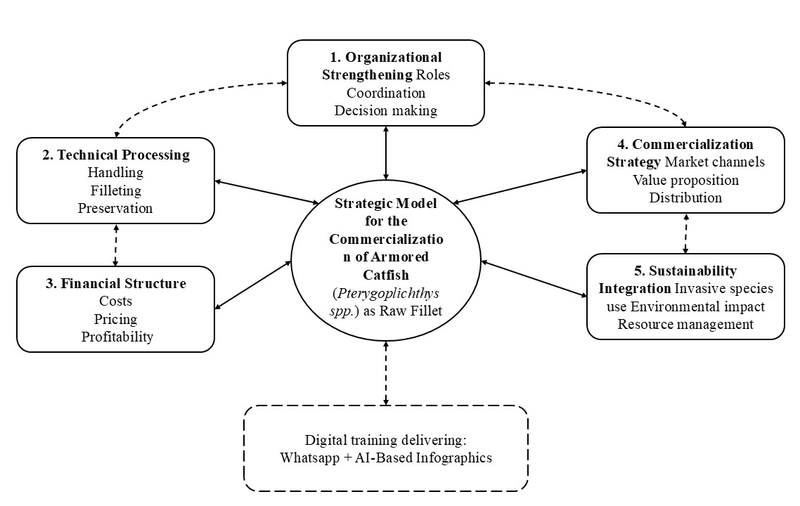

Fig. 1. Strategic model for the commercialization of armored catfish as raw fillet in fishing cooperatives

As shown in Figure 2, the preparation of raw marinated fillets using traditional ingredients, represents a practical example of value addition at the community level. The use of traditional ingredients such as salt, black pepper, sour orange juice, and crushed garlic enhances flavor and contributes to basic preservation, facilitating short term storage and commercialization. This type of product demonstrates the feasibility of transforming armored catfish into a marketable food item with regional identity.

Fig. 2. Raw marinated fillets of armored catfish prepared in a rural community in southeastern Mexico.

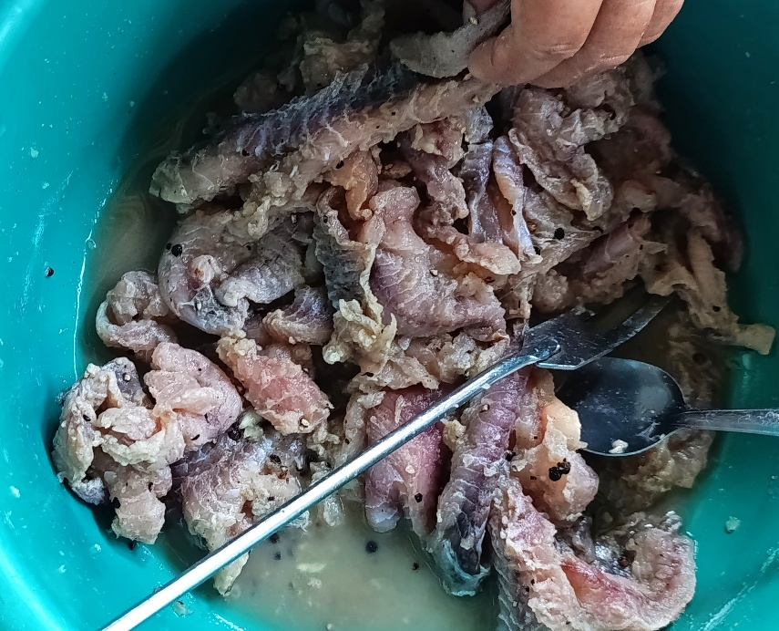

4. Discussion

The results of this study contribute to the emerging body of literature that seeks to integrate environmental management and economic development within fishing dependent socio ecological systems. Unlike traditional approaches that address invasive species primarily from an ecological control perspective, the proposed model advances a valorization strategy that transforms armored catfish into a potential economic resource. This finding aligns with recent discussions on circular economy frameworks, which emphasize the conversion of environmental challenges into productive opportunities.

Training processes within cooperative frameworks require participatory and context sensitive approaches that facilitate collective learning and reflection. In this sense, action oriented learning perspectives emphasize the importance of linking knowledge generation with practical problem solving in real world contexts. According to Elliott, learning processes become more effective when participants are actively involved in reflecting on their own practices and applying knowledge to their immediate environment (16). This perspective is particularly relevant in fishing cooperatives, where experiential knowledge and community-based practices play a central role in the adoption of new productive and organizational strategies.

From an organizational perspective, the model reinforces the relevance of fishing cooperatives as key actors in regional development. Previous studies have demonstrated that strengthening internal governance, coordination, and decision making processes is essential to improve the performance and resilience of cooperative systems (2,5). The present study extends this understanding by integrating these organizational elements with technical processing and commercialization strategies, offering a more comprehensive and operational framework.

The inclusion of a technical processing component, supported by prior training experiences in Ismate y Chilapilla 2da sección, highlights the importance of practical capacity building as a foundation for value addition. While existing literature often emphasizes theoretical or policy level interventions, this study demonstrates that hands on knowledge transfer can significantly enhance the feasibility of transitioning from extractive activities to product oriented value chains. This finding is consistent with research on small scale fisheries, which underscores the role of local knowledge and technical training in improving productivity and market integration (12,13).

In terms of commercialization, the proposed model addresses a critical gap identified in previous studies, namely the lack of structured strategies for accessing markets and defining value propositions in cooperative fisheries. By positioning armored catfish as both an economic product and an environmental solution, the model introduces a dual value narrative that may enhance market acceptance. This approach is particularly relevant in the context of increasing demand for sustainable and environmentally responsible products, as highlighted in recent research on sustainable fisheries and blue economy transitions (9,6).

A key contribution of this study lies in the incorporation of digital training mechanisms, specifically the use of WhatsApp and artificial intelligence based educational materials. Expert validation results indicate that these tools can significantly improve the accessibility and effectiveness of training processes in rural contexts. This finding is consistent with recent evidence demonstrating that mobile based communication platforms facilitate continuous learning and knowledge exchange in communities with limited access to formal education systems. Moreover, the use of AI generated infographics enhances the clarity and usability of technical information, supporting more inclusive and adaptive learning processes (15).

The integration of sustainability into the model also represents a relevant contribution. By promoting the utilization of an invasive species, the strategy aligns economic incentives with environmental objectives, contributing to the reduction of ecological pressure while generating alternative income sources. This approach reflects the principles of social ecological systems, where the interaction between ecological and social components is central to achieving long term sustainability (12). Furthermore, it supports broader development agendas related to sustainable resource management and circular economy practices.

Despite these contributions, the study has limitations that must be acknowledged. The model is conceptual and has not been empirically implemented within cooperatives, which limits the ability to evaluate its real-world performance. Additionally, the validation process, although robust, is based on expert judgment rather than field application. Future research should focus on pilot implementation and longitudinal evaluation to assess the effectiveness, scalability, and economic impact of the proposed strategy.

This study provides a structured and replicable model that integrates organizational strengthening, technical processing, commercialization strategies, and digital training mechanisms for the utilization of armored catfish in fishing cooperatives. By bridging the gap between environmental challenges and economic opportunities, the proposed approach contributes to the advancement of sustainable development strategies in fisheries dependent regions.

5. Conclusion

This study presents a design science based strategic model for the commercialization of armored catfish as raw fillet in fishing cooperatives in southeastern Mexico. The model integrates organizational strengthening, technical processing, financial structure, commercialization pathways, and sustainability principles into a coherent and replicable framework. Expert validation supports its feasibility and highlights the relevance of digital training through WhatsApp and AI based infographics. Although the model has not yet been implemented, it provides a practical foundation for transforming an invasive species into an economic opportunity. Future research should focus on pilot testing and evaluating its impact in real cooperative contexts.

AcknowledgEments

The authors thank the fishing communities of Tabasco, particularly the Federación de Cooperativas Pesqueras y Permisionarios de Tabasco (FEDECOOPTAB), for their collaboration. They also acknowledge the support of the Tecnológico Nacional de México and its campuses in Villahermosa, Tuxtla Gutiérrez, Tlaxiaco, and La Chontalpa, as well as the Academic, Research and Innovation Secretariat.

No funding sources were involved in the design, analysis, or publication of this study.

Competing interests

Authors have declared that no competing interests exist.

Authors’ Contributions

Karina González-Izquierdo, Omar Jiménez-Márquez, and Diana Rubí Oropeza-Tosca conceptualized and designed the study and developed the strategic model. Gaudencio Lucas-Bravo contributed to project administration, including coordination of administrative procedures, organization of field visits, and facilitation of project approval processes. Víctor Manuel Ruiz-Valdiviezo provided expertise in biotechnology and food preservation, contributing to the technical components of the model. Pedro Ramón-Santiago and Rosario Pérez-Belmonte supported the validation process and contributed to the contextual and regional analysis. Alexandre Baptista contributed to the analytical review and strengthening of the scientific approach.
All authors read and approved the final manuscript.

Consent

Not applicable.

Ethical approval

This study did not involve human or animal experimentation, nor the collection of personal or sensitive data. Therefore, formal approval from an Institutional Review Board or Ethics Committee was not required. The research focuses on the design of a strategic model and its validation through expert evaluation. All procedures were conducted in accordance with ethical principles for social research, ensuring voluntary participation of experts and confidentiality of their feedback.

Abbreviations
FEDECOOPTAB: Federación de Cooperativas Pesqueras y Permisionarios de Tabasco

References

- Rodríguez Gregorio, L. L., Pantoja Sánchez, A. J., Montejo López, J., Oropeza-Tosca, D. R., Rivera Rodríguez, M., González Izquierdo, K., Angles Falconi, S. I., & Moreno García, B. V. (2024). Alimentación con bagre armado (Pterygoplichthys spp.) para escuelas de educación básica en comunidades rurales en el sureste de México. In Un puente innovador en las matemáticas y ciencias naturales - Chetumal 2024 (Vol. 16, No. 4, pp. 47–51). Zenodo. https://doi.org/10.5281/zenodo.13759836
- Díaz de León, D., Díaz Fragoso, O., Rivera, I., & Rivera, G. (2021). Cooperatives of Mexico: Their social benefits and their contribution to meeting the Sustainable Development Goals. Social Sciences, 10(5), 149. https://doi.org/10.3390/socsci10050149
- Cano Salgado, M. P., Bello Baltazar, E., & Barba, E. (2012). Innovación social y capacidad de organización de las cooperativas pesqueras en Tabasco, México. Estudios Sociales, 20(39), 1–25.
- García Rodríguez, L., Fuentes Guevara, D., & Pico González, B. (2021). Análisis de la actitud emprendedora en sociedades cooperativas pesqueras en México. REVESCO. Revista de Estudios Cooperativos, 139, e76632. https://doi.org/10.5209/reve.76632
- García Lozano, A., Méndez-Medina, C., Basurto, X., & Tercero Tovar, M. (2023). Multi-scalar politics of collective action among fishing cooperatives in Mexico. Environment and Planning E: Nature and Space. https://doi.org/10.1177/23996544231194426
- Barretto, J., Espinoza-Guzmán, M. A., Cruz-Cruz, C., & Pineda-López, M. R. (2024). Sustainability of fishing cooperatives in the Gulf of Mexico: A case study. Fisheries Research. https://doi.org/10.1016/j.fishres.2024.107105
- Espinoza-Tenorio, A., et al. (2017). The influence of neoliberalization on fishing cooperatives in Mexico. Marine Policy, 80, 96–106. https://doi.org/10.1016/j.marpol.2016.06.024
- Oropeza-Tosca, D. R., Rincón-Molina, C. I., Baptista, A., & Notario-Priego, R. (2024). Perspective chapter: Development of business in rural southeastern Mexican communities and environmental awareness. In Sustainable Development. IntechOpen. https://doi.org/10.5772/intechopen.1007675
- Ovando, D., et al. (2022). Fishery cooperatives and sustainable blue economy: A scoping review from a business perspective. Proceedings, 83(1), 30. https://doi.org/10.3390/proceedings83010030
- Torre, J., Hernández-Velasco, A., Fernández Rivera-Melo, F., López, J., & Espinosa-Romero, M. J. (2019). Women’s empowerment, collective actions, and sustainable fisheries: Lessons from Mexico. Maritime Studies, 18, 373–384. https://doi.org/10.1007/s40152-019-00153-2
- Hevner, A. R., March, S. T., Park, J., & Ram, S. (2004). Design science in information systems research. MIS Quarterly, 28(1), 75–105.
- Berkes, F. (2018). Sacred ecology (4th ed.). Routledge. https://doi.org/10.4324/9781315114644
- Armitage, D., Berkes, F., Dale, A., Kocho-Schellenberg, E., & Patton, E. (2011). Co-management and the co-production of knowledge: Learning to adapt in Canada’s Arctic. Global Environmental Change, 21(3), 995–1004. https://doi.org/10.1016/j.gloenvcha.2011.04.006
- Reed, M. S., Vella, S., Challies, E., de Vente, J., Frewer, L., Hohenwallner-Ries, D., Huber, T., Neumann, R. K., Oughton, E. A., Sidoli del Ceno, J., & van Delden, H. (2018). A theory of participation: What makes stakeholder and public engagement in environmental management work? Restoration Ecology, 26(S1), S7–S17. https://doi.org/10.1111/rec.12541
- Jiménez-Márquez, O., Martínez-Gutiérrez, R., Manzano-Gómez, L. A., González-Izquierdo, K., Rincón-Molina, C. I., Lucas-Bravo, G., Rincón-Rosales, R., & Oropeza-Tosca, D. R. (2025). A replicable rural model, integrating corn, culture, and technology for sustainable experiential tourism: Case Tlaxiaco. Preprints. https://doi.org/10.20944/preprints202509.0811.v1
- Elliott, J. (1993). El cambio educativo desde la investigación–acción. Ediciones Morata.

