Integrated Hydrogeochemical Evaluation of Surface and Groundwater with Emphasis on Irrigation Suitability and Corrosion Potential in a Coastal Semi-Arid Region of Gujarat, India

Abstract
This study presents a comprehensive hydrogeochemical and statistical assessment of surface and groundwater quality in the Gir Somnath District and Diu region of Gujarat (GSDD), India. A total of 57 water samples were systematically collected and analysed for major physicochemical parameters to evaluate their suitability for drinking, irrigation, and industrial purposes. GSDD region’s groundwater is mostly alkaline in nature. However, its composition varies greatly depending on geological formations, evaporation, and human activities. The ionic dominance pattern was Na⁺ > Mg²⁺ > Ca²⁺ > K⁺ and Cl⁻ > HCO₃⁻ > SO₄²⁻ > CO₃²⁻ > NO₃⁻ > F⁻ indicates strong salinity control in coastal aquifers. The irrigation suitability indices and USSL classification show that most of the samples are either suitable or moderately suitable. However, the presence of salinity and magnesium could potentially harm soil structure and reduce crop yields. Industrial indices indicate a dual tendency of scaling and corrosion, suggesting the need for appropriate water treatment before industrial use. Multivariate statistical analysis and hydrochemical facies (Piper diagrams) confirm that groundwater chemistry is primarily governed by rock–water interaction, ion exchange processes, and salinity impact. This study of the GSDD region reveals that its surface and groundwater resources exhibit moderate suitability for various applications. However, it is very important to use sustainable management strategies and salinity control measures to prevent water quality deterioration and make sure that these water resources will be useful for a long-term stability.

Keywords: Groundwater, Hydrochemistry, Irrigation and Corrosion

- Introduction
Freshwater resources are very important for keeping ecological systems, farming, industry, and people's need going around the world (CHAVDA et al., 2026). Agriculture uses the most freshwater resources in the world, taking up almost seventy percent of all water withdrawals. Industrial activities use about twenty percent, and domestic use uses about twelve percent. This means that having enough good freshwater is very important for keeping the economy growing and the environment stable. Groundwater is one of the most important sources of freshwater in the world (Behura et al., 2025). In account of arid and semi-arid climatic condition, groundwater become only source for all the utilities for human being and ecological sustainability. It is a necessary and important resource for drinking water, irrigation, and industrial activities. The chemical composition of groundwater is also highly essential, in addition to its availability, since the quality of the water has a direct influence on how well it can be used for activities such as drinking, irrigation, and industrial operations (Lakhdari et al., 2025; Nabil et al., 2025). Rapid population growth, urbanisation, and industrialisation in India have greatly increased the need for water resources. The Saurashtra Peninsula in Gujarat, which is a hydrogeologically significant region, groundwater plays a significant role in satisfying the water requirements of residential and agricultural establishments as well as commercial enterprises (Vekariya et al., 2017). The study area which is one of the important coastal areas of Saurashtra peninsula of Western Gujarat, India. The geological framework, oceanic influence, and anthropogenic activities within these locales exert a substantial impact on the availability and chemical characteristics of groundwater of study area.
This investigation involved a systematic hydrogeochemical analysis of the Diu region and Gir Somnath District. Sixteen physicochemical parameters were tested using standard laboratory techniques to determine the chemical characteristics of the water samples (APHA, 2017). To evaluate the degree of contamination and safety of the water, the results were compared with/to the analytical results to National and International drinking water standards (BIS, 2012, 2015; Ram et al., 2021). The Simpson ratio was used to calculate the amount of salinity level of water in the coastal aquifers and the likelihood of seawater entering them. The water's suitability for irrigation was assessed using various irrigation indices and the United States Salinity Laboratory diagram method for classification in various classes (Xu et al., 2019). We also used the Ryznar Stability Index, and Larson–Skold Index to assess how well water could be used in industry and how likely it was to scale or corrode (Hu et al., 2024). Graphical methods such as Piper diagrams used to assess the impact of hydrochemical facies and geochemical processes on the evolution of groundwater within the GSDD aquifers (Lakhdari et al., 2025; Mohammed et al., 2022). Additionally, Mifflin diagrams were used to calculate groundwater residence times, and the relationship between Total Hardness and Total Dissolved Solids was investigated to understand salinity variations throughout the study area (Ramos-Leal et al., 2022; Tang et al., 2025). A comprehensive quality assessment of both surface and groundwater is essential to ascertain the spatial variability of hydrochemical characteristics and also evaluate the water's suitability for diverse applications. It is facilitating the management of water resources in this ecologically sensitive coastal region for the sustainability of both ecology and humanity.
- Study Area Profile

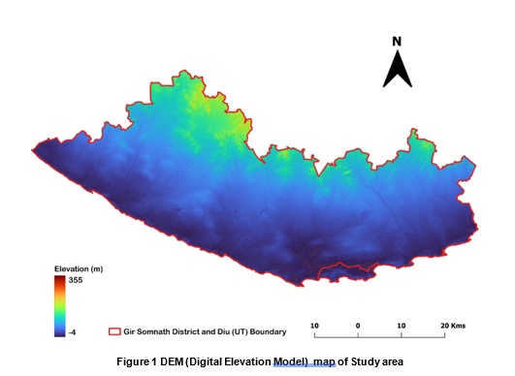

Study area is located in the southwestern portion of Gujarat, beside the Arabian Sea. It covers about 3,754 km² in the Saurashtra Peninsula and is located between 20°42′N and 21°21′N latitude and 70°14′E and 71°01′E longitude. The district shares boundary with Junagadh to the north, Amreli to the east, and the Arabian Sea along its southern and western margins. The region has coastal plains, gently rolling uplands, and forested hill tracts that are part of the Gir ecosystem. The geology of the Gir Somnath District is primarily composed of Deccan Trap basaltic formations, coastal sedimentary deposits, alluvium, laterites, and miliolite limestone (geological survey of India, 2012; Prizomwala et al., 2018). The coastal plains of GSDD have clayey-silty soils, while the black cotton soils that come from basalt weathering are farther inland (Pathak, 2024). The district does not have a lot of rivers, ponds, or reservoirs. Most of the flood-prone areas are near the shore, while the hill ranges are in the north that influences regional drainage and groundwater recharge. The district has a semi-arid to subtropical climate, with hot summers, mild winters, and an average of 900 to 1,000 mm of rain each year, mostly from monsoons (Yadav et al., 2021). Figure 1, showsthe Digital Elevation Model (DEM) map of Gir Somnath District and Diu (GSDD) represents the spatial variation of terrain elevation across the study area which is controlling drainage of the district. The Hiran, Saraswati, Machchundari, and Shingoda rivers are seasonal rivers that start in the uplands and flow to the sea (Jha et al., 2024; Prizomwala et al., 2018). Many check dams and reservoirs help store water during the monsoon season and recharge groundwater, but groundwater is still the main source of water for homes and farms. People mostly make a living by farming, and the most important crops are groundnut, cotton, wheat, sesame, sugarcane, coconut, Kesar mango, and pearl millet (Pandey, 2023). Fishing, tourism, and some small level industries help in district's economical growth such as a Diu, Somnath Mandir, and forest range, especially around Sasan Gir National Park, which famous for The Asiatic lion lives. Groundwater salinisation and rising human pressure are all environmental problems that make hydrogeochemical assessment necessary for managing water resources over the long term.
- Methodology
In this Investigation, initially QGIS 3.28 was used to prepare the study area grid map and obtain sampling coordinates. That Co-ordinates are used during the pre-monsoon season (May-2024) to conduct a hydrochemical investigation in the Gir Somnath District and Diu (GSDD) region of Gujarat. In Figure 2, a total of 57 water samples (G1–G57) were collected using a 6 × 6 km² grid-based sampling approach to ensure uniform spatial coverage of the study area. The sampling points included 20 borewells, 32 dugwells, one sample hand pump, one dam, one lake, one river, and one supply water sample. Water samples were collected in pre-cleaned 1-L high-density polyethylene (HDPE) bottles after flushing the source for 10–15 minutes to avoid contamination.
We used QGIS 3.28 for make the grid map of the study area and get the coordinates for sampling. also, we used Piper and Mifflin diagrams made in Grapher 24.1.213 to understand the hydrochemical properties of the water. These diagrams helped us sort the water into different types and find the main geochemical processes. Additional graphical analyses such as USSL (United states salinity laboratory) diagrams plots were also prepared using the same software. Spatial distribution of parameters was mapped using the Inverse Distance Weighted (IDW) interpolation method in ArcGIS 3.1.5 software.
A comprehensive set of 16 physicochemical parameters was analysed to evaluate the hydrochemical characteristics of surface and groundwater in the GSDD region. To ensure methodological consistency, analytical precision, and reproducibility of results, the Standard protocols of American public health association used for this study of GSDD region of Gujarat (APHA, 2017). Field measurements of power of hydrogen ions (pH), temperature, Electrical Conductivity (EC), and Total Dissolved Solids (TDS) were taken using a Systronics Water Analyzer 371. Major ions were determined using volumetric titration, flame photometry, and spectrophotometric methods. Calcium, magnesium, and total hardness parameters were analysed by EDTA titration, while alkalinity, carbonate, bicarbonate, and chloride were determined using acid–base and AgNO₃ titration methods.
Sodium and potassium were measured using a flame photometer, and anions such as sulphate, nitrate, and fluoride were analysed using UV–Visible spectrophotometry. Charge Balance Error (CBE) was calculated to evaluate analytical accuracy. Quality assurance (QA) and quality control (QC) procedures were followed throughout the sampling and analytical processes to ensure the reliability and accuracy of the dataset of study area. In the laboratory, water samples were pre-filtered to remove suspended particles before analysis. Field instruments were calibrated using standard solutions;for example, the pH meter was standardized with buffer solutions of pH 4.0, 7.0, and 9.2, while the EC meter was calibrated using a 1413 µS/cm KCl solution. Analytical-grade reagents and deionized water were used in all determinations. Reference standards, replicate samples, and procedural blanks were included to maintain analytical consistency. Nothing has been said about the preservation measures followed for the water samples

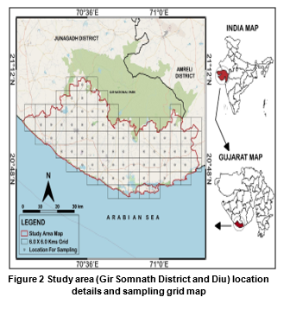
3.1 Simpson ratio
The Simpson ratio was applied to evaluate the extent of salinity deterioration in groundwater. Simpson ratio (SR) applied to quantify the relative dominance of conservative chloride over carbonate alkalinity and to evaluate groundwater salinization intensity (Asare et al., 2021). Elevated values denote saline or marine/evaporative influence, whereas lower ratios indicate fresh recharge conditions and bicarbonate-controlled hydrochemical facies. Calculation of SR commutated by Equation 1. During calculation SR, all ion taken in meq/L unit.
Simpson Ratio (SR) = $\frac{{Cl}^{-} }{HCO₃⁻ + CO₃²⁻ }$………. (1)
3.2 Irrigation suitability assessment
In this study, several standard irrigation indices such as Salinity Hazard (SH), Sodium Adsorption Ratio (SAR), Magnesium Hazard (MH), Potential Salinity (PS), and Sodium Percentage (Na %) were calculated (Chaudhari et al., 2024; Singh et al., 2020). Mathematical representation of SAR, PS, MAR and Na% are given in Equation 2 to 5 respectively. Ion concentrations measured in mg/L were converted into milliequivalents per liter (meq/L) which were used for calculation of these indices for individual sampling location of GSDD region of Gujarat. Also, the USSL diagram was used to assess salinity and sodium hazards in study area (Richards & Staff, 1954).
SAR = $\frac{{Na}^{+}}{\sqrt[2]{\frac{{Ca}^{+2}+ {Mg}^{+2}}{2}}}$ ……….(2) MAR/MH =$\frac{{Mg}^{+2 }}{{( Ca}^{+2}+{ Mg}^{+2 })}$ X 100……….(4)
PS = $\frac{{Cl}^{-}}{\frac{{SO}_{4}^{2-}}{2}}$ ………(3) Na % =$\frac{({Na}^{+}+K^{+})}{{( {Na}^{+}+K^{+}+Ca}^{+2}+{Mg}^{+2 })}$X 100…...….(5)
3.3 Industrial suitability and corrosion potential assessment
Industrial water suitability was evaluated using indices to determine scaling and corrosion potential (Anshar et al., 2023). Elevated salinity and ionic concentration, particularly in coastal regions, may increase corrosion risk and scaling tendencies. That impact on life of equipment of industrial zones of GSDD region. In this study, industrial water quality was assessed using indices such as the Ryznar Stability Index (RSI) and Larson–Skold Index (LS). These indices were calculated using parameters like temperature, Total Dissolved Solids (TDS), alkalinity, and major ions. All parameters were in mg/L unit. Mathematical representation of RSI and LS corrosion indices are given in Equation 6 and Equation 7.
$RSI=2 x pHs-pH$….(6) LS = $\frac{{Cl}^{-}{+ SO}_{4}^{-2}}{{CO}_{3}^{2-}+{HCO}_{3}^{-} }$ …….(7) CR = $\frac{\frac{{Cl}^{-}}{35.5}+\frac{{SO}_{4}^{-2}}{48} }{\frac{{(CO}_{3}^{2-}+{HCO}_{3}^{-})}{50} }$ ..........(8)
Here pHs=(9.3+A+B)-(C+D) and terms are A=Log₁₀(TDS)-1/10, $B=-13.12 x {Log}_{10}(°C+273)+34.55$,$C=\log_{10}\left({Ca}^{+2}x 2.497\right)-0.4$ & $D={Log}_{10}TA$ & pHeq = 1.465 × log₁₀ (TA) + 4.54 are used for evaluate RSI.
3.4 Hydrogeochemical Characterisation
Hydrochemical facies represent the chemical framework of surface and groundwater that reflects its interaction with geological formations and geochemical reactions. To identify these facies, various graphical tools were used. Piper diagram and Mifflin diagram type graphical representation used for identification of hydrogeochemistry by evaluate and hydrochemical facies ,water type and retention time of GSDD region (Hwang et al., 2017). Total Hardness (TH)??? vs TDS and Mifflin diagram become helpful to understand the groundwater salinity level and resident time with local lithological framework (Chaudhari et al., 2025; Liu et al., 2020).

Nothing is said about drinking water as introduced in the abstract and introduction sections. As pointed out already, consistency is critical throughout the document
- Result and Discussion
4.1 General hydrochemistry of GSDD region
In this Investigation, parameters such as pH, Total Dissolved Solids (TDS), Electrical Conductivity (EC), Temperature (T), Total Hardness (TH), Total Alkalinity (TA), Sodium (Na⁺), Potassium (K⁺), Calcium (Ca²⁺), Magnesium (Mg²⁺), Carbonate (CO₃²⁻), Bicarbonate (HCO₃⁻), Chloride (Cl⁻), Sulphate (SO₄²⁻), Fluoride (F⁻), and Nitrate (NO₃⁻) were analysed. All fifteen parameters, along with their statistical measures such as mean, minimum, maximum and standard deviation are given in Table 1. Also this table has Permissible limit (PL) and desired limit (DL) of BIS-2012/15 and WHO-2017 (BIS, 2012, 2015; WHO, 2017).
Table 1 Statistical representation of surface and groundwater parameters in the GSDD region with BIS-2012/15 and WHO-2017 drinking water standards
Parameters (Unit) | MAX | MIN | MEAN | SD | BIS-2012/15 | WHO-2017
p^{H} (no scale) | 10.44 | 7.11 | 8.20 | 0.67 | 6.5 – 8.5 | 7 – 8
EC (µS/cm) | 5180.00 | 209.00 | 1399.12 | 1014.04 | 750 – 3000 | –
TDS (mg/L) | 2590.00 | 112.00 | 768.53 | 519.85 | 500 – 2000 | 600 – 1000
TA (mg/L) | 497.00 | 84.00 | 217.61 | 87.03 | 200–600 | –
TH (mg/L) | 1298.47 | 99.88 | 454.43 | 265.98 | 200 – 600 | 200
Na⁺ (mg/L) | 944.00 | 3.62 | 142.27 | 183.98 | – | 50 – 200
K⁺ (mg/L) | 136.80 | 0.10 | 7.63 | 22.09 | – | 12
Ca⁺² (mg/L) | 321.28 | 3.21 | 41.17 | 51.30 | 75 – 200 | 100 – 300
Mg⁺² (mg/L) | 251.25 | 17.45 | 85.46 | 47.21 | 30–100 | -
Cl⁻ (mg/L) | 1715.78 | 14.18 | 263.77 | 344.26 | 250 – 1000 | 250
SO₄²⁻ (mg/L) | 350.00 | 8.00 | 64.91 | 56.48 | 200 – 400 | 250
CO₃²⁻ (mg/L) | 98.00 | 14.00 | 32.42 | 17.78 | – | 100
HCO₃⁻ (mg/L) | 497.00 | 35.00 | 182.25 | 102.87 | 300–600 | –
NO₃⁻ (mg/L) | 46.00 | 6.00 | 25.42 | 10.40 | 45 | 50
F⁻ (mg/L) | 1.51 | 0.28 | 0.57 | 0.21 | 1–1.5 | 1.5

The results in the Table indicate that Total Dissolved Solids (TDS) varied between 112 and 2590 mg/L (mean ± SD, 768.53 ± 519.85 mg/L), indicating that half of the total samples (50%????) fall within the acceptable range of DL while approximately 18% of samples exceeded the permissible limit(PL= 2000 mg/L). The temperature of groundwater varied from 25.50 to 31.50 °C. Mean and SD of Temp. Are 28.18 ± 1.11 °C.
Among the major cations, sodium (Na⁺) ranged from 3.62 to 944 mg/L with a mean and SD of 142.27 ± 183.98 mg/L, and around 78 % of samples exceeded the WHO guideline value of DL. High Na⁺ in daily water consumption can causes increases risk of cardiovascular disease (Adimalla & Li, 2018). Magnesium (Mg²⁺) ranged from 17.45 to 251.25 mg/L, with a mean and SD of 85.46 ± 47.21 mg/L. approximately 21% of samples exceeded PL and 91.38% samples exceeded DL. Among the major anions, Chloride (Cl⁻) concentrations ranged from 14.18 to 1715.78 mg/L with a mean and SD of 263.77 ± 344.26 mg/L, where about 30% of samples exceeded the Desired limit (250 mg/L). High Chloride concentration was most relevant indicator affecting the laxative effect and noncarcinogenic health risks (Barathkumar et al., 2025). Based on the mean concentration values of your dataset, the ionic dominance trend can be expressed as follows: major cations (mean values, mg/L): Na⁺ (142.27) > Mg²⁺ (85.46) > Ca²⁺ (41.17) > K⁺ (7.63) and major anions (mean values, mg/L): Cl⁻ (263.77) > HCO₃⁻ (182.25) > SO₄²⁻ (64.91) > CO₃²⁻ (32.42) > NO₃⁻ (25.42) > F⁻ (0.57). These results indicate that Na⁺ and Mg²⁺ in cations and Cl⁻ and SO₄²⁻ in anions are the dominant ions influencing groundwater chemistry in the study area (Sun et al., 2024). The high concentration of Cl⁻ and Na⁺ suggests the influence of salinity sources, while bicarbonate dominance reflects rock-water interaction within the aquifer system (Krishna kumar et al., 2015). These results indicate that salinity, moderate mineralization and hardness are the primary factors influencing groundwater quality in the study area. Therefore, it is necessary to prevent and control saline water intrusion and to improve groundwater quality of GSDD region.

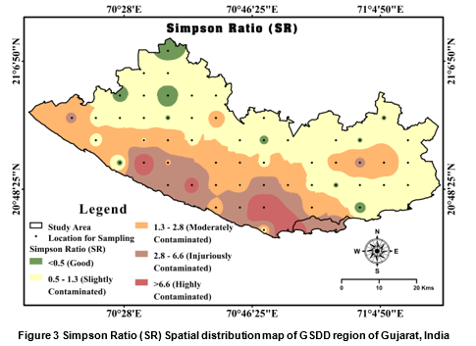
Figure 3 Simpson Ratio (SR) Spatial distribution map of GSDD region of Gujarat, India
4.2 Identification of salinity level in groundwater by Simpson ratio
The calculated values of SR ranged from 0.38 to 20.24, with a mean and SD of 1.83 ± 4.26, indicating considerable spatial variation in salinity influence within the study area (Figure 3). Based on classification criteria, 9.88% of samples fall in the good category (<0.5), indicating fresh water conditions with minimal salinity impact. About 27.16 % of samples are slightly contaminated (0.5–1.3), while 23.46% fall under moderately contaminated (1.3–2.8) conditions. A significant proportion, 24.69% of samples, are categorized as injuriously contaminated (2.8–6.6), and 14.81% show highly contaminated conditions (>6.6). These results suggest that although some groundwater sources remain fresh, a considerable number of samples show moderate to high salinity contamination, likely influenced by marine intrusion, evaporation, and geochemical processes within the coastal aquifer system (Al-shihmani et al., 2025; Jena et al., 2026).

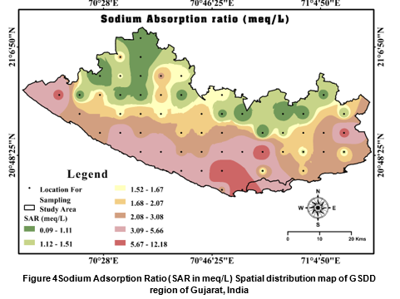

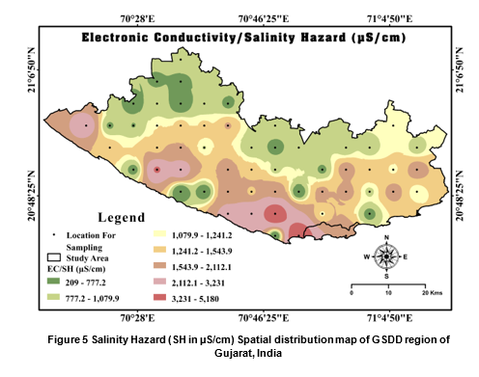

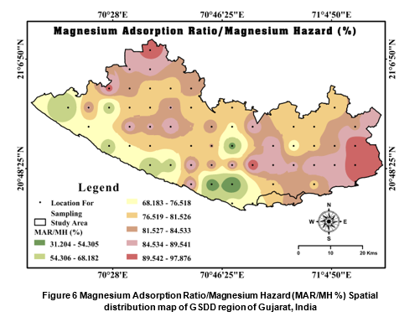
4.3 Irrigation suitability evolution of GSDD region of Gujarat
Salinity Hazard indicates the concentration of dissolved salts in irrigation water. SH Ranged from 209.00 to 5180 µS/cm, Mean ± SD ( 1399.12 ± 1014.04). Individual location SH value shown spatial distribution map of GSDD in Figure 4. Based on classification, water is excellent (<250 µS/cm), good (250–750 µS/cm), permissible (750–2000 µS/cm), doubtful (2000–3000 µS/cm), and unsuitable (>3000 µS/cm) (Sharma et al., 2017). Based on EC classification, 3.51% samples are excellent, 26.32% good, 54.39% permissible, 7.02% doubtful, and 8.77% unsuitable for irrigation. The Sodium Adsorption Ratio (SAR) values ranged from 0.09 to 12.18 meq/L with a mean ± SD of 2.64 ± 2.56, and also individual location SAR value shown spatial distribution map of GSDD in Figure 5. SAR represents the relative abundance of sodium compared with calcium and magnesium in irrigation water (Rawat et al., 2018). Irrigation water quality is classified as excellent (<10), good (10–18), doubtful (18–26), and unsuitable (>26). It is indicating that most samples fall within the excellent category; 96.49 % of samples are excellent and 3.51% are good. The Magnesium Adsorption Ratio (MAR) ranged between 31.20 and 97.88 with a mean ± SD of 79.25 ± 12.39. Individual location MAR value shown spatial distribution map of GSDD in Figure 6. MAR measures the dominance of magnesium over calcium in irrigation water (Pan et al., 2019). For MAR, water is considered suitable (<50%) and unsuitable (>50%) for irrigation. where 94.74% samples exceed the safe limit, indicating magnesium hazard in GSDD region of Gujarat.
Sodium percentage (Na %) ranged from 2.75 to 75.71 % with a mean ± SD of 33.28 ± 15.54. Individual location Na % value shown spatial distribution map of GSDD in Figure 7. Na% represents the proportion of sodium among total cations in irrigation water (Tejashvini et al., 2024). Na % is classified as excellent (<20%), good (20–40 %), permissible (40–60%), doubtful (60–80%), and unsuitable (>80%). Data showing 19.30 % excellent, 49.12% good, 24.56% permissible, and 7.02% doubtful categories. Potential Salinity (PS) ranged from 0.51 to 52.04 meq/L with a mean ± SD of 8.12 ± 10.22. Individual location PS value shown spatial distribution map of GSDD in Figure 8. Potential Salinity reflects the long-term salt accumulation effect of irrigation water on soil(Xu et al., 2019).
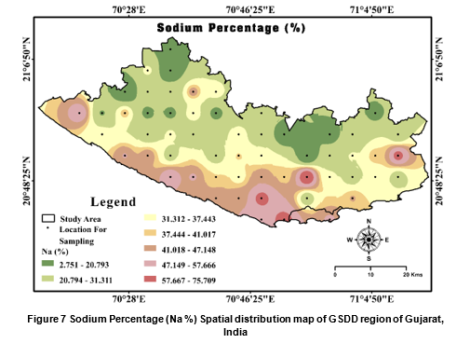
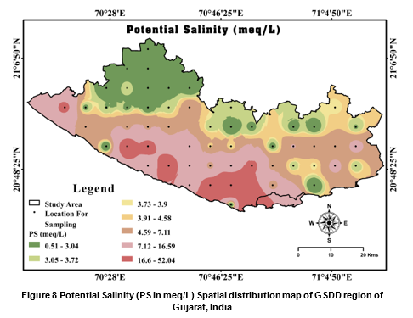
Water is classified as excellent (<3.0 meq/L), moderate (3.0–5.0 meq/L), and unsuitable (>5.0 meq/L). Indicating 35.09% excellent, 21.05% moderate, and 43.86% unsuitable samples.

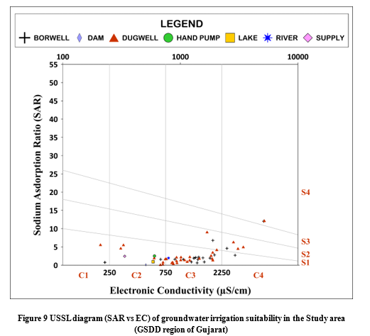
In Figure 9, the USSL diagram (SAR vs EC) was used to evaluate the suitability of groundwater for irrigation by assessing both salinity hazard (C1–C4) and sodium hazard (S1–S4). The plot shows that most samples cluster within the C3S1 and C2S1 fields, indicating medium to high salinity with low sodium hazard, suggesting that water can be used for irrigation with moderate management practices (Ravikumar & Somashekar, 2012). A few samples extend into C4S2 and C4S3 zones, reflecting higher salinity conditions that may require soil drainage and salt-tolerant crops.
Based on the classification ranges, the irrigation suitability distribution is approximately: Good range (C1S1, C2S1): ~36%, Moderate range (C1S2, C2S2, C3S2, C3S1): ~ 49%, Poor range (C1S3, C1S4, C2S3, C2S4, C3S3): ~12% and Unsuitable range (C3S4, C4S1, C4S2, C4S3, C4S4): ~3%. Overall, salinity and Magnesium hazard main causes in GSDD region also the USSL diagram indicates that the majority of groundwater samples fall within the moderate irrigation suitability class, where salinity is the primary limiting factor rather than sodium hazard. Proper soil management and irrigation practices are necessary to prevent long-term soil salinization.
4.4 Corrosion and Scaling potential evaluation for Industrial suitability
The RSI values ranged from 5.33 to 9.09 with a mean ± SD of 7.33 ± 0.72. GSDD region’s Spatial Distribution of RSI given in Figure 10. The dataset reveals a complex water chemistry profile. RSI shows 66 % of samples are corrosive, with 12 % heavily corrosive, while only 6 % indicate scaling (Kalyani et al., 2017). indicating that most samples show corrosive tendencies with a few samples approaching heavy corrosive conditions. The Larson–Skold Index (LS) ranged from 0.25 to 22.14 with a mean ± SD of 2.84 ± 3.96. GSDD region’s Spatial Distribution of LS given in Figure 11. 76% in the high corrosive range, 14% in non-corrosive and 18 % have Scaling and Corrosive (Ahmed et al., 2021). GSDD region’s both indices sample percentage class wise distribution of sample and status are given in Table 2. Overall, the water is predominantly corrosive across both indices, yet simultaneously prone to scaling, reflecting a dual risk of both deposition and material degradation. which may affect industrial pipelines and equipment if untreated water is used.

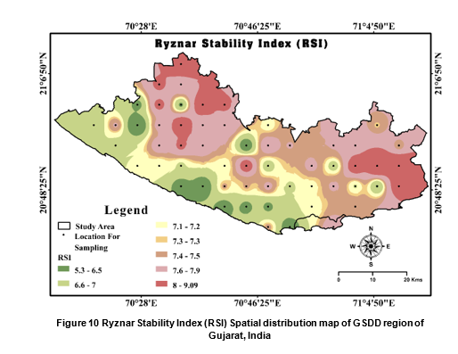
Table 2 Industrial suitability indices ranges, Status and sample % of GSDD region
INDICES | RANGES | STATUS | SAMPLE %
Ryznar Stability Index (RSI) | <5.5 | Heavy Scaling | 0
Ryznar Stability Index (RSI) | 5.5-6.2 | Scaling | 6
Ryznar Stability Index (RSI) | 6.2-6.8 | Balance | 16
Ryznar Stability Index (RSI) | 6.8-8.5 | Corrosive | 66
Ryznar Stability Index (RSI) | >8.5 | Heavy Corrosive | 12
Larson-Skold Index (LS) | <0.8 | Less Scaling / Non-Corrosive | 14
Larson-Skold Index (LS) | 0.8-1.2 | Scaling and Corrosive | 18
Larson-Skold Index (LS) | >1.2 | Heavy Corrosive | 68
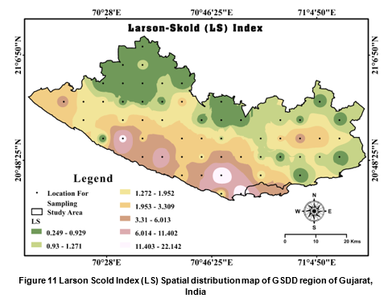
4.5 Evaluation of Hydrogeochemistry in GSDD region of Gujarat
The Piper diagram was included to simplify classification, ionic composition imaging, Hydrochemical facies, water type and quality variations that support comprehensive and sustainable water quality assessment (Arthur M. Piper, 1944). TDS in mg/L, p^{H} (no scale), and all the other ions are expressed in meq/L % for graphical output. In Figure 12, the Piper diagram illustrates the hydrochemical facies and dominant ionic composition of groundwater in the GSDD region. In the cation triangle, most samples cluster toward the Mg²⁺–Ca²⁺ field, indicating the dominance of alkaline earth metals over alkali metals (Ram et al., 2021). In the anion triangle, samples are mainly concentrated in the Cl⁻ field, suggesting chloride as the dominant anion. When projected into the central diamond, the majority of samples fall within the mixed Ca²⁺–Mg²⁺–Cl⁻ facies, indicating mixed water type influenced by rock–water interaction and salinity inputs. A few samples lie in Ca²⁺–Mg²⁺–HCO₃⁻ (freshwater) facies, reflecting recharge conditions. Overall, the hydrochemical facies suggests mixed saline water influenced by weathering and possible marine interaction in GSDD region.

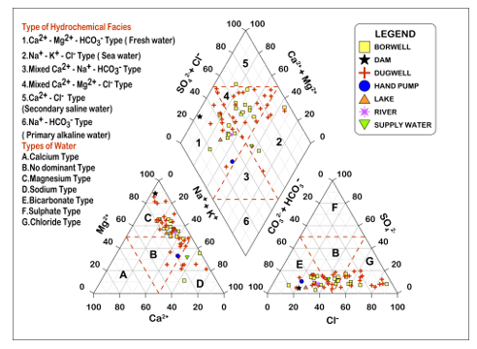
Figure 12 Trilinear Piper diagram of Study area (GSDD region of Gujarat)
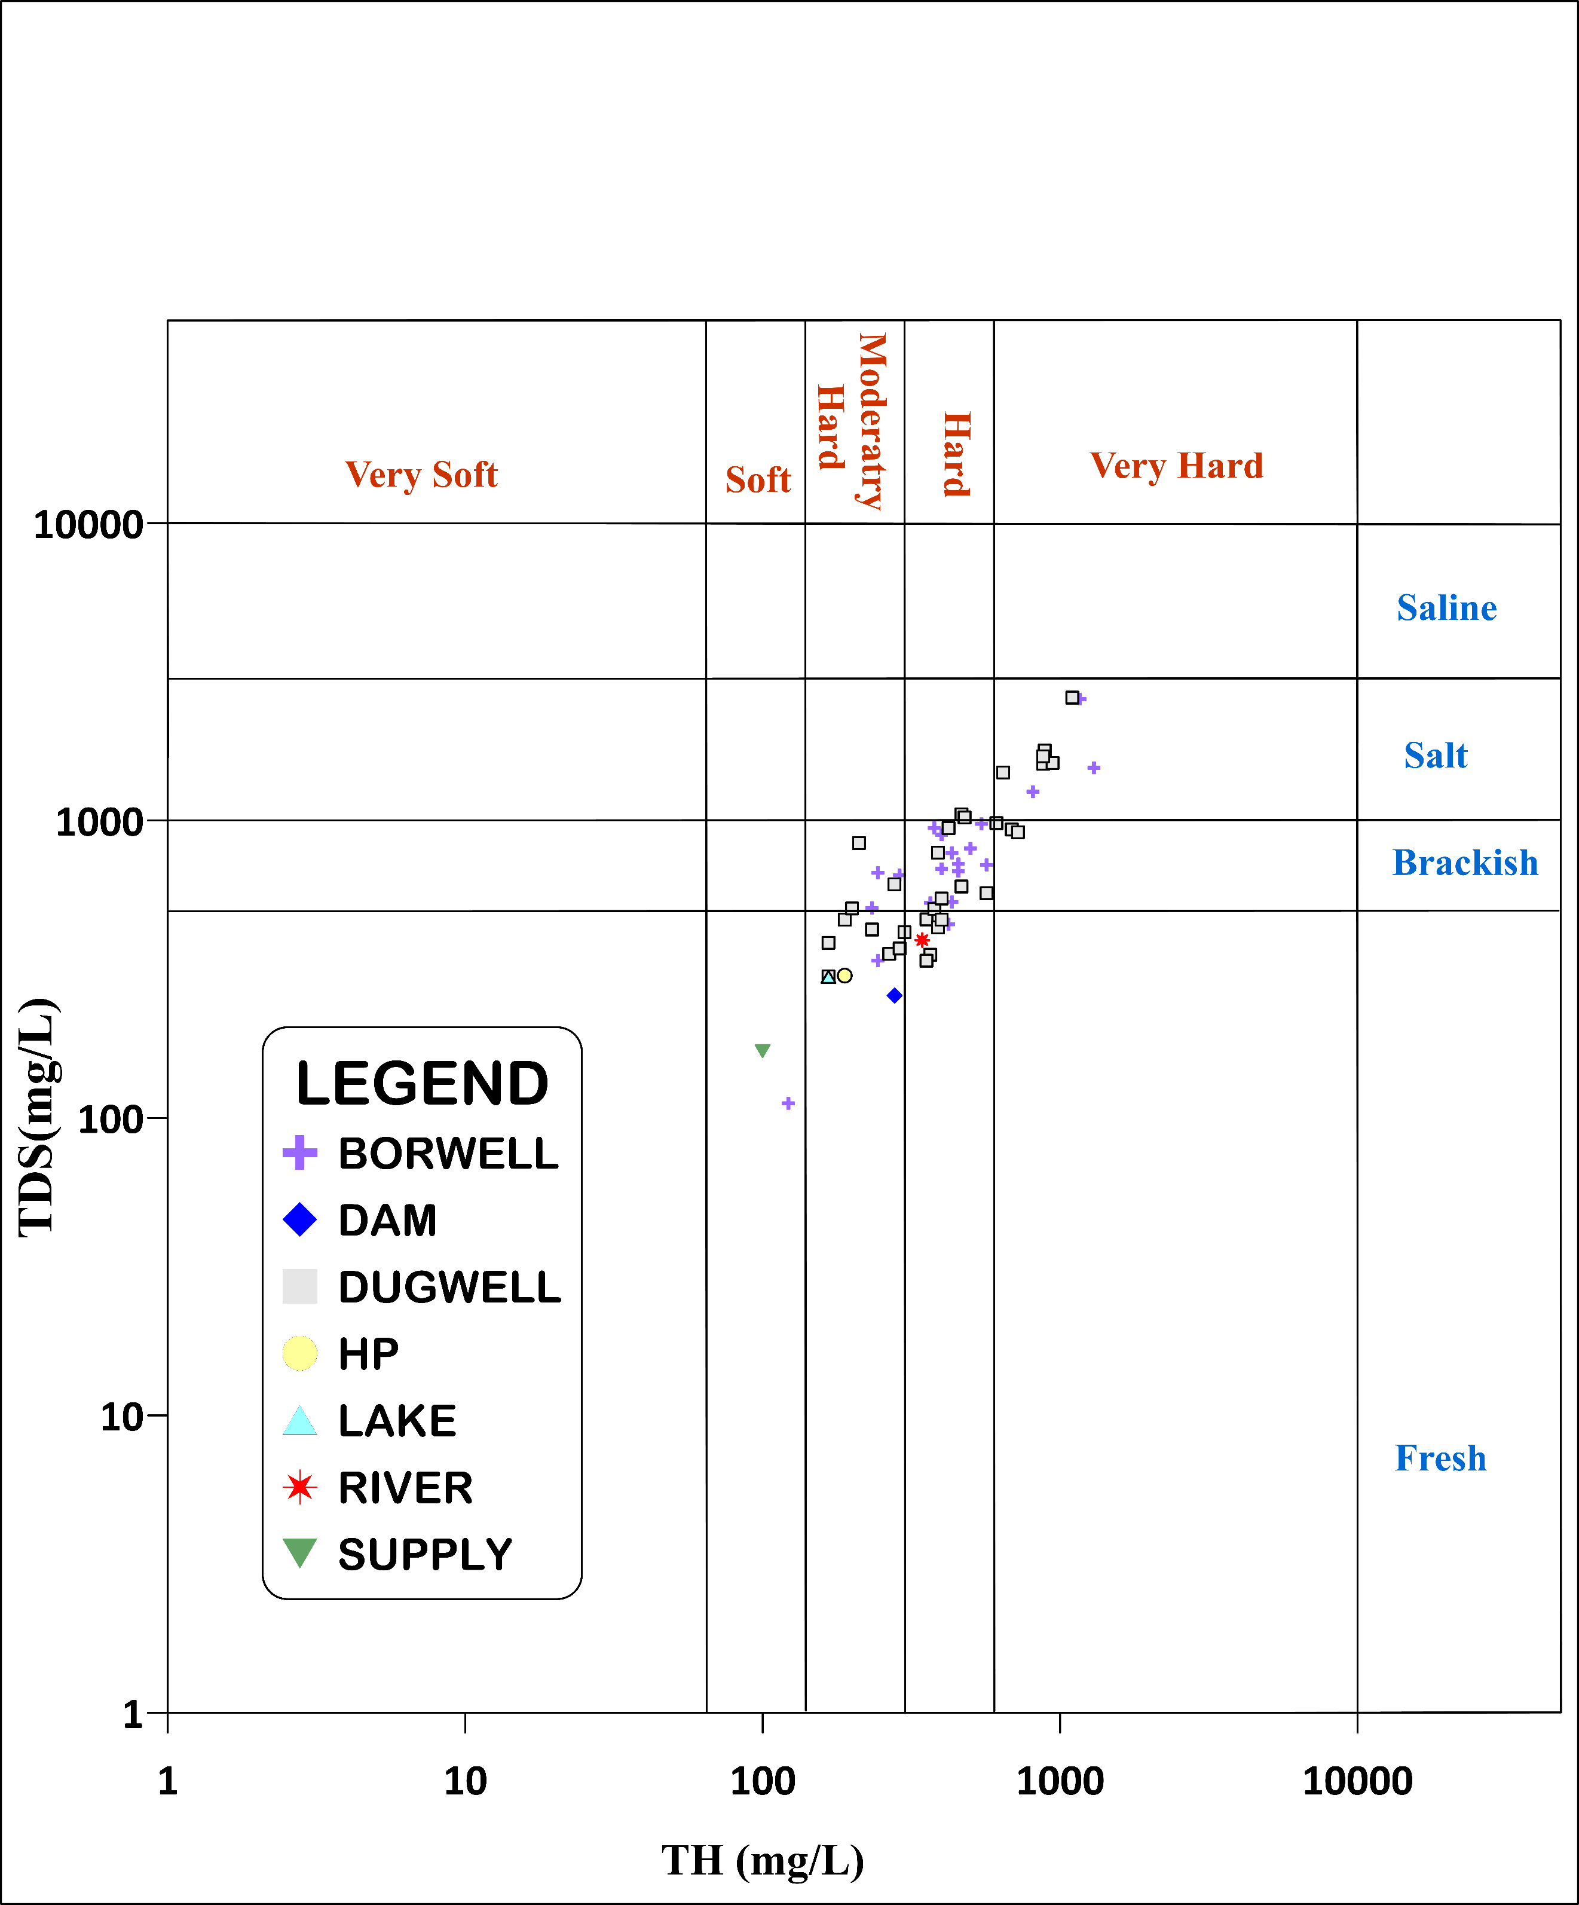
Figure 13 TH vs TDS diagram of Study area (GSDD region of Gujarat)

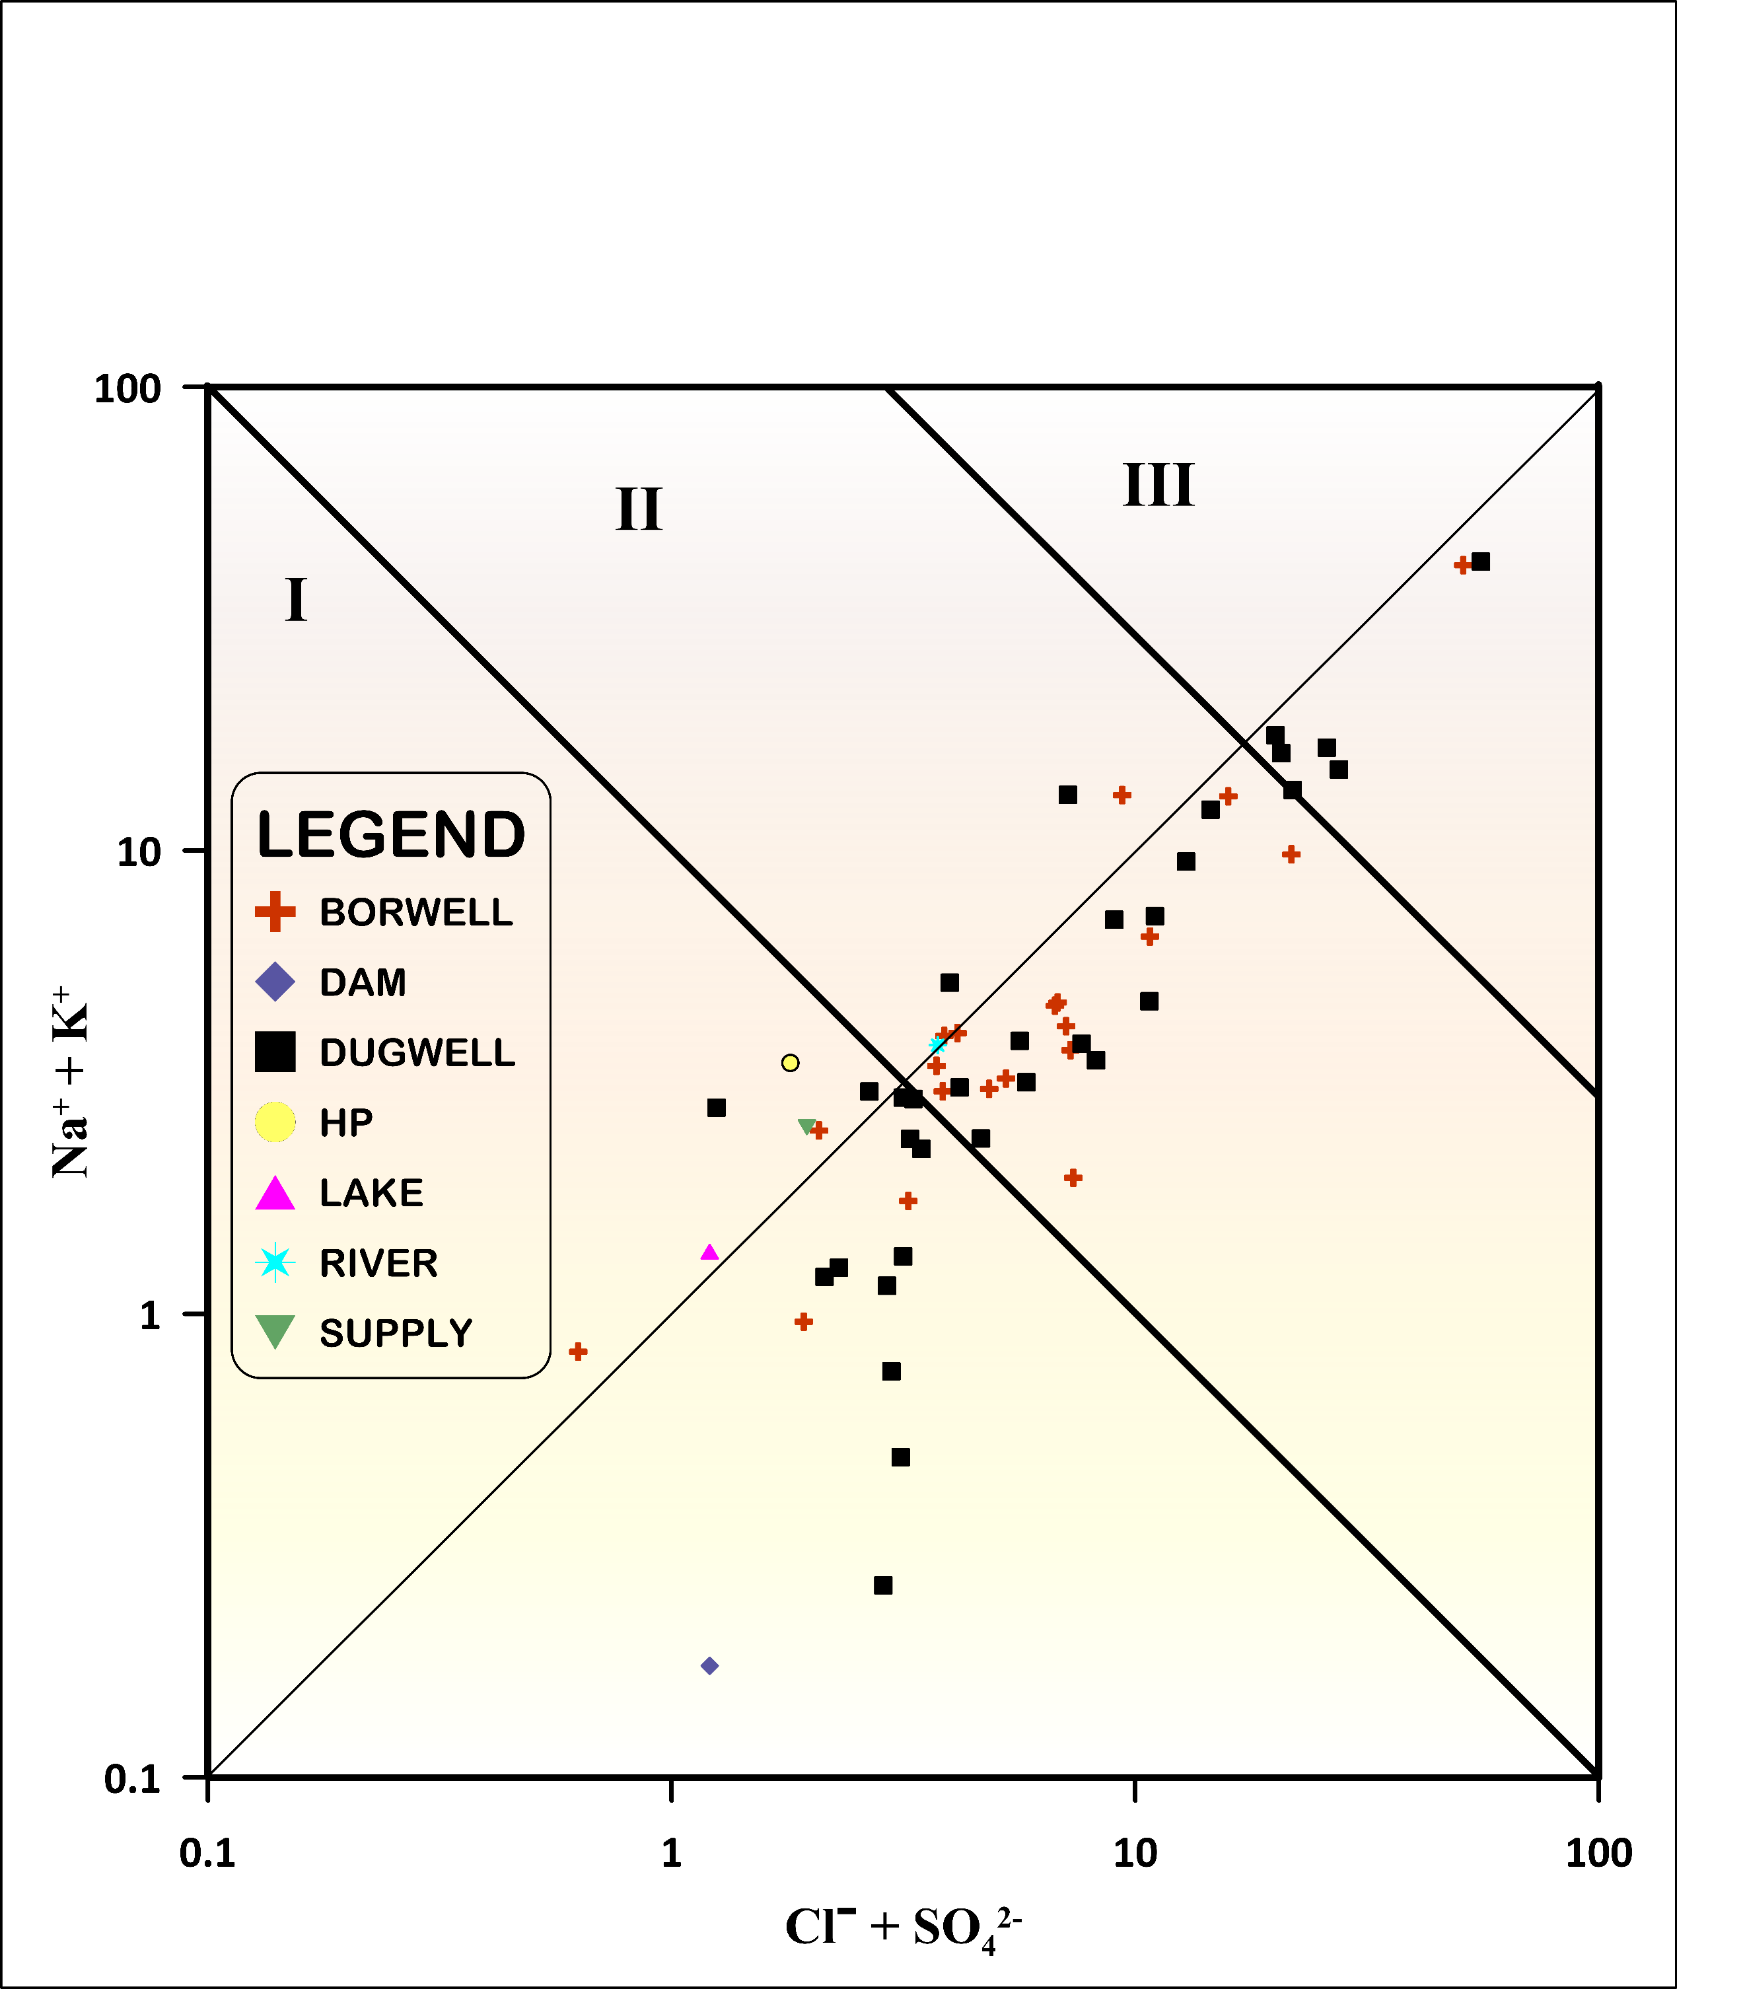In
Figure 14Mifflin diagram of Study area (GSDD region of Gujarat)

Figure 13, the TH vs TDS plot shows that most groundwater samples fall within the hard to very hard water category, with TDS values mainly indicating brackish to slightly saline conditions (Chaudhari et al., 2025). This distribution suggests that groundwater chemistry is influenced by mineral dissolution, rock–water interaction, and salinity effects, reflecting moderate to high hardness and dissolved salt concentrations in GSDD region. The Mifflin diagram (Figure 14) helps determine groundwater origin and residence time by plotting Na⁺ + K⁺ versus Cl⁻ + SO₄²⁻ (Mifflin, 1968). In Calculation of axis all ion value taken in meq/L unit. Most samples fall within Zone III, indicating regional groundwater flow systems with longer residence time and stronger water–rock interaction (Vázquez-Guevara et al., 2026). Some samples appear near Zone II, representing intermediate flow systems. Very few samples lie in Zone I, which represents shallow local flow systems. The clustering toward Zone III suggests that groundwater chemistry is mainly controlled by deep circulation, mineral dissolution, and prolonged interaction with aquifer materials, reflecting evolved groundwater conditions in the study area GSDD region of Gujarat.

Nothing appears to have been said about drinking water as in the introduction section
- Conclusion
Electrical Conductivity (EC) and Total Dissolved Solids (TDS) values were observed to be higher near to coastal area samples. This means that the water is moderately to highly saline. Total Hardness (TH) and Mg²⁺ concentrations were much higher in many samples, which means the water was hard to very hard. A considerable number of samples exceed desirable limits for Na⁺, EC, TH, and Mg²⁺, indicating mineralization and geogenic control in GSDD region. Spatial distribution maps reveal that groundwater quality deteriorates towards the coastal belt, where higher concentrations of EC, TDS, Na⁺, and Cl⁻ indicate strong marine influence and salinity intrusion, while inland areas showed relatively better water quality. The Simpson Ratio (SR) indicates moderate to high salinity contamination in several locations, confirming marine and evaporative influence. Irrigation indices such as SAR and Na% indicate that most samples were suitable to moderately suitable for irrigation. The values for Magnesium Hazard (MH/MAR) and Potential Salinity (PS) suggest that soil permeability and crop yields could be negatively affected. The USSL diagram indicates a predominance of samples within the C2S1 and C3S1 zones. suggests a medium to high salinity level, coupled with a low sodium hazard. Industrial indices, such as RSI and CR, reveal that groundwater has the potential to cause both scaling and corrosion. However, corrosion is the more frequently observed issue. The Mifflin diagram shows that most groundwater samples were in Zone I to II. This suggests that there are regional flow systems with local to intermediate residence times. Hydrochemical facies by Piper, show that the water was in a mix of Ca⁺²–Mg²⁺–Cl⁻ types, which could be caused by the interaction between rocks and water and the exchange of ions.
- References
6.1 Adimalla, N., & Li, P. (2018). Hydrogeochemical Evaluation of Groundwater Quality for Drinking and Irrigation Purposes and Integrated Interpretation with Water Quality Index Studies. 126.
6.2 Ahmed, S., Sultan, M. W., Alam, M., Hussain, A., Qureshi, F., & Khurshid, S. (2021). Evaluation of corrosive behaviour and scaling potential of shallow water aquifer using corrosion indices and geospatial approaches in regions of the Yamuna river basin. Journal of King Saud University - Science, 33(1), 101237. https://doi.org/10.1016/j.jksus.2020.101237
6.3 Al-shihmani, L. S. S., Al-sarraji, A. J., Al-shammary, A. A. G., Fernández-gálvez, J., & Caballero-calvo, A. (2025). Groundwater Quality Near Riverbanks and Its Suitability for Agricultural Use in Semi-Arid Regions. 1–21.
6.4 Anshar, A. M., Musa, B., Ayaz, M., Kasim, S., Raya, I., Ramírez-Coronel, A. A., Chowdhury, S., Zabibah, R. S., Romero-Parra, R. M., Barboza-Arenas, L. A., Mustafa, Y. F., & Al-Khafaji, A. H. D. (2023). A Critical Review on Corrosion and Fouling of Water in Water Distribution Networks and Their Control. Acta Chimica Slovenica, 70(2), 173–183. https://doi.org/10.17344/acsi.2022.7939
6.5 APHA. (2017). Standard Methods for the Examination of Water and Wastewater Standard Methods for the Examination of Water and Wastewater. In W. APHA, AWWA (Ed.), Public Health (23rd editi). American public health association. http://www.ajph.org/cgi/doi/10.2105/AJPH.51.6.940-a
6.6 Arthur M. Piper. (1944). A graphic procedure in the geochemical interpretation of water‐analyses. Eos, Transactions American Geophysical Union, 25(6), 914–928. https://doi.org/10.1029/TR025i006p00914
6.7 Asare, A., Appiah, E. K., Bukari, A., Frederick, A., & Nimo, O. (2021). Assessment of seawater intrusion using ionic ratios : the case of coastal communities along the Central Region of Ghana. Environmental Earth Sciences. https://doi.org/10.1007/s12665-021-09601-x
6.8 Barathkumar, S., Sellamuthu, K. M., Sathiyabama, K., Malathi, P., Kumaraperumal, R., Devagi, P., & Pazhanivelan, S. (2025). Groundwater quality assessment in selected polluted hotspots of Tamil Nadu, India using geospatial and statistical approaches. Desalination and Water Treatment, 322(February), 101047. https://doi.org/10.1016/j.dwt.2025.101047
6.9 Behura, K. B., Mohanty, S., Partha Pratim, & Ghosh, S. (2025). Hydrogeochemical Assessment of Groundwater Quality and Salinity Intrusion in Coastal Aquifers of Eastern India. Journal of Agricultural Engineering (India), 62(1), 152–166. https://doi.org/10.52151/jae2025621.1913
6.10 BIS. (2012). Indian Standard Drinking Water Specification (Second Rev). Bureau of Indian Standards. https://bis.gov.in
6.11 BIS. (2015). Indian Standard Drinking Water Specification (Second Rev). Bureau of Indian Standards. https://bis.gov.in
6.12 Chaudhari, M. P., Ali, G., Nair, R., Chavda, P., & Shrivsatav, P. S. (2025). Assessment of groundwater quality and geochemical characteristics in the desertic zone of Banaskantha region of western India.
6.13 Chaudhari, M. P., George, A., Sanyal, M., & Shrivastav, P. S. (2024). Hydrochemistry and groundwater quality assessment of Gujarat, India: A compendious review. Physics and Chemistry of the Earth, 135(April), 103635. https://doi.org/10.1016/j.pce.2024.103635
6.14 CHAVDA, P., CHAUDHARI, M. P., SOMAIYA, C., SHRIVASTAV, P. S., & PATEL, H. (2026). Hydrochemical Characteristics and Sustainable Quality Assessment of Reservoir Water in the Junagadh District of Saurashtra Peninsula, India1. Asian Journal of Chemistry, 38(3), 723–735.
6.15 Geological survey of India. (2012). Geological and mineral map of Gujarat daman & Diu Geological Maps » State Map 6.13 (Gujarat). Commissioner of Geology and Mining. https://cgm.gujarat.gov.in/uploads/staticData/Geological_map_gujarat_diu_daman.pdf
6.16 Hu, D., Indika, S., Makehelwala, M., Titus, C., Zhu, L., Pang, Z., Zhong, H., Weragoda, S. K., Jinadasa, K. B. S. N., Weerasooriya, R., & Wei, Y. (2024). Chemical characteristics and water stability evaluation of groundwater in the CKDu Zone of Sri Lanka. Journal of Environmental Sciences (China), 146, 67–80. https://doi.org/10.1016/j.jes.2023.05.034
6.17 Hwang, J. Y., Park, S., Kim, H.-K., Kim, M.-S., Jo, H.-J., Kim, J.-I., Lee, G.-M., Shin, I.-K., & Kim, T.-S. (2017). Hydrochemistry for the Assessment of Groundwater Quality in Korea. Journal of Agricultural Chemistry and Environment, 06(01), 1–29. https://doi.org/10.4236/jacen.2017.61001
6.18 Jena, M. R., Tripathy, J. K., Sahu, P., Sahoo, D., & Sahu, C. (2026). Integrated geochemical and geophysical assessment of groundwater salinization, Kujang block, eastern India. Environmental Geochemistry and Health, 48(2), 1–23. https://doi.org/10.1007/s10653-025-02965-0
6.19 Jha, G., Sinha, D. K., Jha, D. K., & Ajithprasad, P. (2024). Coasting into India? - Assessing lithostratigraphic context of Middle Palaeolithic occupation in Saurashtra Peninsula. Quaternary Environments and Humans, 2(6), 100034. https://doi.org/10.1016/j.qeh.2024.100034
6.20 Kalyani, D. S., Rajesh, V., Reddi, E. U. B., Kumar, K. C., & Rao, S. S. (2017). Correlation between corrosion indices and corrosiveness of groundwater: a study with reference to selected areas of Krishna District, Andhra Pradesh, India. Environmental Earth Sciences, 76(16). https://doi.org/10.1007/s12665-017-6908-y
6.21 Krishna kumar, S., Logeshkumaran, A., Magesh, N. S., Godson, P. S., & Chandrasekar, N. (2015). Hydro-geochemistry and application of water quality index (WQI) for groundwater quality assessment, Anna Nagar, part of Chennai City, Tamil Nadu, India. Applied Water Science, 5(4), 335–343. https://doi.org/10.1007/s13201-014-0196-4
6.22 Lakhdari, A. S., Bouselsal, B., Saibi, H., & Ouarekh, M. (2025). Assessment of groundwater quality and hydrogeochemical properties in the adrar continental intercalaire aquifer of the Algerian Sahara. Applied Water Science, 15(7). https://doi.org/10.1007/s13201-025-02552-9
6.23 Liu, J., Wang, M., Gao, Z., Chen, Q., Wu, G., & Li, F. (2020). Hydrochemical characteristics and water quality assessment of groundwater in the Yishu River basin. Acta Geophysica, 68(3), 877–889. https://doi.org/10.1007/s11600-020-00440-1
6.24 Mifflin, M. D. (1968). Delineation of ground-water flow systems in Nevada. University of Nevada, Reno.
6.25 Mohammed, M. A. A., Szabó, N. P., & Szűcs, P. (2022). Multivariate statistical and hydrochemical approaches for evaluation of groundwater quality in north Bahri city-Sudan. Heliyon, 8(11). https://doi.org/10.1016/j.heliyon.2022.e11308
6.26 Nabil, H., Wahiba, H., Azzedine, R., Wahiba, B., & Hakim, K. (2025). Hydrogeochemical Characterization and Assessment of Groundwater Quality in the Touffana Region, Northeastern Algeria: Implications for Irrigation and Water Resource Management. Water Resources, 52(6), 1356–1365. https://doi.org/10.1134/S0097807825700265
6.27 Pan, Y. R., Wang, X., Ren, Z. J., Hu, C., Liu, J., & Butler, D. (2019). Characterization of implementation limits and identification of optimization strategies for sustainable water resource recovery through life cycle impact analysis. Environment International, 133(July 2019), 105266. https://doi.org/10.1016/j.envint.2019.105266
6.28 Pandey, V. (2023). Climate variability, trends, projections and their impact on different crops: A case study of Gujarat, India. Journal of Agrometeorology, 25(2), 224–238. https://doi.org/10.54386/jam.v25i2.2151
6.29 Pathak, Y. P. (2024). Geostatistics & GIS-based thematic Modelling. June, 96–104.
6.30 Prizomwala, S. P., Yadav, G., Bhatt, N., & Sharma, K. (2018). Late Pleistocene relative sea-level changes from Saurashtra, west coast of India. Current Science, 115(12), 2297–2301. https://doi.org/10.18520/cs/v115/i12/2297-2301
6.31 Ram, A., Pandey, S. K. T. H. K., Kumar, A., Supriya, C., & Singh, S. Y. V. (2021). Groundwater quality assessment using water quality index ( WQI ) under GIS framework. Applied Water Science, 11(2), 1–20. https://doi.org/10.1007/s13201-021-01376-7
6.32 Ramos-Leal, J. A., Moran-Ramírez, J., Rodríguez-Robles, U., León, G. S. De, Roy, P. D., Fuentes-Rivas, R. M., & de Oca, R. M. G. F. M. (2022). Hydrogeochemical and isotopic characterizations of an aquifer in the semi-arid region of the Mexican Highlands. Geochemistry, 82(2). https://doi.org/10.1016/j.chemer.2022.125872
6.33 Ravikumar, P., & Somashekar, R. K. (2012). Assessment and modelling of groundwater quality data and evaluation of their corrosiveness and scaling potential using environmetric methods in Bangalore South Taluk, Karnataka state, India. Water Resources, 39(4), 446–473. https://doi.org/10.1134/S0097807812040112
6.34 Rawat, K. S., Singh, S. K., & Gautam, S. K. (2018). Assessment of groundwater quality for irrigation use: a peninsular case study. Applied Water Science, 8(8), 1–24. https://doi.org/10.1007/s13201-018-0866-8
6.35 Richards, L. A., & Staff. (1954). Diagnosis and improvement of saline and alkali soils. In US Salinity Labolatory (Ed.), Agriculture handbook (Vol. 160). United States Department of Agriculture.
6.36 Sharma, D. A., Rishi, M. S., & Keesari, T. (2017). Evaluation of groundwater quality and suitability for irrigation and drinking purposes in southwest Punjab, India using hydrochemical approach. Applied Water Science, 7(6), 3137–3150. https://doi.org/10.1007/s13201-016-0456-6
6.37 Singh, K. K., Tewari, G., & Kumar, S. (2020). Evaluation of Groundwater Quality for Suitability of Irrigation Purposes: A Case Study in the Udham Singh Nagar, Uttarakhand. Journal of Chemistry, 2020. https://doi.org/10.1155/2020/6924026
6.38 Sun, Z., Yang, X., Liu, S., Wang, J., & Li, M. (2024). Spatial Distribution and Health Risk Assessment of Saline Water Intrusion and Potentially Hazardous Pollutants in a Coastal Groundwater Environment. Water (Switzerland), 16(18). https://doi.org/10.3390/w16182573
6.39 Tang, N., Chen, M., Zhou, M., Xie, Z., Liu, W., & Huang, X. (2025). Hydrochemical Characteristics and Drinking Water Quality Assessment of Phreatic Groundwater in the Northwest of the Sichuan Basin, SW China. Water (Switzerland), 17(7). https://doi.org/10.3390/w17071074
6.40 Tejashvini, A., Subbarayappa, C. T., Mudalagiriyappa, M., Chowdappa, H. D., & Ramamurthy, V. (2024). Assessment of irrigation water quality for groundwater in Semi-Arid Region, Bangalore, Karnataka. Water Science, 38(1), 548–568. https://doi.org/10.1080/23570008.2024.2414131
6.41 Vázquez-Guevara, L. G., Ventura-Houle, R., Peña-Alonso, T. A., Guevara-Mansilla, O., Requena-Lara, G. N., Andrade-Limas, E. del C., & Macías-Hernández, B. A. (2026). Groundwater origin and circulation within a karst watershed recharge zone: the case of the Upper Guayalejo-Tamesí River Basin, southern Tamaulipas, Mexico. Journal of South American Earth Sciences, 172(August 2025), 105933. https://doi.org/10.1016/j.jsames.2025.105933
6.42 Vekariya, P. B., Rank, H. D., Vadher, P. G., & Gontia, N. K. (2017). Groundwater utilization and management: policy guidelines for the South West Saurashtra region. Sustainable Water Resources Management, 3(3), 241–255. https://doi.org/10.1007/s40899-017-0086-7
6.43 WHO. (2017). Guidelines for Drinking-Water Quality (W. H. Organization (ed.); 4th editio). https://www.who.int/publications/i/item/9789241549950
6.44 Xu, P., Feng, W., Qian, H., & Zhang, Q. (2019). Hydrogeochemical characterization and irrigation quality assessment of shallow groundwater in the central-Western Guanzhong basin, China. International Journal of Environmental Research and Public Health, 16(9). https://doi.org/10.3390/ijerph16091492
6.45 Yadav, S. M., Bhagat, S. R., & Yadav, V. G. (2021). Temporal analysis of precipitation in Saurashtra, Kutch, and Diu sub-division of Western Indian region. Theoretical and Applied Climatology, 144(1–2), 521–533. https://doi.org/10.1007/s00704-021-03564-6

