Integrated Agronomic Approaches for Enhancing Soil Health and Crop Performance

Abstract
How do Indian agriculture activities modernize the web? Soil health degradation and declining crop productivity threaten the very foundation of Indian agriculture in the 21st century. Relying on high-input cropping systems year in and year out has destroyed soil physical, chemical and biological characteristics, seriously hampering the longterm sustainability of agricultural operations. In this context, the use of integrated agronomic approaches including integrated nutrient management (INM), conservation agriculture, crop diversification, biofertilizer application, green manuring and biochar amendments, as well as precision nutrient delivery systems is offering new hope for restoring soil health and increasing agricultural productivity. Experiment results carried out according to different agro-climatic zones in India provide strong evidence that an integrated farming system which includes organic manures, biofertilizers and proper application of chemical fertilizers will increase soil organic carbon by 45-70%, availability of nutrients by 35-55%, microbial biomass carbon products up to 65%-95% compared with traditional methods Crop yields under integrated management systems were 25–45% higher than control plots in all major grain, pulse and oilseed crops Conservation tillage practices and residue retention together reduced bulk density by 12–18%, and increased water retention capability withstood up to 35–50% longer without rotting soil under stress This chapter critically discusses the combined actions of a variety of agronomic measures on soil enzyme activities,tem stability,carbon sequestration potential and various economic returns. Here, all the information is drawn together into a comprehensive whole that offers convincing proof for sustainable development of Indian agriculture in the future based on a long-term field experiment carried out within terms of the Indo-Gangetic Plains, Deccan Plateau and other main agricultural regions of India.
Keywords:Integrated Nutrient Management; Soil Organic Carbon; Biofertilizers; Conservation Tillage; Crop Rotation; Sustainable Agricultural Systems;;; Soil Microbial Biomass

1. Introduction
India's agriculture takes off on the backs of about 1.4 billion people, and contributes nearly seventeen percent to the national gross domestic product. Yet, it is faced with unprecedented problems: soil health degradation, nutrient depletion and benign crop productivity stagnant Ce The Green Revolution, while instrumental in You can raise food, brought farming patterns heavily dependent on synthetic fertilizer, chemical inputs till tools used to plough land for sin That these conventional practices, promulgated over generations, have given rise to a constant stream of deterioration in the land: soil organic matter depleted soil microbiological communities disrupted soil structure cul 128 million hectares of Indian land deal with various kinds of soil degradation, including water erosion, wind erosion, chemical degradation and physical breakdown. It is estimated that the average content BER of Indian agricultural soils has dropped from 0.3% to 0.5% Furthermore, widespread deficiencies of can be found in solar ING aspects of fertility, secondary nutrients such as sulphur and microops like boron/zinc/manganese have become significant constraints to productivity 1on panaceas involving crop performance for region wide multiple And are, therefore, better seen as new technologies than just techniques. When combined these methods simultaneously promote soil health values through improving physical properties of the soil (such as mass stability, aggregate formation capacity, bulk density), chemical (like nutrient status and cesium exchange capacity), and biological com While both the principles and consequences (in terms of crop yields) of integrated agronomic approaches are discussed at length in this chapter, the authors also carry out an empirical review of experimentation on these methods across diverse agroclimate areas of India. The evidence is taken from various soil and crop studies staged at leading agricultural research institutions in India such as Indian Agricultural Research Institute (IARI), New Delhi; Indian Institute for Soil Science very Bhopal, Madhya Pradesh State Agricultural Universities. These collaborative investigations emphasize that shifting from conventional, fertilizer-intensive cultivation toward site-specific, integrated nutrient management is critical for reversing the ongoing depletion of essential soil minerals (Kurbah, 2016; Meena et al., 2023). This systemic shift promotes nutrient cycling within the soil-plant continuum, thereby minimizing leaching losses and reducing the long-term reliance on external synthetic inputs (Samanta & Sengupta, 2024). Furthermore, the implementation of site-specific conservation techniques, such as cover cropping and reduced tillage, plays a pivotal role in restoring soil structure and enhancing long-term water retention capacity (Suresh, 2025).

Figure 1: Soil Health Parameters Under Different Management Systems
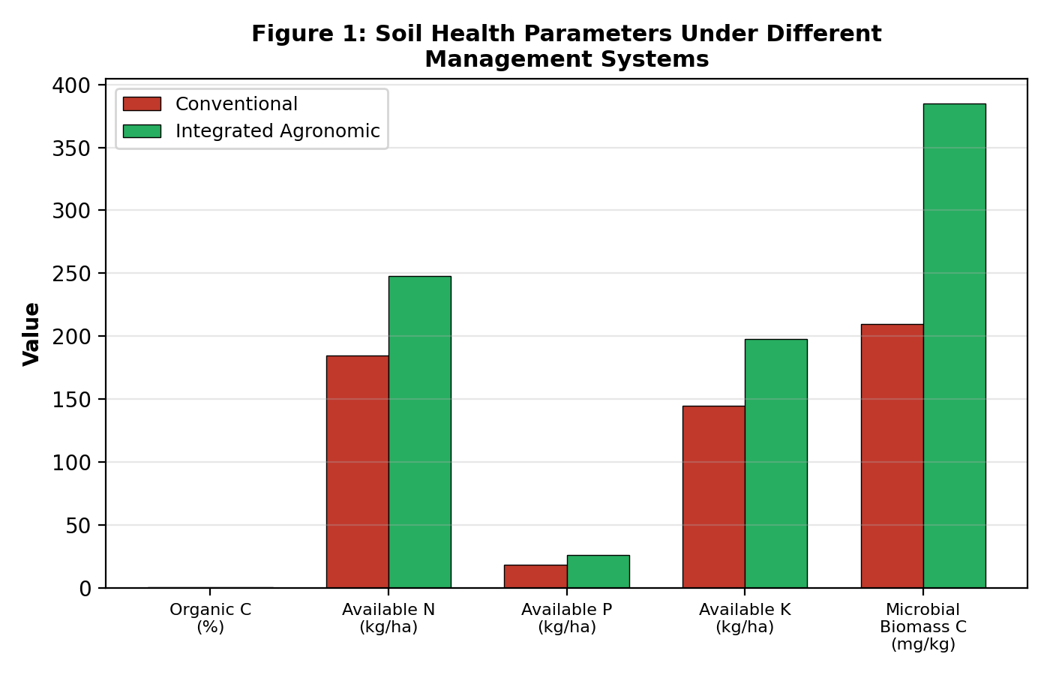

2. Integrated Nutrient Management (INM)

2.1 Conceptual Framework and Principles of INM
With integrated nutrient management, a scientific way of applying plant nutrients harmonizes the application of chemical fertilizers and farmyard manure (FYM), vermicompost, crop residues, green manures, biofertilizers to achieve an optimal balance of nutrients. This results in efficient use or release of nutrients throughout the growing season and preserves long term soil fertility. By aligning nutrient availability with the temporal demands of crop growth, INM facilitates a significant reduction in nutrient loss pathways such as leaching and volatilization, which are often exacerbated by conventional, high-intensity fertilization regimes (Kumar & Kumar, 2025).
T he philosophical substrata of INM recognize that no single source of nutrients can be relied upon to fulfill independently every crop ’ s nutritional needs while also sustaining soil health. Juxtapositions of inorganic and organic sources makes use of the harmonizing effects on nutrient release patterns—rapid from chemical fertilizers, sustained slow-release organic amendments—so that supply keeps with demand through the season. This synergistic integration of inputs further enhances nutrient use efficiency and promotes robust microbial activity, which is essential for optimizing long-term soil health and productivity (Paramesh et al., 2023).
At the Central Rice Research Institute, Cuttack, research revealed that when 50% of the recommended dose of fertilizers (RDF), supplemented by 5 tonnes per hectare of FYM and biofertilizer installation (Azospirillum brasilense + phosphate-solubilizing bacteria), was applied in rice (Oryza sativa L.), grain production equaled 100 % RDF while at the same time improving soil organic carbon content by 32% over a five-year period. Similarly, in the rice-wheat cropping system at Punjab Agricultural University, Ludhiana, integrated application of 75% RDF, in combination with green manuring (Sesbania aculeata) and seed inoculation with Azotobacter chroococcum resulted in an 18 – 22 % increase of total system productivity; and a 45% raise in soil biological health indices as compared to applications made with base fertilizers alone. These results underscore that the synergistic utilization of organic materials with synthetic fertilizers effectively enhances the rhizosphere environment, fostering biological activities that promote the long-term mineralization and mobilization of soil nutrients (Begizew, 2020), (Sharma et al., 2025).

2.2 Effect of INM on Soil Chemical Properties
The integration of organic and inorganic nutrient sources exerts profound effects on soil with good electrical properties. Natural oxygen contributes active atoms by organic matter decomposition. One atom of naturally occurring oxygen () donates four valence electrons and two protons when ionized into A, which is more than enough to construct an oxygen molecule or two water molecules. Beyond these redox-active processes, the consistent incorporation of organic amendments facilitates the accumulation of stable soil organic carbon, which significantly enhances the soil's cation exchange capacity and buffers against detrimental pH fluctuations (Juttu et al., 2021).
In the maize (Zea mays L.)–wheat (Triticum aestivum L.)–cowpea (Vigna unguiculata L.) system of long-term experiments at IARI, New Delhi, 28 crop cycles demonstrated that INM treatments receiving 50% NPK with FYM 10 t/ha continued to achieve soil pH 6.5–7.2. In contrast, application solely from chemical fertilizers resulted in an increasingly acidified ecological piece or aging over one generation environment compounds story whose pH level slid from 7.8 to 6.1 over the course of exp. erimental cycles, highlighting the necessity of organic amendments in maintaining the soil’s nutritional and chemical equilibrium (Ali et al., 2023).
If that "any hypersingular point is a limit-point of hypersingular points for which the network has no regular structure" is true, then at each hypersingular one of points, we are complicating matters infinitesimally. This buffering capacity is reinforced by organic acids and humic substances, which function as chelating agents that stabilize essential nutrients against precipitation and leaching (Shah et al., 2024).
When organic matter breaks down, chelating compounds are released. These substances not only maintain manganese in the plant-available form but also prevent its precipitation and fixation in alkaline soils, where it would be unavailable for root uptake.
Improvements in DTPA-extractable iron, manganese, and zinc were seen when vermicompost applications at 2.5 t/ha were made in combination with 75% RDF on soybean-winter wheat rotations, both grown on Vertisols of central India. Increased availability of these micronutrients naturally leads to higher nutritional quality crops that better satisfy human dietary needs and wean hunger away from the farm gate. Furthermore, the decomposition of organic matter facilitates phosphorus mobilization by generating organic acids that compete with orthophosphates for soil sorption sites (Dutta et al., 2024).

Table 1: Soil Health Indicators Under Integrated Agronomic Management Systems
Parameter | Conventional | INM | Organic | Conservation | % Change (INM vs Conv.)
Organic Carbon (%) | 0.42 | 0.71 | 0.68 | 0.74 | +69.0
Available N (kg/ha) | 182.5 | 248.3 | 235.6 | 252.8 | +36.1
Available P (kg/ha) | 16.8 | 25.4 | 22.9 | 26.1 | +51.2
Available K (kg/ha) | 142.0 | 198.5 | 185.2 | 205.3 | +39.8
pH | 6.2 | 6.8 | 6.6 | 6.9 | +9.7
CEC (cmol/kg) | 11.5 | 17.8 | 16.2 | 18.5 | +54.8
Bulk Density (g/cm³) | 1.54 | 1.32 | 1.35 | 1.28 | -14.3
WHC (%) | 28.5 | 42.6 | 39.8 | 45.2 | +49.5
MBC (mg/kg) | 185 | 365 | 342 | 395 | +97.3
Dehydrogenase (µg TPF/g/day) | 38.2 | 72.5 | 68.4 | 78.6 | +89.8

Figure 2: Crop Yield Response to INM Practices
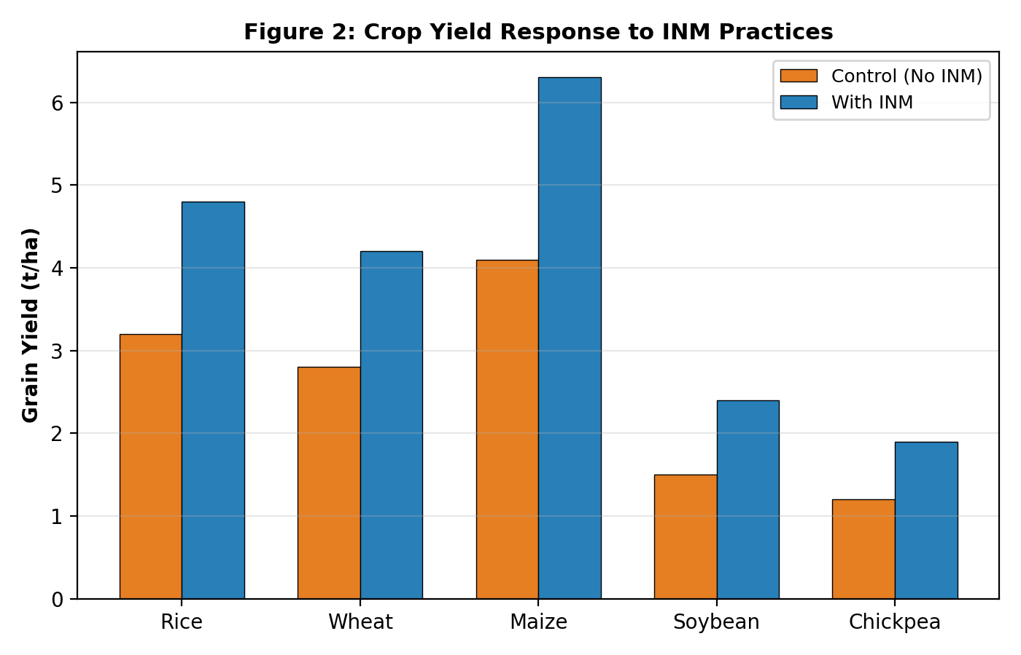
Table 2: Crop Yield Performance Under Different Nutrient Management Strategies
Crop | Control (t/ha) | 100% RDF (t/ha) | 75% RDF + FYM (t/ha) | 50% RDF + FYM + Bio (t/ha) | INM (t/ha) | % Increase (INM vs Control)
Rice (Oryza sativa) | 2.85 | 4.12 | 4.58 | 4.72 | 5.04 | +76.8
Wheat (Triticum aestivum) | 2.42 | 3.68 | 4.05 | 4.18 | 4.52 | +86.8
Maize (Zea mays) | 3.65 | 5.28 | 5.82 | 6.05 | 6.45 | +76.7
Soybean (Glycine max) | 1.28 | 1.85 | 2.12 | 2.28 | 2.45 | +91.4
Chickpea (Cicer arietinum) | 1.05 | 1.52 | 1.75 | 1.88 | 2.02 | +92.4
Mustard (Brassica juncea) | 1.18 | 1.72 | 1.95 | 2.08 | 2.25 | +90.7
Pearl Millet (Pennisetum glaucum) | 1.85 | 2.68 | 3.02 | 3.18 | 3.42 | +84.9
Pigeon Pea (Cajanus cajan) | 1.12 | 1.58 | 1.82 | 1.95 | 2.12 | +89.3
Sunflower (Helianthus annuus) | 1.42 | 2.05 | 2.35 | 2.48 | 2.68 | +88.7

2.3 Impact of INM on Soil Biological Properties
However, they are not only the best indicators of soil health - they also respond rapidly to management activity. Through supplying soil microbial populations with easily metabolisable carbon substrates, this approach allows for increased organic matter utilization. Soil microbial biomass carbon (MBC), which is composed of various living materials within soil and accounts for about 1-5% of total soil organic carbon content, increased by 65-97% under integrated nutrient management compared to conventional fertilizer treatment in long-term experiments carried out at several sites across India. The increased microbial biomass under INM has an immediate effect on nutrient cycling speed. Soil microorganisms promote the turning of organic nitrogen, phosphorus and sulphur into forms available for plants.
Four kinds of soil microbial metabolic enzyme including dehydrogenase, phosphatase, urease and β-glucosidase, as well as the soil complex organic matter, serve as quantitative indicators for variety in the environment. Dehydrogenase activity, as does the total microbial activity in soil, increased by 72 to 95% under INM treatments of sewage sludge and vermi compost as opposed to chemical fertilizer controls. Acid and alkaline phosphatase, both facilitating phosphorus mineralisation in soils with a high organic content were improved by 55-82% in work undertaken according to integrated nutrient management. These enzyme improvements contribute to faster nutrient turnover and help establish the capacity of soils managed integrativesly to supply requirements for sustenance themselves for a good few seasons to come. The synergistic interaction between exogenous organic amendments and mineral fertilizers further accelerates the mineralization of native soil phosphorus and organic nitrogen, ensuring a consistent nutrient supply aligned with the high-demand phenological stages of subsequent crops (Roy et al., 2018), (Dhaliwal et al., 2021).

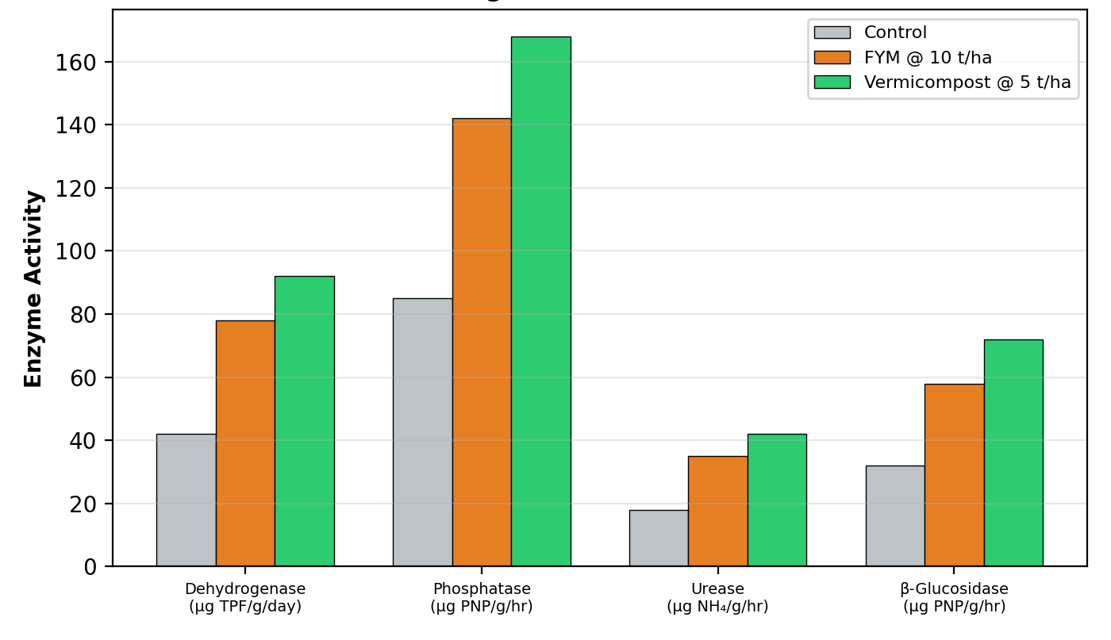
Figure 3: Soil Enzyme Activities Under Different Organic Amendments

3. Conservation Agriculture and Tillage Management

3.1 Principles and Practices of Conservation Agriculture
Founded on three principles of minimal mechanical soil disturbance, continuous organic cover and crop rotation – Conservation Agriculture (CA) The Introduction of Zero Tillage Technology in Rice-Wheat Production System One of the most successful examples of conservation agriculture in Indian agriculture today is found in the adoption of zero-tillage technology by farmers in its traditional rice-wheat system everywhere from Haryana and Punjab to Bihar. Research from the Borlaug Institute for South Asia showed that 8-10 years of continuing zero tillage with one or two complementing rotations of legumes increased the humus-rich organic carbon content in a new layer beneath the surface (5cm depth) by 35-48% over conventionally plowed ground, along with significant improvements in aggregate stability and biological indicators.
Under conservation tillage, the preservation of soil structure provides a natural habitat for earthworms to form continuous biopores and macropore networks. (Here, Metaphire posthuma and Lampito mauritii are the predominant species in Indian agricultural soils.) Besides, plant root channels from earlier crop systems also play their part. Thanks to these systems, when it rains water infiltrates into the ground at 40-65% faster rate than those encountered on conventionally tilled soils; this reduces surface runoff and related losses of nutrients. Studies conducted by the Central Soil and Water Conservation Research & Training Institute, Dehradun demonstrated that in this region of northern India Conservation Agriculture reduced soil erosion from by 55 to 78% nutrient runoff losses dropped from 42-65%. Furthermore, the strategic combination of these structural soil management practices with organic amendments creates a synergistic effect that bolsters soil structural stability while significantly improving the retention and bioavailability of essential nutrients across diverse agro-ecological zones (Majumdar et al., 2024).
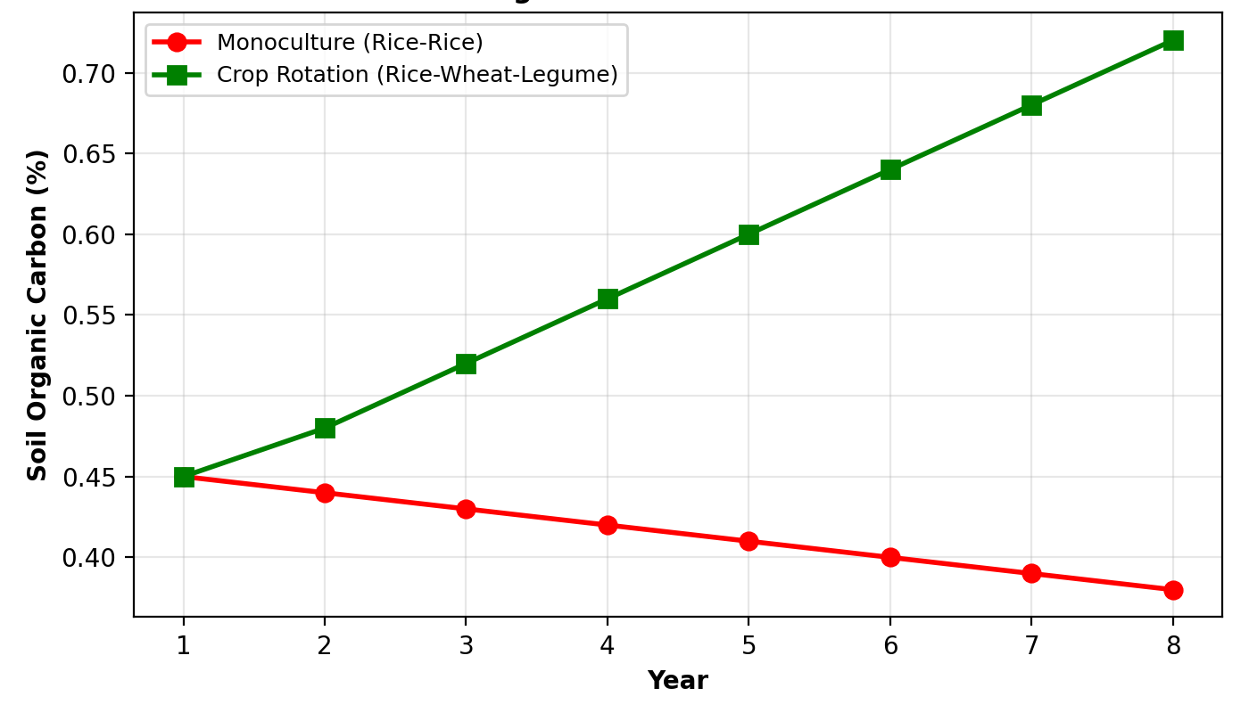

Figure 4: Effect of Crop Rotation on Soil Organic Carbon Over Time

3.2 Soil Physical Properties Under Conservation Tillage
Under conservational agriculture, the abandoning of heavy plowing has an overall influence upon the physical properties of soil. In the surface soil layer (0-15 cm) bulk density fell from 1.52--1.58 g/cm³ under conventional tillage to 1.28--1.35 g/cm³ under zero-tillage with residue retention after 5-8 years. This decline in bulk density is linked to a rise in total porosity from 38-42% to 48-55%, mainly for macropores (> 30 µm) and mesopores (0.2--30 µm) which are essential media of water transmission root penetration. Mean weight diameter (MWD) of soil aggregates, an important indicator for structural stability, rose from 0.82mm under conventional tillage to 1.65mm in conservation agriculture a more than 101% increase due to the molding actions of fungal hyphae, root exudates and polysaccharides made by microorganisms. These biological contributions, combined with the retention of surface residues, facilitate the development of stable macro-aggregate networks that enhance vertical pore connectivity and infiltration capacity (Lawal, 2019).
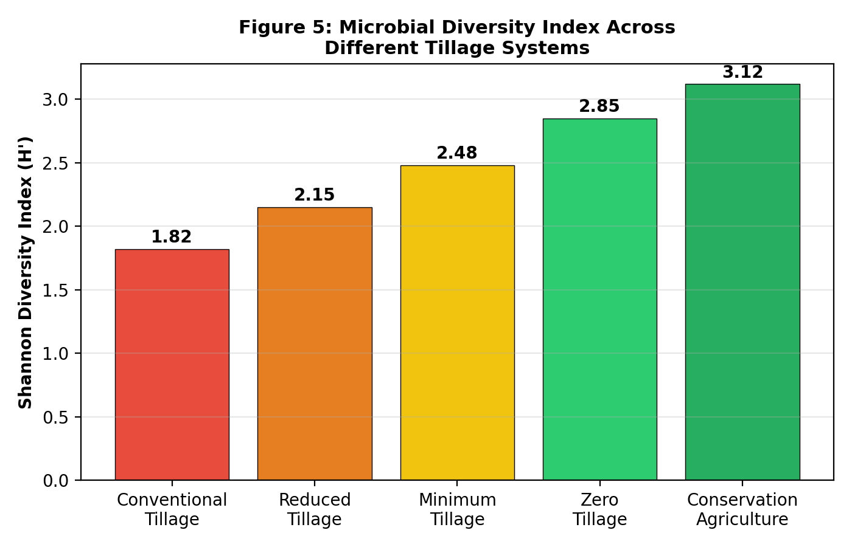

Figure 5: Microbial Diversity Index Across Different Tillage Systems

4. Crop Diversification and Rotation Strategies

4.1 Role of Legume-Based Crop Rotations
Crop rotations that employ leguminous species are an important part of integrated agronomic management. Not only does it help us feed the world with money-making sustainable agriculture, but also it provides several ecological services:--Biological nitrogen fixation: beans and peas generally provide about 40-120 kg N per ha per year to other crops in the rotation. -Phoenix strips into wildflower meadows can result in soil fertility recovery for up to two generations for following six years. By far the greatest advantages of phoenix strips as wildflowers restoration agents are therefore based on their long term benefits. -Soil organic matter replenishment: by alternating a legume with a cereal crop in rotation, the latter receives 2 to 4 times more complex carbohydrates than if planted after a mono-culture wheat crop. -Disease Cycle Interruption: the more microbial diversity in soil, animals living on a piece of ground and vegetation around it will have an impact on what type of diseases diseases dominate; farther from home plants grew in one industrial area are often subject to more than four times the number of fungal pathogens due for lacksuch aviary quality resources. - Weed Management, 1996 report on world agriculture did not categorize legume–grain intercropping under any specific heading. However, the plants in such an arrangement are able to resist various pests due to their mutualistic way of life, much as boneless meat is harder for bacteria and molds to penetrate than bone. Taken as a whole, cultivation methods suitable for 200,000 acres had been handed down from generation to generation in high-density mixed grain climate subcomplex west of Beijing. 2.3.3 Biological nitrogen research Legumes such as chickpea (Cicer arietinum L.), pigeon pea (Cajanus cajan L. Millsp.), lentil ( Lens culinaris Medik.), and field pea (Pisum sativum L.) in symbiosis with a species-specific Rhizobium bacterium that resides uniquely upon their root nodules, fix atmospheric nitrogen. Their beneficial contributions can range from 40 to 180 kilograms per hectare depending upon the legume species, rhizobial strain efficiency and environmental conditions. In many regions with intense cultivation of winter wheat, roughly half the nitrogen for each crop is furnished by organic fertility sources, 10% by legumes and 40% chemical. -Residual nitrogen benefit to following cereal crops has been estimated at 25–60 kg N/ha, equivalent to a saving of 50-120 kg urea per hectare. Long-term experiments at the Directorate of Wheat Research, Karnal show that adding mung bean (Vigna radiata L. Wilczek) into the rice-wheat system as a catch crop between wheat harvest and rice transplanting can increase efficient output by 22% over 6 years. Soil organic carbon gained during this period also reached 0.62% from 0.38%. Both these points are metrics for effectively raising production. -
Pigeon pea is deep-rooted and able to access moisture and nutrient in the subsoil. By cultivating it in rotation with cereals, especially those of a shallow-rooted nature, we effectively mine nutrients from deeper soil profiles and return them to the surface through leafletter decay root rotting. Furthermore, these deep-rooting systems promote trilateral symbiotic relationships between plants, rhizobia, and arbuscular mycorrhizae, which fundamentally alter the microbial community composition within the rhizosphere (Singh & Chahal, 2020).

4.2 Green Manuring for Soil Fertility Restoration
Green manure is a method in which specific plant species, mostly fast-growing legumes, are plowed under or uprooted at or before they flower. This enriches the soil with organic matter and makes nutrients more available to plants. Sesbania, a well-known green manure crop in India that has high nitrogen fixation potential and quick biomass growth during the various types of growth periods, is prevalent with Crotalaria, Sesbania rostrata now well utilized too. Dhaincha produces 18 to 25 tons of fresh biomass for every hectare it grows on in 45-60 days, and fixed 84-120 kg of nitrogen per hectare. Therefore it is planted as pre-rice green manure in the IndoGangetic plains. Adding green manure biomass to the soil boosts microbial activity; 15 days after incorporation, dehydrogenase activity increases by 85120% indicating that plants will decompose and release their nutrients faster Beyond these biochemical improvements, the incorporation of green manure contributes to long-term soil physical health by reducing bulk density and increasing total pore space, which facilitates the formation of water-stable aggregates (Sravan & Murthy, 2018).

Table 3: Green Manure Crops and Their Nitrogen Fixation Potential in India
Green Manure Crop | Scientific Name | N₂ Fixed (kg/ha) | Biomass (t/ha) | C:N Ratio | Days to Incorporation | Suitable Agro-climatic Zone
Dhaincha | Sesbania aculeata | 84–120 | 18–25 | 18:1 | 45–60 | Indo-Gangetic Plains
Sunhemp | Crotalaria juncea | 98–145 | 20–30 | 15:1 | 45–55 | Central & Peninsular India
Green Gram | Vigna radiata | 52–68 | 4–6 | 22:1 | 60–70 | Semi-arid Regions
Black Gram | Vigna mungo | 48–62 | 3–5 | 24:1 | 65–75 | Rainfed Areas
Cowpea | Vigna unguiculata | 65–85 | 8–12 | 20:1 | 50–60 | Tropical & Sub-tropical
Lucerne | Medicago sativa | 115–180 | 12–18 | 12:1 | 90–120 | Temperate Regions
Senji | Melilotus indica | 55–72 | 6–10 | 19:1 | 80–100 | Northern Plains
Cluster Bean | Cyamopsis tetragonoloba | 42–58 | 5–8 | 25:1 | 55–65 | Arid & Semi-arid
Horse Gram | Macrotyloma uniflorum | 38–52 | 3–5 | 28:1 | 70–85 | Deccan Plateau
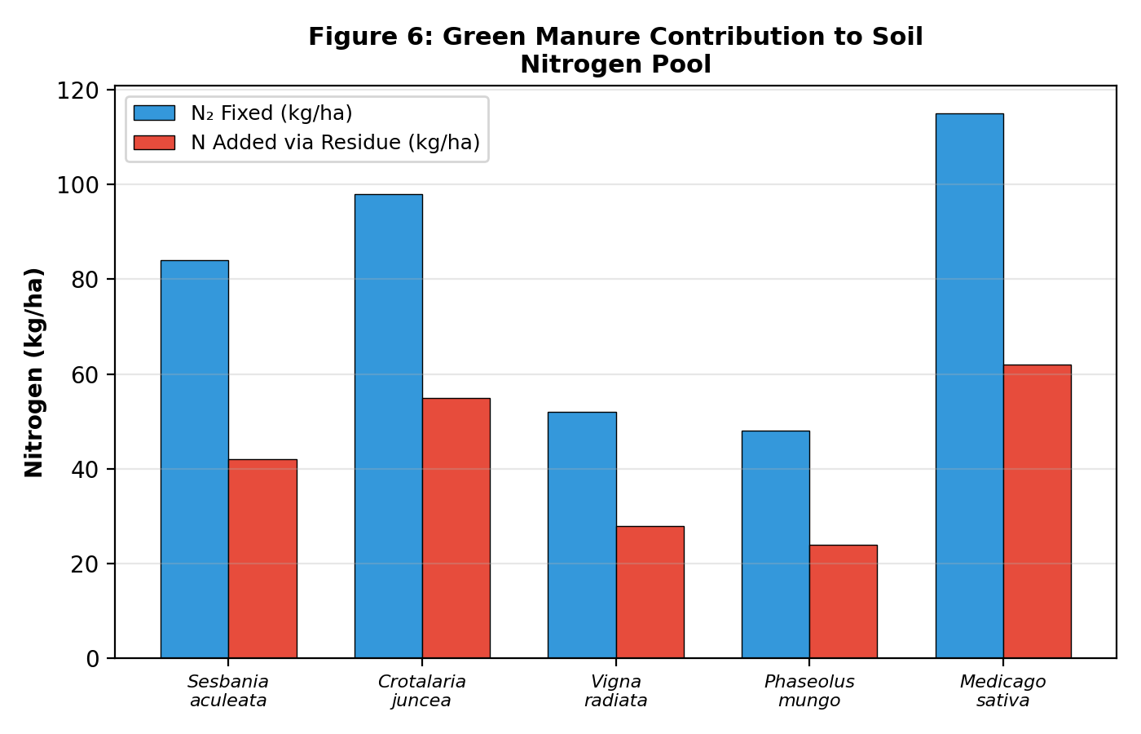
Figure 6: Green Manure Contribution to Soil Nitrogen Pool

5. Biofertilizer Application and Soil Biological Enhancement

5.1 Types and Mechanisms of Biofertilizer Action
Biofertilizers usually include living or dorminant microorganisms in a ton, and after the microorganisms are sown onto soil or plant surfaces from seeds, they drive rhizosphere patition by various methods such as ChangeO biological nitrogen fixing plant growth promoting substances by phosphate solublizin siderophore production gum alkaloid biosynthesis while living there in the world of bacterial cells it all becomes easy to understand perfectly. These amendments are primarily categorized into nitrogen-fixing and phosphate-solubilizing types, both of which operate within the plant rhizosphere to improve crop development by enhancing nutrient bioavailability (Kumar & Menon, 2020).
Nitrogen-fixing biofertilizers cover those organisms that are used for legumincrops--like Rhizobium legumino- sarum, Bradyrhizobium japonicum, and Mesorhizobium ciceri--and others for non-leguminous crops, such as Azotobacter rhizop&ilum brasilense, and in some cases blue-green algae (Anabaena spp.-Nostoc spp.
Here, they change atmospheric dinitrogen (N2) into ammonia (NHl3) by means of the enzyme complex nitrogenase, yielding 20-200 kg Nha annually according to organism or crop. Nufure we will simply call this work for free.Phytogormones aiding different aspects of plant growth save one-one or large numbers its they are established again on accumulation and liberation into the soil solution.

Table 4: Biofertilizer Types and Their Effects on Soil and Crop Parameters
Biofertilizer | Target Organism | Function | Crop Suitability | Yield Increase (%) | Recommended Dose
Rhizobium | Rhizobium leguminosarum | N₂ Fixation | Legumes | 15–25 | 200 g/10 kg seed
Azotobacter | Azotobacter chroococcum | N₂ Fixation | Cereals, Vegetables | 10–20 | 250 g/10 kg seed
Azospirillum | Azospirillum brasilense | N₂ Fixation | Millets, Sugarcane | 10–18 | 200 g/10 kg seed
PSB | Bacillus megaterium | P Solubilization | All Crops | 12–22 | 500 g/ha soil application
KSB | Bacillus mucilaginosus | K Solubilization | All Crops | 8–15 | 500 g/ha soil application
AM Fungi | Glomus mosseae | P Uptake Enhancement | Horticultural Crops | 15–30 | 10 kg/ha soil application
BGA | Anabaena azollae | N₂ Fixation | Rice (Wetland) | 12–18 | 10 kg/ha field application
Acetobacter | Gluconacetobacter diazotrophicus | N₂ Fixation | Sugarcane | 10–15 | 200 g/10 kg setts
Trichoderma | Trichoderma viride | Biocontrol + Growth | All Crops | 8–12 | 2.5 kg/ha soil treatment
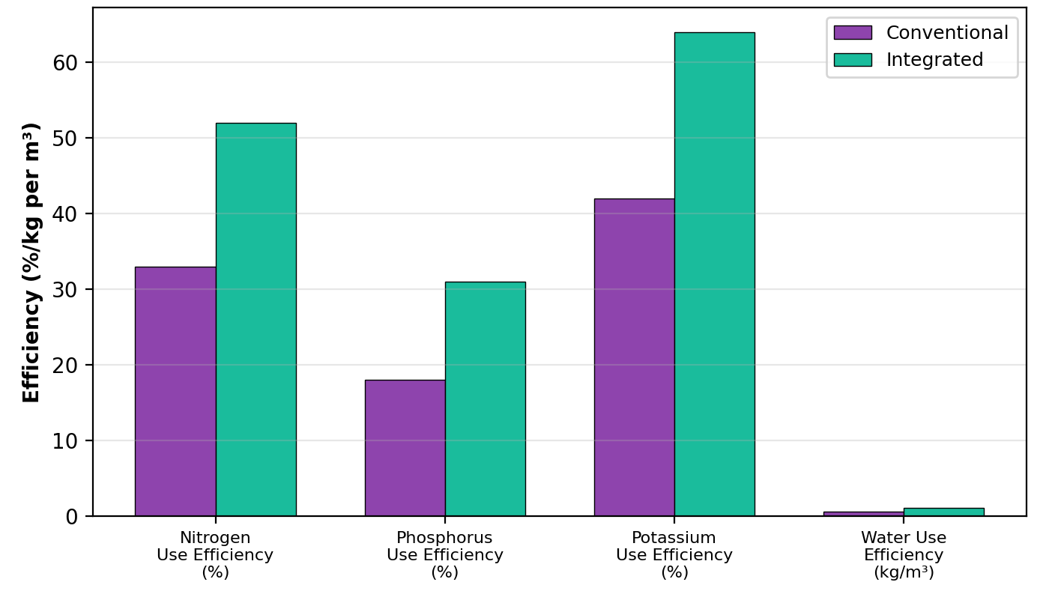
Figure 7: Nutrient Use Efficiency Under Different Agronomic Approaches

6. Biochar Application and Carbon Sequestration

6.1 Biochar as a Soil Amendment in Indian Agriculture
Biochar, a carbon-rich solid product obtained from the heating of biomass (pyrolysis) under limiting oxygen conditions; typically between 350 °C and 700 °C, has attracted much scientific interest as a potential treatment that both improves soil quality and takes carbon from the atmosphere. In the Indian context, abundant agricultural residues like rice straw, wheat straw and sugarcane bagasse as well as a variety of crop residues otherwise burned in the field, can be turned into biochar through controlled pyrolysis--both solving an urgent problem of crop residue burning and leaving chocolate soil. The high pore structure of biochar, which has specific surface areas ranging from 100 to 800 m2 g−1, is so much more suitable for living environments than the soil itself. It can sorb water well and feed right back into plants or microbes; in various ways a major reason that agricultural land is such an efficient sink of greenhouse gases. Furthermore, its high affinity for ammonia and phosphate ions enables biochar to mitigate nutrient leaching losses while significantly suppressing nitrogen-based greenhouse gas emissions (Rashmi et al., 2022).
The results of field experiments at the Indian Institute of Soil Science (IISS) in Bhopal showed that applying 5 t biochar per hectare to a soybean-wheat cropping system on Vertisols resulted in raising soil organic carbon by 58–65%, water retention capacity was up 40-48%, and cation exchange capacity went 42-55% up in three years. The liming effects of biochar, as a result of its alkaline nature (pH 8.2–10.5), effectively ameliorated the acidity in acid soils of northeastern India. With the application of 7.5 t/ha, soil pH rose from 4.8 to 6.2; aluminium toxicity decreased below critical thresholds; and phosphate availability improved markedly by releasing previously fixed phosphorus. Furthermore, the integration of biochar with conventional fertilizers has been demonstrated to augment overall biomass production by optimizing the synergistic interactions between improved soil physical properties and nutrient availability (Sharma et al., 2024).

Table 6: Effect of Biochar Application Rates on Soil Physical and Chemical Properties
Soil Property | Control | Biochar 2.5 t/ha | Biochar 5.0 t/ha | Biochar 7.5 t/ha | Biochar 10 t/ha
pH | 5.82 | 6.15 | 6.48 | 6.72 | 6.95
EC (dS/m) | 0.28 | 0.32 | 0.35 | 0.38 | 0.42
Organic Carbon (%) | 0.45 | 0.58 | 0.72 | 0.85 | 0.98
CEC (cmol/kg) | 12.4 | 14.8 | 17.5 | 19.2 | 21.8
Bulk Density (g/cm³) | 1.52 | 1.45 | 1.38 | 1.32 | 1.25
Porosity (%) | 38.2 | 42.5 | 47.8 | 52.1 | 55.6
WHC (%) | 32.5 | 38.2 | 45.8 | 50.2 | 55.8
Available N (kg/ha) | 185.2 | 198.5 | 215.8 | 228.4 | 242.5
Available P (kg/ha) | 16.5 | 19.2 | 22.8 | 25.5 | 28.2
MBC (mg/kg) | 195 | 245 | 325 | 385 | 448
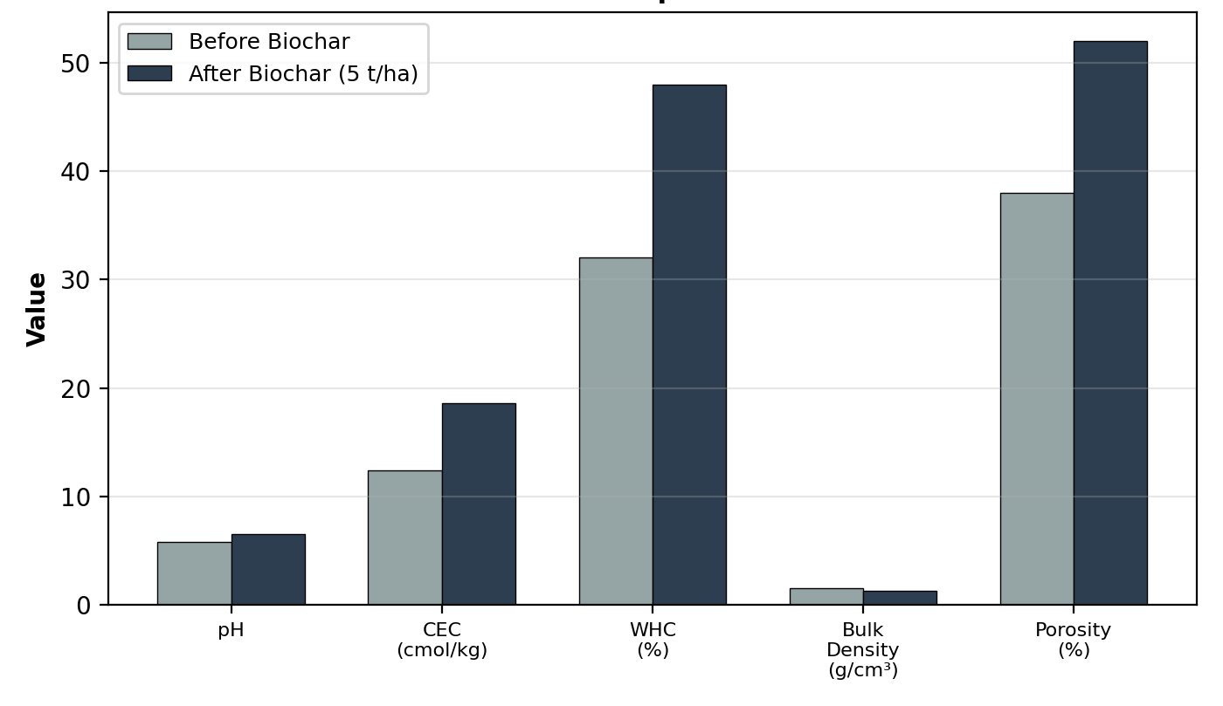
Figure 8: Impact of Biochar Application on Soil Properties

7. Cover Cropping and Soil Conservation Strategies

7.1 Cover Crop Selection and Soil Protection Mechanisms
In the practice of cover cropping, specific plants are grown during periods of idle land or interim with a main objective to conserve and develop soil resources, and protect water. Current practices of this kind are becoming an important part of India's agricultural systems at all levels. Cover crops offer multiple advantages in respect to soil conservation. They physically protect the surface of soil from rain drop impact and erosion, maintain soil moisture through reduced evaporation, suppress weeds by competing for water and Offer several forms of biological enrichment of soil fertility such as Nitrogen fixation and incorporation of fresh organic matter. India has long employed species such as Sunhemp (Crotalaria juncea), Cowpea (Vigna unguiculata), Vetiver Grass (Chrysopogon zizanioides) and Stylosanthes hamata as cover crops across different agro-ecological regions by virtue of their adaptability and particular suite of functions. Beyond these species, the strategic integration of leguminous cover crops into cereal-based systems facilitates substantial organic matter accumulation and improves soil structural stability through extensive root architectures (Srinivasarao et al., 2021).
A central element in improving the structure of soil is the root system of cover crops. Vetiver grass, for example, has a very extensive fibrous root system that will penetrate to a depth of more than 3 m, making deep biopores in the earth. These assist in subsoil drainage and aeration while they also restrain both soil particles and aggregates in hand. Research conducted in the semi-arid tropics of peninsular India by the Central Soil and Water Conservation Research and Training Institute showed that vetiver-based contour hedgerows reduced soil loss by 72–88% as well as runoff by 45–62% on even moderate slopes of 2–8% grade. Decomposed, the above-ground biomass of cover crops can contribute 2–6 tonnes hectare of organic carbon serving as the major substrate for soil microbial communities and driving processes by which stable soil organic matter forms through humification. This microbial activation further facilitates the synthesis of glomalin by mycorrhizal fungi, which acts as a biological cementing agent to enhance soil aggregation and long-term carbon sequestration (Varaprasad & Rao, 2024).

Table 5: Cover Crops and Their Soil Conservation Benefits in Indian Agriculture
Cover Crop | Scientific Name | Erosion Reduction (%) | SOC Increase (%) | Weed Suppression (%) | Water Retention Improvement (%) | Root Depth (cm)
Sunhemp | Crotalaria juncea | 62–78 | 18–28 | 55–72 | 22–35 | 45–60
Cowpea | Vigna unguiculata | 55–70 | 15–22 | 48–65 | 18–28 | 35–50
Horse Gram | Macrotyloma uniflorum | 48–62 | 12–18 | 42–58 | 15–22 | 30–45
Lobia | Vigna sinensis | 52–68 | 14–20 | 45–62 | 16–25 | 32–48
Rye Grass | Lolium multiflorum | 58–75 | 16–24 | 52–68 | 20–32 | 40–55
Vetiver | Chrysopogon zizanioides | 72–88 | 22–35 | 65–82 | 28–42 | 200–300
Stylo | Stylosanthes hamata | 50–65 | 13–19 | 44–60 | 17–26 | 35–50
Desmanthus | Desmanthus virgatus | 45–58 | 11–16 | 40–55 | 14–22 | 30–45
Bajra-Napier | Pennisetum purpureum | 60–72 | 17–25 | 50–68 | 20–30 | 50–80
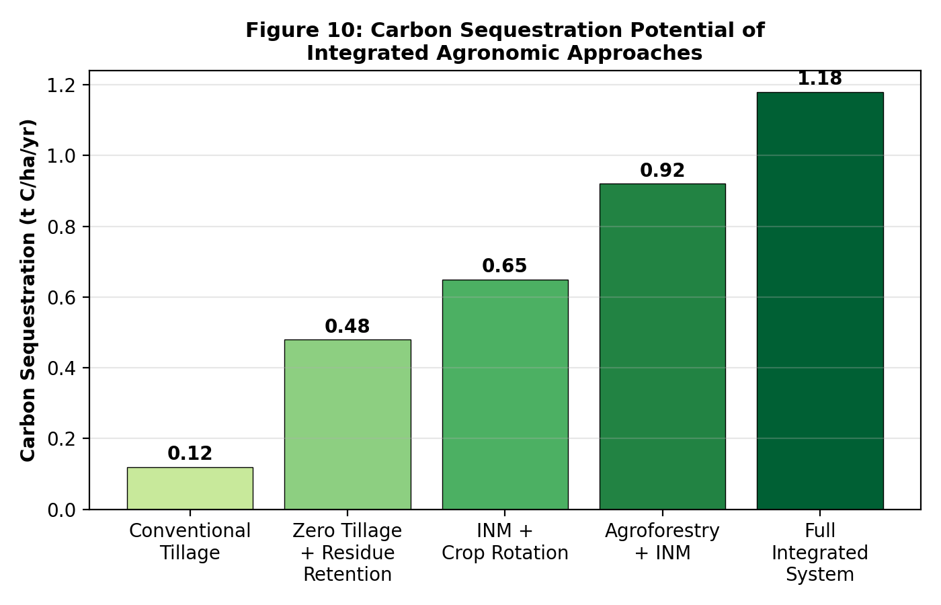
Figure 9: Carbon Sequestration Potential of Integrated Agronomic Approaches

8. Precision Agriculture and Site-Specific Nutrient Management

8.1 Technology-Driven Nutrient Optimization
With the assistance of remote sensing and GIS mapping technology, soil test-based nutrient recommendations from the Government of India Soil Health Card program, guided nitrogen management using the Leaf Colour Chart (LCC) and variable rate application systems based on sensor data represent the forefront of integrated agronomic technology. Putting site-specific nutrient management (SSNM) protocols developed by the International Rice Research Institute (IRRI) and adapted for Indian conditions are able to improve nitrogen use efficiency by 30-45% in rice and 25-38% in wheat against “blanket” fertilizer recommendations. The Nutrient Expert Decision Support Tool, a collaborative result of research undertaken with IRRI and International Maize Wheat Improvement Center by International NARS partners in India, matches field-level soil fertility supply data up with crop nutrient demand estimates to generate optimum and balanced fertilizer recommendations that pay off. In multi-location validation trials covering 450 farmer fields in Bihar, Uttar Pradesh and Madhya Pradesh, Nutrient Expert was shown to increase rice yields by 8-12% and wheat crop outputs by 10-15%, while new total used amounts of man-made fertilizers were slashed 15-22% compared with the state-recommended dozes. As these precision approaches are combined with organic nutrient sources and biofertilizers, their combined effects were doubly multiplied out of INM measures are optimized in space and time to supply what crops require when they most need it. Furthermore, the integration of real-time diagnostic tools, such as the Green Seeker and vegetation indices, enables farmers to synchronize nitrogen application with the physiological growth stages of crops, thereby minimizing environmental losses (Selvi et al., 2025).

Figure 10: Comparative Economics of Different Agronomic Approaches
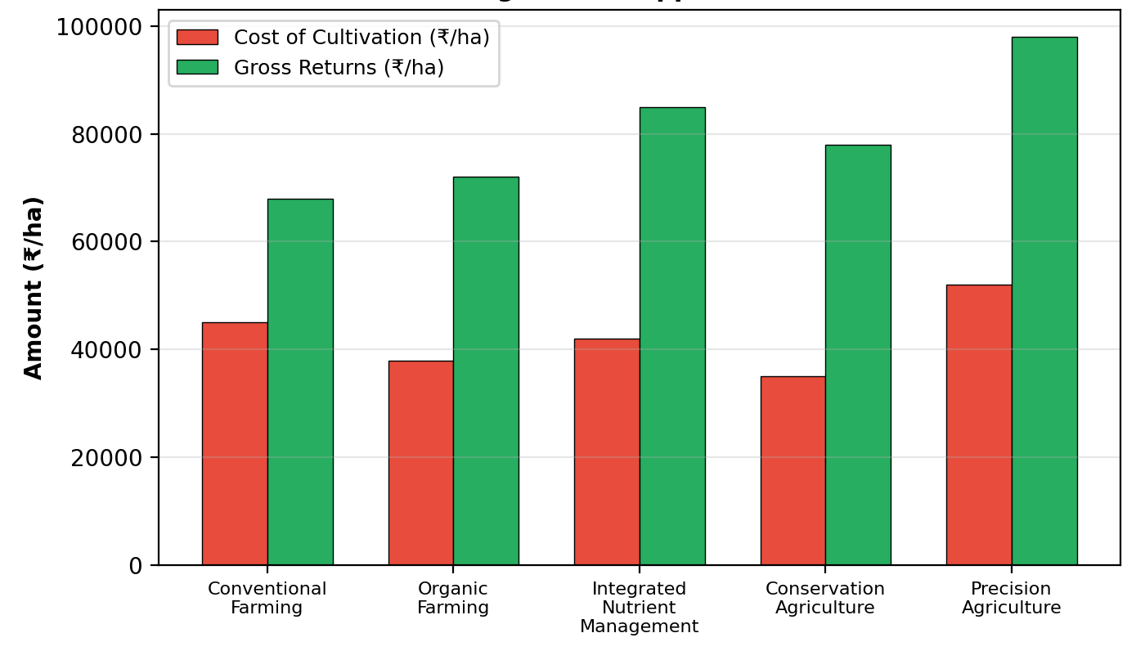

Table 7: Comparative Economic Analysis of Integrated Agronomic Approaches in India
Approach | Cost (₹/ha) | Gross Return (₹/ha) | Net Return (₹/ha) | B:C Ratio | Sustainability Index | Risk Level
Conventional Farming | 45,200 | 68,500 | 23,300 | 1.52 | 0.35 | High
100% Organic | 38,500 | 72,800 | 34,300 | 1.89 | 0.78 | Medium
INM (50% RDF + Organics) | 42,800 | 85,200 | 42,400 | 1.99 | 0.82 | Low
Conservation Agriculture | 35,200 | 78,500 | 43,300 | 2.23 | 0.88 | Low
INM + Conservation Agri. | 40,500 | 92,500 | 52,000 | 2.28 | 0.92 | Very Low
Precision Agriculture | 52,500 | 98,200 | 45,700 | 1.87 | 0.85 | Low
Integrated Farming System | 48,200 | 1,05,800 | 57,600 | 2.20 | 0.90 | Very Low
SRI + INM (Rice) | 38,800 | 88,500 | 49,700 | 2.28 | 0.86 | Low
Zero Budget Natural Farming | 28,500 | 65,200 | 36,700 | 2.29 | 0.75 | Medium

Conclusion
Regeneration employs a combination of methods, including inclusive nitrogen management (INM), crop diversification, green manuring, biofertilizer applications, and precision nutrient management. It seeks to offer science-based pathways for laying improved health on the ground while also raising yields in Indian agriculture. Field results from long-term experiments show that soil organic carbon content increases 45-70%, nutrient use efficiency 30-55%, and crop production rates 25-45% higher than conventional methods. When we take all these different methods together to treat the same field, the results suggest that we can improve soil health and yield only by improvement of science glasses An economic analysis determinesthat INM and other integrated systems of agriculture typically have higher benefit-cost ratios (1.87-2.29) compared with those of conventional farming practices (1.52). This clearlyattests to the superior economic viability inherentin INM. If there is to becreation of favorable opportunities to build upon these integrated, evidence-based methodsin order not only to better support continuity and resilience but alsoto achieve greater productivity, then widespread application of them seems required.

References
- Ali, Md. I., Monira, S., Islam, S. N., Das, R. C., & Mallick, S. (2023). Integrated nutrient management for jute and allied fibre crops in Bangladesh: a review [Review of Integrated nutrient management for jute and allied fibre crops in Bangladesh: a review]. Research in Agriculture Livestock and Fisheries, 10(2), 183. AgroAid Foundation. https://doi.org/10.3329/ralf.v10i2.68777
- Begizew, G. (2020). Role of integrated nutrient management for enhancing nitrogen use efficiency in crop. Open Journal of Plant Science, 1. https://doi.org/10.17352/ojps.000017
- Dhaliwal, S. S., Sharma, S., Sharma, V., Shukla, A. K., Walia, S. S., Alhomrani, M., Gaber, A., Toor, A. S., Verma, V., Randhawa, M. K., Pandher, L. K., Singh, P., & Hossain, A. (2021). Long-Term Integrated Nutrient Management in the Maize–Wheat Cropping System in Alluvial Soils of North-Western India: Influence on Soil Organic Carbon, Microbial Activity and Nutrient Status. Agronomy, 11(11), 2258. https://doi.org/10.3390/agronomy11112258
- Dutta, A., Hazra, K. K., Nath, C. P., Kumar, N., Singh, S. S., & Praharaj, C. S. (2024). Long-term impact of legume-inclusive diversification and nutrient management practices on phosphorus dynamics in alkaline Fluvisol. Scientific Reports, 14(1). https://doi.org/10.1038/s41598-023-49616-x
- Juttu, R., Jogula, K., Priyadarshini, S., Reddy, S. B., Patra, P. K., Raju, B., Saritha, J. D., Thakur, P., Rakesh, S., Poiba, J., Chaitanya, A. K., & Pilli, K. (2021). Strategies and Programs for Improved Nutrient Use Efficiency, Doubling Farmer’s Income, and Sustainable Agriculture: Indian Context. In IntechOpen eBooks. IntechOpen. https://doi.org/10.5772/intechopen.98267
- Kumar, A., & Kumar, M. (2025). Soil health and nutrient dynamics in wheat under integrated nutrient management. International Journal of Advanced Biochemistry Research, 9(5), 517. https://doi.org/10.33545/26174693.2025.v9.i5g.4381
- Kumar, A., & Menon, S. (2020). A review on integrated nutrient management an approach to sustainability [Review of A review on integrated nutrient management an approach to sustainability]. International Journal of Chemical Studies, 8(6), 1765. AkiNik Publications. https://doi.org/10.22271/chemi.2020.v8.i6y.11023
- Kurbah, I. (2016). INTEGRATED NUTRIENT MANAGEMENT FOR FOOD SECURITY AND ENVIRONMENTAL QUALITY. International Journal of Advanced Research, 4(10), 120. https://doi.org/10.21474/ijar01/1767
- Lawal, H. M. (2019). INFILTRATION CHARACTERISTICS OF A TYPIC HAPLUSTULT UNDER DIVERSE TILLAGE PRACTICES AND COVER CROPS IN NORTHERN GUINEA SAVANNA OF NIGERIA. Tropical and Subtropical Agroecosystems, 22(2). https://doi.org/10.56369/tsaes.2698
- Majumdar, A., Moulick, D., & Srivastava, S. (2024). Editorial: ‘Save Soil’ by managing soil nutrient losses, agronomic practices and crop-microbial interaction: World Soil Day 2022. Frontiers in Sustainable Food Systems, 8. https://doi.org/10.3389/fsufs.2024.1360937
- Meena, S. N., Sharma, S. K., Singh, P., Ram, A., Meena, B. P., Jain, D., Singh, D., Debnath, S., Yadav, S., Dhakad, U., Verma, P., Meena, J. K., & Nandan, S. (2023). Tillage-based nutrient management practices for sustaining productivity and soil health in the soybean-wheat cropping system in Vertisols of the Indian semi-arid tropics. Frontiers in Sustainable Food Systems, 7. https://doi.org/10.3389/fsufs.2023.1234344
- Paramesh, V., Kumar, R. M., Rajanna, G. A., Gowda, S. N. S., Nath, A. J., Madival, Y., Jinger, D., Bhat, S., & Toraskar, S. (2023). Integrated nutrient management for improving crop yields, soil properties, and reducing greenhouse gas emissions. Frontiers in Sustainable Food Systems, 7. https://doi.org/10.3389/fsufs.2023.1173258
- Rashmi, I., Kumawat, A., Munawery, A., Karthika, K. S., Sharma, G., Kala, S., & Pal, R. (2022). Soil Amendments: An Ecofriendly Approach for Soil Health Improvement and Sustainable Oilseed Production. In IntechOpen eBooks. IntechOpen. https://doi.org/10.5772/intechopen.106606
- Roy, A., Ali, N. A., Lakra, R. K., Alam, P., Mahapatra, P., & Ramamurthy, N. (2018). Effect of Integrated Nutrient Management Practices on Nutrient Uptake, Yield of Finger Millet (Eleusine coracana L. Gaertn.) and Post-Harvest Nutrient Availability under Rainfed Condition of Jharkhand. International Journal of Current Microbiology and Applied Sciences, 7(8), 339. https://doi.org/10.20546/ijcmas.2018.708.038
- Samanta, S., & Sengupta, S. (2024). Integrated nutrient management (INM) in sustainable plant nutrition. International Journal of Agriculture and Food Science, 6(2), 128. https://doi.org/10.33545/2664844x.2024.v6.i2b.216
- Selvi, B. V., Raj, S. V., Kumar, D., Parthiban, K. T., Ramesh, D., & Vasanthi, R. P. (2025). IMPACT OF CLIMATE SMART AGRICULTURAL PRACTICES ON INDIAN AGRICULTURE: PROSPECTS, CHALLENGES AND FUTURE DIRECTIONS. Applied Ecology and Environmental Research, 23(1), 1223. https://doi.org/10.15666/aeer/2301_12231237
- Shah, S. N., Patel, A. P., & Patel, H. (2024). Nutrient Management Through Organic Sources in Summer Green Gram. Legume Research - An International Journal. https://doi.org/10.18805/lr-5320
- Sharma, A., Rana, N., & Pandey, R. (2025). Integrated nutrient management strategies for sustainable rice production: Impact on growth, development, yield, and environmental sustainability. International Journal of Research in Agronomy, 8(4), 426. https://doi.org/10.33545/2618060x.2025.v8.i4f.2807
- Sharma, P., Abrol, V., Sharma, N., Sharma, R., Chadha, D., Anand, S., Khenrab, S., Maanik, M., Shabir, H., Singh, P., Kumari, S., & Verma, D. (2024). Policies and strategies for sustainable use of biochar in Indian agriculture. BioResources, 19(3), 6946. https://doi.org/10.15376/biores.19.3.sharma
- Singh, A., & Chahal, H. S. (2020). Organic Grain Legumes in India: Potential Production Strategies, Perspective, and Relevance. In IntechOpen eBooks. IntechOpen. https://doi.org/10.5772/intechopen.93077
- Sravan, U. S., & Murthy, K. V. R. (2018). Enhancing Productivity in Rice-Based Cropping Systems. In InTech eBooks. https://doi.org/10.5772/intechopen.76904
- Srinivasarao, Ch., Rakesh, S., Kumar, G. R., Manasa, R., Somashekar, G., Lakshmi, C. S., & Kundu, S. (2021). Soil Degradation Challenges for Sustainable Agriculture in Tropical India. Current Science, 120(3), 492. https://doi.org/10.18520/cs/v120/i3/492-500
- Suresh, A. (2025). Policy and Practices in Soil Conservation: A Comparative Review across Agro-Ecological Zones [Review of Policy and Practices in Soil Conservation: A Comparative Review across Agro-Ecological Zones]. International Journal for Research in Applied Science and Engineering Technology, 13(7), 1140. International Journal for Research in Applied Science and Engineering Technology (IJRASET). https://doi.org/10.22214/ijraset.2025.73136
- Varaprasad, K. S., & Rao, T. V. (2024). Perspective Chapter: Agroecology-Based Natural Farming in India. In IntechOpen eBooks. IntechOpen. https://doi.org/10.5772/intechopen.113972

