Original Research Article
Design and Biological Potential of New 6-Aryl-2-(4-(1,3-dioxoisoindolin-2-yl)phenyl)imidazo(2,1-b)1,3,4-thiadiazoles: Synthesis and Molecular Docking Studies

Abstract
By cyclocondensing 4-(1,3-dioxoisoindolin-2-yl)benzoic acid with thiosemicarbazide to form a crucial intermediate and then reacting with different substituted phenacyl chlorides, a novel series of 6-aryl-2-(4-(1,3-dioxoisoindolin-2-yl)phenyl)imidazo(2,1-b)1,3,4-thiadiazoles (3a-3e). FTIR, ¹H NMR, ¹³C NMR and elemental analysis were used to confirm the chemical structures of these derivatives. Compound 3d demonstrated the greatest antifungal inhibition against Botryodiplodia theobromae, whereas compound 3e had the most reliable and strong antibacterial activity against both Gram-positive and Gram-negative strains, according to biological evaluation utilizing the Agar-Cup diffusion method. These experimental findings were corroborated by molecular docking investigations, which revealed significant binding affinities between -7.7 and -8.4 kcal/mol. With a docking score of -8.4 kcal/mol, compound 3a in particular showed the most stable interaction, establishing crucial connections with residues like ARG-52 and ARG-219(pdbid-1AD4). These results demonstrate the potential of an isoindoline moiety combined with the imidazo[2,1-b][1,3,4]thiadiazole scaffold as a promising template for the development of powerful antibacterial medicines.
Key-words: - 1,3,5-Thiadiazole, Phenyl acyl, Molecular-Docking, Antibacterial, Antifungal.
1.0 Introduction
More and more antibiotic-resistant microbial strains have been discovered in recent years. Infection with multidrug-resistant microbes is leading in increased mortality. Human health is becoming more and more threatened by the issue of microbial antibiotic resistance [1]. With every antimicrobial medication on the market for decades, antibiotic resistance has progressively become a global issue [2]. One effective strategy to address clinical drug resistance is the development of antibacterial medications with distinct chemical structures.
Thiosemicarbazides significance in the synthesis of various heterocycles is demonstrated by their use in organic synthesis. One way to generate physiologically active compounds, such as pyrazole, thiazole, triazole, thiadiazol, oxadiazole, triazine, and thiadiazine, is through their reactions with systems that include C=O and C=N groups. Their widespread utilization in the production of these heterocycles in high yields reflects the development of C−N and C=N bonds as opposed to N−N bond formation [3]. A significant class of five-membered heterocycle rings with nitrogen and sulfur, 1,3,4-thiadiazole has a wide range of biological activities, including antimicrobial [4], anti-inflammatory [5], antibacterial [6], insecticidal [7], and herbicidal [8]. Thiazoles are not carcinogenic and are readily broken down by normal metabolic processes [9]. Pyrazoles have also been described as anti-microbial [10], analgesic [11], anti-hypertensive [13], inflammatory [12], anti-depressant [14], and anticancer [15] agents. The aforementioned discovery led us to synthesize the title compounds (3a–e) with the assumption that thiosemicarbazide-based therapeutic intermediates with different phenyl acyl will provide new thiadiazole derivatives with strong biological activity. IR, ¹H NMR, and nitrogen estimates were used to establish their chemical structure. Using the paper disc diffusion technique, these compounds were tested for antibacterial activity against two gram +ve bacteria (Staphylococcus aureus, Bacillus Cereus) and two gram -ve bacteria (Escherichia coli, Pseudomonas aeruginosa) as well as antifungal activity (Aspergillus niger and Aspergillus fumigatus). It is frequently used in the fields of agricultural and pharmaceutical chemistry. We have synthesized many 2-Amino-5-(4-(1,3-dioxoisoindolin-2-yl)phenyl)-1,3,4- thiadiazole(1) and found that the introduction of phenyl, 4-methylphenyl, 4-methoxyphenyl, 4-chlorophenyl and 4-Nitrophenyl linkage can increase biological activity of synthesised compound. The molecular docking study is used to ascertain the probability that a ligand will bind to the dynamic site of a receptor. It creates a graphic representation of the dynamic site using interaction points, or grid. It then uses either grid search or energy search to fit the ligand in the binding site [16-17].
2.0 Experimental Section
2.1 Materials and Methods
All chemicals and reagents were of analytical grade and used without further purification. 4-(1,3-Dioxoisoindolin-2-yl)benzoic acid and thiosemicarbazide purchased from Sisco Research Laboratory pvt. Ltd Mumbai India. Substituted phenacyl chlorides also purchased from Sisco Research Laboratory pvt. Ltd Mumbai India. Melting points were determined in open capillary tubes and are uncorrected. FT-IR spectra were recorded using KBr pellets. ¹H and ¹³C NMR spectra were recorded in DMSO-d₆ using TMS as an internal standard. Elemental analyses (CHNS) were carried out and found values were within ±0.4% of the calculated values.
2.2 Synthesis of 2-Amino-5-(4-(1,3-dioxoisoindolin-2-yl)phenyl)-1,3,4-thiadiazole (1)
4-(1,3-dioxoisoindolin-2-yl)benzoic acid (0.01 mol) and thiosemicarbazide (0.01 mol) were thoroughly mixed with 25 mL of 100% ethanol in a round-bottom flask fitted with a reflux condenser. A few drops of strong sulfuric acid were carefully added to this reaction mixture as a catalyst to speed up the cyclization process. In order to maintain a consistent reaction temperature, the reaction mixture was then heated by reflux for 6 hours. This ensured that the solvent was continuously boiling and condensing. Thin-layer chromatography (TLC) with mobile phase ethyl acetate: n-hexane (7:3) was used to regularly monitor the reaction's progress in order to verify the consumption of starting materials and the product of the required intermediate. The reaction mixture was allowed to cool to room temperature after the reaction was finished, as shown by TLC, and then it was slowly added to ice-cold water while being continuously stirred. A solid substance precipitated as a result of this process. The resulting solid was collected using vacuum filtration, extensively cleaned with cold water to get rid of any remaining acid and contaminants, and then dried in a desiccator or at room temperature. Ultimately, the desired intermediate substance (Int-1) was obtained in pure form by recrystallizing the crude product from ethanol.
2.3 General Procedure for the Synthesis of Compounds (3a–e)
Absolute ethanol (20–30 mL) was used to dissolve a combination of 2-amino-5-[4-(1,3-dioxoisoindolin-2-yl)phenyl]-1,3,4-thiadiazole (1 equiv) and suitably substituted phenacyl bromide (1.1 equiv), such as 4-bromo, 4-hydroxy, 4-chloro, 4-fluoro and 4-nitro derivatives (2a-2e). For 5 hours, the reaction mixture was refluxed while being constantly stirred. Using ethyl acetate:n-hexane (7:3) as the mobile phase, thin-layer chromatography (TLC) was used to track the reaction's development. Following completion, the solid precipitate was filtered, cleaned with cold ethanol, and dried once the reaction liquid had cooled to room temperature. To obtain pure imidazo[2,1-b][1,3,4]thiadiazole derivatives (3a-3e), the crude product was further recrystallized from ethanol or ethanol–DMF combination.

Figure 1: General Reaction Mechanism
2.4 Computation Preparation
ChemBioDraw Ultra 12 was used to construct the structures of compounds 3a–5e. The Prepare Ligand technique in Discovery Studio was then used to create optimized 3D conformations with the proper bond ordering, ionization states, and canonical tautomers. The Protein Report, Clean Protein, and Prepare Protein protocols were used to fix bond ordering, standardize atom names, and protonate the proteins at pH 7.4 after the crystal structures of specific antibacterial targets were obtained from the Protein Data Bank. After minimizing energy and solvating the produced proteins in a TIP3P water box, the binding sites were determined using the co-crystallized ligands [18]. By redocking each co-crystallized ligand into its matching binding site and computing the RMSD between the docked and native postures, the docking process was verified. The CDOCKER methodology was then used with default parameters to dock the produced compounds into the designated binding sites. LigScore1, LigScore2, PLP1, PLP2, Jain, PMF, and PMF04 scoring functions were used to rescore the resulting docked postures. To determine the most likely antibacterial targets, a Pearson correlation analysis was conducted between docking scores and experimental MIC values[19].
3.0 Spectral Characterization
2-(4-(2-phenylimidazo[2,1-b][1,3,4]thiadiazol-6-yl)phenyl)isoindoline-1,3-dione (3a)
68.5% yield, brown colour solid compound with M.P > 280 ⁰C, 2-(4-(2-phenylimidazo[2,1-b][1,3,4]thiadiazol-6-yl)phenyl)isoindoline-1,3-dione exhibited FTIR bands at 3062 cm⁻¹ (Ar–H), 1776 and 1718 cm⁻¹ (imide C=O), and 1595 cm⁻¹ (C=N). The ¹H NMR (DMSO-d²) showed doublets at 7.62 and 7.42 ppm (para-phenyl), δ 8.12–7.25 (m, Ar–H), and 7.88 (s, imidazole–H). Signals at δ 167–164 (C=O), 154–150 (C=N), and 141–110 ppm (aromatic and heterocyclic carbons) were detected by the ¹³C NMR. For C₂₄H₁₄N₄O₂S, elemental analysis agreed with computed values (C, 70.58; H, 3.45; N, 13.72; S, 7.85). The suggested structure was confirmed by the mass spectrum, which showed m/z 409 [M+H]⁺ along with distinctive fragment peaks.
2-(4-fluorophenyl)-6-[4-(1,3-dioxoisoindolin-2-yl)phenyl]imidazo[2,1-b][1,3,4]thiadiazole (3b)
69.00 % yield, pale yellow colour solid compound with M.P > 278 ºC , the imidazo proton was represented by a singlet at δ 8.44 ppm in the ¹H NMR spectrum of 2-(4-fluorophenyl)-6-[4-(1,3-dioxoisoindolin-2-yl)phenyl]imidazo[2,1-b][1,3,4]thiadiazole in DMSO-d6, whereas the fluorophenyl, phenylene, and phthalimide rings appeared as doublets and multiplets in the δ 7.31–7.93 ppm. The ¹³C NMR spectra showed distinctive signals at δ 167.1 ppm for imide carbonyl carbons, δ 162.9 ppm for aromatic carbons substituted with C–F, and δ 116.0–143.3 ppm for aromatic and heterocyclic carbons. The molecular weight of the synthesized molecule was confirmed by the mass spectrum, which revealed a molecular ion peak at m/z 441 [M+H]⁺ matching to the molecular formula C₂₄H₁₃FN4O₂S. The suggested structure and purity of the compound were supported by elemental analysis values (C, 65.45; H, 2.98; N, 12.72; and S, 7.28) that closely matched the computed values.
2-(4-(2-(4-bromophenyl)imidazo[2,1-b][1,3,4]thiadiazol-6-yl)phenyl)isoindoline-1,3-dione (3c)
71.00 % yields, pale yellow solid compound with M.P > 286 ºC. ¹H NMR (DMSO d6) Signals were detected at δ 8.44 (s, 1H, imidazole-H), 7.92–7.93 (m, 4H, phthalimide aromatic protons), 7.86–7.87 (d, 2H, Ar–H, J = 7.5 Hz), 7.67 (d, 2H, Ar–H, J = 7.5 Hz), and 7.32 (d, 2H, Ar–H, J = 7.5 Hz). The formation of the intended heterocyclic scaffold was confirmed by the ¹³C NMR spectrum (75 MHz, DMSO-d6), which showed distinctive signals at δ 167.2 (C=O), 162.8, 149.5, 138.7, 135.9, 134.2, 132.8, 131.4, 129.7, 128.5, 127.9, 126.8, 124.6, 123.2, and aromatic carbons. The molecular weight of synthesized molecule was confirmed by the mass spectrum, which revealed a molecular ion peak at m/z 498 [M+H]⁺ matching to the molecular formula C₂₄H₁₃BrN₄O₂S. The suggested structure and purity of the compound were supported by elemental analysis values (C, 57.50; H, 2.61; N, 11.18; Br, 15.94 and S, 6.39) that closely matched the computed values.
2-(4-(2-(4-chlorophenyl)imidazo[2,1-b][1,3,4]thiadiazol-6-yl)phenyl)isoindoline-1,3-dione (3d)
69.00 % yields; light yellow compound with M. P > 265 ºC. NMR and mass spectral analysis were used to describe the synthesized molecule, 2-(4-(2-(4-chlorophenyl)imidazo[2,1-b][1,3,4]thiadiazol-6-yl)phenyl)isoindoline-1,3-dione, with molecular formula C₂₄H₁₃ClN₄O₂S and 1H NMR (DMSO-d6). Signals were detected at δ 8.44 (s, 1H, imidazole-H), 8.02 (d, 2H, Ar–H, J = 7.5 Hz), 7.92–7.93 (m, 4H, phthalimide aromatic protons), 7.87 (d, 2H, Ar–H, J = 7.5 Hz), 7.53 (d, 2H, Ar–H, J = 7.5 Hz), and 7.32 (d, 2H, Ar–H, J = 7.5 Hz). The ¹³C NMR spectra (75 MHz, DMSO-d6) at δ 167.1 (C=O), 143.3, 140.1, 136.2, 134.3, 132.7, 132.2, 132.0, 131.6, 129.4, 129.3, 128.9, 128.6, 127.7, 123.7, and 122.3 ppm, which correspond to carbonyl, heteroaromatic, and aromatic carbons. The molecular weight of the produced molecule was confirmed by the mass spectrum, which showed a molecular ion peak at m/z 456.04 [M+H]+. The suggested structure and purity of the compound were supported by elemental analysis values (C, 57.50; H, 2.61; N, 11.18; Br, 15.94 and S, 6.39) that closely
matched the computed values.
2-(4-(2-(4-nitrophenyl)imidazo[2,1-b][1,3,4]thiadiazol-6-yl)phenyl)isoindoline-1,3-dione (3e)
68.00 % yields; pale yellow compounds with M. P > 275 ºC. Mass spectrometry, elemental analysis, ¹H NMR, and ¹³C NMR were used to characterize the synthesized molecule, 2-(4-(2-(4-nitrophenyl)imidazo[2,1-b][1,3,4]thiadiazol-6-yl)phenyl)isoindoline-1,3-dione, with molecular formula C₂₄H₁₃N₅O₄S and molecular weight 467.46. Signals were detected at δ 8.44 (s, 1H, imidazole-H), 8.27 (d, 2H, Ar–H, J = 7.5 Hz), 8.03 (d, 2H, Ar–H, J = 7.5 Hz), 7.92–7.93 (m, 4H, phthalimide aromatic protons), 7.87 (d, 2H, Ar–H, J = 7.5 Hz), and 7.32 (d, 2H, Ar–H, J = 7.5 Hz). The ¹³C NMR spectra (75 MHz, DMSO-d6) showed distinctive peaks at δ 167.1 (C=O), 147.9, 143.3, 140.1, 139.6, 136.2, 132.7, 132.2, 132.0, 129.4, 128.6, 128.4, 127.7, 124.4, 123.7, and phenyl carbons. The suggested structure and purity of the compound were supported by elemental analysis values (C, 61.67; H, 2.80; N, 14.98; O, 13.69 and S, 6.86) that closely matched the computed values. The molecular weight of the produced molecule was confirmed by the mass spectrum, which showed a molecular ion peak at m/z 467.07 ([M+H]+.
Table 1 Melting point, %yield, Molecular formula and Molecular weight of Compounds 3a-3e
Compound | Melting point(⁰C) | Yield | Mol. Formula | Mol.wt
3a | >280 ºC | 68.5 % | C₂₄H₁₄N₄O₂S | 409
3b | >278 ºC | 69.00 % | C₂₄H₁₃FN₄O₂S | 441
3c | >286 ºC | 71.00 % | C₂₄H₁₃BrN₄O₂S | 498
3d | >265 ºC | 69.00 % | C₂₄H₁₃ClN₄O₂S | 456.04
3e | >275 ºC | 68.01 % | C₂₄H₁₃N₅O₄S | 467.07

3.1 Antibacterial and Antifungal Activity of Synthesised compound
Gram-positive bacteria (Staphylococcus aureus and Bacillus subtilis), Gram-negative bacteria (Escherichia coli and Pseudomonas aeuroginosa), and the yeast-like pathogenic fungus Candida albicans were among the standard strains against which the synthesized compounds were evaluated for their in vitro antimicrobial activity. the synthesized compounds (3a–3e) were evaluated against two Gram-positive bacteria, Bacillus subtilis and Staphylococcus aureus, and two Gram-negative bacteria, Klebsiella pneumoniae and Escherichia coli, using the zone of inhibition method (values in mm).
Compound 3a exhibited moderate activity with zones of inhibition of 12 mm against B. subtilis, 12 mm against S. aureus, 09 mm against K. pneumoniae, and 11 mm against E. coli.
Compound 3b showed 13 mm inhibition against B. subtilis, 09 mm against S. aureus, 12 mm against K. pneumoniae, and 13 mm against E. coli, indicating better activity against Gram-negative bacteria compared to Gram-positive strains. Compound 3c demonstrated zones of 14 mm against B. subtilis, 11 mm against S. aureus, 09 mm against K. pneumoniae, and 08 mm against E. coli, showing comparatively lower activity against Gram-negative organisms. Compound 3d displayed enhanced antibacterial activity with inhibition zones of 13 mm against B. subtilis, 13 mm against S. aureus, 13 mm against K. pneumoniae, and the highest observed value of 16 mm against E. coli, indicating broad-spectrum effectiveness. Compound 3e was found to be the most active derivative overall, showing 15 mm against B. subtilis, 14 mm against S. aureus, 15 mm against K. pneumoniae, and 14 mm against E. coli, demonstrating strong and consistent antibacterial activity against both Gram-positive and Gram-negative strains. Overall, among all synthesized compounds, 3e exhibited the highest and most consistent antibacterial potency, followed by 3d, while compounds 3a, 3b, and 3c showed moderate to variable activity. The results suggest that structural modification in compounds 3d and 3e significantly enhances antibacterial efficacy against both Gram-positive and Gram-negative bacterial strains.
Table-2 Antibacterial Activity of Compounds (3a-3e)
Comp.  No. | Zone of Inhibition(mm)
Comp.  No. | Gram +ve |  | Gram -ve
Comp.  No. | Bacillus  Subtilis | Staphylococcus  aureus | Klebsiella  pneumoniae | Escherichia coli
3a | 12 | 12 | 09 | 11
3b | 13 | 09 | 12 | 13
3c | 14 | 11 | 09 | 08
3d | 13 | 13 | 13 | 16
3e | 15 | 14 | 15 | 14

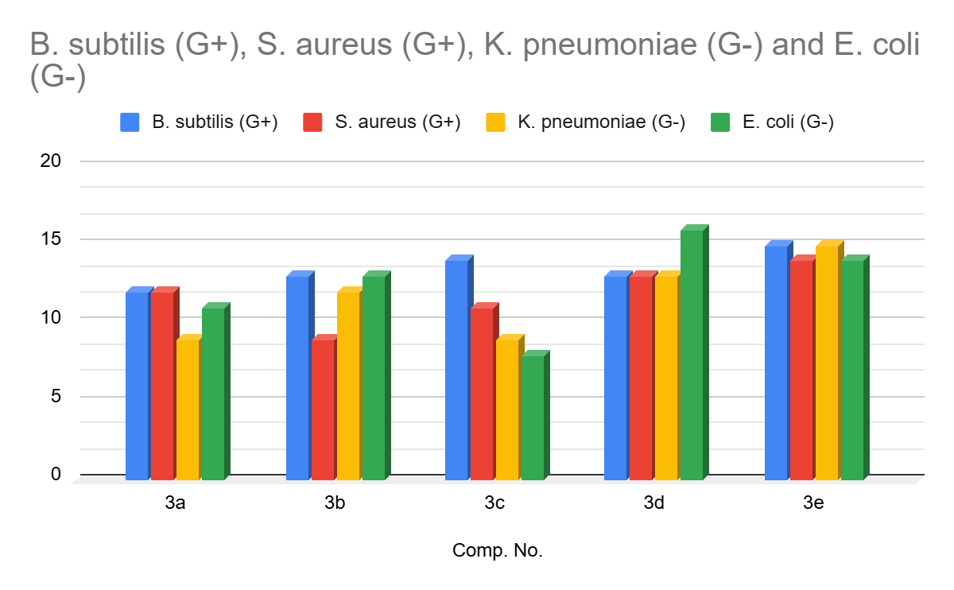
Figure 1 Comparison of Antibacterial activity of Synthesis compounds(3a-3e)
The antifungal activity of synthesized compounds (3a–3e) was evaluated at 1000 ppm against
four fungal strains: Botryodiplodia theobromae, Nigrospora sp., Penicillium expansum, and Rhizopus nigricans. The results demonstrated moderate to good inhibitory activity. Compound 3d exhibited the highest activity against Botryodiplodia theobromae with 73% inhibition, while compound 3b and 3e showed significant inhibition against Nigrospora (71%). Against Penicillium expansum, compound 3b showed maximum inhibition (69%), followed by 3e (67%). In the case of Rhizopus nigricans, compound 3a showed the highest inhibition (67%), whereas compound 3d displayed comparatively lower activity (54%). Overall, compounds 3b, 3d, and 3e demonstrated comparatively better antifungal potential among the tested derivatives

Table-3 Antifungal Activity of Compounds (3a-e)
Comp.  No. | Zone of Inhibition at 1000 ppm (%)
Comp.  No. | Botryodiplodia theobromae | Nigrospora | Penicillium expansum | Rhizopus nigricans
3a | 59 | 67 | 62 | 67
3b | 61 | 71 | 69 | 61
3c | 59 | 61 | 63 | 59
3d | 73 | 59 | 61 | 54
3e | 69 | 71 | 67 | 63

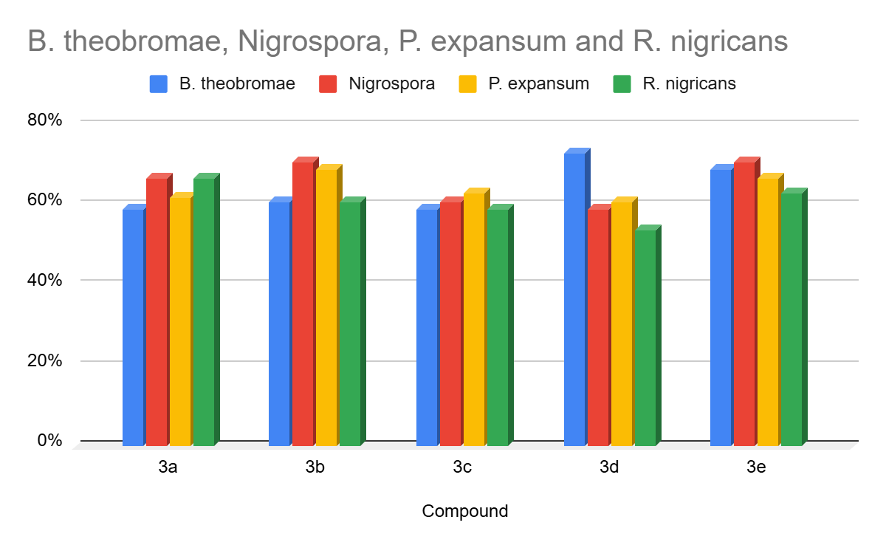
Figure 2 Comparison of Antifungal Activity of Synthesis compounds (3a-3e)
3.2 Molecular Docking
With docking scores ranging from -7.7 to -8.4 kcal/mol, the molecular docking study of compounds 3a–3e shows that all derivatives have a strong binding affinity toward the target protein. With a docking score of -8.4 kcal/mol, compound 3a showed the strongest interaction and the best stability among the assessed series, making it the most promising lead contender. Certain intermolecular interactions inside the active site, where compound 3a forms important contacts with amino acid residues including ARG-52, HIS-55, ARG-202, and ARG-219, facilitate this strong binding. The visualization notably demonstrates hydrogen bonding or tight interactions with ARG-219 at 2.3 Å and ARG-52 at 2.2 Å, which support the stability of the ligand-protein complex. growth.
Table 4 Molecular docking Score of synthesis compound 3a-3e

Compound | Docking Score (kcal/mol)
3a | -8.4
3b | -8.2
3c | -8.0
3d | -7.7
3e | -7.9

Compounds 3b through 3e also had competitive scores, but compound 3a's precise residue interactions and particular orientations support its position as the most potential therapeutic candidate for additional research.

3a
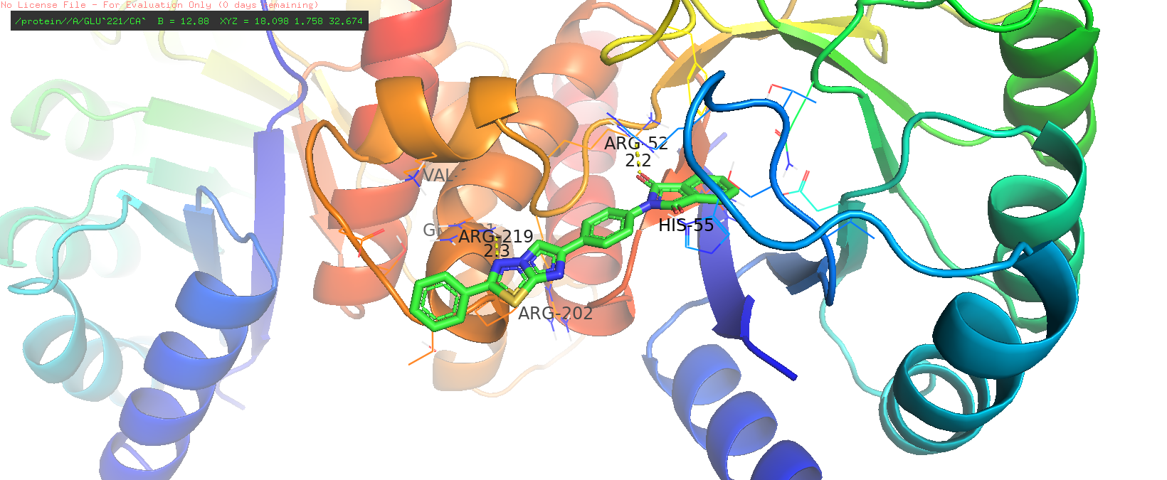
3a
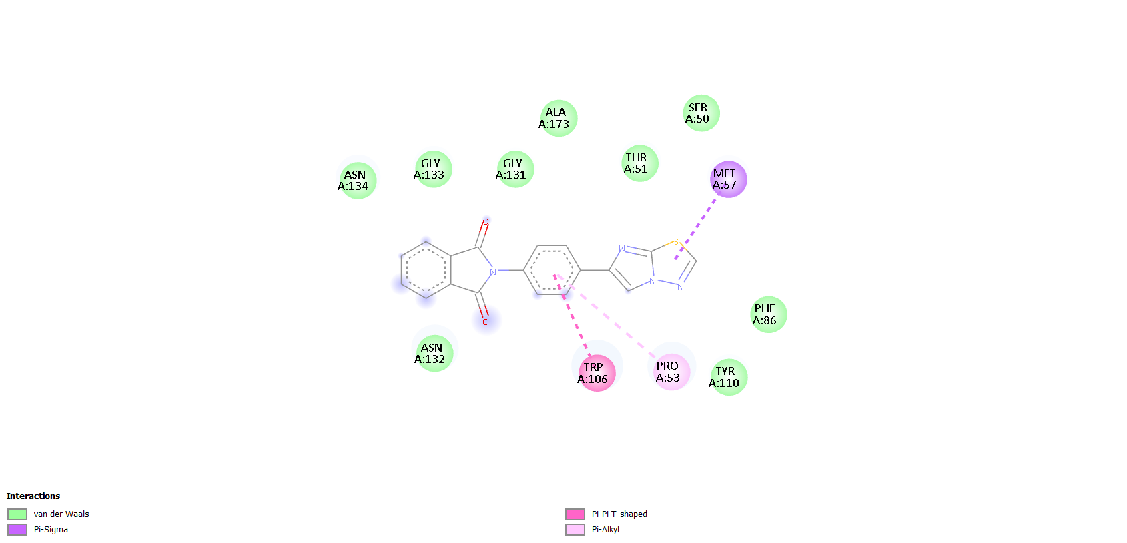
3b
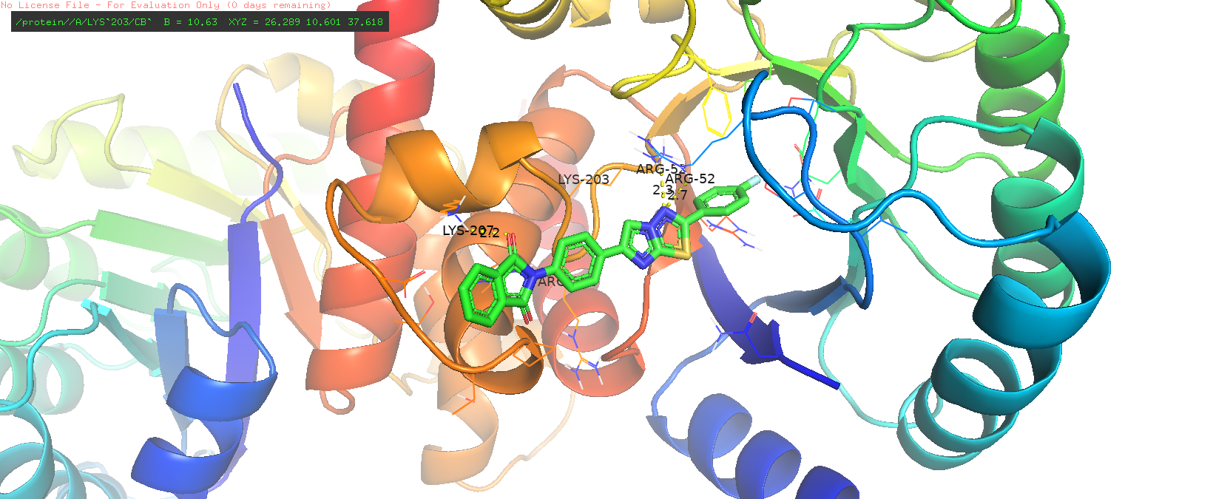
3b

3c
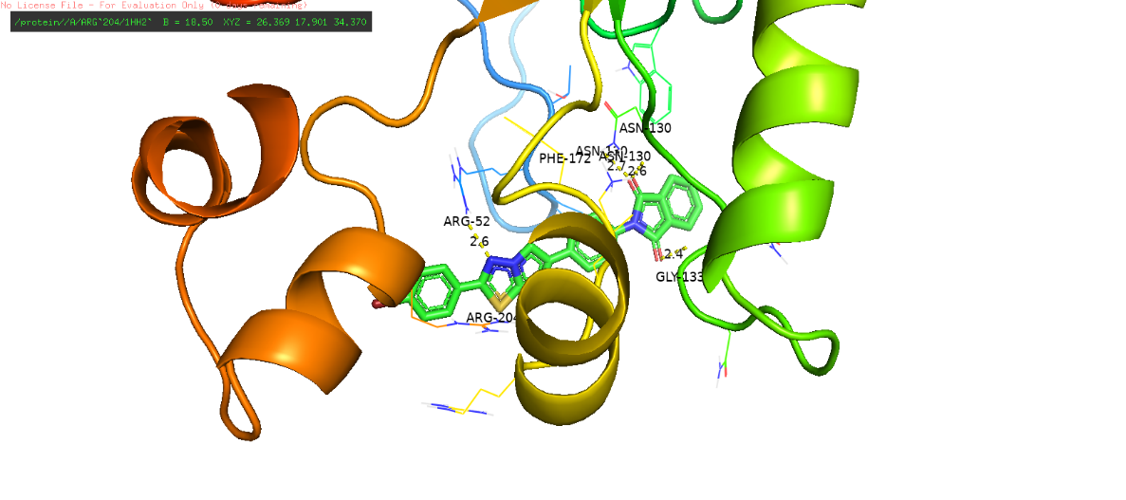
3c
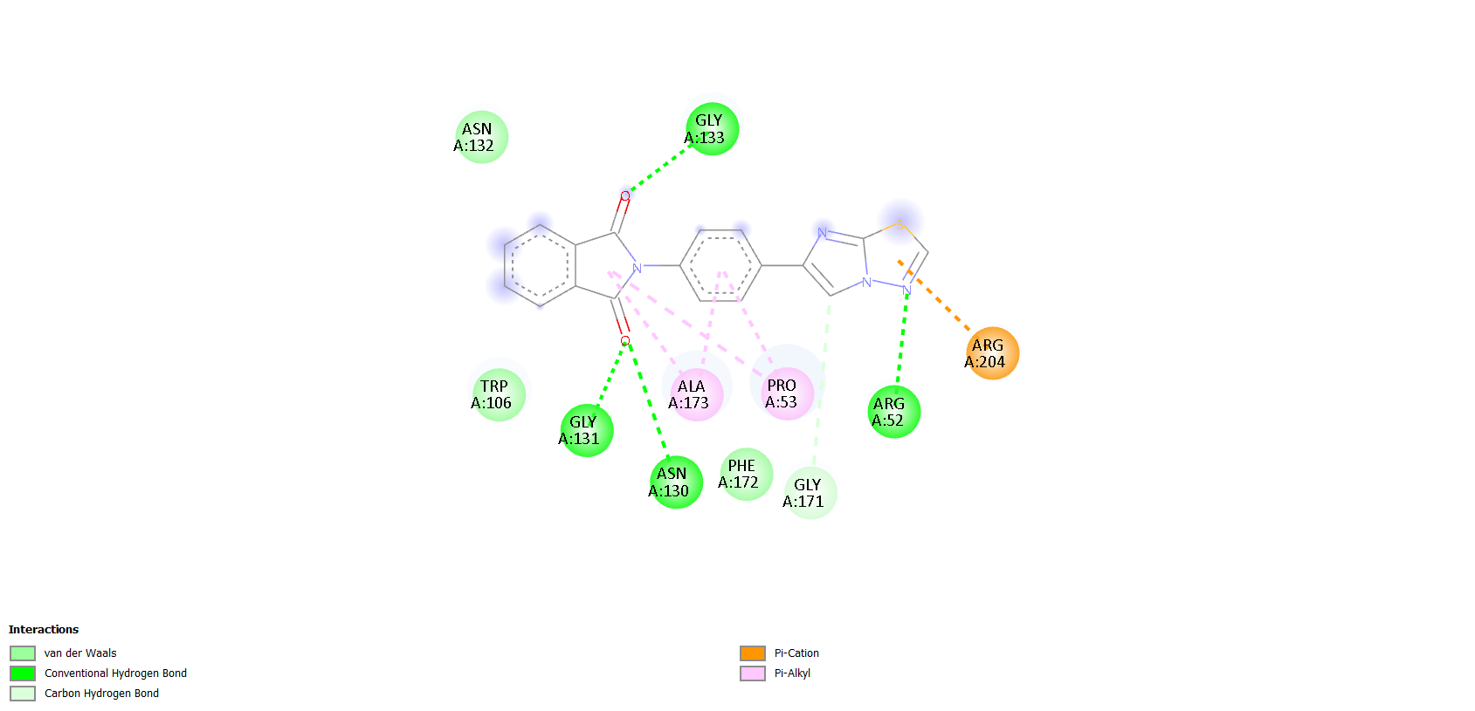
3d
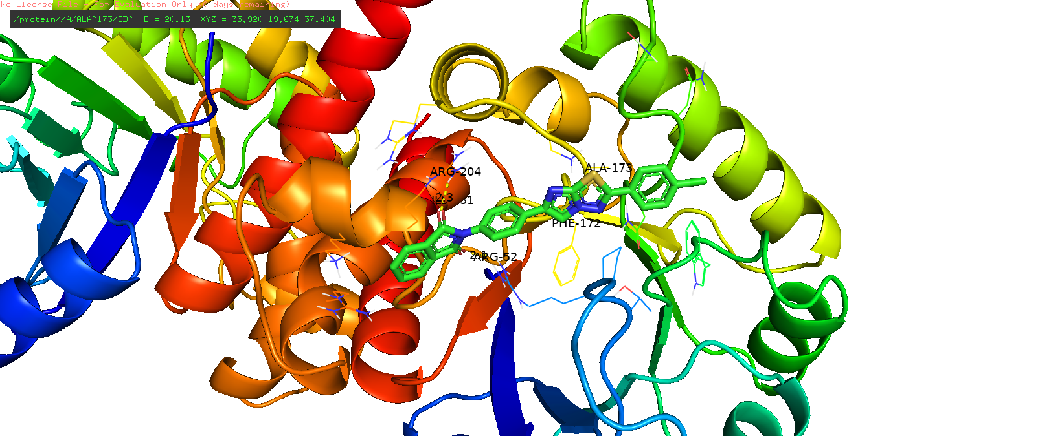
3d
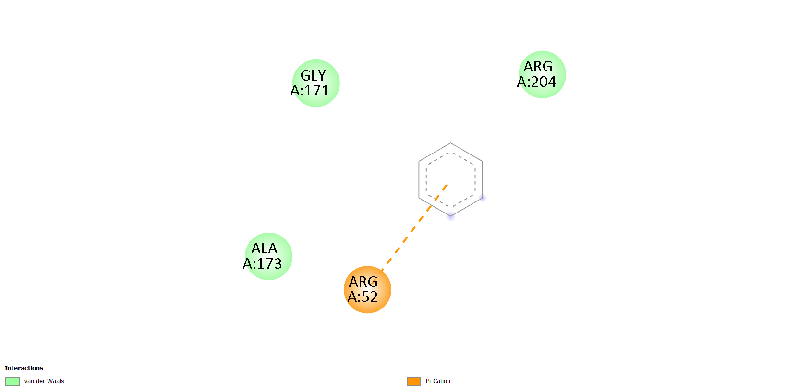
3e
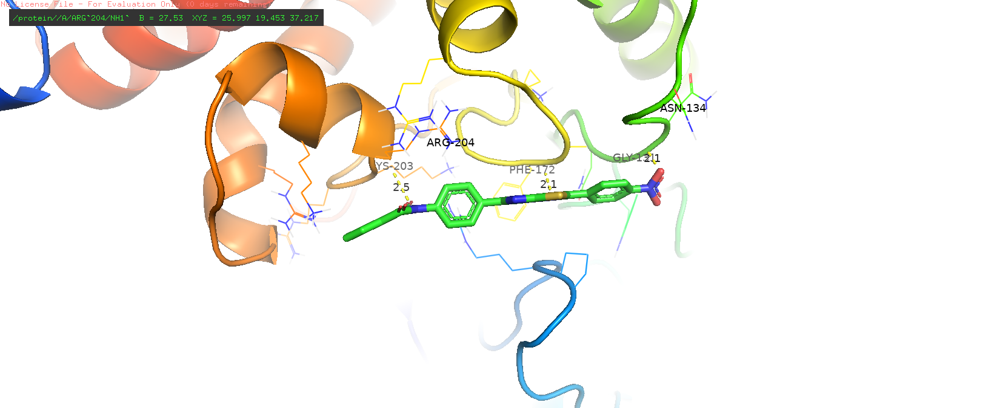
3e
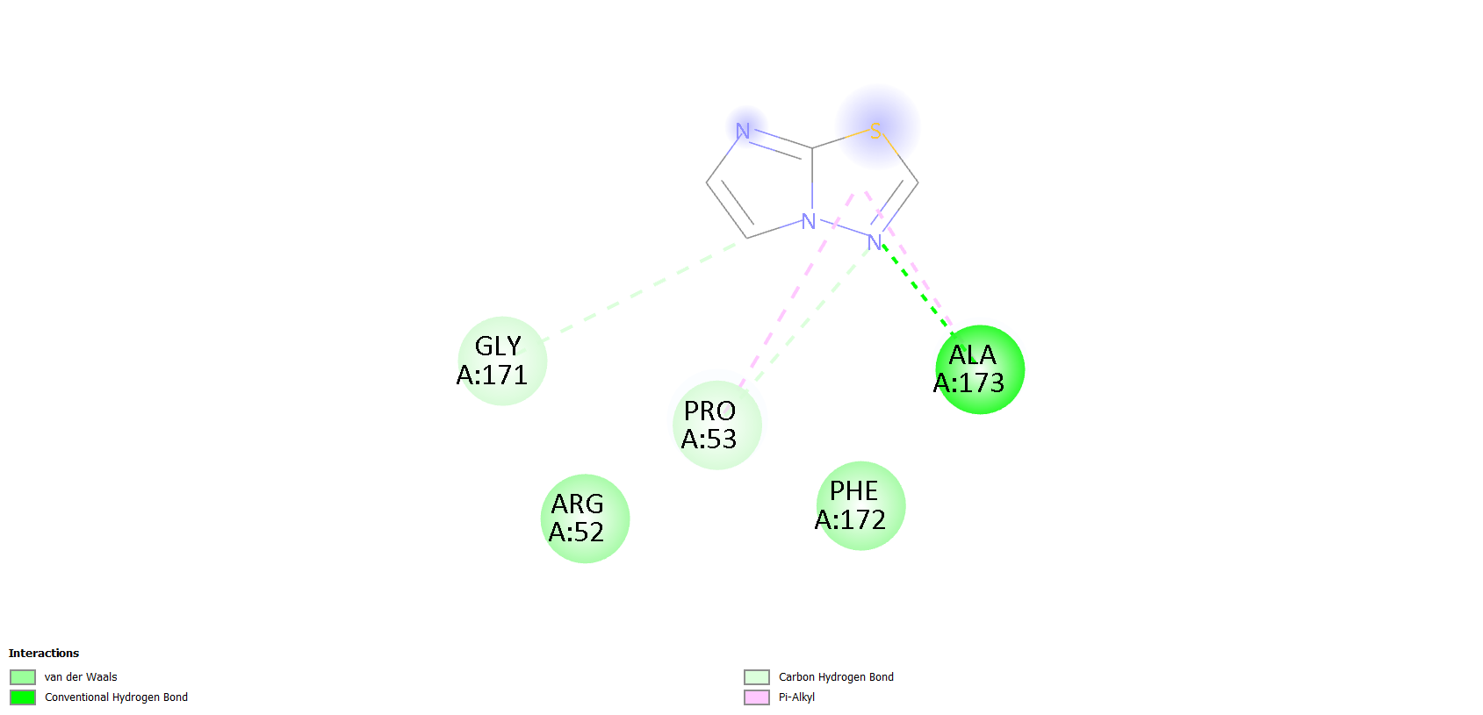

Figure 3 Molecular docking interaction of synthesis compounds 3a-3e
Conclusion
The synthesis, spectral characterization, and biological assessment of a novel series of 6-aryl-2-(4-(1,3-dioxoisoindolin-2-yl)phenyl)imidazo(2,1-b)1,3,4-thiadiazole derivatives (3a–e) are effectively described in this paper. The creation of the required bridgehead nitrogen heterocyclic scaffold was consistently supported by the rigorous confirmation of the chemical structures utilizing FTIR, ¹H NMR, ¹³C NMR and elemental analysis. Imidazo[2,1-b][1,3,4]thiadiazole core integration with an isoindoline moiety greatly influences biological potency, according to in vitro antimicrobial screening. In particular, compound 3e showed broad-spectrum activity against both Gram-positive and Gram-negative bacterial strains, making it the most effective antibacterial agent. Additionally, compound 3d showed the strongest antifungal efficacy, especially against B. theobromae. Molecular docking investigations (PDBID-1AD4), which revealed high binding affinities (-7.7 to -8.4 kcal/mol) for all derivatives, supplemented these experimental results. Compound 3a, which has important hydrogen bonds with residues like ARG-52 and ARG-219, showed the most stable protein-ligand interactions. All things considered, the findings point to these hybrid heterocycles as prospective lead templates for the creation of more potent antibacterial and medicinal substances.
Competing Interests
Authors declare that there is no competing of interests.
References
- C. Opoku-Temeng, G. A. Naclerio, H. Mohammad, N. Dayal, N. S. Abutaleb, M. N. Seleem, H. O. Sintim, Eur. J. Med. Chem. 2018, 155, 797 805.
- J. S. Molton, P. A. Tambyah, B. S. P. Ang, M. L. Ling, D. A. Fisher, Clin. Infect. Dis. 2013, 56, 1310–1318.
- Mustafa, S.M.; Nair, V.A.; Chittoor, J.P.; Krishnapillai, S. Mini-Rev. Org. Chem. 2004, 1, 375–385.
- Mao G, Tian Y, Shi J, Liao C, Huang W, Wu Y, Wen Z, Yu L, Zhu X, Li J. Design, synthesis, antibacterial, and antifungal evaluation of phenylthiazole derivatives containing a 1, 3, 4-thiadiazole thione moiety. Molecules. 2024 Jan 5;29(2):285.
- Krchnak, V.; Holladay, M. Solid phase heterocyclic chemistry. Chem. Rev. 2002, 102, 61–92.
- Wang, X.; Duan. W.; Lin, G.; Chen, M.; Lei, F. Synthesis, antifungal activity and 3D-QSAR study of novel nopol-based 1,3,4 thiadiazole–thioether compounds. Res. Chem. Intermed. 2021, 47, 4029–4049.
- Chen, J.; Yi, C.; Wang, S.; Wu, S.; Li, S.; Hu, D.; Song, B. Novel amide derivatives containing 1,3,4-thiadiazole moiety: Design, synthesis, nematocidal and antibacterial activities. Bioorg. Med. Chem. Lett. 2019, 29, 1203–1210.
- Dai, H.; Li, G.; Chen, J.; Shi, Y.; Ge, S.; Fan, C.; He, B. Synthesis and biological activities of novel 1,3,4-thiadiazole-containing pyrazole oxime derivatives. Bioorg. Med. Chem. Lett. 2016, 26, 3818–3821.
- Ismail, M.; Madkour, H.; Salem, M.; Mohamed, A.; Aly, A. Design, synthesis and insecticidal activity of new 1,3,4-thiadiazole and 1,3,4-thiadiazolo[3,2-a] pyrimidine derivatives under solvent-free conditions. Synth. Commun. 2021, 51, 2644–2660.
- Sucheta, Tahlan S, Verma PK. Synthesis, SAR and in vitro therapeutic potentials of thiazolidine-2, 4-diones. Chemistry Central Journal. 2018 Dec 4;12(1):129.
- National Committee for Clinical Laboratory Standards (NCCLS) Ap proved standard document M-7A, Villanova, PA, 1985.
- Kumar A, Lata S, Saxena KK and Chandra T, Synthesis and evaluation of new substituted indolyl pyrazolines as anti-inflammatory and analgesic activities, Indian Drugs.2009.46 (9): 43 48.
- Kittur BS, Sastri BS, Pattan SR, Rabara PA and Muchhandi IS, Synthesis and anti-inflammatory activity of some novel 1,3,4- oxadiazole and pyrazole derivatives, Indian drugs.2009; 46 (4): 287-290.
- El-Hamouly WS, El-Khamry AMA and Abbaa EMH, Synthesis of new 4 arylisoxazolo[ 5,4-d]pyrimidin-6 one(thione) and 4-aryl-pyrazolo[3,4-d] pyrimidin-6-one derivatives of potential antihypertensive activity, Indian J. Chem.2006; 45B: 2091-2098. 14. Patil PO, Belsare DP, Kosalge SB and Fursule RA, Microwave assisted synthesis and anti-depressant activity of some 1,3,5- triphenyl-2-pyrazolines, Int. J. Chem. Sci.2008;6 (2): 717-725,
- Shikha SD and Anjali MR, Synthesis of substituted 2-(5-(2-chloroquinolin-3 yl)-4,5- yl)phenols dihydro-1H-pyrazol-3 as antibacterial and anticancer agents, Indian J. Hetero. Chem.2009;18: 397-398.
- P. P. Mahulikar, U. D. Patil, A. P. Nikum, and P. S. Nagle, “Synthesis, antimicrobial and antifungal activity evaluation of 2,6-diaryl-4-SEC-aminonicotinonitriles and 4-sec-amino-6 aryl-2-(pyridin-2-YL)pyridine-3-carbonitriles i.e. Bipyridines and their docking study,” The Journal of Pharmacy,vol.5,no. 3, pp. 1383–1386, 2012.
- Bala S, Kamboj S, Kajal A, Saini V, Prasad DN. 1, 3, 4‐oxadiazole derivatives: synthesis, characterization, antimicrobial potential, and computational studies. BioMed research international. 2014;2014(1):172791.
- Wu G, Robertson DH, Brooks IIC, Vieth M. Detailed analysis of grid-based molecular docking: a case study of CDOCKER-A CHARMm-based MD docking algorithm. J Comput Chem 2003;24:1549–62.
- Deb, P. K., Al-Shar’i, N. A., Venugopala, K. N., Pillay, M., & Borah, P. (2021). In vitro anti-TB properties, in silico target validation, molecular docking and dynamics studies of substituted 1, 2, 4-oxadiazole analogues against Mycobacterium tuberculosis. Journal of enzyme inhibition and medicinal chemistry, 36(1), 869-884.

