Economic Optimization of Turmeric (Curcuma longa L.) Cultivation through Canopy Management in a Shisham (Dalbergia sissoo) Based Agrisilviculture System of Central India

Abstract

Agrisilviculture systems that integrate multipurpose trees with agricultural crops offer smallholder farmers diversified income streams; however, optimal canopy management for economic returns requires empirical quantification. A field experiment was conducted during the Kharif season of 2014-15 in a 16-year-old Dalbergia sissoo DC. (Shisham) plantation at the research farm of Jawaharlal Nehru Krishi Vishwa Vidyalaya (JNKVV), Jabalpur, Madhya Pradesh (23 deg N, 79 deg E; 411.78 m a.m.s.l.), to determine the economic viability of turmeric (Curcuma longa L., var. Suroma) cultivation under four pruning intensities (P0 - no pruning, P1 - 25%, P2 - 50%, P3 - 75%) and three nutrient supply treatments (T1 - NPK fertilizer, T2 - organic manure, T3 - vermicompost), along with an open (no-tree) control. Economics were quantified as cost of cultivation, gross monetary return (GMR), net monetary return (NMR), and benefit:cost (B:C) ratio on a per-hectare basis. The maximum GMR (Rs. 2,96,047 ha-1) and NMR (Rs. 1,64,491 ha-1) were recorded under P1+T1 (25% pruning + NPK fertilizer), followed by P1+T2 (NMR: Rs. 1,55,533 ha-1). The mean B:C ratio was highest under P1 (2.14) and lowest under open condition (1.44). The integrated crop+tree system under P1 yielded approximately 2.7 times the NMR of open (crop-alone) condition, clearly demonstrating the economic superiority of managed agrisilviculture. A pruning intensity of 25% of D. sissoo canopy, combined with NPK fertilization, is recommended for economic optimization of turmeric cultivation in central India.

Keywords: agrisilviculture; Curcuma longa; Dalbergia sissoo; economics; gross monetary return; net monetary return; benefit:cost ratio; pruning intensity; central India

1. Introduction
Agroforestry systems that deliberately integrate trees with crops or livestock offer well-documented ecological and economic advantages over monoculture land use, including diversified income streams, reduced production risk, improved soil fertility, and greater resilience to market and climate shocks (Nair 1993; Jose 2009). Agrisilviculture - the sub-system combining trees with annual crops - is particularly relevant to smallholder contexts where land is limited and productivity must be optimised across multiple components simultaneously.
Dalbergia sissoo DC. (Shisham; family: Fabaceae), a fast-growing, nitrogen-fixing, multipurpose deciduous rosewood native to the Indian subcontinent and southern Iran, is among the most widely planted tree species in agroforestry systems of central and north India. It attains heights of up to 30 m, provides high-quality timber, fuelwood, fodder, shade, and atmospheric nitrogen enrichment through biological fixation, and is highly amenable to silvicultural management including pruning (Dhyani and Chauhan 1989; Verma et al. 2018). These properties make it an ideal tree component for agrisilviculture systems in Madhya Pradesh, where arable land is contracting despite the state's large agricultural area.
Turmeric (Curcuma longa L., family: Zingiberaceae) is a high-value spice, medicinal, and cosmetic crop with India producing approximately 80% of the world's supply. Its active curcuminoid compounds have well-established anti-inflammatory, antioxidant, and hepatoprotective medicinal properties (Subramanian et al. 2004; Prasad and Aggarwal 2011). Turmeric is adapted to partial shade and well-suited for under storey cultivation beneath tree canopies, provided that light, moisture, and nutrient environments are appropriately managed.
Tree canopy management through pruning is the primary tool for regulating these environments. Pruning modifies under storey photosynthetically active radiation (PAR), temperature, humidity, and root competition, all of which influence crop performance and economic returns (Frank and Eduardo 2003; Das and Dalvi 1981). Economic analysis - encompassing cost of cultivation, gross monetary return (GMR), net monetary return (NMR), and the benefit:cost (B:C) ratio - provides the integrated performance metric most relevant to farmer decision-making and policy. Despite the widespread adoption of D. sissoo-based agrisilviculture in central India, systematic economic analysis of pruning intensity effects on turmeric cultivation remains limited. The present investigation was therefore designed to quantify the economics of all pruning x nutrient treatment combinations and identify the treatment combination yielding the maximum NMR and B:C ratio.

2. Materials and Methods
2.1 Study Site
The experiment was conducted at the New Dusty Acre research farm, Department of Forestry, College of Agriculture, JNKVV, Jabalpur (23 deg 18 min N, 79 deg 59 min E; 411.78 m a.m.s.l.) during the Kharif season of 2014-15. The climate is dry-subtropical; mean annual rainfall is 1315 mm (90% received June-September). The soil is clay loam, near-neutral pH, with available N = 207 kg/ha (medium), P = 16.26 kg/ha (medium), K = 172 kg/ha (very low). The experiment was established in a 16-year-old D. sissoo plantation at 5 m x 5 m initial spacing (planted Kharif 1998).
2.2 Experimental Design and Treatments
The experiment was laid out in a Strip Plot Design with four replications, 76 total plots. Main treatments were four pruning intensities of D. sissoo: P0 (no pruning), P1 (25%), P2 (50%), and P3 (75%), plus an open (no-tree) control. Sub-treatments: T1 - NPK inorganic fertilizer (300:550:100 g/plot for tree+crop; 900:1600:250 g/plot for open), T2 - organic manure, T3 - vermicompost. Turmeric var. Suroma was planted at 50 cm x 15 cm spacing, seed rate 2000 kg/ha. Sale rates: turmeric rhizomes Rs.60/kg, pruned tree biomass Rs.4/kg, tree fuelwood Rs.5/kg.
2.3 Economic Parameters
Cost of Cultivation (COC): Determined on a per-hectare basis from all inputs. Cost of turmeric cultivation: Rs. 15,645/ha; D. sissoo maintenance: Rs. 4,586/ha/year.
Gross Monetary Return (GMR): Total market value of all produce (rhizomes + pruned biomass + tree biomass) per hectare at prevailing local prices.
Net Monetary Return (NMR): NMR = GMR - COC for each treatment.
Benefit:Cost (B:C) Ratio: B:C = GMR / COC. A B:C ratio > 1.0 indicates economic viability; higher values reflect greater profitability per unit investment.

3. Results
3.1 Full Economic Analysis by Treatment Combination
The complete economic analysis for all 19 treatment combinations is presented in Table 1 and Figures 1 and 2. Across all treatments, the integrated crop+tree system under managed pruning consistently outperformed both tree-alone and open (crop-alone) conditions in absolute NMR.

Table 1. Economic analysis of turmeric cultivation under different pruning intensities and nutrient treatments in D. sissoo agrisilviculture system (per hectare basis).
S.No. | Treatment | Cost of Cultivation  (Rs. ha-1) | Gross Monetary  Return (Rs. ha-1) | Net Monetary  Return (Rs. ha-1) | B:C  Ratio
Section A: P0 - No Pruning
1 | P0 - No pruning + T1 (NPK Fertilizer) | 1,30,356 | 2,67,868.9 | 1,37,512.93 | 2.05
2 | P0 - No pruning + T2 (Organic Manure) | 1,30,356 | 2,50,861.3 | 1,20,505.30 | 1.92
3 | P0 - No pruning + T3 (Vermicompost) | 1,30,356 | 2,27,073.9 | 96,717.93 | 1.74
4 | P0 - Tree alone (no crop) | 4,800 | 42,879.55 | 38,079.60 | 8.60
Section B: P1 - 25% Pruning
5 | P1 - 25% pruning + T1 (NPK Fertilizer) | 1,31,556 | 2,96,047.4 | 1,64,491.35 | 2.25
6 | P1 - 25% pruning + T2 (Organic Manure) | 1,31,556 | 2,87,089.8 | 1,55,533.75 | 2.18
7 | P1 - 25% pruning + T3 (Vermicompost) | 1,31,556 | 2,61,148.8 | 1,29,592.78 | 1.99
8 | P1 - Tree alone (no crop) | 6,000 | 46,259.70 | 40,259.71 | 5.02
Section C: P2 - 50% Pruning
9 | P2 - 50% pruning + T1 (NPK Fertilizer) | 1,31,556 | 2,64,387.1 | 1,32,831.05 | 2.01
10 | P2 - 50% pruning + T2 (Organic Manure) | 1,31,556 | 2,51,027.4 | 1,19,471.35 | 1.91
11 | P2 - 50% pruning + T3 (Vermicompost) | 1,31,556 | 2,33,169.1 | 1,01,613.05 | 1.77
12 | P2 - Tree alone (no crop) | 6,000 | 48,715.73 | 42,715.72 | 5.27
Section D: P3 - 75% Pruning
13 | P3 - 75% pruning + T1 (NPK Fertilizer) | 1,31,556 | 2,18,733.2 | 87,177.18 | 1.66
14 | P3 - 75% pruning + T2 (Organic Manure) | 1,31,556 | 2,12,784.9 | 81,228.90 | 1.62
15 | P3 - 75% pruning + T3 (Vermicompost) | 1,31,556 | 2,05,276.7 | 73,720.73 | 1.56
16 | P3 - Tree alone (no crop) | 6,000 | 32,122.08 | 26,122.08 | 3.61
Section E: Open Condition (No Tree)
17 | Open + T1 (NPK Fertilizer) | 1,25,556 | 1,89,465.0 | 63,909.00 | 1.51
18 | Open + T2 (Organic Manure) | 1,25,556 | 1,83,675.0 | 58,119.00 | 1.45
19 | Open + T3 (Vermicompost) | 1,25,556 | 1,69,095.0 | 43,539.00 | 1.35
T1 = NPK inorganic fertilizer; T2 = Organic manure; T3 = Vermicompost. Sale rates: turmeric rhizomes Rs.60/kg; pruned tree biomass Rs.4/kg; tree fuelwood Rs.5/kg. All monetary values in Indian Rupees (Rs. ha-1).

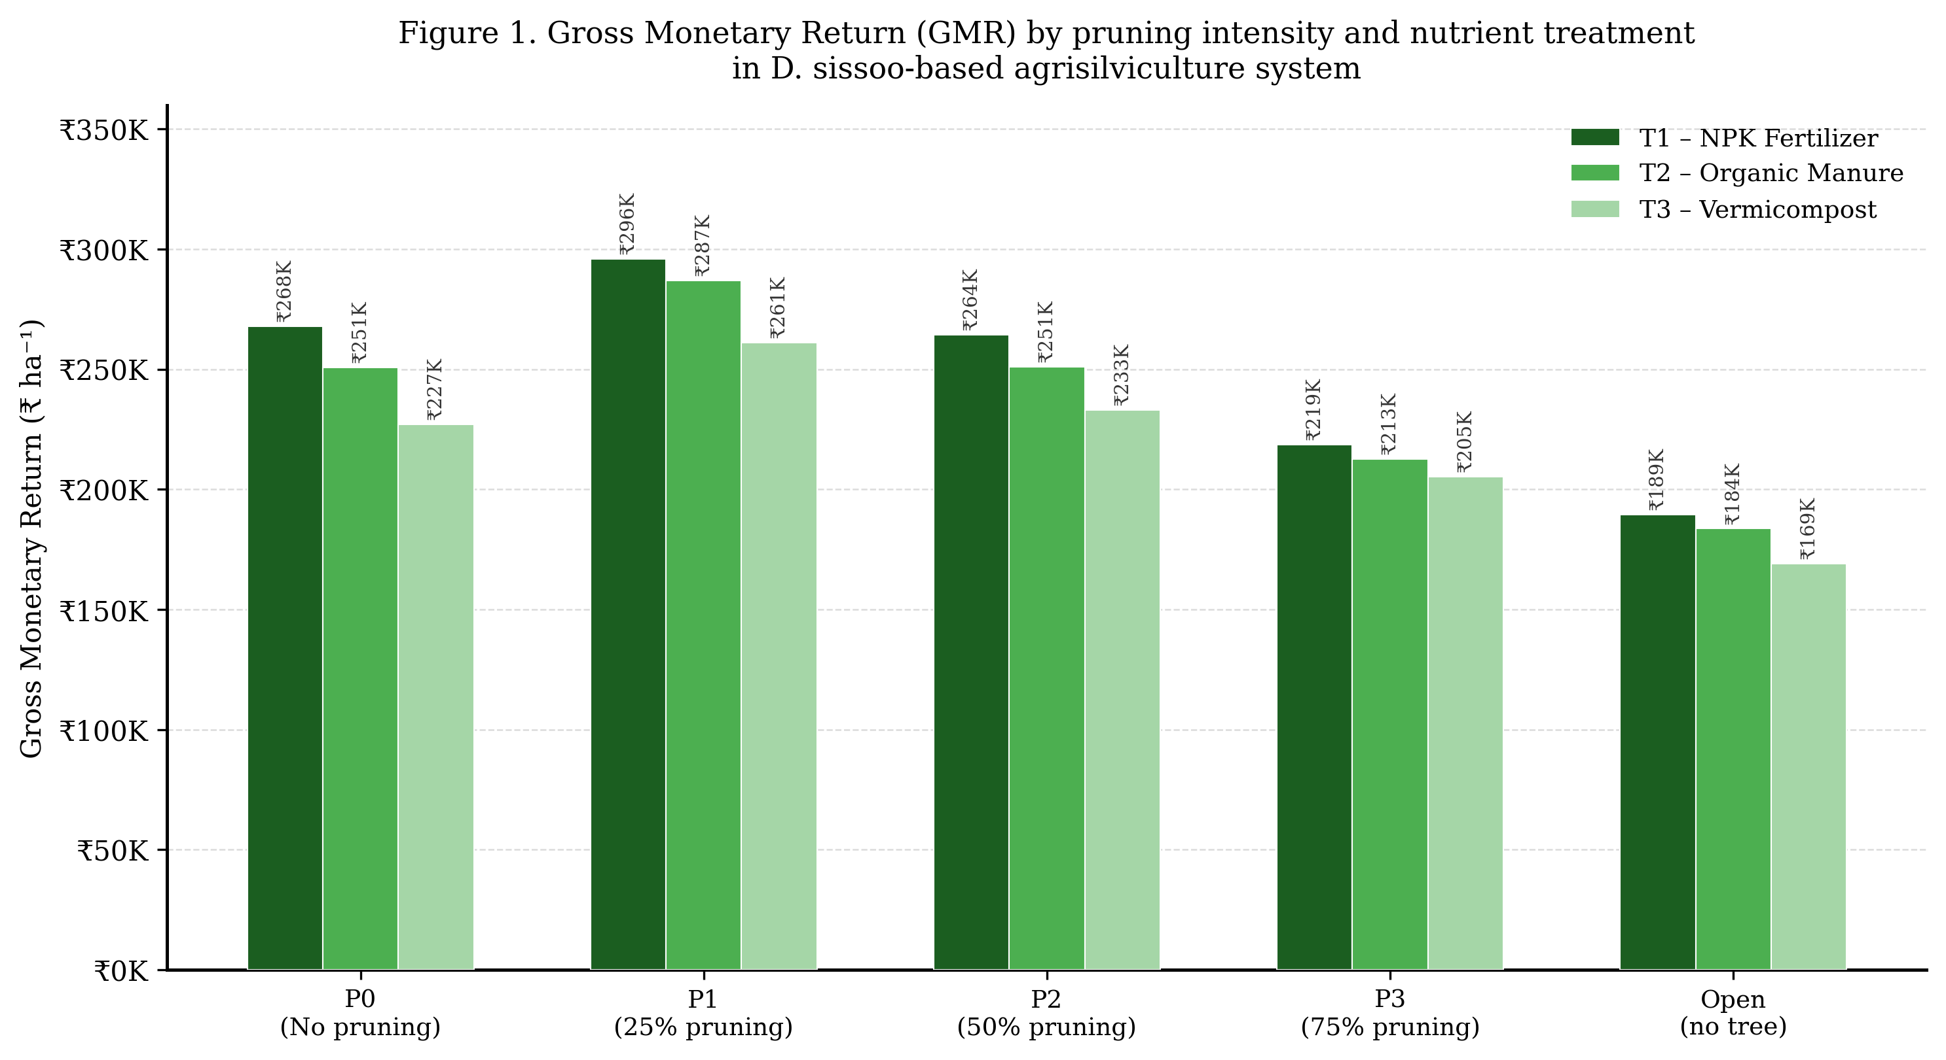
Figure 1. Gross Monetary Return (GMR, Rs. ha-1) under different pruning intensities and nutrient treatments in D. sissoo-turmeric agrisilviculture. T1 = NPK fertilizer; T2 = Organic manure; T3 = Vermicompost.

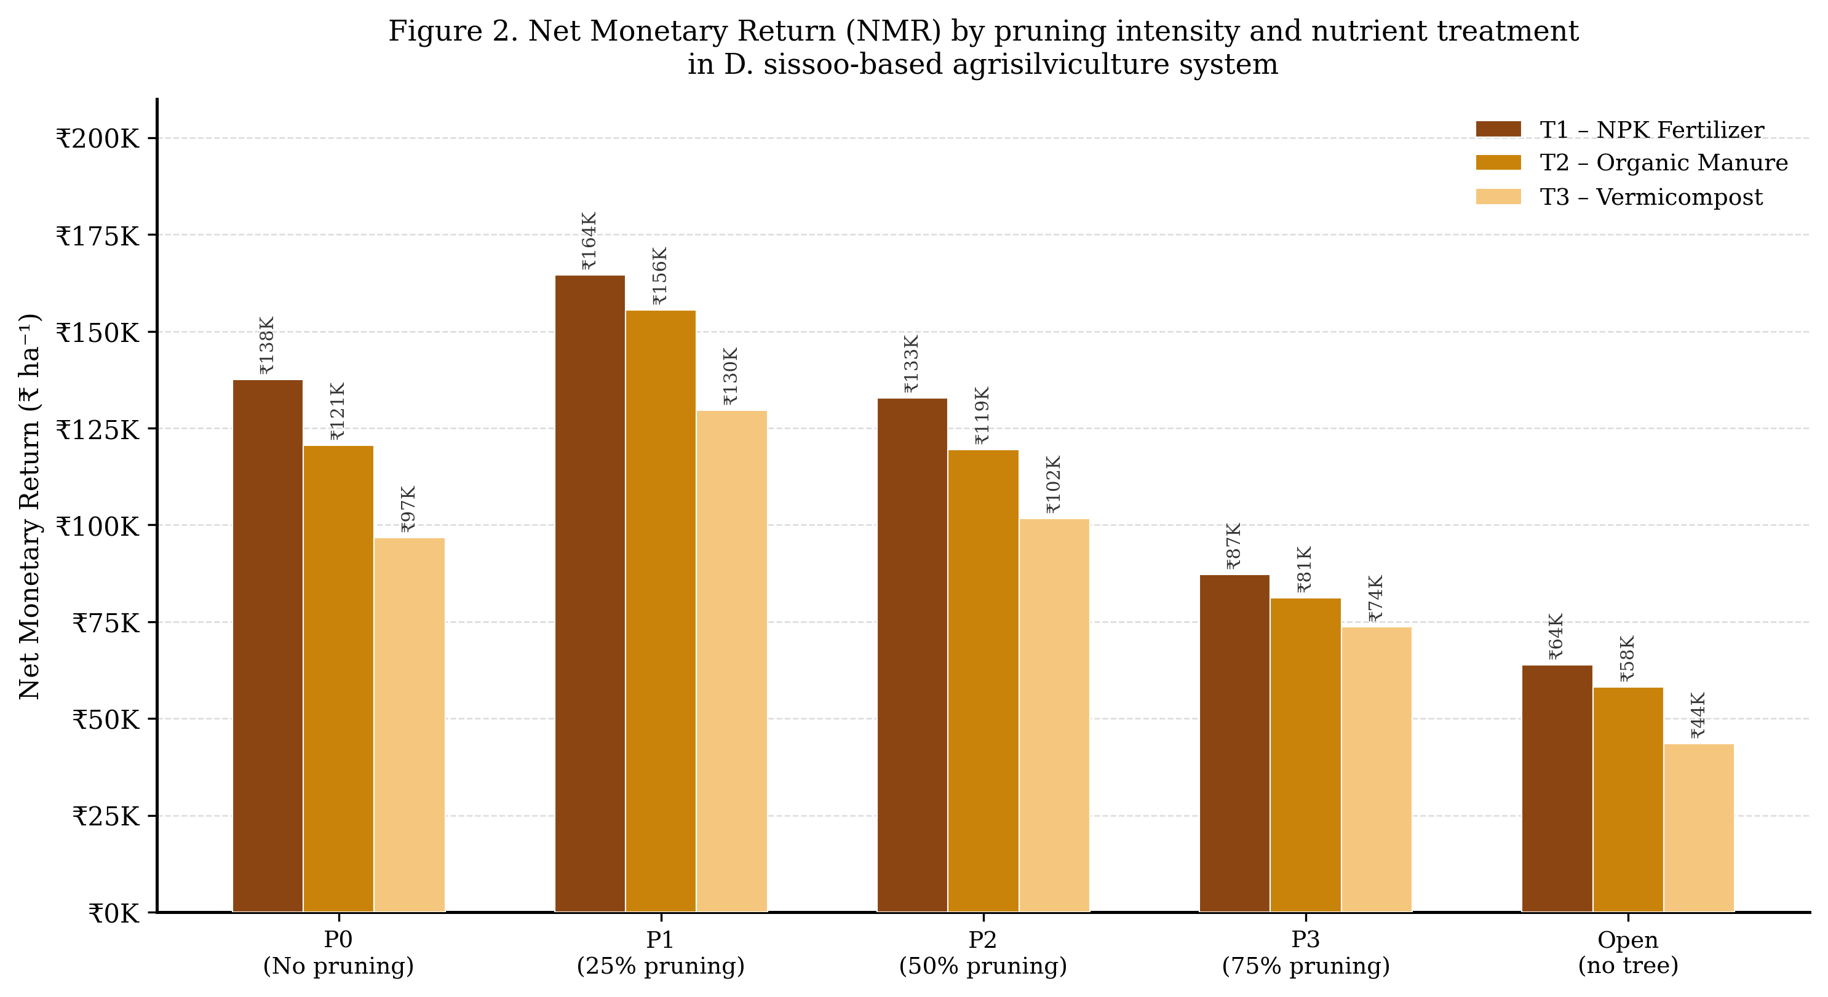
Figure 2. Net Monetary Return (NMR, Rs. ha-1) under different pruning intensities and nutrient treatments. T1 = NPK fertilizer; T2 = Organic manure; T3 = Vermicompost.

3.2 Net Monetary Return by Pruning Intensity
Mean NMR across nutrient treatments, disaggregated by pruning intensity, is presented in Table 2. Pruning intensity had a significant effect on NMR. P1 (25% pruning) recorded the highest mean NMR (Rs. 1,49,872.63 ha-1), which was at par with P0 (no pruning, Rs. 1,18,245.38 ha-1) but significantly superior to P2 (50% pruning, Rs. 1,17,971.82 ha-1), P3 (75% pruning, Rs. 80,708.93 ha-1), and open condition (Rs. 55,189.00 ha-1). The integrated crop+tree system under P1 yielded more than 2.7 times the NMR of the open (crop-alone) condition and approximately 3.7 times that of tree-alone plots.

Table 2. Net Monetary Return (NMR, Rs. ha-1) as influenced by different pruning intensities in D. sissoo-based agrisilviculture system.
Pruning Intensity | Mean NMR - Crop+Tree  (Rs. ha-1) | NMR - Crop only  (Rs. ha-1) | NMR - Tree alone  (Rs. ha-1)
P0 - No pruning | 1,18,245.38 | - | 38,079.60
P1 - 25% pruning | 1,49,872.63 | 1,16,184.46 | 40,259.71
P2 - 50% pruning | 1,17,971.82 | - | 42,715.72
P3 - 75% pruning | 80,708.93 | - | 26,122.08
Open condition (no tree) | 55,189.00 | - | -
Mean | 1,04,397.60 | - | 36,794.30
Mean NMR = mean across T1, T2, and T3 nutrient treatments. '-' = not applicable.

3.3 Benefit:Cost Ratio by Pruning Intensity
The B:C ratio analysis (Table 3; Figures 3 and 4) confirmed significant differences among pruning intensities. P1 (25% pruning) recorded the highest mean B:C ratio (2.14), followed by P0 (1.91) and P2 (1.90), with which it was at par. P3 (75% pruning) recorded a significantly lower B:C ratio (1.61), while the open condition gave the lowest integrated B:C (1.44). All B:C ratios were well above 1.0, confirming economic viability across all treatments. Tree-alone plots exhibited very high B:C ratios (3.61-8.60) due to near-zero input costs, but absolute NMR from these plots was only 16-26% of the NMR achieved under the best integrated treatment (P1+T1).

Table 3. Benefit:Cost (B:C) ratio as influenced by different pruning intensities in D. sissoo-based agrisilviculture system.
Pruning Intensity | Mean B:C - Crop+Tree | B:C - Crop only | B:C - Tree alone
P0 - No pruning | 1.91 | - | 8.60
P1 - 25% pruning | 2.14 | 1.88 | 5.02
P2 - 50% pruning | 1.90 | - | 5.27
P3 - 75% pruning | 1.61 | - | 3.61
Open condition (no tree) | 1.44 | - | -
Mean | 1.80 | - | 5.60
Mean B:C = mean across T1, T2, and T3 nutrient treatments. '-' = not applicable. All B:C ratios > 1.0 confirm economic viability.

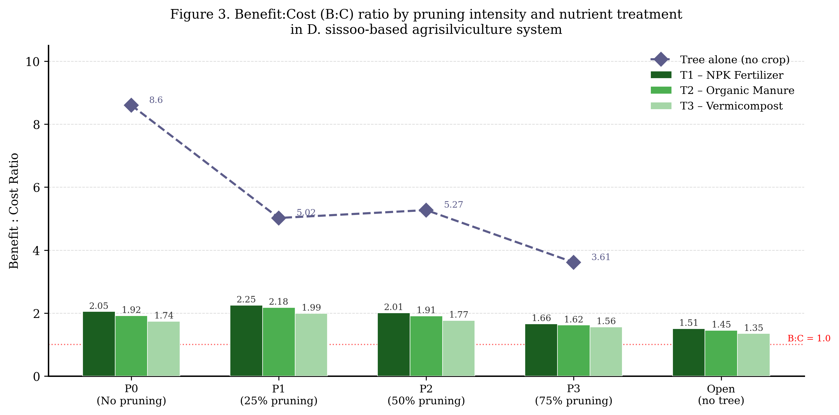
Figure 3. Benefit:Cost (B:C) ratio under different pruning intensities and nutrient treatments. Diamond markers show tree-alone B:C values. Dotted red line: B:C = 1.0 (break-even). T1 = NPK fertilizer; T2 = Organic manure; T3 = Vermicompost.

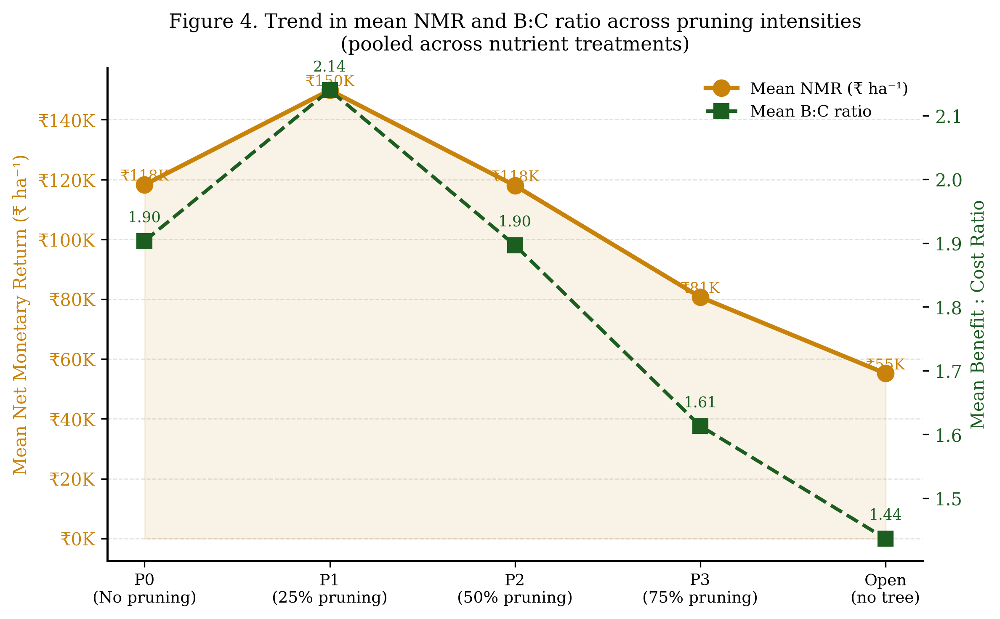
Figure 4. Trend in mean Net Monetary Return (Rs. ha-1) and mean B:C ratio across pruning intensities, pooled across nutrient treatments.

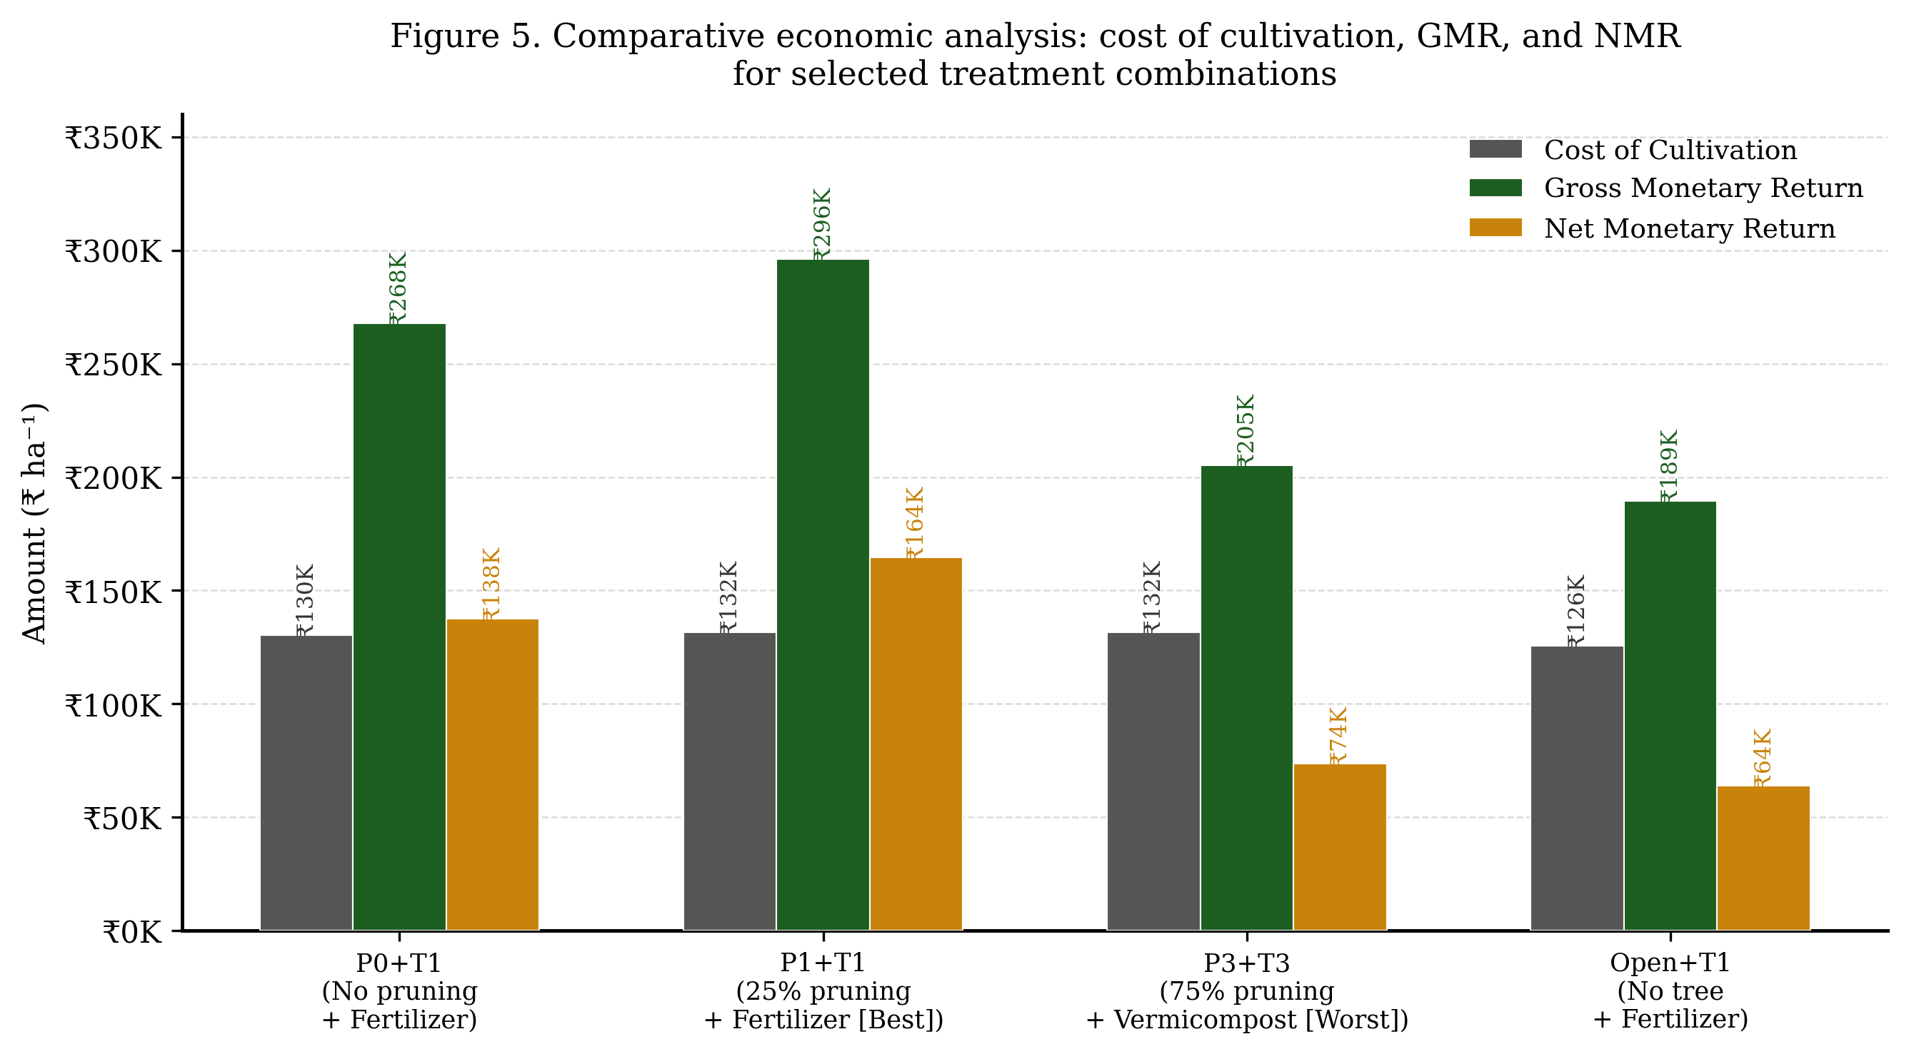
Figure 5. Comparative economic analysis: cost of cultivation, GMR, and NMR for selected treatment combinations (best-performing P1+T1, worst-performing P3+T3, P0+T1, and Open+T1).

4. Discussion
4.1 Economic Rationale for Integrated Agrisilviculture
The consistently superior NMR of the integrated crop+tree system over tree-alone or crop-alone conditions aligns with the foundational economic rationale for agroforestry: simultaneous exploitation of tree and crop components from the same unit generates returns that exceed either component in isolation (Nair 1993; Jose 2009). The present findings corroborate those of Pandey (2007), who reported that Dalbergia sissoo-based agrisilviculture in central Indian plains yielded NMRs 40-60% higher than sole crop controls when canopies were appropriately managed. Kumar et al. (2012) similarly found that light management through pruning in Populusdeltoides-turmeric systems increased NMR by up to 35% over unmanaged controls, confirming generalisability across tree species.
4.2 Optimal Pruning Intensity: Economic Mechanism
The superiority of P1 (25% pruning) in both NMR and B:C ratio reflects the balance between tree biomass value (maximised under low pruning) and crop yield (maximised under moderate-light conditions). Under P0, partial canopy shade limits turmeric yield sufficiently to reduce crop income below P1 without adequate tree biomass compensation. Under P3, the high value of pruned biomass does not compensate for the sharp decline in crop yield caused by excessive light exposure and root system disturbance (Miah et al. 1997; Frank and Eduardo 2003). This quadratic response of NMR to pruning intensity - with a peak at 25% - is consistent with the concept of the 'facilitation window' in agroforestry ecology (Ong and Huxley 1996).
4.3 Nutrient Treatment Effects on Economic Returns
Within each pruning level, T1 (NPK inorganic fertilizer) consistently produced the highest GMR and NMR, followed by T2 (organic manure) and T3 (vermicompost). This reflects the higher immediate yield response of turmeric to rapidly available inorganic N and P. The lower NMR under T3 (vermicompost) at the doses applied suggests that higher input costs were not fully offset by yield gains within a single season. However, vermicompost offers substantial long-term soil health benefits (Tilman et al. 2002), and its economic ranking may improve under multi-year evaluation.
4.4 Comparative Returns: Tree Alone vs Integrated System
Very high B:C ratios for tree-alone plots (3.61-8.60) are a mathematical artefact of near-zero input costs. Absolute NMR from tree-alone plots (Rs. 26,122-42,716 ha-1) was only 16-26% of the NMR achieved under P1+T1 (Rs. 1,64,491 ha-1), confirming that the integrated system delivers far greater absolute economic benefit per unit land area. This has direct implications for Madhya Pradesh's agricultural policy: promoting D. sissoo-based agrisilviculture with appropriate canopy management among smallholder farmers could substantially increase farm income and reduce monoculture risk, consistent with national agroforestry policy objectives (GoI 2014).

5. Conclusions
1. P1 (25% pruning) of D. sissoo recorded the highest mean NMR (Rs. 1,49,872.63 ha-1) and highest mean B:C ratio (2.14), confirming it as the economically optimal pruning intensity for turmeric-based agrisilviculture in central India.
2. The combination P1+T1 (25% pruning + NPK fertilizer) produced the maximum GMR (Rs. 2,96,047 ha-1) and NMR (Rs. 1,64,491 ha-1) among all 19 treatment combinations.
3. The integrated D. sissoo-turmeric agrisilviculture system under P1 yielded approximately 2.7x higher NMR than open (crop-alone) condition and 3.7x higher NMR than tree-alone plots, demonstrating the economic superiority of managed integration.
4. All integrated treatments yielded B:C ratios above 1.0, confirming economic viability of turmeric cultivation under D. sissoo agrisilviculture across all pruning intensities and nutrient supply modes tested.
5. Future studies should evaluate long-term economics including tree timber value at rotation, soil health dividends from organic inputs, and farmer-level livelihood impacts to provide a comprehensive assessment at scale.

Conflicts of Interest
The author declares no conflicts of interest.

References
Das RB and Dalvi GS. 1981. Effect of interval and intensity of cutting Leucaena leucocephala. Research Report 2:21-22.
Dhyani SK and Chauhan DS. 1989. Evaluation of crop in relation to shade intensities of Khasi pine. Progress Report, ICAR Research Complex for NEH Region, Shillong: 1-3.
Fischer KS and Palmer AFE. 1984. Tropical maize. In: The Physiology of Tropical Field Crops. John Wiley, Chichester: 213-248.
Frank E and Eduardo S. 2003. Biomass dynamics of Erythrina lanceolata as influenced by shoot pruning intensity in Costa Rica. Agroforestry Systems 57:19-28.
Government of India (GoI). 2014. National Agroforestry Policy 2014. Ministry of Agriculture, Department of Agriculture and Cooperation, New Delhi. 20 pp.
Harper JL. 1977. Population Biology of Plants. Academic Press, Orlando, Florida. 892 pp.
Jose S. 2009. Agroforestry for ecosystem services and environmental benefits: an overview. Agroforestry Systems 76(1):1-10.
Kumar A, Dhillon WS and Toor GS. 2012. Economic analysis of Populusdeltoides based agroforestry systems with different crop combinations in Punjab, India. Range Management and Agroforestry 33(2):133-138.
Miah MG, Aragon ML and Garrity DP. 1997. Growth, biomass production and distribution of three multipurpose tree species in an agroforestry system as affected by pruning. Journal of Tropical Forest Science 10(1):35-49.
Nair PKR. 1993. An Introduction to Agroforestry. Kluwer Academic Publishers/ICRAF, Dordrecht. 499 pp.
Ong CK and Huxley PA (eds). 1996. Tree-Crop Interactions: A Physiological Approach. CAB International, Wallingford. 386 pp.
Pandey DN. 2007. Multifunctional agroforestry systems in India. Current Science 92(4):455-463.
Prasad S and Aggarwal BB. 2011. Turmeric, the golden spice. In: Herbal Medicine: Biomolecular and Clinical Aspects, 2nd edn. CRC Press, Boca Raton: Chapter 13.
Singh S. 1994. Physiological response of different crop species to light stress. Indian Journal of Plant Physiology 37:147-151.
Subramanian V, Svee Kumar L and Nair GS. 2004. Effect of time and method of planting on the yield of second crop of turmeric in Wynad. Indian Cocoa, Arecanut and Spices Journal 5(1):5-8.
Tilman D, Cassman KG, Matson PA, Naylor R and Polasky S. 2002. Agricultural sustainability and intensive production practices. Nature 418:671-677.
Verma P, Bijalwan A, Shankhwar AK, Dobriyal MJR, Jacob V and Kumar RS. 2018. Scaling up an indigenous tree (Gmelina arborea)-based agroforestry in India. International Journal of Science and Qualitative Analysis 3(6):73-77.
Wani SP, Rego TJ, Rajeswari S and Lee KK. 1995. Effect of legume-based cropping systems on nitrogen mineralisation potential of Vertisol. Plant and Soil 175:265-274.
Yadav RS and Gupta ML. 2003. Economics of Dalbergia sissoo-based agroforestry in Haryana. Indian Journal of Agroforestry 5(1):20-25.

