Diversity and Infestation Pattern of Insect Pests and Diseases in Red Cabbage (Brassica oleracea var. capitata f. rubra) under semi controlled conditions

Abstract
Research was carried out on red cabbage during the rabi season from October to February under a naturally ventilated polyhouse to study the incidence of pests and diseases under different organic nutrient combinations. The treatments included T1 – FYM, lignite and microbial consortium; T2 – vermicompost, lignite and microbial consortium; T3 – neem cake, lignite and microbial consortium; T4 – FYM, vermicompost, lignite and microbial consortium; T5 – vermicompost, neem cake, lignite and microbial consortium; T6 – FYM, vermicompost, neem cake, lignite and microbial consortium; and T7 – control. The major pests observed during the study were yellow aphids, leaf eating caterpillar (Spodoptera litura) and cutworm larvae/pupae. The diseases diagnosed in the crop were wire stem and damping-off. Among all the treatments, the highest pest incidence was recorded in the control treatment, whereas comparatively lower pest population was observed in treatments containing neem cake. The application of neem cake along with other organic amendments appeared to suppress pest incidence and support healthier crop growth under polyhouse conditions.
Key words: Red cabbage, Aphids, leaf eating caterpillar, cutworm, wire stem and damping off
- Introduction
Red cabbage (Brassica oleracea var. capitata f. rubra) is an important cole vegetable cultivated for its nutritional richness, antioxidant properties and market demand. However, its cultivation is often constrained by the incidence of several insect pests and diseases that occur at different stages of crop growth (Gakuru, 2025). In general, red cabbage is affected by a range of insect pests such as aphids, leaf-eating caterpillars, cutworms, flea beetles, thrips and mites, along with diseases including damping-off, wire stem, black leg, alternaria leaf spot, downy mildew and soft rot. Among these, the major and most frequently observed insect pests in the present study were aphids, leaf-eating caterpillars and cutworms, which caused considerable damage to crop growth and yield.
Aphids were predominantly observed infesting tender leaves, growing points and developing heads, where they suck plant sap and cause leaf curling, yellowing, stunted growth and poor head formation. Their honeydew secretion further promotes sooty mould development, reducing photosynthetic efficiency and market quality (Srinivasan and Babu, 2019). Leaf-eating caterpillars caused noticeable defoliation by feeding on foliage, creating holes and reducing leaf area, thereby weakening plant vigor and delaying head development. Cutworms (Agrotis spp.) were mainly observed during the early growth stages, cutting seedlings at the soil surface during night hours, resulting in poor plant stand and uneven crop establishment (Lekamoi, 2025).
In addition to insect pests, soil-borne diseases were observed to be a major constraint, particularly during nursery and early field stages. Among the diseases recorded, damping-off and wire stem were found to be the most destructive. Damping-off, caused mainly by Pythium, Rhizoctonia and Phytophthora species, resulted in both pre-emergence and post-emergence seedling mortality. Affected seedlings showed water-soaked lesions at the collar region, followed by wilting and collapse, leading to poor crop establishment. Wire stem, commonly associated with Rhizoctonia solani, was characterized by dry, sunken, brown lesions at the base of the stem, giving a thin, wire-like appearance. This condition restricted nutrient translocation, reduced plant vigor and in severe cases led to plant death (Singh et al., 2023). These diseases were favored by high soil moisture, poor drainage and low microbial activity in the soil.
The management of these pests and diseases has traditionally relied on chemical pesticides and fungicides; however, their indiscriminate use has led to concerns such as pesticide resistance, residue accumulation, environmental pollution and destruction of beneficial soil microorganisms. Hence, there is a growing emphasis on sustainable and eco-friendly management approaches. Organic nutrient management has emerged as a viable alternative in this context. Organic amendments such as farmyard manure (FYM), vermicompost and neem cake improve soil structure, nutrient availability and microbial activity, thereby enhancing plant growth and tolerance to biotic stress (Yadav et al., 2020). Neem cake additionally possesses insecticidal and antifungal properties, contributing to the suppression of soil-borne pathogens and pests. Lignite, being a rich source of humic substances, enhances root development and nutrient uptake, while the application of a microbial consortium strengthens the rhizosphere through nutrient solubilization, competition and antagonism against pathogenic organisms. In this context, the present investigation was undertaken to study the incidence of major insect pests and diseases in red cabbage under different organic treatment combinations, along with a control without organic amendments, with the objective of identifying effective organic nutrient combinations for sustainable red cabbage production.
- Material and Methods
The present soil cultivation experiment entitled impact of different organic manures on Red cabbage (Brassica oleracea var capitata f. rubra) production was carried out in Rabi- October 2025 to February 2026 by using “different organic manures on raised beds in Naturally ventilated polyhouse at College Farm, School of Agricultural Sciences, Malla Reddy University, Dullapally, Hyderabad situated in southern Telangana Zone. The farm is geographically positioned at 17 019’ 16.4” North latitude and 780 24’ 43” east longitude and at an altitude of 542.3 m above mean sea level.
2.1 Planting material
The hybrid “Red Jewel” of Red cabbage was used in this experiment. The seeds of the hybrid variety were produced by Japanese global corporation named as Sakata.
2.2 Experimental site
To cultivate Red cabbage seedlings, seeds are sown into 15 protrays containing a growth medium composed of cocopeat and vermicompost. Red cabbage (Red jewel) seeds were sown in 44-cell plug trays with 46 cm in length and 30 cm in width on October 07.10.2024 within a fan-and-pad polyhouse that maintained under controlled environmental conditions. One seed is placed individually into a one separate cell. The seeds were sown at a depth of 0.5 cm and covered with about 0.5 cm thick layer. After sowing the portrays were given lightly irrigation through rose can immediately. Watering was done once (or) twice in a day based on moisture.
  - Table- 1: Treatment details
Experiment was designed as a Randomized Block Design (RBD) with 3 replications and 7 treatments in a poly house with dimensions of 2465 m²
Treatment | Combinations | Concentration/ha
T₁ | FYM + Lignite + MC | 20t+ 2t + 2l
T₂ | Vermicompost + Lignite + MC | 2t + 2t + 2l
T₃ | Neem cake + Lignite + MC | 1t + 2t + 2l
T₄ | FYM + Vermicompost + Lignite + MC | 10t + 2t + 2t + 2l
T₅ | Vermicompost + Neem cake + Lignite + MC | 2t + 1t + 2t + 2l
T₆ | FYM + Vermicompost + Neem cake + Lignite + MC | 5t + 2t + 1t + 2t + 2l
T₇ | Absolute control (no organics) | -
All the observed data were statistically analysed by the method of analysis of variance. The data obtained from different treatments during field experimentation were subjected to the analysis of variance by Randomised Block Design (RBD). The total experimental area was 174 m². The spacing followed was 60cm x 45cm row to row, plant to plant respectively.
2.2 Experimental Design
The experiment was laid out using a Randomized Block Design (RBD), which is one of the most commonly used designs in agricultural research. This design was selected because it effectively controls the variability that naturally occurs in the field. In open-field and semi-controlled environments, factors such as soil fertility, moisture levels, temperature variation, or microclimatic differences can influence plant growth. RBD minimizes the impact of such variability by dividing the field into homogeneous blocks, ensuring that each block experiences similar environmental conditions. Each of the 7 treatments (T1–T7) was included once in each block and the blocks were replicated three times, resulting in a total of 21 experimental units. Within every block, the seven treatments were assigned randomly to avoid bias and to ensure that differences in plant performance are due to treatments alone and not to positional effects.
The RBD structure therefore helped achieve:
- Better precision by reducing experimental error
- Fair comparison among treatments
- Statistically reliable conclusions
- Results and discussion

- Aphids:
Aphid infestation is a major problem in red cabbage cultivation, affecting both yield and market quality. Aphids, mainly the cabbage aphid (Brevicoryne brassicae), suck sap from tender leaves, growing points and developing heads, weakening the plants and reducing their growth. Infested plants produce smaller and loosely compact heads with poor colour intensity and reduced vigour. The honeydew secreted by aphids promotes the growth of sooty mould, which further lowers the appearance and market value of the produce. Severe infestation during the early vegetative and head initiation stages can cause considerable yield loss (Kassie and Jenber, 2025).
Nature of Damage
Continuous sap sucking by aphids causes physiological stress in plants, leading to leaf curling, chlorosis, wilting and stunted growth. Heavy infestation reduces photosynthetic activity and interferes with normal nutrient movement within the plant, thereby affecting proper head development. Leaves may become distorted and sticky due to honeydew deposition. Aphids may also act as vectors for viral diseases in cruciferous crops, further affecting crop health and productivity.

Management Practices Followed
Management practices included sowing bold mustard as a trap crop to attract aphids away from the main crop and thereby reduce pest population in red cabbage. Regular monitoring of the field was carried out to identify infestation at an early stage. Infested and damaged leaves were removed and destroyed to prevent further spread of the pest. Proper field sanitation and maintenance of healthy crop conditions also helped in minimizing aphid damage and maintaining better crop quality.
Highly effected – Treatment-7 followed by treatment- 1
Least effected- Treatment-6 followed by Treatment- 3
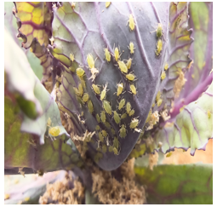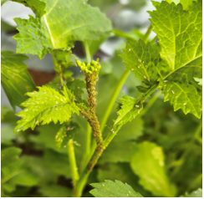
Fig 1: Aphids on red cabbage Fig 2: Aphids on Trap crop(bold mustard)
ii. Leaf Eating Caterpillar: Spodoptera litura
Spodoptera litura is a serious polyphagous insect pest affecting red cabbage and several other vegetable crops. The larval stage is highly destructive and causes severe damage by feeding on tender leaves, foliage and developing heads. Young larvae initially feed gregariously on the leaf surface, scraping the green matter, while older caterpillars become solitary and voracious feeders. Severe infestation reduces plant vigour, delays growth and affects proper head development, ultimately leading to lower yield and poor market quality.
Nature of Damage
The caterpillars cause irregular holes on leaves, skeletonization and partial or complete defoliation. Continuous feeding reduces photosynthetic activity and weakens the plants, thereby affecting normal growth and compact head formation. Severely infested plants produce smaller and loosely compact heads with poor colour expression. Damage to outer wrapper leaves and contamination of heads with larval excreta further reduce the appearance, market value and consumer acceptability of the produce. In severe cases, extensive foliage loss may expose heads directly to sunlight, causing quality deterioration.
Management Practices Followed
Management practices included regular field monitoring and hand picking of larvae during the early stages of infestation to reduce pest population. Infested and damaged leaves were removed and destroyed to prevent further spread of caterpillars within the field. Field sanitation and removal of weeds around the crop were also maintained to reduce favourable conditions for pest multiplication. These practices helped in minimizing caterpillar damage and maintaining better crop growth and head quality.

Highly effected – Treatment-1 followed by treatment- 7
Least effected- Treatment-6 followed by Treatment- 5
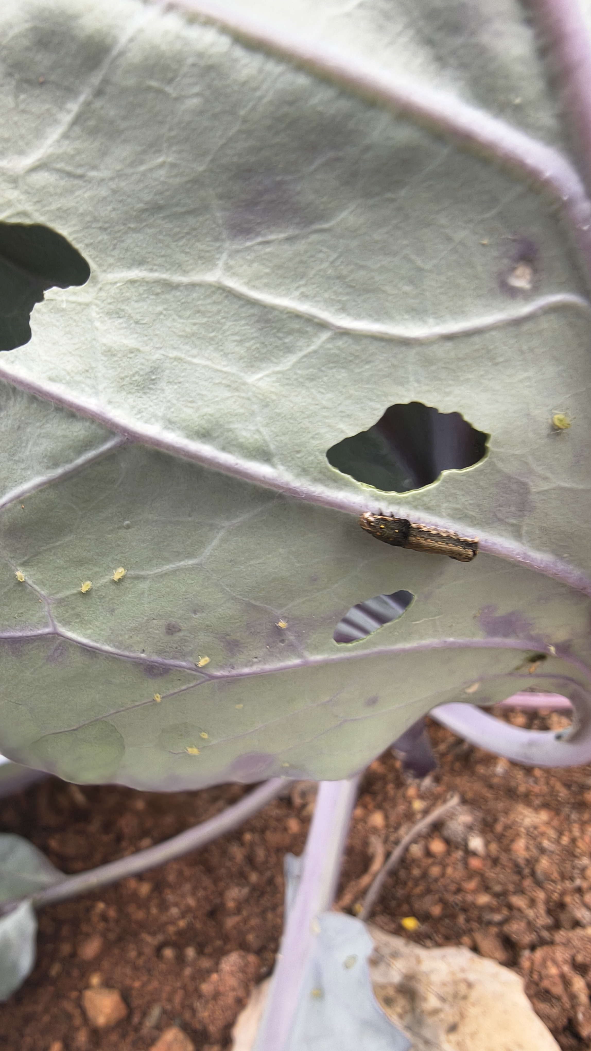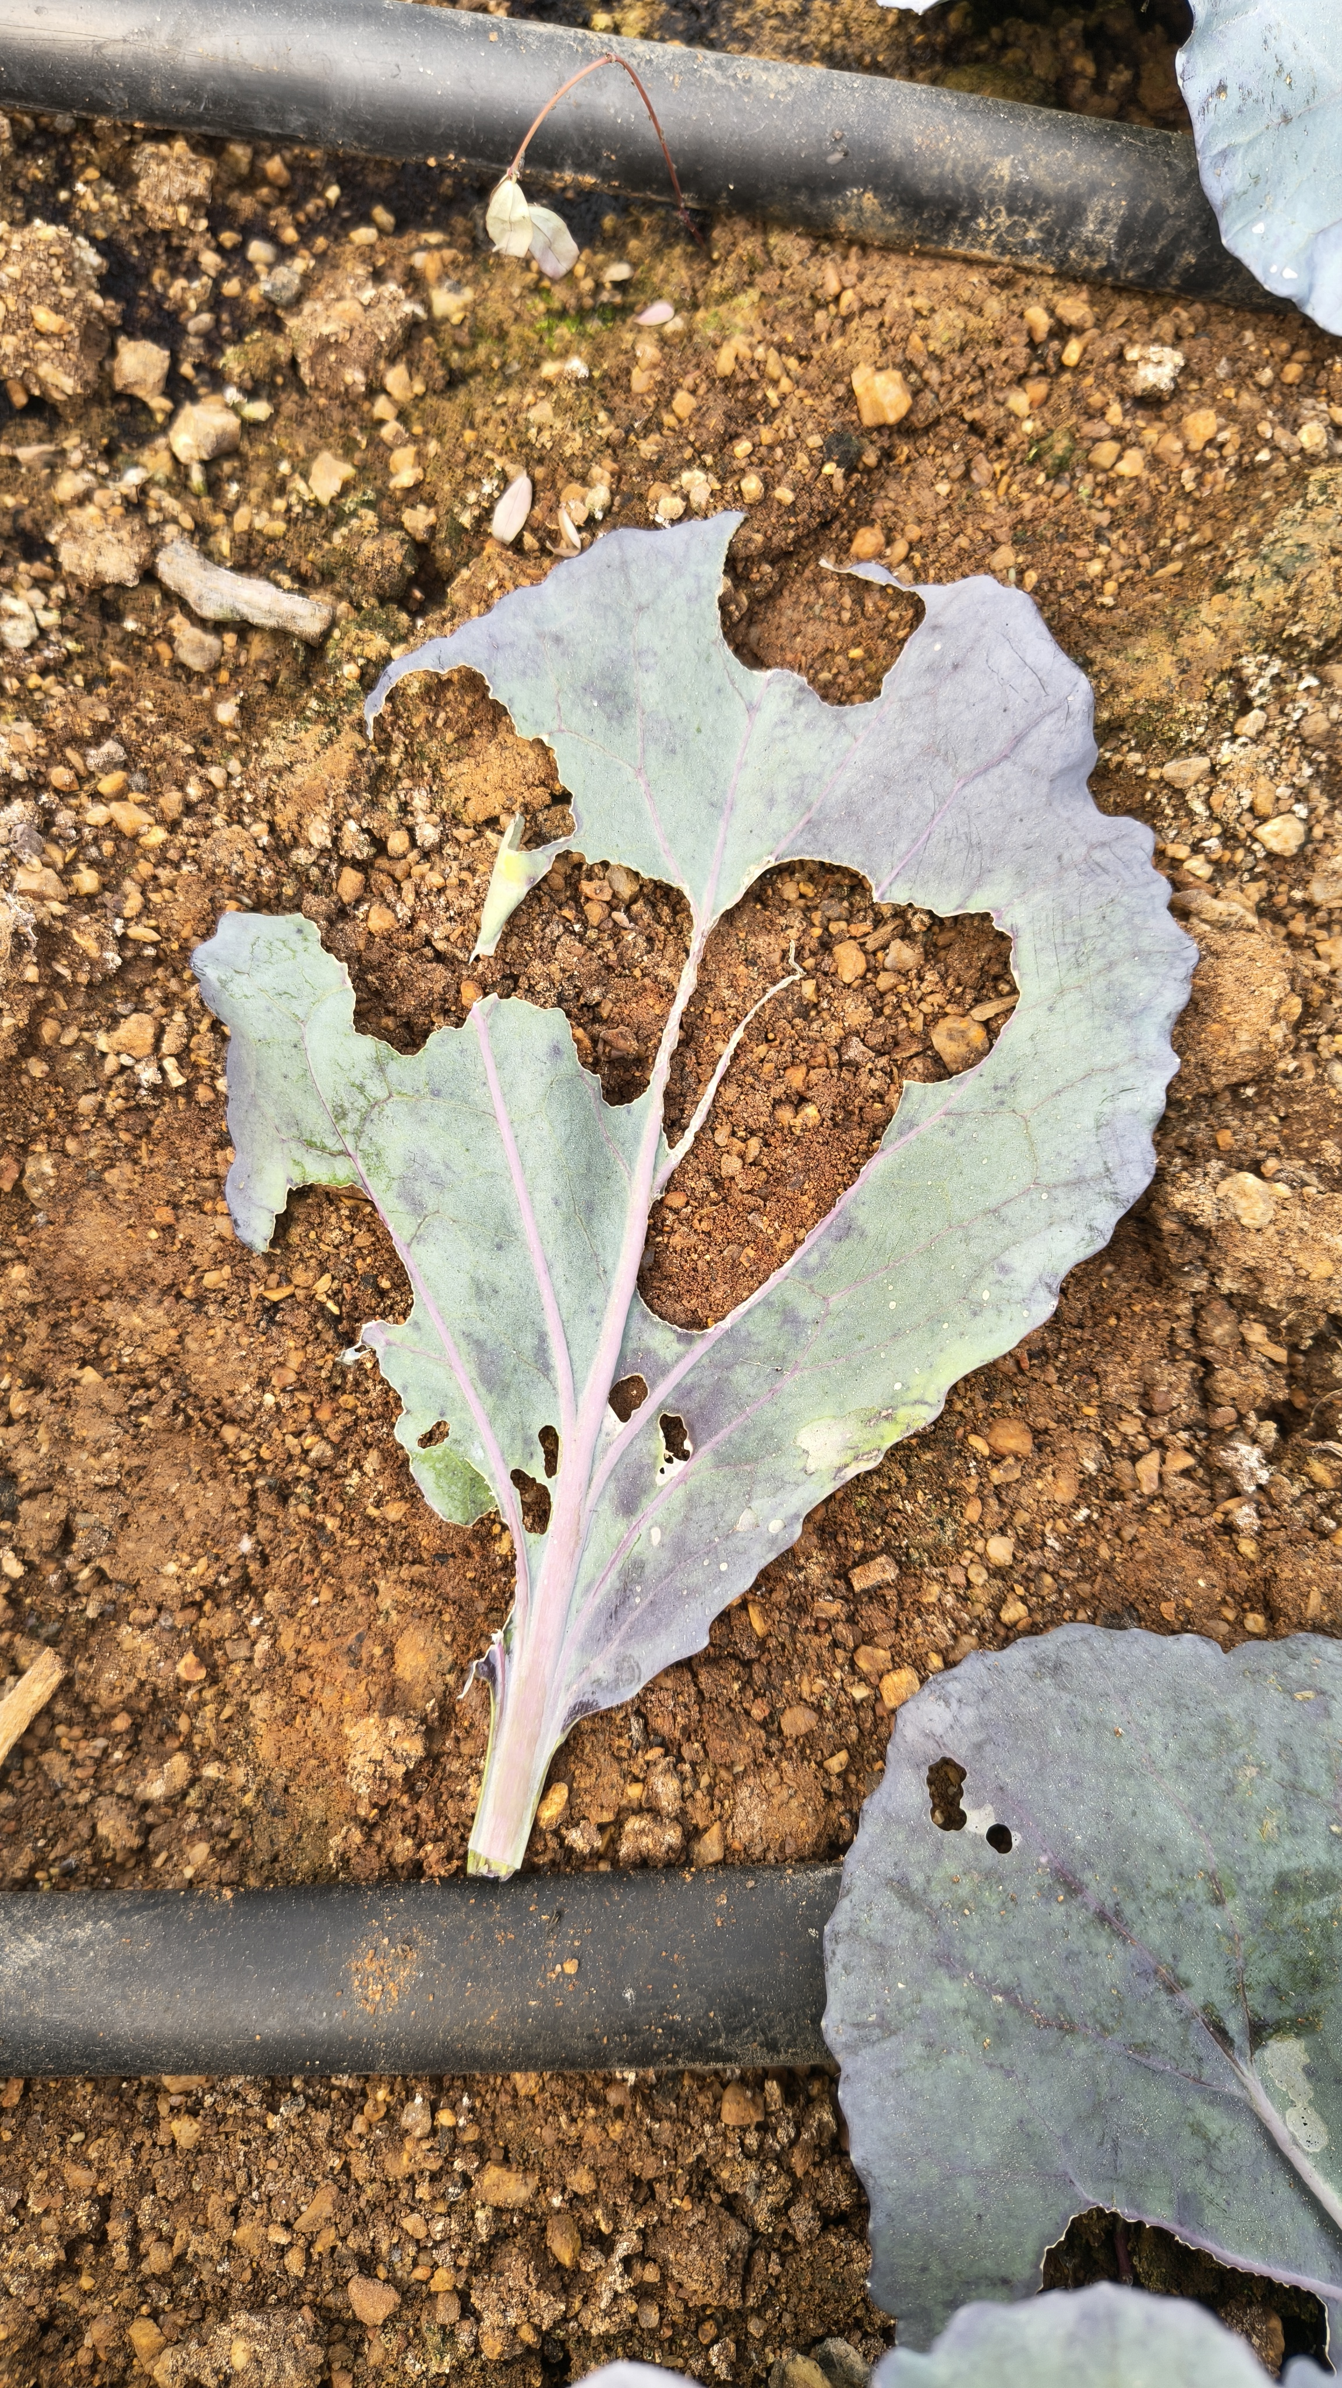
Fig 3: Spodoptera litura Fig 4: Skeletonization of leaf
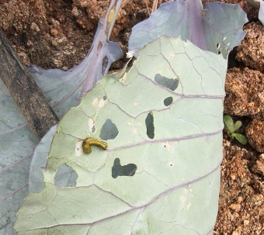
Fig 5: Irregular holes on leaves
- Cut worm: Agrotis ipsilon
Cutworms are nocturnal, soil-inhabiting lepidopteran larvae that cause serious damage to red cabbage, particularly during the early stages of crop growth. The larvae hide in the soil, plant debris or cracks during daytime and become active at night for feeding. In red cabbage, they mainly attack tender seedlings and newly developing heads by feeding at or near the soil surface. Young plants are highly susceptible to cutworm attack, and severe infestation can lead to heavy plant loss and poor crop establishment (Kishore et al., 2024)

Nature of Damage
Cutworms cut young stems at the base and feed on tender plant tissues, causing sudden wilting, drying and collapse of seedlings. They also chew the basal portion and developing heads, resulting in poor head formation and reduced plant vigour. In severe cases, complete plant mortality may occur, leading to gaps in the field and reduced plant population. Feeding damage also creates wounds that may facilitate secondary infection by soil-borne pathogens. Continuous infestation adversely affects crop growth, yield and market quality.

Management Practices Followed
Management practices included regular field inspection and manual collection and destruction of larvae and pupae from the soil and around affected plants. Infested and damaged plants were removed to prevent further spread of the pest. Proper field sanitation, removal of weeds and crop residues, and light earthing up around the plant base were also followed to minimize cutworm incidence. These practices helped in reducing pest population and protecting the crop during the vulnerable early growth stages.
- Top of Form

- Bottom of Form
Effected treatment – Treatment-7

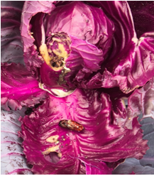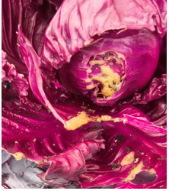
Fig 6: Cut worm pupa Fig 7: Damage of cutworm on cabbage head

DISEASES:
- Wire Stem
Wire stem is an important soil-borne disease of red cabbage caused by the fungus Rhizoctonia solani. The disease mainly affects young seedlings and transplanted plants during the early stages of crop growth. The pathogen attacks the collar region near the soil surface, damaging the cortical tissues and restricting normal growth. Under favourable conditions such as excessive soil moisture and poor aeration, disease incidence becomes severe and may reduce plant establishment in the field.
Symptoms
Affected plants remain erect but show poor vigour, slow growth and stunted appearance. The collar region near the soil surface becomes thin, constricted, hard and wire-like in appearance. In severe cases, the infected portion turns brown and dry, reducing nutrient and water movement within the plant. Diseased plants often fail to develop properly and produce weak or undersized heads, ultimately affecting yield and crop quality.
Management Practices Followed
Management practices included maintaining proper soil moisture and good aeration to reduce favourable conditions for fungal growth. Proper drainage was ensured to avoid water stagnation around the root zone. Removal of infected plants and maintaining field sanitation also helped in minimizing disease spread and improving healthy crop growth.
Effected treatment – treatment-1(2 plants), treatment- 7(1 plant)
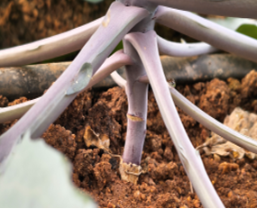
Fig 8: Wired stem at Initial stage

- Damping off:
Damping-off is a common and destructive disease affecting red cabbage during nursery and early growth stages. It is caused by soil-borne fungal pathogens mainly Pythium spp., Rhizoctonia solani and Phytophthora spp. The disease develops rapidly under favourable conditions such as excess soil moisture, poor drainage, overcrowding and high humidity. Young seedlings are highly susceptible, and severe infection may result in heavy seedling mortality and poor crop establishment.

Symptoms
Affected seedlings initially develop water-soaked lesions near the collar region, which later become soft and constricted. This is followed by rapid wilting, collapse and death of seedlings. Infected seedlings often dry suddenly, producing patchy areas in nursery beds or field conditions. Roots and lower stem portions may become weak, rotten and unable to support healthy growth. Severe disease incidence reduces seedling vigour, plant stand and overall crop performance.

Management Practices Followed
Management practices included regular monitoring and removal of dead and infected seedlings to prevent further spread of the disease. Proper drainage and adequate aeration were maintained to avoid excess moisture around the root zone. Overcrowding of seedlings was avoided to improve air circulation and reduce humidity around plants. Field sanitation and proper moisture management also helped in minimizing disease incidence and promoting healthy seedling growth.
Effected treatment: Treatment- 4 (3 plants), treatment- 2 (2 plants)
Table- 2: Percentage of infestation of cabbage pest occurred during the 2025- 2026
Pest/ disease | Average population per plant (pest) | Total plants effected | Plants examined
Aphids | 25- 42 | 20 | 252
Leaf eating caterpillar | 1-2 | 13 | 252
Cut worm | 1 | 2 | 252
Wire stem | - | 3 | 252
Damping off | - | 5 | 252
Conclusion:
The present study highlights that red cabbage cultivation is significantly affected by various insect pests and soil-borne diseases, among which aphids, leaf-eating caterpillars and cutworms were the major insect pests observed, while damping-off and wire stem were the diseases noticed during the early stages of crop growth. These biotic stresses adversely influenced crop establishment, plant vigor and overall productivity. The findings emphasize that sole reliance on chemical control measures is neither sustainable nor environmentally safe. The use of organic nutrient management practices involving FYM, vermicompost, neem cake, lignite and microbial consortium play a crucial role in improving soil health, enhancing microbial activity and reducing pest and disease incidence. Most of the pest and diseases were noticed in treatment- 7(control) and least attack in treatment- 6 followed by treatment- 5. Integrated use of these organic inputs can create a biologically active rhizosphere that suppresses soil-borne pathogens and improves plant tolerance to pests, thereby contributing to sustainable and eco-friendly red cabbage production.
References:
Gakuru, Peter Njoroge, Muriithi, Beatrice, Tonnang, Henri E. Z. and Subramanian, Sevgan (2025). Assessment of Cabbage (Brassica oleracea Linnaeus) insect pest infestation under different management practices. Agriculture. 15(21): 2203-2215.
Kassie, W.A. and Jenber, B. (2025). Efficacy of Botanicals to manage Cabbage Aphid on Cabbage. World Journal of Environmental Biosciences. 14(3): 14-23.
Kishore, S.M., Jemimah, N., Sridevi, G. and Reddy, M.V. (2024). Incidence of major insect pests and its natural enemies of cabbage (Brassica oleracea var. capitata) under polyhouse conditions. International Journal of Environment and Climate Change. 14(4): 9-17.
Lekamoi, U. and co-authors (2025). Sustainable insect pest management for cabbage production in Sub-Saharan Africa: A review. South African Journal of Botany. 186: 259-273.
Patel, J.R., Patel, N.B and Shah, A.H. (2017). Pest complex and management of cabbage under field conditions. Indian Journal of Agricultural Sciences. 87(4): 512–516.
Singh, Rajesh Kumar, Yadav, Om Prakash and Meena, Deepak Kumar (2023). Influence of organic amendments on insect pest incidence in cabbage ecosystem. Indian Journal of Entomology. 85(4): 1021-1027.
Srinivasan, R and Babu, P.C.S. (2019). Insect pest management in cole crops. Journal of Horticultural Sciences, 14(1), 1–10.
Yadav, A.K., Kumar, V and Singh, D. (2020). Role of organic manures and biofertilizers in sustainable vegetable production. International Journal of Chemical Studies, 8(5), 1760–1765.

