Comparative Efficacy of Bioagents, Botanical Extracts, and Fungicides on Seed Germination and Seedling Vigour Enhancement in Brassica juncea: An Integrated Seed Treatment Evaluation

Abstract
Seed-borne pathogens, particularly Alternaria brassicae, cause significant losses in Brassica juncea by reducing germination, lowering seedling vigour, and increasing early-season mortality. Sustainable seed treatment approaches using bioagents and botanical extracts offer eco-friendly alternatives to chemical fungicides, enhancing seed health and crop stand establishment. Seventeen treatments comprising bioagents (Trichoderma spp., Pseudomonas fluorescens, Bacillus subtilis), botanical extracts (garlic, ginger, turmeric, tulsi, lantana) and fungicides (Carbendazim + Mancozeb, Difenoconazole, Trifloxystrobin, Fluxapyroxad, Penflufen) were evaluated using the standard blotter method (ISTA guidelines). Germination percentage, seedling length, and seed vigour index (SVI) were recorded from three replications in a completely randomised design, and treatment means were compared using Duncan’s Multiple Range Test at the 5% probability level. Allium sativum (garlic) extract achieved the highest germination (96%), seedling length (4.1 cm), and vigour index (393.6), followed by Zingiber officinale (ginger) extract (92%, 3.8 cm, 349.6) and the Trichoderma harzianum + T. viride consortium (92%, 3.6 cm, 331.2). Botanical extracts consistently perfromed superior than bioagents and fungicides in vigour enhancement, while fungicide treatments showed moderate efficacy with mild phytotoxic effects at the concentrations tested. The untreated control recorded the lowest values (56%, 2.0 cm, 112.0). Statistical analysis confirmed highly significant inter-treatment differences (SEm ± 0.91; CD₀₅ = 2.63 for germination percentage). These findings demonstrate that garlic and ginger extracts and Trichoderma-based consortia are cost effective and environmentally compatible alternatives to chemical fungicides for integrated seed health management in mustard cultivation.
Keywords: Seed treatment, Bioagents, Botanical extracts, Trichoderma, Seed vigour index, Germination enhancement, Brassica juncea, Integrated disease management

1. Introduction
Brassica juncea L. (Indian mustard), an economically significant oilseed crop cultivated on 14.23 million hectares in India, faces substantial productivity challenges from biotic and abiotic stresses that affect seed quality, germination, and seedling establishment. Among these constraints, seed-borne pathogens, particularly Alternaria brassicae, cause significant economic losses by reducing germination rates, lowering seedling vigour, and increasing early-season mortality, ultimately affecting crop productivity and farmers' livelihoods (Saharan et al., 2016; Rajarammohan, 2023).
Seed treatment is a critical first line of defence in crop protection, providing targeted pathogen control while promoting healthy seedling establishment. Traditional chemical fungicide treatments, while effective against seed-borne pathogens, raise concerns about environmental persistence, residue accumulation, and the development of resistance in target organisms. The growing demand for sustainable agricultural practices has accelerated research into eco-friendly seed treatment alternatives, including biological control agents and plant-derived compounds.
Biological control agents, particularly Trichoderma species, offer multifaceted benefits for seed treatment by directly antagonising seed-borne pathogens, producing growth-promoting metabolites, and enhancing plant defence mechanisms. These beneficial microorganisms colonise seed surfaces, establishing protective biofilms and producing antimicrobial compounds, plant growth regulators, and enzymes that improve nutrient availability and seedling vigour (Harman et al., 2004; Mastouri et al., 2010; Verma et al., 2022).
Botanical extracts derived from medicinal and aromatic plants contain diverse bioactive compounds, including alkaloids, phenolics, essential oils, and phytohormone-like substances that exhibit both antimicrobial and growth-promoting properties. Plants such as garlic (Allium sativum), ginger (Zingiber officinale), and turmeric (Curcuma longa) possess well-documented antimicrobial activities along with compounds that enhance seed germination and seedling vigour through multiple physiological mechanisms (Aleem et al., 2020; Rathore et al., 2020; Rani et al., 2021).
Understanding the comparative efficacy of seed treatment approaches is essential for developing integrated seed enhancement strategies that optimise pathogen control and growth promotion while maintaining environmental sustainability. However, systematic comparative data on the relative performance of bioagents, botanical extracts and fungicides under identical laboratory conditions remain limited for mustard, and the underlying physiological mechanisms of germination enhancement are insufficiently characterised. This study, therefore, aimed to evaluate and compare the effectiveness of these three treatment categories on seed germination, seedling vigour, and seed health parameters in B. juncea under controlled laboratory conditions, and to identify treatment strategies suitable for integration into sustainable mustard production systems.

2. Materials and Methods

2.1 Experimental Materials and Treatment Preparation
Uniform, healthy Brassica juncea seeds were procured from certified sources and subjected to a preliminary quality assessment comprising moisture content determination, physical purity testing, and viability evaluation by tetrazolium chloride staining. Seeds with >85% viability were selected for experimental use. All seeds were surface-sterilised with 1% sodium hypochlorite for 1–2 minutes, followed by three successive washes with sterile distilled water to remove chemical residues, and then air-dried under laminar airflow conditions.
Bioagent formulations comprised talc-based preparations of Trichoderma harzianum, T. viride, T. asperellum, Pseudomonas fluorescens, and Bacillus subtilis, obtained from certified commercial sources. Working suspensions (10% w/v) were prepared by dissolving 10 g of the formulation in 100 mL of sterile distilled water and mixing thoroughly on a magnetic stirrer for 10 minutes to ensure uniform distribution. Fresh suspensions were prepared immediately before use to maintain viability and efficacy.
Botanical extracts were prepared from fresh plant materials, including garlic (Allium sativum) bulbs, ginger (Zingiber officinale) rhizomes, turmeric (Curcuma longa) rhizomes, tulsi (Ocimum tenuiflorum) leaves, and lantana (Lantana camara) leaves. Plant materials were thoroughly washed with sterile distilled water, surface-sterilised with 0.1% sodium hypochlorite, and separately crushed using a sterilized mortar and pestle. Crude extracts were filtered through double-layered muslin cloth, then through Whatman No. 1 filter paper, and finally diluted to 10% (v/v) with sterile distilled water.
Fungicidal solutions were prepared from commercial formulations, including Carbendazim 12% + Mancozeb 63% WP, Difenoconazole 25% EC, Trifloxystrobin 50% WDG, Fluxapyroxad 33.3% G/L, and Penflufen 240 FS. Required quantities of fungicides were accurately weighed on an analytical balance and dissolved in sterile distilled water to prepare 0.1% (w/v) solutions. All solutions were freshly prepared and used within 2 hours to prevent degradation of active ingredients.

2.2 Seed Treatment and Incubation Procedures
Surface-sterilized seeds were treated with respective bioagent suspensions, botanical extracts, or fungicidal solutions under aseptic conditions in a laminar airflow chamber. Seeds were immersed in the treatment solutions for 30 minutes, with gentle agitation every 10 minutes to ensure uniform coverage. Control seeds were treated with sterile distilled water using identical procedures. After treatment, seeds were air-dried on sterile filter papers for 15 minutes to remove excess moisture while retaining treatment efficacy.
Treated seeds were placed on sterilized, moist blotter papers in sterile Petri plates (10 cm diameter) following the standard blotter method as per International Seed Testing Association (ISTA) guidelines, a widely adopted protocol for assessing seed treatment biostimulant effects on germination and early seedling growth (Puglisi et al., 2022). Each plate contained exactly 30 seeds arranged in a systematic grid pattern with adequate spacing to prevent contact between seeds. Three replications were maintained per treatment, with each replication comprising separate plates to ensure statistical validity.
Petri plates were incubated in a BOD incubator at 27±1°C under a 12-hour light/12-hour dark photoperiod to simulate natural conditions. Relative humidity was maintained at 85-90% using saturated blotting papers, with sterile distilled water added as required to maintain optimal moisture levels. Temperature and humidity were continuously monitored using digital sensors to maintain consistent environmental conditions throughout the incubation period.
Germination assessments were conducted daily from the 3rd day post-incubation to monitor germination kinetics. Seeds showing visible radicle emergence (≥2 mm) were considered germinated. Final observations were recorded on the 12th day after incubation, when the maximum difference in germination between treatments was evident, enabling a clear assessment of treatment effects on early germination vigour and seedling establishment potential.

2.3 Data Collection and Analysis
Germination percentage was calculated using the formula: Germination (%) = (Number of seeds germinated / Total number of seeds) × 100. Seedling length was measured from the root tip to the shoot apex using digital callipers with 0.1 mm precision for 10 randomly selected normal seedlings per replicate. Seed vigour index was calculated using the formula of Abdul-Baki and Anderson (1973): SVI = Germination (%) × Mean seedling length (cm).
Morphological observations included assessments of radicle development, shoot emergence, seedling uniformity, and any abnormalities or phytotoxic effects. Digital photography was used to document representative seedlings from each treatment for comparative analysis. Data from three replicates were subjected to analysis of variance (ANOVA) using a completely randomized design.
Statistical analysis was performed using SPSS version 26.0 after testing the data for normality and homogeneity of variances. Treatment means were compared using Duncan's Multiple Range Test (DMRT) at the 5% significance level. Standard error of the mean (SEm±) and critical difference (CD) values were calculated to assess statistical significance and establish confidence intervals for treatment comparisons.

3. Results

3.1 Comparative Efficacy of Seed Treatments on Germination and Vigour
The evaluation of various bioagents, botanical extracts, and fungicides revealed substantial variation among treatments in seed germination enhancement and seedling growth promotion compared to the untreated control (Table 1). Treatments showed distinct patterns of efficacy, with botanical extracts consistently outperforming others across most parameters evaluated.
Allium sativum (garlic) extract exhibited the highest overall performance,recording 96% germination, 4.1 cm seedling length, and a remarkable seed vigour index of 393.6. The treated seeds showed exceptionally dense germination, pronounced radicle elongation, and vigorous shoot development, indicating potent growth-promoting effects. Zingiber officinale (ginger) extract ranked second, with 92% germination, 3.8 cm seedling length, and a vigour index of 349.6, along with uniform seedling emergence with well-developed radicles and healthy shoots.
Curcuma longa (turmeric) extract demonstrated significant positive effects, with 88% germination, 3.6 cm seedling length, and a vigour index of 316.8, characterized by clear radicle and shoot elongation. Ocimum tenuiflorum (tulsi) extract recorded 80% germination, 3.0 cm seedling length, and a vigour index of 240.0, while Lantana camara extract achieved 76% germination, 2.5 cm seedling length, and a vigour index of 190.0. All botanical extracts significantly performed superior over control treatments, demonstrating consistent growth-promoting capabilities.
Regarding bioagent efficacy, the combined formulation of Trichoderma harzianum + T. viride showed the highest performance among microbial treatments, with 92% germination, 3.6 cm seedling length, and a vigour index of 331.2, exhibiting uniform germination patterns and well-developed radicle structures. Individual Trichoderma species showed differential effects: T. harzianum achieved 88% germination with 3.4 cm length (vigour index 299.2), while T. viride recorded 80% germination with 3.2 cm length (vigour index 256.0). T. asperellum showed moderate performance with 72% germination, 2.9 cm length, and a vigour index of 208.8.
Bacterial bioagents showed variable effectiveness, with Pseudomonas fluorescens showing comparatively better performance by recording 75% germination, a seedling length of 2.8 cm, and a vigour index of 210.0, indicating moderate seed enhancement. Bacillus subtilis showed lower efficacy, with 68% germination, a seedling length of 2.4 cm, and a vigour index of 163.2, indicating species-specific variation in growth-promotion mechanisms.
Fungicidal treatments showed moderate effectiveness, with some exhibiting mild phytotoxic effects. Carbendazim 12% + Mancozeb 63% WP and Trifloxystrobin 50% WDG performed comparably, with germination rates of 72% and 73%, seedling lengths of 2.5 and 2.6 cm, and vigour indices of 180.0 and 189.8, respectively. Fluxapyroxad 33.3% G/L and Difenoconazole 25% EC achieved germination rates of 67% and 64%, with corresponding vigour indices of 167.5 and 153.6. Penflufen 240 FS showed the poorest fungicidal performance, with only 60% germination, a seedling length of 2.2 cm, and a vigour index of 132.0, suggesting potential phytotoxic effects at the tested concentrations.
The untreated control exhibited the lowest values across all parameters, with 56% germination, 2.0 cm seedling length, and a vigour index of 112.0, and was characterized by sparse, irregular germination patterns and weak seedling development. Statistical analysis revealed highly significant inter-treatment variation, with standard errors of the mean (SEm) of 0.91 for germination percentage and 0.04 cm for seedling length. The critical difference (CD) at the 5% significance level was 2.63 for germination percentage and 0.12 cm for seedling length, confirming that the observed differences represent genuine treatment effects.

Table 1: Effect of different bioagents, botanical extracts and fungicides on seed germination

Treatment no. | Treatment details | Germination (%) | Seedling length (cm) | Seed vigour index | Appearance
T₁ | Trichoderma harzianum (Indicate the concentrations used) | 88 | 3.4 | 299.2 | Dense root development and healthy seedlings
T₂ | Trichoderma viride | 80 | 3.2 | 256.0 | Good germination with long radicles
T₃ | Trichoderma asperellum | 72 | 2.9 | 208.8 | Moderate germination with medium seedlings
T₄ | T. harzianum + T. viride | 92 | 3.6 | 331.2 | Uniform germination with well-developed radicles
T₅ | Pseudomonas fluorescens | 75 | 2.8 | 210.0 | Moderate germination with visible radicle development
T₆ | Bacillus subtilis | 68 | 2.4 | 163.2 | Moderate germination with small seedlings
T₇ | Allium sativum (Garlic extract) | 96 | 4.1 | 393.6 | Very dense germination with long radicles and vigorous shoots
T₈ | Zingiber officinale (Ginger extract) | 92 | 3.8 | 349.6 | Vigorous seedlings with long radicles and healthy shoots
T₉ | Curcuma longa (Turmeric extract) | 88 | 3.6 | 316.8 | Good germination with long radicles and moderate shoot growth
T₁₀ | Ocimum tenuiflorum (Tulsi extract) | 80 | 3.0 | 240.0 | Moderate seedling growth with medium shoots
T₁₁ | Lantana camara extract | 76 | 2.5 | 190.0 | Moderate germination with short shoots and roots
T₁₂ | Carbendazim 12% + Mancozeb 63% WP | 72 | 2.5 | 180.0 | Moderate germination with medium radicles
T₁₃ | Difenoconazole 25% EC | 64 | 2.4 | 153.6 | Lower germination with small seedlings
T₁₄ | Fluxapyroxad 33.3% G/L | 67 | 2.5 | 167.5 | Moderate germination with slightly short radicles
T₁₅ | Penflufen 240 FS | 60 | 2.2 | 132.0 | Low germination and short seedlings
T₁₆ | Trifloxystrobin 50% WDG | 73 | 2.6 | 189.8 | Good moderate germination with good medium shoot growth
T₁₇ | Control (untreated) | 56 | 2.0 | 112.0 | Sparse germination
 | SEm (±) | 0.91 | 0.04 | 11.24
 | CD (5%) | 2.63 | 0.12 | 32.56

Indicate the isolate names

Fig. 1: Effect of different bioagents, botanical extracts and fungicides on seed germination
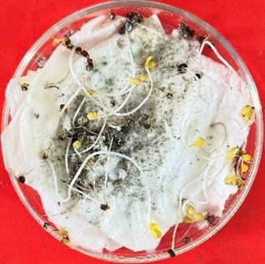  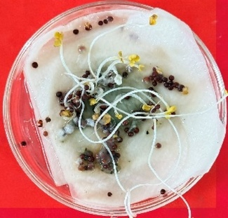 |  | 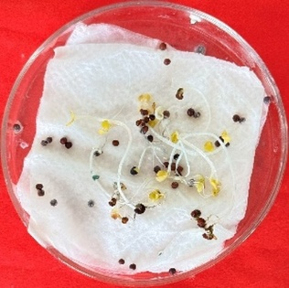 | 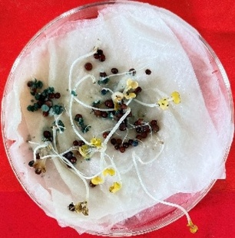 | 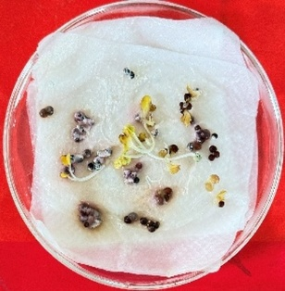  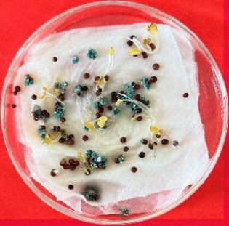
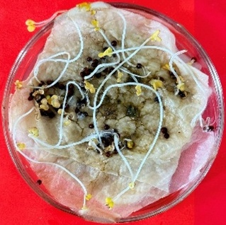  T. harzianum | 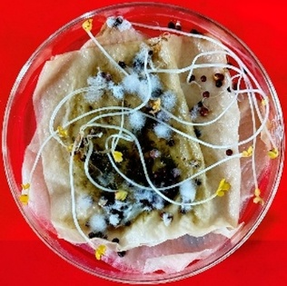  T. viride | 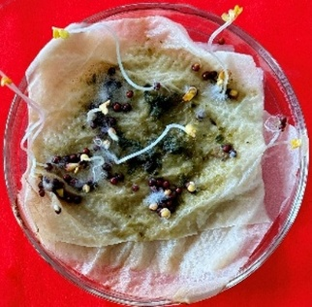  T. asperellum | T. harzianum + T. viride | P. fluorescens | Bacillus subtilis
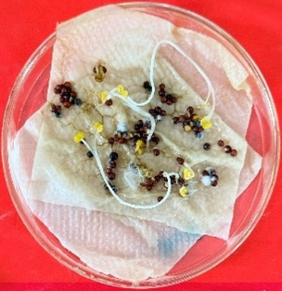
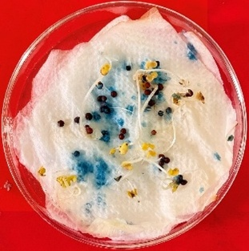
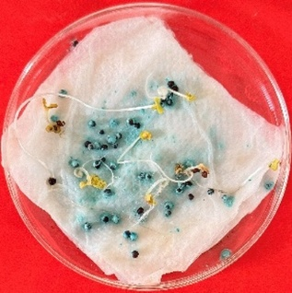  Garlic | Ginger | Turmeric | Tulsi | Lantana | Carbendazim 12% + Mancozeb 63% WP
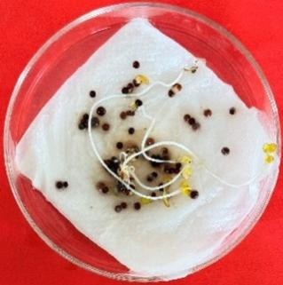 | 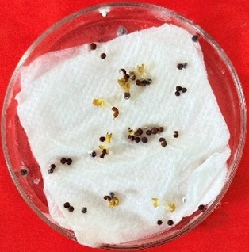 | 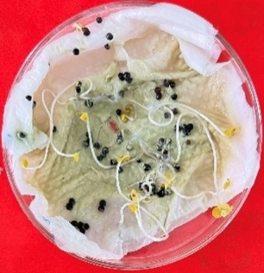 | 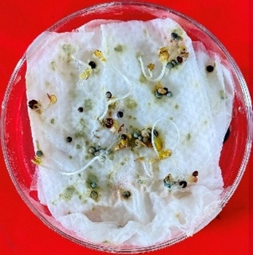
Difenoconazole 25 % EC | Fluxapyroxad 33.3% G/L | Penflufen 240 FS | Trifloxystrobin 50%WDG | Control

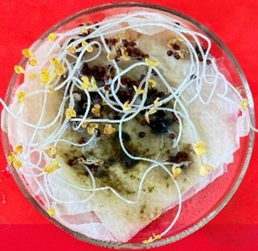

Plate 1: Effect of different bioagents, botanical extracts and fungicides on seed germination

4. Discussion
The enhanced performance of botanical extracts, particularly garlic and ginger, could be associated with their diverse phytochemical constituents, including growth-promoting compounds such as gibberellin-like substances, auxin-like compounds, cytokinins, and essential micronutrients. Garlic extract’s exceptional effectiveness (96% germination, vigour index 393.6) likely results from allicin and related organosulfur compounds that provide antimicrobial protection and metabolic stimulation, and correct poor germination in pathogen-infested seeds (Perelló et al., 2013; Rani et al., 2021). These compounds enhance cellular membrane permeability, accelerate enzyme activation, and promote rapid mobilisation of seed reserves during germination. Similarly, the moderate but significant performance of Ocimum tenuiflorum extract (vigour index 240.0) is consistent with the antimicrobial and growth-stimulating phenolics and terpenoids reported in tulsi (Khan et al., 2023). The superior performance of ginger extract aligns with the well-documented presence of the antimicrobial compounds gingerols and shogaols in Zingiber officinale rhizomes (Aleem et al., 2020). Lantana camara extract, though least effective among botanicals (vigour index 190.0), still outperformed all fungicidal and most bacterial bioagent treatments, indicating the broad utility of plant-derived extracts even from non-food species.
The effectiveness of Trichoderma-based treatments, particularly the T. harzianum + T. viride consortium (vigour index 331.2), demonstrates the synergistic benefits of combining complementary beneficial fungi (Mastouri et al., 2010; Verma et al., 2022; Puglisi et al., 2022). This synergy likely arises from diverse metabolite production, broader-spectrum pathogen suppression, and complementary niche colonization of the seed surface. Individual Trichoderma species exhibited differential performance, suggesting strain-specific variation in growth-promoting metabolites and mycoparasitic potential.
Fungicidal treatments showed moderate efficacy but consistently lower vigour indices than botanical and bioagent treatments, indicating potential phytotoxic interference with seed metabolic processes. The poor performance of Penflufen 240 FS (vigour index 132.0) suggests possible concentration-dependent phytotoxicity, indicating the need for dose optimisation. This observation is consistent with the findings of Yadav et al. (2024), who reported that SDHI fungicides at higher seed-coat concentrations may inhibit early root enzymatic activity.This finding emphasises the importance of balancing pathogen control efficacy with seedling safety in chemical seed treatments.
Bacterial bioagents exhibited intermediate performance between the Trichoderma treatments and the fungicide treatments. Pseudomonas fluorescens (vigour index 210.0) produces siderophores, HCN, and IAA, which promote root elongation and suppress seed-borne pathogens (Sindhu et al., 2022; Mitra et al., 2021), whereas B. subtilis (vigour index 163.2) exhibited the lowest efficacy among bioagents, possibly due to suboptimal colonisation of mustard seed surfaces under the blotter method conditions. The relative inferiority of bacterial bioagents to fungal bioagents in this study may reflect the importance of mycelial colonisation of seed surfaces and the production of cell wall-degrading enzymes, which are not available to bacterial agents, in enhancing early seedling growth under in vitro conditions (Harman et al., 2004).
These results align with findings from Rathore et al., (2020), Rani et al., (2021), and Verma et al., (2022), confirming that botanical extracts and bioagent formulations enhance seedling vigour more effectively than chemical fungicides. The mechanisms underlying the efficacy of botanical extracts include enhanced enzyme activity, improved nutrient mobilisation, and stimulation of early seedling metabolic processes via natural growth regulators and bioactive compounds.

5. Conclusion
This study establishes that plant-based seed treatments, particularly garlic and ginger extracts, are highly effective and environmentally compatible options for seed health management and germination enhancement in Indian mustard. The Trichoderma harzianum + T. viride consortium offers a viable biological alternative when botanical extracts are unavailable, whereas chemical fungicides require careful dose optimisation to avoid phytotoxicity. Future research should validate these treatments under field conditions across diverse environments, investigate optimal combinations of botanical extracts with bioagent consortia, and elucidate the molecular mechanisms underlying seed germination enhancement, including quantification of phytohormones and transcriptomic profiling. Such research will facilitate the development of evidence-based, integrated seed treatment protocols for sustainable Brassica production systems in the Indo-Gangetic plains and comparable agroecological zones.

References
Abdul-Baki, A. A. and Anderson, J. D. (1973). Vigor determination in soybean seed by multiple criteria. Crop Science, 13, 630–633.
Aleem, M., Khan, M. I., Shakshaz, F. A., Akbari, N. and Anwar, D. (2020). Botany, phytochemistry and antimicrobial activity of ginger (Zingiber officinale): A review. International Journal of Herbal Medicine, 8(6), 36–49.
Harman, G. E., Howell, C. R., Viterbo, A., Chet, I. and Lorito, M. (2004). Trichoderma species—Opportunistic, avirulent plant symbionts. Nature Reviews Microbiology, 2, 43–56.
Khan, M. A., Ali, S. and Hussain, T. (2023). Effect of Ocimum tenuiflorum extract on seed germination and seedling development. Crop Protection, 168, 106240.
Mastouri, F., Björkman, T. and Harman, G. E. (2010). Seed treatment with Trichoderma harzianum alleviates biotic and abiotic stresses in germinating seeds and seedlings. Phytopathology, 100, 1213–1221.
Mitra, D., Mondal, R., Khoshru, B., Shadangi, S., Mohapatra, P. K. D. and Panneerselvam, P. (2021). Rhizobacteria-mediated seed bio-priming triggers resistance and plant growth. Current Research in Microbial Sciences, 2, 100071.
Perelló, A., Gruhlke, M. C. H. and Slusarenko, A. J. (2013). Effect of garlic extract on seed germination, seedling health and vigour. Journal of Plant Protection Research, 53, 317–323.
Rani, S., Kumar, A. and Singh, R. (2021). Effect of garlic (Allium sativum) extract on seed germination, seedling growth and vigour of mustard. Indian Journal of Plant Protection, 49, 210–216.
Rajarammohan, S. (2023). Transcriptome analysis of the necrotrophic pathogen Alternaria brassicae reveals insights into its pathogenesis in Brassica juncea. Frontiers in Plant Science, 14, 1071298.
Rathore, R., Sharma, P. and Singh, V. (2020). Effect of turmeric (Curcuma longa) extract on seed germination and seedling vigour. Journal of Plant Pathology and Microbiology, 11, 245–250.
Saharan, G. S., Mehta, N., Meena, P. D. and Dayal, P. (2016). Alternaria diseases of crucifers: Biology, ecology and disease management. Springer, Singapore, pp. 1–293.
Sindhu, S. S., Sharma, R., Sindhu, S. and Sehrawat, A. (2022). Role of plant growth-promoting Pseudomonas in improving crop productivity. Journal of Plant Interactions, 17, 220–238.
Verma, S., Patel, R. and Gupta, N. (2022). Combined application of Trichoderma harzianum and Trichoderma viride enhances seed germination and seed vigour. Journal of Biological Control, 36, 45–52.
Puglisi, I., De Pasquale, F., Nicolosi, E., Vanella, D. and Baglieri, A. (2022). Seed treatments with microorganisms influence germination and seedling growth. Plants, 11, 259.
Yadav, P., Singh, D. and Choudhary, R. (2024). Evaluation of fungicidal seed treatment on germination and seed vigour. Journal of Plant Disease Protection, 131, 89–97.

Declarations
Ethics approval and consent to participate: Not applicable. This study did not involve human participants, human data, or animals.
Consent for publication: Not applicable.
Availability of data and materials: All data generated or analysed during this study are included in this published article.
Competing interests: The authors declare no competing interests.

