Short Research Article
Biology and Phenology of Fimbristylis miliacea (L.) in wet direct seeded rice under humid tropical conditions

ABSTRACT
Aims: To study the phenology, growth, floral biology, seed characteristics, and propagation behaviour of F. miliacea under wet direct-seeded rice conditions.
Study design: Field experiment under wet direct-seeded rice ecosystem.
Place and Duration of Study: Farmer’s field at Moncompu, Alappuzha district, Kerala, India during kharif 2023 (August–December 2023).
Methodology: Ten randomly selected plants of F. miliacea from weedy check plots were tagged and observed from germination to maturity. Phenological stages, growth parameters, floral traits, and seed characters were recorded and statistically analysed using mean, standard deviation, and standard error.
Results: Fimbristylis miliacea completed its life cycle within 76–95 days under humid tropical conditions. Germination occurred within 3–7 days and flowering within 25–32 days. The weed attained a mean height of 82.41 cm and produced an average of 6.2 tillers per plant. High reproductive potential was observed with 91.3 spikelets per inflorescence and 28,394 seeds per plant. The weed produced minute lightweight seeds (0.0332 g per 1000 seeds), which were shed along with glumes after maturity, contributing to persistent soil seed banks and effective dispersal.
Conclusion: Rapid growth, early maturity, prolific seed production, and efficient seed dispersal enable F. miliacea to persist and dominate wet direct-seeded rice ecosystems. Timely integrated management strategies targeting early growth and reproductive stages are essential for effective control.

Keywords: Biology, phenology, Fimbristylis miliacea, ecology, sedges, wet land rice

- INTRODUCTION

Fimbristylis miliacea (L.) Vahl, commonly known as ‘globe fringe rush’ or ‘hoorah grass’, is an important sedge weed belonging to the family Cyperaceae. It is widely recognized as one of the most problematic weed species in rice-based cropping systems (IRRI, 2024). Although the species is believed to have originated in tropical America, it is now widely distributed across major rice-growing regions of the world and is particularly dominant in Southeast Asian rice ecosystems (Moody, 1989). The success of F. miliacea in wetland rice environments could be largely attributed to its high ecological adaptability. The species is capable of germinating under submerged or saturated soil conditions and exhibits rapid early growth, which enhances its competitive ability against rice (Begum et al., 2008).
In recent years, changes in crop establishment methods, particularly the increasing adoption of wet-seeded rice systems has led to severe weed infestation and unrestricted weed growth in rice was reported to remove as much as 43.05 kg N, 3.08 kg P, and 48.28 kg K ha⁻¹ from the system (Reddy and Ameena, 2021). Repeated use of herbicides targeting grass weeds have resulted in shifts in weed flora composition (Sekhar et al., 2024). Consequently, sedges have gained prominence, with F. miliacea emerging as a major weed problem. Ameena et al. (2025a) reported that F. miliacea was the most dominant sedge species in direct-seeded rice ecosystems, frequently prevailing over grasses and broad-leaved weeds causing substantial yield reduction in direct-seeded rice. Inadequate management of this weed can lead to considerable yield reductions, with losses reported up to 42 % in rice (Begum, 2006). The weed also causes considerable damage through lodging, which interferes with mechanized harvesting and reduces overall crop productivity (Sethulakshmi et al.,2024). The present study was undertaken to study the phenology and biology of F. miliacea, with a view to developing effective management strategies.

- MATERIALS AND METHODS
Field experiments were carried out during the kharif season of 2023 (August to December) in a farmer’s field at Moncompu, Alappuzha district, Kerala, where heavy infestation of Fimbristylis miliacea had been consistently reported. The experimental site is located at 9°5′ N latitude and 76°5′ E longitude, with an elevation ranging from 0.5 to 2.0 m below mean sea level. During the cropping period, the mean temperature was 29.77 °C, relative humidity was 82.6 %, and total rainfall received was 185.26 mm. The soil of the experimental field was extremely acidic in nature with a pH of 3.89 with normal electrical conductivity of 0.9 dS m⁻¹ at 25 °C. The soil was high in organic carbon content (2.3%), while available nitrogen (301.76 kg ha⁻¹), available phosphorus (20.72 kg ha⁻¹), and available potassium (264.91 kg ha⁻¹) were in the medium range. The field had been under continuous rice cultivation for several years. Land preparation involved thorough puddling followed by proper levelling. The wet seeded rice crop was raised by broadcasting pregerminated seeds at a seed rate of 100 kg per ha.
For studying the phenology and growth of F. miliacea, ten plants were randomly selected from the plots where no weeding operation was allowed as per treatments (weedy check). The weed flora of the field consisted of a mixture of grasses, sedges, and broad-leaved weeds. The plants of F. miliacea were closely monitored from germination onwards. After germination, ten plants of F. miliacea were randomly selected, tagged and continuously observed until maturity. Observations were recorded on growth stages and developmental parameters throughout the life cycle of the weed. Phenological observations on F. miliacea included days to germination, active tillering, flowering, spike maturity, lodging, seed maturity, and complete drying of the plant, and were recorded as days after emergence based on visual observations. Growth and floral parameters such as plant height, number of leaves and tillers, root length, dry matter production, number of inflorescences, spikelets, spike length, and spike diameter were measured using standard procedures. Reproductive characters including number of seeds per spikelet, number of seeds per plant, and thousand-seed weight were also recorded, and the data were statistically analysed and expressed as minimum, maximum, mean, and standard error of mean (SEm). Statistical analysis was done using the statistical package GRAPES 1.0.0 developed by the Kerala Agricultural University (https://www.kaugrapes.com).
- RESULTS AND DISCUSSION
3.1 Phenology of F. miliacea under humid tropical conditions
F. miliacea was observed to pass through five distinct phenological stages to complete its life cycle under wet-seeded rice conditions. These stages included germination, active tillering, flowering, spike development, seed maturity and complete drying. Seed germination commenced within 3 to 7 days in wet seeded rice under humid tropical conditions with a mean temperature of 30°C and relative humidity of above 80%. These climatic conditions favoured early germination and establishment. Active tillering was observed between 17 and 23 days, indicating rapid vegetative growth and enhanced clump formation competing with the crop for resources during the critical period of crop weed competition exerting intense competition with rice. The prevailing climatic conditions, together with the extremely acidic soil (pH 3.89), normal electrical conductivity, high organic carbon content (2.3%), and medium availability of nitrogen, phosphorus, and potassium, appeared to favour the vegetative growth and establishment of F. miliacea in lowland rice. Flowering was initiated between 25 and 32 days, followed by spike development and maturity between 36 and 43 days. Begum et al. (2008) reported that the seed started emerging 3 days after planting and first tillering of the plant commenced at 35 days after seedling emergence. Early flowering was observed to ensure timely completion of the reproductive phase within the crop duration. Similarly, early flowering behaviour in F. miliacea has been reported by Awan et al. (2020).
Seed maturity occurred between 56 and 68 days with a mean of 63 days, after which seeds were shed into the soil, contributing to the soil seed bank. The weed exhibited lodging after growth for a period of 49 to 58 days (Table 1.). which facilitated seed dispersal by bringing spikelets in close contact with the soil surface. Similar lodging-mediated seed dispersal has been reported in Schoenoplectus juncoides, where the weed exhibited lodging one week after attaining spike maturity which coincided with 40th day of growth (Umkhulzum et al., 2019). Complete drying of the plant occurred between 76 and 95 days, indicating synchronization of the weed life cycle with that of the rice crop. Similar life cycle duration in F. miliacea has been reported by Begum et al. (2008), Begum et al. (2008) where it is observed after reaching maximum height at around 10 weeks. Later the plant enters the senescence phase, characterized by drying of leaf tips and cessation of growth.
Table 1. Phenology of F. miliacea under humid tropical conditions
Characteristics | Range | Mean ± SD | SEm (±)
Days to germination | 3-7 | 4.50 ± 1.27 | 0.40
Days to active tillering (active tillering) | 17-23 | 19.30 ± 2.11 | 0.66
Days to flowering (first anthesis) | 25-32 | 26.90 ± 2.23 | 0.70
Days to spike maturity | 36-43 | 40.10 ± 2.56 | 0.80
Days to lodging | 49-58 | 52.60 ±3.10 | 0.97
Days to seed maturity | 56-68 | 63 ± 4.27 | 1.34
Days to complete drying | 76-95 | 82.50 ± 6.19 | 1.95

Table 2. Habit, habitat and general description of globe fringerush (F. miliacea)
Characteristics | Description
Habit | Annual tufted sedge
Habitat | Wetland rice fields, direct-seeded rice fields, irrigated lowlands, rice bunds, canals, and moist habitats
Season | Occurs throughout the year under favourable moisture conditions; profuse growth observed during the rainy season and kharif period
Shoot | Erect, slender, tufted culms arising from the base; culms smooth and solid.
Leaves | Linear, narrow leaves arising mainly from the base; leaf blades smooth, flat, and grass-like with pointed tips
Root system | Fibrous root system adapted to wetland conditions
Inflorescence | Compound umbel-like inflorescence with numerous spikelets clustered at the tip of the culm
Spikelets | Small, ovoid to oblong spikelets, brown to yellowish-brown at maturity, containing several florets
Seeds (achenes) | Minute, light yellow colour achenes, easily shattered at maturity and capable of forming persistent soil seed banks
Propagation | Mainly through seeds (achenes); prolific seed producer with easy dispersal through irrigation water and field operations

3.2 Shoot and Root Characters
F. miliacea was observed as a tufted, annual sedge with slender, erect shoots arising from the base. Culms (stems) were observed to be thin, smooth, growing upright without branching. Plant height ranged from 4.21 cm at seedling stage to 82.41 cm at maturity with an average tiller production of 6.2 per plant (Table 3.) contributing to clump formation. The humid climate and acidic soil conditions, along with high organic carbon and moderate nutrient availability in lowland rice fields are highly favourable for the vigorous growth of F. miliacea. Similar growth patterns have been earlier reported in F. miliacea by Begum et al. (2008). Similarly, Awan et al., (2020) observed that F. miliacea when grown without rice interference in aerobic condition can produce 7 tillers per plant.
Leaves were long and narrow, with a mean length of 42.49 cm and width of 0.30 cm. Such morphology is typical of sedges and is considered an adaptation to flooded environments In F. miliacea, the leaves are predominantly basal, arising from the base of the plant, while the culm bears only reduced bladeless sheaths. Comparable leaf characteristics have been reported in F. littoralis and F. quinquangularis (Aryal, 2023).
The root system was fibrous with mean length of 18.86 cm. Fibrous roots are characteristic of sedges and enhance nutrient uptake under anaerobic soil conditions. Awan et al. (2020) reported that F. miliacea develops a well-established fibrous root system, which facilitates efficient nutrient uptake under anaerobic conditions. Growth studies conducted in rice fields have indicated that the root system of F. miliacea expands more rapidly compared to that of rice (Holm et al., 1991). The roots proliferate extensively in all directions, penetrating the crop root zone and eventually encircling rice roots, thereby intensifying competition for available nutrients. (Chauhan and Johnson, 2009)
Dry matter production of the weed under humid tropical conditions in soils with higher acidity and nutrient status ranged from 1.4 to 3.7 g per plant (Table 3.). Under these soil conditions, the vigorous growth could be due to its strong adaptability to acidic, waterlogged rice ecosystems. The high organic carbon content and medium availability of major nutrients might have supported active vegetative growth and tillering. Biomass accumulation in sedges is influenced by environmental conditions, particularly moisture and nutrient availability (Rao et al., 2007). This biomass accumulation highlights the significant resource capture potential of individual plants, contributing to their competitive interference with cultivated crops. Such considerable dry matter production can lead to substantial nutrient depletion and light interception, directly impacting the growth and yield of direct seeded lowland rice (Lekshmi et al., 2026).
Table 3. Shoot and root character of F. miliacea under humid tropical conditions
Characteristics | Range | Mean ± SD | SEm (±)
Plant height at seedling stage (cm) | 2.8-5.7 | 4.21 ±0.87 | 0.27
Plant height at flowering (cm) | 38-52 | 46.37 ± 4.00 | 1.26
Plant height at maturity (cm) | 70-93 | 82.41 ± 6.53 | 2.06
No. of tillers | 4-8 | 6.2 ± 1.13 | 0.35
No. of leaves | 5-11 | 8.5 ± 1.84 | 0.58
Leaf length (cm) | 39-5 3 | 42.49 ± 3.90 | 1.23
Leaf width (cm) | 0.26-0.35 | 0.30 ± 0.02 | 0.00
Root length (cm) | 16-22 | 18.86 ± 2.30 | 0.80
Dry matter plant⁻¹ (g) | 1.4-3.7 | 2.529 ± 0.77 | 0.24

3.3 Floral and seed characters of F. miliacea under humid tropical conditions
The weed exhibited high reproductive capacity, with number of inflorescences ranging from 3 to 8 per plant with a mean of five (Plate 2.). The inflorescence of F. miliacea is a compound structure consisting of numerous spikelets arranged in clusters. The length of inflorescence ranged from 4.8 to 9.5 cm. Each inflorescence consisted of 52 to 110 spikelets and each spikelet contained a large number of small seeds, contributing to the higher reproductive potential of the weed.
Seeds of F. miliacea are enclosed within the glumes of the spikelet. The glumes protect the developing seed and aid in dispersal, as spikelets or seeds are detached easily and spread through water and field disturbances. The seeds of F. miliacea are very small and light in weight, with a 1000-seed weight ranging from 0.031 to 0.036 g (mean 0.0332 g). The small seed size facilitates easy dispersal and enhances seed bank persistence. Comparable observations on small and lightweight seeds aiding dispersal have been reported in sedges including Cyperus difformis (Chauhan and Johnson, 2009). The number of seeds produced per spikelet ranged from 38 to 40, with a mean of 33 seeds per spikelet (Table 4.). Similar prolific seed production in F. miliacea has been reported by Begum et al. (2008), indicating its strong reproductive capacity. Seed shedding occurred after maturity and seeds were found to be dispersed along with glumes and contributed to the soil seed bank. Weed species with extensive genetic diversity, adaptable life cycles, abundant seed output, long-lasting soil seed reserves, and varied physiological mechanisms enable them to alter their geographical spread, reproduction, and competitive behaviour in response to changing climatic conditions (Umkhulzum et al., 2024). Overall, early maturity, high reproductive output and efficient seed dispersal enable F. miliacea to persist in wet seeded rice ecosystems.
The total number of seeds produced per plant varied widely from 550 to 41600, with a mean of 28394 seeds per plant, indicating extremely high fecundity. Similar reports on prolific seed production by F. miliacea had been reported earlier with seed output reaching nearly 42,275 seeds per plant, while other sedge species have been reported to produce up to 10,000 seeds per plant (Begum et al., 2008; Xu et al, 2025). Umkhulzum and Ameena (2019) also reported that sedges possess efficient reproductive strategies, including high seed production and effective dispersal mechanisms, which enhance their persistence in rice ecosystems. The capacity for abundant seed production is a key adaptive trait of weeds in rice fields, helping them withstand management practices and maintain the continuity of the species (Ameena et al., 2025b). The seeds are shed along with the glumes soon after maturity, contributing to the soil seed bank (Plate 1.). Their small size and surface characteristics aid dispersal through water, crop residues and field operations. Similar seed dispersal behaviour has been reported in another member of this family Schoenoplectus juncoides (Umkhulzum et al., 2019). Profuse seed production enables weeds to persist and successfully establish in wetland rice ecosystems of tropical regions (Ameena et al., 2025b). The combination of small seed size, prolific seed production, and efficient dispersal capacity enables F. miliacea to maintain severe infestation in wetland rice fields.
Table 4. Floral and seed characters of F. miliacea under humid tropical conditions
Characteristics | Range | Mean ± SD | SEm (±)
No of inflorescences per plant | 3-8 | 5.3 ± 1.50 | 0.47
No of spikelets per inflorescence | 66-130 | 91.3 ± 19.41 | 6.14
Length of inflorescence (cm) | 4.8-9.5 | 7.08 ± 1.48 | 0.47
Length of spike (cm) | 0.109-0.127 | 0.115 ± 0.005 | 0.001
Diameter of spike (cm) | 0.071-0.076 | 0.075 ± 0.003 | 0.0008
No of seeds per spikelet | 28.00-40.00 | 33 ± 4.26 | 1.34
1000 seed weight (g) | 0.031-0.036 | 0.0332 ± 0.002 | 0.0005
No of seeds produced per plant | 5500-41600 | 28394 ± 11638.7 | 3680.20

3.4 Propagation and dispersal of seeds
Propagation of F. miliacea was found to occur primarily through sexual reproduction via seeds, which plays a crucial role in its persistence in rice ecosystems. The species exhibited a high reproductive capacity, producing an average of 28394 seeds per plant. The low thousand-seed weight of 0.031- 0.036 g reflects the minute size of the seeds, facilitating easy dispersal. Holm et al. (1991) also noted that the small, lightweight seeds of F. miliacea are readily dispersed by water and agricultural activities, contributing to its widespread distribution and persistence. High reproductive capacity coupled with effective dispersal strategies, particularly the movement of its minute seeds through water, allows F. miliacea to rapidly invade new areas and sustain a large soil seed bank in disturbed habitats such as rice fields (Begum, 2006). The growth pattern of the weed recorded in the present study showed differences from those reported in earlier investigations with lodging commonly observed in the field. Lodging of plants brings the spikelets into direct contact with the soil, promoting effective seed shedding and incorporation into the soil seed bank. Lodging of F. miliacea under the present ecological conditions could be attributed to the favourable environment prevailing in lowland rice ecosystems, characterized by high humidity, acidic soils, high organic matter and adequate nutrient availability which promoted luxuriant vegetative growth and proliferation. High phenotypic plasticity of blood grass enables it to invade wetlands across diverse soil types and climatic conditions (Renjan et al., 2026). Similarly, Umkhulzum et al. (2019) reported lodging in another member of the same family (S. juncoides), wherein lodging along with the spiny seed structure facilitated dispersal through water, soil movement, and farm implements.
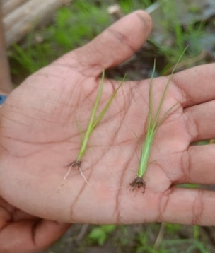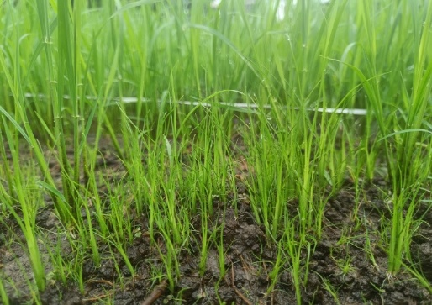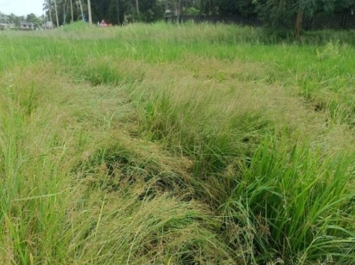
c
b
a
Plate 1. a. Seedling of F. miliacea b. Seedlings of F. miliacea in rice field c. Lodging of F.miliacea

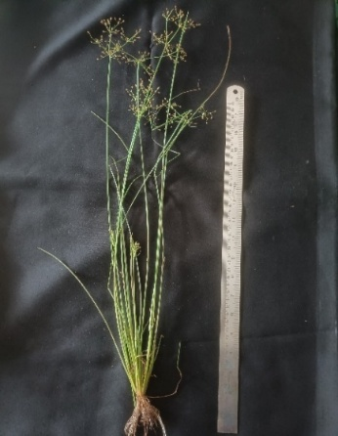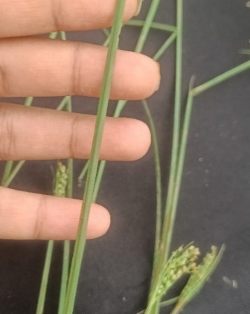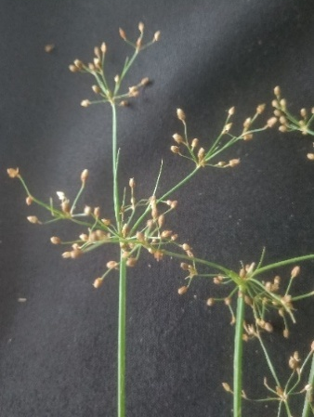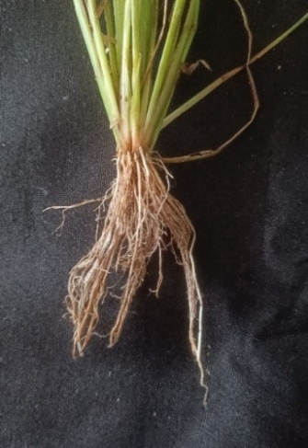
c
d
b
a
Plate 2. a. Plant b. Leaf c. Inflorescence d. Fibrous root system

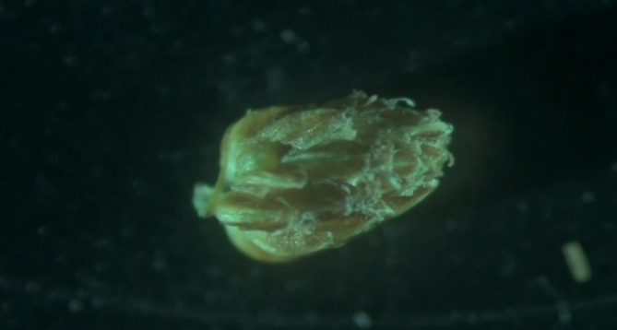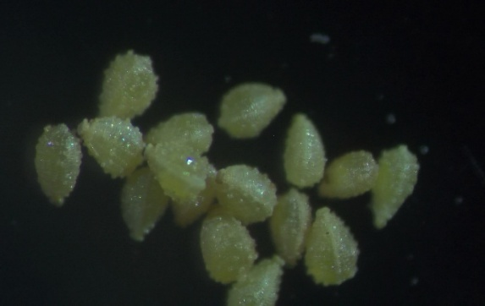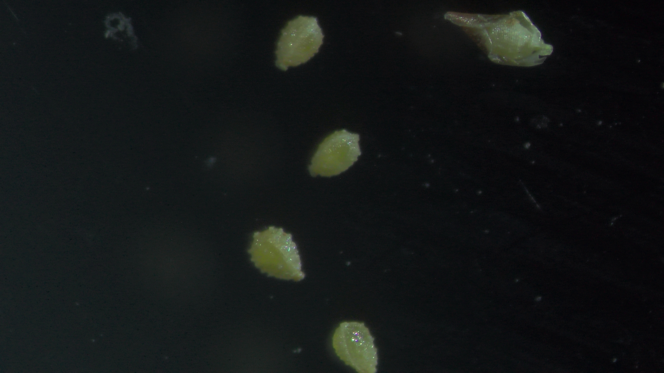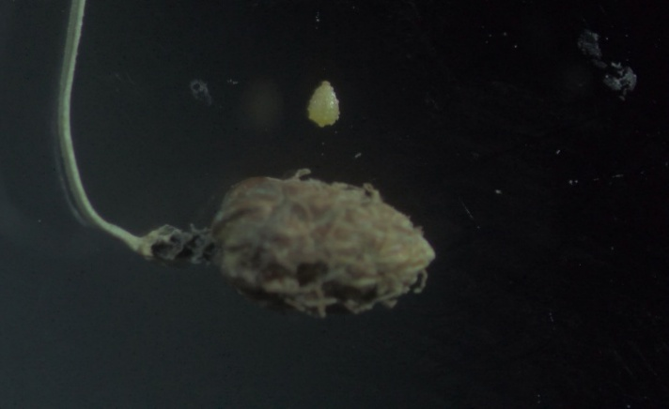
d
c
b
a
Plate .3. Microscopic view (10X) a. spikelet b. seeds c. seeds inside glume d. seed and spikelet
- CONCLUSION
Fimbristylis miliacea exhibited remarkable ecological adaptability and reproductive efficiency under wet direct-seeded rice conditions of the humid tropics. The species was characterized by rapid vegetative growth, early flowering, prolific biomass accumulation, and exceptionally high seed production, enabling completion of its life cycle within the crop duration. The production of numerous small, lightweight seeds with efficient shattering and dispersal mechanisms contributed substantially to persistent soil seed banks and recurring infestations in rice ecosystems. These biological and phenological attributes collectively explain the strong competitive ability and persistence of the weed in wet-seeded rice fields. The findings emphasize the necessity for timely, integrated, and stage-specific management interventions targeting early growth and reproductive phases to effectively suppress population buildup and reduce future weed infestations.
Disclaimer (Artificial Intelligence)
I hereby declare that NO generative AI technologies such as Large Language Models (ChatGPT, COPILOT, etc) and text-to-image generators have been used during writing or editing of this manuscript.
Competing Interests
No competing interests exist
REFERENCES
Ameena, M., Deb, A., Umkhulzum, F., Kalyani, M.S.R., Sethulakshmi, V.S., Sreelakshmi, K., Renjan, B. and Shanavas, S. (2025a). Ecology and management of sedges in direct-seeded rice: A review. Agricultural Reviews, 46(5), pp.774-781.
Ameena, M., Deb, A., Sethulakshmi, V. S., Sekhar, L., Susha, V. S., Kalyani, M. S. R., & Umkhulzum, F. (2025b). Weed ecology: Insights for successful management strategies: A review. Agricultural Reviews, 46(4), 655-662.
Aryal, S. (2023). Taxonomic Study of Genus Fimbristylis Vahl. (Cyperaceae) in Nepal (Doctoral dissertation, Department of Botany). 74p
Awan, T.H., Ahmed, S., Cruz, P.C.S. and Chauhan, B.S., (2020). Ecological studies for plant characteristics of Fimbristylis miliacea under multiple resource limitations in dry-seeded upland ecosystems. International Journal of Pest Management, 68(3), pp.256-266.
Chauhan, B.S. & Johnson, D.E. (2009). Annals of Applied Biology Ecological studies on Cyperus difformis, Cyperus iria and Fimbristylis miliacea: three troublesome annual sedge weeds of rice . 255: 103-112
Begum, M. (2006). Biology and management of Fimbristylis miliacea (L.) Vahl. Ph.D. thesis, Universiti Putra Malaysia, Serdang, Malaysia.
Begum, M., Juraimi, A.S., Amartalingam, R., Rastan, S.O.S. and Man, A. (2008). Growth and development of Fimbristylis miliacea. Biotropia, 15: 1–11.
Holm, L. G., Plucknett, D. L., Pancho, J. V., and Herberger, J. P. (1991). The World’s Worst Weeds: Distribution and Biology. Krieger Publishing Company, Malabar, Florida, USA. 609 p.
IRRI [International Rice Research Institute]. (2022). Fimbristylis miliacea [on-line]. Available: http://www.knowledgebank.irri.org/training/fact-sheets/item/fimbristylis-miliacea [30 July 2025].
Lekshmi, S., Ameena M, Nimmy J, Shalini PP, Susha VS, Sreelakshmi K, Renjan B, Gayathri K. 2026. Emergence dynamics of Chinese sprangletop (Leptochloa chinensis (L.) Nees.) in wet direct-seeded lowland rice. Plant Science Today. 13(sp3): 1-7. https://doi.org/10.14719/pst.13467
Moody, K., (1989). Weeds reported in rice in South and Southeast Asia. Int. Rice Res. Inst.
Rao, A.N., Johnson, D.E., Sivaprasad, B., Ladha, J.K. and Mortimer, A.M., (2007). Weed management in direct‐seeded rice. Advances in agronomy, 93, pp.153-255.
Reddy, M.S.S.K and Ameena, M. (2021). Influence of weed management practices on weed flora, crop yield and nutrient uptake in direct-seeded rainfed lowland rice. Journal of Crop and Weed 17(2):1–8. https://doi.org/10.22271/09746315.2021.v17.i2.1472
Renjan B, Bindu B, Gayathri K, Ameena M. Eco biological adaptability of blood grass (Isachne miliacea) proliferation in wetland rice ecosystems. Plant Science Today. (2025); 13(sp3): 1-7. https://doi.org/10.14719/pst.13447
Sekhar L, Ameena M, Jose N, Pillai SP. Post-emergence herbicide combinations for wet-seeded rice dominated with grass weed flora. (2024). Indian J Weed Sci. 56(3):251–7. https://doi.org/10.5958/0974-8164.2024.00041.8
Sethulakshmi, V.S., Ameena, M., Deb, A., Fathima Umkhulzum, S., Renjan, B. and Shilpa, S., (2024). Germination ecology and ecology-based management of Fimbristylis miliacea (L.) in lowland rice: A review. International Journal of Environment and Climate Change, 14(7), pp.577-589.
Umkhulzum, F., & Ameen, A. M. (2019). Integrated management of rock bulrush (Schoenoplectus juncoides) in wet seeded rice.
Umkhulzum, S. F., Ameena, M., & Pillai, P. S. (2019). Biology of rock bulrush (Schoenoplectus juncoides) in the wet land rice fields of south Kerala. Journal of Tropical Agriculture, 57(2).
Umkulzhum, F., Ameena, M., Susha, V. S., Renjan, B., Sreelekshmi, K., Sethulakshmi, V. S., & Shanavas, S. (2024). Weeds and their response to changing climate: A review. International Journal of Environment and climate change, 14(4), 768-779.
Xu, W.D., Lu, Q., Yao, Z.L. and Zhu, J.W. (2025). Integrated management of Fimbristylis miliacea (L.) Vahl in rice systems: seed ecology, herbicide sensitivity, and crop competition effects. Applied Ecology & Environmental Research, 23(4).

