Original Research Article
Therapeutic Efficacy of Autologous Platelet-Rich Plasma in Bilateral Corneal Ulcers in a Canine Patient: A Pilot Clinical Study on Ocular Surface Regeneration

ABSTRACT
Aims: Corneal ulcers are among the most frequently encountered ophthalmic conditions in small animal practice, particularly in brachycephalic breeds that are predisposed to corneal exposure and trauma. Delayed epithelial healing and recurrence are common challenges associated with conventional therapy. The present study aimed to evaluate the therapeutic efficacy of autologous platelet-rich plasma (PRP) eye drops in the management of bilateral corneal ulcers in a canine patient and to assess its regenerative potential in ocular surface healing.
Study Design: Pilot clinical observational study.
Place and Duration of Study: The study was conducted at Sanchu Animal Hospital, Chennai, India, with a follow-up period of one month.
Methodology: A 4-month-old female Shih Tzu puppy weighing 2.5 kg was presented with bilateral corneal ulcers characterized by blepharospasm, epiphora, and corneal opacity. Initial treatment with systemic antibiotics (ceftriaxone–tazobactam) and topical antimicrobial and lubricating agents failed to produce clinical improvement. Autologous PRP was prepared by centrifugation of whole blood at 1200 rpm for 10 minutes and administered topically four times daily for a period of 20 days. Clinical parameters including ulcer size, fluorescein staining, corneal opacity grading, and pain scoring were monitored on days 0, 10, 15, and 30.
Results: Initial ulcer size measured 4.2 mm (right eye) and 3.8 mm (left eye). Significant reduction in ulcer size was observed by day 10 (1.2 mm and 1.0 mm, respectively), with negative fluorescein staining indicating epithelial healing. Complete epithelialization was achieved by day 15. Pain scores decreased from severe (3) to none (0), and corneal opacity improved from grade 3 to grade 1 by day 30. No recurrence was observed during follow-up.
Conclusion: Autologous PRP therapy significantly accelerated corneal healing and improved clinical outcomes in a canine patient with bilateral corneal ulcers. PRP may serve as a safe, effective, and regenerative therapeutic adjunct in veterinary ophthalmology, particularly in refractory cases.
Keywords: Platelet-rich plasma, corneal ulcer, canine ophthalmology, regenerative therapy, ocular surface healing, PRP
1. INTRODUCTION
Corneal ulcers represent a common and clinically significant ophthalmic disorder in small animal practice, often leading to severe discomfort and potential vision loss if not managed effectively. The incidence of corneal ulcers is particularly high in brachycephalic breeds such as Shih Tzus, Pugs, and Bulldogs due to anatomical features including shallow orbits, lagophthalmos, and increased corneal exposure, which predispose the cornea to trauma and desiccation-related injury. These ulcers may arise secondary to mechanical injury, infection, tear film abnormalities, or eyelid conformational defects, and can progress rapidly to stromal degradation and corneal perforation if untreated. The pathophysiology of corneal ulceration involves disruption of the epithelial barrier followed by stromal degradation mediated by inflammatory cytokines and matrix metalloproteinases, thereby compromising corneal integrity and delaying healing (Ledbetter, 2015).
Conventional therapeutic approaches primarily focus on eliminating infection and maintaining corneal lubrication through the use of topical antibiotics, tear substitutes, and systemic medications. However, these approaches do not actively promote tissue regeneration, and delayed epithelialization remains a common clinical challenge. In severe cases, surgical interventions such as conjunctival grafting or corneal transplantation may be required, increasing both the complexity and cost of treatment (Plummer, 2019).
In recent years, regenerative therapies have gained prominence in both human and veterinary medicine. Platelet-rich plasma is an autologous biological product containing a high concentration of platelets and growth factors that play a crucial role in tissue repair and regeneration. PRP contains bioactive molecules such as platelet-derived growth factor, transforming growth factor-beta, vascular endothelial growth factor, and epidermal growth factor, which stimulate cellular proliferation, collagen synthesis, angiogenesis, and epithelial regeneration (Marx, 2001; Anitua et al., 2004). These properties make PRP an attractive therapeutic option for enhancing corneal wound healing.
Recent studies in veterinary ophthalmology have demonstrated promising outcomes with the use of PRP in corneal ulcers, showing accelerated epithelialization, reduced inflammation, and improved clinical recovery (Farghali et al., 2021; Perego et al., 2022). Despite these encouraging findings, clinical data remain limited, particularly in naturally occurring bilateral corneal ulcer cases. Therefore, the present study aimed to evaluate the clinical efficacy of autologous PRP therapy in a canine patient with bilateral corneal ulcers and to contribute to the growing evidence supporting its application in veterinary regenerative medicine.
2. MATERIALS AND METHODS
A four-month-old female Shih Tzu puppy weighing 2.5 kg was presented with a history of bilateral ocular discomfort, including blepharospasm, excessive lacrimation, and photophobia of four days’ duration. Clinical examination revealed a rectal temperature of 101°F, heart rate of 90 beats per minute, and respiratory rate of 20 breaths per minute, indicating a stable general condition. Ophthalmic examination showed deep stromal ulcers in both eyes, accompanied by corneal edema, opacity, and positive fluorescein staining, confirming epithelial disruption. Schirmer tear test values were within normal limits, measuring 20 mm/min in the right eye and 16 mm/min in the left eye, thereby ruling out keratoconjunctivitis sicca as a potential underlying cause.
Initial treatment included systemic administration of ceftriaxone–tazobactam at a dose of 25 mg/kg intravenously for three days, along with topical moxifloxacin and hydroxymethylcellulose eye drops administered four times daily. However, the absence of clinical improvement necessitated the initiation of regenerative therapy using PRP.
Autologous platelet-rich plasma was prepared by collecting approximately 5 mL of whole blood aseptically from the cephalic vein into anticoagulant-containing tubes. The blood sample was subjected to single-spin centrifugation at 1200 rpm for 10 minutes, following the protocol described by Perego et al. (2022). The plasma fraction enriched with platelets was carefully separated under sterile conditions. The prepared PRP was fortified with amikacin to minimize the risk of contamination and administered topically four times daily for a period of 20 days.
Clinical evaluation was performed on days 0, 10, 15, and 30, and parameters including ulcer size, fluorescein staining, corneal opacity, and pain score were recorded systematically. The progression of healing was documented and is summarized in Table 1.
3. RESULTS AND DISCUSSION
Following the initiation of PRP therapy, a marked improvement in clinical signs was observed. The ulcer size, which initially measured 4.2 mm in the right eye and 3.8 mm in the left eye, showed significant reduction by day 10, decreasing to 1.2 mm and 1.0 mm, respectively. This reduction was accompanied by negative fluorescein staining, indicating successful re-epithelialization of the corneal surface. By day 15, complete epithelialization was achieved in both eyes, with ulcer size reduced to zero. Pain score, which was initially graded as severe (3), progressively decreased to mild (1) by day 10 and reached zero by day 15, reflecting substantial relief from discomfort. Corneal opacity also showed gradual improvement, reducing from grade 3 to grade 1 by day 30, indicating restoration of corneal clarity. No recurrence of the ulcer was observed during the one-month follow-up period.
Table 1. Clinical progression of corneal ulcer healing following PRP therapy
Day | Ulcer Size (Right Eye) | Ulcer Size (Left Eye) | Pain Score | Corneal Opacity | Fluorescein Staining
0 | 4.2 mm | 3.8 mm | 3 | Grade 3 | Positive
10 | 1.2 mm | 1.0 mm | 1 | Grade 2 | Negative
15 | 0 mm | 0 mm | 0 | Grade 2 | Negative
30 | 0 mm | 0 mm | 0 | Grade 1 | Negative
The clinical changes observed before and after treatment are illustrated in Figure 1, where severe corneal opacity and ulceration prior to therapy are contrasted with the progressive healing and restoration of corneal clarity following PRP administration.
The present study demonstrated rapid and complete healing of bilateral corneal ulcers following topical administration of autologous platelet-rich plasma, indicating its strong regenerative potential in canine ophthalmology. The significant reduction in ulcer size observed by day 10, along with early negative fluorescein staining, suggests accelerated epithelial resurfacing and restoration of corneal integrity. These findings are clinically important, as delayed epithelialization is one of the primary factors contributing to ulcer progression and complications such as stromal melting and perforation.
From an anatomical perspective, the cornea is composed of four primary layers: the epithelium, stroma, Descemet’s membrane, and endothelium. The epithelium serves as the first barrier against environmental insults and plays a critical role in maintaining corneal transparency and hydration. Disruption of this layer exposes the underlying stroma, which constitutes approximately 90% of corneal thickness and is highly susceptible to enzymatic degradation by matrix metalloproteinases released during inflammation (Ledbetter, 2015). In the present case, the presence of deep stromal ulcers in both eyes indicated significant structural compromise, necessitating rapid intervention to prevent further tissue loss.
The healing of corneal ulcers is a complex, multi-phase physiological process involving epithelial migration, stromal remodeling, and re-establishment of normal corneal architecture. Initially, epithelial cells at the wound margin undergo migration to cover the defect, followed by proliferation and differentiation to restore normal stratification. This process is heavily dependent on growth factors and cytokines present in the tear film and local microenvironment (Gilger, 2017). In cases where endogenous healing mechanisms are insufficient, as observed in the present study during initial conventional therapy, adjunctive regenerative treatments become essential.
Platelet-rich plasma exerts its therapeutic effects primarily through the release of a concentrated pool of growth factors from platelet alpha granules. Platelet-derived growth factor (PDGF) plays a key role in fibroblast proliferation and chemotaxis, facilitating stromal repair, while transforming growth factor-beta (TGF-β) enhances collagen synthesis and extracellular matrix deposition. Epidermal growth factor (EGF) stimulates epithelial cell proliferation and migration, thereby accelerating re-epithelialization. Additionally, vascular endothelial growth factor (VEGF) promotes angiogenesis, which may contribute to improved nutrient delivery in the early stages of healing (Marx, 2001; Anitua et al., 2004). The synergistic action of these factors likely explains the rapid clinical improvement observed in this case.
From a physiological standpoint, corneal healing is also influenced by inflammatory modulation. Excessive inflammation can lead to the release of proteolytic enzymes, particularly matrix metalloproteinases, which degrade stromal collagen and delay healing. PRP has been shown to downregulate inflammatory cytokines and reduce oxidative stress, thereby creating a more favorable environment for tissue regeneration (Perego et al., 2022). This anti-inflammatory effect was clinically evident in the present study through the reduction in pain score and resolution of scleral congestion.
The bilateral presentation of corneal ulcers in this case further underscores the effectiveness of PRP therapy, as both eyes showed synchronized healing responses. Clinically, bilateral ulcers often indicate systemic or breed-related predispositions rather than localized trauma alone. Brachycephalic breeds such as Shih Tzus are particularly prone to such conditions due to lagophthalmos and reduced blink efficiency, leading to increased corneal exposure and tear film instability (Plummer, 2019). The successful management of bilateral ulcers with PRP in this case highlights its potential as a first-line adjunctive therapy in predisposed breeds.
Comparison with previous studies further supports the findings of this investigation. Farghali et al. (2021) reported significant improvement in corneal ulcer healing in dogs and cats treated with autologous PRP, with reduced healing time and improved corneal clarity. Similarly, Edelmann et al. (2018) demonstrated enhanced epithelial healing and reduced stromal damage in canine models treated with PRP. Human ophthalmology studies have also shown comparable benefits, indicating improved epithelial regeneration and reduced recurrence rates in persistent epithelial defects treated with PRP-derived eye drops (Alio et al., 2007).
Another important clinical consideration is the safety and practicality of PRP therapy. Being autologous in nature, PRP minimizes the risk of immunological reactions and disease transmission. It is also relatively cost-effective and easy to prepare in a clinical setting without the need for advanced infrastructure. In the present study, no adverse effects were observed, further supporting its safety profile.
Despite these promising outcomes, certain limitations must be acknowledged. The study is based on a single clinical case, which limits the generalizability of the findings. Additionally, quantitative assessment of platelet concentration and growth factor levels was not performed, which could have provided more precise correlation with clinical outcomes. Long-term follow-up beyond one month was also not conducted, and therefore, the durability of healing over extended periods remains to be evaluated. Future studies involving larger sample sizes, controlled comparisons, and standardized PRP preparation protocols are necessary to establish definitive clinical guidelines.
Overall, the integration of anatomical understanding, physiological healing mechanisms, and clinical outcomes in this study strongly supports the use of PRP as a regenerative therapeutic modality in veterinary ophthalmology.
4. CONCLUSION
Autologous platelet-rich plasma therapy facilitated rapid and complete corneal healing in the affected eyes in this case, characterized by early epithelialization, significant reduction in pain and opacity, and absence of recurrence. These findings highlight PRP as a safe, biologically active regenerative modality with a clear clinical advantage over conventional therapy, and a viable alternative in cases with poor response to conventional therapy. Further controlled studies are required to validate its routine clinical application.

COMPETING INTERESTS
The authors declare no competing interests.

REFERENCES
Alio JL, Abad M, Scorsetti DH, et al. Use of autologous platelet-rich plasma in the treatment of dormant corneal ulcers. Ophthalmology. 2007;114(7):1286–1293.
Anitua E, Andia I, Ardanza B, Nurden P, Nurden AT. Autologous platelets as a source of proteins for healing and tissue regeneration. Thrombosis and Haemostasis. 2004;91(1):4–15.
Edelmann ML, Stiles J, Michau TM, et al. Effects of platelet-rich plasma on corneal epithelial healing in dogs. Veterinary Ophthalmology. 2018;21(4):1–8.
Farghali HA, AbdElKader NA, AbuBakr HO, et al. Corneal ulcer in dogs and cats: novel clinical application of autologous platelet-rich plasma. Frontiers in Veterinary Science. 2021;8:641265.
Gelatt KN. Veterinary Ophthalmology. 5th ed. Wiley-Blackwell; 2017.
Gilger BC. Diseases and surgery of the canine cornea and sclera. In: Gelatt KN, Gilger BC, Kern TJ, editors. Veterinary Ophthalmology. 5th ed. Ames: Wiley-Blackwell; 2017. p. 1049–1145.
Ledbetter EC. Corneal diseases in dogs and cats. Veterinary Clinics of North America: Small Animal Practice. 2015;45(6):1095–1115.
Maggs DJ, Miller PE, Ofri R. Slatter’s Fundamentals of Veterinary Ophthalmology. 6th ed. Elsevier; 2018.
Marx RE. Platelet-rich plasma (PRP): what is PRP and what is not PRP? Implant Dentistry. 2001;10(4):225–228.
Perego R, Spada E, Baggiani L, et al. Platelet-rich plasma in companion animals: regenerative applications. Veterinary Sciences. 2022;9(2):84.
Plummer CE. Advances in the management of canine corneal ulcers. Veterinary Ophthalmology. 2019;22(1):1–14.

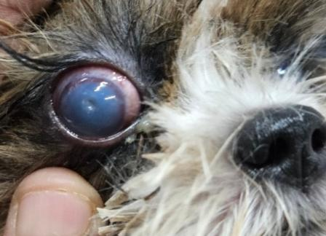
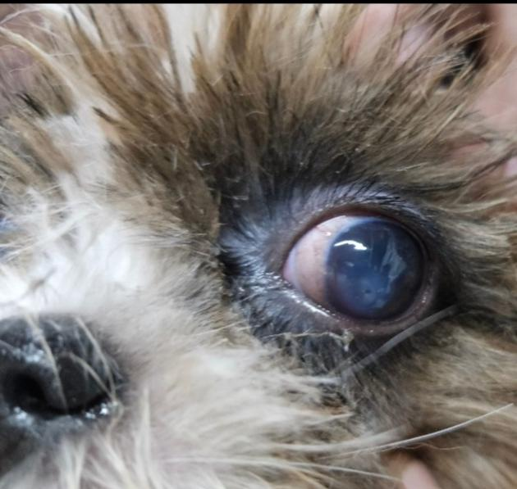

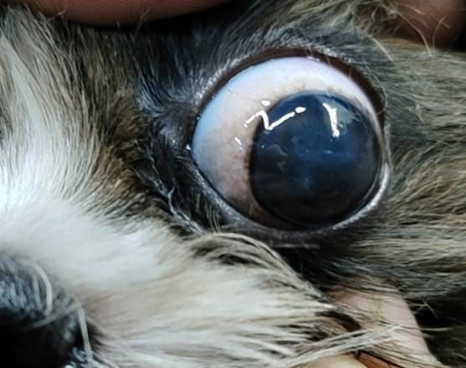
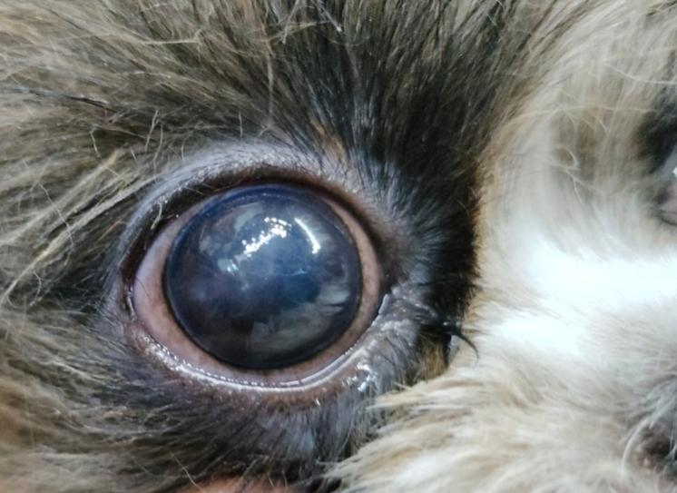
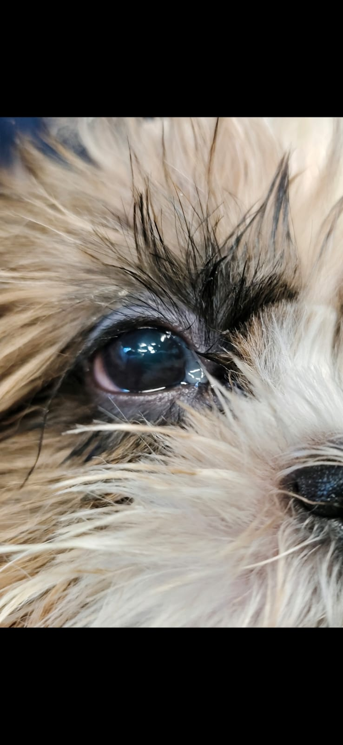
Figure 1. Clinical progression of bilateral corneal ulcers before and after PRP therapy. (a–b) Before treatment right and left eyes showing severe corneal opacity and ulceration; (c–d) Day 10 showing reduction in edema and ulcer size in left and right eyes; (e–f) One-month follow-up showing complete healing and improved corneal clarity in left and right eyes.
a
b
c
e
f
d

