Review Article
Innovations in Pollination Methods: Transition Towards Modern Pollination in Precision Agriculture

Abstract:
Pollination is a critical ecological process that directly influences global food production, biodiversity, and ecosystem stability. Traditional pollination methods—primarily reliant on natural pollinators such as bees, butterflies and manual human-assisted techniques—have supported agriculture for centuries. However, rapid declines in pollinator populations, intensification of farming systems, and the growing demand for higher crop yields have accelerated the shift toward innovative and technologically advanced pollination strategies. This review examines the evolution of pollination approaches from conventional practices to modern precision agriculture techniques. It highlights recent advancements including mechanical pollinators, drone-assisted pollination, artificial intelligence–based flower detection, robotic micro-pollinators, and controlled-environment pollination systems used in protected cultivation. Furthermore, the abstract synthesizes insights on the efficacy, scalability, ecological impacts, and economic feasibility of these innovations. By integrating traditional knowledge with cutting-edge technologies, precision pollination offers promising avenues for sustainable crop production, climate resilience, and enhanced food security. This review underscores the need for interdisciplinary research, farmer-friendly innovations, and policy support to ensure the future of pollination in modern agriculture.
Key words: Pollination, Mechanization, Smart pollination, UAV assisted, Precision farming.
Graphical Abstract:
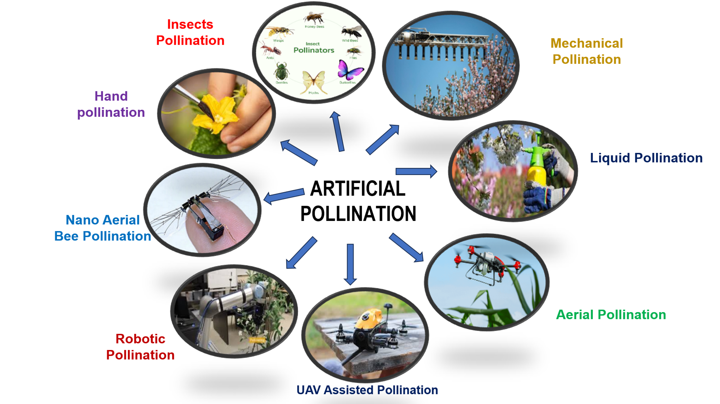

Introduction
In agriculture, pollination is an important input of crop production, comparable to any other input such as fertilizer, labour, pesticides etc. Pollination is the act of transferring pollen grains from the male part(anther) of a flower to the female part(stigma). The goal for every living organism, including plants, is to create offspring for the next generation. The only way a seed can be produced is by the transfer of pollen between flowers of the same species (Sharma and Kaur, 2019). Pollination is an essential biological process responsible for fertilization in flowering plants, directly affecting nearly 75% of global food crops. The Food and Agriculture Organization (FAO) estimates that approximately one-third of global food production depends to some degree on pollinators such as bees, butterflies, birds, and bats. Recent technological innovations—ranging from AI-powered drones to robotic pollinators—have opened new frontiers in pollination science. These advancements are collectively aligned with the global momentum toward precision agriculture, which aims to optimize inputs and maximize output using data-driven tools. This review explores these innovations in depth, comparing their advantages, limitations, and future potential.
Pollination:
Pollination means transfer of viable pollen from mature anther to receptive stigma. Flowers are fully dependent on vector to move pollen. These vectors may be wind, water, birds, butterflies, bats and other animals that visit flowers. An abundance of pollinators sets a greater proportion of early flowers, results in an earlier and more uniform crop with higher quantity as well as quality of fruit. Insects contribute between 15% and 30% of global food production (Halder et al. 2019). Pollination is the process of transferring pollen from the anthers to the stigma, which is crucial for fertilization and seed formation during plant reproduction. Adequate pollination of crops can improve the yield and quality of primary agricultural products, vital as the main source of food for humans, such as grains, fruits, and vegetables (Smith et al., 2022). pollinators are essential for maintaining biodiversity, which contributes to ecosystem stability by ensuring the health and survival of plant communities, which provide habitat, food, and shelter to a multitude of animal species. This intricate web of interactions driven by pollination sustains the harmony of our surroundings, making it a key service vital for human well-being and sustains the delicate balance of natural ecosystems (Meeuse, 2023). The transfer of pollen grains from anther to stigma of same flower or different flower of same plant is called self-pollination. While, the transfer of pollen grains from anther to stigma of a different plant is called cross pollination. Cross-pollination produces stronger plants. The plants must be of the same species (Sharma and Kaur, 2019).
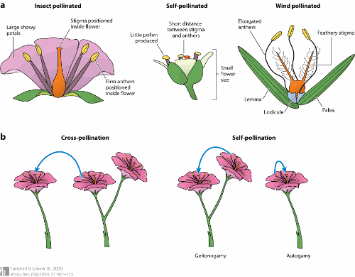‎ Fig 1. Mechanism of Pollination (Fattorini and Glover, 2020)
Pollination syndrome traits:
A pollination syndrome is defined as a suite of floral traits that are associated with the attraction of a specific group of animals as pollinators. Traits such as flower morphology, color, scent, and rewards contribute to the plant's reproductive success by attracting pollinators (Hermann and Kuhlemeier, 2011). Over the past 150 years, the concept of pollination syndromes has been formulated and continuously refined to serve as a large-scale framework for structuring this diversity in floral mode from a functional, pollination-ecological perspective (Ollerton et al., 2009; Rosas-Guerrero et al., 2014). Generally, pollination syndromes represent convergent floral adaptations to specific functional pollinator groups (Smith & Kriebel, 2018; Dellinger et al., 2019c). Importantly, there is no strict definition on how to delimit syndromes (e.g. which traits, which pollinator groups) and different authors have employed different classification systems throughout the years (Fenster et al., 2004; Ollerton et al., 2009). The flower type, shape, colour, odor, nectar and structure are very important for the types of pollinators that visits them. The characteristics are considered as pollination syndromes and can be used to predict the type of pollinator which helps the flower in successful pollination (Halder et al. 2019). Pollination syndromes are also an important tool in conservation and may serve, for example, for large-scale analyses of the effect of environmental perturbations on functional diversity (Dellinger, 2020).
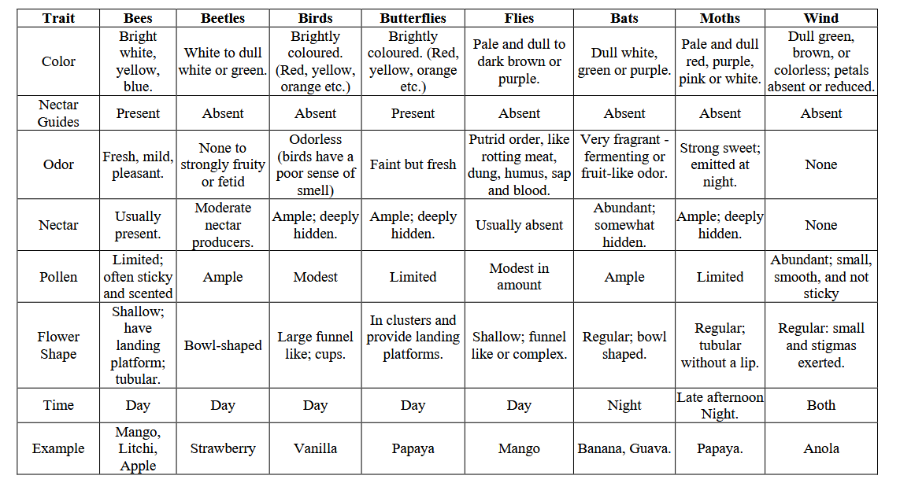
Fig 2. Pollination syndrome traits (Halder et al. 2019)
Artificial Pollination:
Artificial pollination has been applied to solve the problem of low yields caused by insufficient natural pollination and was initially carried out as a manual operation (Broussard et al., 2023, Wurz et al., 2021). Artificial pollination can solve the problems of crops that cannot produce fruits naturally example Vanilla (Sharma and Kaur, 2019). While manual approaches, such as hand pollination, brush pollination, and rope pollination, have been employed for centuries to enhance crop yields, they are now mostly applied in plant breeding where parental control needs to be ensured, as well as in subsistence family farming and smallholders (Toledo-Hernández et al., 2017). Variety of advancements in pollination technologies and devices have been developed, with autonomous pollination systems featuring flower sensing, task planning, and precise execution gaining increasing attention (He et al. 2025). Artificial pollination has been chosen as the substitute against entomophily (pollination by bees) where pollens are manually sprayed to the stigma for the further fertilization, multiplication, production and formation of seeds and fruits (Sharma and Kaur, 2019).
Types
- Hand pollination
- Insects’ pollination
- Mechanical pollination
- Liquid pollination
- Aerial Pollination
- UAV Assisted pollination
- Nano Aerial vehicle
- Robotic Pollination
- Nano Aerial bee
Hand pollination:
Hand pollination is done through manual labour, which is intensive carried out with the help of paintbrush, stick, feather-brush. Hand-held pollination represents the most traditional and widely practiced approach to artificial pollination, which involves the manual transfer of pollen to crops or female parts of flowers using simple or especially designed tools and devices to mimic the natural pollination process (Hiraguri et al., 2023a, Zhang et al., 2022). Where mechanisation is available (even if only in the form of a vibratory wand), it is often more effective and economical than manual pollination (Broussard et al. 2023).
Insects Pollination:
Animal-mediated pollination plays an essential role in fruit and seed production and in improving the quality in many pollinator-dependent crops (Gazzea et al., 2023, Siopa et al., 2024). Insects are the main pollinators of crops worldwide, including bees, wasps, flies and moths (Rader et al., 2016). To ensure and/or enhance pollination in crops, managed bees or flies are routinely used by farmers (Osterman et al., 2021a), particularly the western honeybee (Apis mellifera; Osterman et al., 2021b). In addition to managed pollinators, wild pollinators are also known to contribute to crop production (Reilly et al., 2024). Honeybees are the most abundant visitors in commercial orchards, a pattern also found in other crops (Dymond et al., 2021, Eeraerts et al., 2023a). Within wild bees, bumblebees and mining bees were the most abundant and diverse genera, which is also in line with some other spring-flowering crops (Eeraerts et al., 2023a). Most fly species recorded belong to hoverflies (Syrphidae), yet this might be due to biases in the recording (some studies only recorded species belonging to Syrphidae). Wasps, butterflies and beetles were seldom included in flower-visitor assessments and when recorded, their visitation was rather low (Osterman et al., 2023).
Mechanical pollination:
The mechanical pollination involves the use of hands, drones or other mechanical equipment while biological pollination includes the use of ILGs (Ionic Liquid Gels) (Sharma and Kaur, 2019). Major categories of mechanical pollination technology include: hand-pollination, handheld and backpack devices, vehicle-mounted devices, unmanned aerial vehicles (UAVs), and robotic and autonomous pollinators (Broussard et al. 2023). Numerous authors have tested mechanical sprayers as the source for artificial pollination with mixed results. Electrostatic forces have been used recently as an aid for mechanized pollen application in date palm (Sharma and Kaur, 2019).
Liquid pollination
With Liquid Pollination (LP) female trees flowers are sprayed with pollen grains suspended in water using knapsack or motorized sprayers. LP is much quicker, cheaper and equally effective. In addition, the use of this technology contribute to saving time, reducing cost, and consequently, reduces the risk of climbing accidents to laborers (Raisi et al, 2018). Liquid spray pollination uses an industrial nozzle to atomize pollen suspension and deliver it to the flower. Because it does not directly contact the stigma, uses less pollen and has higher accuracy, showing great potential in kiwifruit robotic pollination, but still falls short of commercial pollination requirements (Li et al., 2022a). Chechetka et al. (2017) developed an ion liquid gel with semi-permanent adhesion properties that can simulate insect pollination. It is necessary to conduct in-depth research on liquid spray pollination to improve pollination effectiveness. The precision liquid pollinator developed for kiwifruit has the advantages of vibration-free and high accuracy, providing technical support for kiwifruit robotic pollination (Hao et al. 2023). it was found that a reduction in pollination cost using liquid pollination was observed in comparison to that for manual pollination of about 89.05% and, consequently, a reduction in the total variable costs per hectare against those for manual pollination of about 56.48%. (Dhehibi et al, 2018). In Date palm, one of the great advantages of adopting the liquid pollination method is the large amount of pollen saved. The proportion of pollen in the liquid suspension must be selected by each farmer, depending on their bunch thinning needs and the age of the plant (Torres et al. 2024).
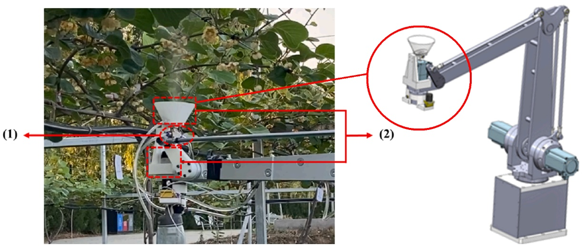
Fig 3. Air–liquid spray pollinator (1) Air-liquid nozzle, and (2) Nozzle mounting brackets
(Gao et al, 2023)
Aerial pollination
Drone pollination is a method of artificial pollination that involves using drones equipped with spray systems to disperse pollen over crops. Instead of relying on natural pollinators like bees or wind, drones are deployed to carry and release pollen, mimicking the action of pollinators to facilitate fertilization in plants (Aruna et al. 2024). Drones have considerable promise in tall tree crops where their ability to dispense pollen above the canopy is an advantage, with potential applications in tree breeding as well as wind-pollinated nut crops, which have shown promise in artificial pollination trials, including hazelnut, pistachio, and walnut (Broussard et al. 2023).
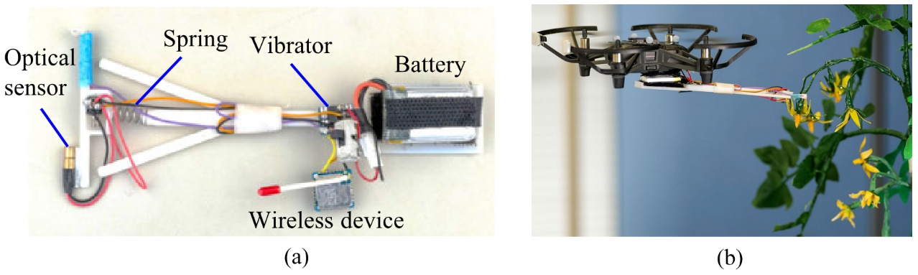
Fig 4. Drone and vibrator based pollinator. (a) Vibratory pollinator, and (b) Vibrator mounted on the drone for tomato flower pollination (Hiraguri et al, 2023b).
UAV-assisted pollination
The use of drones to pollinate crops is an attractive proposition both because drones have a good aesthetic fit for the job—they are airborne pollinators, like bees—and because drone technology has a lower barrier to entry than other forms of robotics. These devices are either directly controlled by a pilot, follow a set path defined by the layout of orchard rows, or utilise a 3-D model of the environment built from an earlier pass by scouting drones. Many drone pollinators are modifications of commercially available drones, particularly those designed for agrichemical sprays, but a number are also being custom-designed for pollination. Arun sekhar et al 2022 has designed a pollination drone which carries pre collected pollens for artificial pollination and it will automatically turn its path on other direction while detecting the obstacles. The drone has a stable performance of flying up to 2 to 3 feet of height. The drone system demonstrated the ability to detect and approach flowers reliably but faced difficulties in achieving successful pollination. The drone's flower survival rate was high, but it was unable to confirm pollination success due to technical challenges (Craigie et al., 2021).
NAV-Nano Aerial Vehicle
Nano drone class is the most suitable for the intended pollination functions, with a weight of 3 to 50 g and a wingspan of 2.5 to 15 centimetres. However, Nano drones are still underutilised in this context, although they can perform tasks more precisely than conventional UAVs (Aruna et al. 2024). The drone is able to detect, approach and touch the flowers totally autonomously. Our 10 cm sized prototype is trained on sunflowers, but the methodology presented in this paper can be retrained for any flower type (Hulens et al. 2022). Hiraguri et al., 2023 developed small drones as a substitute for bees to autonomously fly, search for flowers, and pollinate the discovered flowers. The drones were developed with flower-searching and pollination working modes. Since the nano drone goal is pollination, it must be able to recognise flowers and execute commands to approach them. Identification is possible using perception algorithms to process the images a camera acquires (Pinherio et al., 2023). Flower perception provides the input to the path planning module, which in turn provides the input to the flight control module (Rice et al., 2022). Nano drones hold significant promise for revolutionizing precise pollination in agriculture. These miniature aerial vehicles offer the potential to enhance crop production by efficiently identifying flowers, navigating to them, and conducting pollination while also facilitating cooperation among multiple drones. To optimize pollination success, the development of diverse end effectors customized for different flower types is essential (Aruna et al. 2024). An insect sized drone capable of artificial pollination. They are coated with a blotch of horse hair bristles and an ionic liquid gel, these pint-sized robots have the ability to collect and transfer pollen from one plant to another (Sharma and Kaur, 2019).
Robotic Pollination
Autonomous robotic pollinators equipped with expert-informed targeting systems could identify and target flowers that produce the best fruit, enabling intelligent pollination services—a possibility suggested by Verdant Robotics’ patented apple pollinator and flower thinner (US11308323B2). (Broussard et al. 2023). In 2019, during field trials of the autonomous research prototype robot, the machine fully pollinated >670 export-quality “Hayward” kiwifruit, without contribution from insect pollinators, from a platform moving at 2.5 km/h. Key metrics (fruit set, seed count, fruit weight) were comparable to those of insect-pollinated control samples. Machine-vision systems employing deep learning can locate objects in images with 90%, or higher, accuracy, and with processing rates of up to 100 frames. Systems employing robotic arms tend to be relatively slow. For example, research on a tomato pollination robot reported pollination speeds of 15–20 s per flower, rates that are not practical for pollination of commercial-scale crops.
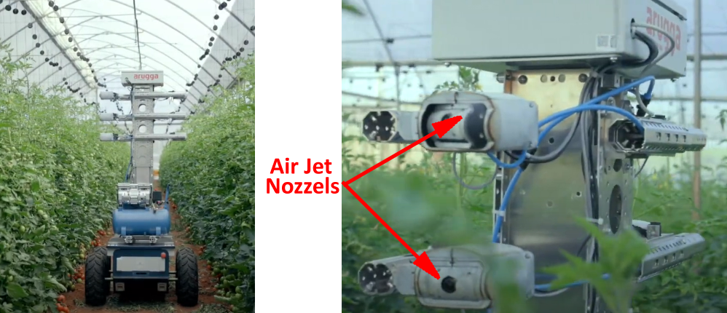
Fig 5. Multiple Air-Jet based pollination system mounted on the mobile platform. The system is already implemented in the Israel greenhouses for commercial purpose (Arugga, 2022).
NAB-Nano Aerial Bee
The NAB is a new open-source NAV with an autonomous flight used for tree pollination to assist bees (Pinherio et al., 2023). The development of the NAB allows crops to be pollinated continuously without being affected by environmental factors, unlike bees. The aim is not to replace bees but to help them pollinate. Artificial pollination makes the natural process more efficient and constant. An algorithm that can define the command to be executed by the NAB based on the position of the flower detected in the frame was implemented (Li et al. 2022). The developed software was tested on videos recorded with a smartphone that mimicked the flight of the NAB (Pinherio et al., 2023).
Conclusion
Pollination sits at the intersection of biology, ecology, and technology. As natural pollinators face growing threats, innovations in pollination methods—from drones to robots and AI-driven systems—offer promising solutions for sustainable agriculture. Yet, these technologies should supplement rather than replace natural pollinators. The future lies in harmonizing traditional ecological knowledge with precision agriculture tools to ensure food security, biodiversity conservation, and resilient agricultural systems. Advanced pollination innovations represent a transformative shift in global agriculture, but their success will depend on responsible implementation, economic accessibility, and continued efforts to restore and protect natural pollinator populations.
Future prospects
The market for robotic pollination is still in its early growth stages, but it holds significant potential, particularly in greenhouse environments. The trend for future pollination robots is to reduce research and development costs while improving the supporting infrastructure of pollination equipment to achieve cost-effectiveness. The integration of image sensors with diverse pollination technologies adds versatility and efficiency to the pollination process across different crop types in greenhouses. These advancements are driving the acceleration of the pollination process while simultaneously addressing cost-effectiveness.

References
- Arugga. 2022. AI farming: Robots treating every plant. https://wwwaruggacom.
- Aruna, T.N., B.A.Anand, Amith Kumar Gupta, Kishan Kumar, Utkarsh Dwivedi and Bhojyareddy Rohit Gaddamwar. 2024. Artificial Pollination by Nano drone Technology: A review. International Journal of Research in Agronomy.,7(2): 551-564.
- Arun Sekar. R., Dhinesh Kumar and Divakar Prabhu. 2022. Novel Pollination Drone for Agricultural Assistance. International Journal for Research in Applied Science & Engineering Technology (IJRASET) ISSN: 2321-9653; 10:VII.
- Broussard, M.A. M. Coates and P. Martinsen. 2023. Artificial Pollination Technologies: A Review. Agronomy 13: 1351. https://doi.org/10.3390/agronomy13051351.
- Chechetka, S,A., Y. Yu and M. Tange. 2017. Materially engineered artificial pollinators. Chem 2(2):224–239. doi:10.1016/j.chempr.2017.01.008.
- Craigie, C., P. Guglielmino, Z.Şeker and N.Stallings. 2021. Autonomous Drone Pollination. WPI;1-51.
- Dellinger, A.S., S.Artuso, S.Pamperl, F.A. Michelangeli, D.S. Penneys D.M.Fernández-Fernández, M. Alvear, F.Almeda, W.S.Armbruster and Y. Staedler. 2019c. Modularity increases rate of floral evolution and adaptive success for functionally specialized pollination systems. Nature Communications Biology 2: doi: 10.1038/s42003-019-0697-7.
- Dellinger, A.S. 2020. Pollination syndromes in the 21st century: where do we stand and where may we go? New Phytol., 228(4):1193-1213. doi: 10.1111/nph.16793.
- Dhehibi, B., M.Ben-Salah, A. Frija, A.Aw-Hassan, Y. M. Al Raisi, I. Al Bousaidi, S. Al Amri, S.Al Sobahi and K. Al Shoaili. 2018. Predicting Farmers’ Willingness to Adopt Liquid Pollination and Polycarbonate Drying House Technologies: A Case Study from the Date Palm Growers in the Sultanate of Oman. Sustainable Agriculture Research, 7(4), 18–30. https://doi.org/10.5539/sar.v7n4p18.
- Dymond, K., J.L. Celis‐Diez, S.G. Potts, B.G. Howlett, B.K. Willcox and M.P. Garratt. 2021. The role of insect pollinators in avocado production: A global review. Journal of Applied Entomology, 145(5), pp.369-383.
- Eeraerts, M., L.W. DeVetter, P.Batáry, J.J. Ternest, R. Mallinger, M. Arrington, F.E Benjamin, B.R.Blaauw, J.W. Campbell, P. Cavigliasso, and Daniels. 2023. Synthesis of highbush blueberry pollination research reveals region‐specific differences in the contributions of honeybees and wild bees. Journal of Applied Ecology, 60(12), pp.2528-2539.
- Fenster, C.B., W.S.Armbruster, P.Wilson, M.R. Dudash, J.D.Thomson. 2004. Pollination syndromes and floral specialization. Annual Review of Ecology, Evolution, and Systematics 35: 375–403.
- Fattorini, R. and B.J. Glover, 2020. Molecular Mechanisms of Pollination Biology. Annu Rev Plant Biol., 29:71:487-515.
- Gao, C., L.He, W. Fang. 2023. A novel pollination robot for kiwifruit flower based on preferential flowers selection and precisely target. Computers and Electronics in Agriculture 207:107762. doi:10.1016/j.compag.2023.107762.
- Gazzea, E., P. Batary and L.Marini. 2023. Global meta-analysis shows reduced quality of food crops under inadequate animal pollination. Nature Communications, 14(1), p.4463.
- Halder, S., Subham Ghosh, Rajesh Khan, Arju Ali Khan, Tamanna Perween, Md. A Hasan. 2019. Role of pollination in fruit crops: A review. Pharma Innovation., 8(5):695-702.
- Hao, W., Xinting Ding, Zhi He, Kai Li, Weixin Gong, Zixu Li, Zhen Yang, Yongjie Cui. 2023. Development and evaluation of precision liquid pollinator for kiwifruit, Computers and Electronics in Agriculture., 213: 2023-108193, ISSN 0168-1699, https://doi.org/10.1016/j.compag.2023.108193.
- Hermann, K. and Cris Kuhlemeier, 2011. The genetic architecture of natural variation in flower morphology, Current Opinion in Plant Biology,14(1): 60-65, ISSN 1369-5266,
- He, L., Liu. Xiaojuan Liu, Yusong Ding, Xudong Jing, Haojie Dang, Bryan Gilbert Murengami, Lamin L. Janneh, Rui Li, Spyros Fountas, Jayme Garcia Arnal Barbedo, Longsheng Fu, Advancements in artificial pollination of crops: from manual to autonomous. Computers and Electronics in Agriculture, Volume 231,2025,110067,ISSN 0168-1699,
- Hiraguri, T., H.Shimizu, T.Kimura, T.Matsuda, K.Maruta and Y.Takemura. 2023. Autonomous drone-based pollination system using ai classifier to replace bees for greenhouse tomato cultivation. IEEE Access,11: 99352–99364.
- Hiraguri, T., H.Shimizu T. Kimura 2023b. Autonomous drone-based pollination system using ai classifier to replace bees for greenhouse tomato cultivation. IEEE Access doi:10.1109/ACCESS.2023.3312151
- Hulens, D., W. Van Ranst, Y. Cao and T. Goedemé. 2022. Autonomous Visual Navigation for a Flower Pollination Drone. Machines., 10(5), 364. https://doi.org/10.3390/machines10050364.
- Li, K., L. Zhai, H.Pan, Y. Shi, X. Ding and Y. Cui. Identification of the operating position and orientation of a robotic kiwifruit pollinator. Biosyst. Eng. 2022. 222, 29–44.
- Meeuse BJd. 2023. Pollination Ecology. Brittanica. Available from: https://www.britannica.com/science/pollination.
- Ollerton, J., R.Alarcón, N.M. Waser, M.V.Price, S. Watts, L. Cranmer, A. Hingston C.I.Peter and J. Rotenberry J. 2009. A global test of the pollination syndrome hypothesis. Annals of Botany 103: 1471–1480.
- Osterman, J., M.A. Aizen, J.C. Biesmeijer, J. Bosch, B.G. Howlett, D.W. Inouye, C. Jung, D.J. Martins, R. Medel, A. Pauw and C.L. Seymour. 2021a. Global trends in the number and diversity of managed pollinator species. Agriculture, Ecosystems & Environment, 322, p.107653.
- Osterman, J., P. Landaverde-González, M.P. Garratt, M. Gee, Y. Mandelik, A. Langowska, M. Miñarro, L.J. Cole, M. Eeraerts, D. Bevk and O. Avrech. 2021b. On-farm experiences shape farmer knowledge, perceptions of pollinators, and management practices. Global Ecology and Conservation, 32, p.e01949.
- Osterman, J., F. Benton, S. Hellström, M. Luderer‐Pflimpfl, A.K. Pöpel‐Eisenbrandt, A.K., B.S. Wild, P. Theodorou, C. Ulbricht and R.J. Paxton. 2023. Mason bees and honey bees synergistically enhance fruit set in sweet cherry orchards. Ecology and evolution, 13(7), p.e10289.
- Pinheiro, I. A. Aguiar, A. Figueiredo and T. Pinho. Nano aerial vehicles for tree pollination. Appl Sci. 2023;1-26. 18.
- Rader, R. I. Bartomeus, L.A. Garibaldi, M.P.D. Garratt, B.G. Howlett, R. Winfree, S.A. Cunningham, M.M. Mayfield, A.D. Arthur and G.K.S.Andersson. 2016. Non-bee insects are important contributors to global crop pollination. Proc. Natl. Acad. Sci. USA 2016, 113, 146–151.
- Raisi Al. Y., M. Ben-Salah, S. Al-Sabahi, S. Al Amri, I. Al Bousaidi and B. Dhehibi. 2018. Liquid Pollination Technology as New Technology to Ameliorate Date Palm Pollination and Facilitate Date Palm Field Operations. Paper presented at the Sixth International Date Palm Conference (SIDPC), Abu Dhabi, UAE. Retrieved from https://hdl.handle.net/20.500.11766/9858.
- Reilly, J., I. Bartomeus, D. Simpson, A. Allen‐Perkins, L. Garibaldi and R. Winfree. 2024. Wild insects and honey bees are equally important to crop yields in a global analysis. Global Ecology and Biogeography, 33(7), p.e13843.
- Rice, R.C., S.T. McDonald, Y. Shi, H. Gan, W.S. Lee and C. Yang. 2022. Perception, path planning, and flight control for a drone enabled autonomous pollination system. Robotics. 1- 32.
- Rosas-Guerrero, V., R. Aguilar, S. Martén-Rodríguez, L. Ashworth, M. Lopezaraiza-Mikel, J.M. Bastida and M.Quesada. 2014. A quantitative review of pollination syndromes: do floral traits predict effective pollinators? Ecology Letters 17: 388–400.
- Sharma, A and S.Kaur. 2019. Future Prospects of Artificial Pollination In Tree Crop Production: A Review. Int. Arch. App. Sci. Technol; Vol 10 [2]: 181-187.
- Siopa, C., L.G. Carvalheiro, H. Castro, J.Loureiro, and S.Castro. 2024. Animal‐pollinated crops and cultivars—a quantitative assessment of pollinator dependence values and evaluation of methodological approaches. Journal of Applied Ecology, 61(6), pp.1279-1288.
- Smith, S.D and R. Kriebel. 2018. Convergent evolution of floral shape tied to pollinator shifts in Iochrominae (Solanaceae). Evolution 72: 688–697.
- Smith, G., R. Raguso, and C. Kim. 2022. Pollen accumulation on hawkmoths varies substantially among moth-pollinated flowers. Journal of Pollination Ecology, 32, 201–211. https://doi.org/10.26786/1920-7603(2022)701
- Torres,S., R., Acosta-Pérez, J. A., Krueger, R. R., Gutiérrez-Pacheco, M. M., Ruisánchez-Ortega, Y., Oihabi, A., Abul-Soad, and A. Zaid. 2024. Influence of pollination in liquid suspension on the date palm (Phoenix dactylifera L.) Mejhoul cultivar in the Mexicali Valley, Mexico. Emirates Journal of Food and Agriculture, 36, 1-8. https://doi.org/10.3897/ejfa.2024.120425.
- Wurz, A., I. Grass and T. Tscharntke. Hand pollination of global crops - A systematic review. Basic and Applied Ecology, 2021; 56: 299–321.
- Zhang, K., C. He, S. Wang and X.Hu. 2022. Influence of pollination methods on fruit development, fruit yield and oil quality in oil tree peony. Scientia Horticulturae 295(6):110877.

