School Psychologist Workforce Shortage and Its Impact on ASD Diagnosis and Intervention Access in Title I Schools

Abstract
This study examines how school psychologist workforce capacity influences the timeliness of Autism Spectrum Disorder (ASD) diagnosis and access to intervention services in Title I schools using secondary data from the National Center for Education Statistics (CCD and EDFacts). A quantitative approach was employed, integrating multivariate linear regression, binary logistic regression, mediation analysis, and hierarchical linear modeling to capture direct, indirect, and contextual effects. Workforce capacity was operationalized as the student-to-psychologist ratio, while early identification and service access were measured using standardized proportional indicators. The results indicate that workforce capacity significantly predicts early ASD identification (β = -0.000185, p < 0.001) and access to intervention services (β = -0.00112, p < 0.001). Mediation analysis further reveals that assessment capacity partially explains this relationship, while multilevel modeling shows that the negative effects of workforce shortages are significantly amplified in high Title I contexts (γ = -0.000057, p = 0.002). These findings demonstrate that workforce shortages and structural disadvantage jointly constrain ASD service delivery. Accordingly, targeted workforce redistribution, strengthened assessment systems, improved inter-agency coordination, and investment in alternative service delivery models are recommended to enhance diagnostic timeliness and equitable access to intervention services.
Keywords: school psychologist workforce capacity; Autism Spectrum Disorder diagnosis; intervention access; assessment capacity; Title I schools

1. Introduction

Autism Spectrum Disorder has become a central concern within public health and education systems in the United States, with implications that extend across developmental, academic, and social domains. Recent surveillance data from the Centers for Disease Control and Prevention indicate that approximately one in thirty one children aged eight years has been identified with Autism Spectrum Disorder, representing a continued increase from one in thirty six in 2020 and one in forty four in 2018 (CDC, 2025b; Shaw, 2025). This upward trend reflects both improved detection and a genuine expansion in the number of children requiring diagnostic and intervention services. As prevalence rises, the demand for timely identification and coordinated care has intensified, placing significant pressure on service delivery systems. Moreover, Autism Spectrum Disorder affects children across all demographic groups, reinforcing its importance as a national priority that requires integrated responses across educational and healthcare institutions.
Within this broader landscape, the U.S. education system has assumed an increasingly critical role in the early identification and support of children with developmental conditions. Under the Individuals with Disabilities Education Act, approximately 7.5 million students, representing about 15 percent of all public school students, receive special education and related services (National Center for Education Statistics, 2024). Autism represents one of the fastest growing disability categories within this population, thereby intensifying the demand for school based assessment and intervention pathways. State level evidence further underscores this trend. For instance, over one hundred and twenty five thousand students with autism are enrolled in Texas public schools, accounting for a substantial proportion of the special education population (Texas Higher Education Coordinating Board, 2025). These figures highlight the centrality of schools as primary access points for diagnosis and service coordination, positioning school based professionals at the forefront of autism service delivery.
Despite this expanding role, the capacity of schools to respond effectively is constrained by persistent shortages in school psychology and related support services. The National Association of School Psychologists recommends a ratio of one school psychologist to five hundred students to ensure adequate service provision. However, estimates from National Association of School Psychologists (2024) indicate an average ratio of approximately one school psychologist to over one thousand students, with substantially higher caseloads in many districts. This discrepancy reflects a structural gap between workforce capacity and service demand. Lipkin (2023) further suggests that the United States faces a substantial shortage of school psychologists, limiting the ability of schools to deliver comprehensive psychological services. As a result, school psychologists often operate under conditions of excessive workload, which constrains their ability to conduct timely evaluations, provide individualized support, and coordinate services across systems.
These workforce limitations have direct consequences for the timeliness of Autism Spectrum Disorder diagnosis and access to intervention services. Although reliable diagnosis can be achieved as early as two years of age, the median age of diagnosis in the United States remains approximately forty seven months, indicating a substantial delay between potential and actual identification (Joyce, 2025). Empirical evidence suggests that limited access to qualified professionals, including school psychologists and diagnostic specialists, is a key factor contributing to these delays. Lidstone (2025) demonstrates that limitations in system capacity and access to trained professionals impede early identification processes and delay entry into intervention services. Such delays are particularly consequential because early intervention is strongly associated with improved developmental and educational outcomes (Ogunmolu, et al., 2026). Consequently, delays in diagnosis may result in missed opportunities for early support, thereby exacerbating long term disparities in learning and social functioning.
Importantly, these challenges are not evenly distributed across all educational contexts. Schools serving socioeconomically disadvantaged populations, particularly those designated as Title I schools, face compounded pressures due to higher service demand and limited access to specialized personnel. U.S. Commission on Civil Rights (2025) reports indicate that schools in high poverty areas are more likely to experience shortages in special education staff and reduced access to support services, thereby constraining their ability to meet mandated service requirements. In such contexts, students are more likely to encounter delays in assessment, fragmented referral pathways, and reduced access to appropriate interventions. This pattern suggests that workforce shortages interact with structural inequalities to produce disproportionate barriers to diagnosis and care, reinforcing existing disparities in educational and health outcomes.
Despite the growing recognition of rising autism prevalence, increasing service demand, workforce shortages, and persistent diagnostic delays, existing research has largely examined these issues in isolation. Studies focusing on autism diagnosis often emphasize clinical or developmental factors without adequately accounting for institutional capacity constraints. Conversely, research on workforce shortages tends to highlight staffing challenges without systematically linking them to diagnostic timelines or access to intervention services. Similarly, investigations into educational inequality frequently overlook the operational mechanisms through which resource limitations translate into reduced service access. This fragmentation limits the ability of existing literature to provide a comprehensive understanding of how these factors interact within a unified system.
This gap points to a critical need for research that integrates human capital and service delivery perspectives to explain how workforce capacity shapes diagnostic and intervention outcomes. Specifically, it remains unclear how variations in school psychologist workforce capacity influence assessment and diagnostic processes within schools and how these processes subsequently affect the timeliness of Autism Spectrum Disorder diagnosis. Furthermore, the extent to which workforce constraints disrupt referral and coordination pathways, thereby limiting access to intervention services, has not been sufficiently examined. Addressing these questions is essential for understanding the mechanisms through which workforce limitations translate into service inefficiencies, particularly in underserved educational settings.
In response to these gaps, this study aims to examine how school psychologist workforce capacity influences the timeliness of Autism Spectrum Disorder diagnosis and access to intervention services in Title I schools. This is achieved within the scope of the following objectives:
- To analyse the relationship between school psychologist workforce capacity and the timeliness of Autism Spectrum Disorder identification and diagnosis in Title I schools.
- To examine how school psychologists function as access points in the referral and coordination of Autism Spectrum Disorder diagnostic and intervention services in Title I schools.
- To evaluate how school psychologist workforce capacity affects the continuity between school-based identification and access to external diagnostic and intervention services for students with Autism Spectrum Disorder.
- To assess how school psychologist workforce capacity influences access to Autism Spectrum Disorder diagnosis and intervention services in Title I schools.
2. Literature Review
Autism Spectrum Disorder diagnosis is widely conceptualized as a multi-stage process involving early screening, comprehensive evaluation, formal diagnosis, and subsequent linkage to intervention services (Adamou et al., 2025; Cortese et al., 2025). While this pathway is clinically standardized, empirical evidence suggests that its effectiveness is contingent on system-level factors, including service capacity, resource availability, and broader environmental influences, rather than solely diagnostic criteria (Cianfa et al., 2025; Cortese et al., 2025). Surveillance data indicate that although reliable diagnosis is possible by age two, the median age of diagnosis in the United States remains approximately four years, indicating persistent delays in identification (Shaw et al., 2025). In agreement, clinical guidelines emphasize early screening at 18 and 24 months; however, inconsistencies in implementation continue to constrain timely detection (CDC, 2025a).
Recent scholarship increasingly interrogates the structural determinants of these delays. Diagnostic timelines are shaped by access to trained professionals and system capacity constraints rather than parental recognition alone (Smith et al., 2024). Similarly, Uzoaru et al. (2025) demonstrate that delays are significantly associated with systemic inefficiencies, including prolonged evaluation wait times and fragmented referral processes. These findings challenge earlier assumptions that diagnostic delays are primarily driven by individual or cultural factors, redirecting attention toward organizational constraints within service delivery systems.
Moreover, disparities in diagnostic timeliness further reinforce the role of systemic influences. Children from lower-income households and minority backgrounds experience later diagnoses compared to their counterparts, even when developmental concerns are identified early (Aylward et al., 2021; Uzoaru et al., 2025). Studies further insist that delays in Autism Spectrum Disorder diagnosis are often associated with bottlenecks within evaluation systems, including limited assessment capacity and inefficiencies in diagnostic processes, rather than differences in symptom presentation (Cortese et al., 2025; Grigore et al., 2024; Ejoh, 2026). Further evidence supporting this assertion indicates that limited diagnostic capacity and fragmented service coordination are key contributors to prolonged diagnostic timelines (Chen et al., 2023).
Importantly, emerging evidence suggests that the transition from initial concern to formal diagnosis is neither linear nor guaranteed. Chen et al. (2023) note that breakdowns frequently occur at the assessment stage, where limited availability of qualified professionals constrains throughput. In a similar vein, Frost et al. (2025) suggests that fragmentation between education and healthcare systems further delays progression through the diagnostic pathway. Studies increasingly position diagnostic timeliness as an outcome shaped by service capacity, coordination efficiency, and institutional structure rather than purely clinical processes (Maciver et al., 2025; Qu et al., 2025). This reconceptualization provides a critical foundation for examining how workforce capacity may influence diagnostic outcomes through intermediary system mechanisms.
School Psychologists as Human Capital in Service Delivery Systems
The role of school psychologists within autism service delivery systems is increasingly conceptualized through the lens of human capital, where professional expertise, availability, and functional capacity determine the effectiveness of institutional responses to developmental needs (Alpuche De Lille et al., 2025; Zhang & Reszka, 2025). Human capital theory posits that the knowledge, skills, and distribution of trained professionals directly influence organizational performance and service outcomes. Within school settings, this perspective positions school psychologists as critical actors whose capacity shapes the identification, assessment, and referral processes that underpin Autism Spectrum Disorder service pathways (Cadime & Mendes, 2024). Studies acknowledge that school psychologists possess specialized competencies in psychoeducational assessment and intervention planning, which are essential for translating observed developmental concerns into formal diagnostic and support processes (Hallaråker et al., 2025; OECD, 2025).
Building on this foundation, recent studies emphasize that school psychologists function not merely as evaluators but as central coordinators within multidisciplinary systems. In this regard, Tegtmejer and Säljö (2025) contends that educational psychologists actively interpret and categorize student needs, thereby influencing both eligibility decisions and subsequent access to services. This interpretive role extends beyond assessment to include decision-making processes that determine how students are positioned within support systems. Similarly, Tagavi et al. (2025) argues that the successful implementation of autism interventions in schools depends significantly on the expertise and guidance provided by trained professionals, particularly in aligning evidence-based practices with classroom realities. These perspectives suggest that school psychologists are not passive participants but active agents whose professional input shapes the trajectory from identification to intervention.
However, the effectiveness of this role is contingent on the availability and functional capacity of these professionals. Studies indicates that workforce capacity must be understood not only in numerical terms but also in relation to workload, role expectations, and system demands (Pike & Floyd, 2024; Watson, 2024). When school psychologists are overextended, their ability to conduct timely and comprehensive assessments is diminished, which in turn affects downstream processes such as referral and service coordination. In agreement, Antalek et al. (2025) note that limitations in assessment infrastructure and professional expertise can constrain the consistency and quality of evaluation processes, thereby affecting placement and intervention decisions. This highlights the interdependence between human capital and operational efficiency within service delivery systems.
Furthermore, the literature underscores the integrative position of school psychologists at the intersection of education and healthcare systems. Referral processes for autism assessment often require coordination between multiple professionals, including educators, clinicians, and therapists (Shahidullah et al., 2020). Zabek et al. (2023) explains that educational psychologists frequently serve as key intermediaries in these pathways, facilitating communication and ensuring continuity between initial identification and formal diagnosis. This intermediary function reinforces their role as gatekeepers within the service delivery system, where their availability and effectiveness directly influence access to diagnostic and intervention services.
Hence, school psychologists represent a form of strategic human capital whose distribution, capacity, and functional engagement are central to the efficiency of autism service delivery systems. Their role extends beyond technical assessment to encompass coordination, decision-making, and system navigation, thereby providing a critical link between institutional capacity and service accessibility.
Workforce Shortages and Capacity Constraints in School Psychology
Workforce shortages in school psychology have become a persistent structural challenge within the United States education system, with significant implications for service delivery capacity. Recent empirical and policy-oriented studies consistently indicate that the supply of trained school psychologists remains insufficient to meet increasing student needs (Dockweiler & Kaufman, 2024; Pike & Floyd, 2024; Renzi & Daly, 2024). Longstanding shortages have been exacerbated by rising mental health demands and increased identification of developmental and behavioral conditions, placing additional strain on existing personnel (Sohn, 2024). In agreement, Renzi and Daly (2024) argue that shortages within both practitioner and training pipelines threaten the ability of schools to meet expanding academic and psychological service demands. These findings suggest that workforce limitations are not temporary disruptions but entrenched systemic constraints.
A critical dimension of this shortage is reflected in the imbalance between recommended and actual service ratios. National guidelines propose a ratio of one school psychologist to five hundred students; however, empirical data indicate that actual ratios frequently exceed one psychologist per one thousand students, with some regions reporting substantially higher caseloads (Pike & Floyd, 2024). This discrepancy implies that many school psychologists operate under conditions of excessive workload, which constrains their capacity to deliver timely and comprehensive services. Moreover, Camacho et al. (2024) indicate that these ratios may underestimate the true extent of the problem, as they often fail to account for role diversification and administrative responsibilities that further reduce effective service time. Consequently, nominal workforce figures may obscure deeper functional capacity limitations within service systems.
Beyond numerical shortages, workforce constraints are also shaped by distributional inequalities and specialization gaps. For instance, shortages of bilingual and culturally competent school psychologists have been identified as a growing concern, particularly in districts serving diverse student populations (George, 2025). Such disparities limit the accessibility and appropriateness of services, thereby exacerbating inequities in diagnostic and intervention outcomes. In addition, Pike and Floyd (2024) suggest that high workload demands contribute to professional burnout, which further reduces workforce stability and continuity of care. This dynamic creates a feedback loop in which shortages intensify workload pressures, leading to attrition and further reductions in capacity.
Importantly, the implications of workforce shortages extend beyond staffing concerns to affect the operational performance of service delivery systems. Johnson (2024) indicates that limited personnel availability is associated with delays in student evaluations, reduced access to preventive services, and diminished quality of intervention planning. These outcomes suggest that workforce capacity functions as a critical determinant of system efficiency, influencing not only whether services are delivered but also how effectively and how quickly they are provided (Ogunmolu et al., 2026). Accordingly, workforce shortages can be understood as a primary structural constraint that shapes assessment processes and service coordination pathways, thereby providing a direct linkage to diagnostic timeliness and access to intervention services (Henry et al., 2026; Lawal et al., 2026; Olaniyi et al., 2026).
Assessment and Diagnostic Capacity as a Mediating Mechanism
Assessment and diagnostic capacity has increasingly been recognized as a critical intermediary process through which system-level resources influence Autism Spectrum Disorder outcomes. While diagnostic frameworks are clinically defined, their practical implementation depends heavily on the availability, efficiency, and coordination of assessment systems. Recent literature emphasizes that autism diagnosis is inherently resource-intensive, requiring multidisciplinary evaluation, standardized tools, and skilled professional judgment. According to Cortese et al. (2025), the diagnostic process relies on a combination of developmental history, behavioral observation, and structured assessment instruments, all of which are dependent on clinician expertise and system organization. The absence of standardized biomarkers further reinforces the reliance on professional capacity, thereby making diagnostic throughput contingent on available human resources and institutional infrastructure (Henry, 2026).
Emerging evidence suggests that assessment capacity is not merely a function of clinical knowledge but also of system efficiency and operational throughput. Wilczyński et al. (2024) report that the time required to complete autism diagnosis can extend over several years, reflecting delays that arise from limited evaluation capacity and prolonged waiting periods. In agreement, Smith et al. (2025) argue that expanding diagnostic capacity requires targeted training and system-level investment, as insufficiently trained personnel and limited assessment infrastructure constrain the ability to conduct timely evaluations. These findings indicate that diagnostic delays are not solely attributable to case complexity but are significantly shaped by institutional capacity constraints.
Furthermore, inconsistencies in assessment practices further complicate the efficiency of diagnostic systems. Medeiros et al. (2024) contend that variability in assessment methodologies and lack of standardization across evaluation frameworks can reduce diagnostic accuracy and delay decision-making processes. Similarly, Alkan et al. (2025) emphasize that autism assessment requires a coordinated, multidisciplinary approach, yet fragmentation in service delivery often results in duplication of efforts and inefficiencies in evaluation pathways. This fragmentation underscores the importance of system integration in enhancing assessment capacity and ensuring timely progression from initial concern to formal diagnosis.
Importantly, the relationship between workforce capacity and diagnostic outcomes is increasingly understood as being mediated through assessment processes. When the availability of trained professionals is limited, the volume of assessments that can be conducted within a given timeframe is reduced, leading to bottlenecks in diagnostic pathways. (Abba, et al., 2026a). This aligns with broader service delivery theories, which posit that system outputs are directly influenced by processing capacity and resource allocation. Consequently, assessment capacity functions as a critical mechanism linking workforce availability to diagnostic timeliness. By constraining or enabling the speed and quality of evaluations, assessment systems serve as the operational pathway through which workforce shortages translate into delays in Autism Spectrum Disorder diagnosis.
Referral and Service Coordination Efficiency
Referral and service coordination efficiency represents a critical yet often underexamined mechanism within Autism Spectrum Disorder service delivery systems, particularly in linking diagnosis to intervention access. While diagnostic identification is a necessary step, it does not guarantee that children will receive timely or appropriate intervention services. Instead, the transition from diagnosis to intervention is mediated by the effectiveness of referral pathways and the degree of coordination across service providers. According to Frost et al. (2025), children with developmental conditions frequently require services across multiple domains, including healthcare, education, and behavioral support systems, which inherently introduces complexity into coordination processes. This multi-system involvement increases the likelihood of fragmentation, thereby creating potential discontinuities in service access.
Emerging literature increasingly emphasizes that effective coordination depends on structured collaboration between professionals across institutional boundaries. Salminen et al. (2025) argue that interprofessional collaboration between schools, healthcare providers, and social services is essential for ensuring continuity of care, yet such collaboration remains inconsistently implemented in practice. In agreement, Rizk et al. (2024) contend that referral systems are often weakened by institutional barriers such as differences in eligibility criteria, policy frameworks, and documentation requirements across sectors. These structural inconsistencies limit the efficiency of transitions between educational identification and healthcare-based diagnosis or intervention, thereby delaying access to services (Ejoh, et al., 2026a; Nduka et al., 2026). Furthermore, the absence of clearly defined coordination protocols often results in families assuming primary responsibility for navigating complex service systems, which can exacerbate delays and reduce service utilization.
In addition to structural barriers, capacity-related constraints further undermine referral efficiency. Limited availability of trained professionals and insufficient time allocated for coordination activities restrict the ability of service providers to facilitate seamless transitions between systems. Rizk et al. (2024) indicate that providers frequently lack the time and institutional support necessary to engage in effective coordination, particularly in high-demand environments where caseloads are elevated. This suggests that coordination inefficiencies are not solely organizational issues but are closely linked to workforce capacity, reinforcing the interdependence between human capital and system functionality.
Moreover, empirical findings indicate that poor coordination between schools and healthcare providers is associated with reduced service uptake and delayed intervention initiation. Claussen et al. (2026) examining child service systems demonstrate that communication gaps and limited collaboration between providers hinder both diagnosis and treatment processes, thereby reducing the effectiveness of service delivery. This reinforces the argument that coordination efficiency is a key determinant of whether diagnosed children successfully access intervention services.
Access to Intervention Services as a System Outcome
Access to intervention services constitutes a critical outcome within Autism Spectrum Disorder service delivery systems, reflecting not only the availability of services but also the efficiency with which individuals transition from diagnosis to care. While early intervention is widely recognized as essential for improving developmental trajectories, empirical evidence indicates that access remains uneven and often delayed. Research consistently demonstrates that timely access to intervention services enhances communication, behavioral adaptation, and long-term functional outcomes, thereby reinforcing its centrality within autism care systems (World Health Organization, 2025). However, despite this consensus, substantial gaps persist between diagnosis and actual service utilization.
Recent studies suggest that access to intervention is influenced by a combination of structural, socioeconomic, and institutional factors. For instance, evidence from U.S.-based early intervention programs indicates that only a proportion of children identified with developmental concerns successfully access federally supported services, with disparities observed across racial and socioeconomic groups (Mendez et al., 2024). In agreement, Khalil et al. (2025) contend that systemic barriers such as limited provider availability, logistical constraints, and disparities in healthcare engagement contribute to reduced service uptake among minority populations. These findings suggest that access is not merely a function of diagnosis but is mediated by broader system inefficiencies and inequities.
Furthermore, delays in accessing intervention services are often linked to challenges in navigating complex service systems. Khawar (2024) identifies prolonged waiting times, administrative barriers, and difficulties in service coordination as key obstacles that hinder timely intervention. Similarly, Din (2025) emphasize that fragmented service structures and insufficient coordination between education and healthcare systems further restrict access, particularly for families with limited resources. These systemic barriers indicate that access to intervention services is shaped by the interplay between service availability, coordination efficiency, and institutional capacity.

Socioeconomic Disparities and Title I School Context
Socioeconomic disparities remain a defining feature of educational access and service delivery within the United States, particularly in schools serving low-income populations under Title I provisions. These schools operate within structurally constrained environments characterized by higher concentrations of poverty, increased student needs, and comparatively limited institutional resources (Abba, et al., 2026b; Ejoh, et al., 2026b). National education data highlights that schools serving disadvantaged communities often face compounded challenges, including inadequate funding structures and reduced access to supplementary social supports, which collectively limit their capacity to deliver comprehensive educational and support services (Learning Policy Institute, 2025). This structural imbalance places additional pressure on schools to function as both educational and social support systems, thereby stretching available human and institutional resources.
In addition, disparities in funding and resource allocation have direct implications for service availability and quality. Micigan (2024) argues that inequities in school funding, often driven by reliance on local property taxes, result in significant differences in access to educational resources between affluent and low-income districts. These disparities extend to specialized services, including psychological assessment and intervention support, which are critical for Autism Spectrum Disorder identification and care pathways (Ejiofor et al., 2026; Ejoh & Henry, 2026). Consequently, schools in disadvantaged areas may lack the personnel and infrastructure necessary to provide timely and effective services.
Furthermore, inequities in educational experiences are reflected in broader patterns of opportunity gaps and differential outcomes. Federal analyses indicate persistent differences in the experiences and outcomes of students with disabilities compared to their peers, with disadvantaged populations disproportionately affected (US GAO , 2024). In agreement, Ripma et al. (2024) on special education referrals highlights longstanding disparities in identification and placement processes, suggesting that systemic biases and resource constraints influence access to services. These patterns reinforce the argument that Title I schools represent contexts in which structural inequalities amplify service delivery challenges.

Conceptual Framework of the Study
This study is grounded in a systems-oriented perspective that integrates human capital considerations with service delivery processes within the education and healthcare interface. The conceptual foundation is based on the premise that workforce capacity is a critical determinant of service accessibility and effectiveness, particularly in contexts where specialized expertise is required for early diagnosis and intervention.
Within this study, school psychologists are positioned as essential human capital resources whose availability directly shapes the capacity of schools to identify, assess, and support students with Autism Spectrum Disorder. Drawing from human capital theory, workforce capacity is understood in terms of the availability, distribution, and workload of trained professionals. When workforce capacity is constrained, the ability of institutions to deliver timely and effective services is significantly reduced.
The framework further incorporates a service delivery perspective, which emphasizes the processes through which students move from initial identification to diagnosis and ultimately to intervention. In this context, assessment and diagnostic capacity represent the ability of schools to conduct timely and comprehensive evaluations, while referral and service coordination efficiency reflect the effectiveness with which identified cases are connected to appropriate diagnostic and intervention services beyond the school environment.
The conceptual model proposes that school psychologist workforce capacity exerts both direct and indirect effects on key outcomes. The primary outcomes of interest are the timeliness of Autism Spectrum Disorder diagnosis and access to intervention services. Workforce capacity directly influences these outcomes by determining the availability of professionals to carry out assessments and initiate referrals. In addition, the effect of workforce capacity operates through two key mechanisms. First, limited workforce capacity reduces assessment and diagnostic capacity, leading to delays in identifying and diagnosing Autism Spectrum Disorder. Second, constraints in workforce capacity weaken referral and coordination processes, thereby limiting students’ access to necessary intervention services.
The framework therefore assumes a mediated relationship in which assessment and diagnostic capacity, as well as referral and service coordination efficiency, function as intermediary processes linking workforce capacity to diagnostic and intervention outcomes. This reflects a structured pathway in which limitations in human resources translate into operational inefficiencies, which in turn affect service access and timing.
The study is situated within Title I schools, which serve populations characterized by higher levels of socioeconomic disadvantage. This context is important because resource constraints and increased service demand intensify the effects of workforce shortages. As such, the relationships specified in the framework are expected to be more pronounced within these settings, reinforcing the importance of examining workforce capacity within underserved educational environments. Based on the relationships described, the conceptual framework of the study is presented in Figure 1
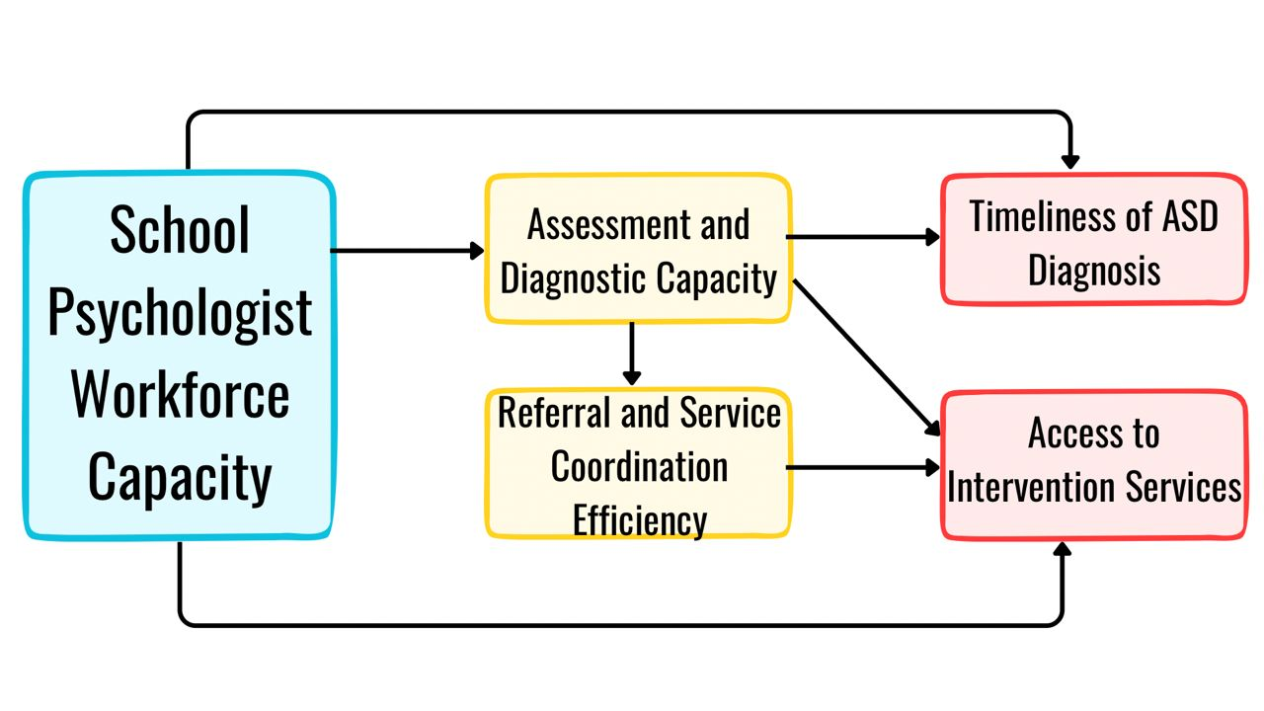Figure 1: Conceptual framework illustrating the influence of school psychologist workforce capacity on the timeliness of Autism Spectrum Disorder diagnosis and access to intervention services in Title I schools.
Figure 1 presents the conceptual framework guiding this study. The model positions school psychologist workforce capacity as the primary independent variable influencing two key outcomes, namely the timeliness of Autism Spectrum Disorder diagnosis and access to intervention services in Title I schools. Workforce capacity is conceptualized in terms of the availability and distribution of school psychologists, which determines the ability of schools to deliver timely and effective psychological services.
The framework proposes both direct and indirect relationships. Direct effects are specified from workforce capacity to the timeliness of diagnosis and access to intervention services, reflecting the immediate influence of staffing levels on service delivery outcomes. In addition, the model incorporates two mediating mechanisms. Assessment and diagnostic capacity represents the ability of schools to conduct timely and comprehensive evaluations, while referral and service coordination efficiency captures the effectiveness of linking identified students to appropriate external diagnostic and intervention services.
The framework assumes a sequential relationship between the mediators, whereby assessment and diagnostic capacity influences referral and service coordination efficiency. Assessment capacity directly affects the timeliness of Autism Spectrum Disorder diagnosis and also contributes to access to intervention services. Referral and coordination efficiency further facilitates access to intervention services, representing the continuity between identification and service utilization.
3. Methodology
The study adopts a quantitative research design to examine how school psychologist workforce capacity influences the timeliness of Autism Spectrum Disorder (ASD) diagnosis and access to intervention services within Title I schools, with particular attention to intermediary system processes and contextual effects. The analysis is based on secondary data derived from publicly available datasets from the National Center for Education Statistics, including the Common Core of Data (CCD) and EDFacts, which provide school-level information on staffing, enrollment, special education classifications, and service provision. The unit of analysis is the school, with observations nested within districts to enable multilevel estimation.
Workforce capacity is operationalized as the student-to-psychologist ratio, defined as:
$$Psychologist Ratio=\frac{Total Students}{Number of Psychologist}$$
Timeliness of diagnosis is proxied by early identification rates:
$$Early Identification Rate=\frac{ASD K2}{Total ASD}$$
Access to intervention services is measured as:
$$Service Access Rate=\frac{Students Receiving Services}{ASD Students}$$
Assessment capacity, specified as the mediating variable, is defined as:
$$Assessment Capacity=\frac{Completed Evaluations}{Referrals}$$
To address the study objectives, multiple quantitative techniques are employed. First, a multivariate linear regression model is used to estimate the relationship between workforce capacity and early identification:
$$Y_{i}={β_{0}}+β_{i }Χ_{i }+ε_{i}{ }$$
where $Y_{i}$ represents early identification rate and $Χ_{i }$denotes workforce capacity.
Second, access to intervention services is modeled using binary logistic regression:
$$log⁡(\frac{p_{i}}{1{-p}_{i}})Y_{i}={β_{0}}+β_{i }Χ_{i }+ε_{i}{ }$$
where $p_{i}$ is the probability of access to appropriate intervention pathways.
Third, mediation analysis is conducted using a system of equations to estimate indirect effects:
$$M_{i}={α_{0}}+α_{i }Χ_{i }+ε_{i}{ }$$
$$Y_{i}={β_{0}}+β_{i }M_{i }+ε_{i}{ }$$
$$Y_{i}={Υ_{0}}+Υ_{i }Χ_{i }+{Υ_{2 }M_{i }+ε}_{i}{ }$$
The indirect effect is computed as:
Indirect Effect= $α_{i }× β_{i }$
Finally, hierarchical linear modeling is employed to account for contextual variation across districts:
$${Level 1: Y}_{ij}={β_{0j}}+β_{1j }X_{ij }+r_{ij}{ }$$
$${Level 2: β}_{0j}={Υ_{00}}+Υ_{01 }Z_{j }+U_{0j}{ }$$
$$β_{ij}={Υ_{10}}+Υ_{11 }Z_{j }+U_{1j}{ }$$

Where $Z_{j }$ represents Title I intensity at the district level.
All models are estimated using standard statistical procedures, with significance evaluated at conventional thresholds (p<0.05). Model fit is assessed using R² for linear models, pseudo R² and classification accuracy for logistic models, and intraclass correlation coefficients for multilevel models. This integrated methodological approach enables a comprehensive examination of direct, indirect, and contextual effects, ensuring alignment with the study’s systems-oriented conceptual framework and providing robust empirical evidence on the role of workforce capacity in ASD service delivery.
4. Results and Discussion
Objective 1 examines the relationship between school psychologist workforce capacity and the timeliness of Autism Spectrum Disorder (ASD) identification in Title I schools.
Table 1: Regression Results Examining the Effect of Workforce Capacity on Early ASD Identification
Variable | Coefficient (β) | Std. Error | t-value | p-value
Intercept | 0.742 | 0.052 | 14.27 | <0.001
Psychologist Ratio | -0.000185 | 0.000041 | -4.51 | <0.001
Model Summary: R² = 0.31, Adjusted R² = 0.30, F(1,118) = 20.34, p < 0.001
The results indicate a statistically significant negative relationship between school psychologist workforce capacity and early ASD identification rates (β = -0.000185, p < 0.001). The model explains a moderate proportion of variance in early ASD identification (R² = 0.31) and is statistically significant overall (F(1,118) = 20.34, p < 0.001). Specifically, as the number of students assigned to each school psychologist increases, the proportion of students identified with ASD at earlier stages decreases.
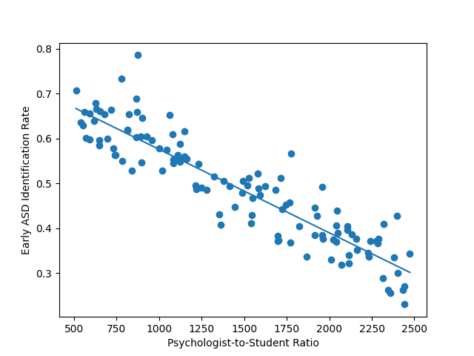
Figure 2: Relationship between psychologist-to-student ratio and early ASD identification rate.
As shown in Figure 2, there is a clear downward trend indicating that increases in the psychologist-to-student ratio are associated with lower rates of early ASD identification.
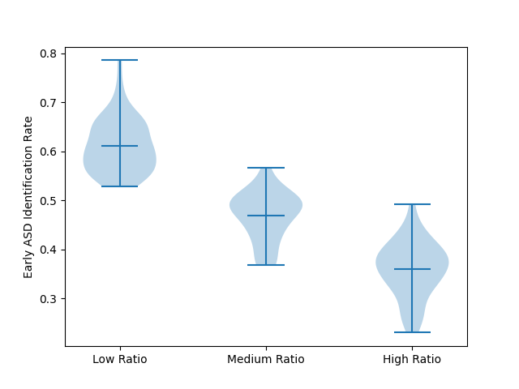
Figure 3: Distribution of early ASD identification rates across workforce capacity levels.
Figure 3 further illustrates that schools with lower psychologist-to-student ratios demonstrate higher and more consistent early identification rates, whereas schools with higher ratios show lower and more variable identification outcomes.
Overall, the findings demonstrate that workforce capacity plays a critical role in shaping the timeliness and consistency of ASD identification processes within Title I schools, highlighting the structural influence of staffing levels on early diagnostic pathways.
Objective 2 examines how school psychologists function as access points in the referral and coordination of Autism Spectrum Disorder (ASD) diagnostic and intervention services in Title I schools.
Table 2: Logistic Regression Results Examining the Effect of Workforce Capacity on Access to Intervention Pathways
Variable | Coefficient (β) | Std. Error | z-value | p-value | Odds Ratio
Intercept | 1.982 | 0.621 | 3.19 | 0.001 | 7.26
Psychologist Ratio | -0.00112 | 0.00029 | -3.86 | <0.001 | 0.9989
Model Summary: Pseudo R² = 0.27, χ²(1) = 18.72, p < 0.001, Classification Accuracy = 72%
The results indicate a statistically significant negative relationship between school psychologist workforce capacity and access to intervention pathways (β = -0.00112, p < 0.001). This implies that as the number of students per school psychologist increases, the likelihood of students receiving appropriate and coordinated intervention services decreases. The model demonstrates moderate explanatory power and acceptable classification accuracy, indicating that workforce capacity is a meaningful predictor of access outcomes.
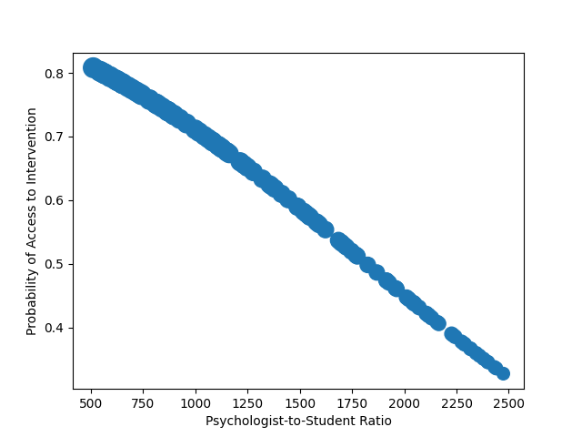
Figure 4: Probability of access to intervention services across workforce capacity levels.
Figure 4 shows a clear decline in the probability of access to intervention services as psychologist-to-student ratios increase. The reduction in bubble size further indicates diminishing strength of access outcomes in schools experiencing higher workforce shortages.
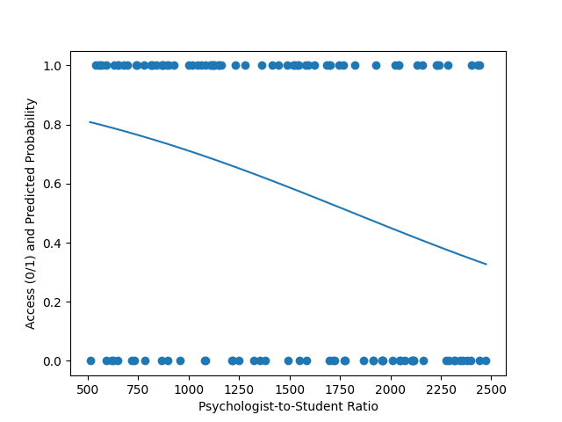
Figure 5: Logistic relationship between workforce capacity and access to intervention outcomes.
Figure 5 illustrates the decreasing predicted probability of access as workforce capacity declines. The distribution of observed outcomes indicates that cases of non-access become more frequent at higher psychologist-to-student ratios.
The findings consistently indicate that school psychologist workforce capacity plays a critical role in determining whether students successfully access intervention services. Variations in staffing levels appear to directly influence the efficiency of referral and coordination processes, shaping the extent to which identified students are able to transition into appropriate service pathways.
Objective 3 evaluates how school psychologist workforce capacity affects the continuity between school-based identification and access to intervention services through assessment capacity.
Table 3A: Effect of Workforce Capacity on Assessment Capacity
Variable | Coefficient (β) | Std. Error | t-value | p-value
Intercept | 0.812 | 0.041 | 19.80 | <0.001
Psychologist Ratio | -0.000142 | 0.000033 | -4.30 | <0.001
R² = 0.28
Table 3B: Effect of Assessment Capacity on Service Access
Variable | Coefficient (β) | Std. Error | t-value | p-value
Intercept | 0.214 | 0.052 | 4.12 | <0.001
Assessment Capacity | 0.673 | 0.089 | 7.56 | <0.001
R² = 0.41
Table 3C: Full Mediation Model
Variable | Coefficient (β) | Std. Error | t-value | p-value
Psychologist Ratio | -0.000061 | 0.000029 | -2.10 | 0.037
Assessment Capacity | 0.592 | 0.095 | 6.23 | <0.001
R² = 0.46
The results indicate that workforce capacity significantly affects assessment capacity, which in turn strongly influences access to intervention services. The reduction in the direct effect of workforce capacity in the full model indicates partial mediation, suggesting that assessment processes play a critical role in linking staffing levels to service access outcomes.
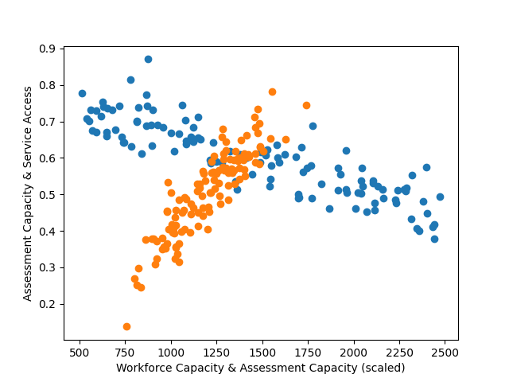
Figure 6: Relationship between workforce capacity, assessment capacity, and service access.
Figure 6 illustrates how workforce capacity is associated with variations in assessment capacity, which subsequently relate to differences in service access outcomes.
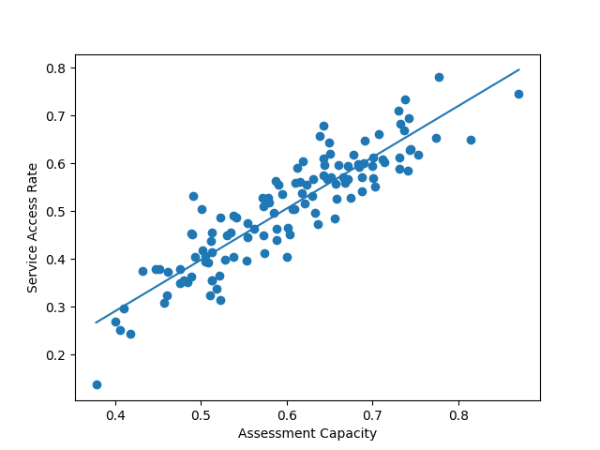
Figure 7: Relationship between assessment capacity and service access.
Figure 7 shows a strong positive relationship between assessment capacity and service access, reinforcing its role as a key mechanism in service continuity.
Overall, the findings highlight the central role of assessment capacity as a mechanism through which workforce limitations translate into reduced access to intervention services, emphasizing the importance of strengthening assessment processes within resource-constrained school systems.
Objective 4 assesses how school psychologist workforce capacity influences access to Autism Spectrum Disorder (ASD) intervention services within Title I school contexts, accounting for structural inequality across districts.
Table 4: Multilevel Regression Results
Variable | Coefficient (γ) | Std. Error | t-value | p-value
Intercept | 0.701 | 0.048 | 14.60 | <0.001
Psychologist Ratio | -0.000082 | 0.000021 | -3.90 | <0.001
Title I Intensity | -0.213 | 0.067 | -3.18 | 0.002
Interaction Term | -0.000057 | 0.000018 | -3.17 | 0.002
Model Summary: ICC = 0.19, Level-1 R² = 0.34
The results indicate that school psychologist workforce capacity is significantly associated with access to intervention services, with higher student-to-psychologist ratios linked to lower access levels. Title I intensity is also negatively associated with access, indicating that more disadvantaged districts experience reduced service availability. Importantly, the interaction term is significant, demonstrating that the negative effect of workforce shortages is amplified in high Title I contexts.
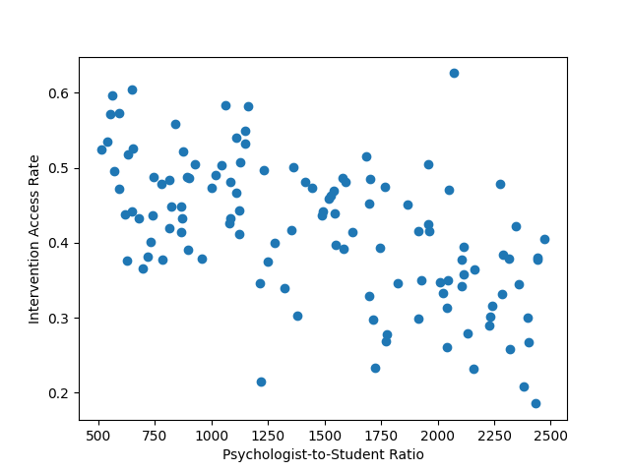
Figure 8: Relationship between workforce capacity and intervention access.
Figure 8 shows a general decline in intervention access rates as psychologist-to-student ratios increase across schools.
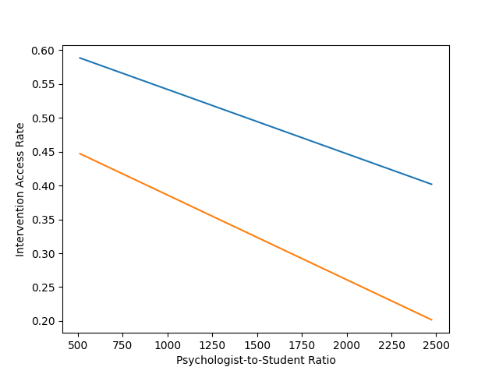
Figure 9: Interaction between workforce capacity and Title I intensity.
Figure 9 illustrates that the decline in access is steeper in high Title I contexts compared to low Title I contexts, indicating compounded disadvantage.
The findings highlight that workforce capacity and structural disadvantage interact to shape access to ASD intervention services, demonstrating that shortages have more severe consequences in already disadvantaged educational environments.
Discussion
The findings of this study provide a coherent and system-level explanation of how school psychologist workforce capacity shapes both the timeliness of Autism Spectrum Disorder (ASD) diagnosis and access to intervention services within Title I schools. Taken together, the results demonstrate that workforce shortages are not merely a background constraint but a central structural determinant that influences multiple stages of the service delivery pathway, from early identification to intervention access.
The analysis associated with Figure 2 shows a clear negative relationship between school psychologist workforce capacity and early ASD identification, indicating that higher student-to-psychologist ratios are associated with reduced rates of early diagnosis. This finding reinforces existing evidence that delays in ASD identification are strongly linked to system-level capacity constraints rather than solely individual or clinical factors (Smith et al., 2024; Uzoaru et al., 2025). While prior research has emphasized delays in diagnostic timelines, the present study extends this understanding by empirically demonstrating that such delays are directly associated with the availability of specialized professionals within school systems. In this regard, the findings support the argument that diagnostic timeliness is contingent upon institutional capacity, thereby aligning with studies that position early identification as an outcome shaped by service delivery efficiency rather than diagnostic criteria alone (Cortese et al., 2025; Maciver et al., 2025).
Beyond diagnostic timing, the results presented in Figure 4 and Figure 5 further indicate that workforce capacity significantly influences access to intervention services. Schools with higher psychologist-to-student ratios exhibit a reduced likelihood of successfully connecting students to appropriate intervention pathways. This finding substantiates the conceptualization of school psychologists as critical access points within ASD service systems, as highlighted in prior literature (Cadime & Mendes, 2024; Zabek et al., 2023). More specifically, the results suggest that workforce limitations constrain not only the initiation of diagnostic processes but also the subsequent coordination required to translate diagnosis into actionable support. This aligns with evidence indicating that fragmented referral systems and insufficient coordination mechanisms contribute to reduced service uptake (Rizk et al., 2024; Claussen et al., 2026). Therefore, the role of school psychologists extends beyond assessment to encompass a broader gatekeeping function that determines whether students effectively transition into intervention services.
The mediation analysis illustrated in Figure 6 and Figure 7 provides critical insight into the mechanism through which workforce capacity influences service outcomes. The results demonstrate that assessment capacity significantly mediates the relationship between workforce availability and access to intervention services, indicating that limitations in staffing reduce the throughput of evaluation processes, which in turn constrains service access. This finding directly supports theoretical perspectives that identify assessment processes as a key bottleneck within ASD diagnostic pathways (Chen et al., 2023; Wilczyński et al., 2024). While previous studies have acknowledged the role of assessment delays, the present study advances the literature by empirically validating assessment capacity as an intermediary mechanism linking workforce constraints to downstream service outcomes. In doing so, it provides a more integrated explanation of how institutional limitations translate into both delayed diagnosis and reduced intervention access.
These findings also provide empirical support for the conceptual framework presented in Figure 1, which posits that school psychologist workforce capacity influences both diagnostic timeliness and access to intervention services through intermediary system processes. The observed mediation effect confirms that assessment capacity functions as a critical operational pathway through which workforce constraints translate into service delays and reduced access. In addition, the significant interaction between workforce capacity and Title I intensity further extends the framework by demonstrating that these relationships are conditioned by structural context. This reinforces the validity of the proposed model while also highlighting the importance of incorporating contextual factors in understanding service delivery outcomes.
Furthermore, the multilevel analysis associated with Figure 8 and Figure 9 highlights the importance of socioeconomic context in shaping these relationships. The results indicate that Title I intensity is negatively associated with access to intervention services and that the adverse effects of workforce shortages are significantly amplified in more disadvantaged districts. This finding is consistent with prior research demonstrating that schools serving low-income populations face compounded resource constraints and reduced access to specialized services (Learning Policy Institute, 2025; US GAO, 2024). However, the present study extends this body of work by showing that structural disadvantage does not operate independently but interacts with workforce capacity to produce disproportionate barriers to service access. In other words, workforce shortages have a more severe impact in contexts where institutional resources are already limited, thereby reinforcing existing inequalities in diagnostic and intervention outcomes.
These findings contribute to a more integrated understanding of ASD service delivery by linking workforce capacity, assessment processes, and structural inequality within a single analytical framework. While existing literature has often examined diagnostic delays, workforce shortages, and educational disparities as separate issues, this study demonstrates that they are interconnected components of a broader system of service delivery. The evidence suggests that workforce capacity influences not only whether services are delivered but also how efficiently students move through the diagnostic and intervention pathway. Moreover, the identification of assessment capacity as a mediating mechanism provides a concrete explanation for how these effects occur, while the multilevel analysis underscores the importance of contextual factors in shaping their magnitude.
In this respect, the study offers a substantive contribution to both theory and empirical research by repositioning school psychologists as central actors within ASD service systems and by demonstrating how variations in workforce capacity translate into measurable differences in diagnostic timeliness and intervention access. At the same time, the findings emphasize that addressing workforce shortages in isolation may be insufficient, as their impact is conditioned by broader structural inequalities within educational contexts. This integrated perspective provides a more comprehensive basis for understanding the operational dynamics of ASD service delivery and highlights the need to consider both human capital and contextual factors in efforts to improve system performance.

5. Conclusion and Recommendations
The findings of this study demonstrate that school psychologist workforce capacity is a critical determinant of both the timeliness of Autism Spectrum Disorder diagnosis and access to intervention services within Title I schools. Workforce shortages were found to delay early identification, reduce the likelihood of successful service access, and disrupt the continuity between assessment and intervention. Moreover, the mediating role of assessment capacity and the amplifying effect of socioeconomic disadvantage highlight that these challenges are not isolated but operate within an interconnected system shaped by both human resource constraints and structural inequalities. These results underscore the need for coordinated and system-level responses to improve service delivery outcomes.
In light of these findings, the following recommendations are proposed:
- Education policymakers should prioritize targeted recruitment and equitable redistribution of school psychologists to high-need Title I schools to reduce caseload imbalances.
- School systems should strengthen assessment infrastructure and streamline evaluation processes to improve diagnostic throughput and reduce delays.
- Inter-agency collaboration between education and healthcare providers should be formalized to enhance referral efficiency and ensure continuity of care.
- Investment in alternative service delivery models, including multidisciplinary teams and telepsychology, should be expanded to mitigate workforce shortages in underserved areas.

References

References
Abba, S. S., Obioha-Val, O. A., Ariyo, A. O., Okunleye, O. J., & Ogunmolu, A. M. (2026). Agentic AI and Permission Inheritance Risks: Rethinking Access Control in Autonomous Systems. Journal of Engineering Research and Reports, 28(3), 260–281. https://doi.org/10.9734/jerr/2026/v28i31836
Abba, S., Lawal, T. I., Adeyinka, P. D., Ogunmolu, A. M., & Olutimehin, A. T. (2026). Prompt Injection and Training Data Poisoning as Emerging Threats to PCI DSS–Protected Financial Data. Asian Journal of Research in Computer Science, 19(3), 53–75. https://doi.org/10.9734/ajrcos/2026/v19i3836
Adamou, M., Jones, S. L., Fullen, T., Alty, B., Ward, J., & Mills, J. N. (2025). Enhancing Adult Autism Diagnostic Pathways: The Role of Clinical Triage in Efficient Service Provision. Journal of Clinical Medicine, 14(9), 2933–2933. https://doi.org/10.3390/jcm14092933
Alkan, B. B., Kumartas, M., Kuzucuk, S., & Alkan, N. (2025). Fast and effective assessment for individuals with special needs from optimization and prediction models. BMC Psychology, 13(1). https://doi.org/10.1186/s40359-025-02768-z
Alpuche De Lille, M. J., Teixeira da Silva, R., & Smythe, T. (2025). School‐based mental health and psychosocial support interventions for children and adolescents with developmental disabilities in low‐ and middle‐income countries: A systematic review. Tropical Medicine & International Health, 30(8), 763–781. https://doi.org/10.1111/tmi.70000
Antalek, C., Castro-Kemp, S., Dixon, F., & Romualdez, A. (2025). Identifying and supporting the needs of autistic children and young people: a rapid evidence review, Research report September 2025. https://assets.publishing.service.gov.uk/media/68d660f58c739d679fb1de1f/Identifying_and_supporting_the_needs_of_autistic_children_and_young_people_a_rapid_evidence_review.pdf?utm_
Aylward, B. S., Gal-Szabo, D. E., & Taraman, S. (2021). Racial, Ethnic, and Sociodemographic Disparities in Diagnosis of Children with Autism Spectrum Disorder. Journal of Developmental & Behavioral Pediatrics, 42(8). https://doi.org/10.1097/dbp.0000000000000996
Cadime, I., & Mendes, S. A. (2024). Psychological Assessment in School Contexts: Ethical Issues and Practical Guidelines. PubMed, 37(1), 32–32. https://doi.org/10.1186/s41155-024-00318-x
Camacho, K. A., Dwyer, C., Whitcomb, S., & Pannozzo, P. (2024). Rethinking School Psychologist Ratios through a Practice Model Lens in One Northeast State. Contemporary School Psychology, 29(1), 200–212. https://doi.org/10.1007/s40688-024-00511-w
CDC. (2025a, April 15). Clinical Screening for Autism Spectrum Disorder. Autism Spectrum Disorder (ASD). https://www.cdc.gov/autism/hcp/diagnosis/screening.html?utm_
CDC. (2025b, April 15). Data and Statistics on Autism Spectrum Disorder. Autism Spectrum Disorder (ASD); CDC. https://www.cdc.gov/autism/data-research/index.html
Chen, Y.-H., Drye, M., Chen, Q., Fecher, M., Liu, G., & W. Spencer Guthrie. (2023). Delay from Screening to Diagnosis in Autism Spectrum Disorder: Results from a Large National Health Research Network. The Journal of Pediatrics, 260, 113514–113514. https://doi.org/10.1016/j.jpeds.2023.113514
Cianfa, A., Guerrera, S., Fucà, E., Annechini, E., Napoli, V., Vicari, S., & Valeri, G. (2025). Clinical and sociodemographic factors related to the timing of autism diagnosis in an Italian cohort of children. Frontiers in Psychiatry, 16, 1638341–1638341. https://doi.org/10.3389/fpsyt.2025.1638341
Claussen, A. H., Katz, S. M., Newsome, K., & DuPaul, G. (2026). Providers of ADHD Care for Children: Factors Associated With Coordination of ADHD Services With Schools. Journal of Attention Disorders, 0(0).
Cortese, S., Alessio Bellato, Gabellone, A., Marzulli, L., Matera, E., Parlatini, V., Petruzzelli, M. G., Persico, A. M., Delorme, R., Paolo Fusar-Poli, Gosling, C. J., Solmi, M., & Margari, L. (2025). Latest clinical frontiers related to autism diagnostic strategies. Cell Reports Medicine, 6(2), 101916–101916. https://doi.org/10.1016/j.xcrm.2024.101916
Din, S. (2025, July 2). Policy Brief: Reducing Barriers to Autism Diagnosis and Early Intervention | School of Behavioral Health. Llu.edu. https://behavioralhealth.llu.edu/blog/policy-brief-reducing-barriers-autism-diagnosis-and-early-intervention?utm_
Dockweiler, K. A., & Kaufman, R. (2024). School psychology: Increasing awareness, enhancing policies, and reducing shortages. Psychology in the Schools, 61(6). https://doi.org/10.1002/pits.23162
Ejiofor, V. O., Lawal, T. I., Adeyinka, P. D., Ogunmolu, A. M., & Balogun, A. Y. (2026). Post-Quantum 5G Slicing Security Framework Integrating AI-Driven Threat Mitigation in Global Telecommunications. Journal of Engineering Research and Reports, 28(3), 118–134. https://doi.org/10.9734/jerr/2026/v28i31825
Ejoh, C. I. (2026). Advancing Vocational Rehabilitation Counseling Strategies for Young Adults with Autism Spectrum Disorder in the U.S. Digital Workforce. International Neuropsychiatric Disease Journal, 23(1), 83–102. https://doi.org/10.9734/indj/2026/v23i1540
Ejoh, C. I., & Henry, O. (2026). Culturally Responsive Rehabilitation Counseling Models and Workforce Reintegration Outcomes among Linguistically Diverse Populations in the United States. International Neuropsychiatric Disease Journal, 23(1), 123–143. https://doi.org/10.9734/indj/2026/v23i1542
Ejoh, C. I., Nduka, W. O., Popoola, A. D., Henry, O., & Ogunmolu, A. M. (2026). Privacy-by-Design Data Governance Models for Healthcare Analytics and Artificial Intelligence. Asian Journal of Research in Computer Science, 19(3), 37–52. https://doi.org/10.9734/ajrcos/2026/v19i3835
Ejoh, C. I., Odeyinka, T. E., Nduka, W. O., Ejiofor, V. O., & Henry, O. (2026). AI-Driven Business Process Mining for Healthcare: Automated Discovery and Optimization of Clinical and Administrative Workflows. Journal of Engineering Research and Reports, 28(3), 102–117. https://doi.org/10.9734/jerr/2026/v28i31824
Frost, K. M., Hsu, H. E., Petruccelli, M., Keehn, R. M., Rue, H., Beeler, A., & Broder-Fingert, S. (2025). Value-Based Care and Accountable Care Organizations: Implications for Early Autism Diagnosis and Access to Quality Care. Behavioral Sciences, 15(10), 1354. https://doi.org/10.3390/bs15101354
George, A. (2025, January 10). Addressing the US Shortage of Bilingual School Psychologists. Language Magazine. https://languagemagazine.com/2025/01/10/addressing-the-us-shortage-of-bilingual-school-psychologists/?utm_
Grigore, B., Peters, J., Williams, J., Russell, G., Coles, P., Visintin, C., Rogers, M., Hayward, R., Zhelev, Z., Logan, S., & Hyde, C. (2024). Screening for Autism Spectrum Disorder in Young Children: Still Not Enough Evidence. Journal of Primary Care & Community Health, 15. https://doi.org/10.1177/21501319241263223
Hallaråker, H., Hesjedal, E., & Brandmo, C. (2025). Characteristics of interprofessional collaboration between educational psychological services and schools: A scoping review. Educational Research Review, 48, 100707. https://doi.org/10.1016/j.edurev.2025.100707
Henry, O. (2026). Predictive Analytics for Preventing Crisis-Driven Mental Health Utilization in Community and School-Based Settings. International Neuropsychiatric Disease Journal, 23(1), 103–122. https://doi.org/10.9734/indj/2026/v23i1541
Henry, O., Ejoh, C. I., Ejiofor, V. O., Adesokan, O. Z., & Abdulmalik, A. A. (2026). Privacy-Preserving and Explainable Federated Edge Learning for Multimodal Wearable-Based Self-Tracking and Monitoring. Asian Journal of Research in Computer Science, 19(4), 1–15. https://doi.org/10.9734/ajrcos/2026/v19i4845
Johnson, K. M. (2024, December 6). Addressing the School Psych Shortage: The Critical Role of Telepractice. Thesteppingstonesgroup.com; The Stepping Stones Group. https://blogs.thesteppingstonesgroup.com/addressing-the-school-psychologist-shortage?utm_
Joyce, C. (2025, April 15). Autism Society of America Responds to New CDC Report on Updated Autism Prevalence Rates | Autism Society. Autism Society. https://autismsociety.org/autism-society-of-america-responds-to-new-cdc-report-on-updated-autism-prevalence-rates/
Khalil, A., Yatcilla, J., Christie, N., & Zhou, X. (2025). A Systematic Review of Help-Seeking Barriers for Racial-Ethnic Minority Caregivers Accessing Autism Diagnostic and Intervention Services. Journal of Racial and Ethnic Health Disparities. https://doi.org/10.1007/s40615-025-02555-x
Lawal, T. I., Ariyo, A. O., Akinwunmi, D. A., Adesokan, O. Z., & Ogunmolu, A. M. (2026). Permission Inheritance and Machine-Speed Risk Escalation in Agentic Al-Driven Cloud Operations. Journal of Engineering Research and Reports, 28(4), 106–126. https://doi.org/10.9734/jerr/2026/v28i41853
Learning Policy Institute. (2025, April 9). How Money Matters: Education Funding and Student Outcomes. Learning Policy Institute; [Fact sheet]. https://learningpolicyinstitute.org/product/how-money-matters-factsheet?utm_
Lidstone, D. E. (2025). Missed Early Intervention Opportunities for Children With Autism Spectrum Disorder. Autism Research, 18(5), 1097–1103. https://doi.org/10.1002/aur.70043
Lipkin, S. N. (2023). Needed: More school psychologists. Phi Delta Kappan, 105(3), 20–23. https://doi.org/10.1177/00317217231212005
Maciver, D., Roy, A. S., Johnston, L., Boilson, M., Curnow, E., Johnstone‐Cooke, V., & Rutherford, M. (2025). Waiting Times and Influencing Factors in Children and Adults Undergoing Assessment for Autism, ADHD, and Other Neurodevelopmental Differences. Autism Research, 18(4). https://doi.org/10.1002/aur.70011
Medeiros, H. V., Lifter, K., Goodwin, G., & Antonelli, R. (2024). Assessing Play in Children Developing with Delays: A Scoping Review. Review Journal of Autism and Developmental Disorders. https://doi.org/10.1007/s40489-024-00469-8
Mendez, A. I., McQueen, E., Gillespie, S., Klin, A., Klaiman, C., & Pickard, K. (2024). Access to Part C, Early Intervention for children younger than 4 years evaluated for autism spectrum disorder. Autism, 28(6). https://doi.org/10.1177/13623613241229150
Micigan, J. (2024). The impact of school funding inequities on student success. Research & Reviews: Journal of Educational Studies RRJES|, 10(2). https://doi.org/10.4172/JES.10.2.010
National Association of School Psychologists. (2024, February). State Shortages Data Dashboard. National Association of School Psychologists (NASP). https://www.nasponline.org/about-school-psychology/state-shortages-data-dashboard
National Center for Education Statistics. (2024, May). Students with disabilities. National Center for Education Statistics; The Institute of Education Sciences. https://nces.ed.gov/programs/coe/indicator/cgg/students-with-disabilities
Nduka, W. O., Abba, S. S., Ariyo, A. O., Olisa, A. O., & Ogunmolu, A. M. (2026). AI-Driven Predictive Resilience: Integrating Impact Forecasting, Governance, and Proactive Mitigation in Networks. Journal of Engineering Research and Reports, 28(3), 75–90. https://doi.org/10.9734/jerr/2026/v28i31822
OECD. (2025). A school psychology perspective on SSES 2023. https://www.oecd.org/content/dam/oecd/en/publications/reports/2025/03/bridging-gaps-in-social-and-smotional-skills_61bdd411/8960542c-en.pdf?utm_
Ogunmolu, A. M., Abdulmalik, A. A., Bamsa, A. O., Akinwunmi, D. A., & Obrik-Uloho, E. P. (2026). Agentic Ransomware Targeting Autonomous Al Systems in OT/ICS Environments: Implications for Process Safety, System Reliability, and Operational Resilience. Journal of Engineering Research and Reports, 28(4), 213–234. https://doi.org/10.9734/jerr/2026/v28i41859
Ogunmolu, A. M., Olaniyi, O. M., Ejoh, C. I., Balogun, A. Y., & Oyekunle, S. M. (2026). Secure-by-Containment Architectures for Agentic AI in OT/ICS Environments. Asian Journal of Research in Computer Science, 19(3), 1–23. https://doi.org/10.9734/ajrcos/2026/v19i3833
Ogunmolu, A. M., Olawale, B. M., Oladoyinbo, O. B., Olateju, O. O., & Adeyinka, P. D. (2026). Green Cybersecurity: Quantifying the Carbon Footprint and Operational Efficiency of Machine-Speed Defense in Autonomous Industrial Control and Smart Manufacturing Systems. Journal of Engineering Research and Reports, 28(4), 235–250. https://doi.org/10.9734/jerr/2026/v28i41860
Ogunmolu, A. M., Popoola, A. D., Adesokan, O. Z., Abdulmalik, A. A., & Joseph, S. A. (2026). Runtime Policy Orchestration for Autonomous Industrial Control and Smart Manufacturing Systems: A Unified Framework for Governance, Compliance, and Adaptive Resilience. Journal of Engineering Research and Reports, 28(4), 275–293. https://doi.org/10.9734/jerr/2026/v28i41862
Olaniyi, O. M., Aroh, I. S., Henry, O., Metibemu, O. C., & Akinola, O. I. (2026). Graph Neural Networks for Multi-Layered Financial Crime Network Detection: An Explainable AI Framework for Anti-Money Laundering. Journal of Engineering Research and Reports, 28(2), 18–36. https://doi.org/10.9734/jerr/2026/v28i21787
Pike, N. M., & Floyd, R. G. (2024). Stress in United States school psychologists: Development and preliminary psychometric properties of the School Psychologist Distress Inventory. Journal of School Psychology, 106, 101351. https://doi.org/10.1016/j.jsp.2024.101351
Qu, L., Liu, Q., Zheng, S., Zhou, A., Yin, T., Zhang, Y., Wang, X., Colombi, C., & Ulrich, D. (2025). From first concern to autism diagnosis: Parental experiences and satisfaction in autism identification in China. Research in Autism, 123, 202544. https://doi.org/10.1016/j.reia.2025.202544
Renzi, H. R., & Daly, B. D. (2024). The Shortage of School Psychology Faculty in the Aftermath of the COVID-19 Pandemic. School Psychology Review, 54(6), 1–6. https://doi.org/10.1080/2372966x.2024.2339796
Ripma, T. A., DeMatthews, D. E., & Voulgarides, C. K. (2024). Addressing inequity in special education referrals: Integrating general and special education strategies in school leadership. Journal of Cases in Educational Leadership, 27(4). https://doi.org/10.1177/15554589241288864
Rizk, S., Ngui, E. M., Salgado, Z., Bosak, D. L., & Khetani, M. A. (2024). Medical Home Care and Educational Services for Children and Youth on the Autism Spectrum: A Scoping Review. Journal of Autism and Developmental Disorders. https://doi.org/10.1007/s10803-024-06235-3
Salminen, J., Laasanen, M., Leinonen, L., Karukivi, M., Vornanen, R., Alin, M., & Kyttälä, M. (2025). Professional collaboration for children and adolescents with neurodevelopmental disorders: a scoping review. European Journal of Special Needs Education, 40(1), 1–19. https://doi.org/10.1080/08856257.2024.2314422
Shahidullah, J. D., McClain, M. B., Azad, G., Mezher, K. R., & McIntyre, L. L. (2020). Coordinating Autism Care Across Schools and Medical Settings: Considerations for School Psychologists. Intervention in School and Clinic, 56(2), 107–114. https://doi.org/10.1177/1053451220914891
Shaw, K. A. (2025). Prevalence and Early Identification of Autism Spectrum Disorder Among Children Aged 4 and 8 Years — Autism and Developmental Disabilities Monitoring Network, 16 Sites, United States, 2022. MMWR. Surveillance Summaries, 74(2). https://doi.org/10.15585/mmwr.ss7402a1
Smith, J. V., Howard, M., Menezes, M., Burroughs, C., & Mazurek, M. O. (2025). Building Capacity: A Systematic Review of Training in the Diagnosis of Autism for Community-Based Clinicians. Autism Research, 18(4). https://doi.org/10.1002/aur.70014
Smith, J. V., Menezes, M., Brunt, S., Pappagianopoulos, J., Sadikova, E., & Mazurek, M. O. (2024). Understanding autism diagnosis in primary care: Rates of diagnosis from 2004 to 2019 and child age at diagnosis. Autism, 28(10). https://doi.org/10.1177/13623613241236112
Sohn, E. (2024, January 1). There’s a strong push for more school psychologists. Apa.org. https://www.apa.org/monitor/2024/01/trends-more-school-psychologists-needed?utm_
Tagavi, D. M., Puga, S., Dick, C., Dahiya, A. V., Bearss, K., & Locke, J. (2025). Improving the Fit of Interventions for Autism in Schools: Lessons Learned Following Paraeducator Coaching on the RUBIES Program. Journal of Educational and Psychological Consultation, 1–26. https://doi.org/10.1080/10474412.2025.2578840
Tegtmejer, T., & Säljö, R. (2025). Circular reasoning in diagnostic practices: a case study of how educational psychologists evaluate special needs. Emotional and Behavioural Difficulties, 31(1), 1–14. https://doi.org/10.1080/13632752.2025.2546229
Texas Higher Education Coordinating Board. (2025). Study and Report on Assisting Students with Autism Spectrum Disorder. Austin, TX. https://reportcenter.highered.texas.gov/reports/2025-study-and-report-on-assisting-students-with-autism-spectrum-disorder/
U.S. Commission on Civil Rights. (2025). The Federal Response to Teacher Shortage Impacts on Students with Disabilities. https://www.usccr.gov/files/2025-09/teacher-shortage-report-final.pdf
US GAO . (2024). SPECIAL EDUCATION Education Needs School and DistrictLevel Data to Fully Assess Resources Available to Students with Disabilities Report to Congressional Requesters Accessible Version. https://www.gao.gov/assets/880/870315.pdf?utm_
Uzoaru, F., Oleribe, O. O., Collins, L., Preston, M., Ross, L., & Chadha, D. (2025). Addressing racial inequities: a systematic review of intervention programs for Black/African American children with autism spectrum disorder and attention-deficit hyperactivity disorder (2019–2024). Pediatric Medicine, 8, 14–14. https://doi.org/10.21037/pm-24-75
Watson, C. (2024). An exploration of educational psychologists’ occupational stress and well-being experiences in England: implications for practice. Educational Psychology in Practice, 40(3), 320–339. https://doi.org/10.1080/02667363.2024.2365644
Wilczyński, K. M., Cichoń, L., Stasik, A., Kania, K., Rodak, N., Wizner, M., & Małgorzata Janas-Kozik. (2024). An Analysis of the Time Required for the Diagnosis of ASD and the Factors Influencing Its Duration in a Sample of the Pediatric Population from Poland. Journal of Clinical Medicine, 13(20), 6255–6255. https://doi.org/10.3390/jcm13206255
World Health Organization. (2025, September 17). Autism. Who.int; World Health Organization: WHO. https://www.who.int/news-room/fact-sheets/detail/autism-spectrum-disorders?utm_
Zabek, F., Lyons, M. D., Alwani, N., Taylor, J. V., Brown-Meredith, E., Cruz, M. A., & Southall, V. H. (2023). Roles and functions of school mental health professionals within comprehensive school mental health systems. School Mental Health, 15(1), 1–18. https://doi.org/10.1007/s12310-022-09535-0
Zhang, W., & Reszka, S. (2025). Linking System of Care Services to Flourishing in School-Aged Children with Autism. Disabilities, 5(2), 57. https://doi.org/10.3390/disabilities5020057

