Review Form (Research)

Journal Name:
Manuscript Number:
Manuscript Title: Article Type
International Journal of Tropical Diseases & Health
Mrs_IJTDH_157885
Prevalence of malaria and Plasmodium species composition in the western highlands of the North west Region, Cameroon. Research Articles

PART 1 (The importance of manuscripts)

Comments from Reviewers Author Feedback

Please write a few sentences about the importance of this manuscript to the scientific community.
Minimum 3-4 sentences are allowed. required for this section.
The study is very important to review because it evaluates malaria cases with plasmodium species in Cameroon.

SECTION 2.1 (Objective Evaluation)

Assessment from the Assessors
Author Feedback

- Is the title clear and appropriate to the research?
4= Good

Rating Scale:
5 = Very Good 4 = Good 3 = Satisfactory 2 = Needs Improvement 1 = Poor N/A = Not Applicable
- Is the article abstract comprehensive?
Rating Scale:
5 = Very Good 4 = Good 3 = Satisfactory 2 = Needs Improvement 1 = Poor N/A = Not Applicable
- Are the keywords appropriate and useful?

There is no background or urgency for the value 2=

Needs improvement

4= Good

Rating Scale:
5 = Very Good 4 = Good 3 = Satisfactory 2 = Needs Improvement 1 = Poor N/A = Not Applicable
- Is the background information in the paper adequate and well-structured?

Rating Scale:
5 = Very Good 4 = Good 3 = Satisfactory 2 = Needs Improvement 1 = Poor N/A = Not Applicable
- Are the research objectives/hypotheses clearly stated?

4= Good

4= Good

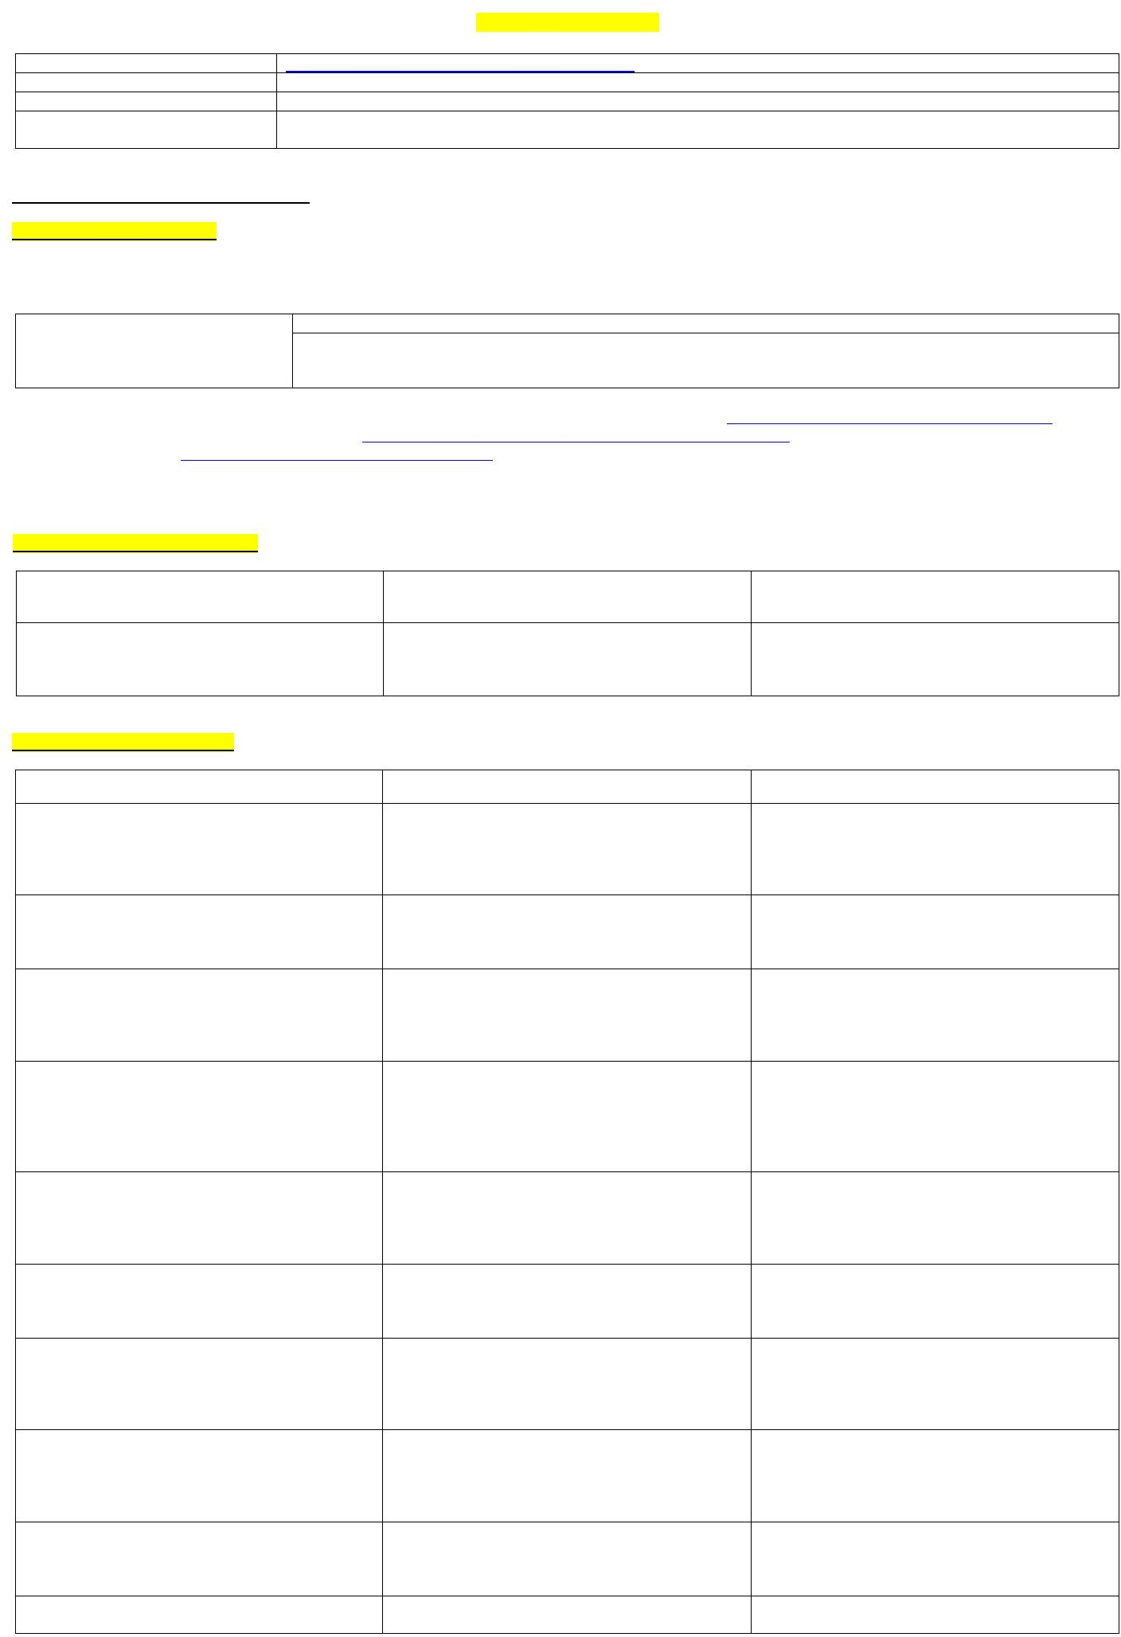
Rating Scale:
5 = Very Good 4 = Good 3 = Satisfactory 2 = Needs Improvement 1 = Poor N/A = Not Applicable
- Is the literature review relevant and up to date?
Rating Scale:
5 = Very Good 4 = Good 3 = Satisfactory 2 = Needs Improvement 1 = Poor N/A = Not Applicable
- Is the research methodology used appropriate for this study?
Rating Scale:
5 = Very Good 4 = Good 3 = Satisfactory 2 = Needs Improvement 1 = Poor N/A = Not Applicable
- Have ethical issues been addressed appropriately (if any)?
Rating Scale:
5 = Very Good 4 = Good 3 = Satisfactory 2 = Needs Improvement 1 = Poor N/A = Not Applicable
- Are the results presented clear?
Rating Scale:
5 = Very Good 4 = Good 3 = Satisfactory 2 = Needs Improvement 1 = Poor N/A = Not Applicable
- Are tables and figures clear, relevant, and necessary?

4= Good

4= Good

4= Good

4= Good

4= Good

Review Form (Research)

Rating Scale:
5 = Very Good 4 = Good 3 = Satisfactory 2 = Necessary Improvement 1 = Bad N/A = Not Applicable

- Does the discussion connect the findings to existing literature?
Rating Scale:
5 = Very Good 4 = Good 3 = Satisfactory 2 = Needs Improvement 1 = Poor N/A = Not Applicable
- Is the conclusion supported by the data?
4= Good

3= Satisfactory

Rating Scale:
5 = Very Good 4 = Good 3 = Satisfactory 2 = Needs Improvement 1 = Poor N/A = Not Applicable
- Are the limitations of the study discussed?
Rating Scale:
5 = Very Good 4 = Good 3 = Satisfactory 2 = Needs Improvement 1 = Poor N/A = Not Applicable
- Are the references provided relevant and adequate (in number)?
Rating Scale:
5 = Very Good 4 = Good 3 = Satisfactory 2 = Needs Improvement 1 = Poor
N/A = Not Applicable
- Is the manuscript written in clear and easy-to-understand language?
Rating Scale:
5 = Very Good 4 = Good 3 = Satisfactory 2 = Needs Improvement 1 = Poor
N/A = Not Applicable

No research limitations 2= Needs improvement

4= Good

4= Good

SECTION 2.2 (Subjective Evaluation)

Reviewer comments
Author Feedback (Authors are required to write their feedback here)

Is the title of the article appropriate? Yes, it is in accordance with the title of the article.

If your answer is NO, please provide a short and clear suggestion for improvement.

Is the article abstract comprehensive?
S
If your answer is NO, please provide a short and clear suggestion for improvement.
Yes, but it needs to be accompanied by background or urgency.

Is the manuscript scientifically accurate? Yes, accurate and ETHICAL data is listed.

If your answer is NO, please provide a short and clear suggestion for improvement.
.
Are the references provided adequate and up to date?

Yes, it is in accordance with the standards

(Yes or no)

If your answer is NO, please provide clear suggestions for improvement.

Are there any ethical issues in this manuscript?
(Yes or no)
There is none, the research is in accordance with procedures.

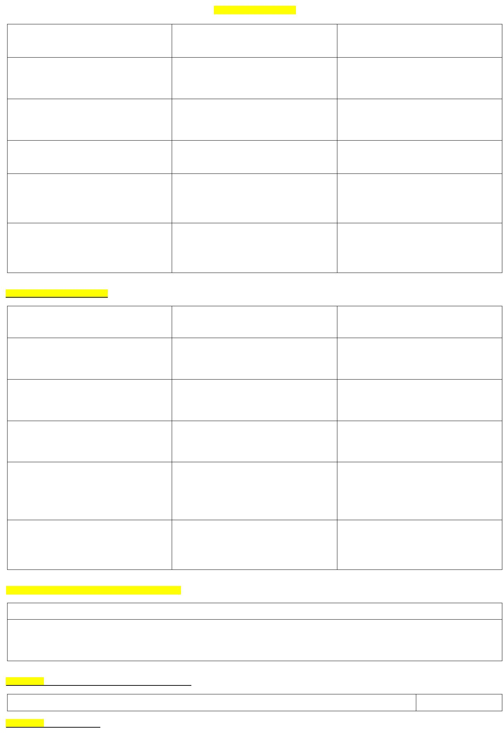
(If yes, please describe the ethical issues in detail here)

Reviewer details:

Junaiddin, Papua College of Health Sciences, Indonesia

