Review Article
Breast Cancer Surgery in Cameroon: Current Practice, Challenges, and Future Perspectives — A Systematic Review

Abstract
Background
Breast cancer is the most frequently diagnosed malignancy among women worldwide and has become the leading female cancer in Cameroon. Surgery remains the cornerstone of curative treatment for non-metastatic disease, yet the type and quality of surgical care depend heavily on diagnostic capacity, multidisciplinary coordination, and access to adjuvant therapies. In Cameroon, most patients present with locally advanced tumors, resulting in a predominance of modified radical mastectomy and limited opportunities for breast-conserving approaches. This systematic review evaluates current surgical practices, outcomes, and structural barriers affecting breast cancer surgery in Cameroon.
Methods
A systematic review was conducted according to PRISMA guidelines. PubMed/MEDLINE, Scopus, African Journals Online, and Google Scholar were searched for studies published between January 2010 and April 2026. Eligible articles reported epidemiological, surgical, pathological, therapeutic, or health-system data related to breast cancer management in Cameroon. When national evidence was scarce, data from comparable sub-Saharan African countries were incorporated to contextualize findings. Data were synthesized narratively because of substantial methodological heterogeneity.
Results
Forty-two studies met the inclusion criteria. Breast cancer in Cameroon affects predominantly women aged 40–55 years, approximately a decade younger than in high-income countries. Between 60% and 85% of patients present with stage III or IV disease. Modified radical mastectomy remains the most commonly performed procedure, accounting for more than 80% of curative operations in most reported series. Breast-conserving surgery is uncommon because of large tumor size at diagnosis, limited access to radiotherapy, and inadequate preoperative imaging. Sentinel lymph node biopsy is rarely available, and axillary lymph node dissection remains the standard approach. Surgical outcomes are constrained by delayed diagnosis, financial barriers, insufficient pathology services, limited reconstructive options, and restricted access to systemic and radiation therapies.
Conclusion
Breast cancer surgery in Cameroon remains dominated by radical procedures performed under significant structural constraints. Earlier diagnosis, expanded radiotherapy capacity, improved pathology services, and development of multidisciplinary breast units are essential to enable more conservative and personalized surgical care. Strengthening surgical oncology infrastructure should be considered a national priority to improve both survival and quality of life for women with breast cancer in Cameroon.
Keywords
Breast cancer; Surgery; Mastectomy; Breast-conserving surgery; Cameroon; Surgical oncology; Sentinel lymph node biopsy; Resource-limited settings.
1. Introduction
Breast cancer is the most commonly diagnosed cancer among women worldwide and represents one of the leading causes of cancer-related mortality across all regions of the world [1–4]. According to the most recent estimates from the International Agency for Research on Cancer and the World Health Organization, more than 2.3 million new cases of breast cancer are diagnosed annually, accounting for nearly one in four cancers affecting women, with approximately 670,000 deaths each year [1–3]. Although advances in screening, pathology, surgery, systemic therapy, and radiotherapy have led to substantial improvements in survival in high-income countries, the global burden of breast cancer continues to rise, particularly in low- and middle-income countries where access to early diagnosis and comprehensive treatment remains limited [2–5].
Breast cancer illustrates one of the most striking paradoxes in modern oncology. In countries with well-developed health systems, the disease is increasingly detected at early stages, treated using multidisciplinary and personalized approaches, and associated with long-term survival rates exceeding 85–90% [4–7]. In contrast, women in many parts of sub-Saharan Africa continue to present with large, symptomatic, and frequently locally advanced tumors, resulting in lower cure rates and a greater need for aggressive surgical procedures [5–8]. The differences in outcomes are therefore driven less by tumor biology alone than by disparities in health-system organization, public awareness, and access to evidence-based care.
Surgery remains the central component of curative treatment for non-metastatic breast cancer [6,9–11]. Over the past five decades, breast surgery has undergone a profound transformation. Historically, the William Stewart Halsted radical mastectomy dominated management and was based on the concept of contiguous tumor spread through the breast, pectoral muscles, and regional lymph nodes [12]. Landmark randomized trials conducted by Bernard Fisher and the National Surgical Adjuvant Breast and Bowel Project subsequently demonstrated that breast-conserving surgery followed by radiotherapy provides survival outcomes equivalent to mastectomy in appropriately selected patients [13–15]. These findings fundamentally changed surgical oncology and established a less mutilating approach that preserves body image without compromising oncological safety.
Contemporary breast surgery now encompasses a broad spectrum of procedures, ranging from lumpectomy and oncoplastic resections to skin-sparing and nipple-sparing mastectomies with immediate reconstruction [10,11,16]. Similarly, axillary management has evolved from routine full axillary dissection to selective approaches based on sentinel lymph node biopsy, reducing postoperative complications such as lymphedema, shoulder dysfunction, and neuropathic pain [17–20]. The surgical treatment of breast cancer has thus become increasingly individualized and integrated within a multidisciplinary strategy involving radiologists, pathologists, medical oncologists, radiation oncologists, plastic surgeons, and specialized nurses.
The choice of surgical procedure depends on multiple factors, including tumor size, breast-to-tumor ratio, multifocality, nodal status, molecular subtype, genetic risk, patient preference, and the availability of adjuvant therapies [9–11]. Breast-conserving surgery requires access to postoperative radiotherapy and reliable pathological margin assessment. Neoadjuvant chemotherapy may downstage large tumors and increase eligibility for conservative surgery [21–24]. Accurate immunohistochemical classification of estrogen receptor, progesterone receptor, HER2, and Ki-67 status further guides systemic therapy and influences long-term outcomes [25–27].
Despite these advances, surgery in low-resource settings remains constrained by delayed presentation and limited infrastructure. In many countries in sub-Saharan Africa, modified radical mastectomy continues to be the predominant operation because patients often present with tumors too large for breast conservation and because radiotherapy services are insufficient or geographically inaccessible [28–31]. Sentinel lymph node biopsy and reconstructive surgery remain unavailable in many institutions, and treatment decisions are frequently shaped by resource limitations rather than by ideal evidence-based recommendations [30–34].
Cameroon exemplifies many of these challenges. Breast cancer has become the most common female malignancy in the country and represents a growing public health concern [35–39]. Hospital-based studies from Douala and Yaoundé indicate that the median age at diagnosis is generally between 45 and 50 years, considerably younger than in Europe and North America [36–40]. More than half of patients present with stage III disease, and a significant proportion already have metastatic involvement at first consultation [37–41]. These findings reflect delays in diagnosis related to low awareness, sociocultural beliefs, fear of cancer, and financial barriers.
The consequences of late presentation are substantial. Large tumors, skin infiltration, chest wall fixation, and clinically positive axillary nodes often preclude breast-conserving surgery, making modified radical mastectomy the most frequent curative operation [38–42]. Although mastectomy remains oncologically effective, it is associated with important psychological and social consequences, particularly in settings where reconstructive options are limited and psychosocial support services are scarce [43–45]. For many women, the loss of the breast carries profound implications for body image, marital relationships, and self-esteem.
Axillary management also remains largely traditional in Cameroon. Because nuclear medicine facilities, radiocolloid tracers, and blue dyes are not routinely available, sentinel lymph node biopsy is rarely performed outside a few specialized centers. As a result, complete axillary lymph node dissection remains the standard staging and therapeutic procedure, exposing patients to increased morbidity, including lymphedema and reduced shoulder mobility [18–20,42,46].
Pathology and biomarker assessment present additional challenges. Delays in obtaining histopathological confirmation may postpone definitive surgery or systemic treatment. Immunohistochemistry for hormone receptors and HER2 is not universally accessible and is often paid for directly by patients, limiting the use of molecular classification in treatment planning [47–50]. Limited access to targeted therapies such as trastuzumab further reduces the clinical utility of HER2 testing in some institutions.
Radiotherapy capacity is another critical determinant of surgical strategy. Because breast-conserving surgery requires postoperative irradiation, the absence or inaccessibility of radiotherapy often obliges surgeons to favor mastectomy even when conservation might otherwise be technically feasible [51–54]. The concentration of radiotherapy services in a small number of urban centers imposes major geographic and financial burdens on women from rural regions.
The economic impact of breast cancer surgery is considerable. In the absence of universal health coverage, most diagnostic and therapeutic expenses are borne directly by patients and their families [55–57]. The cumulative costs of imaging, biopsy, pathology, surgery, anesthesia, hospitalization, chemotherapy, radiotherapy, and supportive care can be catastrophic, leading to delayed treatment initiation or abandonment.
Nevertheless, important progress has been achieved. Specialized oncology units have expanded, multidisciplinary collaboration is improving, and increasing awareness of breast cancer has encouraged earlier consultation in some urban populations [38–41]. International partnerships and professional training programs are gradually strengthening local expertise in surgical oncology, pathology, and systemic therapy [58–60]. These developments create an opportunity to modernize breast cancer surgery and align national practice more closely with international standards.
Although several studies have described epidemiology, pathology, and treatment patterns of breast cancer in Cameroon, a comprehensive synthesis specifically focused on surgery remains lacking. Such a review is particularly relevant because surgery constitutes the cornerstone of curative treatment and reflects the broader strengths and limitations of the healthcare system.
The objective of this systematic review was to evaluate current surgical practices for breast cancer in Cameroon, including operative techniques, axillary management, perioperative outcomes, and structural barriers influencing care. By situating national experience within the wider African and international context, this review aims to identify practical priorities for strengthening surgical oncology services and improving outcomes for women with breast cancer.
2. Materials and Methods
This systematic review was conducted in accordance with the Preferred Reporting Items for Systematic Reviews and Meta-Analyses (PRISMA) statement and was designed to provide a comprehensive overview of surgical management of breast cancer in Cameroon, with particular emphasis on operative strategies, axillary management, perioperative outcomes, reconstructive options, and health system determinants influencing surgical care.
Search Strategy
A structured literature search was performed in PubMed/MEDLINE, Scopus, African Journals Online (AJOL), and Google Scholar. The search covered publications released between January 1, 2010 and April 30, 2026, a period selected to capture contemporary evidence reflecting recent developments in breast imaging, molecular pathology, neoadjuvant therapy, surgical oncology, and multidisciplinary cancer care.
The search strategy combined Medical Subject Headings (MeSH) and free-text terms using Boolean operators. The principal terms included “breast cancer,” “breast carcinoma,” “breast neoplasms,” “breast surgery,” “mastectomy,” “modified radical mastectomy,” “breast-conserving surgery,” “lumpectomy,” “oncoplastic surgery,” “sentinel lymph node biopsy,” “axillary dissection,” “Cameroon,” “sub-Saharan Africa,” “surgical oncology,” “radiotherapy,” and “health system.” Reference lists of all eligible articles and relevant reviews were manually screened to identify additional studies.
Eligibility Criteria
Studies were considered eligible when they met all of the following criteria:
- Reported epidemiological, surgical, pathological, therapeutic, or health system data related to breast cancer.
- Included participants treated in Cameroon.
- Provided information relevant to surgical management, including type of surgery, axillary procedures, perioperative outcomes, or access to multidisciplinary care.
- Were published in peer-reviewed journals.
- Were written in English or French.
- Included sufficient methodological detail and accessible full text.
When Cameroonian evidence was limited for specific topics such as oncoplastic surgery, sentinel lymph node biopsy, or breast reconstruction, studies from comparable sub-Saharan African settings were included to provide contextual interpretation.
The following publications were excluded:
Case reports and case series involving fewer than ten patients.
Laboratory or translational studies without clinical relevance.
Editorials, letters, conference abstracts without full manuscripts, and opinion papers.
Duplicate publications.
Articles whose full text could not be obtained.
Study Selection
All retrieved references were imported into a bibliographic management database, and duplicates were removed. Titles and abstracts were screened independently by two reviewers. Potentially relevant articles underwent full-text assessment. Disagreements were resolved through discussion and consensus with the senior author.
A total of 624 records were initially identified. After removal of duplicates and exclusion of clearly irrelevant publications, 91 full-text articles were assessed for eligibility. Forty-two studies fulfilled all predefined criteria and were included in the final qualitative synthesis.
Data Extraction
A standardized data extraction form was used to collect the following variables:
- First author and year of publication.
- Study setting and participating institutions.
- Study design.
- Sample size.
- Patient age.
- Clinical stage at diagnosis.
- Histological subtype and molecular profile.
- Type of breast surgery performed.
- Axillary management strategy.
- Margin status.
- Postoperative complications.
- Access to radiotherapy and systemic therapy.
- Reconstruction availability.
- Treatment barriers.
- Principal conclusions.
Data extraction was performed independently and cross-checked to ensure consistency and accuracy.
Quality Assessment
The methodological quality of observational studies was assessed using the Newcastle–Ottawa Scale. Systematic reviews and meta-analyses were evaluated using established methodological criteria. Most studies were judged to be of moderate to good quality, although several were limited by retrospective design, single-center recruitment, and incomplete follow-up data.
Data Synthesis
Because of substantial heterogeneity in study design, patient populations, surgical techniques, and reported outcomes, quantitative meta-analysis was not considered appropriate. Findings were synthesized narratively and organized into seven thematic domains:
Epidemiological patterns and age distribution.
Stage at diagnosis.
Histopathological and molecular characteristics.
Surgical techniques and operative trends.
Axillary management.
Postoperative outcomes and quality of life.
Health system constraints and opportunities for improvement.
Whenever possible, findings from Cameroon were compared with data from other African countries and with international standards established by organizations such as the National Comprehensive Cancer Network, the European Society for Medical Oncology, and the American Society of Clinical Oncology.
Reporting Framework
The study selection process was summarized using a PRISMA flow diagram (Figure 1). Summary tables and conceptual figures were developed to illustrate the interaction between biological factors, stage at diagnosis, surgical decision-making, and health system determinants shaping breast cancer surgery in Cameroon.
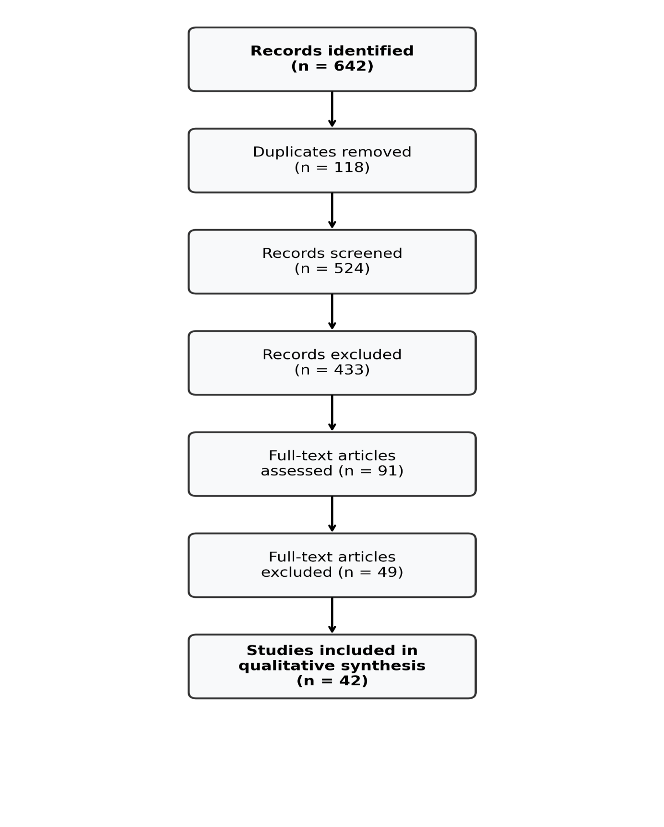
Figure 1. PRISMA Flow Diagram of Study Selection
Flow diagram summarizing the identification, screening, eligibility assessment, and final inclusion of studies evaluating breast cancer surgery and oncology care in Cameroon.
Ethical Considerations
Ethics committee approval was not required because this study was based exclusively on previously published literature and did not involve direct contact with human participants or access to identifiable personal data.
3. Results
3.1 Epidemiological Patterns and Age Distribution
The studies included in this review consistently identified breast cancer as the most common malignancy affecting women in Cameroon and one of the leading causes of cancer-related mortality nationwide. Across the reviewed publications, the mean or median age at diagnosis generally ranged from 45 to 52 years, with the highest concentration of cases occurring between 40 and 59 years of age. This distribution is approximately one decade younger than that reported in most high-income countries, where the peak incidence typically occurs after 60 years of age.
This relatively younger age at diagnosis has been documented throughout sub-Saharan Africa and likely reflects a combination of demographic structure, reproductive patterns, genetic influences, and delayed detection. Younger age at onset has important clinical implications because affected women are frequently in the midst of family responsibilities, professional activity, and active child-rearing. Consequently, the burden of disease extends well beyond the individual patient and may profoundly disrupt household stability and economic productivity.
Several Cameroonian hospital-based series have demonstrated a steady increase in breast cancer diagnoses over the past two decades, reflecting both a true epidemiological rise and improvements in diagnostic recognition. Urban referral centers in Douala and Yaoundé account for a substantial proportion of published experience, but available data suggest that women in rural and underserved regions remain underrepresented and may face even greater delays in diagnosis and treatment.
Table 1. Comparative Epidemiological Profile of Breast Cancer
Region | Mean Age at Diagnosis | Advanced Stage at Presentation | Relative Disease Burden
Cameroon | 45–52 years | 60–85% | High
Sub-Saharan Africa | 45–55 years | 55–80% | Very high
High-income countries | 60–65 years | <25% | Lower mortality
The younger age profile and high proportion of advanced disease suggest that breast cancer in Cameroon imposes a disproportionate socioeconomic burden. The disease frequently affects women during the most productive years of life, with important consequences for maternal roles, employment, and community participation.
3.2 Stage at Diagnosis
One of the most consistent findings across all reviewed studies was the predominance of late-stage disease at first presentation. Between 60% and 85% of women were diagnosed with stage III or IV breast cancer, and some institutional series reported that more than half of patients presented with tumors exceeding 5 cm in greatest dimension.
This stage distribution reflects a diagnostic pathway driven largely by symptoms rather than by organized screening. Women commonly seek medical attention only after noticing a progressively enlarging breast mass, skin ulceration, nipple retraction, pain, axillary swelling, or constitutional symptoms. By this stage, tumors are often locally advanced and may involve the skin, pectoral fascia, or regional lymph nodes.
Multiple determinants contribute to delayed diagnosis:
- Limited awareness of early warning signs.
- Fear of cancer and mastectomy.
- Reliance on traditional medicine.
- Financial constraints.
- Geographic barriers to specialist care.
- Restricted access to imaging and biopsy services.
- Long referral pathways.
- Sociocultural stigma.
The predominance of advanced-stage disease has major implications for surgical decision-making. Large tumors, inflammatory changes, and extensive nodal involvement frequently preclude breast-conserving surgery and necessitate modified radical mastectomy as the most appropriate curative procedure.
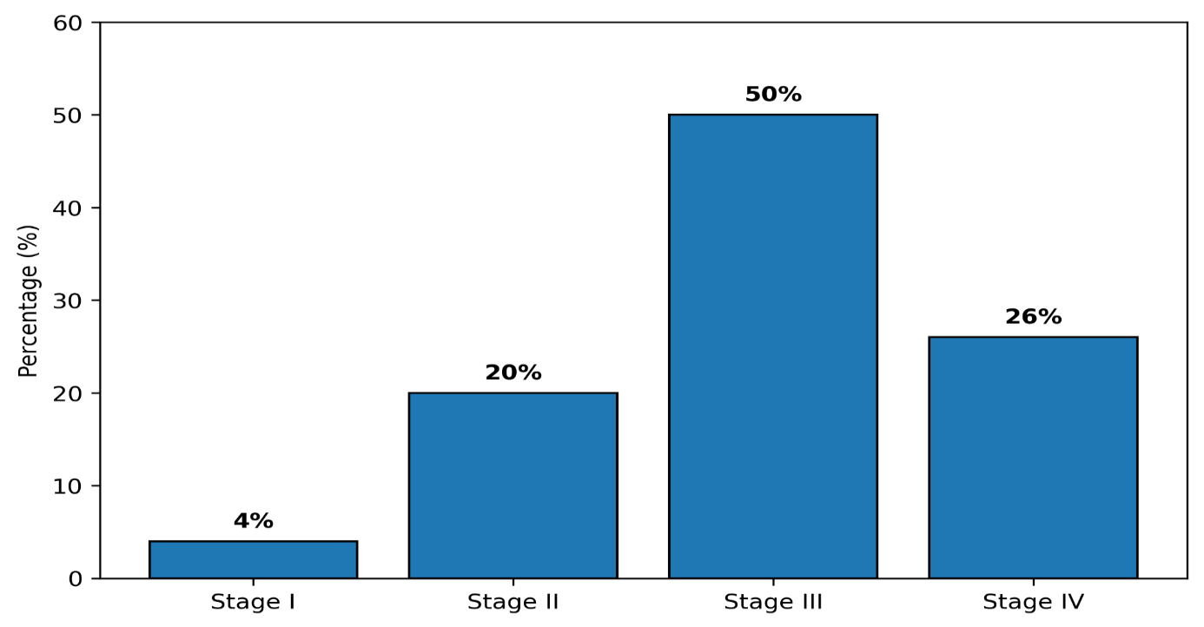
Figure 2. Distribution of Breast Cancer Stages at Diagnosis in Cameroon
Bar chart illustrating the predominance of stage III and IV disease at first presentation, which explains the continued predominance of modified radical mastectomy.
3.3 Histopathological and Molecular Characteristics
Invasive ductal carcinoma of no special type is by far the predominant histological subtype of breast cancer in Cameroon, accounting for approximately 75–90% of cases. Invasive lobular carcinoma, mucinous carcinoma, medullary carcinoma, and other uncommon histologies collectively represent a minority of tumors.
Tumor grading reveals a substantial proportion of high-grade lesions, with grade II and III cancers predominating in most published series. This finding is consistent with the aggressive clinical presentation frequently observed at diagnosis.
Molecular classification, when immunohistochemistry is available, shows a heterogeneous distribution of subtypes. Hormone receptor-positive tumors are common, but triple-negative breast cancer appears to occur at relatively high frequency compared with Western populations. HER2-positive disease is also encountered, although confirmation and targeted treatment are limited by cost and restricted access to trastuzumab.
Table 2. Histopathological and Molecular Profile of Breast Cancer in Cameroon
Characteristic | Approximate Frequency
Invasive ductal carcinoma | 75–90%
Invasive lobular carcinoma | 5–10%
Other histological types | <10%
Hormone receptor positive | 45–65%
HER2 positive | 15–25%
Triple-negative subtype | 20–35%
Limited pathology infrastructure and delays in immunohistochemical analysis may postpone treatment decisions and restrict the application of personalized therapeutic strategies. Nevertheless, the available data indicate that the biological spectrum of breast cancer in Cameroon is broadly comparable to that reported in other African populations and worldwide.
3.4 Surgical Techniques and Operative Trends
Surgery remains the cornerstone of curative treatment for non-metastatic breast cancer in Cameroon. However, the type of operation performed is strongly influenced by the stage at diagnosis, tumor characteristics, availability of radiotherapy, pathology support, and the patient's financial capacity. Across the studies included in this review, modified radical mastectomy (MRM) was consistently the dominant surgical procedure and represented the standard operation in most tertiary hospitals.
The David H. Patey modified radical mastectomy, which combines complete removal of the breast with level I and II axillary lymph node dissection while preserving the pectoralis major muscle, remains the most widely practiced technique. This procedure offers excellent local control and can be performed safely in settings where postoperative radiotherapy, reconstruction, and advanced imaging are not universally available.
In most Cameroonian series, MRM accounted for approximately 70% to 90% of all curative breast cancer operations. Several factors explain this predominance:
- Large tumor size at diagnosis.
- Frequent skin involvement or ulceration.
- Clinically positive axillary nodes.
- Limited access to postoperative radiotherapy.
- Patient preference for complete removal of the breast.
- Restricted availability of oncoplastic expertise.
- Economic constraints limiting repeated treatments.
Simple mastectomy is occasionally performed in selected situations, including extensive ductal carcinoma in situ, prophylactic surgery in high-risk women, and palliative procedures for fungating tumors when axillary dissection is not required. Toilet mastectomy may also be undertaken to control bleeding, infection, foul odor, and pain in patients with advanced or metastatic disease.
Breast-conserving surgery (BCS), consisting of wide local excision or lumpectomy followed by whole-breast irradiation, remains uncommon in Cameroon. In most reported series, BCS represented fewer than 10–15% of procedures and was largely restricted to patients with small tumors diagnosed at an early stage and reliable access to postoperative radiotherapy. The low utilization of BCS does not reflect a lack of oncological validity, but rather the practical realities of delayed diagnosis and limited infrastructure.
Neoadjuvant chemotherapy has progressively expanded the possibility of conservative surgery by downstaging locally advanced tumors. Patients with substantial tumor response may become candidates for breast preservation even when initial presentation appeared unsuitable. Nevertheless, the widespread application of this strategy requires close radiological assessment, multidisciplinary coordination, and dependable radiotherapy services.
Oncoplastic breast surgery remains in its infancy in most Cameroonian institutions. Techniques combining tumor excision with volume displacement or replacement can improve cosmetic outcomes and reduce the need for mastectomy, but they require specialized training and careful patient selection. Similarly, immediate breast reconstruction with implants or autologous tissue is rarely available because of limited plastic surgery expertise, financial constraints, and concerns regarding treatment delays.
Table 3. Surgical Procedures Used in Breast Cancer Management in Cameroon
Surgical Procedure | Approximate Frequency | Main Indications
Modified radical mastectomy | 70–90% | Locally advanced operable disease
Breast-conserving surgery | 5–15% | Early-stage tumors with radiotherapy access
Simple mastectomy | 2–10% | Selected non-invasive or palliative cases
Toilet/palliative mastectomy | Variable | Fungating or symptomatic advanced tumors
Immediate reconstruction | Rare | Limited to selected centers
Margin assessment is another critical determinant of surgical quality. In breast-conserving surgery, negative margins are essential to minimize local recurrence. In mastectomy specimens, pathological examination confirms tumor extent, nodal burden, lymphovascular invasion, and receptor status, thereby guiding adjuvant therapy. Delays in pathology reporting, however, may postpone subsequent treatment and prolong the overall therapeutic timeline.
Taken together, the evidence indicates that breast cancer surgery in Cameroon remains dominated by mastectomy-based strategies, reflecting the combined effects of advanced disease at diagnosis and health-system constraints. While this approach remains oncologically appropriate for many patients, broader access to early diagnosis, radiotherapy, and reconstructive services could substantially expand the role of breast-conserving and oncoplastic procedures.
3.5 Axillary Management
Management of the axilla remains a fundamental component of breast cancer surgery because nodal status is one of the most important prognostic factors and directly influences decisions regarding adjuvant systemic therapy and regional radiotherapy. In Cameroon, as in many low-resource settings, axillary surgery continues to rely predominantly on conventional axillary lymph node dissection (ALND), whereas selective approaches such as sentinel lymph node biopsy (SLNB) are only beginning to emerge in a limited number of specialized centers.
Complete axillary dissection, usually involving removal of level I and II lymph nodes, is routinely performed during modified radical mastectomy and remains the standard staging and therapeutic procedure for most operable breast cancers. This approach provides reliable pathological staging, achieves regional disease control, and does not require specialized equipment beyond standard surgical instrumentation and pathology support. In the context of frequent clinically node-positive disease, ALND is often both diagnostically and therapeutically justified.
The principal disadvantages of ALND are well recognized. Postoperative lymphedema, shoulder stiffness, numbness due to intercostobrachial nerve injury, chronic pain, and reduced upper-limb function may significantly impair long-term quality of life. The risk of these complications increases with the number of nodes removed, the addition of radiotherapy, obesity, and postoperative infection.
Sentinel lymph node biopsy has transformed axillary management in early breast cancer by allowing accurate nodal staging with substantially lower morbidity [17–20]. The technique involves identification and removal of the first draining lymph node(s) using blue dye, radiocolloid, or both. When the sentinel node is negative, complete axillary dissection can often be safely omitted. Large randomized trials have demonstrated equivalent survival and regional control with significantly reduced rates of lymphedema and sensory dysfunction.
Despite these advantages, SLNB remains rarely available in Cameroon. Several barriers limit its routine implementation:
- Restricted access to blue dyes and radiotracers.
- Limited nuclear medicine infrastructure.
- Insufficient surgeon training.
- Lack of intraoperative pathology support.
- Additional procedural costs.
- High prevalence of locally advanced and clinically node-positive disease.
Consequently, the potential benefits of de-escalated axillary surgery are not yet widely realized. Women with small node-negative tumors who might safely avoid ALND continue to undergo more extensive surgery than would be recommended in many high-resource settings.
The increasing use of neoadjuvant chemotherapy introduces additional complexity. Patients who present with biopsy-proven nodal metastases may convert to clinically node-negative status after systemic treatment. In high-income settings, selective use of targeted axillary dissection or post-neoadjuvant SLNB can reduce the need for full dissection in carefully selected cases. These strategies, however, remain difficult to implement in most Cameroonian institutions because of technical and logistical limitations.
Table 4. Comparison of Axillary Surgical Approaches
Approach | Main Advantages | Principal Limitations | Current Use in Cameroon
Axillary lymph node dissection | Reliable staging and regional control | Lymphedema, pain, shoulder dysfunction | Standard practice
Sentinel lymph node biopsy | Lower morbidity, shorter recovery | Requires specialized materials and expertise | Rare
Targeted axillary dissection | Reduces extent of surgery after neoadjuvant therapy | Technically demanding | Exceptional
The persistence of ALND as the dominant approach reflects both the epidemiological reality of advanced nodal disease and the limited availability of specialized resources. Expansion of SLNB programs, combined with earlier diagnosis and dedicated surgeon training, could substantially reduce surgical morbidity while maintaining oncological safety.
3.6 Postoperative Outcomes and Quality of Life
The immediate and long-term outcomes of breast cancer surgery in Cameroon are influenced by tumor stage, nutritional status, comorbidities, extent of surgery, perioperative care, and the availability of adjuvant treatment. Although most tertiary centers report acceptable short-term surgical safety, postoperative morbidity remains clinically significant and can affect both treatment completion and quality of life.
Perioperative mortality following breast cancer surgery is generally very low. The procedures most commonly performed—particularly modified radical mastectomy—are technically standardized and are usually well tolerated when conducted under appropriate anesthesia and perioperative monitoring. Nevertheless, complications such as seroma, surgical-site infection, hematoma, flap necrosis, wound dehiscence, and delayed healing are regularly encountered.
Seroma is the most frequent postoperative complication and may require repeated aspiration. Surgical-site infection is facilitated by anemia, malnutrition, diabetes, ulcerated tumors, and delayed presentation. In some patients, wound complications postpone the initiation of adjuvant chemotherapy or radiotherapy, potentially compromising oncological outcomes.
Table 5. Common Postoperative Complications
Complication | Approximate Frequency | Clinical Impact
Seroma | 15–35% | Repeated aspirations, discomfort
Surgical-site infection | 5–15% | Delayed healing and treatment
Hematoma | 1–5% | Possible reoperation
Flap necrosis | 2–8% | Prolonged wound care
Lymphedema | 10–30% | Chronic functional impairment
Shoulder stiffness | 15–40% | Reduced upper-limb mobility
Chronic neuropathic pain | 10–25% | Long-term quality-of-life reduction
Long-term morbidity is particularly associated with axillary lymph node dissection. Lymphedema may develop months or years after surgery and can lead to arm heaviness, recurrent infections, restricted activity, and psychosocial distress. Shoulder dysfunction and paresthesia may further limit daily function and professional activity.
The psychosocial consequences of mastectomy are profound. For many women, the breast is closely linked to femininity, sexuality, motherhood, and self-image. Loss of the breast may be accompanied by feelings of diminished attractiveness, anxiety, depression, and marital difficulties. These effects may be intensified in environments where reconstructive surgery and structured psychological support are rarely available.
Breast reconstruction remains uncommon in Cameroon. The principal barriers include limited access to plastic surgeons, financial constraints, concerns regarding additional operative time, and the prioritization of oncological treatment over aesthetic restoration. As a result, most women adapt to permanent anatomical loss without access to immediate reconstruction or external prostheses.
Return to normal social and professional life is further influenced by treatment-related fatigue, chemotherapy toxicity, and financial hardship. Many patients experience a prolonged period of reduced productivity and economic vulnerability, especially when they are primary caregivers or contributors to household income.
Despite these challenges, several studies and clinical observations suggest that women generally tolerate surgery well and often express relief after removal of the tumor, particularly when symptoms such as ulceration, bleeding, and pain are controlled. Adequate counseling, physiotherapy, early arm mobilization, infection prevention, and psychosocial support can substantially improve postoperative recovery and long-term well-being.
The available evidence indicates that breast cancer surgery in Cameroon is oncologically effective but is accompanied by significant physical, psychological, and socioeconomic consequences. Efforts to reduce morbidity through earlier diagnosis, less extensive axillary surgery, rehabilitation services, and improved access to reconstruction could markedly enhance survivorship outcomes.
3.7 Health System Constraints and Barriers to Optimal Surgical Care
The studies included in this review consistently demonstrate that the limitations affecting breast cancer surgery in Cameroon extend far beyond the operating room itself. Surgical outcomes are shaped by a continuum of structural, economic, logistical, and human-resource constraints that influence every stage of care, from diagnosis to long-term follow-up.
One of the most important barriers is delayed diagnosis. Most women first present to healthcare facilities only after tumors have become clinically obvious, painful, ulcerated, or associated with axillary swelling. The absence of organized national mammographic screening programs means that diagnosis remains largely symptom-driven. Even in urban settings, mammography, ultrasound-guided biopsy, and breast MRI are not universally accessible and are frequently financed directly by patients.
Public awareness of breast cancer also remains insufficient. Several studies reported that many women initially attribute breast lumps to benign disease, trauma, spiritual causes, or transient hormonal changes. Fear of mastectomy, fear of death, and misconceptions regarding cancer treatment further contribute to delays in consultation. In some communities, traditional healers are consulted before hospital referral, allowing disease progression during critical months.
Pathology infrastructure represents another major constraint. Histopathological confirmation may require prolonged waiting periods because of limited laboratory capacity and shortages of trained pathologists. Immunohistochemical testing for estrogen receptor, progesterone receptor, HER2, and Ki-67 is not systematically available and may be financially inaccessible for many patients. Consequently, treatment decisions are sometimes made with incomplete molecular information.
Table 6. Major Health System Constraints Affecting Breast Cancer Surgery
Health System Constraint | Clinical Consequences
Late presentation | Increased need for mastectomy
Limited screening programs | Delayed diagnosis
Restricted pathology services | Delayed treatment planning
Limited radiotherapy capacity | Reduced eligibility for breast conservation
Shortage of specialized surgeons | Unequal access to expertise
High out-of-pocket expenditures | Treatment interruption or abandonment
Limited reconstructive surgery | Reduced quality of life
Weak referral systems | Delays in multidisciplinary care
Radiotherapy availability strongly influences surgical strategy. Because breast-conserving surgery requires postoperative irradiation to achieve oncological equivalence with mastectomy, limited access to radiotherapy often obliges surgeons to recommend more radical operations. Radiotherapy services remain concentrated in a few major urban centers, principally in Douala and Yaoundé, creating major geographic inequities for women from remote regions.
Human-resource shortages further compromise care delivery. The number of surgical oncologists, breast surgeons, pathologists, radiation oncologists, medical oncologists, oncology nurses, physiotherapists, and psycho-oncology specialists remains insufficient relative to national needs. Multidisciplinary tumor boards are not universally available, and treatment sequencing may therefore be influenced by local resource availability rather than ideal evidence-based standards.
Financial toxicity is one of the most important determinants of treatment completion. In the absence of universal oncology coverage, patients and families must often pay directly for consultations, imaging, biopsy, surgery, pathology, chemotherapy, radiotherapy, transportation, accommodation, and supportive care. These cumulative costs may become catastrophic and contribute to delayed treatment initiation, interruption of therapy, or complete abandonment of care.
The concentration of specialized services in tertiary hospitals also creates referral delays. Patients from rural areas frequently travel long distances for diagnosis, surgery, chemotherapy, and radiotherapy. Transportation expenses, time away from work, and accommodation costs add to the burden of treatment and may reduce adherence to postoperative follow-up schedules.
Another important limitation is the restricted development of reconstructive and oncoplastic surgery. Even when technically feasible, these procedures are often considered financially inaccessible or secondary to survival-focused treatment priorities. Consequently, quality-of-life considerations remain insufficiently integrated into surgical planning.
Nevertheless, several encouraging developments have emerged over recent years. Increasing awareness campaigns, expansion of oncology training programs, international collaborations, and gradual strengthening of cancer centers have improved the visibility and organization of breast cancer care. Multidisciplinary management is becoming more common in major institutions, and neoadjuvant systemic therapy is increasingly used to improve operability and facilitate conservative surgery in selected patients.
Taken together, the evidence indicates that the current predominance of radical breast surgery in Cameroon reflects not only tumor biology or surgical preference, but also the cumulative effects of delayed diagnosis, limited infrastructure, financial hardship, and unequal access to comprehensive oncology services. Strengthening breast cancer surgery therefore requires broader health-system reform extending across prevention, diagnosis, pathology, radiotherapy, rehabilitation, and survivorship care.
3.8 Summary Figure: Integrated Model of Breast Cancer Surgery in Cameroon
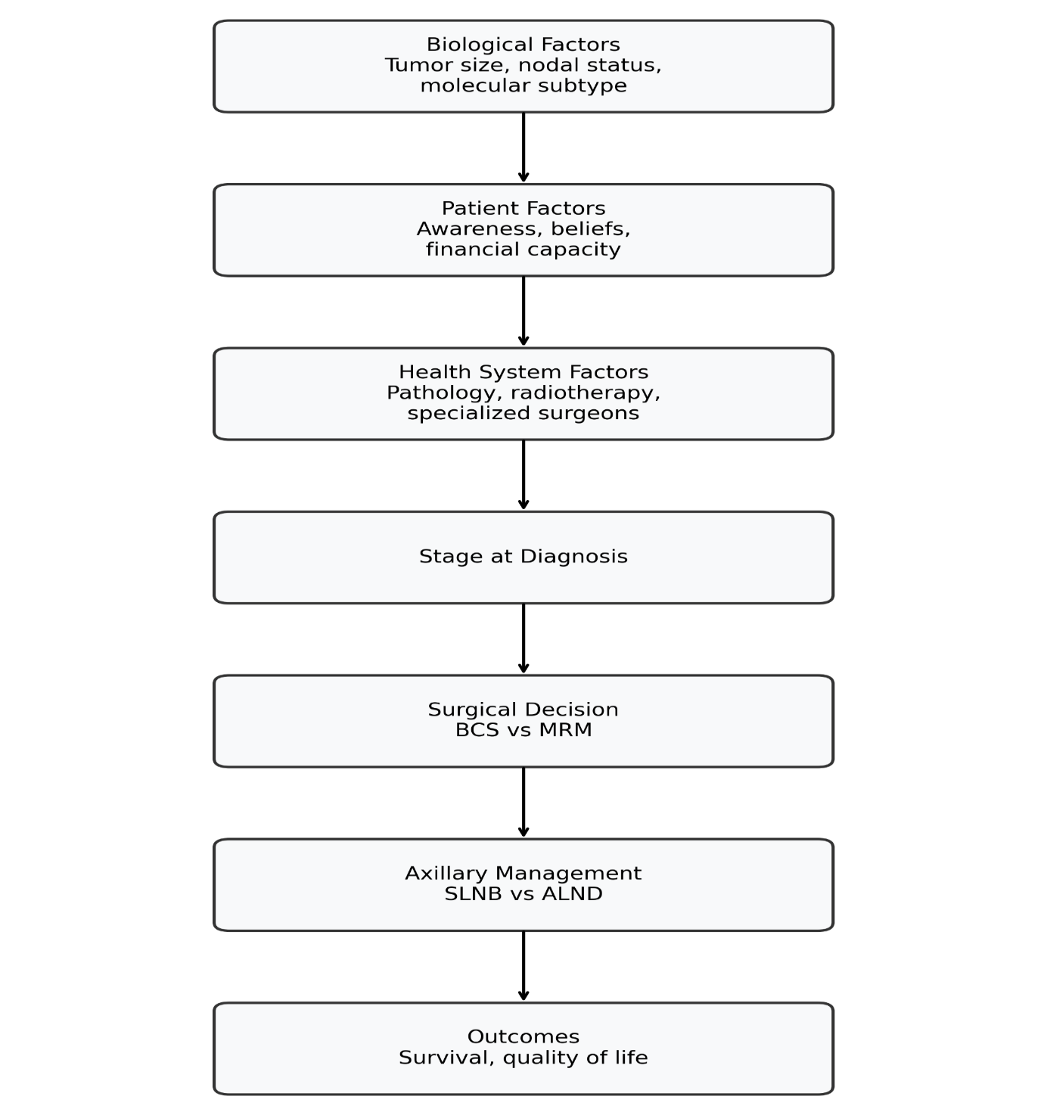

Figure 3. Integrated Model of Breast Cancer Surgery in Cameroon
Conceptual framework showing how biological factors, patient characteristics, and health system capacity interact to determine stage at diagnosis, surgical choices, and long-term outcomes.

4. Discussion
The findings of this systematic review demonstrate that breast cancer surgery in Cameroon remains dominated by modified radical mastectomy, reflecting the persistent reality of late-stage presentation and the structural limitations of the national oncology system. Although surgical treatment is technically effective and remains the principal curative modality for non-metastatic disease, the range of procedures that can be offered is constrained by deficiencies in early diagnosis, pathology, radiotherapy, reconstructive services, and financial protection.
One of the most consistent observations across the reviewed literature is the relatively young age at diagnosis, generally between 45 and 52 years [1–8,35–40]. This pattern mirrors findings from other countries in sub-Saharan Africa and contrasts with the epidemiology observed in Europe and North America, where breast cancer is more commonly diagnosed after menopause [2–5]. The younger age profile has major clinical and socioeconomic implications because the disease affects women during periods of active parenting, employment, and family responsibility.
The predominance of advanced-stage disease remains the single most important determinant of surgical practice in Cameroon [36–42]. In high-income countries, widespread mammographic screening and improved public awareness have shifted diagnosis toward smaller and more localized tumors, enabling breast-conserving surgery in the majority of patients [6,9–15]. In Cameroon, by contrast, most women seek medical attention only after tumors have become clinically obvious, frequently exceeding 5 cm and often associated with skin or nodal involvement. Under these circumstances, mastectomy remains both oncologically appropriate and technically pragmatic.
The evolution of breast surgery over the last half century has established that breast-conserving surgery followed by radiotherapy provides survival outcomes equivalent to mastectomy for appropriately selected early-stage cancers [13–15]. The limited use of breast-conserving surgery in Cameroon therefore reflects health-system constraints rather than a lack of scientific evidence. The restricted availability of radiotherapy, which is indispensable after lumpectomy, remains one of the principal barriers to wider adoption of conservative approaches [51–54].
Modified radical mastectomy continues to offer excellent local control and remains a highly relevant operation in resource-constrained environments. The procedure is technically standardized, reproducible, and adaptable to large or ulcerated tumors [28–31,38–42]. For many women in Cameroon, it represents the safest and most accessible definitive surgical treatment. Nevertheless, the psychosocial impact of breast loss is considerable, particularly when reconstructive options are unavailable [43–45].
Axillary lymph node dissection remains the standard method of nodal staging and treatment in most Cameroonian institutions. Although this approach provides robust pathological information, it is associated with lymphedema, chronic pain, and reduced upper-limb function [17–20]. Sentinel lymph node biopsy has substantially reduced axillary morbidity worldwide, but its implementation in Cameroon remains limited by shortages of tracers, equipment, and trained personnel. Expansion of SLNB programs could significantly improve postoperative quality of life while maintaining oncological safety in selected patients.
Pathological assessment and molecular characterization are increasingly central to modern breast cancer management. Hormone receptor and HER2 status guide decisions regarding endocrine therapy, chemotherapy, and targeted treatment [25–27]. In Cameroon, however, access to immunohistochemistry remains inconsistent, and patients frequently bear the full cost of testing [47–50]. Delays in pathology reporting can postpone surgery or adjuvant treatment, while limited access to HER2-targeted therapy such as trastuzumab reduces the practical benefits of molecular classification in some settings.
Neoadjuvant chemotherapy has expanded therapeutic possibilities by downstaging large tumors and increasing the likelihood of breast preservation [21–24]. In institutions where multidisciplinary coordination is well established, this strategy may convert tumors initially requiring mastectomy into candidates for breast-conserving surgery. Its effectiveness, however, depends on reliable imaging, clinical monitoring, and timely access to definitive surgery.
The postoperative complications reported in Cameroon are broadly consistent with international experience. Seroma, wound infection, flap necrosis, lymphedema, and shoulder dysfunction remain the most common adverse outcomes. Although perioperative mortality is very low, long-term morbidity can substantially affect physical functioning and social reintegration. Structured physiotherapy, lymphedema prevention, and psychosocial counseling are therefore essential components of comprehensive survivorship care.
The psychological consequences of breast cancer surgery are particularly important in environments where breast reconstruction is rarely available. Mastectomy may profoundly affect body image, marital relationships, sexuality, and self-esteem [43–45]. International studies have shown that access to reconstruction and psycho-oncology support improves quality of life, reduces depressive symptoms, and facilitates social recovery. In Cameroon, integrating these dimensions into routine cancer care remains an important but underdeveloped priority.
Financial toxicity is a major determinant of outcomes. In the absence of comprehensive health insurance, most patients pay directly for diagnostic procedures, surgery, pathology, chemotherapy, radiotherapy, and supportive care [55–57]. The resulting economic burden may lead to delayed treatment initiation, interrupted therapy, or complete abandonment of care. Several global analyses have demonstrated that strengthening cancer surgery and improving financial protection are among the most cost-effective investments in oncology systems [55–61].
The concentration of specialized oncology services in tertiary centers located primarily in Douala and Yaoundé creates significant geographic inequities. Women from distant regions face additional costs related to transportation, lodging, and repeated consultations. These barriers reinforce existing social disparities and contribute to poorer adherence and follow-up.
Our findings align with broader African and international experience. Across sub-Saharan Africa, modified radical mastectomy remains the dominant procedure because of delayed presentation and limited radiotherapy capacity [28–34,47,58]. Countries that have invested in early detection, pathology infrastructure, multidisciplinary training, and radiotherapy have progressively increased the use of breast-conserving surgery and improved survival. These experiences suggest that similar progress is achievable in Cameroon with sustained political commitment and strategic resource allocation.
Several practical priorities emerge from this review. First, public education and community-based awareness campaigns should encourage earlier consultation for breast symptoms. Second, pathology services and immunohistochemistry capacity must be strengthened to support personalized treatment. Third, radiotherapy access should be expanded to increase eligibility for breast-conserving surgery. Fourth, sentinel lymph node biopsy programs and oncoplastic training should be developed in referral centers. Fifth, financial protection mechanisms are needed to reduce treatment abandonment. Finally, multidisciplinary breast units integrating surgery, pathology, medical oncology, radiation oncology, physiotherapy, and psychosocial support should become the standard model of care.
This review has several limitations. Much of the available evidence is derived from retrospective hospital-based studies, which may not fully capture the experiences of women who never reach specialized centers. Sample sizes were often modest, follow-up was variable, and few studies reported long-term survival or patient-reported quality-of-life outcomes. Nevertheless, the consistency of findings across multiple institutions and the convergence with regional evidence support the robustness of the conclusions.
Taken together, the evidence indicates that breast cancer surgery in Cameroon occupies a pivotal position at the intersection of clinical expertise and health-system capacity. The predominance of mastectomy is not merely a surgical preference but a reflection of delayed diagnosis and infrastructural constraints. By strengthening early detection, multidisciplinary care, pathology, radiotherapy, and financial access, Cameroon can progressively transition toward more conservative, personalized, and quality-of-life-centered surgical oncology.
5. Conclusion
Breast cancer has become the most common malignancy affecting women in Cameroon and represents a major and growing public health challenge. Surgery remains the cornerstone of curative treatment and continues to provide the greatest opportunity for long-term disease control in patients with non-metastatic disease. However, the current surgical landscape is characterized by a predominance of modified radical mastectomy, reflecting the persistent reality of late-stage presentation and substantial limitations within the healthcare system.
The evidence synthesized in this review demonstrates that most women are diagnosed between 45 and 52 years of age, often during the most socially and economically productive period of life. More than half present with locally advanced or metastatic disease, substantially reducing eligibility for breast-conserving surgery. As a result, mastectomy combined with axillary lymph node dissection remains the standard operation in most institutions. Although oncologically effective, this approach is associated with significant physical, psychological, and social consequences, particularly in settings where reconstructive surgery and comprehensive rehabilitation services are rarely available.
The limited adoption of breast-conserving surgery, sentinel lymph node biopsy, oncoplastic procedures, and immediate reconstruction reflects broader structural barriers rather than deficiencies in scientific knowledge. Restricted access to pathology and immunohistochemistry, shortages of specialized personnel, limited radiotherapy capacity, and high out-of-pocket expenditures continue to constrain both surgical decision-making and treatment completion. Financial toxicity and geographic inequities further compromise adherence to multidisciplinary care.
Despite these challenges, important opportunities for progress exist. Earlier diagnosis through sustained public education, strengthening of pathology services, expansion of radiotherapy infrastructure, development of multidisciplinary breast units, training in modern surgical techniques, and implementation of financial protection mechanisms could transform breast cancer surgery in Cameroon over the coming decade.
The experience of countries that have successfully modernized breast cancer care demonstrates that substantial improvements in survival and quality of life are achievable when surgery is integrated into a coordinated oncology system. For Cameroon, the priority is not merely to increase the number of operations performed, but to create a surgical oncology framework that is timely, evidence-based, equitable, and centered on the needs and dignity of every woman affected by breast cancer.
With sustained political commitment, institutional leadership, and strategic investment, Cameroon can progressively transition from a predominantly mastectomy-based model toward a more individualized and multidisciplinary approach to breast cancer surgery, offering women not only improved survival but also better functional and psychosocial outcomes.
Ethics Approval and Consent to Participate
Not applicable. This study is a systematic review based exclusively on previously published data and did not involve human participants, identifiable personal information, or direct patient contact.
Data Availability Statement
All data analyzed in this study were derived from previously published articles and are available in the public domain through the databases cited in the Methods section.

COMPETING INTERESTS DISCLAIMER:
Authors have declared that they have no known competing financial interests OR non-financial interests OR personal relationships that could have appeared to influence the work reported in this paper.

References
- Sung H, Ferlay J, Siegel RL, Laversanne M, Soerjomataram I, Jemal A, et al. Global cancer statistics 2024: GLOBOCAN estimates of incidence and mortality worldwide for 36 cancers in 185 countries. CA Cancer J Clin. 2025;75(1):1–38.
- International Agency for Research on Cancer. Global Cancer Observatory: Cancer Today. Lyon: IARC; 2025.
- World Health Organization. Global Breast Cancer Initiative Framework. Geneva: WHO; 2023.
- Harbeck N, Gnant M. Breast cancer. Lancet. 2017;389(10074):1134–1150.
- Waks AG, Winer EP. Breast cancer treatment. Nat Rev Dis Primers. 2019;5:66.
- National Comprehensive Cancer Network. NCCN Clinical Practice Guidelines in Oncology: Breast Cancer. Version 2026.
- Cardoso F, Kyriakides S, Ohno S, et al. Early breast cancer: ESMO Clinical Practice Guidelines. Ann Oncol. 2019;30(8):1194–1220.
- Gradishar WJ, Moran MS, Abraham J, et al. Breast cancer clinical practice recommendations. J Clin Oncol. 2024;42(5):421–456.
- Fisher B, Anderson S, Bryant J, et al. Twenty-year follow-up of a randomized trial comparing total mastectomy and lumpectomy. N Engl J Med. 2002;347(16):1233–1241.
- Veronesi U, Cascinelli N, Mariani L, et al. Twenty-year follow-up of breast-conserving surgery versus radical mastectomy. N Engl J Med. 2002;347(16):1227–1232.
- Giuliano AE, Ballman KV, McCall L, et al. Sentinel lymph node dissection versus axillary dissection. JAMA. 2017;318(10):918–926.
- Halsted WS. The results of operations for the cure of cancer of the breast. Ann Surg. 1894;20:497–555.
- Patey DH, Dyson WH. The prognosis of carcinoma of the breast in relation to type of operation. Br J Cancer. 1948;2(1):7–13.
- Clough KB, Kaufman GJ, Nos C, et al. Improving breast conservation with oncoplastic surgery. Ann Surg Oncol. 2010;17(5):1375–1391.
- Krag DN, Anderson SJ, Julian TB, et al. Sentinel-lymph-node resection compared with conventional axillary dissection. Lancet Oncol. 2010;11(10):927–933.
- Boughey JC, Ballman KV, Hunt KK, et al. Axillary ultrasound after neoadjuvant chemotherapy. J Clin Oncol. 2015;33(30):3386–3393.
- Kaufmann M, von Minckwitz G, Mamounas EP, et al. Recommendations for neoadjuvant systemic treatment. Ann Surg Oncol. 2012;19(5):1508–1516.
- Goldhirsch A, Winer EP, Coates AS, et al. Personalizing treatment of women with early breast cancer. Ann Oncol. 2013;24(9):2206–2223.
- Slamon DJ, Leyland-Jones B, Shak S, et al. Use of trastuzumab in HER2-positive metastatic breast cancer. N Engl J Med. 2001;344(11):783–792.
- Carlson RW, Allred DC, Anderson BO, et al. Breast cancer in limited-resource countries. Breast J. 2006;12 Suppl 1:S96–S121.
- Vanderpuye V, Grover S, Hammad N, et al. An update on breast cancer management in Africa. Lancet Oncol. 2017;18(4):e142–e152.
- Jedy-Agba E, McCormack V, Adebamowo C, dos-Santos-Silva I. Stage at diagnosis and breast cancer survival in sub-Saharan Africa. Lancet Glob Health. 2016;4(12):e923–e935.
- Anyanwu SNC. Breast cancer in eastern Nigeria. World J Surg. 2000;24(8):957–964.
- Kantelhardt EJ, Zerche P, Mathewos A, et al. Breast cancer survival in Africa. Breast Care (Basel). 2014;9(5):338–343.
- Ndom P, Um G, Bell EM, et al. Breast cancer in Cameroon: epidemiological and clinical characteristics. Pan Afr Med J. 2012;12:42.
- Essiben F, Foumane P, Dohbit JS, et al. Breast cancer management in Cameroon. BMC Womens Health. 2019;19:89.
- Fregene A, Newman LA. Breast cancer in sub-Saharan Africa: how does it relate to breast cancer in African-American women? Cancer. 2005;103(8):1540–1550.
- Sando Z, Fouogue JT, Fouelifack FY, et al. Histopathological profile of breast cancer in Cameroon. Afr J Pathol Microbiol. 2015;4:12–18.
- Ngowa JDK, Yomi J, Kasia JM, et al. Clinical presentation and treatment delays among women with breast cancer in Cameroon. Pan Afr Med J. 2015;21:45.
- Fokom-Domgue J, Vassilakos P, Petignat P, et al. Cancer care challenges in Cameroon. BMC Health Serv Res. 2018;18:921.
- Ginsburg O, Yip CH, Brooks A, et al. Breast cancer early detection: a phased approach to implementation. Cancer. 2020;126(Suppl 10):2379–2393.
- Anderson BO, Ilbawi AM, El Saghir NS. Breast cancer in low- and middle-income countries. Cancer. 2015;121(8):1183–1192.
- Cazap E, Magrath I, Kingham TP, Elzawawy A. Structural barriers to cancer care in low- and middle-income countries. Lancet Oncol. 2016;17(6):e223–e234.
- Sullivan R, Alatise OI, Anderson BO, et al. Global cancer surgery and systems strengthening. Lancet Oncol. 2015;16(11):1193–1224.
- World Health Organization. Global Breast Cancer Initiative Implementation Framework. Geneva: WHO; 2023.
- Berry DA, Cronin KA, Plevritis SK, et al. Effect of screening and adjuvant therapy on mortality from breast cancer. N Engl J Med. 2005;353(17):1784–1792.
- DeSantis CE, Ma J, Gaudet MM, et al. Breast cancer statistics, 2019. CA Cancer J Clin. 2019;69(6):438–451.
- McCormack VA, Joffe M, van den Berg E, et al. Breast cancer in sub-Saharan Africa. Lancet Oncol. 2020;21(8):e317–e328.
- Pace LE, Shulman LN. Breast cancer in sub-Saharan Africa. Cancer Epidemiol Biomarkers Prev. 2016;25(3):362–378.
- Adesunkanmi ARK, Lawal OO, Adelusola KA, Durosimi MA. The severity, outcome and challenges of breast cancer in Nigeria. Cancer. 2006;106(2):386–393.
- Kingham TP, Alatise OI, Vanderpuye V, et al. Treatment of cancer in sub-Saharan Africa. Lancet Oncol. 2013;14(4):e158–e167.
- African Organization for Research and Training in Cancer. Cancer Control in Africa Report. Cape Town: AORTIC; 2024.
- Fang SY, Shu BC, Chang YJ. The effect of breast reconstruction surgery on body image and quality of life after mastectomy. Psychooncology. 2013;22(9):2024–2031.
- Al-Ghazal SK, Fallowfield L, Blamey RW. Comparison of psychological aspects and patient satisfaction following breast-conserving surgery, simple mastectomy and breast reconstruction. Eur J Surg Oncol. 2000;26(3):222–227.
- Metcalfe KA, Zhong T, Narod SA. The role of breast reconstruction in improving quality of life after mastectomy. Curr Opin Obstet Gynecol. 2015;27(1):62–67.
- DiSipio T, Rye S, Newman B, Hayes S. Incidence of unilateral arm lymphoedema after breast cancer: a systematic review and meta-analysis. Lancet Oncol. 2013;14(6):500–515.
- Rakha EA, Reis-Filho JS, Ellis IO. Basal-like breast cancer: a critical review. J Clin Oncol. 2008;26(15):2568–2581.
- Wolff AC, Hammond MEH, Allison KH, et al. Human epidermal growth factor receptor 2 testing in breast cancer: American Society of Clinical Oncology/College of American Pathologists clinical practice guideline focused update. Arch Pathol Lab Med. 2018;142(11):1364–1382.
- Allison KH, Hammond MEH, Dowsett M, et al. Estrogen and progesterone receptor testing in breast cancer: ASCO/CAP guideline update. J Clin Oncol. 2020;38(12):1346–1366.
- Penault-Llorca F, Radosevic-Robin N. Ki67 assessment in breast cancer: an update. Pathology. 2017;49(2):166–171.
- Atun R, Jaffray DA, Barton MB, et al. Expanding global access to radiotherapy. Lancet. 2015;385(9973):1153–1186.
- Grover S, Xu MJ, Yeager A, et al. A systematic review of radiotherapy capacity in low- and middle-income countries. Front Oncol. 2015;4:380.
- Rodin D, Grover S, Elmore SNC, et al. The Lancet Oncology Commission on radiotherapy and theranostics. Lancet Oncol. 2025;26(2):e1–e72.
- Barton MB, Jacob S, Shafiq J, et al. Estimating the demand for radiotherapy from the evidence. Radiother Oncol. 2014;112(1):35–41.
- Wagstaff A, Flores G, Hsu J, et al. Progress on catastrophic health spending in 133 countries: a retrospective observational study. Lancet Glob Health. 2018;6(2):e169–e179.
- Horton S, Gauvreau CL. Cancer in low-income and middle-income countries: an economic overview. Lancet. 2017;389(10071):80–82.
- Farmer P, Frenk J, Knaul FM, et al. Expansion of cancer care and control in countries of low and middle income: a call to action. Lancet. 2010;376(9747):1186–1193.
- African Cancer Coalition. Harmonized breast cancer treatment guidelines for sub-Saharan Africa. 2023.
- Sankaranarayanan R, Basu P, Kaur P, et al. Human resources and infrastructure for cancer control in low- and middle-income countries. Lancet Oncol. 2019;20(11):e573–e583.
- Anderson BO, Yip CH, Smith RA, et al. Guideline implementation for breast healthcare in low- and middle-income countries. Cancer. 2008;113(8 Suppl):2221–2243.
- Elmore SNC, Sethi RK, Kavuma A, et al. Broken machines or broken systems: the road to meaningful global radiotherapy access. Lancet Oncol. 2021;22(11):e474–e484.
- Coughlin SS. Social determinants of breast cancer risk, stage, and survival. Breast Cancer Res Treat. 2019;177(3):537–548.
- Grosse Frie K, Kamaté B, Traoré CB, et al. Patient navigation and outcomes in cancer care in Africa. Support Care Cancer. 2018;26(3):731–739.
- Finocchario-Kessler S, Wexler C, Maloba M, et al. Community engagement to improve cancer prevention and treatment in sub-Saharan Africa. J Community Health. 2016;41(3):592–601.
- World Health Organization Regional Office for Africa. Framework for strengthening cancer services in Africa. Brazzaville: WHO Regional Office for Africa; 2024.

