Journal Name: | Asian Journal of Research in Zoology
Manuscript Number: | Ms_AJRIZ_158533
Title of the Manuscript: | Assessment of heavy metals in some commercially important fish species of the Bay of Bengal
Type of the Article | Research Article

PART 1 (Importance of the manuscript)

 | Comments of the Reviewers | Author’s Feedback
Please write a few sentences regarding the importance of this manuscript for the scientific community. A minimum of 3-4 sentences may  be required for this part. | This article is important for the safety of the community. It is a basis for developmental planning for the government. In addition, it is a source for literature review and basis for other researches.

PART 2.1 (Objective Evaluation)

 | Rating of the Reviewers | Author’s Feedback
1. Is the title clear and appropriate for the study?  Rating Scale:  5 = Excellent 4 = Good 3 = Satisfactory 2 = Needs Improvement 1 = Poor N/A = Not Applicable | 4
2. Is the abstract of the article comprehensive?  Rating Scale:  5 = Excellent 4 = Good 3 = Satisfactory 2 = Needs Improvement 1 = Poor N/A = Not Applicable | 5
3. Are the keywords appropriate and useful?  Rating Scale:  5 = Excellent 4 = Good 3 = Satisfactory 2 = Needs Improvement 1 = Poor N/A = Not Applicable | 5
4. Is the background information of the paper sufficient and well organized?  Rating Scale:  5 = Excellent 4 = Good 3 = Satisfactory 2 = Needs Improvement 1 = Poor N/A = Not Applicable | 4
5. Are the research objectives/hypotheses clearly stated?  Rating Scale:  5 = Excellent 4 = Good 3 = Satisfactory 2 = Needs Improvement 1 = Poor N/A = Not Applicable | 3
6. Is the literature review relevant and up to date?  Rating Scale:  5 = Excellent 4 = Good 3 = Satisfactory 2 = Needs Improvement 1 = Poor N/A = Not Applicable | 4
7. Is the research methodology appropriate for the study?  Rating Scale:  5 = Excellent 4 = Good 3 = Satisfactory 2 = Needs Improvement 1 = Poor N/A = Not Applicable | 4
8. Were ethical issues properly addressed (if applicable)?  Rating Scale:  5 = Excellent 4 = Good 3 = Satisfactory 2 = Needs Improvement 1 = Poor N/A = Not Applicable | N/A
9. Are the results presented clearly?  Rating Scale:  5 = Excellent 4 = Good 3 = Satisfactory 2 = Needs Improvement 1 = Poor N/A = Not Applicable | 4
10. Are tables and figures clear, relevant, and necessary?  Rating Scale:  5 = Excellent 4 = Good 3 = Satisfactory 2 = Needs Improvement 1 = Poor N/A = Not Applicable | 5
11. Does the discussion relate findings to existing literature?  Rating Scale:  5 = Excellent 4 = Good 3 = Satisfactory 2 = Needs Improvement 1 = Poor N/A = Not Applicable | 4
12. Are the conclusions supported by the data?  Rating Scale:  5 = Excellent 4 = Good 3 = Satisfactory 2 = Needs Improvement 1 = Poor N/A = Not Applicable | 5
13. Are the limitations of the study discussed?  Rating Scale:  5 = Excellent 4 = Good 3 = Satisfactory 2 = Needs Improvement 1 = Poor N/A = Not Applicable | 2
14. Are the references relevant and sufficient (in number)?  Rating Scale:  5 = Excellent 4 = Good 3 = Satisfactory 2 = Needs Improvement 1 = Poor  N/A = Not Applicable | 5
15. Is the manuscript written in clear and understandable language?  Rating Scale:  5 = Excellent 4 = Good 3 = Satisfactory 2 = Needs Improvement 1 = Poor  N/A = Not Applicable | 4

PART 2.2 (Subjective Evaluation)

 | Reviewer’s comment | Author’s Feedback (It is mandatory that authors should write his/her feedback here)
Is the title of the article suitable?  If your answer is NO, please provide a brief, clear suggestion for improvement. | Assessment of heavy metals in some commercially important fish species FROM the Bay of Bengal
Is the abstract of the article comprehensive?  s  If your answer is NO, please provide a brief, clear suggestion for improvement. | YES
Is the manuscript scientifically correct?  If your answer is NO, please provide a brief, clear suggestion for improvement  . | -YES, IMPROVE SOME PARTS  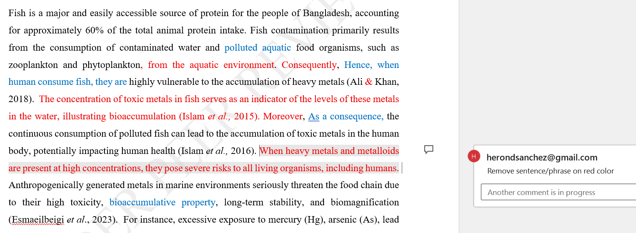  - 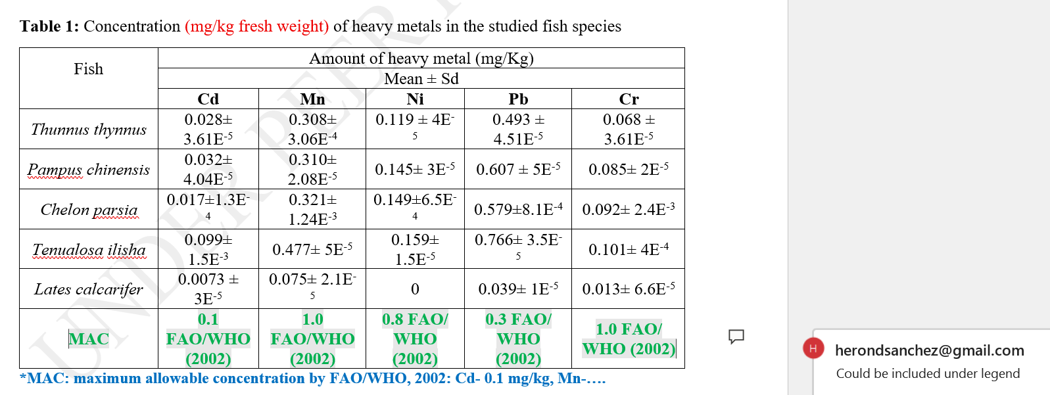  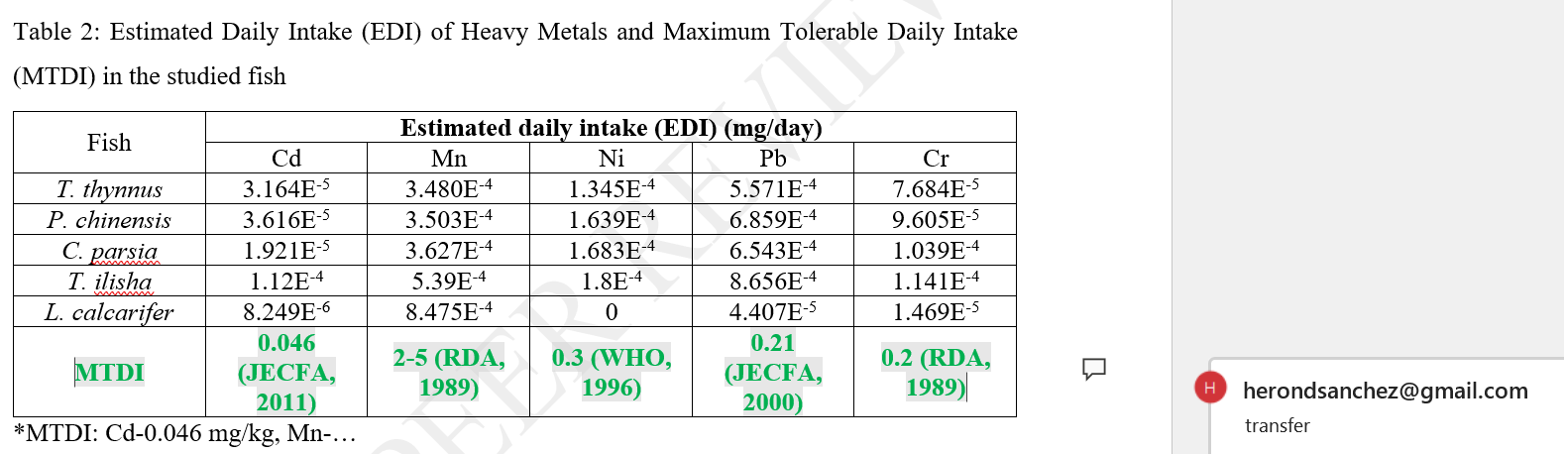  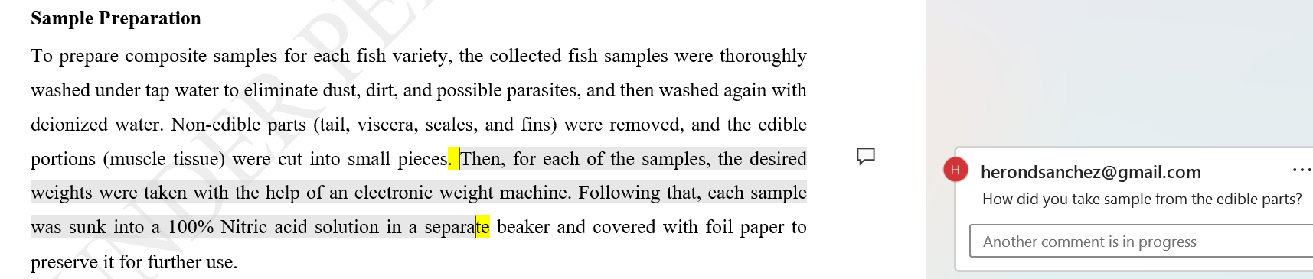  -INCLUDE PLACE OF WHERE LABORATORY WAS DONE  -REVIEW AND IMPROVE REFERENCING FORMAT (e.g..PUNCTUATIONS…)  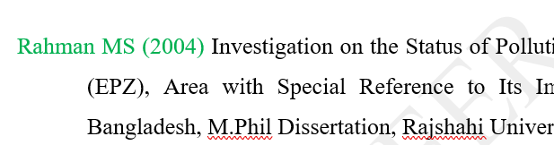  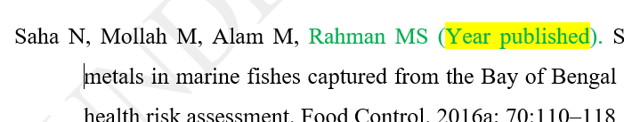
Are the references sufficient and recent?  (YES or NO)  If your answer is NO, please provide clear suggestion for improvement. | YES
Are there ethical issues in this manuscript?  (YES or NO)  (If yes, kindly please write down the ethical issues here in details) | NONE

Reviewer details:

Heronima D. Sanchez, Benguet State University, Philippines

