Original Research Article
SPECIES DIVERSITY AND GUILD STRUCTURE OF ARANEAE IN THE VICINITY
OF KEDAR DAM, SARANGARH-BILAIGARH, DISTRICT, CHHATTISGARH,
INDIA

ABSTRACT

Spiders, belonging to the Phylum Arthropoda, class Arachnida and order Araneae, represent a significantly diverse and ecologically relevant group. The current study examined spider faunal diversity surrounding Kedar Dam, situated in the Kedar village, Sarangarh-Bilaigarh District of Chhattisgarh, India. This research focused on assessing spider species abundance, Guilt structure and developing a comprehensive species checklist for the spider fauna inhabiting the vicinity of Kedar Dam. Spiders were collected from the study area using a variety of methods and were subsequently identified using a taxonomic key specific to Indian spiders. The study was conducted from July 2024 to June 2025. A total of 60 species, representing 16 families, and 53 genera were documented in the study area. The Araneidae family showed the highest prevalence, with fifteen species identified. This research provides current and relevant data on species diversity surrounding Kedar dam. The dataset presented may assist as a valuable resource for upcoming investigations of spider.
KEY WORDS- Araneae, Spider, Kedar dam, Diversity
1.INTRODUCTION- Spiders represent an attractive and diverse group of invertebrate animals (Platnick, 2014), holding considerable interest for both archaeologists and the general public. Fossil records indicate their ancient origins, with emergence during the Devonian period approximately 380 million years ago (Shear et al., 1989). Classified within the Phylum Arthropoda and the Order Araneae, spiders constitute the largest order within the Class Arachnida. Their sensitivity to alterations in habitat structure, vegetation density, and environmental conditions positions them as valuable bioindicators and pest control agents (Utez, 1991). Total known 53,000 species of spiders belonging to 504 genera under 62 families in the all over the worlds (WSC 25) Singh et al. (2023) documented 2,110 species across 527 genera and 55 families in their comprehensive survey of Indian spiders. In Chhattisgarh, a separate study identified 222 spider species belonging to 96 genera within 23 families. Choudhary S, R. et al. (2023). Chhattisgarh exhibits a diverse range of forest types, agroecological zones, and climatic gradients, fostering a rich spider fauna. However, the taxonomic and ecological characteristics of this fauna remain understudied (Bastawade, 2005). Habitat degradation resulting from deforestation, agricultural expansion, and mining activities in Chhattisgarh negatively impacts spider diversity. This is primarily due to the reduction of crucial microhabitats, such as leaf litter and understory vegetation, which are essential for spider survival (Sebastian & Peter, 2009).
The guild concept, referring to a community or organization structure, has been observed across a wide range of animal and plant assemblages. The term "guild" was formally defined in a study of avian niche exploitation patterns as "a group of species that exploit the same class of environmental resources in a similar way," and this concept was subsequently extended to the arthropod fauna of collards (Root 1973). Similarities observed in guild composition imply that plant habitat structure may influence the spider community. (Uetz et al.1999) Spider guilds were delineated through hierarchical clustering techniques. Guild richness and abundance correlations typically exceeded than the correlation of family richness. (Cardoso et al..2011).
Spider diversity in Chhattisgarh remains under documented. The present study investigates the spiders inhabiting surrounding Kedar dam situated in the Deogaon, Patharipali, village, it is 21 km from Sarangarh–Bilaigarh district of Chhattisgarh, India,
. Spiders fulfil a significant ecological function as predators, contributing to the maintenance of ecological equilibrium. Due to their behavioural characteristics, such as web construction, foraging techniques, and habitat specificity, spiders are well-suited for application as bioindicators in environmental monitoring (Pearce & Venier, 2006) The identification of Indian spiders has been achieved through taxonomic keys, morphological characteristics, and behavioural observations, as detailed in Tikader (1982, 1987). Recent publications (2012-2023) and the Indian Biodiversity website provide further resources Research on spider diversity in India has been conducted in several protected areas. Notably, Gajbe, (1995b) in a study within the Indravati Tiger Reserve, documented 13 spider species. Further investigations by Rane and Singh identified five species (1977), while Gajbe P. (2003) recorded 14 species within the Kanha Tiger Reserve, Madhya Pradesh. Additionally, Gajbe 2003) compiled a checklist encompassing 186 spider species, classified into 69 genera and 24 families, across the regions of Madhya Pradesh and Chhattisgarh.
2. METHODOLOGY
2,1 STUDY AREA-- The current study was conducted surrounding Kedar dam situated in the Deogaon, Patharipali, village, it is 21 km from Sarangarh–Bilaigarh district of Chhattisgarh, India, The geographical coordinates of this area are 21°33'50.4"N 82°58'27.5"E and the elevation is 217 m (712 ft). The Dam is situated within a tropical dry deciduous forest environment.
2.2 CLIMATE – Sarangarh-Bilaigarh exhibits a tropical climate characterized by high temperatures, significant humidity, and pronounced monsoon rainfall. Annually, temperatures typically fluctuate between 20°C (68°F) and 34°C (93°F), with April, May, and June representing the warmest period. The region experiences an average annual rainfall of 1596 mm (62.8 inches), with the highest precipitation levels recorded during June, July, and August. August averages the rainiest days at 27.5, while November experiences minimal rainfall, averaging only 5mm (0.2 inches). Sarangarh benefits from approximately 3624 hours of sunshine per year, with March, April, and May receiving the greatest amount of solar radiation.
2.3 VEGETATION – The dam features diverse vegetation characterize by try deciduous flora such as Acaia nilotica, Aegle marmelos, Baunia tomentosa Baunia tomentosa, Biophytum sensitivum, Bombax, Butea monosperma, Cassia fistula, Gardenia latifolia, Lantana camara, Madhuca longifolia,Mengifora indica, Pterocarpus marsupium, Syzium cumuni, Terminalia arjuna, Zizypus oenophilia etc. Cardoso et al. (2011), Sabnam et al. (2021) suggest that vegetation structure influences spider diversity in various plantations..
2,4 SAMPLING METHOD -The spider sampling methods encompassed visual searches, maximizing visible range to locate specimens. Ground searches involved examining leaf litter and beneath fallen or dry wood. Sweep netting was employed to collect foliage-dwelling spiders from herbs and shrubs. Beating traps, utilizing a wooden stick and an umbrella positioned beneath trees, were implemented to capture spiders inaccessible by other means or observed in elevated locations. Web patterns and habitat types were documented for each specimen. Collection date, site, and habitat information were recorded for each sample.
2.5 PHOTOGRAPHY- All observed spider specimens were photographed using a digital SLR camera and the Vivo Mobile application. Following photographic documentation, collected spiders were returned to their native habitats. The Dead specimens were stored in separate vials containing 70% ethyl alcohol for subsequent taxonomic processing.
2.6 IDENTIFICATION-The identification of Indian spiders has been achieved through taxonomic keys, morphological characteristics, and behavioral observations, as detailed in Tikader (1982, 1987), and Barrion & Litsinger (1995). Recent publications (2020-2025) and the Indian
Biodiversity website.

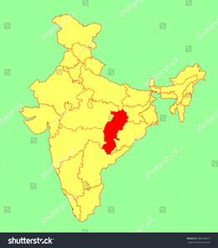 | 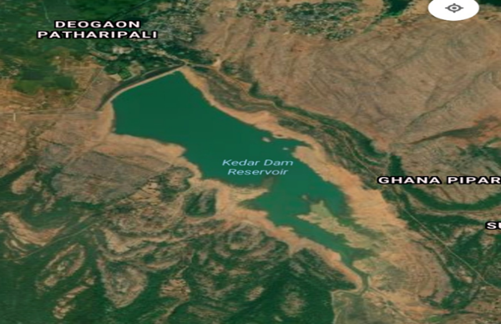
 | 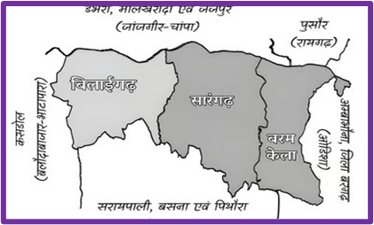
Fig.: 1:Study Area: India-Chhattisgarh-Sarangarh-Bilaigarh -Kedar Dam

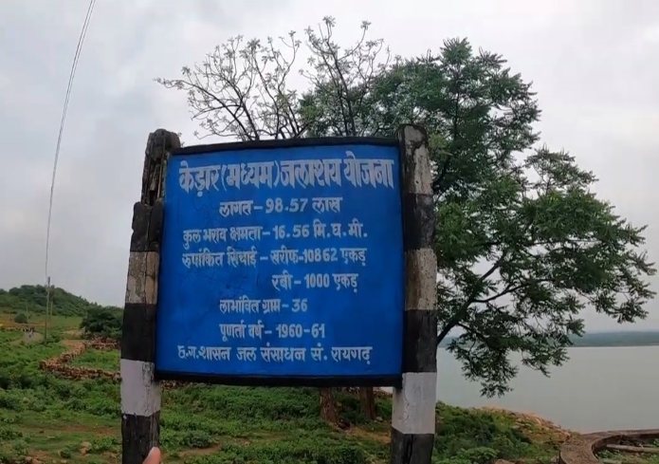 | 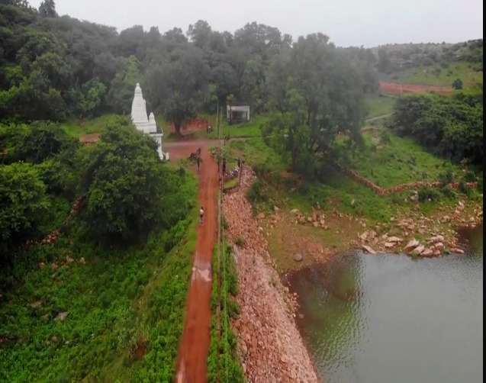
Fig:2.Study Area – a. and b. Surrounding Kedar Dam, Sarangarh- Bilaigarh District, Chhattisgarh, India

Table 1 List of species documented in Kedar Dam” Sarangarh- Bilaigarh District
SL.NO. | Name of Family/ Species
I | FAMILY ARANEIDAE SIMON,1895
1, | Araneus sp.
2. | Argiope aemula (Walckenaer, 1841)
3. | Argiope anasuja Thorell, 1887
4. | Argiope catenulata (Doleschall, 1859)
5 | Argiope pulchella Thorell,1881
7 | Bijoaraneus mitificus (Simon, 1886)
8 | Cyclosa bifida (Doleschall, 1859)
9 | Cyclosa insulana (Costa, 1834)
10 | Cyrtophora cicatrosa
11 | Eriovixia laglaizei (Simon, 1877)
12 | Guizygiella sp.
13 | Neoscona nautica (L. Koch, 1875)
14 | Neoscona theisi (Walckenaer, 1841)
15 | Parawixia dehaani (Doleschall, 1859)
II | FAMILY: FILISTATIDAE
16 | Pritha nana (Simon, 1868)
III | FAMILY GNAPHOSIDAE POCOCK, 1898
17 | Drassodes sagarensis Tikader, 1982
IV | FAMILY LYCOSIDAE SUNDEVALL, 1833
20 | Hippasa holmerae Thorell, 1895
21 | Pardosa pseudoannulata (Bösenberg & Strand, 1906)
22 | Wadicosa fidelis (O. Pickard-Cambridge, 1872)
V | FAMILY NEPHILIDAE SIMON 1984
23 | Nephila kuhlii (Doleschall, 1859)
24 | Nephila pilipes (Fabricius, 1793
VI | FAMILY OXYOPIDAE THORELL, 1870
26 | Oxyopes javanus Thorell, 1887
27 | Oxyopes sertatus L. Koch, 1878
28 | Oxyopes Shweta Tikader, 1970
29 | Oxyopes macilentus L. Koch, 1878
30 | Peucetia viridana (Stoliczka, 1869)
VII | FAMILY: PISAURIDAE SIMON, 1890
32 | Nilus albocinctus (Doleschall, 1859)
VIII | FAMILY PHILODROMIDAE THORELL, 1870
33 | Ebo bharatae Tikader, 1965
34 | Thanatus vulgaris Simon, 1870
IX | PHOLCIDAE C. L. KOCH, 1850
55 | Artema atlanta Walckenaer, 1837
36 | Crossopriza lyoni (Blackwall, 1867)
37 | Holocnemus pluchei (Scopoli, 1763)
38 | Micropholcus fauroti (Simon, 1887)
39 | Pholcus phalangioides(Fuesslin, 1775)
X | FAMILY SALTICIDAE BLACKWALL, 1841
40 | Carrhotus viduus (C. L. Koch, 1846)
41 | Chrysilla volupe (Karsch, 1879)
42 | Hasarius adansoni (Audouin, 1826)
43 | Hyllus semicupreus (Simon, 1885
44 | Menemerus bivittatus (Dufour, 1831
45 | Menemerus nigli Wesołowska & Freudenschuss, 2012
46 | Phintella vittata (C.L. Koch, 1846)
47 | Plexippus paykulli (Audouin, 1825)
48 | Plexippus petersi (Karsch, 1878)
49 | Portia fimbriata (Doleschall, 1859)
51 | Telamonia dimidiata (Simon, 1899)
XI | FAMILY SCYTODIDAE BLACKWALL, 1864
52 | Scytodes fusca Walckenaer, 1837
53 | Scytodes thoracica (Latreille, 1802)
XII | SELENOPIDAE SIMON, 1897
54 | Selenops radiatus Latreille, 1819
XII | SPARASSIDAE BERTKAU, 1872
55 | Heteropoda venatoria (Linnaeus, 1767
57 | Olios lamarcki
XIV | FAMILY TETRAGNATHIDAE MENGE, 1866
58 | Leucauge decorata (Walckenaer, 1842)
59 | Leucauge celebesiana
60 | Tetragnatha javana (Thorell, 1890)
XV | THERIDIIDAE SUNDEVALL, 1833
61 | Latrodectus hasselti Thorell, 1870
63 | Platnickina adamsoni (Berland, 1934) –
XVI | FAMILY THOMISIDAE SUNDEVALL, 1833
64 | Diaea dorsata (Fabricius, 1777)
65 | Misumenoides sp.
66 | Nesticodes rufipes (Lucas, 1846)
67 | Thomisus lobosus
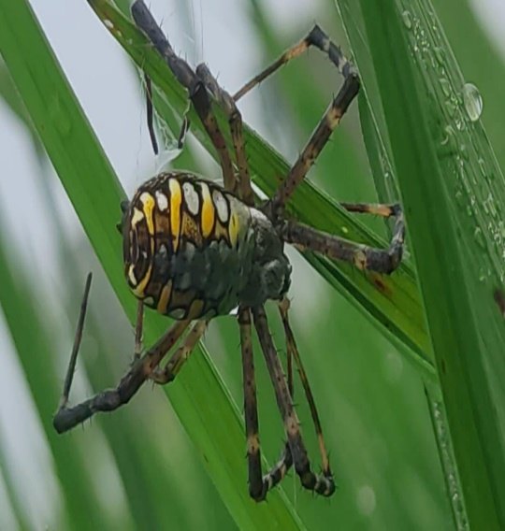 |  | 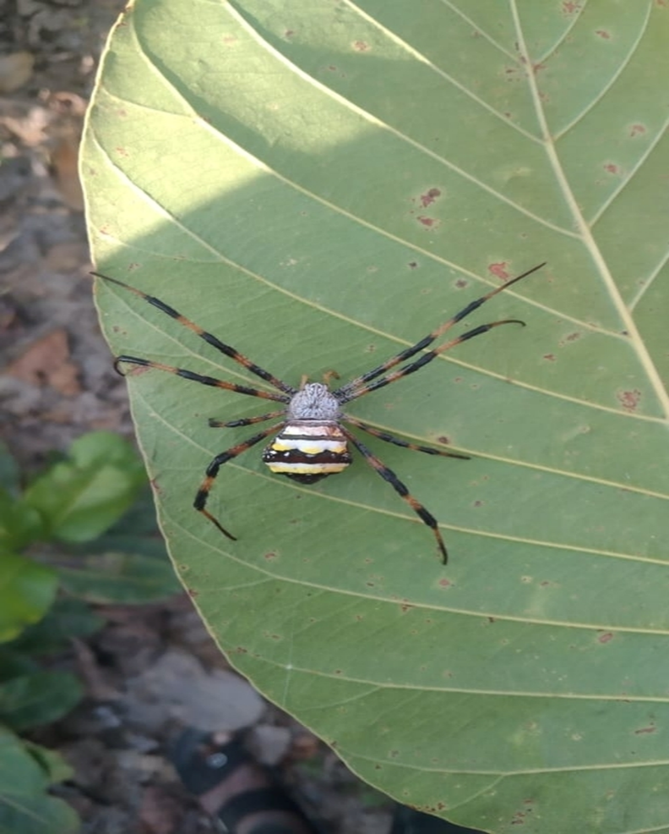 | 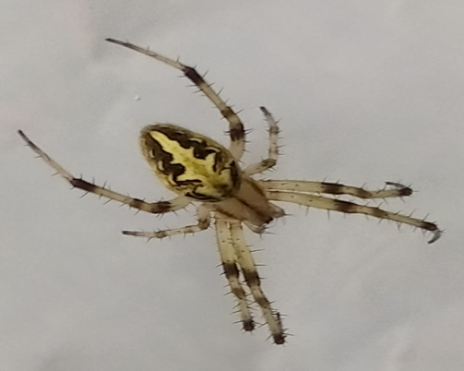
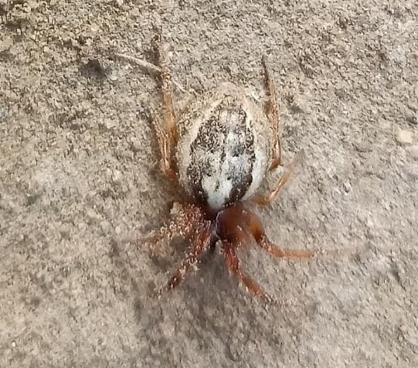 |  | 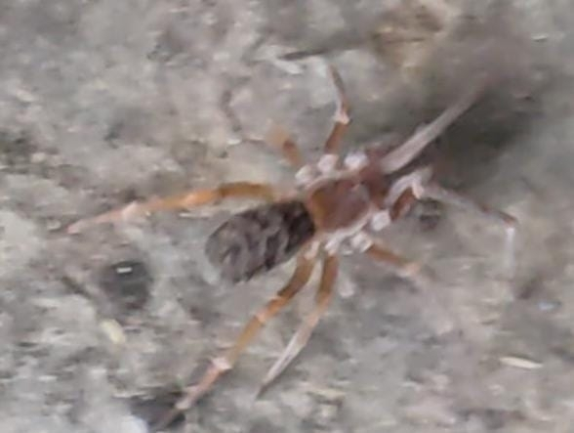 | 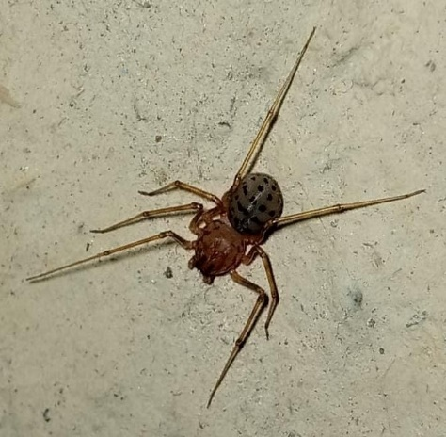
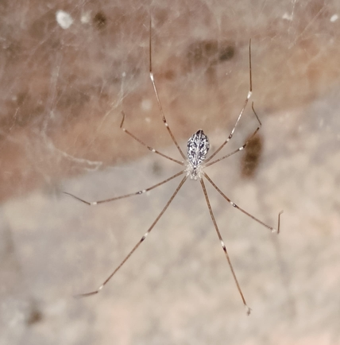 |  | 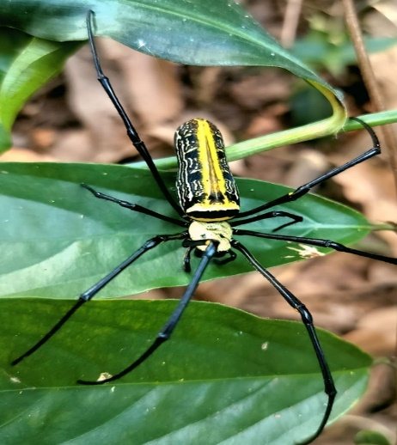 | 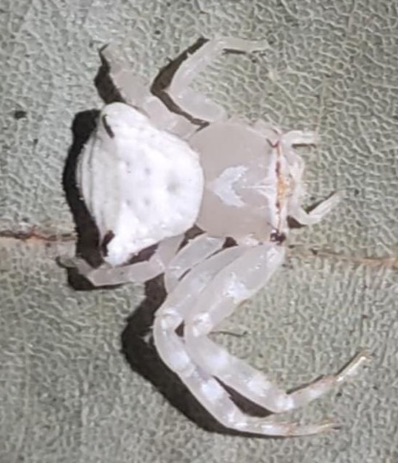
Fig 3 : Spider Photograph -a. Argiope catenulata b, Argiope pulchella c. Neoscona theisi d. Guizygiella spe. e Pritha nana.f. Scytodes fusca. g Holocnemus pluchei h. Nephila pilipes i. Thomisus lobosus

Table.2 Familywise species diversity of spiders recorded in Kedar Dam” Sarangarh- Bilaigarh District, Chhattisgarh India.

Sl. No. | Family | No. of Species | Sl. No. | Family | No. of species
1, | Araneidae | 15 | 09 | Pholcidae | 05
2 | filistatidae | 01 | 10 | Salticidae | 11
3 | Gnaphosidae | 01 | 11 | Scytodidae | 02
4 | Lycosidae | 03 | 12 | Selenopidae | 01
5 | Nephilidae | 02 | 13 | Sparassidae | 02
6 | Oxyopidae | 05 | 14 | Tetragnathidae | 03
7 | Pisauridae | 01 | 15 | Theridiidae | 02
8 | Philodromidae, | 02 | 16 | Thomisidae | 04

Figer 4 : Familywise species diversity of spiders recorded in Kedar Dam” Sarangarh- Bilaigarh District, Chhattisgarh India.
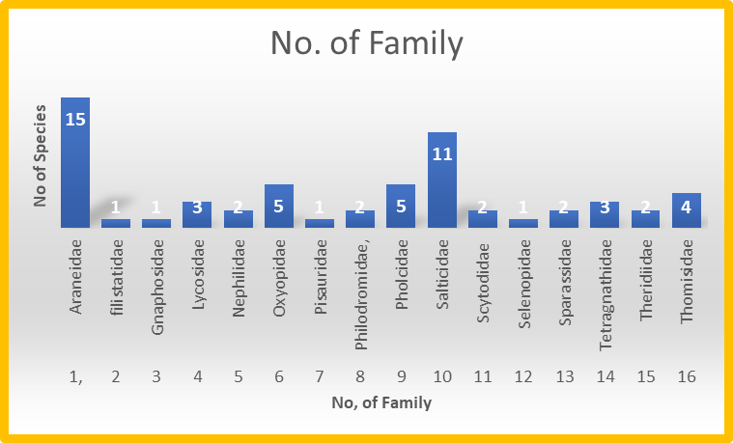
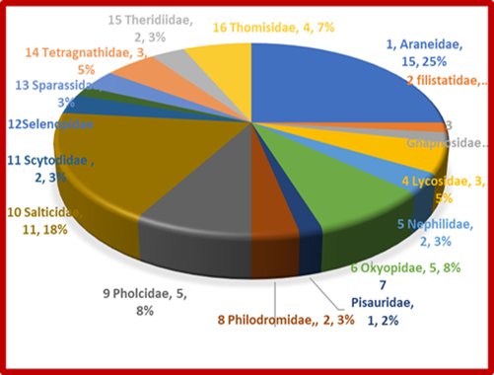
Figure 5 : Familywise species diversity and their percentage of spiders recorded in Kedar Dam” Sarangarh- Bilaigarh District, Chhattisgarh India.
3. RESULTS AND DISCUSSION –
The Kedar Dam supports a varied spider population. A survey of the dam identified 60 spider species representing 16 families and 53 genera. The Araneidae family was the most abundant, with a count of 15 species, contributing 10 percent of the total population, followed by Salticidae with 7 species (18 %). Oxyopidae and Pholcidae were each represented by 5 species (8%), while Thomisidae was represented by 4 species (7%). The families Lycosidae and Tetragnathidae each contributed 3 species (5%). Nephilidae, Philodromidae, Scytodidae, Sparassidae and Theridiidae each contributed 2 species (3%). Filistatidae, Gnaphosidae, Pisauridae, and Selenopidae were each represented by a single species, contributing (2%) to the surveyed fauna., (Table-1) Silwal M. observed 116 species belonging to 66 genera and 25 families in the Purna Wildlife Sanctuary, Dangs, Gujarat, and similar observations family Araneidae was found to be dominant whereas Krishnaveni & kandeepan (2018) observed Salticidae is dominant family. Kujur and Ekka (2016) identified 120 species in Gomarda Wildlife Sanctuary. Thomisidae is the dominant family, contributing 24 species. Furthermore, Patel’s (2003) work described 91 species from 53 genera distributed in 22 families within the Parambikulam Wildlife Sanctuary, Kerala. Vairale and Wagh (2021) reported 120 spider species belonging to 14 families and 37 genera in grassland, bush land, woodland, agricultural land, and wetlands within the tropical reserve forest of Pohra Malkhed, Amravati District. Dharmaraj et al. (2017) documented a total of 40 spider species, representing 36 genera and 11 families, in the Nilgiris region. This study investigated spider microhabitat preferences through active searching at various strata, ranging from ground level to the easily accessible tree canopy layer, employing hand collecting and visual survey methodologies.
Researcher observed guild structure comprised eight distinct types: ambushers, Ground hunters, Cursorial hunters, Foliage runners, orb weavers, ground runners, same observed by Cardoso (2011) Orb web weavers constituted the majority of spiders (29%), followed by Ambush hunters (22%), foliage runners (17%), ground hunter (10%), space web builders (2%), ground runners and cursorial hunter (2%) (Table 3). Wankhede et al. (2013) observed that orb web builders were the most dominant spider guild. In total, five different guilds of spiders were observed. Orb web builders comprised 54% of the observed spiders, foliage runners 24%, ground runners and ambushers 8% each, and scattered line weavers 6% in the Pohara forest of Chandur tehsil, Amravati district. Hirur et al. (2020) documented a total of seven spider guilds within a crop ecosystem, categorized by their prey attack strategies. This diverse assemblage of spiders may prove effective in biological control, owing to their varied hunting strategies, habitat preferences, and activity periods. Rajeevan et al. (2019) documented the presence of 150 species, classified into 7 guilds, representing 73 genera across 20 families, in two selected habitats within the Kartikulam forest reserve of the Mananthavady region, situated in the Western Ghats of North Wayanad region, Kerala, India. Sabnam et al. (2021) identified seven functional groups of spiders from their collected specimens: orb-web builders, stalkers, ambushers, cob-web builders, ground runners, foliage runners, and sheet-web builders. The analysis revealed a total of 93 species, classified into 71 genera within 19 families, representing 49% of the spider families recorded from the selected habitats in the Western Ghats, Kerala.
Table 3 Different functional guild structure of spiders found in Kedar Dam.
SL. NO. | GUILT TYPES | FAMILIES
01 | Ambush hunters | Philodromidae, Pholcidae, Thomisidae,
02 | Ground hunters | Gnaphosidae, Lycosidae, Scytodidae
03 | Cursorial hunters | Pisauridae
04 | Ground runner | Scytodidae
05 | Foliage runners | Salticidae
06 | Orb web weavers | Araneidae, Tetragnathidae, Nephilidae
07 | Space web weavers | Theridiidae
08 | Other hunters | Filistatidae, Oxyopidae, Sparassidae, Selenopidae
Fig 6: Guilt type and number of species in Kedar Dam

CONCLUSION-Sarangarh- Bilaigarh district, demonstrates a notable diversity of spiders, This habitat offers a wider variety of microhabitats, microclimatic features, alternative food sources, retreat sites, and web attachment sites for spiders. The rich floral diversity of this ecosystem provides a favorable environment for spider fauna, emphasizing the need for ecosystem conservation through characterization of species diversity.
OBJECTIVES- This study was undertaken with the following primary objectives:
1. To evaluate the overall status of spider populations in the vicinity of the Kedar Dam, Chhattisgarh, India.
2. To gather an inclusive checklist of spider species identified at Kedar Dam, Chhattisgarh, India.
3. To assessment of guild structure of spider in Kedar Dam, Chhattisgarh, India.

Reference –
- Bastawade DB. (2005) Arachnida: Scorpions and spiders. Fauna of Chhattisgarh, State Fauna Series, Zoological Survey of India ;13:419-436.
- Bucher, R., Menzel, F., Entling, M. H. (2015) Risk of spider predation alters food web structure and reduces local herbivory in the field. Oecologia, 178, 571-577. DOI 10.1007/s00442-015-3226-5
- Caleb, J.T.D. and Sankaran, P.M. 2020. Araneae of India. Version 2020, online at http://www.indianspiders.in (accessed on 09 September 2020)
- Cardoso, P. et al. (2011) Global Patterns of Guild Composition and Functional Diversity of Spiders PLoS One, 2011 ;6(6)
- Choudhury, S.R.et al. (2023) Spider fauna of Chhattisgarh: An updated checklist of spiders of Chhattisgarh, India with new additions. Serket (2024) vol. 20(3): 311-334.
- Gajbe UA. (1995b) Spiders, Fauna of Conservation Areas: Fauna of Indravati Tiger Reserve, Madhya Pradesh. Zoological Survey of India, 53-56.
- Dharmaraj et al. (2017) Diversity of spiders (Arachnida: Araneae) in Nilgiris, Tamilnadu. International Journal of Advanced Research in Biological Sciences, 4, 143-147
- Hirur et al. (2020) Analysis and guild composition of spiders in rabi tomato. Indian Journal of Entomology 82(2): 347-350 (2020)
- Gajbe P. (2003) Checklists of Spiders (Arachnid; Araneae) of Madhya Pradesh and Chhattisgarh. Zoos Print Journal; 18(10):1223-1226.
- Gajbe UA. (1995a,) Spiders Fauna of Conservation Areas: Fauna of Kanha Tiger Reserve, Madhya Pradesh. Zoological Survey of India, 27-30.
- Krishnaveni & kandeepan (2018) Biomonitoring of diversity and composition of spider collection at Sirumalai hills, Dindigul district, Tamil Nadu. International Journal of Zoology Studies; Volume 3; Issue 1; Pp. 44-47

Kujur & Ekka (2016), Int. Res. J. Biological Sci., Volume 5, Issue (6), Pages 31-36,

- Nichat et al. (2024) a study of biodiversity of spider species (arachnida : Aranae : Araneomorphae) in Kokasara region, Kalahandi, Odisha, India;afr.j.bio.sc. 6(15)
- Latha, et al. (2024) A Study on The Seasonal Diversity of Spiders in Selected Sites of
Kollam District, Kerala Afr. J. Biomed. Res. Vol. 27(4s); Pp11542 - 11550
- Patel B.H. (2003) Fauna of Protected Areas - A Preliminary list of Spiders with the descriptions of three new species from Parambikulum Wildlife sanctuary, Kerala. Zoos Print Journal; 18(10):1207-1212.
- Pearce JL, Venier LA. The use of ground beetles (Coleoptera: Carabidae) and spiders (Araneae) as bioindicators of sustainable forest management: A review. Ecological Indicators. 2006;6(4):780-793
- Platnick N.I. (2014)., The world spider catalog, Version 15.0., American Museum of Natura History. http://research.amnh.org/entomology/spiders/catalog/index.html
- Priyadarshini and Mahapatra (2023) Effect of abiotic factors and seasonal influence on spider diversity in rice agroecosystem of Bargarh District, Odisha, India; Nawa geodesia; Vol. 3 No. 4
- Rajeevan, et al. (2019). Spider Diversity (Arachnida:Araneae) in Different Ecosystems of the Western Ghats, Wayanad Region, India, South Asian Journal of Life Sciences, July-December Vol. 7, Issue 2, pp29-39
- Rane PD, Singh RK. (1977) Spiders (Arachnida: Araneae) from Kanha National Park, Madhya Pradesh, India. Newsletter Zoological survey of India 3(2):84.

- Root, R.B. 1973. Organization of a plant-arthropod association in simple and diverse habitats: The fauna of collards (Brassica oleracea). Ecol. Monograph., 43:95–12

- Sabnam et al. (2021) Spider diversity (Arachnida; Araneae) in different plantations of western ghats, Wayanad region, India, European Journal of Ecology, 7.1, 2021, pp. 80-94

- Sen, D.L. 2021. Biodiversity of spider fauna at, Gariaband, Chhattisgarh, India. International Research Journal of Modernization in Engineering Technology and Science, 3(10): 953-961.

- Sebastian PA, Peter KV (Eds.). Spiders of India. Universities Press. 2009.
- Silwal M,et al. (2003) Spiders of Purna wildlife Sanctuary, Dangs, Gujarat. Zoos Print Journal; 18(11):1259 -1263.
- Sing et al. (2023) SPIDER FAUNA OF INDIA, (Book) ISBN- 978-81-959483-4-5
- Singh and Sharma (2022) An updated checklist of spider (Araneomorphae: Araneae: Arachnida) diversity of Madhya Pradesh, India. International Journal of Zoological Investigations 8(8):191- 218
- Shear, W.A., Palmer, J. M., Coddington, J. A., and Bonamo, P. M. (1989). A Devonian spinneret: early evidence of spiders and silk use. Science, 246: 479- 481.
- Tikader BK. Gazetteer of India, Maharashtra state, General Series: Fauna, Chapter 4 –Spiders, 1974, 295- 306.
- Tikader BK. Handbook of Indian Spiders, Zoological Survey of India. Calcutta, India, 1987, 251.
- Tikader BK. Family Araneidae (Argiopidae), typical orb weavers. Fauna India (Araneae) 1982a; 2:1-293. [26] Tikader BK. Family Gnaphosidae. Fauna India (Araneae) 1982b; 2:295-536.
- Tharaheswari et al. (2024) Assessing spider diversity in Puducherry: Rural richness and urban constraints; International Journal of Entomology Research; Volume 9, Issue 8, Page No. 43-47
- Vairale & Wagh (2021) Diversity of Spiders in Microhabitats of a Tropical Reserve Forest of Amravati, Maharashtra, India; Biosc. Biotech. Res. Comm. Vol 14 No (1); Pp 446-45
- Uetz et al. (1999.) GUILD STRUCTURE OF SPIDERS IN MAJOR CROPS; The Journal of Arachnology 27:270–280
- Wankhade, et al. (2013). Diversity and guild structure of Spider fauna at Sawanga-Vithoba Lake (Malkhed Project) area in Pohara forest district Amravati, Maharashtra, India. International Journal of Zoology and Research. ISSN 2278–8816 Vol.3, Issue 1, Pp.7-16
- Wankhade, V. W., and Manwar, N. (2016). Explorativestudy on the diversity and Characteristics of Spider Families, International Journal of Zoology and Research
- (IJZR), ISSN(E): 2278-8824, Vol. 6, Issue 1, 15-2
- Wise, D.H. (1993) Spiders in Ecological Webs. Cambridge University Press, Cambridge, UK.
- (WSC-2025, version-26) https://wsc.nmbe.ch/

