Original Research Article

STOCK AVAILABILITY POTENTIAL OF Epinephelus fasciatus DURING THE FIRST TRANSITIONAL SEASON IN THE ALAS STRAIT, INDONESIA

.
ABSTRACT

Groupers (Epinephelus spp.) are high-value coral reef fishes that are highly susceptible to overfishing due to their slow growth and complex reproductive strategies. Consequently, biologically based stock assessments are essential for sustainable fisheries management. Epinephelus fasciatus is among the dominant grouper species exploited in the Alas Strait waters, Indonesia. This study aimed to evaluate the stock status and size structure of E. fasciatus during the first transitional season. Data collection was conducted from March to May 2025 at the Tanjung Luar Fish Market, East Lombok, West Nusa Tenggara Province. The collected data consisted of the number of captured individuals and total length measurements. Fish lengths were measured using WCS Image Tools, followed by length-frequency analysis and stock assessment using the Length-Based Spawning Potential Ratio (LB-SPR) approach. The LB-SPR analysis incorporated biological parameters, including asymptotic length (L∞), growth coefficient (k), natural mortality (M), length at first capture (Lc), length at first maturity (Lm), length at 50% maturity (L50), and length at 95% maturity (L95), obtained from the Scientific Forum for Sustainable Fisheries Management of West Nusa Tenggara Province. Results showed that all sampled individuals (100%) exceeded the length at first maturity (Lm = 16.28 cm), with total lengths ranging from 17.46 to 28.81 cm, indicating that all captured fish had reached sexual maturity prior to capture. The dominant size class ranged from 20–24 cm. Furthermore, the estimated Lc exceeded Lm, suggesting that most individuals had the opportunity to reproduce at least once before capture. The SPR value was estimated at 71%, indicating an under-exploited stock condition. These findings suggest that fishing pressure on E. fasciatus in the Alas Strait during the first transitional season remains relatively low and that the stock retains adequate reproductive capacity to support population sustainability.

Keywords: Epinephelus fasciatus, Spawning Potential Ratio, , Length distribution, Alas Strait, Fish stock.

1. INTRODUCTION

Groupers are coral reef fishes belonging to the family Epinephelidae and are widely distributed throughout tropical and subtropical waters, including Indonesia. These fish generally inhabit demersal environments associated with coral reefs, seagrass beds, and rocky substrates at depths ranging from 1–150 m, where they function as mesopredators that contribute to maintaining coral reef ecosystem balance (Ghazali et al., 2025). In addition to their ecological importance, groupers are economically valuable fishery commodities with continuously increasing market demand, particularly for export to Asian countries (Khasanah et al., 2020). However, this increasing demand may intensify fishing pressure and potentially lead to overfishing if not accompanied by sustainable fisheries management practices (Azizah et al., 2023).
Increasing grouper fishing activities without proper management may exert substantial pressure on natural stocks. Several studies have reported that grouper exploitation in various Indonesian waters has reached or even exceeded sustainable levels (overexploited) (Santoso et al., 2015). Therefore, stock assessment is essential to support fisheries resource management through analyses of population biological parameters such as growth, natural mortality (M), fishing mortality (F), and exploitation rate (E) (Prince et al., 2015; Hordyk et al., 2015). Theoretically, when fishing mortality exceeds natural mortality (F > M), fish populations are likely to experience overfishing, resulting in declines in biomass and disruptions to population size structure (Irawan et al., 2019). Previous studies on grouper population dynamics in Indonesian waters, including those conducted in Kwandang Bay, Sulawesi, demonstrated that the exploitation level of Epinephelus spp. was approaching the optimal threshold (Achmad et al., 2025).
Limited biological and fisheries data remain a major challenge in fish stock assessments in Indonesia, often resulting in insufficiently accurate evaluations (Dimarchopoulou et al., 2023). Demersal fisheries utilization data from 2022 indicated that several Fisheries Management Areas (WPPs) had experienced high fishing pressure. In WPP 571 and WPP 712, exploitation rates (E) exceeded 1.0, indicating overexploited conditions, while other regions were categorized as fully exploited. These findings suggest that most demersal fish stocks in Indonesia have been intensively exploited. Furthermore, the application of maximum sustainable yield (MSY) as a management reference without considering stock-specific conditions may encourage harvest levels that exceed the actual sustainable potential (Sondita et al., 2025).
The Alas Strait, located between Lombok Island and Sumbawa Island, represents one of the potential habitats for coral reef fishes due to its strong currents and complex coral substrates. High fishery resource potential in a given area tends to stimulate increased fishing activity by local fishers, making the area a primary fishing ground. Fishers generally target areas with high catch probability to maximize harvest yields, which may ultimately increase pressure on resource sustainability if not properly managed (Kusdiantoro et al., 2019). Previous studies reported that grouper exploitation in the Alas Strait had exceeded sustainable potential, indicating overfishing conditions (Santoso et al., 2015). Also, several studies on grouper stock assessments have previously been conducted, including those by Noija et al. (2014), Efendi et al. (2023), and Yandi et al. (2025). However, most studies focused broadly on the genus Epinephelus rather than specific species. Consequently, studies evaluating the stock health of E. fasciatus remain limited, particularly in the Alas Strait. In addition, previous studies generally applied the maximum sustainable yield (MSY) approach without considering seasonal variability that may influence stock availability.
Therefore, this study specifically evaluated the stock health and potential of one grouper species occurring in the Alas Strait during the first transitional season as a continuation of previous fisheries assessments in the region. The species Epinephelus fasciatus was selected because it is among the dominant grouper species commonly captured by fishers in the Alas Strait. This research in the Alas Strait waters will provide scientific evidence supporting sustainable fisheries resource management in the region.

2. mETHODOLOGY
2.1 STUDY AREA
Data collection was conducted at the Tanjung Luar Fish Market, Keruak District, East Lombok Regency, West Nusa Tenggara Province, Indonesia. This study focused on Epinephelus fasciatus individuals captured in the Alas Strait waters and subsequently landed and sold at the Tanjung Luar Fish Market. Figure 1 illustrates the study area and the location of the Alas Strait waters.
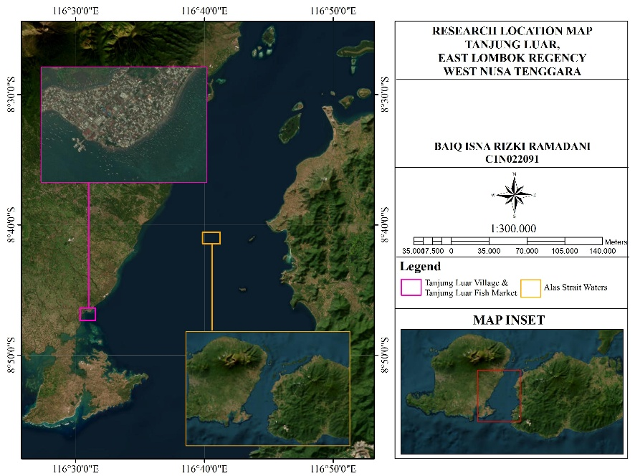
Figure 1. Study Area Map

2.2 DATA COLLECTION

Data collection was carried out from March to May 2025, corresponding to the first transitional season based on Kunarso et al. (2016). The collected data consisted of both primary and secondary data. Primary data included the number of captured E. fasciatus individuals, total body length measurements, fishing grounds, fishing gear types, landing sites, and the names of fish collectors trading E. fasciatus. Secondary data included information regarding length at first maturity (Lm), natural mortality (M), growth coefficient (k), asymptotic length (L∞), length at 50% maturity (L50), and length at 95% maturity (L95) obtained from the Scientific Forum for Sustainable Fisheries Management (FIP2B) of West Nusa Tenggara Province.
The study samples consisted of Epinephelus fasciatus, commonly known as blacktip grouper, captured in the Alas Strait waters and marketed at the Tanjung Luar Fish Market. Fish sampling employed an accidental sampling technique, in which individuals encountered at the sampling site and considered relevant to the study objectives were selected as samples (Sugiyono, 2016). All of E. fasciatus individuals encountered during data collection were photographed using a smartphone camera and subsequently measured using WCS Image Tools software.
Photographs of E. fasciatus individuals were taken following standardized procedures to ensure suitability for image-based measurement using WCS Image Tools. The photographs were captured in a perpendicular position under adequate lighting conditions and included a clearly visible measurement scale to ensure accurate fish length estimation. An example of the photographic procedure is presented in Plate 1.
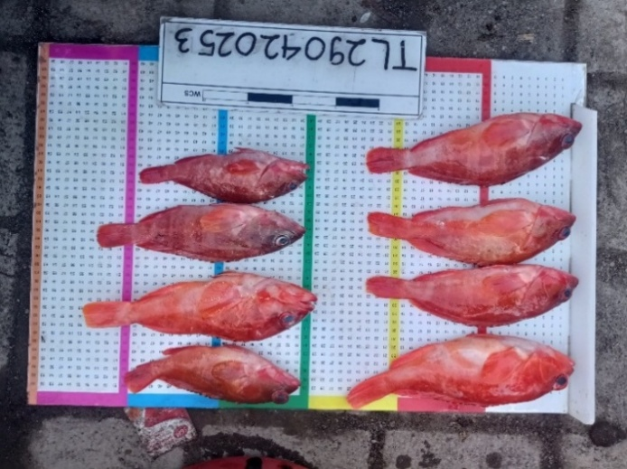
Plate 1. Total Length (TL) measurement of Epinephelus fasciatus

The morphometric measurement conducted in this study was total length. According to Gigentika et al. (2025), total length is measured from the anterior tip of the snout to the posterior tip of the upper caudal fin. In this study, total length measurements were conducted using WCS Image Tools software by tracing the cursor from the anterior mouth tip to the outer edge of the caudal fin on the uploaded image. The total length value for each measured individual was then displayed automatically on the screen.

2.3 DATA ANALYSIS

2.3.1 Length-Frequency Distribution Analysis

According to Kell and Sharma (2025), fish length-based indicators can be used to describe population structure and assess exploitation levels. These indicators are useful for tracking changes in fishing pressure and are considered practical, efficient, and sufficiently sensitive to detect overfishing, although the results may also be influenced by environmental factors. In this study, the length-frequency distribution of E. fasciatus was analyzed using histograms generated through the Data Analysis feature in Microsoft Excel. The number of class intervals and class widths were determined to visually represent fish length distributions. Class number and class width calculations were performed using Sturges’ rule (Ashari et al., 2024).
$$K=1+(3,32 x (\log{(n)))}$$
$$Selang kelas= \frac{nilai maksimum-nilai minimum}{K}$$
Keterangan: K = jumlah kelas, n = jumlah data
The resulting histogram analysis was subsequently compared with the length at first maturity (Lm) obtained from the Scientific Forum for Sustainable Fisheries Management of West Nusa Tenggara Province to determine the proportion of captured individuals classified as legally harvestable.

2.3.2 Fish Stock Health Analysis

The Spawning Potential Ratio (SPR) is a biological stock assessment approach used to estimate fish stock conditions through reproductive potential analysis (Darmawan et al., 2020). In this study, stock assessment was conducted using the Length-Based Spawning Potential Ratio (LB-SPR) method developed by Hordyk et al. (2014) and implemented through the online LBSPR application www.barefootecologist.com.au/lbspr. This method was applied to evaluate catch size structure and fishing gear selectivity in small-scale fisheries (Prince et al., 2015). LB-SPR analysis estimates the Spawning Potential Ratio (SPR), which serves as a biological reference point to support fisheries management decisions, particularly under data-limited conditions (Hordyk et al., 2015).
The LB-SPR analysis incorporated biological parameters including natural mortality (M), growth coefficient (k), asymptotic length (L∞), length at first capture (Lc), length at 50% maturity (L50), and length at 95% maturity (L95). These parameters were entered into the LBSPR platform to estimate the SPR value. Based on NOAA Fisheries stock management guidelines (Badruddin, 2013), SPR values below 30% indicate overexploited conditions, values between 30–50% indicate fully exploited to moderately exploited conditions, and values above 50% indicate under-exploited conditions.

3. RESULT AND DISCUSSION

3.1 Lenght-Frequency Distribution of Epinephelus fasciatus During the First Transitional Season

Based on total length measurements of E. fasciatus collected during the first transitional season (March–May) of 2025, a total of 100 individuals were recorded. The number of landed fish during this period was relatively lower compared with other months, likely due to unstable weather conditions associated with the first transitional season. This period represents a transition from the west monsoon to the east monsoon, resulting in changes in oceanographic conditions such as currents, temperature, and salinity (Sugianto et al., 2021), which consequently limited fishing activities. To describe fish size distribution, a histogram based on Sturges’ rule was generated as a descriptive approach for visualizing the empirical length distribution profile of fish captured in the Alas Strait waters.

Data obtained from FIP2B NTB (2025) indicated that the Lm value of E. fasciatus was 16.28 cm. Based on this threshold, all sampled E. fasciatus individuals exceeded the length at first maturity (>Lm), representing 100 individuals (100%). Therefore, catches of E. fasciatus in the Alas Strait waters during March–May 2025 were dominated by legally harvestable individuals. This finding indicates that most captured fish had reached reproductive maturity. Such conditions suggest that the reproductive organs of the fish had fully developed and were ready for spawning (Deeng et al., 2022). Consequently, mature E. fasciatus individuals likely had the opportunity to spawn before capture, making the exploitation pattern relatively more sustainable and less disruptive to population continuity in the wild.

The length-frequency distribution graph of E. fasciatus during the first transitional season of 2025 is presented in Figure 2.

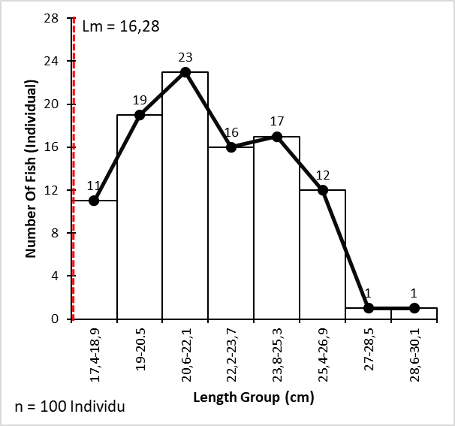
Figure 2. Length-frequency distribution graph of Epinephelus fasciatus during the first transitional season in 2025

Based on the study results, only two individuals were recorded within certain size classes during March 2025, specifically within the approximate length ranges of 18.4 cm and 19.1 cm. The limited abundance within these size classes suggests that population size distribution was uneven and influenced by both biological and environmental factors. Ecologically, the low abundance of individuals at specific size classes may result from naturally low abundance within particular age groups, fishing gear selectivity, and the habitat behavior of groupers, which are generally solitary and territorial species (Khasanah et al., 2020). In addition, seasonal oceanographic dynamics such as changes in currents and temperature during transitional periods may influence fish spatial distribution, causing certain size or age groups to be absent from fishing grounds (Milasari et al., 2021).

Based on the length-frequency distribution graph of E. fasciatus during April 2025 (Figure 3), the captured fish were dominated by individuals with total lengths exceeding the length at first maturity (>Lm), accounting for 49 individuals (100%). This indicates that all of E. fasciatus individuals captured during April 2025 had reached reproductive maturity. This condition was likely associated with improved weather conditions compared with March 2025, which increased fishing activities and the likelihood of capturing larger fish. Furthermore, the concentration of fish within specific size classes suggests the dominance of certain age groups within the captured population. The predominance of legally harvestable individuals (>Lm) during this month reflects a relatively sustainable exploitation pattern because the fish had likely reproduced before capture.
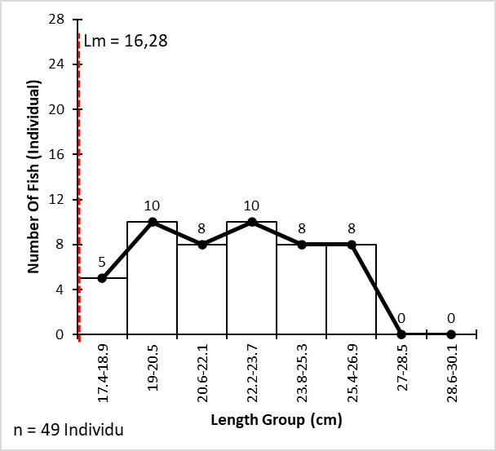
Figure 3. Length-frequency Distribution graph of Epinephelus fasciatus in April 2025

The length-frequency distribution graph of E. fasciatus during May 2025 (Figure 4) showed a similar pattern, with catches still dominated by individuals exceeding the length at first maturity. During this period, which represented the end of the first transitional season, environmental conditions remained influenced by oceanographic dynamics such as gradually changing currents and wind patterns toward more stable conditions. Such dynamics are characteristic of transitional seasons and are strongly influenced by tidal fluctuations and monsoonal wind systems (Milasari et al., 2021), thereby increasing fishing activity. Consequently, the probability of capturing fish across broader size classes, including larger individuals, also increased. Nevertheless, the dominance of individuals >Lm remained evident, with all captured fish (49 individuals, 100%) exceeding the length at first maturity. This condition indicates that fishing pressure on immature fish remained relatively low, suggesting that the size structure of the captured population during May 2025 still reflected a relatively healthy stock condition capable of supporting population sustainability. However, careful fisheries management remains necessary to maintain this balance in the future.
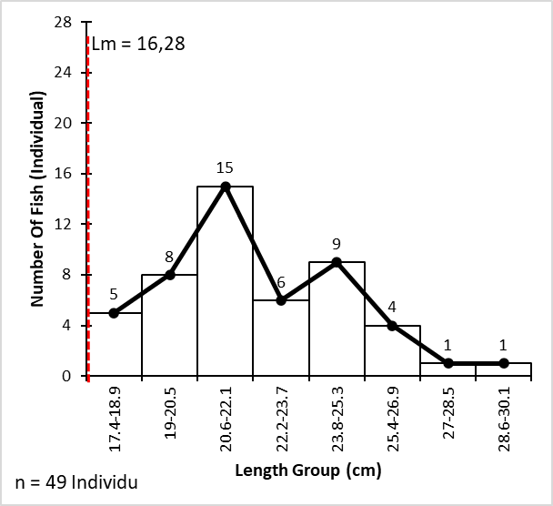
Figure 4. Length-frequency Distribution graph of Epinephelus fasciatus in May 2025

The dominance of fish larger than the length at first maturity (Lm) during March–May 2025 is closely associated with the life-history characteristics and reproductive cycle of E. fasciatus. Several studies have reported that spawning seasons generally occur during the early to mid-year period in tropical waters, with peak reproductive activity occurring during the middle of this period (Longenecker et al., 2024). Reproductive activity and spawning in groupers, including E. fasciatus, increase from early to mid-year and may continue through March–May in tropical regions (Mahe et al., 2022). During this period, populations are dominated by mature individuals that have surpassed the Lm threshold because only reproductively mature fish participate in spawning aggregations. Consequently, fish exceeding Lm become more vulnerable to capture, resulting in catches dominated by mature individuals in the Alas Strait during March–May 2025. Therefore, the observed size distribution pattern indicates that fishing activities coincided with the active reproductive period of E. fasciatus. These findings may provide scientific evidence supporting fisheries management policies that permit E. fasciatus fishing activities during the first transitional season in the Alas Strait waters.

3.2 Stock Health Condition of Epinephelus fasciatus During the First Transitional season

The stock health condition of E. fasciatus in the Alas Strait waters during the first transitional season was comprehensively evaluated using the Length-Based Spawning Potential Ratio (LB-SPR) approach. Within this framework, stock health status was assessed through the interaction between spawning opportunity and the estimated proportion of remaining spawning biomass represented by the SPR value.
The spawning opportunity of E. fasciatus stocks was evaluated by analyzing the size structure of captured fish. This analysis applied LB-SPR modeling through the Barefoot Ecologist platform to compare the reproductive maturity ogive with the fishing gear selectivity curve. This approach is highly effective for evaluating the interaction between species biology and fishing intensity in both pelagic and demersal fisheries (Hordyk et al., 2015; Chodrijah et al., 2020). The modeling results are presented in Figure 5, which illustrates the 50% probability intersection points of each parameter.

Based on the biological parameters used as model inputs (FIP2B NTB data), the maturity curve (black line) reached the 50% probability point (Lm) at 16.28 cm. This value represents the size at which half of the fish population in the waters had reached gonadal maturity and were biologically ready to spawn. In contrast, the selectivity curve (blue line) derived from field catch data indicated that fish vulnerability to fishing gear began increasing at approximately 18 cm, while the probability of capture reached 50% (Lc or S50) at approximately 19-20 cm.
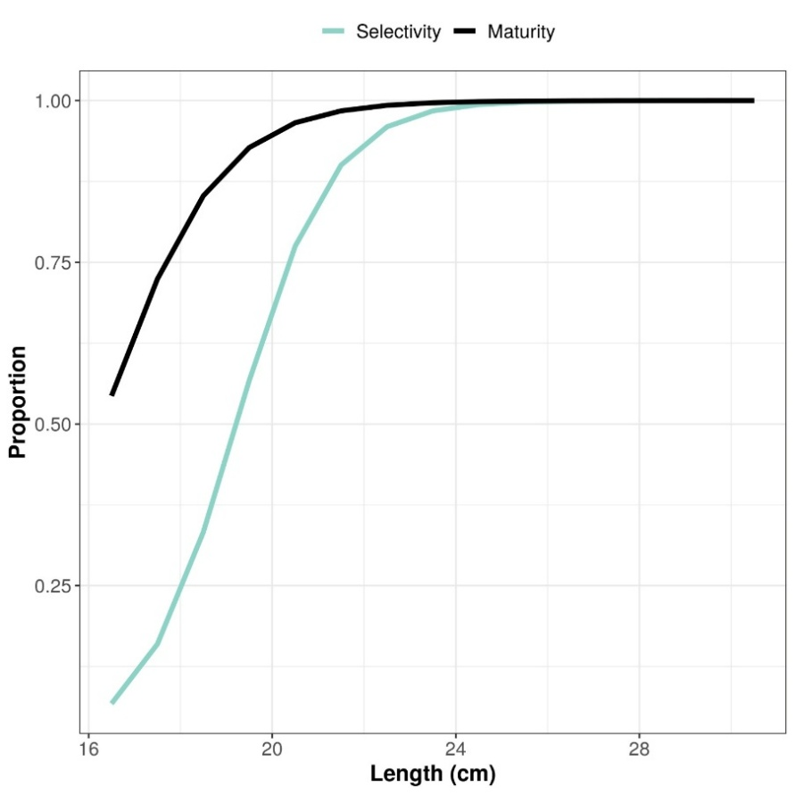
Figure 5. Graph of Lc and Lm proportions

The comparison between these two parameters clearly demonstrated that the length at first capture was greater than the length at first maturity (Lc > Lm). Ecologically, this condition indicates that most E. fasciatus individuals exploited in the Alas Strait during the first transitional season of 2025 consisted of mature fish that had already passed their initial reproductive phase. In other words, the stock population possessed a high spawning opportunity because individuals likely reproduced at least once before capture.

From a fisheries sustainability perspective, the Lc > Lm relationship represents a highly favorable and desirable exploitation pattern. Fishing activities under this condition do not interrupt the species’ life cycle because juvenile individuals still have opportunities to grow and contribute to population recruitment. This principle aligns with modern fisheries sustainability indicators that emphasize allowing fish to spawn at least once before capture (“let them spawn”) (Kindsvater et al., 2017). These findings are also consistent with Widiyastuti et al. (2020), who reported that the biological sustainability of fish stocks is more likely to be maintained and the risk of recruitment overfishing reduced when fishing pressure primarily targets individuals exceeding the length at first maturity.

Additional LB-SPR analysis indicated that the SPR value of E. fasciatus during the first transitional season of 2025 in the Alas Strait waters reached 71%. As illustrated in Figure 6, this SPR value falls within the green zone and is categorized as Above Target Reference Point (>50%). According to NOAA Fisheries stock management guidelines (Badruddin, 2013), an SPR value of 71% indicates that E. fasciatus stocks during the first transitional season of 2025 in the Alas Strait waters remained under-exploited. This favorable spawning opportunity condition directly contributed to the overall healthy stock status. The estimated SPR value of 71% further indicates that the stock health of E. fasciatus in the Alas Strait remained within a biologically healthy category because it exceeded the critical biological threshold (limit reference point) of 20% (Prince et al., 2015). The population’s ability to maintain spawning biomass at a safe level is strongly associated with selective fishing patterns that allow fish to reproduce before capture.

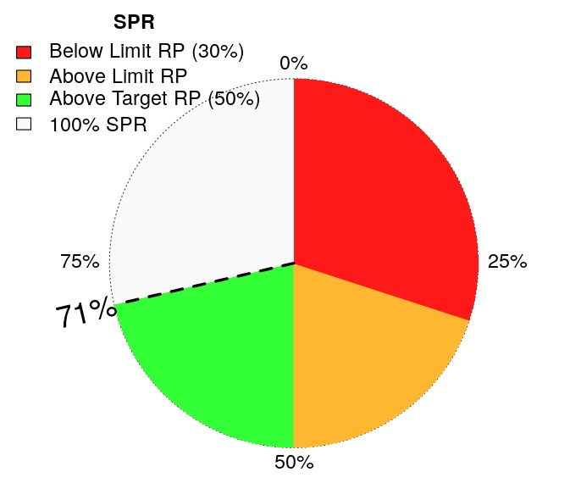

Fig 6. SPR Value Diagram

These findings are particularly important considering the life-history traits of groupers (family Epinephelidae). Demersal coral reef-associated fishes such as E. fasciatus generally exhibit slow growth, long lifespan, and complex reproductive strategies. These biological characteristics make groupers highly vulnerable to overexploitation and severe stock depletion (Sadovy de Mitcheson et al., 2020). Therefore, the fact that fishing gear in the Alas Strait primarily captures mature individuals serves as a natural buffer against local stock depletion.

Based on the obtained SPR values, the first transitional season may be considered an appropriate period for permitting fishing activities targeting E. fasciatus in the Alas Strait waters. Several studies have demonstrated that although high SPR values indicate low exploitation pressure, increased fishing effort without proper management may substantially reduce SPR values due to elevated fishing mortality and declining spawning biomass (Hordyk et al., 2015). SPR reductions approaching biological threshold ranges (approximately 20–40%) have been identified as indicators of increased recruitment impairment risk and declining fish stock status (Prince et al., 2015). Therefore, management measures such as minimum catch size regulations, fishing effort control, and periodic SPR monitoring are essential to maintain fish stocks within biologically safe conditions. Furthermore, implementing minimum catch size regulations allows fish to reach reproductive maturity and contribute to spawning before capture, thereby sustaining spawning biomass over time. Such approaches are consistent with biologically based fisheries management concepts emphasizing the importance of maintaining stock reproductive capacity as the foundation for sustainable fisheries resource management (Hilborn & Ovando, 2014).

4. Conclusion

The results of this study demonstrated that 100% of Epinephelus fasciatus individuals captured in the Alas Strait waters during the first transitional season of 2025 exceeded the length at first maturity and were dominated by sexually mature individuals. LB-SPR analysis produced an SPR value of 71% (under-exploited category) and indicated an Lc > Lm relationship, suggesting that most individuals had the opportunity to spawn before capture. These findings indicate that the stock remained in a healthy condition and supported population sustainability during the first transitional season. Therefore, the first transitional season may represent an appropriate period for harvesting E. fasciatus in the Alas Strait waters as part of fisheries resource management strategies through the implementation of minimum catch size regulations and fishing effort control.

REFERENCE

Achmad, D. S., Nurdin, M. S., Yunus, P., & Moore, A. M. (2025). Population dynamics of three Epinephelus groupers in the Sulawesi Sea, Indonesia. International Journal of Aquatic Biology, 13(4), 18–35.

Ashari, R., Gigentika, S., Hilyanan, S., & Martanina. (2024). Utilization patterns of capture fisheries in the limited-use zone of the Gili Matra Marine Conservation Area, West Nusa Tenggara Province. Jurnal Perikanan dan Kelautan, 14(1), 98–114.

Azizah, Y. A. S. M. I. N., Marliana, I. S. N. A. I. N. I., Agustina, S. I. S. K. A., & Natsir, M. (2023). Fishery stock conditions in Indonesian Fisheries Management Area (WPPNRI) 573. Buletin PSP, 19(3).

Badruddin, M. (2013). Technical guidelines for data-poor fisheries stock assessment: Estimation of spawning potential ratio. Fisheries Technical Workshop, IMACS Project Jakarta.

Chodrijah, U., Bakti, S. T., & Faizah, R. (2020). Length at first maturity and size structure of grouper (Epinephelus spp.) in the Makassar Strait waters. Jurnal Penelitian Perikanan Indonesia, 26(1), 35–44. https://doi.org/10.15578/jppi.26.1.2020.35-44

Darmawan, R., Wiryawan, B., & Wahyuningrum, P. I. (2020). Stock status of yellowtail fusilier (Caesio cuning) during the transitional season in Karimunjawa waters: A spawning potential ratio approach. Albacore Jurnal Penelitian Perikanan Laut, 4(1), 21–32.

Deeng, R. B., Kusen, J. D., Kumampung, D. R., Ompi, M., Paruntu, C. P., & Tombokan, J. (2022). Analysis of gonadal maturity stage and gonadosomatic index in parrotfish of the family Scaridae. Jurnal Pesisir dan Laut Tropis, 10(3), 231–240.

Dimarchopoulou, D., Wibisono, E., Saul, S., Carvalho, P., Nugraha, A., Mous, P. J., & Humphries, A. T. (2023). Combining catch-based indicators suggests overexploitation and poor status of Indonesia’s deep demersal fish stocks. Fisheries Research, 268, 106854.

Efendi, D. S., Karyoto, K., Irawan, A., Priyadi, H. G., Misuari, M. N., & Mulyandari, N. (2023). Estimating stock status and bioeconomic indicators of grouper fisheries in Saleh Bay waters, West Nusa Tenggara Province. Marine Fisheries: Journal of Marine Fisheries Technology and Management, 14(2), 157–168.

Forum Ilmiah Pengelolaan Perikanan Berkelanjutan (FIP2B) NTB. (2025). Retrieved October 25, 2025, from https://data.fip2b-ntb.org/kerapu/frekuensi

Ghazali, S. Z., Abidin, D. H. Z., Saleh, S. H., Nor, S. A. M., & Kamarudin, A. S. (2025). Grouper (family: Epinephelidae) research in Southeast Asia: Unveiling trends and emerging priorities through a scientometric lens. Regional Studies in Marine Science, 92, 104605.

Gigentika, S., Ikhwanushafa, M. K., Ramadani, B. I. R., & Aini, M. (2025). Educational outreach on snapper and grouper body length measurement at Tanjung Luar Fish Market, East Lombok Regency. Jurnal Abdi Insani, 12(7), 2340–2355.

Hilborn, R., & Ovando, D. (2014). Reflections on the success of traditional fisheries management. ICES Journal of Marine Science, 71(5), 1040–1046.

Hordyk, A. R., Ono, K., Valencia, S. R., Loneragan, N. R., & Prince, J. D. (2015). A novel length-based empirical estimation method of spawning potential ratio (SPR), and tests of its performance for small-scale, data-poor fisheries. ICES Journal of Marine Science, 72(1), 217–231.

Irawan, A., & Isdradjad, S. (2019). Population dynamics aspects of gulamah fish (Johnius trachycephalus Bleeker, 1851) in East Lampung waters.

Kantun, W., & Bitti, A. (2025). Bioreproductive characteristics and population size distribution in determining the legal catch size of fringescale sardine (Sardinella fimbriata Valenciennes, 1847) from the Makassar Strait waters. Jurnal Riset Diwa Bahari (JRDB), 110–117.

Kell, L. T., & Sharma, R. (2025). An evaluation of the robustness of length-based stock assessment approaches for sustainable fisheries management in data and capacity limited situations. Sustainability, 17(11), 4791.

Khasanah, M., Nurdin, N., Sadovy de Mitcheson, Y., & Jompa, J. (2020). Management of the grouper export trade in Indonesia. Reviews in Fisheries Science & Aquaculture, 28(1), 1–15.

Kindsvater, H. K., Reynolds, J. D., Sadovy de Mitcheson, Y., & Mangel, M. (2017). Selectivity matters: Rules of thumb for management of plate-sized reef fish. Fish and Fisheries, 18(5), 821–836. https://doi.org/10.1111/faf.12208

Kunarso, K., Irwani, I., Helmi, M., & Bayu Candra, A. (2016). Fishing seasons in the Java Sea waters of Jepara Regency and prediction of fishing ground locations.

Kusdiantoro, K., Fahrudin, A., Wisudo, S., & Juanda, B. (2019). Capture fisheries in Indonesia: Current conditions and sustainability challenges. Jurnal Sosial Ekonomi Kelautan dan Perikanan, 14(2), 145. https://doi.org/10.15578/jsekp.v14i2.8056

Longenecker, K., Langston, R., Mamesah, J., Natan, Y., Pattinasarany, M., Radjab, A. W., ... & Franklin, E. C. (2024). Errors in estimating reproductive parameters with macroscopic methods: A case study on the protogynous blacktip grouper Epinephelus fasciatus (Forsskål 1775). Journal of Fish Biology, 105(4), 1256–1267.

Mahe, K., Gentil, C., Brisset, B., Evano, H., Lepetit, C., Boymond-Morales, R., ... & Roos, D. (2022). Biology of exploited groupers (Epinephelidae family) around La Réunion Island (Indian Ocean). Frontiers in Marine Science, 9, 935285.

Milasari, A., Ismunarti, D. H., Indrayanti, E., Muldiyatno, F., Ismanto, A., & Rifai, A. (2021). Surface current model of Lampung Bay during the second transitional season using a hydrodynamic approach. Buletin Oseanografi Marina, 10(3), 259–268.

Noija, D., Martasuganda, S., Murdiyanto, B., & Taurusman, A. A. (2014). Potential and exploitation level of demersal fish resources in Ambon Island waters, Maluku Province. Jurnal Teknologi Perikanan dan Kelautan, 5(1), 55–64.

Prince, J., Victor, S., Kloulchad, V., & Hordyk, A. (2015). Length based SPR assessment of eleven Indo-Pacific coral reef fish populations in Palau. Fisheries Research, 171, 42–58. https://doi.org/10.1016/j.fishres.2014.12.019

Prince, J., Hordyk, A., Valencia, S. R., Loneragan, N., & Sainsbury, K. (2015). Revisiting the concept of Beverton–Holt life-history invariants with the aim of informing data-poor fisheries assessment. ICES Journal of Marine Science, 72(1), 194–203.

Santoso, D., Baskoro, M. S., Simbolon, D., Novita, Y., & Mustaruddin, M. (2015). Exploitation status of fish resources in the Alas Strait, West Nusa Tenggara Province. Jurnal Penelitian Perikanan Indonesia, 21(2), 87–94.

Sondita, M. F. A., Purbayanto, A., Simbolon, D., & Wahju, R. I. (2025). Fish stock dynamics as a consideration for implementing measurable fishing policies. Albacore Jurnal Penelitian Perikanan Laut, 9(2), 249–260.

Sugianto, D. N., Zainuri, M., Permatasari, G., Atmodjo, W., Rochaddi, B., Ismanto, A., ... & Wirasatriya, A. (2021). Seasonal variability of waves within the Indonesian seas and its relation with the monsoon wind. ILMU KELAUTAN: Indonesian Journal of Marine Sciences, 26(3).

Sugiyono. (2016). Quantitative, qualitative, and R&D research methods. Bandung: Alfabeta.

White, W. T., Dharmadi, Last, P. R., Faizah, R., Chodrijah, U., Prisantoso, B. I., ... & SJ, M. B. (2013). Market fishes of Indonesia. Australian Centre for International Agricultural Research.

Sadovy de Mitcheson, Y., Linardich, C., Barreiros, J. P., Ralph, G. M., Aguilar-Perera, A., Arias-González, J. E., ... & Craig, M. T. (2020). Valuable but vulnerable: Over-fishing and under-management continue to threaten groupers so what now? Marine Policy, 116, 103909. https://doi.org/10.1016/j.marpol.2020.103909

Widiyastuti, H., Herlisman, H., & Pane, A. R. P. (2020). Legal catch size of small pelagic fish in Kendari waters, Southeast Sulawesi. Marine Fisheries: Journal of Marine Fisheries Technology and Management, 11(1), 39–48. https://doi.org/10.29244/jmf.v11i1.31505

Yandi, M., Sebayang, M. B., & Ardiansyah, A. D. (2025). Analysis of optimal utilization levels of grouper (Epinephelus spp.) for sustainable fisheries in Bangka Regency. Journal of Community Development and Disaster Management, 7(2), 541–550.

