THE RELATIONSHIP BETWEEN THE ABUNDANCE OF SAND CRABS AND SEDIMENT GRAIN SIZE

.
Abstract

Indonesia is a maritime country with the largest biological natural resources in the sea. Sand crabs (genus Emerita) are benthic organisms that live on sandy beaches in the intertidal zone and are greatly influenced by substrate characteristics. This study aims to determine the relationship between the abundance of sand crabs and sediment grain size in the coastal areas of West Lombok Regency and the City of Mataram. Sand crab samples were collected at three observation stations using the line transect method with a 1×1 m. Subsequently, sediment samples were taken using a shovel, which will later be ana lyzed using a sieve analysis method to determine the grain size fractions (fine sand, medium sand, and coarse sand). Data analysis was performed using correlation tests to determine the relationship between sand crabs and sediment fractions. The results showed that the sand crabs collected from the transects consisted of a total of 123 individuals with two genera, namely Emerita and Hippa, and two species, namely Emerita emeritus and Hippa adactyla.In addition, the correlation results showed that the abundance of sand crabs with medium sand fraction had a negative correlation with a correlation value of r = -0.64856, while the abundance of sand crabs with a mixture of medium sand fraction and coarse sand fraction also had a negative correlation with a correlation value of r = -0.45244, and lastly, the abundance of sand crabs with very coarse sand fraction had a positive correlation with a correlation value of r = 0.548479. This indicates that sediment grain size has an effect on the abundance of sand crabs.

Keywords: Sand crabs, sediment, West Lombok Regency, Mataram City

1. introduction

Indonesia is a maritime country with abundant natural resources and is a tropical maritime nation with the largest biodiversity found in the sea (Rangkuti et al., 2017). One of the biodiversity found in the sea can be found in coastal areas.The coastal area itself is a region where terrestrial ecosystems, marine ecosystems, and atmospheric ecosystems meet in a vulnerable balance (Tinambunan, 2016).The coastal area is also influenced by the rise and fall of sea water, commonly referred as tides. The tidal conditions in coastal areas do not experience much change unless extreme weather occurs, which can impact the composition and depiction of organisms living in coastal areas (Yulianda et al., 2013).

One of the organisms that live in coastal areas is crustaceans or sand crabs (Mashar, 2013). Sand crabs in Indonesia are still not well known (Darusman et al., 2015).According to Putri et al. (2023), there are three families of sand crabs, two of which have been reported to be found in Indonesia, namely the families Albuneidae and Hippidae (Putri et al., 2023). Sand crabs have two functions: economic and ecological. Economically, sand crabs can support the economy of the community through the processing of sand crabs into specialty foods that can be sold. Ecologically, sand crabs are primary consumers in the food chain cycle that can feed on detritus carried by wave action (Nugraha et al., 2018).

West Lombok Regency and Mataram City are among the regions in West Nusa Tenggara that have potential related to sea cucumbers, including Kuranji Beach, Meninting Beach, and Pondok Perasi Beach. Setyowati et al. (2022) mention that the community at Kuranji Beach works as fishers and sea cucumber harvesters. Additionally, the community at Meninting Beach and Pondok Perasi Beach is also mostly engaged in fishing due to their proximity to the coastline.

Substrate is one of the important factors for the life of sea cucumbers, as biota such as macrozoobenthos live by burrowing into the substrate/sand (Rahmadhani et al., 2023). The size of sediment grains is known to be one of the factors that can influence the presence and distribution of sea cucumbers that live by burrowing into the substrate/sand. Substrates such as mud and fine sand can hinder the growth of biota like sea cucumbers because they are difficult to burrow into. Conversely, substrates with medium-coarse sand types are more likely to support the development of these biota because they facilitate burrowing into the sand to hide from predator attacks (Rahmadhani et al., 2023).

In addition to the diversity of species types, the relationship between the abundance of sea sand crabs and sediment grains is also important to study, as sea sand crabs are one of the benthic animals that live on sandy beaches. However, research on the relationship between sea sand crabs and sediment grains in West Lombok Regency and Mataram City is still very limited or even non-existent. In fact, West Lombok Regency and Mataram City have natural resources of sea sand crabs that can be utilized. Therefore, this research is very important to conduct in order to observe and understand the relationship between sea sand crabs and sediment grains.

2. materials and methods

2.1 Study Site

This research was conducted in October 2025. The study was carried out in West Lombok Regency and Mataram City. The research location is presented in Figure 1. The study consists of three stations, namely Meninting Beach, Pondok Perasi Beach, and Kuranji Beach.
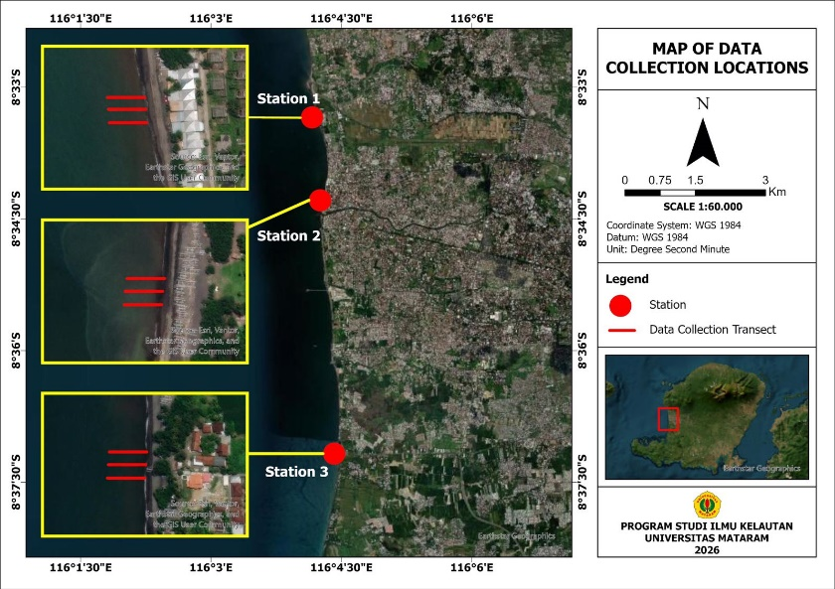
Figure 1. Location Map
2.2 Sampling
Data collection of sea sand crabs was conducted using the line transect method.The line transect method was carried out by drawing a line perpendicular to the beach for a distance of 5-10 m and creating quadrants measuring 1x1 m placed at each transect. Each station consists of 5 points, where each point will be divided into two areas of the swash zone, namely the upper swash zone and the lower swash zone (Figure 2). Sea sand crab samples were taken using a stirring technique with the help of a sand rake. The collected sea sand crab samples were placed in ziplock bags and labeled according to the capture zone or sampling point that had been determined. In addition to the sea sand crab samples, sediment samples at each point were also taken using a scoop and placed in ziplock bags. Furthermore, to analyze the size of the sediment grains, sediment samples will be dried using an oven at a temperature of 100 °C. After drying, the samples will be sieved using a shaker with mesh sizes of 2 mm; 0.5 mm; 0.312 mm; 0.125 mm; and 63 µm, and then the weight of each sample will be measured (Triapriyasen et al., 2016).

Upper swash zone
Lower swash zone
LT 4
5-10 m
LT 1
LT 2
Land
Ocean
LT 3
LT 5
25 m

Figure 2. Transect Design
In situ measurements of sediment temperature and pH were conducted simultaneously with the collection of sea shrimp samples. pH values less than 5 and greater than 9 will create unfavorable conditions for sea shrimp, while the optimum pH is 7.4-8.5 (Pratiwi, 2010 in Handayani et al., 2016).Temperature measurements were taken using a soil thermometer, and sediment pH was measured using a soil meter by inserting the device into the soil/sand up to the sensor limit. Temperature is one of the limiting factors that can affect the metabolic activity and development of organisms present in the sea (Rukminasari et al., 2014).

2.3 Data Analysis

(a). Relative Abundance
Relative abundance is calculated using the formula (Odum, 1971)
$$KR=\frac{ni}{N } ×100\%$$
Where:
KR: Relative Abundance
N: Total number of individuals
ni: Number of individuals
(b). The analysis of sediment grains is calculated using the following formula.
$persen berat= \frac{{berat fraksi }_{i}}{berat total sampel }×100\%$
Where:
Weight of fraction I: weight of each grain size fraction (g)

(c). Correlation Test
The correlation test is conducted to determine the relationship between the abundance of sea slugs and sediment grains. After processing the data on the abundance of sea slugs and sediment grains, the next step is to perform a correlation test to see if there is a relationship between the abundance of sea slugs and sediment grains. The correlation test is conducted to measure the strength and direction of the relationship between two or more variables. The correlation coefficient (r) often ranges from -1 to +1, where a positive value indicates a direct/positive relationship, and a negative value indicates an inverse/negative relationship (Patimah et al., 2025). The correlation test is performed using the formula:
$$r=\frac{(n∑XY)-(∑X)(∑Y)}{\sqrt{[ n∑X^{2}-(∑X^{2}][n∑Y^{2}-(∑Y)² ]}}$$
r = correlation coefficient
x,y = variable values
n = number of data pairs

3. Result and discussion

3.1 Types of Sand Crabs

Based on the research conducted, a total of 123 sand fleas were found at the three research locations, consisting of the Family Hippidae, and two genera, namely the genus Emerita and Hippa, as well as two species, Emerita emeritus and Hippa adactyla. Where, the species E. emeritus was found in a total of 116 individuals and the species H. adactyla was found in a total of 7 individuals. E. emeritus has an elongated oval body shape with colors ranging from gray, dark gray, to black. It has a pair of short antennae that are quite long. In addition, E. emeritus has five pairs of pereopods, with four pairs being large and one pair being small, referred to as uropods. The telson is long with a pointed tip (Bhagawati et al., 2016). Hippa adactyla is known to have a wide body shape with a carapace that is light gray, dark gray, and black. H. adactyla has short antennae and stalked eyes.Pereopods consist of five pairs, four pairs being large and one pair being small, referred to as uropods. The telson reaches the base of maxilliped III, with a pointed tip along the margin that has soft setae (Bhagawati et al., 2016). E. emeritus is mostly found in the intertidal zone between the highest high tide and the lowest low tide (swash zone). This species is commonly found at a depth of 10-15 cm below the sand. In contrast, H. adactyla is not commonly found as this species usually resides at a depth of 15-30 cm.

3.2 Relative Abundance

The relative abundance obtained from the three research stations ranges from 93.94% to 94.64% for the species Emerita emeritus, while Hippa adactyla ranges from 5.36% to 6.06% (Figure 3). This indicates that E. emeritus dominates at the three observation stations. Additionally, based on the research locations, it can be noted that the species E. emeritus is more commonly found at Kuranji Beach. Based on direct observations, this may be due to the wider swash zone area at Kuranji Beach compared to the other two beaches. Conversely, the species H. adactyla found at each research location shows a significant comparison with E. emeritus.The differences observed between these two species may indicate that their habitats differ. Typically, the species E. emeritus prefers to be in the upper layer of sand around 0-30 cm compared to other species (Nugraha et al., 2018).

Figure 3. Relative abundance
3.3 Sediment Types

Sediment is one of the important factors that can influence the presence of sand crabs. Based on observations, the substrate/sediment at the three research locations is relatively black. The differences at the three research stations lie in the color of the sediment, where Meninting Beach has a grayish-black color, Pondok Perasi Beach has very dark black sediment, and Kuranji Beach has a grayish-black sediment. The different colors of sediment can reflect the presence of the species of sand crabs that inhabit them. The sediment/substrate itself serves as a habitat for sand crabs, where the color of the sediment can influence the color of the crab's carapace (Nugraha et al., 2018). The classification of sediment particles can be seen in Figure 4, and the results of the sediment grain size analysis can be seen in Figure 5 and Table 1.

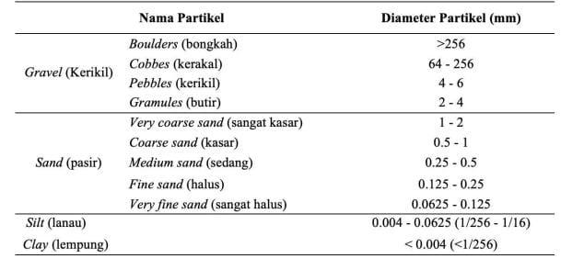
Figure 4 . Sediment Particle Classification (Wentworth, 1922)

Figure 5 . Sediment grain size graph
Table 1 . Sediment grain size
Station | Sediment color | Sediment grain size | Particle name
Meninting Beach | Grayish Black | 0,038-1,00 | Medium sand- Very coarse sand
Pondok Perasi Beach | Black | 0,038-1,00 | Medium sand- Very coarse sand
Kuranji Beach | Grayish Black | 0,038-1,00 | Medium sand- Very coarse sand

3.4 Correlation Test

3.4.1 The correlation between the abundance of sand crabs and the medium sand fraction.

The results of the correlation test analysis indicate that the relationship between the abundance of sand crabs and the medium sand sediment fraction is negatively correlated, with a correlation coefficient of r = -0.64856, as shown by the decreasing trend line and the regression equation y = -8.716x + 15.542, with a coefficient of determination (r²) = 0.4206 (figure 6). This suggests that the dominance of medium sand sediment tends to be less supportive of the presence of sand crabs, leading to a decrease in their abundance. This condition may be caused by finer or less coarse sediment, which can hinder sand crabs from adapting or burrowing into the substrate, as the sediment becomes more compact and oxygen circulation within the sediment is limited. Furthermore, the coefficient of determination (r²) = 0.4206 indicates that only 42.06% of the variation in sand crab abundance can be explained by the medium sand sediment factor, while the remaining variation may be influenced by other factors such as high wave energy, a narrow swash zone, and excessive human activities around the study area.

Figure 6.
3.4. The correlation between the abundance of sand crabs and the medium and coarse sand fractions.

The results of the correlation test between the abundance of sand crabs and the mixed medium and coarse sand fraction show a negative correlation, with a correlation coefficient of r = -0.45244, as indicated by the decreasing trend line and the regression equation y = -12.707x + 20.2714, with a coefficient of determination (R²) of 0.2047 (Figure 7). This indicates that the dominance of mixed medium and coarse sand tends to be less supportive of sand crab abundance at the study site.
Sediments composed of varying grain sizes can create an unstable substrate, making it difficult for sand crabs to burrow and adapt, which may increase the risk of stress and mortality. Furthermore, the coefficient of determination (R²) = 0.2047 indicates that only 20.47% of the variation in sand crab abundance can be explained by the mixed medium and coarse sand sediment factor, while the remaining variation is likely influenced by other factors such as high wave energy that can cause sediment mixing, a narrow swash zone, and human activities.

Figure 7.
3.4.4 The correlation between the abundance of sand crabs and the very coarse sand fraction.

The results of the correlation test conducted between the abundance of sand crabs and the very coarse sand fraction indicate a positive correlation, with a correlation coefficient of r = 0.548479. This is shown by an upward trend line with the regression equation y = 10.5809x + 7.1724 and a coefficient of determination (R²) = 0.30 (Figure 8). This suggests that an increase in very coarse sand sediment is associated with an increase in sand crab abundance, indicating conditions that support their presence. Very coarse sediment may facilitate sand crabs in burrowing more easily for feeding and avoiding predators. Variations in sediment characteristics can influence the distribution of sand crabs, as these organisms are benthic animals for which sediment serves as both habitat and a source of food for many benthic organisms (Nugraha et al., 2018). Furthermore, the coefficient of determination (R²) = 0.30 indicates that only 30% of the variation in sand crab abundance can be explained by the very coarse sand sediment factor, while the remaining variation is likely influenced by other factors such as waves, currents, a narrow swash zone, and excessive human activities at the study site. Differences in sediment grain size are not only derived from the natural substrate of each study location but can also be influenced by factors such as wave action. Coarser sediment generally indicates relatively strong wave energy, whereas finer sediment is associated with calmer wave conditions (Nugroho & Basit, 2014).

Figure 8.
4. Conclusion

Based on the results of this study, two sand crab species, emerita emeritus and hippa adactyla, were identified across the three observation stations: Meninting Beach, Pondok Perasi Beach, and Kuranji Beach. The dominant species was e. Emeritus, with the highest abundance recorded at Kuranji Beach, ranging from 93.94% to 94.64%. In contrast, h. Adactyla was found in relatively low numbers, ranging from 5.36% to 6.06%. Sediments at all study stations were dominated by sand with grain sizes ranging from 0.038 to 1.00 mm, classified as medium to very coarse sand. These sediment characteristics provide suitable habitat conditions for sand crabs, particularly emerita emeritus, by facilitating essential activities such as burrowing, feeding, and protection from predators. The correlation analysis demonstrated that sand crab abundance is related to sediment grain size, with higher abundance observed in very coarse sand fractions. This indicates that sediment grain size is an important factor influencing the distribution and abundance of sand crabs, in addition to other factors such as swash zone width and anthropogenic pressures in coastal areas.

competing interests
The authors declare that there are no conflicts of interest.

References
Alfansuri, DU, Munawaroh, E., & Ilyas, M. (2025). Understanding and Applying Correlation Tests in Educational Research Data Analysis. *Jurnal Inovasi Pendidikan (JEI)*, 3(4), 740–752. Darusman, V., & Muskananfola, MR (2015). Abundance of Sand Crabs (Hippidae) and Sediment Distribution at Pagak Beach, Ngombol District, Purworejo, Central Java. *Jurnal Manajemen Sumber Daya Perairan (MAQUARES)*, 4(1), 9–18.
Masyar, A., & Wardiatno, Y. (2013). Growth Aspects of the Sand Crab, *Emerita emeritus*, from the Sandy Beaches of Kebumen Regency. *Jurnal Biologi Tropis*.
Nugroho, SH, & Basit, A. (2014). Analysis of Sediment Distribution Based on Grain Size in Weda Bay, North Maluku [Sediment Distribution Based on Grain Size Analysis in Weda Bay, North Maluku]. *Jurnal Ilmu dan Teknologi Kelautan Tropis*, 6, 229–240.
Putri, VW. Distribution Patterns and Records of Several Sand Crab Species (Crustacea: Decapoda: Hippoidea) in Indonesia (Doctoral Dissertation, IPB University).
Rahmadhani, GW, & Martuti, NKT (2023). Macrozoobenthos Diversity Around Breakwaters in the Coastal Area of ​​Semarang City as Preliminary Data for Conservation Efforts. *Jurnal Matematika dan Ilmu Pengetahuan Alam Indonesia*, 46(2), 74–82.
Rukminasari, N., Nadiarti, N., & Awaluddin, K. (2014). The Effect of Seawater Acidity (pH) on Calcium Concentration and Growth Rate of *Halimeda* sp. *Jurnal Perikanan dan Ilmu Kelautan Torani*, 24(1). Setyowati, D. N. A., Lumbessy, S. Y., Lestari, D. P., Azhar, F., & Wilisetyadi, L. W. (2022). Implementation of Whiteleg Shrimp (Vanamei) Aquaculture Technology in Kuranji Dalang Village, West Lombok. Indonesian Journal of Fisheries Community Empowerment, 2(1), 7-11.
Suryanti, M., & Rudyanti, S. (2018). Habitat Characteristics and Abundance of Sand Crabs (Hippoidea) on the Purworejo Coast. JFMR (Journal of Fisheries and Marine Research), 2(2), 56-67.
Tinambunan, HSR (2016). A Coastal Area Empowerment Model for Navigating the ASEAN Economic Community Free Market. Mimbar Hukum—Faculty of Law, Universitas Gadjah Mada, 28(2), 250-262.
Yulianda, F., Yusuf, MS, & Prayogo, W. (2013). Zonation and Density of Intertidal Communities in the Tidal Zone of the Batu Hijau Coast, Sumbawa.

