Case report
Unusual Subcutaneous Metastasis of an Abrikossoff Tumor Mimicking Desmoid Fibromatosis: A Radiological Pitfall

.

ABSTRACT

Aims: To report a rare case of subcutaneous abdominal wall metastasis from a laryngeal granular cell tumor (Abrikossoff tumor) mimicking a desmoid-type fibromatosis on magnetic resonance imaging (MRI), and to highlight the role of diffusion-weighted imaging (DWI) in resolving this diagnostic pitfall.
Presentation of Case: A 54-year-old woman with a 9 cm laryngeal granular cell tumor treated by total laryngectomy (R1 resection) and adjuvant radiotherapy developed locoregional and pulmonary metastases approximately 24 months postoperatively. After a further 13 months, a subcutaneous mass of the right anterolateral abdominal wall was detected. Contrast-enhanced CT showed a well-circumscribed soft-tissue mass with mild post-contrast enhancement and regular contours. MRI demonstrated a lobulated lesion with intermediate T2 signal, marked diffusion restriction (ADC = 0.9 × 10⁻³ mm²/s), and intense homogeneous post-gadolinium enhancement, initially suggestive of a desmoid-type fibromatosis. Percutaneous biopsy confirmed a granular cell tumor metastasis identical to the laryngeal primary.
Discussion: Subcutaneous metastases from a malignant granular cell tumor share several morphological MRI features with abdominal wall desmoid-type fibromatosis. Marked diffusion restriction with a low ADC value is the key discriminating feature against the desmoid hypothesis. Retrospective application of Fanburg-Smith criteria (tumor size >9 cm, focally positive surgical margins, subsequent metastatic dissemination) suggests that the laryngeal primary already had malignant potential despite an initial benign histological label.
Conclusion: Any new soft-tissue mass arising in a patient with a previously treated granular cell tumor should be considered a possible metastasis. Multiparametric MRI with DWI is indispensable to differentiate this entity from desmoid-type fibromatosis and guide histological confirmation.

Keywords: Granular cell tumor; Abrikossoff tumor; subcutaneous metastasis; abdominal wall; desmoid tumor; magnetic resonance imaging; diffusion-weighted imaging.

1. INTRODUCTION
Granular cell tumor (GCT), or Abrikossoff tumor, is an uncommon mesenchymal neoplasm of Schwann cell origin, accounting for approximately 0.5% of all soft tissue tumors (Fanburg-Smith et al., 1998). Approximately half of GCTs occur in the head and neck region; laryngeal localization represents only 6–10% of all GCTs (Scala et al., 2008). The malignant variant accounts for only 1–2% of cases and behaves as a high-grade sarcoma, with a 50% metastasis rate and 39% disease-related mortality at a median of three years (Fanburg-Smith et al., 1998). Histological grading relies on the six Fanburg-Smith criteria (necrosis, spindling, vesicular nuclei with prominent nucleoli, mitotic count >2/10 high-power fields, increased nuclear-to-cytoplasmic ratio, pleomorphism), with three or more features defining malignancy. However, true biological malignancy is ultimately defined by metastatic dissemination, irrespective of the initial histological label (Nasser et al., 2011).
The radiological diagnosis of soft-tissue metastases from a malignant GCT is challenging, as these lesions can mimic benign or low-grade mesenchymal entities. Desmoid-type fibromatosis is a particularly relevant differential when the lesion is well-circumscribed, involves the abdominal wall, and exhibits intermediate T2 signal with homogeneous enhancement (Braschi-Amirfarzan et al., 2016). This radiological pitfall has been previously documented in primary abdominal wall GCT, both malignant (Yoon et al., 2016) and benign in the postpartum setting (Qiu et al., 2025). To our knowledge, no similar case has been reported when the abdominal wall lesion is itself a metastasis from a laryngeal primary, though a comprehensive systematic review was beyond the scope of this report. We illustrate this scenario through a case where contrast-enhanced multiparametric MRI was essential to orient the diagnosis.
2. PRESENTATION OF CASE
A 54-year-old woman with a history of laryngeal granular cell tumor (9 cm), treated 37 months earlier by total laryngectomy with focally positive surgical margins (R1) and adjuvant radiotherapy, presented with a subcutaneous mass of the right anterolateral abdominal wall. The disease had previously progressed with locoregional and pulmonary recurrence under palliative chemotherapy.
Contrast-enhanced CT demonstrated a well-circumscribed, ovoid soft-tissue mass with mild post-contrast enhancement and regular contours (Fig. 1A). MRI was subsequently performed with axial T1-weighted, T2-weighted, diffusion-weighted, and post-gadolinium T1-weighted Fat-Sat sequences. The lesion was lobulated and supraumbilical, measuring 33 × 25 mm (transverse × anteroposterior), with intermediate T2 signal intensity (Fig. 1B), marked diffusion restriction with an ADC value of 0.9 × 10⁻³ mm²/s (Fig. 1D), and intense and homogeneous post-gadolinium enhancement (Fig. 1C). A preserved fat plane separated the lesion from the underlying rectus abdominis muscle, with anterior deformation of the cutaneous plane. Based on these features, a desmoid-type fibromatosis was initially considered, although the metastatic clinical context was acknowledged.
Percutaneous biopsy revealed morphological features and an immunohistochemical profile consistent with a granular cell tumor, identical to the laryngeal primary, establishing the diagnosis of subcutaneous metastasis.
3. DISCUSSION
This case highlights a dual diagnostic pitfall: a radiological misclassification on multiparametric MRI, and an underestimation of malignant potential on the initial histopathological assessment of the laryngeal primary.
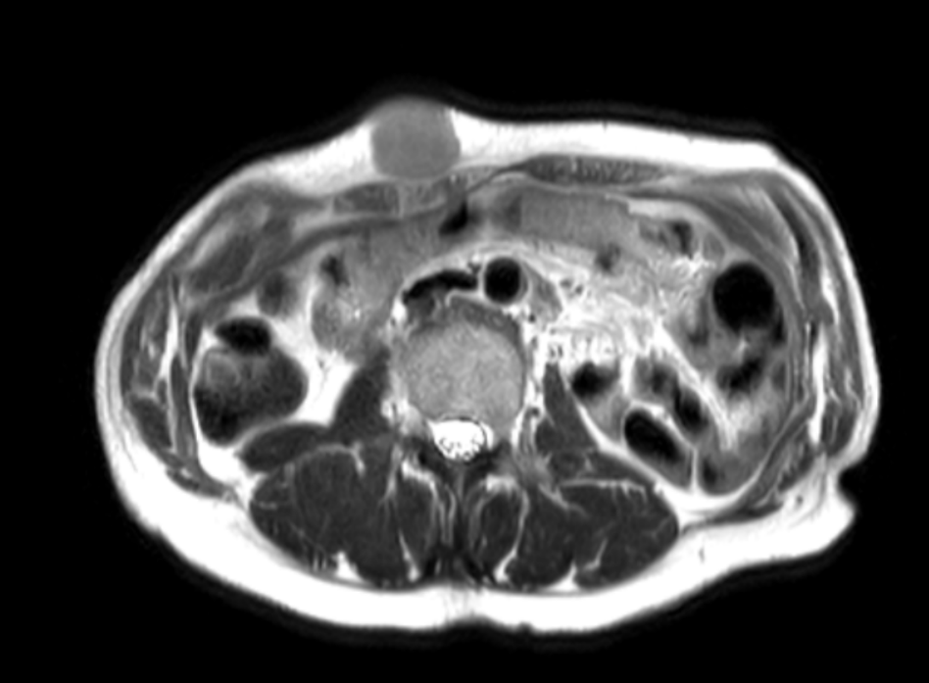
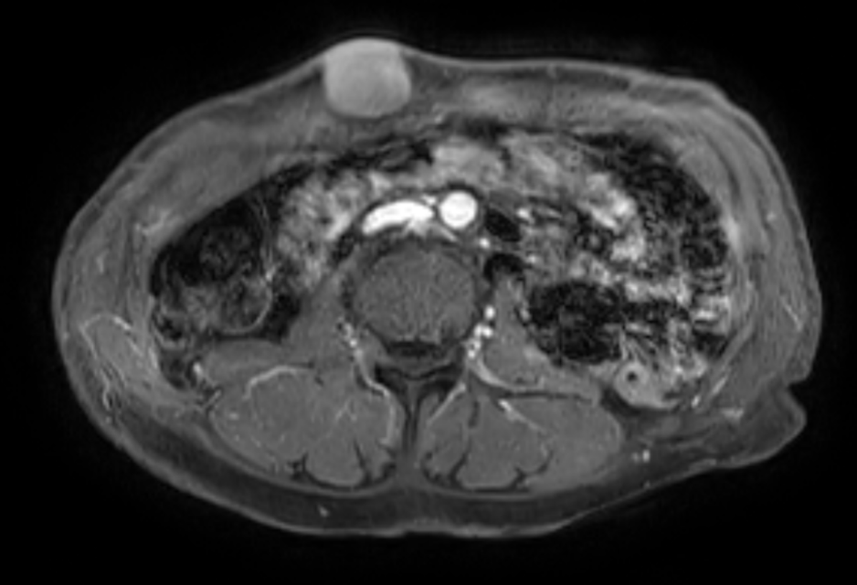
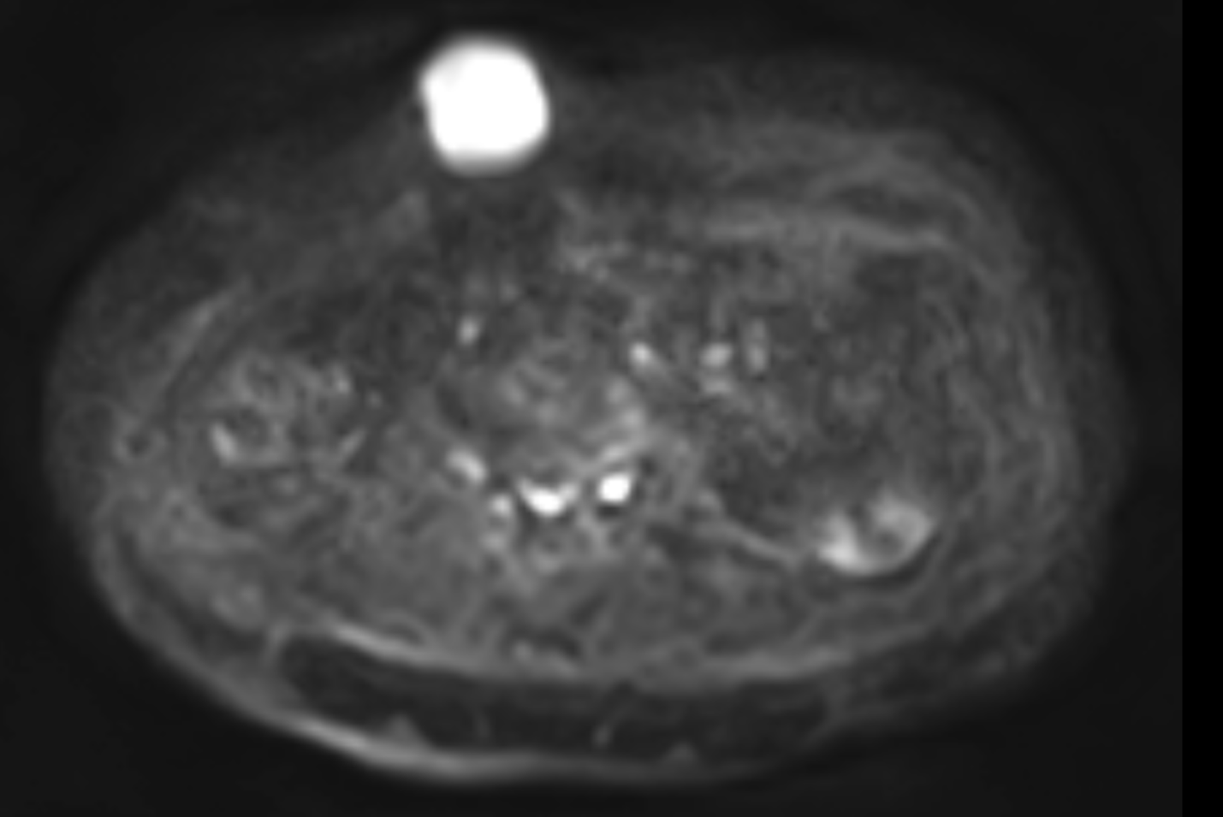
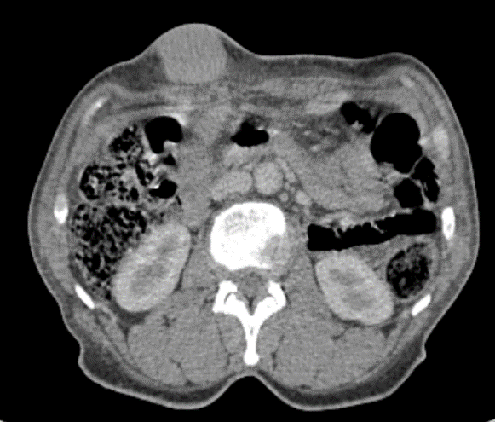
Subcutaneous metastases from a malignant GCT share several morphological features with abdominal wall desmoid-type fibromatosis on MRI — well-defined contours, intermediate T2 signal, and homogeneous post-contrast enhancement (Braschi-Amirfarzan et al., 2016; Iglesias-Hidalgo et al., 2023; Moon et al., 2023). This overlap explains the initial radiological interpretation in our case. The discriminating feature, both in our observation and in the published series, is diffusion-weighted imaging. Granular cell tumors are hypercellular lesions with dense cytoplasmic granular content and typically demonstrate marked diffusion restriction with low ADC values, reported at 0.624–0.857 × 10⁻³ mm²/s in a published soft-tissue MRI series (Iglesias-Hidalgo et al., 2023) and 0.68–0.81 × 10⁻³ mm²/s in a head-and-neck cohort (Moon et al., 2023). Desmoid tumors, predominantly composed of collagenous and fibrous stroma, characteristically display intermediate to high ADC values without marked restriction (mean ADC ≈ 1.46 × 10⁻³ mm²/s, range 1.00–2.20) (Braschi-Amirfarzan et al., 2016). The MRI features distinguishing these two entities are summarized in Table 1.
Fig. 1. Subcutaneous abdominal wall metastasis from a malignant laryngeal granular cell tumor.
(A) Contrast-enhanced axial CT shows a well-circumscribed, ovoid soft-tissue mass of the right anterolateral abdominal wall (arrow), with mild and homogeneous post-contrast enhancement. (B) Axial T2-weighted MRI demonstrates intermediate and homogeneous signal intensity of the lesion (arrow), with well-defined margins. (C) Axial post-gadolinium T1-weighted MRI shows intense and homogeneous enhancement of the lesion (arrow). (D) Diffusion-weighted imaging reveals marked diffusion restriction (arrow), reflecting high cellularity.

A
B
C
D

Previous reports have addressed similar pitfalls in primary abdominal wall GCT. Yoon et al. (2016) described a malignant primary abdominal wall GCT initially mistaken for a desmoid tumor on CT, and Qiu et al. (2025) reported a benign abdominal wall GCT mimicking a postpartum desmoid tumor on multiparametric MRI. The present case extends this radiological pitfall to the metastatic setting from a laryngeal primary, a combination not previously documented in the English literature.
The initial pathological report of the 2021 laryngectomy specimen stated “absence of malignant transformation,” yet the subsequent clinical course — local recurrence, pulmonary metastases, subcutaneous abdominal metastasis, and progression under chemotherapy — is unequivocally that of a malignant granular cell tumor. Several Fanburg-Smith risk features were retrospectively identifiable on the index tumor: size of 9 cm, focally positive surgical margins in three planes, and locally advanced disease invading the laryngotracheal lumen. A Ki-67 index >10% has been independently associated with metastatic risk in subsequent series (Nasser et al., 2011). In this context, the histological label of “benign” GCT did not preclude metastatic behavior; true malignancy in GCT is ultimately defined by metastatic dissemination, occurring in approximately 2.5% of all cases (Nasser et al., 2011). Systematic re-evaluation of large laryngeal granular cell tumors with positive surgical margins using Fanburg-Smith criteria and Ki-67 indexing is therefore warranted to identify patients with underestimated malignant potential.
Table 1. Multiparametric MRI features distinguishing subcutaneous granular cell tumor (metastasis) from abdominal wall desmoid-type fibromatosis.

Feature | Granular cell tumor (metastasis) | Desmoid-type fibromatosis
CT density | Soft-tissue density, regular contours | Soft-tissue density, often infiltrative
CT enhancement | Mild, homogeneous | Mild to moderate, often heterogeneous
T1 signal | Iso- to hypointense vs muscle | Iso- to hypointense vs muscle
T2 signal | Intermediate, often homogeneous; iso to muscle in ≈80% of cases | Intermediate; hypointense fibrous bands (“band sign”)
Margins | Well-circumscribed, lobulated (≈81%) | Infiltrative, ill-defined; “fascial tail sign”
Enhancement | Intense, homogeneous | Substantial, often late-phase
ADC value | Marked restriction; 0.6–0.9 × 10⁻³ mm²/s | No or mild restriction; mean 1.46 × 10⁻³ mm²/s (1.00–2.20)
Clinical context | Known primary malignancy; multi-site disease | Sporadic; FAP-associated; postpartum or post-surgical scar
ADC : apparent diffusion coefficient; FAP : familial adenomatous polyposis.
4. CONCLUSION
Subcutaneous metastases from a laryngeal granular cell tumor represent an exceptional radiological situation in which the lesion may closely mimic a desmoid-type fibromatosis on MRI. Marked diffusion restriction with a low ADC value is the single most useful feature against this benign hypothesis. In any patient with a previously treated granular cell tumor — including those initially classified as benign — a new soft-tissue mass should be considered metastatic until histopathologically proven otherwise.
CONSENT
All authors declare that written informed consent was obtained from the patient for publication of this case report and accompanying images.
ETHICAL APPROVAL
All authors hereby declare that all procedures performed in this case report were in accordance with the ethical standards laid down in the 1964 Declaration of Helsinki and its later amendments.
DISCLAIMER (ARTIFICIAL INTELLIGENCE)
Author(s) hereby declare that NO generative AI technologies such as Large Language Models (ChatGPT, COPILOT, etc.) and text-to-image generators have been used during the writing or editing of this manuscript.
COMPETING INTERESTS
Authors have declared that no competing interests exist.

REFERENCES
Braschi-Amirfarzan, M., Keraliya, A. R., Krajewski, K. M., Tirumani, S. H., Shinagare, A. B., Hornick, J. L., Baldini, E. H., George, S., Ramaiya, N. H., & Jagannathan, J. P. (2016). Role of imaging in management of desmoid-type fibromatosis: A primer for radiologists. RadioGraphics, 36(3), 767–782. https://doi.org/10.1148/rg.2016150153
Fanburg-Smith, J. C., Meis-Kindblom, J. M., Fante, R., & Kindblom, L. G. (1998). Malignant granular cell tumor of soft tissue: Diagnostic criteria and clinicopathologic correlation. American Journal of Surgical Pathology, 22(7), 779–794. https://doi.org/10.1097/00000478-199807000-00001
Iglesias-Hidalgo, G., Lopez-Maseda, A., Zaldumbide-Dueñas, L., & Canteli-Padilla, B. (2023). Granular cell tumor of soft tissues: MR findings. Radiología (English Edition), 65(Suppl 2), S83–S87. https://doi.org/10.1016/j.rxeng.2022.12.008
Moon, H. H., Jin, K., Choi, Y. J., Cho, K. J., Lee, Y. S., & Lee, J. H. (2023). Imaging findings of granular cell tumours of the head and neck. Clinical Radiology, 78(12), e1075–e1080. https://doi.org/10.1016/j.crad.2023.09.003
Nasser, H., Ahmed, Y., Szpunar, S. M., & Kowalski, P. J. (2011). Malignant granular cell tumor: A look into the diagnostic criteria. Pathology - Research and Practice, 207(3), 164–168. https://doi.org/10.1016/j.prp.2010.12.007
Qiu, W., Patel, Z., Pierce, J., & Iafe, T. (2025). Benign granular cell tumor of the abdominal wall mimicking postpartum desmoid tumor. Skeletal Radiology, 54(9), 1983–1992. https://doi.org/10.1007/s00256-025-04913-6
Scala, W. A., Fernandes, A. M., Duprat, A. D., & Costa, H. O. (2008). Granular cell tumor of the larynx in children: A case report. Brazilian Journal of Otorhinolaryngology, 74(5), 780–785. https://doi.org/10.1016/S1808-8694(15)31391-4
Yoon, J., Ahn, S. E., Lee, D. H., Park, S. J., Moon, S. K., & Lim, J. W. (2016). Malignant granular cell tumour of the abdominal wall mimicking desmoid tumour: A case report with CT imaging findings and literature review. Journal of the Korean Society of Radiology, 75(2), 138–142. https://doi.org/10.3348/jksr.2016.75.2.138

