Case report
Autonomic Dysfunction and Plasmapheresis Intolerance in Guillain-Barré syndrome: A Case Report

ABSTRACT:
Guillain-Barré syndrome is an acute immune-mediated polyradiculoneuropathy and a major cause of acute flaccid paralysis, often triggered by antecedent infections through molecular mimicry. Autonomic dysfunction is a significant complication that contributes to morbidity, mortality, and challenges in treatment. We report a case of a 27-year-old previously healthy male who developed progressive ascending weakness following an episode of acute gastroenteritis. Clinical evaluation and electrophysiological findings were consistent with acute inflammatory demyelinating polyradiculoneuropathy (AIDP) with secondary axonal involvement. The patient developed significant dysautonomia, manifesting as tachycardia, hypotension, diaphoresis, and respiratory discomfort during therapeutic plasma exchange. Plasmapheresis had to be discontinued after three sessions due to intolerance related to autonomic instability. The case highlights the clinical complexity of managing GBS with severe autonomic dysfunction and emphasizes the importance of close hemodynamic monitoring and individualized therapeutic strategies in patients undergoing immunomodulatory treatment.

KEYWORDS: Acute Inflammatory Demyelinating Polyneuropathy; Autonomic Dysfunction; Guillain-barré Syndrome; Plasmapheresis Intolerance;

INTRODUCTION:
Guillain-Barré syndrome (GBS) is an acute immune-mediated polyradiculoneuropathy and a leading cause of acute flaccid paralysis worldwide. It is commonly triggered by antecedent infections that induce an aberrant autoimmune response through molecular mimicry, resulting in peripheral nerve injury. Among its subtypes, acute inflammatory demyelinating polyradiculoneuropathy (AIDP) is the most common form, characterized by immune-mediated demyelination of the peripheral nerves [1,2]. A major determinant of morbidity and mortality in GBS is autonomic dysfunction, which can present with marked blood pressure fluctuations, cardiac arrhythmias, and other features of cardiovascular instability. Such dysautonomia necessitates intensive monitoring and complicates both disease course and therapeutic interventions [3]. Immunomodulatory treatment with intravenous immunoglobulin or plasma exchange forms the mainstay of management; however, treatment tolerance may be limited in patients with severe autonomic involvement, posing significant clinical challenges [4]. This report describes a case of AIDP with secondary axonal involvement complicated by dysautonomia and intolerance to plasmapheresis, underscoring the complexity of managing demyelinating GBS in the critical care setting.

CASE PRESENTATION:
A 27-year-old previously healthy male with no known comorbidities or recent vaccination history presenting with progressive limb weakness to our hospital in 2026. Fourteen days prior to the onset of the symptoms, he had a history of travel during which he consumed food from the external vendor, following which he developed acute gastroenteritis characterized by abdominal pain and loose stools occurring approximately three times daily for three to four days which resolved spontaneously. Approximately three days after the diarrhoeal illness, the patient developed tingling and numbness in both palms and fingers, along with tingling sensation of the tongue. Within the next one to two days, he noticed weakness in both upper limbs, evidenced by repeated dropping of his mobile phone from his hands. This was followed by progressive weakness in the lower limbs, eventually leading to inability to stand, walk, or move his limbs independently. The weakness reached its nadir approximately one week after onset. He was initially admitted to another hospital where a clinical diagnosis of Guillain-Barré syndrome was made. Therapeutic plasmapheresis was initiated, but after three sessions, it was discontinued due to episodes of breathlessness, sweating, and hypotension during therapy. He was subsequently referred to our centre for further management. At the time of admission to the previous hospital, he had tachycardia (pulse rate 119 beats/min) and elevated blood pressure (160/90 mmHg), with oxygen saturation of 99% at room air, suggesting autonomic dysfunction. After arrival to our centre his vital signs stabilized (BP 120/80 mmHg, pulse 101 beats/min, SpO₂ 98%). In view of the risk of autonomic instability, the patient was kept under continuous monitoring, however he remained hemodynamically stable and did not require intensive care. The patient remained conscious, alert, and oriented throughout the illness. He denied dysphagia, nasal regurgitation, slurred speech, diplopia, facial weakness, or bladder dysfunction. There was mild constipation but no urinary retention. No significant pain or backache was reported.

Motor examination revealed generalized hypotonia with flaccid weakness. Initially, muscle power was graded as 1/5 in both upper limbs, 1/5 in the left lower limb, and 4/5 in the right lower limb. Deep tendon reflexes were absent in both upper and lower limbs. Plantar responses were mute. Sensory examination was normal, with intact light touch, pain, vibration, and joint position sense, despite subjective paresthesias. Cranial nerve examination was normal, with no facial, bulbar, or ocular involvement. The patient was able to count up to 30 in the single-breath test, and there were no signs of respiratory distress.

Routine laboratory investigations including complete blood count, thyroid function tests and serum electrolytes were within normal limits (Table 1). Serology for HIV, hepatitis B, and hepatitis C was negative. Magnetic resonance imaging (MRI) of the brain and spine showed no abnormalities (Figure 1, 2). Two-dimensional echocardiography demonstrated preserved left ventricular function (ejection fraction >69%) with mild aortic regurgitation. Serial ECGs showed no arrhythmias. Nerve conduction studies performed subsequently demonstrated a demyelinating motor neuropathy with secondary axonal and sensory involvement in all four limbs.

Table 1: Blood investigation results
Laboratory parameter | Result | Range
Hemoglobin | 165 g/L | 130-180 g/L
Red cell count | 5.42 x 10¹²/L | 4.0-5.9 x 10¹²/L
Mean corpuscular volume | 81.7 fL | 76.0-100.0 fL
Mean corpuscular hemoglobin | 30.4 pg | 27.0-33.0 pg
Hematocrit | 0.44 L/L | 0.40-0.54 L/L
White cell count | 10.6 x 10⁹/L | 3.7-11.0 x 10⁹/L
Neutrophils | 71 % | 40-70 %
Lymphocytes | 24 % | 20-45 %
Platelet count | 245 x 10⁹/L | 150-450 x 10⁹/L
Serum calcium (ionized) | 1.21 mmol/L | 1.12-1.32 mmol/L
Serum sodium | 137 mmol/L | 133-146 mmol/L
Serum potassium | 4.3 mmol/L | 3.5-5.3 mmol/L
Serum chloride | 98 mmol/L | 96-106 mmol/L
Serum urea | 10.57 mmol/L | 2.5-7.8 mmol/L
Serum creatinine | 70.74 umol/L | 62-106 umol/L
Estimated GFR* | 124 mL/min | >90 mL/min
T3 triiodothyronine | 2.12 nmol/L | 1.3-3.1 nmol/L
T4 thyroxine | 140.28 nmol/L | 57-148 nmol/L
Thyroid stimulating hormone | 3.71 mIU/L | 0.4-5.0 mIU/L
Hepatitis B surface antigen | Negative | -
Hepatitis C antibody | Negative | -
HIV 1 and 2 antibodies | Not detected | -
*GFR: Glomerular filtration rate

Figure 1: MRI brain
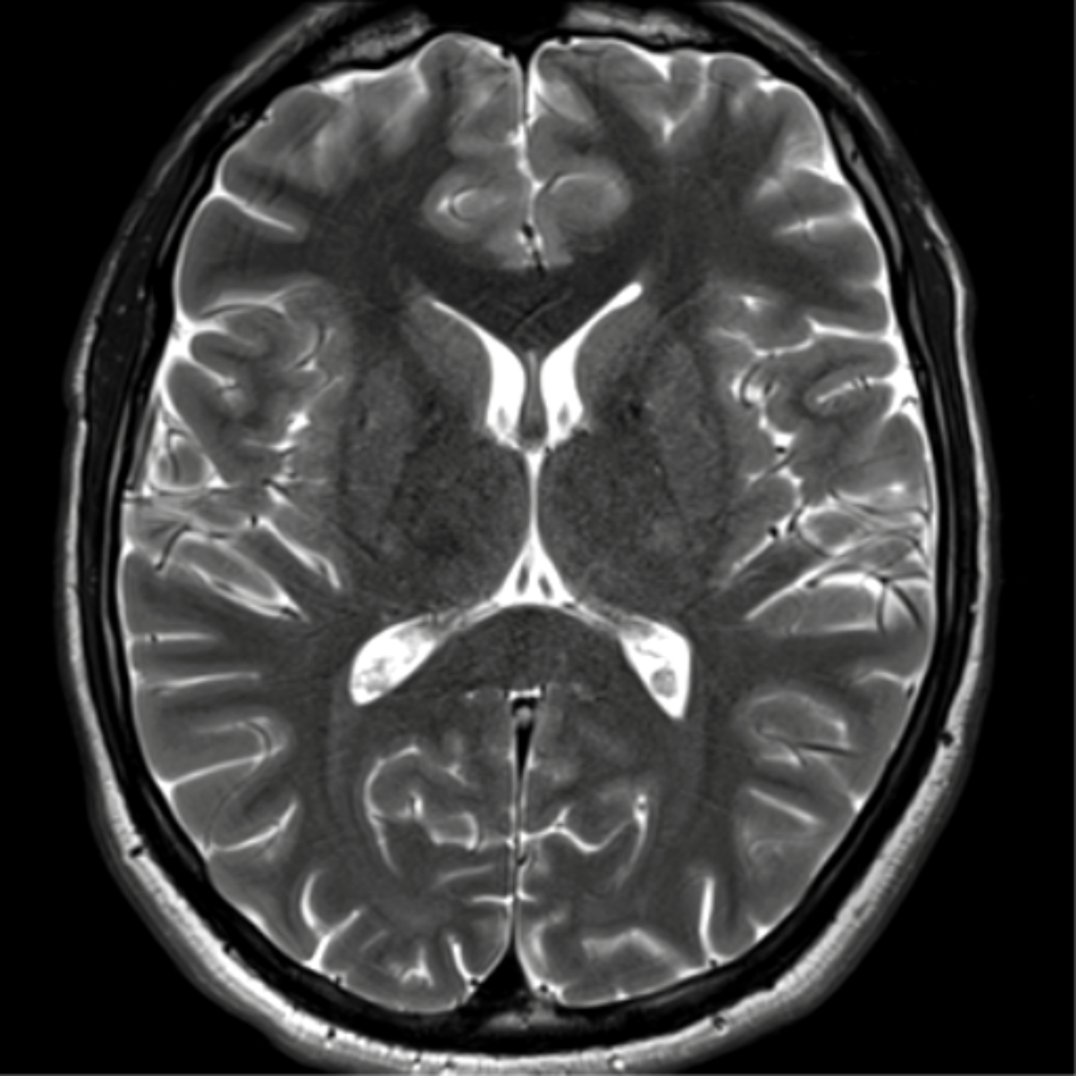
Axial T2-weighted MRI of the brain demonstrating normal ventricular configuration and preserved gray-white matter differentiation with no evidence of focal intracranial lesion, edema, or demyelinating changes.

Figure 2: MRI spine
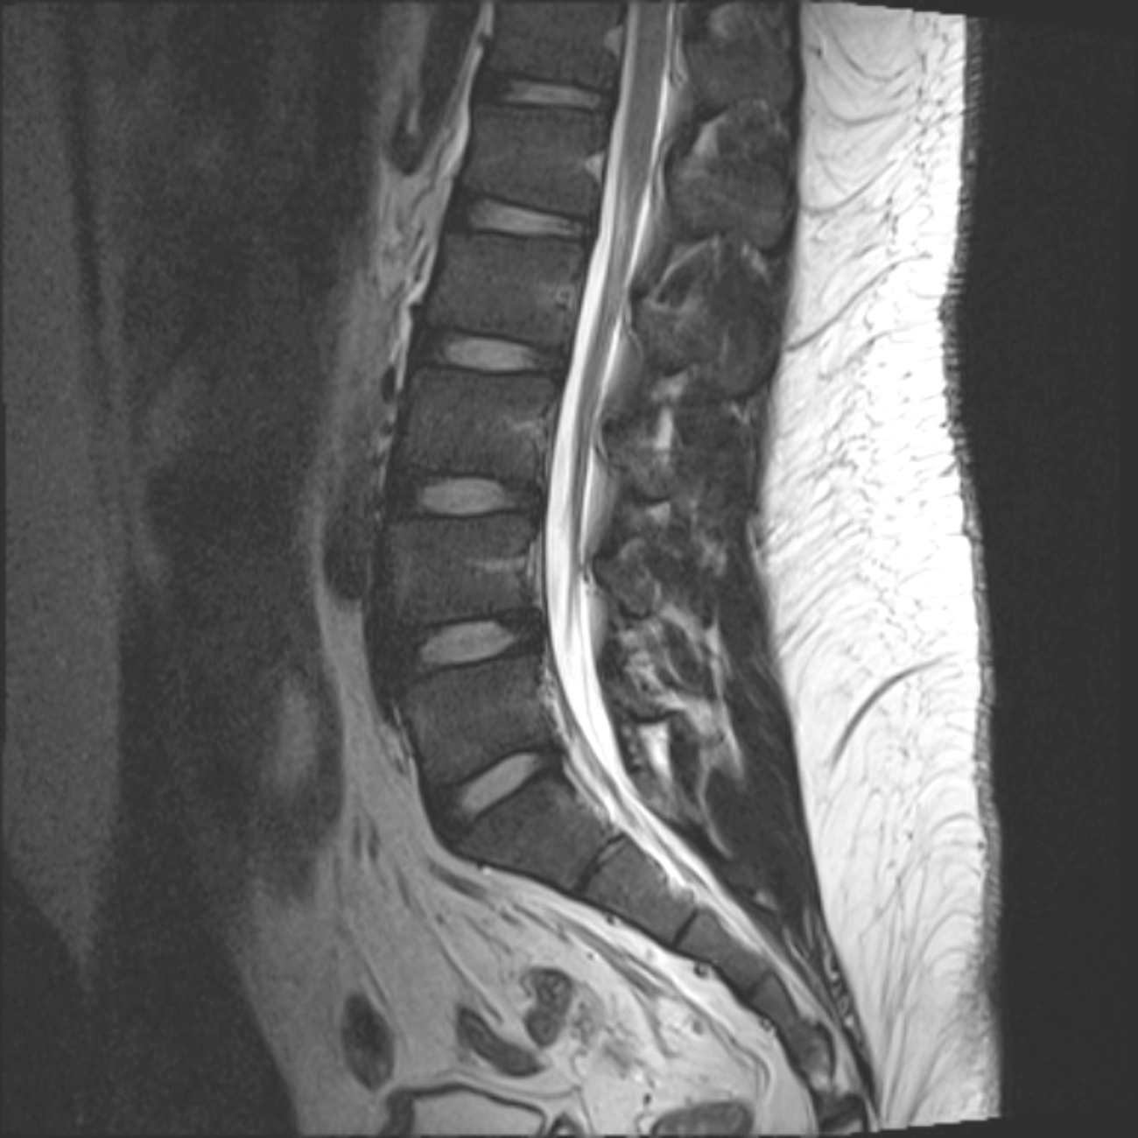
Sagittal T2-weighted MRI of lumbosacral spine showing normal vertebral alignment, preserved intervertebral disc spaces, and no evidence of spinal canal stenosis or compressive pathology.

In view of intolerance to plasmapheresis and ongoing weakness, the patient was started on intravenous immunoglobulin (IVIG) at a dose of 0.4 g/kg/day for five consecutive days in our hospital. The patient responded well to IVIG and clinical improvement was observed by the third day of therapy, with muscle strength improving to 3/5 in both upper limbs, 4/5 in the right lower limb, and 3/5 in the left lower limb.

DISCUSSION:
Guillain-Barré syndrome (GBS) is an acute immune-mediated polyradiculoneuropathy typically triggered by an antecedent infection that induces an aberrant autoimmune response through molecular mimicry, resulting in peripheral nerve injury. It is characterized by rapid progressive, symmetrical limb weakness, areflexia, and variable sensory and autonomic involvement [2]. A distinct preceding history of acute gastroenteritis approximately three days prior to neurological symptom onset is notable. The patient developed rapidly progressive, predominantly motor weakness beginning in the upper limbs and subsequently involving the lower limbs, reaching its nadir within approximately one week, consistent with the monophasic progression typical of GBS [5]. Deep tendon reflexes were absent in all limbs, while objective sensory examination including vibration and joint position sense remained normal, despite subjective paresthesias. Cranial sensory symptoms such as tongue paresthesia, although uncommon, have been described in GBS and may reflect involvement of sensory nerve roots or cranial nerve sensory fibers without detectable objective deficits [6]. Cranial nerve examination was normal, and there was no bulbar or respiratory compromise. An additional important feature in this case was early autonomic dysfunction, manifested by tachycardia and transient hypertension, along with sweating episodes during plasmapheresis. Autonomic involvement is reported in a significant proportion of GBS patients and is associated with increased morbidity due to risks of arrhythmias and blood pressure instability [3].

A noteworthy aspect of this case is intolerance to therapeutic plasmapheresis. The patient developed breathlessness, hypotension, and diaphoresis during plasmapheresis sessions, necessitating discontinuation after three cycles. These manifestations may be related to autonomic instability, rapid intravascular volume shifts, or citrate-related reactions. This highlights an important clinical consideration, even though both plasmapheresis and intravenous immunoglobulin (IVIG) are considered equally effective first-line therapies, individual tolerance may differ, and early recognition of complications is essential. Following discontinuation of plasmapheresis, the patient received IVIG at a dose of 0.4 g/kg/day for five days, with clinical improvement noted by the third day of therapy. Prompt initiation of immunotherapy is known to shorten disease progression and improve functional outcomes [7,8]. This case is notable for the combination of post-diarrhoeal onset, early autonomic features, unusual tongue paresthesia, and intolerance to plasmapheresis requiring a switch to IVIG. These elements highlight the heterogeneity of GBS presentations and reinforce the importance of individualized management strategies.

CONCLUSION:
This case illustrates a post-infectious Guillain-Barré syndrome most consistent with the AIDP, characterized by rapidly progressive motor weakness following gastroenteritis, preserved objective sensory function, and areflexia. Early autonomic dysfunction and intolerance to plasmapheresis complicated management, necessitating transition to intravenous immunoglobulin therapy, which led to prompt clinical improvement. The case highlights the importance of recognizing demyelinating GBS subtypes, monitoring for autonomic instability, and individualizing immunotherapy when first-line treatment is not tolerated.

CONSENT:
Consent was obtained from the patient for publication of the case report.

ETHICAL APPROVAL:
Not applicable.

COMPETING INTERESTS:
Authors have declared that no competing interests exist.

REFERENCES:
- Bhatti KS, Maheshwary A, Sun CE, et al. Guillain–Barré syndrome (Nursing). In: StatPearls [Internet]. Treasure Island (FL): StatPearls Publishing; 2026. Available from: https://www.ncbi.nlm.nih.gov/books/NBK568815/
- Shahrizaila N, Lehmann HC, Kuwabara S. Guillain–Barré syndrome. Lancet 2021;397:1214–28. https://doi.org/10.1016/S0140-6736(21)00517-1.
- Chakraborty T, Kramer CL, Wijdicks EFM, Rabinstein AA. Dysautonomia in Guillain–Barré syndrome: prevalence, clinical spectrum, and outcomes. Neurocrit Care 2020;32:113–20. https://doi.org/10.1007/s12028-019-00781-w.
- Zaki HA, Iftikhar H, Najam M, Masood M, Al-Marri NDR, Elgassim MAM, et al. Plasma exchange (PE) versus intravenous immunoglobulin (IVIG) for the treatment of Guillain–Barré syndrome (GBS) in patients with severe symptoms: a systematic review and meta-analysis. eNeurologicalSci 2023;31:100468. https://doi.org/10.1016/j.ensci.2023.100468.
- Leonhard SE, Mandarakas MR, Gondim FAA, Bateman K, Ferreira MLB, Cornblath DR, et al. Diagnosis and management of Guillain–Barré syndrome in ten steps. Nat Rev Neurol 2019;15:671–83. https://doi.org/10.1038/s41582-019-0250-9.
- Bhargava A, Banakar BF, Pujar GS, Khichar S. A study of Guillain–Barré syndrome with reference to cranial neuropathy and its prognostic implication. J Neurosci Rural Pract 2014;5(Suppl 1):S43–47. https://doi.org/10.4103/0976-3147.145200.
- Bellanti R, Rinaldi S. Guillain–Barré syndrome: a comprehensive review. Eur J Neurol 2024;31:e16365. https://doi.org/10.1111/ene.16365.
- Joshi R, Mendhe D, Wanjari M. Guillain–Barré syndrome: a case report and literature review. J Pharm Res Int 2021;33:158–61. https://doi.org/10.9734/jpri/2021/v33i58A34101.

