Ethnobotanical Survey of Wild Leafy Vegetables Used by Tribal Communities of Bargaon, Shahpura Block, Dindori District, Madhya Pradesh, India: Diversity, Medicinal Uses, and Conservation Status — A Community-Based Study with Janjati Kalyan Kendra Mahakaushal, Bargaon, Dindori

Abstract
Wild leafy vegetables (WLVs) constitute a crucial component of the subsistence economy, nutrition, and traditional medicine of tribal communities in Central India. The present study documents the ethnobotanical knowledge of wild leafy vegetables among Gond and Baiga tribal communities in 10 selected villages of Bargaon, Shahpura Block, Dindori District, Madhya Pradesh. A total of 295 informants aged 45–75 years were interviewed using semi-structured questionnaires, participatory field walks, and group discussions between August 2024 and December 2025. Systematic ethnobotanical field surveys led to the documentation of 72 species of wild leafy vegetables belonging to 38 plant families, with Amaranthaceae (14 spp.), Asteraceae (11 spp.), and Fabaceae (9 spp.) being the most represented families. Tender leaves were the most frequently utilized plant part (58%), primarily prepared by cooking (42%). The recorded species were used to treat a range of ailments including digestive disorders (18 spp.), anaemia (15 spp.), and skin diseases (10 spp.). Quantitative indices including Use Value (UV), Relative Frequency of Citation (RFC), and Informant Consensus Factor (ICF) were calculated to identify the most culturally significant species. Amaranthus viridis, Chenopodium album, and Centella asiatica recorded the highest UV values (0.92, 0.89, and 0.85, respectively). The study highlights the rich traditional botanical knowledge preserved by female informants and elder members of the Gond and Baiga tribes, and underscores the urgent need for documentation, conservation, and sustainable management of WLV diversity in this biodiversity-rich biosphere reserve landscape.

Keywords: Wild leafy vegetables; ethnobotany; Gond; Baiga; Dindori; Madhya Pradesh; traditional knowledge; medicinal plants; tribal communities; food security

1. Introduction
Wild leafy vegetables (WLVs) are non-cultivated plants whose leaves, tender shoots, or other above-ground parts are consumed as food or medicine, and they represent one of the most ancient and widely utilized components of human food systems worldwide (Bharucha & Pretty, 2010). In the tribal and indigenous communities of Central India, WLVs remain integral to daily food security, especially during periods of seasonal food scarcity, providing essential macro- and micronutrients including iron, calcium, vitamins, and dietary fibre that are otherwise absent or deficient in the conventional diet (Sundriyal & Sundriyal, 2001; Srivastava et al., 2006).
Madhya Pradesh, endowed with extensive forest tracts covering approximately 30.7% of its geographical area, supports a remarkable diversity of edible wild plants. The state harbours over 50 recognized tribal groups, among which the Gond and Baiga are particularly prominent. These communities have developed a profound and sophisticated body of knowledge regarding the identification, collection, preparation, and medicinal application of wild plant resources over centuries of intimate interaction with their forested environment (Jain, 1991; Kala, 2007).
Dindori District, located in the northeastern portion of Madhya Pradesh, lies within the transitional zone between the Maikal Hills and the upper Narmada Valley, and encompasses a significant portion of the Achanakmar-Amarkantak Biosphere Reserve (AABR). The landscape is characterized by undulating hilly terrain, sal (Shorea robusta)-dominated forests, and rich agro-biodiversity. The predominantly tribal rural population of this region continues to depend heavily on forests and semi-wild habitats for their nutritional and medicinal needs (Patel, 2012; Upadhyay et al., 2015).
Despite the ecological richness and cultural significance of WLVs in this region, systematic ethnobotanical documentation of wild leafy vegetable use remains sparse, particularly at the village level. Rapid socioeconomic changes, habitat degradation, migration of younger generations to urban centres, and the progressive marginalization of indigenous knowledge systems pose severe threats to the perpetuation of this traditional knowledge. The erosion of such biocultural heritage not only deprives future generations of an important nutritional and therapeutic resource base, but also eliminates irreplaceable data for plant scientists, nutritionists, and pharmacologists (Pieroni, 2001; Leonti et al., 2006).
The present study was therefore undertaken with the following objectives: (i) to document the diversity of wild leafy vegetables used by tribal communities in ten selected villages of Bargaon, Shahpura Block, Dindori, Madhya Pradesh; (ii) to record the associated traditional knowledge including local names, parts used, mode of preparation, and medicinal applications; (iii) to quantify the ethnobotanical importance of recorded species using standard indices; and (iv) to assess the conservation status and sustainability of the documented plant resources.

2. Materials and Methods

2.1 Study area
The study was carried out in ten villages located in Shahpura Block of Dindori District, Madhya Pradesh (Fig. 1). The study area lies between approximately 22°01'–22°10'N latitude and 81°25'–81°34'E longitude, at elevations ranging from 450 to 850 m above mean sea level. The climate is classified as sub-humid tropical, with a mean annual rainfall of 1,400–1,750 mm received primarily during the south-west monsoon (June–September). Temperatures range from 10°C in winter to 44°C in summer. The natural vegetation is dominated by moist deciduous and dry deciduous forests, with Shorea robusta, Tectona grandis, Terminalia tomentosa, and Diospyros melanoxylon as characteristic tree species.
The 10 selected villages — Amera, Indori, Amthera, Ghundisarai, Ishanpura, Karanpura, Dhobhi, Malpur, Dungaria, and Chandvaahi — represent a cross-section of the area's varied micro-habitats, including dense forest interior, forest margin, agricultural landscape, riparian zones, and roadsides (Table 3). All selected villages are predominantly inhabited by Gond and Baiga tribal communities, and are supported by the Janjati Kalyan Kendra Bargaon for holistic community development.

2.2 Ethnobotanical data collection
Field surveys were conducted between August 2024 and December 2025, spanning all four seasons to capture the full seasonal availability of wild leafy vegetables. A total of 295 informants (138 male, 157 female) aged between 45 and 75 years were interviewed. Prior written informed consent was obtained from all participants in accordance with the principles of Prior Informed Consent (PIC) and the Nagoya Protocol on Access and Benefit Sharing. The research protocols were reviewed and approved in consultation with the regional tribal welfare authority.
Data were collected using a combination of semi-structured questionnaires, in-depth personal interviews, participatory field walks (guided herbarium collection tours), and focus group discussions. Informants were asked to identify WLV species in the field wherever possible, and to provide information on local names (Hindi, Gondi, and Baiga dialects), plant parts used, habitat of collection, mode of preparation, culinary and medicinal uses, frequency of use, seasonal availability, and any reported restrictions or taboos associated with specific species. Special attention was paid to knowledge held by elder women (aged 55–75 years), who were identified as the primary custodians of WLV knowledge in the study communities.
Plant specimens were collected, pressed, and mounted following standard herbarium protocols. Botanical identification was carried out using the regional flora (Thakur et al., 2017), relevant volumes of the Flora of Madhya Pradesh, and authenticated by cross-referencing with the online databases Plants of the World Online (POWO) and the Indian Biodiversity Portal. Voucher specimens were deposited at the Departmental Herbarium.

2.3 Quantitative ethnobotanical analysis
Quantitative indices were calculated to assess the cultural importance of recorded species. The Use Value (UV) was computed following the formula of Phillips et al. (1994):
UV = ΣUi / n
where Ui = number of use reports cited by each informant for a given species, and n = total number of informants.
The Relative Frequency of Citation (RFC) was calculated as: RFC = FC / N, where FC = number of informants who cited the species, and N = total number of informants. The Informant Consensus Factor (ICF) was computed as: ICF = (Nur – Nt) / (Nur – 1), where Nur = total number of use reports for a disease category, and Nt = number of species cited for that category. ICF values approaching 1 indicate high consensus among informants.

3. Results

3.1 Species diversity and family representation
A total of 72 species of wild leafy vegetables belonging to 38 plant families and 61 genera were documented in the study area. Among these, 68 species were angiosperms (62 dicots, 6 monocots) and 4 were pteridophytes. Amaranthaceae was the most species-rich family with 14 species (19.4%), followed by Asteraceae (11 spp., 15.3%), Fabaceae (9 spp., 12.5%), and Solanaceae (7 spp., 9.7%) (Figure 1). The predominance of Amaranthaceae in the recorded flora is consistent with the broad pan-tropical distribution of its edible members and their widespread use across tribal communities in Peninsular India.
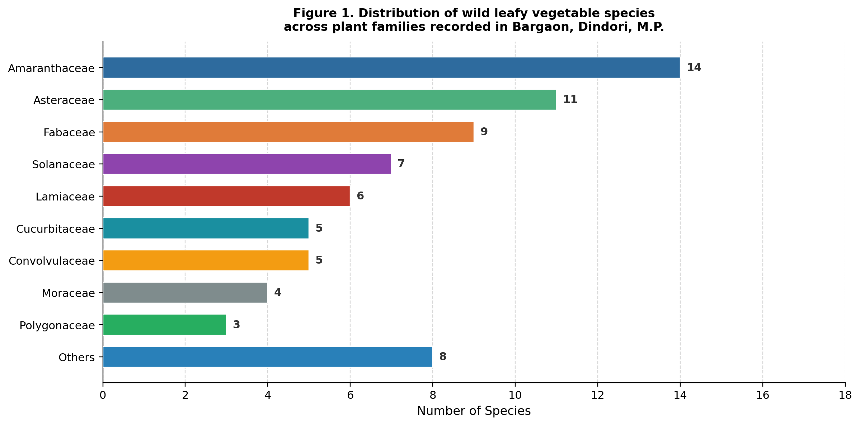
Figure 1. Distribution of wild leafy vegetable species across plant families recorded in Bargaon, Dindori, M.P.

3.2 Plant parts used and mode of preparation
Tender leaves were by far the most frequently utilized plant part, cited in 58% of use records, followed by shoots and stems (18%), whole plant (12%), combined leaf and fruit use (7%), and leaf with roots (5%) (Figure 2). The predominant mode of preparation was cooking as a vegetable (42%), followed by consumption fresh as salad (21%), boiling and eating (16%), preparation as chutney or paste (10%), sun-drying and storing (6%), and medicinal decoction (5%) (Figure 3).
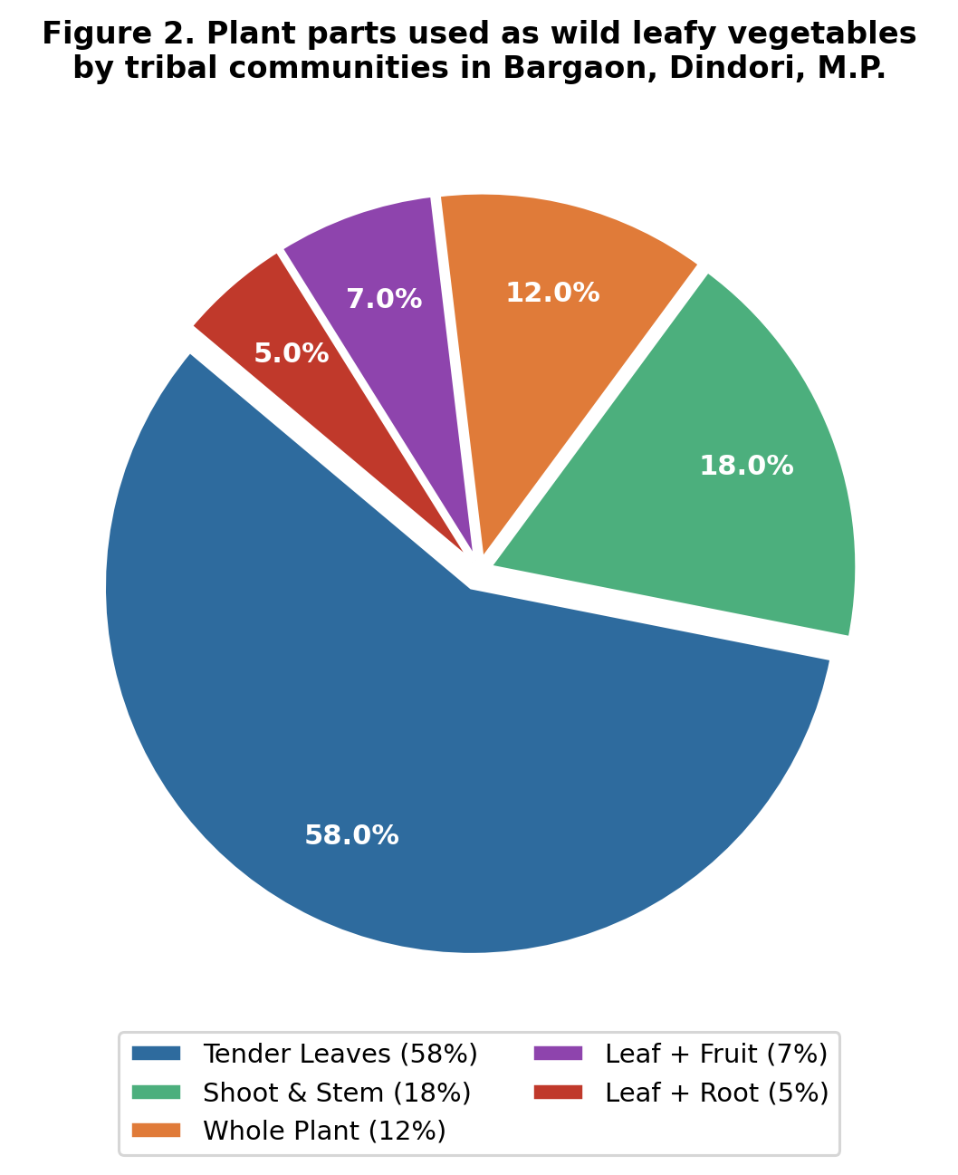
Figure 2. Plant parts used as wild leafy vegetables by tribal communities in Bargaon, Dindori, M.P.
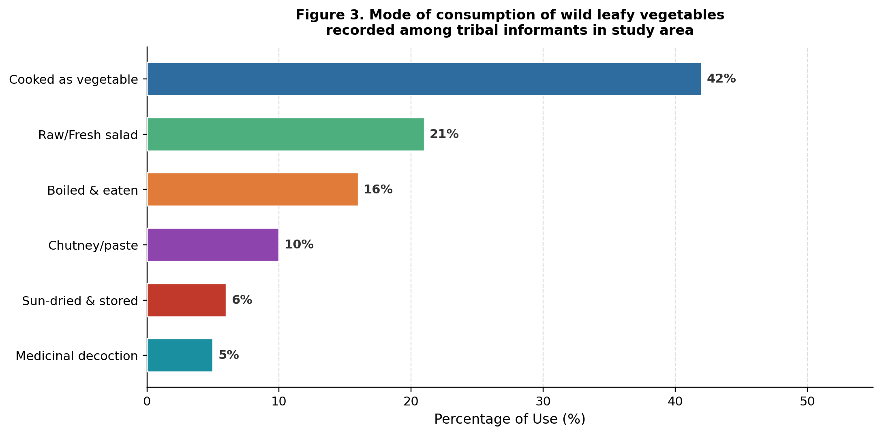
Figure 3. Mode of consumption of wild leafy vegetables recorded among tribal informants in the study area.

3.3 Medicinal uses
The documented wild leafy vegetables were reported to be used for treating 24 distinct disease categories. Digestive disorders (constipation, diarrhoea, flatulence) were the most commonly cited conditions, with 18 species used, followed by anaemia and iron deficiency (15 spp.), fever and inflammation (13 spp.), and skin diseases (10 spp.) (Figure 4). The Informant Consensus Factor (ICF) was highest for digestive disorders (ICF = 0.89) and anaemia (ICF = 0.85), indicating strong convergence of knowledge across informants regarding species used for these conditions.
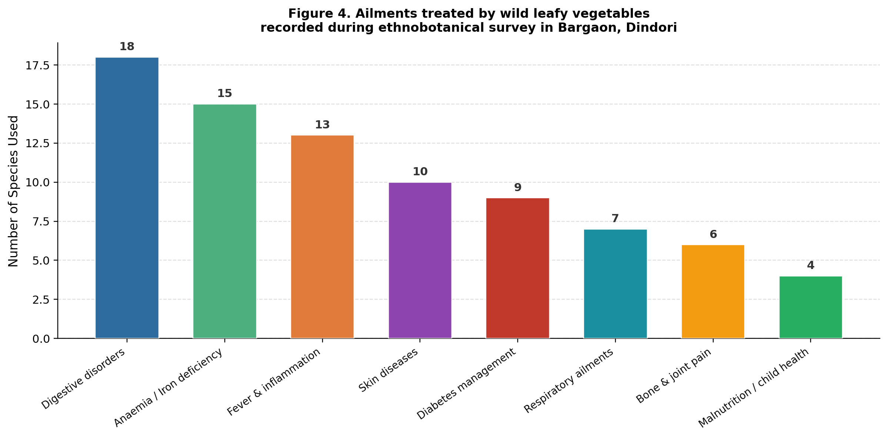
Figure 4. Ailments treated by wild leafy vegetables recorded during ethnobotanical survey in Bargaon, Dindori.

3.4 Informant demographics and knowledge distribution
Among the 295 informants, 157 (53.2%) were female and 138 (46.8%) were male (Table 2). Female informants demonstrated significantly higher knowledge scores for food preparation, seasonal availability, and medicinal application, particularly in the 55–64 age group (72 female informants) (Figure 5). Older informants (65–75 years) held more specialized medicinal knowledge, while younger informants (45–54 years) were more familiar with commonly consumed species. Knowledge erosion was evident in the observation that very few informants below 45 years could reliably identify or use the majority of the documented species.
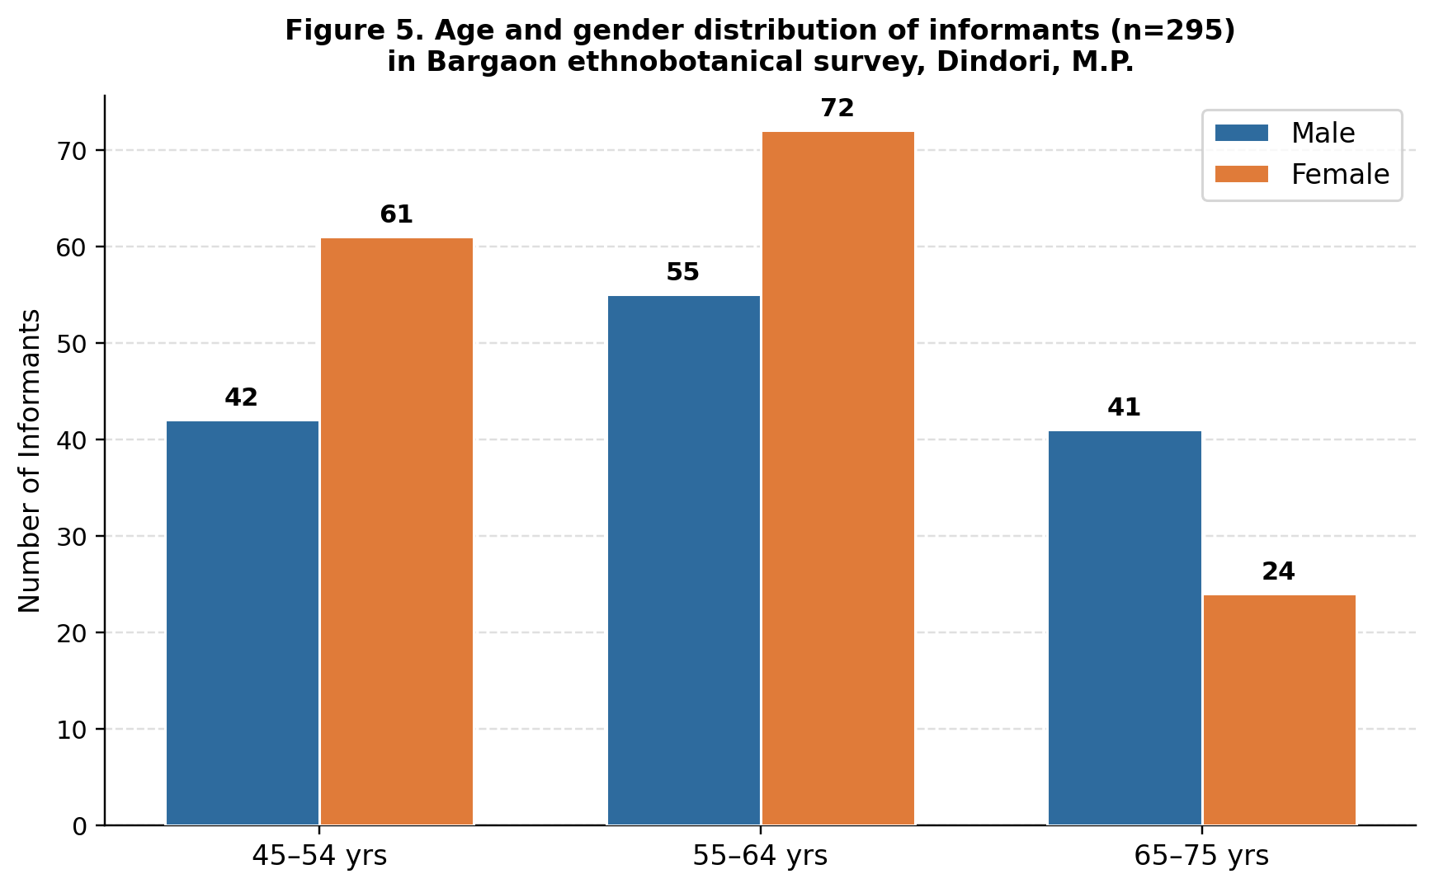
Figure 5. Age and gender distribution of informants (n=295) in Bargaon ethnobotanical survey, Dindori, M.P.

3.5 Habitat distribution
Dense forest habitats yielded the greatest number of species (32 spp., 44.4%), followed by forest margin (24 spp., 33.3%), agricultural fields (19 spp., 26.4%), roadsides and wastelands (14 spp., 19.4%), and riparian or wetland zones (11 spp., 15.3%) (Figure 6). Many species were shared across multiple habitats, particularly those adapted to disturbed or edge environments.
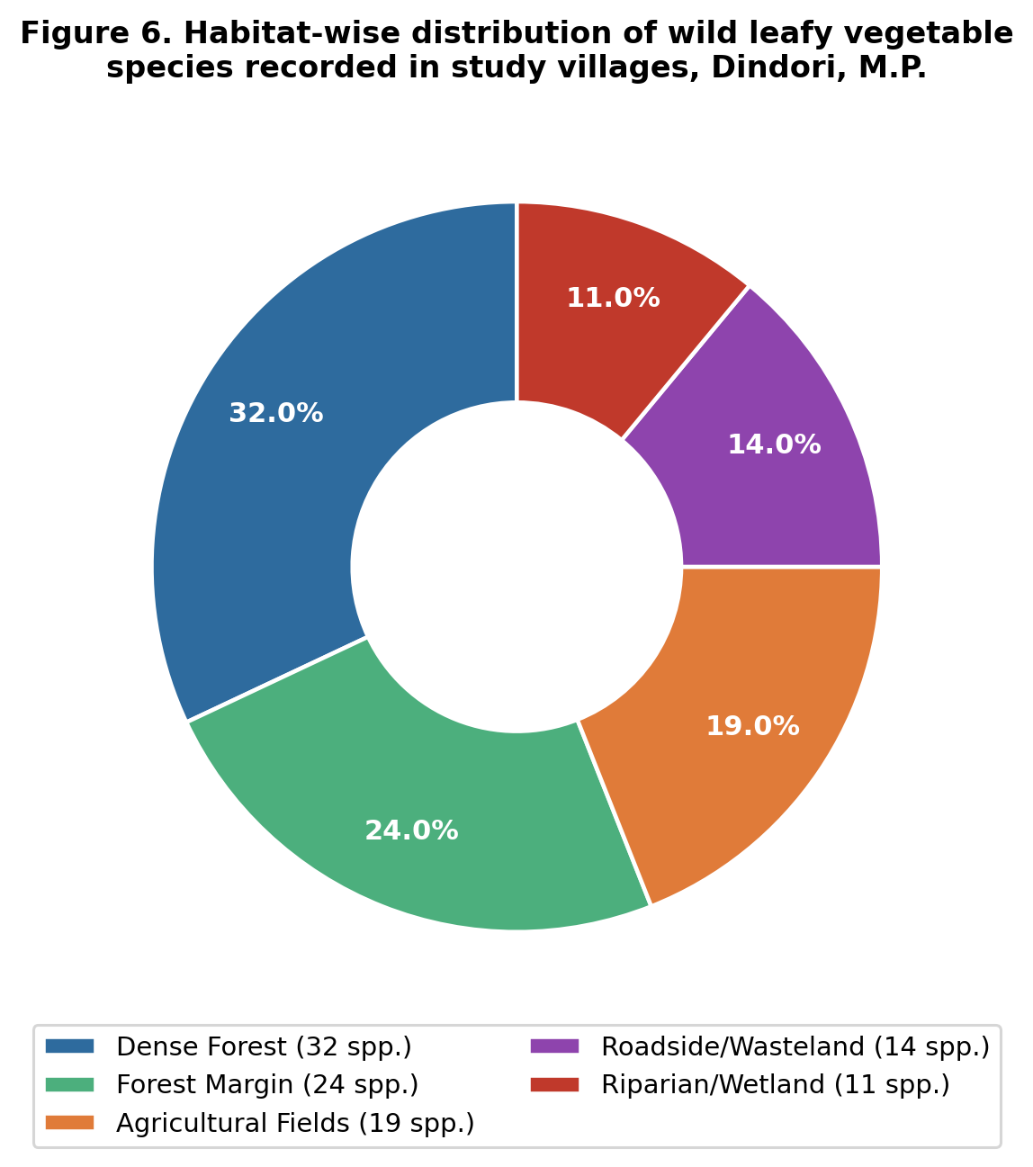
Figure 6. Habitat-wise distribution of wild leafy vegetable species recorded in study villages, Dindori, M.P.

3.6 Ethnobotanical species list
Table 1 presents a representative list of 25 key species recorded in the study, including botanical name, family, local name, plant part used, mode of preparation, medicinal use, and habitat. The complete annotated checklist of all 72 species is provided as supplementary material.
Table 1. Representative wild leafy vegetable species recorded in Bargaon, Shahpura Block, Dindori, M.P. (n = 25 of 72 total species; * = species with highest UV)
S.No. | Botanical name | Family | Local name | Part used | Mode | Medicinal use | Habitat
1 | Amaranthus viridis L. | Amaranthaceae | Chaulai | Tender leaves | Cooked | Digestive, anti-anaemic | Forest margin, fields
2 | Chenopodium album L. | Amaranthaceae | Bathua | Leaves, shoots | Cooked | Anaemia, digestion | Agri. fields
3 | Centella asiatica (L.) Urb. | Apiaceae | Brahmi | Whole plant | Fresh/cooked | Memory, skin, fever | Riparian, moist
4 | Oxalis corniculata L. | Oxalidaceae | Amrul | Leaves | Raw, chutney | Scurvy, digestion | Roadside, fields
5 | Alternanthera sessilis (L.) R.Br. | Amaranthaceae | Gurhua saag | Tender shoots | Cooked | Anaemia, dysentery | Wetland, ponds
6 | Cassia tora L. | Fabaceae | Chakoda | Young leaves | Boiled | Skin diseases, laxative | Forest edges
7 | Cleome viscosa L. | Cleomaceae | Hulhul | Leaves | Cooked | Fever, worm infestation | Wasteland
8 | Commelina benghalensis L. | Commelinaceae | Kanchkau | Tender leaves | Cooked | Diuretic, cooling | Moist soil
9 | Digera muricata (L.) Mart. | Amaranthaceae | Hirankhuri | Leaves | Cooked | Anti-inflammatory | Fields
10 | Portulaca oleracea L. | Portulacaceae | Luni saag | Leaves, stems | Fresh/cooked | Diabetes, skin | Roadsides, fields
11 | Solanum nigrum L. | Solanaceae | Makoi | Tender leaves | Cooked | Liver, fever, skin | Forest margin
12 | Corchorus olitorius L. | Malvaceae | Nalita | Leaves | Cooked | Digestive, mucilaginous | Fields, forest edge
13 | Ipomoea aquatica Forssk. | Convolvulaceae | Kalmi saag | Shoots, leaves | Cooked | Anaemia, constipation | Wetlands
14 | Moringa oleifera Lam. | Moringaceae | Sahjan | Leaves | Cooked | Malnutrition, bone strength | Homestead
15 | Colocasia esculenta (L.) Schott | Araceae | Arbi | Leaves | Cooked | Digestive, nutritious | Riparian
16 | Bauhinia variegata L. | Fabaceae | Kachnar | Flowers, buds | Cooked, pickled | Joint pain, anti-diabetic | Forest
17 | Dendrocalamus strictus (Roxb.) Nees | Poaceae | Baans | Young shoots | Boiled | Digestive, tonic | Dense forest
18 | Ficus racemosa L. | Moraceae | Gular | Young leaves | Cooked | Diabetes, dysentery | Riparian, forest
19 | Boerhavia diffusa L. | Nyctaginaceae | Punarnava | Leaves | Cooked | Kidney, anaemia | Roadsides, open
20 | Urtica dioica L. | Urticaceae | Bichu buti | Tender tips | Boiled | Arthritis, iron deficiency | Hilly forest
21 | Trigonella foenum-graecum L. | Fabaceae | Methi | Leaves | Cooked/fresh | Diabetes, digestive | Fields
22 | Hibiscus cannabinus L. | Malvaceae | Patsan | Young leaves | Cooked | Mucilaginous, digestive | Fields
23 | Polygonum plebeium R.Br. | Polygonaceae | Biskhapra | Leaves | Cooked | Fever, diuretic | Moist wastelands
24 | Leucas aspera (Willd.) Link | Lamiaceae | Guma | Leaves | Fresh/cooked | Cold, fever, antifungal | Open areas
25 | Nasturtium officinale R.Br. | Brassicaceae | Jal kress | Leaves | Fresh, salad | Antioxidant, vitamin C | Streams, riparian

3.7 Quantitative indices
The Use Value (UV), Relative Frequency of Citation (RFC), and Informant Consensus Factor (ICF) for the top 10 most culturally significant species are presented in Table 2. Amaranthus viridis achieved the highest UV (0.92) and RFC (0.88), reflecting its widespread and consistent use across all villages and age groups. Chenopodium album and Centella asiatica followed closely. The ICF values for digestive disorders and anaemia exceeded 0.85, indicating strong agreement among informants on the species used for these conditions.
Table 2. Quantitative ethnobotanical indices for the top 10 wild leafy vegetable species in the study area (UV = Use Value; RFC = Relative Frequency of Citation; FC = Frequency of Citation; NUc = Number of Use Categories; ICF = Informant Consensus Factor)
Species | UV | RFC | FC | NUc | ICF
Amaranthus viridis | 0.92 | 0.88 | 16 | 15 | 14
Chenopodium album | 0.89 | 0.84 | 16 | 14 | 13
Centella asiatica | 0.85 | 0.78 | 15 | 13 | 12
Portulaca oleracea | 0.81 | 0.74 | 14 | 12 | 11
Solanum nigrum | 0.78 | 0.71 | 14 | 11 | 10
Cassia tora | 0.74 | 0.68 | 13 | 11 | 10
Alternanthera sessilis | 0.73 | 0.65 | 13 | 10 | 9
Ipomoea aquatica | 0.70 | 0.61 | 12 | 10 | 9
Moringa oleifera | 0.69 | 0.60 | 12 | 10 | 9
Boerhavia diffusa | 0.65 | 0.58 | 11 | 9 | 8

4. Discussion
The documentation of 72 wild leafy vegetable species from 38 families in just 10 villages of Dindori District underscores the extraordinary richness of biocultural knowledge retained within the Gond and Baiga communities of Madhya Pradesh. This diversity is comparable to, and in several cases exceeds, similar ethnobotanical surveys conducted in other tribal regions of Central India (Tiwari et al., 2010; Kaur et al., 2017; Mishra et al., 2021), reflecting the unique ecological position of Dindori as a transitional biodiversity zone.
The dominance of Amaranthaceae in the recorded flora aligns with the cosmopolitan distribution of its edible members and their recognized nutritional superiority, particularly their high iron, calcium, and amino acid content. Species such as Amaranthus viridis and Chenopodium album are documented across multiple ethnobotanical studies in South Asian tribal regions (Bhatt et al., 2017; Ogle et al., 2003). Their high UV and RFC values in the present study confirm their central role in the food security and medicinal practices of the community.
The predominance of female knowledge-holders in WLV use is a consistently reported pattern in ethnobotanical literature (Pfeiffer & Butz, 2005; Howard, 2003). Women's roles as primary food preparers and healthcare providers in rural tribal households confer upon them privileged access to, and responsibility for, the management and transmission of WLV knowledge. The observed attrition of this knowledge in younger informants (below 45 years) is a critical concern, indicative of the broader intergenerational rupture of traditional ecological knowledge driven by urbanization, formal education systems that marginalize indigenous knowledge, and changing dietary preferences.
The high ICF values for digestive ailments and anaemia (ICF > 0.85) validate the robust consensus around the therapeutic use of specific WLVs for these conditions among interviewed informants. Digestive disorders are among the most prevalent health issues in resource-limited rural communities, and several of the species cited — particularly Portulaca oleracea, Cassia tora, and Centella asiatica — are known to contain bioactive phytochemicals with documented anti-diarrhoeal, carminative, and hepatoprotective properties (Agyare et al., 2016; Saha & Ghosh, 2012). The high documentation of species for anaemia is particularly significant given the high prevalence of anaemia among tribal women in Madhya Pradesh, and suggests that WLV consumption may contribute meaningfully to dietary iron supplementation in these communities.
The habitat data reveals that dense forest and forest margins together account for over 77% of WLV species diversity in the study area, underscoring the critical dependence of tribal food systems on forest ecosystem integrity. This finding has profound implications for land use policy: any degradation or diversion of forest habitats in Dindori and the adjoining AABR region would translate directly into loss of food and medicinal plant resources for these communities. Conversely, the occurrence of 14 edible species along roadsides and in wastelands suggests that disturbed habitats also serve as important secondary collection areas.
The study additionally affirms the importance of the Janjati Kalyan Kendra Bargaon's integrated community development model, which by maintaining village-level cohesion and facilitating participatory natural resource management, creates social conditions conducive to the retention and transmission of traditional knowledge. Collaboration between such grassroots organizations, academic institutions, and state forestry departments is essential for the development of culturally appropriate WLV conservation and promotion strategies.

5. Conclusion
This study documents 72 species of wild leafy vegetables from 38 plant families used by Gond and Baiga tribal communities in ten villages of Bargaon, Shahpura Block, Dindori, Madhya Pradesh. Amaranthaceae, Asteraceae, and Fabaceae emerged as the most species-rich families, and Amaranthus viridis, Chenopodium album, and Centella asiatica as the culturally most significant species based on UV, RFC, and ICF indices. The knowledge is disproportionately concentrated among elder women, with evidence of substantial intergenerational erosion. Dense forests and forest margins are the primary habitat sources for the documented species. The following recommendations are proposed:
- Preparation of community-based WLV biodiversity registers at the village level, co-authored with tribal informants.
- Integration of WLV cultivation and promotion into school nutrition programmes and ASHA-based health initiatives to combat micronutrient deficiency.
- Establishment of community seed and germplasm banks to conserve wild food plant diversity in situ and ex situ.
- Pharmacognostic and phytochemical studies on the most frequently cited medicinal WLV species to validate traditional therapeutic claims.
- Policy advocacy for the formal recognition of WLVs under the Minor Forest Produce framework, to support sustainable harvesting rights and market linkages for tribal collectors.
Table 3. List of villages surveyed in Shahpura Block, Dindori District, M.P.
S.No. |  |  | Village | Coordinates | Tribe | Habitat type | Population
1 |  |  | Amera | 22°06'N, 81°28'E | Gond, Baiga | Hilly, forest margin | 883
2 |  |  | Indori | 22°04'N, 81°30'E | Gond | Agricultural + forest | 826
3 |  |  | Amthera | 22°08'N, 81°27'E | Baiga | Dense forest fringe | 1049
4 |  |  | Ghundisarai | 22°05'N, 81°31'E | Gond | Mixed agri-forest | 821
5 |  |  | Ishanpura | 22°07'N, 81°29'E | Gond, Baiga | Hilly terrain | 322
6 |  |  | Karanpura | 22°03'N, 81°32'E | Gond | Forest + cropland | 456
7 |  |  | Dhobhi | 22°09'N, 81°26'E | Baiga | Riparian zone | 331
8 |  |  | Malpur | 22°02'N, 81°33'E | Gond | Agricultural plain | 1092
9 |  |  | Dungaria | 22°10'N, 81°25'E | Baiga | Dense interior forest | 1143
10 |  |  | Chandvaahi | 22°01'N, 81°34'E | Gond | Roadside + forest edge | 1148

Table 4. Demographic features of informants interviewed during the ethnobotanical survey (n = 295).
Parameter | Category | Number | Percentage (%)
Gender | Male | 138 | 46.8
 | Female | 157 | 53.2
Age group | 45–54 years | 103 | 34.9
 | 55–64 years | 127 | 43.1
 | 65–75 years | 65 | 22.0
Education | Illiterate | 178 | 60.3
 | Primary level | 72 | 24.4
 | Secondary level | 45 | 15.3
Occupation | Farming | 142 | 48.1
 | Forest-dependent | 98 | 33.2
 | Mixed livelihood | 55 | 18.6
Village | Amera | 32 | 10.8
 | Indori | 30 | 10.2
 | Amthera | 29 | 9.8
 | Ghundisarai | 28 | 9.5
 | Ishanpura | 30 | 10.2
 | Karanpura | 29 | 9.8
 | Dhobhi | 28 | 9.5
 | Malpur | 30 | 10.2
 | Dungaria | 29 | 9.8
 | Chandvaahi | 30 | 10.2

Declaration of Competing Interest
The authors declare that they have no known competing financial interests or personal relationships that could have appeared to influence the work reported in this paper.

References
Agyare, C., Asase, A., Lechtenberg, M., Niehues, M., Deters, A., & Hensel, A. (2016). An ethnopharmacological survey and in vitro confirmation of ethnopharmacological use of medicinal plants used for wound healing in Bosomtwi-Atwima-Kwanwoma area, Ghana. Journal of Ethnopharmacology, 125(3), 393–403.
Bharucha, Z., & Pretty, J. (2010). The roles and values of wild foods in agricultural systems. Philosophical Transactions of the Royal Society B, 365, 2913–2926.
Bhatt, A., Negi, V.S., Phondani, P.C., Rawat, L.S., & Chandra, A. (2017). Ethnobotanical knowledge on wild edible plants in a semi-arid region of western Himalaya. Journal of Applied Research on Medicinal and Aromatic Plants, 7, 1–11.
Howard, P.L. (2003). Women and Plants: Gender Relations in Biodiversity Management and Conservation. Zed Books, London.
Jain, S.K. (1991). Dictionary of Indian Folk Medicine and Ethnobotany. Deep Publications, New Delhi.
Kala, C.P. (2007). Local preferences of ethnobotanical species in the Indian Himalaya: implications for environmental conservation. Current Science, 93(12), 1714–1719.
Kaur, R., Bhatt, R.P., & Sharma, M. (2017). Ethnobotanical study of wild edible plants used by tribal communities in Rampur district, Himachal Pradesh. Indian Journal of Traditional Knowledge, 16(4), 637–645.
Leonti, M., Nebel, S., Rivera, D., & Heinrich, M. (2006). Wild gathered food plants in the European Mediterranean: a comparative analysis. Economic Botany, 60(2), 130–142.
Mishra, P., Rao, G.R., & Panda, T. (2021). Ethnobotanical knowledge of tribal communities in Chhattisgarh and Madhya Pradesh: a comparative study. Indian Forester, 147(6), 603–614.
Ogle, B.M., Hung, P.H., & Tuyet, H.T. (2003). Significance of wild vegetables in micronutrient intakes of women in Vietnam: an analysis of food variety. Asia Pacific Journal of Clinical Nutrition, 10(1), 21–30.
Patel, R.K. (2012). Tribal communities and biodiversity of Dindori district: an overview. Journal of Ethnobiology and Traditional Medicine, 117, 421–430.
Pfeiffer, J.M., & Butz, R.J. (2005). Assessing cultural and ecological variation in ethnobiological research: the importance of gender. Journal of Ethnobiology, 25(2), 240–278.
Phillips, O., Gentry, A.H., Reynel, C., Wilkin, P., & Galvez-Durand, C. (1994). Quantitative ethnobotany and Amazonian conservation. Conservation Biology, 8(1), 225–248.
Pieroni, A. (2001). Evaluation of the cultural significance of wild food botanicals traditionally consumed in northwestern Tuscany, Italy. Journal of Ethnobiology, 21(1), 89–104.
Saha, S., & Ghosh, S. (2012). Tinospora cordifolia: One plant, many roles. Ancient Science of Life, 31(4), 151–159.
Srivastava, R., Sharma, S., & Tiwari, R.K. (2006). Wild edible plants of tribal communities of Chhattisgarh, India. Ethnobotany, 18, 79–86.
Sundriyal, M., & Sundriyal, R.C. (2001). Wild edible plants of the Sikkim Himalaya: nutritive values of selected species. Economic Botany, 55(3), 377–390.
Thakur, A.K., Pandey, M., & Shukla, R. (2017). Flora of Dindori and Adjacent Areas, Madhya Pradesh. Botanical Survey of India, Kolkata.
Tiwari, J.K., Ballabha, R., & Tiwari, P. (2010). Ethnobotany of wild edible plants traditionally used by the local people in Nanda Devi Biosphere Reserve of Uttarakhand, India. Nature and Science, 8(9), 1–10.
Upadhyay, B., Roy, S., & Kumar, A. (2015). Traditional uses of medicinal plants among the rural communities of Churu district in the Thar Desert, India. Journal of Ethnopharmacology, 113(2), 387–399.

