Original Research Article
Oil- Oil Correlation of the North-central Niger Delta Basin: Implications for Production, Exploration and Petroleum System Modelling

ABSTRACT
Geochemical evaluation was conducted on thirteen crude oil samples (BW1–BW7 and ND1–ND6) collected from the North-central Niger Delta basin. Gas chromatography–mass spectrometry was applied to assess organic matter (OM) source, thermal maturity, depositional environment and biodegradation level. Parameter cross-plots were used to establish oil–oil correlations within the basin. Sterane cross-plots (C28/C27 αββR versus C27/C29 αααR), C27–C29 sterane distributions and the 1-methylphenanthrene/9-methylphenanthrene ratio reveal a mixed OM origin (Type II/III kerogen) for both BW and ND oils, with some BW samples dominated by marine algal input and most ND samples showing stronger terrestrial influence. Saturated biomarker maturity ratios (C29 versus C30 αβ/(αβ + βα) hopanes) indicate attainment of early oil window, while aromatic indices (MPI-3 and calculated %R_{o}) suggest medium to high maturity. Dibenzothiophene/Phenanthrene versus Pristane/Phytane and API gravity versus Pristane/Phytane indicate that a few BW oils were deposited in fluvio-deltaic settings under oxic conditions. Other BW samples originated from marine shale–lacustrine environments under anoxic condition, whereas most ND oils were sourced from marine carbonate and marl facies deposited in oxic setting. Pr/n-C17 versus Ph/n-C18 suggests non-to-mild biodegradation for BW oils and moderate to high biodegradation for ND oils, attributed to fault-controlled migration and mixing histories.
Key words: Niger Delta basin, Biomarker, Petroleum system, Oil-oil correlation.
1. INTRODUCTION
Petroleum geochemistry is fundamental to enhancing exploration success and production performance by assessing controls on hydrocarbon volume and quality within reservoirs (Asif et al. 2011; Okoroh et al. 2020). Accurate estimation of the quantity, composition and timing of petroleum generation from organic matter (OM) is vital for minimizing exploration uncertainty. A comprehensive understanding of petroleum systems is therefore necessary to establish whether hydrocarbons were derived from single or multiple source rocks (Anyanwu et al. 2021). Since petroleum originates from OM preserved in fine-grained sediments, oils generated from the same source but stored in different stratigraphic intervals can be genetically related.
Biomarkers function as molecular fingerprints of crude oils, preserving information on biological input, depositional setting and thermal evolution of OM (Hancock et al. 2013). Differences in source material, burial history, migration pathways and reservoir conditions produce distinctive biomarker patterns that enable oil–oil and oil–source correlations. Unlike saturated indicators that may equilibrate or invert at high maturity, aromatic compounds are more resistant to biodegradation and respond systematically to thermal stress through isomerization and alkylation (Adekola et al. 2025). Although integrated saturate–aromatic approaches are common globally (Asif et al. 2011), they remain limited in the Niger Delta, underscoring the significance of this study for the North-central Niger Delta petroleum system.
The Niger Delta basin is a prolific hydrocarbon province, traditionally interpreted as hosting a single petroleum system largely derived from terrestrial organic matter. More recent investigations, however, have demonstrated the existence of multiple petroleum systems and distinct oil families across the basin (Eneogwe and Ekundayo, 2003). A robust understanding of the petroleum system—encompassing source rocks, migration pathways and reservoir characteristics—is critical for effective correlation and exploration risk evaluation. Limited regional data on stratigraphy and source-rock distribution has constrained reliable assessment of hydrocarbon volume, structure and generation timing. Although Paleocene Akata Formation source rocks with Type II/III kerogen are widely regarded as the principal hydrocarbon generators, additional source intervals may have contributed to different petroleum systems within the basin. Given the geological complexity of the Niger Delta, its petroleum systems remain incompletely resolved, underscoring the need for further investigation to reduce exploration risk and associated costs. Notably, detailed organic geochemical data and oil–oil correlations for the North-central Niger Delta have not been previously documented. Accordingly, this study aims to (i) characterize organic matter source, lithology, maturity, depositional setting and biodegradation, (ii) Determine whether or not one or more source rocks was or were responsible for the accumulation of the oils in the reservoirs, and (iii) elucidate oil charge history, geochemical variability and exploration potential.
- EXPERIMENTAL
2.1. GEOLOGICAL SETTINGS OF THE NIGER DELTA BASIN
The tectonic architecture of the Niger Delta is largely governed by fracture zones expressed as ridges and troughs within the simatic crust, formed during rifting associated with the opening of the South Atlantic Ocean (Onyekuru et al. 2023). This rifting episode terminated in the Cretaceous and coincided with the southern closure of the Benue Trough, which defined the regional tectonic framework of the delta. After rifting ceased, extensional or pull-apart tectonics became dominant. Continued deformation triggered shale diapirism caused by the mobilisation of under-compacted, over pressured Akata Formation clays against the denser Agbada Formation sands, resulting in slope instability due to limited structural support (Tuttle et al. 1999). Extensional tectonism ended across all five depobelts before deposition of the Benin Formation. The Niger Delta stratigraphy comprises Cretaceous to Recent marine siliciclastics, inferred from nearby Anambra Basin outcrops (Agumanu et al. 2024). In the Greater Ughelli depobelt, Paleocene–Early Eocene deposition featured extensive Akata shales and seaward-dipping growth faults, with Eocene–Oligocene marine shales such as the Orogho Shale marking key stratigraphic boundaries (Anyanwu and Ekpo, 2025). The study area falls within the Greater Ughelli depobelt where regression rates and delta cave in heralded in Late Eocene shore face deposits that steeped into open-marine/pro-delta deposits.
2.2. SAMPLE AND API GRAVITY DETERMINATION
With authorization from the Nigerian Upstream Petroleum Regulatory Commission, thirteen crude oil samples were collected from wellheads in the North-Central Niger Delta Basin. Seven samples (BW1–BW7) and six samples (ND1–ND6) were obtained from eight vertically producing reservoirs (Fig. 1). BW wells were drilled and produced much earlier than the ND wells within the same field and samples were selected to represent wells spaced 400–500 m apart. Samples were collected at atmospheric conditions, stored in labelled containers, and preserved at −20 °C. Approximately 1000 ml of crude oil was homogenized, transferred into a pre-cleaned 500 ml measuring cylinder, and API gravity determined using a thermal hydrometer, ensuring bubble-free immersion and temperature-corrected readings. Details as optimized in Ekpo et al., 2018.
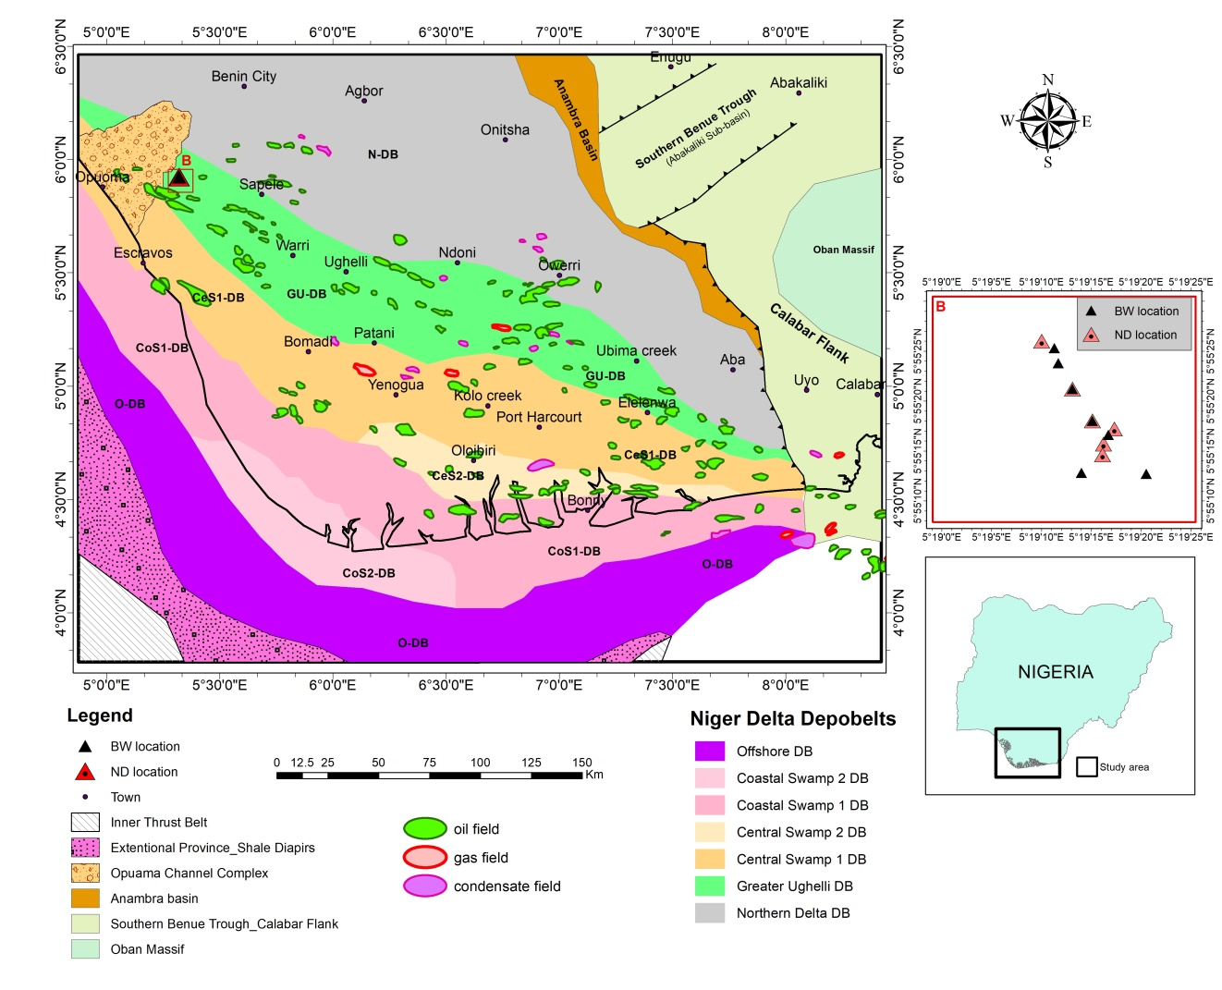
Fig. 1: Map of study area showing the depobelts, field locations, locations of the wells where studied oils were collected and other structural elements in the Niger delta basin.
1.3. CRUDE OIL ANALYSIS AND INSTRUMENTATION
Petroleum spirit (boiling range: 40–60 °C), n-hexane, methanol and dichloromethane were supplied by Shanghai Ruizheng Chemical Technology Ltd., China. Additional chemicals, including chromatographic-grade silica gel 40 (0.063–0.200 mm) and aluminium oxide 90 active neutral (0.063–0.200 mm) were procured from Sigma-Aldrich (St Louis, MO, USA). De-asphaltation of 2 g oil samples followed the procedure of Oyo-Ita et al. (2023), involving precipitation with dichloromethane:petroleum spirit (1:30 v/v) and centrifugation at 3500 rpm for ~30 min. The de-asphaltened oils were fractionated into saturates, aromatics and resins using open mini-column chromatography packed with alumina (neutral, activated 2 h at 700 °C) and silica gel (70/230 mesh, activated 6 h at 400 °C). Saturates were eluted with 100 mL n-hexane, aromatics with 100 mL dichloromethane, and resins with 100 mL dichloromethane:methanol (2:1 v/v). Eluents were concentrated using a rotary evaporator prior to GC–MS analysis. GC–MS was carried out on an HP 5890 Series II equipped with a 30 m HP-5 column (0.25 mm i.d., 0.25 µm film). Hydrogen was used as carrier gas at 2 mL min⁻¹. The oven was programmed from 50 °C (2 min) to 300 °C at 4 °C min⁻¹ and held for 20 min. Compound identification was based on relative retention times against standards.
  - DATA EVALUATION
Micro Soft Excel was used for parameter cross plots. The total ion current (TIC) peak areas were used in calculating proportions of saturates and aromatic biomarkers by deploying the integrated peak areas of the compound’s indices. The empirical estimation of vitrinite reflectance (%R_{o}) related to the methyl phenanthrene index (MPI) can be expressed as MPI-3 (3‐MPI + 2‐MPI/9‐MPI + 1‐MPI) (Chuan et al. 2019). The R_{o} value of 1.35% was regarded as a critical point shifted from methylation and rearrangement to demethylation (Okoroh et al. 2020).
3. RESULTS AND DISCUSSION
3.1 ORGANIC MATTER SOURCE: SATURATES VERSUS AROMATICS
Saturate biomarker parameters, including steranes and hopanes, derived from the analyzed oils are
compiled in Table 1. Differences in the proportions of regular and rearranged steranes are effective indicators of organic matter (OM) source variability. Notably, C29 regular steranes occur in higher relative abundance in ND oils than in BW oils (Table 1), suggesting a stronger terrigenous OM contribution to the ND oils compared to the BW oils (Burton et al. 2019). C28 steranes originate predominantly from sterols synthesized by diatoms, which are widespread in aquatic systems (Volkman, 1989). According to Grantham and Wakefield (1988), C28 regular steranes are linked to thorny diatom inputs and tend to increase in marine oils through geological time. In this study, some BW oils (BW5–BW7) show C28 steranes occurring in greater proportions than C27 and C29 steranes. In contrast, many ND oils exhibit dominance of C29 steranes over C27 and C28 components (Table 1), reinforcing the inference of greater terrestrial OM input, particularly in the ND oils.
The cross-plot of C27/C29 ααα versus C28/C29 αββ regular steranes (Fig. 2) distinguishes the North-central Niger Delta oils into two major groups. Most ND oils (ND3, ND4, ND5 and ND6), together with BW1 and BW5, display moderate C28 sterane abundance, indicative of mixed but appreciable algal OM input. In contrast, BW2, BW3, BW7 and ND1 plot at higher C27 and C29 βα/(ββ + αα) ratios (1.5–2), reflecting stronger marine clastic influence. ND2, positioned between values of 1 and 1.5, shows the highest marine OM contribution, whereas BW6 and BW4 exhibit enhanced algal and marine inputs, respectively. These patterns are consistent with αββ sterane distributions, where ND2 follows C28 > C27 > C29 and BW6/BW4 display C28 > C29 > C27 trends (Table 1).
The separation of ND2 and BW4/BW6 from other oil groups implies limited reservoir communication, possibly related to compartmentalization and distinct charging histories, supporting multiple oil families in the basin. Oleanane index values (18α(H)-oleanane/C30 hopane) range from 0.55–0.64 for BW oils and 0.64–0.72 for ND oils (Table 1), indicating variable but generally higher terrestrial OM influence in ND oils. 18α (H)-oleanane is sourced from taraxerene, betulin, and other pentacyclic triterpeniods of land plants (Grantham and Wakefield, 1988).
To further constrain organic matter (OM) provenance, aromatic hydrocarbon compositions of the North-central Niger Delta oils were examined. The aromatic fraction consists of both parent and alkylated naphthalenes (Ns) and phenanthrenes (Ps). Although trimethylnaphthalenes (TMNs) and

Biomarkers | Sample ID
Biomarkers | BW1 | BW2 | BW3 | BW4 | BW5 | BW6 | BW7 | ND1 | ND2 | ND3 | ND4 | ND5 | ND6
API | 43 | 41 | 35 | 40 | 43 | 39 | 40.5 | 43.0 | 42.9 | 42.50 | 43.15 | 44.70 | 41.70
Coordinates (N) | 5⁰ 19ʹ 20.5ʺ E | 5⁰ 19ʹ 20.5ʺ E | 5⁰ 19ʹ 20.5ʺ E | 5⁰ 19ʹ 20.5ʺ E | 5⁰ 19ʹ 20.5ʺ E | 5⁰ 19ʹ 20.5ʺ E | 5⁰ 19ʹ 20.5ʺ E | 5⁰ 19ʹ 20.5ʺ E | 5⁰ 19ʹ 20.5ʺ E | 5⁰ 19ʹ 20.5ʺ E | 5⁰ 19ʹ 20.5ʺ E | 5⁰ 19ʹ 20.5ʺ E | 5⁰ 19ʹ 20.5ʺ E
Coordinates (E) | 5⁰ 19ʹ 20.5ʺ E | 5⁰ 19ʹ 20.5ʺ E | 5⁰ 19ʹ 20.5ʺ E | 5⁰ 19ʹ 20.5ʺ E | 5⁰ 19ʹ 20.5ʺ E | 5⁰ 19ʹ 20.5ʺ E | 5⁰ 19ʹ 20.5ʺ E | 5⁰ 19ʹ 20.5ʺ E | 5⁰ 19ʹ 20.5ʺ E | 5⁰ 19ʹ 20.5ʺ E | 5⁰ 19ʹ 20.5ʺ E | 5⁰ 19ʹ 20.5ʺ E | 5⁰ 19ʹ 20.5ʺ E
Well Depth (FT) | 9,913 | 9,444 | 9,303 | 9407.5 | 9669.5 | 9770 | 9557 | 9,660 | 9,770 | 9,780 | 9,700 | 10,755 | 4718
Pr/Ph | 1.54 | 2.14 | 1.74 | 2.81 | 2.04 | 1.54 | 2.09 | 1.03 | 1.10 | 0.99 | 1.02 | 1.00 | 1.08
Pr/nC17 | 1.09 | 1.14 | 1.35 | 1.21 | 1.01 | 0.50 | 0.98 | 0.92 | 0.92 | 0.96 | 0.99 | 0.96 | 0.94
Ph/nC18 | 0.48 | 0.43 | 0.47 | 0.47 | 0.54 | 0.41 | 0.51 | 2.33 | 2.23 | 3.23 | 2.49 | 2.87 | 2.25
C32:22S/(22S+22R) | 0.59 | 0.54 | 0.56 | 0.61 | 0.61 | 0.57 | 0.64 | 0.57 | 0.57 | 0.57 | 0.57 | 0.59 | 0.57
C29:(20S/20S+20R) | 0.59 | 0.57 | 0.58 | 0.57 | 0.62 | 0.63 | 0.62 | 0.64 | 0.57 | 0.83 | 0.72 | 0.69 | 0.71
βα (Mor)/αβC30H | 0.16 | 0.14 | 0.15 | 0.17 | 0.17 | 0.14 | 0.18 | 0.15 | 0.16 | 0.19 | 0.18 | 1.55 | 1.44
C30:αβ(αβ+βα) | 0.86 | 0.85 | 0.86 | 0.86 | 0.86 | 0.88 | 0.85 | 0.87 | 0.86 | 0.84 | 0.85 | 0.86 | 0.83
C29:αβ(αβ+βα) | 0.85 | 0.78 | 0.81 | 0.76 | 0.84 | 0.90 | 0.86 | 0.75 | 0.77 | 0.75 | 0.76 | 0.71 | 0.76
C27/C29αααR | 0.89 |  |  | 0.32 | 0.88 | 1.51 | 0.37 | 0.50 | 0.58 | 0.97 | 1.05 | 0.96 | 1.11
C28/C27 αββR | 1.59 |  |  | 2.05 | 1.65 | 1.81 | 1.73 | 1.65 | 1.20 | 1.76 | 1.86 | 1.88 | 2.00
Sterane trend | C29>C28>C27 | C29>C28>C27 | C29>C28>C27 | C29>C28>C27 | C28>C27>C29 | C28>C29>C27 | C28>C29>C27 | C28>C29>C27 | C28>C27>C29 | C29>C27>C28 | C29>C28>C27 | C29>C28>C29 | C29>C28>27
Ole/C30H | 0.64 |  |  | 0.58 | 0.59 | 0.61 | 0.55 | 0.68 | 0.71 | 0.66 | 0.72 | 0.64 | 0.69
C29/C30H | 0.65 |  |  | 0.60 | 0.60 | 0.66 | 0.64 | 0.57 | 0.59 | 0.56 | 0.58 | 0.53 | 0.59
Gammacerane/ αβ 30H | 0.00 | 0.00 | 0.00 | 0.00 | 0.00 | 0.00 | 0.00 | 0.05 | 0.09 | 0.05 | 0.05 | 0.07 | 0.06
C31(R+S)/C30H | 0.39 |  |  | 0.38 | 0.40 | 0.36 | 0.40 | 0.46 | 0.45 | 0.44 | 0.45 | 0.33 | 0.29
Table 1: Saturate geochemical parameters for BW and ND oil samples.

Fig 2: Cross plots of C₂₈/C₂₇ αββR versus C₂₇/C₂₉ αααR differentiates the studied oils on basis of organic matter source.

dimethylphenanthrenes (DMPs) were detected, they were poorly resolved, likely due to analytical or column limitations, while ethylnaphthalene (EN) and ethylphenanthrenes (EP) occurred only in trace amounts.
Comparative distributions indicate that BW oils contain greater proportions of naphthalenes relative to phenanthrenes, whereas ND oils show phenanthrene dominance, reflected by ∑Ns/∑Ps values > 1 for BW oils and < 1 for ND oils (Table 2). These trends resemble those reported for central Niger Delta oils (BW) and north-western Niger Delta oils (ND) (Akinlua and Ajayi, 2009).
Homolog distributions in BW oils generally follow the sequence DMN > MN > N > EN, while most ND oils—except ND2 and ND6—show MN > DMN > N > EN (Table 2). The BW oil patterns are comparable to oils from the Northwest Niger Delta, Gulf of Suez, Nile Delta, Western Desert of Egypt, and source rocks of the Cretaceous Orange Basin, South Africa (Akinlua and Ajayi, 2009; Adekola et al. 2025). ND2 and ND6, however, deviate from these global analogues. Phenanthrene series exhibit either MP > P > EP or P > MP > EP relationships. Marine OM is typically characterized by enhanced naphthalene abundance, whereas terrestrial OM shows phenanthrene enrichment (Adekola et al. 2025). Accordingly, BW oils display higher ∑Ns/∑Ps ratios (7.33–24.41) than ND oils (0.11–0.78). Methylphenanthrene isomer ratios further suggest
that most ND oils have stronger terrestrial input (1-MP/9-MP > 1), except ND1 (0.68) and ND2 (0.39), while some BW oils show greater marine influence (Ji et al. 2014). Minor inconsistencies among aromatic and sterane indicators likely reflect source-rock heterogeneity, migration processes and oil mixing, underscoring the need for further source-to-oil correlation within the basin.

Table2: Aromatic geochemical parameters for BW and ND oil samples
Biomarkers | BW1 | BW2 | BW3 | BW4 | BW5 | BW6 | BW7 | ND1 | ND2 | ND3 | ND4 | ND5 | ND6
MNR | 1.37 | 1.06 | 1.44 | 1.49 | 1.31 | 1.25 | 1.53 | 1.09 | 1.17 | 1.04 | 1.40 | 1.04 | 1.10
1-MP/9-MP | 1.22 | 0.77 | 0.13 | 1.03 | 1.16 | 0.94 | 1.00 | 0.68 | 0.39 | 1.05 | 1.07 | 1.42 | 1.79
N-trend | $$DMN>MN>N≫EN$$ | $$DMN>MN>N≫EN$$ | $$DMN>MN>N≫EN$$ | $$DMN>MN>N≫EN$$ | $$DMN>MN>N≫EN$$ | $$DMN>MN>N≫EN$$ | $$DMN>MN>N≫EN$$ | $$DMN>MN>N≫EN$$ | $$MN>DMN>N≫EN$$ | $$DMN>MN>N≫EN$$ | $$DMN>MN>N≫EN$$ | $$DMN>MN>N≫EN$$ | $$MN>DMN>N≫EN$$
Rc | 0.57 | 0.53 | 0.62 | 0.74 | 0.54 | 0.55 | 0.66 | 0.70 | 0.83 | 0.56 | 0.69 | 0.91 | 1.05
MPI-3 | 1.03 | 1.27 | 1.38 | 1.49 | 1.09 | 0.97 | 1.40 | 1.03 | 1.29 | 0.44 | 0.70 | 1.19 | 0.84
Rcs | 0.87 | 0.92 | 0.94 | 0.96 | 0.88 | 0.85 | 0.94 | 0.84 | 0.92 | 0.74 | 0.80 | 0.90 | 0.83
P-trend | $$P>MP≫EP$$ | $$MP>P≫EP$$ | $$MP>P≫EP$$ | $$MP>P≫EP$$ | $$P>MP≫EP$$ | $$P>MP≫EP$$ | $$P>MP≫EP$$ | $$MP>P≫EP$$ | $$P>MP≫EP$$ | $$MP>P≫EP$$ | $$P>MP≫EP$$ | $$MP>P≫EP$$ | $$MP>P≫EP$$
$$\sum{Ns ÷} \sum{Ps}$$ | 24.41 | 18.34 | 12.72 | 7.33 | 13.6 | 11.4 | 11.9 | 0.38 | 0.47 | 0.17 | 0.50 | 0.14 | 0.11

3.2 THERMAL MATURITY; SATURATES VERSUS AROMATICS
Thermal maturity of oils from the North-central Niger Delta basin was evaluated using integrated saturated and aromatic hydrocarbon biomarker parameters. The C32 hopane epimerization ratio, 22S/(22S + 22R), ranged from 0.54–0.64 for BW oils and 0.57–0.59 for ND oils (Table 1), values that approach equilibrium and indicate attainment of at least the early oil-generation window. Although this parameter has limited resolution for differentiating oil maturities (Peters et al. 2005), additional hopane-based indices provide further constraint. The moretane/hopane ratios expressed
as αβ/(αβ + βα) for C29 and C30 homologues, which equilibrate at higher maturities (Asif et al. 2011), ranged from 0.71–0.90 (C29) and 0.83–0.88 (C30) (Table 1), consistent with oils generated from mature source rocks (George et al. 2004). Cross-plots of C29 versus C30 αβ/(αβ + βα) (Fig. 3) show most samples within the early oil window, except BW6, which approaches full equilibrium and suggests advanced maturity.

Fig 3: Hopane maturity parameter plot between C₂₉ versus C₃₀ of αβ/(αβ + βα) showing most of the studied oils were in the early stage of oil generation window except BW6 which has fully entered the oil generation window.

Sterane maturity parameters further support these observations. Ethylcholestane ratios [C29; 20S/(20S + 20R)] ranged from 0.57–0.63 for BW oils and 0.57–0.83 for ND oils (Table 1), exceeding equilibrium values (0.52–0.55; Seifert and Moldowan, 1986). This indicates that most samples reached full sterane equilibrium, with ND3 reflecting relatively higher maturity. Correspondingly, oleanane index values (Ole/C30H) of 0.55–0.64 (BW) and 0.64–0.72 (ND) suggest slightly greater maturity in ND oils. Given that many saturated maturity indicators plateau early in the oil window (Van Graas, 1990), aromatic biomarkers were applied for improved resolution.
Thermal maturity estimates based on methylnaphthalene ratios (MNR) yielded values of 1.06–1.53 for BW oils and 1.04–1.40 for ND oils (Table 2), corresponding to medium to high maturity classes.
MPI-1 and MPI-2 were unsuitable; therefore, MPI-3 was employed. MPI-3 values (0.97–1.49 for BW; 0.44–1.29 for ND) and calculated %Ro (0.85–0.96 and 0.74–0.92, respectively) indicate overall medium–high maturity, with ND3 being the least mature (Chuan et al. 2019). Collectively, these results confirm that MPI-3 provides a more reliable maturity proxy for Niger Delta basin oils.

3.3 LITHOLOGY AND DEPOSITIONAL ENVIRONMENT: SATURATES VERSUS AROMATICS
Data presented in Tables 1 and 2 were assessed to infer source-rock lithology and depositional environments using saturated and aromatic hydrocarbon biomarkers. Source-rock lithology was evaluated primarily with the dibenzothiophene to phenanthrene ratio (DBT/P). DBT/P values > 1 are characteristic of carbonate facies with elevated sulfur incorporation into organic matter, whereas values < 1 typically indicate shale lithology, where sulfur preferentially binds with iron in clay minerals, limiting DBT formation (Asif et al. 2011). The BW oils displayed DBT/P ratios between 0.23 and 2.07, while ND oils ranged from 0.89 to 1.66 (Table 2). These results suggest predominantly shaly source rocks for most BW oils, with the exception of BW7, which indicates a carbonate source. In contrast, most ND oils reflect carbonate lithology, except ND4, which shows shale affinity. The DBT/P value of 0.99 for ND6 suggests derivation from a mixed shale–carbonate source.
Pristane/phytane (Pr/Ph) versus DBT/P values plotted on the Hughes diagram (Hughes et al. 1995; Fig. 4a) indicate that most ND oils (ND1, ND2, ND3 and ND5) originated from marine carbonate and marl facies. Some BW oils (BW2, BW4 and BW5) plot within fluvio-deltaic shale fields, while BW1, BW3, BW6, ND4 and ND6 fall within marine shale–lacustrine settings. BW7 reflects a strong marine carbonate signature. These lithologies are comparable to marine shale oils from the Precambrian Iremeken Formation, Texas, USA (Peters et al. 2005).
Cross-plots of Pr/Ph against API gravity (Fig. 4b) further distinguish BW and ND oils. BW oils generally exhibit intermediate Pr/Ph ratios (1.5–2.5) with high API gravity, whereas ND oils are characterized by lower Pr/Ph (mostly < 1.5) and high API values, consistent with the Hughes plot separation. C31 (R + S)/C30 hopane ratios ranged from 0.36–0.40 for BW and 0.29–0.46 for ND oils (Table 1), all well below 0.75, indicating non-dysoxic depositional settings (Peters and Moldowan, 1993).
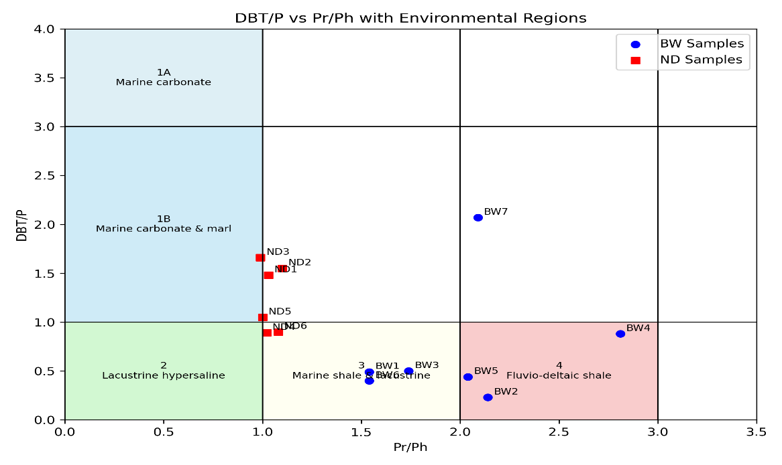
(a)
(b)
Fig 4 a and b: Cross plot of (a) DBT/P versus Pr/Ph indicating lithology and depositional environment, (b) a cross plot of API gravity and Pr/Ph separating the North-central Niger Delta basin oils

Redox conditions were further constrained using Pr/n-C17 and Ph/n-C18 ratios. BW oils show lower ranges (0.50–1.21 and 0.41–0.54), indicative of anoxic deposition, whereas ND oils exhibit higher values (0.92–0.99 and 2.23–3.23), consistent with oxic environments (Inengite et al. 2017). This BW trend aligns with marine reducing settings reported by Peters et al. (2005) and analogous anoxic systems such as Biluo Co Oil Shale (Changjun et al. 2014) and Eagle Ford Shale, Texas (Andrea et al. 2018). Conversely, ND oils correspond with oxic to sub-oxic Niger Delta settings reported by Oyo-Ita et al. (2022), Ekpo et al. (2018) and Anyanwu et al. (2021). Low gammacerane indices (0.05–0.09) further support oxic/sub-oxic depositional conditions for ND oils (Manila and Eking, 2008).
Overall, anoxic shaly source rocks responsible for some BW oils favored enhanced organic matter preservation, leading to greater hydrocarbon expulsion potential relative to the more oxic carbonate-dominated ND sources.
3.4. EXTENT OF BIODEGRADATION AND EVIDENCE OF MIXED HYDROCARBONS
Biodegradation of the investigated oils was evaluated using n-alkane distributions, pristane and phytane patterns, and the presence or absence of unresolved complex mixtures (UCMs) in gas chromatograms (Oyo-Ita et al. 2022). Chromatograms of the BW oils display well-resolved n-alkanes together with pristane and phytane, and lack baseline humps or UCMs, indicating non-biodegraded to slightly biodegraded oils (Fig. 5a). In contrast, chromatograms of the ND oils show pronounced UCM humps, reflecting a measurable degree of biodegradation (Fig. 5b).
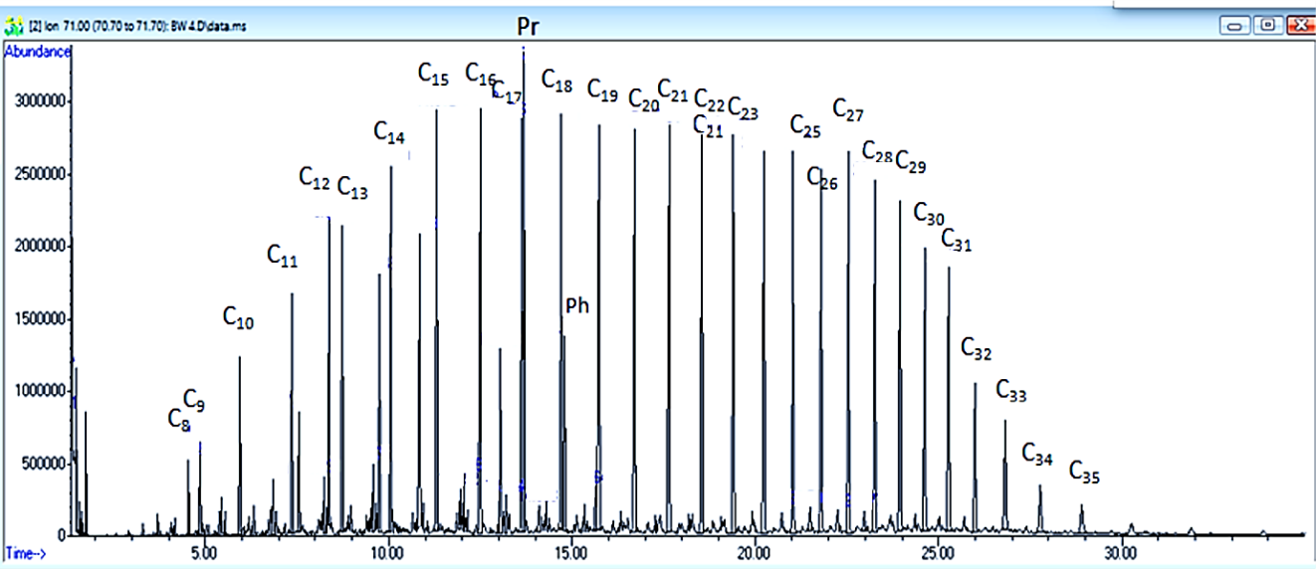
(a)
BW6

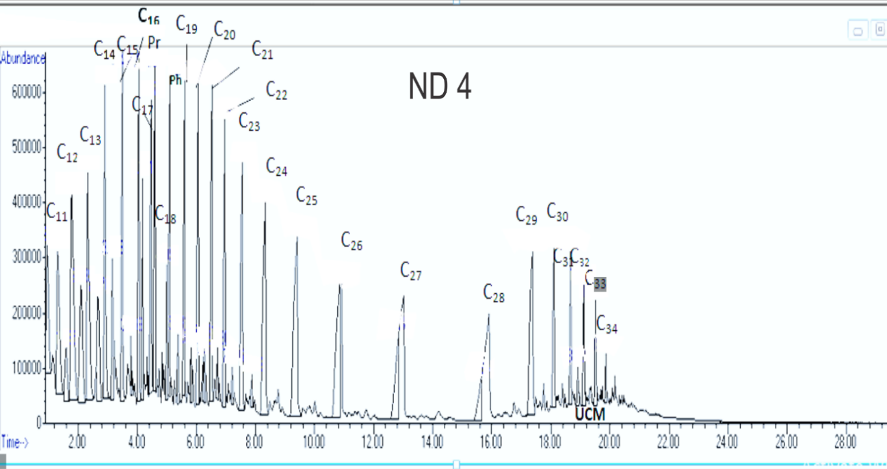
(b)
Fig 5 a and b: (a) Representative mass chromatogram (m/z 71) of n-alkanes and isoprenoids hydrocarbon distributions for one of the BW oils and (b) Representative mass chromatogram of total ion current (TIC) showing n-alkanes series, isoprenoid hydrocarbon and unresolved complex mixture (UCM) for one of the ND oils
At increasing thermal maturity, n-alkanes are generated more rapidly than isoprenoids, whereas during biodegradation n-alkanes are preferentially removed relative to pristane and phytane (Peters et al. 2005; Inengite et al. 2017). Consequently, elevated isoprenoid/n-alkane ratios signify increasing biodegradation, with Pr/n-C17 and Ph/n-C18 values > 1 indicating biodegraded oils (Asif et al. 2011). Cross-plots of Ph/n-C18 versus Pr/n-C17 (Fig. 6) reflect progressive biodegradation trends. Among BW oils, BW6 exhibits minimal biodegradation, whereas BW1–BW5 and BW7 show mild alteration. ND oils experienced more extensive biodegradation, with ND3 being the most affected.

Fig 6: Cross of Pr/n-C₁₇ versus Ph/n-C₁₈ indicating the extent of biodegradation.
API gravities range from 35–43° for BW oils and 41.70–44.70 for ND oils (Table 1). An inverse relationship between API gravity and Pr/n-C17 (Fig. 5b) further supports biodegradation effects, as higher isoprenoid ratios correspond to reduced API gravity (Asif et al. 2011). Thus, BW6 is interpreted as non-biodegraded, BW oils as mildly biodegraded, and ND oils as moderately to highly biodegraded.
Fingerprint differences among ND oils are attributed to biodegradation, evidenced by persistent UCMs. The coexistence of n-alkanes, isoprenoids and UCMs in ND oils suggests mixing of an earlier biodegraded charge with a later non-biodegraded influx (Cao et al. 2006). The presence of gammacerane in ND oils, absent in BW oils, supports this mixing hypothesis, as gammacerane is linked to biodegraded algal organic matter, commonly associated with lacustrine environments dominated by taxa such as Botryococcus braunii (Peters and Moldowan, 1993).
3.5. IMPLICATIONS FOR PRODUCTION, EXPLORATION AND PETROLEUM SYSTEM MODELLING
Organic matter (OM) type plays a critical role not only in controlling hydrocarbon generative potential but also in influencing the nature of the hydrocarbons produced (Xu and Li, 2016). The dominance of Type II/III kerogens in the present study indicates the capacity to generate both oil and gas. This suggests that the investigated reservoirs were charged by hydrocarbons sourced from multiple source rocks that experienced different thermal histories. Source rocks responsible for BW oils appear to have expelled relatively more oil than gas, whereas ND oils were likely derived from source rocks that generated gas-rich hydrocarbons. This behavior contrasts with several Niger Delta oils previously reported to be gas-dominated (Akinlua et al. 2005; Ekpo et al. 2018; Okoroh et al. 2020; Anyanwu et al. 2021). Marine regression along with variations in migration distance and pathways likely contributed to reservoir filling from multiple source rock units.
Although carbonate lithologies (e.g., limestone and dolomite) commonly exhibit favorable porosity and organic richness, shaly source rocks generally contain higher OM volumes and wider spatial distribution, making them more effective hydrocarbon generators. Consequently, exploration should prioritize areas underlain by shaly source rocks such as BW1 and BW6, where hydrocarbons expelled could more readily migrate and accumulate, rather than carbonate-dominated settings (BW7 and ND1–ND6).
Thermal maturity indicators further constrain petroleum generation. The C32 22S/(22S+22R) ratio (0.54–0.64; Table 1) confirms that oils reached equilibrium (El-Sabagh et al. 2017). MPI-3–derived vitrinite reflectance (Rs) values ranging from 0.85–0.96 (BW) and 0.74–0.92 (ND) indicate medium–high maturity (Chuan et al. 2019). Consequently, mature Akata Formation source rocks represent promising exploration targets.
Owing to repeated faulting events in the Greater Ughelli depobelt, where the study area is located, two distinct hydrocarbon charging phases are recognized: Paleocene–Eocene and Oligocene–Miocene. Based on regional tectonic development and source rock maturation history, the Akata Formation attained the oil window (early mature to mature stage). Consequently, hydrocarbons generated mainly from the upper Akata and lower Agbada Formations—which are the probable sources of the studied oils—are fully mature. Petroleum migration and mixing were likely concentrated within faulted zones, where fractures served as effective migration pathways. The proposed filling history suggests that early oils emplaced during Paleocene faulting were redistributed into reservoirs. Fresh hydrocarbons generated from early Akata source rocks later mixed with biodegraded remnants of an initial charge derived from the late Agbada Formation, producing the observed oil composition characterized by UCM. Biodegradation likely preceded the second charge, as the presence of intact n-alkanes in current oils indicates no recent alteration (Cao et al., 2006). The later charge dominates BW oil composition and is attributed to Oligocene–Neogene Agbada sources. Biodegradation of the first charge may have resulted from oxygenated meteoric water influx during basin-margin exposure. Migration occurred mainly through high-permeability reservoirs before trapping. Previous studies confirm a complex, mixed-source filling history in the Niger Delta (Anyawu & Ekpo, 2025). Fault development appears limited around BW source rocks but pronounced along ND source intervals, likely due to back-thrusting and rapid sedimentation near organic-rich belts.
4. CONCLUSION
Geochemical characterization and classification of crude oils from the North-central Niger Delta basin were carried out using saturated and aromatic biomarker data. Sterane distributions and their cross plots as well as 1-methlyphenathrene/9-methylphenathrene ratio show that both BW and ND oils are mainly derived from mixed organic matter (Type II/III kerogen). However, several BW oils reflect a stronger marine algal contribution, whereas most ND oils display increased terrestrial organic matter input. Based on organic matter source indicators and petroleum charge history, isolated samples (ND2, BW4 and BW6) show no communication with the two main oil groups, most likely as a result of reservoir compartmentalization. Saturated hydrocarbon biomarkers indicate that the oils have attained at least early oil-window maturity, while aromatic indices and calculated vitrinite reflectance values suggest medium to high oil-generation maturity. Some BW oils originated from terrestrial organic matter deposited in fluvio-deltaic settings under oxic conditions, whereas others were derived from marine shale or lacustrine environments under anoxic conditions, except BW7, which, together with ND oils, was deposited in marine carbonate and marl under oxic conditions. The identified Type II/III kerogens are capable of generating both oil and gas, implying multiple source rocks with contrasting thermal histories. The BW oils were largely expelled from anoxic shaly source rocks that favored organic matter preservation, leading to higher hydrocarbon yields compared to carbonate-dominated ND sources. Consequently, exploration should prioritize shaly source regimes. The unresolved complex mixtures (UCMs) in ND oils indicate biodegradation followed by later oil mixing controlled by fault-assisted migration in the tectonically complex Niger Delta basin.

Competing interests

The authors declare no conflicts of interest associated with this manuscript. We confirm that this manuscript is not under consideration for publication elsewhere, that its publication in Journal of Scientific Research and Reports is approved by all authors and tacitly or explicitly by the responsible authorities where the work was carried out.

REFERENCES
Adekola, A., Mangelsdorf, K. & Akinlua, A. (2025). Geochemistry of aromatic hydrocarbons in source rocks of the Cretaceous Orange basin. AAPG Bull, 109, 99-116.
Akinlua, A., Ajayi,T. R. & Adeleke, B. B. (2005). A re-appraisal of the application of Rock- Eval pyrolysis to source rock studies in the Niger Delta. Pet Geol, 28, 3948.
Akinlua, A. & Ajayi, T. R. (2009). Geochemical characterization of central Niger Delta oils. Pet Geol., 32, 373-382.
Andrea, A., Miceli, R., Thanh N. & Paul, P. (2018). Organic geochemistry of the Eagle Ford Group in Texas. AAPG Bulletin 102: 1379–1412.
Anyanwu, T. O., Ekpo, B. O. & Aleruchi B. O. (2021). Geochemical characterization of coastal and offshore Niger delta crude oils, Nigeria. Adv Acad Res 7: 2488-9849.
Anyanwu, T.C. & Ekpo, B.O. (2025). Petroleum system, filling history and age appraisal of source rocks of the Niger Delta Basin: Fingerprinting of pentacyclic triterpenoids. Energy Geosci 6:100399.
Asif, M., Nazir, A., Fazeela,t T., Grice, K., Nasir, S. & Saleem, A. (2011). Applications of Polycyclic Aromatic Hydrocarbons to Assess the Source and Thermal Maturity of the Crude Oils from the Lower Indus Basin, Pakistan, Pet Sci and Tech 29: 2234-224
Burton, Z. F. M., Moldowan, J. M., Magoon, L. B., Syke, R. & Graham, S. A. (2019). Interpretation of source rock depositional environment and age from seep oil, east coast of New Zealand, Earth Sci 108: 1079-1091.
Cao, J., Yao, S., Jin, Z., Hu, W., Zhang, Y., Wang, X., Zhang, Y. & Tang, Y. (2006). Petroleum migration and mixing in the northwestern Junggar basin (NW China): constraints from oil- bearing fluid inclusion analyses. Org Geochem 37: 827-846.
Changjun, J., Guoqing, X., Haisheng, Y., Xinhe, U., Qilai, I., Lingling, M. & Chaogang, F. (2014). Aromatic hydrocarbons in the biluo co oil shale of the shuanghu area, northern tibetan plateau, and their implications. EAP Estonia 31: 351–364.
Chuan, H., Haiping, H., Qianru, W. & Zongxing, L. (2019). Correlation of Maturity Parameters derived from Methylphenanthrenes and Methyldibenzothiophenes in the Carboniferous source Rocks from Qaidam Basin, NW China. Geofluids, 28: 1-12
Ekpo, B. O., Essien, N., Neji, P. A. & Etsenake, R. O. (2018). Geochemical fingerprinting of western offshore Niger Delta oils, Pet Sci Eng 160: 452–464.
Eneogwe, C. & Ekundayo, O. (2003). Geochemical correlation of crude oils in the NW Niger delta, Nigeria. Pet geol 26: 95-103.
George, S. C., Ahmed, M., Liu, K. & Volk, H. (2004). The analysis of oil trapped during secondary migration Org Geochem 35:1489-1511.
Grantham, P. I. & Wakefield, L. L. (1988). Variations in the sterane carbon number distributions of marine source rock derived crude oils through geological time Org Geochem12: 61-73.
Hancock, P., Dunstan, J., Hall, K. & Harriman, G. (2013). Investigating source, age, maturity and alteration characteristics of oil reservoirs using APGC/MS/MS analysis of petroleum. Waters Corporation, Manchester.
Hughes, W. B., Holba, A. G. & Dzou, L. I. (1995). The ratio of dibenzothiophene to phenanthrene and pristane to phytane as indicators of depositional environment and lithology of petroleum source rocks. Geochimicaet Cosmochimica Acta 59: 3581-3593.
Inengite, A. K., Angaye, S.S. & Ajoko TI, (2017). Biomarker Characteristics of Crude Oil Blends from Some Flow-Stations in Bayelsa State, Nigeria. Scientific Research Reports 15: 1-9.
Ji, C. G., Xia, Y. X., Wu, Q., Li, L., Mao, C. & Fang, F. (2014). Aromatic hydrocarbons in the Biluo Co oil shale of the Shuanghu area, northern Tibetan Plateau, and their implications: Oil Shale, 31: 351-364.
Joshi, H. C. & Pandey, I. P. (2014). Physicochemical and biomarkers study of petroleum oils of KG Basin in India. Sci Research Eng. Tech. 2: 595-603.
Manilla, P. N. & Eking, P.A. (2008). Typing/correlation of Nigerian crude oils using saturates and aromatic biomarkers. Pure Applied. Science 14,77-83.
Okoroh, N. C., Onyema, M. O. & Osuji, L. (2020). Aromatic hydrocarbon as indicators of maturation and source: Correlative geochemical evaluation of comingled Niger delta crude oils. Pet Petrochem Eng 4: 2578-4846.
Onyekuru, S.O., Achukwu-Ononye, O. U., Ukpong, A. I., Ofoh, I. J., Ibeneme, S. I. & Anyanwu, T. C. (2023). Stratigraphy and paleoenvironment of the late cretaceous deposits in ohafia area, Afikpo basin, Southeastern Nigeria. Earth Sci 197: 104713.
Oyo-ita, E. E., Innocent, M. C., Oyo-ita, I. O., Oyo-ita, O. E. (2022). A preliminary study of the petroleum geochemistry of Eastern and Western onshore Niger Delta basin:oil-oil comparism and correlation using bulk properties. Unicross J of Sci Tech 12: 150 -158.
Oyo-ita, I. O., Ogbonna, V., Akinlua, A., Oyo-ita, O. E. (2023). Petroleum Geochemistry of the Central and Eastern Onshore Niger Delta Basin: Oil-oil correlation using Biomarkers and Multi-variate statistics. Appl. Chem. Research13:40-55.
Peters, K. E. & Moldowan, J. M. (1993) The Biomarker Guide. Interpreting Molecular Fossils in Petroleum and Ancient Sediments. Prentice Hall, New Jersey.
Seifert, W. K. & Moldowan, J. M. (1986). Use of biological markers in petroleum exploration. In: Johns RB(Ed), Meth in Geochem and geophysics 24:261-290.
Tuttle, W. L. M., Brownfield, E. M., Charpentier, R. R. (1999). The Niger delta petroleum system.Chapter A: tertiary Niger delta (Akata-Agbada) petroleum system. Niger delta province, Nigeria. Cameroon and Equatorial Guinea, Africa. U.S. Geological Survey, Open File Report,99-50-H.
Van Graas, G. W. (1990). Biomarker maturity parameters for high maturities: calibration of the working range up to the oil/condensate threshold. Org. Geochem 16:1025-1032.
Volkman, J. K., Banks, M.R., Denwer, K.& Aquino-Neto, F.R. (1989). Biomarker composition and depositional setting of tasmanite oil shale from northern Tasmania, Australia [C]. In 14th Intl. Conf. Org Geochem, Paris.
Xu, R. & Li, J. (2016). Basic Characteristics of Hydrocarbon Source Rocks of Marine Carbonate Rocks. Sch bull 2: 401-403.

