Original Research Article

Evaluation of the Nootropic Activity of the Ethanolic Leaf Extract of Couroupita guianensis in Scopolamine-Induced Amnesia Models

ABSTRACT
Background: Alzheimer’s disease and related cognitive disorders are characterized by progressive impairment of learning and memory, often associated with cholinergic dysfunction. Natural plant-derived compounds are being explored as potential nootropic agents with neuroprotective properties. Therefore, this study was undertaken to evaluate the nootropic potential of the ethanolic leaf extract of Couroupita guianensis (ELECG) in mice.
Methods: The nootropic activity of ELECG was assessed at selected dose levels using established behavioral models of learning and memory. Donepezil was used as the standard reference drug, while Scopolamine (1 mg/kg, i.p.) was administered to induce experimental amnesia. Cognitive performance was evaluated using the Elevated Plus Maze, Radial Arm Maze, and Y-maze paradigms in scopolamine-induced amnesic mice. Brain acetylcholinesterase (AChE) activity was estimated in whole-brain homogenates to assess cholinergic function.
Results: Treatment with ELECG significantly improved behavioral performance and increased spontaneous alternation behavior in the Y-maze test, indicating enhancement of spatial working memory. In the Elevated Plus Maze model, ELECG significantly reduced transfer latency in scopolamine-treated mice, suggesting improved learning and memory retention. The extract also enhanced locomotor activity and markedly decreased brain AChE levels compared with the normal control, disease control, and standard-treated groups, indicating restoration of cholinergic neurotransmission disrupted by scopolamine.
Conclusion: These findings demonstrate that ELECG enhances learning and memory across multiple experimental paradigms. The reduction in brain AChE activity further supports its neuroprotective and cognition-enhancing effects. Therefore, the leaf extract of Couroupita guianensis may represent a promising therapeutic candidate for the management of Alzheimer’s disease and related cognitive disorders.
Keywords: Nootropic activity, Couroupita guianensis, Alzheimer’s disease, Donepezil, scopolamine

INTRODUCTION
According to the World Health Organisation, in 2021, 57 million people had dementia worldwide, over 60% of whom lived in low-and middle-income countries. Every year, there are nearly 10 million new cases. According to the World Health Organisation’s 2022 blueprint for dementia research, an estimated 55.2 million individuals globally are affected [1–3]. Dementia, a progressive age-associated cognitive syndrome, represents one of the principal clinical manifestations of Alzheimer’s disease. Alzheimer’s disease is a chronic neurodegenerative disorder often accompanied by cerebrovascular dysfunction, leading to gradual neuronal loss and progressive impairment of brain function. Clinically, it is characterized by memory decline, impaired reasoning, behavioral abnormalities, personality changes, and loss of functional independence, which may ultimately result in death. Neuropathologically, the disease is marked by the accumulation of neurofibrillary tangles and neuritic plaques, along with widespread neuronal degeneration. The cholinergic neurotransmitter system, particularly Acetylcholine, plays a central role in learning, attention, and memory processes. Reduced cerebral levels of Acetylcholine are considered a major contributor to cognitive decline and dementia associated with Alzheimer’s disease. Experimental agents such as Scopolamine are widely used to induce transient learning and memory deficits in both animals and humans by disrupting cholinergic neurotransmission. Cognitive dysfunction, including memory impairment, amnesia, anxiety-related symptoms, schizophrenia-associated deficits, and dementia, may arise from multiple factors such as ageing, chronic stress, and emotional disturbances [4,5]. Substances such as scopolamine induce learning and memory deficits in both animals and humans. Memory loss, amnesia, dementia, anxiety, schizophrenia, and Alzheimer’s disease can arise due to various factors, including ageing, stress, and emotional disturbances [3,6].
Nootropic agents are a group of psychotropic medications used to manage Alzheimer’s disease (AD). The term nootropic originates from the Greek words noon (mind) and tropos (turn), reflecting their role in enhancing cognitive functions. Often referred to as “smart drugs,” nootropics improve memory, promote cerebral blood flow, and enhance oxygen delivery to the brain [5,7]. Synthetic nootropics, such as tacrine, donepezil, aniracetam, piracetam, and rivastigmine, are widely prescribed for cognitive impairment and memory decline associated with AD. Although clinically beneficial, these drugs are often associated with adverse effects, dependency concerns, and limited bioavailability. To address these limitations, scientific interest has shifted toward herbal formulations with nootropic potential. Many plant-based compounds exhibit strong antioxidant properties that help protect neuronal cells from oxidative damage and may serve as safer and more effective alternatives to conventional synthetic agents [8]. A wide range of medicinal herbs has been extensively investigated, and many have demonstrated notable memory-enhancing properties. Couroupita guianensis is an important medicinal plant traditionally used in the Ayurvedic system. It has been prescribed for diverse health conditions, including strong antibiotic, antifungal, anti-inflammatory, and wound-healing properties, anxiety, stress, and pain. Modern studies on its crude extract have validated its role as a CNS depressant. Pharmacological studies have reported its antioxidant, anti-hepatotoxic, antimalarial, analgesic, anti-inflammatory, antipyretic, diuretic, and laxative activities [9–11].
Previous research has also highlighted the strong antioxidant potential and in vitro anti-Alzheimer properties of this plant, suggesting its possible therapeutic relevance in managing dementia [12]. In light of this evidence, the present study aimed to evaluate the nootropic activity of the ethanolic leaf extract of C. guianensis (ELECG) using an experimental animal model.

MATERIALS AND METHODS

Experimental animals
Swiss albino mice of either sex weighing between 22 and 30 g, respectively, were used in the present study. They were housed under standard laboratory conditions (temperature 25°C ± 1°C), relative humidity 55% ± 5%, and 12.00:12.00 h dark: light cycle) with a standard pellet diet and water ad libitum. The experiment was conducted according to the standard procedure prescribed by the CPCSEA, India. The study protocol was approved by the Ethical Committee of the IAEC (Regd. No. 1362/C/10/CPCSEA) at Sri Vasavi Institute of Pharmaceutical Sciences, Pedatadepalli, Andhra Pradesh, India.

Drugs and chemicals
Donepezil (Dr Reddy’s, India), scopolamine hydrobromide (APP Pharmaceuticals, India), and normal saline were used in this study. All other reagents and chemicals were of analytical grade and procured from Loba Chemie (Mumbai, India).

Plant material and preparation of extracts
Fresh leaves of C. guianensis were collected from the Andhra Pradesh region of India in October 2025. The plant material was authenticated by Dr M. Madhavi, Y.S.R. Horticultural University, Venkata Ramannagudem, Andhra Pradesh. The leaves were shade-dried, powdered, and sieved to obtain a uniform fine powder. The powdered material (700 g) was Soxhlet-extracted with 99.9% ethanol, a solvent known for its efficiency as a universal solvent for phytochemical extraction. The extract was concentrated using a rotary evaporator, yielding a dark green, sticky mass with an 8.8% yield. The extract was designated as the ethanolic leaf extract of Couroupita guianensis (ELECG) [13].

Preliminary phytochemical investigation
The ethanolic extract (ELECG) was screened for major phytochemical constituents, including alkaloids, flavonoids, glycosides, saponins, carbohydrates and tannins [14].

Acute toxicity study
An acute toxicity study was conducted in accordance with OECD Guideline 420 (Fixed Dose Procedure). Six female Swiss albino mice (20–25 g) were administered the test extract at a dose of 2,000 mg/kg. Following administration, the animals were monitored at 30 min, 1 h, 2 h, 4 h, 24 h, 48 h, and 72 h, and thereafter, daily for 14 days to assess clinical signs, behavioural changes, and mortality [15].

Behavioural study
The mice underwent one week of behavioural training without receiving any extract or drug. Only animals that demonstrated complete training responses were included in this study. All behavioral assessments were conducted during the light phase between 9:00 a.m. and 4:00 p.m. in a soundproof environment [16].

Scopolamine-induced amnesia in mice
Scopolamine, a muscarinic antagonist that crosses the blood–brain barrier, impairs short-term memory and learning by blocking acetylcholine receptors. A dose of 1 mg/kg is widely used to induce cognitive deficits without causing severe peripheral anticholinergic effects and is considered a suitable model for mimicking Alzheimer-like memory impairment [7,17]. For the evaluation of nootropic activity, the animals were divided into five groups:
Group 1: Normal control
Group 2: Scopolamine control (1 mg/kg, i.p.)
Group 3: Standard (Donepezil 10 mg/kg, p.o.)
Group 4: ELECG 100 mg/kg
Group 5: ELECG 400 mg/kg
Animals were trained in the maze for 7 days without treatment, and fully trained animals were selected for the study. All groups received their respective treatments once daily for 14 days. On the final day, scopolamine (1 mg/kg, i.p.) was administered intraperitoneally to all groups except the normal control group 60 min after dosing. Behavioural assessments of nootropic activity were performed on day 14 and the following day [18].

Transfer latency test by the Elevated Plus Maze
The Elevated Plus Maze (EPM) served as an exteroceptive behavioural model for assessing memory in mice. The apparatus consisted of two open arms (50 × 10 cm) and two closed arms (50 × 10 × 40 cm) arranged perpendicular to each other, connected by a central platform (5 × 5 cm), and elevated 50 cm above the floor in a dimly lit room. Each animal was placed individually at the end of an open arm, and the time taken to move from the open arm to one of the closed arms was recorded as transfer latency (TL). A cutoff time of 120 s was applied. A significant reduction in TL during retention assessment was considered indicative of improved memory performance [19].

Radial arm maze:
The radial arm maze is an exteroceptive behavioral model used to evaluate learning and memory in rodents. It consists of an octagonal central platform with eight radial arms, each containing food cups. The animals were food-restricted to 85% of their normal intake to ensure motivation. Before treatment, the mice were trained to explore all eight arms within 300 seconds, and training was considered complete when each animal successfully visited all arms. The time taken to locate food and the number of re-entries into previously visited arms were recorded as the baseline performance [20].
Mice were then treated with donepezil for 14 days, followed by scopolamine (1 mg/kg, i.p.) to induce amnesia on day 15. 60 minutes later, the animals were retested in the maze. Learning and memory were assessed using the number of days required to learn the task, latency to find food, and the number of initial correct entries. Errors were categorized as Working Memory Errors (re-entering visited arms) and Reference Memory Errors (entering arms that never contained food) [21].

Y-maze task
The Y-maze task is a simple method for evaluating memory-enhancing activity in laboratory animals. It is generally used to check the behavioral patterns of animals. A wooden Y-maze was used in this study. It consists of three arms with an angle of 120° between each of the two arms. Each arm was 8 cm wide, 30 cm long, and 15 cm deep. The arms were designated as the start arm (A), the novel arm with food stimuli (B), and the other arm (C). In the first trial, the mice were placed just inside the arm and allowed to move freely through the apparatus for 6 min. In the second trial, the mice were placed in the maze and systematically explored arms A, B, and C. The ability to alternate requires that the mice know which arm they have visited. A total of 13 entries were recorded for each mouse, and the percentage of spontaneous alteration was calculated using the following formula:[22,23]
% Alternations = Number of positive alternations X100
Total arm entries −2

Estimation of acetylcholinesterase enzyme
Animals of the same group were grouped in the Y-maze task after 15 days, mice were decapitated, and the whole brains were removed quickly and stored in ice-cold saline. The frontal cortex, hippocampus, and septum were quickly dissected onto a chilled Petri dish containing crushed ice. The tissues were weighed and homogenized in 0.05 M phosphate buffer (pH 7.2). The homogenate (0.4 mL) was added to a test tube containing 2.6 mL phosphate buffer and 100 µL of 5,5-dithiobisnitrobenzoic acid, and the mixture was mixed thoroughly. The absorbance of the resulting mixture was measured at 412 nm using a spectrophotometer. The stable absorbance value was recorded. Acetylthiocholine iodide (20 µL) was added, and the change in absorbance per minute was determined. The mean change in absorbance was calculated using the following formula, and acetylcholinesterase activity was measured as µM/L/min/g of tissue [24,25].
R = (δ OD volume of assay / E) × mg of protein
Where R is the Mice of enzyme activity in “n” mole of Ach iodide hydrolyzed per minute per mg of protein, δ OD is the change in absorbance per minute, and E is the extinction coefficient (1.36x10⁴ M⁻¹cm⁻¹).

Statistical analysis
Statistical analysis was performed using GraphPad Prism software version 6.0, and the results were compared using one-way analysis of variance (ANOVA) followed by Tukey’s multiple comparison test. Statistical significance was set at p < 0.05.

RESULTS

Preliminary phytochemical investigation
Results of preliminary phytochemical screening of the ethanolic leaf extract of Couroupita guianesis (ELEGC). are given in Table 1. The ELECG extract tested positive for alkaloids, flavonoids, amino acids, glycosides, and saponins. Proteins, steroids, and phenols were not detected.
Table 1: Phytochemical analysis of the ethanolic leaf extract of Couroupita guianesi (ELECG).
S.No | Chemical Test | ELECG
1  2  3  4  5  6  7  8  9 | Tests for steroids  Tests for saponin  Tests for Alkaloids  Tests for carbohydrates  Test for Amino acids  Tests for Flavonoides  Tests for Tannins  Tests for Cardiac Glycosides  Tests for Proteins | +  +  +  -  +  +  +  +  +

Acute toxicity test
Because female mice are more sensitive to drugs than males, female mice were used in the acute oral toxicity study in accordance with OECD Guideline 420^{[26]}. ELECG did not show any toxic effects at an oral dose of 2000 mg/kg. Central nervous system (CNS) stimulation parameters, such as hyperactivity, irritability, tremors, and convulsions, were not observed in mice. CNS depressant parameters, such as hypoactivity, narcosis, and ataxia, were found to be negative in mice ^{[27]}.

Reduction of transfer latency in mice by ELECG using the Elevated Plus Maze.
In the Elevated Plus Maze, transfer latency is considered an index of exploratory drive and cognitive performance. Scopolamine administration significantly increased transfer latency (77.3 ± 3.10 on day 14 and 93.3 ± 2.86 on day 15, p < 0.01), confirming impairment of learning and memory. Donepezil treatment markedly reduced transfer latency (56.53% on day 14 and 41.62% protection on day 15; p < 0.01), indicating significant protection against scopolamine-induced amnesia. The ELECG extract also demonstrated dose-dependent improvement in memory, as evidenced by a decrease in transfer latency (51.37 ± 3.06 at 100 mg/kg and 42.36 ± 1.92 at 400 mg/kg). The results were represented
Table 2: Effect of Ethanolic leaf extract of Couroupita guianensis (ELECG) and Donepezil on Transfer latency of mice using Elevated plus maze
Group | Transfer latency (Seconds)  (Percent of memory protection)
Group | DAY 14 | DAY 15
Normal Control | 38.5 ± 2.28 | 39.00 ± 2.57
Disease Control (Scopolamine 1 mg/kg) | 77.3 ± 3.10# | 93.3 ± 2.86#
Standard (Donepezil Hcl 10 mg/kg) + Scopolamine 1mg/kg | 44.5 ± 2.95**  (41.62) | 40.67 ± 4.25**  (56.53)
ELECG 100 mg/kg p.o. + Scopolamine 1mg/kg | 65.8± 2.51*  (52.33) | 51.37±3.06*  (45.08)
ELECG 400 mg/kg p.o+ Scopolamine 1mg/kg | 46.2± 2.44**  (39.33) | 42.36 ±1.92**  (58.7)
All values are expressed as mean ± SEM (n = 6). # indicates p < 0.05 when compared to the Normal Control group; ns = not significant; * indicates p < 0.05 and ** indicates p < 0.01 when compared to the Disease Control group.

Reduction of Working memory and reference memory errors in mice by ELECG using the radial arm maze.
Scopolamine administration produced a pronounced increase in both reference and working memory errors during the acquisition and retention phases, confirming significant cognitive impairment in the mice. Specifically, reference memory errors increased to 4.70 ± 0.81 on day 14 and 6.21 ± 0.32 on day 15, whereas working memory errors increased to 3.90 ± 0.43 on day 14 and 4.9 ± 0.52 on day 15. Treatment with Donepezil markedly reduced these deficits, demonstrating the effective prevention of scopolamine-induced memory impairment. Similarly, ELECG produced dose-dependent protection on both days, significantly lowering memory errors and indicating improvements in both reference and working memory performance.
Table 3: Effect of ELECG on Working memory error and reference memory error in mice using the Radial Arm Maze.
Group | Working memory error -frequency (Number) |  | Reference memory error-frequency (Number)
Group | DAY 14 (Acquisition) | DAY 15(Retention) | DAY 14 (Acquisition) | DAY 15  (Retention)
Normal control | 1.20 ± 0.37 | 1.0 ± 0.45 | 2.20 ± 0.37 | 1.80 ± 0.37
Disease control (Scopolamine 1mg/kg) | 3.90 ± 0.43# | 4.9 ± 0.52# | 4.70 ± 0.81 # | 6.21 ±0.32#
Standard (Donepezil Hcl 10 mg/kg) | 2.00 ± 0.32** | 1.8 ± 0.37** | 2.00 ± 0.32** | 2.20± 0.37**
ELECG 100 mg/kg p.o + Scopolamine 1mg/kg | 1.60 ± 0.25^{ns} | 2.0 ± 0.32* | 2.20 ± 0.37* | 2.40±0.25*
ELECG 400 mg/kg p.o + Scopolamine 1mg/kg | 1.40 ± 0.245** | 1.6 ± 0.24** | 2.00 ± 0.32** | 2.20± 0.20*

Reduction in Alteration in the mice Y-maze task
The Y-maze model is a sensitive measure of spatial recognition memory. In the Y-maze, scopolamine markedly decreased the percentage of alternation compared to the normal control on both Day 14 (21.8 ± 1.52) and Day 15 (22.7 ± 2.10), indicating reduced short-term spatial working memory. Donepezil significantly increased the number of squares crossed on both test days. ELECG also produced a dose-dependent increase in alteration activity in scopolamine-treated mice on days 14 and 15. The results are shown in Graph 1.

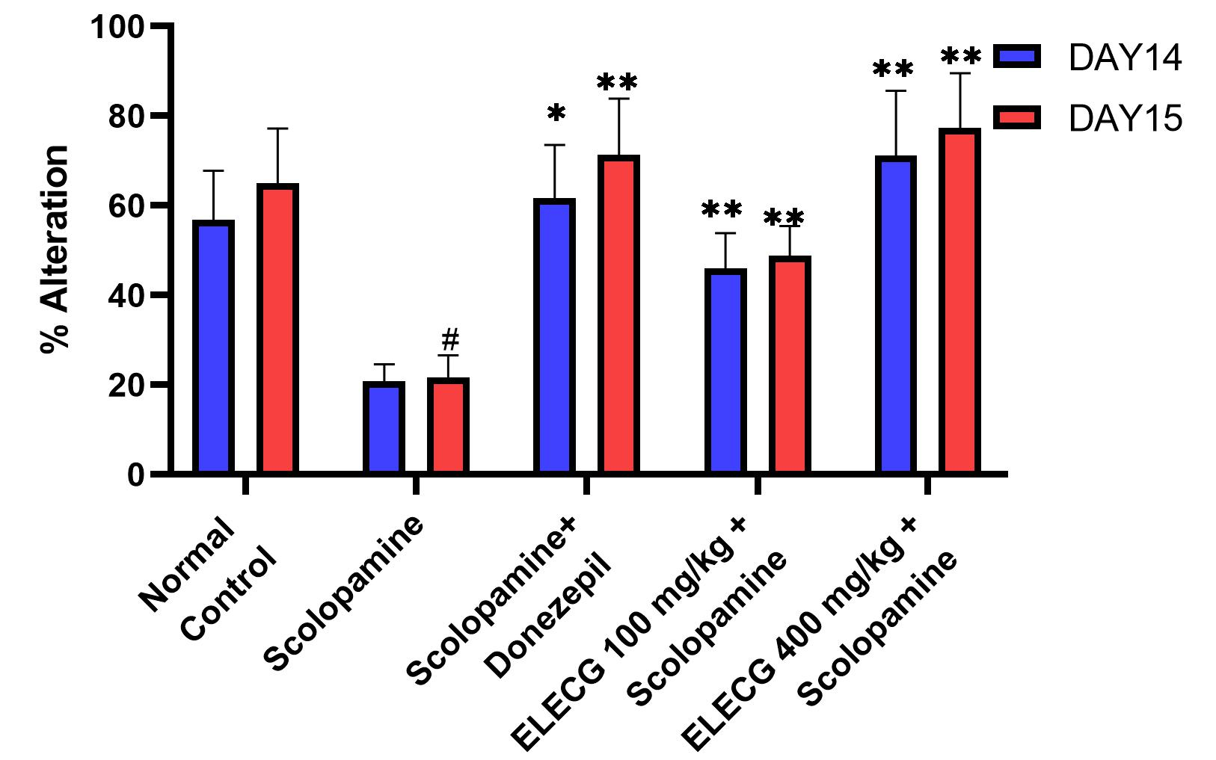
Graph 1: Effect of ELECG on the % Alteration by Y maze

Reduction of Aetylcholinesterase (AChE) enzyme by EELC
The results for AChE levels are shown in Graph 2. In the normal control group, scopolamine administration significantly increased brain AChE activity in mice compared to the control group. Donepezil treatment markedly decreased AChE activity (1.95 ± 0.08) compared to the disease control group. Similarly, ELECG produced a dose-dependent, significant reduction in AChE activity compared with the disease control group.
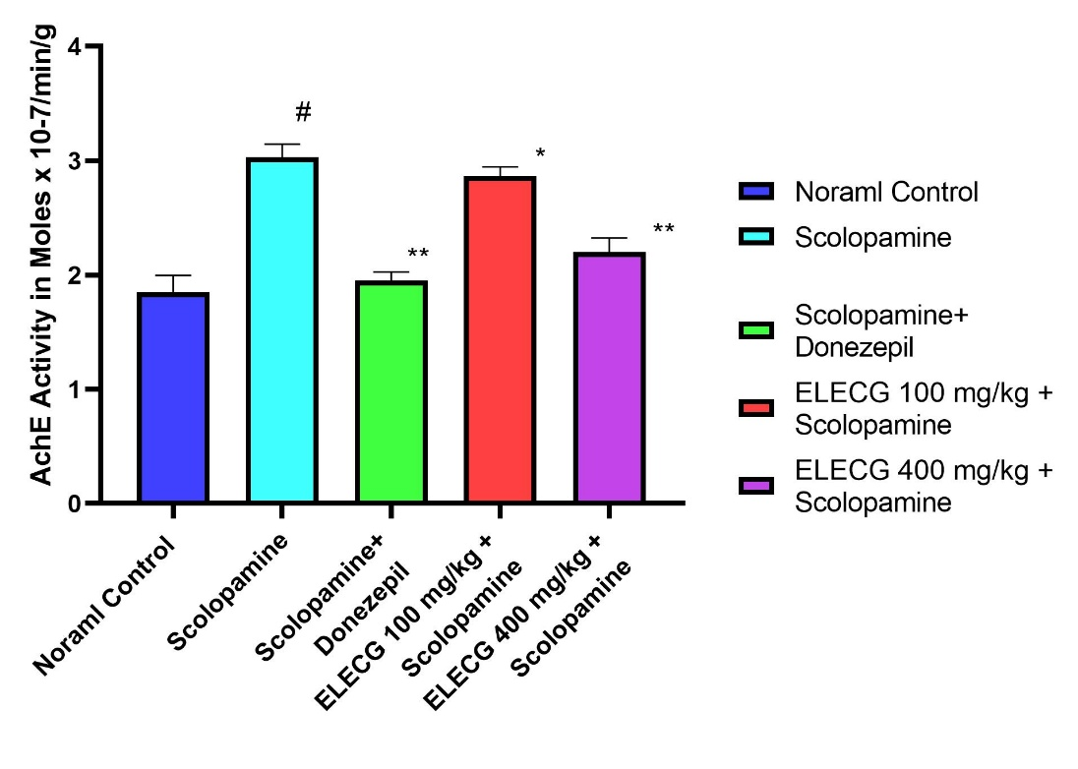
Graph 2: Effect of ELECG and donepezil on acetylcholinesterase (AChE) levels challenged with scopolamine.

DISCUSSION
Nootropics are drugs, also known as smart drugs, cognitive enhancers, supplements, functional foods, or nutraceuticals, that improve mental functions such as attention, concentration, motivation, intelligence, and memory. The other Nootropic agents are: Aniracetam, Fosracetam, Nefiracetam, Pramiracetam, Nebracetam and Oxiracetam, Deprenyl, Modafinil, Piracetam, Centrophenoxine, and Human growth hormone.
The current study aimed to explore the nootropic effect of the ethanolic leaf extract of Couroupita guianensis (ELECG) using different screening methods. To explore the nootropic activity, amnesia was induced by scopolamine at a dose of 1 mg/kg body weight to produce cognitive and memory changes [7,17]. First, the animals were trained for 1week for the elevated plus maze test, radial arm maze test, and Y maze test.
In the Elevated Plus Maze test, mice received ELECG (100 or 400 mg/kg, p.o.) or vehicle 30 min before placement in the open arm, and the transfer latency (time taken to enter a closed arm) was recorded. Shorter transfer latency reflects improved memory. Scopolamine produced a marked increase in transfer latency compared to the normal control, confirming its memory-impairing action via cholinergic blockade. In contrast, ELECG treatment significantly reduced transfer latency in a dose-dependent manner on both days 14 and 15, indicating protection of memory retention against scopolamine, with effects comparable to those of donepezil.
In the Radial Arm Maze test, animals were administered the standard drug donepezil for 14 consecutive days, and 24 h after the final dose (Day 15), amnesia was induced with scopolamine (1.4 mg/kg, i.p.). Reference Memory Errors (RME) were recorded when the animal entered an arm that never contained food, while Working Memory Errors (WME) were counted when the animal revisited an already explored arm within the same session[19,21]. These parameters reflect long- and short-term memory performance, respectively. After 60 minutes of scopolamine administration, each animal was exposed to the maze. Scopolamine markedly increased both RME and WME, confirming the induction of amnesia ^{[19]}. Treatment with ELECG reduced these errors in a dose-dependent manner on both days 14 and 15, demonstrating memory protection. This improvement was comparable to that observed with donepezil.
In the Y-maze test, the total number of arm entries and the number of positive alternations were recorded. Scopolamine markedly reduced spontaneous alternation behavior, indicating impaired spatial awareness and cognitive performance[19]. Treatment with ELECG (100 and 400 mg/kg) and donepezil significantly increased the percentage of alternations compared to the disease control group, demonstrating protection against scopolamine-induced memory deficits and improvement in short-term spatial memory.
Dose-dependent cognitive improvement with ELECG was consistently observed in the Elevated Plus Maze, radial arm, and Y-maze assessments on both days 14 and 15, suggesting sustained memory-enhancing effects. These behavioural findings were further supported by significant inhibition of AChE activity in mouse brain tissue. The cognitive enhancement produced by ELECG may be attributed to the diverse bioactive constituents present in Couroupita guianensis leaves, including alkaloids, flavonoids, glycosides, polyacetylenes, triterpenoids, phenolic acids, saponins, sterols, and sesquiterpene lactones

CONCLUSION:
The present study demonstrated that the ethanolic leaf extract of Couroupita guianensis exhibits significant nootropic activity in a scopolamine-induced cognitive dysfunction model. Scopolamine caused pronounced impairments in learning, memory acquisition, retention, and consolidation, whereas treatment with the extract markedly improved cognitive performance in a dose-dependent way. These results indicate that the memory-enhancing effects of the extract may be linked to cholinergic modulation. The observed neuroprotective and cognitive benefits are likely associated with its diverse phytoconstituents, including alkaloids, flavonoids, glycosides, polyacetylenes, triterpenoids, and phenolic acids. Although behavioural and biochemical evaluations were performed in this study, further research is needed to isolate and characterise the active constituents of Couroupita guianensis and to confirm its therapeutic potential in dementia and related neurocognitive disorders.

COMPETING INTERESTS DISCLAIMER:
Authors have declared that they have no known competing financial interests OR non-financial interests OR personal relationships that could have appeared to influence the work reported in this paper.

REFERENCES

Alzheimer’s disease facts and figures. (2024). Alzheimer’s & Dementia : The Journal of the Alzheimer’s Association, 20(5), 3708–3821. https://doi.org/10.1002/ALZ.13809

Breijyeh, Z., & Karaman, R. (2020). Comprehensive Review on Alzheimer’s Disease: Causes and Treatment. Molecules, 25(24), 5789. https://doi.org/10.3390/MOLECULES25245789

Chandana, Y., Suchitra, M., & Chandra, Y. P. (2025). A potential review on Couroupita guianensis aubl: A sacred botanical treasure of India, known for its numerous medicinal uses. Journal of Pharmacognosy and Phytochemistry, 14(5), 563–570. https://doi.org/10.22271/PHYTO.2025.V14.I5G.15620

Chiranthanut, N., Lertprasertsuke, N., Srisook, E., & Srisook, K. (2022). Acute and subchronic oral toxicity assessment of extract from Etlingera pavieana rhizomes. Toxicology Reports, 9, 1472. https://doi.org/10.1016/J.TOXREP.2022.07.005

CNS pharmacology and clinical therapeutic effects of oxiracetam - PubMed. (n.d.). Retrieved December 2, 2025, from https://pubmed.ncbi.nlm.nih.gov/3594458/

Cordner, Z. A., & Tamashiro, K. L. K. (2015). Effects of high-fat diet exposure on learning & memory. Physiology and Behavior, 152, 363–371. https://doi.org/10.1016/j.physbeh.2015.06.008

Gallistel, C. R., & Balsam, P. D. (2013). Time to rethink the neural mechanisms of learning and memory. Neurobiology of Learning and Memory, 0, 136. https://doi.org/10.1016/J.NLM.2013.11.019

Gupta, V. H., Gunjal, M. A., Wankhede, S. S., Deshmukh, V. S., & Juvekar, A. R. (n.d.). Neuropharmacological Evaluation of the Methanolic Extract of Couroupita guianensis Aubl. Flower in Mice. International Journal of Pharmaceutical and Phytopharmacological Research, 242(5), 242–246. Retrieved April 23, 2026, from www.eijppr.com

Hu, J., He, K., Yang, Y., Huang, C., Dou, Y., Wang, H., Zhang, G., Wang, J., Niu, C., Bi, G., Zhang, L., & Zhu, S. (2024). Amino acid formula induces microbiota dysbiosis and depressive-like behavior in mice. Cell Reports, 43(3), 113817. https://doi.org/10.1016/J.CELREP.2024.113817

Ito, L., & Yamamoto, H. (2022). Prediction of acute oral toxicity using the Hansen solubility parameter. Toxicology in Vitro : An International Journal Published in Association with BIBRA, 83. https://doi.org/10.1016/J.TIV.2022.105408

Kohler, J., Mei, J., Banneke, S., Winter, Y., Endres, M., & Emmrich, J. V. (2022). Assessing spatial learning and memory in mice: Classic radial maze versus a new animal-friendly automated radial maze allowing free access and not requiring food deprivation. Frontiers in Behavioral Neuroscience, 16, 1013624. https://doi.org/10.3389/FNBEH.2022.1013624/FULL

Kothari, S., & Sahu, M. (2022). Effect of aqueous extract of cynodon dactylon (doob grass) on normal and impaired memory in mice. Asian Journal of Pharmaceutical and Clinical Research, 130–133. https://doi.org/10.22159/AJPCR.2022.V15I9.45109

Latif, R., & Nawaz, T. (2025). Medicinal plants and human health: a comprehensive review of bioactive compounds, therapeutic effects, and applications. Phytochemistry Reviews 2025, 1–44. https://doi.org/10.1007/S11101-025-10194-7

Liu, T., Su, K., Cai, W., Ao, H., & Li, M. (2023). Therapeutic potential of puerarin against cerebral diseases: From bench to bedside. European Journal of Pharmacology, 953. https://doi.org/10.1016/j.ejphar.2023.175695

Matta, S., Sayyad Arshiya, M., Sai, D., Nallajerla, K., & Satapathy, D. K. (2026). Evaluation of the Nootropic Activity of the Ethanolic Leaf Extract of Neolamarckia cadamba in Experimental Animal Models. Journal of Drug Delivery and Therapeutics, 16(4), 1–7. https://doi.org/10.22270/JDDT.V16I4.7655

Mukherjee, S., Sen, S., Biswas, A., Barman, T., & Tripathi, S. (2015). Impact on behavioral changes due to chronic use of sertraline in Wistar albino rats. Indian Journal of Pharmacology, 47(6), 657–662. https://doi.org/10.4103/0253-7613.169590

ONAOLAPO, O. J. (2012). Elevated Plus Maze and Y-Maze Behavioral Effects of Subchronic, Oral Low Dose Monosodium Glutamate in Swiss Albino Mice. IOSR Journal of Pharmacy and Biological Sciences, 3(4), 21–27. https://doi.org/10.9790/3008-0342127

Pohanka, M., Hrabinova, M., Kuca, K., & Simonato, J. P. (2011). Assessment of Acetylcholinesterase Activity Using Indoxylacetate and Comparison with the Standard Ellman’s Method. International Journal of Molecular Sciences, 12(4), 2631. https://doi.org/10.3390/IJMS12042631

Pranav, J., & Joshi, P. C. (n.d.). A review on natural memory enhancers (Nootropics). Unique Journal of Engineering and Advanced Sciences, 2013(01), 8–18. Retrieved December 2, 2025, from www.ujconline.net

Redfern, J., Kinninmonth, M., Burdass, D., & Verran, J. (2014). Using Soxhlet Ethanol Extraction to Produce and Test Plant Material (Essential Oils) for Their Antimicrobial Properties. Journal of Microbiology & Biology Education, 15(1), 45. https://doi.org/10.1128/JMBE.V15I1.656

Rizi, A. A., Amjad, L., Shahrani, M., & Khoei, A. H. (2024). Investigating the Mechanisms Involved in Scopolamine-induced Memory Degradation. Archives of Razi Institute, 79(3), 555. https://doi.org/10.32592/ARI.2024.79.3.555

Rumzhum, N. N., Rahman, Md. M., & Islam, A. R.-U. (2012). CNS Depressant Effect of Crude Ethanolic Extract of Flowers of Couroupita guianensis Aubl. in Swiss-albino Mice. Research Journal of Pharmacy and Technology, 5(5), 615–618. https://indianjournals.com/article/rjpt-5-5-007

Singh, B., Day, C. M., Abdella, S., & Garg, S. (2024). Alzheimer’s disease current therapies, novel drug delivery systems and future directions for better disease management. Journal of Controlled Release, 367, 402–424. https://doi.org/10.1016/J.JCONREL.2024.01.047

Singh, S., Sapra, A., Kakkar, S., Bhan, M., & Jangra, A. K. (2022). To Evaluate In Vitro Acetylcholinesterase Inhibitory Activity of Various Indian Medicinal Plants. Asian Pacific Journal of Health Sciences, 9(2), 205–212. https://doi.org/10.21276/APJHS.2022.9.2.41

Test No. 420: Acute Oral Toxicity - Fixed Dose Procedure. (2002). OECD Guidelines for the Testing of Chemicals, Section 4. https://doi.org/10.1787/9789264070943-EN

Viña, J., Borras, C., Abdelaziz, K. M., Garcia-Valles, R., & Gomez-Cabrera, M. C. (2013). The Free Radical Theory of Aging Revisited: The Cell Signaling Disruption Theory of Aging. Antioxidants & Redox Signaling, 19(8), 779. https://doi.org/10.1089/ARS.2012.5111

Yu, H., Jeong, H., Yang, K. Y., Cho, J. Y., Hong, I. K., & Nam, S. H. (2021). Synthesis of ellagic acid glucoside using glucansucrase from Leuconostoc and characterization of this glucoside as a functional neuroprotective agent. AMB Express, 11(1). https://doi.org/10.1186/S13568-021-01265-X

