Advanced Technologies in Sportswear and Performance Textiles: A Comprehensive Review

Abstract
The rapid evaluation of sportswear has been driven by the integration of advanced textile technologies that have been designed to improve performance, comfort and functionality. The innovations in modern sports and performance textiles include engineered fibres, finishes made with nanotechnology, smart textiles and environmentally friendly processing methods. The technologies allow the creation of fabrics with enhanced moisture control, antimicrobial properties, thermal control, UV protection and mechanical characteristics. This review covers a detailed discussion of the main technological innovations in sportswear, their mechanisms, usage and impact on performance characteristics. Special focus is given to the emergent technologies such as wearable electronics, bio-based finishing systems that help in the development of multifunctional and environmentally sustainable textiles. The prospective approaches underscore the rising significance of intelligent, adaptive and environmentally friendly designs in designing the next generation sportswear. The paper will be useful in offering insights to researchers and industry experts in the efforts to develop high performance and sustainable sports textiles.
Keywords: Sportswear textiles, advanced technologies, smart textiles, nanotechnology, moisture management
1. Introduction
The global expansion of the sports and fitness sector which consequently has seen the growing demand of high-performance sportswear that has the ability to make the sporting industry more comfortable, functional and more efficient. Compared to traditional clothes, sport clothes are exposed to dynamic mechanical forces, constant sweats and different weather factors that require the implementation of a high level of textile technologies. Consequently, the sportswear of today has become a multi-purpose system incorporating material and surface engineering and intelligent technologies to address the demands of performance. Over the last few years, there has been a tremendous advancement in development of functional and performance textiles by advancement in fibre engineering, nanotechnology and finishing. High-level fibres whose cross-sections are modified and whose structures of fabrics are engineered to enhance breathability, elasticity and the movement of moisture. Also, the use of nanotechnology-based finishes has facilitated the integration of functional nanoparticles like silver, zinc oxide and titanium dioxide imbuing textiles with antimicrobial, UV-protective and self-cleaning properties (Gulati et al., 2022). Such innovations have greatly enhanced the longevity and performance of sportswear in extreme conditions of use.
The moisture management is also one of the most important performance parameters in the sportswear design. Recent textile technologies are based on capillary-driven wicking systems and hydrophilic/hydrophobic balance, which enable speedy transport of sweat, evaporation it and create thermal comfort. Moreover, antimicrobial technologies have also become popular because they can suppress the proliferation of microorganisms that cause odors. Recent review articles emphasize the growing trend towards both synthetic agents and bio-based materials, such as plant-derived extracts and biopolymers, to achieve sustainable antimicrobial finishing (Álvarez-Martínez et al., 2021). The introduction of smart fabrics and wearables is one of the major innovations in the sportswear. Such systems integrate sensors and electronic systems into textile designs to measure physiological data like heart rate, body temperature and physical activity. The recent reviews state that smart and wearable textiles are going to be a groundbreaking solution to improving athletic performance, injury prevention and real-time health monitoring (Islam et al., 2025). Alongside these advancements, there is a growing popularity of sustainable technologies with growing environmental concerns over traditional processing of textiles. To minimize the environmental impact of textile manufacturing, eco-friendly processes, such as bio-based finishing agents and waterless processes are actively being developed (Ghosh et al., 2025).
Despite these advancements, several challenges which remain in the extensive use of advanced textile technologies in sportswear despite these innovations. The problem of poor durability of functional finishes, expensive production and possible environmental and health hazards of some nanomaterials are also crucial challenges. Consequently, it needs to conduct ongoing research to come up with cost effective, long-lasting and sustainable solutions to the environment.
The purpose of this review is to thoroughly analyse the mechanisms, applications and effects of advanced technologies implemented in sportswear and performance textiles on their performance qualities. The focus on the latest trends in functional finishes, smart textiles and green technologies, as well as the problems and the perspectives of this actively developing sphere.
2. Advanced Fibre and Fabric Technologies
2.1 High-Performance Synthetic Fibres
The backbone of modern sportswear is synthetic fibres like polyester, nylon (polyamide) and elastane (spandex) that have better mechanical strength, elasticity and durability. These fibres are designed by a means of controlled polymer processing methods which allow fine adjustment of their physical and functional characteristics. They are very lightweight, have high tensile strength and wear resistance, which makes them very suitable in high-performance applications. Polyester is the most popular fibre in sportswear as it has very good dimensional stability, low moisture regains and fast drying properties. The recent developments in fibre engineering have added cross-sectional geometries like hollow fibres and multi-channel fibres, which improve the process of transporting moisture based on the capillary action and higher rate of evaporation. Such structural changes can greatly enhance thermos physiological comfort in the course of physical exercise (Basuk and Bait, 2018; Paul, 2015). Nylon (polyamide) has a high strength to weight ratio, flexibility and a high abrasion resistance, making it possible to use in sportswear applications that require durability like compression garments. Elastane is added in minimal amounts in order to provide high quality elasticity and recovery to allow the garments to follow the body motion without deformation. The combination of these fibres will lead to multifunctional fabrics, which will be strong, flexible and comfortable.
Moreover, synthetic textiles have also improved its performance greatly through the use of microfibre technology. Microfibres become larger in surface area because of their minute diameter and this enhances their moisture-wicking properties and softness. This will add to a higher level of comfort and performance in sportswear applications. Moreover, the recent advancements in functional fibre modification, such as the addition of additives and surface treatment, have made it possible to create fibres that have antimicrobial and UV-protective qualities (Paul, 2015).
2.2 Engineered Fabric Structures
In addition to fibre composition, the structure of the fabric is also a very important factor in defining the performance properties of sportswear. Textile designs such as knitted, woven and nonwoven fabrics are engineered to achieve maximum breathability, flexibility, mechanical strength and moisture management.
Knitted fabrics are very common in sportswear because they are inherently elastic, soft and comfortable. Their circular nature gives them great stretch and recovery which enables the garments to fit the movements of the body. Also, knit fabrics are highly permeable to air, which increases ventilation and body temperature in physical activity (Spencer, 2001).
Woven fabrics have a lesser elasticity compared to knitted fabrics, but have better dimensional stability and strength. These materials are typically employed in areas of need where resistance to the external environment and durability is important like outer clothes and sports protective clothing. The development of the weaving technologies has made it possible to create lightweight woven fabrics with higher comfort and performance properties (Adanur, 2000).
The nonwoven fabrics are being employed in special sportswear uses because it is highly porous and permeable. Specifically, these fabrics are used in creating applications that need insulation, filtration or cushioning.
According to recent research, structural parameters of fabrics (porosity, thickness and yarn arrangement) play a huge role in determining the transport of moisture, thermal insulation and overall comfort. An example is meshing fabrics with open structures to increase airflow and spacer fabrics are made of two layers of fabrics attached by a three-dimensional structure, which offers better breathability, cushioning and moisture control (Dias, 2015). Additionally, bi-layer and multi-layer fabric structures have been designed to manage moisture and temperature regulation. These designs help to transfer the sweat efficiently between the inside surface and the outer one to achieve a high evaporation rate and thermal balance, which is crucial in high-performance sportswear (Paul, 2015).
3. Nanotechnology in Sportswear
Nanotechnology has greatly enhanced sportswear as it has made it possible to add nanoparticles like silver (Ag), zinc oxide (ZnO) and titanium dioxide (TiO₂) to the textile materials. Such nanoparticles confer functionality such as antimicrobial effect, UV protection and self-cleaning, without negative impact on fabric comfort or breathability. They are very reactive due to their high surface area and can be used in low concentrations (Dastjerdi and Montazer, 2010). Silver nanoparticles are also commonly used due to their high antimicrobial activity that is effective in controlling odor by preventing bacterial growth. Nanoparticles of zinc oxide and titanium dioxide have a role in UV protection, absorbing and scattering the harmful radiation and have some extra antimicrobial and photocatalytic effects. The sol-gel processing and plasma treatment are sophisticated nano finishing processes that increase adhesion of nanoparticles to textile substrates, which increases their durability and resistance to washing. These techniques offer a durable functionality effect with little effect on the fabric characteristics compared to the traditional technique.
Recent surveys point out that nanotechnology allows creating multifunctional sportswear through the integration of such characteristics as antimicrobial protection, UV resistance and enhanced durability within one fabric system (Yetisen et al., 2016). Nevertheless, issues related with the environment and safety of nanoparticles still exist and the research is still directed towards sustainable and biocompatible options.
4. Moisture Management and Thermal Regulation Technologies
4.1 Moisture-Wicking Systems
Moisture-wicking is a fundamental sportswear technology because it has a considerable impact on comfort, thermoregulation and even athletic performance. The purpose of these systems is to move the sweat off of the skin to the outer part of the fabric, where it is able to evaporate effectively. The process is mainly based on capillary action which is improved using engineered fibre structures, surface modifications and optimised fabric constructions (Mahalakshmi et al., 2024). Multi-layer fabric systems are commonly used in modern sportswear to provide excellent moisture management. In this type of system, the layers play a different role so as to facilitate the directional movement of moisture. The inner layer that is in direct contact with the skin is usually made of hydrophilic or modified fibres which quickly absorb sweat and the wicking process begins. The middle layer is a transport medium that spreads moisture over a greater surface area and increases the flow of capillary. The outer layer is engineered to encourage rapid evaporation, which can be through hydrophobic or fast-drying fibre which disperses moisture to the environment.
The effectiveness of such a layered system is determined by the fibre type, structure of the yarn, porosity of the fabric and surface energy gradients. More sophisticated fibre structures, such as microfibres or multi-channel cross-sections, have been shown to increase transport of moisture by increase surface area and capillary pathways (Huaxiong et al., 2008). Consequently, the systems keep the skin dry, cut skin irritation and enhance overall thermo physiological comfort during exercise.
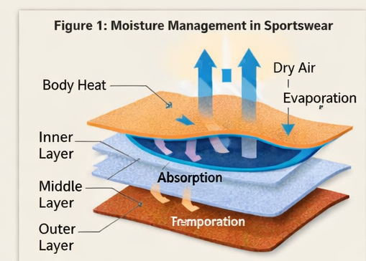
Fig 1- Moisture-wicking Technology

4.2 Phase Change Materials (PCMs)
Phase Change Materials (PCMs) are a new high-tech way of thermal management in the sportswear industry, which allows them to actively regulate the exchange of heat through the body and the environment. The materials work by capturing, storing and releasing latent heat when changing phase, which is usually solid and liquid phases. PCMs take up surplus heat to melt when the body temperature goes up and when it goes down, it solidifies and releases stored heat, so that the body temperature remains constant (Mondal, 2008). PCMs are commonly used in sportswear applications, where they may be embedded in layer textile systems in order to achieve the best possible effects. The inner layer is comfortable and it enables the body heat to pass over to PCM layer. The active thermal component is a PCM-embedded layer and includes microencapsulated PCMs embedded in fibres or coatings. This layer controls the temperature by storing and giving out the heat when needed. It has an outer layer that serves as a protective barrier and allows the transfer of heat to the surrounding environment and is breathable and durable.
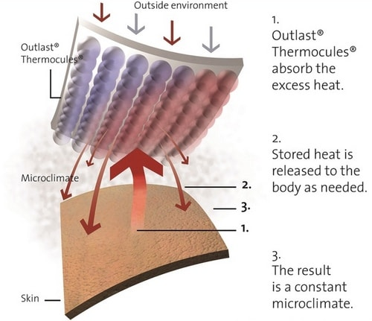
Fig 2- Phase Change Materials (PCMs) Technology
Microencapsulation methods also guarantee that PCMs can be used and washed again and again. PCM-integrated textiles are sensitive to the performance of the encapsulation, distribution of the proofs in the fabric and thermal capacity of materials. Recent research results have shown that these systems contribute greatly to thermal comfort especially with varying weather conditions (Salaün et al., 2010).
5. Antimicrobial and Hygiene Technologies
Antimicrobial finishes are very important in ensuring that a sportswear is hygienic and does not cause odors due to the growth of bacteria and other microorganisms that grow well in wet conditions. These finishes act in many ways depending on the kind of antimicrobial agent applied. Metallic nanoparticles and especially silver nanoparticles have extensive applications in the field of antimicrobial agents because of their high and extended spectrum of antimicrobial usage. They do so by liberating silver ions, which react with the cell membranes of microbes, disorganize the enzymatic systems and disrupt the replication of DNA and eventually cause the cell death (Rai et al., 2009; Dastjerdi and Montazer, 2010).
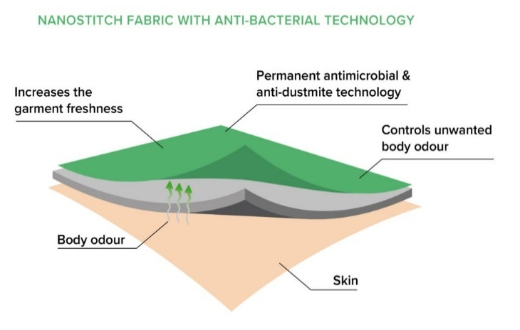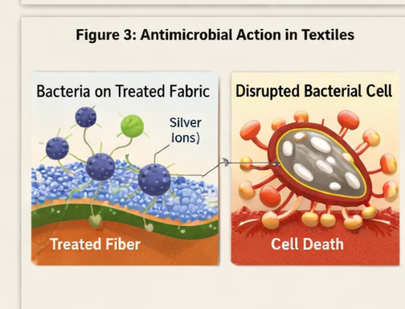
Fig 3- Anti-bacterial Technology
Quaternary ammonium compounds (QACs) are another significant group of antimicrobial agents, which acts by interfering with cell membrane integrity of microorganisms by electrostatic interactions, resulting in cellular leakage and cell lysis (Simoncic and Tomsic, 2010). Besides synthetic agents, there has been an augmented focus on bio-based antimicrobial finishes like chitosan and plant extracts. Chitosan, a natural biopolymer, has antimicrobial effects because of its polycationic structure, which enables the polymer to bind negatively charged microbial cell walls and change their permeability and prevent the growth of microorganisms (Gao and Cranston, 2008). These antimicrobial agents can be applied to textile by either padding, coating or adding the fibres during the manufacturing process. Most recent works are aimed at increasing the longevity of antimicrobial finishes, by making them cling to the textile substrate, which will allow them to remain functional despite repeated laundering. Altogether, antimicrobial technologies are important to the contemporary performance textiles as they can increase the hygiene, durability and user comfort of sportswear.
6. Smart Textiles and Wearable Technologies
Smart textiles are an important improvement in sportswear where electronic devices, sensors and conductors are embedded into textile designs, which allow real-time measurement of physiological and environmental conditions. These fabrics operate based on integrated sensing devices to pick up measurements like heart rate, body temperature, movement and muscle activity and relay them to external devices to be analysed (Stoppa and Chiolerio, 2014).
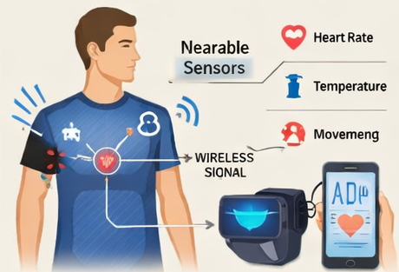
Fig 4- Smart textiles in sportswear

The principles of smart textile operation include the use of conductive fibres, flexible sensors and microelectronic elements in the material. These sensors transform physical or physiological events into electrical impulses which are interpreted and processed with integrated circuits or wearable devices attached. As an example, strain sensors on clothes can be used to detect body movements and thermal sensors on clothes can be used to detect thermal conditions at the skin surface (Cherenack and van Pieterson, 2012). Another way in which wearable technologies improve sports performance is through real-time feedback, which allows athletes to check their physical state and training plans to be optimized. Smart clothing data can also be wirelessly sent to smartphones or monitoring systems and provide the opportunity to analyse performance indicators in detail and prevent fatigue or injuries. Flexible electronics, energy storage systems, have also allowed the creation of lightweight and comfortable smart clothes without reducing their wearability (Heo et al., 2018).
Recent studies highlight the increasing convergence of smart textiles and artificial intelligence and data analytics, allowing predictive performance monitoring and custom training solutions. Although such improvements have taken place, issues like durability, washable, power source and price are important factors that should be considered when implementing smart sportswear technologies on a large scale.
7. Sustainable Technologies in Sportswear
The increasing environmental issues and the regulatory forces have hastened the advancement of sustainable technologies in sportswear fabrics. Traditional textile treatment is linked with a lot of water usage, use of chemicals and pollution, which led to the transition to eco-friendly options. Sustainable solutions are based on biodegradable fibres, dyes that are environmentally safe to use and methods of processing that consume fewer resources (Muthu, 2020).
Alternatives to petroleum-based synthetics are increasingly considered biodegradable materials like polylactic acid (PLA) and cellulose-based regenerated materials. These materials cause less environmental effects but still acceptable mechanical and comfort properties. Moreover, green dyeing processes, such as natural dyes and less harmful artificial dyes, assist in reducing the release of toxic effluents and energy use (Sandin and Peters, 2018). Waterless and low-water finishing technologies have also gained importance. The textile surface is altered by plasma treatment without water and dangerous chemicals and its wettability and adhesion properties are enhanced (Kan, 2015). Likewise, supercritical carbon dioxide (CO₂) dyeing does not require water and minimizes chemical waste and thus is a sustainable alternative to traditional dyeing techniques (Agrawal, 2015).
Moreover, bio-based finishes, which are based on plant extracts, enzymes and natural polymers are gaining popularity as an environmentally friendly substitute to the traditional chemical treatment. These finishes have the functional benefits of antimicrobial activity and UV protection and are biodegradable and less toxic. In general, sustainable textile technologies strive to achieve a balance between high performance and environmental responsibility.
8. Challenges and Limitations
Although there have been tremendous improvements in the sportswear technologies, there are still a number of challenges. The high cost of advanced materials, nanotechnology-based finishes and smart textile systems is one of the greatest drawbacks as it limits large-scale commercialization. The other major issue is that of the low durability of functional finishes. Other properties like antimicrobial activity and moisture management can degrade with repeated laundering and decrease performance over time. Enhancing the adhesive power of functional agents and textile substrates is thus crucial. Nanomaterials have some serious environmental and health issues as well. During washing and disposal, the release of nanoparticles can cause the possible ecological and toxicological risks (Nowack and Bucheli, 2007; Keller et al., 2013). These issues raise the challenges of safer and greener nanomaterials.
Also, it is difficult to integrate various functionalities in a single textile system. Integrating characteristics like moisture control, thermal control and antimicrobial functionality without affecting the comfort, breathability and durability is a major technical challenge.
9. Future Perspectives
The future trends in sportswear textile are anticipated to be on adoption of cutting-edge technologies as well as sustainability and improved functionality. One of the key trends is the incorporation of artificial intelligence (AI) and data-driven systems into wearable textiles. These intelligent clothes can offer real-time tracking, anticipatory data and customized responses that allow athletes to excel more and avert injuries.
Another significant trend is the creation of completely biodegradable and sustainable materials. It is also becoming the subject of research to consider bio-based polymers, recyclable fibres and circular textile systems that minimize environmental impact without compromising performance levels (Muthu, 2020). Additionally, the sportswear of the future will focus on multifunctional performance, where a single material system can be used to deliver moisture management, antimicrobial protection, thermal regulation and mechanical longevity at the same time. This integration is likely to be supported by the advances in material science and hybrid technologies of finishing. Enhancing the longevity and affordability of cutting-edge textile technologies is also a significant concern. There are also efforts being made in scalable production techniques, greater stability of functional finishes and lower production costs to help make high-performance sportswear more affordable. Furthermore, flex electronics and wearable systems combined with smart textiles are also anticipated to enhance the potential of the next-generation sportswear (Hughes-Riley et al., 2018).
10. Conclusion
The textile technology in the sportswear industry has evolved to stop at the traditional textile that is now more of a performance-based system combining functionality on various levels. The focus of modern innovations is not on the mechanical and comfort qualities but on the capability of textile to communicate with the human body and environment, through the regulation of moisture, thermal condition and intelligent characteristics. The significant change has been the movement towards the multifunctional and adaptive textiles where various technologies are integrated to achieve maximum performance. Meanwhile, the growing environmental awareness is prompting the use of sustainable materials and environmentally friendly processing techniques where there should be a trade-off between performance and environmental responsibility.
Although these innovations have been made, issues affecting durability, cost and technology complexity still exist. The next advancement will hinge on the formation of scalable, efficient and sustainable solutions that will provide a predictable performance. All in all, further incorporation of innovative materials and intelligent technologies is likely to influence the next generation of sportswear, which will be more efficient, responsive and environmentally friendly.
References
Adanur, S. (2000). Handbook of Weaving (1st ed.). CRC Press. https://doi.org/10.1201/9780429135828
Agrawal, B., J. (2015). Supercritical Carbon-dioxide Assisted Dyeing of Textiles: An Environmental Benign Waterless Dyeing Process. International Journal of Innovative Research and Creative Technology, 1(2), 201-206.
Álvarez-Martínez, F. J., Barrajón-Catalán, E., Herranz-López, M. and Micol, V. (2021).
Antibacterial plant compounds, extracts and essential oils: An updated review on their effects and putative mechanisms of action. Phytomedicine, 90, 153626.
Basuk, M. and Bait, S. (2018). Moisture management properties of textiles and their evaluation. International Dyer, 48-54.
Cherenack, K. and van Pieterson, L. (2012). Smart textiles: Challenges and opportunities. Journal of Applied Physics, 112(9), 091301.
Dastjerdi, R. and Montazer, M. (2010). A review on the application of inorganic nano-structured materials in textiles Focus on Anti-Microbial Properties. Colloids and Surfaces B: Biointerfaces, 79(1), 5–18.
Dias, T. (2015). Electronic Textiles: Smart Fabrics and Wearable Technology. Woodhead Publishing. https://doi.org/10.1016/C2013-0-16390-8
Gao, Y. and Cranston, R. (2008). Recent advances in antimicrobial treatments of textiles. Textile Research Journal, 78(1), 60–72. https://doi.org/10.1177/0040517507082332
Ghosh, J., Rupanty, N. S., Noor, T., Asif, T. R., Islam, T. and Reukov, V. (2025).
Functional coatings for textiles: Advancements in flame resistance, antimicrobial defense and self-cleaning performance. RSC Advances, 15(14), 10984–11022.
Gulati, R., Sharma, S. and Sharma, R. K. (2022). Antimicrobial textile: Recent developments and functional perspective. Polymer Bulletin, 79, 5747–5771. https://doi.org/10.1007/s00289-021-03826-3
Heo, J. S., Eom, J., Kim, Y. H. and Park, S. K. (2018). Recent Progress of Textile-Based Wearable Electronics: A Comprehensive Review of Materials, Devices and Applications. Small, 14(3), 1703034.
Huaxiong, H., Changhua, Y. and Weiwei, S. (2008). Moisture transport in fibrous clothing assemblies. Journal of Engineering Mathematics, 61(1), 35-54.
Hughes-Riley, T., Dias, T. and Cork, C. (2018). A historical review of the development of electronic textiles. Fibres, 6(2), 34. https://doi.org/10.3390/fib6020034
Islam, M. T., Hosen, M. I., Islam, T., Mamun, M. A. A. and Islam, T. (2025).
Advancements in functional smart and wearable textiles for sportswear applications. RSC Advances, 15, 50206–50232. https://doi.org/10.1039/D5RA07231
Kan, C. W. (2015). Plasma treatments for textile materials. Textile Progress, 47(1), 1–42.
Keller, A. A., McFerran, S., Lazareva, A. and Suh, S. (2013). Global life cycle releases of engineered nanomaterials. Journal of Nanoparticle Research, 15, 1692.
Mahalakshmi, V., Pachiayappan, K. M., Prakash, C. and Rajwin, A. J. (2024). Influence of plasma treatment on moisture management properties of cotton/polyester knitted fabrics. Polym. Bull. 81, 1291–1302.
Mondal, S. (2008). Phase change materials for smart textiles – An overview. Applied Thermal Engineering, 28(11–12), 1536–1550. https://doi.org/10.1016/j.applthermaleng.2007.08.009
Muthu, S. S. (2020). Assessing the environmental impact of textiles and clothing supply chain. Woodhead Publishing.
Nowack, B. and Bucheli, T. D. (2007). Occurrence, behavior and effects of nanoparticles in the environment. Environmental Pollution, 150(1), 5–22.
Paul, R. (2015). Functional Finishes for Textiles: Improving Comfort, Performance and Protection. Woodhead Publishing.
Rai, M., Yadav, A. and Gade, A. (2009). Silver nanoparticles as a new generation of antimicrobials. Biotechnology Advances, 27(1), 76–83.
Salaün, F., Devaux, E., Bourbigot, S. and Rumeau, P. (2010). Development of Phase Change Materials in Clothing Part I: Formulation of Microencapsulated Phase Change. Textile Research Journal, 80(3):195-205.
Sandin, G. and Peters, G. M. (2018). Environmental impact of textile reuse and recycling – A review. Journal of Cleaner Production, 184, 353–365.
Simoncic, B. and Tomsic, B. (2010). Structures of novel antimicrobial agents for textiles. Textile Research Journal, 80(16), 1721–1737.
Spencer, D. J. (2001). Knitting Technology: A Comprehensive Handbook and Practical Guide. Woodhead Publishing.
Stoppa, M. and Chiolerio, A. (2014). Wearable electronics and smart textiles: A critical review. Sensors, 14(7), 11957–11992.
Yetisen, A. K., Qu, H., Manbachi, A., Butt, H., Dokmeci, M., Hinestroza, J., Skorobogatiy, M., Khademhosseini, A. and Yun, S. H. (2016). Nanotechnology in textiles. ACS Nano, 10(3), 3042–3068.

