Original Research Article
Effect of Land Use Change on Vegetation Change in Ezza South Local Government Area, Ebonyi State, Nigeria

ABSTRACT
This study examines the spatiotemporal dynamics of land use and vegetation change in Ezza South Local Government Area (LGA), Ebonyi State, Nigeria, between 2000 and 2024 using geospatial techniques. Multi-temporal satellite imagery from the Sentinel-2 (Google Dynamic World dataset) and Landsat archives was analyzed within the Google Earth Engine (GEE) platform to generate Land Use/Land Cover (LULC) maps and assess long-term vegetation health through the Normalized Difference Vegetation Index (NDVI). The results reveal significant landscape transformation characterized by extensive deforestation, rapid agricultural expansion, and increasing urbanization. Forest cover declined sharply, largely converted to farmland, while built-up areas expanded steadily in response to population growth and socio-economic pressures. NDVI trends showed strong seasonal variability but no long-term greening, underscoring the stress on vegetation health and ecological stability. The findings highlight the critical role of anthropogenic drivers such as agriculture, urbanization, and mining in shaping environmental change. This research contributes timely spatial evidence for policymakers, land managers, and environmental agencies, emphasizing the need for sustainable land management, reforestation, and integrated urban planning to mitigate further degradation and ensure ecological resilience in Ezza South.
Key words: Vegetation, Land use, Deforestation, Land cover, Ezza South
HIGHLIGHTS
This study utilizes a descriptive and retrospective geospatial technique to assess the changing land use and vegetation patterns in Ezza South Local Government Area (LGA) of Ebonyi State, Nigeria and identifies significant transformations in the landscape, primarily driven by rapid population growth, increased agricultural activities, urbanization, and other anthropogenic pressures, leading to shifts in land cover types and varying vegetation health trends over the 24-year period.
1.0 INTRODUCTION
Land use and vegetation change are key indicators of the environmental and socio-economic health of a region. Land use refers to the ways in which land is employed for different purposes. Land is a ﬁnite natural resource that supports life on Earth, and its conservation and efﬁcient utilization is vital. Vegetation changes act as a driver for changing habitat and cause disturbance in ecosystem conditions and performance (Gebrehiwot, Tola, 2023). forest cover change is an inescapable occurrence worldwide (Igu et. al, 2021). However, the burgeoning human population and global economic growth is strongly increasing the demand for land resources and changing the dynamics of land use (Adepoju et. al 2025). As a result of land use, and habitat loss, global vegetation has changed dramatically over the past 18,000 years (Mottl et al. 2021; Li et al. 2022). In most developing countries, like Nigeria, vegetation cover is regarded as an open-access resource (Osemeobo 1991), which can therefore be overexploited in the present with no regard for the needs of future generations (Klee et al. 2000; Hula 2010; Kankara 2013). There is a decline in plant diversity in the dry forests of Nigeria, which are important sources of fruit, food, and medicinal resources and are under threat from climate change (abdulhakim et al. 2017). It involves human activities and practices that take place on a particular area of land, encompassing various purposes such as residential, commercial, industrial, agricultural, recreational, or conservation activities (Duru et. al, 2024) In Ezza South Local Government Area (LGA) of Ebonyi State, Nigeria, these patterns have undergone significant changes over the years, driven by factors such as population growth, agricultural expansion, urbanization, and deforestation. Ezza South, which is predominantly rural, relies heavily on agriculture as the primary source of livelihood, with crops such as yam, cassava, and maize being cultivated.
Ezza South Local Government Area (LGA) in Ebonyi State, Nigeria, has experienced significant changes in land use and vegetation patterns over the years. These changes are primarily driven by human activities, such as agricultural expansion, urbanization, and deforestation as the population in the area grows, there is increasing pressure on the land for farming, settlement, and infrastructure development, which often leads to the conversion of forested areas into cultivated land or urban spaces. Humans have been altering land for food and essential resources for millennia, the extent of land use has escalated significantly since the early 20th century (Mondal & Zhang, 2018). These alterations have been extensive, resulting in an increase of agricultural land, human population, economic production, energy consumption, and an increase in carbon dioxide emissions (Olorunfemi et al. 2020). The main course of vegetation changes in Ezza South of Ebonyi state is deforestation. As the population grows, there is a rising demand for agricultural land, leading to the clearing of forests for farming. This practice, while economically beneficial in the short term, has long-term consequences such as biodiversity loss serious environmental concern such as pollution, desertification, erosion, drought and flooding etc, has been linked to deforestation and industrial activities (Olowoyeye, 2021).
Land use refers to the various ways in which human beings utilize the land and its resources, including agriculture, settlement, infrastructure, and industrial development. Vegetation, on the other hand, encompasses the plant life or flora found in a particular area. It plays a vital role in ecological balance by supporting biodiversity, regulating the water cycle, controlling erosion, and contributing to carbon sequestration (FAO, 2010). When land use changes - through activities such as farming, construction, deforestation, or mining, it often leads to corresponding changes in vegetation patterns and coverage. Unlike land cover, which includes all physical features on the Earth's surface (such as water bodies, bare soil, and buildings), vegetation is a biological and ecological component that is directly influenced by how land is used. For instance, the expansion of farmlands or urban settlements often leads to the clearance of forested areas, grasslands, or other vegetated surfaces, resulting in vegetation loss or alteration. In areas like Ezza South, changes in land use practices over time whether due to population growth, agricultural pressure, or infrastructural development have likely led to noticeable shifts in the quantity and quality of vegetation. The study of land use and vegetation change is essential for understanding environmental degradation, habitat loss, and climate variability at the local level. Vegetation acts as a natural buffer against climate extremes and soil erosion, but when altered due to unsustainable land use practices, it can contribute to flooding, desertification, and loss of ecosystem services (Jimoh et al., 2012). Therefore, monitoring vegetation change is crucial for assessing the environmental impacts of human activities and guiding land management policies. Remote sensing has become a powerful tool for tracking land use and vegetation change over time. Through satellite imagery analysis, researchers are able to detect spatial and temporal changes in vegetation cover, assess the extent of human influence, and identify critical areas in need of conservation or restoration. This method is particularly useful in regions like Ezza South, where consistent field observation over extended periods may not be feasible. Remote sensing provides both a visual and quantitative basis for evaluating vegetation trends resulting from human land use decisions (Makinde & Badejo, 2015). By focusing on vegetation rather than broader land cover categories, this study aligns more closely with ecological realities and management concerns. It emphasizes the importance of preserving natural vegetation amidst growing anthropogenic pressures and highlights the need for sustainable land use planning.
Vegetation is a fundamental component of terrestrial ecosystems, providing essential ecosystem services such as carbon sequestration, biodiversity support, climate regulation, and protection of soil and water resources (FAO, 2010; Van der Werf et al., 2009). Forests, wetlands, grasslands, and other vegetative ecosystems serve as buffers against natural hazards and contribute to environmental stability at global and regional levels. Vegetation also plays a crucial role in the hydrological cycle by enhancing water infiltration, reducing surface runoff, and maintaining groundwater recharge. It helps regulate microclimates by providing shade, reducing temperature fluctuations, and enhancing evapotranspiration (Jimoh et. al, 2012). Moreover, vegetation provides vital habitats for various species, contributing to the preservation of biodiversity and ecological balance. However, in recent decades, there has been a dramatic decline in global vegetation cover, primarily due to human activities like agricultural expansion, deforestation, infrastructure development, and urbanization. Ellis (2011) noted that over 75% of the Earth's terrestrial biosphere has been altered by human actions, leading to the emergence of "anthropogenic biomes” landscapes dominated by human infrastructure and managed ecosystems. This transition has resulted in widespread ecological stress, habitat loss, and disruption of natural processes. The loss of vegetation, particularly through deforestation, significantly contributes to climate change by releasing stored carbon dioxide into the atmosphere. Van der Werf et al. (2009) highlighted that emissions from vegetation loss account for a substantial portion of anthropogenic greenhouse gases. These emissions not only contribute to global warming but also reduce the Earth's capacity to regulate atmospheric carbon, complicating efforts to mitigate climate change. In Nigeria, the impact of vegetation change is particularly significant. Unsustainable practices like shifting cultivation, logging, bush burning, and land clearing for housing and roads have led to widespread degradation of vegetative resources. Makinde and Badejo (2015) reported that urban development in areas like Ikorodu, Lagos State, has caused the continuous decline of vegetation cover, contributing to issues like increased flooding, soil erosion, and rising local temperatures. Additionally, converting vegetated areas into impervious surfaces leads to poorer air quality, disrupted rainfall patterns, and increased vulnerability to natural disasters. Without effective environmental policies and reforestation efforts, the loss of vegetation in Nigeria may contribute to long-term ecological and socio-economic instability.
Human activities are the primary drivers of vegetation change globally. These changes stem from a combination of socio-economic, political, and demographic factors. For example, rapid population growth increases the demand for food, shelter, and infrastructure, which often results in the conversion of vegetated areas into agricultural lands, housing, and urban infrastructure (Madulu, 2004; FAO, 2010). Urbanization is one of the dominant forces behind vegetation loss, particularly in developing countries like Nigeria. Land-use models also serve various purposes. They help achieve a better understanding of the urban dynamic system and also enable virtual experimentation, allowing the possible impacts of new infrastructures, technologies, or policies to be determined (Berglund 2014). As rural populations move to urban areas in search of better opportunities he demands for housing and services grows. This leads to the clearance of natural vegetation for construction projects. According to Orji and People (2015), land conversion due to urban sprawl in Nigeria often occurs without adequate consideration for environmental sustainability. Industrialization and infrastructural development also play a significant role in modifying vegetated landscapes. Projects like road construction, mining, and urban development lead to the widespread removal of vegetation. Often, these developments are carried out without comprehensive Environmental Impact Assessments (EIAs), increasing the risk of soil degradation, habitat destruction, and climate-related challenges (Makinde & Badejo, 2015). Poverty also drives unsustainable land use practices, particularly in rural areas where economic survival depends on the land. People may resort to practices like shifting cultivation, charcoal production, and timber extraction, further exacerbating vegetation loss and land degradation (Adeola et al., 2004). While climate variability is not inherently anthropogenic, it interacts with human-induced drivers to accelerate vegetation loss. Prolonged droughts, erratic rainfall, and flooding can worsen vegetation degradation, especially when combined with unsustainable farming practices or overgrazing (Ellis, 2011). Overall, vegetation change results from a complex interaction of economic pressures, policy failures, weak governance, and environmental factors. In places like Ezza South, the lack of effective land use management and enforcement mechanisms allows for indiscriminate land exploitation, which threatens vegetation cover and long-term ecological sustainability.
The aim of this study is to conduct a geospatial assessment of the of land use/land cover and vegetation health/change in Ezza South LGA from 2014 to 2024, in order to identify the primary patterns of change and providing recommendations for sustainable land management practices. To achieve this aim, the following objectives have been established:
(i) To generate and validate annual Land Use/Land Cover (LULC) maps for Ezza South LGA for the period 2014–2024 using Sentinel-2 imagery and the Google Dynamic World dataset. (ii). To quantify the primary LULC transitions between 2014 and 2024, specifically focusing on the rates of deforestation, agricultural expansion, and urbanization. (iii). To analyze the long-term trend in vegetation health and density from 2014 to 2024 by generating a Normalized Difference Vegetation Index (NDVI) time-series chart from the harmonized Landsat satellite archive. (iv). To synthesize the findings from the LULC and NDVI analyses to provide an integrated assessment of landscape change in the context of the region's known socio-economic and environmental pressures.
1.1 Study Area.
Ezza South is a Local Government Area located in Ebonyi State in south-eastern Nigeria. Its headquarters is Onueke, which also serves as a central town for the Ezza nation as well as the headquarters of Ebonyi Central senatorial zone. It is bounded in the north, south, east and west by Abakaliki, Onicha, Ezza North and Ikwo L.G.A. respectively. The people are predominantly of Igbo stock. They speak Ezza dialect and the central Igbo language. South-eastern Nigeria is an area in tropical African that is well known for high population growth rate and crude density, high rate of urbanization and poor agricultural resource base (Okafor.2005). Their major occupations are farming and trading as well as emerging civil servant class. It has an area of 324 km² and a population of 133,625 people based on 2006 census (National Population Census (NPC), (2006), (Brinkhoff 2013) and now estimated to be about 197,097 people using the national annual growth rate of 2.5 percent. Coordinates for Ezza South LGA are: 6.1777°N 8.0403°E
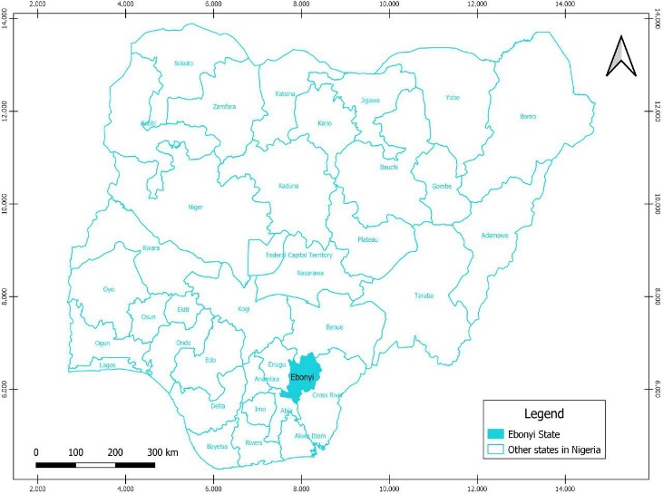
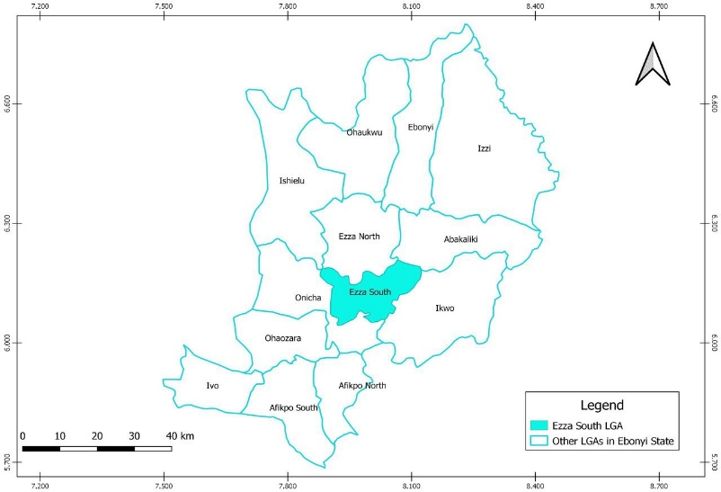
Fig.1: Map of Nigeria Showing Ebonyi State Fig. 2: Map of Ebonyi showing Ezza South LGA

2.0 MATERIALS AND METHODS

2.1 Research Design
This study employs a descriptive and retrospective geospatial research design. It utilizes a quantitative analysis of multi-temporal satellite imagery to systematically document, quantifies and analyses historical changes in land use/land cover (LULC) and vegetation health within Ezza South LGA from 2014 to 2024.
2.2 Types of Data
Primary and secondary data were used in this study. Primary data includes visits to the area, observations made, and interactions with farmers, and community leaders, stakeholders in the area during ground-truthing. Secondary data were collected from satellite (satellite image).
Sources of Data
The primary and secondary data used for the analysis were derived from two key satellite programs: Sentinel-2 for high-resolution LULC mapping and the Landsat program for long-term vegetation trend analysis and interactions with people in the area as well as review of available literature on the area.
Instrumentation
The primary data for the analysis were derived from two key satellite programs: Sentinel-2: Used for high-resolution LULC mapping. The Google Dynamic World dataset, which provides near real-time, 10-meter resolution classifications, leverages Sentinel-2 imagery. Landsat Program: Utilized for long-term vegetation trend analysis. This included harmonized data from Landsat 5 TM, Landsat 7 ETM+, Landsat 8 OLI, and Landsat 9 OLI-2. All data acquisition, preprocessing, and analysis were conducted within the Google Earth Engine (GEE) platform, a cloud-based computational platform designed for planetary-scale geospatial analysis.
Procedure for Data Collection
The study followed a descriptive and retrospective geospatial research design, focusing on quantitative analysis of multi-temporal satellite imagery in carrying out this research. More so, necessary consultations with the leaderships of the area were made and required permission granted. Safety and security measures were taken in the course of data collection, ground-truthing, and visits.
Data Acquisition and Preprocessing:
The administrative boundary of Ezza South LGA was imported into GEE as an Area of Interest (AOI) to filter and clip all satellite data for LULC analysis (2014–2024), the GOOGLE/DYNAMICWORLD/V1 Image Collection (from Sentinel-2) was filtered by date and spatially to the Ezza South AOI. A temporal aggregation technique, specifically the mode reducer, was applied to the time-series of the label band for each year to create a single, representative LULC map. For long-term vegetation trend analysis (2014–2024), Tier 1 Surface Reflectance collections from Landsat 5, 7, 8, and 9 were merged into a single, harmonized Image Collection. A function was created for cloud masking using the QA_PIXEL band in each Landsat image.
3.0 RESULTS AND DISCUSSION

3.1 Land Use Land Cover 2014-2024
The LULC analysis for the period 2014 to 2024 reveals a dynamic and rapidly transforming landscape in Ezza South. The classification results for the start and end years of the high-resolution analysis are summarized in Table 1, showing the area and percentage cover for each major LULC class.
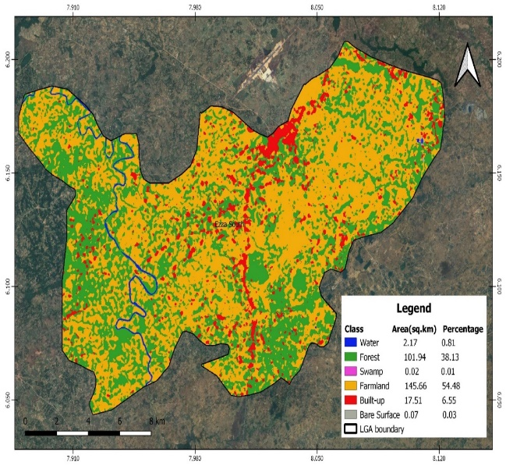 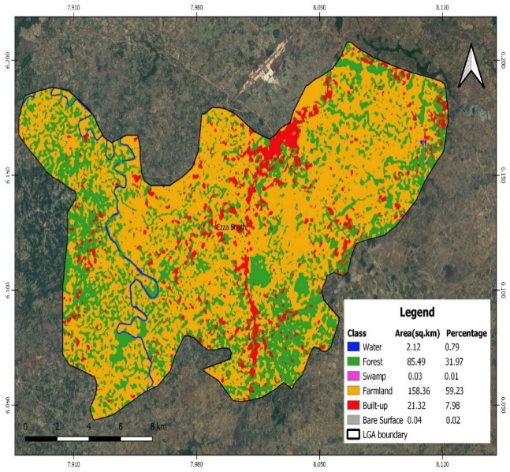Fig.3: LULC 2014 image for Ezza South LGA based on Sentinel-2 Fig. 4: LULC 2016 image for Ezza South LGA based on Sentinel-2
Figure 3 above shows the satellite image of Ezza South indicating the different land use classes like water bodies, forest, swamp, farmland, built-up area and bar surface for the year 2014. As shown in Table 1. Water bodies occupied 2.17km² while forest is 101.94km², swamp is 0.02km², farmland is 145.66km², built-up area is 17.51km² and bare surface is 0.07km².
Figure 4 above shows the satellite image of Ezza South indicating the different land use classes like water bodies, forest, swamp, farmland, built-up area and bar surface for the year 2016. The magnitude of the different classes as shown in table 1 are water bodies 2.12km² , forest is 85.49km², swamp is 0.03km², farmland is 158.36km², built-up area is 21.32km² and bare surface is 0.04km².
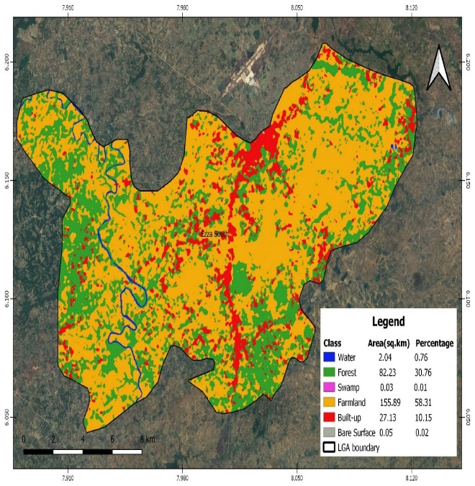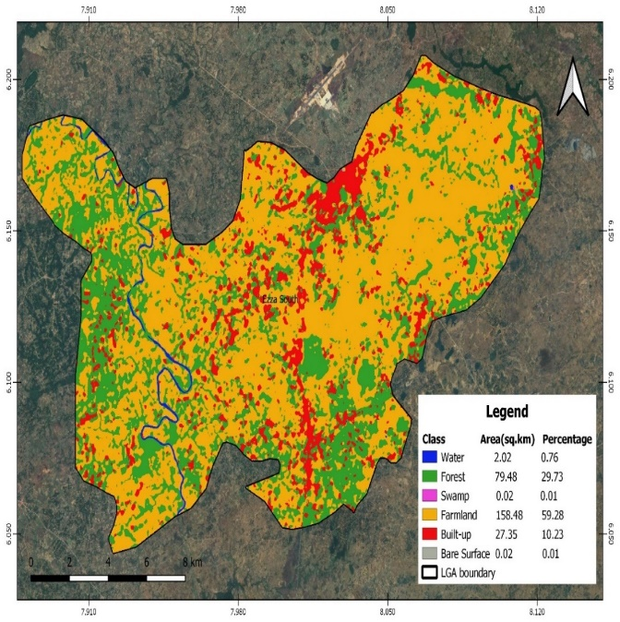
Fig.5: LULC 2018 Image for Ezza South LGA based on Sentinel-2 Fig.6: LULC 2020 Image for Ezza South LGA based on Sentinel-2

Figure 5 above shows the satellite image of Ezza South indicating the different land use classes like water bodies, forest, swamp, farmland, built-up area and bar surface for the year 2018. The magnitude of the different classes as shown in table 1 are water bodies 2.04km² , forest is 82.23km², swamp is 0.03km², farmland is 155.89km², built-up area is 27.13km² and bare surface is 0.02km².
Figure 6 above shows the satellite image of Ezza South indicating the different land use classes like water bodies, forest, swamp, farmland, built-up area and bar surface for the year 2020. The magnitude of the different classes as shown in table 1 are water bodies 2.02km², forest is 79.48km², swamp is 0.02km², farmland is 158.48km², built-up area is 27.35km² and bare surface is 0.02km².
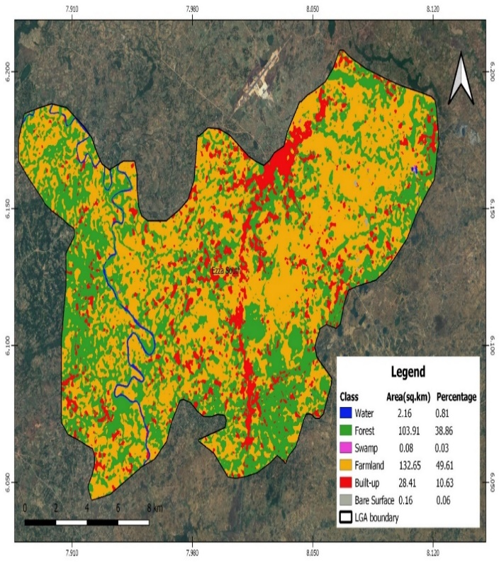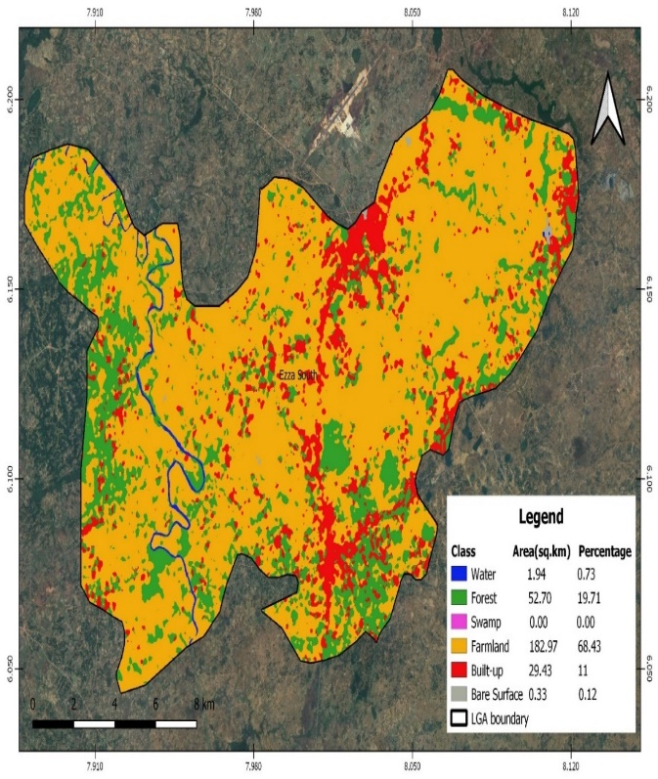
Fig. 7: LULC 2022 Image for Ezza South LGA based on Sentinel-2 Fig. 8: LULC 2024 Image for Ezza South LGA based on Sentinel-2

Figure 7 above shows the satellite image of Ezza South indicating the different land use classes like water bodies, forest, swamp, farmland, built-up area and bar surface for the year 2022. The magnitude of the different classes as shown in table 1 are water bodies 2.16km² , forest is 103.91km², swamp is 0.08km², farmland is 132.65km², built-up area is 28.41km² and bare surface is 0.16km².
Figure 8 above shows the satellite image of Ezza South indicating the different land use classes like water bodies, forest, swamp, farmland, built-up area and bar surface for the year 2024. The magnitude of the different classes as shown in table 1 are water bodies 1.94km² , forest is 52.7km², swamp is 0.01km², farmland is 182.97km², built-up area is 28.41km² and bare surface is 0.33km².
Table 1: LULC Distribution in Ezza South for 2014 to 2024
 |  | Land Use/Land Cover Class Area (km²)
S/N | Class/Category | (km²)  2014 | (km²)  2016 | (km²)  2018 | (km²)  2020 | (km²)  2022 | (km²)  2024
1 | Water | 2.17 | 2.12 | 2.04 | 2.02 | 2.16 | 1.94
2 | Forest | 101.94 | 85.49 | 82.23 | 79.48 | 103.91 | 52.7
3 | Swamp | 0.02 | 0.03 | 0.03 | 0.02 | 0.08 | 0.01
4 | Farm Land | 145.66 | 158.36 | 155.89 | 158.48 | 132.65 | 182.97
5 | Built-up | 17.51 | 21.32 | 27.13 | 27.35 | 28.41 | 29.43
6 | Bare Surface | 0.07 | 0.04 | 0.02 | 0.02 | 0.16 | 0.33

The most striking trend observed between 2014 and 2024 is the dramatic shift or changes that occur among the following variables: forest, farmland, built-up area and water bodies. Table 2 quantifies the net changes over this eight-year period by clearly showing the magnitude of change and the percentage of change that occur among the variables, and equally highlighting the primary trajectories of landscape transformation. Thus as seen in Table 2 below, water bodies decreased from 2.17km² in 2014 to 1.94km² in 2024 by (-0.016) representing 0.81 % change. Forest decreased from 101.94km² in 2024 to 52.7km² in 2024 by 49.24km² representing 48.3% change. Swamp experienced no significant change in magnitude. Farmland increased from 145.66km² in 2014 to 182.97km² in 2024 by 37.31km² representing 25.6% overall change during the period.
From Table 2 below it is clearly evident that farmland recorded the highest increase of 68.43% change in 2024 followed by forest with 19.71% and built-up area with 11%. This indicates that the vegetation change in Ezza South is driven by population growth as increase in farmland cultivation is geared towards food production for the growing number of people while forest is being rapidly transformed into farmland and built-up area with a view to catering for the increasing population of Ezza South which has grown by over 68% between 2006 and 2024.
Thus the impact or effect of land use change on vegetation change in Ezza South is significant, substantial ad portends serious threat to the ecosystems and livelihoods in the area if left unchecked. Efforts should be made deliberately to reduce the number of people in Ezza South that depend on forests and forest resources for livelihoods in order to reduce the pressure on forest resources and the overall land use in the area. Better agricultural practices that will enhance yields per unit of land cultivated should be encouraged, as well as public enlightenment on public health concerns particularly family planning. Women should be empowered and made to have choices regarding reproduction health.

Table 2: Magnitude of Change Between 2014 – 2024
S/N | Class/Category | 2014 (km²) | 2024 (km²) | Magnitude of Change (km²) | Percentage of change 2014 (%) | Percentage of change 2024 (%) | Percentage of change (%)
1 | Water | 2.17 | 1.94 | -0.106 | 0.81 | 0.73 | 0.098
2 | Forest | 101.94 | 52.7 | 49.24 | 38.13 | 19.71 | 0.483
3 | Swamp | 0.02 | 0 | 0.02 | 0.01 | 0.01 | 0
4 | Farmland | 145.66 | 182.97 | 37.31 | 54.48 | 68.43 | 0.256
5 | Built-up | 17.51 | 29.43 | 11.92 | 6.55 | 11 | 0.679
6 | Bare Surface | 0.07 | 0.33 | 0.26 | 0.03 | 0.12 | 3

Fig. 9: Percentage of change in 2014 Category based on Table 1 and 2 Fig.10: Percentage of change in 2024 Category based on Table 1 and 2

The results clearly indicate three dominant processes shaping the Ezza South landscape:
The most significant change was a drastic reduction in forest cover, with a net loss of 32.79 km². This represents a loss of over 38 percent of the forest area that existed in 2014.
Farmland emerged as the most rapidly expanding land use, gaining 24.61 km². This gain corresponds closely with the area of forest lost, suggesting a direct conversion of forested land to agricultural use. By 2024, farmland constituted over 68 percent of the entire LGA.
Built-up areas also showed significant growth, expanding by 8.11 km², an increase of approximately 38% from its 2016 extent. This points to a steady pace of urban and infrastructural development. Other changes were minor in comparison. Water bodies showed a slight decrease, and bare surfaces increased marginally, which could be linked to construction, erosion, or mining activities. The complete disappearance of the 'Swamp' class suggests it was either too small to be consistently classified or was converted to other uses.
3.2 Long-Term Vegetation Health Trend (2000–2024)
The long-term vegetation dynamics were assessed using a time-series of the Normalized Difference Vegetation Index (NDVI) from 2000 to 2024. The resulting line chart (Figure 13) plots the mean NDVI value for the entire Ezza South LGA for each available Landsat image over the 24-year period.
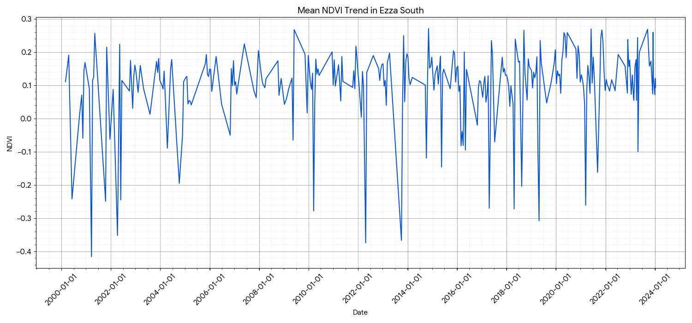 Fig. 11: Mean NDVI Trend in Ezza South based on earth blox

3.3 The NDVI time-series exhibits several key characteristics:
Strong Seasonality:
The chart displays a distinct and repeating cyclical pattern, with NDVI values typically peaking during the wet season (roughly April-October) and reaching a trough during the dry season (November-March). This reflects the natural phenological cycle of the derived savannah ecosystem, where vegetation flourishes with the onset of rains and senesces or becomes dormant during the dry, Harmattan-influenced months.
High Variability:
The mean NDVI values show considerable fluctuation, ranging from highs of approximately 0.27 to lows dipping into negative values.¹ While the positive values indicate periods of healthy, dense vegetation, the sharp negative spikes are likely attributable to atmospheric contamination (e.g., clouds, haze) that were not fully removed by the cloud-masking algorithm, or the presence of water bodies and bare surfaces within the pixels used to calculate the mean.
No Clear Long-Term Greening Trend:
Despite the seasonal peaks, the time-series does not show a consistent, long-term increasing trend (or "greening") over the 24-year period. The mean NDVI values appear to oscillate around a relatively stable, albeit highly variable, baseline. The absence of a positive trend, especially in the face of significant deforestation revealed by the LULC analysis, suggests that the expansion of seasonal croplands has not compensated for the loss of permanent, year-round forest cover in terms of overall vegetation density and health.
The results from both the LULC change analysis and the NDVI time-series provide a clear, data-driven narrative of landscape transformation in Ezza South, driven by powerful anthropogenic pressures. The findings are consistent with the research problem and align with established trends across Southeastern Nigeria. The most significant finding is the rapid conversion of forest to farmland. The loss of nearly 33 km² of forest in just eight years is a stark indicator of the immense pressure on land resources. This directly supports the hypothesis that agricultural expansion is a primary driver of environmental change in the region. This expansion is fuelled by the socio-economic reality of Ezza South: a growing population with a heavy dependence on subsistence agriculture. As the population increases, the demand for food and cultivable land rises, leading to the clearing of natural vegetation to create new farms. The steady growth of built-up areas by over 8 km² further corroborates the impact of population growth and urbanization. This trend is a hallmark of developing regions in Nigeria, where administrative centers like Onueke expand, consuming surrounding agricultural and natural lands for housing and infrastructure. This process fragments the landscape, reduces green spaces, and intensifies the pressure on the remaining agricultural land. The role of mining as an indirect driver, as proposed in the research problem, provides a crucial layer of context to these findings. While the LULC analysis primarily captures the direct conversion of forest to farm, the underlying reasons for this expansion may be more complex. Extensive lead-zinc mining in areas like Ameka is known to cause severe soil and water contamination with heavy metals, reducing soil fertility and crop yields. Farmers facing declining productivity on contaminated lands are likely forced to abandon them and seek new, fertile ground, which often means clearing virgin forest. Therefore, the observed deforestation is likely a combined result of population-driven demand and a desperate search for uncontaminated land, a cycle where one form of environmental degradation (mining pollution) catalyses another (deforestation). The NDVI analysis complements this narrative. The lack of a long-term greening trend, coupled with high variability, suggests an ecosystem under stress. While the expansion of agriculture adds seasonal greenness, the loss of permanent forest cover represents a net loss in year-round biomass, carbon storage, and ecological stability. The forest provides consistent, high NDVI values throughout the year, whereas cropland values are high only during the growing season and drop significantly after harvest, contributing to the high amplitude of the NDVI signal. The overall trend suggests that the landscape's ecological resilience is being eroded, not enhanced. In conclusion, the results paint a picture of a landscape caught between the competing demands of a growing population for food and settlement, and the degrading legacy of resource extraction. The conversion of forest to farmland is the dominant spatial process, driven by a combination of direct population pressure and indirect pressures from environmental degradation caused by mining. This transformation, confirmed by both high-resolution LULC mapping and long-term vegetation health analysis, underscores the urgent need for integrated land use planning and sustainable resource management to mitigate further environmental decline in Ezza South. The study, "Land Use and Vegetation Change in Ezza South, Ebonyi State, Nigeria (2014–2024), employed geospatial techniques to analyze land use and vegetation changes. Here's a breakdown of the methodology used: Sampling Size and Sampling Technique For the validation and accuracy assessment of the Land Use/Land Cover (LULC) classification, a minimum of 300 validation points was generated across the study area using a stratified random sampling design. This method ensured that all LULC classes were adequately represented within the validation sample.
4.0 CONCLUSIONS
The geospatial analysis reveals that Ezza South LGA has undergone substantial land use and vegetation dynamics between 2014 and 2024. The observed changes, particularly the expansion of built-up areas, agricultural lands, and a corresponding decrease in natural vegetation covers such as forests and grasslands, underscore the environmental pressures faced by the region. These transformations have significant implications for the local ecosystem, including potential impacts on biodiversity, soil erosion, water resources, and overall ecological balance. The continuous monitoring of these changes using remote sensing technologies is crucial for understanding the drivers of land degradation and for informing sustainable land management practices. The reliance on the Google Earth Engine platform proved effective in handling and processing large volumes of satellite data, enabling comprehensive and timely assessments of environmental change.
REFERENCES
AbdulHakim, M., Bello, N. J., & Gambo, A. (2017). Decline of plant diversity in dry forests of Nigeria. Dutse Journal of Pure and Applied Sciences (DUJOPAS) Vol. 3 No. 2 December 2017
Adeol, A. O., Ogunwale, A. B., & Ibrahim, K. (2004). Land use and rural livelihoods in Nigeria.
Adepoju, A. A., Adelabu, A. A., & Ojo, O. O. (2025). Geospatial analysis of land use and land cover changes in Ado-Odo Ota, Nigeria. Land, 14(2), 389.
Berglund, L. (2015). Review of Land-Use Models. WSP, Nordregio.
Brinkhoff, T. (2013). City population of Nigeria. Retrieved from http://www.citypopulation.de/php/nigeria-admin.php?adm2id=NGA011006
City Population. (2024). Ezza South. Retrieved April 2024, from https://www.citypopulation.de/en/nigeria/admin/ebonyi/NGA011006__ezza_south/
Duru, C. I., Chima, U. D., & Fredrick, C. (2024). Land use practices and environmental consequences in Nigeria.
Dynamic World, Dynamic World App. (2024). Retrieved April 2024, from https://dynamicworld.app/
Earth Blox Dataset Review: Dynamic World Landcover @ 10m. Earth Blox. (2024). Retrieved April 2024, from https://www.earthblox.io/resources/earth-blox-dataset-review-dynamic-worldlandcover--10m
Ebonyi State Government. (2024). Ebonyi State Profile. Retrieved April 2024, from https://ebonyistate.gov.ng/page/ebonyi-state-profile
Ejati, E. A., Goro, S. A., & Nabegu, A. B. (2024). Assessment of the socio-demographic drivers of land use and land cover transformation in Central Taraba State, Nigeria. Journal of Ecology and Natural Resources, 8(1), 1-10.
Ellis EC (2011). Anthropogenic transformation of the terrestrial biosphere. Philos Trans A Math Phys Eng Sci. 2011 Mar 13;369(1938):1010-35. doi: 10.1098/rsta.2010.0331. PMID: 21282158.
FAO. (2010). Global forest resources assessment. Food and Agriculture Organization of the United Nations.
Gebrehiwot, M. A., & Tola, H. M. (2023). Analysis of vegetation dynamics and their response to climate change in the Central Rift Valley of Ethiopia using time-series satellite data. Remote Sensing, 15(20), 5032.
Google Earth Engine and Dynamic World. GeoVisualization.net. (2024). Retrieved April 2024, from https://geovisualization.net/2022/09/09/google-earth-engine-and-dynamic-world/
Hula, M. A. (2010). Population Dynamics And Vegetation Change In Benue State, Nigeria. Journal of Environmental Issues and Agriculture in Developing Countries, 2(1).
Igu, C., Unigwe, C., & Anyanwu, S. O. (2021). Analysis of forest cover change and its drivers in Awka-South, South-East Nigeria. African Journal of Environmental Science and Technology, 15(1), 13-26.
Introduction to Dynamic World - Part 1. Google Earth Engine Community Tutorials. (2024). Retrieved April 2024, from https://developers.google.com/earth-engine/tutorials/community/introduction-to-dynamic-world-pt-1
Kankara, I. A. (2013). Deforestation and vegetation dynamics in Nigeria.
Klee, G. A., Joy, D. C., & Olowu, A. (2000). Resource depletion and land use policy in sub-Saharan Africa.Liu, Y., Zhang, X., & Mondal, P. (2025). A bibliometric analysis of land use change modeling: Research trends, thematic evolutions, and future directions. Frontiers in Sustainable Food Systems, 9.
Madu, I. A. (2008). Population pressure and environmental resource degradation in southeastern Nigeria. GeoJournal, 71(4), 209-218.
Madulu, N. F. (2005). Impacts of population pressure and poverty alleviation strategies on common property resource availability in rural Tanzania. AJEAMRAGEE, 10, 26–49.
Makinde, E. 0 and Badejo O.T (2015). Investigating Vegetation Changes in Ikorodu, Lagos State Using Multitemporal Satellite Images. International Journal of Institute of
Ecology and Environmental Studies. 3.2:100-117
Meteoblue. (2024). Climate (modelled). Retrieved April 2024, from https://www.meteoblue.com/en/weather/historyclimate/climatemodelled/ebonyistate_nigeria_2595345
Mondal, P. P., & Zhang, Y. (2018). Research progress on changes in land use and land cover in the western Himalayas (India) and effects on ecosystem services. Sustainability, 10(12), 4504.
Moses, M. A., Ekpo, O. M., & Nwankwo, P. U. (2020). Hydrology and drainage in mining areas of Ebonyi State.
Mottl, O., Flantua, S. G., Bhatta, K. P., Felde, V. A., Giesecke, T., Goring, S., ... & Williams, J. W. (2021). Global acceleration in rates of vegetation change over the past 18,000 years. science, 372(6544), 860-864.
NaijaDetails. (2024). Facts about Ebonyi State population in 2025. Retrieved April 2024, from https://naijadetails.com/ebonyi-state-population/
National Population Census (NPC). (2006). 2006 Population and Housing Census of the Federal Republic of Nigeria. Abuja: National Population Commission.
Nweke, O. O., Okonkwo, E. I., & Ude, C. C. (2024). Distribution and antibiotic resistanceprofile of Enterobacteriaceae isolates from well-drinking water in the rural communities of Ezza South Local Government Area of Ebonyi State. International Journal of Preclinical and Pharmaceutical Research, 15(3), 1-8.
Nwibo, S. U., Mbam, B. N., & Ugwuanyi, C. A. (2018). Environmental impacts of mining in Ebonyi State.
Okafor, F. C. (2005). Rural land use change in southeastern Nigeria: Evidence and environmental consequences. Global Journal of Social Sciences, 4(1).
Okechukwu, E. C. (2025). Land use and vegetation change in Ezza South. Unpublished manuscript, Department of Geography, Alex Ekwueme Federal University Ndufu-Aleke.
Okoro, C. I., Ugwuanyi, A. E., & Eze, F. C. (2016). Socio-economic determinants of sweet potato production among small holder women farmers in Ezza South Local Government Area of Ebonyi State, Nigeria. Global Journal of Agricultural Research, 4(9), 871-879.
Okoro, D., & Ugwuanyi, C. (2023). Agricultural development and land degradation in southeastern Nigeria.
Okoro, D., Nwankwo, U. E., & Eze, J. C. (2017). Rice production and environmental sustainability in Ebonyi State.
Olorunfemi, S. O., Adeoti, J. S., & Fagbemi, T. (2020). Carbon emissions and land use in sub-Saharan Africa.
Olowoyeye, T. (2021). A review of the environmental impact of deforestation and industrial activities in Nigeria. Preprint, no. January.
Orji, K. E., & Pepple, G. (2015). Urban sprawl and environmental sustainability in Nigeria.
Osemeobo, G.J. Effects of common property resource utilization on wildlife conservation in Nigeria. GeoJournal 23, 241–248 (1991). https://doi.org/10.1007/BF00204841
Ume, S. U., Ucha, S. C., & Nnaji, J. O. (2020). Socioeconomic determinants of farmers' participation in off-farm income employment in Ezza South Local Government Area of Ebonyi State, Nigeria. ResearchGate Publication 342101617.
van der Werf, G., Morton, D., DeFries, R. et al. CO₂ emissions from forest loss. Nature Geosci 2, 737–738 (2009). https://doi.org/10.1038/ngeo671
Wikipedia contributors. (2024). Ebonyi State. Wikipedia. Retrieved April 2024, from https://en.wikipedia.org/wiki/Ebonyi_State
Wikipedia contributors. (2024). Ezza South. Wikipedia. Retrieved April 2024, from https:// https://en.wikipedia.org/wiki/Ezza_South

