Original Research Article

MULTI-CRITERIA OPTIMIZATION OF SANITATION SYSTEMS FOR THE TRANSITION TO A CIRCULAR URBAN METABOLISM IN PERI-URBAN ECOSYSTEMS IN MEXICO

.
ABSTRACT

The migration towards a circular urban metabolism merits the modernization of the infrastructure for wastewater treatment, essentially in peri-urban ecosystems that receive mixed organic loads and hydraulic variability. This research proposes a multi-criteria optimization in the design of a Wastewater Treatment System (WTS) in the town of Etzatlán, belonging to the Valles de Jalisco Region, Mexico. Methodologically, a retrospective-prospective demographic modelling (horizon 2020-2045) and a direct in situ flow measurement were used to define the hydraulic regime. The results revealed an atypical hourly coefficient of variation (k₂ = 2.19) and organic load with high concentration (BOD₅ of 652.3 mg/l, with fats and oils that exceed the regulations) related to agro-industrial pig discharges. Through a qualitative-quantitative decision matrix, five technological alternatives were evaluated, determining that the configuration of an Imhoff Tank coupled to Biological Filters provides greater operational resilience. The system absorbs toxic shocks through physical phase separation, minimizes the carbon footprint and offers a 43% saving in operating costs, compared to conventional activated sludge systems. It is concluded that the modular design facilitates the closure of the hydrological cycle through the revaluation of nutrients for agricultural fertigation, strengthening the water-energy-food-ecosystem (WEFE) nexus.
Keywords: Circular urban metabolism; multicriteria analysis; wastewater treatment; bioeconomy; water-energy-food-ecosystem nexus (WEFE).

1. INTRODUCTION
Water security in arid and semi-arid regions in Mexico has been compromised in recent decades, due to multiple concurrent factors, such as climate change, accelerated population growth, and inefficient management of water resources. UNESCO identifies that the overexploitation of aquifers, as well as the contamination of surface bodies, is one of the most representative and priority challenges to achieve sustainability (UNESCO, 2022); this makes it necessary to recover and treat effluents, so that they become alternative sources of supply. This problem transcends environmental barriers to become a systemic risk, because the availability of water is a limiting factor to ensure continuity in the food supply chain and for the industrial stability of Mexico (Food and Agriculture Organization of the United Nations, 2012).
In the state of Jalisco, particularly in the Valles Region, the anthropogenic pressure of water systems requires an update that goes from conventional (linear) sanitation systems to models of circular urban metabolism. In the region, it is identified that the sewerage system receives both domestic discharges and agro-industrial discharges from urban pig farms, which contribute a high organic and nitrogen load to the system. Various studies have pointed out that the optimization of the so-called metabolic flows, in which a circular management of inputs and outputs of resources in the city is carried out, recovering nutrients derived from sanitation, for agricultural reuse, is essential to reduce the ecological footprint in expanding populations (Wielemaker et al., 2018). From this perspective, effluent discharges without correct treatment and with a load that exceeds the maximum permissible limits, degrade receiving ecosystems such as rivers and streams, and at the same time reduce the probability of indirectly reusing the resource, thus multiplying water stress in this area. Some studies that address strategies for economic development identify that the lack of resilient infrastructure, without the proper preparation to withstand severe fluctuations in pollutants, affects social well-being and productive capacity, which forces us to rethink that water management is a pillar in development and not only a public service (Daboin et al., 2025).
Thus, the objective of this research is to address a multi-criteria methodological approach for the design of a Wastewater Treatment System (WTS). The proposal is based on empirical field data which were obtained through direct gauging and physicochemical characterization of the hydrological baseline, and are oriented towards a long-term sustainability vision, including the social and technical dimension that guarantee the viability of the project (Kharmylliem & Kipgen, 2025). In this study, the methodology compares five technological configurations that analyze variables of resilience to polluting peaks, operational simplicity and economic viability, to determine the most effective solution for peri-urban ecosystems.
2. material and methods
2.1. Study area
The research was carried out in the municipal seat of Etzatlán, located in the Valles Region of the state of Jalisco, Mexico (coordinates 20° 45' 52.9" N and -104° 04' 49.8" W)(Figure 1). The study area is located at an altitude of 1396 meters above sea level and has a territorial extension of 388.19 km². The region has a semi-warm-semi-humid climate, registering an average annual temperature of 18.9 °C and rainfall of 908.0 mm, mainly in summer. The population interacts with surface runoff that converges with the Huixtla Stream and channels interconnected to the Palo Verde Lagoon, which serve as receiving bodies for untreated discharges. The study area is characterized by an important agricultural and livestock activity, with more than 8600 hectares dedicated to these activities, which places this population in an interdependence of the water resources of this basin. Considering the historical evolution of this settlement in an urban morphology, this represents a high technical complexity in the modernization of both collectors and emitters, due to the obsolescence of concrete pipes and topographic slopes, predominantly mountainous above 15 degrees with regosol and feozem type soils that hinder the flow by gravity (Municipal Government of Etzatlán, 2021).
2.2. Diagnosis of hydraulic and sanitary infrastructure
The diagnosis identified that the current wastewater management requires a profound reengineering to comply with the maximum permissible limits (MPL) of NOM-001-SEMARNAT-2021 (Ministry of Environment and Natural Resources, 2022), given that the infrastructure faces significant problems of physical obsolescence, as well as treatment capacity exceeded by the organic load. The literature recommends that transitioning from traditional plants to resource recovery facilities is a viable path to sustainability (Gherghel et al., 2019). Therefore, a modular design based on an on-site characterization is proposed to facilitate the adaptability of the infrastructure to changing challenges

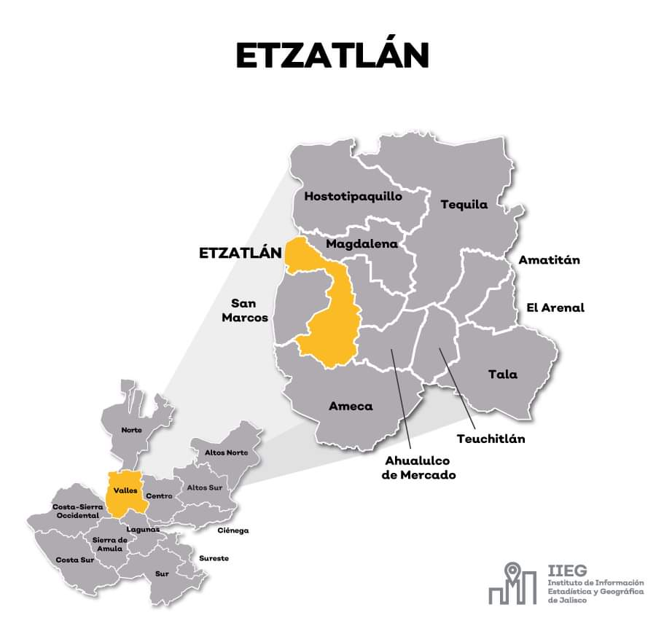
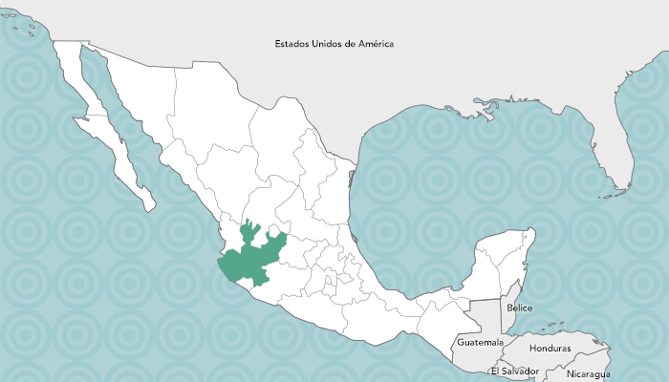


Fig. 1 Geographical Location of Etzatlán, Jalisco, Mexico.

2.3. Site Characterization and Demographic Dynamics
The studied area has a heterogeneous topography due to the presence of soils of volcanic origin, composed mainly of basalt and andesite, which adds complex geotechnical challenges for excavation and foundation activities of the reactors of the treatment plants. In hydrological matters, the seasonal rainfall regime adds another complex condition: the intrusion of rainwater into the sanitary sewer system. Previous studies indicate that this phenomenon generates alterations to the plant's hydraulics, due to the dilution of the biological load and flow peaks that could wash away the biomass (Cui et al., 2026). The mitigation of this risk factor is considered central in the calculations of the over-dumping landfills and regulation tanks.
During the health infrastructure planning process, atypical demographic trends in the region have been considered, which are characterized by rates of migratory expulsion to larger urban centers and abroad. The design of standard linear growth models could result in the underutilization of infrastructure, increasing operating costs per cubic meter. As Qin et al. (2011) suggest, in the face of changing demographic dynamics, engineering models should prioritize adaptability, due to the rigidity of large civil works.
3. results and discussion
3.1 Demographic modeling
Given the conditions of uncertainty and seeking to guarantee the resilience of the project, an evaluation of four probabilistic scenarios was carried out, contrasting historical trends with urban planning guidelines. To calculate the demographic demand without depending entirely on static statistical censuses, a retrospective-prospective mathematical modeling was applied, which allows obtaining data on population behavior over time. Through the application of analytical methods (arithmetic, simple geometric and geometric by increments) and statistical methods (least squares) (Table 1). The calculation of these models was anchored to a longitudinal demographic baseline based on official data from the 2020 Population and Housing Census (National Institute of Statistics and Geography, 2020), which yielded a population of 14,864 inhabitants of the municipal capital, which represents 74.2% of the total population of the municipality with 20,011 inhabitants. From this base, the year 2025 was established as the "year zero" of operations, projecting a useful life horizon of 20 years (2045).
Table 1 Comparison of demographic projection models for the study area. Own elaboration.
Projection Method | Projected Population (inhab) | Technical Observation
Least Squares (Linear/Log) | 16,850 - 17,120 | Underestimation by historical trend; risk of obsolescence.
Arithmetic | 17,908 | Linear constant growth; it does not reflect migratory dynamics.
Simple Geometric | 18,635 | Constant percentage growth.
Geometric by Increments | 19,840 | Adjustment for variability of historical rates.
Scenario B (Adopted PDU) | 20,050 | Scenario of maximum technical demand (Robust Design).

The arithmetic method was selected as the base scenario for the design. The selection was not arbitrary, but was based on a robust design exercise to mitigate the risk of undersizing, considering that the plant can absorb seasonal population peaks (vacations, patron saint holidays, return of migrants), without compromising the quality of the effluent, or altering the food-microorganism relationship in biological reactors.
3.2. Diagnosis of the Hydraulic and Sanitary Infrastructure
The supply system in the study area has an installed capacity of 95 l/s. Therefore, the design of the WTS must guarantee that the treatment infrastructure is not exceeded under any scenario; that is why the proposal is a scalability strategy through parallel treatment trains (mirror plant). By incorporating a regulation tank at the head, it is feasible to couple two modules of 45 l/s each, ensuring capacity in the face of population growth in the next 20 years. When reviewing the billing of the water resource, a large amount of Non-Revenue Water (NRW) is identified. In this sense, the reduction of NRW is a priority. Reports such as Toronto Water (2025) show that leak control is one of the most cost-effective strategies in preventing the infiltration of clean water into the sewer system, thus avoiding unnecessary dilution of the influent that reduces and affects the efficiency of biological processes.
3.3 The Challenge of the Mixed System and the "Swine Factor"
The sewer system works as a mixed system, transporting both wastewater and rainwater. This factor generates risks of biomass washing during heavy rainfall events (New York State Department of Environmental Conservation et al., n.d.). Likewise, the diagnosis identified the presence of pig production units in the urban area; these clandestine discharges are dumped directly into the municipal network and this condition introduces high loads of ammonia nitrogen and refractory organic matter, thus demanding that the treatment train has robust nitrification and sludge digestion capacities, this condition is documented in co-treatment systems (Deng et al., 2023). This condition methodologically justifies the need to introduce secondary treatment technologies with the capacity to cushion these toxic and organic shocks.
3.4. Hydraulic Characterization: Direct flow measurement Methodology
To strengthen the study, in addition to the theoretical estimates, a continuous monitoring of 7 days in situ was carried out directly at the main discharge point (confluence of the Laguna Palo Verde channel). The methodological justification for this gauging, carried out by means of tie rod reading with 4-hour intervals, was based on the need to capture the stochastic peaks of industrial discharge that traditional models tend to underestimate, which is why the design of the pretreatment units must respond to the real hydraulic dynamics rather than to the theoretical average flows revealing a hydraulic dynamic with great variability, as can be seen in table 2.

Table 2 Weekly hydraulic behavior in the main discharge. Own elaboration.
Flow rate | Registered Value (l/s) |  | Technical Observation
Minimum Flow (Qmin) | 6.73 | Nightly baseflow (phreatic infiltration and leakage).
Maximum Flow (Qmax) | 83.10 | Morning peak (domestic and industrial discharge).
Average Flow (Qprom) | 37.67 | Basis for the calculation of average daily organic load.

This behavior, where the maximum flow exceeds the minimum by more than 12 times, represents a critical condition. The literature is clear in warning that oscillations of this type destabilize secondary settlers. Therefore, the implementation of an "Equalization Tank" upstream of the biological reactor is necessary. This measure is essential to dampen hydraulic peaks and homogenize the contaminant load, through this method a stable Hydraulic Residence Time (HRT) for bacteria is guaranteed (West Yost & Black & Veatch, 2023).
3.5 Prospective Modeling and Modularity Strategy
When making the calculations, and considering the demographic and financial uncertainty, the evolution of consumption of 39.85 l/s towards a saturation flow has been projected. Therefore, modular construction based on the configuration of treatment trains in parallel, aligned with the sustainability guidelines of the UNIDO (2022), has been proposed.
Table 3 Hydraulic load projection and scalability of the treatment system. Own elaboration.
Design Period | Population (inhab) | Average flow Generated (l/s) | Proposed Capacity (l/s) | Utilization (%)
Phase I (Implementation) | 13,640 - 17,536 | 39.85 - 51.23 | 45.00 | 88.5% - 113%
Phase II (Saturation) | 17,832 - 20,050 | 52.10 - 58.58 | 60.00 | 86.8% - 97.6%

This design allows the optimization of the Hydraulic Residence Time of operation in the first years, avoiding conditions of biomass starvation, a phenomenon that occurs when plants are oversized with insufficient organic load reception. It also considers the capital investment (CAPEX) of Phase II, until justified by demand.
3.6 Analysis of the Hydraulic Regime
When analyzing consumption and download patterns, peak discharge patterns were identified in the morning hours (Table 4).
Thus, the relationship between the peak instantaneous flow and average daily flow yields an Hourly Coefficient of Variation (k₂) of 2.19. Values that exceed conventional standards and confirm the influence of point discharges, which allows identifying the parameters for the dimensioning of pretreatment channels and landfills (Alsulaili et al., 2026).
Table 4 Hourly dynamics of the waste flow (Representative Weekly Profile). Own elaboration.
Time | Average flow (l/s) | Standard Deviation | Operational Observation
03:00 | 7.18 | Low | Base flow (Infiltration and network leaks).
11:00 | 67.05 | High | Morning peak of domestic demand.
19:00 | 58.21 | Media | Evening peak (commerce and services).

3.7 Technical Design Parameters
To ensure the resilience of the model to extreme events and to comply with the criteria for self-cleaning of pipes, the adjusted Harmon Coefficient (M=2.73) has been used considering an additional safety factor.
Table 5 Summary of hydraulic design flow rates (Final Design Horizon). Own elaboration.
Flow rate | Value (l/s) | Function in Design
Minimum Flow (Qmin) | 19.19 | Self-cleaning verification (>0.60 m/s) to prevent sand sedimentation.
Average Flow (Qmed) | 38.38 | Calculation of biological residence times and sludge production.
Instant Maximum Flow | 104.96 | Sizing of pumping equipment and pressure pipes.
Maximum Expected Flow | 157.45 | Bypass capacity and management of rainfall excesses.
Nominal Flow Adopted | 40.00 | Technical-economic break-even point for Phase I.

3.8 Technology Selection and Multi-Criteria Analysis
Table 6 shows the technological configurations evaluated under strict economic sustainability criteria (CAPEX/OPEX) considering energy efficiency and operational simplicity.
Table 6 Economic evaluation of technological alternatives. Own elaboration.
Alternative | Technology | CAPEX  (MMXN) | OPEX (MXN/month) | Cost (MXN/m³)
Alt. 1 | Simple Biological Filters | $25.00 | $185,000 | $4.09
Alt. 2 | Imhoff Tank + Biological Filter | $26.00 | $207,000 | $4.39
Alt. 3 | Activated Sludge (Conventional) | $34.00 | $466,000 | $7.60
Alt. 4 | Biologic Discs (RBC) | $42.50 | $388,000 | $7.65
Alt. 5 | Oxidation Ditches | $31.50 | $424,000 | $6.97
CAPEX (Capital Investment), OPEX (Operating Expenses), MMXN (Millions of Mexican Pesos, MXN Mexican Pesos)

Alternative 1 has the lowest cost per cubic meter ($4.09 MXN). This allows the municipality to recover the investment faster if a recovery quota is established with the farmers for the fertigation water. Alternative 2 is the most robust option, the Imhoff Tank allows superior sludge management (biosolids metabolism) without the need for complex pumping equipment, reducing the risk of technical failures in the region. Alternative 3 is the most common technology in large cities, its cost of $6.97 MXN/m³ and its high complexity make it less suitable for a decentralized circular metabolism model in medium-sized municipalities, due to the high energy consumption that "cleans" water but generates a large carbon footprint.
The proposal of the treatment train in option 2 lies in its three-phase physical separation capacity: the upper compartment of the Imhoff Tank facilitates the sedimentation of solids, as well as the surface retention of fats and oils of pig origin, preventing them from saturating the subsequent stage of the treatment. The next phase stabilizes the organic matter through the anaerobic digestion of the primary sludge. Finally, the effluent passes through trickling beds (biological filters), where the biomass degrades the dissolved organic load. Solution two offers superior resilience to organic load peaks and mixed hydraulic shocks, because biological filters are less susceptible to collapse and washout than suspended biomass systems (activated sludge). Options 4 and 5 have higher costs and are more complex so they are not an option.
3.9 Effluent characterization
The statistical deviation shown by the average BOD₅ of the effluent of 652.3 mg/l is significant in relation to conventional parameters, used in the design of sanitary engineering in Mexico, since these are based on theoretical averages of organic load (≈220 mg/l). Traceability studies of pollutants in basins such as the Santiago River identify these atypical loads due to agro-industrial activities in residential areas (Morán Loza et al., 2025).
In the case study, the BOD/COD ratio of 0.64 indicates high biodegradability, which would theoretically favor standard biological processes. However, the presence of fats and oils (166.07 mg/l), which exceeds the regulatory limits by 1000%, causes a significant operational risk. By opting for Alternative 3 (Activated Sludge), this load would cause problems of sludge bulging (bulking) and the formation of harmful foams, causing oxygen transfer collapse. Instead, the selection of Alternative 2 Imhoff Tank acts as a robust defense barrier: the sedimentation compartment allows the physical separation of fats before entering the biological stage, while anaerobic digestion stabilizes the primary sludge without the need for external energy. That is why this buffering capacity confirms the correct technological choice, not only for costs but also for process safety (Ross, 2023).
3.10 Life Cycle Assessment (LCA) and Economic Sustainability
Based on an environmental economics perspective, we find that alternative 2 is superior because the unit cost of treatment of 4.39 MXN/m³ represents a financial savings of 42% compared to activated sludge systems (7.60 MX/m³). In addition to the operational cost, qualitative life cycle analysis benefits the configuration of the Imhoff + Biological Filters thanks to its low carbon footprint. With this alternative, the reduction of mechanical aeration, which usually consumes 60% of the energy in a conventional plant, allows the proposed system to be aligned with the global strategies for decarbonization of the water sector (Pan et al., 2025). Passive technologies have a significantly longer survival rate than mechanized plants, because they are usually abandoned when municipalities do not have the capacity to maintain the costs of electricity and specific spare parts.
3.11 Potential for Circular Economy and Water Security
The proposed design considers a strategic perspective that contemplates the water-energy-food-ecosystem (WEFE) nexus. Recently, Cai et al. (2025) define this type of approach as the necessary transition to a system where wastewater is revalued as a productive input and not as a waste.
The location of the future plant, which is close to the 8,611 agricultural hectares of the valley, becomes an opportunity for the closure of the local hydrological cycle. In this sense, the research by Cisneros-Estrada and Saucedo-Rojas (2016) validates that the use of wastewater treated under the standard allows mitigating the deficit of overexploited aquifers and at the same time generates added value through fertigation. Thus, the treated effluent, rich in stabilized phosphorus and nitrogen, makes it easier to minimize dependence on synthetic fertilizers, reducing production costs for local farmers. Under this circular bioeconomy perspective, an environmental liability becomes a strategic element for food security, providing a very attractive economic incentive for farmers (Soo & Shon, 2024).
3.12 Multi-Criteria Decision Analysis (MCDA) using a weighted sum.
This approach allows the integration of variables of different nature (economic, technical and environmental) in a single Suitability Index (Si), facilitating an objective comparison between the five proposed alternatives of the Circular Urban Metabolism (MUC).
Five critical factors were selected (Table 7), which were weighted according to their relevance for operational sustainability and resource recovery in the regional context of Jalisco:
- Economic Dimension (W=35%): Represents the total annualized cost ($MXN/m3). It is the most important factor because financial viability is the main limitation for the continuity of municipal sanitation.
- Circularity (W=25%): Evaluates the potential for nutrient recovery (N and P) and the quality of the effluent for agricultural reuse. This criterion prioritizes that technologies not only "clean" water, but also value it as a resource.
- Process Robustness (W=20%): Measures the ability of the system to absorb sudden variations in organic load and flow, ensuring the stability of the process in the face of seasonal or climatic (rainfall) discharges.
- Area Requirement (W=10%): Evaluates the surface footprint necessary for implementation. Although there is land availability, it is considered to minimize the opportunity cost of the land.
- Technical Simplicity (W=10%): Evaluates the ease of operation and maintenance, seeking to minimize dependence on specialized spare parts and labor of high sophistication and cost.
The values were normalized on a scale of 1 to 10, where the value 10 represents the most favorable scenario for meeting the model's sustainability objectives (Table 8, figure 2).
Table 7 Evaluation factors for Multicriteria Decision Analysis. Own elaboration.
Evaluation Factor | Weight (Wi) | Description of the Success Criterion (10 pts)
Economy | 0.35 | Lower total cost per m³ treated.
Circularity | 0.25 | Maximum availability of nutrients for fertigation.
Robustness | 0.20 | High biological inertia in the face of load peaks.
Area | 0.10 | Compact design with minimal carbon footprint.
Technique | 0.10 | Gravity operation and simple preventive maintenance.

Table 8 Decision Matrix of the Multicriteria Analysis. Own elaboration.
Alternative | Technology | Eco (0.35) | Rob (0.20) | Circ (0.25) | Area (0.10) | Tech (0.10) | Yes
Alt. 1 | Simple Biological Filters | 10 (3.5) | 8 (1.6) | 9 (2.25) | 3 (0.3) | 10 (1.0) | 8.65
Alt. 2 | Imhoff Tank + Biological Filters | 9( 3.15) | 10 (2.0) | 10 (2.50) | 5 (0.5) | 8 (0.8) | 9.30
Alt. 3 | Activated Sludge (Conventional) | 2 (0.7) | 4 (0.8) | 4 (1.0) | 9 (0.9) | 3 (0.3) | 3.70
Alt. 4 | Biologic Discs (RBC) | 2 (0.7) | 6 (1.2) | 5 (1.25) | 10 (1.0) | 5 (0.5) | 4.65
Alt. 5 | Oxidation Trenches | 4 (1.4) | 7 (1.4) | 7 (1.75) | 2 (0.2) | 6 (0.6) | 5.35

Fig. 2 Multi-criteria analysis of sanitation process alternatives. Own elaboration.
4. Conclusion
In the present work, some decisive conclusions have been established, which will serve as a roadmap in the intervention of contexts of similar organic urbanization:
- The integration of retrospective-prospective demographic modeling tools and direct hydraulic measurement allowed the development of a robust methodological scheme to more accurately estimate the future demand for wastewater treatment in peri-urban contexts with high population uncertainty.
- The physicochemical characterization of the tributary evidenced a contamination scenario significantly higher than the conventional parameters used in the design of municipal plants in Mexico, identifying high concentrations of BOD₅, fats and oils mainly associated with agro-industrial swine discharges incorporated into the urban sewerage system.
- The hydraulic behavior of the system showed a high temporal variability, reflected in an hourly coefficient of variation of 2.19 and differences of more than twelve times between the minimum and maximum flow, which gives the need to incorporate regulation tanks and resilient infrastructure to stabilize biological processes.
- The multi-criteria analysis allowed to demonstrate that the technological configuration based on Imhoff Tank coupled to Biological Filters is the most appropriate alternative for the studied context, obtaining the highest Suitability Index (Si = 9.30), due to its balance between economic efficiency, operational robustness, technical simplicity and circularity potential.
- The selected alternative showed relevant technical advantages over conventional mechanized systems, particularly due to its ability to cushion hydraulic and organic shocks through physical separation of solids, fat retention and primary anaerobic digestion, reducing the risk of biological collapse.
- From an economic perspective, the Imhoff + Biological Filters system presented considerably lower operating costs compared to activated sludge, generating savings of 43% in operation and maintenance, which increases the financial viability of the project for medium-sized municipalities with limited resources.
- The modular proposal based on parallel treatment trains proved to be an effective strategy to face demographic and financial uncertainties, allowing the installed capacity to be progressively scaled up without generating oversized infrastructure or loss of hydraulic efficiency.
- The study confirms that sanitation models based on circular urban metabolism offer additional benefits beyond the removal of pollutants, as they allow the recovery and reuse of nutrients for agricultural fertigation, strengthening the water-energy-food-ecosystem (WEFE) nexus.
- The proximity of the future plant to agricultural areas represents a strategic opportunity to reuse the treated effluent and reduce dependence on synthetic fertilizers and groundwater extraction, simultaneously contributing to regional water and food security.
- Finally, the research demonstrates that the transition from conventional sanitation schemes to resilient, decentralized systems oriented towards the circular economy constitutes a technically viable and environmentally sustainable alternative for peri-urban municipalities in western Mexico with similar hydraulic and socio-environmental characteristics.

References

Alsulaili, A., Al-Fadhli, F. M., Garcia, H. A., Ali, O., & Alenezi, N. (2026). Environmental and socioeconomic factors shaping regional dynamics of wastewater characteristics. Journal of Environmental Engineering, 152(3). https://doi.org/10.1061/JOEEDU.EEENG-8436
Cai, X., Wei, N., Pinheiro Privette, A., & Barros, A. (2025). Circular economy for sustainable water management [White paper]. Center for Secure Water, University of Illinois Urbana-Champaign. https://cee.illinois.edu/news/circular-economy-for-sustainable-water-management
Cisneros Estrada, O. X., & Saucedo Rojas, H. (2016). Wastewater reuse in agriculture. Mexican Institute of Water Technology.
Cui, Y., Wen, L., Liu, J., Shen, P., Wei, Y., Richnow, H. H., & Zhang, J. (2026). Heavy rainfall alters molecular transformation of dissolved organic matters (DOM) in the wastewater treatment plant. Process Safety and Environmental Protection, 207, Article 108388. https://doi.org/10.1016/j.psep.2026.108388
Daboin, J., Stein, E., Fortunato, A., Lamby, L., & Shah, T. (2025). An Economic Growth Strategy for Hermosillo (Growth Lab Working Paper Series No. 241). John F. Kennedy School of Government, Harvard University. https://growthlab.hks.harvard.edu/wp-content/uploads/2025/02/2025-01-glwp-241-estrategia-crecimiento-economico-para-hermosillo.pdf
Deng, L., Zheng, D., Zhang, J., Yang, H., Wang, L., Wang, W., He, T., & Zhang, Y. (2023). Treatment and utilization of swine wastewater – A review on technologies in full-scale application. Science of the Total Environment, 880, Article 163223. https://doi.org/10.1016/j.scitotenv.2023.163223
Food and Agriculture Organization of the United Nations. (2012). Coping with water scarcity: An action framework for agriculture and food security (FAO Water Reports No. 38). https://openknowledge.fao.org/handle/20.500.14283/i3015e
Gherghel, A., Teodosiu, C., & De Gisi, S. (2019). A review on wastewater sludge valorisation and its challenges in the context of circular economy. Journal of Cleaner Production, 228, 244–263. https://doi.org/10.1016/j.jclepro.2019.04.240
Municipal Government of Etzatlán. (2021). Municipal Development and Governance Plan Etzatlán, Jalisco 2021-2024. https://etzatlan.gob.mx/wp-content/uploads/2022/05/PMDG-2021-2024.pdf
National Institute of Statistics and Geography. (2020). Population and Housing Census 2020: Quick results. https://www.inegi.org.mx/app/cpv/2020/resultadosrapidos/default.html?texto=Etzatlán
Kharmylliem, B., & Kipgen, N. (2025). Village councils, social capital and sustainability: A study of urban water management of Shillong in Meghalaya, India. Water Policy, 27(3), 301–316. https://doi.org/10.2166/wp.2025.209
Morán Loza, J. M., García Arreola, A., Hernández Barragán, J. de J., & Almaguer Medina, J. F. (2025). Multi-dimensional correlation analysis for pollution process identification: Advanced clustering and source fingerprinting in the Santiago River Basin. International Journal of Computer Techniques, 12(5). https://ijctjournal.org/multi-dimensional-correlation-analysis-pollution-process-identification-ijct/
New York State Department of Environmental Conservation, Stearns & Wheler, & SUNY Morrisville. (n.d.). Wet weather operating practices for POTWs with combined sewers: Technology transfer document. Ohio Environmental Protection Agency. https://dam.assets.ohio.gov/image/upload/epa.ohio.gov/Portals/35/cso/wwpotwops.pdf
Pan, X., Zhao, Y., Lin, X., Zhao, N., Sun, M., & Ma, J. (2025). Towards sustainable urban water system: A strategic approach to advance decarbonizing water management. Engineering, 50(7), 31–39. https://doi.org/10.1016/j.eng.2025.03.028
Qin, H.-P., Su, Q., & Khu, S.-T. (2011). An integrated model for water management in a rapidly urbanizing catchment. Environmental Modelling & Software, 26(12), 1502–1514. https://doi.org/10.1016/j.envsoft.2011.07.003
Ross, B. (2023, October 12). What we know after 23 years of FOG program work [PowerPoint slides]. U.S. Environmental Protection Agency. https://www.epa.gov/system/files/documents/2023-10/fog-slides.pdf
Ministry of Environment and Natural Resources. (2022). Official Mexican Standard NOM-001-SEMARNAT-2021, which establishes the permissible limits of pollutants in wastewater discharges in receiving bodies owned by the nation. Official Gazette of the Federation. https://www.dof.gob.mx/nota_detalle.php?codigo=5645374&fecha=11/03/2022
Soo, A., & Shon, H. K. (2024). A nutrient circular economy framework for wastewater treatment plants. Desalination, 592, Section 118090. https://doi.org/10.1016/j.desal.2024.118090
Toronto Water. (2025). Ashbridges Bay Wastewater Treatment Plant 2024 annual report. City of Toronto. https://www.toronto.ca/wp-content/uploads/2025/04/9617-2024-TAB-Annual-Report-Final-AODA.pdf
UNESCO. (2022, March 22). Water challenges and proposed solutions for Mexico are identified by UNESCO and partners. https://www.unesco.org/es/articles/retos-hidricos-y-propuestas-de-soluciones-para-mexico-son-identificados-por-la-unesco-y-asociados
UNITED. (2022). International Guidelines for Industrial Parks: Cross-cutting drivers. United Nations Industrial Development Organization. https://ipp.unido.org/sites/default/files/knowledge/2022-11/IAFP%20guidelines__low_res.pdf
West Yost, & Black & Veatch. (2023). Regional wastewater reclamation facility pre-design report (RFQ NO. WFC2301-PD). City of Medford.
Wielemaker, R. C., Weijma, J., & Zeeman, G. (2018). Harvest to harvest: Recovering nutrients with New Sanitation systems for reuse in Urban Agriculture. Resources, Conservation and Recycling, 128, 426-437. https://doi.org/10.1016/j.resconrec.2016.09.015

