Opinion Article

Finite Element Analysis and Optimization Design of the Metal Structure for a Trough-Making Machine

.
ABSTRACT

Trough-making machine is a key special equipment for aqueduct construction, which effectively solves the construction difficulties of long-span, large-volume and high-altitude operation. At present, most trough-making machines are non-standardized equipment designed by empirical methods, leading to material waste and difficulties in controlling structural strength, stiffness and stability. Taking a trough-making machine as the research object, this paper selects the dangerous working condition of full-load pouring under 8-grade wind, calculates wind load and other design loads, establishes a finite element model by ANSYS Parametric Design Language (APDL), and carries out strength and stiffness analysis on its metal structure. On this basis, a zero-order optimization algorithm is used to carry out lightweight optimal design for the main beam, with the minimum volume as the objective function and strength and stiffness as constraints. The results show that the maximum equivalent stress of the whole machine is 216.34 MPa, which is less than the allowable stress of Q355B material; the maximum mid-span deflection of the main beam meets the stiffness limit of L/1000, and all metal structures satisfy the strength and stiffness requirements. After optimization, the mass of the main beam is reduced by about 15.9%, and the overall weight of the trough-making machine is reduced by 5.83%, equivalent to about 54 tons of steel. The optimized structure still meets the design requirements under critical working conditions such as pouring and hole-crossing. The research provides a feasible finite element analysis and structural optimization method for the design of trough-making machines, which can give full play to material performance and realize lightweight design on the premise of ensuring construction safety and pouring quality.

Keywords: trough-making machine; aqueduct; finite element analysis; strength; stiffness; sliding formwork.

1. INTRODUCTION

As specialized construction equipment designed specifically for building aqueducts,its core function is to efficiently complete the fabrication and forming of the aqueduct’s main structural components—such as the trough body and support elements—through processes like on-site casting or prefabricated assembly. It effectively addresses the construction challenges associated with “long spans, large volumes, and high-altitude operations” in scenarios such as deep, wide river valleys and vast floodplains, facilitating the large-scale and standardized construction of aqueducts. At the same time, it provides structural assurance for the aqueduct to subsequently deliver advantages such as low head loss, convenient navigation, and easy management(1-3) .
Currently, channel-forming machines are mostly non-standardized equipment tailored to the specific characteristics of individual projects, lacking universal design specifications. Design typically relies on empirical methods, employing relatively high safety factors to ensure structural strength. In practical use, such design principles lead to unnecessary material waste and result in excessive load-bearing capacity of the equipment.As construction spans increase and the weight of poured concrete rises, the loads borne by the channel-forming machine increase significantly, making its stiffness, strength, and stability more difficult to control during both design and construction.These issues may trigger serious safety incidents during construction, such as structural deformation, component failure, or even complete overturning. Therefore, to ensure the rationality of the channel-forming machine’s design and construction safety, it is crucial to perform finite element analysis on the strength, stiffness, and stability of its metal structure before it is put into service(4-6) .

2. Current Status of Sliding Formwork Development at Home and Abroad

The technology of in-situ casting using sliding formwork, one span at a time, first emerged in Western Europe in the 1950s, initially developed by companies in Germany and Austria. In 1959, during the construction of the Kettinger Hang Bridge, the German company Strabag first employed a sliding formwork system; however, at that time, the technology was still immature and the equipment was extremely costly, leading the market to view its future prospects with skepticism.In 1964, after improvements were made to the equipment, it was applied to the construction of the Krahnenberg Bridge in Germany. During the construction of the Amsinck Interchange in 1969, the German company PZ first employed a cast-in-place method involving a single pass with double-beam support beneath the bridge deck; hence, this method is also known as the PZ Method ((7, 8) .
In 1968, Japan introduced the moving formwork construction technology from Germany and first applied it to a bridge project on the Tokyo Expressway in 1969. Subsequently, through continuous research and improvement, Japan introduced a new type of suspended moving scaffold system in 1984.Tracking formwork technology has been widely adopted in the construction of large-scale bridges in Japan. Statistics show that during the 15-year period from the introduction to the refinement of this technology, it was utilized in the construction of nearly 30 major bridges, including the Kitagawa Line Railway Bridge, the Kuraishi Island Viaduct, and the Yotsuba-cho Viaduct.In 1970, Norwegian engineers designed a new type of mobile formwork equipment, which was named the Mobile Scaffold Bridge-Building Machine (MSS). By 1973, Norwegian engineers had developed a more practical double-span mobile formwork bridge-building machine—the(9, 10) —based on the original MSS design.
In summary, the development history and practical engineering applications of sliding formwork systems both domestically and internationally demonstrate that the use of sliding formwork construction methods not only improves bridge construction efficiency and reduces construction costs but also exhibits significant advantages in the construction of long-span bridges. Following extensive engineering practice and continuous research and improvement in various countries, sliding formwork technology has become increasingly mature, steadily advancing toward larger load-bearing capacities and longer spans.However, based on existing literature, research on mobile formwork systems and related technologies for the construction of large-scale hydraulic aqueducts remains relatively scarce both domestically and internationally(11-13).

3. Finite Element Analysis of Aqueduct Equipment

3.1 Analysis of Critical Operating Conditions for Aqueduct Equipment

The pouring operation of the aqueduct forming machine primarily relies on the pouring legs supported at the top of the piers, with the outer ribs closed at this stage. The analysis accounts for the self-weight of the forming machine, external wind conditions, and loads generated by the poured concrete beams. Based on the maximum wind resistance and maximum weight of the poured concrete beams before and after concrete pouring, the following hazardous design conditions were identified:
Wind Force 8 at Full Load: This scenario accounts for the maximum wind load the structure can withstand during pouring and the load from the concrete beam;

3.1.1 Wind Load Calculation
Wind loads primarily consider the impact of lateral wind forces on the stability of the slot-forming machine. Since the windward surface area of the machine’s main beam, guide beams, outer ribs, and outriggers is relatively large, wind loads are applied to these components to simulate the wind effects experienced by the machine during outdoor construction(14,15).
During concrete pouring operations, the machine can withstand wind loads up to Wind Force 8. The formula for calculating wind pressure is as follows:
 | . | (1)
Where:
p — Calculated wind pressure (N/m²)
s— design wind speed (m/s).
According to the "Code for Design of Cranes" GB 3811-2008, the maximum average wind speeds for Wind Class 8 are 28.3 m/s, resulting in a calculated wind pressure of 500 N/m². The formula for wind load calculation is as follows:
 | . | (2)
Where:
C — wind coefficient;
P — maximum wind load acting on the groover (N);
A — total wind-facing area of each structure perpendicular to the wind direction (m²).

3.2 Strength Requirements for the Trenching Machine

The main components of the trencher are made of Q235B and Q355B, both of which are ductile materials. The allowable stress method is used to design the strength of the trencher.The allowable stress method involves calculating the actual stress generated in parts or components under combined loads, then comparing it with the allowable stress determined based on material properties, part or component type, and specific service conditions to ensure that the actual stress does not exceed the allowable stress. For ductile materials, the yield strength of the material—taking into account the size of the parts, heat treatment methods, and load characteristics—is used to calculate the stress:
 | . | (3)
Where,
σ — Calculated stress at the critical section;
σ(s)—material yield strength;
n — safety factor;

3.3 Stiffness Requirements for the Channel-Forming Machine
When casting the aqueduct, the span L of the formwork machine is 45 m. The stiffness criterion selected is such that, under load, the maximum allowable vertical deflection should not exceed L/1000. The maximum change in deflection at the front and rear of the main beam is:
 | . | (4)

3.4 Full-Load Finite Element Analysis
After concrete pouring under an 8-beaufort wind, a flow simulation was performed using the APDL command. A simplified schematic of the trough-forming machine’s metal structure is shown in Figure 1 below
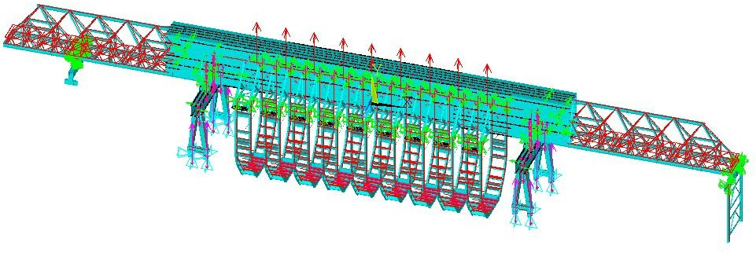
Figure 1 Structural Diagram of the Trenching Machine

(1) Strength Analysis
The overall equivalent stress contour of the trough-making machine is shown in Figure 2. According to the contour analysis, the maximum overall stress is 216.34 MPa, which is located on the suspended outer rib structure. The material of the suspended outer rib is Q355B with an allowable stress of 236.7 MPa. Therefore, the whole trough-making machine and the suspended outer rib meet the strength requirements.
The equivalent stress contour of the main girder is shown in Figure 3. The maximum stress of the main girder is 170.59 MPa, which is located at the mid-span of the main girder. The material of the main girder is Q355B with an allowable stress of 236.7 MPa. Therefore, the main girder meets the strength requirements.
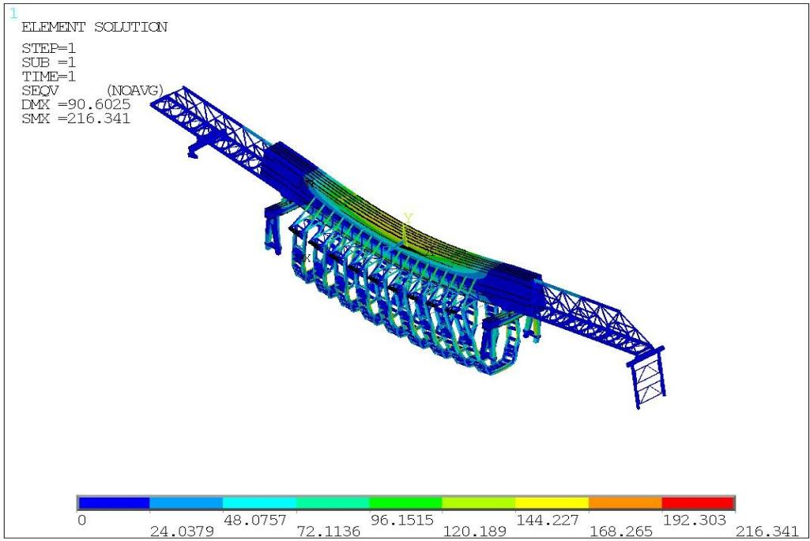
Figure 2 Overall Stress Analysis of the Channel Forming Machine
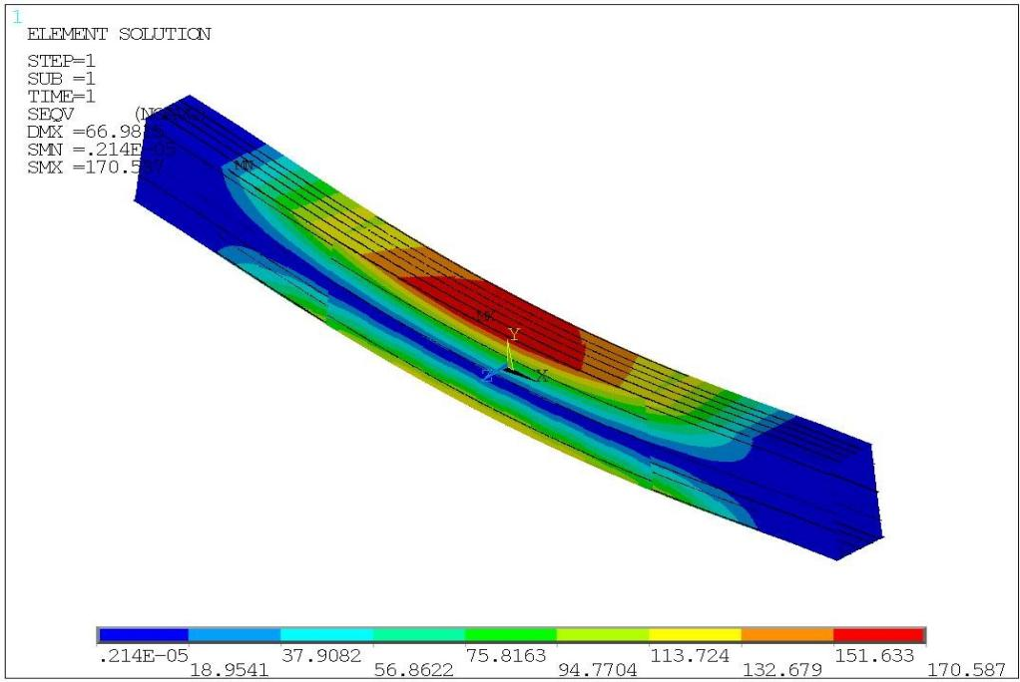
Figure 3 Stress Contour Plot of Main Girder
(2) Stiffness Analysis
The overall Y-direction deformation contour of the trough-making machine is shown in Figure 4. The maximum deformation is −88.37 mm, located at the middle suspended outer rib structure.The Y-direction deformation contour of the main girder is shown in Figure 5. The maximum Y-direction deformation of the main girder is −66.25 mm, located at the mid-span of the main girder.In the deformation contour, the red positive values represent the camber of the trough-making machine, and the blue negative values represent the deflection of the trough-making machine.The maximum Y-direction deformation of the main girder is −66.25 mm. The allowable deflection of the main girder is 45 mm. By comparing the actual mid-span deformation with the allowable deflection, it can be concluded that the main girder meets the stiffness requirements.
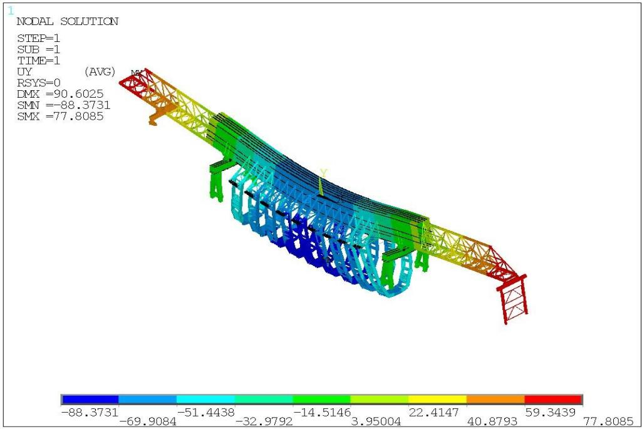
Figure 4 Overall Y-direction deformation contour plot of the grooving machine
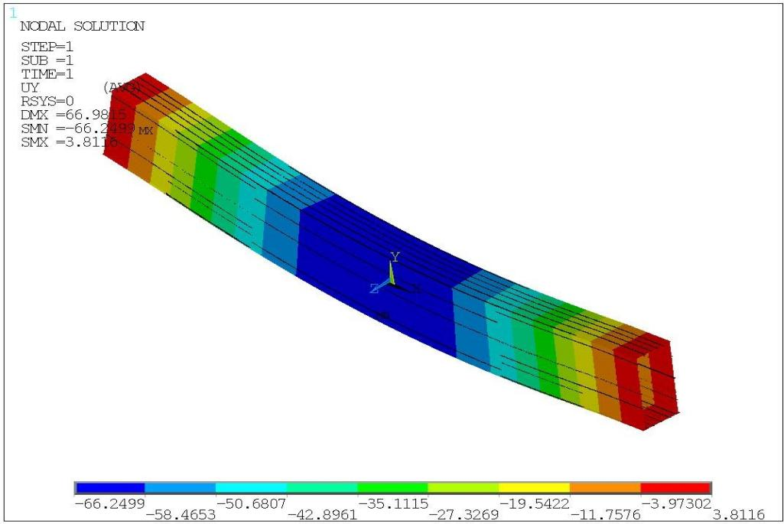
Figure 5 Deformation Diagram of Main Girder in Y-Direction

4 Optimal Design of Metal Structure for Trough-Making Machine Main Beam

4.1 Analysis of Optimization Scheme
As the primary load-bearing structure of the trough-making machine, the main beam weighs approximately 267.8 t, while the total weight of the trough-making machine is about 927 t. The main beam accounts for 28.8% of the machine’s total weight. According to the foregoing finite element analysis results, the actual maximum Y-direction deflection at the mid-span of the main beam under full-load condition with Grade-8 wind load is 29.78 mm, against an allowable deflection of 45 mm, leaving a 33.8% margin for optimization in maximum Y-direction displacement. The maximum stress of the main beam is 170.59 MPa, compared with the allowable stress of 236.7 MPa, providing a 27.9% optimization margin for maximum stress. Considerable safety margin exists in the load-bearing capacity, particularly the stiffness, of the main beam.
The following factors are taken into account in developing the optimization scheme:(1) The web plate and upper/lower flange plates of the main beam exert significant effects on beam deflection. Therefore, only the geometric dimensions of the main beam cross-section are optimized without altering its length.(2) Longitudinal stiffeners of the main beam web have minor impacts on overall stiffness and strength and are omitted in parametric modeling. The cross-sectional areas of stiffeners for upper and lower flange plates are equivalent-integrated into the respective flange plates, and the slideway area on the lower flange plate is also equivalent-integrated into the lower flange plate.

4.2 Optimization Program Design
Structural optimization design of the trough-making machine aims to minimize its mass under the constraints of strength, stiffness and stability. Since the cross-section of the main beam is proportional to its overall volume and mass, cross-sectional dimensions of components forming the main beam are selected as design variables. The total length of the main beam is 101 m, consisting of box-girder and truss structures.
(1) Design Variables
In this optimization, the original steel cross-section dimensions of the box-type main beam are taken as initial values. Cross-sectional dimensions are optimized by setting reasonable value ranges for design variables in the optimization program. The original cross-section contains numerous stiffeners, slideways and other components, resulting in complex geometry that hinders optimization. Hence, the main beam cross-section is simplified. For instance, longitudinal stiffeners on the main beam web have negligible effects on overall stiffness and strength and are omitted in parametric modeling. The cross-sectional areas of stiffeners for upper and lower flange plates are equivalently incorporated into the corresponding flange plates, and the slideway area on the lower flange plate is also equivalently incorporated into the lower flange plate.Initial calculation results of the simplified main beam slightly differ from those of the original model. The rationality of calculation results will be further verified by substituting the optimized results into the model.
The main beam design variables (DV) mainly include: cross-sectional width (X) and height (Y) of the main beam, web thickness (G), upper flange plate thickness (E), and lower flange plate thickness (F). The main beam cross-section and design variables are shown in Figure 6 and 7, with each variable listed in Table1 below:
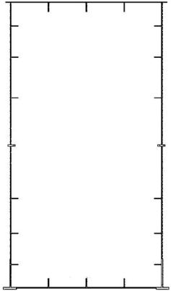 | 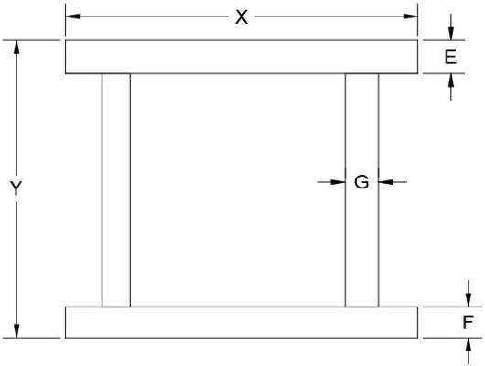
Figure. 6 Initial cross-section of main beam | Figure7 Cross-sectional design variables
Table 1 Main beam design variables
Design Variable Name | DV | Original Dimension (mm)
Cross-sectional width of main beam | X | 3400
Cross-sectional height of main beam | Y | 6400
Upper flange thickness of Main Beam 1 | E1 | 24
Lower flange thickness of Main Beam 1 | F1 | 24
Web thickness of Main Beam 1 | G1 | 12
Upper flange thickness of Main Beam 2 | E2 | 22
Lower flange thickness of Main Beam 2 | F2 | 20
Web thickness of Main Beam 2 | G2 | 12
Upper flange thickness of Main Beam 3 | E3 | 22
Lower flange thickness of Main Beam 3 | F3 | 20
Web thickness of Main Beam 3 | G3 | 14

(2) Objective Function
This optimization aims to realize lightweight design for the main beam of the trough-making machine. Given a constant material density, the weight is determined by the volume of the main beam. Therefore, the optimization objective of minimizing mass can be converted into minimizing volume. The objective function is defined as the total volume of the main beam, denoted as VOLUME.
(3) State Variables
The state variables for this optimization are the strength and stiffness under the full-load condition with Grade-8 wind load. This working condition represents the most complex stress state of the whole machine, so selecting it as the optimization condition can best ensure the validity of results. The strength and stiffness constraints during optimization are as follows:
 | σmax ≤ [σ]  . | (5)
 | YL ≤ [YL ]  . | (6)
Where σ_{max} is the maximum equivalent stress of the main beam; YL is the maximum Y-direction deflection of the main beam.
According to the aforementioned stiffness and strength requirements, the allowable stress of the trough-making machine main beam under all working conditions is [σ]=236.7 MPa, and the allowable deflection is YL=45 mm.
(4) Optimization Procedure
The optimization design procedure for the main beam is as follows:
/CLEAR
X=3400
Y=6400 E1=24 F1=24 G1=12
/PREP7 SECTYPE,3001,BEAM,HREC
SECOFFSET,CENT
SECDATA,X,Y,G1,G1,F1,E1
SOLVE
/POST1
*USE,SCRATCH
/OPT
OPANL,SCRATCH
OPVAR,X1,DV,3200,3600
OPVAR,Y1,DV,6200,6600 OPVAR,E1,DV,16,26 OPVAR,F1,DV,16,26 OPVAR,G1,DV,8,16
OPVAR,DY,SV,0,45
OPVAR,SMAX,SV,0,236.7
OPTYPE,SUBP
OPSUBP,40
OPEXE
PLVAROPT,DMAX,SMAX
PLVAROPT,VOLUME

4.3 Analysis of Optimization Results

4.3.1 Optimization Results of the Main Beam
Zero-order optimization algorithm is adopted in this optimization design to optimize the main beam structural model of the trough-making machine. The maximum number of iterations is set to 40 during optimization, and a total of 30 iterations are completed upon termination, with the optimal solution obtained at the 27th iteration. After optimization, the comparison between optimized results and initial data is shown in Table 2 below:
Table 2 Variation of each parameter of main beam before and after optimization

Optimization Variables | Before Optimization (mm) | After Optimization (mm) | Change Rate
X | 3400 | 3426.6 | 0.78%
Y | 6400 | 6409.9 | 0.15%
E1 | 24 | 20.253 | 15.61%
F1 | 24 | 21.713 | 9.52%
G1 | 12 | 9.7725 | 18.56%
E2 | 22 | 16.33 | 25.77%
F2 | 20 | 20.406 | 2%
G2 | 12 | 8.8245 | 26.46%
E3 | 22 | 21.835 | 0.75%
F3 | 20 | 21.341 | 6.7%
G3 | 14 | 10.138 | 27.59%
DY/mm | 61.132 | 70.917 | 16%
SMAX/MPa | 158.9 | 168.17 | 5.8%
V/mm3 | 0.16152E+11 | 0.13576E+11 | 15.9%
It can be seen from the change rates in the table that the upper flange thickness and web thickness of the 1st and 2nd main beam segments decrease significantly, while the web thickness of the 3rd main beam segment shows a notable reduction. The cross-sectional width and height of the main beam, as well as the upper and lower flange thicknesses of the 2nd main beam segment, have minor variations. Accordingly, it is proposed to reduce the upper flange thickness and web thickness of the 1st and 2nd main beam segments, and the web thickness of the 3rd main beam segment. Iteration diagrams of stress, displacement and volume of the main beam are plotted, as shown in Figures 8 and 9.
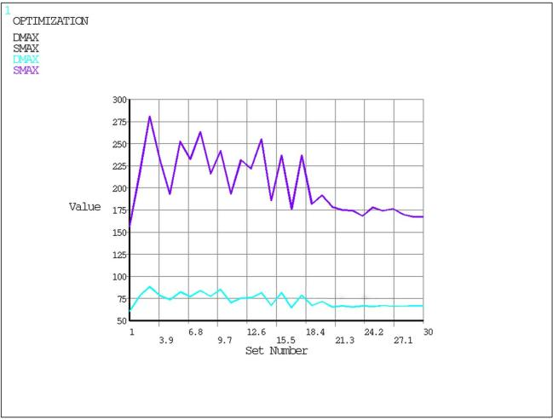 | 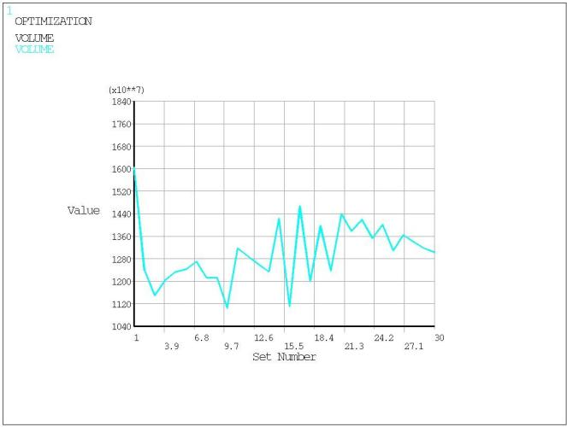
Figure 8 Stress and displacement iteration plot | Figure 9 .Volume iteration diagram
It can be observed from Figures 8 and 9 that with the increase in iteration times, the volume first decreases, then fluctuates within a certain range and tends to be stable. The maximum Y-direction deflection of the main beam varies slightly and fluctuates around a fixed value, while the maximum equivalent stress of the main beam rises first, then declines, and finally converges to a steady value. At the optimal solution, the maximum stress of the main beam is 168.17 MPa, and the maximum Y-direction deflection DY is 70.917 mm. After optimization, the mass of the main beam is reduced by approximately 15.9%, indicating favorable optimization performance for the main beam.

5 Conclusions
This paper introduces the current state of research on the development of slot-forming machines. Taking the slot-forming machine as the research object, ANSYS finite element analysis software was used to conduct a study on finite element calculation techniques for its metal structure. The main research findings are as follows:
Based on the grooving machine’s operational workflow and performance parameters, the design conditions were determined. A typical operating condition during concrete pouring was selected for specific analysis, specifically a fully loaded pouring condition under a Category 8 wind.
Using the Parametric Design Language (APDL) and based on actual construction conditions, the wind load and other design loads were determined. By applying the corresponding loads and constraints to the overall model, a finite element model of the trencher under critical operating conditions was established.
A finite element analysis was conducted on the hazardous operating conditions of the channel-forming machine. The following conclusions were drawn: the maximum stress across the entire machine was 216.34 MPa, and the actual maximum deflection at the midspan of the main beam under full load during a Category 8 wind was -33.03 mm. The finite element analysis results indicate that all metal structures meet the strength and stiffness requirements during the machine’s operation.
Optimization design is carried out for the main beam, a critical metal structure of the trough-making machine. Based on the optimization results, the thicknesses of the upper flanges and webs of the 1st and 2nd main beam segments, as well as the web thickness of the 3rd main beam segment, are reduced. Meanwhile, the lower flange of the 2nd main beam segment is thickened to maintain structural strength. After optimization, the overall weight of the trough-making machine decreases by 5.83%, equivalent to approximately 54 tons of steel. While ensuring pouring quality, more reasonable structural parameters are obtained, and material performance is fully utilized. The optimized parameters are verified under critical working conditions of pouring and hole-crossing. Finite element calculation results indicate that the optimized trough-making machine still meets the design requirements.

COMPETING INTERESTS DISCLAIMER:
Authors have declared that they have no known competing financial interests OR non-financial interests OR personal relationships that could have appeared to influence the work reported in this paper.

References

[1] Chen G, Yang F, Chi JJ. Research on standardized design of aqueducts. Design of Water Resources & Hydroelectric Engineering. 2025;44(1):21‑25. https://doi.org/10.20275/j.cnki.issn.1007‑6980.2025.01.005
[2] Guo Q, Zhang T, Yang C. Structural design optimization of DZS40/500 aqueduct‑making machine. Water Conservancy Construction and Management. 2019;39(1):29‑34. https://doi.org/10.16616/j.cnki.11‑4446/TV.2019.01.05
[3] Huang P, Liu CY, Ma ZF, Wang MT. Construction of cross‑canal bridge cap using hoop method in the Middle Route of South‑to‑North Water Diversion Project. Yangtze River. 2014;45(10):55‑56,72. https://doi.org/10.16232/j.cnki.1001‑4179.2014.10.002
[4] Pu ZB, Yang ZH, Jin X. Application and practice of movable formwork in construction of large‑scale hydraulic aqueducts. Engineering Technology Research. 2019;4(4):88‑89. https://doi.org/10.19537/j.cnki.2096‑2789.2019.04.043
[5] Wen TY. Cast‑in‑situ beam construction technology of MZ900S overhead movable formwork for Wuhan‑Guangzhou Passenger Dedicated Line. Railway Investigation and Surveying. 2008(3):74‑77. https://doi.org/10.19630/j.cnki.tdkc.2008.03.024
[6] Pacheco, Coelho, Borges, Guerra. Technical challenges of large movable scaffolding systems. Structural Engineering International. 2011;21(4):450‑455. https://doi.org/10.2749/101686611x13131377725640
[7] Editorial Department of China Journal of Highway and Transport. Academic research review of road construction machinery in China·2018. China Journal of Highway and Transport. 2018;31(6):1‑164.
[8] Liu HG, You JQ, Zhang CF. Prospect of standardization and modernization of movable formwork technology in China. Railway Standard Design. 2014;58(4):37‑43. https://doi.org/10.13238/j.issn.1004‑2954.2014.04.009
[9] Lü PM. Innovation and development of movable formwork bridge‑building equipment in China. Construction Machinery. 2019(8):20‑24.
[10] Xiang YQ, Zhang SJ, Cheng Y, Wang JF, Jing Q, Wang LC. Application and research innovation of movable formwork construction technology. Journal of China & Foreign Highway. 2008(1):52‑56. https://doi.org/10.14048/j.issn.1671‑2579.2008.01.013
[11] Li Y B. Application of trough-making machine in construction of super-large U-shaped thin-walled prestressed aqueduct[J]. Sichuan Water Conservancy, 2025, 46(06): 75-78.
[12] Zhang Y J. Preloading Test of U‑shaped Aqueduct Trough‑making Machine[J]. Shaanxi Water Resources, 2018(05): 211‑212+215. DOI:10.16747/j.cnki.cn61‑1109/tv.2018.05.084.
[13] Zhang Y M, Jia J J, Ma C A, et al. Structural Design of Large‑flow Prestressed Thin‑walled Multi‑cell Rectangular Trough[J]. Yangtze River, 2013, 44(16): 12‑14. DOI:10.16232/j.cnki.1001‑4179.2013.16.012.
[14] Lin J ,Ding X ,Zhang J , et al.Mechanical and Acoustic Performance of Foamed Concrete Noise Barriers Applied in Attenuating Railway Noise[J].Transportation Research Record,2026,2680(6):126-147.DOI:10.1177/03611981251381776.
[15] Tian J ,Chen X .Assessing probabilistic response of wind-excited structures under mixed wind climate with consideration of wind directionality using closed-form formulations[J].Journal of Wind Engineering & Industrial Aerodynamics,2026,274106491-106491.DOI:10.1016/J.JWEIA.2026.106491.

