Original Research Article

STRENGTH CAPACITY CHARACTERISTICS OF WELDED AND MECHANICAL COUPLE SPLICED STEEL BARS FOR REINFORCING CONCRETE

.
ABSTRACT

The structural performance of reinforcement bar splices plays a critical role in ensuring the continuity and load transfer capacity of reinforced concrete members. This study experimentally investigated the tensile behaviour of steel reinforcement bars connected using threaded couplers and welded joints, with particular emphasis on the influence of connection development length and bar diameter. Tensile tests were conducted on 12 mm, 16 mm, and 20 mm diameter reinforcing bars with threaded engagement lengths of d, 3d, and 5d, and weld lengths of end-to-end, 3d, 5d, and 7d. The results show that connection length significantly affects the mechanical performance of both joining techniques. For threaded couplers, the 12 mm bars exhibited substantial reductions in yield and ultimate strengths at short thread engagement (d), achieving only 29–37% of the control strength. However, increasing the thread length to 3d and 5d significantly improved performance, with the 16 mm and 20 mm bars nearly recovering the full strength of the control specimens. In welded connections, increasing the weld length resulted in substantial strength recovery, with welded bars at 5d and 7d achieving strengths comparable to or slightly exceeding those of the control bars. The findings demonstrate that both threaded and welded reinforcement connections can achieve mechanical performance comparable to continuous bars when sufficient connection development length is provided. However, their efficiency varies with bar diameter and connection configuration.

Keywords: stress-strain, steel reinforcement, tension, coupler, welded joint

1. INTRODUCTION

Reinforcement, such as steel bars, are embedded in concrete to form a composite element. This composite element is capable of resisting tensile stress which plain concrete is unable to. Having continuous reinforcement bars in concrete elements is quite impossible. This can be attributed to many reasons such as; fabrication lengths, transportation limitations, change in reinforcement diameter and steel reinforcement detailing (Zhang et al., 2024; Fayed et al., 2023). In terms of construction cost, reinforcement bars form quite a large proportion of the total cost of a reinforced concrete (RC) building. Therefore, exploring economically optimized procedures to join rebars has attracted researchers’ interest to lessen the construction cost (Kheyroddin et al., 2020). The choice of splicing method depends on factors such as the type of structure, loading conditions and construction constraints (Ma et al. 2025).
Lap splicing, which is considered as the commonest due to its ease of usage (Alyousef, 2018; Najafgholipour et al.,2018) is often achieved by overlapping of two parallel bars with enough length, has long been considered as an effective and economical splicing method. Nevertheless, the method may result in excessive section reinforcement, which result in non-ductile response at the spliced region due to stress localization at both ends of the overlap, hence altering the deformation capacity (Aaleti et al., 2012 and Bompa and Elghazouli, 2018). The construction industry is embracing the use of mechanical couplers for splicing reinforcement due to their unique advantages compared to lap splices. The use of mechanical couplers can result in the reduction of splice length (Tazarv & Saiidi, 2016), considerable reduction in reinforcement congestion in RC structures (Dahal & Tazarv, 2020), and they also provide the added advantage of easy assembly in the case of precast concrete (Bompa and Elghazouli, 2017).
Due to reinforcement congestion and potential construction challenges associated with overlapping splices in heavily reinforced joints, Mohammed et al. 2025 evaluated the structural performance of reinforced concrete (RC) columns incorporating mechanical couplers under axial and cyclic loading conditions. Quasi-static cyclic lateral loading tests were conducted on RC columns with different splicing configurations to examine the influence of coupler properties, geometry, and placement. The results indicated that mechanical couplers can maintain or slightly improve ductility, energy dissipation, and self-centering capacity, while preserving the stiffness and strength of the columns. The findings suggest that mechanical couplers are an effective and reliable alternative to conventional lap splicing, particularly for large-scale reinforced concrete structures.
Welding is commonly used to connect steel members because of its design simplicity and ability to provide high structural rigidity (Tamboli, 1999). However, the welding process can produce microstructural inhomogeneities within the weld zone (Chen et al., 2019), which may alter the mechanical properties of the steel and create localized stress concentrations (Güral et al, 2007; Boumerzoug et al., 2010; Pham & Kim, 2015). These conditions can promote crack initiation and propagation. Additionally, solid-state phase transformations that occur during welding significantly influence the final microstructure of the weld zone, thereby affecting important mechanical properties such as hardness and toughness (Borodin & Mayer (2017).
Furthermore, the non-uniform distribution of mechanical properties in welded joints leads to local stress concentrations. To better understand the local constitutive behavior across welded steel joints, Peng et al. 2018 investigated joints fabricated from Q345 steel using two single V-groove butt welds prepared through metal arc welding. The results indicated that the Young’s modulus across the various sub-regions of the welded steel joints remained nearly constant. However, the yield strength and tensile strength gradually decreased from the weld metal (WM) to the heat-affected zone (HAZ) and then to the base metal (BM). In addition, the hardening characteristics of the different sub-regions followed the order: BM > WM > HAZ.

Current design standards such as Eurocode 8 do not explicitly address welding procedures for repairing RC structural elements due to the limited availability of experimental evidence on their performance. Rodrigues et al. 2018 did a study to evaluate the effectiveness of different welded steel bar configurations on the structural capacity of damaged RC columns.
The experimental program consisted of monotonic and cyclic tensile strength tests performed on 45 specimens made from S500 reinforcing steel. The specimens were fabricated in accordance with BS EN ISO 17660-1:2006 and welded with lap lengths of 5ϕ and 10ϕ using the shielded metal arc welding process with specified electrodes. The experimental results demonstrated that the welded reinforcement bar configurations exhibited mechanical behaviour comparable to that of the reference steel bars.
Studies have shown that reinforcing bars produced in Ghana from scrap metals may exhibit significant variability in yield strength, tensile strength, and ductility, which can influence the performance of spliced regions in reinforced concrete beams (Abubakar, 2023; Banini and Kankam, 2022; Quarm et al., 2025). Therefore, understanding the behavior of different splicing methods during tensile testing is essential for ensuring structural reliability prior to being incorporated in concrete.
This paper presents a study on the experimental evaluation and comparison of the tensile strength capacity and failure characteristics of welded and mechanical coupler spliced reinforcing steel bars.

2. material and methods
The threaded-rebar coupling system consisted of a high yield steel rebar of 25mm diameter with rolled-on grooves that have matching internal threads with the rebar, and forces are transferred by direct thread bearing. The coupler had a yield and ultimate strength of 483N/mm² and 762N/mm² respectively. The splice was provided with standard female threads at the coupler and matching male threads at the rebars. To obtain a detailed insight into the proposed mechanical splices, uniaxial monotonic tests were carried out using the parallel threaded couplers (PTC) as illustrated in Fig. 1, to connect the various reinforcement bars. The bar sizes considered were 12mm, 16mm and 20mm. The PTC had constant diameter coupler with diameter d_{c}×length L_{c}=Ø25×72mm for 12mm bars, Ø25×96mm for 16mm bars and Ø25×120mm for 20mm bars. All the test specimens were subjected to monotonic loading and had a minimum clear length l_{s}=350mm between the testing machine jaws. For each bar size, d, considered, the threaded lengths considered were d, 3d and 5d. Five test specimens were prepared for each threaded length. A total of 45 specimens were prepared and tested according to ASTM A 370.

Table 1 Mechanical Properties of Coupler and Electrode
Material | Yielding Strength, N/mm² | Ultimate Strength, N/mm² | Ultimate Strain, %
Coupler | 483 | 762 | 22.3
Electrode | 630 | 660-880 | 22-24
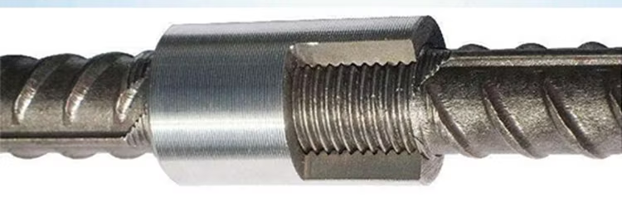

Figure 1: Details of the Mechanical Coupler

On the other hand, the welded tensile test specimens of length 300mm were fabricated and tested as shown in Figure 2. The lengths of the weld were 3d, 6d and 9d (d = 12, 16, 20mm). End-to-end joints were also tested with non-spliced bars as the control. Five test specimens were prepared for each welded length. A total of 45 specimens were prepared and tested.

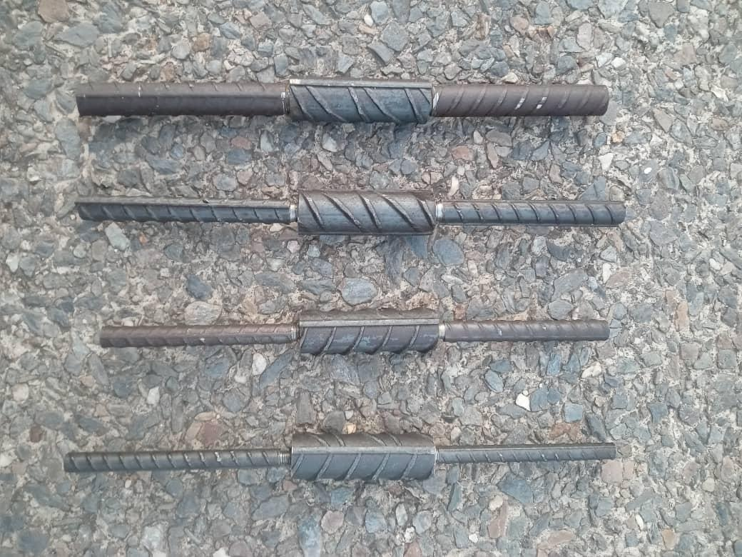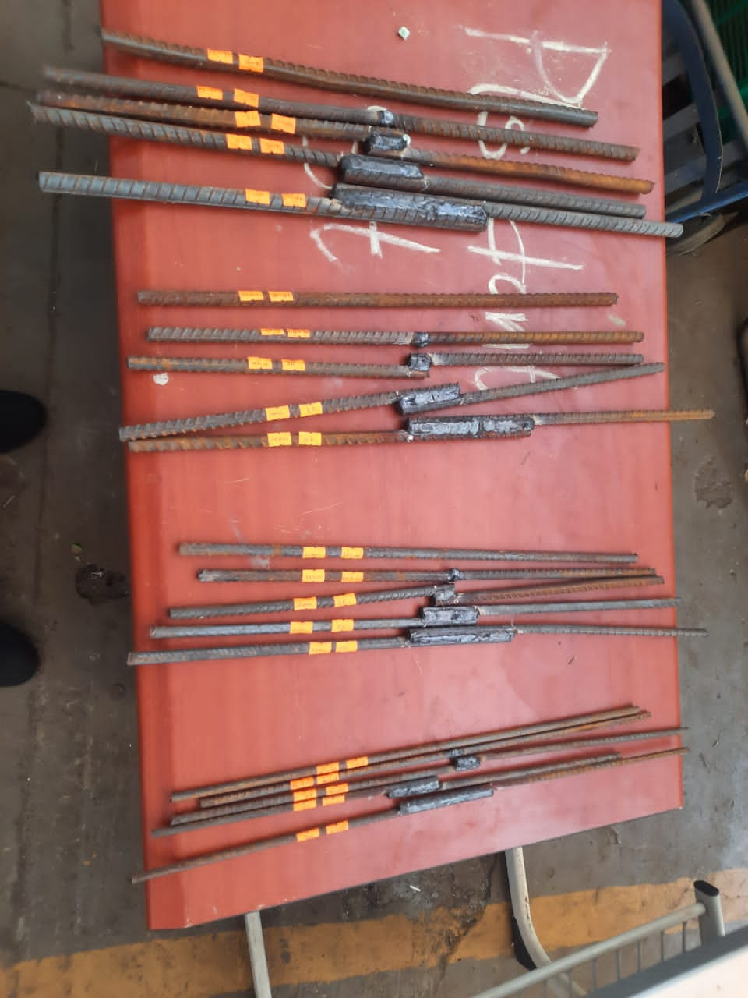
(a) (b)
Figure 2 (a) Mechanical coupler spliced reinforcing steel bars. (b) Welded spliced reinforcing bars

3. results and discussion
Tables 2 and 3 show the tensile test results for the reinforcement bars splice by means of a mechanical coupler and welding respectively. The yield strength, ultimate strength, and strains were the parameters studied. The stress-strain graphs of the specimens can be seen in Figure

Table 2 Tensile Test Results for Rebars Spliced by Couplers
Bar Size (mm) | Avg. Yield Strength, N/mm² |  |  |  | Avg. Ultimate Strength, N/mm²
Bar Size (mm) | Length of Thread |  |  |  | Length of Thread
Bar Size (mm) | Control | d | 3d | 5d | Control | d | 3d | 5d
12 | 342.57 | - | - | - | 551.05 | 102.35 | 119.35 | 129.25
16 | 349.73 | - | 350.11 | 349.21 | 594.93 | 202.73 | 556.49 | 560.24
20 | 351.84 | - | 352.30 | 350.71 | 558.49 | 224.57 | 541.94 | 554.46

3.1 Modes of Failure
None of the tested bars fractured through the coupler as also reported by Chiari & Moreno (2018) and Haber et al., (2015). Some failed through the threaded end of the bar that was closer to the end of the coupler after assembling them. The higher diameter bars with threaded length of d failed by a pull-out of the bars from the coupler. Similar failure modes were reported by Bompa and Elghazouli, 2018, and Neupane et al., 2025. On the other hand, the welded bars failed by the rupture of the weld for smaller welded lengths. However, failure occurred through the bars when the welded lengths increased to 3d and 5d.
3.2 Strength Performance of Mechanical Coupler Splices
For the 12 mm reinforcement bars, the coupler-spliced specimens developed significantly lower yield strengths compared with the control bars. The specimens with thread lengths of d, 3d, and 5d achieved only 29.9%, 34.8%, and 37.7% of the control yield strength, respectively. Although a gradual improvement in strength was observed as the thread engagement increased, the coupler connection did not achieve strength levels comparable to the control specimen. This reduction is primarily attributed to the loss of effective cross-sectional area and the introduction of stress concentrations within the threaded region, which reduce the bars’ resistance to yielding compared with the unthreaded control specimens. Fig. 3 shows the stress-strain relationship for the mechanically spliced bars of diameter 12mm, 16mm and 20mm respectively.

- (b)

(c)
Figure 3 Stress-Strain relationship for a) 12 mm bars spliced with coupler b) 16 mm bars spliced with coupler c) 20 mm bars spliced with coupler
For the 16 mm and 20 mm reinforcement bars, yield strength increased significantly with increasing thread engagement. The specimens with thread length d developed approximately 58.0% and 63.8% of the control yield strength, respectively, indicating limited stress transfer at the splice interface. However, when the thread length was increased to 3d and 5d, the yield strengths increased to approximately 100% of the control values for both bar sizes. This improvement may be attributed to sufficient bearing resistance developed between the threads and grooves of the coupler, enabling effective load transfer and allowing the spliced bars to achieve strengths comparable to the original reinforcement. In terms of ultimate tensile strength, the coupler-spliced specimens for the 16 mm and 20 mm bars exhibited reduced strengths at 3d thread engagement, developing approximately 54% and 56% of the control ultimate strength, respectively. However, when the thread length was increased to 5d, the ultimate tensile strengths increased significantly to 99.2% and 99.3% of the control strengths, respectively. Rowell et al., 2009 also reported ultimate strengths comparable to control bars. This demonstrates that longer thread engagement is required to ensure the full development of the tensile capacity of the reinforcement bars. 90% of the ultimate strength of the bar can be achieved.
3.3 Strength Performance of Welded Splices
Table 3 Tensile Test Results of Welded Steel Bars
Bar Size  (mm) | Avg. Yield Strength (N/mm²) |  |  |  |  | Avg. Ultimate Strength (N/mm²)
Bar Size  (mm) | Length of Weld |  |  |  |  | Length of Weld
Bar Size  (mm) | Control | End-to-End | 3d | 5d | 7d | Control | End-to-End | 3d | 5d | 7d
12 | 342.57 | - | - | 342.23 | 342.03 | 551.05 | 32.38 | 215.21 | 551.22 | 562.28
16 | 349.73 | - | - | 349.38 | 349.55 | 594.93 | 55.20 | 219.45 | 593.96 | 593.71
20 | 351.84 | - | - | 351.82 | 351.79 | 558.49 | 69.91 | 218.61 | 556.12 | 557.32

Figure 4. Stress-Strain relationship for a) 12 mm bars spliced by welding b) 16 mm bars spliced by welding c) 20 mm bars spliced by welding
The tensile results for the welded reinforcement bars reveal a clear relationship between weld length and strength development. The end-to-end welded specimens exhibited very low yield strengths, developing only 9.5%, 15.8%, and 19.9% of the control yield strengths for the 12 mm, 16 mm, and 20 mm bars, respectively. These values indicate that the end-to-end welding configuration is structurally inadequate for developing the tensile capacity of the reinforcement bars. Their failures were sudden and along the welded joint.
When the weld length was increased to 3d, the yield strengths improved substantially but remained limited to approximately 62–63% of the control yield strength for all bar diameters. Although this represents a considerable increase compared with the end-to-end weld configuration, the strength development was still insufficient to match that of the unspliced reinforcement bars.
A significant improvement in strength was observed when the weld length was increased to 5d and 7d. At these weld lengths, the welded specimens achieved approximately 99–100% of the control yield strength for all bar diameters tested. This indicates that weld lengths of 5d and above are capable of developing the full yield strength of the reinforcement bars.
The ultimate tensile strength results further support this observation. For weld lengths of 5d and 7d, the welded specimens developed 99–102% of the control ultimate tensile strength, indicating that the welded splice was able to fully mobilize the tensile capacity of the reinforcement bars. Fig. 4 shows the stress-strain relationship for the reinforcements spliced by welding.

3.4 Statistical Analysis of Mechanical Properties of Spliced Reinforcing Steel Bars
3.4.1 Influence of splice length on strength (yield and ultimate) of bar
The influence of splice length on the yield and ultimate strengths of reinforcing steel bars was evaluated using mechanically coupled and welded splice specimens with varying development lengths expressed as multiples of bar diameter. The statistical analysis revealed that splice length had minimal influence on the yield strength of the reinforcing bars. The mean yield strengths of the specimens were relatively close to that of the control specimen, with the 3D threaded splice recording the highest mean yield strength of 351.21 MPa compared with 348.05 MPa for the straight control bar. Welded specimens with 5D and 7D splice lengths produced mean yield strengths of 347.81 MPa, indicating only marginal variation from the control. The ANOVA result, F(4,60) = 1.37, P > 0.05, confirmed that the observed differences in yield strength were statistically insignificant. This suggests that both threaded and welded splice systems were capable of maintaining the elastic behaviour and yielding characteristics of the reinforcement irrespective of splice length.
In contrast, splice length significantly influenced the ultimate strength performance of the bars. The highest ultimate strengths were obtained from the 7D-W and 5D-W welded specimens, which recorded mean strengths of 571.10 MPa and 567.10 MPa respectively, values comparable to or slightly exceeding the control specimen strength of 568.15 MPa. Shorter splice configurations, particularly D-T, End-to-End-W, and 3D-W, exhibited substantially lower ultimate strengths, indicating premature failure and insufficient stress transfer across the splice region. The ANOVA analysis yielded F(7,112) = 52.719, P = .05, confirming statistically significant differences among the splice categories. Post hoc comparisons further established that the 5D-W and 7D-W specimens did not differ significantly from the control bars, whereas shorter splice lengths showed significant reductions in ultimate capacity. The findings therefore demonstrate that while splice length has negligible effect on yield behaviour, adequate development length is critical for achieving full ultimate strength capacity, particularly in welded splice systems.
3.4.2 Influence of splice length on yield strain of bar
The influence of splice length on the yield strain behaviour of reinforcing steel bars was evaluated for both mechanically coupled and welded splice systems. The results showed noticeable variations in yield strain across the splice configurations. The control specimen recorded the highest mean yield strain of 21.6×10⁻⁴, while the 7D-W and 5D-W welded specimens exhibited comparable values of 20.73×10⁻⁴ and 20.4×10⁻⁴, respectively. In contrast, shorter splice configurations such as D-T, End-to-End-W, and 3D-W produced significantly lower yield strain values, indicating reduced deformation capacity prior to yielding.
The one-way ANOVA analysis yielded F(7,112) = 23.219, P = .05, confirming that the differences in yield strain among the splice lengths and methods were statistically significant. Post hoc analysis further revealed that the yield strains of 5D-T, 5D-W, and 7D-W were not significantly different from the control specimen, suggesting that longer splice lengths were capable of preserving the deformation characteristics of the original reinforcement. Conversely, shorter splice lengths exhibited significantly lower yield strains, indicating premature stiffness concentration and reduced ductility. Overall, the findings demonstrate that adequate splice development length is essential for maintaining the strain capacity and deformation compatibility of spliced reinforcement bars.
3.4.3 Influence of splicing method on Strength (Yield and Ultimate) of Bar
The effect of splicing method on the mechanical performance of reinforcing steel bars was evaluated by comparing the yield and ultimate strengths of control, threaded (mechanically coupled), and welded specimens. Statistical analysis showed that the splicing method had minimal influence on the yield strength of the reinforcement bars. The threaded specimens recorded the highest mean yield strength of 350.58 MPa, followed by the control specimens with 348.05 MPa, while the welded specimens exhibited the lowest mean value of 347.81 MPa. Despite these slight variations, the one-way ANOVA result, F(2,62) = 2.607, P > .05, indicated that the differences were not statistically significant. This suggests that both threaded and welded splicing techniques were capable of maintaining the yield characteristics of the parent reinforcement bars. Therefore, yielding behavior was generally unaffected by the splice method adopted.
In contrast, the splice method significantly influenced the ultimate strength of the reinforcement bars. The control specimens achieved the highest mean ultimate strength of 568.15 MPa, whereas the threaded and welded specimens recorded substantially lower values of 332.37 MPa and 352.11 MPa, respectively. The ANOVA result, F(2,117) = 8.073, P = .05, confirmed that these differences were statistically significant. Post hoc comparisons further revealed significant reductions in ultimate strength between the control specimens and both splice methods, while the difference between threaded and welded specimens was not statistically significant. This indicates that although both splicing techniques adequately preserved yield performance, they reduced the ultimate load-carrying capacity of the reinforcement bars. Nevertheless, the comparable performance of threaded and welded specimens suggests that either method may be adopted in practice depending on construction requirements, provided that adequate attention is given to achieving sufficient ultimate resistance and structural ductility.
3.4.3 Influence of Splice Method on Yield Strain
The influence of splice method on the yield strain of reinforcing steel bars was evaluated by comparing the deformation characteristics of control, threaded (mechanically coupled), and welded specimens. The control specimens recorded the highest mean yield strain of 2.16×10⁻³, while welded and threaded specimens exhibited lower mean values of 1.48×10⁻³ and 1.39×10⁻³, respectively. These results indicate that the introduction of splicing generally reduced the strain capacity of the reinforcement bars at yielding.
The one-way ANOVA result, F(2,117) = 8.249, P = .05, confirmed that significant differences existed among the splice methods with respect to yield strain. Post hoc analysis further revealed that both threaded and welded specimens differed significantly from the control specimens, showing lower yield strain capacities. However, the difference between threaded and welded specimens was not statistically significant, indicating that the two splice methods performed similarly in terms of deformation at yield.
The findings suggest that while both threaded and welded splicing techniques maintained satisfactory structural continuity, they reduced the ductility-related deformation characteristics of the reinforcement bars compared with the unspliced control specimens. This reduction in yield strain may have important implications for structural members expected to undergo large inelastic deformations under loading conditions such as seismic actions.
3.4.4 Influence of splice bar size on strength (Yield and Ultimate) of Bar
The influence of splice bar size on the mechanical performance of reinforcing steel bars was assessed by examining the yield and ultimate strengths of 12 mm, 16 mm, and 20 mm diameter bars under control, threaded, and welded splice conditions. For yield strength, the results showed a progressive increase with bar diameter. The 20 mm control and welded specimens recorded the highest mean yield strengths of 351.84 MPa and 351.80 MPa, respectively, while the 12 mm control and welded specimens exhibited the lowest values of 342.57 MPa and 342.16 MPa. Statistical analysis using one-way ANOVA indicated a significant difference among the bar sizes and splice methods, F(7,57) = 15.835, P = .05. Post hoc comparisons revealed that the 16 mm and 20 mm specimens consistently outperformed the 12 mm specimens in yield strength, whereas no significant differences existed between the 16 mm and 20 mm bars across the splice methods. This suggests that increasing bar diameter improved the yielding resistance of the reinforcement bars regardless of the splice technique adopted.
Similarly, splice bar size significantly influenced the ultimate strength of the reinforcement bars. The highest ultimate strength was observed in the 16 mm control specimen with a mean value of 594.93 MPa, while the lowest value occurred in the 12 mm threaded specimen with a mean of 116.98 MPa. The ANOVA result, F(8,111) = 6.290, P = .05, confirmed that significant differences existed among the bar sizes and splice conditions. Post hoc analysis showed that the 12 mm threaded specimens had significantly lower ultimate strength compared with the 16 mm and 20 mm threaded and welded specimens. However, no significant differences were observed between the 16 mm and 20 mm bars across the splice methods. Overall, the findings indicate that larger bar diameters generally enhanced both yield and ultimate strength performance, whereas smaller diameter threaded specimens were more susceptible to premature failure and reduced load-carrying capacity.
3.4.5 Influence of Splice bar size on Yield Strain
The effect of splice bar size on the yield strain of reinforcing steel bars was evaluated using 12 mm, 16 mm, and 20 mm diameter bars under control, threaded, and welded splice conditions. The control specimens exhibited the highest yield strain values, with the 12 mm control bar recording the maximum mean yield strain of 0.00236, followed by the 16 mm and 20 mm control bars with values of 0.00208 and 0.00204, respectively. In contrast, the threaded and welded specimens generally showed lower yield strain capacities, particularly the 12 mm threaded specimen which recorded the lowest mean value of 0.00081.
The one-way ANOVA result, F(8,111) = 6.726, P = .05, indicated that significant differences existed among the splice bar sizes and methods. Post hoc analysis revealed that the 12 mm control specimen differed significantly from the 12 mm threaded, 12 mm welded, and 16 mm welded specimens, all in favour of the control specimen. However, no significant differences were observed among the 16 mm and 20 mm bars across the splice methods.
The findings suggest that smaller diameter spliced bars, particularly threaded 12 mm bars, experienced reduced deformation capacity at yielding, while larger diameter bars demonstrated more stable yield strain behaviour regardless of the splice method adopted.

4. Conclusion
The results indicate that splice engagement length governs the tensile performance of both mechanical coupler and welded reinforcement splices. Mechanical couplers exhibited poor strength at low thread engagement, particularly for 12 mm bars (< 40% of control yield strength), but achieved approximately 100% yield and up to 99% ultimate strength at 3d–5d for 16 mm and 20 mm bars.
Similarly, welded splices showed very low strength at short weld lengths (9–20% of control yield strength), improving to about 62–63% at 3d, and reaching 99–102% of both yield and ultimate strength at 5d–7d.
In conclusion, both methods can achieve strength comparable to continuous reinforcement when adequate engagement length is provided. However, mechanical couplers attain full strength at slightly shorter engagement lengths than welded splices, emphasizing the importance of proper splice design and execution.

Competing interests

Authors declare that no competing interest exists.

References

Aaleti, S., Brueggen, B., Johnson, B., French, C. and Sritharan. S. (2012). “Cyclic
response of reinforced concrete walls with different anchorage details: experimental
investigation”. J Struct Eng;139(7):1181–91. https://doi.org/10.1061/(ASCE)ST.1943- 541X.0000732.
Abubakar, M. (2023). Characterization, Mechanical Properties and Probabilistic Failure Analysis of Reinforcement Bars Produced from Scraps in Southern and Northern Region of Nigeria. Journal of Failure Analysis and Prevention. https://doi.org/10.1007/s11668-023-01675-y
Alyousef, R.; Topper, T.; Al-Mayah, A. (2018) Crack growth modeling of tension lap spliced reinforced concrete beams strengthened with fibre reinforced polymer wrapping under fatigue loading. Constr. Build. Mater. 166, 345–355.
Banini, E.K., & Kankam, C.K. (2022). Strength, Ductility and Chemical Properties of Reinforcing Steel Bars in Ghana’s Building Construction Industry. Journal of Materials Science Research and Reviews, 5(2), 186–203.
Bompa, D. V., & Elghazouli, A. Y. (2017). Ductility considerations for mechanical reinforcement couplers. Structures, 12, 115–119. https://doi.org/10.1016/j.istruc.2017.08.007
Bompa, D. V., and A. Y. Elghazouli. (2018) “Monotonic and Cyclic Performance of Threaded Reinforcement Splices.” Structures 16 (November 1, 2018): 358–72. https://doi.org/10.1016/j.istruc.2018.11.009.
Borodin, E., & Mayer, A. (2017). Influence of structure of grain boundaries and size distribution of grains on the yield strength at quasistatic and dynamical loading. Materials Research Express, 4, 085040. https://doi.org/10.1088/2053-1591/aa8514
Boumerzoug, Z., Derfouf, C. , Baudin, T. (2010) Effect of welding on microstructure and mechanical properties of an industrial low carbon steel, Engineering 2 (7) 502–506.
Chen, C., Chiew, S.-P., Zhao, M.-S., Lee, C.-K., & Fung, T.-C. (2019). Welding effect on tensile strength of grade S690Q steel butt joint. Journal of Constructional Steel Research, 153, 153–168. https://doi.org/10.1016/j.jcsr.2018.10.009
Chiari, V., & Moreno, A. (2018). Experimental evaluation of coupler behavior for mechanical rebar splices in reinforced concrete structures. Revista IBRACON de Estruturas e Materiais, 11(6), 1326–1353. https://doi.org/10.1590/S1983-41952018000600009
Dahal, P. K., & Tazarv, M. (2020). Mechanical bar splices for incorporation in plastic hinge regions of RC members. Construction and Building Materials, 258, 120308. https://doi.org/10.1016/j.conbuildmat.2020.120308
Fayed, S., Mansour, W., Tawfik, T. A., Sabol, P., & Katunský, D. (2023). Techniques Used for Bond Strengthening of Sub-Standard Splices in Concrete: A Review Study. Processes, 11(4), 1119. https://doi.org/10.3390/pr11041119
Güral, A., Bostan, B., & Özdemir, A. (2007). Heat treatment in two phase region and its effect on microstructure and mechanical strength after welding of a low carbon steel. Materials & Design, 28, 897–903. https://doi.org/10.1016/j.matdes.2005.10.005
Kheyroddin, Ali, Amirhossein Mohammadkhah, Hamed Dabiri, and Ahmad Kaviani.(2012) “Experimental Investigation of Using Mechanical Splices on the Cyclic Performance of RC Columns.” Structures 24 (April 1, 2020): 717–27. https://doi.org/10.1016/j.istruc.2020.01.043.
Ma, G., Zhang, Y., Hwang, H.-J., & Kim, D.-J. (2025). Mechanical properties of half grouted sleeve connections with insufficient grouting and bar eccentricity defects. Structures, 75, 108852. https://doi.org/10.1016/j.istruc.2025.108852
Mohamed, N., Laurent, M., Emmanuel, F., Aron, G., Rémi, G., Richard, B., Philippe, H., Poissonnet, C., & jean-marie, D. (2025). Impact of incorporating parallel-threaded mechanical coupler splices on the seismic behaviour of reinforced concrete columns. Engineering Structures, 323, 119289. https://doi.org/10.1016/j.engstruct.2024.119289
Najafgholipour, M.A.; Dehghan, S.M.; Khani, M.; Heidari, A. (2018) The performance of lap splices in RC beams under inelastic reversed cyclic loading. Structures 15, 279–291.
Neupane, U., Lequesne, R. D., Lepage, A., & Darwin, D. (2025). Behavior of Earthquake-Resistant Rectangular Walls with Mechanically Spliced Grade 100 Steel Bars. Structural Journal, 122(6), 155–167. https://doi.org/10.14359/51746822
Peng, Y., Wu, C., Gan, J., & Dong, J. (2018). Determination of the local constitutive properties of the welded steel joints using digital image correlation method. Construction and Building Materials, 171, 485–492. https://doi.org/10.1016/j.conbuildmat.2018.03.182
Pham, T.-H., & Kim, S.-E. (2015). Determination of mechanical properties in SM490 steel weld zone using nanoindentation and FE analysis. Journal of Constructional Steel Research, 114, 314–324. https://doi.org/10.1016/j.jcsr.2015.08.014
Quarm, J., Kankam, C., Mansal, E., Afrifa, R., & Banahene, J. (2025). Bond characteristics of recycled scrap metal based milled reinforcing steel bars with reference to deformations of self-compacted concrete beams in sustainable construction. 3, 01–16. https://doi.org/10.5281/zenodo.17047420
Rodrigues, H., Furtado, A., Arêde, A., Vila-Pouca, N., & Varum, H. (2018). Experimental study of repaired RC columns subjected to uniaxial and biaxial horizontal loading and variable axial load with longitudinal reinforcement welded steel bars solutions. Engineering Structures, 155, 371–386. https://doi.org/10.1016/j.engstruct.2017.11.043
Tamboli, A. (1999). Handbook of Structural Steel Connection Design and Details. McGraw-Hill Professional. NY, USA.
Tazarv, M., & Saiidi, M. S. (2016). Seismic design of bridge columns incorporating mechanical bar splices in plastic hinge regions. Engineering Structures, 124, 507–520. https://doi.org/10.1016/j.engstruct.2016.06.041
Zhang, Z., Bai, G., Luo, F., Xu, G., Xu, G., Ren, L., & Tian, Y. (2024). Flexural performance of RC beams with prefabricated steel reinforcement cage using mechanical sleeves. Structures, 70, 107817. https://doi.org/10.1016/j.istruc.2024.107817
Haber, Z.B., Saiidi, M.S., Sanders, D.H. (2015) Behavior and simplified modeling of mechanical reinforcing bar splices. ACI Struct J Mar 1 2015;112(2):179. https://doi.org/10. 14359/51687455.

