Original Research Article
Investigating Yield Curve Inversions and Recession Forecasting: Evidence from 32 Economies

Abstract
Aims: This study examined whether the 10-year/3-month government bond yield spread predicts recessions across a broad international sample and whether its forecasting performance depends on monetary-policy structure and recession base rates.
Study design: The paper used a quantitative, cross-country forecasting design based on monthly macro-financial panel data and country-level logistic regression models.
Place and Duration of Study: The analysis covered 32 advanced and emerging market economies from January 2000 to December 2025, using publicly available data from the Federal Reserve Economic Data database, the OECD, the IMF World Economic Outlook, and national recession chronologies.
Methodology: The main predictor was the 10-year minus 3-month yield spread. For each country and for forecast horizons from 1 to 24 months, recession probability was modeled using logistic regression. Predictive performance was evaluated using the receiver operating characteristic area under the curve (ROC-AUC), with country-level and grouped comparisons used to assess heterogeneity.
Results: Predictive power was highly uneven. The United Kingdom (AUC = 0.918) and the United States (AUC = 0.737 at the 12-month horizon and up to 0.870 at longer horizons) showed strong recession-prediction performance. In contrast, many eurozone economies clustered near the no-skill benchmark, including France (AUC = 0.488), Spain (AUC = 0.487), Greece (AUC = 0.449), and Ireland (AUC = 0.429). The pooled global panel reached only modest performance, with AUC peaking at approximately 0.633 around 7 to 9 months ahead.
Conclusion: The yield curve is not a universal recession indicator. It is most informative in countries with independent monetary policy and market-determined bond yields, while its usefulness is limited in monetary unions, policy-suppressed regimes, and countries with high unconditional recession frequency.
Keywords: yield curve; recession forecasting; term spread; ROC-AUC; logistic regression; eurozone; monetary policy; financial economics

1. Introduction
The slope of the yield curve, commonly measured as the spread between long-term and short-term government bond yields, has long been treated as a leading indicator of future economic activity. The basic intuition is that when short-term interest rates rise above long-term rates, the bond market may be signaling that investors expect weaker economic conditions and future policy easing. This idea was first developed in the term-structure literature and later formalized in recession-forecasting models (Kessel, 1965; Harvey, 1988; Estrella and Hardouvelis, 1991; Estrella and Mishkin, 1998). In the United States, every recession since the 1960s has been preceded by a yield-curve inversion, making the spread one of the most closely watched indicators in applied macroeconomics.
The empirical evidence is strongest for the United States. Estrella and Mishkin (1998) showed in a probit framework that the 10-year/3-month Treasury spread outperformed several alternative financial and macroeconomic indicators at horizons of four to six quarters. Rudebusch and Williams (2009) further found that the spread retained marginal forecasting value even when compared with professional forecasts, and Wright (2006) improved near-term recession probability estimates by adding the level of the federal funds rate to the baseline spread model. Bauer and Mertens (2018a) also found that the U.S. signal remained robust after the global financial crisis and during the low-interest-rate period that followed.
The forecasting mechanism operates through several channels. An inverted yield curve can compress bank net interest margins, tighten credit supply, and reduce investment incentives (Bernanke and Blinder, 1992). It can also reflect market expectations that the central bank will eventually cut policy rates in response to a weakening economy. Long-term yields may also decline when investors seek safe assets before or during a downturn. In each case, the spread acts as a market-based summary of expectations about future monetary policy, credit conditions, and aggregate demand.
The theoretical expectation that the yield spread should predict recessions depends on a key institutional assumption: the short end of the yield curve must be set by domestic monetary policy that responds to the domestic business cycle. This assumption may fail in countries that share a supranational policy rate. In the euro area, for example, France, Spain, Ireland, and other member states share a common short-term interest rate set by the European Central Bank. Consequently, the 10-year/3-month spread in any individual member country may no longer contain a country-specific monetary-policy signal. Moneta (2005) found that the 10-year/3-month spread was useful for euro-area aggregate recessions, but country-level predictive evidence was weaker. Wheelock and Wohar (2009) also emphasized that the term spread performs differently across monetary regimes, while Chinn and Kucko (2015) showed that probit models performed well in some economies but failed to anticipate many recession episodes in others.
The Asia-Pacific region presents a different set of structural complications. Japan operated under near-zero nominal interest rates for a prolonged period and later adopted quantitative easing, negative interest-rate policy, and yield-curve control. These interventions weakened the interpretation of the spread as a market signal. Bauer and Mertens (2018b) noted that at the zero lower bound, term spreads may reflect the expected duration of low rates rather than conventional recession risk. Australia and South Korea have more conventional monetary-policy systems, but their cycles are heavily affected by commodity prices, Chinese demand, and external trade shocks. These forces can generate recessions without the domestic monetary-tightening sequence that the yield curve is designed to capture.
This study therefore asks whether cross-country heterogeneity in yield-curve forecasting performance is systematic rather than random. The central argument is that two constraints explain much of the variation. First, countries with policy-suppressed or externally constrained spreads lose the domestic monetary signal that makes the yield curve informative. Second, countries with high unconditional recession frequency make it harder for any single predictor to discriminate recession months from non-recession months. The paper tests this argument across 32 economies using monthly data from 2000 to 2025, logistic regression at multiple forecast horizons, and ROC-AUC as the primary measure of predictive performance.

2. Methodology

2.1 Data sources and sample construction
Bond-yield data were collected from two primary sources. For the United States, 10-year and 3-month Treasury constant-maturity yields were obtained from the Federal Reserve Economic Data (FRED) database using series GS10 and TB3MS. For all other economies, 10-year government benchmark yields and 3-month money-market rates were obtained from OECD.Stat through the JSON-SDMX application programming interface.
Recession indicators were constructed as binary monthly series equal to 1 during officially recognized recession periods and 0 otherwise. The recession dating combined OECD Composite Leading Indicator dating, IMF World Economic Outlook classifications, and, for the United States, the National Bureau of Economic Research chronology. After filtering for months with complete spread and recession data, the final panel contained 32 economies at monthly frequency from January 2000 to December 2025, yielding 8,206 country-month observations. Figure 1 summarizes the coverage of recession indicators by country.
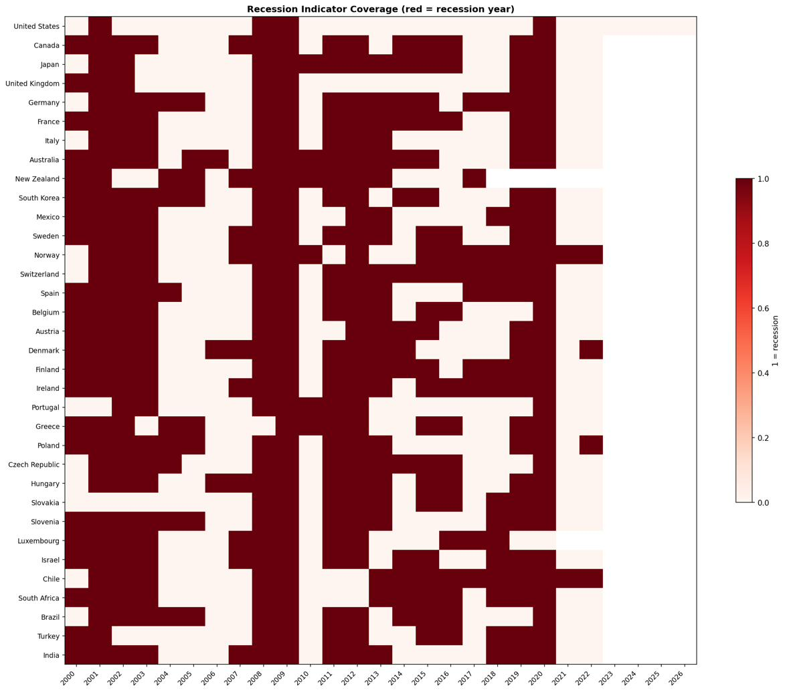
Figure 1. Monthly observations per country after filtering for complete spread and recession data. Red cells indicate recession months. The final panel contained 8,206 country-month observations across 32 economies.

2.2 Yield-spread variable
The main predictor was the term spread, defined as the difference between the 10-year government bond yield and the 3-month money-market or Treasury yield:
Spread_i,t = Yield10Y_i,t - Yield3M_i,t. (1)
A negative value denotes a yield-curve inversion. Figure 2 shows the monthly 10-year/3-month yield spread for selected economies, with recession periods shaded. Figure 3 provides the cross-country heatmap of 10-year yields and illustrates the broad post-2022 global repricing of government debt.
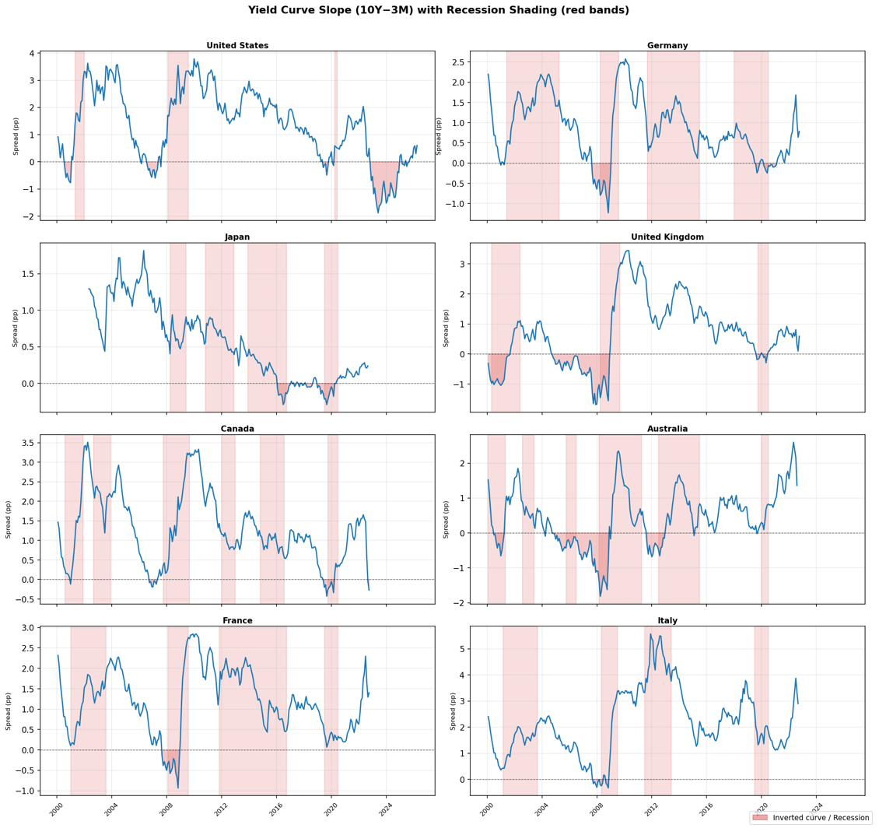
Figure 2. Monthly 10-year/3-month yield spreads for selected economies, 2000-2025. Shaded bands denote recession periods. Pre-recession compression and inversion are visible across multiple countries and episodes.
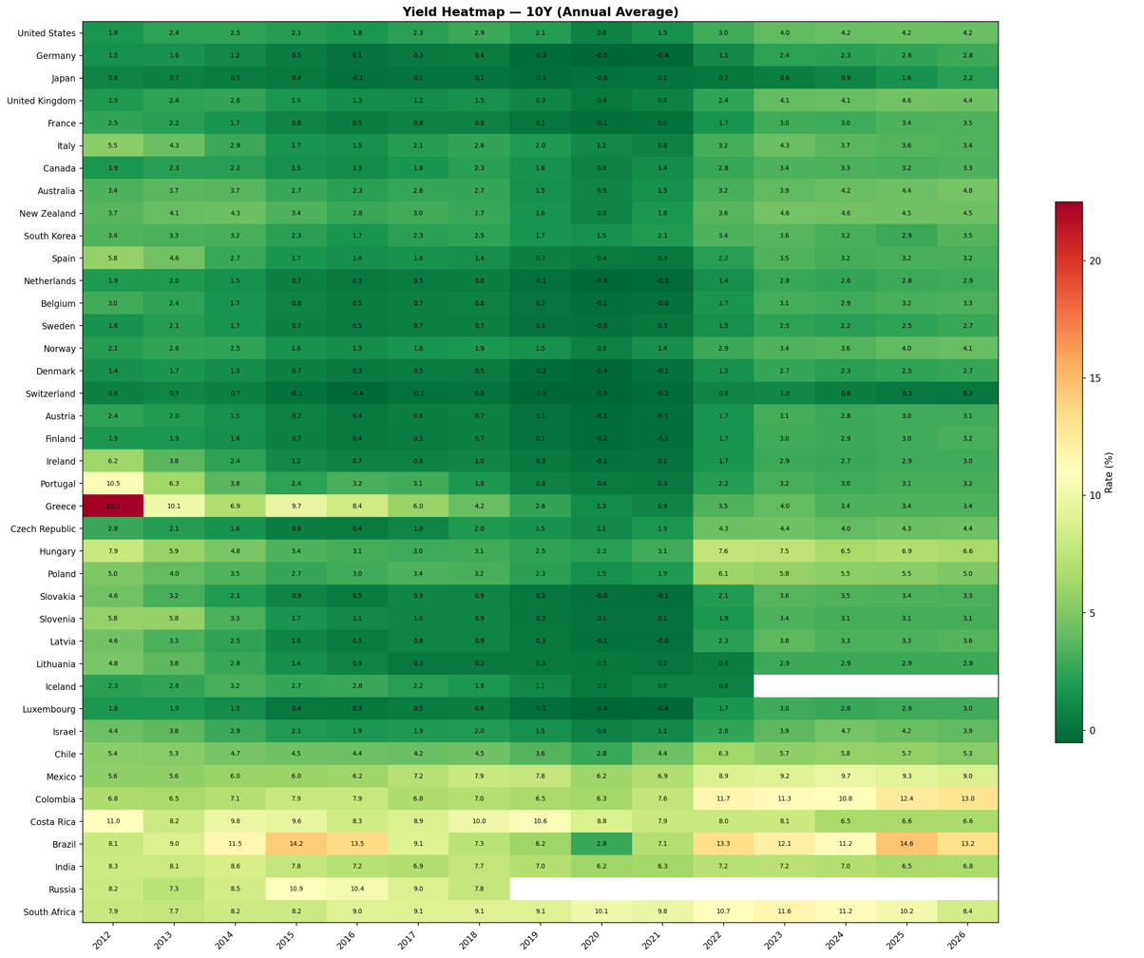
Figure 3. Heatmap of 10-year yields across 32 economies, 2000-2025. The post-2022 global repricing is visible as a broad darkening of the panel.

2.3 Econometric approach
For each country i and forecast horizon h from 1 to 24 months, recession probability was estimated using a logistic model:
Pr(Recession_i,t+h = 1) = Lambda(alpha_i + beta_h * Spread_i,t). (2)
In this specification, a negative coefficient indicates that a lower spread, or an inverted curve, is associated with a higher recession probability at horizon h. Predictive performance was evaluated using the area under the receiver operating characteristic curve (ROC-AUC). AUC values above 0.50 indicate better-than-random discrimination, while values close to or below 0.50 indicate little useful forecasting content. Incremental AUC was calculated as AUC minus 0.50, or against a country fixed-effect baseline when the pooled model was examined.
As a non-parametric check, an event-study plot was also produced around recession onset. Figure 4 traces average 10-year/3-month spreads from 24 months before to 24 months after recession start for each country. This visual inspection helps determine whether spreads tended to compress before recessions even in countries where logistic forecasting performance was weak.
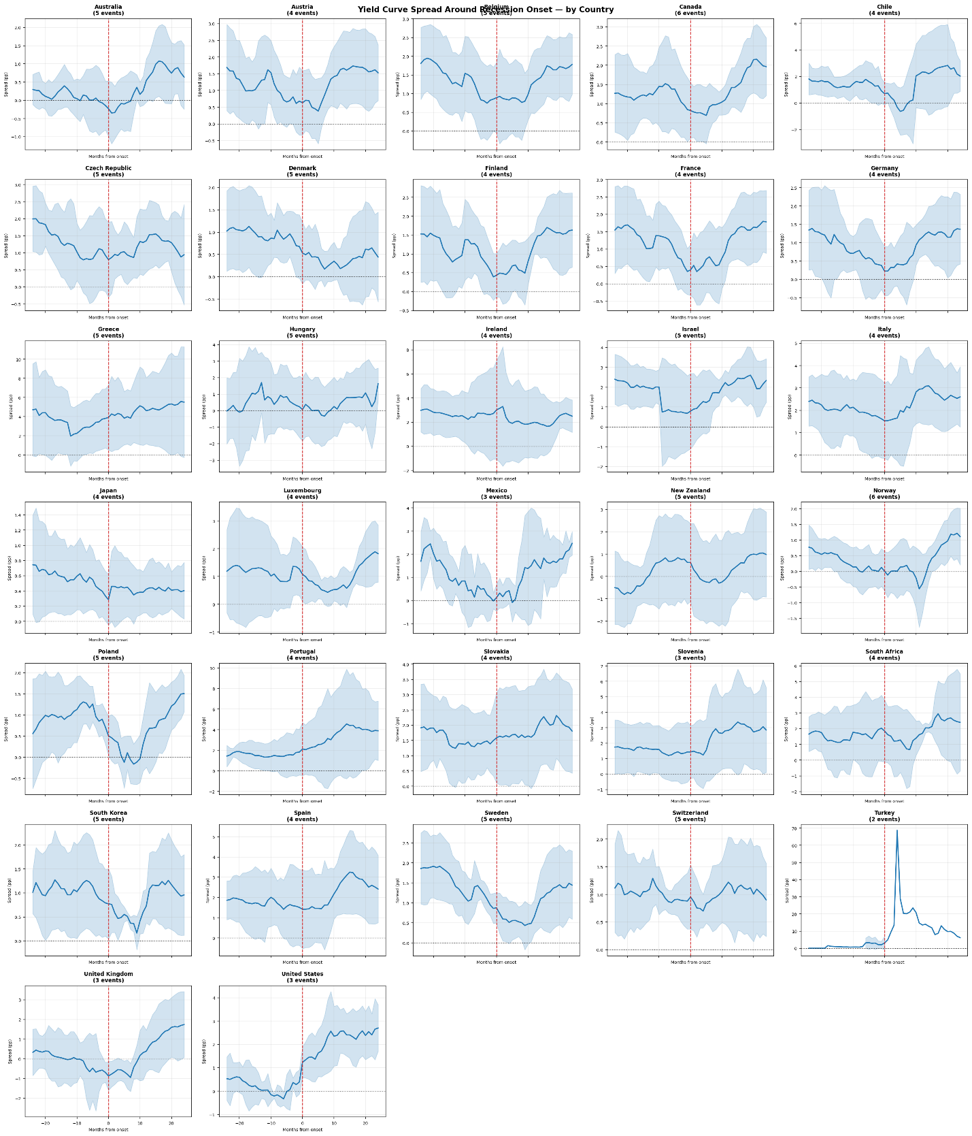
Figure 4. Event study of the 10-year/3-month spread around recession onset by country. Each line traces the average spread from 24 months before to 24 months after recession start (month 0). Pre-recession compression is visible for most economies, with substantial variation in depth and timing.

3. Results and Discussion

3.1 Cross-country yield-curve slopes
Table 1 reports country-level logistic regression results. Twenty-seven of the 32 countries had negative slope coefficients, consistent with the inversion hypothesis. Fourteen countries were statistically significant at the 5% level. The United Kingdom showed the strongest result, with beta = -1.316, P < .001, and AUC = 0.918. The United States also showed strong predictive performance, with beta = -0.318, P < .001, and AUC = 0.737. Norway, Switzerland, Sweden, and Israel also had large negative coefficients. At the other end of the distribution, eurozone periphery members clustered near or below the no-skill benchmark, including France (AUC = 0.488), Spain (AUC = 0.487), Greece (AUC = 0.449), and Ireland (AUC = 0.429).
These results suggest that the yield curve was not equally informative across economies. Strong predictive power appeared mainly in economies with independent monetary policy and relatively market-determined yield curves, while weak predictive power appeared in economies where the short-rate signal was shared, suppressed, or distorted.
Table 1. Country-level logistic regression results. Shaded rows: green = AUC >= 0.65 (strong); red = AUC < 0.50 (below random). ***P < .001, **P < .01, *P < .05.
Country | Coeff. (beta) | P value | AUC | Rec. rate | Eurozone
United Kingdom | -1.316*** | <.001 | 0.918 | 18.7% | -
United States | -0.318*** | <.001 | 0.737 | 8.9% | -
New Zealand | +0.239*** | <.001 | 0.692 | 38.6% | -
Norway | -0.472*** | <.001 | 0.670 | 44.3% | -
Chile | -0.316*** | <.001 | 0.670 | 44.8% | -
Israel | -0.361*** | <.001 | 0.651 | 39.6% | -
Slovakia | +0.209** | .001 | 0.649 | 27.9% | Yes
Mexico | -0.279** | .002 | 0.648 | 30.6% | -
Sweden | -0.447*** | <.001 | 0.638 | 38.8% | -
Hungary | -0.143*** | <.001 | 0.634 | 38.1% | -
Denmark | -0.271** | .005 | 0.612 | 46.0% | -
Poland | -0.223*** | <.001 | 0.599 | 38.8% | -
Switzerland | -0.450*** | <.001 | 0.596 | 44.0% | -
Luxembourg | -0.206 | .053 | 0.591 | 43.2% | Yes
Slovenia | -0.093 | .063 | 0.577 | 35.4% | Yes
Australia | -0.141 | .163 | 0.556 | 41.7% | -
Germany | +0.076 | .439 | 0.555 | 50.5% | Yes
Czech Republic | +0.124 | .157 | 0.551 | 38.3% | -
Canada | -0.093 | .278 | 0.541 | 35.2% | -
Austria | +0.023 | .805 | 0.540 | 39.0% | Yes
Japan | -0.274 | .108 | 0.534 | 34.7% | -
Finland | -0.165 | .106 | 0.534 | 43.4% | Yes
South Korea | +0.179 | .100 | 0.533 | 37.1% | -
Belgium | -0.044 | .612 | 0.525 | 31.6% | Yes
Italy | -0.024 | .701 | 0.524 | 29.0% | Yes
Turkey | -0.034 | .398 | 0.503 | 16.4% | -
Portugal | +0.042 | .162 | 0.491 | 22.3% | Yes
France | -0.002 | .981 | 0.488 | 44.0% | Yes
Spain | +0.005 | .928 | 0.487 | 44.1% | Yes
South Africa | -0.031 | .462 | 0.464 | 41.6% | -
Greece | -0.014 | .349 | 0.449 | 33.7% | Yes
Ireland | +0.021 | .597 | 0.429 | 57.7% | Yes

Figure 5 displays the same country-level slope estimates graphically. The figure highlights the clustering of eurozone members near zero and the larger negative estimates among Nordic and Anglo-Saxon economies.
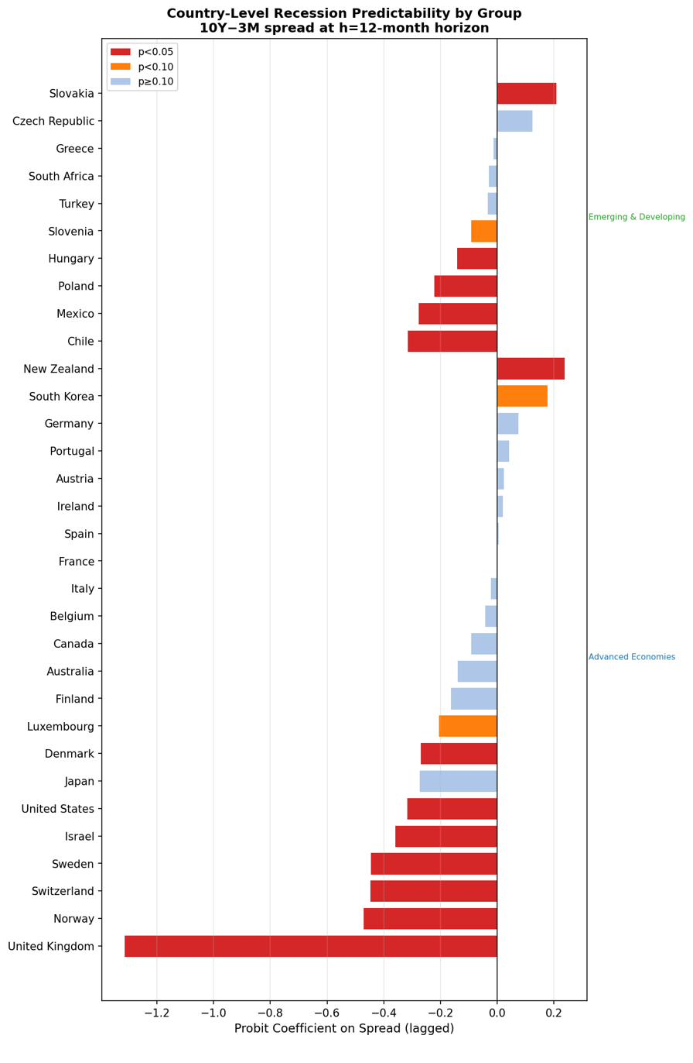
Figure 5. Estimated logistic coefficient by country, grouped by region. Filled markers indicate significance at 5%. Eurozone members cluster near zero, whereas Nordic and Anglo-Saxon economies show larger negative estimates.

3.2 Forecasting performance by horizon
The pooled panel model estimated at 24 forecast horizons revealed a consistent timing pattern. At the 1-month horizon, the spread coefficient was not statistically significant (beta = -0.003, P = .64, AUC = 0.615). Statistical significance emerged by the 3-month horizon. Predictive performance peaked at approximately 7 to 9 months ahead, with AUC reaching about 0.633, and the signal remained statistically significant but weaker through 24 months.
This pattern is consistent with the interpretation that yield-curve inversion operates as a medium-term leading indicator rather than an immediate recession signal. The strongest pooled performance appeared roughly two to three quarters before recession, which aligns with the monetary-transmission lag described in earlier U.S. studies.
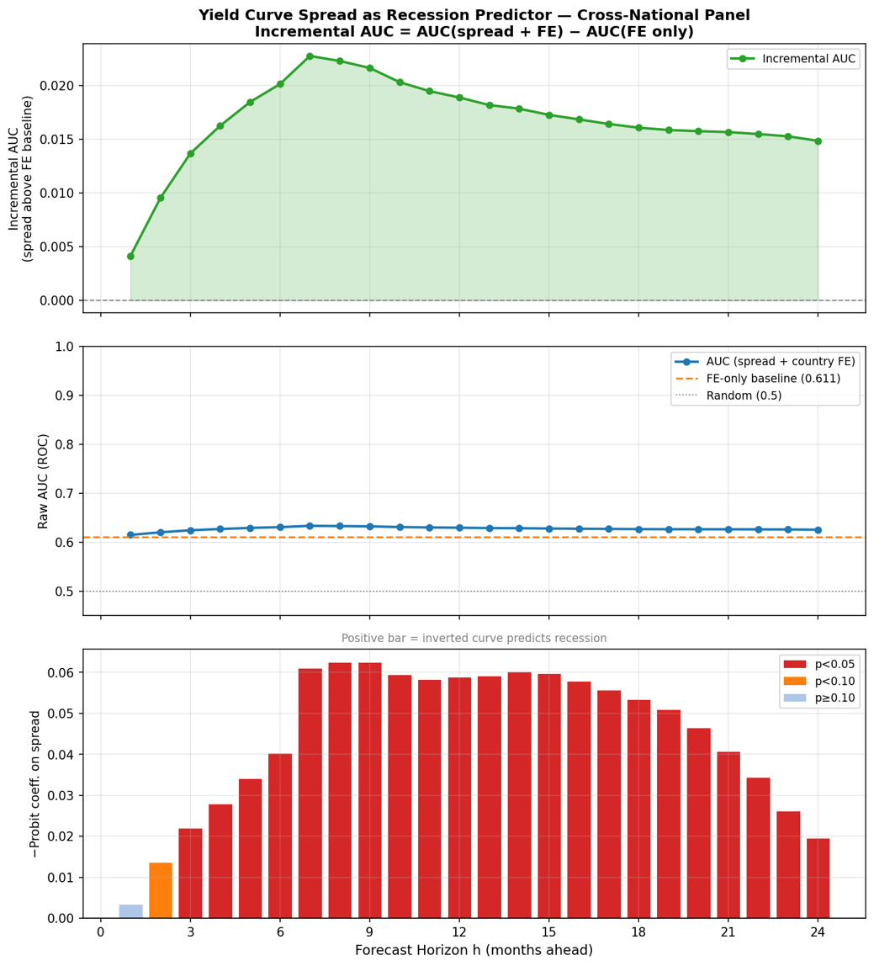
Figure 6. AUC as a function of forecast horizon in the pooled global panel. Predictive power peaks at approximately 7-9 months and remains statistically significant through 24 months.

3.3 Advanced and emerging economies
Grouping countries by economic classification further clarified the pattern (Figure 7). The United States was distinctive: its AUC increased from 0.661 at the 1-month horizon to 0.870 at the 24-month horizon. This rising pattern likely reflected the long and variable lag of U.S. monetary-policy transmission. Advanced economies excluding the United States peaked around AUC = 0.644 at month 7. Emerging and developing economies produced the weakest signal, with AUC values generally between 0.552 and 0.596 and with weaker statistical significance at the shortest and longest horizons.
These group-level results show that the pooled global average masks large structural differences. A single global coefficient is therefore not a reliable description of any individual country. Instead, regime-aware and country-stratified models are more appropriate for interpreting the yield curve as a recession predictor.
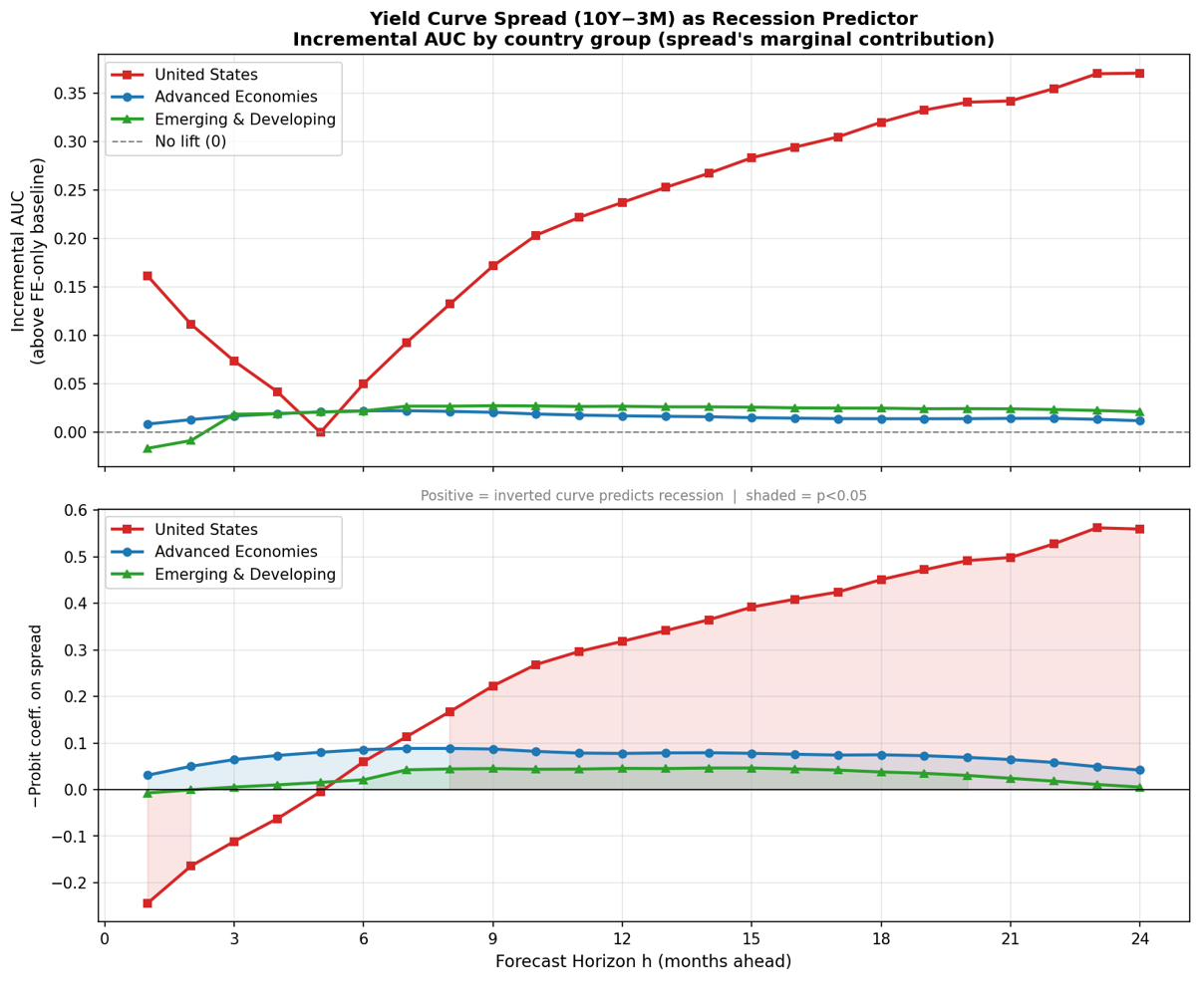
Figure 7. AUC by horizon for three groups: United States, advanced economies excluding the United States, and emerging and developing economies. The U.S. curve rises with horizon; other advanced economies peak around month 7; emerging markets remain persistently weaker.
The full country-level AUC distribution is shown in Figure 8. The distribution was clearly bimodal, with a small group of strong performers and a larger group clustered near the 0.50 no-skill benchmark.
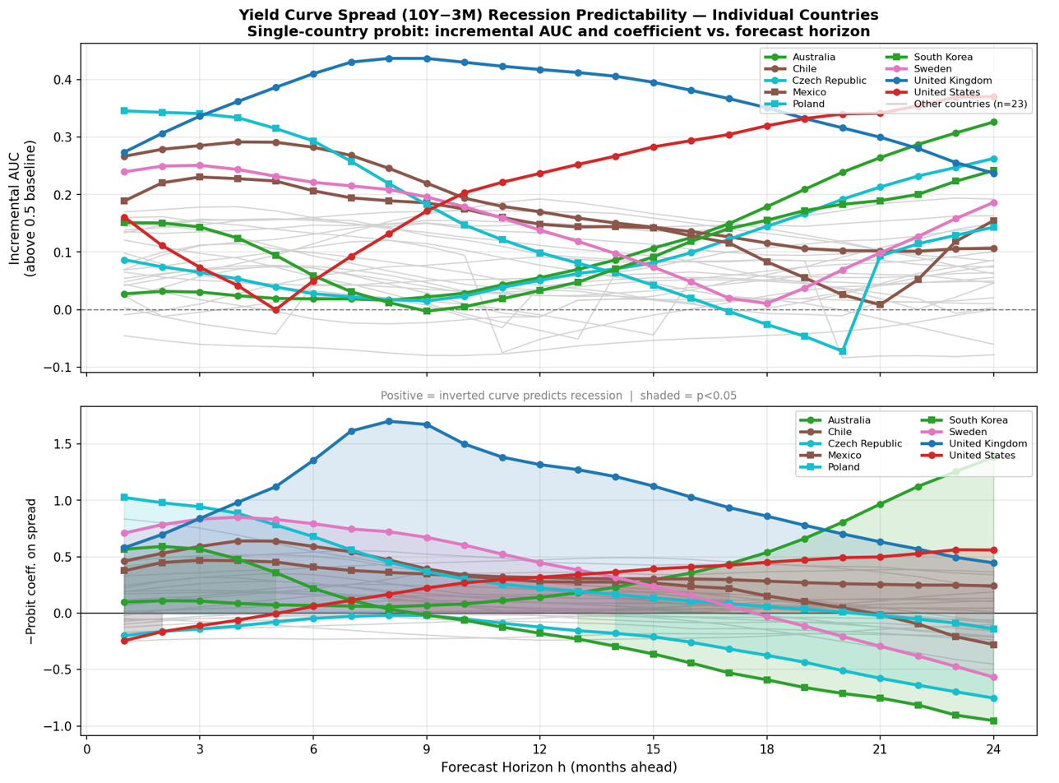
Figure 8. Country-level AUC values. The dashed line at 0.50 is the no-skill benchmark. The bimodal distribution, with a cluster of strong performers above 0.62 and a cluster near or below 0.50, motivates the structural interpretation developed in the discussion.

3.4 Structural interpretation of heterogeneity
The cross-country results indicate that yield-curve forecasting success depends on whether the spread is a genuine market-based monetary-policy signal. The strongest predictors - including the United Kingdom, the United States, Norway, Chile, Israel, and New Zealand - share several features. Their short-term interest rates are set by domestic central banks, their bond markets are relatively deep, and their yield curves are not mechanically tied to a common supranational short-rate regime. In these settings, a low or inverted spread plausibly reflects expectations that current monetary tightening will be followed by economic weakness and future easing.
Eurozone economies illustrate the first weak-signal mechanism: policy-suppressed spreads. Member states share a common short-term rate set by the European Central Bank. As a result, the country-level 10-year/3-month spread reflects local long-term yields and risk premia, but the short end does not carry a country-specific policy signal. In this sample, eurozone members averaged AUC = 0.526, compared with 0.618 for non-eurozone economies. Germany performed somewhat better than several other eurozone members, likely because German yields play a benchmark role in ECB policy calibration and European bond markets.
The same principle applies, in attenuated form, to countries where yield curves are distorted by managed exchange rates, unconventional policy, risk premia, or commodity-cycle shocks. Turkey had a low recession rate but an AUC near 0.50, consistent with the idea that repeated currency and policy shocks weakened the business-cycle interpretation of its spread. South Africa also showed weak predictive performance, likely because exchange-rate and commodity-cycle dynamics dominated the standard domestic yield-curve channel. Japan represents an even clearer case of policy suppression because quantitative easing, negative interest-rate policy, and yield-curve control directly altered the information content of the term structure.
A second weak-signal mechanism operates through the base rate of recession. When the unconditional recession frequency is high, especially near 50%, a predictor must work harder to discriminate recession months from non-recession months. In this sample, the correlation between recession rate and AUC was -0.36. Ireland was the clearest case: it had the highest recession rate in the sample at 57.7% and an AUC of only 0.429. Greece and France also combined weak predictive performance with either high base rates, eurozone membership, or both.
High recession frequency alone, however, did not eliminate predictive power. Norway, Chile, and New Zealand had relatively high recession rates but still produced strong AUC values because they retained independent monetary policy and market-determined spreads. The most damaging combination was therefore high recession frequency together with a policy-constrained or distorted spread.
Table 2. Summary of heterogeneity mechanisms. Countries are grouped by the dominant explanation for their AUC performance. Recession rate and average spread are shown as contextual variables.
Group | Dominant mechanism | Representative countries | Avg AUC | Avg rec. rate | EZ share
Strong signal | Independent policy and lower base rate | UK, US, Norway, Israel, Chile | 0.74 | 29% | 0%
Moderate signal | Independent policy and moderate base rate | Sweden, Hungary, Denmark, Poland | 0.62 | 40% | 0%
Weak signal | Eurozone constraint and moderate base rate | Germany, Austria, Belgium, Finland | 0.54 | 40% | 100%
Near-zero signal | Eurozone constraint plus high base rate or spread distortion | France, Spain, Ireland, Greece, South Africa | 0.47 | 47% | 80%

4. Conclusion
This study examined the predictive power of the 10-year/3-month yield spread across 32 economies from 2000 to 2025. The main result is that the yield curve is a selective, not universal, recession indicator. The pooled global AUC of approximately 0.633 suggests modest overall forecasting value, but this average masks substantial heterogeneity across monetary regimes and national economic structures.
The yield curve performed best in countries with independent monetary policy, relatively deep bond markets, and market-determined short- and long-term interest rates. The strongest results were found for the United Kingdom and the United States, with additional meaningful signals in several other non-eurozone economies. In contrast, many eurozone countries produced AUC values near or below the no-skill benchmark because the shared ECB short-term rate removes much of the country-specific monetary-policy signal from the spread. Japan and several externally exposed economies also showed weaker results because policy interventions, exchange-rate dynamics, commodity cycles, or external demand shocks distorted the standard yield-curve channel.
The analysis also showed that high unconditional recession frequency can reduce the incremental discriminatory value of the yield spread, especially when combined with policy-constrained interest rates. Ireland, France, Greece, and Spain illustrate this problem. However, high recession frequency did not by itself eliminate predictive power when countries retained independent monetary policy and market-determined yield curves.
The practical implication is that researchers and policymakers should avoid applying a single global yield-curve rule across all countries. In the United States and the United Kingdom, the yield curve remains a useful medium-term recession indicator. In much of the eurozone and in policy-suppressed regimes, it should be interpreted with caution and supplemented with country-specific indicators such as credit spreads, purchasing managers’ indexes, labor-market indicators, and real-activity measures. Future research could improve forecasting in weaker-signal economies by combining the term spread with broader financial-condition and macroeconomic variables in regime-aware models.

Consent
Not applicable. This study used publicly available macroeconomic and financial data and did not involve human participants.

Ethical Approval
Not applicable. This study used publicly available aggregate economic and financial data and did not involve human or animal subjects.

References
1. Kessel, R. A. (1965). The cyclical behavior of the term structure of interest rates. NBER Occasional Paper 91. National Bureau of Economic Research.
2. Harvey, C. R. (1988). The real term structure and consumption growth. Journal of Financial Economics, 22(2), 305-333.
3. Estrella, A., & Hardouvelis, G. A. (1991). The term structure as a predictor of real economic activity. Journal of Finance, 46(2), 555-576.
4. Estrella, A., & Mishkin, F. S. (1998). Predicting U.S. recessions: Financial variables as leading indicators. Review of Economics and Statistics, 80(1), 45-61.
5. Rudebusch, G. D., & Williams, J. C. (2009). Forecasting recessions: The puzzle of the enduring power of the yield curve. Journal of Business & Economic Statistics, 27(4), 492-503.
6. Wright, J. H. (2006). The yield curve and predicting recessions. Finance and Economics Discussion Series 2006-07. Board of Governors of the Federal Reserve System.
7. Bauer, M. D., & Mertens, T. M. (2018a). Economic forecasts with the yield curve. FRBSF Economic Letter 2018-07. Federal Reserve Bank of San Francisco.
8. Bernanke, B. S., & Blinder, A. S. (1992). The federal funds rate and the channels of monetary transmission. American Economic Review, 82(4), 901-921.
9. Moneta, F. (2005). Does the yield spread predict recessions in the euro area? International Finance, 8(2), 263-301.
10. Wheelock, D. C., & Wohar, M. E. (2009). Can the term spread predict output growth and recessions? A survey of the literature. Federal Reserve Bank of St. Louis Review, 91(5), 419-440.
11. Chinn, M. D., & Kucko, K. J. (2015). The predictive power of the yield curve across countries and time. International Finance, 18(2), 129-156.
12. Bauer, M. D., & Mertens, T. M. (2018b). Information in the yield curve about future recessions. FRBSF Economic Letter 2018-20. Federal Reserve Bank of San Francisco.

