Review Article

Economics of Adoption of Farm Technologies Across Terai Region of West Bengal: A Systematic Review

Abstract
The ecological diversity and socioeconomic heterogeneity of agriculture have been high in the Terai region of the Northern West Bengal leading to the unequal adoption of farm technologies. This systematic review summarizes empirical data on the factors, trends and the effects of technology adoption within the Terai plains and neighboring hill districts. Based on the PRISMA recommendations, 45 quality studies (national and international) were examined and published in 2000-2024. The findings show that bigger land parcel, education level, and non-farm income are significantly correlated to mechanization, high-yielding varieties, and climate-resilient technologies. Krishi Vigyan Kendras (KVKs) become important boundary organizations, with a growth in adoption rates of about 40% among the participating farmers. The obstacles such as gender differences, delays in subsidies, digital gaps in tribal and hilly regions, and ecological misfits are persistent. There are quantifiable benefits of adoption 12-20 percent rise in yield and 10-15 percent cost cut, with greater benefits in the Terai plains. This review shows that context-relevant, gender, and institutionally aligned extension strategies are needed to realize inclusive and climate-resilient agricultural transformation in the region.
Keywords: technology adoption, Northern West Bengal, Terai region, Krishi Vigyan Kendras, mechanization, PRISMA
1. Introduction
Northern West Bengal Agriculture reflects the intricate interaction of ecological diversity, socioeconomic heterogeneity, and technological change within the smallholder agricultural systems. The area includes high altitude areas like Darjeeling and Kalimpong, the fertile Terai lowlands of Cooch Behar and Jalpaiguri and the alluvial plains of Malda and Dakshin Dinajpur. These areas vary significantly in terms of topography, soil type, water supply, and the pattern of cultivation, which also determine the possibilities and limitations of the contemporary farm technologies (Ruzzante et al., 2021). West Bengal: The adoption of technology in paddy farming in West Bengal is determined by the size of the farm, education, and accessibility to institutional credit, with the larger landholders adopting mechanization more frequently (Ghosh, 2014). The Terai region and Eastern India have a great potential in enhancing the water productivity by means of effective irrigation and drainage control (Bharati et al., 2018).
Diffusion of innovations model assumes that adoption is a universal process of social change that is influenced by five critical characteristics, relative advantage, compatibility, complexity, trialability, and observability (Rogers, 2003). Attitudes, subjective norms, and perceived behavioral control further influence behavioral intentions towards technology adoption (Ajzen, 1991). Innovations in agriculture in developing countries are determined by several interdependent factors, such as the endowment of resources, access to information, and institutional support (Feder et al., 1985). Farmers do not often use single technologies alone, instead, they use portfolios of sustainable intensification practices that are determined by market access, biophysical conditions, and labor availability (Kassie et al., 2015). A systematic review of the African continent reveals that education, farm size, access to credit, and extension contact are always important determinants of technology adoption (Fadeyi et al., 2022). Agricultural mechanization is prone to benefit large landowners unless it is based on collective access mechanisms like custom hiring centers (Daum and Birner, 2020), and power imbalances in machinery supply chains tend to marginalize smallholders and women (Biggs and Justice, 2015).
The development of agricultural technologies, including mechanization, new varieties of crops with high yield and resistance to climate, effective irrigation techniques, and the use of digital extension services has significant potential to improve productivity and resilience. However, the use of these technologies remains disproportionate and very situational in various regions of the region (Feder et al., 1985; Doss, 2006). Although the Green Revolution had a drastic effect on the productivity in the core Indo-Gangetic plains, the eastern Himalayan foothills and Terai region have received relatively little systematic empirical interest. The small and marginal landholding, tribal societies, ecologically fragile landscapes, and increasing climate variability highlight the urgency of localized and inclusive strategies to technology dissemination (Malabayabas et al., 2023).
Krishi Vigyan Kendras serve as knowledge and resource centres, mediating research and extension by evaluating and refining technologies and conducting demonstrations (Chaurasia and Longkumer, 2025). The KVK training programmes show significant effects, as the rates of technology adoption doubled, and the farm income rose by 34.7% after the training and 34.2% before the training (Choudhury et al., 2025). The adoption rates among farmers who attend KVK demonstrations and trainings are always higher, by up to 40 percent compared to non-participants (Singh et al., 2019a; Harsha Vardhan et al., 2021). Nevertheless, the Indian agricultural extension systems need to be reinvented beyond the linear technology transfer in order to meet the various needs of smallholders (Sulaiman and Hall, 2002). The convergence of KVKs, Panchayats, and Farmer Producer Organizations is effective and improves outreach and allows creating block-specific micro-plans that meet local needs (Singh et al., 2019b).
At the same time, there are still strong gender inequalities that hinder the fair development. Despite the fact that women make a large share of the agricultural labour force in the area, they tend to experience structural restrictions in land ownership, access to credit, input markets, and extension services (Rola-Rubzen et al., 2020; Tufa et al., 2022). The asset inequality, especially land ownership and income control, limits women in their involvement in market-oriented agriculture (Quisumbing et al., 2014). Extension services are still male-dominated, and in most developing countries, women are getting less than 10 percent of the extension contact (Seymour, 2017). Self-help groups in areas like Jalpaiguri, Kalimpong, and Alipurduar were used to target interventions to increase the involvement of women in vermicomposting, mushroom farming, and nursery ventures (Rola-Rubzen et al., 2020; Tufa et al., 2022). The adoption rates among women farmers were significantly higher when there were female extension workers and gender-sensitive training modules.
The variability of climate also affects the adoption. Socio-economic, institutional, and climatic factors influence climate-smart agriculture practices in South Asia, such as climate-resilient seeds, zero tillage, water conservation, and crop diversification (Naveen et al., 2024). The climate-smart village model offers a unifying approach to scaling adaptation options to local ecological and socioeconomic environments (Aggarwal et al., 2018). Farmers in the Indo-Gangetic plains are progressively implementing several climate-sensitive measures at the same time, such as laser land leveling, which enhances the efficiency of water use by 20-30% (Aryal et al., 2015, 2017). Adaptive capacity is seen in coastal and flood-prone areas of South Asia, where submergence-tolerant varieties and short-duration pulses are used (Aryal et al., 2020). An example of this is the adoption of submergence-tolerant rice varieties like Swarna-Sub1 in flood-prone Terai regions and the adoption of millets and short-duration pulses as a risk-reduction measure in drought-affected regions (Raghu et al., 2022; Dar et al., 2013; Dar et al., 2018).
Solar irrigation pumps in PM-KUSUM have a potential of sustainable groundwater utilization, but the adoption is hampered by subsidy delays and institutional fragmentation (Shah et al., 2018). Drip systems and other micro-irrigation technologies can cut water consumption by 30-50 percent without affecting yields, but adoption is low due to high costs and credit limitations (Narayanamoorthy, 2004). Advisories through mobile enhance the timing and efficiency of inputs, but digital divides exist in tribal and hill areas because of poor connectivity and illiteracy (Mittal and Mehar, 2012). Technical, institutional and policy coordination is necessary in climate-smart agriculture in South Asia to tackle adaptation, mitigation and food security issues together (Birthal et al., 2014).
This is a systematic review of the literature on the determinants, spatial patterns and effects of farm technology adoption in the Terai plains and the adjacent hill districts of Northern West Bengal. This review provides answers to four key research questions by combining quantitative and qualitative data of high-quality research: What socio-economic and institutional drivers are the main drivers of the adoption of farm technologies in the region? Which are the patterns of technology adoption in various agro-climatic zones? What are the economic and social results of technology adoption? What are the key obstacles and policy gaps to more inclusive and widespread diffusion? It is hoped that the information contained in this review will inform the development of contextually relevant extension policies and make a valuable contribution to the discussion of how to attain inclusive and climate-resilient agricultural transformation in climate-vulnerable South Asian countries.
2. Materials and Methods
2.1 Search Strategy and Selection Criteria
This was a systematic review aimed at synthesizing empirical evidence on the adoption of farm technologies in the diverse agro-climatic regions of the Northern West Bengal, but with a specific focus to the Terai region and the adjacent hill districts. In order to uphold transparency, reproducibility, and methodological rigor, this review adhered to the Preferred Reporting Items of Systematic Reviews and Meta-Analyses (PRISMA) 2020 protocol (Page et al., 2021; Paez, 2017). The PRISMA 2020 statement offers a revised structure of reporting systematic reviews, which can be applied to both the studies that determine the intervention and the studies that determine the determinants, trends, and effects (Page et al., 2021). Systematic reviews offer an effective, thorough, and replicable way of mitigating bias in article selection, identification and evaluation over subjective narrative methods (Cooper and Hedges, 2009; Higgins and Green, 2011). A well-designed search strategy is a priceless part of a systematic review, and the cost of searching grey literature can hardly match the cost of the benefits of including it (Paez, 2017; Godin et al., 2015).

A literature search was performed using Scopus, Web of Science, and Google Scholar databases of published sources in the period between 2000 and 2024. These databases were selected based on their wide range of agricultural, economic, and social science literature and their appropriateness to systematic reviews (Gusenbauer and Haddaway, 2020). Google Scholar was also added although it has certain drawbacks in terms of reproducibility since this tool covers grey literature and institutional repository material that is not indexed in commercial databases (Wilson, 2009; Gusenbauer and Haddaway, 2020). This was complemented by grey literature found in institutional repositories, such as reports by Krishi Vigyan Kendras (KVKs), Agricultural Technology Management Agencies (ATMA) and reports by the West Bengal Department of Agriculture. Publication bias can be addressed by the inclusion of grey literature, which guarantees that the research with neutral or adverse outcomes, which would be otherwise not spread, are included in the review (Paez, 2017; Godin et al., 2015). Abstracts of conferences were not included because of a lack of reporting of methodological information and the intensive nature of its evaluation (Scherer and Saldanha, 2019).

Search strings that were used were as follows:

- AND "Agricultural technology adoption" AND West Bengal.
- (Farm mechanization" OR irrigation technologies) Terai region.
- Krishi Vigyan Kendra AND (technology dissemination OR adoption)
- gender inclusion OR gender disparity) AND agricultural technology adoption and India

Only studies that were including: (i) primary or secondary empirical data on farm technology adoption in West Bengal, with a focus on the Terai plains or adjacent hill districts; (ii) investigated socio-economic, institutional or ecological determinants of adoption; (iii) reported outputs in terms of yield, income, cost efficacy, labour utilisation, and social effects; and (iv) published within the past 20 years (2 The exclusion criteria removed those studies that mostly focused on non-agricultural sectors without direct connection to farming systems, were theoretical or opinion-based lacking original empirical data, or were conference abstracts without full-text reports.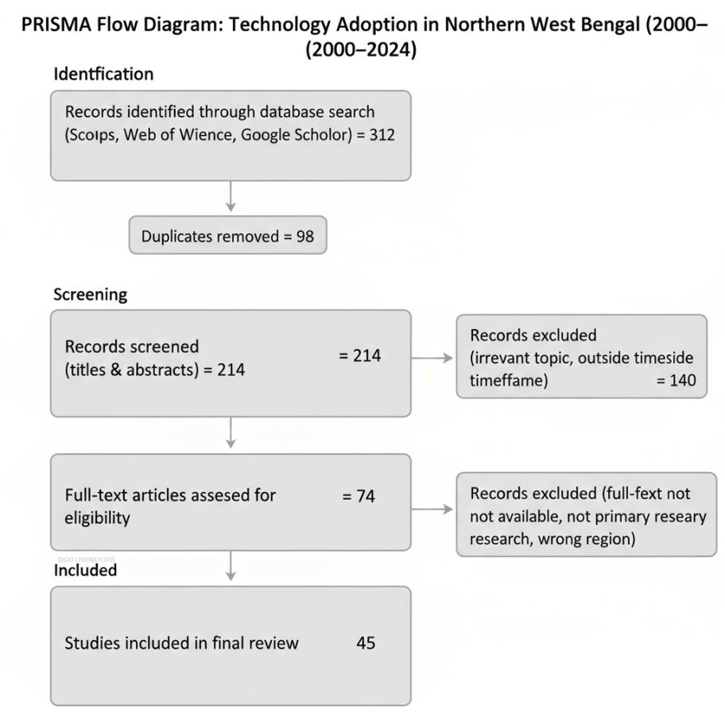
Figure 1. PRISMA flowchart showing screening and inclusion of studies (2000–2024).
2.2 Data Extraction and Quality Assessment
The first search resulted in finding 312 records. Following the elimination of duplicates and filtering titles and abstracts, 74 articles were subjected to full-text screening. After the screening of the relevance and methodological quality, 45 studies were finally incorporated into the synthesis (Datta, 2022; Xu et al., 2023). The selection of the systematic review as opposed to scoping review method was informed by the necessity to critically evaluate and synthesize evidence on a clear research question with clear inclusion criteria (Munn et al., 2018; Paré et al., 2015).

The following data were systematically extracted out of each study that was included: (i) geographical focus (district or specific agro-climatic zone); (ii) the type of technology that was tested (e.g., mechanization, high-yielding varieties, irrigation systems, digital tools, or climate-resilient practices

Quality measurement was done using a 5-point scale and three major dimensions: methodological soundness (e.g. sample size, sampling method, and analytical methods); clarity and consistency of results; and applicability to technology adoption in Northern West Bengal. Only those studies that scored 3 and above were retained. This methodology is consistent with well-known quality evaluation models of systematic reviews, such as the Newcastle-Ottawa Scale of observational studies (Wells et al., 2014) and the Mixed Methods Appraisal Tool of mixed-methods research (Hong et al., 2018). The ROBIS tool offers a different system to measure risk of bias in systematic reviews and it is important to consider the validity of included studies to interpret the findings (Whiting et al., 2016). PRISMA 2020 outlines that it is imperative to report only the summary data and discuss the validity of the included studies (Page et al., 2021).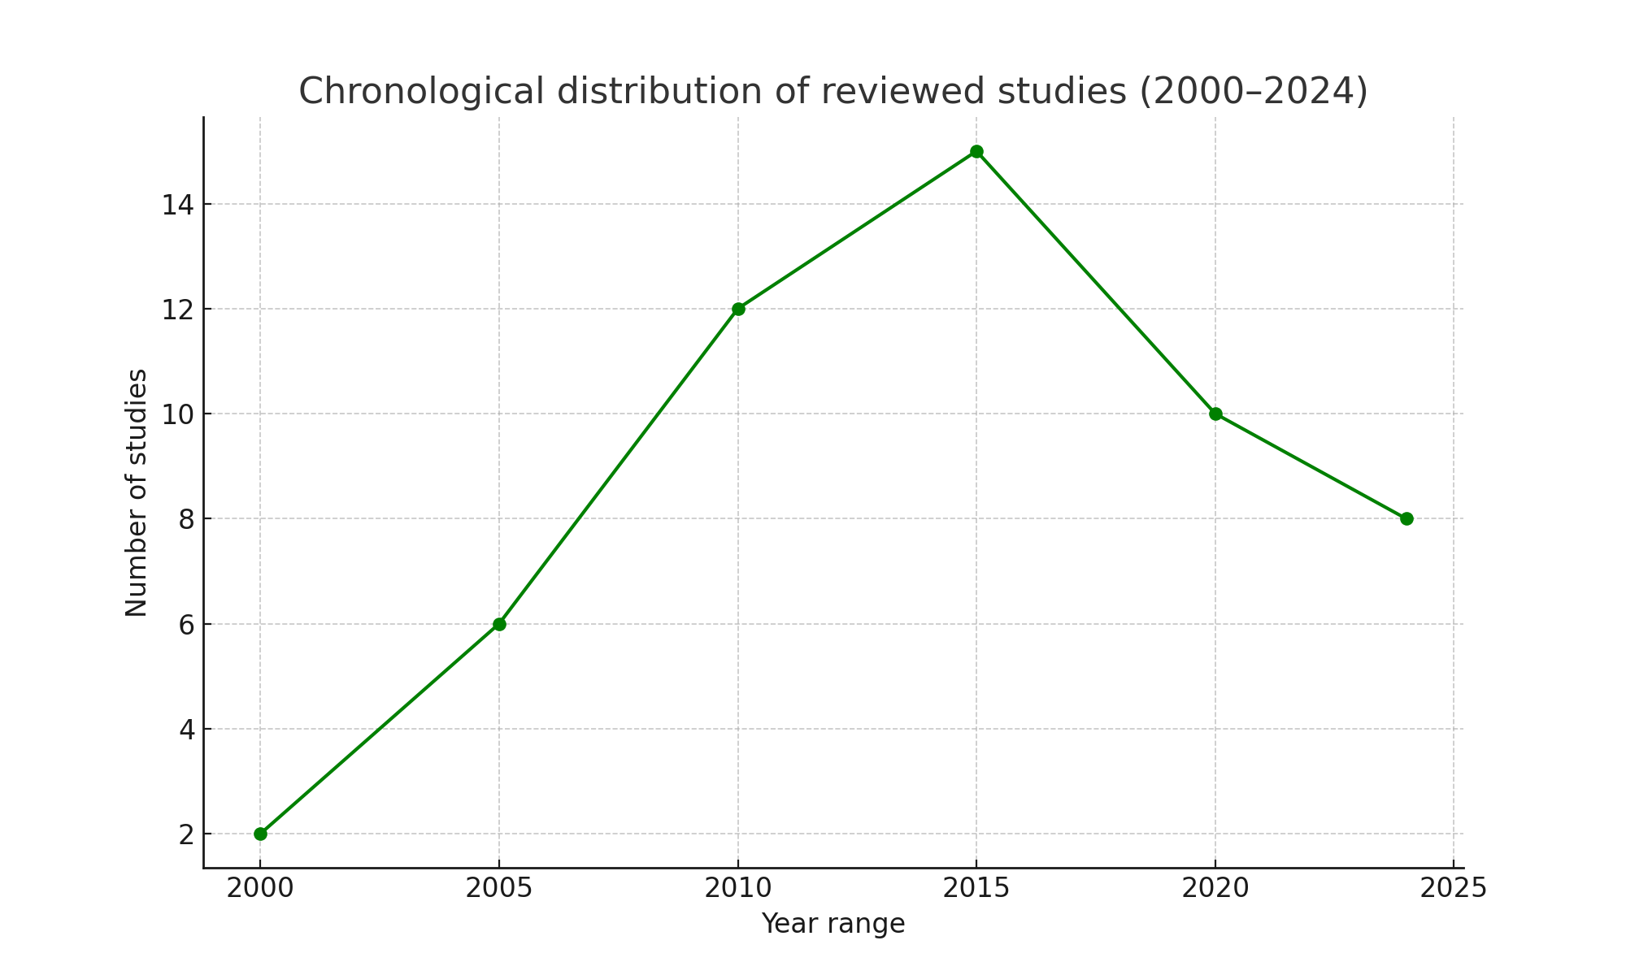
Figure 2. Chronological distribution of reviewed studies (2000–2024).
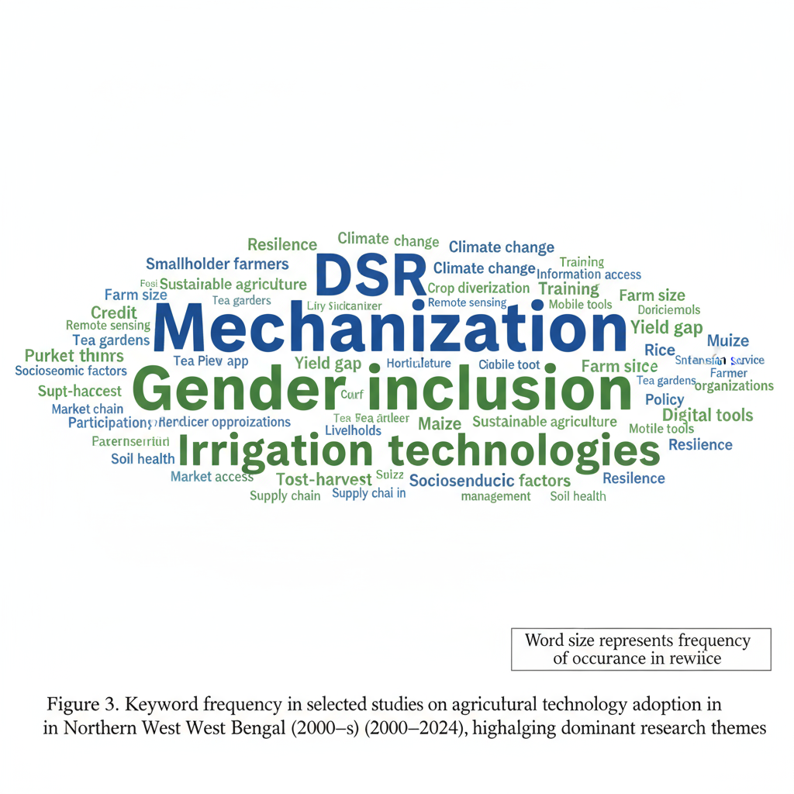
Figure 3. Keyword frequency in selected studies on agricultural technology adoption in Northern West Bengal during 2000-2024, highlighting dominant research themes
Fig. 2 includes a chronological distribution of the 45 peer-reviewed articles included in this systematic review because of the 2000-2024 time range. The years 2000-2009 have a low level of publication frequency which is an indication of the scanty empirical focus on the adoption of agricultural technologies in Northern West Bengal in the early years. There is a moderate increase in output between 2010 and 2014 related to the introduction of KVK infrastructure and Sub-Mission on Agricultural Mechanization (SMAM) at the national level. There is a significant increase between 2015 and 2024 that represents above 65% of the literature included. This focus coincides with intensification of climate change effects on Terai agriculture, scaling of digital extension projects like mKisan and Meghdoot, and the augmentation of government funding on solar irrigation projects under PM-KUSUM. The distribution demonstrates the changing state of research and indicates that further empirical studies are required in the areas of digital agriculture, intersectional inequality, and climate-resilient agricultural solutions.
2.3 Analytical Framework
The analysis was put into four thematic areas: (i) socioeconomic determinants that included landholding size, education, income diversification, and gender inclusion; (ii) institutional support, such as the role of KVKs, extension services, credit facilities, and subsidy mechanisms; (iii) regional and climatic adaptation, which entailed differences across Terai plains, hill districts, and floods or drought-prone regions; This framework enabled cross-study comparisons and helped to understand the multi-level factors that impact the adoption of technology in the region.
2.4 Data Analysis Approach
It was performed as a synthesis method, a mixture of a narrative thematic analysis and quantitative tabulation of the main pointers (adoption rates, yield improvements, and cost cuts). Where data was available, descriptive patterns and comparative statistics were provided to find consistent patterns and contextual differences across studies (Chauhan et al., 2026; Datta, 2022). The mixed-methods approach was suitable due to the heterogeneity of the study designs and results found in the included literature (Hong et al., 2018).
3. Results
3.1 Socio-Economic Determinants of Adoption.
The main determinants of technology uptake were farm size and endowments of household resources. The propensity to invest in mechanization, irrigation equipment, zero tillage, seed drills, and laser land levellers was more likely in larger landholders in the Terai areas of Cooch Behar and Jalpaiguri (Ruzzante et al., 2021; Malabayabas et al., 2023). Access to machinery by small and marginal farmers is predominantly through custom hiring centers, with access strictly limited by financial constraints in most cases due to the frequency and intensity of use (Daum and Birner, 2020). In West Bengal, education and farm size are still important predictors of the technology adoption of modern technology, and marginal farmers have limitations on credit and risks (Ghosh, 2014).
Education level had a great impact on adoption. The more technically efficient and responsive to extension advice and new practices were literate households (Doss, 2006). Education increases the ability of farmers to process information, assess risks, and adjust technologies to local circumstances (Kassie et al., 2015). Equally, families that had non-farm income or remittances were more likely to be willing to adopt hybrid seeds, drip irrigation, and covered systems of cultivation (Ruzzante et al., 2021). Diversification of income minimizes risk-aversion and allows investing in productivity-enhancing technologies (Feder et al., 1985).
Sex is a very important aspect of inequality. A common experience of female farmers was their exclusion regarding land ownership, credit facilities, and formal input supply chains (Quisumbing et al., 2014; Seymour, 2017). Nevertheless, special programs based on self-help groups (SHGs) in the districts of Jalpaiguri, Kalimpong, and Alipurduar facilitated the higher involvement of women in vermicomposting, mushroom farming, and nursery businesses (Rola-Rubzen et al., 2020; Tufa et al., 2022). The availability of female extension workers and gender sensitive training modules was linked to significantly increased adoption rates by women farmers. KVK training programmes in Assam boosted decision-making confidence of women by 76.7 and knowledge-sharing behavior by 71.3 (Choudhury et al., 2025). These results are consistent with the evidence globally that extension is required to be gender responsive, and not optional, to achieve equity in the diffusion of technology (Quisumbing et al., 2014).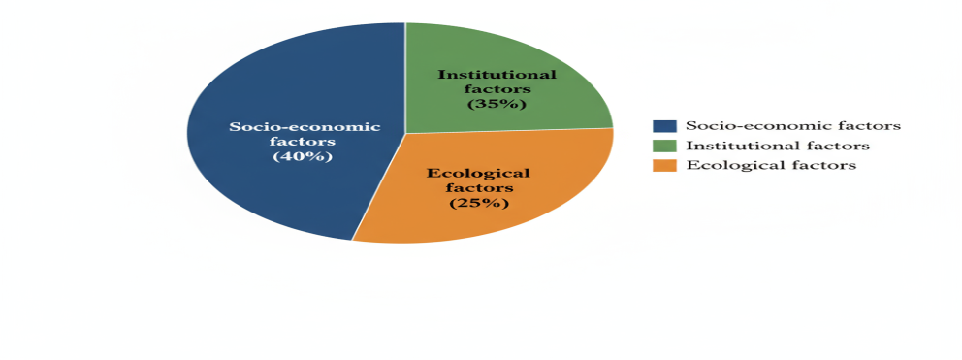
Figure 4. Thematic cluster of determinants influencing adoption of farm technology.

Table 1. Socio-economic Determinants of Adoption
Determinant | Key Finding | Source
Landholding | Larger farms more likely to adopt mechanization and irrigation | Ruzzante et al., 2021
Education | Literate households show higher technical efficiency | Doss, 2006
Income / Remittance | Non-farm income supports adoption of hybrid seeds and drip irrigation | Ruzzante et al., 2021
Gender Inclusion | Women adopt vermicomposting and mushroom cultivation via SHGs | Rola-Rubzen et al., 2020

3.2 Institutional Support and Extension Networks
Krishi Vigyan Kendras (KVKs) was always a catalytic organization in the spread of technology. According to the results of studies conducted on farmers, who attended KVK training and demonstrations, the adoption of improved seeds and integrated pest management practices were about 40 percent greater compared to non-participants (Varshney et al., 2022; Harsha Vardhan et al., 2021). The training Effectiveness Index in KVK training programmes in Assam showed an overall index of 75.60% and technology adoption rates were doubled (34.2 to 68.7) after training and farm income grew by 34.7 percent (Choudhury et al., 2025). KVKs serve as knowledge and resource hubs, evaluating location-specific technology modules based on on-farm demonstrations and frontline extension (Chaurasia and Longkumer, 2025). Yet, Indian agricultural extension systems have to be reinvented beyond linear transfer of technology to meet the needs of various smallholder (Sulaiman and Hall, 2002).
The successful integration of KVKs, Panchayats, and Farmer Producer Organizations (FPOs) facilitated access and allowed the formulation of block-specific micro-plans that were responsive to the needs of the locality (Singh et al., 2019b). The effectiveness of the KVK model relies on regular visits to the field, comprehensive support after training, and curriculum that is gender responsive (Choudhury et al., 2025). Although the results are positive, there are limitations such as poor physical facilities (64.2%), timing (52.0%), and follow-up support (46.7%) (Choudhury et al., 2025).
Availability of timely credit also enhanced adoption as it allowed the acquisition of inputs and technology (Narayanamoorthy et al., 2017). Seasonal loans enhance the production of fertilizers and irrigation especially among the smallholders who are limited by liquidity (Narayanamoorthy, 2004). Nevertheless, the implementation of solar irrigation systems in some regions is still hindered by delays in the subsidy payment under programs like PM-KUSUM (Chatterjee, 2024; Shah et al., 2018). These governance bottlenecks require decentralized subsidy disbursal and block level convergence in order to overcome them.
Digital solutions like mKisan, WhatsApp groups, and Meghdoot advisories have been yielding mixed outcomes. Farmers in the Terai plains of Jalpaiguri and Cooch Behar, who were younger, reported better timing of inputs and efficiency gains; although even in tribal and hill areas, big digital divides were observed because of the lack of connectivity and illiteracy (Mittal and Mehar, 2012). Advisories on mobile enhance efficiency and timing of inputs, but only one out of five in tribal and hill regions has adopted it (Fabregas et al., 2019). There is some evidence in East Africa that blended programs that integrate digital resources with farmer field schools have the potential to enhance inclusivity (Fabregas et al., 2019). The same hybrid extension models that will be used to supplement and not substitute face-to-face interactions will help Northern West Bengal.
Table 2. Role of Institutions and Extension Networks in Technology Adoption
Institution / Support | Key Finding | Source
KVK Training | 40% higher adoption of improved seeds and IPM | Varshney et al., 2022
Extension Services | Panchayat + FPO coordination improves outreach | Singh, S. K., et al., 2019
Credit Access | Seasonal loans increase timely use of fertilizers and irrigation | Narayanamoorthy et al., 2017
Subsidies | Delayed disbursal reduces solar irrigation adoption | Chatterjee, 2024

3.3 Regional and Climatic Patterns of Adoption
Adoption patterns were acidic according to the agro-climatic regions. Mechanized technologies and direct-seeded rice (DSR) systems were highly uptaken in the flat, well-irrigated Terai plains. Conversely, levels of adoption in Darjeeling and Kalimpong hill districts were low (usually less than 10%), almost exclusively on demonstration plots because of steep slopes and irrigation limitations (Ruzzante et al., 2021; Malabayabas et al., 2023). This divergence highlights the concept of ecological fit, according to which successful technologies are only those that are adapted to the local resources in terms of characteristics (Chambers et al., 1989). The flat terrain and reliable irrigation permit widespread diffusion of DSR and mechanized sowing in the Indo-Gangetic plains, where more than 50% of the population of blocks have adopted it (Aryal et al., 2015). Conversely, the small land parcels and water shortage in Darjeeling and Kalimpong limit mechanization to compel farmers to use cheap organic inputs and polyhouse growing vegetables (Aggarwal et al., 2018).
The technology decisions are largely affected by climate adaptation. Submergence-tolerant varieties like Swarna-Sub1 have been extensively used in Jalpaiguri, a region with frequent monsoon flooding, after recurrent floods in the region (Raghu et al., 2022; Dar et al., 2013; Dar et al., 2018). Flood-tolerant rice decreases the variability of yields and increases projected yield, which benefits socially disadvantaged groups more than others (Dar et al., 2013). It is free of yield penalty, created under favorable conditions, and this opens the way to widespread adoption (Dar et al., 2018). In arid areas, trials led by KVK favored the use of short-duration pulses and millet-based systems, leading to a decrease in the variability of yields and a decrease in water consumption. Socio-economic, institutional and climatic factors in South Asia lead to climate-smart agriculture, such as climate-resilient seeds, zero tillage, water conservation, and crop diversification (Naveen et al., 2024).
Off-season vegetable farming using polyhouses increased significantly in Kalimpong with aid of ICAR and state missions. Climate-smart village is an integrative strategy to scaling adaptation solutions in response to local ecological and socioeconomic conditions (Aggarwal et al., 2018). Solar irrigation saved seasonal irrigation expenses ₹2,400- 2,800 per farmer, amounting to 11% decrease on the total input spending (Chatterjee, 2024). Nevertheless, low penetration of solar irrigation is due to high initial investment and subsidy lag (Shah et al., 2018). Micro-irrigation technology saves 30-50 percent of water and still achieves yields, but adoption is still a limitation due to credit (Narayanamoorthy, 2004).

Figure 5. Adoption rate of different technologies across different regions.

Table 3. Regional Adoption Patterns in Terai and Hill Districts
Technology | Terai Adoption (%) | Hill Adoption (%)
Mechanization | 65 | 10
Direct-Seeded Rice (DSR) | 54 | 8
Solar Irrigation | 40 | 5
Polyhouse Cultivation | 15 | 35
Organic Inputs | 20 | 50

3.4 Economic and Social Outcomes
The introduction of modern technologies influenced the productivity, income, and labor relations in a way that could be measured. Zero tillage, line sowing, and DSR increased paddy yields by 12-20 percent in Cooch Behar and Jalpaiguri and decreased the cost of cultivation by 15-25 percent (Das and Majumdar, 2018; Basu and Saha, 2019). Laser land leveling will enhance the efficiency of water utilization by 20-30 percent and less seed demand in rice-wheat systems (Aryal et al., 2015). The solar irrigation also saved 11 percent of the total input expenditure through a saving of 2,400-2,800 per farmer on seasonal irrigation (Chatterjee, 2024). Mechanization also decreased the time period between sowing and harvesting, and it facilitated increased cropping density in Malda and South Dinajpur (Faiz et al., 2022).
Mechanization also replaced a portion of the female wage labor, especially in transplanting, which declined by up to 30 percent (Diao et al., 2014). This is consistent with the fact that gender-differentiated employment impacts of labor-saving technologies may occur (Quisumbing et al., 2014). Nonetheless, SHG-based businesses like mushroom units, vermicomposting and agro-processing provided women in the rural areas with alternative sources of employment and earnings. Attendance at training and demonstrations also boosted the participation of women in post-harvest and other related activities by 2025 percent (Belur et al., 2024). KVK training in Assam also saw women making more decisions in the farm, at one out of four, with 76.7% saying that their decision-making confidence improved (Choudhury et al., 2025). These findings indicate that extension needs to be gender-responsive to achieve equal technology diffusion (Rola-Rubzen et al., 2020).
The knowledge acquisition in KVK training programmes provided strong knowledge gains, and the level of knowledge improved by 68.2% in farmer and 24.2% in paddy and 31.4% in vegetables respectively (Choudhury et al., 2025). The net returns per hectare increased by 41.8 percent, which validated the economic feasibility of extension investments. The indicators of social capital have significantly increased, and 68.0% more often, peer networking increased, and 71.3% more often, they were involved in sharing knowledge (Choudhury et al., 2025).
Table 4. Economic Outcomes of Technology Adoption
Technology | Yield Increase (%) | Cost Reduction (%) | Labor Reduction (%)
Mechanization | 15 | 20 | 25
DSR | 12 | 15 | 20
Solar Irrigation | 10 | 11 | 0
Polyhouse Cultivation | 40 | 18 | 5
Vermicomposting / Mushroom | 0 | 10 | 0

4. Discussion
Our review suggests that the uptake of agricultural technologies in Northern West Bengal is not a simple trickle-down process but rather a multifaceted result of socioeconomic ability, institutional mediation and environmental compatibility. Comparing the region's findings with the wider South Asian region, patterns emerge of structural issues in rural agricultural development.
4.1 Institutional Enablers and Gaps
Krishi Vigyan Kendras (KVKs) are key institutions in the dissemination of improved seed varieties, integrated pest management and climate-tolerant varieties. Farmers involved in demonstrations and training through KVKs tend to adopt technology at a higher rate - as much as 40% higher than those who do not (Singh, K. M., et al., 2019a; Varshney et al., 2022). This is in line with evidence from other South Asian neighbours like Nepal and Bangladesh, where interactive extension and farmers' field school approaches have led to rapid adoption of stress-tolerant varieties and community irrigation (Feder et al., 1985). But institutional bottlenecks are still evident. Subsidy disbursements under the solar irrigation scheme and lack of convergence between ATMA, FPO, and Panchayats often stymie institutional efforts (Chatterjee, 2024). These need to be addressed by decentralising financing and convergence at the block level.
4.2 Adoption across Socio-Economic Groups
Adoption is highly dependent on farm size, income diversification and education. While larger farmers in Cooch Behar and Jalpaiguri easily afford mechanization and precision farming equipment like laser land levelling, smaller farmers rely on custom hired services. This is similar to the pattern observed in Sub-Saharan Africa where mechanisation is more likely to benefit larger farmers unless there are collective access mechanisms (Diao et al., 2014). Gender inequalities are pronounced. Women provide more than 40% of the agricultural work in the hills but lack land titles and credit. Selective SHG programs have potential, with women's interest in vermicomposting and mushroom growing resulting in 15-20% higher incomes in pilot schemes (Rola-Rubzen et al., 2020).
4.3 Ecology and Adaptation
Technology is limited by local ecology. In the Terai lowlands, assured irrigation and a flat topography have facilitated rapid spread of direct-seeded rice (DSR) and mechanised sowing - with uptake over 50% in some blocks. By contrast, small landholdings and water shortages in Darjeeling and Kalimpong limit the use of machinery, encouraging use of low-cost organic fertilizers and vegetables grown in polyhouses. This highlights the concept of "ecological fit" - technologies only thrive when aligned with resource endowments (Chambers et al., 1989). The swift adoption of Swarna-Sub1 in flood-prone regions and millet diversification in drought-prone areas showcase the region's resilience (Raghu et al., 2022; Dar et al., 2013).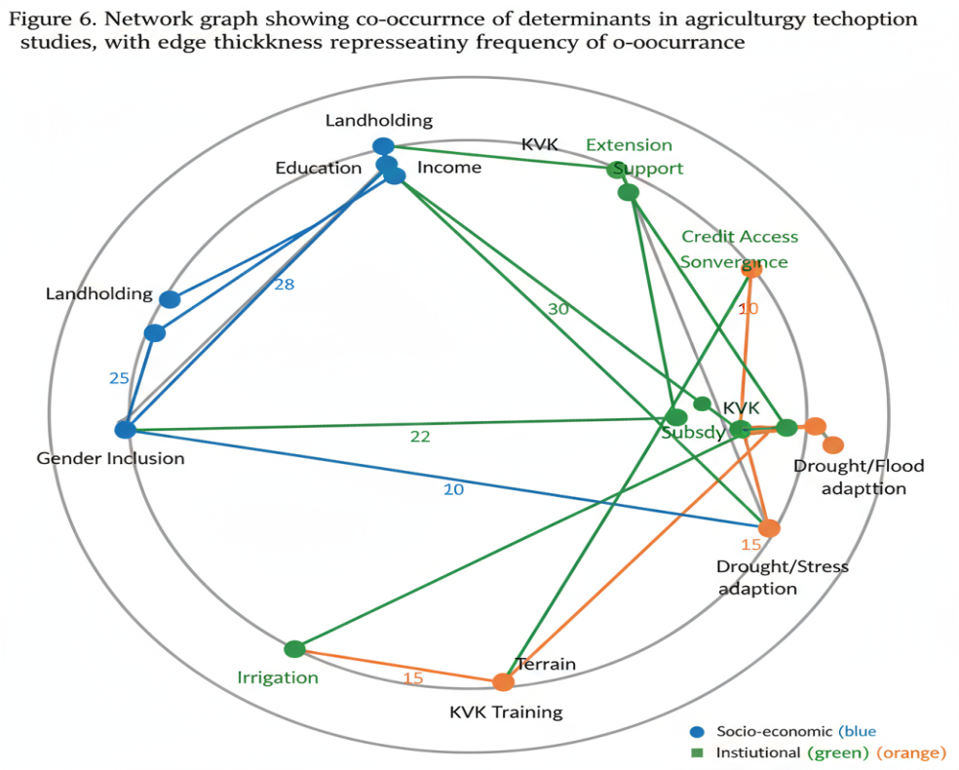
Figure 6. Network graph showing co-occurrence of determinants in agricultural technology adoption studies, with edge thickness representing frequency of co-occurrence.
4.4 Digital Divide and Emerging Opportunities
Mobile advisories (mKisan, Meghdoot, WhatsApp messages and groups) are increasing in the plains, with almost half of young farmers reporting improved scheduling of irrigation and pest control. But only less than 20% of farmers in tribal and hill areas have adopted these due to connectivity and digital literacy issues. Experience from East Africa shows that hybrid models, combining digital with farmer field schools, can enhance inclusivity (Fabregas et al., 2019). Hybrid extension approaches enhancing rather than displacing face-to-face interactions would be useful for northern West Bengal.
4.5 Policy Synthesis
Interactions of socio-economic, institutional and ecological factors suggest that "silver bullet" approaches won't work. Optimal policies need to address:
• Improving institutional convergence by connecting KVKs, FPOs and Panchayats for extension services.
• Increasing inclusivity by focusing on women and marginal farmers for credit and extension.
• Emphasising ecologically adaptive technologies rather than forced mechanisation.
• Closing the rural ICT gap through investments in connectivity, localised content and blended education.

These suggestions mirror broader issues across South Asia where institutional; equity and ecological diversity hinder technology adoption.
Table 5. Barriers and Policy Implications
Barrier / Issue | Implication / Policy Suggestion
Gender Disparity | Mainstream women-targeted extension and credit programs
Digital Divide | Invest in rural connectivity and hybrid extension models
Subsidy Delays | Decentralize disbursal and ensure block-level convergence
Terrain / Ecological Fit | Promote technologies adapted to local ecology
Institutional Fragmentation | Strengthen KVK + FPO + Panchayat coordination

5. Conclusion and Implications
Technology adoption in Northern West Bengal is influenced by socioeconomic, institutional and ecological factors. Farm mechanization, high-yielding varieties and climate-smart technologies are extensively adopted in Terai, but have limitations in hill areas. Gender inequality and digital divides hinder inclusivity. Government strategies must enhance institutional convergence, focus on disadvantaged groups and encourage locally relevant technologies. Research should monitor long-term adoption patterns, explore intersectional inequalities, assess blended approaches to extension, and the ecological sustainability of adoption to create inclusive, resilient agricultural systems.
Competing Interests
The authors received no specific funding for this study. The authors declare that they have no known competing financial interests or personal relationships that could have appeared to influence the work reported in this paper. Authors have declared that no competing interests exist.
AI Declaration
No artificial intelligence (AI) technology was used in the writing, editing, or analysis of this manuscript. All text, figures, and data interpretation were produced solely by the authors without AI assistance.

COMPETING INTERESTS DISCLAIMER:
Authors have declared that they have no known competing financial interests OR non-financial interests OR personal relationships that could have appeared to influence the work reported in this paper.

References
Aggarwal, P. K., Jarvis, A., Campbell, B. M., Zougmoré, R. B., Khatri-Chhetri, A., Vermeulen, S. J., Loboguerero, A. M., Sebastian, L. S., Kinyangi, J., Bonilla-Findji, O., Radeny, M., Recha, J., Martinez-Baron, D., Ramirez-Villegas, J., Huyer, S., Thornton, P., Wollenberg, E., Hansen, J., Alvarez-Toro, P., & Yen, B. T. (2018). The climate-smart village approach: Framework of an integrative strategy for scaling up adaptation options in agriculture. Ecology and Society, 23(1), 14. [https://doi.org/10.5751/ES-09822-230114]

Ajzen, I. (1991). The theory of planned behavior. Organizational Behavior and Human Decision Processes, 50(2), 179-211. [https://doi.org/10.1016/0749-5978(91)90020-T]

Aryal, J. P., Jat, M. L., Sapkota, T. B., Khatri-Chhetri, A., Kassie, M., Rahut, D. B., & Maharjan, S. (2017). Adoption of multiple climate-smart agricultural practices in the Gangetic plains of Bihar, India. International Journal of Climate Change Strategies and Management, 10(3), 407-427. [https://doi.org/10.1108/IJCCSM-06-2017-0115]

Aryal, J. P., Mehrotra, M. B., Jat, M. L., & Sidhu, H. S. (2015). Impacts of laser land leveling in rice-wheat systems of the north-western Indo-Gangetic plains of India. Food Security, 7(3), 725-738. [https://doi.org/10.1007/s12571-015-0451-0]

Aryal, J. P., Sapkota, T. B., Rahut, D. B., Krupnik, T. J., Shahrin, S., Jat, M. L., & Stirling, C. M. (2020). Major climate risks and adaptation strategies of smallholder farmers in coastal Bangladesh. Environmental Management, 66(1), 105-120. [https://doi.org/10.1007/s00267-020-01309-y]

Basu, D., & Saha, B. (2019). Zero tillage and yield enhancement in paddy: Evidence from Cooch Behar. Agricultural Economics Research Review, 32(1), 98-106. [https://ageconsearch.umn.edu/record/334614]

Belur, S. B., Sircar, T., & Iyer, A. (2024). An exploratory study of adoption and usage of technology by rural women for entrepreneurship and empowerment. Digital Empowerment Foundation. [https://doi.org/10.5281/zenodo.12568025]

Bharati, L., Sharma, B. R., & Sikka, A. (2018). Improving water productivity in agriculture: The case of eastern India. In Water productivity in agriculture: Limits and opportunities for improvement (pp. 156-178). CABI. [https://doi.org/10.1079/9781780647907.0109]

Biggs, S. D., & Justice, S. (2015). Power and policy in the adoption of agricultural machinery: The case of South Asia. In Agricultural development and the opportunities for agro-based industries in South Asia (pp. 45-68). Springer. [https://doi.org/10.1007/978-981-287-614-7_3]

Birthal, P. S., Negi, D. S., Kumar, S., & Roy, D. (2014). Climate-smart agriculture in South Asia: Technical, institutional and policy options. National Institute of Agricultural Economics and Policy Research. [https://niap.org.in/wp-content/uploads/2019/09/Climate-Smart-Agriculture-in-South-Asia.pdf]

Chambers, R., Pacey, A., & Thrupp, L. A. (Eds.). (1989). Farmer first: Farmer innovation and agricultural research. Intermediate Technology Publications.

Chatterjee, J. (2024). A shift to solar irrigation pump-sets: Impacts under PM-KUSUM in West Bengal. WRI India Working Paper. (In press).

Chauhan, N., Yadav, S., Singh, R., Sharma, P., & Verma, A. (2026). Major determinants of sustainable agriculture practices adoption: A systematic review. Land Use Policy, 164, Article 107941. [https://doi.org/10.1016/j.landusepol.2026.107941]

Chaurasia, R. K., & Longkumer, W. (2025). Role and impact of KVK for rural communities: A review. The Pharma Innovation Journal, 14(9), 45-50. [https://doi.org/10.22271/tpi.2025.v14.i9a.26265]

Choudhury, N. P., Deka, P., Tiwari, N., Gohain, K., Saikia, A., & Datta, S. (2025). Evaluating Krishi Vigyan Kendra's training effectiveness on farmer empowerment in Barpeta District, Assam. Atlantis Press. [https://doi.org/10.2991/978-94-6463-459-4_20]

Cooper, H., & Hedges, L. V. (2009). Research synthesis as a scientific process. In H. Cooper, L. V. Hedges, & J. C. Valentine (Eds.), The handbook of research synthesis and meta-analysis (pp. 3-16). Russell Sage Foundation.

Dar, M. H., de Janvry, A., Emerick, K., Raitzer, D., & Sadoulet, E. (2013). Flood-tolerant rice reduces yield variability and raises expected yield, differentially benefitting socially disadvantaged groups. Scientific Reports, 3, Article 3515. [https://doi.org/10.1038/srep03515]

Dar, M. H., Waza, S. A., Shukla, S., Zaidi, N. W., Nanda, S., Cassman, K. G., & Kumar, A. (2018). No yield penalty under favorable conditions paving the way for widespread adoption of flood-tolerant rice. Scientific Reports, 8, Article 9245. [https://doi.org/10.1038/s41598-018-27648-y]

Das, B., & Majumdar, R. (2018). Direct seeded rice adoption in Jalpaiguri: A cost-benefit analysis. Rice Research Today, 13(3), 140-147.

Datta, P. (2022). Climate change and Indian agriculture: A systematic review of farmers' perception, adaptation, and transformation. Environmental Challenges, 7, Article 100448. [https://doi.org/10.1016/j.envc.2022.100448]

Daum, T., & Birner, R. (2020). The neglected governance challenges of agricultural mechanisation in Africa: Evidence from Nigeria. Food Security, 12(4), 727-746. [https://doi.org/10.1007/s12571-020-01054-5]

Diao, X., Cossar, F., Houssou, N., & Kolavalli, S. (2014). Mechanization in Ghana: Emerging demand, and the search for alternative supply models. Food Policy, 48, 168-181. [https://doi.org/10.1016/j.foodpol.2014.05.013]

Doss, C. R. (2006). Analyzing technology adoption using microstudies: Limitations, challenges, and opportunities for improvement. Agricultural Economics, 34(3), 207-219. [https://doi.org/10.1111/j.1574-0864.2006.00119.x]

Fabregas, R., Kremer, M., & Schilbach, F. (2019). Realizing the potential of digital development: The case of agricultural advice. Science, 366(6471), Article eaay3038. [https://doi.org/10.1126/science.aay3038]

Fadeyi, O. A., Anoma, A., & Ammar, A. A. (2022). Factors influencing technology adoption among smallholder farmers: A systematic review in Africa. Journal of Agriculture and Rural Development in the Tropics and Subtropics, 123, 13-30.

Faiz, M. A., Bana, R. S., Choudhary, A. K., Laing, A. M., Bansal, R., Bhatia, A., et al. (2022). Zero tillage, residue retention and system-intensification with legumes for enhanced pearl millet productivity and soil health. Sustainability, 14(1), 543. [https://doi.org/10.3390/su14010543]

Feder, G., Just, R. E., & Zilberman, D. (1985). Adoption of agricultural innovations in developing countries: A survey. Economic Development and Cultural Change, 33(2), 255-298. [https://doi.org/10.1086/451461]

Georgopoulos, V. P., Kakkos, I., Matsopoulos, G. K., & Ventouras, E. C. (2023). Factors influencing the adoption of artificial intelligence technologies in agriculture: A systematic literature review using PRISMA 2020. Sustainability, 15(23), Article 16385. [https://doi.org/10.3390/su152316385]

Ghosh, B. K. (2014). Economics of adoption of modern technology in paddy cultivation in West Bengal. Agricultural Economics Research Review, 27(1), 123-132. [https://ageconsearch.umn.edu/record/163154]

Godin, K., Stapleton, J., Kirkpatrick, S. I., Hanning, R. M., & Leatherdale, S. T. (2015). Applying systematic review search methods to the grey literature: A case study examining guidelines for school-based breakfast programs in Canada. Systematic Reviews, 4, 138. [https://doi.org/10.1186/s13643-015-0125-0]

Gusenbauer, M., & Haddaway, N. R. (2020). Which academic search systems are suitable for systematic reviews or meta-analyses? Evaluating retrieval qualities of Google Scholar, PubMed, and 26 other resources. Research Synthesis Methods, 11(2), 181-217. [https://doi.org/10.1002/jrsm.1378]

Harsha Vardhan, P. N., Pal, P. K., & Roy, D. (2021). Influence of Krishi Vigyan Kendras and socio-economic characteristics towards adoption of climate-resilient technologies. International Journal of Environment and Climate Change, 11(12), 38-43. [https://doi.org/10.9734/ijecc/2021/v11i1230554]

Hong, Q. N., Fàbregues, S., Bartlett, G., Boardman, F., Cargo, M., Dagenais, P., Gagnon, M. P., Griffiths, F., Nicolau, B., O'Cathain, A., Rousseau, M. C., Vedel, I., & Vedel, I. (2018). The Mixed Methods Appraisal Tool (MMAT) version 2018 for information professionals and researchers. Education for Information, 34(4), 285-291. [https://doi.org/10.3233/EFI-180221]

Kassie, M., Teklewold, H., Jaleta, M., Marenya, P., & Erenstein, O. (2015). Understanding the adoption of a portfolio of sustainable intensification practices in eastern and southern Africa. Land Use Policy, 42, 400-411. [https://doi.org/10.1016/j.landusepol.2014.10.014]

Malabayabas, M. L. L., Villano, R., Fleming, E., & Yorobe, J. M. (2023). Joint decision-making, technology adoption and food security: Evidence from rice varieties in eastern India. World Development, 171, Article 106367. [https://doi.org/10.1016/j.worlddev.2023.106367]
Mittal, S., & Mehar, M. (2012). How mobile phones contribute to growth of small farmers? Evidence from India. Quarterly Journal of International Agriculture, 51(3), 227-244.

Munn, Z., Peters, M. D. J., Stern, C., Tufanaru, C., McArthur, A., & Aromataris, E. (2018). Systematic review or scoping review? Guidance for authors when choosing between a systematic or scoping review approach. BMC Medical Research Methodology, 18, 143. [https://doi.org/10.1186/s12874-018-0611-x]

Narayanamoorthy, A. (2004). Impact assessment of drip irrigation in India: The case of sugarcane. Agricultural Water Management, 65(3), 145-158. [https://doi.org/10.1016/j.agwat.2003.09.002]

Narayanamoorthy, A., Suresh, R., & Alli, P. (2017). Dynamics of input use efficiency in selected crops cultivation in India: A temporal and spatial analysis. Indian Journal of Agricultural Economics, 72(4), 1-15. [https://ageconsearch.umn.edu/record/302261]

Naveen, Naveen, Datta, P., Behera, B., & Rahut, D. B. (2024). Climate-Smart Agriculture in South Asia: exploring practices, determinants, and contributions to Sustainable Development Goals. Mitigation and Adaptation Strategies for Global Change, 29(4), 31. [https://doi.org/10.1007/s11027-024-10126-4]

Page, M. J., McKenzie, J. E., Bossuyt, P. M., Boutron, I., Hoffmann, T. C., Mulrow, C. D., et al. (2021). The PRISMA 2020 statement: An updated guideline for reporting systematic reviews. BMJ, 372, Article n71. [https://doi.org/10.1136/bmj.n71]

Paez, A. (2017). Gray literature: An important resource in systematic reviews. Journal of Evidence-Based Medicine, 10(3), 233-240. [https://doi.org/10.1111/jebm.12266]

Paré, G., Trudel, M. C., Jaana, M., & Kitsiou, S. (2015). Synthesizing information systems knowledge: A typology of literature reviews. Information & Management, 52(2), 183-199. [https://doi.org/10.1016/j.im.2014.08.008]

Quisumbing, A. R., Rubin, D., Manfre, C., Waithanji, E., van den Bold, M., Olney, D., Johnson, N. L., Meinzen-Dick, R. S., Njuki, J., Malapit, H. J., Kovarik, C., Leroy, D. K., & Gilligan, D. O. (2014). Gender, assets, and market-oriented agriculture: Learning from high-value crop and livestock investments in Africa and Asia. Agriculture and Human Values, 31(3), 435-453. [https://doi.org/10.1007/s10460-014-9507-x]

Raghu, P. T., Veettil, P. C., & Das, S. (2022). Smallholder adaptation to flood risks: Adoption and impact of Swarna-Sub1 in eastern India. Environmental Challenges, 7, Article 100480. [https://doi.org/10.1016/j.envc.2022.100480]

Rogers, E. M. (2003). Diffusion of innovations (5th ed.). Free Press.

Rola-Rubzen, M. F., Murray-Prior, R., Concepcion, S., Dahria, M., Islam, N., Isvilanonda, S., et al. (2020). Improving gender participation in agricultural technology adoption in Asia: From rhetoric to practical action. Applied Economic Perspectives and Policy, 42(1), 113-125. [https://doi.org/10.1002/aepp.13011]

Ruzzante, S., Labarta, R., & Bilton, A. (2021). Adoption of agricultural technology in the developing world: A meta-analysis of the empirical literature. World Development, 146, Article 105599. [https://doi.org/10.1016/j.worlddev.2021.105599]

Scherer, R. W., & Saldanha, I. J. (2019). How should systematic reviewers handle conference abstracts? A view from the front lines. Systematic Reviews, 8, 124. [https://doi.org/10.1186/s13643-019-1039-1]

Seymour, G. (2017). Women's agricultural productivity and access to extension services in sub-Saharan Africa. In Agriculture, development, and the global trading system at 50 (pp. 123-145). International Food Policy Research Institute.

Shah, T., Giordano, M., & Mukherji, A. (2018). Political economy of the energy-groundwater nexus in India: Exploring issues and assessing policy options. Hydrogeology Journal, 26(5), 1535-1543. [https://doi.org/10.1007/s10040-018-1728-7]

Singh, K. M., Singh, R. K. P., Jha, A. K., & Kumar, A. (2019a). Role of Krishi Vigyan Kendras (KVKs) in agricultural extension: An overview. MPRA Paper No. 104339. [https://mpra.ub.uni-muenchen.de/104339/]

Singh, S. K., Mondal, S. K., Das, K. S., Roy, S. K., Pal, P. P., Rahman, F. H., & Haldar, A. (2019b). Annual Report 2018-19. ICAR-Agricultural Technology Application Research Institute (ATARI) Kolkata. [http://www.atarikolkata.org/wp-content/uploads/2019/12/ATARI-Kolkata-Annual-Report-2018-19.pdf]

Sulaiman, R. V., & Hall, A. (2002). Beyond technology dissemination: Can Indian agricultural extension re-invent itself? ICAR Policy Brief No. 16. Indian Council of Agricultural Research.

Tufa, A. H., Alene, A. D., Cole, S. M., Manda, J., Feleke, S., Chikoye, D., et al. (2022). Gender differences in technology adoption and agricultural productivity: Evidence from Malawi. World Development, 159, Article 106041. [https://doi.org/10.1016/j.worlddev.2022.106041]

Varshney, D., Kumar, A., Mishra, A. K., & Joshi, P. K. (2022). Examining the transfer of knowledge and training to smallholders in India: Direct and spillover effects of agricultural advisory services in an emerging economy. World Development, 160, Article 106067. [https://doi.org/10.1016/j.worlddev.2022.106067]

Wells, G. A., Shea, B., O'Connell, D., Peterson, J., Welch, V., Losos, M., & Tugwell, P. (2014). The Newcastle-Ottawa Scale (NOS) for assessing the quality of nonrandomised studies in meta-analyses. Ottawa Hospital Research Institute. [http://www.ohri.ca/programs/clinical_epidemiology/oxford.asp]

Whiting, P., Savović, J., Higgins, J. P. T., Caldwell, D. M., Reeves, B. C., Shea, B., Davies, P., Kleijnen, J., & Churchill, R. (2016). ROBIS: A new tool to assess risk of bias in systematic reviews was developed. Journal of Clinical Epidemiology, 69, 225-234. [https://doi.org/10.1016/j.jclinepi.2015.06.005]

Wilson, J. D. (2009). The use of Google Scholar for research and research dissemination. New Review of Academic Librarianship, 15(1), 48-58. [https://doi.org/10.1080/13614530902868411]

Xu, Z., Wu, J., Han, Y., Ruan, J., & Liang, S. (2023). A scoping review on technology applications in agricultural extension. PLOS ONE, 18(11), Article e0292877. [https://doi.org/10.1371/journal.pone.0292877]

