Original Research Article
Hybrid statistical model for forecasting production of Rice crop in Karnataka State

ABSTRACT
The current study used both linear and nonlinear time series techniques to anticipate Rice production in Karnataka state from 1962–1963 to 2021–2022. First, the Autoregressive Integrated Moving Average (ARIMA) model was used, and the best fit was chosen using diagnostic metrics like the Coefficient of Determination (R²), Mean Absolute Error (MAE), Mean Absolute Percentage Error (MAPE) and Root Mean Square Error (RMSE). The ARIMA (2,1,2) model was found to be the best suitable of the linear models. Advanced machine learning techniques like Time Delay Neural Network (TDNN), Nonlinear Support Vector Regression (NLSVR) and their hybrid combinations with ARIMA (ARIMA–TDNN and ARIMA–NLSVR) were used to identify potential nonlinear patterns in the data. The adoption of hybrid models was justified by the BDS test on ARIMA residuals, which verified the existence of nonlinearity. RMSE, MAE and MAPE were used to assess the model performance for the nonlinear and hybrid techniques. The most recent three years of data were used for testing, while 57 years of data were used for training in the adopted training and testing framework. In terms of forecast accuracy, the ARIMA (2,1,2)–TDNN (3–7–1) hybrid model outperformed the other models. Forecasts up to 2027–28 was also produced using the model, estimating that Karnataka would produce 4432.68 thousand tons of Rice. These findings imply that, in comparison to individual models, hybrid models that include linear and nonlinear features offer more accurate and consistent forecasts for agricultural production series.
Key words: - Rice, ARIMA, TDNN, NLSVR, RMSE, MAE, MAPE, R² and BDS
- INTRODUCTION
Karnataka is the eighth largest state in India, with a total size of 192 lakh square kilometres, or 6.3 per cent of the nation's total land area. According to the 2011 Population Census, 13.74 million people are employed in agriculture, with farmers accounting for 23.61 per cent and agricultural labourers for 25.67 per cent of the workforce. In Karnataka, during economic survey 2022-23 it is estimated that 81.56 lakh ha of area under food crops will be cultivated with the production of 1348.9 thousand metric tonnes. Food crops cover 76.46 per cent of the total cropped area, while non-food crops occupy the remaining 23.54 per cent in Karnataka. The food grains alone constitute 56.9 per cent of the cropped area with total food grain production reaching about 146 lakh tonnes during 2020-21 in Karnataka (Nagaveni et al, 2024).
Rice, scientifically known as Oryza sativa L., is a staple crop for more than half of the world's population and is crucial to India's food security system. In India, Rice is a tropical and subtropical crop which is widely farmed in a variety of agroclimatic zones, from irrigated lowlands to rainfed uplands. It is an important commodity in the public distribution system and makes a substantial contribution to the livelihood of millions of farmers.
India is the world's top producer and consumer of Rice, followed by China (USDA, 2024-25). With an average productivity of 2882 kg/ha, Rice was grown on around 47828.29 thousand hectares in India during the 2023–24 crop year, yielding about 137824.58 thousand tonnes. One of Karnataka's main food crops, Rice is typically farmed in both rainfed and irrigated areas. Rice was grown on around 953 thousand hectares, yielding an average of 3282 kg/ha and a production of 3127.44 thousand tonnes (Indiastat,2023–24). Among Karnataka's most notable Rice-growing districts are Uttara Kannada, Haveri, Hassan, Kalburgi, Kodagu, Belagavi, Shivamogga, Udupi, Yadgir, Mysuru and Mandya (Economic Survey, 2022-23).
Over the past two decades (2000-2020), production of Rice in Karnataka have shown significant changes, reflecting both policy interventions and market-driven shifts. However, the year-to-year variation also shows nonlinear trends influenced by climatic factors and external shocks. This complexity underscores the need for accurate forecasting models that go beyond traditional linear approaches. Therefore, Rice has been selected as one of the key crops for this study, which explores advanced hybrid forecasting models like ARIMA, TDNN, NLSVR, ARIMA-TDNN, ARIMA-NLSVR to predict its production. These models aim to provide reliable insights for stakeholders involved in agricultural planning, policy formulation, and market regulation.
Statistical forecasting is used to provide assistance in decision making and planning the future more effectively and efficiently. Forecasting is a primary aspect of developing economy so that proper planning can be undertaken for sustainable growth of the country. Considering the above-mentioned facts, a study was conducted to model and forecast the Rice production in Karnataka state, India.
The major drawback of the Auto Regressive Integrated Moving Average (ARIMA) model is that it does not capture nonlinear structure. It assumes a linear correlation pattern among the time series data, and therefore cannot adequately capture nonlinear patterns often present in agricultural datasets.
In reality, time series data such as Rice production in Karnataka state often include both linear and nonlinear components due to variations in weather, market conditions and technological adoption. As a result, the performance of ARIMA alone becomes limited when dealing with such mixed data structures. To overcome this challenge, researchers have developed hybrid forecasting models that combine the linear modelling capabilities of ARIMA with the nonlinear learning strengths of neural networks. In this study, a hybrid ARIMA-TDNN/NLSVR model along with individual models is used to forecast Rice production in Karnataka state. While ARIMA is used to model the linear structure of the series, TDNN and NLSVR is employed to capture the nonlinear residuals that ARIMA fails to explain. TDNN, being a dynamic version of neural networks, utilizes past time-lagged inputs to learn from temporal dependencies in the data. Nonlinear Support Vector Regression (NLSVR) is a machine learning technique that uses kernel functions to capture complex nonlinear relationships between input variables and outputs.
Studies such as Zhang (2003), Kumar and Prajneshu (2015) and Ray et al. (2016) have demonstrated that such hybrid models can significantly enhance the accuracy and reliability of forecasts. Thus, the integration of ARIMA and TDNN or NLSVR in this research provides a more comprehensive forecasting framework, particularly suitable for agricultural time series data. The resulting model offers improved predictive insights for stake holders involved in planning, policy making and resource allocation related to Maize cultivation in Karnataka state.

- MATERIALS AND METHODOLOGIES
2.1 Data Source
The study has been illustrated with the time series data. The secondary data on the Rice production in Karnataka state for 60 years (from 1962-63 to 2021-22) was obtained from the Directorate of Economics and Statistics, Dept. of Agriculture, Cooperation and Farmers Welfare, Ministry of Agriculture, Govt. of India.
2.2 Statistical Methodologies
In this study, Auto Regressive Integrated Moving Average (ARIMA), Time Delay Neural Network (TDNN), Nonlinear Support Vector Regression (NLSVR) and a proposed hybrid methodology combining ARIMA-TDNN or NLSVR are employed to forecast the Production of Rice in Karnataka state, India. The analysis is carried out using R software. To examine the stationarity of the time series data, the Augmented Dickey-Fuller (ADF) test is performed. The Brock-Dechert-Scheinkman (BDS) test is used to detect nonlinear dependencies in the residuals, ensuring an appropriate model selection process. Additionally, the Box Pierce/Ljung-Box test is applied to check for autocorrelation in the residuals, validating the adequacy of the fitted models. The forecasting performance of the models is assessed using Root Mean Square Error (RMSE), Mean Absolute Error (MAE) and Mean Absolute Percentage Error which provide measures of predictive accuracy and reliability.
2.2.1 Box-Jenkins ARIMA model
Before ARIMA, the concept of validation of data and Stationary was discussed briefly.
validation of data: For model development and evaluation, the dataset comprising 60 annual observations was divided into training and testing sets. Out of these, 57 data points (1962–63 to 2018–19) were utilized for training the models, while the remaining 3 data points (2019–20 to 2021–22) were reserved as a testing set to assess the predictive accuracy and generalization performance of the models. This split ensures that the models are trained on a sufficiently large sample while also being validated on unseen data to avoid overfitting and to obtain realistic forecasting performance.
Stationary: A stochastic process is said to be stationary if its mean and variance are constant over time and the value of the covariance between the two time periods depends only on the disturbance or lag between the two time periods and not on the actual time at which the covariance is computed.
It can be identified through Autocorrelation Function (ACF) of actual data, if the ACF does not die out rapidly, it indicates that the data is non-stationary. Under this situation, the auto correlation corresponding to most of lags are statistically significant.
For reducing the data to stationary, selected data has to transform by taking first order differences (d=1). If the autocorrelation functions of first differenced data indicate a rapid decrease, then it can be concluded that the transformed data is stationary. If not, again the data has to be transformed by taking second order differences (d=2). Continuing in a similar way as that of d=1, thus the order of differencing i.e.,‘d’ can be determined.
Test of Stationary: The order of differencing can be assessed by performing unit root test. The most widely used test for detecting the unit root (non-stationary) of time series is Augmented Dickey Fuller (ADF) test. In conducting Dickey Fuller (DF) test, it has assumed that the error term is uncorrelated. But in most of cases correlated, hence Dickey-Fuller (1979) has developed another test, known popularly known as the ADF test. This test is conducted by augmenting the regression $(ΔY_{t}=β_{1}+δY_{t-1}+e_{t})$, by adding the lagged values of dependent variable$(ΔY_{t})$. The ADF test consist of estimating following regression,
$ΔY_{t}=β_{1}+δY_{t-1}+\sum_{i=1}^{m}{α_{i}}ΔY_{t-i}+e_{t}$ ...(1)
Where:
- m is number of lagged difference terms required so that the error term
- e_{t} is serially independent.
- The test can be carried out by performing a t (= τ) -statistic of $'δ'$ with dickey fuller table values at 5% and 10% LOS. If absolute t (= τ) statistic of $'δ'$ is greater than its table value, it indicates that the series is Stationary.

ARIMA (Auto Regressive Integrated Moving Average): It’s denoted by ARIMA (p,d,q) which is a combination of Auto Regressive (AR) and Moving Average (MA) with an order of integration or differencing (d), where p and q are the order of autocorrelation and moving average respectively (Box and Jenkins, 2015).
The Auto-regressive model of order p denoted by AR (p) is as follows:
Y_{t} = c + Ø₁ Y_{t-1} + Ø₂ Y_{t-2} + … + Ø_{p} Y_{t-p} + e_{t} ...(2)
The Moving Average (MA) model of order q or MA (q) can be written as:
Y_{t} = c – θ₁ e_{t-1} – θ₂ e_{t-2} –… θ_{q} e_{t-q} + e_{t} ...(3)
Where:
- c is constant term.
- Ø_{p} is the p^{th} autoregressive parameter.
- θ_{q} is the q^{th} moving average parameter and
- e_{t} is the error term at time ‘t’.
ARIMA in general form is as follows:
Δ^{d} Y_{t} = c + (Ø₁ Δ^{d} Y_{t-1} + … + Ø_{p} Δ^{d} Y_{t-p}) – (θ₁ e_{t-1} + … + θ_{q} e_{t-q}) + e_{t} ...(4)
where Δ denotes difference operator like
- Δ Y_{t} = Y_{t} - Y_{t-1}(data form of first order differentiation) ... (5)
- Δ² Y_{t-1} = ΔY_{t} - ΔY_{t-1} (data form of second order differentiation) ... (6)
Here, Y_{t-1}, …, Y_{t-p} are values of past series with lag 1, …, p, respectively.
ARIMA methodology consists of four steps viz., model identification, model estimation, diagnostic checking and forecasting (Box and Jenkins, 2015).
(1) Model Identification: ARIMA (p, d, q) model identification is based on the concept of time-domain analysis i.e., autocorrelation function (ACF) and partial autocorrelation function (PACF). The ACF and PACF play vital role for the internal structure of the analysed series. For the identification of data stationarity, ADF test was used in the study, to find unit root in the time series data of variable under consideration. Once the order of differencing has been diagnosed, the differenced univariate time series can be analyzed by the method of time-domain.
(2) Estimation: After identification of the appropriate p and q values for the model, the parameter of the autoregressive and moving average terms have been estimated. Presently, standard statistical package R was used to estimate relevant parameters using iterative procedure.
(3) Diagnostic checking: Later, the estimated model is checked to verify as it adequately represents the series or not further. For evaluating the adequacy of ARIMA process, various diagnostic checks have been selected in this present study, were R² value, Root Mean Square Error (RMSE), Mean Absolute Error (MAE) and Mean Absolute Percentage Error.

Formulas of these diagnostics are mentioned in the following page.
$R^{2}=1-\frac{{\sum_{i=1}^{n}{(Y_{i}-{\hat{Y}}_{i})}}^{2}}{\sum_{i=1}^{n}{(Y_{i}-\bar{Y})^{2}}}$ ...(7)
$RMSE={\left[\sum_{i=1}^{n}{(Y_{i}-{\hat{Y}}_{i})^{2}/n}\right]}^{1/2}$ ...(8)
$MAE=\frac{1}{n}\sum_{t=1}^{n}{\left|Y_{t}-{\hat{Y}}_{t}\right|}$ ...(9)
MAPE =$\frac{100}{n}\sum_{t=1}^{n}{\left|Y_{t}-{\hat{Y}}_{t}\right|}/\left|{\hat{Y}}_{t}\right|$ ….(10)
Where, ‘$Y_{i}$’ be actual value of data, ‘$\hat{Y}$’ be the forecasted value, ‘$\bar{Y}$’ be the mean value of the actual data, ‘n’ be the number of data points.
In the present study, the model with minimum values of RMSE, MAE and with high R² value was considered as an appropriate model for forecasting (Kumar et al. 2022). In addition to above diagnostics, Ljung-Box test was also tried in the study as to verify the autocorrelations of residual series.
Ljung-Box test: It is a classical hypothesis test, designed to test whether a residual series of autocorrelations on a fitted time series model are differed significantly from zero or not. The test does not test each individual lag for randomness, but rather tests the randomness over a group of lags.
The test statistic,
$Q(h)=n(n+2)\sum_{k=1}^{h}{\frac{{\overset{̑}{ρ}}_{k}^{2}}{n-k}}$ ...(11)
Where n is the length of time series, 𝜌̂_{𝑘} is sample autocorrelation at lag k and h is the number of lags under the test. Null hypothesis is rejected if $Q(h)>χ_{1-σ,m}^{2}$; Where ‘m’ must be equal to h-p-q, where p and q are the number of parameters in the ARIMA (p,q) model.
• Null Hypothesis (H₀):
There is no autocorrelation in the residuals up to the specified lag.
(i.e., residuals are independently distributed — white noise)
• Alternative Hypothesis (H₁):
There is autocorrelation in the residuals at one or more lags.
(i.e., residuals are not independently distributed)
(4) Forecasting: The optimal ARIMA model was selected based on the highest R², low RMSE and MAE values. The selected model used to forecast future values. The forecast values are the point forecasts along with the confidence intervals.
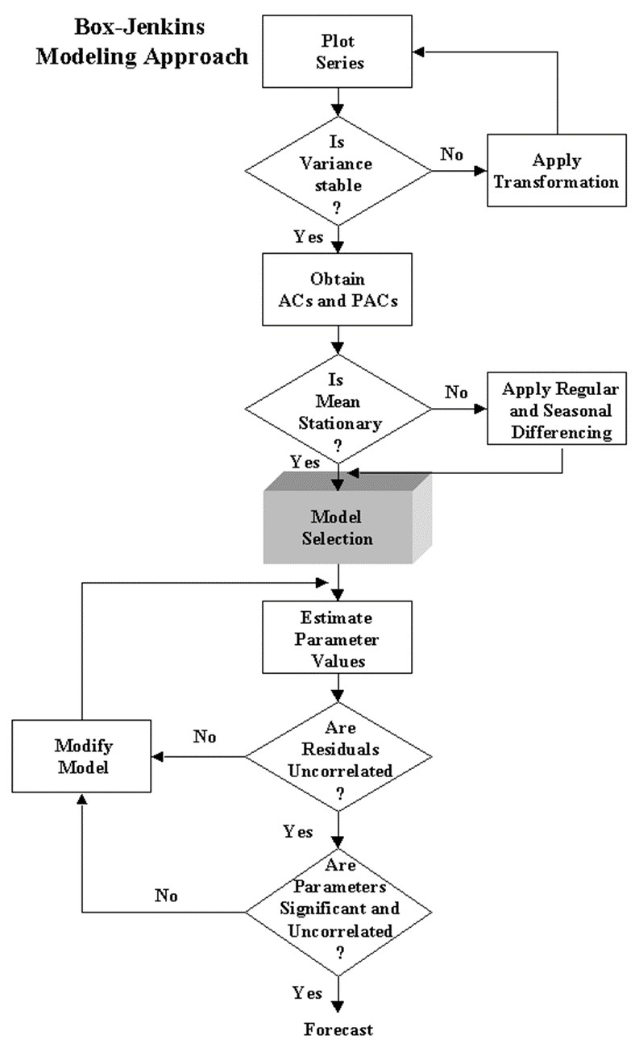
Figure. 1. Flow chart of Box-Jenkins Methodology

2.2.2 Time Delay Neural Network (TDNN)
The ANN for time series analysis is termed as Time Delay Neural Network (TDNN). The time series phenomenon can be mathematically modelled using neural network with implicit functional representation of time, whereas static neural network like multilayer perceptron is presented with dynamic properties (Haykin,1999). One simple way of building artificial neural network for time series is the use of time delay also called as time lags. These time lags can be considered in the input layer of the ANN. The TDNN is the class of such architecture. In this study, the R package “nnfor” was customized and implemented for developing Time Delay Neural Network (TDNN) models.
This package provides a flexible and powerful framework for fitting artificial neural networks specifically designed for time series forecasting problems. In view of the residual nonlinearity detected through the BDS test, Time Delay Neural Network (TDNN) models were employed to model the residual series obtained from the ARIMA models for Rice production in Karnataka. The TDNN models are well suited for capturing complex, nonlinear and dynamic dependencies in the time series data through their feedback and delay structure.
For each data series, multiple TDNN networks were trained by varying the number of neurons in the hidden layer from 1 to 10, with the sigmoid function employed as the activation function in the hidden layer, while keeping the output layers fixed and input layer varying from 2 to 5. To identify the optimal network configuration based on performance metrics such as RMSE, MAE, MAPE and model adequacy through the Ljung Box test p values. The structure of each network is denoted in the format Input-Hidden-Output. Following is the general expression for the final output Y_{t} of a multi- layer feed forward time delay neural network.
The TDNN can be mathematically expressed as:
Y_{t} =𝑓(𝑌_{t−1} ,Y_{t-2},…….,𝑌_{t-p};𝑊 ) …(12)
Where,
• 𝑌̂_{t} is the predicted value at time t
• 𝑓 (⋅) represents the non-linear activation function
• 𝑌_{t-1} ,𝑌_{t-2} ,…,𝑌_{t-p} are the lagged inputs
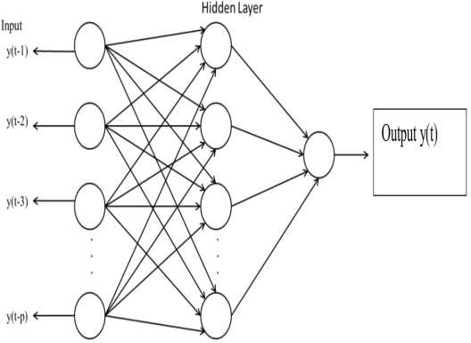
• 𝑊 represents the weights of the network

Figure. 2. Architecture of Neural Network
2.2.3 Non-Linear Support Vector Regression (NLSVR) model
Support Vector Machine (SVM) is a supervised machine learning technique which was originally developed for linear classification problems. Later in the year 1997, the support vector machine for regression problems were developed by Vapnik by introducing ε-insensitive loss function (Vapnik et al., 1997) and it has been extended to the nonlinear regression estimation problems. Modeling of such problems is called as Nonlinear Support Vector Regression (NLSVR) model. The basic principle involved in Non-Linear Support Vector Regression (NLSVR) is to transform the original input time series into a higher-dimensional feature space using a nonlinear kernel function, where a linear regression function is then fitted, enabling the model to capture complex, nonlinear relationships present in the data. The general form of NLSVR is:
𝑓(𝑥) = $\sum_{i=1}^{N}{α_{i}K(x_{i}, x) + b }$ .... (13)
Where:
    - 𝛼_{𝑖} are the coefficients,
    - 𝐾 (𝑥_{𝑖}, 𝑥) is the kernel function and
    - 𝑏 is the bias term.

In this study R package, “e1071” was customized and implemented. This package provides several options for SVR model fitting using different types of kernels like linear, radial basis, sigmoid and polynomial. Although the most often used and recommended function is radial basis.
After detecting potential nonlinear patterns in the ARIMA residuals using the BDS test, a nonlinear model such as Nonlinear Support Vector Regression was applied to capture the nonlinear structures not modelled by ARIMA. The NLSVR models were fitted to the residuals of the optimal ARIMA models for Rice production dataset. The radial basis function (RBF) kernel was chosen due to its flexibility and ability to model complex nonlinear relationships. The optimal hyperparameters for the NLSVR models, include Cost, Gamma, Epsilon were determined through iterative tuning to minimize the error while ensuring good generalization ability. A 10-fold cross validation procedure was adopted to ensure the robustness and generalization capability of the selected hyperparameters. This method involves dividing the datasets into ten subsets, iteratively training the model on nine subsets and validating it on the remaining one thereby minimizing overfitting and improving model reliability. The number of support vectors selected in each model reflects the complexity of the fitted regression function. The best performance value represents the minimal error achieved during the cross-validation process for each model.
- a high dimensional feature space and then build the regression model in a new feature space.
- Let us consider a vector of data set where is the input vector, y_{i} is the scalar output and N is the size of data set. The general equation of Nonlinear Support Vector Regression estimation function is given as follows:
f(x) = W^{T} ϕ (x) + b ... (14)
where, ϕ(.): R^{n} → R^{nh} is a nonlinear mapping function which maps the nonlinear mapping function which maps the original input space into a higher dimensional feature space vector. W ∈ R^{nh} is weight vector, b is bias term and superscript T denotes the transpose.
Hyperparameter Tuning
The performance of NLSVR depends significantly on the choice of three key hyperparameters:
- Cost (C): Controls the trade-off between model complexity and the degree to which deviations larger than ε are tolerated.
- Gamma (γ): Defines the influence of each data point on the regression function.
- Epsilon (ε): Specifies the margin of tolerance within which no penalty is given for prediction errors.
2.2.4 The Proposed Hybrid Methodology
The hybrid method considers the time series $y_{t}$ as a combination of both linear and non-linear components. This approach follows the Zhang’s (2003) hybrid approach. Accordingly, the relationship between linear and nonlinear components can be expressed as follows
$y_{t}$ = ${\hat{L}}_{t}$ + ${\hat{N}}_{t}$ … (15)
Where, ${\hat{L}}_{t}$ and ${\hat{N}}_{t}$represent the linear and nonlinear component, respectively. In this work, the linear part is modeled using ARIMA model and non-liner part by TDNN or NLSVR. The methodology consists of three steps. Firstly, an ARIMA model is employed to fit the linear component. Let the prediction series provided by ARIMA model be denoted as . In the second step, the residuals ( ) obtained from ARIMA model are tested for non-linearity by using BDS test (Brock et al., 1996) Once the residuals confirm the non-linearity, then, they are modelled and predicted using TDNN and NLSVR. Finally, the forecasted linear and nonlinear components are combined to generate aggregate forecast.
$\hat{y_{t}}$= ${\hat{L}}_{t}$ + ${\hat{N}}_{t}$ … (16)
Where ${\hat{L}}_{t}$ and ${\hat{N}}_{t}$ represent the predicted linear and nonlinear component, respectively.
2.2.4(a) Hybrid ARIMA-TDNN Model
The hybrid ARIMA-TDNN model is constructed by first fitting the ARIMA model to capture the linear patterns in the data and then applying the TDNN model to the residuals from the ARIMA model to account for non-linear patterns.
The hybrid model can be formulated as:
${\hat{Y}}_{t}={\hat{Y}}_{{ARIMA}_{t}}+{\hat{Y}}_{{TDNN}_{t}}$ … (17)
Where:
- ${\hat{Y}}_{t}$is the final forecasted value
- ${\hat{Y}}_{{ARIMA}_{t}}$ is the ARIMA forecasted value at time $t$
- ${\hat{Y}}_{{TDNN}_{t}}$ is the TDNN forecasted residual value at time $t$

2.2.4(b) Hybrid ARIMA + NLSVR Model
A hybrid ARIMA + NLSVR (Non-Linear Support Vector Regression) model combines the strengths of both ARIMA and NLSVR to forecast time series data.
The hybrid model can be formulated as:
${\hat{Y}}_{t}={\hat{Y}}_{ARIMA}\left(t\right)+\hat{R} \left(t\right)$ .... (18)
Where:
- ${\hat{Y}}_{t}$is the final forecasted value
- ${\hat{Y}}_{{ARIMA}_{t}}$ is the ARIMA forecasted value at time $t$
- $\hat{R} \left(t\right)$is the NLSVR forecast applied to residuals R(t)
The graphical representation of hybrid methodology has shown below.
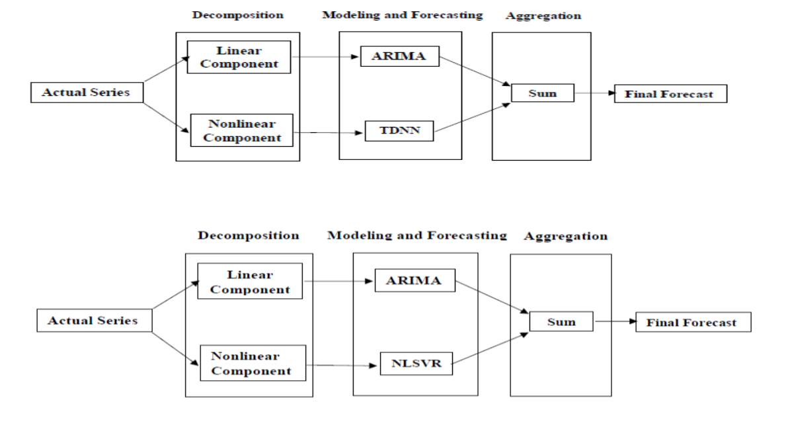
Figure. 3. Graphical representation of Hybrid Methodology

2.2.5 Performance Criteria, Non-Linearity Test and Stationarity test
The performance of the models was evaluated using the following criteria:
2.2.5(a) The coefficient of determination (R²):
The coefficient of determination (R²) is a statistical measure used to assess the goodness-of-fit of a model. It represents the proportion of the variance in the dependent variable that is predictable from the independent variable.

$R^{2}=1-\frac{{\sum_{i=1}^{n}{(Y_{i}-{\hat{Y}}_{i})}}^{2}}{\sum_{i=1}^{n}{(Y_{i}-\bar{Y})^{2}}}$ … (19)
Where:
- $y_{i}$​ = observed values.
- ${\hat{y}}_{i}$ = predicted values from the model.
- $\overline{y}$ = mean of observed values.
An R² value closer to 1 indicates a better fit of the model to the data, meaning that the model’s predictions closely match the actual observations.

2.2.5(b) Root Mean Square Error (RMSE):
RMSE is a measure of the differences between predicted values by a model and the actual observed values. It is calculated as the square root of the average of the squared differences between prediction and actual observations.
Formula:
$RMSE={\left[\sum_{i=1}^{n}{(Y_{i}-{\hat{Y}}_{i})^{2}/n}\right]}^{1/2}$ … (20)
Where:
- $Y$_{t} is the actual value at time $t$
- ${\hat{Y}}_{t}$ is the forecasted value at time $t$
- $n$ is the number of observations
2.2.5(c) Mean Absolute Error (MAE):
MAE is the average of the absolute differences between predicted and actual values. It measures the average magnitude of the errors in a set of predictions, without considering their direction.
Formula:
$MAE=\frac{1}{n}\sum_{t=1}^{n}{\left|Y_{t}-{\hat{Y}}_{t}\right|}$ … (21)
Where:
- $Y$_{t} is the actual value at time $t$
- ${\hat{Y}}_{t}$ is the forecasted value at time $t$
- $n$ is the number of observations
2.2.5(d) Mean Absolute Percentage Error (MAPE)
Mean Absolute Percentage Error (MAPE) is a forecasting accuracy metric that expresses the average absolute error between predicted and actual values as a percentage of the actual values.
MAPE =$\frac{100}{n}\sum_{t=1}^{n}{\left|Y_{t}-{\hat{Y}}_{t}\right|}/\left|{\hat{Y}}_{t}\right|$ …. (22)
Where:
- $Y$_{t} is the actual value at time $t$
- ${\hat{Y}}_{t}$ is the forecasted value at time $t$
- $n$ is the number of observations
2.2.5(e) BDS Test:
The Brock-Dechert-Scheinkman (BDS) test is a statistical method used to detect non-linear dependencies in time series data. It assesses whether the time series can be well-described by a linear model or if there are underlying non-linear structures that the linear model fails to capture. The BDS test evaluates the null hypothesis that the time series follows a linear process against the alternative hypothesis of non-linearity.
The BDS test statistic is given as:
$Z\left(m, τ, ∈\right)=\frac{C\left(m, τ, ϵ\right)-E\left[C\left(m, τ, ϵ\right)\right]}{Var\left[C\left(m, τ, ϵ\right)\right]}$ … (23)

where $E[C(m,τ,ϵ)]$ and $Var[C(m,τ,ϵ)]$ are the expected value and variance of the correlation integral under the null hypothesis of linearity.
3. RESULTS AND DISCUSSIONS
3.1 Descriptive Statistics of Rice Production of Karnataka State
A detailed descriptive statistical analysis was carried out to examine the characteristics and distribution of the production (in thousand tonnes) of Rice in Karnataka for the period from 1962-23 to 2021-22. These measures provide information on central tendency, dispersion, distribution pattern and behaviour of the data. The summary of descriptive statistics is presented in Table 1. The production data set been plotted vs time as seen in Figure 4.
Table 1. Descriptive statistics of Rice production
Statistic | Value | Statistic | Value  (in thousand tonnes)
Mean (in thousand tonnes) | 2780.17 | Range | 4584.30
Median (in thousand tonnes) | 2529.95 | Minimum | 1159.70
SD (in thousand tonnes) | 893.74 | Maximum | 5744.00
CV % | 32.14 | Inter Quartile Range | 1346.20
Kurtosis | 0.52 | Lower limit | 104.25
Skewness | 0.62 | Upper limit | 5489.05

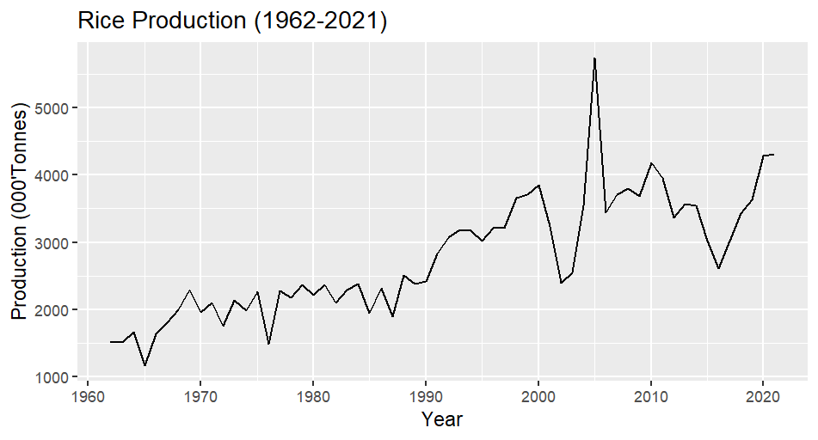
Figure: 4. Time series plot of Rice production
3.2 Fitting of Box Jenkins (ARIMA) model for Rice Production in Karnataka State
The ACF plots of the trained data series of Rice production displayed in the Figure 4, have a slow and gradual decay pattern, indicating the presence of significant autocorrelations at several lags. This pattern is characteristic of a non-stationary time series, suggesting that the data series required differencing to achieve stationarity. To statistically confirm this, Augmented Dickey-Fuller test was performed on the production of Rice in Karnataka State. From the Table 2 it is concluded that the data series was non-stationary and became stationarity at first difference as the null hypothesis was not accepted at 5 per cent Level of Significance as p value was less than 0.05.
Table 2. Augmented Dickey-Fuller Stationarity Test for Rice production
Rice crop | Data type | ADF statistic | critical value | Decision
Production | ADF at zero difference level | -2.43 | 0.4009 | Non-Stationary
Production | ADF at 1st difference | -6.41 | 0.01 | Stationary

Consequently, the ACF plots of the differenced series for production was examined in Figure 5. The differenced series exhibited a rapid decay of autocorrelations with most of the autocorrelation coefficients falling within the 95 per cent confidence limits, indicating that the data had attained stationarity.
After setting d=1 to achieve stationarity, several ARIMA models were developed. The models were compared using R², RMSE, MAE and MAPE criteria which was shown in Table 3. Among them, ARIMA (2,1,2) was identified as best model with high R², low RMSE, MAE and MAPE values.

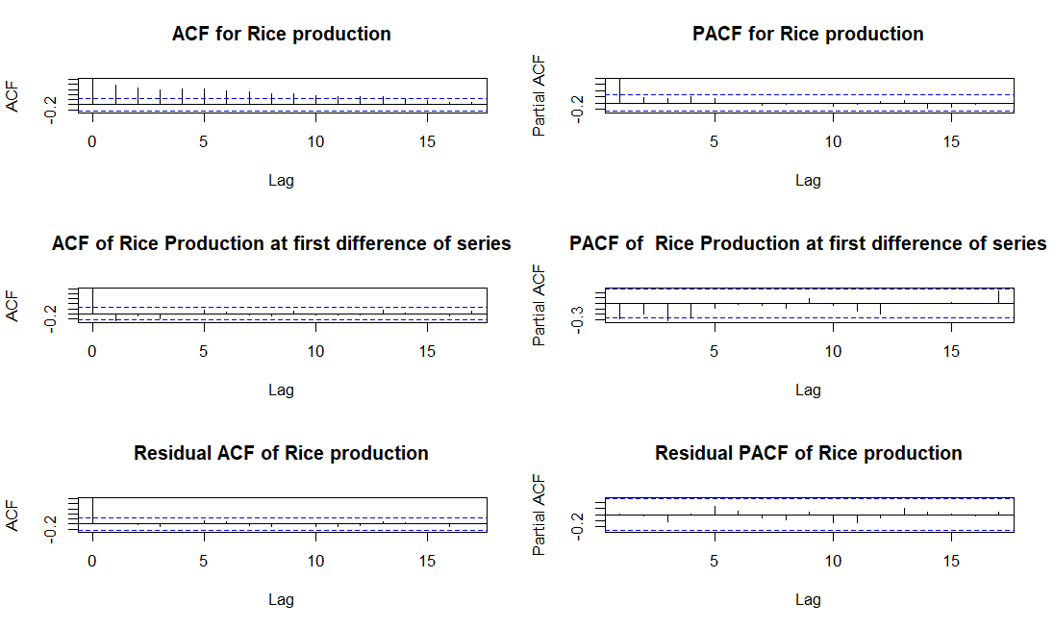
Figure: 5. ACF and PACF plots for Rice production

Table 3. Model fit statistics for Rice Production

ARIMA model | c | Parameters Estimate |  |  |  |  | Goodness of Fit
ARIMA model | c | Autoregressive Coefficient |  |  | Moving Average Coefficient |  | R² | RMSE | MAE | MAPE
ARIMA model | c | AR1 | AR2 | AR3 | MA1 | MA2
ARIMA (0,1,2) | 35.3 |  |  |  | -0.55 | -0.23 | 0.67 | 483.69 | 329.36 | 12.31
ARIMA (1,1,0) | 32.87 | -0.28 |  |  |  |  | 0.61 | 533.33 | 335.64 | 12.47
ARIMA (1,1,1) | 41.14 | 0.41 |  |  | -1 |  | 0.7 | 467.05 | 310.5 | 11.58
ARIMA (1,1,2) | 41.17 | 0.39 |  |  | -0.98** | -0.02 | 0.7 | 466.96 | 311.42 | 11.62
ARIMA (2,1,1) | 41.18 | 0.41** | -0.01 |  | -1 |  | 0.7 | 466.93 | 311.71 | 11.63
ARIMA (2,1,2) | 41.11 | -0.19** | 0.27 |  | -0.39 | -0.6 | 0.7 | 466.92 | 306.53 | 11.41
**Significant at 1%, *Significant at 5%
The ARIMA (2,1,2) fitted equation:
Rice production in Karnataka (Δ Y_{t}) = 41.11-0.19Y_{t-1}+0.27Y_{t-2}-0.39Ꜫ_{t-1} -0.6Ꜫ_{t-2} +e_{t}
Further, a residual analysis was conducted to assess the adequacy of the selected model. The analysis revealed that none of the lag values in the residual ACF and PACF plots were significant, as shown in the Figure 5. Additionally, Ljung-Box test and Kolmogorov-Smirnov test were conducted to check whether the residuals were independently and normally distributed or not. The Ljung-Box test statistic was Q = 2.89 (p = 0.71) K-S test statistic was D = 0.12 (p value = 0.28). The p values were greater than 0.05 indicating that the residuals were independently and normally distributed. This confirms the validity and goodness of fit of the selected ARIMA models for forecasting Rice production in the Karnataka State.
3.3 Fitting of Time Delay Neural Network (TDNN) for Rice Production in Karnataka State
From Table 4, it is shown that the best performing network was 3-6-1, which achieved low RMSE, MAE and MAPE values. Further, residual analysis was also carried out to check the adequacy of the selected neural network model and it was discovered that none of the lags of residual ACF chart were found to be significant as per Figure 6. Furthermore, the p-value (0.92) for the Ljung-Box test was greater than 0.05, indicating that the residuals were independently distributed.
Table 4. Performance of TDNN Models with Varying Network Structures on Rice production
Particulars | Network structure | RMSE | MAE | MAPE
Production | 3-1-1 | 458.43 | 320.91 | 12.59
Production | 3-2-1 | 344.93 | 248.93 | 9.83
Production | 3-3-1 | 247.29 | 194.82 | 8.01
Production | 3-4-1 | 207.81 | 160.63 | 6.76
Production | 3-5-1 | 193.67 | 141.49 | 5.98
Production | 3-6-1 | 172.16 | 132.48 | 5.61
Production | 3-7-1 | 187.03 | 137.64 | 5.89
Production | 3-8-1 | 185.63 | 135.95 | 5.67
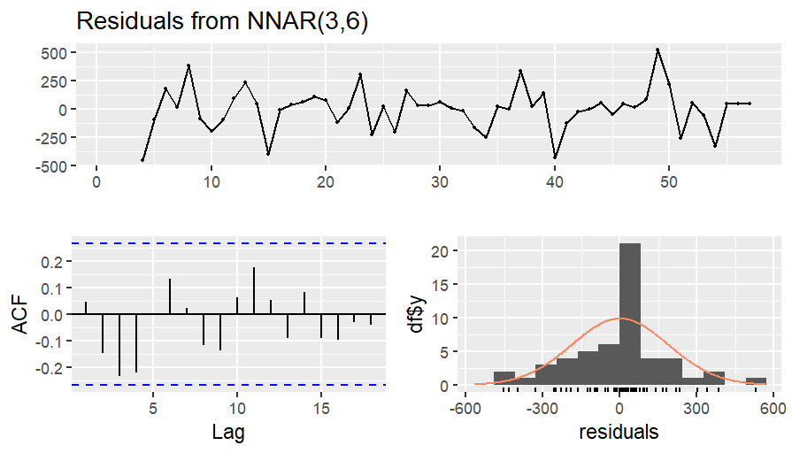

Figure: 6. Residual plot of NNAR (3,6)

3.4 Fitting of Nonlinear Support Vector Regression (NLSVR) Model on Rice production

The results of the Non-Linear Support Vector Regression (NLSVR) model for Karnataka Rice production are shown in Table 5. The model was built using a Radial Basis Function (RBF) kernel under the EPS-Regression type, with an Epsilon (ε) value of 0.1, a Cost (C) value of 256, and a Gamma (γ) value of 0.03125. The final model utilized 43 support vectors, indicating the number of data points that contributed to defining the regression function. This configuration aimed to enhance prediction accuracy while preventing overfitting. During tuning, the objective function, which usually represents the error measure, had a minimum value of 213571.1, which was the model's best performance value. In order to adequately capture the non-linear patterns found in the Rice production data, these parameter sets sought to strike a balance between model complexity and forecast accuracy.
Table 5. Parameters Specification of NLSVR on Rice production
Particulars | SVM  Type | SVM  Kernel | Cost | Gamma | Epsilon | No. Of  Support Vectors | Best  Performance
Production | EPS-  Regression | Radial | 256 | 0.03125 | 0.1 | 43 | 213571.1

3.5 BDS Test for Nonlinearity in ARIMA Residuals of ARIMA (2,1,2) model for Rice Production
The Brock-Dechert-Scheinkman (BDS) test was employed to detect the presence of nonlinearity in the residuals of the fitted ARIMA model for Rice production. A significant p-value was observed at Embedding Dimension 2 and 3, implying the presence of a nonlinear structure not captured by the fitted ARIMA model, as shown in the Table 6. These results indicated that, ARIMA models adequately captured the linear structure in the data series but some nonlinear structures remained. Hence it was justified to adopt a nonlinear model to capture the nonlinear structures.
In the present study, to enhance the forecasting accuracy nonlinear models are integrated with the ARIMA structure. Further the ARIMA residuals are fitted by nonlinear models such as Time Delay Neural Network (TDNN) and Nonlinear Support Vector Regression (NLSVR). This hybrid ARIMA-TDNN and ARIMA-NLSVR approach combines the strengths of ARIMA for capturing linear trends and nonlinear models for addressing remaining nonlinear structures in the data.
Table 6. BDS Test on ARIMA (2,1,2) Residuals
BDS Test |  |  |  |  |  |  |  |  | Decision
Embedding Dimension | 2 |  |  |  | 3 |  |  |  | Presence of nonlinearity
Epsilon | 235.48 | 470.97 | 706.46 | 941.95 | 235.48 | 470.97 | 706.46 | 941.95 | Presence of nonlinearity
p-value | 0.46 | 0.21 | 0.04* | 0.0064** | 0.57 | 0.24 | 0.09 | 0.0264* | Presence of nonlinearity
**Significant at 1%, *Significant at 5%

3.6 Fitting of Time Delay Neural Network (TDNN) Models on ARIMA Residuals
From Table 7, it is shown that the best performing network was 3-7-1, which achieved low RMSE, MAE and MAPE values. Further, residual analysis was also carried out to check the adequacy of the selected neural network model and it was discovered that none of the lags of residual ACF chart were found to be significant as per Figure 7. Furthermore, the p-value (0.89) for the Ljung-Box test was greater than 0.05, indicating that the residuals were independently distributed. These findings suggest that the selected model fits the ARIMA residuals well.

Table 7. Performance of TDNN Models with Varying Network Structures on ARIMA Residuals.

Particulars | Network structure | RMSE | MAE | MAPE
Production | 3-1-1 | 387.81 | 297.63 | 6.92
Production | 3-2-1 | 307.52 | 238.21 | 10.46
Production | 3-3-1 | 292.02 | 229.33 | 7.46
Production | 3-4-1 | 231.6 | 183.47 | 11.06
Production | 3-5-1 | 182.6 | 141.22 | 10.92
Production | 3-6-1 | 179.09 | 135.46 | 9.11
Production | 3-7-1 | 154.52 | 125.96 | 5.4
Production | 3-8-1 | 161.39 | 129.71 | 8.64
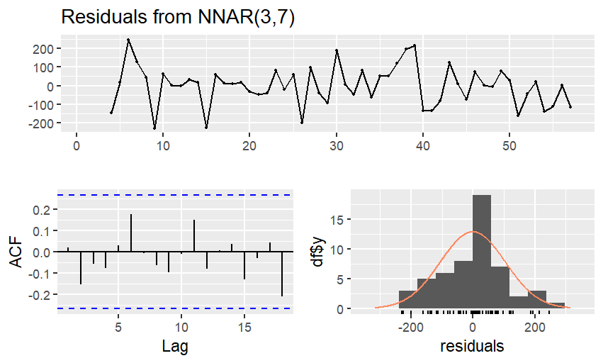
Figure: 7. Residual plot of NNAR (3,7)
3.7 Fitting of Nonlinear Support Vector Regression (NLSVR) Model on ARIMA Residuals
The results of the Non-Linear Support Vector Regression (NLSVR) model for Karnataka Rice production are shown in Table 8. The model was built using a Radial Basis Function (RBF) kernel under the EPS-Regression type, with an Epsilon (ε) value of 0.1, a Cost (C) value of 4, and a Gamma (γ) value of 0.25. The final model utilized 51 support vectors, indicating the number of data points that contributed to defining the regression function. This configuration aimed to enhance prediction accuracy while preventing overfitting. During tuning, the objective function, which usually represents the error measure, had a minimum value of 234910.6, which was the model's best performance value. In order to adequately capture the non-linear patterns found in the Rice production data, these parameter sets sought to strike a balance between model complexity and forecast accuracy.
Table 8. Parameters Specification of NLSVR on ARIMA (3,1,2) Residuals
Particulars | SVM  Type | SVM  Kernel | Cost | Gamma | Epsilon | No. Of  Support Vectors | Best  Performance
Production | EPS-  Regression | Radial | 4 | 0.25 | 0.1 | 51 | 234910.6

3.8 Performance Comparison of Fitted Models
Both training datasets (1962–63 to 2018–19) and testing datasets (2019–20 to 2021–22) were used to assess the fitted models using RMSE, MAE and MAPE. The accuracy of the hybrid techniques was higher than that of the individual models (ARIMA, TDNN, and NLSVR), which performed moderately well which is shown in the Table 9. On both datasets, ARIMA–TDNN consistently performed better than the others, demonstrating the benefit of combining linear and nonlinear approaches.
Table 9. Performance Metrics Comparison of the Fitted Models of Rice Production in Karnataka State
Model/Criteria | Training Dataset |  |  | Testing Dataset
Model/Criteria | RMSE | MAE | MAPE | RMSE | MAE | MAPE
ARIMA | 466.94 | 306.53 | 11.41 | 333.54 | 296.02 | 0.51
TDNN | 187.03 | 132.48 | 5.6 | 442.13 | 387.09 | 0.1024
NLSVR | 455.84 | 302.13 | 12.26 | 607.9 | 538.79 | 0.15
ARIMA-TDNN | 102.37 | 77.82 | 0.032 | 228.15 | 206.37 | 0.0519
ARIMA-NLSVR | 440.43 | 290.87 | 0.105 | 312.27 | 286.6 | 0.0734

Table 10. Forecasted Rice production in Karnataka State from 2022-23 to 2027-28 using the ARIMA-TDNN hybrid model.
Year | 2022-23 | 2023-24 | 2024-25 | 2025-26 | 2026-27 | 2027-28
Forecasted values  ('000 tonnes) | 4168.87 | 4282.28 | 3912.83 | 4298.77 | 3752.58 | 4432.68

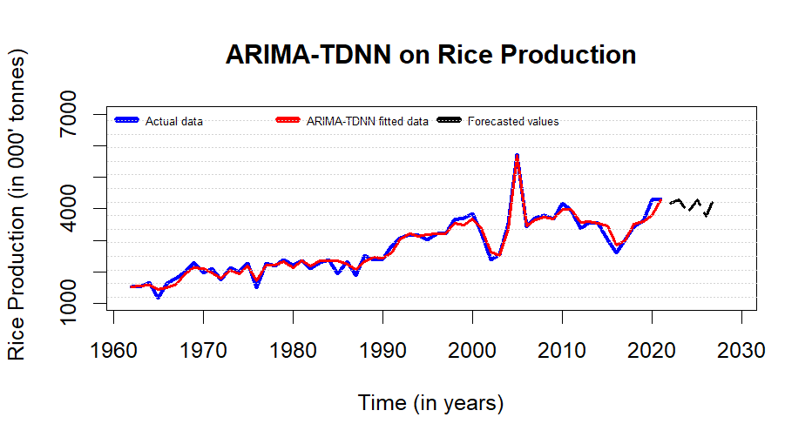
Figure: 8. Actual vs ARIMA-TDNN fitted for Rice production in Karnataka State

Finally, the actual and fitted values of Rice production in Karnataka State were generated using the ARIMA (2,1,2) -TDNN (3-7-1) hybrid model as shown in the Figure 8. The forecasted values of Rice production for the year 2027-28 were determined to be 4432.68 thousand tonnes. The results obtained from this hybrid model, as presented in Table 10, indicate a constant increasing trend in Rice production of Karnataka State.
4. CONCLUSION
The hybrid ARIMA–TDNN model produced the best accuracy of all fitted models, as demonstrated by the lowest error metrics on both training and testing datasets, according to a comparative analysis of several forecasting models. This hybrid model's improved performance shows how well linear and nonlinear techniques may be combined to produce accurate forecasts. This model was used to estimate Karnataka's Rice production through 2027–2028, revealing significant annual variations. When formulating plans for resource management and food security, farmers, planners, and legislators can all benefit greatly from these projections. All things considered, the ARIMA–TDNN hybrid model proves to be a reliable instrument for predicting agricultural output.
COMPETING INTERESTS
The authors declare that there are no competing interests.

REFERENCES
1. Ali AM, Mushi J. Investigation of a Suitable Hybrid Time Series Model for Predicting Clove Rice. Journal of ICT Systems. 2023;1(2):1-16.
2. Box GE, Jenkins GM, Reinsel GC, Ljung GM. Time series analysis: Forecasting and control. John Wiley & Sons; 2015.
3. Devra SJ, Patel DV, Shitap MS, Raj SR. Time series forecasting of price for oilseed crops by combining ARIMA and ANN. International Journal of Statistics and Applied Mathematics. 2023;8(4):40-54.
4. Kumar S, Arora K, Singh P, Gupta AK, Sharma I, Vatta K. Performance comparison of ARIMA and time delay neural network for forecasting of potato price in India. Agricultural Economics Research Review. 2022;35(2).
5. Kumar TM, Prajneshu. Development of hybrid models for forecasting time-series data using nonlinear SVR enhanced by PSO. Journal of Statistical Theory and Practice. 2015;9(4):699-711.
6. Jha GK, Sinha K. Time-Delay Neural Networks for Time Series Prediction: An Application to the Monthly Wholesale price of Oilseeds in India. Neural Comput Appl. 2014;24(3):563-571.
7. Rathod S, Mishra GC. Statistical models for forecasting mango and banana yield of Karnataka, India. Journal of Agricultural Science and Technology. 2018;20(4):803 816.
8. Rathod Santosha, Singh KN, Patil SG, Naik RH, Ray M, Meena VS. Modelling and forecasting of oilseed production of India through artificial intelligence techniques. Indian J Agric Sci. 2018;88(1):22-27.
9. Ray M, Rai A, Ramasubramanian V, Singh KN. ARIMA-WNN hybrid model for forecasting wheat yield time-series data. J Ind Soc Agric Stat. 2016;70(1):63-70.
10. Vapnik, V., Golowich, S and Smola, A. 1997. Support Vector Method for Function Approximation, Regression Estimation and Signal Processing. In: “Advances in Neural Information Processing Systems”, (Eds.): Mozer, M., Jordan, M and Petsche, T. MIT Press, Cambridge, MA. 9:281 -287.
11. Zhang GP. Time series forecasting using a hybrid ARIMA and neural network model. Neurocomputing. 2003; 50:159-175.

