Original Research Article
Effects of BK Fertilizer-based organic-mineral fertilization on the growth and yield of maize (Zea mays L.) in the Sudano-Guinean zone of Côte d’Ivoire : Bouaké case

ABSTRACT
Facing rapid population growth, land resources are becoming scarce and their degradation is increasing due to inappropriate practices. This study carried out to evaluates the agronomic potential of BK Fertilizer biofertilizer in improving maize productivity at the Food Crops Research Station of the National Agronomic Research Center (CNRA) in Bouaké, Côte d’Ivoire. A Fisher block trial with six treatments (four doses of BK Fertilizer, one control with mineral fertilizer and one absolute control) was conducted. Growth and yield parameters were evaluated. Results show significant differences between treatments (P < 0.05). Mineral fertilizer (MF) treatment showed the best performance for fresh ear weight (218.9 ± 12.3 g for 10 ears), while BK60+1/2MF treatment gave the highest 1000-grain dry weight (252.0 ± 8.5 g). Combined BK Fertilizer + half-dose mineral fertilizer treatments (T3, T4, T5) showed promising intermediate performances with 24.5 to 26.6 ear-bearing plants compared to 20.7 for the absolute control. These results suggest that combined use of BK Fertilizer with low doses of mineral fertilizers could be a sustainable alternative to improve maize productivity while reducing dependence on chemical inputs.
Keywords : Biofertilizer; BK Fertilizer; Yield; Maize; Bouaké; Côte d’Ivoire

1. INTRODUCTION
Maize (Zea mays L.) is one of the most widely cultivated cereals in the world, with global production of 1.2 billion tons on 201 million hectares (FAO, 2020). In Africa, production reaches 90 million tons on 43 million hectares. In Côte d’Ivoire, this crop plays a central role in human and animal diets, with national production of 1.2 million tons on 56 million hectares (FAO, 2020) and estimated consumption of 28.4 kg per capita per year (Countrystat, 2013).
However, this production has declined significantly due to soil degradation. The depletion of soil organic matter, nitrogen, and other minerals is recognized as one of the main causes of declining agricultural productivity in tropical Africa (Kasongo et al., 2012). Soil acidity and its associated effects severely limit agricultural production. Aluminum and manganese toxicity, as well as nutrient deficiencies, negatively affect plant growth (Denaix et al., 2016). In sub-Saharan Africa, soil mineral nutrient stocks decline annually by 22 kg of nitrogen (N), 2.5 kg of phosphorus (P), and 15 kg of potassium (K) per hectare (Sanchez, 2002).
To address this situation, farmers traditionally rely on crop rotation, fallowing, intercropping, and, above all, mineral fertilization (Roose et al., 2008 ; Nyembo et al., 2013). While chemical fertilization has helped increase agricultural yields for several decades, it now presents major drawbacks: high costs that are unaffordable for smallholder farmers and negative impacts on soil microfauna.
The development of rational, efficient, accessible, and environmentally friendly fertilization techniques is therefore necessary. Organo-mineral fertilizers could offer a solution to this problem.
The objective of this study is to evaluate the effect of the biofertilizer BK Fertilizer on the growth and yield parameters of maize at the Food Crops Research Station (SRCV) of the CNRA in Bouaké, in central Côte d’Ivoire. It is based on the hypothesis that the application of BK Fertilizer, used alone or in combination with low doses of mineral fertilizers, could significantly increase corn productivity while providing a sustainable alternative to intensive mineral fertilization.

2. MATERIAL AND METHODS

2.1. Study site
The study was conducted at the Food Crops Research Station (SRCV) of the National Agricultural Research Center (CNRA) in Bouaké, located in central Côte d'Ivoire. The experimental plot covers an area of 884 m² (34 m × 26 m). The city of Bouaké exhibits agroecological conditions characteristic of the forest-savanna transition zone. The climate is of the Sudano-Guinean type, characterized by two distinct seasons: a rainy season from April to October, peaking between June and September, and a dry season from November to March, influenced by the harmattan. Average annual rainfall ranges from 1,000 to 1,200 mm, while temperatures fluctuate between 25 and 30 °C, with a small daily temperature range (FAO, 2015 ; SODEXAM, 2020). This climate is generally favorable for maize cultivation, although irregular rainfall patterns can affect yields. In terms of soil type, the soils are predominantly ferrallitic, with a sandy to sandy-clay texture, characterized by low organic matter content and limited chemical fertility, particularly in nitrogen, phosphorus, and potassium. These soils, subject to leaching and erosion processes, require appropriate management practices to maintain their productivity (IRD, 2012 ; FAO, 2015).

2.2. Experimental setup
The experiment was set up using a Fisher block design with six (6) treatments (T0 to T5) repeated three (3) times, for a total of 18 plots. Each plot measures 40 m² (10 m × 4 m), with a distance of 1.5 m between plots and 2 m between blocks. The planting density used is 1 m between rows and 0.5 m between plants, resulting in a theoretical density of 20,000 plants per hectare. Each plot contains an average of 126 plants.

2.3. Treatments applied
The BK Organic Fertilizer used is an enriched organic product designed to improve soil fertility and plant nutrition. It contains microorganisms that act not only as a biofertilizer but also as a soil biostimulant. The six treatments studied are listed in Table 1.
Table 1. Description of the treatments applied
Treatment | Code | Detailed description
T0 | Absolute witness (AW) | Without the use of fertilizer
T1 | Mineral fertilizer (MF) | NPK 12-22-22 at 200 kg/ha before sowing + 46% N urea at 150 kg/ha 30 days after sowing (DAS)
T2 | BK 60 | BK Fertilizer at 600 kg/ha (60 g/m²) before sowing + 400 kg/ha (40 g/m²) at 30 DAS
T3 | BK 30 + 1/2 MF | BK Fertilizer at 300 kg/ha (30 g/m²) before sowing + 200 kg/ha (20 g/m²) at 30 DAS + NPK 12-22-22 at 100 kg/ha + urea (46% N) at 75 kg/ha
T4 | BK 60 + 1/2 MF | BK Fertilizer at 600 kg/ha (60 g/m²) before sowing + 400 kg/ha (40 g/m²) at 30 DAS + NPK 12-22-22 at 100 kg/ha + urea (46% N) at 75 kg/ha
T5 | BK 90 + 1/2 MF | BK Fertilizer at 900 kg/ha (90 g/m²) before sowing + 600 kg/ha (60 g/m²) at 30 DAS + NPK 12-22-22 at 100 kg/ha + urea (46% N) at 75 kg/ha

2.4. Conducting the trial : from site preparation to plant protection
Site preparation began with manual weeding using a machete, followed by tilling the soil and staking out the locations of the individual plots. Seeding was done by hand, with three seeds per hole, followed by thinning to one plant per hole 15 days after germination. Manual weeding was performed twice using a hoe and a machete. Weeding was carried out every two weeks from sowing until fruit set. Insecticide spraying (EMACOTT: Emamectin Benzoate 50 g/kg) was performed weekly for one month after the plants emerged to control insect pests.

2.5. Data collection
The observations focused primarily on the following agromorphological parameters, measured 60 and 90 days after sowing (DAS) :
- Number of plants bearing ears per row (10 plants selected at random per plot) ;
- Average number of ears per plant ;
- Number of rows of kernels per ear ;
- Fresh weight of 10 ears (g) ;
- Dry weight of 1,000 kernels (g) ;
- Pest damage severity index.
The ears were harvested at physiological maturity (approximately 90 DAS), air-dried for 15 days, and then weighed. The 1,000 kernel weight was determined after complete drying.

2.6. Statistical analysis
The collected data were analyzed using a one-way analysis of variance (ANOVA) with a single factor (treatment) using the R software (version 4.5.2). Means were compared using Tukey’s HSD test at a significance level of 5% (P < .05). Coefficients of variation (CV) were calculated to assess the variability of the data. Pearson correlation analyses were performed between the various yield parameters to identify significant relationships.

3. RESULTS

3.1. Effect of treatments on corn production parameters

3.1.1. Number of plants bearing ears
Figure 1A shows significant differences in the average number of plants bearing ears across treatment groups (F = 8.42; P < .001; CV = 9.3%). Treatments T3 (BK 30 + 1/2 MF) and T5 (BK 90 + 1/2 MF) yielded the highest values, with 26.6 ± 1.2 and 26.2 ± 1.4 plants, respectively, compared to those of T0 (20.7 ± 1.8 plants) and treatment T2 (BK 60) (19.8 ± 2.1 plants). The T1 (MF) and T4 (BK 60 + 1/2 MF) treatments yielded intermediate values of 25.2 ± 1.5 and 24.5 ± 1.6 plants, respectively, with no significant difference between them.

3.1.2. Number of ears per plant
The average number of ears per plant showed significant differences among treatments (F = 12.67; P < .001; CV = 11.2%). Treatment T3 (BK 30 + 1/2 MF) had the highest value (39.8 ± 2.3). The T1 (MF), T4 (BK 60 + 1/2 MF), and T5 (BK 90 + 1/2 MF) treatments showed intermediate values (between 33.3 ± 2.0 and 36.0 ± 1.9). In contrast, trea The T1 (MF), T4 (BK 60 + 1/2 MF), and T5 (BK 90 + 1/2 MF) treatments showed intermediate values (between 33.3 ± 2.0 and 36.0 ± 1.9). In contrast, treatments T0 and T2 (BK 60) recorded the lowest values (25.0 ± 2.5 and 22.8 ± 2.7, respectively) (Figure 1B).
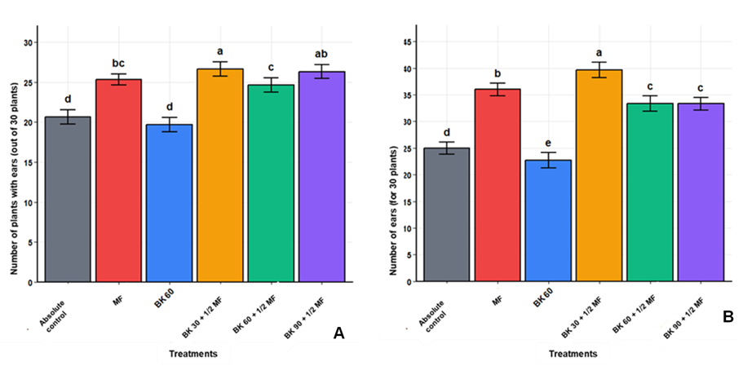
Figure 1. Effect of treatments on maize production parameters
(A) number of plants bearing ears per row (based on 30 plants observed) and (B) total number of ears per plant (based on 30 plants).
Error bars represent the standard error. Different letters indicate significant differences according to Tukey’s HSD test (P < .05).

3.2. Components of corn yield

3.2.1. Number of rows of kernels per ear
Figure 2 shows that the treatments had a significant effect on the average number of rows of kernels per ear (F = 3.21; P = .032; R² = 3.8%). The T1 (MF) and T4 (BK 60 + 1/2 MF) treatments had the highest values, with 13.7 ± 0.3 and 13.6 ± 0.3 rows per ear, respectively, while T2 (BK 60), T3 (BK 30 + 1/2 MF), and T5 (BK 90 + 1/2 MF) show values ranging from 13.4 ± 0.4 to 13.5 ± 0.3 rows. T0 recorded the lowest value (13.1 ± 0.4 rows), although this difference was not statistically significant compared to the other treatments, except for T1 and T4.
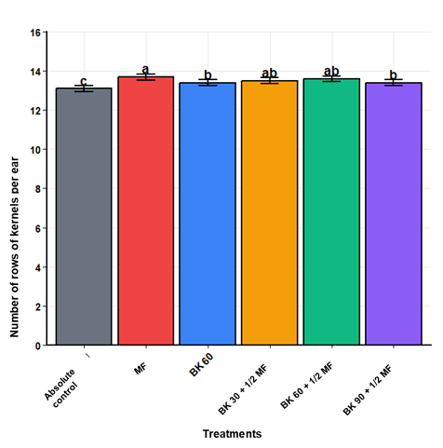
Figure 2. Average number of rows of kernels per ear by treatment
Error bars represent the standard error. Different letters indicate significant differences according to Tukey’s HSD test (P < .05).

3.2.2. Fresh weight of ears and dry weight of 1,000 kernels
An examination of Figures 3A and 3B revealed significant differences between treatments in the fresh weight of 10 ears (F = 15.83; P < .001; CV = 8.7%) and the dry weight of 1,000 grains (F = 6.94; P = .002; CV = 5.4%), respectively. For the fresh weight of 10 ears, treatments T1 (MF) and T4 (BK 60 + 1/2 MF) had the highest values, at 218.9 ± 12.3 g and 218.2 ± 11.8 g per 10 ears, respectively. In contrast, treatments T2 (BK 60) and T0 had the lowest weights, at 193.1 ± 14.2 g and 191.6 ± 15.1 g, respectively (Figure 3A).
With regard to the dry weight of 1,000 grains, treatments T4 (BK 60 + 1/2 MF) and T2 (BK 60) recorded the highest means, at 252.0 ± 8.5 g and 246.3 ± 9.2 g, respectively. The T0 (absolute control) and T3 (BK 30 + 1/2 MF) treatments showed intermediate values of 235.3 ± 10.1 g and 234.0 ± 9.8 g. Treatments T1 (MF) and T5 (BK 90 + 1/2 MF) recorded the lowest weights at 226.7 ± 8.9 g and 225.0 ± 10.5 g, which were significantly lower (P < 0.05) than those of treatments T4 and T2 (Figure 3B).
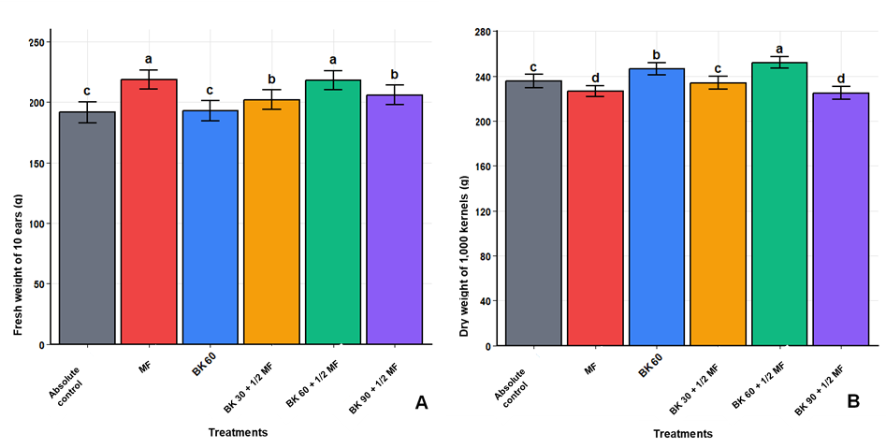
Figure 3. Components of maize yield according to the treatments applied : (A) fresh weight of 10 ears and (B) dry weight of 1,000 kernels
Error bars represent the standard error. Different letters indicate significant differences according to Tukey’s HSD test (P < .05).

3.3. Severity of pest attacks
Figure 4 shows moderate pest infestations, particularly from caterpillars, under treatments T4 (BK 60 + 1/2 MF), T5 (BK 90 + 1/2 MF), T2 (BK 60), and T1 (MF). In contrast, treatments T3 (BK 30 + 1/2 MF) and T0 showed greater resistance, with the lowest severity indices (Figure 4).
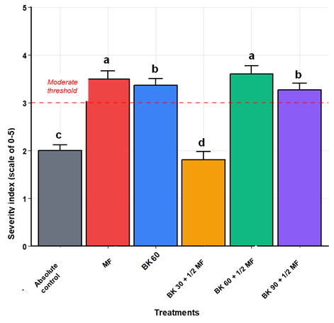
Figure 4. Disease and pest severity indices for maize crops based on the treatments applied
Error bars represent the standard error. Different letters indicate significant differences according to Tukey’s HSD test (P < .05).

3.4. Correlation analysis of parameters
Table 2 shows a strong correlation between, on the one hand, the number of plants bearing ears and the number of ears per plant (r = 0.87, P < .001) and, on the other hand, the fresh weight of the ears (r = 0.76, P < .01). The fresh weight of the ears is strongly correlated with the number of rows of kernels per ear (r = 0.81, P < .001). However, the 1,000 grain weight shows no significant correlation with the other parameters, suggesting that it is influenced by different factors. Pearson’s correlation analysis reveals several significant relationships among the yield parameters (Table 2).

Table 2. Pearson correlation matrix between maize yield parameters
Parameters | Plants bearing ears | Number of ears / plant | Rows of kernels / ear | Fresh weight 10 ears | Weight 1,000 seeds
Plants bearing ears | 1,00 | - | - | - | -
Number of ears / plant | 0,87*** | 1,00 | - | - | -
Rows of kernels / ear | 0,52* | 0,48* | 1,00 | - | -
Fresh weight 10 ears | 0,76** | 0,69** | 0,81*** | 1,00 | -
Weight 1,000 seeds | -0,24^{ns} | -0,31^{ns} | 0,15^{ns} | -0,08^{ns} | 1,00
*P < .05 ; **P < .01 ; ***P < .001 ; ns = non significatif

3.5. Summary of agronomic performance
Table 3 presents a comparative summary of the relative performance of each treatment compared to the absolute control (T0 = 100%). Table 3 shows that the combined treatments (T3, T4, T5) result in substantial yield increases compared to the absolute control, with gains of up to 59% in the number of ears per plant (T3) and 29% in the number of ear-bearing plants (T3).
Table 3. Relative performance of treatments compared to the absolute control (T0)
Treatment | Vector plants (%) | Ear/plant (%) | Fresh ear weight (%) | Weight 1,000 seeds (%)
T0 (Witness) | 100 | 100 | 100 | 100
T1 (MF) | 122 | 144 | 114 | 96
T2 (BK 60) | 96 | 91 | 101 | 105
T3 (BK 30 + 1/2 MF) | 129 | 159 | 105 | 99
T4 (BK 60 + 1/2 MF) | 118 | 140 | 114 | 107
T5 (BK 90 + 1/2 MF) | 127 | 133 | 107 | 96

4. DISCUSSION
The study was conducted as part of an effort to optimize cultural factors with a view to improving maize yields. In practical terms, it aimed to increase the productivity of this crop through better management of production factors, particularly growth and yield parameters. The observations made during this study highlighted the effects of applying BK Fertilizer, either alone or in combination with mineral fertilizers, on the agronomic performance of corn.

4.1. Effect of treatments on maize production parameters
Overall, the application of various doses of organo-mineral fertilizers resulted in a significant improvement in maize production parameters compared to the unfertilized control. More specifically, treatment T3 (BK 30 + 1/2 MF) performed best compared to treatment T0, particularly in terms of the number of plants bearing ears and the average number of ears per plant. This result demonstrates the remarkable effect of the combined use of fertilizers particularly mineral and organic fertilizers on improving crop productivity. Our results corroborate those of Muyayabantu et al. (2012), who demonstrated that the application of organo-mineral fertilizers promotes the growth and development of maize under field conditions, resulting in a significant improvement in yield. Furthermore, Mulaji (2011) emphasized that the application of various types of organic matter and mineral fertilizers to increase the availability of soil nutrients for plants is one of the promising approaches for boosting agricultural production in smallholder farming systems. Thus, Pypers et al. (2010) demonstrated that organo-mineral fertilizers increase crop yields in soils by 40 to 100 percent. As for the plants in the control treatment, the low yield obtained can be attributed to the soil’s lack of nutrients, as demonstrated by Siene et al. (2020). Indeed, these authors noted that the lack of nutrients in the soil could also be the underlying cause of the low crop productivity.

4.2. Components of corn yield
The highest yields were obtained with treatments T1 (MF) and T4 (BK 60 + 1/2 MF) in terms of the number of rows of kernels per ear, the fresh weight of 10 ears, and the dry weight of 1,000 kernels, compared to the control T0. These results suggest a relationship between maize and fertilizers, as highlighted by numerous studies (Andric et al., 2012 ; Nazli et al., 2014). These authors have shown that fertilizer application ensures stable maize yields in terms of both quantity and quality. Boldea et al. (2015) also demonstrated that increased maize yields are closely linked to the amounts of mineral fertilizers particularly nitrogen (N), phosphorus (P), and potassium (K) applied to the soil.
The best yield performance was observed with mineral fertilizers. This could be explained by the nature of plant uptake. Indeed, Nyembo et al. (2012) and Ilunga et al. (2018) demonstrated that, because mineral fertilizers are more soluble, they release the mineral elements N, P, and K in ionic form, which can be rapidly and directly assimilated by plants. However, regarding the dry weight of 1,000 seeds, treatments T1 (MF) and T5 (BK 90 + 1/2 MF) recorded the lowest weights. This finding can be explained by the excessive amounts of fertilizer applied. Useni et al. (2014) found that excessive fertilizer application can lead to low crop yields, as there is an application threshold for any fertilizer applied to the soil.

4.3. Severity of pest and disease outbreaks
Attacks were moderate under treatments T4 (BK 60 + 1/2 MF), T5 (BK 90 + 1/2 MF), T2 (BK 60 alone), and T1 (MF). In contrast, treatments T3 (BK 30 + 1/2 MF) and T0 resulted in greater resistance, as evidenced by lower severity indices. These results therefore suggest that there is a nonlinear relationship between fertilization and pest resistance : the absence of fertilizer or low fertilizer application rates can reduce the attractiveness of the plants, while moderate fertilization improves their tolerance. In contrast, high doses appear to disrupt this balance by promoting vegetation that is more vulnerable and more susceptible to infestations (Zhai et al., 2022).

4.4. Correlation analysis of parameters
Our results showed a significant positive correlation between the number of plants bearing ears and the number of ears per plant; between the number of plants bearing ears and the fresh weight of the ears; and between the fresh weight of the ears and the number of rows of kernels per ear. This significant positive correlation between these parameters suggests favorable environmental conditions that enhance the overall vigor of the plants, thereby resulting in more ears, higher fresh ear weights, and a greater number of rows of kernels per ear. These results could be explained, first and foremost, by the vigor of the plants, which are capable of developing not only a main ear but also secondary ears, thereby increasing the number of ears per plant (Haegele et al., 2014). Second, through improved nutrition, particularly in potassium, which increases the number of kernels per ear and, consequently, the fresh weight of the ears (Fromme et al., 2019). Finally, through plant vigor, which produces a larger, better-structured ear, further promoting rows of kernels and increasing the fresh weight of the ear (Haegele et al., 2013).

4.5. Summary of agronomic performance
The best agronomic performance was achieved with the combined treatments (T3, T4, T5) compared to the control. These results may be explained by the fact that these treatments provide nutrients in sufficient quantities that are readily available and assimilable by the plant, thereby ensuring higher yields, as noted by Kouakou et al. (2025) in their study on tomatoes. Soro’s (2022) research also revealed a significant increase in tomato yields through the combined application of BK Fertilizer organic fertilizer and mineral fertilizers. However, the poor performance observed in the treatments without fertilizer and those using only BK Fertilizer may highlight the limitations of fertilizer-free approaches or those with improperly adjusted doses, as Kouakou et al. (2025) have pointed out.

CONCLUSION
The study, which examined the effect of BK Fertilizer on maize growth and yield, highlights the agronomic benefits of this biofertilizer in improving maize growth and yield. The results of the study revealed that the agromorphological parameters evaluated varied significantly depending on the treatments applied. The mineral fertilizer (MF) treatment yielded the highest fresh weight of the ears, while the BK60+1/2 MF treatment produced the highest dry weight per 1,000 seeds. These results show that a balanced organic-mineral fertilization program not only increases maize productivity but also reduces the amount of mineral fertilizer used, thereby lowering production costs and minimizing the risk of soil degradation. BK Fertilizer thus appears to be a sustainable and promising alternative for maize production systems in Côte d’Ivoire. However, further trials spanning multiple growing seasons and conducted on different soil types are still needed to determine the optimal application rates and assess the long-term effects on soil fertility and farm profitability. Further long-term studies will be needed to better understand changes in soil fertility and to determine the optimal application rates for BK Fertilizer.
Disclaimer (Artificial Intelligence)
Author(s) hereby declare that NO generative AI technologies such as Large Language Models (ChatGPT, COPILOT, etc) and text-to-image generators have been used during writing or editing of this manuscript.
Competing Interests
Authors have declared that no competing interests exist.

REFERENCES
FAO. (2020). Agricultural production, crop primary database. Food and agricultural organization of the United Nations, Rome. http://faostat.fao.org/faostat/.Consulté le 22/02/22.
Countrystat, (2013). Manuel statistique de référence sur la dissémination des données sur le système CountrySTAT. Organisation des Nations Unies pour l’alimentation et l’agriculture, Rome (Italie). 74 p. https://www.fao.org/fileadmin/templates/ess/CountrySTAT/Docs/FR_Manual_JAN_2013.pdf
Kasongo, R. K., Van, R. E., Kanyankogote, P., Verdoodt, A. & Baert, G. (2012). Réponse du soja (Glycine max) à l’application de phosphate de Kanzi et de dolomie rose de Kimpese sur sol sableux en RD Congo. Canadian Journal of Soil Science, 92 : 905-916. DOI:10.4141/CJSS2011-097
Denaix, L., Anatole, M. L. & Thiéry, D. (2016). Effet de l’utilisation répétée de bouillie bordelaise sur la contamination des sols, la biodisponibilité du cuivre et son accumulation dans la vigne. 46e congrès du Groupe Français des Pesticides, 17-19 mai 2016, BORDEAUX.
Sanchez, A., Ysunza, F., Beltran, G. M. J. & Esqueda, M. (2002). Biodegradation of viticulture wastes by Pleurotus : a source of microbial and human food and its potential use in animal feeding.
Journal of Agricultural Food Chemistry, 50 (9) : 2537-2542. doi.org/10.1021/acs.jafc.2c01143
Roose, E., Albergel, J., De, N. G., Sabir, M. & Laouina, A. (2008). Efficacité de la GCES en milieu semi-aride. AUF, EAC et IRD éditeurs, Paris, p. 425.
Nyembo, K. L., Useni, S. Y., Chukiyabo, K. M., Tshomba, K. J., Ntumba, N. F., Muyambo, M. E., Kapalanga, K. P., Mpundu, M. M., Bugeme, M. D. & Baboy, L. L. (2013). Rentabilité économique du fractionnement des engrais azotés en culture de maïs (Zea mays L.) : cas de la ville de Lubumbashi, sud-est de la RD Congo. Journal of Applied Biosciences, 65 : 4945-4956.
FAO. (2015). Status of the World’s Soil Resources: Main Report. Rome: Food and Agriculture Organization.
SODEXAM. (2020). Données climatiques de la station météorologique de Bouaké (1980-2020). Abidjan, Côte d’Ivoire.
IRD. (2012). Les sols ferralitiques de Côte d’Ivoire : contraintes et gestion durable. Paris : Institut de Recherche pour le Développement.
Muyayabantu, G. M., Kadiata, B. D. & Nkongolo, K. K. (2012). Response of maize to different organic and inorganic fertilization regimes in monocrop and intercrop systems in a Sub-Saharan Africa Region. Journal of Soil Science and Environmental Management, 3(2) : 42-48. DOI: 10.5897/JSSEM11.079
Mulaji, K. C. (2011). Utilisation des composts de bio-déchets ménagers pour l’amélioration de la fertilité des sols acides de la province de Kinshasa (République Démocratique du Congo). Thèse de Doctorat, Université de Liège -Gembloux Agro-Bio Tech, p. 220.
Pypers, P., Vandamme, E., Sanginga, J. M., Tshibinda, T., Walangululu, M. J., Merckx, R. & Vanlauwe, B. (2010). K and Mg deficiencies corroborate farmer’s knowledge of soil fertility in the Highland of South-Kivu, Democratic Republic of Congo. in E.M. Bagura (Ed): évaluation de l’efficacité d’usage des engrais dans les sols dégradés du Sud-Kivu sur la culture du maïs et du haricot commun: cas du groupement de burhale”. Mémoire de fin d’études, Université Évangélique en Afrique, (2010), 59 p.
Siene, L. A. C., Doumbouya, M., Traore, M. S., Conde, M., N’guettia, T. V. F. & Kone, M. (2020). Effet de quatre types de fertilisants sur la croissance et la productivité de deux génotypes de maïs (Zea mays L.) en cas d’un semis tardif à Korhogo au Centre-Nord de la Côte d’Ivoire. International Journal of Biological and Chemical Sciences, 14(1) : 55-68. DOI: https://dx.doi.org/10.4314/ijbcs.v14i1.6
Andric, L., Rastija, M., Teklic, T. & Kovacevic, V. (2012). “Response of maize and soybeans to liming". Turkish Journal of Agriculture and Forestry, 36 : 415-420. Doi: 10.3906/tar-1107-23
Nazli, R. I., Kuşvuran, A., Inal, I., Demirbaş, A. & Tansi, V. (2014). “Effects of different organic materials on forage yield and quality of silage maize (Zea mays L.) ". Turkish Journal of Agriculture and Forestry, 38 : 23-31.
Boldea, M., Sala, F., Rawashdeh, H. & Luchian, D. (2015). “Evaluation of agricultural yield in relation to the doses of mineral fertilizers". Journal of Central European Agriculture, 16 (2) : 149-161.
Nyembo, K. L., Useni, S. Y., Mpundu, M. M., Bugeme, M. D., Kasongo, L. E. & Baboy, L. L. (2012). “Effets des apports des doses variées de fertilisants inorganiques (NPKS et Urée) sur le rendement et la rentabilité économique de nouvelles variétés de Zea mays L. à Lubumbashi, Sud Est de la RD Congo". Journal of Applied Biosciences, 59 : 4286-4296.
Ilunga, T. H., Banza, M. J., Lukusa, M. L., Mukunto, K. I., Malongo, H. L., Kanyenga, L. A. & Nyembo, K. L. (2018). “Influence du moment d’application du NPK sur la croissance et le rendement du maïs (Zea mays L.) installé sur un ferralsol". Journal of Applied Biosciences, 127 : 12794-12803, ISSN 1997-5902.
Useni, S. Y., Mwema, L. A. M. L., Chinawej, M. M. D. & Nyembo, K. L. (2014). L’apport des faibles doses d’engrais minéraux permet-il d’accroitre le rendement du maïs cultivé à forte densité ? Un exemple avec deux variétés de maïs à Lubumbashi. Journal of Applied Biosciences, 74 : 6131-6140, ISSN 1997-5902.
Zhai, J., Zhang, Y., Zhang, G., Tian, M., Xie, R., Ming, B., Hou, P., Keru, Wang, K., Xue, J. & Li, S. (2022). Effects of nitrogen fertilizer management on stalk lodging resistance traits in summer maize, Agriculture 2022, 12, 162. https://doi.org/10.3390/ agriculture12020162
Haegele, J. W., Becker, R. J., Henninger, A. S. & Below, F. E. (2014). Row arrangement, phosphorus fertility, and hybrid contributions to managing increased plant density of maize. Agronomy Journal, 106 : 1838-1846. https://doi.org/10.2134/agronj2013.0382
Fromme, D. D., Spivey, T. A. & Grichar, W. J. (2019). Agronomic response of corn (Zea mays L.) hybrids to plant populations. International Journal of Agronomy, 2019 : 1-8. https://www.hindawi.com/journals/ija/2019/3589768/
Haegele, J. W., Cook, K. A., Nichols, D. M. & Below, F. E. (2013). Changes in nitrogen use traits associated with genetic improvement for grain yield of maize hybrids released in different decades. Crop Science, 53 : 1256-1268. https://doi.org/10.2135/cropsci2012.07.0429
Kouakou, N. K. P., Coulibaly, N. D., Gadji, A. A. G., Essehi, J. L., N’gaza, A. L. F., Ossey, C. L. & Fondio, L. (2025). Effets de la fertilisation organo- minérale sur les performances agronomiques de la tomate et les propriétés physico-chimiques du sol en zone centre de Côte d’Ivoire. Journal of Animal & Plant Sciences, 66(2) : 13026 -13035. https://doi.org/10.35759/JAnmPlSci.v66.2.2
Soro, S. (2022). Effets comparés de la fertilisation organique et minérale sur les performances agronomiques de la tomate (Solanum lycopersicum L.) en Côte d'Ivoire. European Scientific Journal, 18(15) : 188-202.

