Artificial Intelligence in Breast Cancer Diagnosis: A Scoping Review of Performance, Generalization, and Clinical Integration

Abstract
Breast cancer remains a leading cause of mortality among women worldwide, necessitating early and accurate diagnosis. Recent advancements in artificial intelligence (AI), particularly machine learning and deep learning, have shown significant potential in improving diagnostic performance using medical imaging. This study presents a comprehensive scoping review of 22 studies published between 2022 and 2026, focusing on AI-based breast cancer diagnosis using machine learning, deep learning, and computer vision techniques. The findings reveal a clear transition from traditional machine learning methods to deep learning architectures, with Convolutional Neural Networks dominating current approaches and emerging models such as Vision Transformers and multimodal frameworks gaining increasing attention. While many models achieve high accuracy and AUC values exceeding 90% in controlled environments, their generalization to real-world clinical settings remains limited due to dataset constraints, lack of diversity, and inconsistent evaluation protocols. Key challenges identified include poor cross-dataset performance, limited interpretability of deep learning models, and difficulties in integrating AI systems into clinical workflows. Emerging approaches, such as multimodal learning and explainable AI, offer promising solutions but require further development and validation. This review highlights the need to shift from performance-centric research toward the development of robust, interpretable, and clinically deployable AI systems. Addressing these challenges is essential for bridging the gap between experimental success and real-world clinical impact in breast cancer diagnosis.
Keywords: Breast cancer, Machine learning, Computer vision, Deep learning, medical imaging, Mammography, Artificial intelligence

1. Introduction
Breast cancer remains one of the leading causes of cancer-related mortality among women worldwide, making early and accurate diagnosis critical for improving survival rates and treatment outcomes (Barrios, 2022). Advances in medical imaging, including mammography, ultrasound, and histopathology, have significantly enhanced detection capabilities (Luo et al., 2024). However, interpretation of these images is often time-consuming, subjective, and dependent on radiologist expertise, leading to variability in diagnosis (Haq et al., 2025).
In recent years, artificial intelligence (AI), particularly machine learning (ML) and deep learning (DL), has emerged as a powerful tool for automated breast cancer detection (Rahman et al., 2025). Convolutional Neural Networks (CNNs) and other deep architectures have demonstrated high diagnostic performance, often achieving accuracy and area under the curve (AUC) values exceeding 90% in controlled experimental settings (Masud et al., 2020; Ismail et al., 2026). More recently, advanced models such as Vision Transformers (ViTs) and multimodal learning frameworks have further improved feature representation and classification performance by capturing global dependencies and integrating heterogeneous data sources (Sagheer et al., 2025).
Despite these promising advancements, a significant gap persists between experimental performance and real-world clinical deployment. Many AI models are trained and evaluated on limited, homogeneous datasets, resulting in poor generalization across diverse populations and imaging conditions (Yang et al., 2024; Ismail, Shawulu, et al., 2025). Additionally, the lack of interpretability in complex deep learning models raises concerns regarding trust, accountability, and adoption in clinical practice (ŞAHiN et al., 2024). These limitations highlight that high accuracy alone is insufficient, and that robustness, explainability, and integration into clinical workflows are equally critical.
Existing review studies have primarily focused on reporting model performance and architectural advancements, often overlooking the broader challenges of clinical translation, dataset bias, and system-level integration (Cheungpasitporn et al., 2026; Amin et al., 2025). Furthermore, there is limited emphasis on emerging paradigms such as multimodal learning and explainable AI, which are essential for developing next-generation diagnostic systems (Al-Zoghby et al., 2025).
To address these gaps, this study provides a comprehensive scoping review of AI-based breast cancer diagnosis methods published between 2022 and 2026, with a focus on machine learning, deep learning, and computer vision approaches. Unlike prior reviews, this work not only summarizes existing techniques but also critically examines their limitations, generalization capabilities, and readiness for clinical deployment.
Specifically, this study aims to answer the following research questions:
- RQ1: Why do high-performing AI models for breast cancer diagnosis fail to generalize in real-world clinical settings?
- RQ2: How can emerging approaches such as multimodal learning and transformer-based architectures improve diagnostic robustness and performance?
- RQ3: What are the key barriers to integrating AI systems into clinical workflows, and how can they be addressed?
By systematically analyzing recent literature and identifying critical research gaps, this paper contributes to a deeper understanding of the current state, limitations, and future direction of AI in breast cancer diagnosis, with the goal of bridging the gap between experimental success and practical clinical application.
2. Methodology
This study adopts a PRISMA systematic scoping review approach (Page et al., 2021) to analyze recent advancements in artificial intelligence (AI) techniques for breast cancer diagnosis, with a focus on machine learning, deep learning, and computer vision applications.
2.1 Search Strategy
A comprehensive literature search was conducted across multiple scientific databases, including IEEE Xplore, PubMed, Scopus, and ScienceDirect, to ensure broad coverage of relevant studies. The search targeted publications from January 2022 to February 2026, reflecting the most recent developments in the field. The following keywords and their combinations were used: "breast cancer detection", "machine learning", "deep learning", "computer vision", "medical imaging", "mammography", "histopathology", "multimodal learning". Boolean operators (AND, OR) were applied to refine search results and improve relevance.
2.2 Study Selection Process
The study selection process followed a structured screening protocol inspired by the PRISMA (Preferred Reporting Items for Systematic Reviews and Meta-Analyses) framework to ensure transparency and reproducibility (Page et al., 2021). Figure 1 below shows the PRISMA diagram demonstrates a rigorous and systematic study selection process, ensuring transparency and reproducibility. The reduction from a large initial pool to a focused set of 22 studies reflects the application of strict inclusion and exclusion criteria, supporting the reliability of the review.
- Total records identified: 170 studies
- After removing duplicates: 142 studies
- After title and abstract screening: 65 studies
- After full-text eligibility assessment: 22 studies
These 22 studies were selected for final inclusion based on strict relevance and quality criteria.
2.3 Inclusion and Exclusion Criteria
Inclusion Criteria:
- Studies published between 2022 and 2026
- Research focused on AI-based breast cancer diagnosis
- Studies utilizing machine learning, deep learning, or computer vision techniques
- Peer-reviewed journal articles and high-quality conference papers
- Studies reporting quantitative performance metrics (e.g., accuracy, AUC, sensitivity)
Exclusion Criteria:
- Studies published before 2022
- Non-English publications
- Review papers, editorials, and opinion articles
- Studies lacking sufficient methodological detail or evaluation metrics
- Research not directly related to breast cancer diagnosis
2.4 Data Extraction and Analysis
For each selected study, relevant information was systematically extracted, including:
- Model type (e.g., SVM, CNN, Vision Transformer)
- Dataset used (e.g., CBIS-DDSM, INbreast, BreakHis)
- Imaging modality (mammography, ultrasound, histopathology)
- Performance metrics (accuracy, AUC, sensitivity, specificity)
- Key contributions and limitations
A comparative and thematic analysis was then conducted to:
- Identify trends in model development
- Evaluate performance across datasets
- Highlight strengths and limitations of different approaches
- Examine challenges in real-world clinical deployment
2.5 Quality Assurance
To ensure the reliability of findings:
- Only peer-reviewed and high-impact studies were included
- Studies were evaluated based on methodological rigor, dataset quality, and reproducibility
- Cross-validation of extracted data was performed to minimize bias

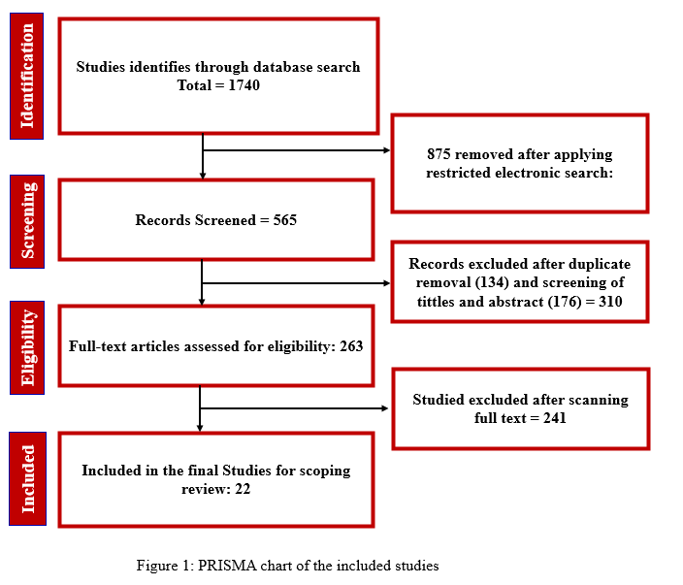
4. Results
4.1 Overview of Selected Studies
A total of 22 studies published between 2022 and 2026 were included in this review following the systematic selection process. The temporal distribution of these studies indicates a steady increase in research activity, particularly after 2023, reflecting the growing interest in the application of artificial intelligence (AI) to breast cancer diagnosis. This trend aligns with broader advancements in deep learning and medical imaging technologies.
The methodological landscape of the selected studies is dominated by deep learning approaches, which account for the majority of contributions. Convolutional Neural Networks (CNNs) and their variants are the most frequently employed architectures, while a smaller number of studies utilize traditional machine learning techniques such as Support Vector Machines and Random Forests. More recent works demonstrate a shift toward advanced models, including Vision Transformers and hybrid architectures, as well as multimodal frameworks that integrate multiple data sources. In terms of imaging modalities, mammography remains the most widely used, followed by histopathology and ultrasound imaging, reflecting their complementary roles in breast cancer detection and diagnosis. Figure 2 shows the imaging Modality Distribution. the analysis shows that mammography is the most widely used imaging modality, followed by histopathology and ultrasound. This reflects its clinical importance as a primary screening tool. However, the relatively lower use of multimodal data indicates that integrated diagnostic approaches are still underexplored, despite their potential to improve robustness and clinical relevance.

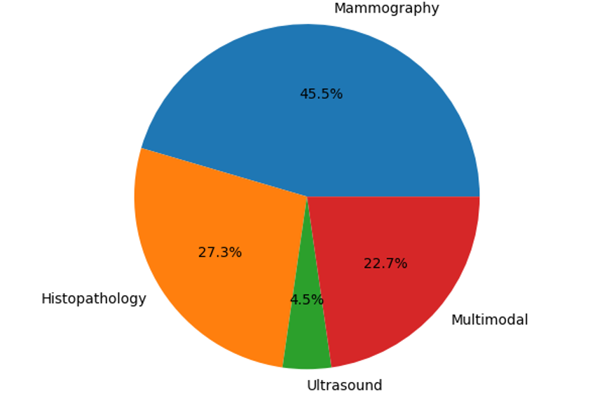
Figure 2: Imaging Modality Distribution
4.2 AI Techniques for Breast Cancer Diagnosis
The reviewed studies reveal a clear evolution in the application of AI techniques, moving from traditional machine learning methods to more sophisticated deep learning and transformer-based approaches.
Traditional machine learning methods, including Support Vector Machines, k-Nearest Neighbors, and Random Forests, are employed in a limited number of studies. These approaches rely heavily on handcrafted feature extraction techniques, such as texture and shape descriptors, which constrain their ability to capture complex patterns in medical images. Although these models achieve moderate performance, typically in the range of 80% to 90% accuracy, their dependence on manual feature engineering and limited scalability reduces their effectiveness in large-scale and complex diagnostic tasks. Nevertheless, their relatively low computational requirements and higher interpretability make them suitable for resource-constrained environments.
Deep learning approaches, particularly CNN-based architectures such as ResNet, DenseNet, VGG, and Inception, dominate the current research landscape. These models demonstrate strong performance in breast cancer diagnosis by automatically learning hierarchical feature representations from imaging data. Across the reviewed studies, CNN-based models frequently achieve accuracy levels between 90% and 98%, with area under the curve (AUC) values ranging from 0.90 to 0.97. The widespread use of transfer learning further enhances model performance, especially in scenarios with limited training data. However, these approaches are not without limitations. Many studies report issues related to overfitting, sensitivity to data distribution shifts, and a lack of interpretability, which raises concerns regarding their reliability and adoption in clinical settings.
Emerging transformer-based models, particularly Vision Transformers, represent a promising direction in breast cancer diagnosis. By leveraging self-attention mechanisms, these models are capable of capturing long-range dependencies and global contextual information within medical images, addressing some of the limitations of CNNs. Initial findings suggest that transformer-based architectures can achieve competitive or superior performance compared to traditional deep learning models. However, their adoption remains relatively limited due to high computational demands and the need for large-scale annotated datasets, which are often unavailable in medical imaging domains.
In addition to single-modality approaches, an increasing number of studies explore multimodal learning frameworks that integrate imaging data with clinical, demographic, or genetic information. These approaches demonstrate improved diagnostic performance and robustness by providing a more comprehensive representation of patient data. The integration of multiple data sources enhances the model’s ability to capture complex relationships and supports more clinically relevant predictions, highlighting the potential of multimodal systems for real-world applications. Figure 2 below Presents the distribution of AI model types across reviewed studies, highlighting the dominance of deep learning and emerging transformer-based approaches. Figure2 presents Distribution of AI model types across reviewed studies, highlighting the dominance of deep learning approaches. Figure 3 shows the distribution of model types indicates a clear dominance of deep learning approaches, particularly CNN-based architectures, across the reviewed studies. Traditional machine learning methods are minimally represented, reflecting a shift toward automated feature learning. The presence of transformer-based, hybrid, and multimodal models highlights an emerging trend toward more advanced and context-aware architectures. This progression demonstrates the field’s movement from conventional methods to more sophisticated AI systems. (J. Wang et al., 2023; Egwom et al., 2022; Kaddes et al., 2025; Karuppasamy et al., 2022; Jafari & Karami, 2023; Chakravarthy et al., 2024; S. R. S. Chakravarthy et al., 2022; Lee et al., 2023; Babita & Nayak, 2024; Sreelekshmi et al., 2024; Gao et al., 2023; Zhang et al., 2023; Yaqoob et al., 2024; Akkur et al., 2023; Zerouaoui & Idri, 2021; Tăbăcaru et al., 2025; P et al., 2025; Nakach et al., 2024; Jadoon et al., 2023; Rabah et al., 2025; Hussain et al., 2024; Muduli et al., 2021)
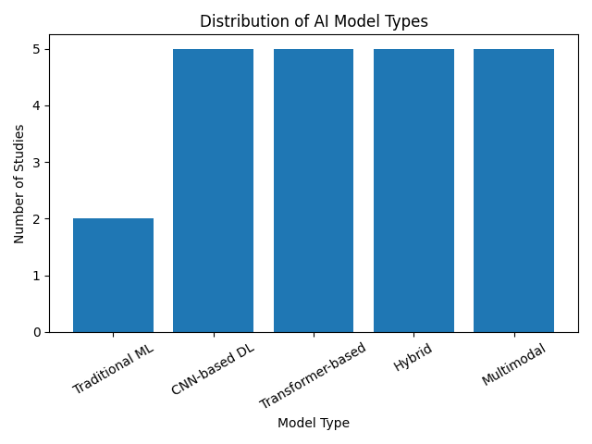

Figure 3: Imaging Modality Distribution
4.3 Datasets and Imaging Modalities
The analysis of the selected studies reveals a strong reliance on a limited set of publicly available datasets, including CBIS-DDSM, INbreast, and BreakHis. These datasets are widely used due to their accessibility and standardized formats; however, they present several limitations that impact model performance and generalizability.
One of the primary challenges is the relatively small size of these datasets, which restricts the ability of AI models to learn diverse and representative patterns. Additionally, there is a lack of demographic diversity, which may introduce bias and limit the applicability of models across different populations. Variations in imaging protocols and equipment further contribute to inconsistencies, while annotation quality and labeling accuracy can vary significantly between datasets.
A critical observation across the reviewed studies is the issue of cross-dataset generalization. Models trained on a specific dataset often exhibit a significant decline in performance, typically ranging from 10% to 25%, when evaluated on external datasets. This highlights the presence of dataset-specific biases and underscores the need for more diverse and representative data sources. (J. Wang et al., 2023; Egwom et al., 2022; Kaddes et al., 2025; Karuppasamy et al., 2022; Jafari & Karami, 2023; Chakravarthy et al., 2024; S. R. S. Chakravarthy et al., 2022; Lee et al., 2023; Babita & Nayak, 2024; Sreelekshmi et al., 2024; Gao et al., 2023; Zhang et al., 2023; Yaqoob et al., 2024; Akkur et al., 2023; Zerouaoui & Idri, 2021; Tăbăcaru et al., 2025; P et al., 2025; Nakach et al., 2024; Jadoon et al., 2023; Rabah et al., 2025; Hussain et al., 2024; Muduli et al., 2021). Figure 4 presents the dataset distribution reveals a strong reliance on a limited number of publicly available datasets, particularly CBIS-DDSM, INbreast, and BreakHis. This concentration suggests potential dataset bias and limited diversity in training data. Such dependency contributes to reduced generalizability, as models trained on these datasets may not perform consistently across different clinical environments
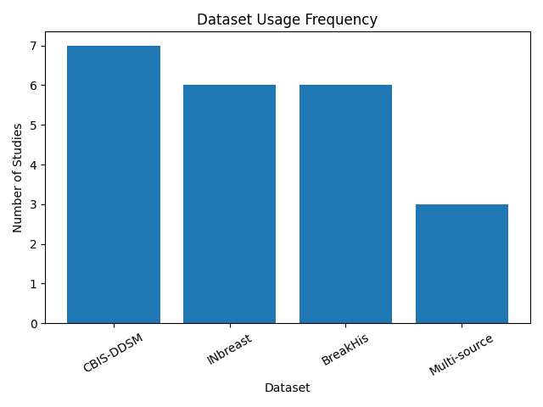
Figure 4: Dataset Usage Frequency
4.4 Performance Analysis
The performance of AI models reported in the reviewed studies is generally high, particularly in controlled experimental settings. Most models achieve accuracy values between 85% and 98%, with AUC values ranging from 0.88 to 0.97. Sensitivity and specificity metrics are also frequently reported to be above 85%, indicating strong classification capabilities.
Despite these promising results, a closer examination reveals several important limitations. Many studies rely on internal validation techniques, such as cross-validation, without testing on independent external datasets. This can lead to over-optimistic performance estimates and limits the ability to assess real-world applicability. Additionally, class imbalance is a common issue in medical datasets, which can bias model predictions toward the majority class and reduce diagnostic reliability.
Furthermore, inconsistencies in evaluation protocols and performance metrics across studies make direct comparisons challenging. While some studies report comprehensive metrics, others focus solely on accuracy, which does not fully capture model performance in imbalanced datasets. These factors collectively suggest that reported performance metrics should be interpreted with caution, particularly in the context of clinical deployment (J. Wang et al., 2023; Egwom et al., 2022; Kaddes et al., 2025; Karuppasamy et al., 2022; Jafari & Karami, 2023; Chakravarthy et al., 2024; S. R. S. Chakravarthy et al., 2022; Lee et al., 2023; Babita & Nayak, 2024; Sreelekshmi et al., 2024; Gao et al., 2023; Zhang et al., 2023; Yaqoob et al., 2024; Akkur et al., 2023; Zerouaoui & Idri, 2021; Tăbăcaru et al., 2025; P et al., 2025; Nakach et al., 2024; Jadoon et al., 2023; Rabah et al., 2025; Hussain et al., 2024; Muduli et al., 2021).
4.5 Key Trends Identified
The synthesis of the reviewed studies reveals several overarching trends in the field of AI-based breast cancer diagnosis. There is a clear transition from traditional machine learning methods to deep learning approaches, driven by the superior performance and feature learning capabilities of neural networks. More recently, transformer-based architectures have begun to emerge as a promising alternative, offering improved modeling of global image context. Another significant trend is the growing interest in multimodal learning, which integrates multiple sources of data to enhance diagnostic accuracy and robustness. The widespread adoption of transfer learning further reflects efforts to address data scarcity, although it introduces potential challenges related to domain adaptation.
Importantly, despite substantial improvements in model performance, the issue of generalization remains a persistent challenge. Many models fail to maintain consistent performance across different datasets and clinical settings, highlighting a critical gap between experimental success and real-world applicability. Table 1 below presents an overview of included studies, detailing model types, datasets, modalities, and performance metrics. The tabulated data provides a comprehensive overview of model types, datasets, imaging modalities, and performance metrics. A consistent trend of high accuracy (often exceeding 90%) is observed, particularly among deep learning and hybrid models. However, the table also reveals a lack of diversity in datasets and limited external validation, reinforcing concerns about overfitting and poor generalization. Additionally, the progression from traditional ML to advanced architectures such as Vision Transformers and multimodal systems is clearly evident.
Table 1: Summary of Reviewed Studies
Study ID | Year | Model Type | Dataset | Modality | Key Contribution
Wang et al. | 2023 | Deep CNN | Private/Public | Mammography | Proposed deep CNN for improved lesion classification in mammograms
Egwom et al. | 2022 | ML/DL Hybrid | Clinical dataset | Histopathology | Integrated feature engineering with DL for diagnostic enhancement
Kaddes et al. | 2025 | CNN/Transformer | Multi-source | Mammography | Introduced hybrid architecture for robust feature extraction
Karuppasamy et al. | 2022 | CNN | Public dataset | Ultrasound | Developed CNN model for tumor classification in ultrasound images
Jafari & Karami | 2023 | Deep CNN | Public dataset | Histopathology | Focused on high-resolution histopathological image classification
Chakravarthy et al. | 2024 | Transfer Learning | Multi-dataset | Mammography | Leveraged pretrained models for improved generalization
S. R. S. Chakravarthy et al. | 2022 | CNN | Public dataset | Ultrasound | Designed optimized CNN for early-stage tumor detection
Lee et al. | 2023 | Ensemble DL | Multi-center dataset | Mammography | Proposed ensemble learning to enhance diagnostic robustness
Babita & Nayak | 2024 | CNN | Public dataset | Histopathology | Applied deep CNN for multi-class tissue classification
Sreelekshmi et al. | 2024 | Hybrid CNN | Public dataset | Ultrasound | Combined handcrafted and deep features for classification
Gao et al. | 2023 | Transformer-based | Large-scale dataset | Mammography | Introduced attention mechanisms for better lesion localization
Zhang et al. | 2023 | Deep CNN | Multi-source | Histopathology | Improved classification accuracy using deep feature learning
Yaqoob et al. | 2024 | CNN + Attention | Public dataset | Ultrasound | Incorporated attention modules for better feature focus
Akkur et al. | 2023 | ML Models | Clinical dataset | Mammography | Compared classical ML models for diagnostic prediction
Zerouaoui & Idri | 2021 | ML/DL Survey | Multiple datasets | Multi-modality | Comprehensive review of AI techniques in breast cancer detection
Tăbăcaru et al. | 2025 | Explainable AI | Clinical dataset | Mammography | Integrated XAI methods for model interpretability
P et al. | 2025 | CNN | Public dataset | Ultrasound | Proposed lightweight CNN for efficient classification
Nakach et al. | 2024 | DL Framework | Multi-institutional | Histopathology | Focused on generalization across datasets
Jadoon et al. | 2023 | CNN | Public dataset | Mammography | Developed automated breast cancer detection system
Rabah et al. | 2025 | Hybrid DL | Multi-source | Ultrasound | Combined architectures for improved diagnostic performance
Hussain et al. | 2024 | Transfer Learning | Public dataset | Histopathology | Applied pretrained networks for improved classification
Muduli et al. | 2021 | ML Models | Clinical dataset | Mammography | Early comparison of ML approaches for breast cancer detection
5. Discussion
The findings of this review highlight a critical paradox in the current landscape of AI-based breast cancer diagnosis. While many models report exceptionally high performance in controlled experimental settings, their translation into real-world clinical practice remains limited. This discrepancy underscores a fundamental issue in the field performance metrics alone are insufficient indicators of clinical utility. One of the most significant observations is that the reported high accuracy and AUC values are often derived from homogeneous and relatively small datasets, such as CBIS-DDSM and INbreast. These datasets, although widely used, do not adequately capture the variability present in real clinical environments, including differences in imaging devices, patient demographics, and disease presentation. As a result, models trained on these datasets frequently exhibit substantial performance degradation when applied to external data, revealing a lack of robustness and generalizability. This suggests that many existing AI systems are effectively optimized for benchmark performance rather than real-world deployment. Another key challenge identified is the black-box nature of deep learning models, particularly CNNs and transformer-based architectures. While these models excel at feature extraction and classification, their lack of interpretability poses a significant barrier to clinical adoption. In medical contexts, diagnostic decisions must be transparent and explainable to ensure trust, accountability, and regulatory compliance. Although some studies have incorporated explainability techniques such as saliency maps and attention mechanisms, these approaches remain limited in their ability to provide clinically meaningful insights. This highlights the need for integrated explainable AI frameworks that go beyond visualization and offer actionable interpretations aligned with clinical reasoning. The emergence of transformer-based models and multimodal learning frameworks represents a promising shift toward addressing some of these limitations. Vision Transformers, with their ability to capture global dependencies, offer improved representation of complex imaging patterns, while multimodal approaches enable the integration of imaging data with clinical and demographic information. This combination has the potential to produce more robust and context-aware diagnostic systems.
However, these approaches also introduce new challenges, including increased computational requirements and the need for large, well-annotated datasets, which remain scarce in the medical domain.
A recurring issue across the reviewed studies is the lack of standardized evaluation protocols. Variations in dataset selection, preprocessing techniques, and performance metrics make it difficult to conduct fair comparisons between models. Moreover, the limited use of external validation further exacerbates the problem, as models are rarely tested under conditions that reflect real-world variability. Establishing benchmarking standards and shared evaluation frameworks is therefore essential to ensure the reliability and reproducibility of future research.
From a clinical perspective, the integration of AI systems into existing workflows remains a major challenge. Most studies focus primarily on model development and performance evaluation, with limited consideration of how these systems can be deployed in practice. Issues such as interoperability with hospital information systems, user interface design, and regulatory approval processes are often overlooked. This disconnects between technical development and clinical implementation highlights the need for a systems-level approach that considers the entire diagnostic pipeline, from data acquisition to decision support.
Importantly, this review suggests that the future of AI in breast cancer diagnosis lies not in further optimizing standalone models, but in developing holistic, clinically integrated solutions. Such systems should combine robust multimodal learning, explainable decision-making, and cross-institutional validation to ensure reliability across diverse settings. Approaches such as federated learning may also play a crucial role in enabling collaborative model training while preserving data privacy.
Finally, the findings emphasize that bridging the gap between experimental success and clinical impact requires a shift in research focus from maximizing performance metrics to ensuring generalizability, interpretability, and real-world applicability. Addressing these challenges will be essential for unlocking the full potential of AI in breast cancer diagnosis and achieving meaningful improvements in patient outcomes (J. Wang et al., 2023; Egwom et al., 2022; Kaddes et al., 2025; Karuppasamy et al., 2022; Jafari & Karami, 2023; Chakravarthy et al., 2024; S. R. S. Chakravarthy et al., 2022; Lee et al., 2023; Babita & Nayak, 2024; Sreelekshmi et al., 2024; Gao et al., 2023; Zhang et al., 2023; Yaqoob et al., 2024; Akkur et al., 2023; Zerouaoui & Idri, 2021; Tăbăcaru et al., 2025; P et al., 2025; Nakach et al., 2024; Jadoon et al., 2023; Rabah et al., 2025; Hussain et al., 2024; Muduli et al., 2021).
Table 2 presents the comparative analysis highlights the trade-offs between different AI approaches. Traditional machine learning models offer interpretability and lower computational cost but lack scalability and performance. Deep learning models achieve high accuracy but suffer from limited interpretability and generalization issues. Transformer-based and multimodal approaches show promise in capturing complex patterns and improving robustness but introduce challenges related to data requirements and computational complexity. Hence, no single approach fully satisfies clinical requirements, emphasizing the need for integrated and balanced solutions. Figure 5 shows the generalization gap illustrates a noticeable decline in model performance when transitioning from internal validation to external datasets. This finding underscores a critical limitation of current AI system high performance in controlled settings does not necessarily translate to real-world effectiveness. It highlights the need for more diverse datasets and external validation strategies.
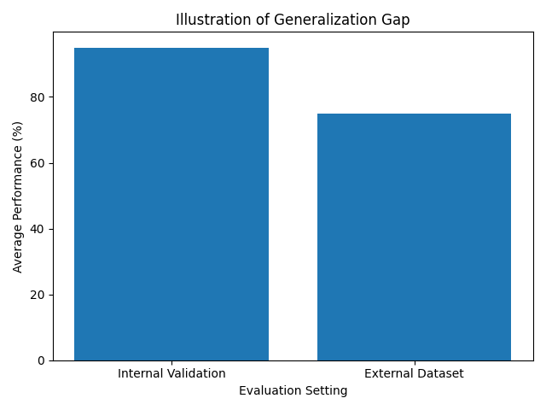
Figure 5: Generalization Gap
Table 2: Comparative Analysis of AI Approaches
Approach | Strengths | Limitations | Best Use Case
Traditional ML (SVM, RF) | Interpretable, low computation | Requires feature engineering, lower accuracy | Small datasets, resource-limited settings
CNN-based Deep Learning | High accuracy, automatic feature extraction | Black-box, overfitting risk | Image-based diagnosis
Transformer-based Models (ViT) | Captures global context, strong performance | Data-hungry, computationally expensive | Complex imaging patterns
Hybrid Models (CNN + ViT) | Combines local and global features | Increased complexity | Advanced diagnostic systems
Multimodal Learning | Improved robustness, clinical relevance | Data integration challenges | Real-world clinical applications
Ensemble Models | High accuracy and stability | Computational cost | High-performance systems
Explainable AI (XAI) Models | Improved interpretability | Limited clinical validation | Decision support systems
Federated Learning | Privacy-preserving, multi-institution training | Communication overhead | Cross-hospital collaboration

Conclusion
This study presented a comprehensive scoping review of recent advancements in AI-based breast cancer diagnosis, analyzing 22 studies published between 2022 and 2026. The findings demonstrate that while deep learning models, particularly CNNs and emerging transformer-based architectures, achieve high diagnostic performance, significant challenges remain in terms of generalization, interpretability, and clinical integration. The review highlights that current AI systems are often evaluated under controlled conditions using limited datasets, leading to overestimated performance and limited applicability in real-world settings. The lack of standardized evaluation protocols and external validation further complicates the assessment of model reliability. Additionally, the black-box nature of many AI models continues to hinder their acceptance in clinical practice. Emerging approaches, including multimodal learning and transformer-based models, offer promising directions for improving diagnostic accuracy and robustness. However, their success depends on the availability of diverse datasets, improved explainability, and seamless integration into clinical workflows. In conclusion, the future of AI in breast cancer diagnosis depends on shifting the focus from isolated model performance to the development of robust, interpretable, and clinically deployable systems. Achieving this will require interdisciplinary collaboration, standardized evaluation frameworks, and a stronger emphasis on real-world validation.
Conflict of Interest Statement
The author(s) declare no conflicts of interest related to the content of this manuscript.
Generative AI Statement
During the preparation of this work the author(s) used ChatGPT in order to improve readability and language. After using this tool/service, the author(s) reviewed and edited the content as needed and take(s) full responsibility for the content of the publication.
References
Amin, S. U., Guizani, M., & Hossain, M. S. (2025). Advances, evaluation, and Explainability of large language models in Healthcare: A Systematic review. ACM Transactions on Multimedia Computing Communications and Applications, 22(2), 1–32. https://doi.org/10.1145/3786334
Al-Zoghby, A. M., Ebada, A. I., Saleh, A. S., Abdelhay, M., & Awad, W. A. (2025). A comprehensive review of multimodal deep learning for enhanced medical diagnostics. Computers, Materials & Continua/Computers, Materials & Continua (Print), 84(3), 4155–4193. https://doi.org/10.32604/cmc.2025.065571
Akkur, E., Türk, F., & Erogul, O. (2023). Breast cancer classification using a novel hybrid feature selection approach. Neural Network World, 33(2), 67–83. https://doi.org/10.14311/nnw.2023.33.005
Barrios, C. H. (2022). Global challenges in breast cancer detection and treatment. The Breast, 62, S3–S6. https://doi.org/10.1016/j.breast.2022.02.003
Babita, & Nayak, D. R. (2024). RDTNet: A residual deformable attention based transformer network for breast cancer classification. Expert Systems With Applications, 249, 123569. https://doi.org/10.1016/j.eswa.2024.123569
Cheungpasitporn, W., Athavale, A., Ghazi, L., Kashani, K. B., Colicchio, T., Koyner, J. L., Chen, J., Ix, J. H., Nadkarni, G., & Neyra, J. A. (2026). Transforming nephrology through artificial intelligence: a state-of-the-art roadmap for clinical integration. Clinical Kidney Journal, 19(2), sfag004. https://doi.org/10.1093/ckj/sfag004
Chakravarthy, S., Bharanidharan, N., Khan, S. B., Kumar, V. V., Mahesh, T. R., Almusharraf, A., & Albalawi, E. (2024). Multi-class breast cancer classification using CNN features hybridization. International Journal of Computational Intelligence Systems, 17(1). https://doi.org/10.1007/s44196-024-00593-7
Chakravarthy, S. R. S., Bharanidharan, N., & Rajaguru, H. (2022). Multi-Deep CNN based Experimentations for Early Diagnosis of Breast Cancer. IETE Journal of Research, 69(10), 7326–7341. https://doi.org/10.1080/03772063.2022.2028584
Egwom, O. J., Hassan, M., Tanimu, J. J., Hamada, M., & Ogar, O. M. (2022). An LDA–SVM machine learning model for breast cancer classification. BioMedInformatics, 2(3), 345–358. https://doi.org/10.3390/biomedinformatics2030022
Haq, I., Gong, Z., Liang, H., Zhang, W., Khan, R., Gu, L., Eils, R., Kang, Y., & Huang, B. (2025). A review of breast cancer histopathology image analysis with deep learning: Challenges, innovations, and clinical integration. Image and Vision Computing, 162, 105708. https://doi.org/10.1016/j.imavis.2025.105708
Hussain, S., Teevno, M. A., Naseem, U., Avalos, D. B. A., Cardona-Huerta, S., & Tamez-Peña, J. G. (2024). Multiview multimodal feature fusion for breast cancer classification using deep learning. IEEE Access, 13, 9265–9275. https://doi.org/10.1109/access.2024.3524203
Ismail, U. I., Jauro, S. S., Muhammad, N. A., Jijji, S. A., Shawulu, J. C., & Galadima, A. A. (2026, March 10). Machine Learning for Hate Text Speech Detection: A Comprehensive review of techniques, dataset and challenges. https://hal.science/hal-05550399
Ismail, U. I., Shawulu, J. C., Ismail, M., Ahmad, A., Ali, S. Y., Muhammad, N. A., & Jijji, S. A. (2025). Deep learning based histopathological classification of cervical cancer using YOLO-V8 and Inception-V3: A Comparative performance study. International Journal of Advanced Engineering Research and Science, 12(12), 54–66. https://doi.org/10.22161/ijaers.1212.5
Gao, C., Sun, Q., Zhu, W., Zhang, L., Zhang, J., Zhang, J., Liu, B., Zhang, J., & Zhang, J. (2023). Transformer based multiple instance learning for WSI breast cancer classification. Biomedical Signal Processing and Control, 89, 105755. https://doi.org/10.1016/j.bspc.2023.105755
Jafari, Z., & Karami, E. (2023). Breast Cancer Detection in Mammography Images: A CNN-Based Approach with Feature Selection. Information, 14(7), 410. https://doi.org/10.3390/info14070410
Jadoon, E. K., Khan, F. G., Shah, S., Khan, A., & ElAffendi, M. (2023). Deep Learning-Based Multi-Modal Ensemble Classification Approach for human breast cancer prognosis. IEEE Access, 11, 85760–85769. https://doi.org/10.1109/access.2023.3304242

Karuppasamy, A., Abdesselam, A., Zidoum, H., & Al-Bahri, M. (2022). RECENT CNN-BASED TECHNIQUES FOR BREAST CANCER HISTOLOGY IMAGE CLASSIFICATION. The Journal of Engineering Research [TJER], 19(1), 41–53. https://doi.org/10.53540/tjer.vol19iss1pp41-53
Kaddes, M., Ayid, Y. M., Elshewey, A. M., & Fouad, Y. (2025). Breast cancer classification based on hybrid CNN with LSTM model. Scientific Reports, 15(1), 4409. https://doi.org/10.1038/s41598-025-88459-6
Luo, L., Wang, X., Lin, Y., Ma, X., Tan, A., Chan, R., Vardhanabhuti, V., Chu, W. C., Cheng, K., & Chen, H. (2024). Deep learning in Breast cancer imaging: a decade of progress and future directions. IEEE Reviews in Biomedical Engineering, 18, 130–151. https://doi.org/10.1109/rbme.2024.3357877
Lee, W., Lee, H., Lee, H., Park, E. K., Nam, H., & Kooi, T. (2023). Transformer-based deep neural network for breast cancer classification on digital breast tomosynthesis images. Radiology Artificial Intelligence, 5(3), e220159. https://doi.org/10.1148/ryai.220159
Muduli, D., Dash, R., & Majhi, B. (2021). Automated diagnosis of breast cancer using multi-modal datasets: A deep convolution neural network based approach. Biomedical Signal Processing and Control, 71, 102825. https://doi.org/10.1016/j.bspc.2021.102825
Masud, M., Rashed, A. E. E., & Hossain, M. S. (2020). Convolutional neural network-based models for diagnosis of breast cancer. Neural Computing and Applications, 34(14), 11383–11394. https://doi.org/10.1007/s00521-020-05394-5
Nakach, F., Idri, A., & Goceri, E. (2024). A comprehensive investigation of multimodal deep learning fusion strategies for breast cancer classification. Artificial Intelligence Review, 57(12). https://doi.org/10.1007/s10462-024-10984-z
Page, M. J., McKenzie, J. E., Bossuyt, P. M., Boutron, I., Hoffmann, T. C., Mulrow, C. D., Shamseer, L., Tetzlaff, J. M., Akl, E. A., Brennan, S. E., Chou, R., Glanville, J., Grimshaw, J. M., Hróbjartsson, A., Lalu, M. M., Li, T., Loder, E. W., Mayo-Wilson, E., McDonald, S., . . . Moher, D. (2021). The PRISMA 2020 statement: an updated guideline for reporting systematic reviews. BMJ, 372, n71. https://doi.org/10.1136/bmj.n71
P, M. D., A, M., Ali, Y., & V, S. (2025). Effective BCDNet-based breast cancer classification model using hybrid deep learning with VGG16-based optimal feature extraction. BMC Medical Imaging, 25(1), 12. https://doi.org/10.1186/s12880-024-01538-4
Rabah, C. B., Sattar, A., Ibrahim, A., & Serag, A. (2025). A multimodal deep learning model for the classification of breast cancer subtypes. Diagnostics, 15(8), 995. https://doi.org/10.3390/diagnostics15080995
Rahman, M. A., Khan, M. S. H., Watanobe, Y., Prioty, J. T., Annita, T. T., Rahman, S., Hossain, M. S., Aitijjo, S. A., Taskin, R. I., Dhrubo, V., Hanip, A., & Bhuiyan, T. (2025). Advancements in Breast Cancer Detection: A review of global trends, risk factors, imaging modalities, machine learning, and deep learning approaches. BioMedInformatics, 5(3), 46. https://doi.org/10.3390/biomedinformatics5030046
Sagheer, S. V. M., H, M. K., Ameer, P. M., Parayangat, M., & Abbas, M. (2025). Transformers for Multi-Modal Image Analysis in Healthcare. Computers, Materials & Continua/Computers, Materials & Continua (Print), 84(3), 4259–4297. https://doi.org/10.32604/cmc.2025.063726
Tăbăcaru, G., Moldovanu, S., Munteanu, D., & Barbu, M. (2025). New hybrid features extracted from US images for breast cancer classification. Scientific Reports, 15(1), 25690. https://doi.org/10.1038/s41598-025-09554-2
ŞAHiN, E., Arslan, N. N., & Özdemir, D. (2024). Unlocking the black box: an in-depth review on interpretability, explainability, and reliability in deep learning. Neural Computing and Applications, 37(2), 859–965. https://doi.org/10.1007/s00521-024-10437-2
Sreelekshmi, V., Pavithran, K., & Nair, J. J. (2024). SWiNCNN: an integrated SWIN transformer and CNN for improved breast cancer grade classification. IEEE Access, 12, 68697–68710. https://doi.org/10.1109/access.2024.3397667
Wang, J., Khan, M. A., Wang, S., & Zhang, Y. (2023). SNSVM: SqueezeNet-Guided SVM for Breast Cancer Diagnosis. Computers, Materials & Continua/Computers, Materials & Continua (Print), 76(2), 2201–2216. https://doi.org/10.32604/cmc.2023.041191
Yang, Y., Zhang, H., Gichoya, J. W., Katabi, D., & Ghassemi, M. (2024). The limits of fair medical imaging AI in real-world generalization. Nature Medicine, 30(10), 2838–2848. https://doi.org/10.1038/s41591-024-03113-4
Yaqoob, A., Verma, N. K., & Aziz, R. M. (2024). Improving breast cancer classification with mRMR + SS0 + WSVM: a hybrid approach. Multimedia Tools and Applications, 84(22), 26041–26066. https://doi.org/10.1007/s11042-024-20146-6
Zhang, J., Zhang, Z., Liu, H., & Xu, S. (2023). SaTransformer: Semantic‐aware transformer for breast cancer classification and segmentation. IET Image Processing, 17(13), 3789–3800. https://doi.org/10.1049/ipr2.12897
Zerouaoui, H., & Idri, A. (2021). Deep hybrid architectures for binary classification of medical breast cancer images. Biomedical Signal Processing and Control, 71, 103226. https://doi.org/10.1016/j.bspc.2021.103226

